**Task to do a linux commands:**

1. **List all files (including hidden files) in the current directory and its subdirectories:**

ls -laR

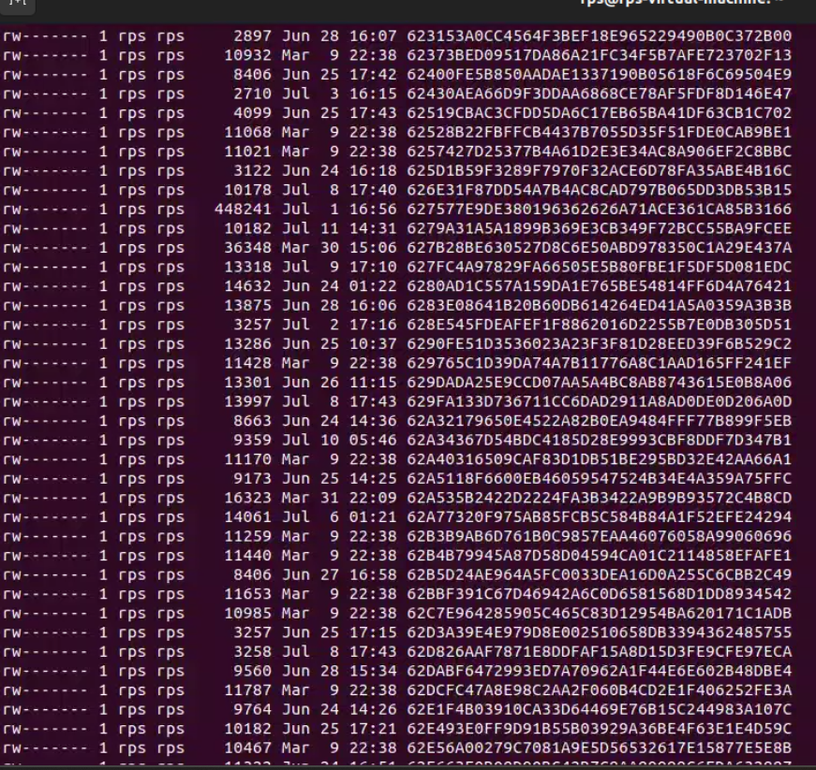

1. **List only files with a specific extension (e.g., .txt):**

find . -type f -name "*.txt"

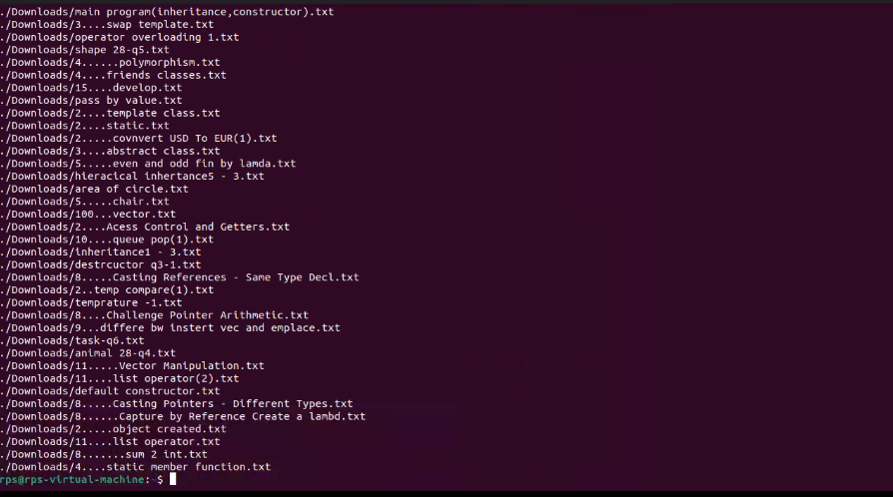

1. **Include the file size for each listed file:**

find . -type f -name "*.txt" -exec ls -lh {} \;

1. **Display only files modified within the last 24 hours:**

find . -type f -mtime -1

1. **Combine the functionalities to list only files with a specific extension (e.g., .jpg) modified in the last day:**

find . -type f -name "*.jpg" -mtime -1

**Explanation:**

1. ls -laR:
   * -l: Use a long listing format.
   * -a: Include hidden files.
   * -R: List subdirectories recursively.
2. find . -type f -name "*.txt":
   * find: Command to search for files.
   * .: Start the search in the current directory.
   * -type f: Search for files (not directories).
   * -name "*.txt": Search for files ending with .txt.
3. find . -type f -name "*.txt" -exec ls -lh {} \;:
   * -exec: Execute a command on each file found.
   * ls -lh {}: List the file with human-readable file size.
   * \;: End of the -exec command.
4. find . -type f -mtime -1:
   * -mtime -1: Find files modified in the last 24 hours.
5. find . -type f -name "*.jpg" -mtime -1:
   * Combines the search for files with a specific extension and the time-based search criteria.

**TASK 2**

1. **List all files and folders in the current directory:**

ls

* + **Count files:** ls | wc -l

1. **Display only files with a specific extension (.txt):**

ls *.txt

* + **Count .txt files:** ls *.txt | wc -l

1. **Navigate to Downloads and list contents:**

cd ~/Downloads

ls -lt --time-style=+%Y-%m-%d

* + **Check for today’s date in the output.**

1. **Display filename and size for each file:**

ls -lh

* + **Identify the largest file from the size column.**

1. **List all files with a specific extension pattern (e.g., .docx):**

ls *.docx

#### cd (5)

1. **Navigate to Documents:**

cd ~/Documents

pwd

1. **Move back one directory level:**

cd ..

1. **Display the full path after navigating:**

pwd

1. **Use shortcuts to reach specific locations:**

cd ~

1. **Combine cd with ls to navigate and list contents:**

cd ~/Documents

ls

#### cp / mv (5)

1. **Copy a file from Desktop to Documents:**

cp ~/Desktop/filename ~/Documents/

ls ~/Documents/

1. **Rename a file on Desktop:**

mv ~/Desktop/oldname ~/Desktop/newname

ls ~/Desktop/

1. **Copy an image file to another folder:**

cp ~/Pictures/image.jpg ~/Documents/

1. **Move a folder to a different location:**

mv ~/Documents/OldFolder ~/Documents/NewLocation/

1. **Copy a file that already exists in the destination:**

cp -i ~/Desktop/filename ~/Documents/

# Use -i flag to prompt before overwrite

#### mkdir / rmdir (5)

1. **Create a new folder inside Documents:**

mkdir ~/Documents/ProjectReports

ls ~/Documents/

1. **Create a nested folder structure:**

mkdir -p ~/Documents/ProjectX/Reports

ls ~/Documents/ProjectX/

1. **Delete an empty folder:**

rmdir ~/Documents/EmptyFolder

ls ~/Documents/

1. **Identify empty folders within a specific directory:**

find ~/Documents -type d -empty

### Windows CMD Commands

#### dir (5)

1. **List all files and folders in the current directory:**

dir

* + **Count files:** dir /b | find /c /v ""

1. **Display only files with a specific extension (.txt):**

dir *.txt

* + **Count .txt files:** dir *.txt /b | find /c /v ""

1. **Navigate to Downloads and list contents:**

cd %USERPROFILE%\Downloads

dir /T:W

* + **Check for today’s date in the output.**

1. **Display filename and size for each file:**

dir /s

* + **Identify the largest file from the size column.**

1. **List all files with a specific extension pattern (e.g., .docx):**

dir *.docx

#### cd (5)

1. **Navigate to Documents:**

cd %USERPROFILE%\Documents

echo %cd%

1. **Move back one directory level:**

cd ..

1. **Display the full path after navigating:**

echo %cd%

1. **Use shortcuts to reach specific locations:**

cd %USERPROFILE%

1. **Combine cd with dir to navigate and list contents:**

cd %USERPROFILE%\Documents

dir

#### cp / mv (5)

1. **Copy a file from Desktop to Documents:**

copy %USERPROFILE%\Desktop\filename %USERPROFILE%\Documents

dir %USERPROFILE%\Documents

1. **Rename a file on Desktop:**

rename %USERPROFILE%\Desktop\oldname newname

dir %USERPROFILE%\Desktop

1. **Copy an image file to another folder:**

copy %USERPROFILE%\Pictures\image.jpg %USERPROFILE%\Documents

1. **Move a folder to a different location:**

move %USERPROFILE%\Documents\OldFolder %USERPROFILE%\Documents\NewLocation

1. **Copy a file that already exists in the destination:**

copy /-y %USERPROFILE%\Desktop\filename %USERPROFILE%\Documents

# Use /-y flag to prompt before overwrite

#### mkdir / rmdir (5)

1. **Create a new folder inside Documents:**

mkdir %USERPROFILE%\Documents\ProjectReports

dir %USERPROFILE%\Documents

1. **Create a nested folder structure:**

mkdir %USERPROFILE%\Documents\ProjectX\Reports

dir %USERPROFILE%\Documents\ProjectX

1. **Delete an empty folder:**

rmdir %USERPROFILE%\Documents\EmptyFolder

dir %USERPROFILE%\Documents

1. **Identify empty folders within a specific directory:**

for /d %i in (*) do @if not exist "%i\*" echo %i