DAY 28 TCP Server and Client

Problem Statement: Write a TCP server and client program in C where the server listens for incoming connections and echoes back any message it receives from the client. The client should be able to send a message to the server and display the echoed message.

Requirements:

The server should run indefinitely, waiting for client connections.

The client should take a message as input from the user, send it to the server, and display the response.

Implement proper error handling and cleanup (e.g., closing sockets).

UDP Server-Client Communication:

Code sever:

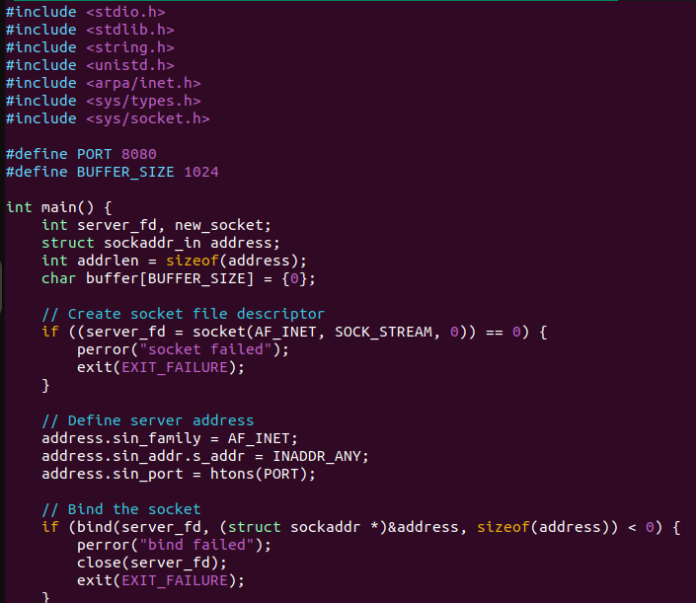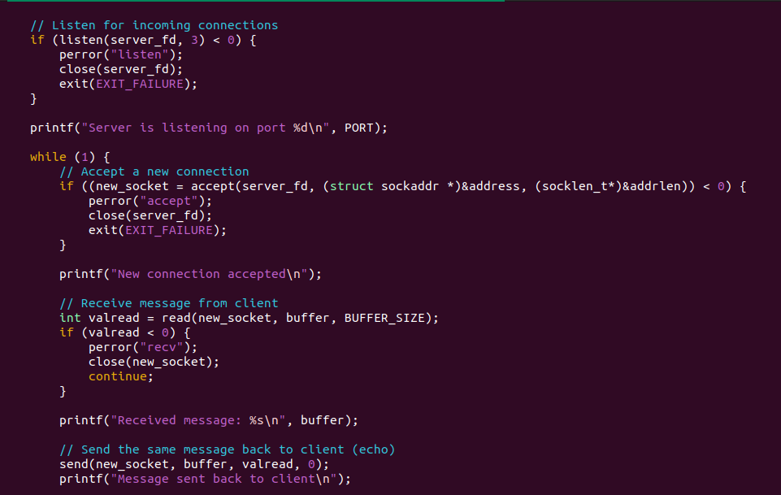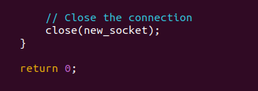

Output server :

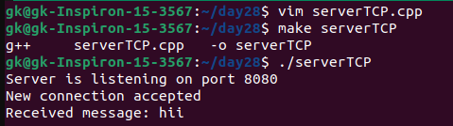

Client Code :

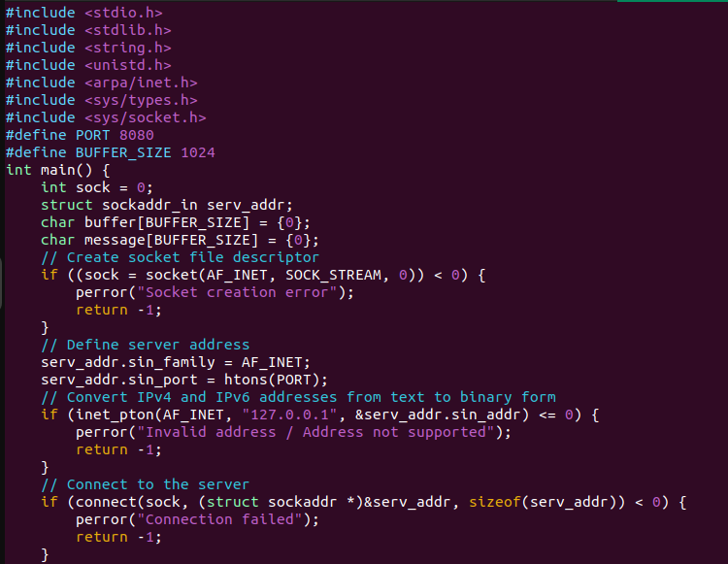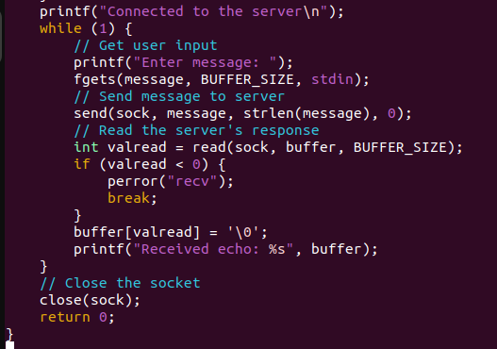

Output client :

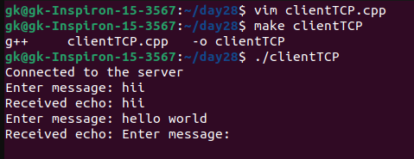

Problem Statement: Write a UDP server and client program in C to implement a simple broadcast messaging system. The server should broadcast a message to all clients in the network, and each client should display any broadcast messages it receives.

Requirements:

The server should send a broadcast message to a specific port.

Each client should listen on the same port and display any messages it receives.

Implement proper error handling and use UDP broadcast mechanisms.

Chat Application using TCP:

Code sever :

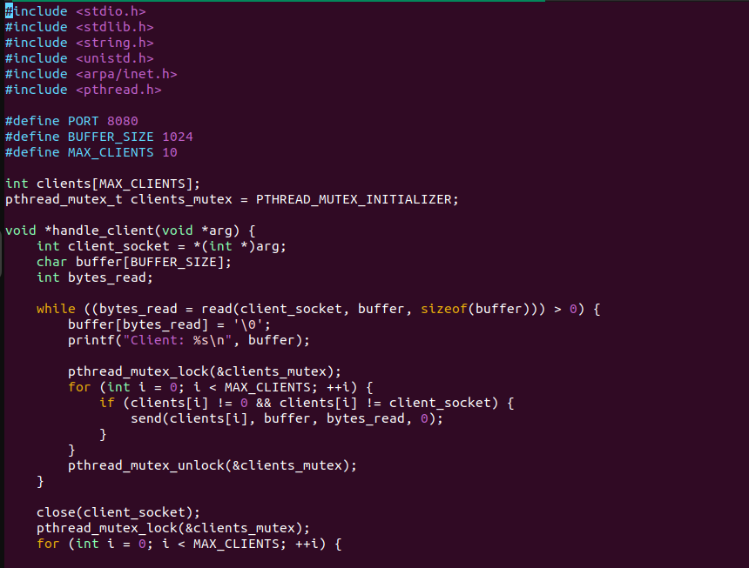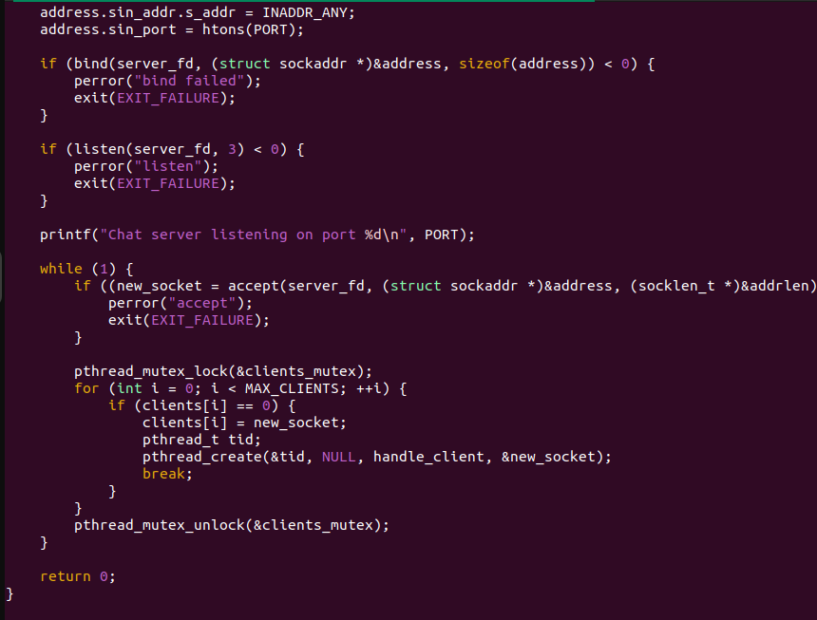

Output server :

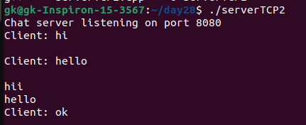

Code client :

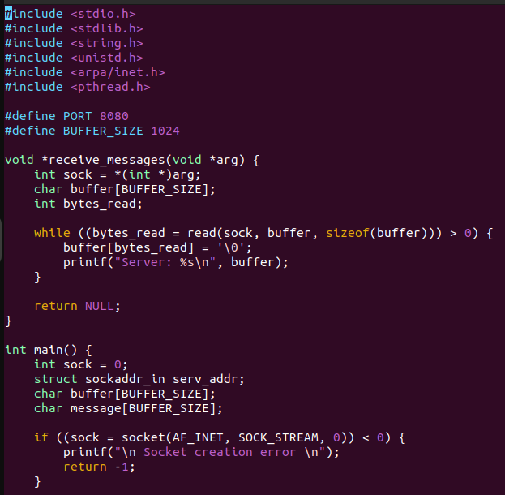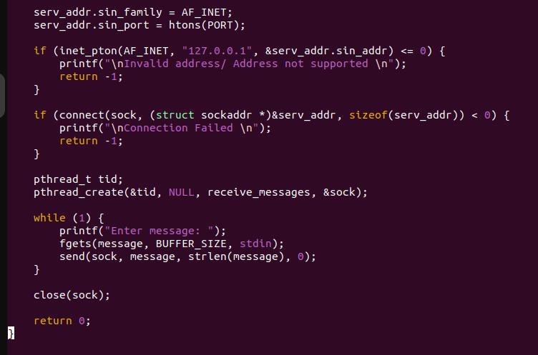

Output client :

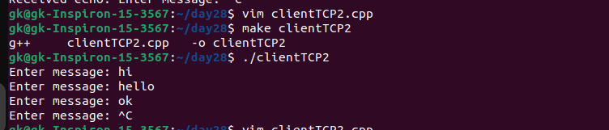

Problem Statement: Write a UDP server and client program in C where the server listens on a specific port and responds with "Hello, Client!" whenever it receives a message. The client should send a message to the server and print the response.

Requirements:

The server should run indefinitely, waiting for incoming messages.

The client should send a predefined message (e.g., "Hello, Server!") and display the server's response.

Implement proper error handling

Code server :

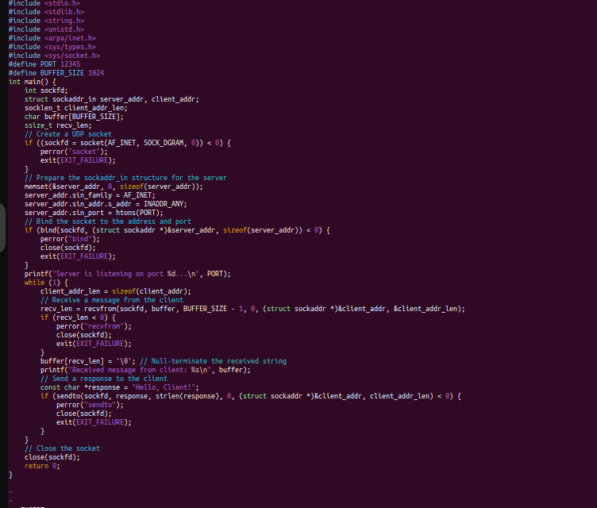

Output

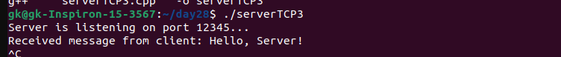

Code client :

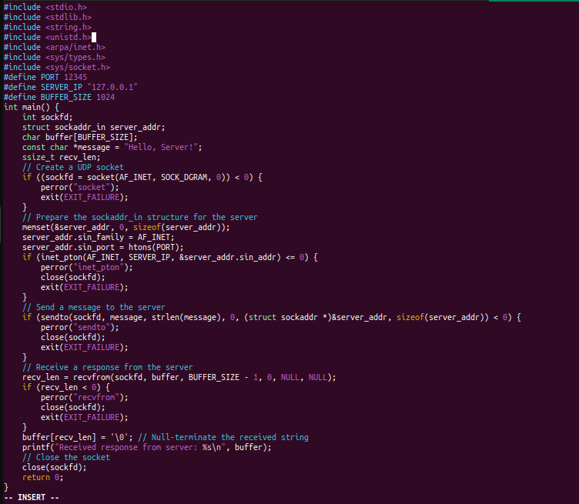

Output :

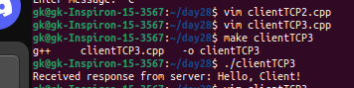

File Transfer using TCP:

Problem Statement: Write a TCP server and client program in C to transfer a file from the client to the server. The server should save the received file with the same name, and the client should specify the file to be sent.

Requirements:

The server should run indefinitely, waiting for file transfer requests.

The client should prompt the user for a file path, read the file, and send its contents to the server.

Implement proper error handling and file operations.

Code server :

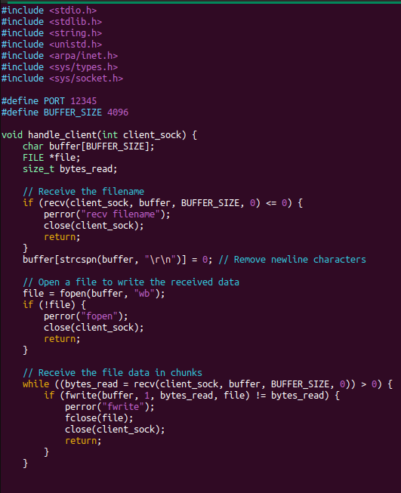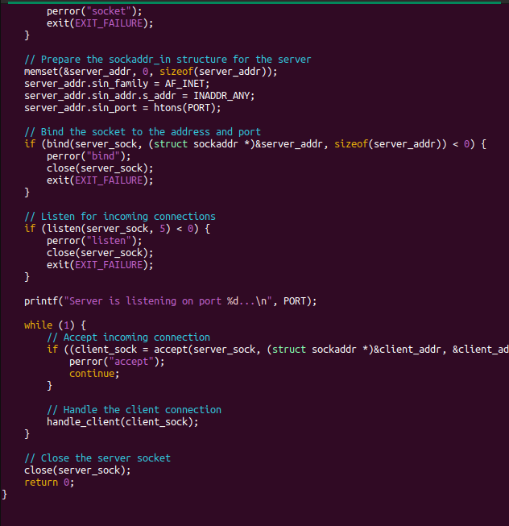

Output

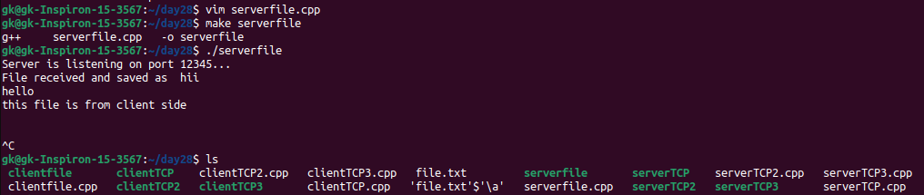

Code client

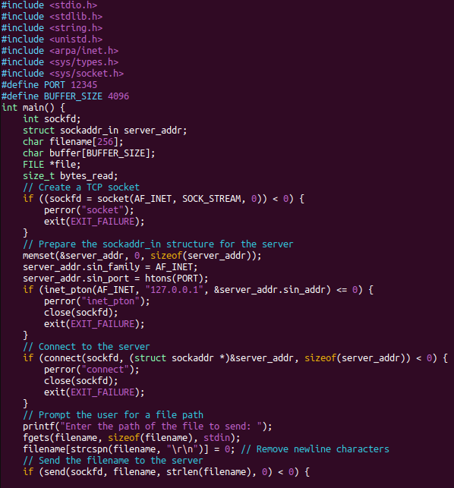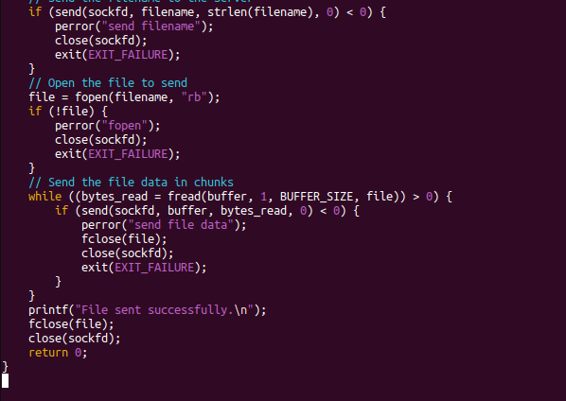

Output :

