Question 1:

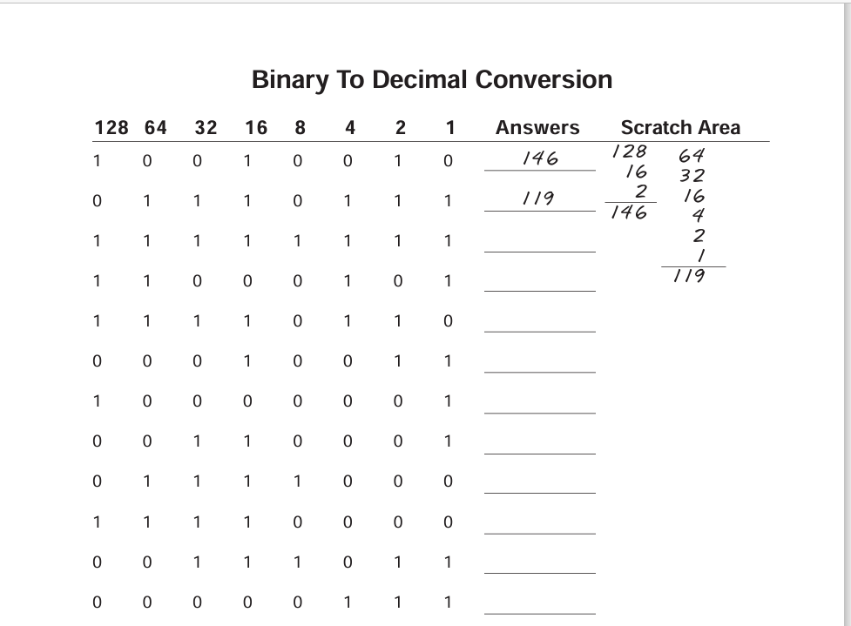

Answer: Binary to decimal:

1.255

2.197

3.246

4.19

5.129

6.49

7.120

8.240

9.59

10.7

Question 2:

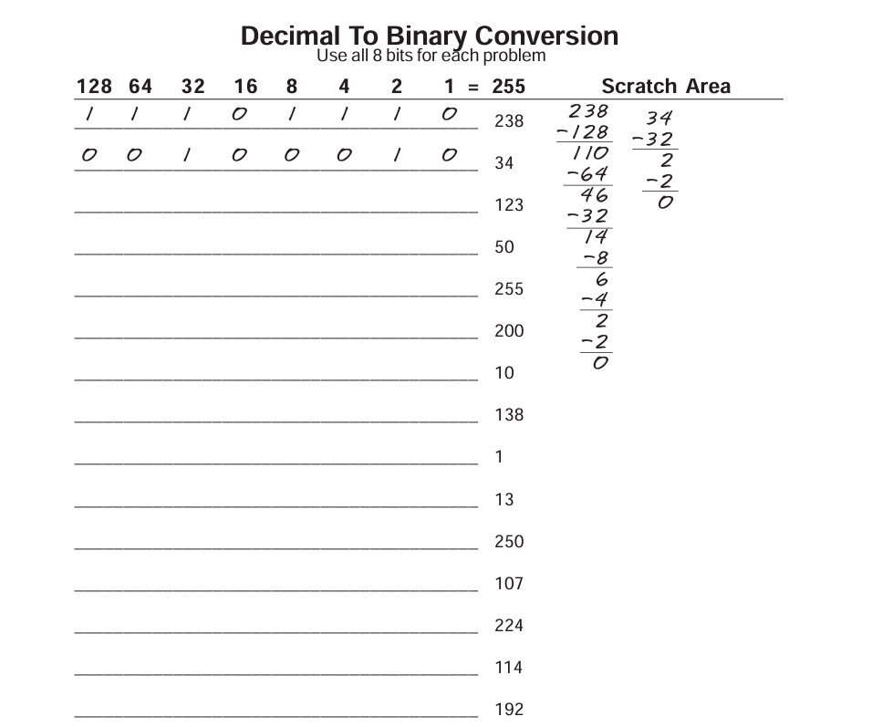

Answer:

Decimal To Binary:

1.01111011

2.00110010

3.11111111

4.11001000

5.00001010

6.10001010

7.00000001

8.00001101

9.11111010

10.01101011

11.11100000

12.01110010

13.11000000.

Question 3:

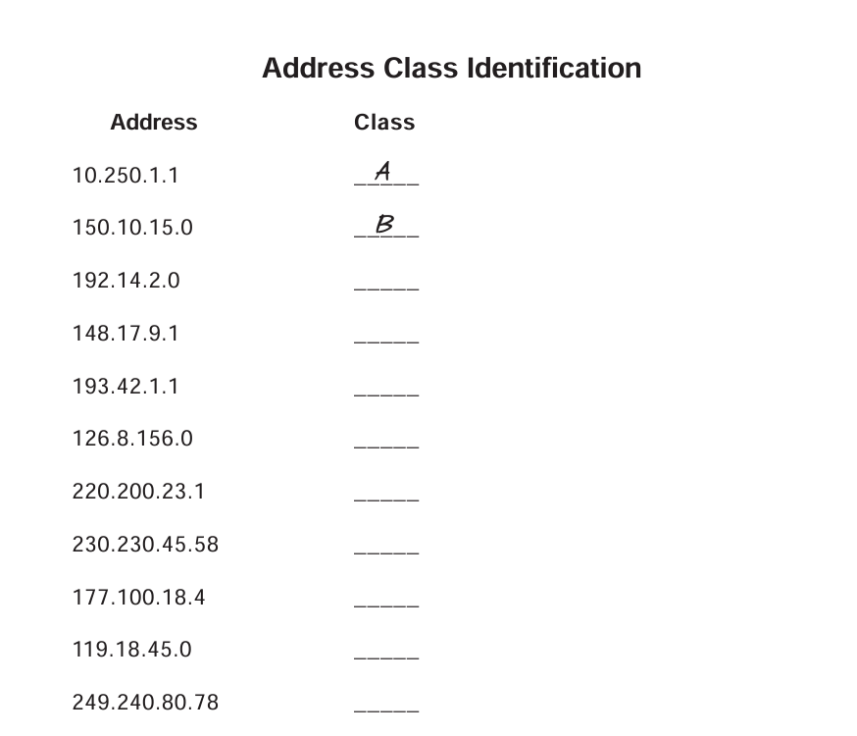

Answer:

class identification:

1.class C

2.class B

3.class C

4.class A

5.class C

6.class D

7.class B

8.class A

9.class E

**Cisco packet tracker:(lab 1)**

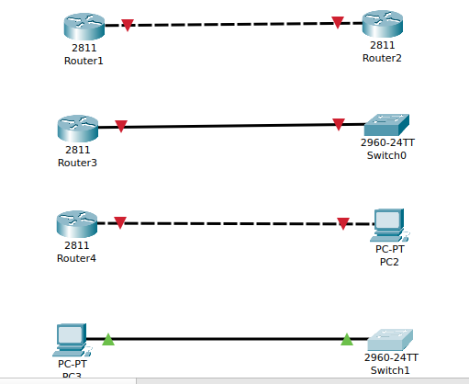

**Lab(4):**

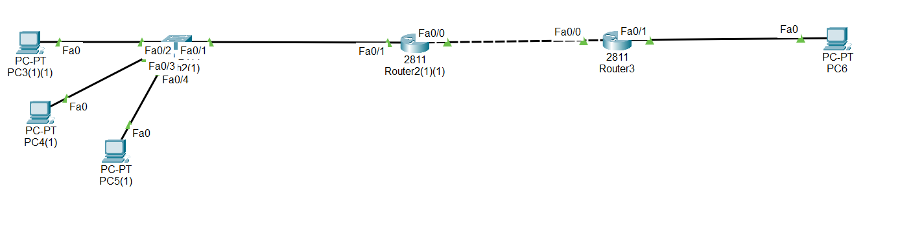

**OSI Model:**

1.physical layer

2.data link layer

3.network layer

4.transport

5.session

6.presentation,and

7.Application layer.

**Question: Diffrence between OSI and TCP/IP model.**

| **Parameters** | **OSI Model** | **TCP/IP Model** |
| --- | --- | --- |
| **Full Form** | OSI stands for Open Systems Interconnection. | TCP/IP stands for Transmission Control Protocol/Internet Protocol. |
| **Layers** | It has 7 layers. | It has 5 layers. |
| **Usage** | It is low in usage. | It is mostly used. |
| **Approach** | It is vertically approached. | It is horizontally approached. |
| **Delivery** | Delivery of the package is guaranteed in OSI Model. | Delivery of the package is not guaranteed in TCP/IP Model. |
| **Replacement** | Replacement of tools and changes can easily be done in this model. | Replacing the tools is not easy as it is in OSI Model. |
| **Reliability** | It is less reliable than TCP/IP Model. | It is more reliable than OSI Model. |

**Last Lab On Routing:**

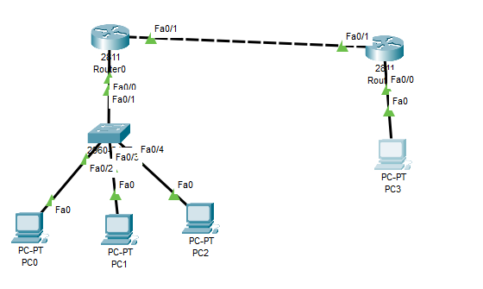

**Solution:**

