AIKAM AGENTIC AI INNOVATION CHALLENGE
Department of Energy · Problem Statement #6: Personalized Billing Assistance
Vidyut Sahaayam
An electricity-bill assistant for every Telangana household, in Telugu and English, on the web and on WhatsApp
Feature summary and solution overview
Built on Crest, OMFYS's sovereign on-premise agentic AI platform
Submitted by OMFYS Technologies India Pvt. Ltd.
Unit No. 1, Electronic Sadan-3, MIDC Bhosari, Pune, Maharashtra 411026 · +91 20 4860 1860 · omfysgroup.com
Version 1.0 · 22 October 2026

Contents

1. Summary 3
2. The problem 3
3. The solution at a glance 3
4. The citizen journey 4
4.1 On WhatsApp 4
4.2 On the web app 4
5. Features 5
5.1 Bill Reader agent 5
5.2 Billing Assistant agent 5
5.3 Smart Assist agent 5
5.4 Web app 6
5.5 WhatsApp channel 6
6. Trust, sovereignty and security 6
7. Validation and current status 7
8. Deployment 7
9. Roadmap and proposed pilot 7
9.1 Next steps 7
9.2 Proposed pilot 7

1. Summary
Vidyut Sahaayam (“electricity helper”) lets any household understand its electricity bill in its own language. The citizen sends a photo of the bill, on WhatsApp or through a web page. Crest agents read the bill, explain every charge in Telugu and English, estimate next month’s bill, check the bill for errors, suggest specific ways to save, find the government schemes the household qualifies for, and draft a complaint when something is wrong.
Everything runs on Crest, OMFYS’s on-premise agentic AI platform, so bill data stays on infrastructure the department controls. The solution has been tested end to end with real bill photos on both channels and has been selected for the AIKAM demonstration.
Problem statement | #6 Personalized Billing Assistance, Department of Energy
Platform | Crest, on-premise agentic AI (OMFYS)
Channels | WhatsApp and a mobile-first web app
Languages | Telugu and English, side by side
Bill intake | Photo or PDF of the bill; QR code where printed; structured data
AI agents | Bill Reader, Billing Assistant, Smart Assist
Status | Working end to end on web and WhatsApp; selected for demonstration

2. The problem
An electricity bill is a dense document. It splits consumption into tariff slabs at different rates, then adds fixed charges, customer charges, electricity duty, fuel cost adjustments, subsidies and arrears. Most households cannot tell why a bill went up, whether it is correct, or what they could change to pay less.
- The bill people actually hold is hard to read. Most domestic consumers receive a thermal spot-billing receipt printed at the door: small print, no QR code, and it fades over time.
- Language is a barrier. Bills are printed in English; many consumers are more comfortable in Telugu.
- Errors go unnoticed. An unusual spike, an estimated reading or a slab calculation mistake is easy to miss, and few consumers know how to word a complaint.
- Savings advice is generic. Consumers rarely get advice tied to their own slab position, their own appliances, or the schemes they are eligible for.

3. The solution at a glance
Two citizen channels sit in front of three Crest agents. The web app reaches Crest through a small proxy that holds the platform key, so the key never reaches a browser. The WhatsApp service holds its own key and calls Crest directly.
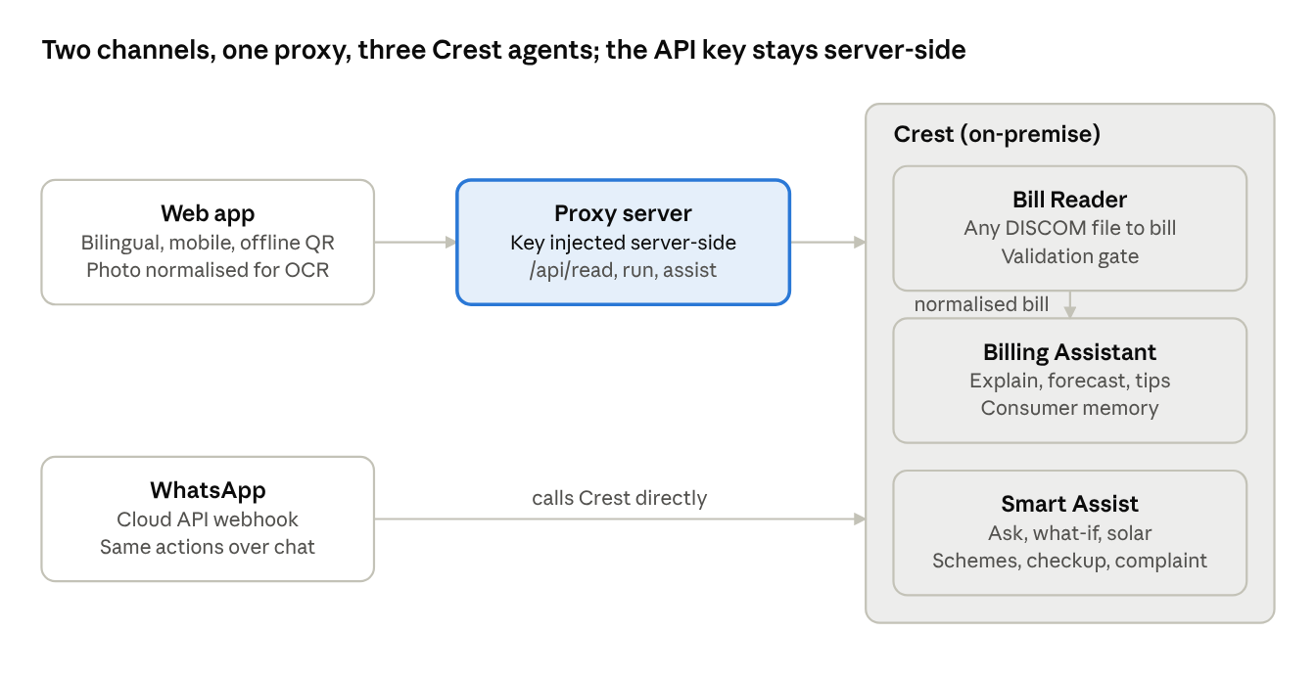
Figure 1. Two channels, one proxy, three Crest agents; the platform key stays server-side.
Every bill follows the same path:
- The Bill Reader turns the photo or PDF into a standard bill record, whatever the DISCOM’s layout.
- A validation gate checks the record’s arithmetic; a bill that does not add up is marked for the citizen to confirm instead of being explained with wrong figures.
- The Billing Assistant explains each charge, estimates next month from the consumer’s own history, and gives three personalised saving tips.
- Smart Assist answers follow-up questions: savings by appliance, what-if scenarios, solar, schemes, bill checkup and complaints.

4. The citizen journey

4.1 On WhatsApp
- The citizen sends “Hi” to the Vidyut Sahaayam number. The bot greets them in Telugu and English and asks for a photo of this month’s bill.
- The citizen sends the photo (or a PDF). The bot confirms it is reading the bill.
- The bot replies with a short summary: consumer name, service number, units, amount and due date.
- It then sends the full explanation in Telugu and English, the three saving tips and next month’s estimate, the same content as the web app.
- A menu offers the next steps: check my bill, how can I save, schemes for me, solar rooftop, draft a complaint. The citizen can also type any question.
- For “how can I save”, the bot asks which appliances are used, with wattage and daily hours, and returns rupee savings per appliance.

4.2 On the web app
- The citizen opens the page on a phone and uploads a bill photo, a PDF or a sample bill.
- The page shows the explanation, a full charges table that reconciles to the printed total, a chart of recent months with next month’s estimate, and saving tips.
- The Smart Assist panel offers Ask (with voice input), Checkup, Breakdown, What-if, Solar, Schemes and Grievance.
- A one-page energy report card summarises usage, the bill, the estimate, the top saving and eligible schemes, ready to print, save as PDF or share.

5. Features

5.1 Bill Reader agent
Reads a bill from any Indian distribution company without a template per DISCOM. It maps whatever layout it sees onto one standard 39-field bill record.
- Accepts photos, PDFs and Word files; bills printed in English or a regional script.
- Reads text on the platform itself, so bill images never leave the department’s infrastructure.
- Fills gaps from the bill’s own figures: units from the meter readings, the total from its components, a slab amount from units times rate.
- Rebuilds Telangana domestic tariff slabs when a receipt prints only the energy total, and keeps them only if they reproduce the printed amount to the rupee.
- Checks the arithmetic (slabs against energy charge, components against total, readings against units) and marks the bill for confirmation when a check fails.

5.2 Billing Assistant agent
- Explains every line of the bill in simple Telugu, then English, using only the numbers on the bill.
- Estimates next month’s units and amount from the consumer’s own history, priced on the real tariff slabs, and states how confident the estimate is.
- Gives three personalised saving tips with a rupee figure, including a warning when the consumer is close to a higher slab.
- Keeps a separate history for each consumer, shared across web and WhatsApp, so each forecast uses only that household’s own bills.

5.3 Smart Assist agent
Capability | What the citizen gets
Ask | Answers to free-text questions in Telugu and English, grounded in the bill and history
Appliance savings | Rupee savings per appliance, from the appliances, wattage and hours the citizen lists
What-if | Any usage cut or shift to off-peak hours re-priced on the actual tariff
Breakdown | Which charges drove the bill, and usage against the household’s own average
Checkup | Flags an unusual spike, a suspiciously low reading, a total that does not add up, or a slab calculation error
Complaint | A ready-to-send letter to the Assistant Engineer, citing the exact figures in question
Schemes | Eligibility for PM Surya Ghar, Gruha Jyothi (200 free units) and Time-of-Day tariff
Scheme application | A pre-filled application letter for the chosen scheme
Solar | Suggested rooftop size, subsidy, net cost, monthly saving and payback period

5.4 Web app
- Single page, mobile-first, with a Telugu/English toggle and a light, accessible design.
- Reads the QR code on bills that carry one, directly in the phone’s browser; other photos are straightened and sharpened before they are sent for reading.
- When a bill cannot be read, the page says exactly why and what to do next.
- Each Checkup finding becomes a one-tap complaint letter quoting the exact discrepancy.
- Energy report card: a shareable one-page summary, printable or saved as PDF.
- Keeps working in demonstration mode if the platform is unreachable, so the screen is never blank.

5.5 WhatsApp channel
- The full journey in section 4.1, on the channel citizens already use every day.
- Replies come from the same number the citizen wrote to.
- Responds to WhatsApp immediately and does the reading in the background, so long photos never cause repeated or duplicate replies.
- Verifies that every incoming message genuinely comes from Meta before acting on it.

6. Trust, sovereignty and security
Principle | How Vidyut Sahaayam meets it
Data stays in government control | Runs on Crest on-premise; bill photos are read on the platform, not sent to an outside reading service
No invented figures | Money is calculated by fixed rules, not by the AI model; the model explains only figures on the bill; failed checks lead to confirmation, not a guess
Keys never exposed | The platform key lives on the server; the browser never receives it
Genuine messages only | Each WhatsApp message is checked against Meta’s signature before it is processed
Per-household privacy | Each consumer’s history is kept separate and used only for that consumer
Hardened deployment | Containers run without administrator rights; no secrets in images or source control

7. Validation and current status
Results below were observed on the team’s demonstration setup with real bill photos.
Test | Result
Real TGSPDCL thermal spot-billing receipt (photo, no QR code) | 294 units and a total of Rs 1,911 recovered; slabs rebuilt as 200 × Rs 5.10 + 94 × Rs 7.70 = Rs 1,743.80, matching the printed energy charge
WhatsApp, end to end, real phone (22 October 2026) | Bill photo in; summary, Telugu and English explanation, estimate and menu returned in the same chat
Reading time per photo | Between 32 and 53 seconds for the Bill Reader; 7 to 8 seconds for the Billing Assistant
Forecast isolation | Each consumer’s estimate drawn only from that consumer’s own bills

Status: working end to end on the web and on WhatsApp. The public demonstration needs a WhatsApp business number with an approved display name; this is in progress with Meta.

8. Deployment
- The three Crest agents are imported from export files into the department’s Crest instance.
- The web app and WhatsApp service run as one container stack, configured from a single settings file, with health checks and automatic restart.
- A built-in smoke test confirms the stack is healthy and can reach Crest before go-live.
- HTTPS is terminated at the department’s load balancer, or by an included automatic-certificate option once a domain is assigned.

9. Roadmap and proposed pilot

9.1 Next steps
- Approved WhatsApp business number with the display name “Vidyut Sahaayam by OMFYS” (in progress).
- Stronger reading of difficult photos (faded or skewed receipts) using a vision model hosted on-premise.
- Reading of bills printed only in Telugu or another regional script.
- With consent, a connection to DISCOM billing records so that history and estimates are available from a consumer’s first message.

9.2 Proposed pilot
Scope: [To confirm: DISCOM, circle or section office, number of households]
Duration: [To confirm]
Success measures: [To confirm with the department, e.g. bills explained, complaints drafted, scheme applications started]

