MoSJE Product 1 platform: hosting guide (GitHub + Render)
This guide is for someone who is not a developer. Follow the numbered steps in order. You will put the project files on GitHub, then Render will read them and build three things for you:
- a database that holds the synthetic Jan Aadhaar, CBSE and scheme data, plus the results,
- an API, the "engine room", which runs record linkage and eligibility,
- a dashboard, the web page you and your colleagues will open.
Total time: about 45 minutes the first time. Cost: free (read step 9 for the limits).
Screens change. Button names on GitHub and Render may be slightly different from what is written here (for example "New +" instead of "New", or "Env Groups" instead of "Environment Groups"). Look for the closest match.
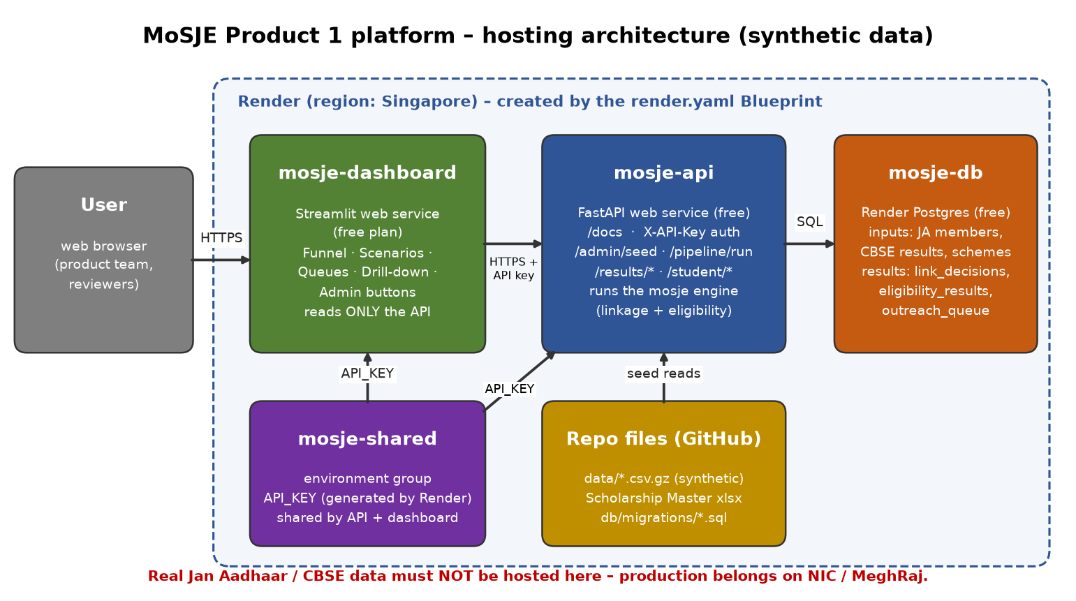
Figure: hosting architecture (dashboard → API → Postgres on Render; synthetic data only)

What you need before starting
1. The file mosje_platform.zip. Unzip it. You will get a folder called mosje_platform.
2. An email address you can open. You will use it for GitHub and Render.
3. A laptop with Chrome, Edge or Firefox.
Upload limits to know about. On the GitHub website, each file can be at most 25 MB, and you can upload at most 100 files at a time. This project is well within both limits: it has about 70 files and the biggest one is about 0.5 MB, because the data files are compressed as .csv.gz. Do not unzip the .gz files. The system reads them as they are.

Step 1: Put the files on GitHub
1. Go to https://github.com and click Sign up. Create a free account and confirm your email.
2. When you are logged in, click the + at the top right, then New repository.
3. Fill in the form:
- Repository name: mosje-platform
- Choose Private. Render can still read private repositories, and private keeps the work out of public view.
- Do not tick "Add a README", ".gitignore" or "license". The zip already contains them.
- Click Create repository.
4. On the next page, click the link uploading an existing file. If you don't see it, use Add file → Upload files.
5. Open the unzipped mosje_platform folder on your computer. Select everything inside it: the folders api, dashboard, data, db, docs, mosje, tests and tools, and all the files such as render.yaml and requirements.txt. Drag them into the GitHub upload box.
- Important: drag the contents of the folder, not the mosje_platform folder itself. The file render.yaml must end up at the top level of the repository, not inside a sub-folder.
- Hidden files. Some files start with a dot: .gitignore, .python-version, .env.example, .dockerignore. On a Mac, press Cmd + Shift + . in Finder to show them. On Windows, go to File Explorer → View → Show → Hidden items. These files are helpful but not essential. The deployment still works without them.
6. Wait until every file shows in the list. Scroll to the bottom, type a message such as "first upload" and click Commit changes.
7. Check the result. The main page of the repository should show render.yaml, README.md, requirements.txt and the folders listed above. Click into data and confirm the three .csv.gz files and the .xlsx are there.
Optional, for people comfortable with a terminal:
cd mosje_platform
git init && git add . && git commit -m "MoSJE platform"
git branch -M main
git remote add origin https://github.com/<your-user>/mosje-platform.git
git push -u origin main

Step 2: Sign up for Render and connect GitHub
1. Go to https://render.com and click Get Started (or Sign up).
2. Choose Sign up with GitHub. This is the easiest option because it connects the two accounts in one go. Approve the permissions GitHub shows you.
3. If Render asks which repositories it may see, choose Only select repositories, pick mosje-platform and save. You can change this later under GitHub → Settings → Applications.
4. Render may ask you to create a workspace (any name is fine). It may also ask for a payment card to verify your account. Free resources are not charged.

Step 3: Deploy everything with the Blueprint
A "Blueprint" is the file render.yaml in your repository. It tells Render exactly what to build, so you don't have to set anything up by hand.
1. In the Render dashboard, click New (top right), then Blueprint.
2. Pick the repository mosje-platform. If it is not listed, click Configure account or Connect GitHub and give Render access to it (step 2.3).
3. Give the Blueprint a name, e.g. mosje. Leave the branch as main.
4. Render shows what it will create. You should see:
- mosje-db: PostgreSQL, Free
- mosje-api: Web Service, Free
- mosje-dashboard: Web Service, Free
- mosje-shared: Environment Group (it holds the generated API_KEY)
5. Click Apply (or Deploy Blueprint).
6. Wait. The database is ready in a minute or two. Each web service then builds (installs software, 3–6 minutes) and deploys. You can click a service and open Logs to watch. The API also loads the data and runs the pipeline once automatically on its first start (step 5).
7. When both web services show Live (green), the deployment is done.
Write down the two web addresses shown at the top of each service page. They look like:
- API: https://mosje-api-xxxx.onrender.com (the -xxxx part may not be there)
- Dashboard: https://mosje-dashboard-xxxx.onrender.com

Step 4: Find your API key
The API is protected by a password-like key. Render generated it for you.
1. In Render, open Environment Groups (in the left menu; it may be called Env Groups).
2. Click mosje-shared.
3. Next to API_KEY, click the eye icon (or Reveal) and copy the value.
4. Keep it private. Share it only with people who need to call the API directly. You don't need the key to view the dashboard, because the dashboard already has it.
To change the key, edit the value in the same place and click Save. Render restarts both services, and the new key applies to both automatically.

Step 5: Load the data into the database ("seed")
Normally you don't have to do anything. The Blueprint sets AUTO_SEED=true, so on its first start the API creates the tables and loads the synthetic data files and the scheme master by itself.
To check it, open https://<your-api-address>/health in the browser. You should see "seeded": true.
If it says false, or you want to reload the data, use either of these:
- Easiest: open the dashboard, go to the Admin tab and click 1 · Load (seed) the database.
- Or: open https://<your-api-address>/docs, click Authorize, paste the API key and click Authorize again. Then open POST /admin/seed, click Try it out, then Execute. A response of "status": "seeded" or "skipped" (already loaded) means it worked. Setting force to true reloads everything and clears old results.
(Render's "Shell" and "one-off jobs" are not available on the free plan. That is why loading is done through the API.)

Step 6: Run the pipeline (linkage + eligibility)
The first run also happens automatically after the first seed (AUTO_RUN_PIPELINE=true).
To run it again, for example after re-seeding:
- Dashboard: open the Admin tab and click 2 · Run the pipeline. On the free plan it takes about 1–3 minutes. A green "SUCCEEDED" message appears. Then click Refresh results.
- Or /docs: POST /pipeline/run → Try it out → Execute. Watch progress with GET /pipeline/runs.

Step 7: Open the dashboard and the API docs
- Dashboard: https://<your-dashboard-address>. The tabs are Funnel, Linkage decisions, Match quality, Eligibility & schemes, Outreach queues, Student drill-down, Scenarios (matching and non-matching students for all 56 matrix scenarios), Compiled rules, Admin, Match Outcomes (the six headline match numbers with plain-English definitions) and 36-Scenario Matrix (a reporting view of the earlier 36-row matrix).
- API docs: https://<your-api-address>/docs. This is an interactive page listing every endpoint. Click Authorize first.
If a page takes about a minute to open, the service was asleep. This is normal on the free plan (step 9).

Step 8: Checklist to confirm it all works
Tick each line:
1. ☐ https://<api>/health shows "status": "ok", "database": "postgresql", "seeded": true and a latest_run with "status": "SUCCEEDED".
2. ☐ https://<api>/schemes in the browser shows 401 "missing or invalid X-API-Key". This is good: the key protection works.
3. ☐ In /docs, after Authorize, GET /results/funnel returns data.
4. ☐ The dashboard header shows CBSE records 5,000 · Linked 3,712 (74.2%) · Precision 1.000 · Recall 0.873 · QUEUE_FOR_OUTREACH 3,712 · DISCOVERY 141 · eligible schemes/student 18.1. These are exactly the prototype's numbers.
5. ☐ The Scenarios tab shows Unreachable rows: 27 of 56 and totals of TP 3,712 · FP 0 · FN 538 · TN 750 · G7-blocked 48.
6. ☐ Student drill-down opens a student and lists their eligible schemes.
7. ☐ The Admin tab shows the row counts: jan_aadhaar_members 21,173, cbse_results 5,000, scheme_rules 547, eligibility_results 248,704.

Step 9: Costs and free-plan limits
Item | Free plan behaviour
Web services (API, dashboard) | Free. They go to sleep after 15 minutes with no visitors. The next visit wakes them, which takes about 1 minute. Render gives 750 free hours per workspace per month, which is enough for these two services because sleeping services don't use hours.
Postgres database | Free: 1 GB storage (this project uses about 250 MB). It expires 30 days after creation. After that you have 14 days to upgrade it to a paid plan, or Render deletes it. To keep using the free plan, delete the old database and create a new one: re-apply the Blueprint, and the data loads again automatically.
One free database | Only one free Postgres database is allowed per workspace.
Shell / one-off jobs | Not available on the free plan, so seeding happens through the API or dashboard (step 5).

For a longer pilot or a demo that must always be fast, upgrade in the Render dashboard (the service's
Settings → Instance type, and the database's Change plan):
- API and dashboard: the smallest paid instance ("Starter", roughly US$7 per month each). These never sleep.
- Database: the smallest paid Postgres (roughly US$6–7 per month). It has no 30-day expiry and includes backups.
That comes to roughly US$20 per month in total. Check render.com/pricing for current prices. In the Blueprint you can change plan: free to the paid plan names later.

Step 10: Troubleshooting
What you see | What it means | What to do
Blueprint says "render.yaml not found" | The file is not at the top level of the repo | On GitHub, check that render.yaml is on the repository's main page and not inside a folder. Re-upload if needed.
Build fails with "Could not open requirements file" | requirements.txt or requirements-dashboard.txt is missing | Upload the missing file to the top level of the repo. Render redeploys automatically.
Build fails mentioning a Python version | The Python version is wrong | The Blueprint sets PYTHON_VERSION=3.13.5 in the mosje-shared group. Check that it is still there.
Dashboard shows "Cannot reach the API" | The API is asleep, still deploying, or the dashboard is guessing the wrong address | Wait 1–2 minutes and reload. If it keeps happening: open mosje-dashboard → Environment, add API_BASE_URL = your API address (e.g. https://mosje-api-xxxx.onrender.com), and save.
Dashboard shows 401 / "invalid X-API-Key" | The dashboard and the API have different keys | Make sure both services use the mosje-shared group and that no service has its own API_KEY that overrides it.
/health shows "seeded": false or a startup_error | Loading failed | Open mosje-api → Logs and look for the red error. Check that the data/ folder was uploaded with all four files. Then use Admin → Load (seed).
Pipeline run shows FAILED | See the error column in the Admin tab | Most often the data is not loaded yet: seed first, then run.
A run stays RUNNING after a restart | The service restarted mid-run | The API marks it FAILED on its next start. Just run again.
Database expired (after 30 days) | Free Postgres limit | Upgrade the database, or delete it and re-sync the Blueprint (Blueprints → mosje → Manual sync). The API reloads the data by itself.
Everything is slow the first time | Free services were asleep | Normal. Open the dashboard a minute before a demo.

Step 11: Security notes (read this)
- Synthetic data only. Every name, ID and mobile number in this deployment is fictional (generated with a fixed seed). Render is a commercial, overseas cloud. Real Jan Aadhaar, CBSE or any other government personal data must never be uploaded to Render or GitHub.
- Production goes on government infrastructure. As the concept note says, the real system must be hosted on NIC / MeghRaj (GI Cloud). It must follow the department's data-sharing agreements, Aadhaar-related rules and the DPDP Act, 2023, with proper access control and audit logging. This Render setup is for demos and for reviewing the rules only.
- API key. Treat it like a password. Don't paste it into chats or documents. Change it if it leaks (step 4). The key protects the API. The dashboard itself has no login: anyone who has the dashboard address can view it. That is acceptable for synthetic data, but keep the address within the team.
- Private repository. Keep the GitHub repository private. Never upload a .env file containing real keys.
- Outreach. The system only builds outreach queues. It does not send any WhatsApp or SMS messages. The eligible-shortlist message text is a prototype draft that still needs departmental approval.

Appendix A: Updating the code later
Upload the changed files to GitHub (Add file → Upload files, using the same folder structure) and commit. Render notices the change and redeploys both services automatically in a few minutes.

Appendix B: Running it on your own laptop
If Docker Desktop is installed: copy .env.example to .env, set API_KEY, and run docker compose up --build. Then open http://localhost:8501 (dashboard) and http://localhost:8000/docs (API).

Appendix C: Glossary
- Repository (repo): a project folder on GitHub.
- Blueprint: the render.yaml file that describes all the services.
- API: a program other programs talk to. The dashboard talks to it.
- Seed: loading the starting data into the database.
- Pipeline: the run that links CBSE students to Jan Aadhaar and checks scheme eligibility.
- Environment variable: a named setting (like API_KEY) given to a service without being written into the code.

