ACTIVITY 1

Create the Same Visual with Multiple AI Tools:
PROMPT: Generate a photorealistic scene showing a female airline customer-service professional at a contemporary international airport check-in desk. She should wear a formal navy-blue uniform and face the camera. Gentle natural light should enter from the left side of the camera. Keep the terminal clean and modern, with passengers blurred in the background. Use lifelike skin detail, natural facial characteristics, commercial photography styling, a shallow depth of field, and a 16:9 frame. Avoid airline branding, logos, and any readable wording.

TOOL 1: CHATGPT


TOOL 2 GEMINI
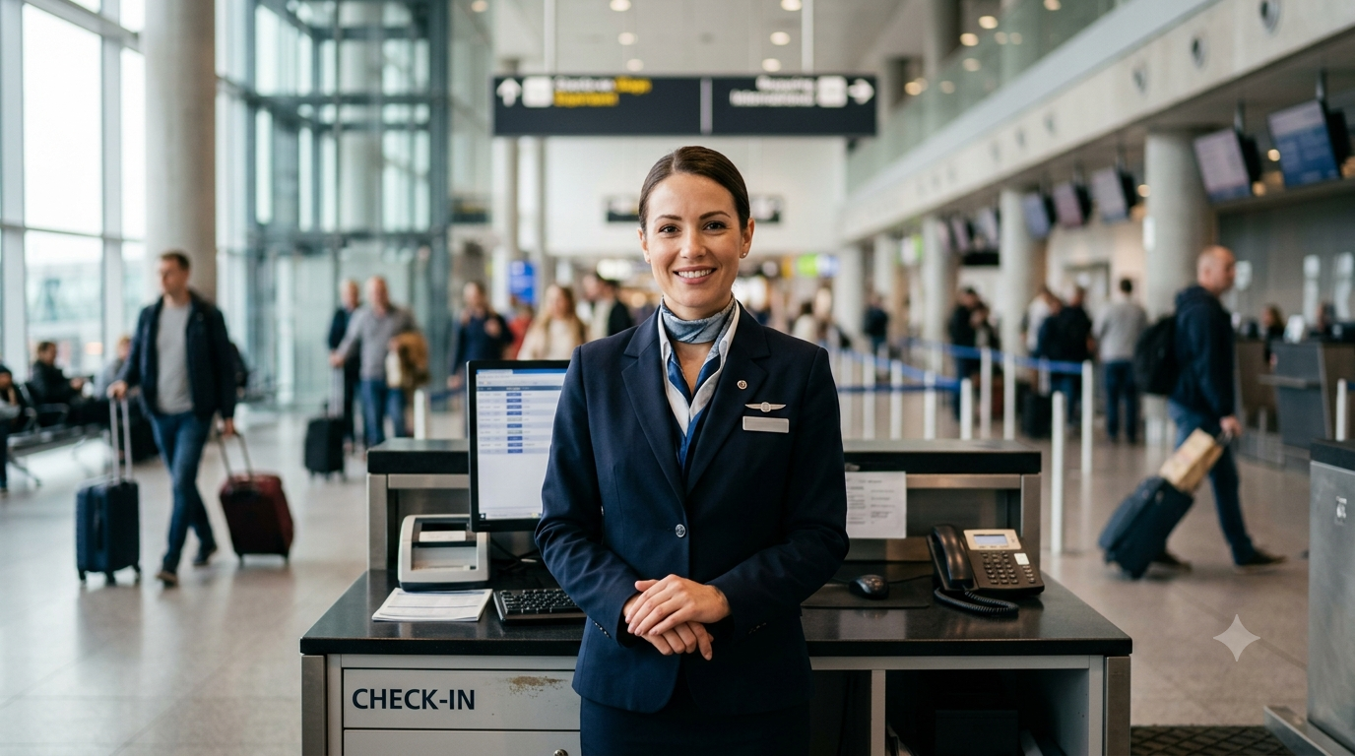

Activity 2

Examine the Visual Style of Each Model

Activity 2: Examine the Visual Style of Each Model

Evaluation Criterion | Tool 1 – Gemini | Tool 2 – ChatGPT
Name of AI tool | Gemini | ChatGPT
Prompt followed correctly? | Mostly | Mostly
Human face appears realistic? | Yes | Yes
Skin texture appears natural? | Fairly natural | Yes, highly natural
Eyes and hands are correct? | Eyes look correct; hands are generally accurate | Eyes look correct; hands are generally accurate
Airport environment is realistic? | Yes | Yes
Light comes from camera-left? | Yes | Yes
Uniform is professional? | Yes | Yes
Unwanted text or logos present? | Yes – visible “CHECK-IN” wording and some background signs | No clear readable wording or airline branding
Image looks AI-generated? Why? | Slightly – polished facial details, hands, and artificial-looking text | Slightly – highly polished face and background details
Overall rating out of 10 | 8/10 | 9/10

Analysis Questions

1. Which tool matched the instructions more closely?
ChatGPT matched the requested instructions more closely. Its output showed a professional female airline executive in a navy-blue uniform, natural facial details, light coming from the camera-left, and a contemporary airport setting without clearly readable wording or airline branding.
2. Which visual looked more realistic?
The ChatGPT result looked a little more realistic overall. Its facial details, skin appearance, lighting, and depth in the background gave it a stronger resemblance to a professionally captured commercial photograph.
3. What variation did you notice in the lighting?
Both visuals used bright, diffused illumination mainly from the camera-left direction. Gemini distributed the light somewhat more evenly, whereas ChatGPT showed gentler highlights and shadows that appeared more natural.
4. Were there any noticeable distortions in the eyes, hands, or facial features?
Neither result showed major problems with the eyes or facial structure. Gemini’s hands looked somewhat less natural, while ChatGPT’s hands were mostly convincing, although part of them was obscured by the counter.
5. Which visual would you select for an airline website?
I would select the ChatGPT image because its presentation is clean and professional and it aligns more closely with the requested visual direction. It also avoids prominent readable text and airline logos, which makes it suitable for general airline website content.

6. What distinctive visual style does each model show?
Gemini: Its visual style emphasizes a formal airport-service setting, with a clear full-body view and a detailed terminal environment.
ChatGPT: Its visual style leans toward soft, polished commercial realism, giving greater emphasis to the executive’s face, lifelike skin detail, and shallow background focus.

Activity 3: Test Directional / Spatial Instructions

Prompt A — Light from Camera-Left
Generate a photorealistic image of an airport ground-service executive standing next to a check-in counter. Soft morning illumination should come from the camera-left and brighten the left portion of the scene. The executive must be holding a tablet. Add a contemporary airport terminal in soft focus behind the subject. Use professional photographic styling, realistic facial details, a 16:9 composition, and exclude logos and readable text.



Prompt B — Light from Camera-Right
Generate a photorealistic image of an airport ground-service executive standing beside a check-in desk. Soft morning light should enter from the camera-right and illuminate the right portion of the scene. The executive should carry a tablet, with a modern airport environment softly blurred behind them. Apply professional photography, natural facial features, a 16:9 frame, and no visible logos or readable wording.



Question | Observation
Did the direction of illumination change? | Yes. The first visual placed the light on the camera-left side, while the second shifted it to camera-right.
Was the camera-left instruction followed? | Yes. In the first visual, soft illumination enters from the camera-left and brightens the left portion of the scene.
Was the camera-right instruction followed? | Yes. In the second visual, the morning light comes from camera-right and illuminates the right side of the composition.
Did the background stay consistent? | Yes. Both outputs retain a modern airport check-in setting with counters, travelers, glass windows, and a blurred background.
Did the subject’s appearance change? | The subject remained broadly consistent in both outputs, wearing a formal navy-blue uniform with a neat hairstyle and professional presentation.
Was any instruction missed or ignored? | The major instructions were followed. A few background screens contain vague visual details, but there is no clearly readable wording or visible airline logo.

