**Disease modeling Week 1 Report**

Visualization for multiple cities on the same graph plot was completed today.

**Week 1 Task: Migrating MATLAB code to d3 visualization of Disease model.**

1. Completed for multiple cities plot on the same graph

2. User can input number of cities and get corresponding plot of Infected humans vs Time(in years).

3. All the values are presently hard coded except the initial state of parameters for cities.

4. Runge Kutta method run over similar number of iterations in MATLAB and D3 (~73000)

**Time comparison study for 3 cities model evaluation:**

MATLAB: 6-12 secs

D3: 2.5-3.5 secs.

**Next week planned task:**

1. Validation of plots

2. Code cleanup and optimization

3. User interface for entries on parameters

All the code and references are shared at this location: <https://drive.google.com/open?id=0B91uUYlaIEDtUllOOE1LNUVibEk&authuser=0>

**Disease modeling Week 2 & 3 Report**

Validation, Scaling, Parallelization, code cleaning

**Validation**

1. Talked with Alhaji and gathered some range values for parameters.

2. The initial plot on random variable gave similar looking curves for MATLAB code and JS code.

3. Baselined plots shows negative population, which according to Alhaji is theoretically possible with formulae. Will work with Alhaji more on Monday and Tuesday over this.

4. Initial check shows that the plot takes the correct direction.

**Scaling:**

1. Parameter values inputted from files now rather than using random values.

**Parallelization in JS:**

Still in work, but looks possible, Need to analyze later if it would be fruitful. ~80% done

**Code cleaning**

Documentation and cleanup.

**Next week planned task:**

1. Validation with Alhaji for plots

2. Possibly porting program to server/ Complete parallelization on JS.

3. Documentation.

**Disease modeling Week 4 & 5 Report**

Completed parallelization, documentation.

Validation, mapping on Africa/Nigeria map under progress

**Parallelization**

Completed parallelization of computing Ih values for different cities. Decreased in time taken for computation by approximately number of cities/regions being plotted.

**Documentation**

Every code file is thoroughly documented till last week. All the references used will be available under :[https://drive.google.com/file/d/0B91uUYlaIEDtNlVPVnJWNFhkUjA/edit](https://drive.google.com/file/d/0B91uUYlaIEDtNlVPVnJWNFhkUjA/edit" \t "_blank)

**Sliders**

Temperature and time sliders implemented. Temperature slider is disabled for now due to problem with temperature dependent model.

**Validation**

Still a big continuous problem, likely because of the difference in how Javascript and MATLAB libraries are. The problem is not just with accuracy, but sometimes the plot would not get computed till the maximum time.

Asked help from library creator to sort out the issue.

**Next week planned task:**

1. Accurate and complete plotting of values for all cities and values (match it with MATLAB). Possibly working on numeric.js library

2. Color mapping on Africa/Nigeria map.

3. Code cleanup and commenting.

**Disease modeling Week 6 & 7 Report**

Completed mapping on Africa map, the Infected humans mapping of different regions are color coded from blue to red.

Formatted the webpage to include sliders, linechart and map on a single viewpage.

**Africa Map**

All the African countries are shown on a static map with color code. Nigeria map was not used as it was difficult to find out shapefile for six zones that Nigeria had. But this is very much possible and can be taken up if the need arises.

**Next week planned task:**

1. Enable temperature slider, ensure valid values. This part is also currently being researched by Alhaji and will require experimentation.

2. Improving numeric.js to have complete plot of graph and accurate matching with MATLAB (rolled from last report)

3. Documentation. (rolled from last report)

**Disease Modeling Week 8, 9 & 10 Report**

Completed working on improving numeric.js. The graph now shows complete plot till the defined year limit.

Extracted data for temperature for Africa/Nigeria. Gathered monthly data for last 50 years.

Ported from datamaps to leaflet

**Temperature values for Africa**

I started off with taking those values and checking which country that coordinate belongs to and aggregating accordingly. Data provided by Chen was not suitable for this project as the resolution was too high and data very localized, although his program worked really well. Later, I got mean monthly temperature data for all African countries from other sources. The idea is to allow users to input anomaly in temperature and see the effect.

The present screen looks something like this

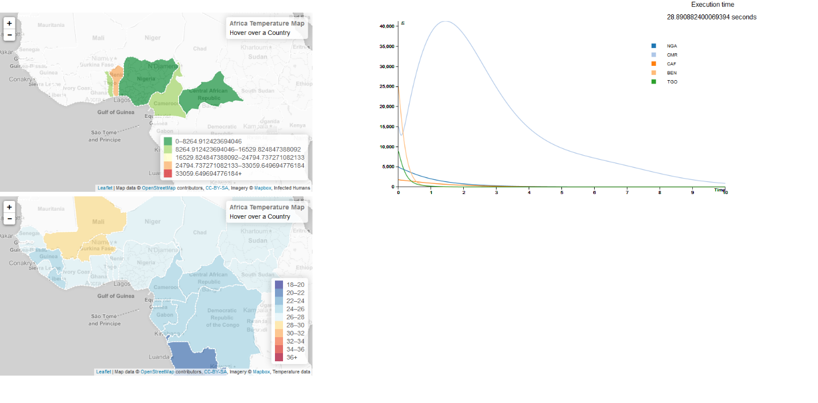

**This week's and next week's task**

Enable sliders with two sliders - one for year and one for month. Integrate all the sliders with all the maps.

Plot cumulative and incident cases in a country that is selected.

**Disease Modeling Week 11-15 Final Report [sent on 8/26/2015]**

1. Completed presenting 3 Africa maps with visualization on Infected human count, precipitation and temperature. Also line charts for created for following:

* Ih vs time (in years)
* Sh vs time
* Eh vs time
* Rh vs time
* Monthly mean temperature vs time (in months)
* Monthly mean precipitation vs time(in months)

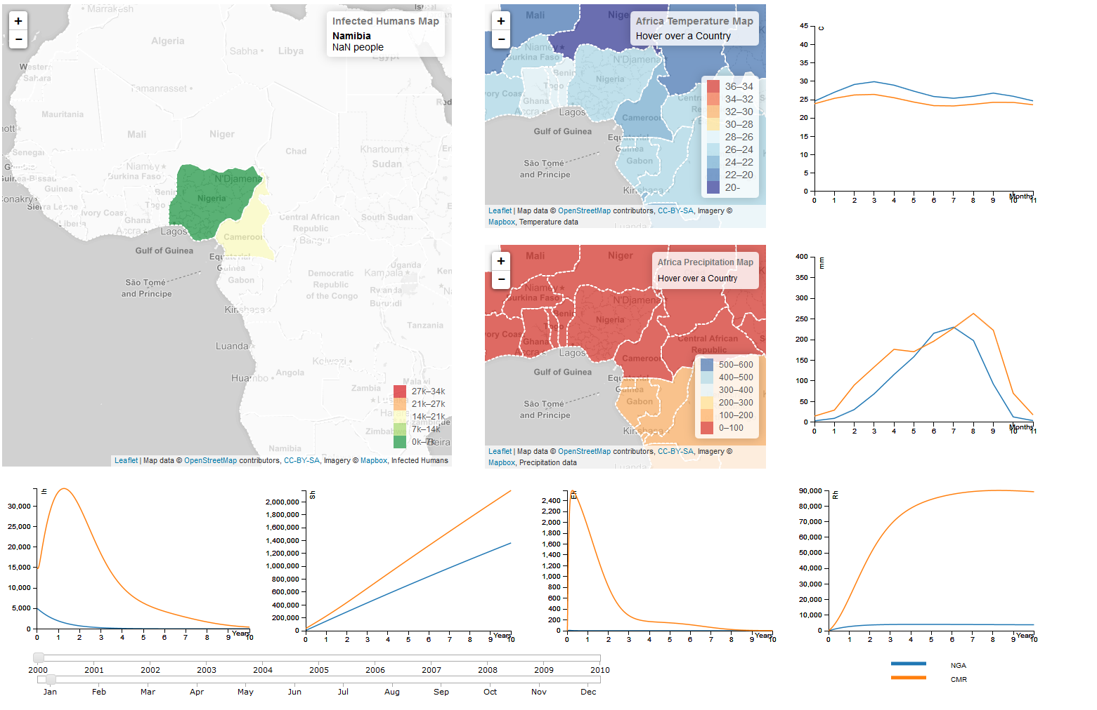

Two horizontal sliders to manipulate year and month are provided and one section for labels for all line chart is shown beside it. Whenever sliders are changed all 3 maps changes interactively. The entire source code is designed to be screen independent i.e no matter which screen you choose to see the visualization, it will look alike.

2. Completed documentation of source code and restructuring of directories.

3 Complete all supporting documentation.

**Remaining work**

1. Work on relationship between temperature and precipitation with disease modeling. Once the formulae are present we might need to enable vertical sliders for temperature and precipitation anamoly.
2. Plot cumulative and incidence cases of infection. Data is already calculated, just need to plot this over graph.
3. Write a detailed paper over visualization section.

Live view of visualization: [Live Demo Link](http://www.public.asu.edu/~raaggar1/DiseaseModeling/Visualization/index.html)

Source code: [Google drive Link](https://drive.google.com/folderview?id=0B91uUYlaIEDtSlUwbE1PTmhWSUE&usp=sharing)

Documentation: [Google drive link](https://drive.google.com/folderview?id=0B91uUYlaIEDtTWxJc0lrS1JDQms&usp=sharing)