GAME DESIGN DOCUMENT
BREAKOUT (ARKANOID)

Objective
- To destroy the five special bricks (rectangles), by touching them with a ball, from a cluster of different colored bricks to proceed to the next level. A slider is present at the bottom of the screen to be used by the player to prevent the ball from falling off the screen.
Game Play
- Destroying every special brick triggers a question on the curriculum word.
- Answering the question correctly reduces the number of special bricks by 1 and adds 100 points to the player score.
- Answering the question incorrectly keeps the number of special bricks same and reduces the player score by 25 points. The player will need to re-hit the brick and answer the corresponding question again until he/she answers the question correctly. This brick will be replaced in the cluster at a random position.
- There are 4 types of other bricks, apart from the special bricks, Red, Blue, Yellow, Green.
  - Blue : 40 points
  - Green : 30 points
  - Yellow : 20 points
  - Red : 10 points
- Hitting Blue bricks drops a random power from a set of special powers towards the bottom of the screen which could be grabbed by the player using the slider.
- The powers include :
  - Increasing/Decreasing the size of the slider.
  - Capability for the slider to destroy the bricks using laser fire for a specified interval of time ( for instance 15 seconds)
  - Increase the number of balls in the game play by 1.
  - Increase/decrease the speed of the ball
  - Get bonus points (for instance 200 points)
  - The capability for the slider to make the ball stick onto itself for a specified interval of time so that the player can aim the ball towards a target and then release the ball by pressing ‘space bar’.
  - The last layer of the cluster of bricks could be a hard layer, i.e. it needs to be touched twice by the ball in order to be destroyed.

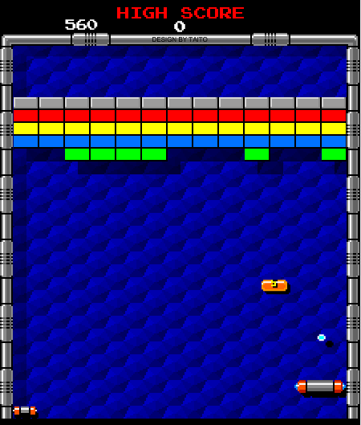

In this sample image for the proposed Breakout game,
- The grey bricks are the hard layer, i.e they need to be touched twice to be destroyed.
- The screen shows one of the power ( an orange brick having the symbol of the name of the power on it) dropping on hitting a brick in the cluster.
- The cluster will also contain five special ( star marked) bricks that are not present in the sample image.
- On hitting the special bricks the background will fade, and the question will appear on the game screen along with the images, similar to the concept used in the market and farm games. The number of images and the style of question ( i.e text etc) depends on the type of learning being imparted.
- The navigation in the interface during the question would be using left/right/up/down and ‘enter’ keys.
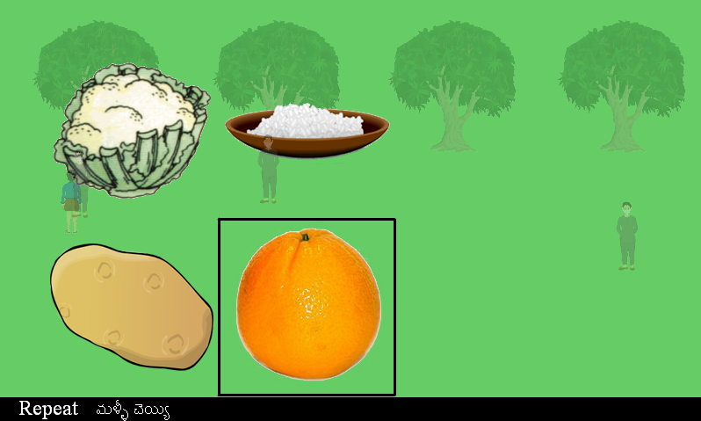

A sample Image from the Farm game depicting the proposed method and spatial arrangement of showing the question in the Breakout game. The background is made transparent.
- The number of levels could be dependent upon the number of curriculum words that need to be taught.

Game Controls
- q(Q) and p(P) keys to move the slider left/right respectively.
- Spacebar to release the ball and use the laser fire.

