GreyB
CONFIDENTIAL RESEARCH STUDY
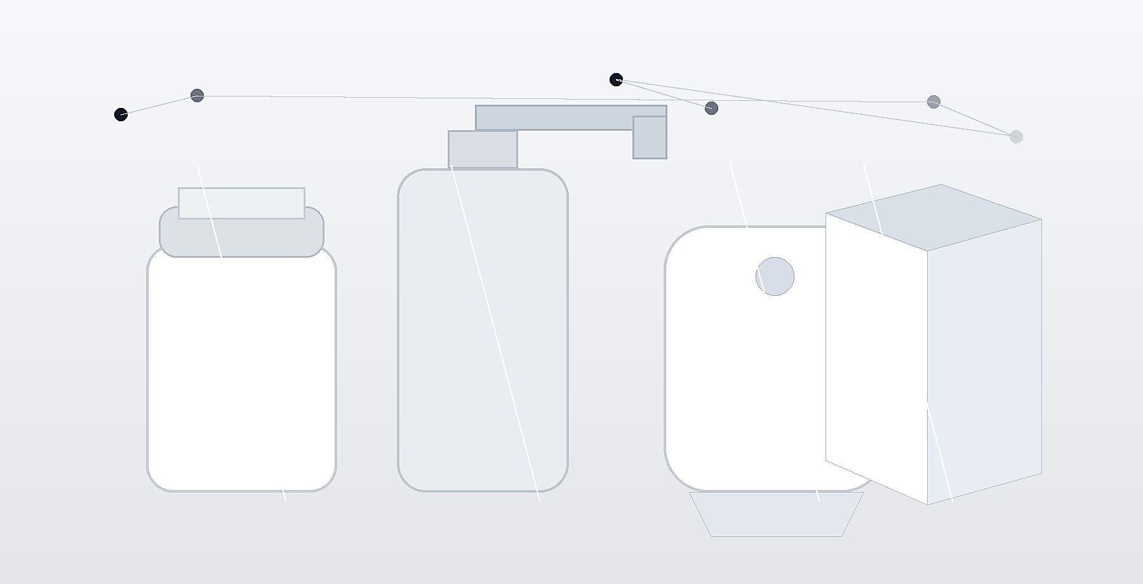
Cosmetic Packaging Lightweighting Study
Commercial Material Opportunity Landscape complemented by Patent Landscape & IP White-Space Analysis
Prepared for | GreyB
Prepared by | Scultra Research Workspace
Date | 07/07/2026
Scope: material-based lightweighting across cosmetic and personal care packaging, with commercial screening and IP landscape alignment.
Prepared as a corporate-style title page for the combined study package.

