Minor Project Synopsis
On

“Employee Payroll Management”

This Synopsis is submitted to

G H Raisoni College of Engineering & Management, Nagpur

In partial fulfillment of the requirement for the award of degree of

“Master in Computer Application”


Submitted by

Roshan Ramesh Deshpande

Roll no.: B60 , Sec : B

Rajat Rameshwar Bhendarkar

Roll No.: B52 , Sec : B

Under the guidance of

Prof.

Neeraj Kumar Jha

Designation, MCA Dept.

Department Master in Computer Application
G H Raisoni College of Engineering & Management Nagpur
(Approved by AICTE, New Delhi and Recognized by DTE, Maharashtra)
An Autonomous Institute Affiliated to Rashtrasant Tukadoji Maharaj Nagpur University, Nagpur
Accredited by NAAC with A+ Grade

Session: 2025-2026

G H Raisoni College of Engineering & Management, Nagpur
(Approved by AICTE, New Delhi and Recognized by DTE, Maharashtra)
An Autonomous Institute Affiliated to Rashtrasant Tukadoji Maharaj Nagpur University, Nagpur
Accredited by NAAC with A+ Grade

I/we, the below mentioned 2nd Semester, Master in Computer Application Department, wish to undergo Minor Project (MC4PT209) titled ‘Employee Payroll Management’ under the guidance of Prof. Neeraj Kumar Jha for the Session 2025-26.

Roll No. | Name of Student/s | Signature
B60 | Roshan Ramesh Deshpande
B52 | Rajat Rameshwar Bhendarkar

Prof. Neeraj Kumar Jha
(Guide)
Professor
Department of Master in Computer Application

Dr. Sandhya Dahake
(HOD)
Assistant Professor
Department of Master in Computer Application
Prof. Neeraj Kumar Jha
(Project Coordinator)
Assistant Professor
Department of Master in Computer Application

Index

Sr. No. | Topic | Page No.
1. | Introduction | 4
2. | Motivation | 5-7
3. | Problem Statement
4. | Objective of Project
5. | System Analysis
6. | Survey of Technologies
7. | Data Flow Diagrams (DFD/ER Diagram)
8. | Modules of the Project
9 | Data Modelling
10 | Scope of the Project/Future Application
11. | Expected Results & Discussion
12. | Chapters Plan
13. | Month-wise Work Plan
14. | References

1. Introduction

In the modern digital era, organizations are increasingly adopting information systems to automate and streamline their business operations. One of the most important administrative functions in any organization is payroll management. Payroll refers to the process of calculating and distributing employee salaries, including basic pay, allowances, deductions, bonuses, and tax calculations. According to global business reports, many small and medium-sized enterprises still rely on semi-manual or outdated payroll systems, which increase the chances of human errors, delays, and inefficiencies. Studies in management information systems show that automation of payroll and HR processes can significantly reduce administrative workload and improve operational accuracy.
With the rapid growth of technology and digital transformation, web-based payroll management systems have become essential tools for organizations. These systems not only automate salary calculations but also integrate attendance tracking, leave management, employee record maintenance, and report generation into a single centralized platform. The Employee Payroll Management System developed in this project aims to provide a secure, efficient, and user-friendly solution for managing employee-related operations.

Conceptual Definitions of Key Constructs

To better understand the project, the following key concepts are defined:
- Payroll Management: The process of managing employee salary calculations, deductions, bonuses, and payment records.
- Attendance Management: The system used to track employee working hours, clock-in and clock-out times.
- Leave Management: The process of handling employee leave applications, approvals, and tracking leave balances.
- Role-Based Access Control (RBAC): A security method where system access is restricted based on user roles (Admin and Employee).
- Human Resource Management System (HRMS): A digital system used to manage employee-related data and organizational processes.
- Authentication & Authorization: Security processes that verify user identity and control system access

Theories and Models Linking the Topic
This project is related to the field of Management Information Systems (MIS), which focuses on using technology to improve decision-making and organizational efficiency. MIS theory states that computerized systems enhance accuracy, speed, and data accessibility in organizations.
The system also relates to the System Development Life Cycle (SDLC) model, which provides a structured approach for developing software. The stages include requirement analysis, system design, implementation, testing, and deployment.
Another relevant concept is the Client-Server Architecture Model, where the frontend (client) interacts with the backend server and database. In this project, Node.js acts as the server-side technology handling requests and managing data stored in MongoDB.
The project also uses the Role-Based Access Control (RBAC) Model, which ensures that users can only access features permitted to their specific roles (Admin or Employee). This improves system security and data privacy.

2. Motivation
The main motivation behind developing the Employee Payroll Management System is to solve common problems faced in manual payroll and employee management processes. In many organizations, payroll calculation, attendance tracking, and leave management are handled manually or using basic tools, which often leads to errors, delays, and inefficiencies.
Manual payroll systems increase the chances of salary miscalculations and data loss. Maintaining paper-based records is time-consuming and difficult to manage. These issues can affect employee satisfaction and overall organizational productivity. Therefore, there is a need for a secure and automated system that can manage payroll and employee data accurately and efficiently.
This project was also chosen because payroll systems are essential for every organization. Developing such a system provides practical knowledge of how real-world HR and payroll operations work. It helps in understanding how technology can improve accuracy, transparency, and efficiency in business processes.
From a technical perspective, this project provides hands-on experience in full-stack development using Node.js, database management, authentication, and system security. It also helps in applying software development concepts such as system design and role-based access control.
In conclusion, the motivation for choosing this project is to develop a practical, secure, and modern solution that simplifies payroll management while enhancing technical knowledge and development skills.

3. Problem Statement

Many small and medium-sized organizations still use manual or basic systems to manage payroll, attendance, and leave records. These methods often result in salary calculation errors, delayed payments, poor record management, and security risks. There is usually no proper integration between attendance, leave, and payroll modules, which reduces efficiency and increases administrative workload.
A major gap identified is the lack of a simple, affordable, and fully integrated web-based payroll system designed for small organizations. Existing systems are often expensive, complex, or lack proper security features such as role-based access control. There is also limited practical implementation of modern technologies like Node.js in building secure payroll systems.
Therefore, the main problem addressed in this project is:
How to develop a secure, user-friendly, and integrated web-based payroll management system that automates salary processing, attendance tracking, and leave management while reducing errors and improving efficiency?

Significance / Rationale of the Study
This study is important because payroll is a critical function in every organization. An automated system improves accuracy, saves time, and enhances data security. It contributes to knowledge in Management Information Systems by showing how modern web technologies can solve real-world HR problems. The system also provides practical benefits for organizations by offering a cost-effective and scalable solution.

4. OBJECTIVE OF THE PROJECT

Objectives
The main objective of this project is to develop a secure and user-friendly web-based Employee Payroll Management System that automates payroll processing, attendance tracking, leave management, and employee record maintenance. The system aims to reduce manual errors, improve accuracy in salary calculations, and enhance organizational efficiency through digital automation.
Another objective is to implement role-based access control to ensure secure authentication and proper authorization for Admin and Employee users. The project also focuses on integrating multiple HR functions into a single centralized system for better data management and transparency.

Purpose
The purpose of this project is to provide a practical solution to problems faced in manual payroll systems, such as calculation errors, poor record management, and lack of integration between attendance and payroll. By using modern web technologies like Node.js and MongoDB, the system improves efficiency, data security, and productivity.
The project is based on concepts such as Management Information Systems (MIS), System Development Life Cycle (SDLC), and Role-Based Access Control (RBAC), ensuring structured development and secure system implementation.

Project Category
- Web-Based Application
- Management Information System (MIS)
- Human Resource Management System (HRMS)
- Full-Stack Development Project

5. System Analysis
Identification of Need
In many organizations, payroll and employee management tasks are still performed manually or using basic software tools. This creates problems such as incorrect salary calculations, difficulty in tracking attendance and leave records, and delays in payment processing. Manual systems are time-consuming, less secure, and prone to data loss.
Therefore, there is a need for a centralized, secure, and automated web-based system that can efficiently manage payroll, attendance, leave, and employee records. The Employee Payroll Management System is designed to fulfill this need by integrating all HR functions into one platform.
Preliminary Investigation
A preliminary study was conducted to understand the problems in existing payroll systems. It was observed that:
- Many small organizations lack an integrated payroll solution.
- Existing systems are often expensive or too complex.
- There is limited use of secure authentication and role-based access control.
- Attendance and leave records are not properly connected to payroll calculations.
Based on this investigation, it was decided to develop a secure, affordable, and user-friendly payroll management system using modern web technologies.
Feasibility Study
A feasibility study was conducted to determine whether the proposed system is practical and beneficial.

Economic Feasibility
The system is cost-effective because it uses open-source technologies such as Node.js and MongoDB. It reduces administrative costs by automating payroll and record management. Therefore, the project is economically feasible.

Operational Feasibility
The system is easy to use and designed with a simple interface. Admin and Employees can operate the system without advanced technical knowledge. It improves daily operations by reducing manual workload and increasing accuracy.

Technical Feasibility
The system is technically feasible because it uses reliable and widely used technologies such as Node.js, Express.js, and MongoDB. The required hardware and software resources are easily available. The development team has the necessary technical knowledge to implement the system successfully.

6. Survey Of Technologies
To develop the Employee Payroll Management System, different technologies were studied and selected based on simplicity, security, and performance.

Frontend Technologies
For the frontend, technologies like React, Angular, and basic HTML/CSS/JavaScript were considered.
In this project, HTML, Tailwind CSS, and JavaScript are used.
- HTML is used to create the structure of web pages.
- Tailwind CSS is used to design a modern and responsive user interface.
- JavaScript is used to make the website interactive and dynamic.
These technologies were selected because they are simple, easy to use, and suitable for building a clean and modern design.

Backend Technology
Different backend options include PHP, Python, Java, and Node.js.
For this project, Node.js is used.
- Node.js helps handle server requests.
- It is fast and efficient.
- It supports JavaScript, which makes development easier.
Node.js was selected because it is lightweight, scalable, and suitable for web applications.

Database Technology
Different database options include MySQL, MongoDB, and Supabase.
In this project, Supabase is used.
- Supabase provides a secure and reliable database.
- It is easy to connect with Node.js.
- It supports structured data storage.
Supabase was selected because it is simple, secure, and easy to manage.

Authentication Technology
For security, JWT (JSON Web Token) is used.
- It provides secure login.
- It protects user data.
- It allows role-based access (Admin and Employee).
JWT was selected because it is secure and widely used in web applications.

Conclusion
The combination of HTML, Tailwind CSS, JavaScript, Node.js, Supabase, and JWT makes the system secure, modern, and efficient. These technologies help achieve the project goals of automation, accuracy, and easy management.

Tools / Platform Software & Hardware Requirements
Software Requirements
- Operating System: Windows / Linux / macOS
- Frontend: HTML, Tailwind CSS, JavaScript
- Backend: Node.js
- Database: Supabase
- Authentication: JWT
- Code Editor: Visual Studio Code
- Web Browser: Google Chrome
Hardware Requirements
- Processor: Intel i3 or above
- RAM: Minimum 4GB
- Storage: At least 10GB free space
- Internet connection

7. DATA FLOW DIAGRAM (DFD/ER Diagram)

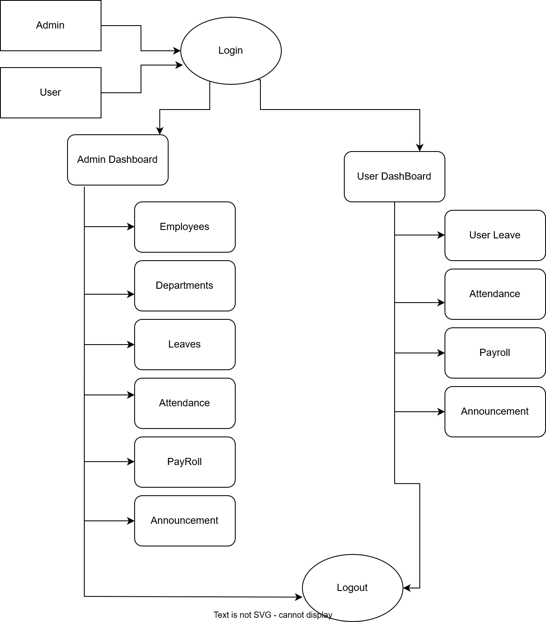

8. Module Of the Project

The Employee Payroll Management System is divided into several modules, each responsible for a specific function.

1. Authentication Module
- Secure login for Admin and Employee.
- Uses JWT for authentication.
- Provides role-based access control.
- Protects sensitive data.

2. Employee Management Module
- Add, view, edit, and delete employee records.
- Approve or reject employee registration.
- Search and filter employee data.
This module helps maintain employee information efficiently.

3. Department Management Module
- Create, view, update, and delete departments.
- Organize employees based on departments.

4. Attendance Management Module
- Employees can clock in and clock out.
- Employees can view attendance history.
- Admin can view and update attendance records.
This ensures accurate tracking of working hours.

5. Leave Management Module
- Employees can apply for leave and check status.
- Admin can approve or reject leave requests.
This module manages leave records properly.

6. Payroll Management Module
- Admin creates and processes salary records.
- Mark payroll as paid.
- Generate payslips.
- Employees can view and download payslips.
This module automates salary calculation and payment.

7. Announcement Module
- Admin can create and manage announcements.
- Employees can view company updates.

8. Dashboard Module
- Admin dashboard shows overall statistics.
- Employee dashboard shows personal records.

9. Data Modelling
The data modelling defines how information is stored in the database according to different modules of the system. The project uses Supabase (PostgreSQL) to store structured and related data.
1. Users Table (Authentication)
Stores login details.
Fields:
- user_id (Primary Key)
- name
- email
- password (hashed)
- role (Admin / Employee)
Used for secure login and role-based access.
2. Employees Table
Stores employee details.
Fields:
- employee_id (Primary Key)
- user_id (Foreign Key)
- department_id (Foreign Key)
- designation
- joining_date
- salary
Links employees to users and departments.
3. Departments Table
Stores department information.
Fields:
- department_id (Primary Key)
- department_name
- description
4. Attendance Table
Tracks daily attendance.
Fields:
- attendance_id (Primary Key)
- employee_id (Foreign Key)
- date
- clock_in
- clock_out
5. Leave Table
Stores leave requests.
Fields:
- leave_id (Primary Key)
- employee_id (Foreign Key)
- start_date
- end_date
- status
6. Payroll Table
Stores salary details.
Fields:
- payroll_id (Primary Key)
- employee_id (Foreign Key)
- month
- net_salary
- payment_status
7. Announcements Table
Stores company announcements.
Fields:
- announcement_id (Primary Key)
- title
- message

10. Scope of The Project / Future Application
Scope
The Employee Payroll Management System focuses on automating payroll and employee management processes. It covers employee records, attendance tracking, leave management, salary processing, and secure role-based login.
The system follows a structured development approach including analysis, design, implementation, and testing. It uses a web-based client-server architecture.
Main Functions:
- Secure login (Admin & Employee)
- Employee and department management
- Attendance and leave tracking
- Payroll processing and payslip generation
- Dashboard with key information
Assumptions: Users have basic computer knowledge and internet access.
Limitations: Designed mainly for small and medium organizations. Advanced features like tax management and mobile apps are not included but can be added in the future.
Applicability
Direct Applications:
- Useful for organizations to manage payroll digitally.
- Helps reduce manual work and errors.
Indirect Applications:
- Can be expanded into a complete HR system.
- Useful for learning full-stack web development.
The project shows how modern technologies can build secure and efficient management systems.
Achievements & Goals Achieved
Through this project, knowledge was gained in full-stack development, database management, authentication, and system design.
The main objectives were achieved by developing a secure and functional payroll system that improves efficiency and accuracy.

11. EXPECTED RESULTS & DISCUSSION

The expected result of this project is the successful development of a secure and fully functional web-based Employee Payroll Management System. The system is designed to automate payroll processing, attendance tracking, leave management, and employee record handling.
One of the main expected outcomes is accurate and automated salary processing. The system will allow the Admin to create payroll records, process salaries, and generate digital payslips. Employees will be able to view and download their salary details, improving transparency and reducing errors.
The system is also expected to provide efficient attendance and leave management. Employees can clock in and clock out, apply for leave, and track leave status. Admin users can monitor attendance and approve or reject leave requests, ensuring proper workforce management.
Secure authentication using JWT ensures that only authorized users can access the system. Role-based access control separates Admin and Employee functionalities, protecting sensitive data.
The dashboard will display important information such as total employees, pending leave requests, and payroll status, helping management monitor operations effectively.

Discussion
The project demonstrates how automation improves efficiency, reduces manual work, and increases accuracy in payroll management. By integrating all HR-related functions into one platform, the system ensures better data organization and security.
Overall, the project achieves its objectives by providing a practical, scalable, and user-friendly payroll management solution using modern web technologies.

12. Chapter Plan
The thesis for the Employee Payroll Management System is organized into the following chapters:

Chapter 1: Introduction
This chapter provides background information about payroll systems, motivation for the project, problem statement, objectives, scope, and significance of the study.

Chapter 2: Literature Review
This chapter reviews existing payroll and HR management systems. It discusses related research, technologies used in similar systems, and identifies gaps that the current project aims to address.

Chapter 3: System Analysis
This chapter explains the identification of need, preliminary investigation, feasibility study (economic, technical, and operational), and requirement analysis of the proposed system.

Chapter 4: System Design
This chapter describes the overall architecture of the system, data modelling, database structure, ER diagrams, Data Flow Diagrams (DFD), and module design.

Chapter 5: Implementation
This chapter explains the technologies used (HTML, Tailwind CSS, JavaScript, Node.js, Supabase, JWT) and the development process of different modules.

Chapter 6: Testing and Results
This chapter presents system testing methods, test cases, results obtained, and discussion of system performance and functionality.

Chapter 7: Conclusion and Future Scope
This chapter summarizes the project work, achievements, limitations, and possible future improvements or enhancement.
13. MONTH WISE WORK PLAN

Month-wise Activities | JAN’26 | FEB’26 | MAR’26 | APR’26 | MAY’26
Literature Reviews | √ | √
System Analysis |  | √
System Designing
Coding
System Testing
Testing and Debugging
Preparation of Project Report

14. REFERENCES

- Books
  - Silberschatz, A., Galvin, P. B., & Gagne, G. (2018). Operating system concepts (10th ed.). Wiley.
  - Pressman, R. S., & Maxim, B. R. (2019). Software engineering: A practitioner’s approach (9th ed.). McGraw-Hill Education.
  - Sommerville, I. (2016). Software engineering (10th ed.). Pearson Education.
- Official Documentation & Websites
  - Node.js Foundation. (2024). Node.js documentation. Retrieved from https://nodejs.org
  - Supabase Inc. (2024). Supabase documentation. Retrieved from https://supabase.com/docs
  - W3Schools. (2024). Web development tutorials. Retrieved from https://www.w3schools.com

Date of Submission with Student’s Signature:

Guide Signature:

