**mUC/RCC-Predict: A GUI for Accurate Prediction of Metastatic Urothelial/Renal Cell Carcinoma Treatment Responses**

**Abstract**

**Motivation:** Accurately predicting treatment response is critical for advancing personalized medicine and improving clinical decision-making in metastatic urothelial carcinoma (mUC)/Renal Cell Carcinoma (RCC). To address this need, we developed mUC/RCC-Predict, an innovative graphical user interface (GUI) designed to provide intuitive and efficient treatment response predictions. This system integrates both mUC and RCC including advanced feature selection with logistic regression modelling, ensuring clinicians and researchers a streamlined, user-friendly experience.

**Results:** The logistic regression model was trained on immunotherapy gene datasets and validated using a rigorous 5-fold cross-validation approach, achieving a strong ROC AUC for mUC (RCC) of 75% (72%).

**Availability and implementation:** mUC/RCC-Predict can be accessed at <https://logitda.shinyapps.io/logitda_appdirectory/>. .

**Contact:**

1. **Introduction**

Metastatic urothelial carcinoma (mUC) is a highly aggressive malignancy responsible for about 90% of cancer-related deaths. Globally, urothelial carcinoma ranks ninth most common cancer, with approximately 550,000 new cases reported in 2018 (Bray et al., 2020). Concurrently, Renal Cell Carcinoma (RCC) constitutes approximately 90% of all renal malignancies. (Reference Required Here…)

In recent years, the treatment landscapes for mUC and RCC havebeen revolutionized by novel therapeutic agents (Gajate et al., 2020), particularly immune checkpoint inhibitors (ICIs) and targeted molecular therapies. ICIs, which modulate immune pathways like PD-1 and PD-L1, have transformed cancer management by enhancing tumor-specific T-cell immunity and improving patient outcomes.

Atezolizumab, a PD-L1 inhibitor, has been especially notable for its efficacy in treating mUC, while also demonstrating activity in RCC. (Li et al., 2020). This humanized monoclonal antibody selectively blocks PD-L1 from interacting with PD-1 and the co-stimulatory molecule B7.1. By disrupting these interactions, atezolizumab restores tumor-specific T-cell activity, enabling a more effective immune response. ICIs, including atezolizumab, have demonstrated durable clinical responses, particularly in patients with PD-L1-positive tumors. Consequently, ICIs have become the frontline treatment for select cases and the standard of care for second-line patients experiencing disease progression following platinum-based chemotherapy (Powles et al., 2018). While ICIs offer significant survival benefits for responding patients, their overall response rate (ORR) remains relatively low, at approximately 20% (15%) in mUC (RCC) (Naimi et al., 2022), highlighting the need for more effective strategies to predict therapy outcomes and personalize treatment approaches in oncology.

The growing reliance on digital tools in healthcare underscores the necessity for accessible and reliable platforms that support clinicians and patients. However, current biomarker-driven approaches, while promising, often fall short of providing accurate predictions to individual patients. Machine learning (ML) has demonstrated immense potential in predicting drug responses, increasing the number of patients benefiting from targeted therapies while reducing adverse side effects for non-responders.

This study introduces a graphical user interface (GUI) based drug response predictor built upon the LogitDA model (Langfelder et al., 2025). Predicting treatment response for metastatic cancer is crucial. This user-friendly platform is designed to provide clinicians or users with a practical and intuitive tool with accurate and efficient decision-making support to ICI treatment for advanced/metastatic cancers.

1. **Workflow**

**The architecture of GUI**

This section describes the GUI structure, which consists of two main components: the **Interface unit** and the **Computing unit**. The overall workflow is illustrated in Figure 1, demonstrating the integration of user interaction and backend processes.

1. **Interface unit**: This component serves as the user-facing side of the system, allowing users to upload data files through an intuitive and interactive interface. It provides multiple interactive elements, such as a “Browse” option for CSV file selection, an indicator showing “Upload complete”, a dropdown menu to select a pre-trained model out of mUC and RCC models, a “Generate Predictions” button to apply prediction to the uploaded data, and finally a “Download Predictions” button to save the results in a CSV file. Furthermore, it flashes real-time feedback messages, such as the number of rows in predictions and confirmation messages once the prediction is generated successfully.
2. **Computing unit:** This backend module processes the uploaded test data by extracting genes and ensuring they match the relevant features of selected trained models (either mUC or RCC). The system first extracts the number of features from the uploaded data corresponding to the expected number for the selected model: 49 (27) features for the mUC (RCC) model. Once the relevant genes are extracted, the system proceeds with scaling and the data is standardized using the scaling parameters from the training data. For the mUC model, the data is standardized by scaling the features whereas for the RCC model, no scaling is applied. If the number of features does not match the expected value, an error is displayed, notifying users of the mismatch. After processing the test data, the system generates predictions based on the selected model and outputs a CSV file with the results, including sample IDs, predicted labels, and prediction probabilities. The users are then notified of the successful generation of predictions and can download the results directly.



Figure 1. The flow diagram of the mUC and RCC treatment response prediction application.

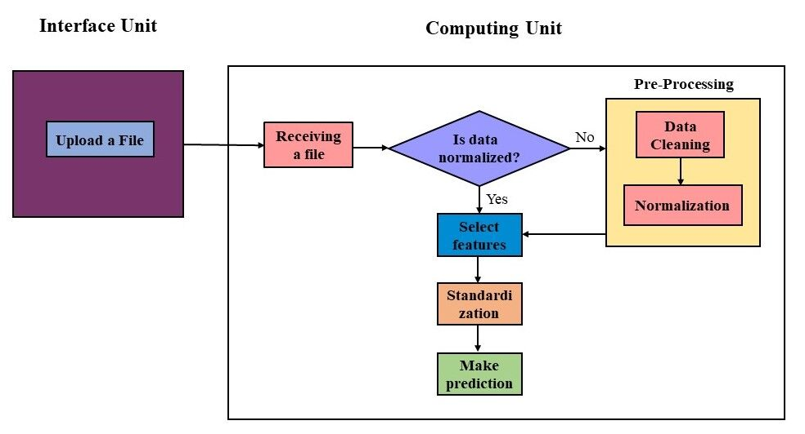

**Installation and dependencies**

Users can access the mUC/RCC-Predict which is publicly available at <https://logitda.shinyapps.io/logitda_appdirectory/>. The critical operations of the application are implemented in R (v. 4.3.2) for preprocessing, machine learning, and application development, leveraging their robust ecosystems. The system runs on an Intel Core (TM) i7-13700, with 16 GB RAM, and operates on Windows.

**Example**

Data of the phase I trial of Atezolizumab (PCD4989g, NCT01375842; Herbst et al., 2014) from Genentech (South San Francisco, USA) is used as the test set for both mUC and RCChis test set contains whole transcriptome profiles (i.e., RNA-seq data) and clinical information for 94 (58) patients with mUC (RCC). Since the data is normalized, the relevant genes, such as 49 (27) genes for mUC (RCC), are extracted (Yuan et al., 2023; Langfelder et al., 2025). Then the system performs standardization step (only for mUC) and predicts the treatment response to Atezolizumab using a trained logistic regression model (Langfelder et al., 2025). Usingthe gene expression of these 49 (27) genes for mUC (RCC), the highest prediction metrics for the test set are as follows: an AUC of 0.75 (0.72) and accuracy of 0.71 (0. 83). Among the 94 (58) patients, the true positives (TP) and the true negatives (TN) are 12 (4) and 55 (44), respectively, corresponding to a sensitivity of 54% (50%) and a specificity of 76% (88%). This whole process takes about 2 minutes. For processed data, it takes around 2.6 seconds.

1. **Conclusion**

In conclusion, by deploying our web-tool on server with an accessible link, users can obtain treatment response predictions from anywhere conveniently with internet access. This web-based deployment makes it possible for healthcare professionals to generate insights through a simple browser interface without the need for local installation and computational resources. This cloud deployment strategy significantly broadens the usability and impact of the system, making advanced drug response predictions accessible to a wider audience across various healthcare settings and geographical locations. **Acknowledgment**

**Conflict of interest**

None declared.

**Funding**

**References**

1. Balar, A.V., Galsky, M.D. and Rosenberg, J.E. Atezolizumab as first-line treatment in cisplatin-ineligible patients with locally advanced and metastatic urothelial carcinoma: a single-arm, multicentre, phase 2 trial (vol 389, pg 67, 2017). *Lancet* 2017;390(10097):848-848.
2. Bray, F.*, et al.* Global cancer statistics 2018: GLOBOCAN estimates of incidence and mortality worldwide for 36 cancers in 185 countries (vol 68, pg 394, 2018). *Ca-Cancer J Clin* 2020;70(4):313-313.
3. Gajate, P.*, et al.* Practice change in the management of metastatic urothelial carcinoma after ASCO 2020. *World J Clin Oncol* 2020;11(12):976-+.
4. Li, C.X., Chen, J. and Su, Z.J. KIF4A is a promising prognostic marker and correlates with immune infiltration in clear cell renal cell carcinoma. *Transl Cancer Res* 2020;9(11):7165-7173.
5. Naimi, A.*, et al.* Tumor immunotherapies by immune checkpoint inhibitors (ICIs); the pros and cons. *Cell Commun Signal* 2022;20(1).
6. Powles, T.*, et al.* Atezolizumab versus chemotherapy in patients with platinum-treated locally advanced or metastatic urothelial carcinoma (IMvigor211): a multicentre, open-label, phase 3 randomised controlled trial. *Lancet* 2018;391(10122):748-757.
7. Yuan, S.S.*, et al.* Feature selection translates drug response predictors from cell lines to patients. *Front Genet* 2023;14.