How to run the Doctor Appointment System Django Python
1. Download the zip file
2. Extract the file, copy doctorappointment folder, and paste it on the desktop

3. Open MySQL Create a database docaspythondb then import the SQL File available in the MySQL File Folder (For MySQL we used XAMPP server)

4. Open PyCharm and click on the terminal

5. Navigate the project folder using the cd command
cd project_path
For ex: cd C:\Users\ANUJ\OneDrive\Desktop\doctorappointment

6. Now Navigate to the Company Visitor Management System folder
cd docappsystem

7. Run the Project using the following command
python manage.py runserver
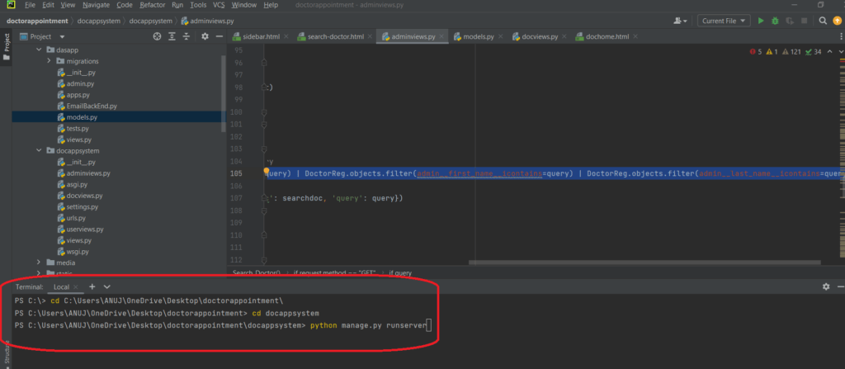

Now click the URL http://127.0.0.1:8000 and the Project will Run

