

UNIVERSITY INST.OF TECHNOLOGY

BURDWAN

**NAME-RAJAT DWIVEDI**

**ROLL-20201025**

**REGISTRATION:A/F**

**SEMESTER-5TH**

**DEPT:CSE**

**TITLE OF PROPOSAL:ATTENDANCE SYSTEM WITH QR CODE**

**PROBLEM STATEMENT-**Can we Develop AttendanceTaking Mechanism Which Doesn’t Require Teacher’s Role As well as Covinient to use?

**Introduction-**

The **Student Attendance Management System Project In Python** was developed using **Python OpenCV** in **Real-Time**, This **Attendance Management System Project In Python** provide a valuable attendance service for both teachers and students. Reduce manual process errors by provide automated and a reliable attendance system uses QR scan technology.

A **Attendance Management System Using QR Scan Python** is a simple python script that recognizes Barcodes and mark attendance for the recognized QR in an file. We seek to provide a valuable attendance service for both teachers and students. Reduce manual process errors by provide automated and a reliable attendance system uses QR Scan technology.

**Proposed Solution-**

The project is a system that takes down students' attendance using barcode. This is an interesting concept set forth to automate the traditional attendance system by using authentication technique. The traditional system requires a register maintained for manually marking attendance for the students which is time consuming. Hence this proposed project eliminates the need of maintaining attendance sheet.

The proposed system uses barcode method for authenticating students with a unique barcode that represents their unique id. Every student is provided with a card that contains the barcode. Students just have to scan their cards using barcode reader and the system notes down their attendance as per dates. System then stores all the students' attendance records and generates defaulter list and reports for admin. Such kind of application is very useful in school as well as in college for taking daily attendance.

**Features:**

* **Admin login:** Admin is provided with a login from where he monitors and administers all the students' information and records.
* **Barcode Reading:** Students have to scan their card through barcode reader and the id thus read by the system is stored for that particular day.
* **Defaulter list:** The system generates defaulter list in excel sheet for specified period provided by admin.
* **Report generation:** At the end of attendance process system automatically generates overall report for the class in excel sheet.
* **Search option:** Admin can even search for particular student's attendance details using search option in the system.

**Algorithm-**

**A-Student.txt->**

**Step 1:** Store the information about the students.

**B-Generate.py->**

**Step 1:** Import required libraries like MyQR to generate QR, OS and base64 for encoding and decoding.

**Step 2:** Create and read the file

**Step 3:** Generate QR for the data

**Step 4:** Personalizing the background

**C- Attend.py**

**Step 1:** Import required libraries like cv2, numpy, pyzbar, sys, time, pybase64

**Step 2:** Start web cam to store the encoded data of students

**Step 3:** Create function for attendance file

**Step 4:** Checking the input data is present or not

**Step 5:** Store the encoded data

**Step 6:** Exit.

**Source Code-**

**Generating QR-**

from MyQR import myqr

import os

import base64

#create and read

f=open('students.txt','r')

lines=f.read().split("\n")

print(lines)

for i in range(0,len(lines)):

data=lines[i].encode()

name=base64.b64encode(data)

version, level, qr_name = myqr.run(

str(name),

level='H',

version=1,

#background

picture='bg.jpg',

colorized=True,

contrast=1.0,

brightness=1.0,

save_name=str(lines[i]+'.bmp'),

save_dir=os.getcwd()

)

**Taking Attendance-**

import cv2

import numpy as np

import pyzbar.pyzbar as pyzbar

import sys

import time

import pybase64

#start web cam

cap = cv2.VideoCapture(0)

names=[]

#function for attendence file

fob=open('attendence.txt','a+')

def enterData(z):

if z in names:

pass

else:

names.append(z)

z=''.join(str(z))

fob.write(z+'\n')

return names

print('Reading............')

#Data present or not

def checkData(data):

data=str(data)

if data in names:

print('Already present')

else:

print('\n'+str(len(names)+1)+'\n'+'Present done')

enterData(data)

while True:

_,frame=cap.read()

decodeObjects = pyzbar.decode(frame)

for obj in decodeObjects:

checkData(obj.data)

time.sleep(1)

cv2.imshow("Frame",frame)

#close

if cv2.waitKey(1)& 0xFF == ord('s'):

cv2.destroyAllWindows()

break

fob.close()

**Result-**

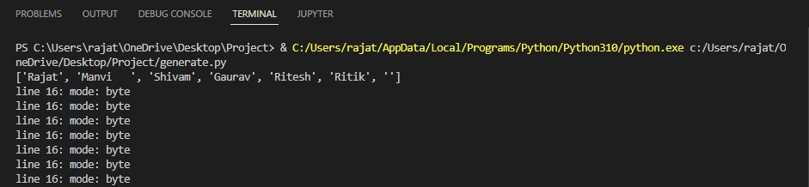

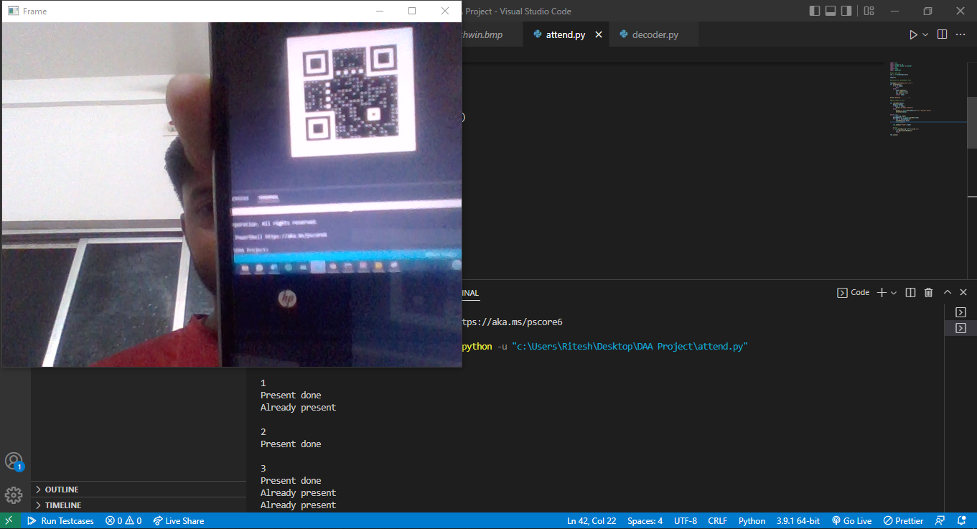

**Advantages of the proposed project: -**

Students will be more regular in attending their classes since now no attendance sheet signature is required, so no friend or any other student can make an attendance on behalf of others as barcodes are unique for every student.

1. Teachers do not need to waste their time approximately 15min of 1hour for taking attendance of students.
2. No need to maintain attendance sheet as the attendance are electronically stored in database.
3. The system helps the faculty to easily find out defaulters.
4. User may easily get attendance history of a particular student.
5. It saves time, cost, efforts and institute resources.

**Disadvantages:**

The only disadvantage is that every class requires a barcode reader to access the system.

**UN SDG-**

Industry,Innovation and Infrastructure.

**Applications:**

1. The system can be used for schools, college, or universities for taking down attendance.

**Conclusion:**

This work describes the information management system of students, which uses attendance system by barcode scan. It shows the potential application of using barcode to carry useful information, how the system can be helpful in providing information to the users.

**References:**

YouTube

GeeksforGeeks

Github