Security Analysis of SDN Wan Application Using Strid

Rajat jain
Fraunhofer SIT, Tu Darmstadt
Darmstadt , Germany
rajat. stud@tu-darmstadt. de

Abstract—In this article, we will present the security analysis of two SDN Wan applications. SDN which is new IP networking paradigm aims to solve the challenges faced by Wan network. Both the application Cisco IWAN and Google 's B4 discussed in paper delivers the solution for Wan network challenges like data management , end to end application control and security . Among the listed application SDN wan application B4 and IWAN is chosen because B4 is largest open flow implementation and IWAN because its feature enriched. The security of these applications are analyzed by decomposing the application architecture into multiple components using Data Flow Diagram (DFD). Security is analyzed based on STRIDE, which is a threat modeling technique developed by Microsoft. The security analysis concludes that both B4 and IWAN suffer from similar security threats like spoofing, tampering, information disclosure and denial of service. However, these threats could be tranquilized by threat mitigation techniques specified in the paper.

Introduction
The data increment of IP applications over past few years has alarming risen . As per study in [1] data usage will surpass zettabyte (i. e 1000 exabytes) in 2016. Result of which new protocol stacks , high bandwidth links are invented and implemented in the network . However such implementation making management of today's tightly coupled control and data plane IP network complex and tedious. These factors increasing the CAPEX and OPEX for the network operators Reconfiguring this network for fault, load balance and complex policies for mission critical application has become whole new challenge for them. Many attempts have been made to make network management easier but difficulty of changing underlying network always become a major roadblocks to each of them[2]. A new IP networking paradigm ,Software defined networking [3] aims to ease network management with an idea of separating control and data plane. In this network switches are assigned the duty of packet forwarding where the control plane moves to the central controller. Flow-based routing is established by the instructions given from the controller to the switches using southbound interface open flow protocol [4]. The controller provides access to data collected from data layer to application using north bound interface. Application have the complete view of the network topology thus can implement complex policies from a central orchestration point.

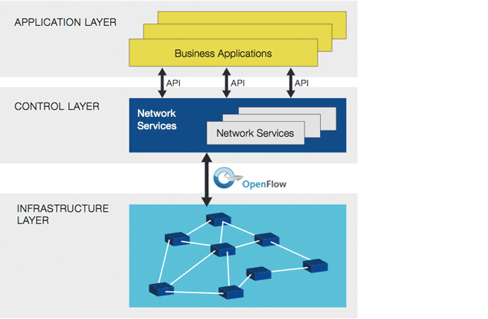
Fig 1. SDN Architecture

Figure 1 describes the basic architecture and concept behind SDN. Management of wan network was always a big concern for big organizations. Over the past years the organization have been investing lot on their Wan infrastructure but still facing huge challenges to manage QOS for business critical applications. . Hybrid Wan somewhat has produces some relief in terms of cost but its management has created whole new challenges for the network team. SDN has tried to ease out Wan challenges with centralized controller feature[5] . Various applications of software defined WAN has various security benefits which comes with encryption in data plane and security in control plane [6]. Table I shows various applications of software defined networking in WAN and on which plane their security is enabled.
This paper studies the security analysis of these Wan application. In this we have decided to work on two applications B4 and IWAN . B4 because it is already implemented in data-centers of Google and IWAN because it is a complete suite for Wan management includes feature for Wan Qos , Application visibility , dynamic vpn creation. Detail description in section 4. We also decided to use Stride to be the threat modeling tool. The reason and procedure to use Stride is explained in section 2. Finally in Section3 we explained B4 architecture followed by its security analysis and in Section4 IWAN is analyzed. Moreover, mitigation techniques are also specified for addressing such vulnerabilities. Section 5 concludes with

Table 1. Various SDN Wan Solutions
Sdn Application | Vendor | Description | Area of Use | Security
IWAN  [7] | Cisco | Virtual WAN, Intelligently routes based on priority ,uses DMPVN | WAN | Firewall (Based on security rules) and Cloud-based (Security applications)
ION  [8] | Cloud  Genix | SD-WAN, virtual elEMents on existing device acts as flow forwarders | WAN | OpenFlow (SSL,TLS) and Cloud-based (Security applications)
SEN  [9] | Vipetala | Delivers secure end-to-end virtualization for enterprise to build large scale network | WAN | Datagram TLS, IPsec
B4  [10] | Google | Connecting datacenters of Google worldwide | WAN | OpenFlow (SSL,TLS) based
SDX  [11] | Prototype | Software defined IXP | WAN | OpenFlow (SSL,TLS) based

Application Threat modelling
Application threat model analysis is becoming the key part of security engineering team for most organization these days
It not only helps finding the bug in the product but also helps the team members to understand the product in much detail [12]. Moreover, threat model provides a structured display of causes that compromises the security of an application. Based on these listed causes security analysis of product becomes much more clear. General steps to be follow for any threat modeling includes creation of structural overview of the application, splitting the application, identification of threats in each part and documentation of threats. Next phase includes prioritizing the threats, and final is to define mitigation techniques or tool .
Different schemes for identifying and classifying threats have been developed
A) PASTA is attack simulation methodology suitable for designers and developers in the enterprises or organizations where user needs to know the definition, technical scope of app and system from inside to work on threat analysis[13].
B) Trike is threat modelling tool which is best suitable for design phase as it is requirement centric and involves stakeholders. Trike is outdated now[14].
C) Attack Tree Other threat modelling methodology is attack tree which is available as open source and commercial software but it is more attacker oriented than system oriented so, not good choice for entire system analysis[15].
D) UMLSec is more model based approach where each component of system is analysed with various stereotypes which requires to know the source code which is our interest here[16].
E) OCTAVE is risk assessment tool for organisations where analysis team of expertise from various departments are required for analysis which makes it unsuitable for our analysis[17].
G) Misuse cases is business process modelling tool based on expert guidance of various fields like architecture, design, testing which is not possible here when we are analysis system alone. [18]
H)DREAD is also used for risk assessment, but it is more subjective in nature when giving ratings to the threats and model itself is out of order now[19].
I) CORAS is used for organizational purpose as it needs customer interaction in security analysis which is out of scope for this paper[20].
Comparing with above schemes STRIDE [21] is perfectly suitable for analyzing our software defined wide area network application B4 and IWAN because it is simple, easy to use and categorizes most of the threats in our application as well as it overcomes all the above disadvantages presented by other application threat classification techniques.

2. 1 STRIDE
STRIDE is a methodology developed by Microsoft for identification and categorization of various threats in applications [21]. Initial letters of security threats like Spoofing, Tampering, Repudiation, Information disclosure, Denial of service, Elevation of Privileges forms STRIDE. According to [21] individual security threat are defined as follows.
Spoofing of Identification means pretending to be authorized user for accessing a certain service or application.
Tampering with Data involves unsanctioned manipulation of data. Change of data can be done during transmission or when it is not in transit.
Repudiation means denial of action after its occurrence. For example, user denies truth that the action was performed by him. Information.
Disclosure involves the leak of information to anyone, who are not authorized to access the information.
Component | Representation | Description
Data Flows | Arrow | Represents direction of flow of data
Data Stores | Parallel Horizontal lines | File database
Process | Circle | Application
Multi-process | Concentric circle | Compilation of various sub process
Interactors | Rectangle | It represents end-points, which provides as well as consumes data in system.
Trust Boundary | Straight Line | It is the boundary between trusted and untrusted components
Table 2. DFD Components
Denial of Service is the prevention of authorized user from accessing a service or application.
Elevation of Privileges means that an ineligible user gets a privileged access to applications or services.
For analyzing each security threat from the above STRIDE model, our application architecture needs to be represented by a Data Flow Diagram (DFD). In DFD, we split our application into multiple components based on their functionality and analyze the security threats for each component. TABLE 2 shows various DFD components, its representation and description in accordance to [22]. Additionally, each component is vulnerable to a group of threats that needs to be addressed. Data flows and data stores are vulnerable to tampering, information disclosure and denial of service. Processes are vulnerable to all the threats. Whereas, interactors are vulnerable to spoofing and repudiation.

B4
Before diving into Google's SDN Wan solution , let's have a overview of Google's big and diverse Wan network . Architecturally its divided into two WANS, one for directing requests/responses and other for synching users data across geographically distributed data centers i.e B4 . The requirement of QOS of traffic for both of these networks are quite varied in nature where user facing Wan is much more dense requiring high bandwidth while the B4 requires high availability of data. Furthermore the thousands of application which run over B4 require range of QOS classes some of them are low in volume demands low latency whereas others requires high bandwidth [11]
According to [11] maintenance of these number of QOS classes , end to end application control and cost became the driving motivation for Google to implement SDN technology. Google B4 is based on the core definition of SDN i.e.
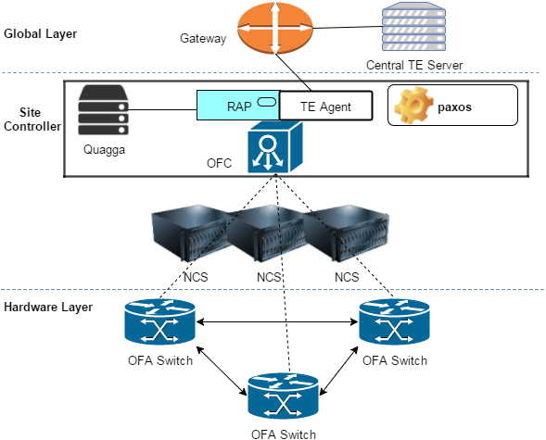
Fig2. B4 Architecture
separation of control and data plane, additionally controlling the traffic engineering the data traffic by a centralized controller. In fact, the design of B4 can be viewed as three logical layers such as hardware layer, controller layer and global layer.
Figure 2 shows the architecture of B4 which is built on its three layers
A) Hardware Layer: Cost effectiveness and need of high control over switching behaviour motivated Google to build their own low buffer open flow commodity switches. The Open Flow Controller (OFC) present in the controller layer forwards the appropriate Open Flow commands to the OFA on the switches which converts those commands into forwarding information for the underlying hardware layer whereas OFA sends topology status of the underlying network to OFC [11].
B)Controller layer: Each data center site for fault tolerance runs multiple number of Network Control Server (NCS) on their site and among them Paxos selects one as master. Each NCS server runs an instance of OFC and Quagga. Quagga provides the BGP/ISIS connectivity between Ncs server and Gateway . It forwards the TE updates from Gateway to OFC and network status info from OFC to Gateway . OFC hosts application RAP which helps in exchanging info between Quagga and OFC . It converts Quagga RIB to NIB and vice versa[11].
C) Global Layer: Global layer consists of Gateway and central Traffic Engineering . Multiple data center sites are connected to the gateway using BGP/ISIS . Gateway forwards the information from Te server to the sites and vice versa. TE is the brain of the this SDN solution. It has complete view of the network topology using which it builds the Tunnels between source and destination and perform traffic engineering by assigning different flow groups to it[11]

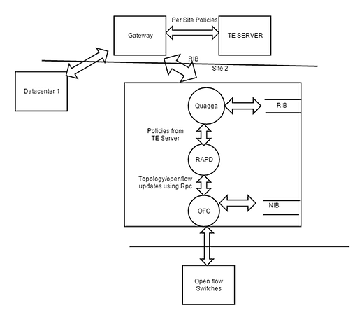 Figure3. B4 DFD

3. 1 Security Analysis
B4 uses very general routing technique. In this RAPD (Routing application proxy process) subscribes to the updates in Quagga stack, as soon as it detects any change it forwards the Routing information Base (RIB) to SDN application RAP using Routing Procedure Call (RPC) protocol . Rap converts the RIB to NIB which is used by OFC to set the flow tables for open flow switches . Same happens when hardware switch detects any interface status change the information is flooded to Quagga all through Rap application and Quagga furthers passes it towards the Te Server via gateway . In addition, for Traffic engineering (TE) application, data is forwarded from TE server to SDN gateway and further to OFC via TE agent [11].
For analyzing the security features of B4 we followed the steps mentioned above in section2. Data flow diagram of B4 is defined Figure 3. and 2. Analyzed it using Stride model. In Figure3 DFD's standard entities like division data flows, interactors, data stores and processes are identified. Interactors are the endpoints that provides and consume data. In B4 interactors are switches TE Server Gateway and NCS Server . Moreover, data flow is specified according to the interaction of data with each DFD component. Components that are present outside the trust boundary are treated as untrustworthy. Branch Switches are kept outside trusted boundary because users connected to the outside trusted boundary because users connected to the switches so cannot be trusted. Gateways and the central TE server are also present outside trusted boundary as they are orchestration point for multiple data center sites.
A) Data Flows - Data flow is vulnerable to tampering, information disclosure, and denial of service which leads to attack on integrity ,confidentiality and availability of data. If not secured it can further compromises the processes and data stores which process and stores the flow. Data flow from switches to the gateway and vice versa passes through controller which makes it much more important to be secured . Switches lie outside the trusted zone but uses Open Flow protocol for communicating with OFC. Open Flow is inherently secure as it uses Transport Layer Security (TLS) for securing communication. It protects from tampering of data and information disclosure by encrypting the data and uses public key cryptography, that ensures a private communication between the entities. However, Open Flow is vulnerable to denial of service, which according to [22] can be mitigated by bounding the number of requests by using access control also called as throttling. Whereas, data flow between gateway to Ncs server and gateway and Te server are vulnerable to all the three threats. Tampering and information disclosure can be mitigated by using encryption and message integrity check mechanism. Whereas, denial of service can be prevented by throttling mechanism or Qos. Data flows inside the Ncs server like between Quagga and Rap or Rap and OFC are inherently considered to be secured.
B) Data Stores: Data stores are vulnerable to tampering, information disclosure and denial of service. In B4 data is stored in RIB, NIB . Compromising security of any of these data stores would result in the vulnerability of the whole systEM . However both these data stores are considered to present locally inside the Ncs Servers so can only be attacked if Ncs server is compromised .
C) Process: Processes are vulnerable to all the six threats though for processes RAPD, TE client and OFC spoofing, tampering and information disclosure can be neglected as they are present in same server thus inherently can be trusted. Moreover, repudiation can be prevented by maintaining a log file with entries of each communication stored in it for later analysis. For mitigating elevation of privileges only minimum required privileges must be considered. For mitigating denial of service attack on process the requests to it should be authenticated or authorized and throttling must be used, because of this the entity which causes denial of service attack will not be able to enter the process and legitimate entity would not be able to flood the process.
D) Interactors: Interactors are prone to spoofing and repudiation. In our DFD, switches, Ncs Server Gateway and TE server are the interactors. Switches and Ncs servers consider safe from both these attacks as they both use and Tls prevent both spoofing and repudiation attacks. Gateways and TE server can be spoofed if one is able to get access to cli . He/she can push certain commands which can network to halt. In order to protect OS access must be authenticated and authorize. For example usage of AAA server can mitigate such attacks. AAA feature will account each and every activity of user so any malicious attempt made by user can easily trace back to him thus mitigate repudiation attack .
Summary of threat analysis is shown in the Table 3

Table 3. Summary of threat analysis of B4 where √ shows threat mitigation technique provided * indicates threat mitigated by application.
Threat | Intreactor |  |  |  | Process |  |  | DataFlows |  |  |  |  | Data Stores
Threat | G | T | N | S | OFC | RAP | Quagga | G=T | OFC=S | G=Quaga | OfC=NB | Ofc=RIB | NiB | RIB
Spoofing | √ | √ | * | * | * | * | *
Tampering |  |  |  |  | * | * | * | √ | * | √ | * | * | * | *
Repudiation | √ | √ | * | * | √ | √ | √
Information Disclosure |  |  |  |  | * | * | * | √ | * | √ | * | * | * | *
Denial of Service |  |  |  |  | √ | √ | √ | √ | √ | √ | * | * | * | *
Elevation of Privileges |  |  |  |  | √ | √ | √
G represent gateway , t is Topology server , N is Ncs server and S = Switches

IWAN
Cisco IWAN is one of the Cisco APIC EM controller application developed for hybrid wan management using
SDN technology. It supplies all the capabilities of wan management such as Wan optimization ,performance routing and deep packet inspection and VPN tunnelling in one suite . IWAN makes it possible for business to run smoothly on both private expensive Wan connection as well as on less expensive internet transport[23].Fig 4 represents the architecture of IWAN. Structure is basically structured into four components[23].

A) Transport Independent Design- DMVPN help organizations to easily build scalable VPNS to private and public clouds using both private and internet links with full encryption using ikev2 and IPsec In DMVPN environment spokes build a dynamic tunnel to hub and register itself as NHRP client to the NHRP server. Whenever a spoke wants to communicate to the other spoke it queries NHRP server and dynamically build mGre tunnel . Once the communication is
finished the tunnel is removed. As the number of branch sites increase management and configuration of DMVPN becomes complex. Cisco IWAN helps organizations to Zero touch deployment and management of IPSec DMVPN overlay network tunnels with a centralized controller.

B)Intelligent Path Control - One of most important feature of Wan management is to switch the application data dynamically among private MPLS line and internet . Cisco IWAN eases it by using pre defined policies and path metrics (jitter , latency) to enable performance based routing . It dynamically sets the routing decision for application. Branch routers connected to private line and internet collects the path metric data and sends to the master router which further pass to the APIC-EM controller. . Using the collected data and policies IWAN changes the routing entry for that particular application on master router.

C)Application Optimization - As more and more application are now turning web based , application classification according to the port number is no longer a efficient method . IWAN helps or smoothen this by deep level packet inspection

using Cisco AVC . AVC provides application visibility and control by Using Nbar2 Net Flow, quality of service (QOS) and Performance Monitoring. This increased visibility of application helps IT of an organization to prioritize business critical application among others. Cisco WASS is the other feature included in IWAN which optimize the Wan bandwidth efficiencies. Cisco WASS optimization along with Tcp optimization enable more efficient and high performance usage of Wan.

D)Secure Connectivity - For leveraging secure usage of public cloud over internet link IWAN projects the idea of using Zone based firewall on premises router and redirecting the public cloud data to CWS for scanning malware or unauthorized access . Zone based firewalls is a Cisco OS feature which blocks all the traffic except DMVPN tunnel traffic from entering the edge routers.

4. 1 Security Analysis
Same as for B4 we first defined the DFD for IWAN in Fig 5 then analyze it using stride. As already mentioned intreactors are those who consume or provide data. In this figure Lan switch , Cisco APIC EM , master router and both Border routers are interactors. AVC ,PFR and WASS,IWAN are the process and two trust boundaries are stated . Branch switches are kept outside because users connected to the switches can't be trusted they can overhaul the link between the master router and border router which with bogus traffic which can deteorite the IWAN performance . Other boundary is between edge router of the organisation and Wan link. Data and users from the Wan link can't be trusted either. Data flow is mentioned according to the interaction with the components.
A) Data flow - Data flow is vulnerable to tampering, information disclosure, and denial of service which leads to attack on integrity ,confidentiality and availability of data according to stride model . Information disclosure attack on flow between master and border routers can be perform by tapping the network between them but it is hard to achieve as it traverses only one link. No specification is given in [23] but In case to provide confidentiality of data we can use IPsec between them. Same way the data between the flow can only be tampered if tap network and spoof the TCP packets which
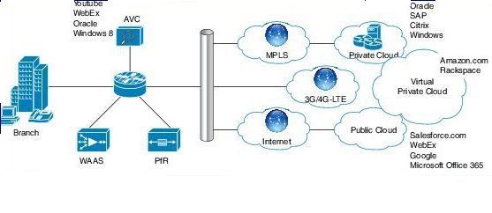
Fig 4, IWAN Architecture
both are not trivial . Denial of service attack can be performed if overload the link between the routers this is easy to perform just need to exhaust the link bandwidth with the data from thebranch LAN . To counter this authentication , authorization ,filtering and Qos security mechanism can be used. In flow between master and branch routers authentication and authorization of users on branch LAN can be one solution but more security can be added by adjusting the Qos for the routing protocol packets and Performance based routing packets containing metrics data .
Data flow between controller and master router is immune to both tampering and information disclosure attack . Both these interactor use Open flow protocol between them for communication which is TLS enabled. The link bandwidth can only can be exhausted if there is large number of open flow requests sent to the controller which can be mitigated by throttling mechanism.
Data flow between Branch LAN and master router is prone to all three attacks . To increase overall network security data can be sent using TLS. The flow of data from branch routers to internet is immune to tampering and information disclosure attack because of IPsec ike2 encryption. Whereas the DDos attack on it can surely hamper the working of IWAN . Unavailability to pass data through one link will cause the IWAN to change the policies and routing entry on master router which can make the possibility of sending business critical data on less secure internet link. To protect either use dynamic Ip on wan ports of branch routers or prioritize the business critical data on private links.
B) Interactor - Interactors are prone to spoofing and repudiation. In our DFD ,Master router ,Border router Controller and LAN switches are interactors. One of the attack by spoofing the switch is that attacker attached to switch port congest the Wan with certain type of traffic which can make the controller to alter the policies on the master. It can be protected either by setting edge ports to static access or disable DTP auto negotiation[24]. Repudiation attack can be prevented using synchronized log entries which can be created by configuring Syslog [25] on switch or other way is to authenticate the user connected to switch using AAA[26]. IWAN controller and master router are both immune to tampering and repudiation attack because of open flow Transport layer security feature. On Border routers spoofing attack can be performed if console or management passwords
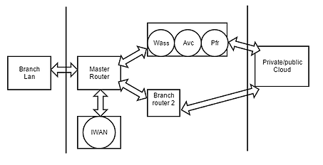
Fig 5. IWAN DFD
are compromised. Cisco OS access are generally through AAA server which accounts authenticates and authorize the router. IPsec Ike use RSA signature as one of the three option for authentication this provide immunity to non repudiation attacks[27].
3)Process - Process -As already stated in security analysis of B4 , process are vulnerable to all six threats mentioned in Stride model . In IWAN DFD we have four process mentioned WASS, AVC , PFR , and IWAN App. Attacks will only possible if hardware comprising these process get compromised. In case AVC ,WASS , PFR if border routers are compromised then only attacker will be able to execute further attacks. Spoofing and tampering of the process can be performed by modifying the Cisco Os (Cisco-Xe for routers and APIC EM for controller) binary image. It can be done by adding malware to Cisco Os. To protect Os Cisco Image Verification feature can be used . It is builds on the MD5 File
Validation and it ensure any corruption to Os image functionality to network administrators . Further security of OS can be improved by providing authorization to certain user for commands like config-register , show memory[28]. Information disclosure attack can be possible If the attacker is able to get its hand on the binary image of Os it can perform both static and dynamic code analysis thus able to acquire intelligence like flow of data[28] . Attacker can alter the flow of data which can bring the Wan application to halt. This can be protected by encrypting the binary file. In this system , attacker can perform DDos attack to shutdown the availability of process. For example the attacker from the branch LAN keep sending the bogus data which can overwhelm the router OS thus halts the AVC , PFR ,and WASS process. This can be mitigated using Cisco Copp [29] or Acl . IWAN is immune to this attack as controller lies in the isolated management plane. Elevation of privileges can be mitigated by running each process with least privileges.
Summary of the threats are shown in Table 4.

Table 4. Summary of Summary of threat analysis of IWAN where √ shows threat mitigation technique provided * indicates threat mitigated by application. Cont represent Controller , M.R represent master router , B.r is Border router
Threat | Interactor |  |  |  | Process |  |  |  | Data Flows
Threat | LAN | Cont | M. R | B. R | AVC | PFR | WASS | IWAN | LAN  <>M. R | M. R  <->Cont | M. R  <->B. R | B. Router  <->WAN
Spoofing | √ | * | * | √ | √ | √ | √ | √
Tampering |  |  |  |  | √ | √ | √ | √ |  | * | * | *
Repudiation | √ | * | * | * | √ | √ | √ | √
Information Disclosure |  |  |  |  | √ | √ | √ | √ |  | * | * | *
Denial of Service |  |  |  |  | √ | √ | √ | * |  | √ | √ | √
Elevation of privileges |  |  |  |  | √ | √ | √ | √

Conclusion

References
- The Zettabyte Era Trends and Analysis. [Online]. Avail-able: http : / / www . Cisco . com / c / en / us / solutions / collateral/ service - provider /visual - networking - index - vni / VNI Hyperconnectivity WP . html (accessed on 02/01/2016).
- W. Stallings, Software-Defined Networks and Open-Flow. [Online]. Available: http://www. Cisco. com/web/ about/ac123/ac147/archived issues/ipj 16- 1/161 sdn. html (accessed on 02/01/2016).
- Software-Defined Networking: Why We Like It and How We Are Building On It. [Online]. Available: http://www. Cisco . com / c / dam / en us / solutions / industries / docs / gov/cis13090 sdn sled white paper. pdf (accessed on 02/01/2016).
- N. McKeown, T. Anderson, H. Balakrishnan, G. Parulkar, L. Peterson, J. Rexford, S. Shenker, and J. Turner, “OpenFlow: Enabling innovation in campus networks,” ACM SIGCOMM Computer Communication Review, vol. 38, no. 2, pp. 69–74, 2008.
- D. Jacobs,How software-defined WAN architecturechanging the market. [Online]. Available: http : / /searchsdn . techtarget . com/tip/How - software - defined - WAN - architecture - is - changing - the - market (accessed on 02/01/2016).
- J. Dix, The first place to tackle SDN: in the WAN. [Online]. Available: http : / / www. networkworld . com / article/2873964/sdn/the- first- place- to- tackle- sdn- in-the-wan. html?page=2 (accessed on 02/01/2016).
- Cisco Intelligent WAN. [Online]. Available: http://www. Cisco . com / c / en / us / solutions / enterprise - networks / intelligent-wan/index. html (accessed on 03/02/2016).
- SOFTWARE-DEFINED WAN: MORE UPTIME FOR YOUR NETWORK, MORE DOWNTIME FOR YOU. [Online]. Available: http : / / www . cloudgenix . com / software-defined wan/ (accessed on 03/02/2016).

- Secure Extensible Network (SEN) Solution. [Online]. Available: http : / / viptela . com / solutions / overview/ (accessed on 03/02/2016).
- S. Jain, M. Zhu, J. Zolla, U. Holzle,¨ S. Stuart, A. Vahdat, A. Kumar, S. Mandal, J. Ong, L. Poutievski, A. Singh, S. Venkata, J. Wanderer, and J. Zhou, “B4: Experience with a globally-deployed software defined WAN,” in ACM SIGCOMM Computer Communication Review, ACM, vol. 43, 2013, pp. 3–14.
- N. Feamster, J. Rexford, S. Shenker, R. Clark, R. Hutchins, D. Levin, and J. Bailey, “SDX: A software-defined internet exchange,” Open Networking Summit, 2013.
- Microsoft, Improving Web Application Security: Threats and Countermeasures. [Online]. Available: https : / / msdn . microsoft . com / en - us / library / ff648644 . aspx (accessed on 02/01/2016).
- T. UcedaVelez, “Real World Threat Modeling Using the PASTA Methodology”, OWASP App Sec EU 2012
- P Saitta, B Larcom, M Eddington, “Trike v. 1 methodologydocument[draft]”,URL:http://dymaxion. org/trike/Trike_v1_Methodology_Documentdraft. pdf, 2005
- Bruce Schneier “Attack trees”, Dr. Dobb's journal, 1999
- Jan Jürjens, “UMLsec: Extending UML for Secure SystEMs Development” , J. -M. J ́ez ́equel, H. Hussmann,S. Cook (Eds. ): UML 2002, LNCS 2460, pp. 412–425, 2002. c©Springer-Verlag Berlin Heidelberg 2002
- Christopher Alberts,Audrey Dorofee,James Stevens,Carol Woody, Introduction to the OCTAVE®Approach. Pittsburgh, PA 15213-3890 : Carnegie Mellon University , August 2003Pittsburgh, PA 15213-3890 : Carnegie Mellon University , August 2003
- Misusecases-- //not able to fnd
- “Qualitative Risk Analysis with the DREAD Model”, http://resources. infosecinstitute. com/qualitative-risk-analysis-dread-model/ Posted in General Security on May 21, 2014
- “The CORAS approach to model- driven risk analysis”, https://securitylab. disi. unitn. it/lib/exe/fetch. php?media=research_activities:erise:erise_2011:tutorials:erise2011_coras_pres. pdf
- M. N. Johnstone, “Threat modelling with STRIDE and UML,” 2010.
- M. Tasch, R. Khondoker, R. Marx, and K. Bayarou, “Security Analysis of Security Applications for Soft-ware Defined Networks,” in Proceedings of the AINTEC 2014, ACM, 2014, p. 23.
- http://www. cisco. com/c/dam/en/us/td/docs/solutions/CVD/Jan2015/CVD-IWANDesignGuide-JAN15. pdf (accessed on 29/07/2016).
- http://www. cisco. com/c/en/us/tech/lan-switching/dynamic-trunking-protocol-dtp/index. html (accessed on 29/07/2016).

- http://www. cisco. com/c/en/us/tech/ip/syslog/index. html (accessed on 29/07/2016).
- http://www. cisco. com/c/en/us/support/docs/security-vpn/terminal-access-controller-access-control-system-tacacs-/10384-security. html (accessed on 29/07/2016).
- http://www. cisco. com/c/en/us/td/docs/ios-xml/ios/sec_conn_ikevpn/configuration/xe-3s/sec-ike-for-ipsec-vpns-xe-3s-book/sec-key-exch-ipsec. html (accessed on 29/07/2016).
- http://www. cisco. com/c/en/us/about/security-center/integrity-assurance. html (accessed on 29/07/2016).
- http://www. cisco. com/c/en/us/about/security-center/copp-best-practices. html (accessed on 29/07/2016).

