There are two broad classes of data retrieval
1] Sequential : Give me list of all employee names, addresses etc.
2] Random : Give me information of employee "J.Smith"

Now, lets say you have a cabinet, which has drawers and each drawer has folders. One folder for each employee in a company.
Let say the drawers are label "A-I" , "J-R" , "S-Z" based on the starting alphabet of their surnames, and then the folders are labeled with the "lastnames" of each employee.

If you have to carry out a sequential retrieval, then you have to traverse each folder, but if you want information on any one employee, you are guided by the labels on the drawers and the folders.

Similarly, associated with large, randomly accessed file in a computer system, is an index file which acts like labels on the drawers and folders and speeds up retrieval by directing the search process to a smart part of the file containing the desired item.

Let’s assume we have a very large file which has a set of n records, of the form

R_{i} = (k_{i}, α_{i})

Where k_{i} is the key for each record and α_{i} is the associated information. Further we assume that although the key information is much smaller than the associated information itself, the set of all keys is too large too fit into main memory. These assumptions apply that if records are to be randomly using the keys, it would be advantageous to construct an index to speed up retrieval. The following are the most common operations one would apply on the file

1] Searching: retrieve α_{i} given k_{i}
2] Insertion: add a new record (k_{i}, α_{i}) making sure that k_{i} is unique.
3] Deletion: remove record (k_{i}, α_{i}) for a given k_{i}
4] Next: Retrieve α_{i+1} given that α_{i} was just retrieved.

B-tree
--------
B-Tree is a self balancing tree. In general, each node in a B-Tree of order d contains at most 2d keys and 2d+1 pointers. Actually the number of keys may vary from node to node, but each must have atleast d keys and d+1 pointers. As a result, each node is atleast ½ full. You can think of a node in a B-tree as forming one record of the index file, which has a fixed length capable of accommodating 2d keys and 2d+1 pointers. The keys are maintained in nodes in a sorted order. Also, the elements in a B-tree are restricted by the elements of its parent node.Eg: Consider the following B-Tree
The elements in node A are required to be between 18 and 26. Similarly, the elements in the B subtree are constrained to be greater than 42.
Although the B-tree here stores integer type of values, B-trees can be used to store other kind of values, such as strings.

The height of a B-tree is given by
h ≤ log_{t} [(n+1)/2] ~ O(log_{t} n)

Definition of a B-tree in terms of math
---------------------------------------

1] Each node is represented as x. n[x] is the number of keys. and (n[x] + 1) are the number of children.
2] All leaves are at the same depth.
3] The root of a B-tree "T" is denoted as root[T].
4] Every node x has the following 4 fields.
4.a] The number of keys currently stored in node x, denoted by n[x]
4.b] The n[x] keys themselves, stored in increasing order, denoted by
4.c] A boolean value,
leaf[x] = TRUE, if x is a leaf
FALSE, if otherwise.

4.d] n[x] + 1 pointers to its children, denoted by
4.e] A pointer to its parent node.

The worst case height of a B-tree is given by:

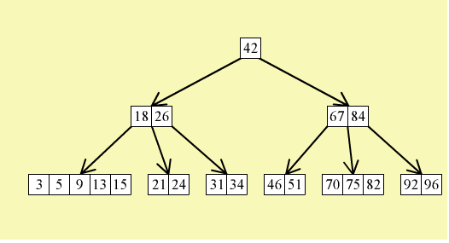

The beauty of B-trees lies in the methods for inserting and deleting records that always leave the tree balanced. In a binary search tree, a random insertion of records can leave the tree unbalanced. That is why the worst case running time of binary search trees is O(n). In B-trees on the other hand, all leaves are at the same depth, and all operations take about O(log_{d} n), where n is the number of keys and d is the order of the tree.
Space left for derivation of height of a binary tree.

The advantage of nodes containing a large number of keys should now be clear. As the branch factor, d, increases, the logarithmic base increases, and the costs of find, insert, delete operations decrease.

Insertion
-----------

Insertion of a new key requires a two step process. Also insertion is always performed at a leaf node.
1] First, a find proceeds from root to locate the proper leaf for insertion.
2] The insertion is performed, and the balance is restored (if required) by a procedure that moves from the leaf back to the root. The rebalancing is required when a key needs to be inserted in a node that is already full. In such a case, a split occurs. The split occurs at the median key of the node. All keys less than the median form one node, keys greater than the median form another node, and the median key is promoted up to the root where it acts as a separator. In case the parent too is full, then the same splitting is applied again. In the worst case, splitting propagates all the way to the root and the tree increases I height by one level. In fact, a B-tree only increases in height because of a split at the root.

