

AMC ENGINNERING COLLEGE,BANGLORE
Department of Master of Computer Application

A Skill Development Report on

REGISTRATION FORM

A Skill Development Activity-1 report submitted in partial fulfilment of the requirements as a part of the 1 semester for the award of degree of Master of Computer Applications.

Submitted By

PREETHI SHREE N

Under the guidance Of
Prof.Gunasekaran K Assistant Professor

INDEX

Sl.No | Contents | Page No.
1. | Abstract | 1
2. | Introduction | 2
3. | Technology Used | 3
4. | Constraints Used | 4-5
5. | How It Differs | 6
6. | Flowchart | 7
7. | Code | 8-13
8. | Screenshots | 14-15
9. | Conclusion | 16

ABSTRACT

This program implements a comprehensive user registration and login system using HTML, CSS, and JavaScript, providing a responsive and interactive web interface. The registration form collects essential user information, including name, mobile number, email, country, city, education, address, password, confirm password, and gender, with real-time validation to ensure accurate input. Validation rules enforce constraints such as Gmail-only emails, password complexity, numeric mobile numbers, and character limits for text fields. The system also includes a login form for returning users, allowing secure access to protected pages. Additionally, the program integrates simulated Google and Facebook login buttons to demonstrate third-party authentication, redirecting users to the respective login pages. Password fields feature visibility toggling for enhanced usability. The program uses JavaScript functions to manage form switching, input validation, and redirects, offering a complete, user- friendly solution for web-based registration and authentication workflows.

INTRODUCTION

This program is designed to create a complete registration and login system for web applications using HTML, CSS, and JavaScript. It provides a user-friendly interface where new users can register by providing essential personal information, such as name, mobile number, email, country, city, education, address, and gender. The registration form ensures that user input is accurate and secure through real-time validation, including checks for proper email format, numeric-only mobile numbers, character limits, and password complexity. Passwords must include letters, numbers, and special characters, and the form also requires confirmation to prevent mistakes.
In addition to the registration functionality, the system includes a login interface for returning users. Users can enter their email and password to access the application, and the form validates the input to prevent empty or incorrect entries. The program allows users to switch seamlessly between registration and login forms and includes password visibility toggles to enhance usability. This ensures that the system is not only secure but also convenient for end-users.
Furthermore, the program demonstrates integration with third-party authentication services, such as Google and Facebook. While the buttons are simulated in this version, they provide a clear framework for OAuth-based login in real-world applications. Overall, this program offers a complete, interactive, and secure solution for web-based user registration and authentication.

TECHNOLOGY USED

HTML (HyperText Markup Language):
HTML is used to structure the web page. It defines the registration and login forms, input fields, buttons, and layout of the user interface. Tags like <form>, <input>,
<select>, <textarea>, and <button> are used to create interactive elements for collecting user information.

CSS (Cascading Style Sheets):
CSS is used for styling the web page. It enhances the user interface by applying colors, fonts, spacing, borders, gradients, and shadows. CSS ensures that the forms are responsive, visually appealing, and easy to navigate, including hover effects on buttons and layout for Google/Facebook login buttons.

JavaScript:
JavaScript is used to add interactivity and functionality. It performs tasks such as input validation, password visibility toggle, form switching between registration and login, and redirecting users to different pages. It also simulates third-party login (Google/Facebook) and ensures secure and correct data entry before submission.

Icons & Images:
External icon sources (e.g., Icons8) are used for Google and Facebook login buttons, making the interface more recognizable and user-friendly.

Web Browser:
A modern web browser (like Chrome, Firefox, or Edge) is used to render the HTML, CSS, and JavaScript, allowing users to interact with the forms.

CONSTRAINTS USED
Constraints Used

Name:
  - Only letters, spaces, and dot (.) allowed.
  - Maximum length: 15 characters.

Mobile Number:
  - Only numeric values allowed.
  - Must be exactly 10 digits.

Email:
  - Only Gmail addresses are allowed (@gmail.com).
  - Must follow proper email format.

Country:
  - Must select a country from the dropdown list (cannot be empty).

City:
  - Only letters, spaces, and dot allowed.
  - Maximum length: 20 characters.

Education Qualification:
  - Maximum 20 characters allowed.

Address:
  - Maximum 70 characters allowed.

Password:
  - Length must be 8–20 characters.
  - Must contain at least one letter, one number, and one special character.

Confirm Password:
  - Must match the password.
- Gender:
  - One option (Male/Female/Other) must be selected.

Login Form:
  - Email and password fields cannot be empty.

Test Case 1 (Valid Input)
- Name: Rahul Kumar
- Mobile: 9876543210
- Email: preethi@gmail.com
- City: Hyderabad
- Password: Rahul@123
Result: Registration Successful

Test Case 2 (Invalid Mobile & Email)
- Mobile: 98A65432
- Email: preethi@yahoo.com
Result: Error messages displayed for mobile and email

Test Case 3 (Password Mismatch)
- Password: Test@123
- Confirm Password: Test@124 Result: Password mismatch error

Test Case 4 (Missing Gender)
- Gender: Not selected
Result: Gender selection error displayed

HOW THIS REGISTRATION PAGE IS DIFFERENT FROM OTHER REGISTRATION PAGES

Unique Features of This Registration Page
- Comprehensive Validation:
Unlike many standard registration forms, this page enforces strict validation rules on all fields:
  - Name and city allow only letters, spaces, and dots.
  - Mobile number must be exactly 10 digits.
  - Email allows only Gmail addresses.
  - Password requires a combination of letters, numbers, and special characters (8–20 characters).
This ensures higher data accuracy and security compared to generic forms.

Integrated Login & Registration in One Page:
This page combines both registration and login forms in a single interface with a switch link, allowing users to toggle between registration and login without navigating to different pages. Most websites use separate pages for registration and login, making this more user-friendly.

Third-Party Login Simulation:
It includes Google and Facebook login buttons for demonstration, simulating OAuth- based authentication, which is not common in basic forms. This allows users to log in using social accounts, offering convenience and a modern web experience.

Enhanced Usability Features:
  - Password visibility toggle for easier input.
  - Clear error messages displayed in real-time for every field.
  - Responsive and visually appealing layout with gradient background, shadow effects, and styled buttons.

Client-Side Interactivity:
All validations, form switching, and redirection are handled purely on the client-side using JavaScript, providing instant feedback without server interaction, which is faster than many traditional forms.

FLOWCHART

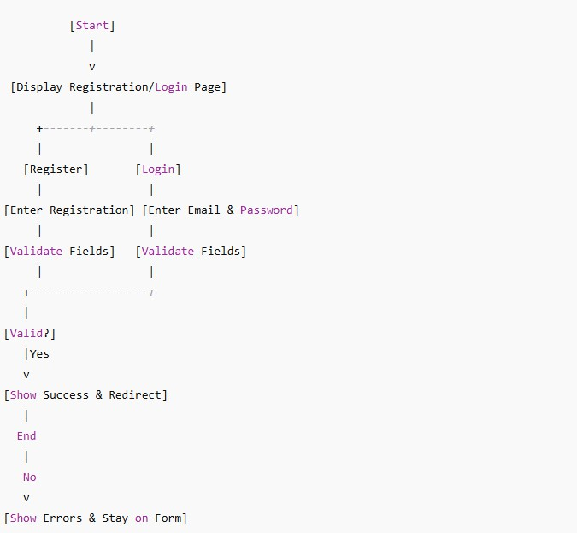

CODE

<!DOCTYPE html>
<html lang="en">
<head>
<meta charset="UTF-8">
<meta name="viewport" content="width=device-width, initial-scale=1.0">
<title>Registration & Login</title>
<style> body {
font-family: Arial, sans-serif;
background: linear-gradient(135deg, #2193b0, #6dd5ed); margin: 0;
padding: 0;
}
.container { width: 420px;
margin: 30px auto; background: #fff; padding: 20px; border-radius: 6px;
box-shadow: 0 0 10px #333;
}
h2 {
text-align: center;
}
label {
font-weight: bold;
}
input, select, textarea { width: 100%; padding: 8px; margin: 5px 0 10px;
}
textarea { resize: none; }
.gender input { width: auto; }
.password-box { position: relative; }
.password-box span { position: absolute; right: 10px; top: 9px; cursor: pointer; }
.error { color: red; font-size: 13px; } button {
width: 100%; padding: 10px; background: #0b5ed7; color: white;
border: none; font-size: 16px; cursor: pointer;
}

button:hover { background: #084298; }
.oauth-btn { display: flex;
align-items: center; justify-content: center; margin: 8px 0; padding: 10px;
border-radius: 4px; font-size: 16px; cursor: pointer; color: white;
}
.google { background: #db4437; }
.facebook { background: #4267B2; }
.oauth-btn img { width: 20px; margin-right: 10px; }
.switch-link {
text-align: center; margin-top: 10px;
}
.switch-link a { color: #0b5ed7; cursor: pointer; text-decoration: none; }
.switch-link a:hover { text-decoration: underline; }
</style>
</head>
<body>
<div class="container" id="registerForm">
<h2>Register</h2>
<form onsubmit="return validateForm()">
<label>Name</label>
<input type="text" id="name" maxlength="15" onkeypress="return allowLetters(event)">
<div class="error" id="nameError"></div>
<label>Mobile Number</label>
<input type="text" id="mobile" maxlength="10" onkeypress="return allowNumbers(event)">
<div class="error" id="mobileError"></div>
<label>Email (Gmail)</label>
<input type="text" id="email">
<div class="error" id="emailError"></div>
<label>Country</label>
<select id="country">
<option value="">Select Country</option>
<option>India</option>
<option>USA</option>
<option>UK</option>
<option>Canada</option>
</select>
<div class="error" id="countryError"></div>
<label>City</label>
<input type="text" id="city" maxlength="20" onkeypress="return allowLetters(event)">
<div class="error" id="cityError"></div>
<label>Education Qualification</label>
<input type="text" id="education" maxlength="20">

<div class="error" id="educationError"></div>
<label>Address</label>
<textarea id="address" maxlength="70"></textarea>
<div class="error" id="addressError"></div>
<label>Password</label>
<div class="password-box">
<input type="password" id="password">
<span onclick="togglePassword('password')">·•s● </span>
</div>
<div class="error" id="passwordError"></div>
<label>Confirm Password</label>
<div class="password-box">
<input type="password" id="confirmPassword">
<span onclick="togglePassword('confirmPassword')">•·•s● </span>
</div>
<div class="error" id="confirmPasswordError"></div>
<label>Gender</label>
<div class="gender">
<input type="radio" name="gender" value="Male"> Male
<input type="radio" name="gender" value="Female"> Female
<input type="radio" name="gender" value="Other"> Other
</div>
<div class="error" id="genderError"></div>
<button type="submit">Register</button>
<div class="switch-link">
Already have an account? <a onclick="showLogin()">Login</a>
</div>
<div style="margin-top:15px;">
<div class="oauth-btn google" onclick="googleLogin()">
<img src="https://img.icons8.com/color/48/google-logo.png"> Login with Google
</div>
<div class="oauth-btn facebook" onclick="facebookLogin()">
<img src="https://img.icons8.com/color/48/facebook-new.png"> Login with Facebook
</div>
</div>
</form>
</div>
<!-- Login Form -->
<div class="container" id="loginForm" style="display:none;">
<h2>Login</h2>
<form onsubmit="return loginForm()">
<label>Email</label>
<input type="text" id="loginEmail">
<div class="error" id="loginEmailError"></div>
<label>Password</label>
<div class="password-box">
<input type="password" id="loginPassword">
<span onclick="togglePassword('loginPassword')"> ·•s●</span>
</div>
<div class="error" id="loginPasswordError"></div>

<button type="submit">Login</button>
<div class="switch-link">
Don't have an account? <a onclick="showRegister()">Register</a>
</div>
<div style="margin-top:15px;">
<div class="oauth-btn google" onclick="googleLogin()">
<img src="https://img.icons8.com/color/48/google-logo.png"> Login with Google
</div>
<div class="oauth-btn facebook" onclick="facebookLogin()">
<img src="https://img.icons8.com/color/48/facebook-new.png"> Login with Facebook
</div>
</div>
</form>
</div>
<script>
function allowLetters(e) {
let char = String.fromCharCode(e.which); return /^[A-Za-z .]$/.test(char);
}
function allowNumbers(e) {
let char = String.fromCharCode(e.which); return /^[0-9]$/.test(char);
}
function togglePassword(id) {
let field = document.getElementById(id);
field.type = field.type === "password" ? "text" : "password";
}
function showLogin() { document.getElementById("registerForm").style.display = "none"; document.getElementById("loginForm").style.display = "block";
}
function showRegister() { document.getElementById("loginForm").style.display = "none"; document.getElementById("registerForm").style.display = "block";
}
function validateForm() { let valid = true;
document.querySelectorAll(".error").forEach(e => e.innerHTML = ""); let name = document.getElementById("name").value.trim();
let mobile = document.getElementById("mobile").value.trim(); let email = document.getElementById("email").value.trim(); let country = document.getElementById("country").value;
let city = document.getElementById("city").value.trim();
let education = document.getElementById("education").value.trim(); let address = document.getElementById("address").value.trim();
let password = document.getElementById("password").value;
let confirmPassword = document.getElementById("confirmPassword").value; let gender = document.querySelector('input[name="gender"]:checked');S
if (!/^[A-Za-z .]{1,15}$/.test(name)) {

document.getElementById("nameError").innerHTML = "Only letters, space & dot allowed (max 15)";
valid = false;
}
if (!/^\d{10}$/.test(mobile)) {
document.getElementById("mobileError").innerHTML = "Mobile must be exactly 10 digits";
valid = false;
}
if (!/^[a-zA-Z0-9._%+-]+@gmail\.com$/.test(email)) { document.getEleme
ById("emailError").innerHTML = "Only Gmail allowed"; valid = false;
}
if (country === "") {
document.getElementById("countryError").innerHTML = "Select country"; valid = false;
}
if (!/^[A-Za-z .]{1,20}$/.test(city)) {
document.getElementById("cityError").innerHTML = "Only letters, space & dot allowed (max 20)";
valid = false;
}
if (education.length === 0 || education.length > 20) { document.getElementById("educationError").innerHTML = "Max 20 characters
allowed";
valid = false;
}
if (address.length === 0 || address.length > 70) { document.getElementById("addressError").innerHTML = "Max 70 characters allowed"; valid = false;
}
let passPattern = /^(?=.*[A-Za-z])(?=.*\d)(?=.*[@$!%*#?&])[A-Za-
z\d@$!%*#?&]{8,20}$/;
if (!passPattern.test(password)) { document.getElementById("passwordError").innerHTML = "8–20 chars with letter,
number & special char"; valid = false;
}
if (password !== confirmPassword) { document.getElementById("confirmPasswordError").innerHTML = "Passwords do not
match";
valid = false;
}
if (!gender) {
document.getElementById("genderError").innerHTML = "Select gender"; valid = false;
}
if (valid) {

alert("Registration Successful!");
// Redirect to welcome page window.location.href = "welcome.html";
}
return valid;
}
function loginForm() { let valid = true;
document.getElementById("loginEmailError").innerHTML = ""; document.getElementById("loginPasswordError").innerHTML = "";

let email = document.getElementById("loginEmail").value.trim(); let password = document.getElementById("loginPassword").value; if (email === "") {
document.getElementById("loginEmailError").innerHTML = "Enter email"; valid = false;
}
if (password === "") {
document.getElementById("loginPasswordError").innerHTML = "Enter password"; valid = false;
}
if (valid) {
alert("Login Successful!"); window.location.href = "welcome.html";
}
return valid;
}
function googleLogin() { alert("Redirecting to Google Login...");
window.location.href = "https://accounts.google.com/signin"; function facebookLogin() {
alert("Redirecting to Facebook Login..."); window.location.href = "https://www.facebook.com/login";
}
</script>
</body>
</html>

SCREENSHOTS

Signin Page :
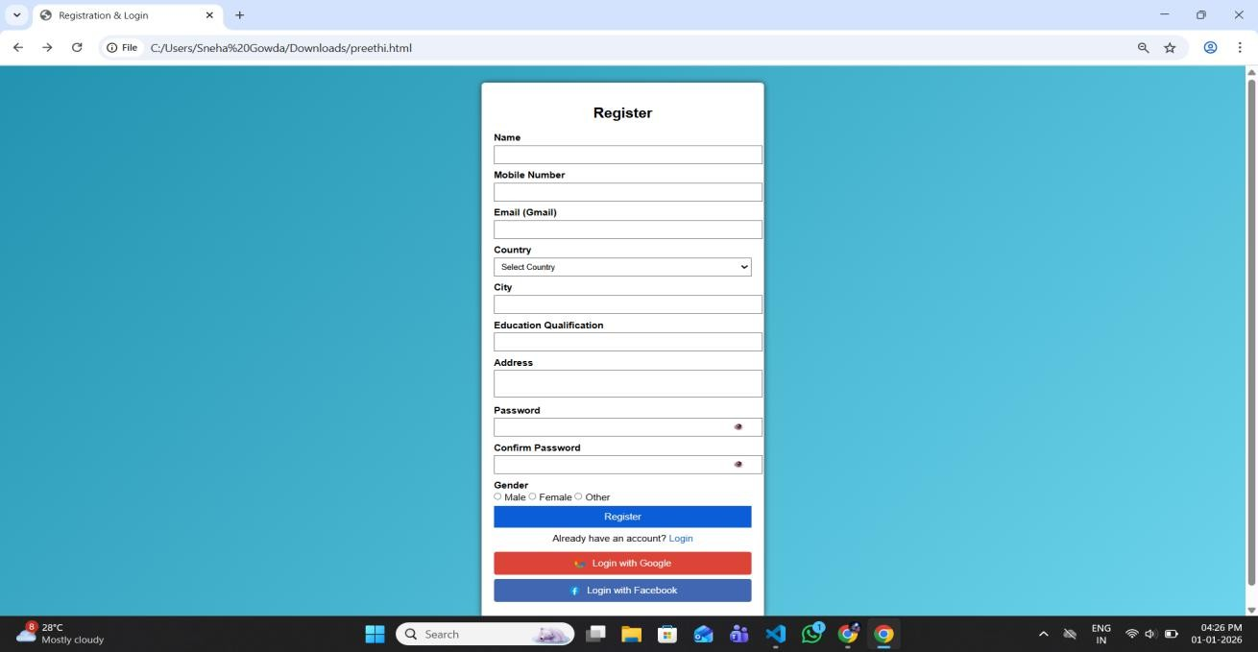

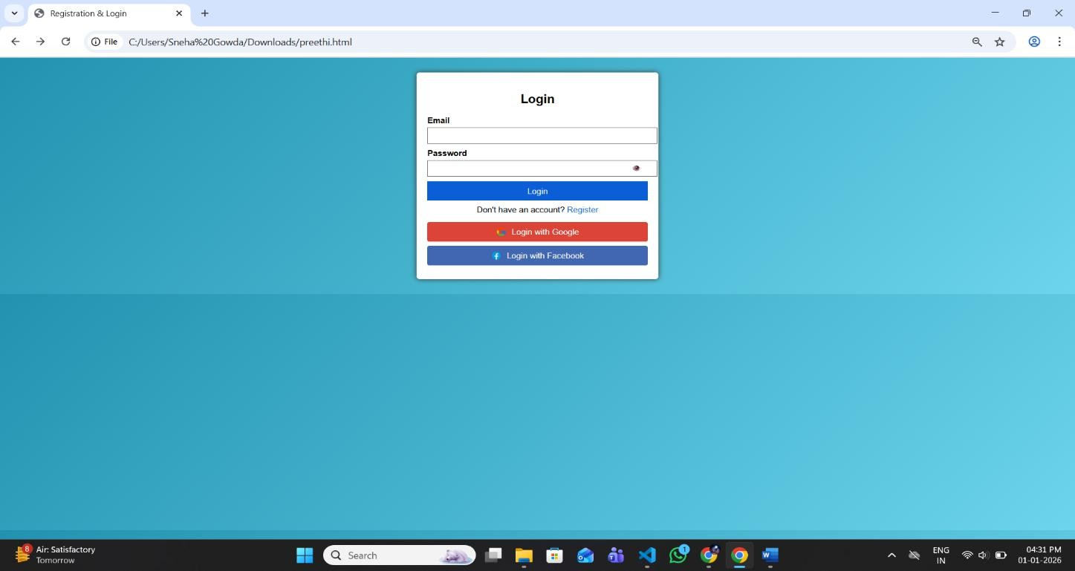
Login Page:

Google Login Page:
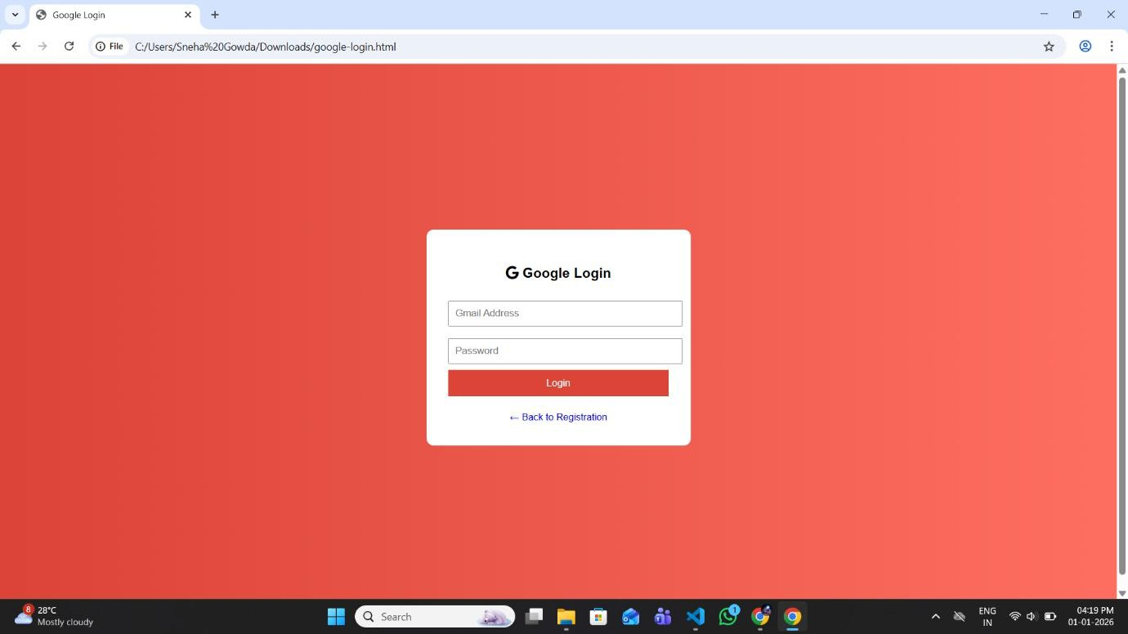

Facebook Login Page:
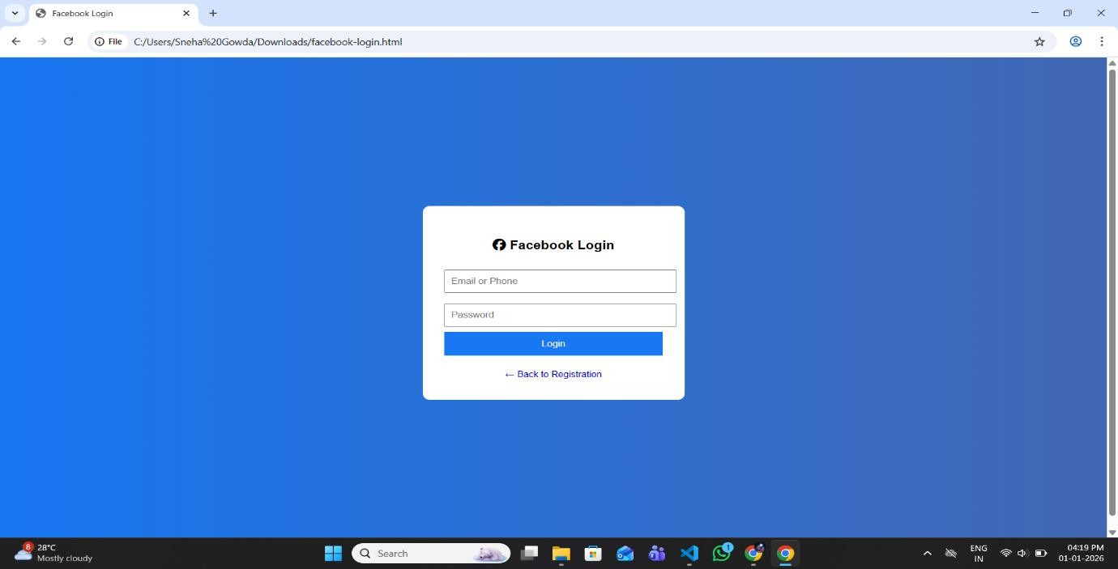

CONCLUSION

The Registration and Login program provides a secure, user-friendly, and interactive web interface for managing user accounts. Through comprehensive client-side validation, it ensures that all inputs, such as name, mobile number, email, password, and other details, follow strict rules, minimizing errors and improving data integrity. The integration of password visibility toggling and clear error messages enhances user convenience, while the option to switch between registration and login forms in a single page makes navigation smooth and efficient.
Additionally, the inclusion of Google and Facebook login buttons demonstrates modern authentication practices and provides a foundation for integrating third-party OAuth logins, which are widely used in real-world applications. The program combines HTML, CSS, and JavaScript to create a responsive and visually appealing interface, showing how front-end technologies can work together to deliver a functional system without requiring backend processing for validation.
Overall, this program serves as a practical example of a complete web-based registration and authentication system, emphasizing security, usability, and modern web standards, making it a valuable tool for learning and implementing real-world user management solutions.

