**Many-to-Many Relationship** 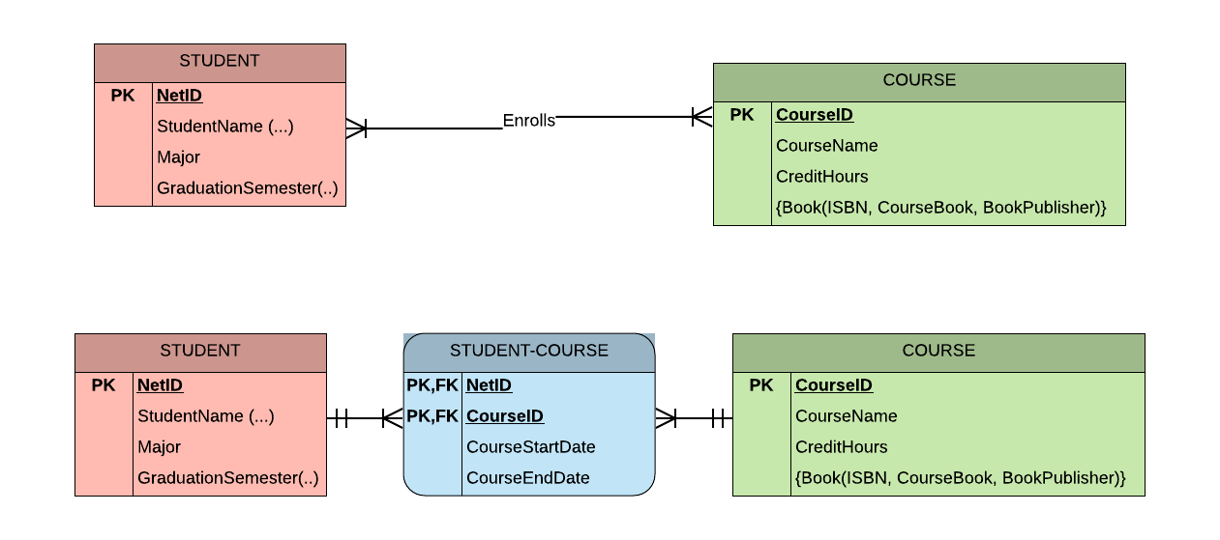

**Associative Entity**

**Multivalued Attribute into Relationship**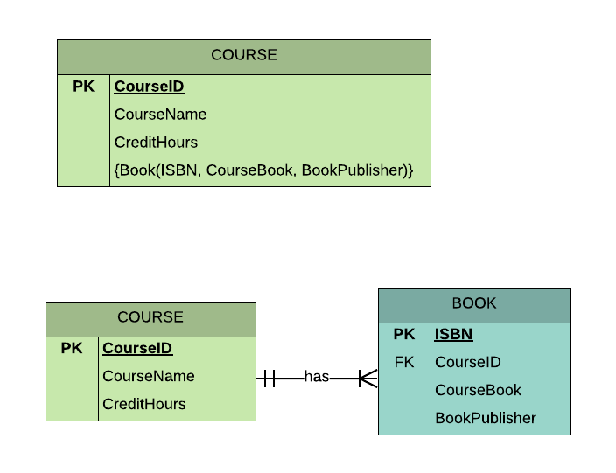

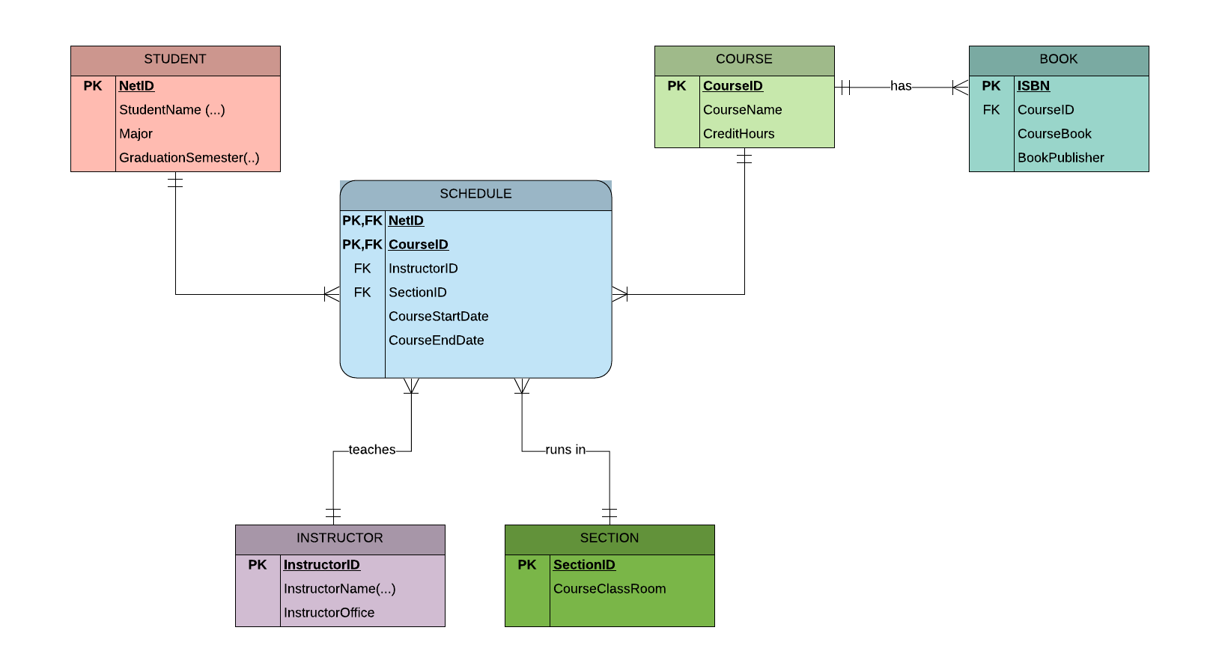

**ER Diagram**