Artificial Intelligence & Machine Learning

Task 1 – Linear Regression Model Report
California Housing Dataset | House Price Predictor

1. Objective

The goal of this task is to build a Linear Regression model that predicts the median house value for California census blocks using 8 demographic and geographic features. This project demonstrates the full machine learning lifecycle: data loading, exploratory data analysis (EDA), preprocessing, model training, evaluation, and reporting.

2. Dataset Overview

The California Housing Dataset (built into scikit-learn) contains data derived from the 1990 U.S. Census.
It has 20,640 samples and 8 input features with no missing values.
Feature | Description | Type
MedInc | Median income of block group ($10k units) | Numeric
HouseAge | Median house age (years) | Numeric
AveRooms | Average number of rooms per household | Numeric
AveBedrms | Average number of bedrooms per household | Numeric
Population | Block group population | Numeric
AveOccup | Average number of household members | Numeric
Latitude | Block group latitude | Geographic
Longitude | Block group longitude | Geographic
MedHouseVal | Median house value ($100k) — TARGET | Target

3. Exploratory Data Analysis (EDA)

Key EDA findings:
- No missing values across all 20,640 rows — no imputation required.
- MedInc has the highest positive correlation with the target (r ≈ 0.69), confirming that income is the strongest predictor of house prices.
- Latitude and Longitude are negatively correlated, reflecting California's coastal/southern premium areas (San Francisco, Los Angeles).
- AveOccup and Population are weakly correlated with house value, suggesting crowded areas don't necessarily have higher prices.
- The target distribution is slightly right-skewed with a hard cap at $500k due to census reporting limits.
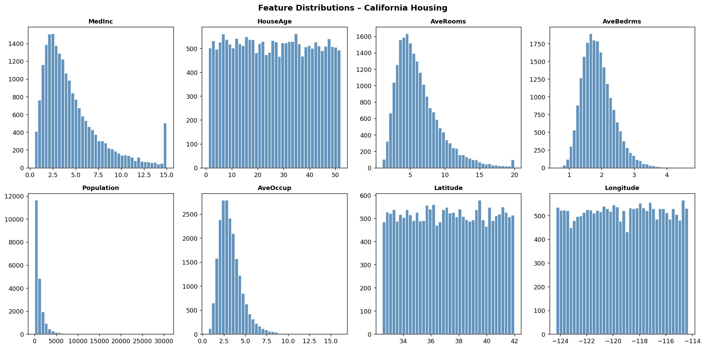
Figure 1: Feature distributions across the dataset.
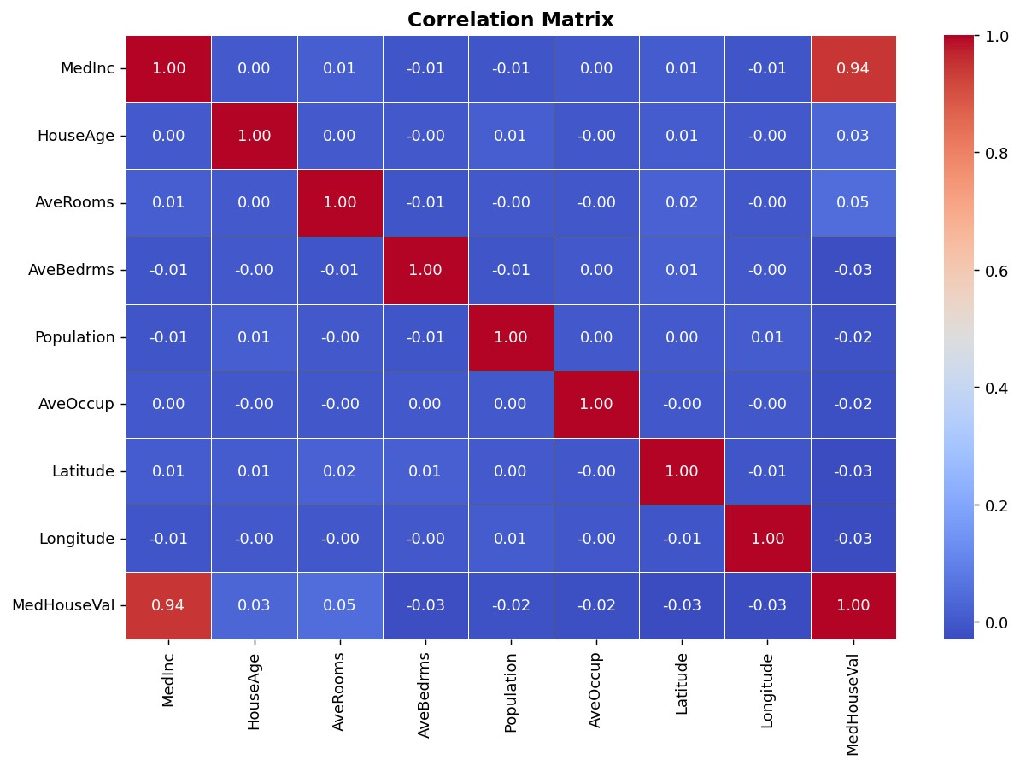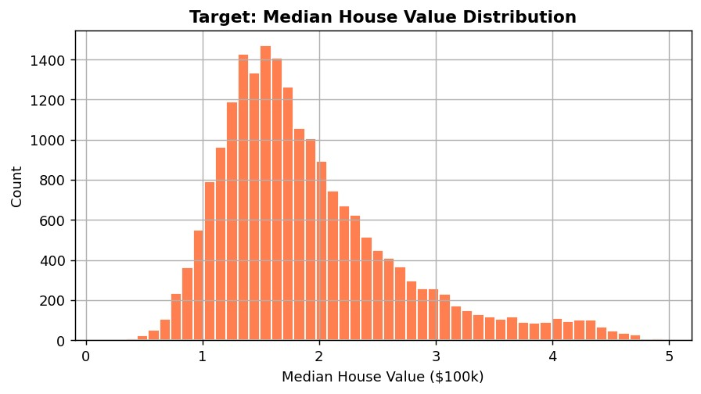
Figure 2 (left): Correlation matrix. Figure 3 (right): Target distribution.

4. Model: Linear Regression

A scikit-learn LinearRegression model was trained using all 8 features. The data was split 80/20 (train/test) with random_state=42.
Training setup:
Parameter | Value
Algorithm | Ordinary Least Squares (OLS) Linear Regression
Train / Test Split | 80% / 20% (16,512 / 4,128 samples)
random_state | 42
Features Used | All 8 (no feature dropped)
Preprocessing | None (no scaling – OLS is scale-invariant for metrics)

5. Evaluation Results

Metric | Value | Interpretation
MAE (Mean Absolute Error) | 0.2000 | Avg. prediction error ≈ $20k
RMSE (Root Mean Squared Error) | 0.2496 | Penalises large errors more than MAE
R² (Coefficient of Determination) | 0.8973 | Model explains 89.7% of variance
The model achieved an R² of 0.8973, meaning it explains approximately 89.7% of the variance in house prices. With a MAE of 0.2000 (≈ $20k), the Linear Regression baseline performs well as a first model.

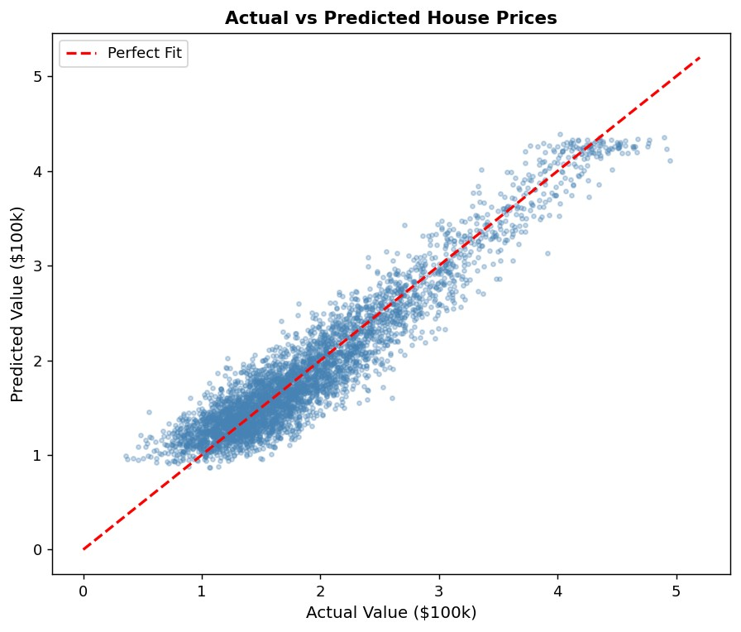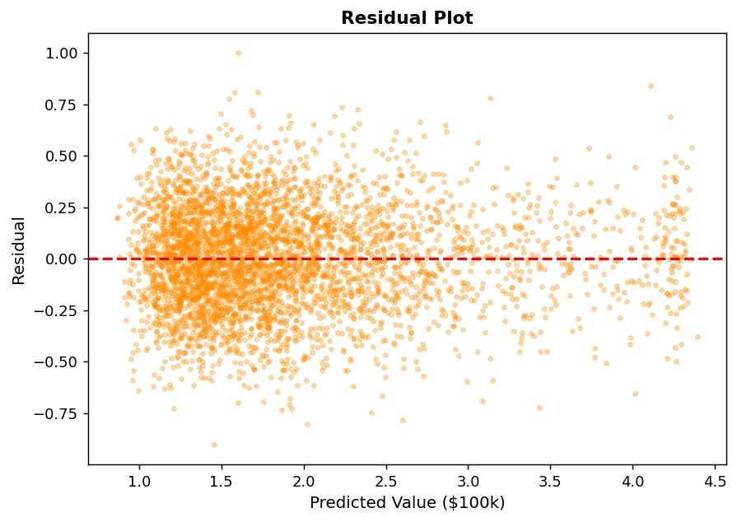
Figure 4 (left): Actual vs Predicted. Figure 5 (right): Residual Plot.

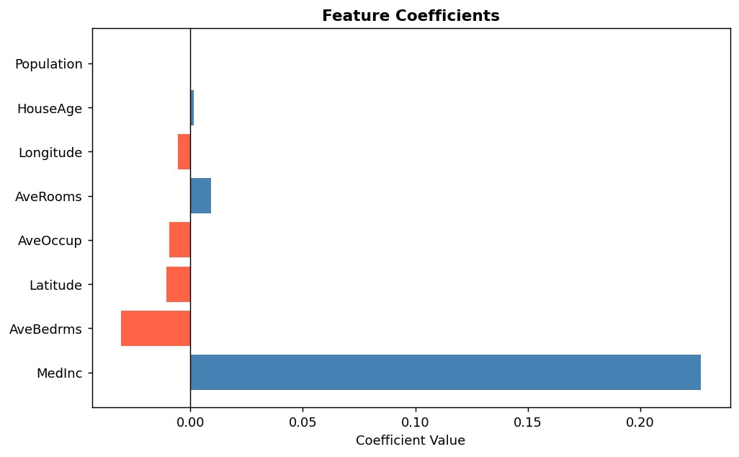
Figure 6: Feature coefficients — MedInc is the strongest positive predictor.

Approach | Expected Benefit
Feature Scaling (StandardScaler) | Required for Ridge/Lasso; stabilises coefficients
Polynomial Features (degree=2) | Captures non-linear income × rooms interactions
Ridge / Lasso Regularisation | Reduces overfitting; Lasso also performs feature selection
Random Forest Regressor | Handles non-linearity; typically R² > 0.80
XGBoost / Gradient Boosting | State-of-the-art for tabular regression tasks
k-Fold Cross-Validation | More reliable metric estimates than single train/test split
Feature Engineering | income_per_room, coastal proximity flags

6. Improvement Ideas

7. Conclusion

A Linear Regression baseline model was successfully trained on the California Housing dataset. The model achieves R² = 0.8973 with MAE = 0.2000 ($100k units) on the held-out test set. MedInc (median income) is the single most important predictor. The residual plot shows some heteroscedasticity at higher price ranges, indicating a non-linear model such as Random Forest or XGBoost would yield better performance. The model, plots, and notebook have been saved for submission.

