Untitled

Rajath Prabhakar

2024-08-22

library(tidyverse)

## Warning: package 'ggplot2' was built under R version 4.3.3

## Warning: package 'dplyr' was built under R version 4.3.2

## Warning: package 'stringr' was built under R version 4.3.2

## Warning: package 'lubridate' was built under R version 4.3.2

## ── Attaching core tidyverse packages ──────────────────────── tidyverse 2.0.0 ──  
## ✔ dplyr 1.1.4 ✔ readr 2.1.4  
## ✔ forcats 1.0.0 ✔ stringr 1.5.1  
## ✔ ggplot2 3.5.1 ✔ tibble 3.2.1  
## ✔ lubridate 1.9.3 ✔ tidyr 1.3.0  
## ✔ purrr 1.0.1   
## ── Conflicts ────────────────────────────────────────── tidyverse_conflicts() ──  
## ✖ dplyr::filter() masks stats::filter()  
## ✖ dplyr::lag() masks stats::lag()  
## ℹ Use the conflicted package (<http://conflicted.r-lib.org/>) to force all conflicts to become errors

library(cowplot)

##   
## Attaching package: 'cowplot'  
##   
## The following object is masked from 'package:lubridate':  
##   
## stamp

combined_data_year <- read_csv("Results/CSV Files/combined_data_year.csv")

## Rows: 27840 Columns: 7  
## ── Column specification ────────────────────────────────────────────────────────  
## Delimiter: ","  
## chr (4): Variable, City, State, Sign  
## dbl (3): year, Max_ACF, Lag  
##   
## ℹ Use `spec()` to retrieve the full column specification for this data.  
## ℹ Specify the column types or set `show_col_types = FALSE` to quiet this message.

rank_avg_year <- read_csv("Results/CSV Files/AverageCityRankYear.csv")

## Rows: 13920 Columns: 10  
## ── Column specification ────────────────────────────────────────────────────────  
## Delimiter: ","  
## chr (3): Variable, City, State  
## dbl (7): year, Max_ACF_Positive, Lag_Positive, Positive_Lag_Rank, Max_ACF_Ne...  
##   
## ℹ Use `spec()` to retrieve the full column specification for this data.  
## ℹ Specify the column types or set `show_col_types = FALSE` to quiet this message.

table2 <- read_csv("Results/CSV Files/average_acf_lag_year.csv")

## Rows: 484 Columns: 6  
## ── Column specification ────────────────────────────────────────────────────────  
## Delimiter: ","  
## chr (1): Variable  
## dbl (5): year, Average_ACF_negative, Average_Lag_negative, Average_ACF_posit...  
##   
## ℹ Use `spec()` to retrieve the full column specification for this data.  
## ℹ Specify the column types or set `show_col_types = FALSE` to quiet this message.

rank_avg <- read_csv("Results/CSV Files/Average_City_Rank.csv")

## Rows: 120 Columns: 3  
## ── Column specification ────────────────────────────────────────────────────────  
## Delimiter: ","  
## chr (1): Variable  
## dbl (2): avg_rank_pos, avg_rank_neg  
##   
## ℹ Use `spec()` to retrieve the full column specification for this data.  
## ℹ Specify the column types or set `show_col_types = FALSE` to quiet this message.

table1 <- read_csv("Results/CSV Files/table_of_average_acf_lag.csv")

## Rows: 120 Columns: 5  
## ── Column specification ────────────────────────────────────────────────────────  
## Delimiter: ","  
## chr (1): Variable  
## dbl (4): Average_ACF_positive, Average_Lag_positive, Average_ACF_negative, A...  
##   
## ℹ Use `spec()` to retrieve the full column specification for this data.  
## ℹ Specify the column types or set `show_col_types = FALSE` to quiet this message.

combined <- read_csv("Results/CSV Files/combined_data.csv")

## Rows: 6960 Columns: 8  
## ── Column specification ────────────────────────────────────────────────────────  
## Delimiter: ","  
## chr (4): Variable, City, State, Sign  
## dbl (4): Max_ACF, Lag, Est_Population, Population  
##   
## ℹ Use `spec()` to retrieve the full column specification for this data.  
## ℹ Specify the column types or set `show_col_types = FALSE` to quiet this message.

# Average Lag Plots

## Positive

### 2020

figure1 <- ggplot(table2 %>%  
 filter(year == 2020) %>%   
 arrange(Average_Lag_positive) %>%  
 head(25), aes(x = Average_Lag_positive, y = reorder(Variable, -Average_Lag_positive)))+  
 geom_bar(stat = "identity")+  
 labs(x = "Lag",  
 y = "Variable",   
 title = "Average Positive Lag Plot", subtitle = "2020")+  
 theme_minimal()  
figure1

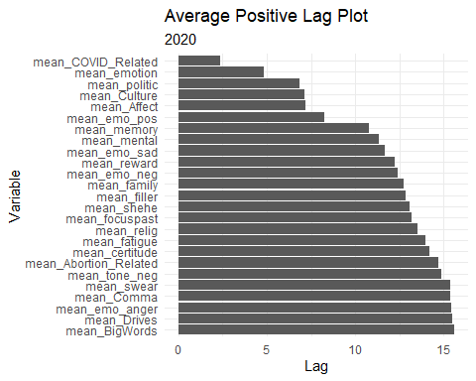

### 2021

figure2 <- ggplot(table2 %>%  
 filter(year == 2021) %>%   
 arrange(Average_Lag_positive) %>%  
 head(25), aes(x = Average_Lag_positive, y = reorder(Variable, -Average_Lag_positive)))+  
 geom_bar(stat = "identity")+  
 labs(x = "Lag",  
 y = "Variable",   
 title = "Average Positive Lag Plot", subtitle = "2021")+  
 theme_minimal()  
figure2

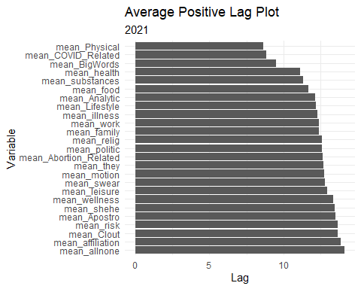

### 2022

figure3 <- ggplot(table2 %>%  
 filter(year == 2022) %>%   
 arrange(Average_Lag_positive) %>%  
 head(25), aes(x = Average_Lag_positive, y = reorder(Variable, -Average_Lag_positive)))+  
 geom_bar(stat = "identity")+  
 labs(x = "Lag",  
 y = "Variable",   
 title = "Average Positive Lag Plot", subtitle = "2022")+  
 theme_minimal()  
figure3

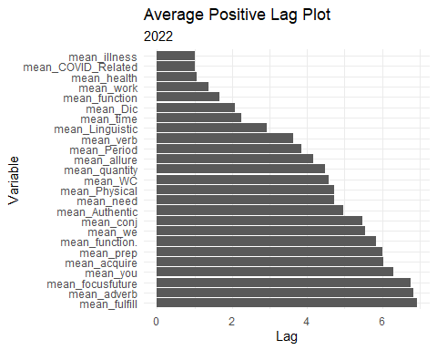

###2023

figure4 <- ggplot(table2 %>%  
 filter(year == 2023) %>%   
 arrange(Average_Lag_positive) %>%  
 head(25), aes(x = Average_Lag_positive, y = reorder(Variable, -Average_Lag_positive)))+  
 geom_bar(stat = "identity")+  
 labs(x = "Lag",  
 y = "Variable",   
 title = "Average Positive Lag Plot", subtitle = "2023")+  
 theme_minimal()  
figure4

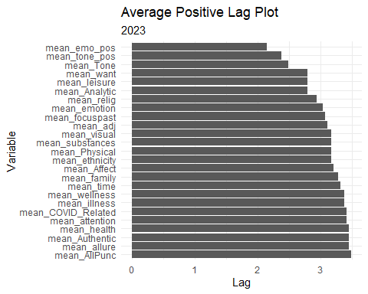

plot_grid(figure1, figure2, figure3, figure4, rel_widths = c(1,1))

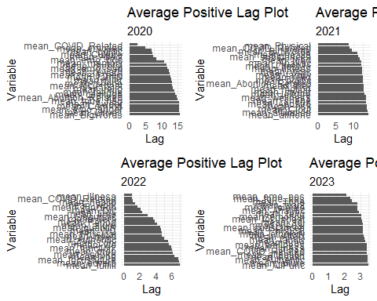

##Negative

###2020

figure5 <- ggplot(table2 %>%  
 filter(year == 2020) %>%   
 arrange(abs(Average_Lag_negative)) %>%  
 head(25), aes(x = Average_Lag_negative,  
 y = reorder(Variable, -abs(Average_Lag_negative))))+  
 geom_bar(stat = "identity")+  
 labs(x = "Lag",  
 y = "Variable",   
 title = "Average Negative Lag Plot", subtitle = "2020")+  
 theme_minimal()  
figure5

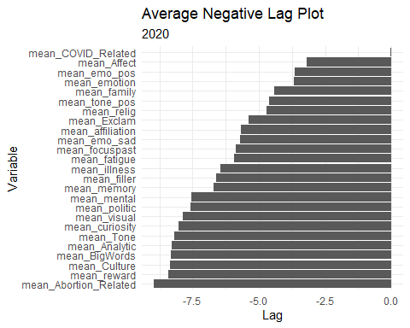

###2021

figure6 <- ggplot(table2 %>%  
 filter(year == 2021) %>%   
 arrange(abs(Average_Lag_negative)) %>%  
 head(25), aes(x = Average_Lag_negative,  
 y = reorder(Variable, -abs(Average_Lag_negative))))+  
 geom_bar(stat = "identity")+  
 labs(x = "Lag",  
 y = "Variable",   
 title = "Average Negative Lag Plot", subtitle = "2021")+  
 theme_minimal()  
figure6

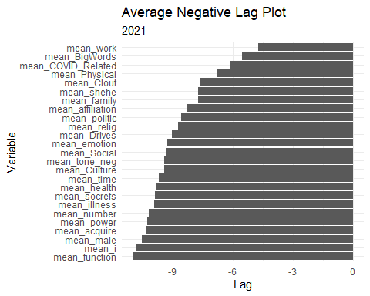

###2022

figure7 <- ggplot(table2 %>%  
 filter(year == 2022) %>%   
 arrange(abs(Average_Lag_negative)) %>%  
 head(25), aes(x = Average_Lag_negative,  
 y = reorder(Variable, -abs(Average_Lag_negative))))+  
 geom_bar(stat = "identity")+  
 labs(x = "Lag",  
 y = "Variable",   
 title = "Average Negative Lag Plot", subtitle = "2022")+  
 theme_minimal()  
figure7

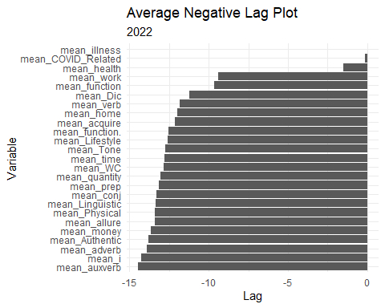

###2023

figure8 <- ggplot(table2 %>%  
 filter(year == 2023) %>%   
 arrange(abs(Average_Lag_negative)) %>%  
 head(25), aes(x = Average_Lag_negative,  
 y = reorder(Variable, -abs(Average_Lag_negative))))+  
 geom_bar(stat = "identity")+  
 labs(x = "Lag",  
 y = "Variable",   
 title = "Average Negative Lag Plot", subtitle = "2023")+  
 theme_minimal()  
figure8

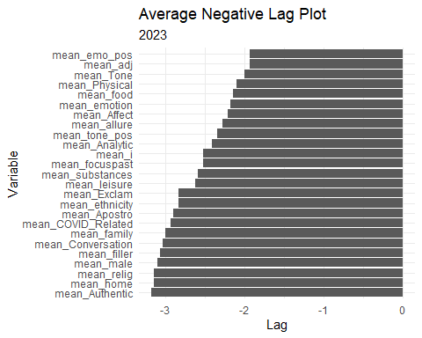

# Average Correlation Plots

## Positive

### 2020

figure9 <- ggplot(table2 %>%  
 filter(year == 2020) %>%   
 arrange(-abs(Average_ACF_positive)) %>%  
 head(25), aes(x = Average_ACF_positive,  
 y = reorder(Variable, -abs(Average_ACF_positive))))+  
 geom_bar(stat = "identity")+  
 labs(x = "Lag",  
 y = "Variable",   
 title = "Variables by Average Correlation (Positive)", subtitle = "2020")+  
 theme_minimal()  
figure9

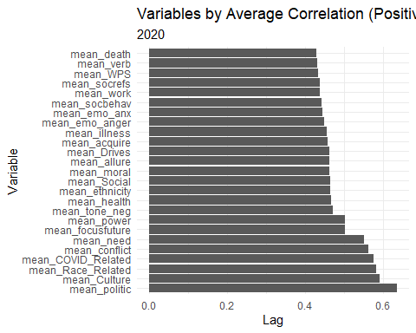

### 2021

figure10 <- ggplot(table2 %>%  
 filter(year == 2021) %>%   
 arrange(-abs(Average_ACF_positive)) %>%  
 head(25), aes(x = Average_ACF_positive,  
 y = reorder(Variable, -abs(Average_ACF_positive))))+  
 geom_bar(stat = "identity")+  
 labs(x = "Lag",  
 y = "Variable",   
 title = "Variables by Average Correlation (Positive)", subtitle = "2021")+  
 theme_minimal()  
figure10

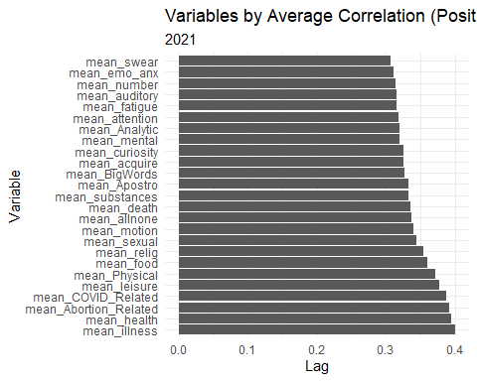

### 2022

figure11 <- ggplot(table2 %>%  
 filter(year == 2022) %>%   
 arrange(-abs(Average_ACF_positive)) %>%  
 head(25), aes(x = Average_ACF_positive,  
 y = reorder(Variable, -abs(Average_ACF_positive))))+  
 geom_bar(stat = "identity")+  
 labs(x = "Lag",  
 y = "Variable",   
 title = "Variables by Average Correlation (Positive)", subtitle = "2022")+  
 theme_minimal()  
figure11

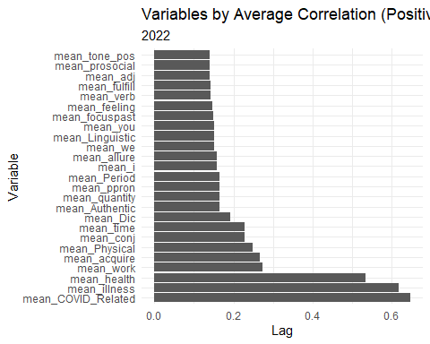

###2023

figure12 <- ggplot(table2 %>%  
 filter(year == 2023) %>%   
 arrange(-abs(Average_ACF_positive)) %>%  
 head(25), aes(x = Average_ACF_positive,  
 y = reorder(Variable, -abs(Average_ACF_positive))))+  
 geom_bar(stat = "identity")+  
 labs(x = "Lag",  
 y = "Variable",   
 title = "Variables by Average Correlation (Positive)", subtitle = "2023")+  
 theme_minimal()  
figure12

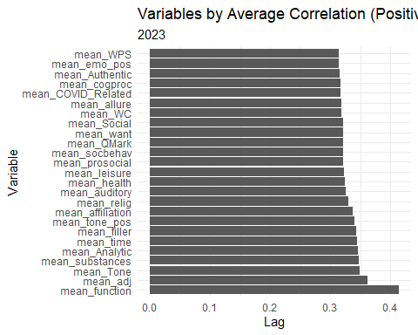

##Negative

###2020

figure13 <- ggplot(table2 %>%  
 filter(year == 2020) %>%   
 arrange(-abs(Average_ACF_negative)) %>%  
 head(25), aes(x = Average_ACF_negative,  
 y = reorder(Variable, -abs(Average_ACF_negative))))+  
 geom_bar(stat = "identity")+  
 labs(x = "Lag",  
 y = "Variable",   
 title = "Variables by Average Correlation (Negative)", subtitle = "2020")+  
 theme_minimal()  
figure13

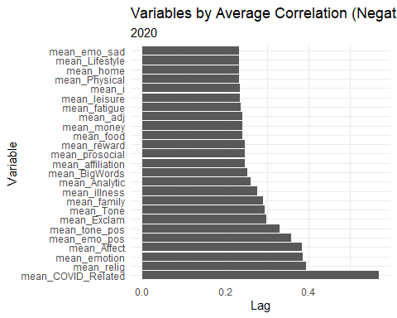

###2021

figure14 <- ggplot(table2 %>%  
 filter(year == 2021) %>%   
 arrange(-abs(Average_ACF_negative)) %>%  
 head(25), aes(x = Average_ACF_negative,  
 y = reorder(Variable, -abs(Average_ACF_negative))))+  
 geom_bar(stat = "identity")+  
 labs(x = "Lag",  
 y = "Variable",   
 title = "Variables by Average Correlation (Negative)", subtitle = "2021")+  
 theme_minimal()  
figure14

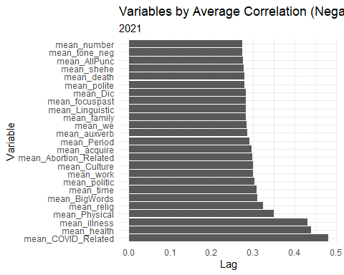

###2022

figure15 <- ggplot(table2 %>%  
 filter(year == 2022) %>%   
 arrange(-abs(Average_ACF_negative)) %>%  
 head(25), aes(x = Average_ACF_negative,  
 y = reorder(Variable, -abs(Average_ACF_negative))))+  
 geom_bar(stat = "identity")+  
 labs(x = "Lag",  
 y = "Variable",   
 title = "Variables by Average Correlation (Negative)", subtitle = "2022")+  
 theme_minimal()  
figure15

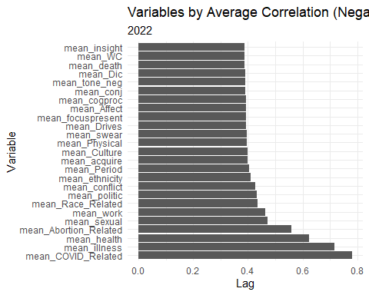

###2023

figure16 <- ggplot(table2 %>%  
 filter(year == 2023) %>%   
 arrange(-abs(Average_ACF_negative)) %>%  
 head(25), aes(x = Average_ACF_negative,  
 y = reorder(Variable, -abs(Average_ACF_negative))))+  
 geom_bar(stat = "identity")+  
 labs(x = "Lag",  
 y = "Variable",   
 title = "Variables by Average Correlation (Negative)", subtitle = "2023")+  
 theme_minimal()  
figure16

