SOLUTION REPORT
Education Agent Management System
How it works, why it was built this way, and what comes next — in plain English.

The one-paragraph version
An Australian university works with dozens of overseas education agents — the businesses that recruit international students. Today that relationship usually lives in spreadsheets, email threads and people’s memories. In a tightly regulated industry, that is risky: things get missed, and money gets paid when it shouldn’t. This system puts the whole relationship in one place. Agents apply, get checked, get approved, are monitored, and are eventually let go — with every step recorded and every commission checked automatically against the rules.
The problem it removes
- “Who approved this agent, and when?” — now there’s a permanent, tamper-proof history.
- “Did we pay commission we shouldn’t have?” — the rules are enforced by the computer, not by memory.
- “Are agents still using last year’s fee sheet?” — they must confirm they’ve switched to the current one.

The big picture
People use it through a web browser. Everything they do goes to one secure application, which stores every record in one trusted database.
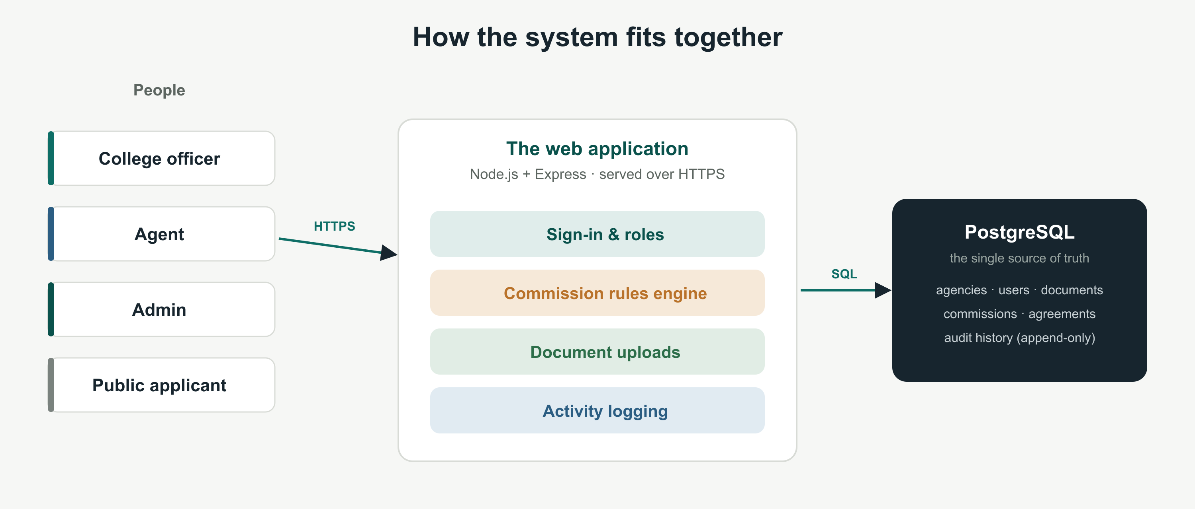

An agency’s journey — the four phases
The product follows the real-life relationship with an agent, from first contact to final goodbye. It was built in this order on purpose (explained below).
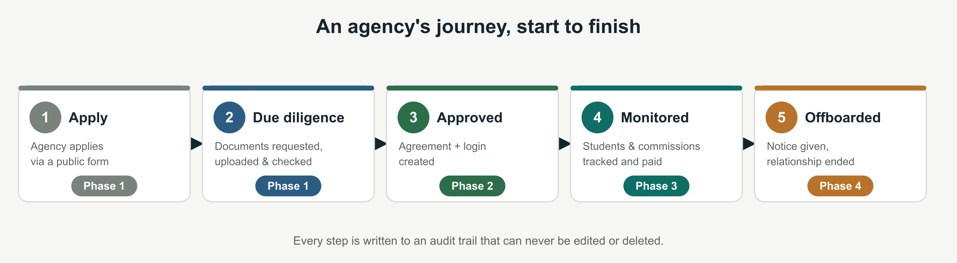
Phase 1 — Selection & due diligence (the front door)
What it does: an agency applies, the college asks for the right documents (business registration, certificates, references), the agency uploads them, and an officer checks and approves — or rejects with a reason. Approving instantly creates the agreement and the agency’s login.
Why it was first: you can’t onboard or pay anyone you haven’t vetted. This is the front door, and the very first thing built was a real, saved approval that survives a restart — proof the system is trustworthy, not just a mock-up.
Phase 2 — Onboarding & marketing materials
What it does: the college keeps one official version of each document (like the fee schedule). When a new version replaces an old one, every agent must confirm they’ve discarded the old file — creating audit evidence that no one is recruiting on out-of-date information.
Why next: once an agent is approved, the very next real-world need is giving them the current rules and making sure old ones are gone.
Phase 3 — Monitoring & commission checks (the clever part)
What it does: students are linked to agents, and every commission is automatically checked against the regulations before it can be paid. This is where the system earns its keep (next page).
Why prioritised: this is the feature a spreadsheet simply cannot do safely — it protects real money and keeps the university compliant.
Phase 4 — Offboarding
What it does: the college gives notice to end an agreement, the agent confirms it, and the college completes the wind-down. The agent keeps read-only access to their final statement.
Why last: ending a relationship only matters once agents exist and are active — so it was built after the others.

The clever bit: commissions that check themselves
Every commission passes through a short series of automatic checks. If any check trips, the payment is held back — and the screen shows exactly why. The rules live on the server and are covered by automated tests, so the answer is always consistent.
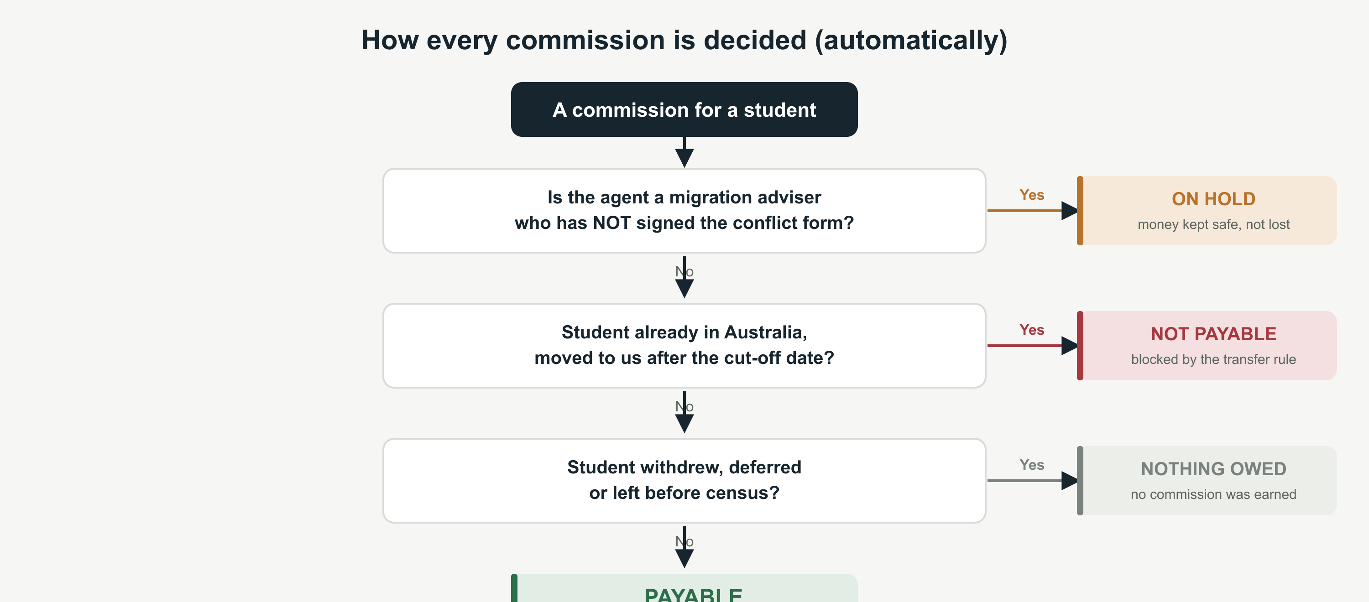
The two rules that matter most
- The transfer rule (grandfathering): a student who was already in Australia and switched to us after a cut-off date is not payable — but one accepted on or before that date still is. The date genuinely matters, so it’s stored, not guessed.
- The conflict-of-interest freeze: if an agent also gives migration advice but hasn’t signed a conflict-of-interest form, their students are put on hold and the money is held (not lost).

Held, never lost — until compliance is met
The officer can request the conflict form and send reminders; only the agent can sign it. The moment they do, the freeze lifts by itself and the money is released.
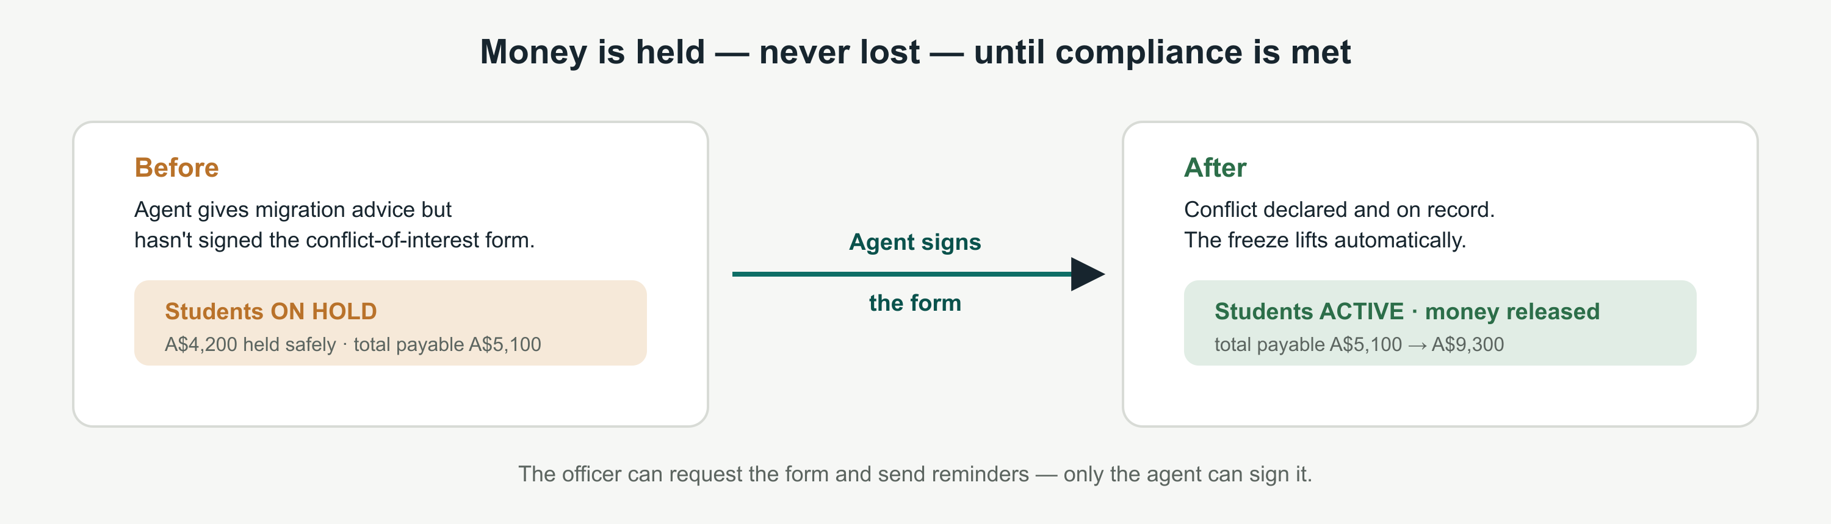

Two automated intakes that save officer time
Beyond the core phases, two flows bring work in automatically:
- Public applications: a new agency can apply through a public web form. Their details wait in a safe holding area (never the live system) until an officer reviews and approves — which then creates the agency and its login in one clean step.
- Reference checks by email: an officer sends a referee an email form; the referee’s answer comes straight back into the system as a pass or fail — no phone tag.
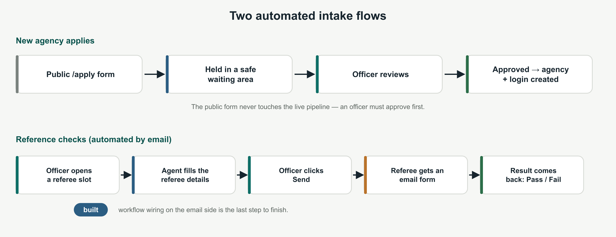

A live dashboard, always up to date
Officers open to a summary that counts real work as it happens: how many agencies are in the pipeline and awaiting review, how many documents are still outstanding (and which have been chased for over a week), how many were verified this month, and which certificates are about to expire. Every number is calculated from live records, so it is never stale.

Built to be safe
- Separate logins for officers, agents and admins — an agent can only ever see their own agency’s data (enforced by the server, not just hidden on screen).
- Passwords are scrambled one-way; the connection is encrypted.
- Every action is logged with a tracking ID, so any hiccup can be traced from the click to the cause.

What it’s built with
Part | What we used | Why (in plain terms)
The engine | Node.js + Express | Fast to build with, widely understood, easy to maintain.
The filing cabinet | PostgreSQL database | Rock-solid and consistent — the single source of truth for every record.
The screens | Plain HTML / CSS / JavaScript | No heavy frameworks: loads fast and is simple to change.
The lock | Scrambled passwords + secure cookies | Passwords are stored one-way (never readable); sign-in is protected.
Document intake | Multer file uploads | Accepts real files (PDF/image) safely, size- and type-checked.
Email automation | Dify workflow | Sends reference-check emails without us building an email system.
The home | DigitalOcean server | Runs online, walled off from the other apps sharing the machine.

The order it was built (and why)
Rather than build everything at once, the work followed the value: prove the record is trustworthy, then protect the money, then round out the experience.
- 1. Foundation — the database, accounts and secure sign-in.
- 2. The front door — the application pipeline and a real, saved approval (the first thing proven to survive a restart).
- 3. The money — the commission rules engine — the guardrails that make this more than a spreadsheet.
- 4. Onboarding — one official version of each document, with agent confirmations.
- 5. Real documents — officer requests a file, the agent uploads it, both can view it, the officer verifies it.
- 6. Automated intakes — the public application form and email reference checks.
- 7. Offboarding — ending an agreement cleanly.
- 8. Polish — the live dashboard, plain-English wording, and a cleaner look.
- 9. Online — deployed to a server, carefully walled off from the other apps on the same machine.

What’s still to do
- Finish the reference-check email loop. Our side is built and tested; the last mile is a small configuration step inside the email tool.
- A proper web address and trusted certificate. Right now the site uses a self-signed certificate, so browsers show a one-time “not trusted” warning. A domain name would remove it.
- Nice-to-haves. A summary strip on the agent’s own screen, quick filters on lists, and a refreshed demo script.

In one line
A regulated agent relationship — application, approval, documents, commissions and offboarding — captured in one place, with the rules enforced automatically and a permanent history behind every decision.
Prototype status: working end-to-end and running online. Prepared as a plain-English overview for stakeholders.

