**Installing Kubernetes**

1. First of all, we require Docker installed on the machine. Refer below link:

<https://docs.docker.com/desktop/setup/install/windows-install/>

(I already have docker desktop installed)

1. Download “kubectl.exe” from below link:

[Download Kubernetes | Kubernetes](https://kubernetes.io/releases/download/#binaries)

1. Place this exe in “C:\kube” and add this path to Environment variable’s Path variable.
2. Open Powershell in admin mode and run command –

>kubectl version --client

This is to check if kubectl is available.

1. If you are intending to run a Kubernetes cluster on your laptop (locally), you will need a tool like Minikube to be installed.

Download exe from below link:

<https://github.com/kubernetes/minikube/releases/latest/download/minikube-windows-amd64.exe>

1. Place this exe in same dir “C:\kube” and rename file to ‘minikube.exe’ and add this path to Environment variable’s Path variable.
2. Execute Docker desktop application and then use below command –

>minikube start --driver=docker

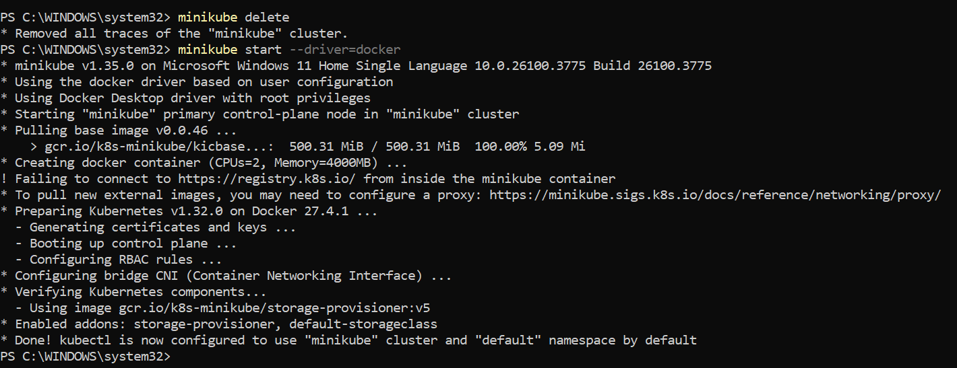

1. To check:

>kubectl get nodes

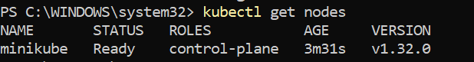

Now Kubernetes is setup on my machine.