MPI Analysis

Question 1

root@f36a2b313128:/T2_files/implementation/Q1# nano ~/machinefile
root@f36a2b313128:/T2_files/implementation/Q1# mpiexec -n 2 -machinefile ~/machinefile python -m mpi4py T3.py
received from Worker slave 1
0 1
0 Southwest Airlines Co. 2326
1 American Airlines Inc. 759
2 Republic Airlines 704
3 United Air Lines Inc. 633
4 JetBlue Airways 487
5 GoJet Airlines, LLC d/b/a United Express 428
6 Spirit Air Lines 316
7 SkyWest Airlines Inc. 297
8 Delta Air Lines Inc. 295
9 Air Wisconsin Airlines Corp 286
10 Comair Inc. 202
11 Commutair Aka Champlain Enterprises, Inc. 202
12 Mesa Airlines Inc. 160
13 Envoy Air 135
14 Capital Cargo International 132
15 Alaska Airlines Inc. 127
16 Endeavor Air Inc. 80
17 Frontier Airlines Inc. 79
18 Allegiant Air 50
19 Horizon Air 42
20 Hawaiian Airlines Inc. 36
0 Southwest Airlines Co.
1 2326
Name: 18, dtype: object
time taken with 1 slaves (MPI execution): 42.55 second(s)
Worker 1 is assigned chunk info [6311870, 1] ../../Combined_Flights_2021.csv
Worker slave 1 is done. Sending back to master
root@f36a2b313128:/T2_files/implementation/Q1# mpiexec -n 3 -machinefile ~/machinefile python -m mpi4py T3.py
Worker 1 is assigned chunk info [3155935, 1] ../../Combined_Flights_2021.csv
Worker slave 1 is done. Sending back to master
received from Worker slave 1
received from Worker slave 2
0 1
0 Southwest Airlines Co. 2326
1 American Airlines Inc. 759
2 Republic Airlines 704
3 United Air Lines Inc. 633
4 JetBlue Airways 487
5 GoJet Airlines, LLC d/b/a United Express 428
6 Spirit Air Lines 316
7 SkyWest Airlines Inc. 297
8 Delta Air Lines Inc. 295
9 Air Wisconsin Airlines Corp 286
10 Comair Inc. 202
11 Commutair Aka Champlain Enterprises, Inc. 202
12 Mesa Airlines Inc. 160
13 Envoy Air 135
14 Capital Cargo International 132
15 Alaska Airlines Inc. 127
16 Endeavor Air Inc. 80
17 Frontier Airlines Inc. 79
18 Allegiant Air 50
19 Horizon Air 42
20 Hawaiian Airlines Inc. 36
0 Southwest Airlines Co.
1 2326
Name: 18, dtype: object
time taken with 2 slaves (MPI execution): 34.3 second(s)
Worker 2 is assigned chunk info [None, 3155936] ../../Combined_Flights_2021.csv
Worker slave 2 is done. Sending back to master
root@f36a2b313128:/T2_files/implementation/Q1# mpiexec -n 4 -machinefile ~/machinefile python -m mpi4py T3.py
Worker 1 is assigned chunk info [2103956, 1] ../../Combined_Flights_2021.csv
Worker slave 1 is done. Sending back to master
Worker 2 is assigned chunk info [2103957, 2103957] ../../Combined_Flights_2021.csv
Worker slave 2 is done. Sending back to master
received from Worker slave 1
received from Worker slave 2
received from Worker slave 3
0 1
0 Southwest Airlines Co. 2326
1 American Airlines Inc. 759
2 Republic Airlines 704
3 United Air Lines Inc. 633
4 JetBlue Airways 487
5 GoJet Airlines, LLC d/b/a United Express 428
6 Spirit Air Lines 316
7 SkyWest Airlines Inc. 297
8 Delta Air Lines Inc. 295
9 Air Wisconsin Airlines Corp 286
10 Comair Inc. 202
11 Commutair Aka Champlain Enterprises, Inc. 202
12 Mesa Airlines Inc. 160
13 Envoy Air 135
14 Capital Cargo International 132
15 Alaska Airlines Inc. 127
16 Endeavor Air Inc. 80
17 Frontier Airlines Inc. 79
18 Allegiant Air 50
19 Horizon Air 42
20 Hawaiian Airlines Inc. 36
0 Southwest Airlines Co.
1 2326
Name: 18, dtype: object
time taken with 3 slaves (MPI execution): 21.48 second(s)
Worker 3 is assigned chunk info [None, 4207914] ../../Combined_Flights_2021.csv
Worker slave 3 is done. Sending back to master
root@f36a2b313128:/T2_files/implementation/Q1# mpiexec -n 5 -machinefile ~/machinefile python -m mpi4py T3.py
Worker 1 is assigned chunk info [1577967, 1] ../../Combined_Flights_2021.csv
Worker slave 1 is done. Sending back to master
Worker 3 is assigned chunk info [1577968, 3155936] ../../Combined_Flights_2021.csv
Worker slave 3 is done. Sending back to master
Worker 2 is assigned chunk info [1577968, 1577968] ../../Combined_Flights_2021.csv
Worker slave 2 is done. Sending back to master
received from Worker slave 1
received from Worker slave 2
received from Worker slave 3
received from Worker slave 4
0 1
0 Southwest Airlines Co. 2326
1 American Airlines Inc. 759
2 Republic Airlines 704
3 United Air Lines Inc. 633
4 JetBlue Airways 487
5 GoJet Airlines, LLC d/b/a United Express 428
6 Spirit Air Lines 316
7 SkyWest Airlines Inc. 297
8 Delta Air Lines Inc. 295
9 Air Wisconsin Airlines Corp 286
10 Comair Inc. 202
11 Commutair Aka Champlain Enterprises, Inc. 202
12 Mesa Airlines Inc. 160
13 Envoy Air 135
14 Capital Cargo International 132
15 Alaska Airlines Inc. 127
16 Endeavor Air Inc. 80
17 Frontier Airlines Inc. 79
18 Allegiant Air 50
19 Horizon Air 42
20 Hawaiian Airlines Inc. 36
0 Southwest Airlines Co.
1 2326
Name: 18, dtype: object
time taken with 4 slaves (MPI execution): 21.27 second(s)
Worker 4 is assigned chunk info [None, 4733904] ../../Combined_Flights_2021.csv
Worker slave 4 is done. Sending back to master
root@f36a2b313128:/T2_files/implementation/Q1# mpiexec -n 6 -machinefile ~/machinefile python -m mpi4py T3.py
Worker 1 is assigned chunk info [1262374, 1] ../../Combined_Flights_2021.csv
Worker slave 1 is done. Sending back to master
Worker 2 is assigned chunk info [1262375, 1262375] ../../Combined_Flights_2021.csv
Worker slave 2 is done. Sending back to master
Worker 4 is assigned chunk info [1262375, 3787125] ../../Combined_Flights_2021.csv
Worker slave 4 is done. Sending back to master
Worker 5 is assigned chunk info [None, 5049500] ../../Combined_Flights_2021.csv
Worker slave 5 is done. Sending back to master
received from Worker slave 1
received from Worker slave 2
received from Worker slave 3
received from Worker slave 4
received from Worker slave 5
0 1
0 American Airlines Inc. 759
1 United Air Lines Inc. 633
2 JetBlue Airways 487
3 GoJet Airlines, LLC d/b/a United Express 428
4 Spirit Air Lines 316
5 SkyWest Airlines Inc. 297
6 Delta Air Lines Inc. 295
7 Air Wisconsin Airlines Corp 271
8 Comair Inc. 202
9 Commutair Aka Champlain Enterprises, Inc. 202
10 Envoy Air 135
11 Capital Cargo International 132
12 Alaska Airlines Inc. 127
13 Endeavor Air Inc. 80
14 Frontier Airlines Inc. 79
15 Allegiant Air 50
16 Horizon Air 42
17 Hawaiian Airlines Inc. 36
0 Southwest Airlines Co. 2326
1 Republic Airlines 704
2 Mesa Airlines Inc. 160
3 Air Wisconsin Airlines Corp 15
0 Southwest Airlines Co.
1 2326
Name: 18, dtype: object
time taken with 5 slaves (MPI execution): 19.54 second(s)
Worker 3 is assigned chunk info [1262375, 2524750] ../../Combined_Flights_2021.csv
Worker slave 3 is done. Sending back to master

number of containers | 2 | 3 | 4 | 5 | 6
Time Taken | 42.55 | 34.3 | 21.48 | 21.27 | 19.54

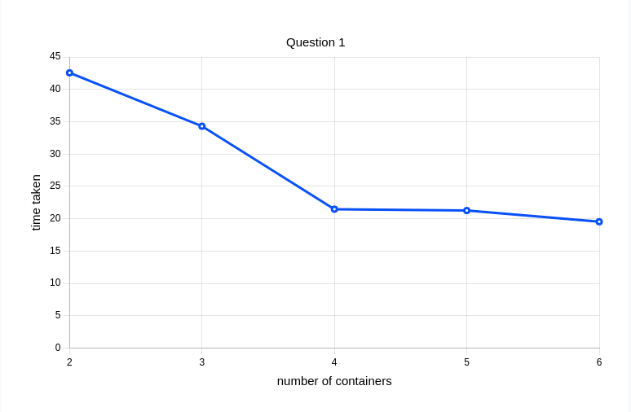

Question 2

root@f36a2b313128:/T2_files/implementation/Q2# mpiexec -n 2 -machinefile ~/machinefile python -m mpi4py T3.py
received from Worker slave 1
263
time taken with 1 slaves (MPI execution): 52.09 second(s)
Worker 1 is assigned chunk info [6311870, 1] ../../Combined_Flights_2021.csv
Worker slave 1 is done. Sending back to master
root@f36a2b313128:/T2_files/implementation/Q2# mpiexec -n 3 -machinefile ~/machinefile python -m mpi4py T3.py
Worker 1 is assigned chunk info [3155935, 1] ../../Combined_Flights_2021.csv
Worker slave 1 is done. Sending back to master
received from Worker slave 1
received from Worker slave 2
263
time taken with 2 slaves (MPI execution): 30.39 second(s)
Worker 2 is assigned chunk info [None, 3155936] ../../Combined_Flights_2021.csv
Worker slave 2 is done. Sending back to master
root@f36a2b313128:/T2_files/implementation/Q2# mpiexec -n 4 -machinefile ~/machinefile python -m mpi4py T3.py
Worker 1 is assigned chunk info [2103956, 1] ../../Combined_Flights_2021.csv
Worker slave 1 is done. Sending back to master
Worker 2 is assigned chunk info [2103957, 2103957] ../../Combined_Flights_2021.csv
Worker slave 2 is done. Sending back to master
received from Worker slave 1
received from Worker slave 2
received from Worker slave 3
263
time taken with 3 slaves (MPI execution): 23.72 second(s)
Worker 3 is assigned chunk info [None, 4207914] ../../Combined_Flights_2021.csv
Worker slave 3 is done. Sending back to master
root@f36a2b313128:/T2_files/implementation/Q2# mpiexec -n 5 -machinefile ~/machinefile python -m mpi4py T3.py
Worker 1 is assigned chunk info [1577967, 1] ../../Combined_Flights_2021.csv
Worker slave 1 is done. Sending back to master
Worker 2 is assigned chunk info [1577968, 1577968] ../../Combined_Flights_2021.csv
Worker slave 2 is done. Sending back to master
Worker 4 is assigned chunk info [None, 4733904] ../../Combined_Flights_2021.csv
Worker slave 4 is done. Sending back to master
received from Worker slave 1
received from Worker slave 2
received from Worker slave 3
received from Worker slave 4
263
time taken with 4 slaves (MPI execution): 24.43 second(s)
Worker 3 is assigned chunk info [1577968, 3155936] ../../Combined_Flights_2021.csv
Worker slave 3 is done. Sending back to master
root@f36a2b313128:/T2_files/implementation/Q2# mpiexec -n 6 -machinefile ~/machinefile python -m mpi4py T3.py
Worker 1 is assigned chunk info [1262374, 1] ../../Combined_Flights_2021.csv
Worker slave 1 is done. Sending back to master
Worker 2 is assigned chunk info [1262375, 1262375] ../../Combined_Flights_2021.csv
Worker slave 2 is done. Sending back to master
Worker 3 is assigned chunk info [1262375, 2524750] ../../Combined_Flights_2021.csv
Worker slave 3 is done. Sending back to master
Worker 4 is assigned chunk info [1262375, 3787125] ../../Combined_Flights_2021.csv
Worker slave 4 is done. Sending back to master
received from Worker slave 1
received from Worker slave 2
received from Worker slave 3
received from Worker slave 4
received from Worker slave 5
263
time taken with 5 slaves (MPI execution): 24.16 second(s)
Worker 5 is assigned chunk info [None, 5049500] ../../Combined_Flights_2021.csv
Worker slave 5 is done. Sending back to master

number of containers | 2 | 3 | 4 | 5 | 6
Time Taken | 52.09 | 30.39 | 23.72 | 24.43 | 24.16
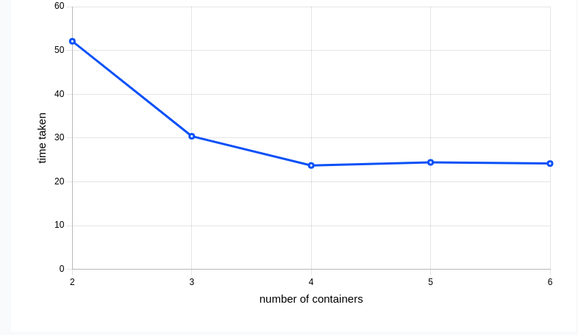

Question 3

root@f36a2b313128:/T2_files/implementation/Q2# cd ../Q3/
root@f36a2b313128:/T2_files/implementation/Q3# mpiexec -n 2 -machinefile ~/machinefile python -m mpi4py T3.py
received from Worker slave 1
72.51327755547472
time taken with 1 slaves (MPI execution): 25.47 second(s)
Worker 1 is assigned chunk info [3155934, 1] ../../Combined_Flights_2021.csv
Worker slave 1 is done. Sending back to master
root@f36a2b313128:/T2_files/implementation/Q3# mpiexec -n 3 -machinefile ~/machinefile python -m mpi4py T3.py
Worker 1 is assigned chunk info [2103955, 1] ../../Combined_Flights_2021.csv
Worker slave 1 is done. Sending back to master
received from Worker slave 1
received from Worker slave 2
72.73409801876956
time taken with 2 slaves (MPI execution): 32.88 second(s)
Worker 2 is assigned chunk info [None, 2103956] ../../Combined_Flights_2021.csv
Worker slave 2 is done. Sending back to master
root@f36a2b313128:/T2_files/implementation/Q3# mpiexec -n 4 -machinefile ~/machinefile python -m mpi4py T3.py
Worker 1 is assigned chunk info [1577966, 1] ../../Combined_Flights_2021.csv
Worker slave 1 is done. Sending back to master
Worker 2 is assigned chunk info [1577967, 1577967] ../../Combined_Flights_2021.csv
Worker slave 2 is done. Sending back to master
received from Worker slave 1
received from Worker slave 2
received from Worker slave 3
72.73409801876956
time taken with 3 slaves (MPI execution): 26.96 second(s)
Worker 3 is assigned chunk info [None, 3155934] ../../Combined_Flights_2021.csv
Worker slave 3 is done. Sending back to master
root@f36a2b313128:/T2_files/implementation/Q3# mpiexec -n 5 -machinefile ~/machinefile python -m mpi4py T3.py
Worker 2 is assigned chunk info [1262374, 1262374] ../../Combined_Flights_2021.csv
Worker slave 2 is done. Sending back to master
Worker 3 is assigned chunk info [1262374, 2524748] ../../Combined_Flights_2021.csv
Worker slave 3 is done. Sending back to master
Worker 1 is assigned chunk info [1262373, 1] ../../Combined_Flights_2021.csv
Worker slave 1 is done. Sending back to master
received from Worker slave 1
received from Worker slave 2
received from Worker slave 3
received from Worker slave 4
72.73409801876956
time taken with 4 slaves (MPI execution): 23.53 second(s)
Worker 4 is assigned chunk info [None, 3787122] ../../Combined_Flights_2021.csv
Worker slave 4 is done. Sending back to master
root@f36a2b313128:/T2_files/implementation/Q3# mpiexec -n 6 -machinefile ~/machinefile python -m mpi4py T3.py
Worker 1 is assigned chunk info [1051977, 1] ../../Combined_Flights_2021.csv
Worker slave 1 is done. Sending back to master
Worker 4 is assigned chunk info [1051978, 3155934] ../../Combined_Flights_2021.csv
Worker slave 4 is done. Sending back to master
Worker 2 is assigned chunk info [1051978, 1051978] ../../Combined_Flights_2021.csv
Worker slave 2 is done. Sending back to master
Worker 3 is assigned chunk info [1051978, 2103956] ../../Combined_Flights_2021.csv
Worker slave 3 is done. Sending back to master
received from Worker slave 1
received from Worker slave 2
received from Worker slave 3
received from Worker slave 4
received from Worker slave 5
72.73409801876956
time taken with 5 slaves (MPI execution): 26.0 second(s)
Worker 5 is assigned chunk info [None, 4207912] ../../Combined_Flights_2021.csv
Worker slave 5 is done. Sending back to master

number of containers | 2 | 3 | 4 | 5 | 6
Time Taken | 25.47 | 32.88 | 26.96 | 23.53 | 26.0

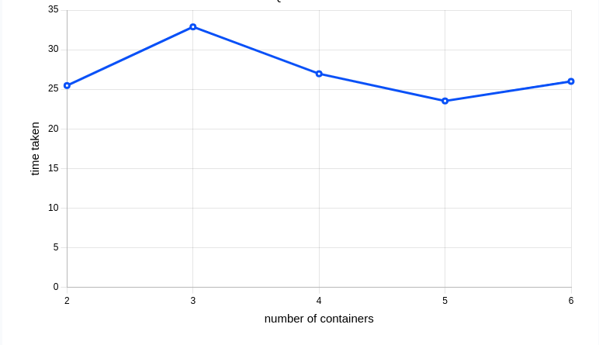
Question 4

root@f36a2b313128:/T2_files/implementation/Q4# mpiexec -n 2 -machinefile ~/machinefile python -m mpi4py T3.py
Worker 1 is assigned chunk info [6311870, 1] ../../Combined_Flights_2021.csv
Worker slave 1 is done. Sending back to master
received from Worker slave 1
365
time taken with 1 slaves (MPI execution): 55.2 second(s)
root@f36a2b313128:/T2_files/implementation/Q4# mpiexec -n 3 -machinefile ~/machinefile python -m mpi4py T3.py
Worker 1 is assigned chunk info [3155935, 1] ../../Combined_Flights_2021.csv
Worker slave 1 is done. Sending back to master
Worker 2 is assigned chunk info [None, 3155936] ../../Combined_Flights_2021.csv
Worker slave 2 is done. Sending back to master
received from Worker slave 1
received from Worker slave 2
365
time taken with 2 slaves (MPI execution): 32.98 second(s)
root@f36a2b313128:/T2_files/implementation/Q4# mpiexec -n 4 -machinefile ~/machinefile python -m mpi4py T3.py
Worker 1 is assigned chunk info [2103956, 1] ../../Combined_Flights_2021.csv
Worker slave 1 is done. Sending back to master
Worker 2 is assigned chunk info [2103957, 2103957] ../../Combined_Flights_2021.csv
Worker slave 2 is done. Sending back to master
Worker 3 is assigned chunk info [None, 4207914] ../../Combined_Flights_2021.csv
Worker slave 3 is done. Sending back to master
received from Worker slave 1
received from Worker slave 2
received from Worker slave 3
365
time taken with 3 slaves (MPI execution): 27.26 second(s)
root@f36a2b313128:/T2_files/implementation/Q4# mpiexec -n 5 -machinefile ~/machinefile python -m mpi4py T3.py
Worker 1 is assigned chunk info [1577967, 1] ../../Combined_Flights_2021.csv
Worker slave 1 is done. Sending back to master
Worker 2 is assigned chunk info [1577968, 1577968] ../../Combined_Flights_2021.csv
Worker slave 2 is done. Sending back to master
Worker 3 is assigned chunk info [1577968, 3155936] ../../Combined_Flights_2021.csv
Worker slave 3 is done. Sending back to master
Worker 4 is assigned chunk info [None, 4733904] ../../Combined_Flights_2021.csv
Worker slave 4 is done. Sending back to master
received from Worker slave 1
received from Worker slave 2
received from Worker slave 3
received from Worker slave 4
365
time taken with 4 slaves (MPI execution): 27.95 second(s)
root@f36a2b313128:/T2_files/implementation/Q4# mpiexec -n 6 -machinefile ~/machinefile python -m mpi4py T3.py
Worker 1 is assigned chunk info [1262374, 1] ../../Combined_Flights_2021.csv
Worker slave 1 is done. Sending back to master
Worker 2 is assigned chunk info [1262375, 1262375] ../../Combined_Flights_2021.csv
Worker slave 2 is done. Sending back to master
Worker 3 is assigned chunk info [1262375, 2524750] ../../Combined_Flights_2021.csv
Worker slave 3 is done. Sending back to master
Worker 4 is assigned chunk info [1262375, 3787125] ../../Combined_Flights_2021.csv
Worker slave 4 is done. Sending back to master
Worker 5 is assigned chunk info [None, 5049500] ../../Combined_Flights_2021.csv
Worker slave 5 is done. Sending back to master
received from Worker slave 1
received from Worker slave 2
received from Worker slave 3
received from Worker slave 4
received from Worker slave 5
365
time taken with 5 slaves (MPI execution): 28.84 second(s)

number of containers | 2 | 3 | 4 | 5 | 6
Time Taken | 55.2 | 32.98 | 27.26 | 27.95 | 28.84

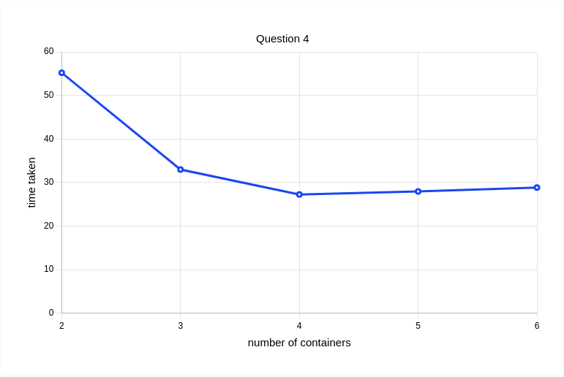

Analysis

This shows that when there is an increase in the number of slaves the time taken decreases and there
will be a value of the worker where the value will be the minimum. The decrease in the time taken is logarithmic and there comes a certain number of slaves where the decrease in time is almost constant.

