**Weekly Returns of Market Indexes**

|  |  |  |
| --- | --- | --- |
| **SUMMARY OF WEEKLY RETURNS** | | |
|  | **Dow Jones** | **S&P 500** |
| **Min.** | -8.594% | -6.923% |
| **Median** | 0.428% | 0.281% |
| **Mean** | 0.207% | 0.102% |
| **Max** | 6.108% | 3.968% |
| **Std. Dev.** | 0.02479 | 0.01701 |

The weekly returns of the observed five ETFs were calculated previously. The same approach was followed when calculating the weekly returns of the market indexes, which were the S&P 500 (S&P) and Dow Jones US Technology (DJUSTC). The returns were calculated using the log return formula, $r_{t}=\log\left(P_{t}\right)- \log\left(P_{t-1}\right).$ On average the weekly returns for the DJUSTC were 0.21%, which was 0.11% higher than that of the S&P 500. The Dow Jones US Technology Index invests in niche companies, particularly technology companies. On the other hand, S&P500’s investments are spread across different industries and sectors, making it the basket of investments more diversified than the DJUSTC. By observing the standard deviation of the weekly returns of the DJUSTC and the S&P, we can see that the DJUSTC’s weekly returns are higher due to higher risk taken from investment.

**Excess Returns**

The excess return of an asset is the amount earned more than the risk-free rate with respect of time. The excess returns were calculated for each ETF and market indexes by subtracting the risk-free rate from weekly returns. When analyzing the results, positive excess returns indicate that the stock, or portfolio outperformed the riskless rate or benchmark. On the other hand, negative excess returns occur when an investment underperforms in comparison to the risk-free rate or benchmark.

**CAPM Single-Factor Model**

|  |  |  |  |  |  |
| --- | --- | --- | --- | --- | --- |
| **Regression on DJUSTC** | | | | | |
|  | **QQQ** | **XLK** | **PNQI** | **FDN** | **IYW** |
| **Alpha** | 0.00132 | 0.00167 | 0.00151 | 0.00151 | 0.00234 |
| **Beta** | 0.3809 | 0.3732 | 0.3650 | 0.3669 | 0.3900 |

The Capital Asset Pricing Model (CAPM) is a model that estimates the return of an asset based on the return of the market. That asset’s linear relationship to the return of the market is referred to as the stock’s beta coefficient. The excess returns of the ETFs and market indexes were used to estimate the alphas and betas of the ETFs. Alpha and beta measure the risk and volatility of a security, or fund compared to that of a benchmark. Alpha observes the performance of the asset, while beta observes the level of inherent risk when comparing it to the Capital Asset Pricing Model.

The observations indicate that iShares U.S Technology ETF (IYW) had the highest alpha and beta. This tells us that, IYW’s returns were more volatile than the other ETFs that were compared. In addition, IYW’s alpha shows that it outperformed the DJUSTC and is also greater than the other ETFs due to the higher level of risk that IYW assumed.

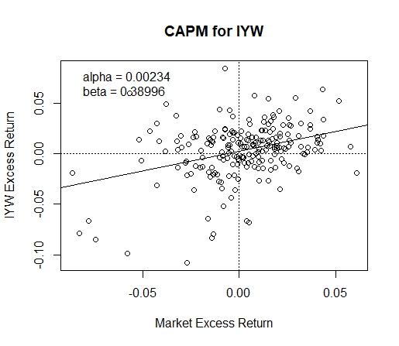

**Evaluating the Model**

Analysis of Variance (ANOVA) is a statistical method used to test the difference between means. There are three types of ANOVA tests. The one-way ANOVA test has one independent variable and one dependent variable. The Two-way ANOVA has one dependent variable and two independent variables. The N-way ANOVA observes more than two independent variables. The single-factor model of excess returns of an ETF regressed on the excess returns of a market index was observed by using the one-way ANOVA test. The test makes three general assumptions. Firstly, it assumes that the population of samples tested are normally distributed. Secondly, sample cases are independent of each other. Lastly, it assumes that the variance among the groups should be approximately equal.

Based on the ANOVA table, the variability in the excess returns are significantly different for each ETF case. The probability of getting the F-values or a more extreme value, if the null hypothesis is true, is very small. Therefore, we reject the null hypothesis, which assumes that the means are equal.



In addition, we observed the R-Squared values for each Model to determine good-fit. R-squared is a statistical measure of how close the data are to the fitted regression line. In general, the higher the R-squared, the better the model fits your data. For instance, 100% indicates that the model explains all the variability of the response data around its mean. On the other hand, 0% indicates that the model explains none of the variability of the response data around its mean. Based on the ratios, we see that they are below 20%. One observation that may cause a low percentage is the outliers in the data. Between December 2015 and January 2016, the Federal Reserve increased rates for the first time since they initiated Quantitative Easing. This increased volatility in the returns of equities for that period, including ETFs. This analysis tells us that it cannot describe the data appropriately. Hence, the model is not a good fit for the data that is used.