**PIZZA SALES SQL QUERIES**

**A. KPI’s**

**1. Total Revenue:**

SELECT SUM(total_price) AS Total_Revenue FROM pizza_sales;



**2. Average Order Value**

SELECT (SUM(total_price) / COUNT(DISTINCT order_id)) AS Avg_order_Value FROM pizza_sales



**3. Total Pizzas Sold**

SELECT SUM(quantity) AS Total_pizza_sold FROM pizza_sales



**4. Total Orders**

SELECT COUNT(DISTINCT order_id) AS Total_Order FROM pizza_sales;



**5. Average Pizzas Per Order**

SELECT CAST(CAST(SUM(quantity) AS DECIMAL(10,2)) / CAST(COUNT(DISTINCT order_id) AS DECIMAL(10,2)) AS DECIMAL(10,2)) AS Avg_Pizzas_Per_Order FROM pizza_sales;



**B. Daily Trend for Total Orders**

**SELECT DATENAME(DW, order_date) AS Order_Day,**

**COUNT(DISTINCT order_id) AS Total_Order**

**FROM pizza_sales**

**GROUP BY DATENAME(DW, order_date);**

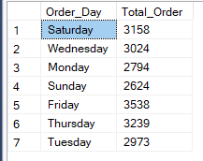

**C. Hourly Trend for Orders**

**SELECT DATEPART(HOUR, order_time) AS Order_Hour, COUNT(DISTINCT order_id) AS Total_Order**

**FROM pizza_sales**

**GROUP BY DATEPART(HOUR, order_time)**

**ORDER BY DATEPART(HOUR, order_time)**

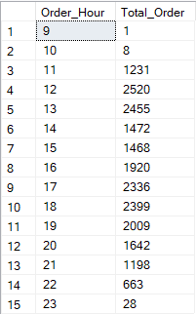

**D. % of Sales by Pizza Category**

SELECT pizza_category, SUM(total_price) AS Total_Price, SUM(total_price) * 100 /

(SELECT SUM(total_price) FROM pizza_sales WHERE MONTH(order_date) = 1) AS PCT

FROM pizza_sales

WHERE MONTH(order_date) = 1

GROUP BY pizza_category

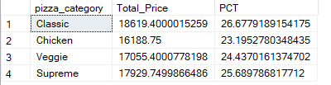

**E. % of Sales by Pizza Size**

SELECT pizza_size, SUM(total_price) AS Total_Price, CAST(SUM(total_price) * 100 /

(SELECT SUM(total_price) FROM pizza_sales) AS DECIMAL(10,2)) AS PCT

FROM pizza_sales

GROUP BY pizza_size

ORDER BY PCT DESC

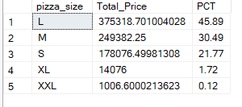

**F. Total Pizzas Sold by Pizza Category**

SELECT pizza_category, SUM(quantity) AS Total_Pizzas_Sold FROM pizza_sales

GROUP BY pizza_category

ORDER BY Total_Pizzas_Sold DESC

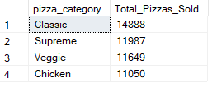

**G. Top 5 Best Sellers by Total Pizzas Sold**

SELECT TOP 5 pizza_name, SUM(quantity) AS Total_Pizzas_Sold FROM pizza_sales

GROUP BY pizza_name

ORDER BY Total_Pizzas_Sold DESC

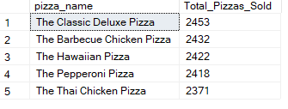

**H. Bottom 5 Best Sellers by Total Pizzas Sold**

SELECT TOP 5 pizza_name, SUM(quantity) AS Total_Pizzas_Sold FROM pizza_sales

GROUP BY pizza_name

ORDER BY Total_Pizzas_Sold ASC

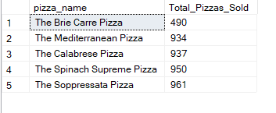**S**