# Competitive Edge – IIT Chemistry

**First Edition**

# By

Rajat Kalia

December 7, 2018

# Physical Chemistry

**States of Matter**

**Single-Answer MCQ**

1. The density of neon will be highest at :

(1) STP (2) 0oC, 2atm

(3) 273o, 1atm (4) 273o, 2atm **[1990]**

2. The rate of diffusion of methane at a given temperature is twice that of a gas X. The molecular weight of X is

(1) 64 (2) 32

(3) 4.0 (4) 8.0 **[1990]**

3. At constant volume, for a fixed number of mole of a gas, the pressure of the gas increases with rise of temperature due to :

(1) increase in average molecular speed

(2) increase in number of moles

(3) increase in molecular attraction

(4) decrease in mean free path **[1992]**

4. A gas behaves most like an ideal gas under conditions of :

(1) high pressure and low temperature

(2) high temperature and high pressure

(3) low pressure and high temperature

(4) low pressure and low temperature **[1993]**

5. If C1, C2, C3, …. Represent the speeds of n1, n2, n3, …. Molecules, then the root mean square speed is:

(1) 

(2) 

(3) 

(4)  **[1993]**

6. The compressibility factor of a gas is defined as Z = PV/nRT. The compressibility factor of an ideal gas is :

(1) Zero (2) infinite

(3) 1 (4) -1 **[1996]**

7. A gas will approach ideal behaviour at :

(1) low T and high P (2) low T and low P

(3) high T and low P (4) high T and high P **[1999]**

8. At 100o and 1 atm, if the density of liquid water is 1.0 g cm-3 and that of water vapour is 0.0006 gcm-3, then the volume occupied by water molecules in one litre of stream at that temperature is :

(1) 6 cm3 (2) 60 cm3

(3) 0.6 cm3 (4) 0.06 cm3 **[2000]**

9. The rms speed of hydrogen is  times the rms speed of nitrogen. If T is the temperature of the gas, then :

(1)  (2) 

(3)  (4)  **[2000]**

10. The root mean square velocity of an ideal gas at constant pressure varies with density (d) as :

(1) d2 (2) d

(3)  (4)  **[2001]**

11. When the temperature is increased, surface tension of water :

(1) increases

(2) decreases

(3) remains constant

(4) shows irregular behaviour **[2002]**

12. Which of the following volume (V), temperature (T) plots represents the behaviour of one mole of an ideal gas at one atmosphere ?

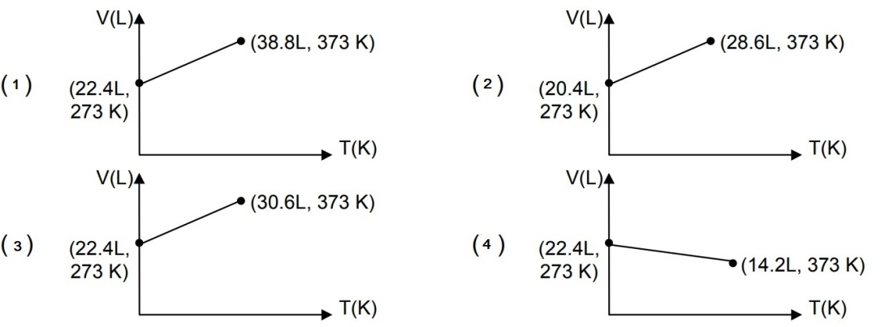 **[2002]**

13. Positive deviation from ideal behaviour takes place because of :

(1) molecular interaction between atoms and PV/nRT > 1

(2) molecular interaction between atoms and PV/nRT < 1

(3) finite size of atoms and PV/nRT > 1

(4) finite size of atoms and PV/nRT < 1 **[2003]**

14. For 1 mole of gas, the average kinetic energy is given as E. The urms of gas is :

(1)  (2) 

(3)  (4)  **[2004]**

15. The ratio of rate of diffusion of helium and methane under identical conditions of pressure and temperature is :

(1) 4 (2) 2

(3) 1 (4) 0.5 **[2005]**

16. A monoatomic ideal gas undergoes a process in which the ratio of P to V at any instant is constant and equal to unity. The molar heat capacity of the gas is :

(1) 4R/2 (2) 3R/2

(3) 5R/2 (4) zero **[2006]**

**Multiple Answer MCQ**

1. At constant volume, for a fixed number of mole of a gas, the pressure of the gas increases with rise of temperature due to :

(1) increase in average molecular speed

(2) increased rate of collisions amongst molecules

(3) increase in molecular attraction

(4) decrease in mean free path **[1992]**

2. The given graph represents the variation of Z (compressibility factor) v.s. P for three real gases A, B and C. Identify the correct statements.

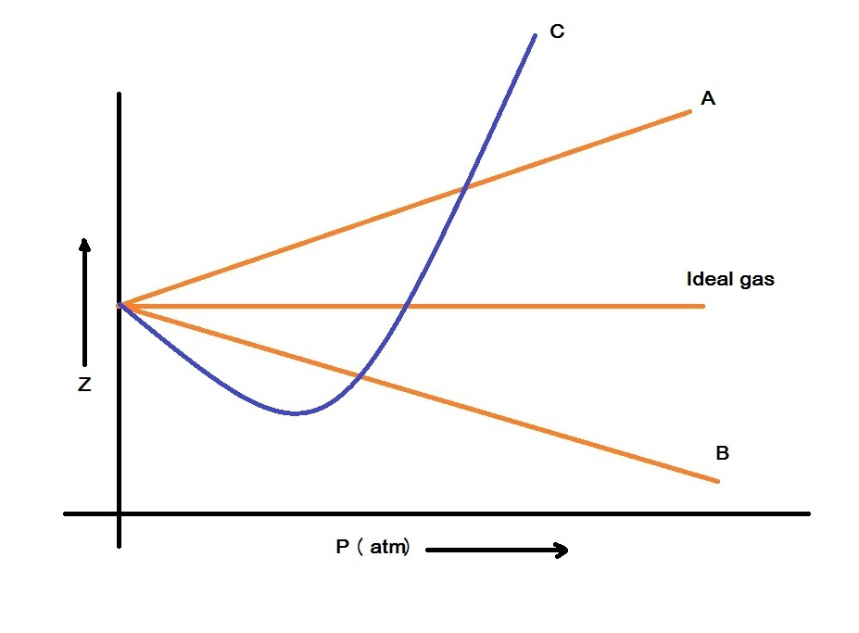

(1) For the gas A, a = 0 and its dependence on P is linear at all pressure.

(2) For the gas B, b = 0 and its dependence on P is linear at all pressure

(3) For the gas C, which is typical real gas for which a≠0, b≠0. By knowing the minima and the point of intersection with Z = 1, a and b can be calculated

(4) At high pressure, the slope is positive for all real gases. **[2008]**

3. A gas described by van der walls’ equation : **[2008]**

(1) behaves similar to an ideal gas in the limit of large molar volumes

(2) behaves similar to an ideal gas in the limit of large pressure

(3) is characterised by van der walls’ coefficients that are dependent on the identity of gas but are independent of the temperature

(4) has the pressure that is lower than the pressure exerted by the same gas behaves ideally

**Atomic Structure**

**Single-Answer MCQ**

1. A 3p-orbital has :

(1) two non-spherical nodes

(2) two spherical nodes

(3) one spherical and one non-spherical node

(4) one spherical and two non-spherical nodes **[1995]**

2. The number of nodal planes in a px-orbital is :

(1) 1 (2) 2

(3) 3 (4) zero **[2000]**

3. The electronic configuration of an element is 1s2, 2s22p6, 3s23p63d5, 4s1. This represents its :

(1) excited state (2) ground state

(3) cationic form (4) anionic form **[2000]**