**Alpha Classes | Rajat Kalia http://www.alphaclasses.com**

Electrochemistry

**Chemistry**

**Galvanic Cells**

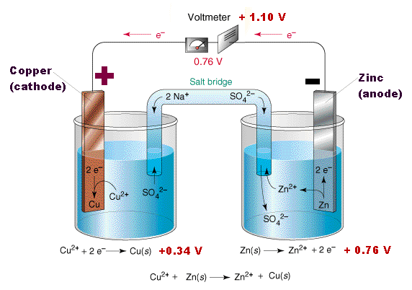

Zn(s) + Cu2+(aq) ---> Zn2+(aq) + Cu(s)

Zn(s) | Zn2+(1M) || Cu2+(1 M) | Cu(s)

Ecell = Eright - Eleft

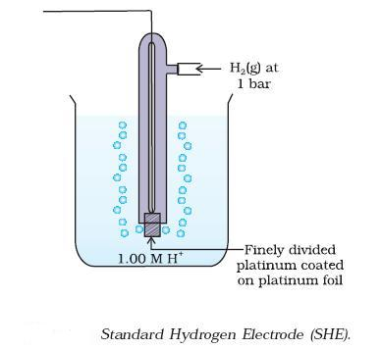

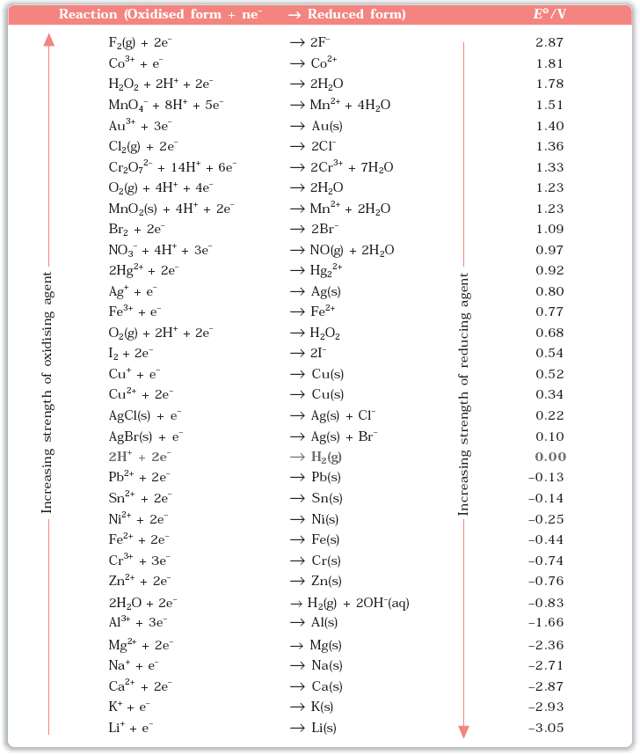

**Nernst equation**

**aA + bB ----> cC + dD**

**E cell = Eocell - ln $\frac{{[C]}^{c}{[D]}^{d}}{{[A]}^{a}{[B]}^{b}}$**

Q. Represent the cell in which the following reaction takes place **(NCERT)**

Mg(s) + 2Ag+(0.0001M) ---->Mg2+(0.130M) + 2Ag(s) Calculate its *E*(cell) if *Eθ*cell = 3.17 V.

Q. Calculate the emf of the cell in which the following reaction takes place **(NCERT)**

Ni(s) + 2Ag+ (0.002 M) ---> Ni2+ (0.160 M) + 2Ag(s)

Given that *Eθ*cell  = 1.05 V

**Equilibrium constant from Nernst Equation**

Eocell  = log Kc

Q. Calculate the equilibrium constant of the reaction: **(NCERT)**

Cu(s) + 2Ag+(aq) ---> Cu2+(aq) + 2Ag(s)

*Eθ*cell = 0.46 V

**Gibbs Energy of Reaction**

Δr Go= -nFEocell

Q. The standard electrode potential for Daniell cell is 1.1V. Calculate the standard Gibbs energy for the reaction: **(NCERT)**

Zn(s) + Cu2+(aq) --->Zn2+(aq) + Cu(s)

Q. The cell in which the following reaction occurs: **(NCERT)**

2Fe3+(aq) + 2I-(aq) ---> 2Fe2+(aq) + I2 (s) has *Eθ*cell = 0.236 V at 298 K.

Calculate the standard Gibbs energy and the equilibrium constant of the cell reaction.

Q. Calculate the potential of hydrogen electrode in contact with a solution whose pH is 10. **(NCERT)**

**Conductance of Electrolytic Solutions**

R **=** ρ $\frac{l}{A}$

R = Resistance

ρ = Resistivity

G = κ $\frac{A}{l}$

G = Conductance

κ = Conductivity

G* = $\frac{l}{A}$ = Cell Constant

Λm =

Q. Resistance of a conductivity cell filled with 0.1 mol L-1 KCl solution is 100 Ω. If the resistance of the same cell when filled with 0.02 mol L-1 KCl solution is 520 Ω, calculate the conductivity and molar conductivity of 0.02 mol L-1 KCl solution. The conductivity of 0.1 mol L-1 KCl solution is 1.29 S/m. **(NCERT)**

Q. The electrical resistance of a column of 0.05 mol L-1 NaOH solution of diameter 1 cm and length 50 cm is 5.55 × 103ohm. Calculate its resistivity, conductivity and molar conductivity. **(NCERT)**

**Kohlrausch law of independent migration of ions**

The law states that *limiting molar conductivity of an electrolyte can be represented as the sum of the individual contributions of the anion and cation of the electrolyte.*

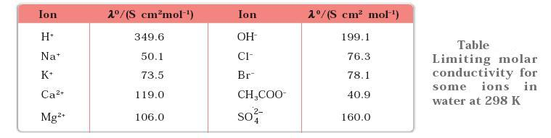

Q. Calculate *Ë*°m for CaCl2 and MgSO4 from the data given in Table **(NCERT)**

Q. *Ëm* for NaCl, HCl and NaAc are 126.4, 425.9 and 91.0 S cm2 mol-1 respectively. Calculate Λo for HAc.

**(NCERT)**

Degree of Dissociation α = $\frac{Λ_{m}}{Λ_{m}^{o}}$

Q. The conductivity of 0.001028 mol L-1 acetic acid is 4.95 × 10-5 S cm-1. Calculate its dissociation constant if *Ë*om for acetic acid is 390.5 S cm2 mol–1. **(NCERT)**

**Q.** The molar conductivity of 0.025 mol L-1 methanoic acid is 46.1 S cm2 mol-1.Calculate its degree of dissociation and dissociation constant. Given λ(H+) = 349.6 S cm2 mol-1 and λ(HCOO–) = 54.6 S cm2 mol-1 **(NCERT)**

**Faraday’s Laws of Electrolysis**

First Law : The amount of chemical reaction which occurs at any electrode during electrolysis by a current is proportional to the quantity of electricity passed through the electrolyte (solution or melt).

Second Law : The amounts of different substances liberated by the same quantity of electricity passing through the electrolytic solution are proportional to their chemical equivalent weights (Atomic Mass of Metal ÷ Number of electrons required to reduce the cation).

Q. A solution of CuSO4 is electrolysed for 10 minutes with a current of 1.5 amperes. What is the mass of copper deposited at the cathode? **(NCERT)**

**Q.** If a current of 0.5 ampere flows through a metallic wire for 2 hours, then how many electrons would flow through the wire? **(NCERT)**

**Q.** Consider the reaction: **(NCERT)**

Cr2O72-+ 14H+ + 6e– 🡪 2 Cr3+ + 8H2O

What is the quantity of electricity in coulombs needed to reduce 1 mol of Cr2O72- ?

# NCERT Exercise

1. Arrange the following metals in the order in which they displace each other from the solution of their salts. Al, Cu, Fe, Mg and Zn.

**2.** Given the standard electrode potentials, K+/K = –2.93V, Ag+/Ag = 0.80V, Hg2+/Hg = 0.79V, Mg2+/Mg = –2.37 V, Cr3+/Cr = – 0.74V

Arrange these metals in their increasing order of reducing power.

**3.** Depict the galvanic cell in which the reaction Zn(s)+2Ag+(aq) -->Zn2+(aq)+2Ag(s) takes place. Further show:

(i) Which of the electrode is negatively charged?

(ii) The carriers of the current in the cell.

(iii) Individual reaction at each electrode.

**4.** Calculate the standard cell potentials of galvanic cell in which the following reactions take place:

(i) 2Cr(s) + 3Cd2+(aq)  2Cr3+(aq) + 3Cd

(ii) Fe2+(aq) + Ag+(aq)  Fe3+(aq) + Ag(s)

Calculate the Δr*Gθ*_ and equilibrium constant of the reactions.

**5.** Write the Nernst equation and emf of the following cells at 298 K:

(i) Mg(s) | Mg2+(0.001M) || Cu2+(0.0001 M) | Cu(s)

(ii) Fe(s) | Fe2+(0.001M) || H+(1M) | H2(g)(1bar) | Pt(s)

(iii) Sn(s) | Sn2+(0.050 M) || H+(0.020 M) | H2(g) (1 bar) | Pt(s)

(iv) Pt(s) | Br2(*l*) | Br-(0.010 M) || H+(0.030 M) | H2(g) (1 bar) | Pt(s).

**6.** In the button cells widely used in watches and other devices the following reaction

takes place:

Zn(s) + Ag2O(s) + H2O(*l*) ---> Zn2+(aq) + 2Ag(s) + 2OH- (aq)

Determine Δ*rGθ*  and *Eθ* for the reaction.

**7.** Define conductivity and molar conductivity for the solution of an electrolyte.Discuss their variation with concentration.

**8.** The conductivity of 0.20 M solution of KCl at 298 K is 0.0248 S cm-1. Calculate its molar conductivity.

**9.** The resistance of a conductivity cell containing 0.001M KCl solution at 298 K is 1500 Ω. What is the cell constant if conductivity of 0.001M KCl solution at 298 K is 0.146 × 10-3 S cm-1.

**10.** The conductivity of sodium chloride at 298 K has been determined at different concentrations and the results are given below:

Concentration/M 0.001 0.010 0.020 0.050 0.100

102 × к/S m-1 1.237 11.85 23.15 55.53 106.74

Calculate *Λm* for all concentrations and draw a plot between *Λm* and *c*1/2. Find the value of *Λom*

**11.** Conductivity of 0.00241 M acetic acid is 7.896 × 10-5 S cm-1. Calculate its molar conductivity and if *Λom* for acetic acid is 390.5 S cm2 mol-1, what is its dissociation constant?

**12.** How much charge is required for the following reductions:

(i) 1 mol of Al3+ to Al.

(ii) 1 mol of Cu2+ to Cu.

(iii) 1 mol of MnO-4-  to Mn2+.

**13.** How much electricity in terms of Faraday is required to produce

(i) 20.0 g of Ca from molten CaCl2.

(ii) 40.0 g of Al from molten Al2O3.

**14.** How much electricity is required in coulomb for the oxidation of

(i) 1 mol of H2O to O2.

(ii) 1 mol of FeO to Fe2O3.

**15.** A solution of Ni(NO3)2 is electrolysed between platinum electrodes using a current of 5 amperes for 20 minutes. What mass of Ni is deposited at the cathode?

**16.** Three electrolytic cells A,B,C containing solutions of ZnSO4, AgNO3 and CuSO4, respectively are connected in series. A steady current of 1.5 amperes was passed through them until 1.45 g of silver deposited at the cathode of cell B. How long did the current flow? What mass of copper and zinc were deposited?

**17.** Using the standard electrode potentials given in **Table** predict if the reaction between the following is feasible:

(i) Fe3+(aq) and I-(aq)

(ii) Ag+ (aq) and Cu(s)

(iii) Fe3+ (aq) and Br- (aq)

(iv) Ag(s) and Fe3+ (aq)

(v) Br2 (aq) and Fe2+ (aq).

**18.** Predict the products of electrolysis in each of the following:

(i) An aqueous solution of AgNO3 with silver electrodes.

(ii) An aqueous solution of AgNO3 with platinum electrodes.

(iii) A dilute solution of H2SO4 with platinum electrodes.

(iv) An aqueous solution of CuCl2 with platinum electrodes.

## Assignment

1. Copper sulphate solution (250 ml.) was electrolysed using a platinum anode and a copper cathode. A constant current of 2 mA was passed for 16 minute. It was found that after electrolysis, the absorbance of the solution was reduced to 50% of its original value. Calculate the concentration of copper sulphate in the solution to begin with. [IIT 2000]

2. Chromium metal can be plated out from an acidic solution containing CrO3 according to following equation.

CrO3(aq.) + 6H+ + 6e 🡪 Cr(s) + 3H2O

Calculate:

I. How many gram of chromium will be plated out by 24000 coulomb?

II. How long will it take to plate out 1.5 g of Cr by using 12.5 ampere current? [IIT 1993]

3. Electrolysis of a solution of MnSO4 in aqueous sulphuric acid is a method for the preparation of MnO2 as per reaction,

Mn2+ (aq) + 2H2O 🡪 MnO2(s) + 2H+ (aq) + H2(g)

Passing a current of 27 ampere for 24 hour gives one kg of Mno2. What is the value of current efficiency? Write the reaction taking place at the cathode and at the anode. [IIT 1997]

4. In a fuel cell H2 and O2 react to produce electricity. In the process H2 gas is oxidized at the anode and O2 at cathode. If 67.2 litre of H2 at STP reacts in 15 minute, what is average current produced? If the entire current is used for electro deposition of Cu from Cu2+, how many g of Cu are deposited?

Cathode: O2 + 2H2O + 4e 🡪 4OH-

Anode: H2 + 2OH- 🡪 2H2O + 2e [IIT 1988]

5. An aqueous solution of NaCl on electrolysis gives H2(g), Cl2(g) and NaOH according to reaction:

2Cl-(aq) + 2H2O 🡪 2OH(aq) + H2(g) + Cl2(g)

A direct current of 25 ampere with a current efficiency of 62 % is passed through 20 litre of NaCl solution (20% by weight).

a) Write down the reactions taking place at the electrodes.

b) How long will it take to produce 1 kg of Cl2?

c) What will be the molarity of solution with respect to OH- ?

Assume no loss of volume due to evaporation. [IIT 1992]

6. A current of 1.7 ampere is passed through 300 ml. of 0.160 M solution of ZnSO4 for 230 sec with a current efficiency of 90%. Find the molarity of Zn2+ after the deposition of Zn. Assume the volume of the solution remains constant during electrolysis.

[IIT 1991]

7. An acidic solution of Cu2+ salt containing 0.4 g of Cu2+ is electrolysed until all the Cu is deposited. The electrolysis is continued for seven more minutes with the volume of solution kept at 100 ml. and the current at 1.2 ampere. Calculate volume of gases evolved at NTP during entire electrolysis. At. Wt. of Cu=63.6 [IIT 1989]

8. Calculate the quantity of electricity that would be required to reduce 12.3 g of nitrobenzene to aniline, if current efficiency is 50%. If the potential drop across the cell is 3.0 volt, how much energy will be consumed? [IIT 1990]

9. during the discharge of a lead storage battery, the density of sulphuric acid fell from 1.294 g ml-1 to 1.139 g ml-1 . sulphuric acid of density 1.294 g ml-1 is 39% by weight and that of density 1.139 g ml-1 is 20% by weight. The battery holds 3.5 litre of acid and the volume practically remained constant during the discharge. Calculate the no. of ampere hour for which the battery must have been used. The charging and discharging reactions are:

Pb + SO42- 🡪Pb SO4 + 2e charging

PbO2 + 4H+ + SO42- + 2e 🡪 PbSO4 + 2H2O discharging [IIT 1986]

10. How many grams of silver could be plated out on a serving tray by electrolysis of solution containing silver in +1 oxidation state for a period of 8.0 hour at a current of 8.46 ampere? What is the area of the tray if the thickness of the silver plating is 0.00254 cm? Density of silver is 10.5 g/cm3. [IIT 1997]

11. Calculate the equilibrium constant for the reaction:

Fe2+ + Ce4+ Fe3+ + Ce3+

Given: EoCe4+/Ce3+ = 1.44 V and EoFe3+/Fe2+ = 0.68V [IIT 1997]

12. The following electrochemical cell has been set up.

Pt(I) | Fe3+, Fe2+ (a=1) || Ce4+,Ce3+ (a=1) | Pt(II)

EoFe3+/Fe2+ = 0.77V and EoCe4+/Ce3+ = 1.61V

If an ammeter is connected between the two platinum electrode, predict the direction of flow of current. Will the current increase or decrease with time? [IIT 2000]

13. Calculate the equilibrium constant for the reaction, 2Fe3+ + 3I- 2Fe2+ + I-3. The standard reduction potentials in acidic conditions are 0.77 and 0.54 V respectively for Fe3+|Fe2+ and I-3|I- couples. [IIT 1998]

14. Zinc granules are added in excess to 500 ml of 1M Ni(NO3)2 solution at 25oC until the equilibrium is reached. If EoZn2+/Zn and EoNi2+/Ni are -0.75V and -0.24V respectively, find out the [Ni2+] at equilibrium.

[IIT 1991]

15. The standard reduction potential for Cu2+| Cu is + 0.34V. Calculate the reduction potential at pH = 14 for the above couple, KSP of Cu(OH)2 is 1.0 x 10-19. [IIT 1996]

16. The standard reduction potential of Cu2+|Cu and Ag+|Ag electrodes are 0.337 V and 0.799 V respectively. Construct a galvanic cell using these electrodes so that its Eosell is +ve. For what [Ag+] will the emf of cell at 25oC be zero if [Cu2+] is 0.01 M? [IIT 1990]

17. Find the solubility product of a saturated solution of Ag2CrO4 in water at 298 K if the e.m.f. of the cell Ag | Ag+ (satd. Ag2CrO4 sol.) || Ag+(0.1M) | Ag is 0.164 V at 298 K . [IIT 1998]

18. The standard reduction potential at 25oC for the reaction 2H2O + 2*e* 🡪 H2 + 2OH- is -0.8277 V. Calculate the equilibrium constant for the reaction 2H2O ⇌ H3O+ + OH- at 25oC. [IIT 1989]

19. An excess of liquid Hg was added to 10-3 acidified solution of Fe3+ ions. It was found that only 5% of the ions remained as Fe3+ at equilibrium at 25oC. Calculate Eo for 2Hg | Hg22+ at 25oC for

2Hg + 2Fe3+ ⇌ Hg22+ + 2Fe2+ and Eo Fe2+|Fe3+ = -0.77 V. [IIT 1995]

20. A cell Ag | Ag+ || Cu2+ | Cu initially contains 1 M Ag+ and 1 M Cu2+ ions . Calculate the change in the cell potential after the passage of 9.65 ampere of current for 1 hour. [IIT 1999]

## Objective

1. If Φ denotes standard, reduction potential, which is true: [AIEEE 2002]

(a) Eocell = ΦR - ΦL

(b) Eocell = ΦL + ΦR

(c) Eocell = ΦL - ΦR

(d) Eocell = - (Φ L+ Φ R)

2. Emf of a cell in terms of reduction potential of its left and right electrodes is: [AIEEE 2002]

(a) *E* = ELeft - Eright

(b) *E* = ELeft + Eright

(c) *E* = Eright - ELeft

(d) *E* = -[Eright + ELeft]

3. Conductance (Siemens, S) is directly proportional to the area of the vessel and the concentration of solution in it and is inversely proportional to the length of the vessel then, the unit of constant of proportionality is: [AIEEE 2002]

(a) S m mol-1 (b) S m2 mol-1

(c) S-2 m1 mol (d) S2 m2 mol-2

4. The emf of given cell Pt-H2 I H+ I H2-Pt is:

*P*1 *P*2[AIEEE 2002]

*a) (RF/F)* log (P1/ P2) (b) (*RF/F*) log *e (P1/P2*) c) (*RF/F*) log *e (P2/P1*) d) None of these

5. The EoM3+/*M2+* values for Cr, Mn, Fe and Co are -0.41, +1.57, +0.77 and +1.97V respectively. For which one of these metals the change in oxidation state from +2 to +3 is easiest: [AIEEE 2003]

(a) Co (b) Mn

(c) Fe (d) Cr

6. Standard reduction electrode potentials of three metals *A,* B and C are +0.5 V, -3.0 V and -1.2 V respectively. The reducing power of these metals are: [AIEEE 2003]

(a) *B>C>A* (b) *A>B>C*

*(c) C>B>A (d) A>C>B*

7. For a cell reaction involving a two electron change, the standard e.m.f., of the cell is found to be 0.295V at 25°C. The equilibrium constant of the reaction at 25°C will be: [AIEEE 2003]

(a) 1 x 10-10 (b) 29.5 x 10-2

(c) 10 (d) 1 x 1010

8. When during electrolysis of a solution of AgNO3, 9650 coulombs of charge pass through the electroplating bath, the mass of silver deposited on the cathode will be: [AIEEE 2003]

(a) 1.08 g (b) 10.8 g

(c) 21.6 g (d) 108 g

9. For the redox change; [AIEEE 2003]

Zn(s) + Cu2+ 🡪 Zn2+ + Cu(s), taking pIace in a cell Eocell is 1.10 volt. Ecell for the cell would be: 0.1M 1M

(a) 1.07 V (b) 0.82 V

(c) 2.14 V (d) 180V

10. In a hydrogen-oxygen fuel cell, combustion of hydrogen occurs to : [AIEEE 2004]

(a) remove adsorbed oxygen from electrode surfaces

(b) create potential difference between the two electrodes

(c) produce high purity water

(d) generate heat

11. Consider the following *Eo* values. *Eo Fe*3+/Fe 2+ = +0.77V, *EoSn2+/Sn* = -0.14 V, TheEocell for the reaction:

Sn(s) + 2Fe3+(aq) 🡪 2Fe2+(aq) + Sn2+(aq) is [AIEEE 2004]

(a) 0.63 V (b) 1.40 V

(c) 0.91 V (d) 1.68 V

12. The standard emf of a cell having one electron change is found to be 0.591 V at 25°C. The equilibrium constant of the reaction is: [AIEEE 2004]

(a) 1.0 x 1030 (b) 1.0 x 105

(c) 1.0 x 1010 (d) 1.0 x 101

13. In a cell that utilises the reaction;

Zn(s) + 2H+(aq.) 🡪Zn2+(aq) + H2(g)

addition of H2SO4 to cathode compartment will : [AIEEE 2004]

(a) increase the *E* and shift equilibrium to the left

(b) lower the *E* and shift equilibrium to the right

(c) increase the *E* and shift equilibrium to the right

(d) lower the *E* and shift equilibrium to the left

14. The limiting molar conductivities ∧° for NaCl, KBr and KCI are 126, 152 and 150 S cm2 mol-1 respectively. The ∧° for NaBr S cm2 mol-1 is: [AIEEE 2004]

(a) 302 (b) 176

(c) 278 (d) 128

15. The highest electrical conductivity of the following aqueous solutions is of: [AIEEE 2005]

(a) 0.1*M* acetic acid (b) 0.1*M* chloroacetic acid

(c) 0.1*M* fluoroacetic acid (d) 0.1*M* difluoroacetic acid

16. The molar conductance of acetic acid at infinite dilution if ∧° for CH3COONa, NaCI and HCl are 91.0, 126.5 and 426.2 S cm2 mol-1 respectively: [AIEEE 2005]

(a) 517.2 (b) 552.7

(c) 390.7 (d) 217.5

17. Aluminium oxide may be electrolysed at 1000°C to furnish AI metal (at. mass =27 amu). The cathode reaction is: Al3+ + *3e 🡪*  Al

How much electricity is required to prepare 5.12 kg of Al by this method: [AIEEE 2005]

(a) 5.49 x 107 coulomb (b) 1.83 x 107 coulomb

(c) 5.49 x 104 coulomb (d) 5.49 x 1010 coulomb

18.The molar conductivity ∧°NaOAc and ∧°HCl at infinite dilution in water at 25°C are 91.0, 426.2 S cm2 mol-1 respectively. To calculate ∧°HAc , the additional value required is: [AIEEE 2006]

(a) ∧°H2O (b) ∧°KCl

(c) ∧°NaOH  (d) ∧°NaCI

19. The ionic mobility of alkali metal ion in aqueous solution is maximum for: [AIEEE 2006]

(a) K+ (b) Rb+

(c) Li+ (d) Na+

20. Resistance of a conductivity cell filled with a solution of an electrolyte of concentration 0.1*M* is 100 ohm. The conductivity of this solution is 1.29 S m-1. Resistance of the same cell filled with *0.02M* of the same solution if the electrolyte is 520 ohm. The molar conductivity of *0.02M* solution of electrolyte would be :

[AIEEE 2006]

(a) 124 x 10-4 S m2 mol-1 (b) 1240 x 10-4 S m2 mol-1

(c) 1.24 x 10-4 S m2 mol-1  (d) 12.4 x 10-4 S m2 mol-1

21. At 25°C, Ag + I- 🡪 AgI + *e; Eo* = 0.152V

Ag 🡪 Ag++ *e*; *E*o =-0.80V

The log *KSP* of AgI is: (2.303RT/F = 0.059V) [AIEEE 2006]

(a) -80.12 (b) +8.612

(c) -37.83 (d) -16.13