# A Complete Course in Physics ( Graphs ) - Extended First Edition

## Manas Kalia and Rajat Kalia

## March 09, 2017

# Preface

The First Edition was a collection of tough problems but the file was small , only being 12 pages not meeting the Amazon crieteria of minimum 24 pages for paperback printing. Moreover, the toughness of problems required that answers be provided Intext.

Graphs is a very catchy topic for +1/+2 level and Competitive Exams, it is apparent that books in this particular topic would be written and available soon in the near future.

# Acknowledgements

I first of all thank my son Manas Kalia for the love and support.

Today, he is writing an essay on “Myself” for all of us

1 My name is Manas.  
2 I am six years old.  
3 I study in KGF.  
4 I like to play ludo.  
5 I love my family.

I would also like to show few of his designs, he has made while playing on computer.

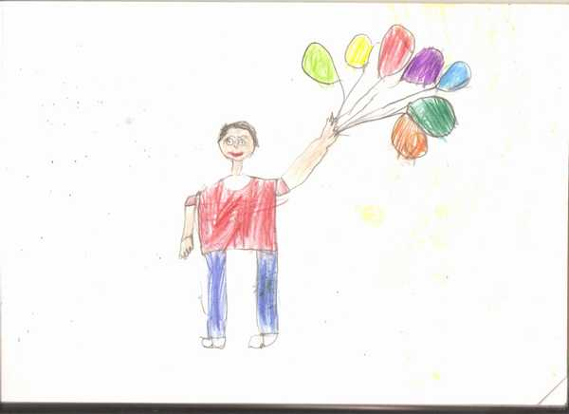

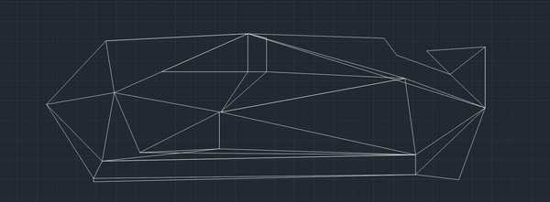

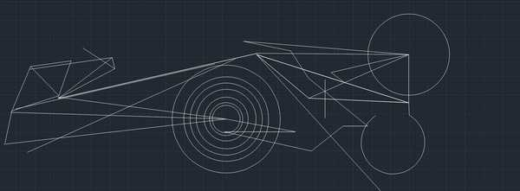

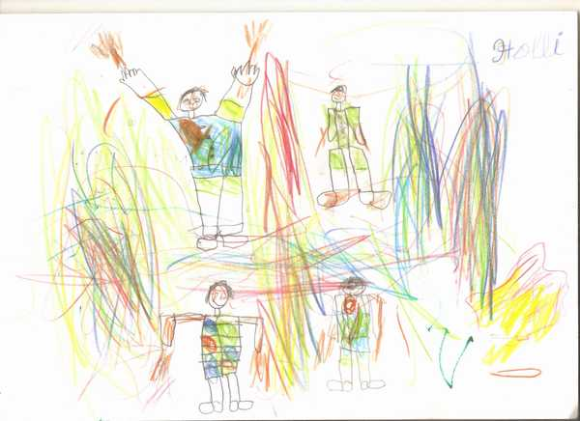





Table of Contents

Chapter: Preface

Chapter: Acknowledgements

Chapter 1: Concepts of Graphs

Section 1.1: The Equations of motion and the origin of Graph Handling

Subsection 1.1.1: The First Equation

Subsection 1.1.2: The Second Equation

Subsection 1.1.3: The Acceleration-Position Graph Variate

Section 1.2: Other Types of Graphs

Subsection 1.2.1: Sign of Acceleration from Position-Time Graph

Subsection 1.2.2: The Average-Velocity / Instantaneous Velocity , Equal Case

Subsection 1.2.3: The Velocity-Displacement Case

Subsection 1.2.4: Motion Under Free Fall due to Gravity

Subsection 1.2.5: Projectile Motion

Subsection 1.2.6: Miscelleneous

Section 1.3: Question Types

Subsection 1.3.1: Passage Type

Subsection 1.3.2: Matching

Section 1.4: Previous Year Problems IIT

Index

# 1 Concepts of Graphs

## 1.1 The Equations of motion and the origin of Graph Handling

### 1.1.1 [↓](" \l "index-The-First-Equation)The First Equation

The Equation *v* = (*dx*)/(*dt*) in linear motion implies

i) The **Slope** of **Position-Time Graph** is **Instantaneous Velocity.**

ii) The **Area** under the **Velocity-Time Graph** is **Change in Position**.

{ The second one requires the manipulation , *dx* = *vdt* i.e. ∫*dx* = ∫*vdt* }

The equations can be further manipulated to obtain the Speed Time Graph , where

speed = rate of change of distance wrt time

Few of the following examples illustrate this concept:

Example: On a displacement-time graph, two straight lines make angles of 30° and 60° with the time-axis. The ratio of the velocities represented by them is

a) 1:√(3)  
b) 1:3  
c) √(3):1  
d) 3:1  
{ Hint: The velocity in a displacement-time is given by the slope of the curve. Slope = tan(gent) of angle of inclination of s-t graph. This gives the respective ratios tan 30*o* / tan 60*o*   
Answer: b) is the correct answer. }

Example: A body is moving in a straight line as shown in velocity-time graph. The displacement and distance travelled by body in 8 second are respectively:

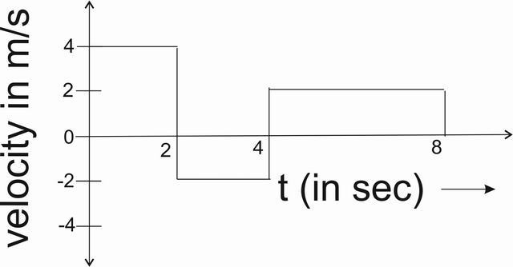

a) 12 m, 20 m  
b) 20 m, 12 m  
c) 12 m, 12 m  
d) 20 m, 20 m  
{ Hint: The displacement in a velocity-time graph is given by the area under the graph with proper signs. From 0s - to 2s , the area is 8m . From 2s - to 4s , the area is -4m . From 4s - to 8s , the area is 8m. Adding these 3 values , we get 8m + (-4m) + 8m = 12m. } The distance in a v-t graph is given by the absolute area under the graph. So, taking the absolute values of individual area divisions, we get 8m + 4m + 8m =20m  
Answer: a) is the correct answer. }

Example: The graph shows position as a function of time for two trains running on parallel tracks. Which statement is true?

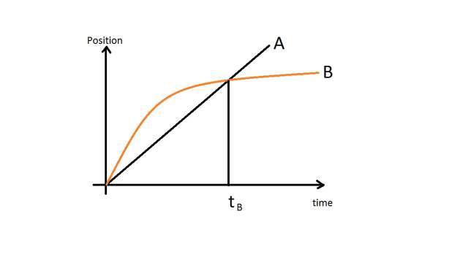

a) At time t*B* both trains have the same velocity.  
b) Both trains have the same velocity at some time after t*B* .  
c) Both trains have the same velocity at some time before t*B* .  
d) Somewhere on the graph, both trains have the same acceleration.  
{ Hint: Depending on the question requirements, we’ll have to check all the assertions one by one.  
a) In a position time graph, the slope gives velocity. It can be clearly seen that Graph B has a much lower slope than Graph A at time *tB*. So, the assertion is wrong.  
b,c) By drawing a line parallel to the line A which is a tangent to Graph B , it can be seen where the two graphs have same slope. It is clear that the graphs have same slope between 0 and *tB* as noted from the figure. So, assertion b is wrong while c is correct.

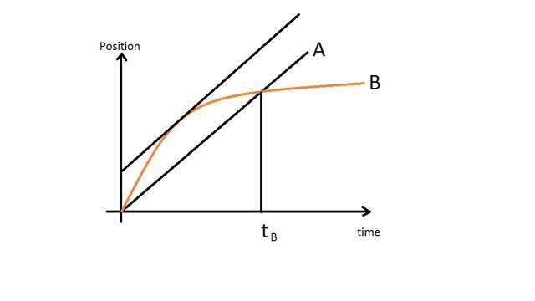

d) As the Graph A has a constant slope, so the acceleration of body A is zero. Whereas Graph B is constantly turning, so the slope can be assumed to be non-zero throughout. According to some revelations, however it is noted that the figure is not clear enough to show whether Graph B is straight after *tB* or bending. In case it is assumed to be straight, then after *tB* both trains will have same (zero) acceleration. Also at start both have large (infinite) accelration, in which case the ratio of the two large ( infinite ) values may be calculated if initial conditions are mentioned and is required.  
At our level we would assume this assertion to be wrong, however making a note that the image should have been more clearly presented.  
Answer: c) is the correct assertion. }

Example: The velocity-time graph of a particle in linear motion is as shown. Both v and t are in SI units. The displacement of the particle is

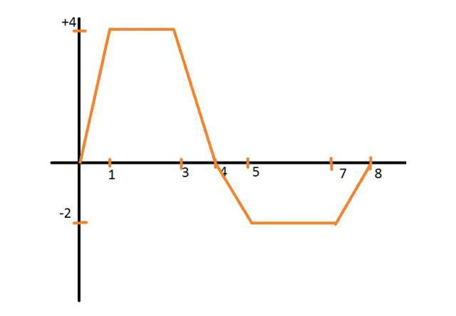

a) 6 m  
b) 8 m  
c) 16 m  
d) 18 m  
{ Hint : For displacement calculations, between 0 - to 4 , area of the positive trapesium = (4+2)X4 = 24  
between 4 - to 8, area of negative trapesium = (2+4)X(-2) = -12.  
So , the answer is +12 , which is not in the options.   
So , the anser is None of these. }

### 1.1.2 [↓](" \l "index-The-Second-Equation)The Second Equation

Proceeding similar to above, the equation *a* = (*dv*)/(*dt*) implies

i) The **Slope** of **Velocity-Time Graph** is **Instantaneous Acceleration**.

ii) The **Area** under **Acceleration-Time Graph** is **Change in Velocity**.

{ The second one requires the manipulation , *dv* = *adt* i.e. ∫*dv* = ∫*adt* }

A few of the following examples illustrate it.

Example: A car starts from rest acquires a velocity v with uniform acceleration 2*ms*− 2 then it comes to stop with uniform retardation 4*ms*− 2 . If the total time for which it remains in motion is 3 sec, the total distance travelled is:

a) 2 m  
b) 3 m  
c) 4 m  
d) 6 m   
{Hint: For solving this problem, we draw the graph of the problem,

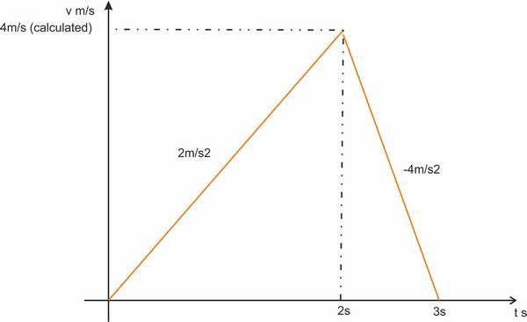

Accordning to graph, let the time when it reaches maximum velocity be T, and the maximum velocity be V.   
 ⇒ V = 2XT and also V = 4X(3-T)  
Equating the equations,  
2T = 12-4T = V  
 ⇒ 6T = 12  
 ⇒ T = 2  
 ⇒  V = 2T = 4  
Calculating the area under the graph using the calculated parameters, Area = 1/2 X 4 X 3 = 6m  
So , area under the graph is 6m = displacement . Also, as all the area is on the positive side, so distance = 6m.   
}

Example: A particle starts from rest. Its acceleration (a) vs time (t) is as shown in the Figure. The maximum speed of the particle will be

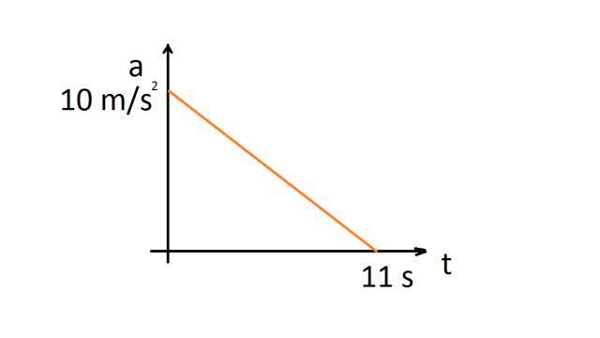

a) 110 m/s  
b) 55 m/s  
c) 550 m/s  
d) 660 m/s  
{ Hint : Writing the equation of the graph , we get (*a*)/(10) + (*t*)/(11) = 1  
 ⇒ *a* = (10)/(11)(11 − *t*)  
Integrating, ( we will assume initial velocity to be zero as the body starts from rest. )  
*v* = (10)/(11)(11*t* − (1)/(2)*t*2)  
Substituting *t* = 11*s*  
*v*11*s* = 55*m* ⁄ *s*  
Answer: b) is the correct answer }

Example: Acceleration-time graph of a particle moving in a straight line is shown in Figure. The velocity of particle at time t = 0 is 2 m/s. Velocity at the end of fourth second is

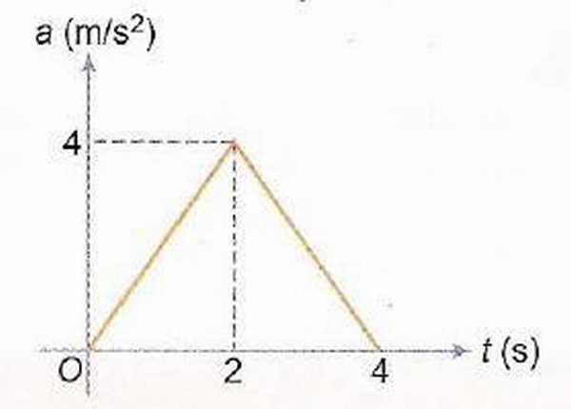

a) 8 m/s  
b) 10 m/s  
c) 12 m/s  
d) 14 m/s  
{ Hint: Area under the acceleration-time graph is change in velocity. Area of the triangle is Half ( into ) base ( into ) altitude = 8m/s. Adding the initial value of 2m/s , we get 2 + 8 = 10m/s.   
Answer: b) is the correct answer }

Example: Each of the three graphs represents acceleration vs time for an object that already has a positive velocity at time *t*1 . Which graph/graphs show an object whose speed is increasing for the entire time interva1 between *t*1 and *t*2 ?

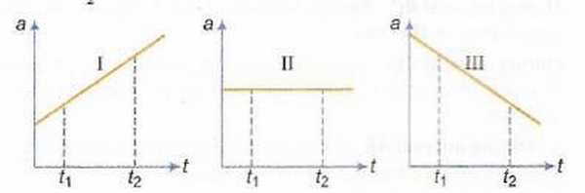

a) Graph I only  
b) Graphs I and II  
c) Graphs I and III  
d) Graphs I, II and III  
{Hint: Area under the acceleration time graphs give change in velocity. In all the three figures, the area under the graphs are +ve, hence velocity is increasing in all cases. As the initial velocity is +ve , in all three cases the velocity remains throughout positive. So , the speed is also increasing in all cases.}

Example: A body starts from rest and moves along a straight line with constant acceleration. The variation of speed v with distance s is given by the graph

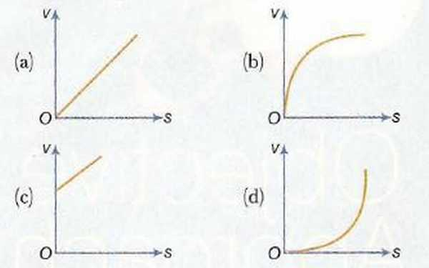

{ Hint: The problem given has *vo*= 0   
Now acceleration = constant ( lets say k ) = (*dv*)/(*dt*)  
 ⇒ *k* = *v*(*dv*)/(*ds*)  
 ⇒ ∫0*vvdv* = ∫0*skds*  
 ⇒ *v* = √(2*ks*)  
The graph is proportional to square root function  
Hence , b (as it is the only graph with such a property )  
Answer : b) is the correct graph }

### 1.1.3 The Acceleration-Position Graph Variate

This kind of graph requires the manipulation of the Equation *a* = (*dv*)/(*dt*) as follows  
*a* = (*dv*)/(*dx*).(*dx*)/(*dt*)  
 ⇒ *a* = (*dv*)/(*dx*).*v*  
 ⇒  *adx* = *vdv* and integration can be performed to further solve it.

Example: A body, initially at rest, starts moving along x-axis in such a way that its acceleration vs displacement plot is as shown in the Figure. The maximum velocity of the particle is

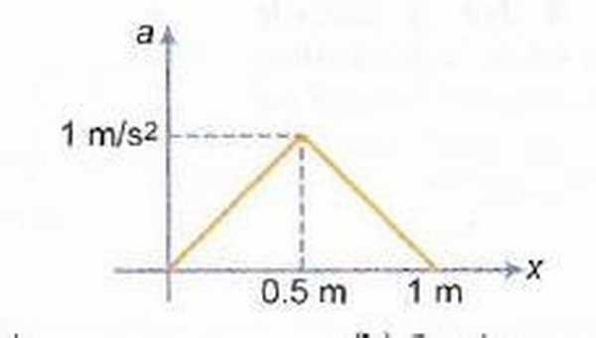

a) 1 m/s  
b) 6 m/s  
c) 2 m/s  
d) None of these  
{ Hint : The area under the a-x graph gives change in (*v*2)/(2) as can be evaluated by Integration method. The area of triange is (0.5) X (1) X (1) = 0.5  
 ⇒ v = 1m/s . Initial position is given to be 0 in the graph. Hence, we take only the positive sign.  
Answer : a) is the correct answer. }

Example : A particle initially at rest, it is subjected to a non-uniform acceleration a, as shown in the gure. The maximum speed attained by the particle is

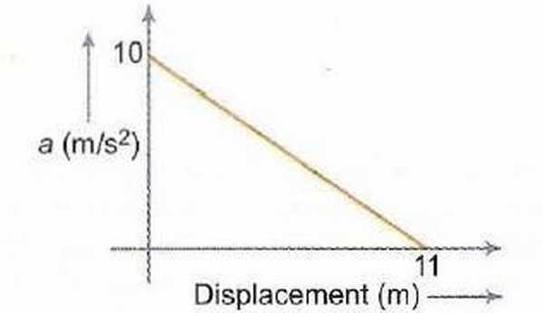

a) 605 m/s  
b) 110 m/s  
c) 55 m/s   
d) 110 m/s  
{ Hint: The answer is 55m/s as calculated in the example above(In the second equation section). Hence, c) is the correct response.  
Answer : c) is the correct answer. }

## 1.2 Other Types of Graphs

### 1.2.1 Sign of Acceleration from Position-Time Graph

The sign of Acceleration can be determined from the Position-Time Graph. The methodology involves of looking at the Concavity of the Graph  
i) If the graph is Concave-Up, the Acceleration is Positive.  
ii) If the graph is Concave-Down, the Acceleration is Negative.  
iii) If the graph is a straight line, the Acceleration is ZERO. { Irrespective of any other factor , such as the slope or direction of line}

Example: The graph given below is a plot of distance vs time. For which labelled region is the “Velocity Positive and the Acceleration Negative”

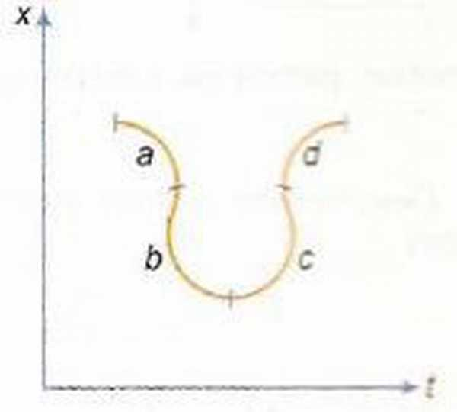

a) a  
b) b  
c) c  
d) d   
{ Hint: By the above mentioned propositions, d) is the required section with positive velocity and negative accleration. }

### 1.2.2 [↓](" \l "index-The-Average-Velocity-/-Instantane)The Average-Velocity / Instantaneous Velocity , Equal Case

We know , that ( in a x-t graph) the slope of the Secant is the Average Velocity , whereas the slope of Tangent is the Instaneous Velocity. The point where these two lines coincide, is the point where Average Velocity is equal to Instantaneous Velocity.

Example: Position-time graph is shown which is a semicircle from t = 2 to t = 8 s. Find time t at which the instantaneous velocity is equal to average velocity over first t seconds,

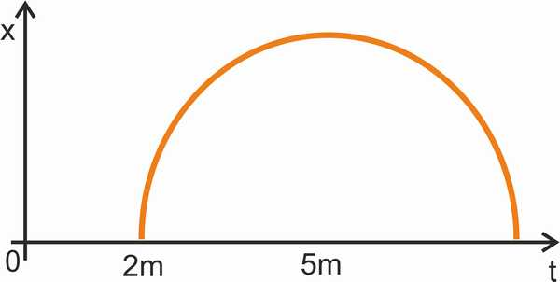

a) 4.8 s  
b) 3.2 s  
c) 2.4 s  
d) 5 s  
{ Hint: The tangent from 0 to the circle is drawn. It’s normal passes through the center of the circle. Time at this instant needs to be calculated.  
If H=5 , R = 3 , Length of tangent = 4. (By Pythagoras.)  
Angle which the tangent makes with the t axis is *θ* = *sin*− 1(3 ⁄ 5)  
So, the projection of tangent on t axis ( i.e. the required time ) = 4 cos *θ* = 4 × (4)/(5) = 3.2

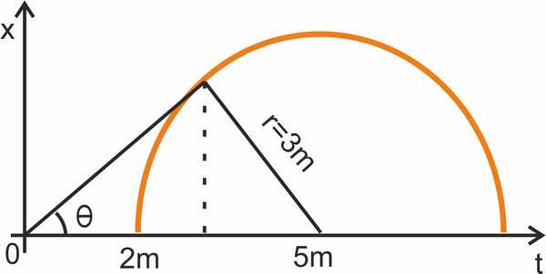

}

### 1.2.3 The Velocity-Displacement Case

This can be handled in a similar way as Acceleration-Displacement case by integrating the respective equation. Here the problem is of v = f(x) type, which can be integrated by writing (*dx*)/(*dt*) = *f*(*x*)  
i.e. dx = f(x)dt

Example: The velocity-displacement graph of a particle moving along a straight line is shown here.

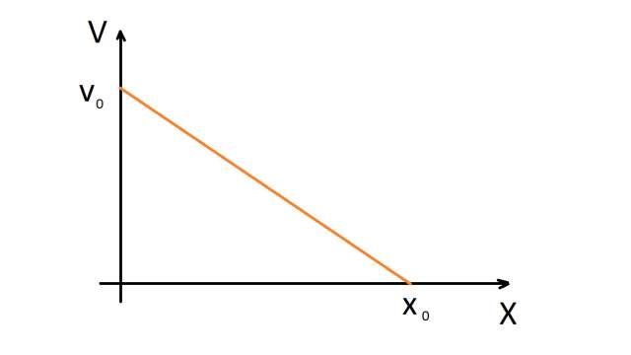

The most suitable acceleration-displacement graph will be

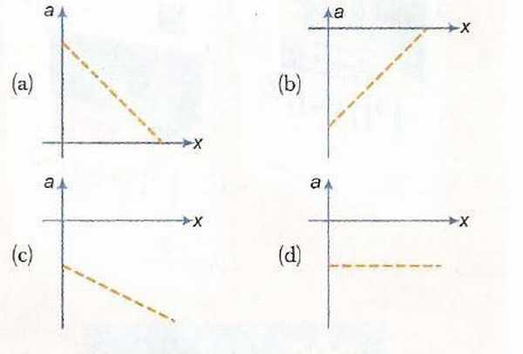

{Hint: Using Co-Ordinate Geometry Result studied in +1 Mathematics, we get the equation of the graph  
(*v*)/(*vo*) + (*x*)/(*xo*) = 1  
We are supposed to find the a-x graph from this.  
So, we rewrite this equation as *v* = *vo*(1 − (*x*)/(*xo*))  
Differentiating, we get *a* =  − (*vo*)/(*xo*) = *constant*  
Hence d) is the requisite graph.  
Answer: d) is the correct answer. }

Example. The velocity (v) of a body moving along the postive x-direction varies with displacement (x) from the origin as p v = k x , where k is a constant. Which of the graphs shown in Fig. correctly represents the displacement-time (x - t) graph of the motion?

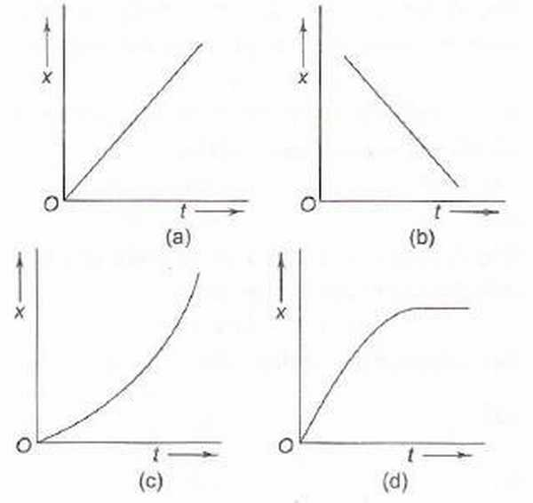

{Hint: The variable p removes the dependence of v on x and gives emphasis only on the first condition that body is moving along positive x-direction. In Graphs a) ,c) body is moving along positive x-direction, However, a) is a specific case when p is proportional to x and not the general case. Only c) covers the general case of all possible p and still moving in positive x-direction. Hence c) is the correct answer  
Answer: c) is the required answer. }

### 1.2.4 [↓](" \l "index-Motion-Under-Free-Fall)Motion Under Free Fall due to Gravity

In such examples, the governing equations rule and the coordi-nate system needs to be properly chosen.

Example: Which of the following graphs correctly represents velocity-time relationship for a particle released from rest to fall freely under gravity?

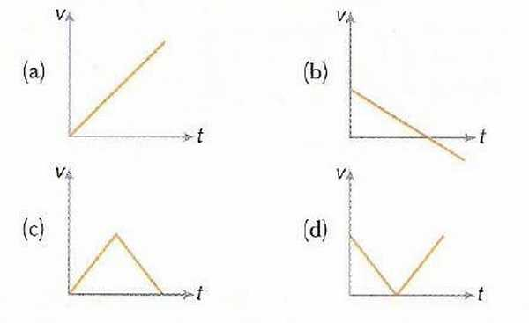

{ Hint: If we take the downward axis as positive, v will keep on increasing till the object hits something.   
So, a) is the correct answer.}

Example: The velocity-time graph of a body falling from rest under gravity and rebounding from a solid surface is represented by which of the following graphs?

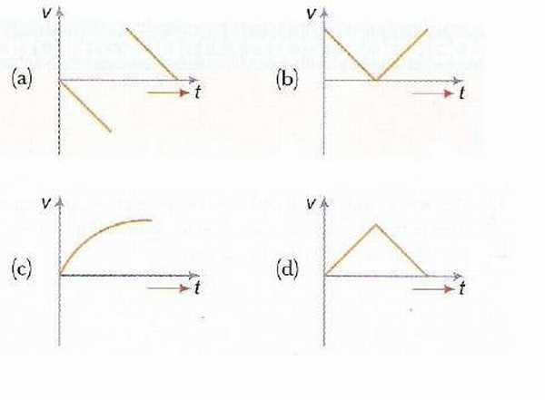

{ Hint: At rebound, the velocity would become negative of itself if the collision is perfectly elastic. Only in graph (a) such a thing is happening.   
a) is the correct answer.}

Example: A body A is thrown vertically upwards with such a velocity that it reaches a maximum height of h. Simultaneously another body B is dropped from height h. It strikes the ground and doesn’t rebound. The velocity of A relative to B vs time graph is best represented by (upward direction is positive.)

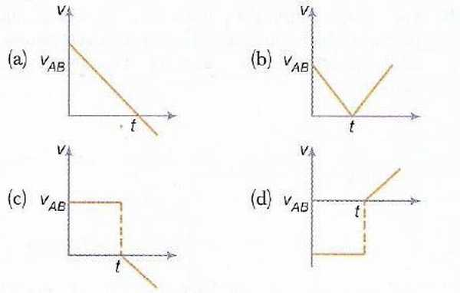

{ Hint: Before the strike, body A has velocity u-gt whereas body B has velocity -gt. So, a constant difference of u remains. Before strike, u-gto+gto=u . However , after that it is u-gt , the time being to=u/g of strike. So, the negative slope line starts from the x-axis and a discontinuity comes into picture.   
So , C) is the required graph.}

### 1.2.5 Projectile Motion

Example: A shell is fired from a gun at an angle to the horizontal. Graphs are drawn for its horizontal component of velocity *vx* and its vertical component of velocity *vy*.

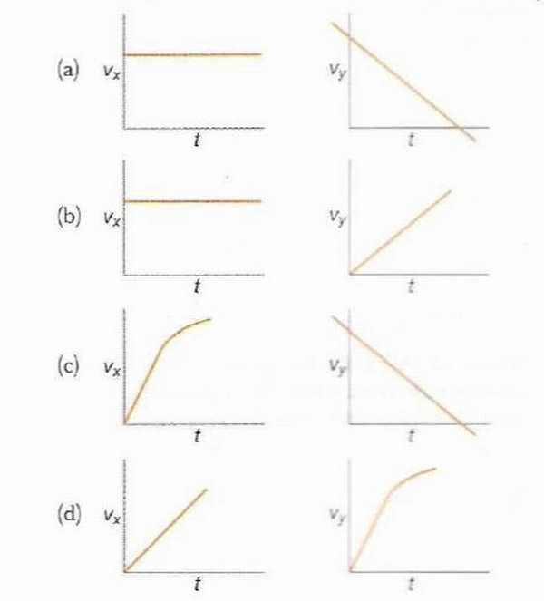

{ Hint: *vx* would remain constant as ucos*θ* and *vy* would linearly decrease and go negative after maximum height is attained(if the fire angle is +ve).  
So, a) is the requisite graph.}

### 1.2.6 Miscelleneous

Example. Figure shows the displacement-time ( x-t ) graph of body moving in a straight line. Which one of the graphs shown in Fig. represents the velocity- time ( v-t ) graph of the motion of the body.

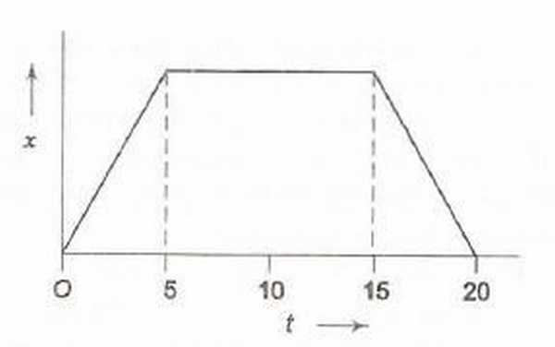

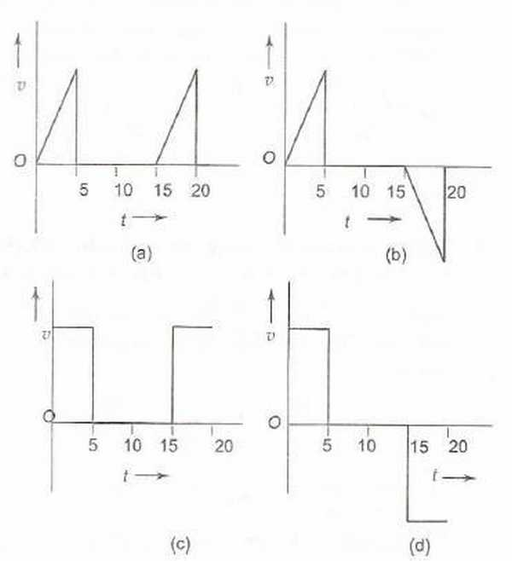

{ Hint: The graph has initially (0-5) a +ve slope, then zero slope and then (15-20) an equal -ve slope  
So, d) is the correct answer. }

Example. Which of the displacement-time (x−t) graphs shown in Fig. can possibly represent one dimensional motion of a particle?

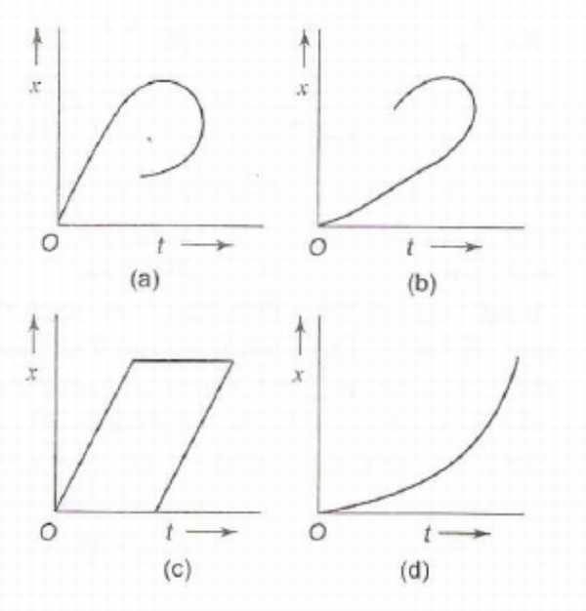

{ Hint: The object cannot be at two positions on a single time instant,  
So, d) is the correct option. }

Example. A car starts from rest, accelerates uniformly for 4 seconds and then moves with uniform velocity. Which of the (x-t) graphs shown in Fig. represents the motion of the car upto t = 7 s?

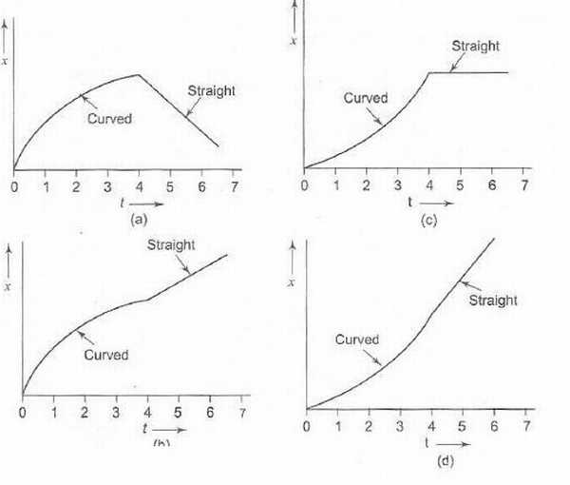

{ Hint: As the car is accelerating upto 4 seconds, the graph should be concave up. Further ahead , it moves with constant velocity , so a positive slope ahead of 4 seconds.   
d) is the correct answer. }

Example. Two stones are thrown up simultaneously with initial speeds of *u*1 and *u*2, (*u*2 > *u*1) . They hit the ground after 6 s and 10 s respectively. Which graph in Fig. correctly represents the time variation of △*x* = *x*2 − *x*1, the relative position of the second stone with respect to the first upto t = 10 s? Assume that the stones do not rebound after hitting the ground.

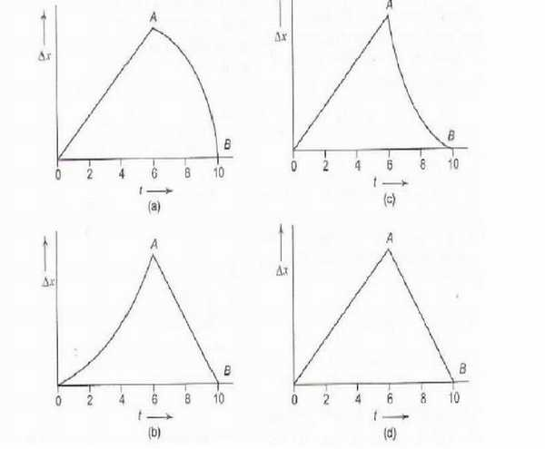

{ Hint : While both are in air, the differece of their velocity vectors would be a constant vector , so △*x* = *c*1*t* . Also, after the first stone hits ground, △*x* = *c*2*t* − *xo* as the velocity component in x direction of second stone is constant. There is no discontinutiy. So, both before and after one hits the ground , it would be a straight line.   
Hence, d) is the correct answer. }

Example. Figure shows the velocity-time (v - t) graphs for one dimensional motion. But only some of these can be realized in practice. These are

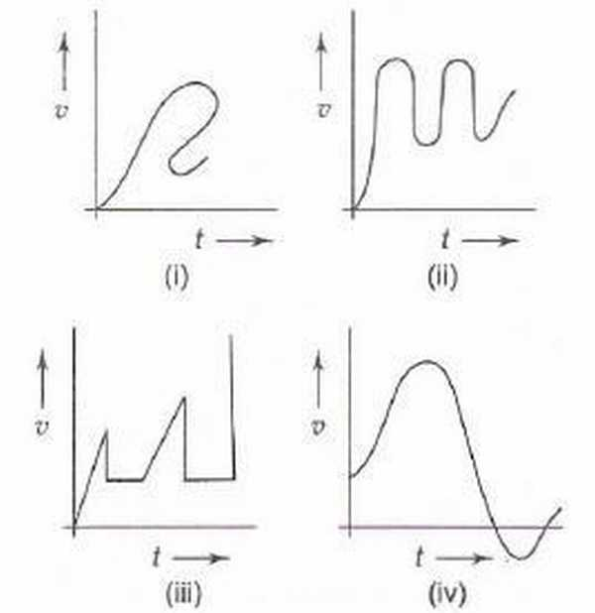

a) (i), (ii) and (iv) only  
b) (i), (ii) and (iii) only  
c) (ii) and (iv) only  
d) all  
{ Hint: At one particular instant, the object cannot have two different velocities.   
Hence, c) is the correct answer. }

Example. Which of the velocity-time (v-t) graphs shown in Fig. can possibly represent one-dimensional motion of a particle?

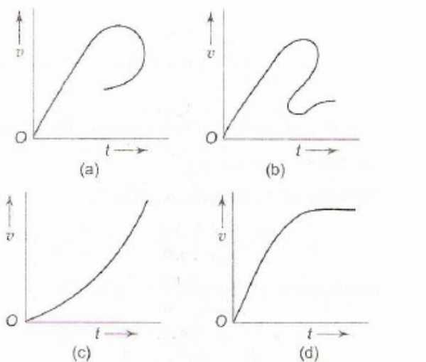

{Hint: In c) , the particle is constantly increasing in one dimension, In d) , it stops near the end.  
c),d) are the correct answers. }

## 1.3 Question Types

### 1.3.1 Passage Type

Example: The speed-time graph of the motion of a body is shown in Fig.

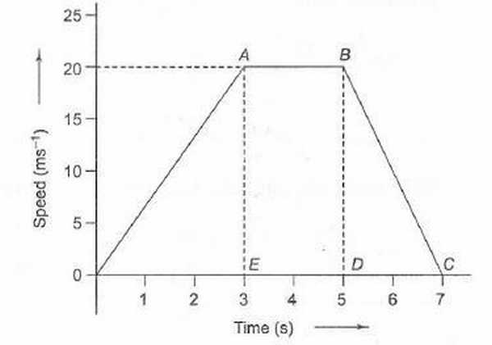

1. The accelerations of the body during the last 2 second is

a) (20)/(3)*ms*− 2  
b)  − (20)/(7)*ms*− 2  
c)  − 10*ms*− 2  
d) Zero

2. The ratio of distance travelled by the body during the last 2 seconds to the total distance travelled by it is

a) 1/9   
b) 2/9   
c) 3/9   
d) 4/9

3. The average speed of the car during the whole journey is

a) 10 m/s   
b) 20 m/s   
c) 90/7 m/s   
d) 40/7 m/s   
{Hint: 1. As no contradictory statements are present, we would take velocity as the value of speed only. Actually velocity is required for calculation of acceleration but here , speed doesn’t contradict anything so we’ll use it’s value for velocity.  
-10 from slope, c)  
2. Speed time graph’s area is distance. From area calculation, in last 2 seconds, the area is 20 and total area is 90.   
So, 2/9 is the required ration b)  
3. Total distance from area is 90, and total time is 7.   
So, 90/7. c)}

Example: A body starts from rest at time t = 0 and undergoes an acceleration as shown in Fig.Which of the graphs shown in Fig. represents the velocity-time (v-t) graph of the motion of the body from t = 0 s to t = 4 s?

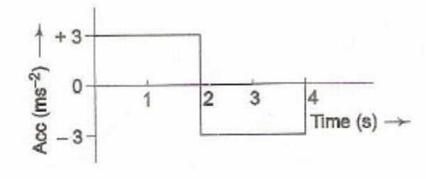

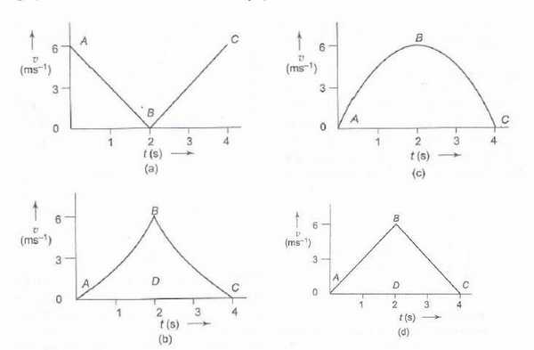

{Hint: d) is the v-t graph by calculating area function.}

1. In Question above, what is the velocity of the body at time t = 2.5 s?

a) 2.5 m/s  
b) 3.5 m/s  
c) 4.5 m/s  
d) 5.5 m/s

2. In above question, how much distance does the body cover from t = 0 s to t = 4 s?

a) 6 m  
b) 9 m  
c) 12 m  
d) 15 m

3 In above question, which of the graphs shown in Fig. represents the displacement-time (x-t) graph of the motion of the body from t = 0 s to t = 4 s?

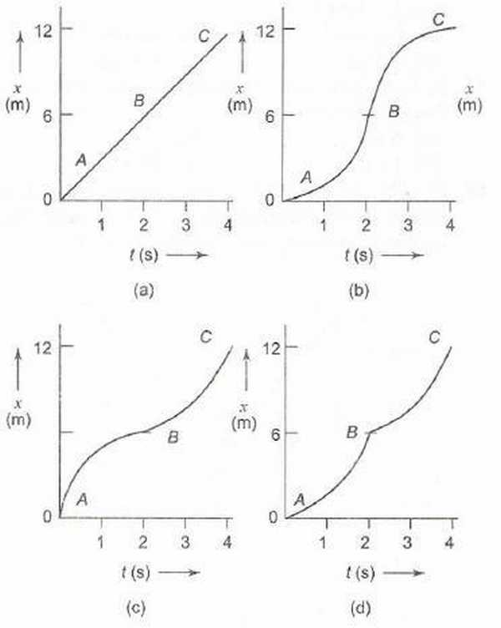

{ Hint: 1. The area under the accln-time graph gives change in velocity. Till 2.5s, 6-1.5=4.5 is the required area.   
So, c)  
2. Area under the v-t graph d) is 12 till 4 seconds.   
So, c)  
3. Till 2 seconds , the graph should be concave-up while from 2 to 4 it should be concave-down.  
So, b)  
}

### 1.3.2 Matching

1. Match the graphs (a), (b), (c) and (d) shown in Fig. with the types of motions (p), (q), (r) and (s) that they represent

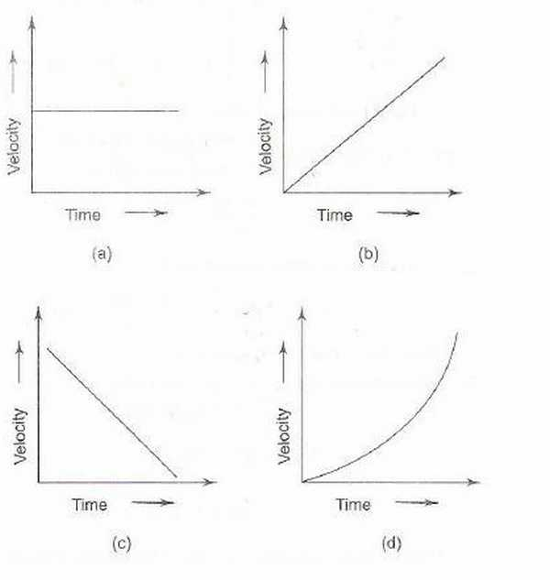

p) Motion with non-uniform acceleration  
q) Motion of a body covering equal distances in equal intervals of time  
r) Motion having a constant retardation  
s) Uniformly accelerated motion.  
{ Hint: p->d , q->a, r ->c , s->a,b,c }

2. Figure shows the displacement ·time (x - t) graph of the m-tion of a body.

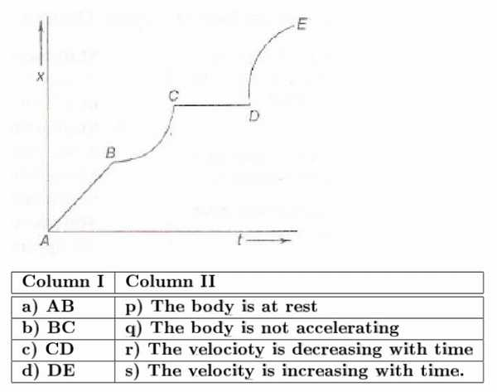

{ Hint p->c, q->a,c, r-> d , s->b }

## 1.4 [↓](" \l "index-Previous-Year-Problems-IIT)Previous Year Problems IIT

Q1: A particle starts from rest. Its acceleration ( a ) versus time ( t ) is as shown in the gure. The maximum speed of the particle will be



a ) 110 m /s   
b ) 55 m /s   
c ) 550 m /s   
d ) 660 m /s  
{ Hint : See In chapter examples for solution. }

Q2: If graph of velocity vs. distance is as shown, which of the following graphs correctly represents the variation of acceleration with displacement ?



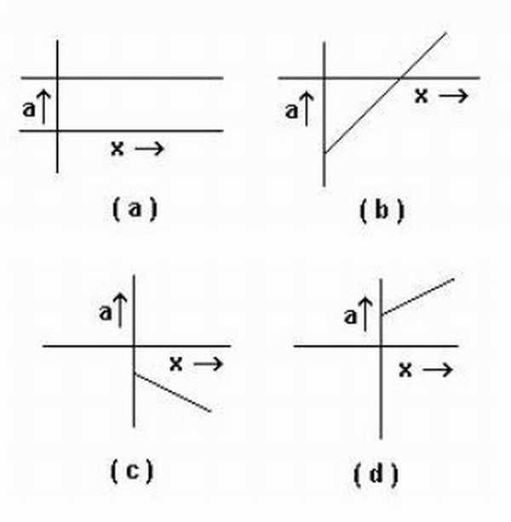

{ Hint : The graph of the question is a straight line with the equation, (*x*)/(*xo*) + (*v*)/(*vo*) = 1   
This gives , *v* = *vo*(1 − *x* ⁄ *xo*)  
So, diffrentiating it, we get  
*a* =  − *vo* ⁄ *xo* which is a constant. Only in a) it is shown to be a constant.   
So, a) }

Passage A lift is going up. The variation in the speed of the lift is as given in the graph.

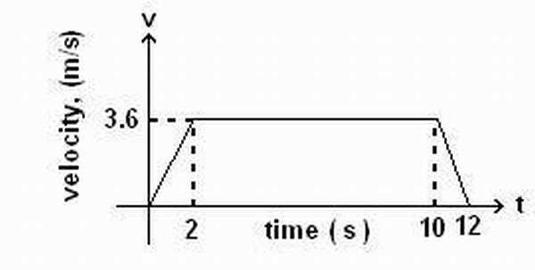

Q3: What is the height to which the lift takes the passengers ?

a ) 3.6 m   
b ) 28.8 m   
c ) 36 m  
d ) cannot be calculated from the above graph

Q4: In the above graph, what is the average velocity of the lift?

a ) 1 m/s   
b ) 2.88 m/s  
c ) 3.24 m/s   
d ) 3 m/s

Q5: In the above graph , what is the average acceleration of the lift?

a ) 1.8*m* ⁄ *s*2   
b ) −1.8*m* ⁄ *s*2   
c ) 0.3*m* ⁄ *s*2   
d ) zero   
{Hint: Q3: Area under the graph is 36. Taking initial position as zero, c) is the best fit answer.  
Q4. For av. velocity, total displacement / total time should be calculated. which is 36/12 = 3m/s . d ) is the required answer.  
Q5. The accln is 1.8 from 0s to 2s, 0 from 2s to 10s and -1.8 from 10s to 12s. So, area under the a-t graph is zero. So av. accln is zero d)  
}

Q6: Four persons K, L, M and N are initially at the corners of a square of side of length d. If every person starts moving with velocity v such that K is always headed towards L, L towards M, M towards N and N towards K, then the four persons will meet after

a ) d/v s   
b ) d2/ v s   
c ) d / 2v s   
d ) d / 2v s  
{Hint: Not a graphs question, we’ll discuss it in kinematics book. Athough an easy one. It was mistakenly added to graphs book. Let’s use it to signify the fact that even if a diagram is made, it is still not a graph.}

Example. A ball is dropped vertically from a height h above the ground. It hits the ground and bounces up vertically to a height h/2. Neglecting subsequent motion and air resistance, its velocity v varies with the height h as (see Fig.) (l.l.T. 2000)

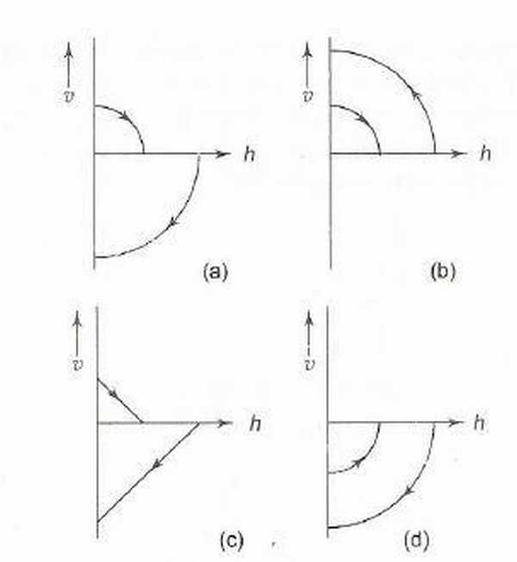

{ Hint : Case 1: Thrown from height h with zero initial velocity, v=-gt and h = *ho* − 1 ⁄ 2*gt*2, so eliminating t, we get *h* = *ho* − *v*2 ⁄ 2*g*. So, *v* =  − √(2*g*(*ho* − *h*))  
Case 2: We assume the opposite for solving purpose that the ball is now thrown from a height *ho* ⁄ 2 and replace ho only and see the effect. Taking upward velocity as positive , we get *v* = √(2*g*(*ho* ⁄ 2 − *h*))  
a) is the required answer. }

# Index

Motion Under Free Fall:

Previous Year Problems IIT:

The Average-Velocity / Instantaneous Velocity , Equal Case:

The First Equation:

The Second Equation: