# A Complete Course in Physics ( Graphs ) - First Edition

## Manas Kalia and Rajat Kalia

## July 30, 2012

Table of Contents

Chapter: Preface and Acknowledgements

Chapter 1: Concepts of Graphs

Section 1.1: The Equations of motion and the origin of Graph Handling

Subsection 1.1.1: The First Equation

Subsection 1.1.2: The Second Equation

Subsection 1.1.3: The Acceleration-Position Graph Variate

Section 1.2: Other Types of Graphs

Subsection 1.2.1: Sign of Acceleration from Position-Time Graph

Subsection 1.2.2: The Average-Velocity / Instantaneous Velocity , Equal Case

Subsection 1.2.3: The Velocity-Displacement Case

Subsection 1.2.4: Motion Under Free Fall due to Gravity

Subsection 1.2.5: Projectile Motion

Subsection 1.2.6: Miscelleneous

Section 1.3: Question Types

Subsection 1.3.1: Passage Type

Subsection 1.3.2: Matching

Section 1.4: Previous Year Problems IIT

Index

# Preface and Acknowledgements

This book is a research evaluate stuff on Kinematics covering graphs. The material has got acclaim locally and now looking for it internationally.

I would like to thank my family, well wishers for their support and consistent encouragement and most of all God for his grace and Guidance.

# 1 Concepts of Graphs

## 1.1 The Equations of motion and the origin of Graph Handling

### 1.1.1 [↓](" \l "index-The-First-Equation)The First Equation

The Equation *v* = (*dx*)/(*dt*) in linear motion implies

i) The **Slope** of **Position-Time Graph** is **Instantaneous Velocity.**

ii) The **Area** under the **Velocity-Time Graph** is **Change in Position**.

{ The second one requires the manipulation , *dx* = *vdt* i.e. ∫*dx* = ∫*vdt* }

The equations can be further manipulated to obtain the Speed Time Graph , where

speed = rate of change of distance wrt time

Few of the following examples illustrate this concept:

Example: On a displacement-time graph, two straight lines make angles of 30° and 60° with the time-axis. The ratio of the velocities represented by them is

a) 1:√(3)  
b) 1:3  
c) √(3):1  
d) 3:1

Example: A body is moving in a straight line as shown in velocity-time graph. The displacement and distance travelled by body in 8 second are respectively:

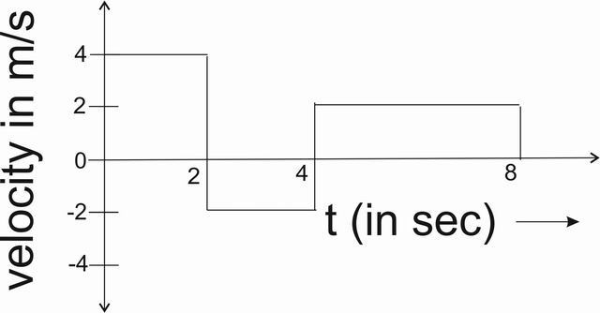

a) 12 m, 20 m  
b) 20 m, 12 m  
c) 12 m, 12 m  
d) 20 m, 20 m

Example: The graph shows position as a function of time for two trains running on parallel tracks. Which statement is true?

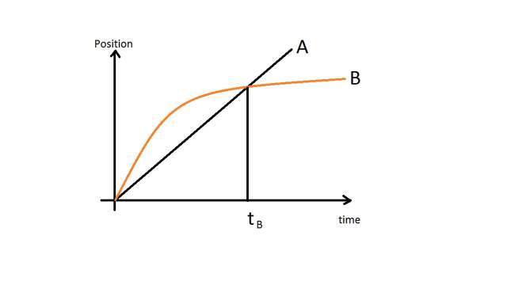

a) At time t*B* both trains have the same velocity.  
b) Both trains have the same velocity at some time after t*B* .  
c) Both trains have the same velocity at some time before t*B* .  
d) Somewhere on the graph, both trains have the same acceleration.

Example: The velocity-time graph of a particle in linear motion is as shown. Both v and t are in SI units. The displacement of the particle is

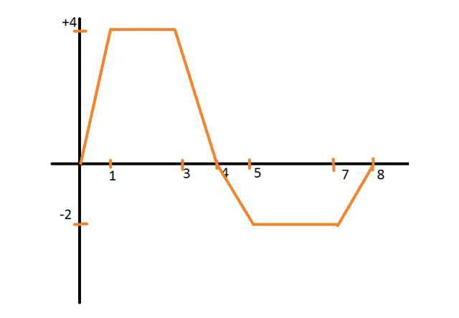

a) 6 m  
b) 8 m  
c) 16 m  
d) 18 m

### 1.1.2 [↓](" \l "index-The-Second-Equation)The Second Equation

Proceeding similar to above, the equation *a* = (*dv*)/(*dt*) implies

i) The **Slope** of **Velocity-Time Graph** is **Instantaneous Acceleration**.

ii) The **Area** under **Acceleration-Time Graph** is **Change in Velocity**.

{ The second one requires the manipulation , *dv* = *adt* i.e. ∫*dv* = ∫*adt* }

A few of the following examples illustrate it.

Example: A car starts from rest acquires a velocity v with uniform acceleration 2*ms*− 2 then it comes to stop with uniform retardation 4*ms*− 2 . If the total time for which it remains in motion is 3 sec, the total distance travelled is:

a) 2 m  
b) 3 m  
c) 4 m  
d) 6 m

Example: A particle starts from rest. Its acceleration (a) vs time (t) is as shown in the Figure. The maximum speed of the particle will be

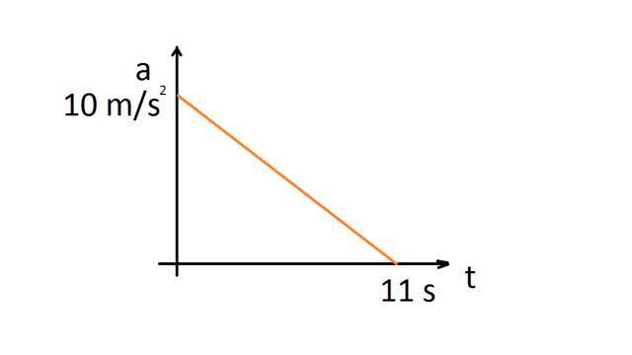

a) 110 m/s  
b) 55 m/s  
c) 550 m/s  
d) 660 m/s

Example: Acceleration-time graph of a particle moving in a straight line is shown in Figure. The velocity of particle at time t = 0 is 2 m/s. Velocity at the end of fourth second is

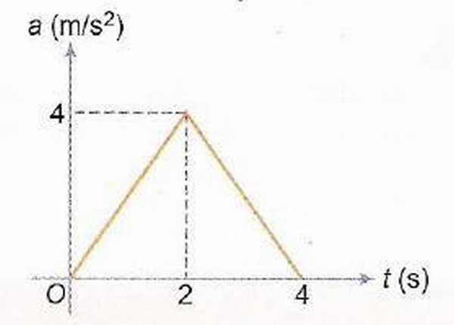

a) 8 m/s  
b) 10 m/s  
c) 12 m/s  
d) 14 m/s

Example: Each of the three graphs represents acceleration vs time for an object that already has a positive velocity at time *t*1 . Which graph/graphs show an object whose speed is increasing for the entire time interva1 between *t*1 and *t*2 ?

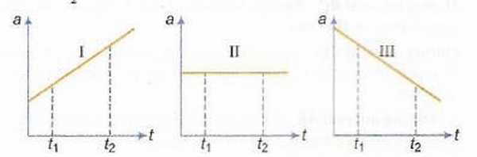

a) Graph I only  
b) Graphs I and II  
c) Graphs I and III  
d) Graphs I, II and III

Example: A body starts from rest and moves along a straight line with constant acceleration. The variation of speed v with distance s is given by the graph

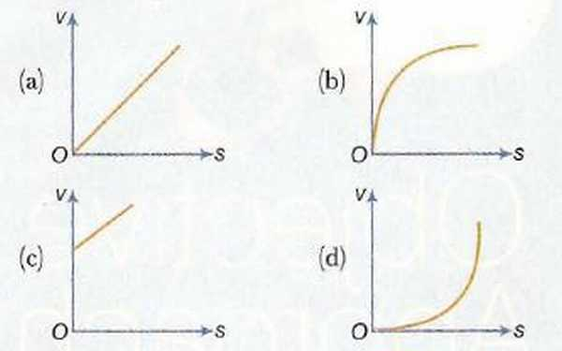

### 1.1.3 The Acceleration-Position Graph Variate

This kind of graph requires the manipulation of the Equation *a* = (*dv*)/(*dt*) as follows  
*a* = (*dv*)/(*dx*).(*dx*)/(*dt*)  
 ⇒ *a* = (*dv*)/(*dx*).*v*  
 ⇒  *adx* = *vdv* and integration can be performed to further solve it.

Example: A body, initially at rest, starts moving along x-axis in such a way that its acceleration vs displacement plot is as shown in the Figure. The maximum velocity of the particle is

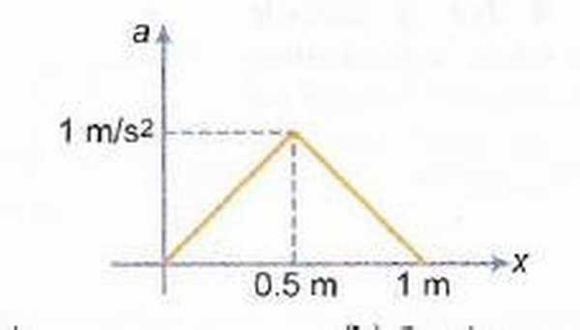

a) 1 m/s  
b) 6 m/s  
c) 2 m/s  
d) None of these

Example : A particle initially at rest, it is subjected to a non-uniform acceleration a, as shown in the figure. The maximum speed attained by the particle is

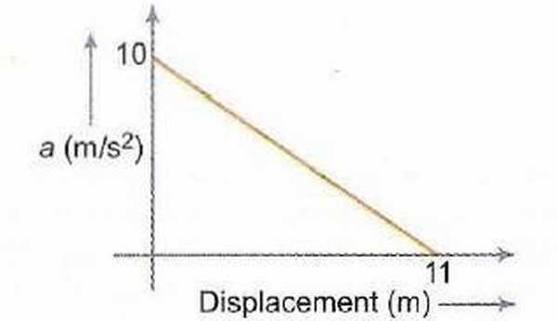

a) 605 m/s  
b) 110 m/s  
c) 55 m/s   
d) 110 m/s

## 1.2 Other Types of Graphs

### 1.2.1 Sign of Acceleration from Position-Time Graph

The sign of Acceleration can be determined from the Position-Time Graph. The methodology involves of looking at the Concavity of the Graph  
i) If the graph is Concave-Up, the Acceleration is Positive.  
ii) If the graph is Concave-Down, the Acceleration is Negative.  
iii) If the graph is a straight line, the Acceleration is ZERO. { Irrespective of any other factor , such as the slope or direction of line}

Example: The graph given below is a plot of distance vs time. For which labelled region is the “Velocity Positive and the Acceleration Negative”

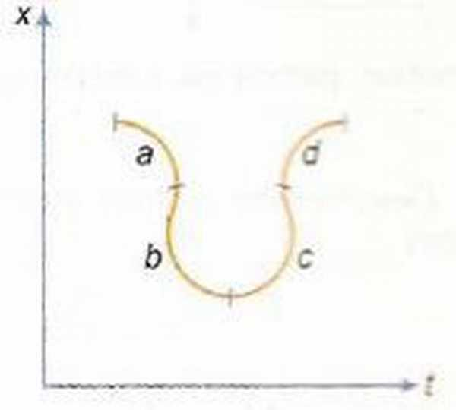

a) a  
b) b  
c) c  
d) d

### 1.2.2 [↓](" \l "index-The-Average-Velocity-/-Instantane)The Average-Velocity / Instantaneous Velocity , Equal Case

We know , that ( in a x-t graph) the slope of the Secant is the Average Velocity , whereas the slope of Tangent is the Instaneous Velocity. The point where these two lines coincide, is the point where Average Velocity is equal to Instantaneous Velocity.

Example: Position-time graph is shown which is a semicircle from t = 2 to t = 8 s. Find time t at which the instantaneous velocity is equal to average velocity over first t seconds,

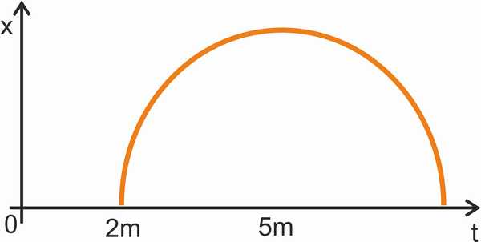

a) 4.8 s  
b) 3.2 s  
c) 2.4 s  
d) 5 s

### 1.2.3 The Velocity-Displacement Case

This can be handled in a similar way as Acceleration-Displacement case by integrating the respective equation. Here the problem is of v = f(x) type, which can be integrated by writing (*dx*)/(*dt*) = *f*(*x*)  
i.e. dx = f(x)dt

Example: The velocity-displacement graph of a particle moving along a straight line is shown here.

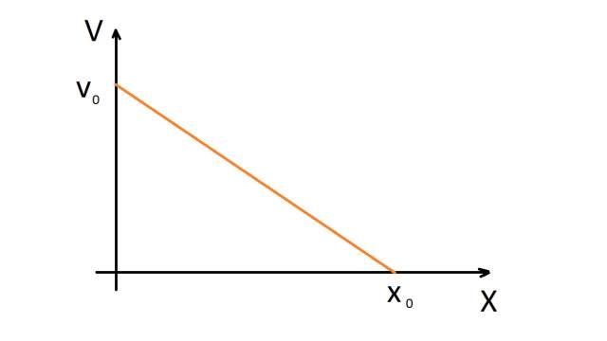

The most suitable acceleration-displacement graph will be

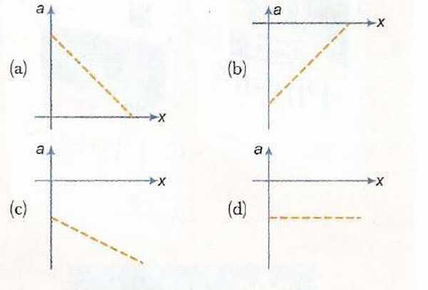

Example. The velocity (v) of a body moving along the postive x-direction varies with displacement (x) from the origin as p v = k x , where k is a constant. Which of the graphs shown in Fig. correctly represents the displacement-time (x - t) graph of the motion?

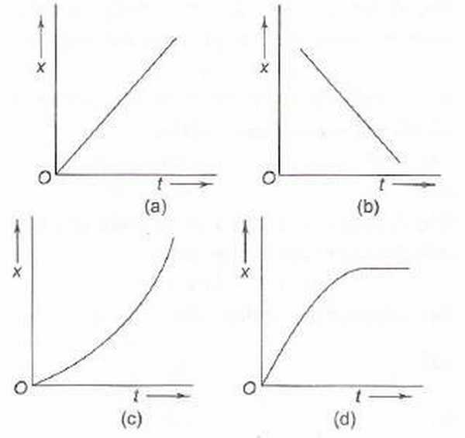

### 1.2.4 [↓](" \l "index-Motion-Under-Free-Fall)Motion Under Free Fall due to Gravity

In such examples, the governing equations rule and the coordi-nate system needs to be properly chosen.

Example: Which of the following graphs correctly represents velocity-time relationship for a particle released from rest to fall freely under gravity?

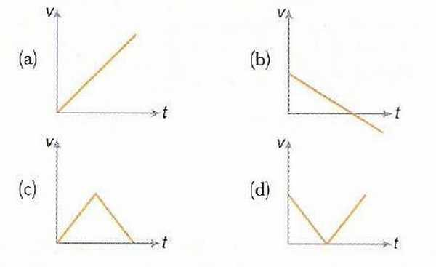

Example: The velocity-time graph of a body falling from rest under gravity and rebounding from a solid surface is represented by which of the following graphs?

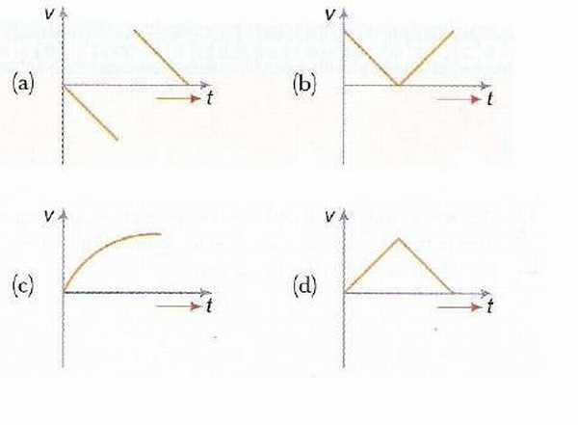

Example: A body A is thrown vertically upwards with such a velocity that it reaches a maximum height of h. Simultaneously another body B is dropped from height h. It strikes the ground and doesn’t rebound. The velocity of A relative to B vs time graph is best represented by (upward direction is positive.)

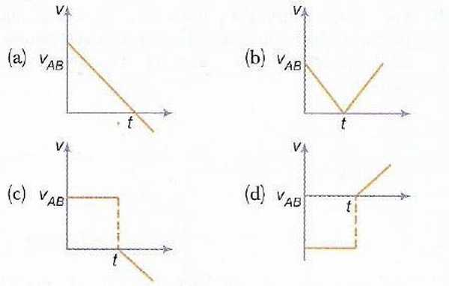

### 1.2.5 Projectile Motion

Example: A shell is fired from a gun at an angle to the horizontal. Graphs are drawn for its horizontal component of velocity *vx* and its vertical component of velocity *vy*.

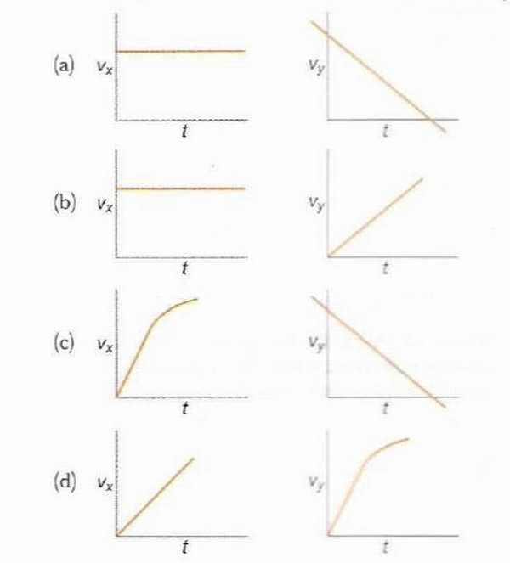

### 1.2.6 Miscelleneous

Example. Figure shows the displacement-time ( x-t ) graph of body moving in a straight line. Which one of the graphs shown in Fig. represents the velocity- time ( v-t ) graph of the motion of the body.

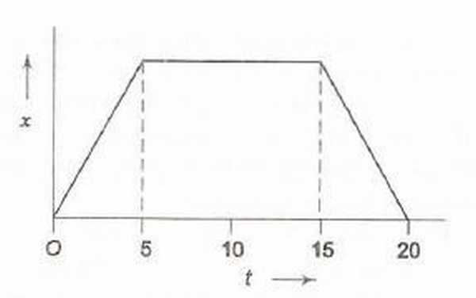

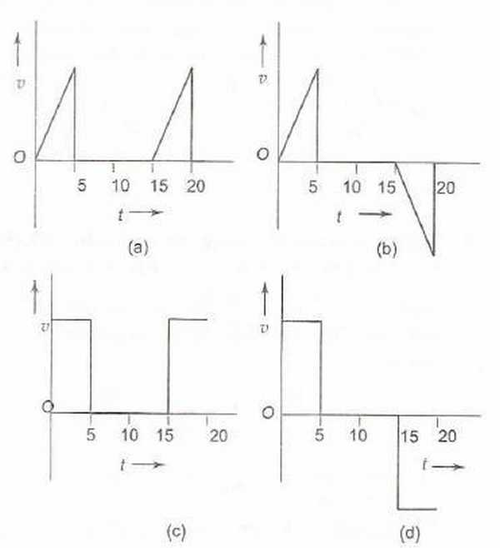

Example. Which of the displacement-time (x−t) graphs shown in Fig. can possibly represent one dimensional motion of a particle?

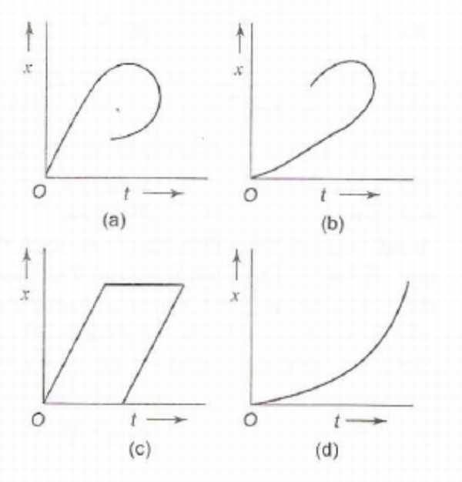

Example. A car starts from rest, accelerates uniformly for 4 seconds and then moves with uniform velocity. Which of the (x-t) graphs shown in Fig. represents the motion of the car upto t = 7 s?

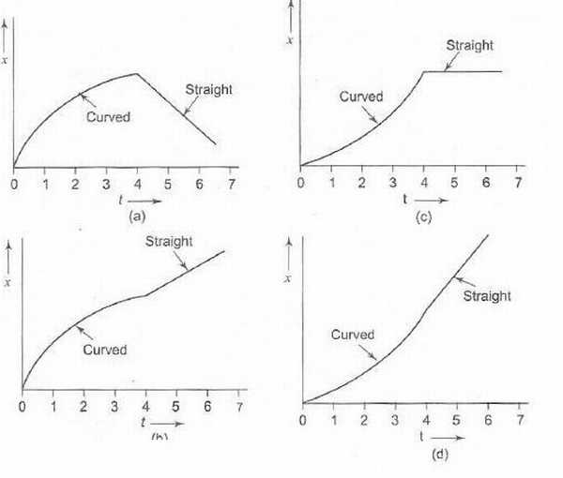

Example. Two stones are thrown up simultaneously with initial speeds of *u*1 and *u*2, (*u*2 > *u*1) . They hit the ground after 6 s and 10 s respectively. Which graph in Fig. correctly represents the time variation of △*x* = *x*2 − *x*1, the relative position of the second stone with respect to the first upto t = 10 s? Assume that the stones do not rebound after hitting the ground.

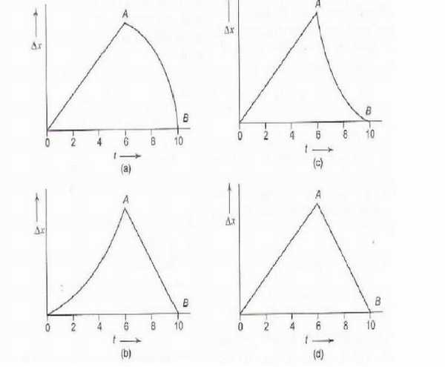

Example. Figure shows the velocity-time (v - t) graphs for one dimensional motion. But only some of these can be realized in practice. These are

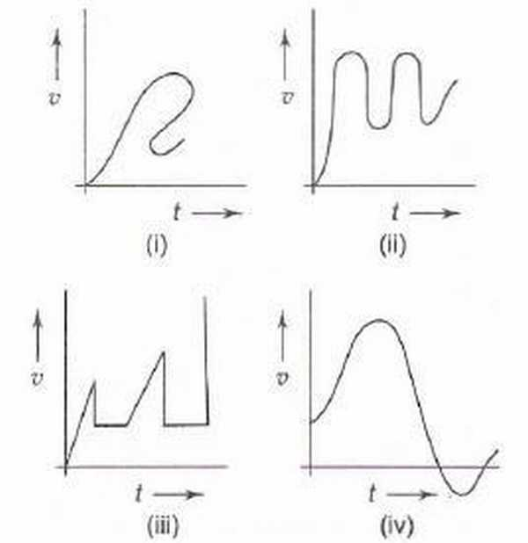

a) (i), (ii) and (iv) only  
b) (i), (ii) and (iii) only  
c) (ii) and (iv) only  
d) all

Example. Which of the velocity-time (v-t) graphs shown in Fig. can possibly represent one-dimensional motion of a particle?

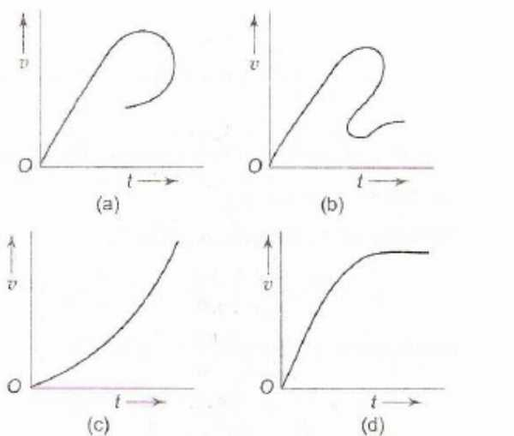

## 1.3 Question Types

### 1.3.1 Passage Type

Example: The speed-time graph of the motion of a body is shown in Fig.

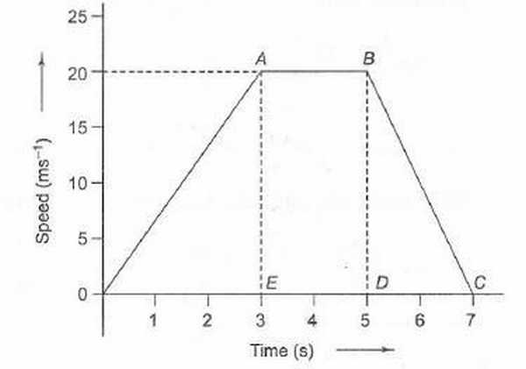

1. The accelerations of the body during the last 2 second is

a) (20)/(3)*ms*− 2  
b)  − (20)/(7)*ms*− 2  
c)  − 10*ms*− 2  
d) Zero

2. The ratio of distance travelled by the body during the last 2 seconds to the total distance travelled by it is

a) 1/9   
b) 2/9   
c) 3/9   
d) 4/9

3. The average speed of the car during the whole journey is

a) 10 m/s   
b) 20 m/s   
c) 90/7 m/s   
d) 40/7 m/s

Example: A body starts from rest at time t = 0 and undergoes an acceleration as shown in Fig.Which of the graphs shown in Fig. represents the velocity-time (v-t) graph of the motion of the body from t = 0 s to t = 4 s?

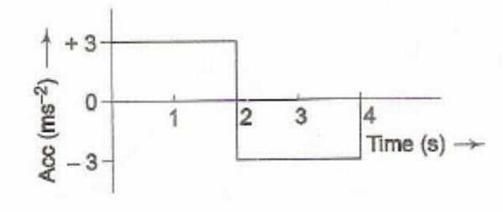

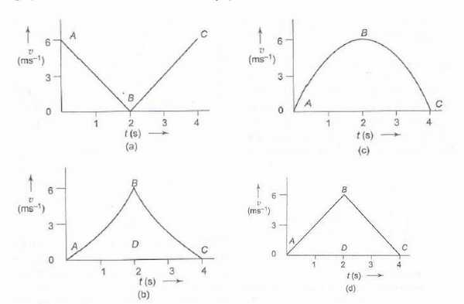

1. In Question above, what is the velocity of the body at time t = 2.5 s?

a) 2.5 m/s  
b) 3.5 m/s  
c) 4.5 m/s  
d) 5.5 m/s

2. In above question, how much distance does the body cover from t = 0 s to t = 4 s?

a) 6 m  
b) 9 m  
c) 12 m  
d) 15 m

3 In above question, which of the graphs shown in Fig. represents the displacement-time (x-t) graph of the motion of the body from t = 0 s to t = 4 s?

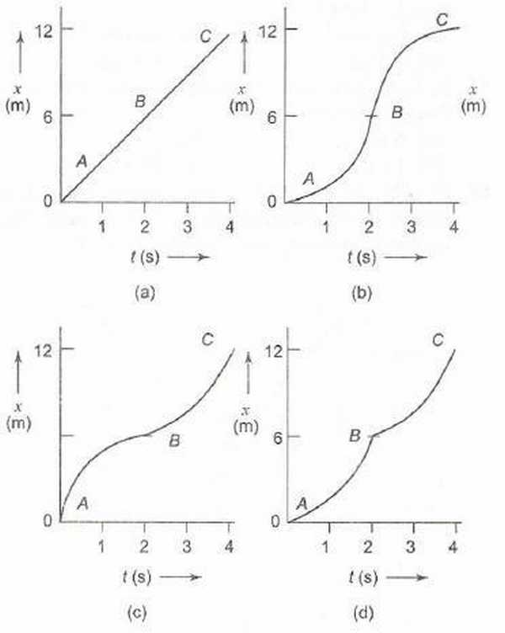

### 1.3.2 Matching

1. Match the graphs (a), (b), (c) and (d) shown in Fig. with the types of motions (p), (q), (r) and (s) that they represent

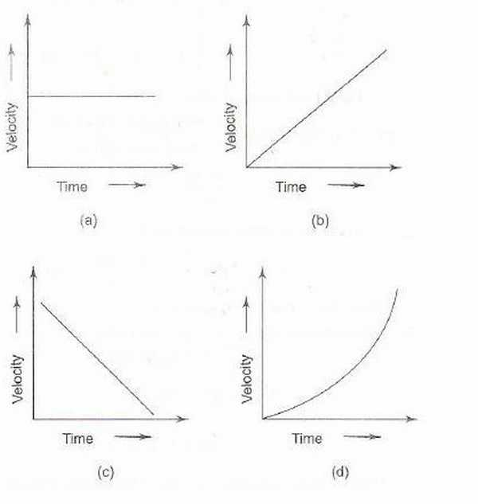

p) Motion with non-uniform acceleration  
q) Motion of a body covering equal distances in equal intervals of time  
r) Motion having a constant retardation  
s) Uniformly accelerated motion.

2. Figure shows the displacement ·time (x - t) graph of the m-tion of a body.

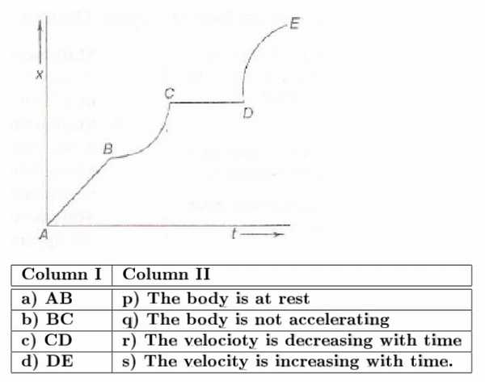

## 1.4 [↓](" \l "index-Previous-Year-Problems-IIT)Previous Year Problems IIT

Q1: A particle starts from rest. Its acceleration ( a ) versus time ( t ) is as shown in the gure. The maximum speed of the particle will be



a ) 110 m /s   
b ) 55 m /s   
c ) 550 m /s   
d ) 660 m /s

Q2: If graph of velocity vs. distance is as shown, which of the following graphs correctly represents the variation of acceleration with displacement ?



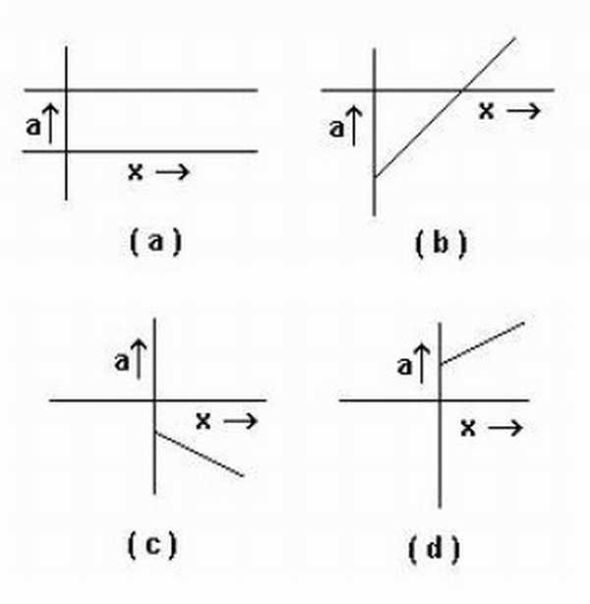

Passage A lift is going up. The variation in the speed of the lift is as given in the graph.

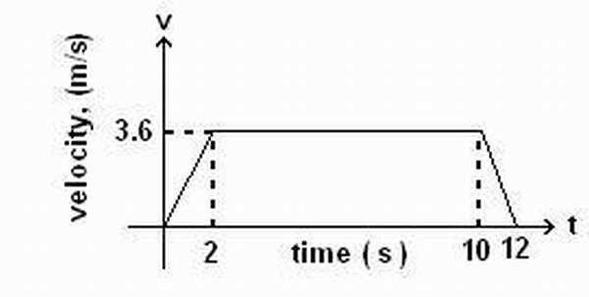

Q3: What is the height to which the lift takes the passengers ?

a ) 3.6 m   
b ) 28.8 m   
c ) 36 m  
d ) cannot be calculated from the above graph

Q4: In the above graph, what is the average velocity of the lift?

a ) 1 m/s   
b ) 2.88 m/s  
c ) 3.24 m/s   
d ) 3 m/s

Q5: In the above graph , what is the average acceleration of the lift?

a ) 1.8*m* ⁄ *s*2   
b ) −1.8*m* ⁄ *s*2   
c ) 0.3*m* ⁄ *s*2   
d ) zero

Q6: Four persons K, L, M and N are initially at the corners of a square of side of length d. If every person starts moving with velocity v such that K is always headed towards L, L towards M, M towards N and N towards K, then the four persons will meet after

a ) d/v s   
b ) d2/ v s   
c ) d / 2v s   
d ) d / 2v s

Example. A ball is dropped vertically from a height h above the ground. It hits the ground and bounces up vertically to a height h/2. Neglecting subsequent motion and air resistance, its velocity v varies with the height h as (see Fig.) (l.l.T. 2000)

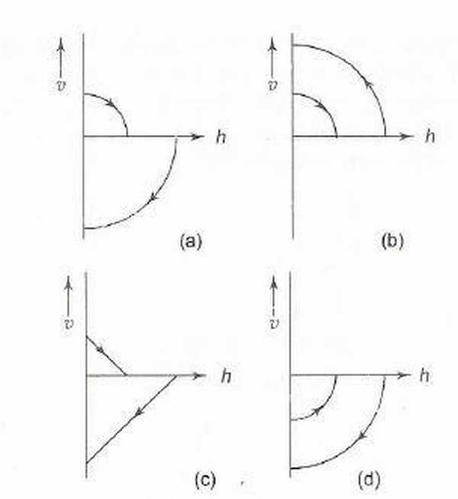

# Index

Motion Under Free Fall:

Previous Year Problems IIT:

The Average-Velocity / Instantaneous Velocity , Equal Case:

The First Equation:

The Second Equation: