# A Complete Course in Physics ( Graphs ) - Second Edition

## Manas Kalia and Rajat Kalia

## 7 December , 2016

764 41-A , Chd

Table of Contents

Part: Initiation

Chapter: Preface

Chapter: Acknowledgements

Part I: Introduction

Chapter 1: Theory

Section 1.1: Introduction

Section 1.2: Elements of a good Graph

Section 1.3: Graphical Representation of Uncertainties

Section 1.4: Curve Fitting

Section 1.5: Uncertainty in a Slope

Section 1.6: Graphical Analysis of Data

Section 1.7: EXERCISES.

Chapter 2: Common Graph Forms in Physics

Section 2.1: Linear Relationship

Section 2.2: Inverse Relationship

Section 2.3: Inverse-Square Relationship

Section 2.4: Double-Inverse Relationship

Section 2.5: Power Relationship

Section 2.6: Power Relationship 2

Section 2.7: Polynomial of Second Degree

Section 2.8: Exponential Relationship

Section 2.9: Natural Log (LN) Relationship

Part II: Kinematics

Chapter 3: Abstract Introduction

Section 3.1: Displacement-Time Graph

Section 3.2: Velocity-time graph

Section 3.3: Acceleration-time graph

Section 3.4: One More Go in a different perspective

Subsection 3.4.1: Distance-Time Graphs

Subsection 3.4.2: Displacement-time graphs

Subsection 3.4.3: Velocity-time graphs

Subsection 3.4.4: Acceleration-time graphs

Subsection 3.4.5: Self-Test Questions

Section 3.5: Revision

Subsection 3.5.1: Position vs. Time Graphs

Subsection 3.5.2: Average Velocity

Subsection 3.5.3: Average Speed

Subsection 3.5.4: Curved Position vs. Time Graphs

Subsection 3.5.5: Calculating Displacement

Subsection 3.5.6: Curved Velocity vs. Time Graphs

Subsection 3.5.7: Acceleration vs. Time Graphs

Subsection 3.5.8: Calculating Change in Velocity

Chapter 4: Few Basic Problems

Chapter 5: Theory and Problems

Section 5.1: The First Equation

Subsection 5.1.1: Problems on Position-Time Graph

Subsubsection 5.1.1.1: Subjectives

Subsubsection 5.1.1.2: MCQ

Subsection 5.1.2: Problems on Velocity-Time Graph

Subsubsection 5.1.2.1: Subjective

Subsubsection 5.1.2.2: MCQ

Subsection 5.1.3: Problems on Area Under v-t graph

Section 5.2: The Second Equation

Subsection 5.2.1: Problems on Average Velocity

Section 5.3: Miscelleneous

Chapter 6: Review Exercise I

Section 6.1: True/False

Section 6.2: Multiple Choice

Section 6.3: Completion

Chapter 7: Review Exercise II

Part III: Laws of Motion

Chapter 8: Abstract Introduction

Section 8.1: Force – Time Graphs

Section 8.2: Change in Momentum or the "Impulse"

Subsection 8.2.1: Force vs Time Graphs

Section 8.3: Impulse graphs ( A Case Study)

Chapter 9: Theory and Problems

Section 9.1: Impulse as Force-time Graph

Section 9.2: Force Time graph with respect to momentum

Part IV: Energy Conservation

Chapter 10: Abstract Introduction

Section 10.1: KINETIC ENERGY

Section 10.2: Work Done by a Variable Force

Section 10.3: The net force vs. position graph

Chapter 11: Theory and Problems

Section 11.1: Force vs. Distance graph.

Chapter 12: Review Questions I

Part V: Simple Harmonic Motion

Chapter 13: Abstract Introduction

Section 13.1: Position vs time

Section 13.2: Velocity vs time

Section 13.3: Acceleration vs time

Subsection 13.3.1: Peak Height

Section 13.4: Graphing position, velocity, and acceleration with respect to each other

Section 13.5: Position and acceleration verses velocity

Index

# Initiation

# Preface

This book is a plethora on Graphs. Usually this topic , i.e. graphs is studied with lots of hype in Coachings but unfortunately , not lots of good study material is available. This book fulfills a long felt need by students and teachers for an authorative text on graphs.

# Acknowledgements

I would like to thank my son Manas for his love and support. Moreover, the rest of the family is helpfull too.

# Part I. Introduction

# 1 Theory

## 1.1 Introduction [[1](" \l "biblio-1)]

A graph is an accurate pictorial representation of data. The accuracy of data in physics requires that graphs be made on good quality graph paper. Nearly all graphs in physics are smooth line graphs; broken line (connect the dots) graphs and bar graphs are seldom appropriate.

The style and format of a graph will depend upon its intended purpose. Three types are common in physics:

1. PICTORIAL GRAPHS. These are the kind found in mathematics and physics textbooks. Their purpose is to simply and clearly illustrate a mathematical relation. No attempt is made to show data points or errors on such a graph.

2. DISPLAY GRAPHS. These present the data from an experiment. They are found in laboratory reports, research journals, and sometimes in textbooks. They show the data points as well as a smooth line representing the mathematical relation.

3. COMPUTATIONAL GRAPHS. These are drawn for the purpose of extracting a numerical result from the data. An example is the calculation of the slope of a straight line graph, or its intercepts.

## 1.2 [↓](" \l "index-Elements-of-a-good-Graph)Elements of a good Graph

Certain informational and stylistic features are required in all graphs:

1. The graph must have a descriptive title or caption, clearly stating what the graph illustrates.

2. Data points are plotted as small dots with a sharp pencil, or as pinpricks. Some method should be used to emphasize the location of the points, for example, a neat circle drawn around each point.

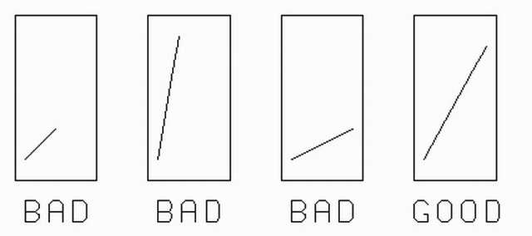

Figure :Good and bad choices of geometric slope of a graph.

3. Curves drawn through the points should be smooth (use  [A]  [A]

A French curve is a template usually made from metal, wood or plastic composed of many different curves. It is used in manual drafting to draw smooth curves of varying radii. The shapes are segments of the Euler spiral or clothoid curve. The curve is placed on the drawing material, and a pencil, knife or other implement is traced around its curves to produce the desired result.  
Modern computer-aided design (CAD) systems use vector-based graphics to achieve a precise radius, so no template is required. Digital computers can also be used to generate a set of coordinates that accurately describe an arbitrary curve, and the points can be connected with line segments to approximate the curve with a high degree of accuracy. Some computer-graphics systems make use of Bézier curves, which allow a curve to be bent in real time on a display screen to follow a set of coordinates, much in the way a French curve would be placed on a set of three or four points on paper.

French curves if your hand is not steady). The curve should stand out clearly.

4. Choose scales that are convenient to plot and easy to read.

5. Choose scales such that the graph occupies most of the page. The two scales need not have the same size units. Also, the scales need not begin at zero.

6. Indicate the name, letter symbol and units of each variable plotted on each axis.

7. All text (title, labels, etc.) should be printed.

PHYSICAL SLOPE AND GEOMETRIC SLOPE

Slope. When textbooks refer to the "slope" of a plotted graph line we mean the "physical slope"

physical slope = (Δ*y*)/(Δ*x*)

where Δy and Δx are expressed in the physical units of the x and y axes. This slope has physical significance in describing the physical data.

Geometric slope. A line which makes a 45° angle with an axis will not necessarily have a physical slope of size 1. Some authors introduce the term "geometric slope" to describe the tilt of the line on the page. This is a ratio of lengths of the legs of the triangle, without reference to the units plotted on the axes.

There is seldom (probably never) any need to calculate the geometric slope of a line on a graph. The idea is only useful when describing the appearance of the graph on the page. One rule of graph construction states that the graph should occupy most of the page. For square graph paper this suggests a geometric slope of 45°. See Fig 1-1 for examples of good and bad choices of geometric slope.

THE APPEARANCE OF THE GRAPH

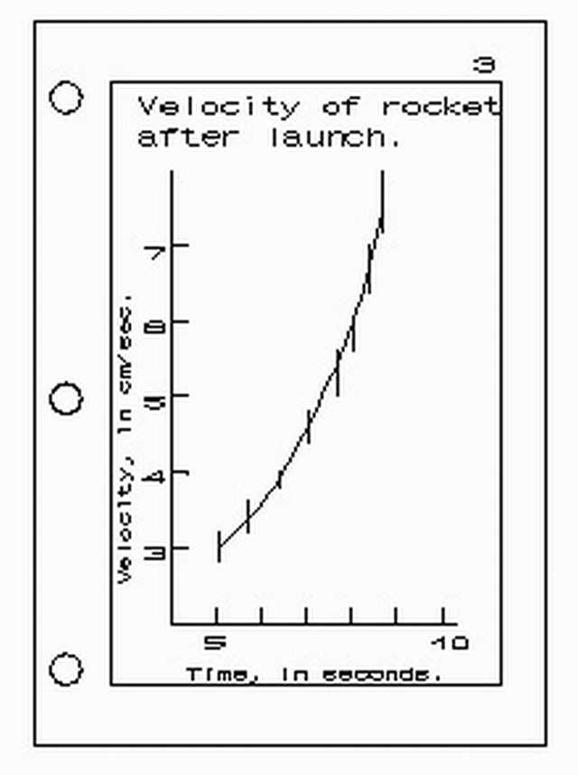

Figure : Elements of a graph.

Use quality graph paper, size 8.5 by 11 inches only.

The left margin is largest, for binding or stapling.

Nothing should be in the white margins except a page number. Axes, lettering and labeling should all be within the printed grid area. [The grid lines serve as guide lines for neat, uniform printed lettering.]

The title must be descriptive.

Both axes are labeled with the full name of the quantity (not merely its symbol), and its units.

The plotted points and curve should occupy most (more than half) of the area of the graph paper.

Sometimes a small sketch of the experimental situation may be included, located where it will not confuse the interpretation of the graph. In the same manner an equation, or short explanatory comment, may be included.

## 1.3 [↓](" \l "index-Graphical-Representation-of-Uncer)Graphical Representation of Uncertainties

Display graphs and computational graphs should clearly show the size of the experimental uncertainties (errors) in each plotted point. There are several conventional ways to do this, the commonest being the use of error bars illustrated below:

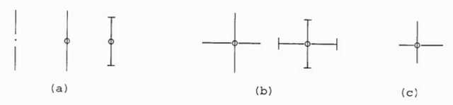

Figure : Various styles of error bars.

The plotted point is represented as a dot, and the range of uncertainty is shown by the extent of the bars on either side. The types shown in (a) are suitable where the error is entirely in one variable, or where the errors in both variables have been lumped together. The types shown in (b) are preferred where it is necessary to show the error in each variable explicitly.

When the uncertainties have a symmetric distribution about the mean, the error bars extend equally on either side of the points. If the data distributions are not symmetric, the plotted points will not be centrally located in the range of uncertainty and the error bars might look like those in Figure. part (c).

Error bars may not be necessary when the data points are so numerous that their scatter is clearly shows the uncertainty. In these cases error bars would clutter the graph making it difficult to interpret. Another situation where error bars are inapprop- riate is when the scale of the graph is such that the bars would be very small. In this case, it may be possible to indicate the uncertainty by the size of the circle or rectangle surrounding each point.

## 1.4 Curve Fitting[↓](" \l "index-Curve-Fitting)

The curve drawn through plotted data need not pass exactly through every data point. But usually the curve should pass within the uncertainty range of each point, that is, within the error bars, if the bars represent limits of error.

One principle of curve fitting is also a fundamental rule of science itself:

Assume the simplest relation consistent with the data. We are not justified in assuming a more complex relation than can be demonstrated by the data. If a curve were drawn with detail smaller than the data uncertainty, that detail would be only a guess.

This rule of simplicity may also be expressed mathematically. The mathematical relations encountered in physics may often be represented by power series such as

*y* = *A* + *Bx* + *Cx*2 + *Dx*3 + *Ex*4 + ...

where A, B, C, ... are constants.

For very "wiggly" curves, many terms of this equation, including high powers of x, might be required to express the equation of the relation. The simplest relations are those which contain the smallest powers of x. The simplest relations of all are

y = a or y = a + bx

which describe straight lines. Many relations in physics are, fortunately, of this form. Others only include the x2 term, describing a parabolic curve. Note that double valued curves, sometimes encountered in physics, cannot be represented by Equation.

When sizable amounts of data are taken, standard mathematical methods are available which generate the equation of the simplest curve which statistically "best fits" the data.

The student may wonder how one can be certain that the curve fitted to the data is the "correct" curve. The answer is that relations are never known with certainty. The uncertainty of available data always limits the certainty of the results. Someday someone may obtain more accurate data and be able to show that the old relations are slightly incorrect, and provide us with better ones. As data improves, so does our understanding of relations—this is the way of scientific progress. But we never should claim to know a relation better than the data allows.

## 1.5 [↓](" \l "index-Uncertainty-in-a-Slope)Uncertainty in a Slope

One use of a computational graph is to determine the slope of a straight line. This is illustrated in Figure. Eight data points are shown with error bars on each. If these bars represent maximum error, any line drawn to represent this data should pass within all bars.

If the error bars represent error estimates smaller than the maximum (average deviation, standard deviation, etc.), then the fitted curve need not pass within all of the error bars, just most of them.

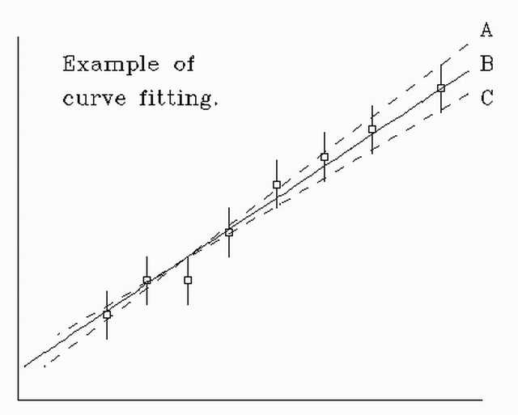

Figure : Fitting a curve.

Even a simple "manual" curve fit with a ruler can reveal the uncertainties in the slope resulting from uncertainties in the data. Figure. illustrates this process.

The dotted lines A and C fall within the error bars, and represent the maximum and minimum slope one could justify from this data. The "best" value of slope might be that of solid line B.

The third point from the left seems to limit the slope the most, and would appear to be "suspect." But one ought not to "throw it out" without better reason, based on further investigation.

## 1.6 [↓](" \l "index-Graphical-Analysis-of-Data)Graphical Analysis of Data

Graphs can be a valuable tool for determining or verifying functional relations between variables. Many special types of graph paper are available for handling the most frequently encountered relations. You are probably already familiar with linear graph paper and polar coordinate paper.

You may have purchased a packet of graph paper for this course. It includes samples of graph papers you will use in this course, and a few other types. As you read the material below, examine the corresponding papers from your packet.

LINEAR RELATIONS are those which satisfy the equation

y = mx + b

where the variables are x and y, and m and b are constants. When y is plotted against x on ordinary Cartesian (linear) graph paper, the points fall on a straight line with slope m and a y-intercept b, as shown in Fig. 1.5.

The slope of an experimental relation is often physically significant. It is obtained by choosing two well-separated points on the line (x1, y1) and (x2, y2). From Eq. 7-3:

*y*1 = *mx*1 + *b*

and *y*2 = *mx*2 + *b*

Subtract the first from the second.

(*y*2 − *y*1) = *m*(*x*2 − *x*1) .

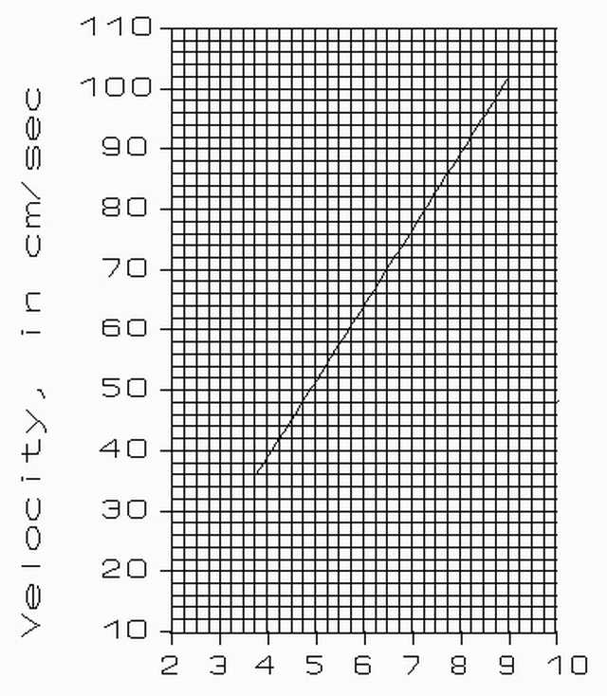

Figure : Measuring a slope on linear graph paper.

Therefore,

m = (*y*2 − *y*1)/(*x*2 − *x*1) = (Δ*y*)/(Δ*x*)

The slope of a straight line is a ratio of the "lengths" of two legs of a right triangle constructed with the legs parallel to the graph axes and with the graph line along the hypotenuse. Figure. illustrates this, the slope being Δy/Δx.

So far this discussion has been strictly mathematical. Now let’s consider a fairly realistic physical example. Figure. shows the curve from measurements of the velocity of a moving body as a function of time.

If we use letters v for velocity and t for time, we’d expect this curve to be described by the relation:

v = v*o* + at

Here the constant a (acceleration) is the slope of the line, while vo plays the role of b in Equation. These two constants are physically significant, and we wish to find their values from the graph.

We choose two points on the line at t = 4.25 and 8.75, with corresponding values of velocity: 42 cm/s and 98 cm/s. Mark these points on Figure. , to confirm these values. The slope of the line is therefore:

*a* = ((98*cm* ⁄ *s* − 42*cm* ⁄ *s*))/(8.75*s* − 4.25*s*) = (56)/(4.5) *cm* ⁄ *s*2 = 56 ⁄ 4.5 *cm* ⁄ *s*2 = 12.44*cm* ⁄ *s*2

When calculating this ratio do not use ruler-measured lengths. The lengths are expressed in the units marked on the graph axes. The calculated slope is therefore independent of the particular choice of units, of the way you choose to label the graph scale divisions, and is also independent of the size of the graph paper.

INTERCEPTS: The values of the intercepts are often physically significant. They can be simply read from the graph—if the *x* = 0 and *y* = 0 axes happen to be within the graph’s boundaries. In the equation y = mx + b, the y intercept is b.

The v intercept of Figure. is the value of v when t = 0. It has the same units and dimensions as y. If, as in this case, the v intercept does not lie within the area of the graph, it may be calculated using the slope and one value taken from a point on the fitted line. Take the point v = 98 cm/s when t = 8.75 sec.

v = v*o* + at , in our case, v = v*o* + 12.44 t

so,

v = v*o* - 12.44 t = 98 - 12.44(8.75) = -10.89 cm/s A check of the graph, Figure. , shows that this looks reasonable.

STRAIGHTENING A CURVE. When it is possible to convert an experimental relation to a straight line graph it is usually useful to do so. Look for such opportunities. For example, when studying gases at constant temperature we find that

PV = C

where P is pressure, V is the gas volume and C is constant. The graph of P vs. V is a branch of an hyperbola. But if we graph P vs. 1/V, or V vs. 1/P, the data would fall on a straight line.

*P* = ((1)/(*V*))*C*

One reason for doing this is that it is easier to fit the experimental data with a ruler-drawn straight line, than to draw the best hyperbola on a PV graph. Another advantage is that the P vs. 1/V graph has a slope

*C* = (△*P*)/(△((1)/(*V*)))

Therefore the constant C is easily determined from the straight line. This constant was not evident, nor was it easy to determine from the PV graph!

Inexpensive electronic calculators make it so easy to manipulate data that there is no good excuse to pass up an opportunity to "linearize" experimental graphs.

## 1.7 EXERCISES.

In each case state how you could plot (x,y) data on linear paper to obtain a straight line graph. What quantity in the equation is determinable from the slope of the straight line? What quantity is determinable from an intercept?

(1.1) x (y + 1) = 3

(1.2) 1/x + 1/y = 5

(1.3) *y* = *Ae*−*x*

(1.4) *y* = √(*A* − *x*)

(1.5) *y*2 + *x*2 = 7

# 2 [↓](" \l "index-Common-Graph-Forms-in-Physics)Common Graph Forms in Physics

Working with graphs – interpreting, creating, and employing – is an essential skill in the sciences, and especially in physics where relationships need to be derived. As an introductory physics student you should be familiar with the typical forms of graphs that appear in physics. Below are a number of typical physical relationships exhibited graphically using standard X-Y coordinates (e.g., no logarithmic, power, trigonometric, or inverse plots, etc.). Study the forms of the graphs carefully, and be prepared to use the program Graphical Analysis to formulate relationships between variables by using appropriate curve-fitting strategies. Note that all non-linear forms of graphs can be made to appear linear by “linearizing” the data. Linearization consists of such things as plotting X versus Y2 or X versus 1/Y or Y versus log (X), etc. Note: While a 5th order polynomial might give you a better fit to the data, it might not represent the simplest model.

## 2.1 [↓](" \l "index-Linear-Relationship)Linear Relationship

What happens if you get a graph of data that looks like this? How does one relate the X variable to the Y variable? It’s simple, Y = A + BX where B is the slope of the line and A is the Y-intercept. This is characteristic of Newton’s second law of motion and of Charles’ law:

F= ma

P/T = const.

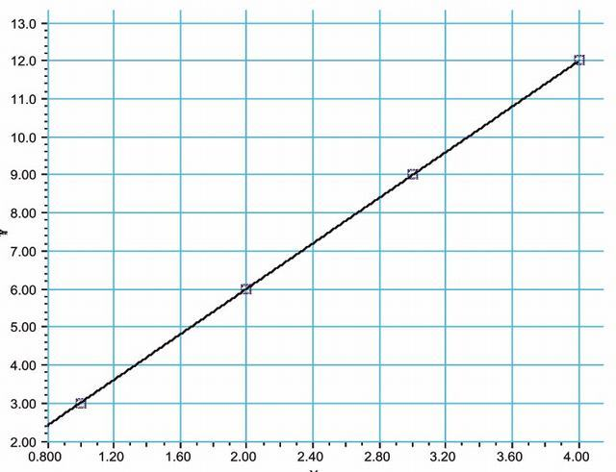

## 2.2 [↓](" \l "index-Inverse-Relationship)Inverse Relationship

This might be a graph of the pressure and temperature for a changing volume constant temperature gas. How would you find this relationship short of using a computer package? The answer is to simplify the plot by manipulating the data. Plot the Y variable versus the inverse of the X variable. The graph becomes a straight line. The resulting formula will be Y = A/X or XY = A. This is typical of Boyle’s law:

PV = const

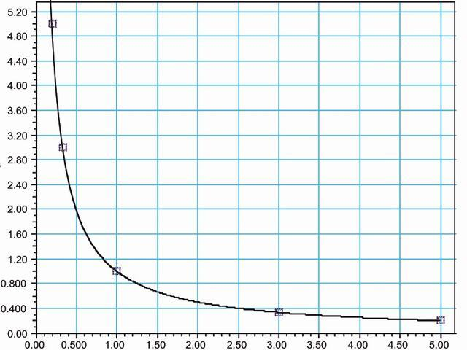

## 2.3 [↓](" \l "index-Inverse-Square-Relationship)Inverse-Square Relationship

Of the form Y = A/X2. Characteristic of Newton’s law of universal gravitation, and the electrostatic force law:

*F* = (*Gm*1*m*2)/(*r*2)

*F* = (*kq*1*q*2)/(*r*2)

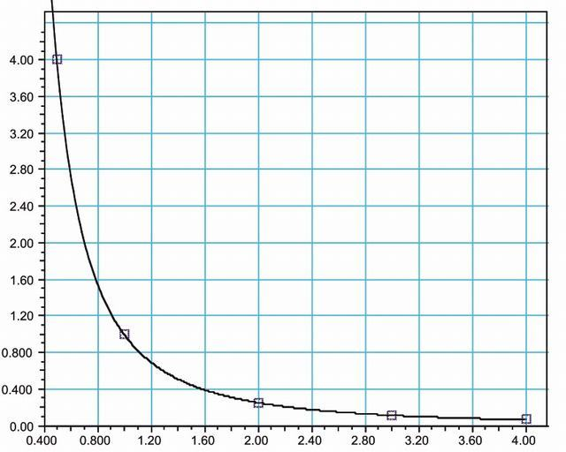

In the latter two examples above there are only subtle differences in form. Many common graph forms in physics appear quite similar. Only by looking at the “RMSE” (root mean square error provided in Graphical Analysis) can one conclude whether one fit is better than another. The better fit is the one with the smaller RMSE. See below for more examples of common graph forms in physics.

## 2.4 [↓](" \l "index-Double-Inverse-Relationship)Double-Inverse Relationship

Of the form 1/Y = 1/X + 1/A. Most readily identified by the presence of an asymptotic boundary (y = A) within the graph. This form is characteristic of the thin lens and parallel resistance formulas.

(1)/(*f*) = (1)/(*di*) + (1)/(*do*)

and

(1)/(*Rt*) = (1)/(*R*1) + (1)/(*R*2)

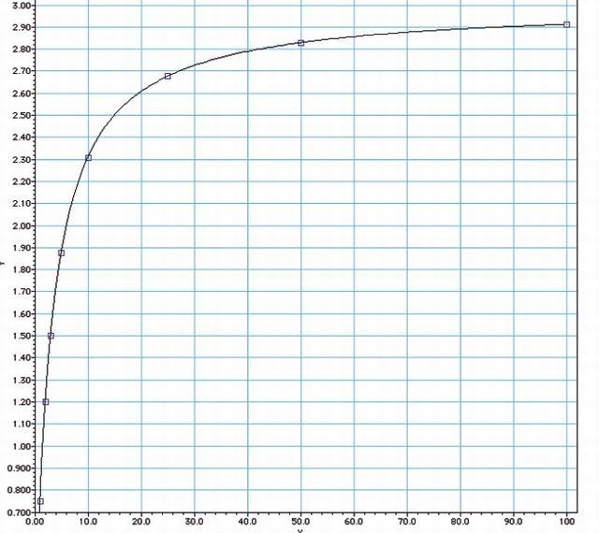

## 2.5 [↓](" \l "index-Power-Relationship)Power Relationship

Top opening parabola. Of the form *Y* = *AX*2. Typical of the distance-time relationship:

*d* = (1)/(2)*at*2

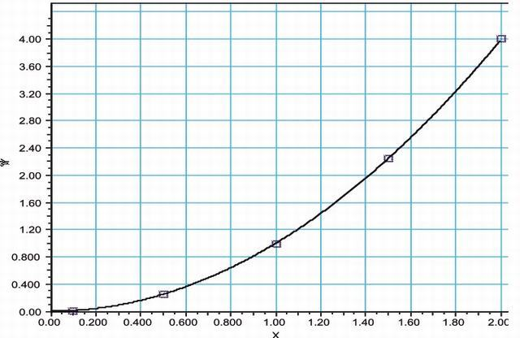

## 2.6 [↓](" \l "index-Power-Relationship-2)Power Relationship 2

Side opening parabola. Of the form *Y*2 = *A*1*X* or *Y* = *A*2*X*1 ⁄ 2. Typical of the simple pendulum relationship: *P*2 = *k*1*l* or *P* = *k*2√(*l*)

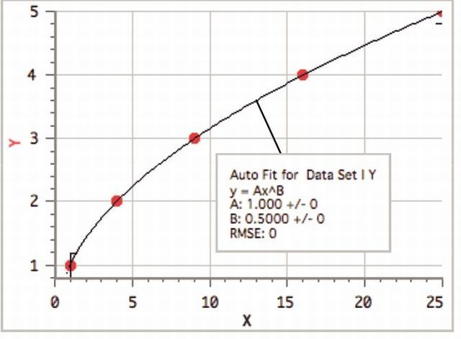

## 2.7 [↓](" \l "index-Polynomial-of-Second-Degree)Polynomial of Second Degree

Of the form *Y* = *AX* + *BX*2. Typical of the kinematics equation:

*d* = *vot* + (1)/(2)*at*2

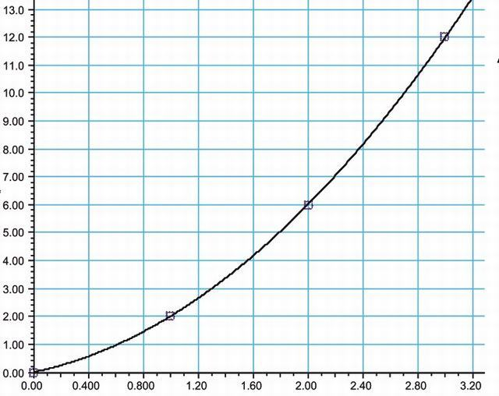

## 2.8 [↓](" \l "index-Exponential-Relationship)Exponential Relationship

Of the form Y = A * exp(BX). Characteristic of exponential growth or decay. Graph to left is exponential growth. The graph of exponential decay would look not unlike that of the inverse relationship. Characteristic of radioactive decay.

*N* = *Noe*−*λt*

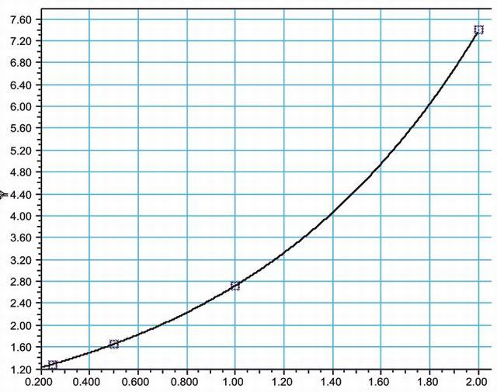

## 2.9 [↓](" \l "index-Natural-Log-(LN)-Relationship)Natural Log (LN) Relationship

Of the form Y = A ln(BX). Characteristic of entropy change during a free expansion:

*Sf*−*Si* = *nRln*(*Vf* ⁄ *Vi*)

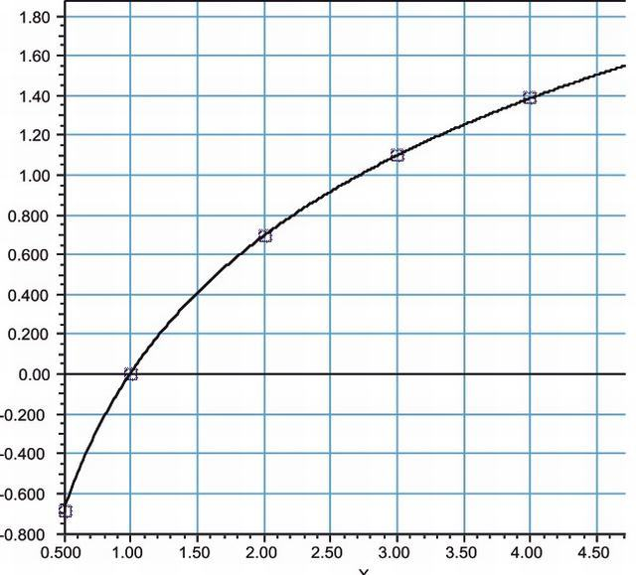

\printbibliography

# Part II. Kinematics

# 3 Abstract Introduction

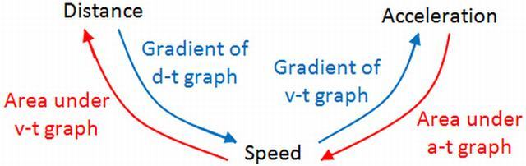

Figure : Graphical Representation of what we are going to learn in this chapter.

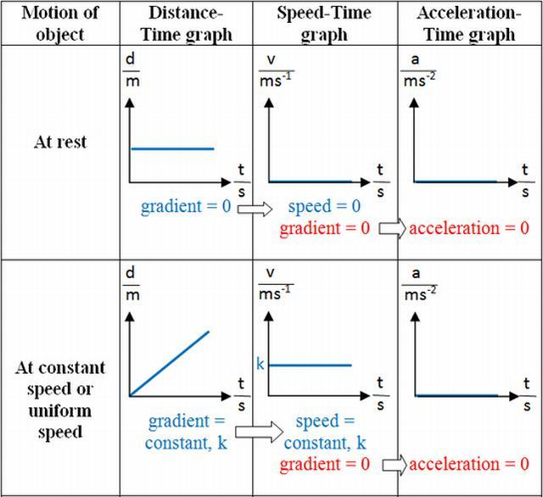

Figure : Some Graphs

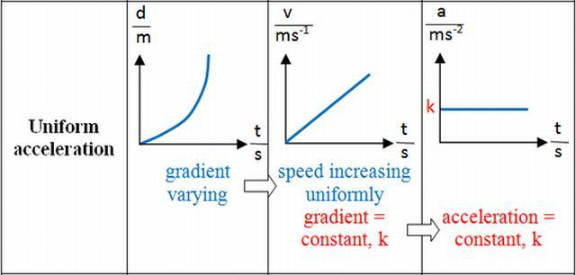

Figure : Few more graphs

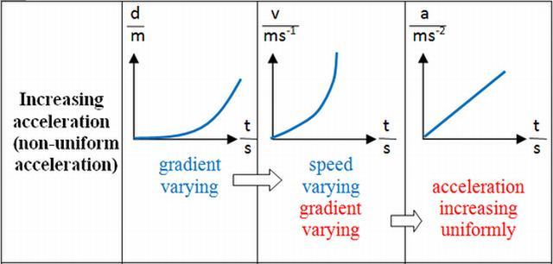

Figure : Few more

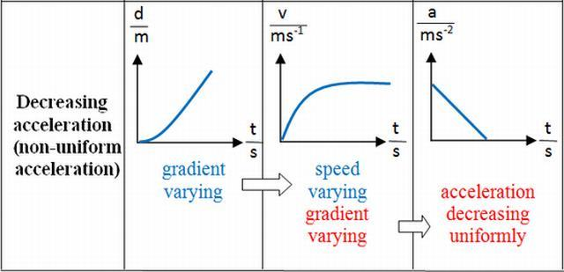

Figure : Just last in this category.

If we have a high velocity, the graph has a steep slope. If we have a low velocity the graph has a shallow slope (assuming the vertical and horizontal scale of each graph is the same).

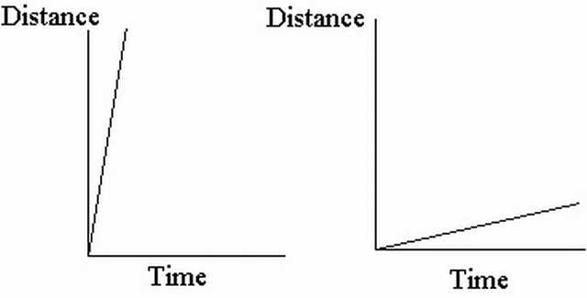

Figure : Graph comparision of high speed vs low speed. [ It may be noted that in Distance-Time Graphs , the slope is Speed (Distance and corresponding Speed both being Scalars), while in Displacement-Time Graphs, the slope is velocity(Displacement and corresponding Velocity both being Vectors).]

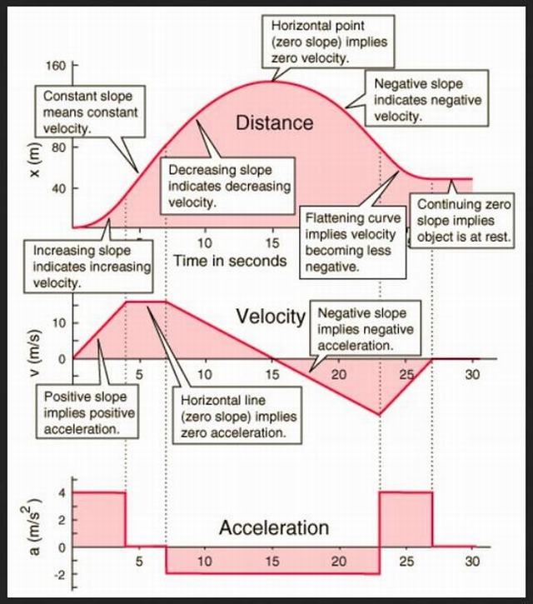

Figure : Graphical representation of the paradigms of this chapter.

## 3.1 Displacement-Time Graph

A displacement-time graph shows the positions of a moving object at different times. Fig. shows the displacement-time graph of a car. From time *t* = 0 to *t* = 5s , the car moves forwards, and at *t* = 5s it has a displacement of 60 m. Then it remains stationary there for 5 s, and finally moves back to its starting position in another 5 s.[4]

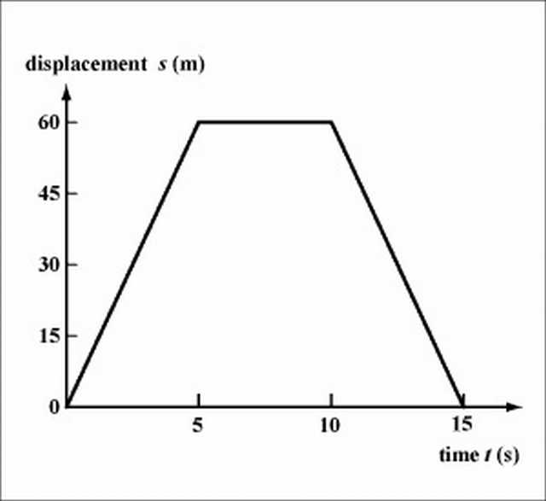

Figure : Displacement-Time Graph of the problem being discussed.

The velocity of motion can be determined from the slope of the displacement-time graph. The velocity of the car is (60)/(5) = 12*m* ⁄ *s* from t=0 to t=5s , it is zero (the car is at rest) from t=5s to t=10s and is (0-60)/(15-10) from t=10s to t=15s. The negative slope in the last 5 s indicates that the car is moving backwards. Note that the slope of the graph in each of the time intervals is a constant, showing that the car is in a uniform motion (constant velocity) in each interval.

Question : An object starts from rest and undergoes a positive, constant acceleration for ten seconds, it then continues on with constant velocity. Which of the following graphs correctly describes the situation?

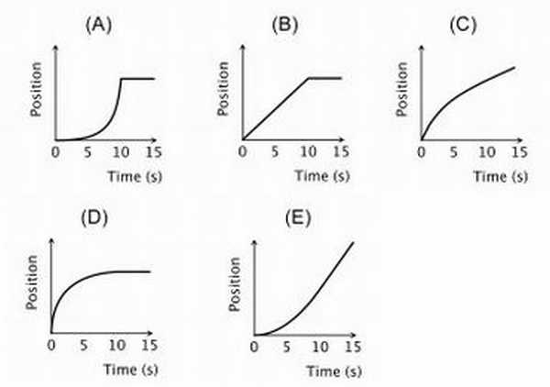

[5]

## 3.2 Velocity-time graph

A velocity-time graph shows the velocities of a moving object at different times. Figure. shows three velocity-time graphs.[4]

Fig. (a) represents motion at a constant velocity, the acceleration is zero and thus the slope of the graph is zero. Fig. represents a uniform acceleration given by

*a* = (*v* − *u*)/(*t*) = (6 − 0)/(15) = 0.4*ms*− 2

,

This is represented by the slope of the velocity-time graph. Fig. represents a uniform deceleration given by ,

*a* = (*v* − *u*)/(*t*) = (0 − 4)/(15) ≈  − 0.27*ms*− 2

which is also represented by the slope of the graph. The negative slope indicates that the object decelerates. Note that the steeper the slope, the larger is the magnitude of the acceleration.

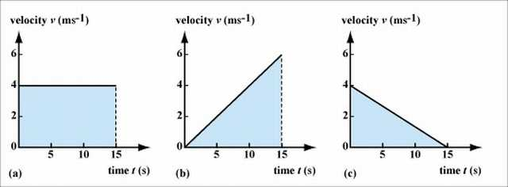

Fig. For the uniform motion shown in Fig. (a), the displacement is given by velocity  ×  time = 4  ×  15 = 60 . This is represented by the area of the rectangle under the graph. In fact, for any velocity-time graph, the displacement at a certain time can be calculated from the area under the graph. Following this rule, we can work out the displacement for an object in uniform acceleration or deceleration. For Fig. (b) , the displacement is6 × 15 ⁄ 2 = 45*m* , while for Fig. (c), the displacement is 4 × 15 ⁄ 2 = 30*m*

Fig. shows the velocity-time graph of an elevator moving upwards. The elevator is initially at rest on the ground floor. It accelerates from rest for 2.5 s, reaching a velocity of 1ms− 1, then it moves at this constant velocity for 5 s, and finally decelerates to rest in 2.5 s.

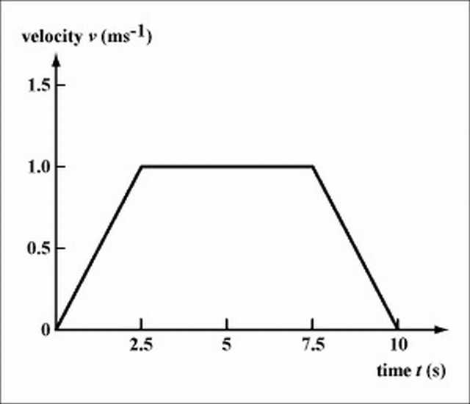

The acceleration of the elevator at each time interval can be deduced from the slope of the graph. In the first 2.5 s, the elevator accelerates at 1/2.5=0.4ms− 2 . The acceleration is zero for the next 5 s, and in the last 5 s the elevator decelerates at(0-1)/(10-7.5)=-0.4ms− 2 to rest (the negative slope indicates a deceleration). Note that for the whole trip, the elevator is going upwards.

The total displacement can be calculated from the area under the graph. In this example, the total displacement of the elevator is the area of the trapezium under the graph, i.e., total displacement =(5+10) × 1/2=7.5m.

## 3.3 Acceleration-time graph

Fig. An acceleration-time graph shows the accelerations of a moving object at different times. Fig. shows the acceleration-time graph constructed from the velocity-time graph in Fig. . It can be seen that during the first 2.5 s and the last 2.5 s, the elevator is moving with a constant acceleration and deceleration respectively, and in between it moves at a constant velocity (zero acceleration).

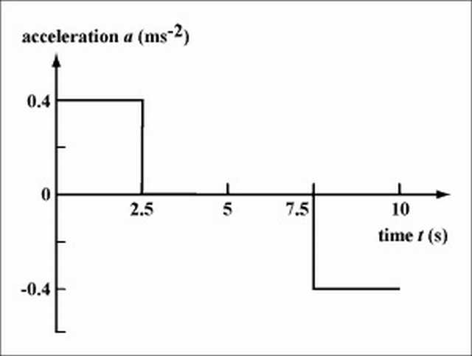

Question : Acceleration vs time graphs for five objects are shown below. All axis have the same scale. Which object has the greatest change in velocity during the interval?

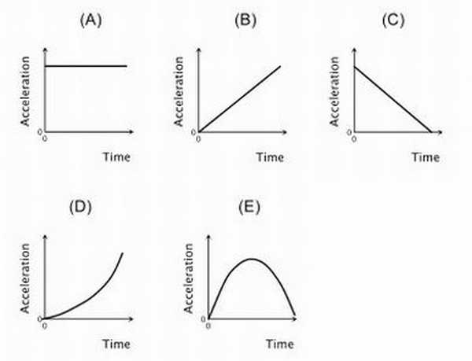

[[5](" \l "biblio-5)]

## 3.4 One More Go in a different perspective

### 3.4.1 Distance-Time Graphs

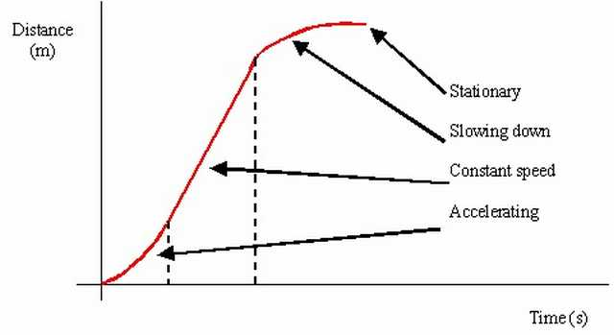

For a distance-time graph, the distance never decreases. When the object is stationary, the distance-time graph will be horizontal. The gradient of a distance-time graph is the instantaneous speed of the object. For straight line with positive gradient, it means that the object is travelling at uniform speed There is no straight line with negative gradient (as the distance never decreases) For curves, it means that the object is travelling at non-uniform speed [6]

### 3.4.2 Displacement-time graphs

The details are similar as distance-time graphs, except that the distance is now displacement, and speed is now velocity. One minor difference: There is a straight line with negative gradient, it means that the object is travelling at uniform velocity in the opposite direction.[6]

### 3.4.3 Velocity-time graphs

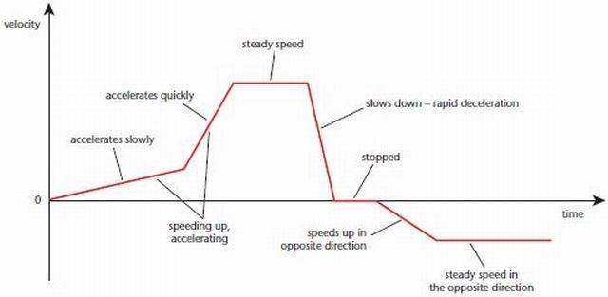

When the object is stationary, it is a straight horizontal line at 0. When the object is undergoing uniform motion, it is a straight horizontal line at vm s−1vm s−1, where v is the velocity of the object. For straight line with positive gradient, it means that the object is accelerating. For straight line with negative gradient, it means that the object is decelerating. For curves, it means that the acceleration of the object is changing. The area under the graph is the change in displacement of the object

### 3.4.4 Acceleration-time graphs

Area under graph is the change in velocity [6]

The figure below shows the displacement-time graph, velocity-time graph and acceleration-time graph for the respective state of motion. It serves as a summary of the text above.

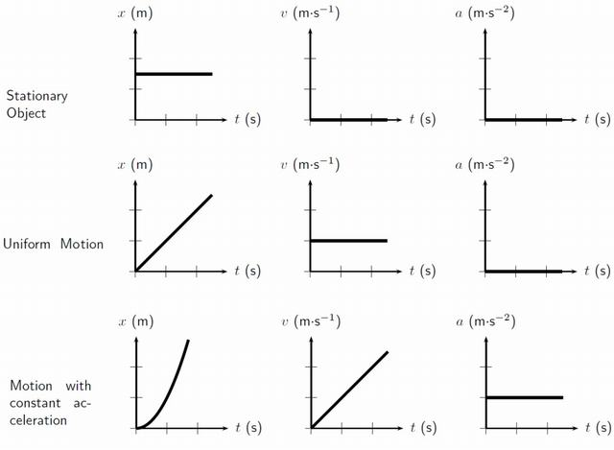

[7]

### 3.4.5 Self-Test Questions[[6](" \l "biblio-6)]

Q Can you tell from a displacement-time graph whether an object is stationary?

Answer Yes. If the object is stationary, it will appear as a horizontal line on a displacement-time graph.

Q How can you obtain the average velocity and instantaneous velocity from a displacement-time graph.

Answer The average velocity can be found by using(*total* *displacement*)/(*total* *time* *taken*)

The instantaneous velocity at a point in time can be found from the gradient of the tangent to that point in time.

Q Can you tell from a velocity-time graph whether an object is stationary?

Answer Yes. If the object is stationary, the velocity-time graph will be a horizontal line at v=0.

QHow would you obtain the acceleration of an object from a velocity-time graph? What does the area under a velocity-time graph represent?

Answer The acceleration of an object at a point in time can be obtained from the gradient of the tangent to that point in time.

The area under a velocity-time graph represents the total distance traveled.

Q Can you tell from an acceleration-time graph whether an object is stationary?

Answer No, you cannot. Do you know why?

## 3.5 Revision

Since you are not allowed to use calculators, SAT II Physics places a heavy emphasis on qualitative problems. A common way of testing kinematics qualitatively is to present you with a graph plotting position vs. time, velocity vs. time, or acceleration vs. time and to ask you questions about the motion of the object represented by the graph. Because SAT II Physics is entirely made up of multiple-choice questions, you won’t need to know how to draw graphs; you’ll just have to interpret the data presented in them. Knowing how to read such graphs quickly and accurately will not only help you solve problems of this sort, it will also help you visualize the often-abstract realm of kinematic equations. In the examples that follow, we will examine the movement of an ant running back and forth along a line.[7]

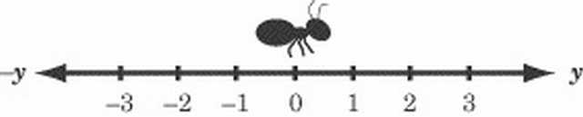

### 3.5.1 Position vs. Time Graphs

Position vs. time graphs give you an easy and obvious way of determining an object’s displacement at any given time, and a subtler way of determining that object’s velocity at any given time. Let’s put these concepts into practice by looking at the following graph charting the movements of our friendly ant.[7]

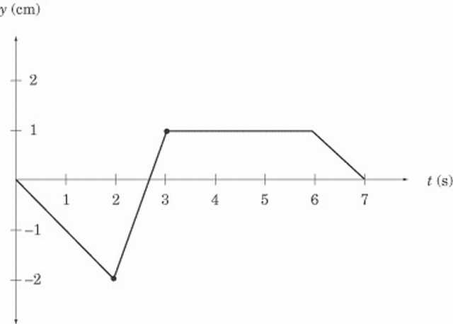

Any point on this graph gives us the position of the ant at a particular moment in time. For instance, the point at (2,–2) tells us that, two seconds after it started moving, the ant was two centimeters to the left of its starting position, and the point at (3,1) tells us that, three seconds after it started moving, the ant is one centimeter to the right of its starting position. Let’s read what the graph can tell us about the ant’s movements. For the first two seconds, the ant is moving to the left. Then, in the next second, it reverses its direction and moves quickly to y = 1. The ant then stays still at y = 1 for three seconds before it turns left again and moves back to where it started. Note how concisely the graph displays all this information. Calculating Velocity We know the ant’s displacement, and we know how long it takes to move from place to place. Armed with this information, we should also be able to determine the ant’s velocity, since velocity measures the rate of change of displacement over time. If displacement is given here by the vector y, then the velocity of the ant is

*v* = (△*y*)/(△*t*)

If you recall, the slope of a graph is a measure of rise over run; that is, the amount of change in the y direction divided by the amount of change in the x direction. In our graph, is the change in the y direction and is the change in the x direction, so v is a measure of the slope of the graph. For any position vs. time graph, the velocity at time t is equal to the slope of the line at t. In a graph made up of straight lines, like the one above, we can easily calculate the slope at each point on the graph, and hence know the instantaneous velocity at any given time. We can tell that the ant has a velocity of zero from t = 3 to t = 6, because the slope of the line at these points is zero. We can also tell that the ant is cruising along at the fastest speed between t = 2 and t = 3, because the position vs. time graph is steepest between these points. Calculating the ant’s average velocity during this time interval is a simple matter of dividing rise by run, as we’ve learned in math class.

### 3.5.2 Average Velocity

*velocity* = (*yfinal* − *yinitial*)/(*tfinal* − *tinitial*)

 = (1 − ( − 2) *cm*)/(3 − 2*s*)

=3 cm/s to the right

How about the average velocity between t = 0 and t = 3? It’s actually easier to sort this out with a graph in front of us, because it’s easy to see the displacement at t = 0 and t = 3, and so that we don’t confuse displacement and distance.

### 3.5.3 Average Speed

Although the total displacement in the first three seconds is one centimeter to the right, the total distance traveled is two centimeters to the left, and then three centimeters to the right, for a grand total of five centimeters. Thus, the average speed is not the same as the average velocity of the ant. Once we’ve calculated the total distance traveled by the ant, though, calculating its average speed is not difficult:

5cm/3s = 1.67cm/s

### 3.5.4 Curved Position vs. Time Graphs

This is all well and good, but how do you calculate the velocity of a curved position vs. time graph? Well, the bad news is that you’d need calculus. The good news is that SAT II Physics doesn’t expect you to use calculus, so if you are given a curved position vs. time graph, you will only be asked qualitative questions and won’t be expected to make any calculations. A few points on the graph will probably be labeled, and you will have to identify which point has the greatest or least velocity. Remember, the point with the greatest slope has the greatest velocity, and the point with the least slope has the least velocity. The turning points of the graph, the tops of the “hills” and the bottoms of the “valleys” where the slope is zero, have zero velocity.[7]

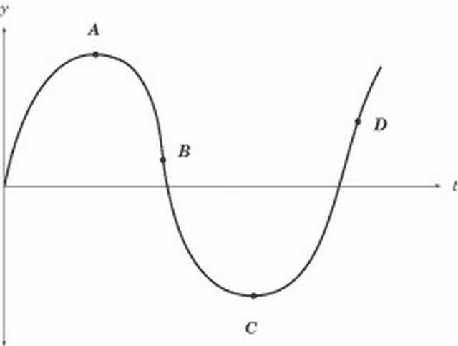

In this graph, for example, the velocity is zero at points A and C, greatest at point D, and smallest at point B. The velocity at point B is smallest because the slope at that point is negative. Because velocity is a vector quantity, the velocity at B would be a large negative number. However, the speed at B is greater even than the speed at D: speed is a scalar quantity, and so it is always positive. The slope at B is even steeper than at D, so the speed is greatest at B. Velocity vs. Time Graphs Velocity vs. time graphs are the most eloquent kind of graph we’ll be looking at here. They tell us very directly what the velocity of an object is at any given time, and they provide subtle means for determining both the position and acceleration of the same object over time. The “object” whose velocity is graphed below is our ever-industrious ant, a little later in the day.

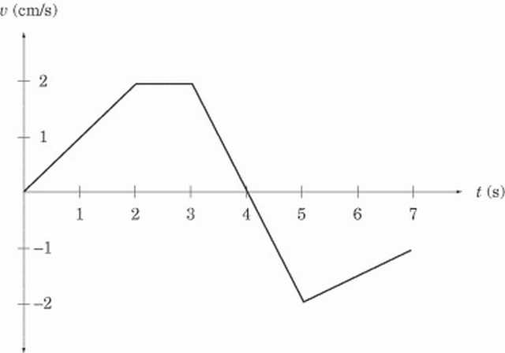

We can learn two things about the ant’s velocity by a quick glance at the graph. First, we can tell exactly how fast it is going at any given time. For instance, we can see that, two seconds after it started to move, the ant is moving at 2 cm/s. Second, we can tell in which direction the ant is moving. From t = 0 to t = 4, the velocity is positive, meaning that the ant is moving to the right. From t = 4 to t = 7, the velocity is negative, meaning that the ant is moving to the left. Calculating Acceleration We can calculate acceleration on a velocity vs. time graph in the same way that we calculate velocity on a position vs. time graph. Acceleration is the rate of change of the velocity vector, , which expresses itself as the slope of the velocity vs. time graph. For a velocity vs. time graph, the acceleration at time t is equal to the slope of the line at t. What is the acceleration of our ant at t = 2.5 and t = 4? Looking quickly at the graph, we see that the slope of the line at t = 2.5 is zero and hence the acceleration is likewise zero. The slope of the graph between t = 3 and t = 5 is constant, so we can calculate the acceleration at t = 4 by calculating the average acceleration between t = 3 and t = 5:

*velocity* = (*yfinal* − *yinitial*)/(*tfinal* − *tinitial*)

=( − 2 − (2) *cm* ⁄ *s*)/(5 − 3 *s*)

= -2 cm/s2

The minus sign tells us that acceleration is in the leftward direction, since we’ve defined the y-coordinates in such a way that right is positive and left is negative. At t = 3, the ant is moving to the right at 2 cm/s, so a leftward acceleration means that the ant begins to slow down. Looking at the graph, we can see that the ant comes to a stop at t = 4, and then begins accelerating to the right. [7]

### 3.5.5 Calculating Displacement

Velocity vs. time graphs can also tell us about an object’s displacement. Because velocity is a measure of displacement over time, we can infer that:

displacement = velocity  ×  time

Graphically, this means that the displacement in a given time interval is equal to the area under the graph during that same time interval. If the graph is above the t-axis, then the positive displacement is the area between the graph and the t-axis. If the graph is below the t-axis, then the displacement is negative, and is the area between the graph and the t-axis. Let’s look at two examples to make this rule clearer. First, what is the ant’s displacement between t = 2 and t = 3? Because the velocity is constant during this time interval, the area between the graph and the t-axis is a rectangle of width 1 and height 2.

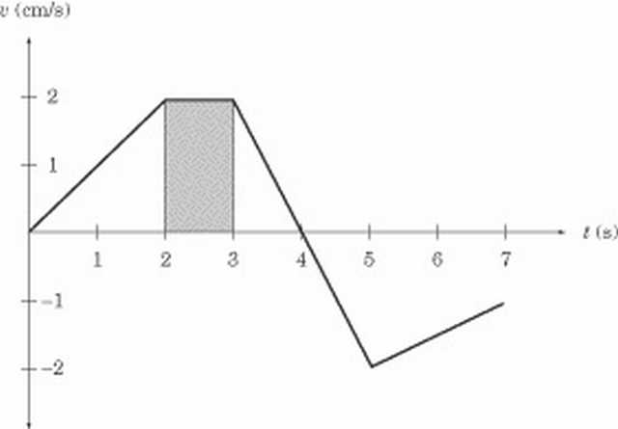

The displacement between t = 2 and t = 3 is the area of this rectangle, which is 2 cm/s.1s = 2 cm to the right. Next, consider the ant’s displacement between t = 3 and t = 5. This portion of the graph gives us two triangles, one above the t-axis and one below the t-axis.

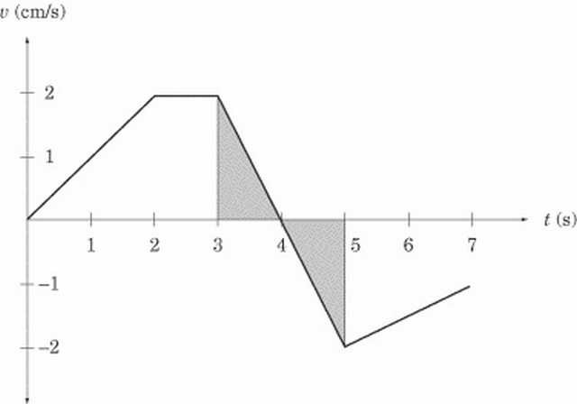

Both triangles have an area of 1 /2(1 s)(2 cm/s) = 1 cm. However, the first triangle is above the t-axis, meaning that displacement is positive, and hence to the right, while the second triangle is below the t-axis, meaning that displacement is negative, and hence to the left. The total displacement between t = 3 and t = 5 is:

In other words, at t = 5, the ant is in the same place as it was at t = 3. [7]

### 3.5.6 Curved Velocity vs. Time Graphs

As with position vs. time graphs, velocity vs. time graphs may also be curved. Remember that regions with a steep slope indicate rapid acceleration or deceleration, regions with a gentle slope indicate small acceleration or deceleration, and the turning points have zero acceleration.

### 3.5.7 Acceleration vs. Time Graphs

After looking at position vs. time graphs and velocity vs. time graphs, acceleration vs. time graphs should not be threatening. Let’s look at the acceleration of our ant at another point in its dizzy day.

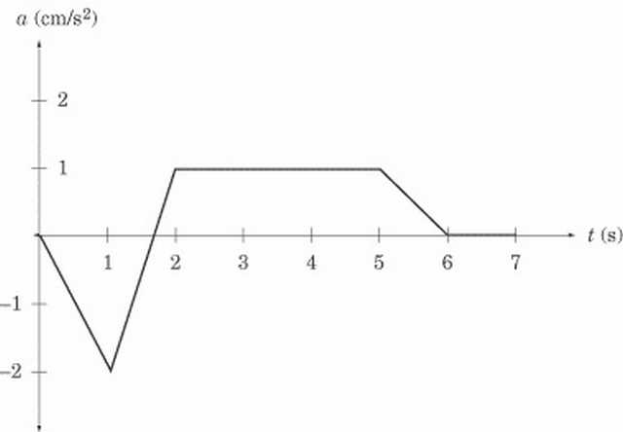

Acceleration vs. time graphs give us information about acceleration and about velocity. SAT II Physics generally sticks to problems that involve a constant acceleration. In this graph, the ant is accelerating at 1 m/s2 from t = 2 to t = 5 and is not accelerating between t = 6 and t = 7; that is, between t = 6 and t = 7 the ant’s velocity is constant.[7]

### 3.5.8 Calculating Change in Velocity

Acceleration vs. time graphs tell us about an object’s velocity in the same way that velocity vs. time graphs tell us about an object’s displacement. The change in velocity in a given time interval is equal to the area under the graph during that same time interval. Be careful: the area between the graph and the t-axis gives the change in velocity, not the final velocity or average velocity over a given time period. What is the ant’s change in velocity between t = 2 and t = 5? Because the acceleration is constant during this time interval, the area between the graph and the t-axis is a rectangle of height 1 and length 3.[[7](" \l "biblio-7)]

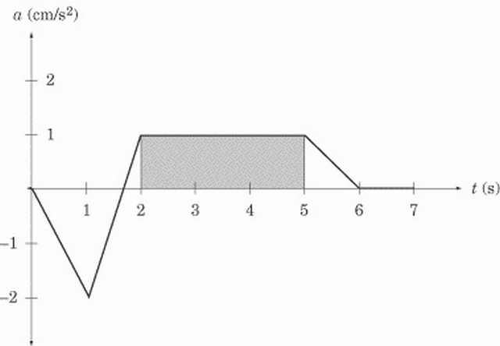

The area of the shaded region, and consequently the change in velocity during this time interval, is 1 cm/s2 · 3 s = 3 cm/s to the right. This doesn’t mean that the velocity at t = 5 is 3 cm/s; it simply means that the velocity is 3 cm/s greater than it was at t = 2. Since we have not been given the velocity at t = 2, we can’t immediately say what the velocity is at t = 5. Summary of Rules for Reading Graphs You may have trouble recalling when to look for the slope and when to look for the area under the graph. Here are a couple handy rules of thumb: The slope on a given graph is equivalent to the quantity we get by dividing the y-axis by the x-axis. For instance, the y-axis of a position vs. time graph gives us displacement, and the x-axis gives us time. Displacement divided by time gives us velocity, which is what the slope of a position vs. time graph represents. The area under a given graph is equivalent to the quantity we get by multiplying the x-axis and the y-axis. For instance, the y-axis of an acceleration vs. time graph gives us acceleration, and the x-axis gives us time. Acceleration multiplied by time gives us the change in velocity, which is what the area between the graph and the x-axis represents. We can summarize what we know about graphs in a table:

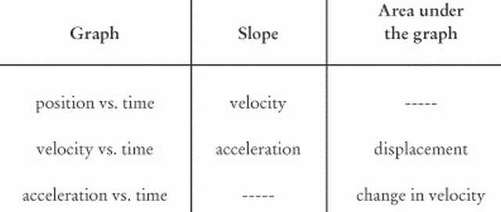

# 4 Few Basic Problems

**Problem Set 1**

Use the following graph to answer Questions #1 - #7.



1. Which object(s) is(are) maintaining a state of motion (i.e., maintaining a constant velocity)?

Answer ; Objects A, B, D, and E.

Objects A, B, D, and E are maintaining a state of motion (i.e., remaining with constant velocity) as demonstrated by the constant slope. If the slope is constant, then the velocity is constant.

2. Which object(s) is(are) accelerating?

Answer : Object C

Object C is accelerating. An accelerating object has a changing velocity. Since the slope of a p-t graph equals the velocity, an accelerating object is represented by a changing slope.

3. Which object(s) is(are) not moving?

Answer : Objects A and E.

Objects A and E are not moving. An object which is not moving has a zero velocity; this translates into a line with zero slope on a p-t graph.

4. Which object(s) change(s) its direction?

Answer : None of the objects change direction.

None of these objects change direction. An object changes its direction if it changes from a + to a - velocity (or vice versa). This translates into a p-t graph with a + slope and then a - slope (or vice versa).

5. On average, which object is traveling fastest?

Answer : Object B.

Object B is traveling fastest. To be traveling fastest is to have the greatest speed (or greatest magnitude of velocity). This translates into the line on a p-t graph with the greatest slope.

6. On average, which moving object is traveling slowest?

Answer : Object D.

Object D is traveling slowest. To be traveling slowest is to have the smallest speed (or smallest magnitude of velocity). This translates into the line on a p-t graph with the smallest slope.

7. Which object has the greatest acceleration?

Answer ; Object C.

Object C has the greatest acceleration. It is the only object with an acceleration. Accelerated motion on a p-t graph is represented by a curved line.

**Problem Set 2**

Use the following graph to answer Questions #8 - #13.



8. Which object(s) is(are) maintaining its state of motion?

Answer : Objects A and E.

Objects A and E are maintaining their state of motion. To maintain the state of motion is to keep a constant velocity (i.e., to have a zero acceleration). This translates into a zero slope on a v-t graph.

9. Which object(s) is(are) accelerating?

Answer : Objects B and C (and D during the first part of its motion).

Objects B and C are accelerating (and for a while, object D). Accelerated motion is indicated by a sloped line on a v-t graph.

10. Which object(s) is(are) not moving?

Answer : Each of the objects are moving.

Each of the objects are moving. If an object were not moving, then the v-t graph would be a horizontal line along the axis (v = 0 m/s).

11. Which object(s) change(s) its direction?

Answer : Objects B and C.

Objects B and C change their direction. An object that is changing its direction is changing from a + to a - velocity. Thus, the line on a v-t graph will pass from the + to the - region of the graph. Object D is not changing its direction; object D first moves in the - direction with increasing speed and then maintains a constant speed.

12. Which accelerating object has the smallest acceleration?

Answer : Object B.

Object B has the smallest acceleration. Acceleration is indicated by the slope of the line. The object with the smallest acceleration is the object with the smallest slope.

13. Which object has the greatest velocity?

Answer : Object A (E is a close second place).

Object A has the greatest velocity (and object E is a "close second"). The velocity is indicated by how far above or how far below the axis the line is. Object A has a large + velocity. Object E has a large (but not as large) - velocity.

**Problem Set 3**

14. Sketch a position-time graph for an object which is moving with a constant, positive velocity.

Answer : A position-time graph for an object which is moving with a constant, positive velocity is shown below. A positive, constant velocity is represented by a line with constant slope (straight) and positive slope (upwards sloping).



Graph of Question 14

15. Sketch a position-time graph for an object which is moving with a constant, negative velocity.

Answer : A position-time graph for an object which is moving with a constant, negative velocity is shown below. A negative, constant velocity is represented by a line with constant slope (straight) and negative slope (downwards sloping).



Graph of Question 15

16. Sketch a position-time graph for an object moving in the + dir’n and accelerating from a low velocity to a high velocity.

Answer : A position-time graph for an object moving in the + dir’n and accelerating from a low velocity to a high velocity is shown below. If the object is moving in the + dir’n, then the slope of a p-t graph would be +. If the object is changing velocity from small to large values, then the slope must change from small slope to large slope.



Graph of Question 16

17. Sketch a position-time graph for an object moving in the + dir’n and accelerating from a high velocity to a low velocity.

Answer : A position-time graph for an object moving in the + dir’n and accelerating from a high velocity to a low velocity is shown below. If the object is moving in the + dir’n, then the slope of a p-t graph would be +. If the object is changing velocity from high to low values, then the slope must change from high slope to low slope.



Graph of Question 17

18. Sketch a position-time graph for an object moving in the - dir’n and accelerating from a high velocity to a low velocity.

Answer : A position-time graph for an object moving in the - dir’n and accelerating from a high velocity to a low velocity is shown below. If the object is moving in the - dir’n, then the slope of a p-t graph would be -. If the object is changing velocity from high to low values, then the slope must change from high slope to low slope.



Graph of Question 18

19. Sketch a position-time graph for an object moving in the - dir’n and accelerating from a low velocity to a high velocity.

Answer : A position-time graph for an object moving in the - dir’n and accelerating from a low velocity to a high velocity is shown below. If the object is moving in the - dir’n, then the slope of a p-t graph would be -. If the object is changing velocity from low to high values, then the slope must change from low slope to high slope.



Graph of Question 19

20. Sketch a position-time graph for an object moving in the + dir’n with constant speed; first a slow constant speed and then a fast constant speed.

Answer : A position-time graph for an object moving in the + dir’n with constant speed; first a slow constant speed and then a fast constant speed is shown below. If an object is moving in the + dir’n, then the slope of the line on a p-t graph would be +. At first, the line has a small slope (corresponding to a small velocity) and then the line has a large slope (corresponding to a large velocity).



Graph of Question 20

21. Sketch a position-time graph for an object moving in the + dir’n with constant speed; first a fast constant speed and then a slow constant speed.

Answer : A position-time graph for an object moving in the + dir’n with constant speed; first a fast constant speed and then a slow constant speed is shown below. If an object is moving in the + dir’n, then the slope of the line on a p-t graph would be +. At first, the line has a large slope (corresponding to a large velocity) and then the line has a small slope (corresponding to a small velocity).



Graph of Question 21

22. Sketch a position-time graph for an object moving in the - dir’n with constant speed; first a slow constant speed and then a fast constant speed.

Answer : A position-time graph for an object moving in the - dir’n with constant speed; first a slow constant speed and then a fast constant speed is shown below. If an object is moving in the - dir’n, then the slope of the line on a p-t graph would be -. At first, the line has a small slope (corresponding to a small velocity) and then the line has a large slope (corresponding to a large velocity).



Graph of Question 22

23. Sketch a position-time graph for an object moving in the - dir’n with constant speed; first a fast constant speed and then a slow constant speed.

Answer : A position-time graph for an object moving in the - dir’n with constant speed; first a fast constant speed and then a slow constant speed is shown below. If an object is moving in the - dir’n, then the slope of the line on a p-t graph would be -. At first, the line has a large slope (corresponding to a large velocity) and then the line has a small slope (corresponding to a small velocity).



Graph of Question 23

24. Sketch a position-time graph for an object which moves in the + direction at a slow constant speed and then in a - direction at a fast constant speed.

Answer : A position-time graph for an object which moves in the + direction at a slow constant speed and then in a - direction at a fast constant speed is shown below. The object must first have a + slope (corresponding to its + velocity) then it must have a - slope (corresponding to its - velocity). Initially, the slope is small (corresponding to a small velocity) and then the slope is large (corresponding to a large velocity).



Graph of Question 24

25. Sketch a position-time graph for an object which moves in the + direction at a fast constant speed and then in a - direction at a slow constant speed.

Answer : A position-time graph for an object which moves in the + direction at a fast constant speed and then in a - direction at a slow constant speed is shown below. The object must first have a + slope (corresponding to its + velocity) then it must have a - slope (corresponding to its - velocity). Initially, the slope is large (corresponding to a large velocity) and then the slope is small (corresponding to a small velocity).



Graph of Question 25

26. Sketch a position-time graph for an object which moves in the - direction at a slow constant speed and then in a + direction at a fast constant speed.

Answer : A position-time graph for an object which moves in the - direction at a slow constant speed and then in a + direction at a fast constant speed is shown below. The object must first have a - slope (corresponding to its - velocity) then it must have a + slope (corresponding to its + velocity). Initially, the slope is small (corresponding to a small velocity) and then the slope is large (corresponding to a large velocity).



Graph of Question 26

27. Sketch a velocity-time graph for an object moving with a constant speed in the positive direction.

Answer : A velocity-time graph for an object moving with a constant speed in the positive direction is shown below. To have "a constant speed in the positive direction" is to have a + velocity which is unchanging. Thus, the line on the graph will be in the + region of the graph (above 0). Since the velocity is unchanging, the line is horizontal. Since the slope of a line on a v-t graph is the object’s acceleration, a horizontal line (zero slope) on a v-t graph is characteristic of a motion with zeo acceleration (constant velocity).



Graph of Question 27

28. Sketch a velocity-time graph for an object moving with a constant speed in the negative direction.

Answer : A velocity-time graph for an object moving with a constant speed in the negative direction is shown below. To have "a constant speed in the negative direction" is to have a - velocity which is unchanging. Thus, the line on the graph will be in the - region of the graph (below 0). Since the velocity is unchanging, the line is horizontal. Since the slope of a line on a v-t graph is the object’s acceleration, a horizontal line (zero slope) on a v-t graph is characteristic of a motion with zeo acceleration (constant velocity).



Graph of Question 28

29. Sketch a velocity-time graph for an object which is at rest.

Answer : A velocity-time graph for an object which is at rest is shown below. To be "at rest" is to have a zero velocity. Thus the line is drawn along the axis (v=0).



Graph of Question 29

30. Sketch a velocity-time graph for an object moving in the + direction, accelerating from a slow speed to a fast speed.

Answer : A velocity-time graph for an object moving in the + direction, accelerating from a slow speed to a fast speed is shown below. An object which is moving in the + direction and speeding up (slow to fast) has a + acceleration. (If necessary, review the dir’n of the acceleration vector in the Physics Classroom Tutorial.) Since the slope of a line on a v-t graph is the object’s acceleration, an object with + acceleration is represented by a line with + slope. Thus, the line is a straight diagonal line with upward (+) slope. Since the velocity is +, the line is plotted in the + region of the v-t graph.



Graph of Question 30

31. Sketch a velocity-time graph for an object moving in the + direction, accelerating from a fast speed to a slow speed.

Answer : A velocity-time graph for an object moving in the + direction, accelerating from a fast speed to a slow speed is shown below. An object whgich is moving in the + direction and slowing down (fast to slow) has a - acceleration. (If necessary, review the dir’n of the acceleration vector in the Physics Classroom Tutorial.) Since the slope of a line on a v-t graph is the object’s acceleration, an object with - acceleration is represented by a line with - slope. Thus, the line is a straight diagonal line with downward (-) slope. Since the velocity is +, the line is plotted in the + region of the v-t graph.



Graph of Question 31

32. Sketch a velocity-time graph for an object moving in the - direction, accelerating from a slow speed to a fast speed.

Answer : A velocity-time graph for an object moving in the - direction, accelerating from a slow speed to a fast speed is shown below. An object whgich is moving in the - direction and speeding up (slow to fast) has a - acceleration. (If necessary, review the dir’n of the acceleration vector in the Physics Classroom Tutorial.) Since the slope of a line on a v-t graph is the object’s acceleration, an object with - acceleration is represented by a line with - slope. Thus, the line is a straight diagonal line with downward (-) slope. Since the velocity is -, the line is plotted in the - region of the v-t graph.



Graph of Question 32

33. Sketch a velocity-time graph for an object moving in the - direction, accelerating from a fast speed to a slow speed.

Answer : A velocity-time graph for an object moving in the - direction, accelerating from a fast speed to a slow speed is shown below. An object whgich is moving in the - direction and slowing down (fast to slow) has a + acceleration. (If necessary, review the dir’n of the acceleration vector in the Physics Classroom Tutorial.) Since the slope of a line on a v-t graph is the object’s acceleration, an object with + acceleration is represented by a line with + slope. Thus, the line is a straight diagonal line with upward (+) slope. Since the velocity is -, the line is plotted in the - region of the v-t graph.



Graph of Question 33

34. Sketch a velocity-time graph for an object which first moves with a slow, constant speed in the + direction, and then with a fast constant speed in the + direction.

Answer : A velocity-time graph for an object which first moves with a slow, constant speed in the + direction, and then with a fast constant speed in the + direction is shown below. Since there are two parts of this object’s motion, there will be two distinct parts on the graph. Each part is in the + region of the v-t graph (above 0) since the velocity is +. Each part is horizontal since the velocity during each part is constant (constant velocity means zero acceleration which means zero slope). The second part of the graph will be higher since the velocity is greater during the second part of the motion.



Graph of Question 34

35. Sketch a velocity-time graph for an object which first moves with a fast, constant speed in the + direction, and then with a slow constant speed in the + direction.

Answer : A velocity-time graph for an object which first moves with a fast, constant speed in the + direction, and then with a slow constant speed in the + direction is shown below. Since there are two parts of this object’s motion, there will be two distinct parts on the graph. Each part is in the + region of the v-t graph (above 0) since the velocity is +. Each part is horizontal since the velocity during each part is constant (constant velocity means zero acceleration which means zero slope). The first part of the graph will be higher since the velocity is greater during the first part of the motion.



Graph of Question 35

36. Sketch a velocity-time graph for an object which first moves with a constant speed in the + direction, and then moves with a positive acceleration.

Answer : A velocity-time graph for an object which first moves with a constant speed in the + direction, and then moves with a positive acceleration is shown below. Since there are two parts of this object’s motion, there will be two distinct parts on the graph. Each part is in the + region of the v-t graph (above 0) since the velocity is +. The slope of the first part is zero since constant velocity means zero acceleration and zero acceleration is represented by a horizontal line on a v-t graph (slope = acceleration for v-t graphs). The second part of the graph is an upward sloping line since the object has + acceleration (again, the slope = acceleration for v-t graphs)



Graph of Question 36

37. Sketch a velocity-time graph for an object which first moves with a constant speed in the + direction, and then moves with a negative acceleration.

Answer : A velocity-time graph for an object which first moves with a constant speed in the + direction, and then moves with a negative acceleration is shown below. Since there are two parts of this object’s motion, there will be two distinct parts on the graph. Each part is in the + region of the v-t graph (above 0) since the velocity is +. The slope of the first part is zero since constant velocity means zero acceleration and zero acceleration is represented by a horizontal line on a v-t graph (slope = acceleration for v-t graphs). The second part of the graph is an downward sloping line since the object has - acceleration (again, the slope = acceleration for v-t graphs)



Graph of Question 37

# 5 Theory and Problems

## 5.1 [↓](" \l "index-The-First-Equation)The First Equation

The Equation *v* = (*dx*)/(*dt*) in linear motion implies

i) The Slope of Position-Time Graph is Instantaneous Velocity

ii) The Area under the Velocity-Time Graph is Change in Position. { The second one requires the manipulation , dx = vdt i.e. ´ ∫*dx* = ∫*vdt*}

The equations can be further manipulated to obtain the SpeedTime Graph , where

speed = rate of change of distance wrt time

Few of the following examples illustrate this concept:

### 5.1.1 Problems on Position-Time Graph

#### 5.1.1.1 Subjectives

Example : Which position-versus-time graph represents the motion shown in the motion diagram?

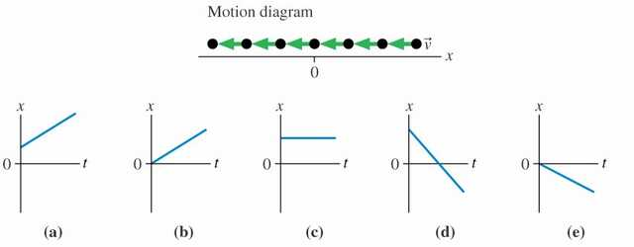

Solution :

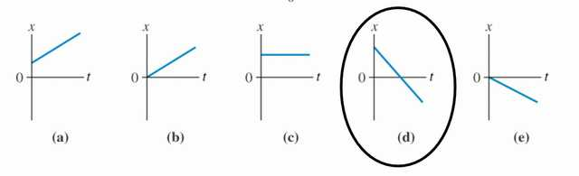

Example : Which velocity-versus-time graph goes with this position-versus-time graph on the left?

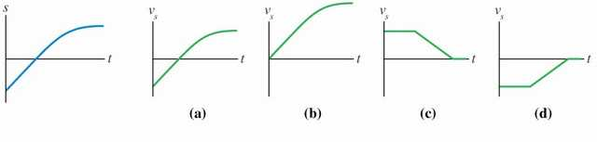

Note that the variable “s” denotes a generic Cartesian coordinate. It could be x or y.

Solution :

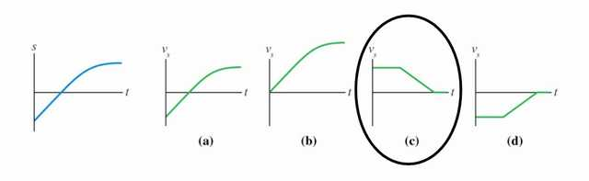

The velocity graph must match the slope of the position graph. The position graph starts with a constant positive slope. Then the slope decreases to zero.

Example : Which position-versus-time graph goes with this velocity-versus-time graph on the left? The particle’s position at ti = 0 s is xi = –10 m .

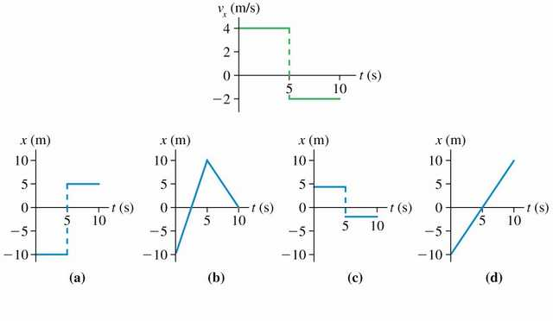

Solution :

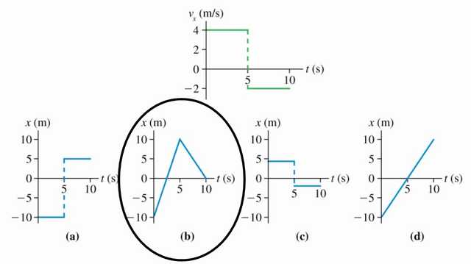

The velocity graph must match the slope of the position graph. The intercept of the position graph is arbitrary.

Example : Which velocity-versus-time graph or graphs goes with this acceleration-versus-time graph? The particle is initially moving to the right and eventually to the left.

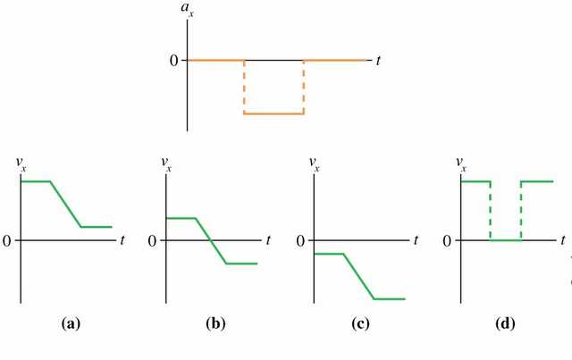

Solution :

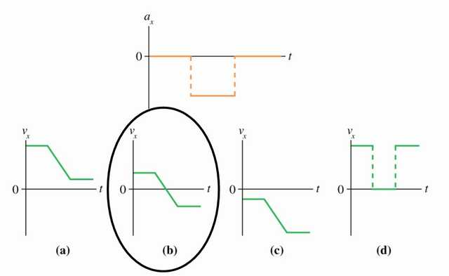

The slope of the velocity graph must match the acceleration graph. The intercept is based on the direction information.

Example : The ball rolls up the ramp, then back down. Which is the correct acceleration graph?

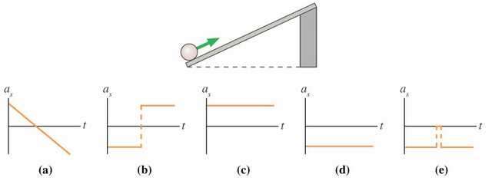

Solution :

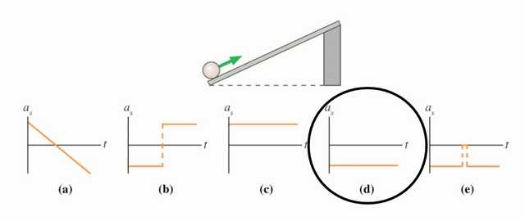

The ball will move up the ramp while slowing down, then it will reach a turnaround point and begin to move down the ramp with increasing speed. The velocity graph at right is consistent with that description. The acceleration graph shown in graph d is consistent with the requirement that it match the slope of the velocity graph.

Example : An expectant father paces back and forth producing the potison-versus-time graph shown here.

(a) Without performing a calculation indicate whether the father’s velocity is positive, negative, or zero on the segments of the graph labeled A, B, C, and C.

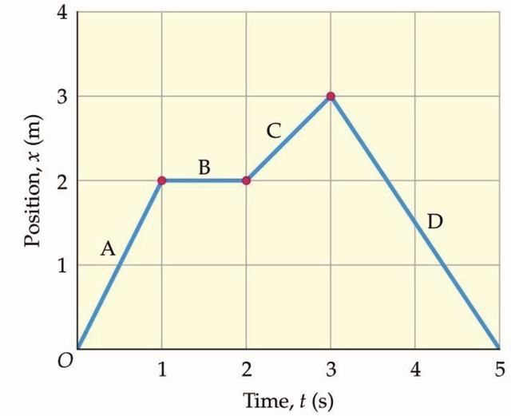

Segment A:

Segment B:

Segment C:

Segment D:

(b) Calculate the average velocity for each segment and show that your results verify your answers to part (a).

Segment A:

Segment B:

Segment C:

Segment D:

Example : 2. A motorcycle moves according to the velocity-versus-time graph shown. Find the displacement of the motorcycle for each of the segments A, B, and C.

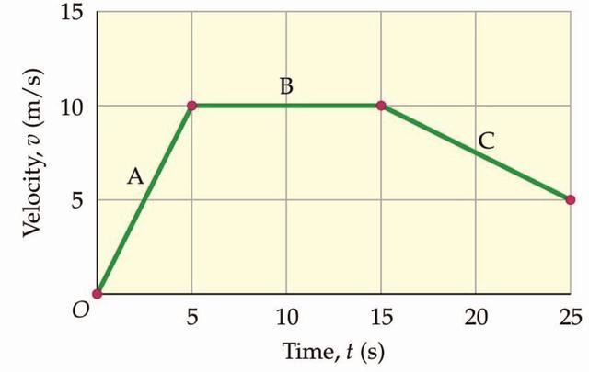

Segment A:

Segment B:

Segment C:

Example : Fig. shows the displacement-time graph of a car during parking. Describe the motion of the car and find the velocity in each time interval.[4]

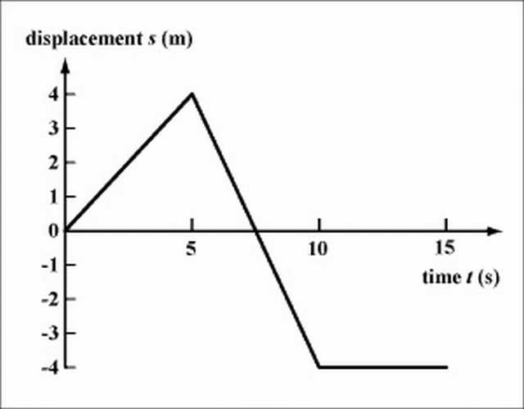

Solution: Stage 1: The car moves forwards from the origin to s=4m in the first 5 s.

v=4/5=0.8m/s (forwards)

Stage 2: The car moves backwards, passes the origin, to s=-4m in the next 5 s.

v=(-4-4)/(10-5)=-1.6m/s (backwards)

Stage 3: The car remains at rest in the last 5 s.

v=0m/s

Example : Fig. is the displacement-time graph for a car encountering a traffic light. Describe the motion of the car at each stage qualitatively.[4]

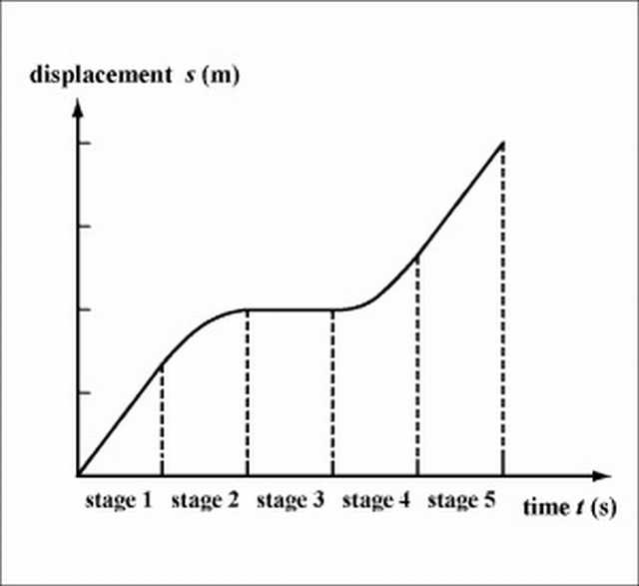

Solution : Stage 1: moving with constant velocity; stage 2: decelerating; stage 3: at rest; stage 4: accelerating; stage 5: moving with the same constant velocity as in stage 1.

Note: In stage 2 the slope of the curve is decreasing, while in stage 4 the slope is increasing. This indicates that the car is decelerating in stage 2 and accelerating in stage 4.

Example : A boy walks at a velocity of 0.5 m/s along a street for 50 s, suddenly he remembers that he has to buy something in a shop that he has passed by, so he turns around and walks at a velocity of -1 m/s for 10 s. He then stops for 30 s at the shop, and finally walks forward again at 0.5 m/s for another 20 s. Plot a displacement-time graph for the motion of the boy.[[4](" \l "biblio-4)]

Solution : See Fig.

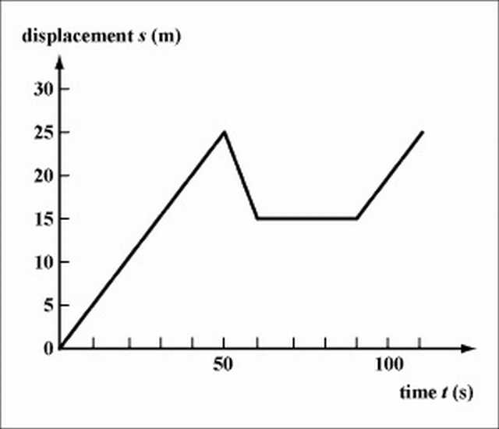

Example : A marathon runner runs at a constant \displaystyle 12 km/h.[2]

a. Express her displacement travelled as a function of time.

b. Graph the motion for 0≤*t*≤4*h*

Solution : a. *s* = 12*t*, for displacement s and time t.

b. Graph of *s* = 12*t*.

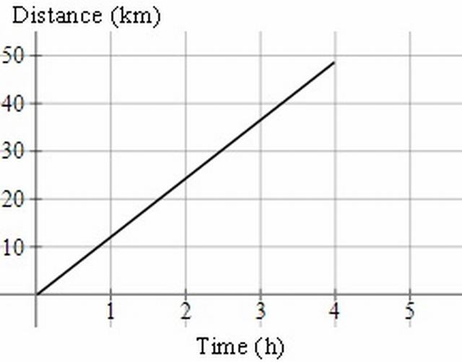

We stop the graph at (4, 48).

Example : This is the graph of a journey by sports car:[2]

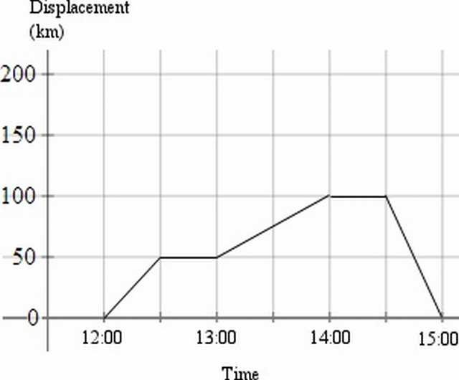

a. What is the velocity for each stage of the journey?

b. What is the average (mean) velocity for the whole journey?

Solution : a. This table outlines the stages of the journey.

|  |  |
| --- | --- |
| 12:00 to 12:30 | Travelled 50 km in30 minutes, so 100 km/h |
| 12:30 to 13:00 | Stopped |
| 13:00 to 14:00 | Travelled 50 km in 60 minutes, so 50 km/h |
| 14:00 to 14:30 | Stopped |
| 14:30 to 15:00 | Travelled 100 km back towards the starting point in 30 minutes, so −200 km/h |

b. Even though the whole journey was 200 km (100 km out and 100 km back) in 3 hours, the displacement for the journey (the distance from the starting point) is 0km.

So the average velocity is 0 km/h.

On the other hand, the average speed was (200)/(3) = 66.7  km/h

In summary,

ave velocity = (displacement)/(time)

ave speed = (distance)/(time)

Example : A particle in a magnetic field moves as follows:[[2](" \l "biblio-2)]

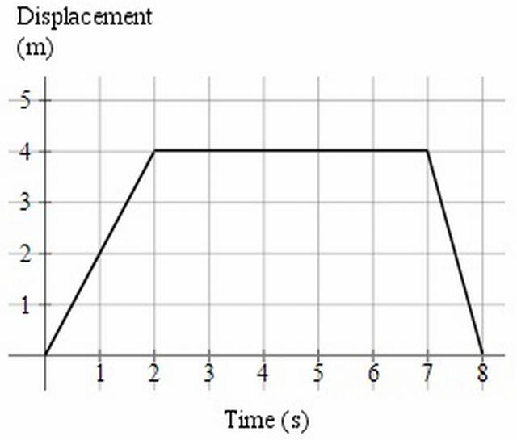

Find the velocity for each part of the motion.

Solution :

For t=0 to 2: (Δ*s*)/(Δ*t*) = (4)/(2) = 2  ms− 1

For t=2 to 7: (Δ*s*)/(Δ*t*) = (0)/(5) = 0  ms− 1

For t=7 to 8:(Δ*s*)/(Δ*t*) = ( − 4)/(2) =  − 4  ms− 1

(The velocity is negative, since the particle is going in the opposite direction.)

#### 5.1.1.2 MCQ

Example: On a displacement-time graph, two straight lines make angles of 30° and 60° with the time-axis. The ratio of the velocities represented by them is

a) 1 : √3

b) 1 : 3

c) √3:1

d) 3 : 1

Example : The graph shows position as a function of time for two trains running on parallel tracks. Which statement is true?

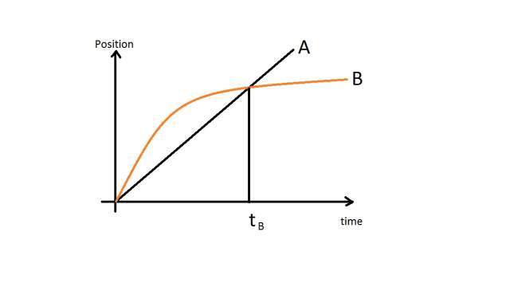

a) At time t*B* both trains have the same velocity.

b) Both trains have the same velocity at some time after t*B* .

c) Both trains have the same velocity at some time before t*B* .

d) Somewhere on the graph, both trains have the same acceleration.

### 5.1.2 Problems on Velocity-Time Graph

#### 5.1.2.1 Subjective

Example : Fig. shows the velocity-time graph of a train travelling from station 1 to station 2. The train moves along a straight railway.

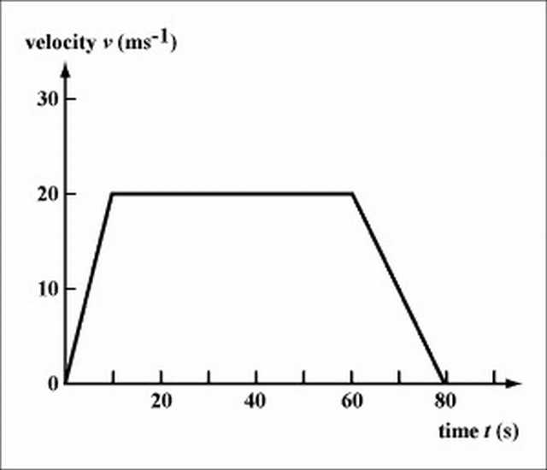

Describe the motion of the train, stating the acceleration and velocity in each stage. What is the displacement of station 2 from station 1?

Solution : From t=0 to t=10s , the train accelerates from v=0 to v=20m/s .

a=20/10=2 m s− 2

From t=10s to t=60s , the train moves at a constant velocity v=20m/s. a=0 .

From t=60s to t=80s , the train decelerates from v=20m/s back to v=0m/s .

a=(0-20)/(80-60)=-1m s− 2

Total displacement = the area under the velocity-time graph

*s* = ((80 + 50))/(2) × 20 = 1300*m*

Example : A car is initially moving at a velocity of 36 . Suddenly the driver sees a girl running across of the road at 13 m in front of the car. It takes 0.5 s for the driver to react and start braking the car. The car then takes one more second to stop. Plot the velocity-time graph for the car, starting from the time when the driver sees the girl. What is the deceleration of the car? Would the car hit the girl?

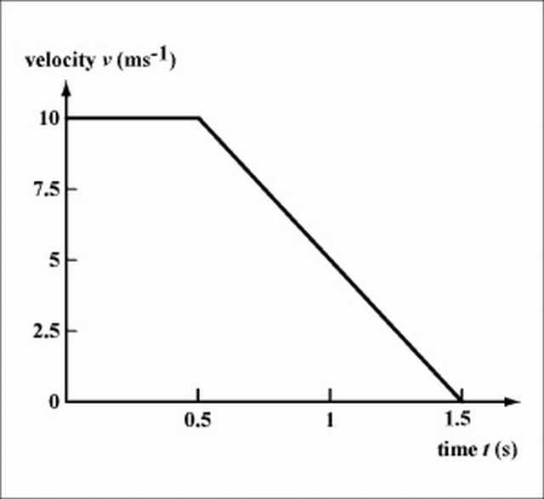

Solution : See Fig. . The car decelerates at 10 ms− 2. It travels a total distance of (0.5+1.5)*10/2=10m , so it would not hit the girl, but stop at a distance of 3 m from the girl.

Note: The total distance travelled by the car after the driver seeing the danger is called the stopping distance. See the next chapter for more analysis on car braking.

Example ; Fig. shows the displacement-time graph of an object. Plot its velocity-time graph. Find the average velocity of the object.

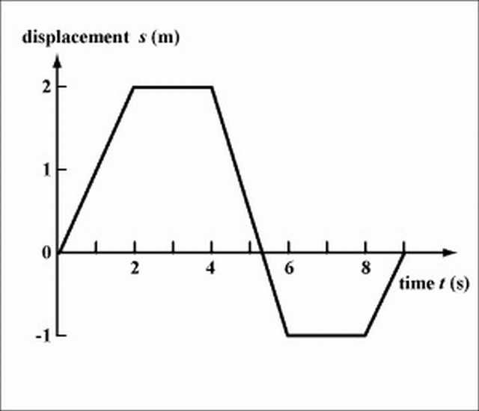

Solution : See Fig. .

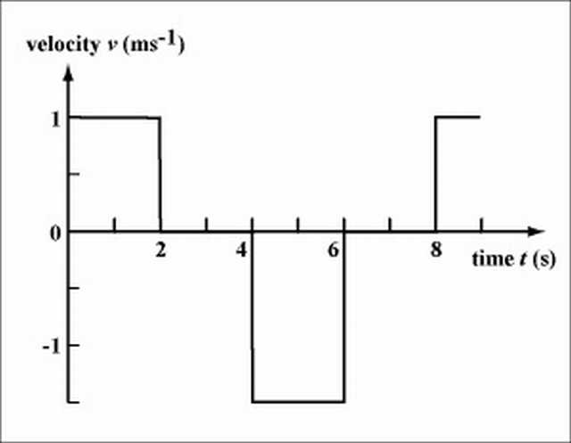

Since the total displacement of the object is zero, the average velocity is also zero.

Note: The object moves backwards from t=4s to t=6s . In this interval, the area bounded by the velocity-time graph is negative (i.e., the area is under the time axis), indicating that the object has a displacement in the opposite direction.

Example : A particle in a generator is accelerated from rest at the rate of 55 ms −2 .

a. What is the velocity at t=3 s?

b. What is the acceleration at t=3 s?

c. What is the distance travelled in 3 seconds?

d. Graph the acceleration (as a v - t graph) for 0 ≤ *t* ≤ 3  s0≤*t*≤3*s*.

Solution : a. Velocity =55×3=165 ms −1

b. The acceleration is a constant 55 ms −2 , so at t=3 s, the acceleration will be 55 ms−2 .

c. The distance travelled in \displaystyle 3 seconds is 165×1.5=247.5 m. We obtain this from the area under the line between 0 and 3 (i.e. the area of the shaded triangle below).

d. Note in the graph that we have velocity on the vertical axis, and the units are m/s.

The graph finishes at (3, 165).

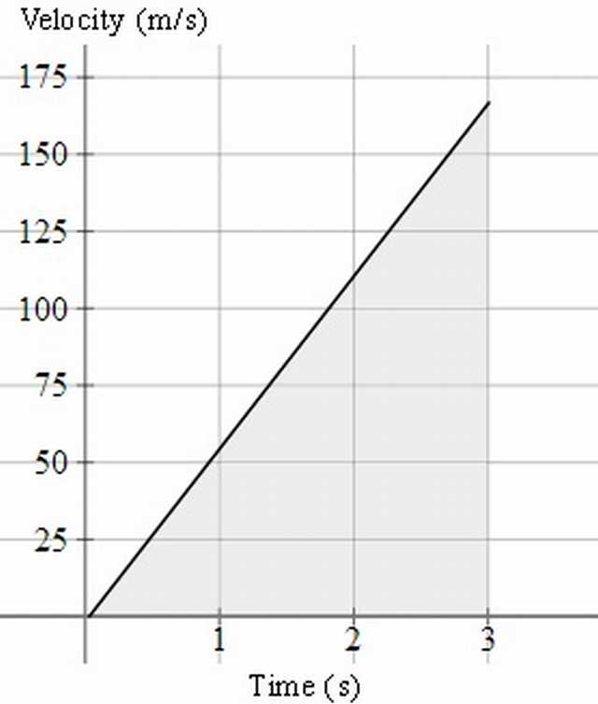

Example : A girl starts from rest and travels along a straight line. The diagram below shows the velocity-time graph of the girl from 0 s to 90 s.

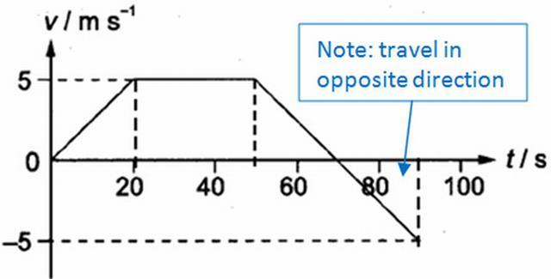

(a) Describe the motion of the girl from 0 s to 40 s.

(b) Find the average velocity of the girl in the first 70 s.

(c) Draw the acceleration-time graph of the girl from 0 s to 90 s.

(d) Find the displacement of the girl from the starting point to the position at 90 s.

Solution : (a) From 0 s to 20 s, she travels with constant acceleration of 0.25 ms^(-2); From 20 s to 40 s, she travels at constant velocity of 5 m/s.

(b) Total displacement = area under v-t graph = ½ (30 + 70) * 5 = 250 m Average velocity = 250/70 = 3.57 m/s

(c) Acceleration is the gradient of v-t graph.

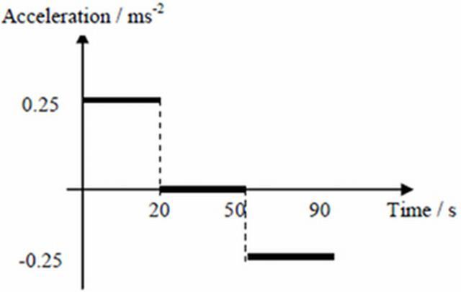

(d) Displacement = area under v-t graph = 250 – ½ * 20 * 5 = 200 m

Tips: (1) It is very easy to mix up kinematics graphs. The only way to differentiate these graphs is to look at the y-axis!

(2) When describing the motion, do it region by region! And always talk about acceleration or speed / velocity with values if applicable. Refer to example above.

Example : Two sport cars start from rest at the same place. One of them, colored red, accelerates at 0.90 ms −2 for 15 s, and continues at constant speed thereafter. The other car, colored blue, accelerates at 0.85ms −2 for 20 s and then remains at that speed.

Draw both journeys on the same velocity-time graph and determine the time and distance that the second car overtakes the first car.

Solution :

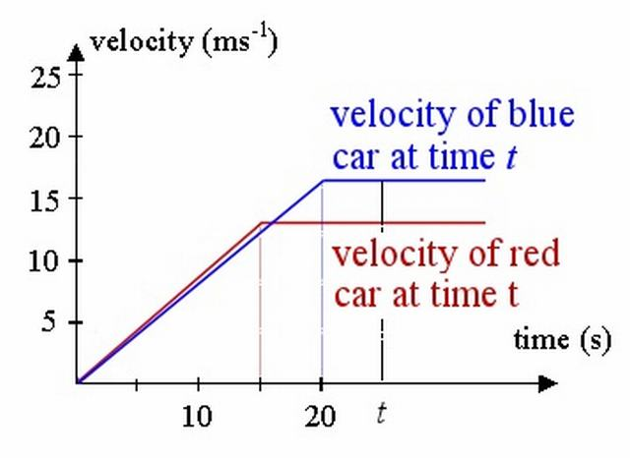

The velocities they reach are 0.9 × 15 = 13.5 ms-1 and 0.85 × 20 = 17 ms-1 respectively.

Similar to the problem above, we have:

First car’s (red) distance at time t is found by finding the area of the trapezoid whose boundary is the t-axis, the red lines and the vertical line representing time at t seconds. This of course assumes t>15 (otherwise, we have negative distances, and the trapezoid only starts at t=15.)

So the distance (at time t) = (1)/(2) × 13.5(*t* + *t* − 15)

= The distance of the second car (blue) is found by finding the area of the blue trapezoid, bounded by the blue lines, the t-axis and the vertical line. (And this one assumes t>20, for the same reasons as above.)

So the distance (at time t) = (1)/(2) × 17(*t* + *t* − 20)

The distance when they meet is the same, so:

(1)/(2) × 13.5 × (2*t* − 15)=(1)/(2) × 17 × (2*t* − 20)

Solving gives:

Time =19.643 s

Distance=163.93 m

Dilemma

However, this solution gives us a dilemma. As mentioned above, the expressions we found for the area of the trapezoids required t to be more than 15 s and 20 s, respectively.

We can confirm the blue car overtakes the red car before 20 seconds, by calculating the distances travelled at that time.

After 20 seconds:

Red car has travelled 0.5×(20+5)×13.5=168.75 m

Blue car has travelled 0.5×20×17=170 m The blue car has travelled further than the red car, so it means it has already overtaken the red car.

Back to the drawing board

So, in fact, for this question we need to consider the area of the blue triangle, not the blue trapezoid.

This is the correct diagram for finding t:

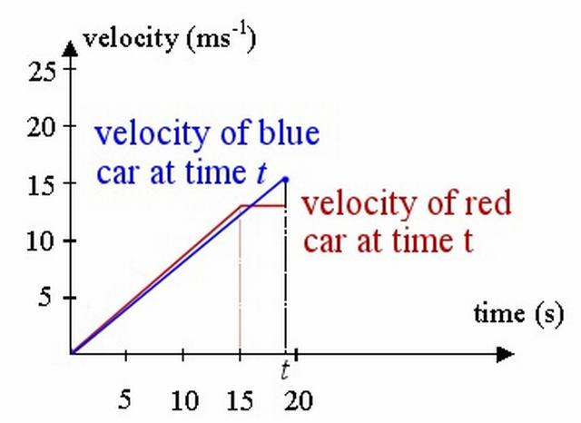

The red car’s distance is fine from before (it’s a trapezoid):

*d* = (1)/(2) × 13.5(*t* + *t* − 15)

But the blue car’s distance at t is the area of the triangle (not trapezoid) bounded by the blue line and the vertical line at t (we are taking (1)/(2) base times height):

*distance* = (1)/(2) × *t* × 0.85 × *t*

Equating these gives:

6.75(2t − 15) = 0.425t2

Solving gives:

t =12.14 s, t = 19.63 s

The first solution has no practical meaning, since t>15 for the expression to work.

So we conclude the time taken for the blue car to overtake the red car is 19.63 s and the distance travelled at that time is 163.7 m.

Further Information

To illustrate we have found the correct answer, below is the graph of distance against time. Labelling of axes is very important in this work!

The red curve corresponds to the acceleration portion of the first race car. At t=15, or point C(15,101.25), the red car stops accelerating and continues at a constant speed (CA is no longer a curve, but a straight line).

The blue curve corresponds to the second (blue) car. It doesn’t accelerate as hard (its curve is below the red curve, indicating it covers less distance in the same time), but it accelerates for longer. At t=20, or point D (20,170), it stops accelerating and its graph is now a straight line.

We can see the curves intersect at time t=19.63 s, or point A (19.63,163.7), as we found in the calculation above. This means they have covered the same distance (163.7 m) at that time, so that’s when the blue car passes the red car.

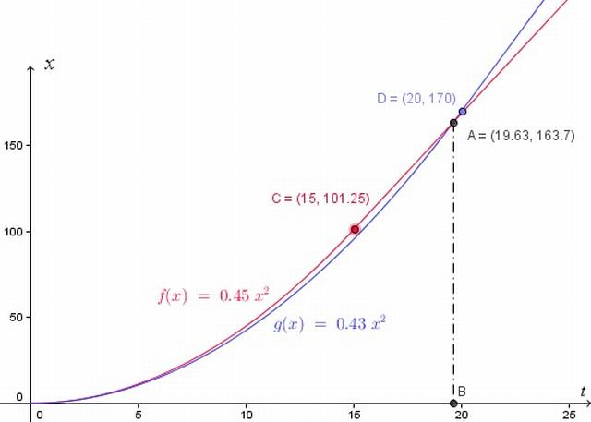

#### 5.1.2.2 MCQ

Example: A body is moving in a straight line as shown in velocity-time graph. The displacement and distance travelled by body in 8 second are respectively:

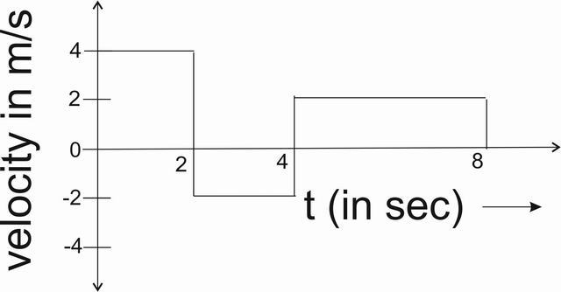

Velocity time graph for the given example

a) 12 m, 20 m

b) 20 m, 12 m

c) 12 m, 12 m

d) 20 m, 20 m

Example: The velocity-time graph of a particle in linear motion is as shown. Both v and t are in SI units. The displacement ofthe particle is

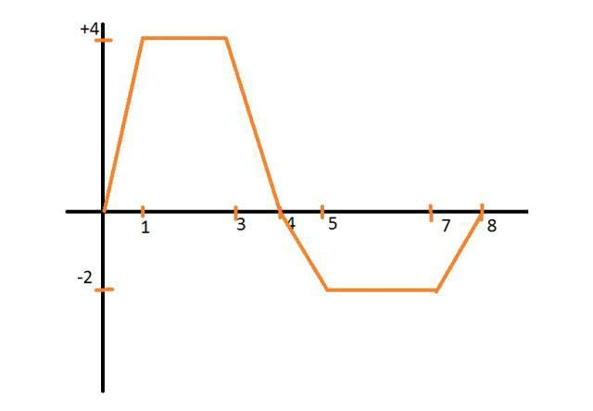

a) 6 m

b) 8 m

c) 16 m

d) 18 m

Example : You drive a car in such a way that its motion is described by the velocity-time graph shown here. Draw the displacement-time and acceleration-time graphs that correspond to this motion, and describe in words how the car moves.[[3](" \l "biblio-3)]

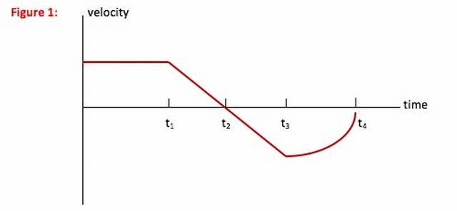

Solution : (Hint : In this problem, you are asked to describe the motion of the car. Whenever you are asked to describe the motion of an object without worrying about the cause of that motion, you have a kinematics problem. This problem is different from most kinematics problems, however, in that you are not asked for a numerical description but rather to use words and graphs to describe how the car moves.)

(Queries : How did you know that x = 0 at t = 0?

You don’t! If you are given a velocity-time graph, you know the initial speed but not the initial location of the object. (Calculus students, remember v = dx/dt, and the derivative of a constant—your initial location—is zero.) I chose to call the location of the car at t = 0 the origin, but you could start your graph at any point. The shape of the graph, however, should look the same.

Why can’t I treat the straight line from t1 to t3 in a single step?

Any time velocity is above the t-axis, it has a positive value and so slope of the x-t graph is also positive. A positive slope means that the line or curve is in such a direction as to make between a 0 and a 900 angle above the +x axis. Any time velocity is below the t-axis, it has a negative value and so the slope of the x-t graph is also negative. A negative slope means that the line or curve is in such a direction as to make between a 0 and a 900 angle below the +x axis.

Why doesn’t the line from t3 to t4 look more curved?

As the velocity-time curve gets closer and closer to v = 0 (the t-axis), velocity’s value is getting smaller regardless of direction. As the value of v decreases, so does the slope of the x-t graph. A decreasing slope means that the slope gets smaller and smaller—the line gets becomes more horizontal.

The curve from t3 to t4 on the x-t graph shown here doesn’t look very curved. This is because its slope goes from the same value as it ended with on the t2 to t3 curve to almost zero (a horizontal line) and so not a lot of change as I have drawn it. Any line you draw that curves down and to the right becoming more horizontal as it goes is fine.)

Select a relation

To go between a velocity-time graph and a displacement-time or acceleration-time graph, you need to understand how velocity, displacement and acceleration are related to each other. In other words, you need to use the definitions of velocity and acceleration:

v = Δx/Δt In words, the value of velocity = the slope of the x-t graph.

a = Δv/Δt In words, the value of acceleration = the slope of the v-t graph.

Hint: Graphing problems seem like they should be straightforward, and the equations that you need are only those given above. It is very, very common, however, to make mistakes on these problems because it feels like the graphs should be pictures of the motion and they are not. In order to avoid those mistakes, make a table based on the sentences above and then draw the graph from the table.

Displacement-Time Graph

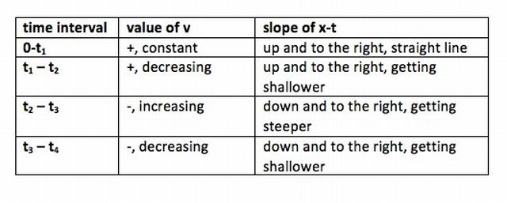

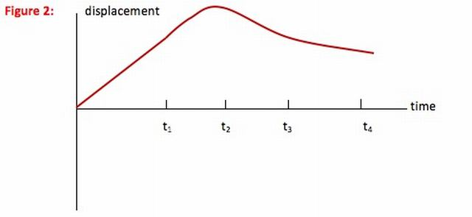

Once you understand the displacement-time graph, continue down to the acceleration-time graph.

Acceleration-time Graph

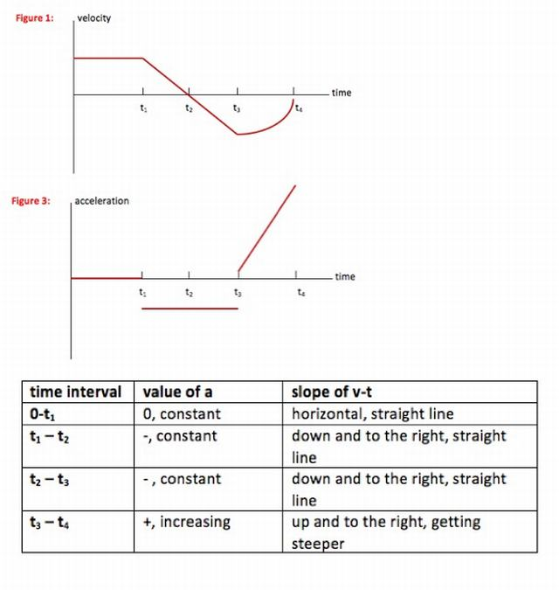

Understand

In this problem, you are given the velocity-time graph for the motion of a car. By relating the value of velocity to the slope of the x-t graph (this is just the definition of velocity) you are able to draw the x-t graph corresponding to this motion.

By relating the slope of the v-t graph to the value of acceleration (this is just the definition of acceleration) you are able to draw the a-t graph corresponding to this motion.

You can describe the motion looking at any of the three graphs. From t = 0 to t1 : The car travels forward (+ direction) with a constant speed. There is no acceleration and the car moves away from its starting point at a constant rate.

From t1 to t2 : The car slows to a stop at a constant rate. It is still moving forward, but the amount of distance it covers in each second is decreasing. Acceleration acts against the motion of the car, or in the negative direction.

From t2 to t3 : The car reverses direction, moving faster and faster (at a constant acceleration) in the negative direction. Acceleration is acting with the motion of the car, so it is also in the negative direction. The amount of distance the car covers each second increases.

From t3 to t4 : The car continues to move in the negative direction but at a decreasing speed. The rate at which the speed decreases is getting greater—the driver is braking harder as the car stops—and so acceleration increases. Acceleration is acting against the motion of the car, or in the positive direction. The car covers less and less distance each second.

### 5.1.3 Problems on Area Under v-t graph

Example : A charged particle in an accelerator starts from rest, accelerates at 1.5 ms −2 for3 s and then continues at a steady speed for a further 6 s.

Draw the v-t graph and find the total distance travelled.

Solution:

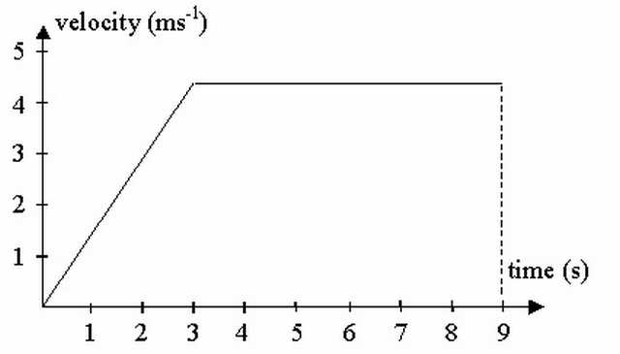

Total distance travelled is the area under the graph (in this case we need to find the area of a trapezium).

distance = ((*a* + *b*)*h*)/(2)

 = ((9 + 6) × 4.5)/(2)

=33.75 m

Example : A car is travelling at a constant speed of 72 km/h and passes a stationary police car. The police car immediately gives chase, accelerating uniformly to reach a speed of 90 km/h in 10 s and continues at this speed until he overtakes the other car. Find:

(a) the time taken by the police to catch up with the car,

(b) the distance travelled by the police car when this happens.

Solution :

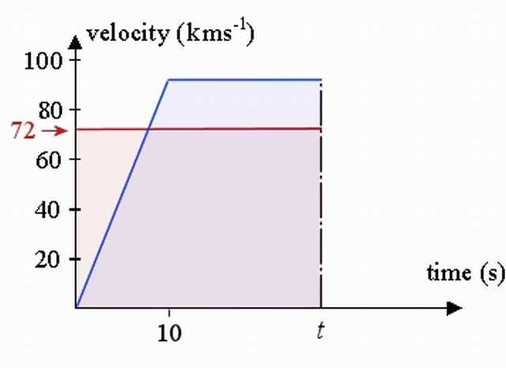

The v-t curve for the car is represented by the red line, while that v-t curve for the police car is the blue line.

We need to find the unknown time t (in seconds), when the police catch up to the car. We find this by comparing the distance travelled by each (it will be the same distance at the overtaking point.) So we need to set the area under the v-t curve for the car (the pink shaded area) to be equal to the area under the v-t curve for the police car (the blue shaded area).

a. The area under the curve for the car at time t (in seconds) is simply 72t. (It is a rectangle, 72 high and width t).

The area under the trapezium (trapezoid) for the police car at unknown time t, using *A* = (*a* + *b*)(*h*)/(2) is:

(*t* + *t* − 10) × (90)/(2)=45(2*t* − 10)

We set these equal to find the required time: 72t=45(2t−10) That is, when 72t=90t−450 So t=25 s will be the time the police car catches up.

b. Both of the cars have travelled \displaystyle72 × ((25)/(3600)) × 1000 = 500  m during those 25 s.

[We have used d=s×t and converted from seconds to hours (since the velocities are given in km/h).]

## 5.2 The Second Equation

Proceeding similar to above, the equation

*a* = (*dv*)/(*dt*) implies

i) The Slope of Velocity-Time Graph is Instantaneous Acceleration.

ii) The Area under Acceleration-Time Graph is Change in Velocity.

{ The second one requires the manipulation , dv = adt i.e. ∫*dv* = ∫*adt*}

A few of the following examples illustrate it.

Example : A car starts from rest requires a velocity v with uniform acceleration 2m/s2 then it comes to stop with uniform retardation 4m/s2 . If the total time for which it remains in motion is 3 sec, the total distance travelled is:

a) 2 m

b) 3 m

c) 4 m

d) 6 m

Example : A particle starts from rest. Its acceleration (a) vs time (t) is as shown in the Figure. The maximum speed of the particle will be

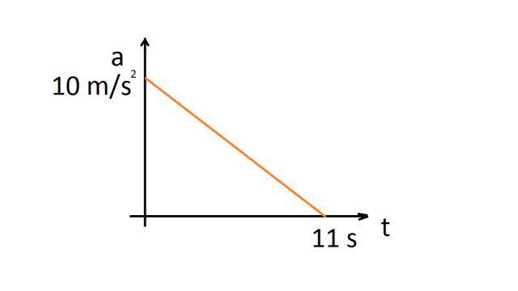

a) 110 m/s

b) 55 m/s

c) 550 m/s

d) 660 m/s

Example : Acceleration-time graph of a particle moving in a straight line is shown in gure. The velocity of particle at time t = 0 is 2 m/s. Velocity at the end of fourth second is

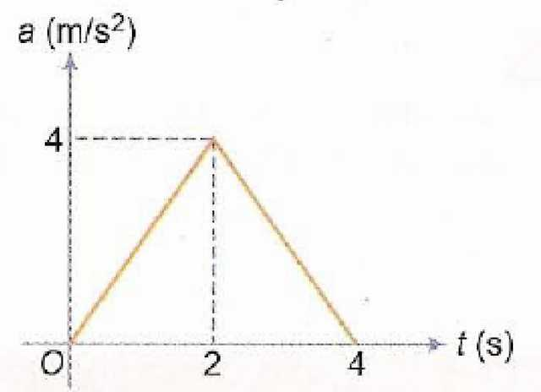

a) 8 m/s

b) 10 m/s

c) 12 m/s

d) 14 m/s

Example : Each of the three graphs represents acceleration vs time for an object that already has a positive velocity at time t1 . Which graph/graphs show an object whose speed is increasing for the entire time interva1 between t1 and t2 ?

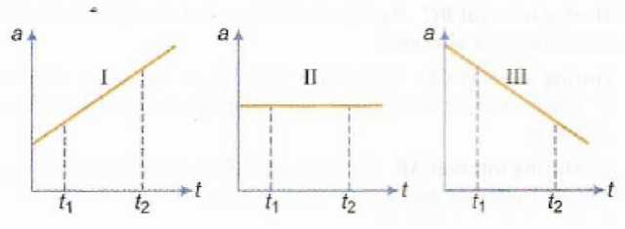

a) Graph I only

b) Graphs I and II

c) Graphs I and III

d) Graphs I, II and III

Example : A body starts from rest and moves along a straight line with constant acceleration. The variation of speed v with distance s is given by the graph

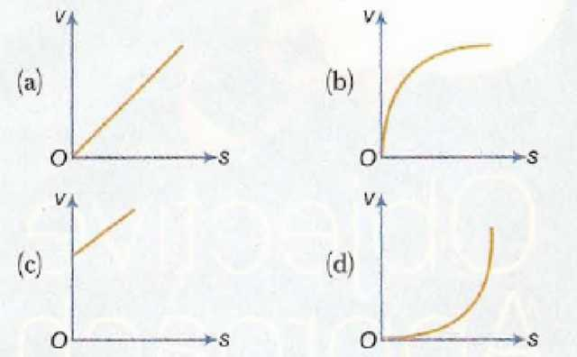

### 5.2.1 Problems on Average Velocity

Example : A body moves as described by the following v-t graph.

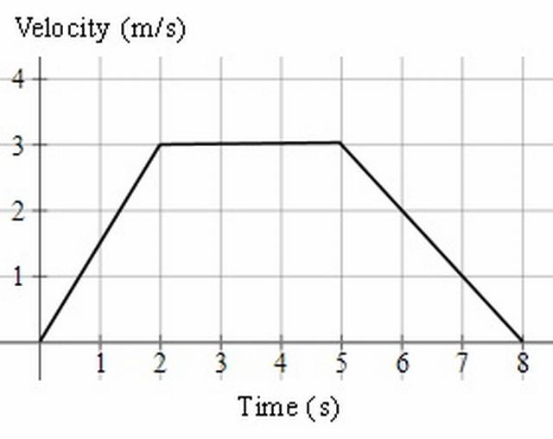

a) Describe the motion.

b) What is the distance travelled during the motion?

c) What is the average speed for the motion?

Solution : a) From t=0 to 2, the acceleration was *a* = (Δ*v*)/(Δ*t*) = (3)/(2) = 1.5  ms− 2

From t=2 to 5, the acceleration was 0 ms−1 .

The body was neither speeding up nor slowing down.

From t=5 to 8, the acceleration was *a* = (Δ*v*)/(Δ*t*) = ( − 3)/(3) =  − 1  ms− 2

The body was slowing down, so the acceleration was negative.

b) The distance travelled is the area of the trapezoid (trapezium).

distance = ((*a* + *b*)*h*)/(2) = ((8 + 3)(3))/(2) = 16.5  m

c) average speed = (distance travelled)/(time taken)  = (16.5)/(8)

=2.1 ms−1

Example : A speedboat starts from rest, accelerating at 2 ms −2 for 20 s. It then continues at a steady speed for a further 30 s and decelerates to rest in 30 s. Find:

(a) the distance travelled in m,

(b) the average speed in ms −1 and,

(c) the time taken to cover half the distance.

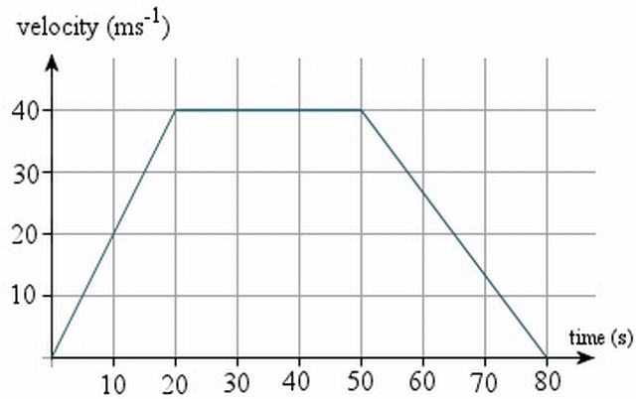

Solution : a) distance=area of trapezium  = ((*a* + *b*)*h*)/(2)

 = ((80 + 30)(40))/(2)

=2200 m

b) average speed = (distance travelled)/(time taken)

 = (2200)/(80)

=27.5 ms −1

c) We need to find the time when the area of the trapezium is half of its original area, or 1100m , as shown in the graph.

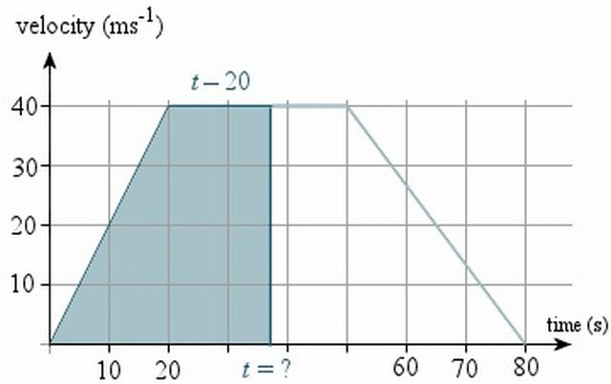

The base of this unknown trapezium has length \displaystyle{t}t, and the top of the trapezium will have length t−20. So we have:

area of trapezium = ((*a* + *b*)*h*)/(2)

1100 = ((*t* + [*t* − 20])40)/(2) = 20(2*t* − 20)

55=2t−20

75=2t

t=37.5s

So it will take 37.5 s to cover half the distance.

Example : An object’s position during a 10 second time interval is shown by the graph below:

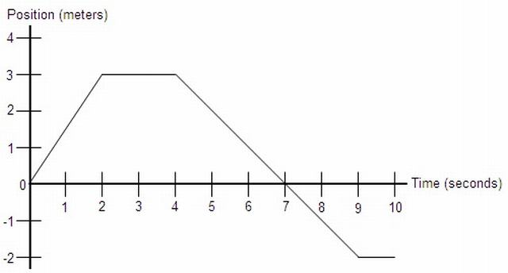

a.) Determine the object’s total distance traveled and displacement.

b.) What is the object’s velocity at the following times: t = 1, t = 3, and t = 6.

c.) Determine the object’s average velocity and average speed from t = 0 to t = 10.

d.) What is the object’s acceleration at t = 5?

Solution : a.) The total distance traveled by the object is the sum of all the distances it traveled during the time interval. In the first two seconds it traveled 3 m. Then it traveled 0 m in the next two seconds. Then over the next five seconds, the object moved 5 m, then remained at rest. so the total distance is 3 + 5 = 8 m. The displacement of the object is simply the final position minus the initial position, or -2 - 0 = -2 m.

b.) Notice that each of these points is in the middle of a line segment on the graph. Because of this, the instantaneous velocity at these points is the same as the average velocity over the time intervals represented by each segment, so: v(t) = (xf - xi)/(tf - ti) v(1) = (3 - 0)/(2 - 0) = 3/2 = 1.5 m/s v(3) = (3 - 3)/(4 - 2) = 0/2 = 0 m/s v(6) = (-2 - 3)/(9 - 4) = -5/5 = -1 m/s

Notice that the formula (xf - xi)/(tf - ti) is the same as the slope formula for this graph. The velocity at any point on a position vs. time graph is simply the slope of the graph at that point. By this definition, we also know that the velocity of any position function is its derivative with respect to time. You can also go from a velocity function to a position function using integration. Go to calculus notes

c.) Average velocity is displacement divided by time. We found in part a that the object’s displacement is -2 m, so: vavg = -2/10 = -0.2 m/s

Average speed is total distance divided be time, and we found in part a that the object’s total distance traveled is 8 m. so: 8/10 = 0.8 m/s

d.) We determined in part b that the object’s velocity is represented by the slope of the line segment on the graph. Since the slope of this segment is constant, the object’s velocity at t = 5 is constant. Since constant velocity means there is no acceleration, a = 0.

Example : An object’s velocity during a 10 second time interval is shown by the graph below:

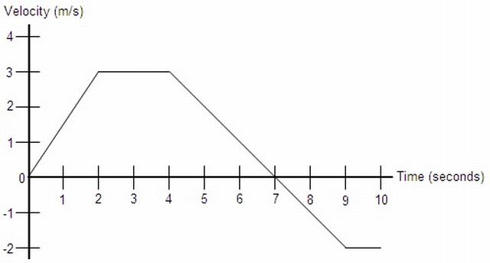

a.) Determine the object’s total distance traveled and displacement.

b.) At t = 0, the object’s position is x = 2 m. Find the object’s position at t = 2, t = 4, t = 7, and t = 10.

c.) What is the object’s acceleration at the following times: t = 1, t = 3, and t = 6.

d.) Sketch the corresponding acceleration vs. time graph from t = 0 to t = 10.

Solution : a.) Recall that the equation for velocity is v = x/t. If we solve this for x, we get x = vt. Notice that this is the same as the area of a rectangles whose sides are lengths v and t, so we can determine that the displacement is the area enclosed by the velocity vs. time graph. So, we will find the area of each section under the graph:

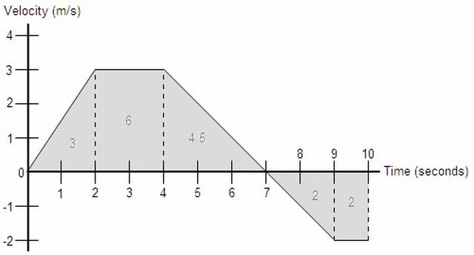

The total distance traveled by the object is simply the sum of all these areas: 3 + 6 + 4.5 + 2 + 2 = 17.5 m The displacement is found in a similar fashion, except areas below the x-axis are considered negative: 3 + 6 + 4.5 - 2 - 2 = 9.5 m Interestingly enough, the area enclosed by any function can be represented by a definite integral. For example, if this graph were defined as a function v(t), then the displacement would be the integral from 0 to 10 of v(t)dt, and the total distance traveled would be the integral from 0 to 10 of |v(t)|dt Go to calculus notes

b.) The position of the object at a given point in time can be found in much the same way we found the displacement in part a, except this time we must also add in the initial value given. So: x(2) = 2 + 3 = 5 m x(4) = 2 + 3 + 6 = 11 m x(7) = 2 + 3 + 6 + 4.5 = 15.5 m x(10) = 2 + 3 + 6 + 4.5 - 2 - 2 = 11.5 m

Notice that this can also be done by adding the integral from 0 to t of v(t)dt to the initial value of 2. Go to calculus notes

c.) Like velocity in part b of problem 22, the instantaneous acceleration at any point along one of the graph’s line segments is the same as the average acceleration across that line segment. The formula for acceleration is aavg = Δv/Δt = (vf - vi)/(tf - ti), so: a(t) = (vf - vi)/(tf - ti) a(1) = (3 - 0)/(2 - 0) = 3/2 = 1.5 m/s2 a(3) = (3 - 3)/(4 - 2) = 0/2 = 0 m/s2 a(6) = (-2 - 3)/(9 - 4) = -5/5 = -1 m/s2

Similarly to the relationship between velocity and position, the formula for acceleration is the same as the slope formula for a velocity vs. time graph. So, we can say that the slope of any velocity vs. time graph is its acceleration. Notice that this definition defines acceleration as the derivative of velocity. So, it is true that for any velocity function v(t), its derivative is an acceleration function a(t). Also, integration can be used to go from an acceleration function to a position function. Go to calculus notes

d.) We know that the acceleration along each line segment of this velocity vs. time graph is equal to the slope of the line segment. We determined these slopes in part c, so the acceleration graph would look like:

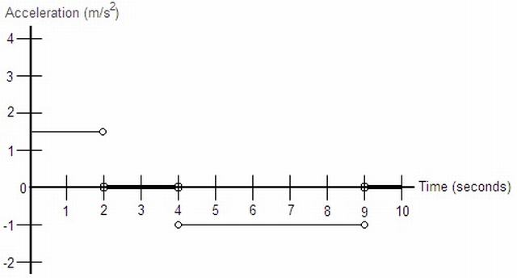

This graph uses horizontal lines instead of points to represent that the acceleration is defined at that value at any point along that section. The open circles at the end of each line segment simply indicate that at those time values, acceleration is not defined at either value represented by the horizontal lines. At these points, acceleration is undefined because it changes instantaneously from one value to the next, which cannot be represented numerically.

Example : An object’s position during a given time interval is shown by the graph below:

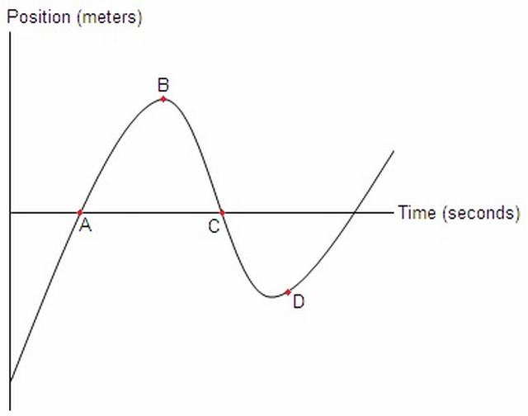

a.) At which of the marked points is the object’s velocity the greatest? The least?

b.) Is the object’s acceleration positive or negative between points A and B?

c.) Suppose this curve can be modeled by the function x(t) = t3 - 9.5t2 + 23t - 9. Find the object’s velocity and acceleration at t = 1, t = 3, and t = 5.

d.) Using the function from part c, determine the object’s maximum and minimum positions and velocities within the interval from t = 1 to t = 6.

Solution : a.) Remember from problem 22 that velocity is the slope of a position vs. time graph such as this. By looking at lines tangent to the curve, we can see which point has the highest and lowest slope:

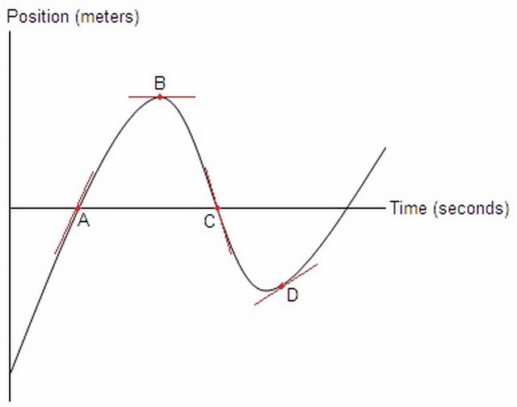

Looking at the red tangent lines, we can immediately eliminate point B as a candidate for both the maximum and minimum velocity, as its tangent is horizontal and thus has a slope of 0. Point C is the only marked point whose tangent line has a negative slope, so point C has the lowest velocity. Looking at points A and D, point A’s tangent line has a steeper positive slope so point A has the highest velocity.

b.) We know that acceleration is a change in velocity, so by asking whether acceleration is positive or negative, we are asking if the velocity is increasing or decreasing. Since velocity is the slope of this graph, we must determine how the slope of the curve is changing between points A and B. Looking at the diagram in part a, we see that the slope at point A is positive, and the slope at point B is 0. As such, the slope, and thus the velocity, must be decreasing. Therefore, the object’s acceleration is negative in this interval.

c.) We know from problem 22 that velocity is the derivative of position, and from problem 23 that acceleration is the derivative of velocity. So, we will begin by differentiating the position function twice: x(t) = t3 - 9.5t2 + 23t - 9 v(t) = 3t2 - 19t + 23 a(t) = 6t - 19

Now that we know the velocity and acceleration functions, all that is left is to plug the values of t into these functions and simplify: v(1) = 3 * 12 - 19 * 1 + 23 = 3 - 19 + 23 = 7 m/s v(3) = 3 * 32 - 19 * 3 + 23 = 27 - 57 + 23 = -7 m/s v(5) = 3 * 52 - 19 * 5 + 23 = 75 - 95 + 23 = 3 m/s

a(1) = 6 * 1 - 19 = 6 - 19 = -13 m/s2 a(3) = 6 * 3 - 19 = 18 - 19 = -1 m/s2 a(5) = 6 * 5 - 19 = 30 - 19 = 11 m/s2

d.) Thinking logically about the graph, the possible candidates for maximum and minimum position are at the end points of the interval and at the spots, like point B, where the slope of the graph is 0. So, first we set the velocity function from part c equal to 0 and solve for t: v(t) = 3t2 - 19t + 23 = 0 t = 1.63008 s or t = 4.70326 s

Note that this was solved using a graphing calculator. The AP exam will not ask you to solve a quadratic this complicated by hand, however you may have to solve a simpler function using the quadratic formula. Also, we keep as many decimal places as we can at this stage in order to maintain accuracy. Now that we know all the possible times at which the position could be at a maximum or minimum within the interval, we simply plug these t values into x(t). Don’t forget to check the end points: x(t) = t3 - 9.5t2 + 23t - 9 x(1) = 5.5 m x(1.63008) = 7.58 m x(4.70326) = -6.93 m x(6) = 3 m

We see that the minimum position is -6.93 m, and the maximum position is 7.58 m. Finding the maximum and minimum velocities is achieved in the same manner, except we set the acceleration function equal to 0 and plug the t values into the velocity funtion: a(t) = 6t - 19 = 0 6t = 19 t = 19/6 = 3.16667 s

v(t) = 3t2 - 19t + 23 v(1) = 7 m/s v(3.16667) = -7.08 m/s v(6) = 17 m/s

So the minimum velocity is -7.08 m/s, and the maximum velocity is 17 m/s.

## 5.3 Miscelleneous

Example : A ball is thrown vertically downward from a 120-m high building. The ball hits the ground in 2 seconds. How fast was the ball thrown?

Sketches of the velocity and acceleration graphs are shown in Fig. 1. For simplicity, the downward direction is assumed to be positive, and, for ease of calculations, the freefall acceleration g is taken to be 10 m/s2. Knowing that the area under the acceleration graph is equal to the change in velocity (△*v* ) of the object yields △*v* = gt = 10 m/s2 ×  2 s = 20 m/s.

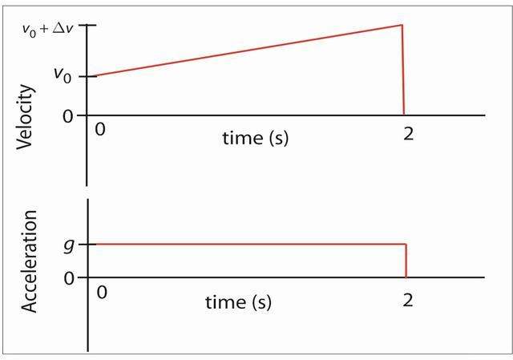

Velocity and acceleration graphs for Problem 1.

The area under the velocity graph is the displacement, which was given to be 120 m. Breaking the area under graph into a rectangle and a triangle yields 120 m = v0 3 t + 1 2 Dv 3 t = 2 s 3 v0 + 1 2 20 m/s 3 2 s. (2) One can easily solve this for the initial velocity of the object, thus obtaining the answer to the problem (50 m/s is a quite unrealistic initial velocity for a thrown ball). No explicit use of the standard kinematic equations is made; the solution is based on only the graphs. The above problem is relatively simple; to see the real power of the method requires a more difficult 1-D kinematics problem.

Example : Determined to test gravity, a student walks off the cN Tower in Toronto, which is 553 m high, and falls freely. His initial velocity is zero. The rocketeer arrives at the roof of the building 5 seconds later to save the student. The rocketeer leaves the roof with an initial velocity downward and then is in freefall. in order both to catch the student and to prevent injury to him, the rocketeer should catch the student at a sufficiently great height and arrive at the ground with zero velocity. The upward acceleration that accomplishes this is provided by the rocketeer’s jet pack, which he turns on just as he catches the student; before then the student is in freefall. To prevent discomfort to the student, the magnitude of the acceleration is limited to five times gravity. How high above the ground must the rocketeer catch the student?

Solution : As I was grading the assignment, one student’s solution stuck out. When I first saw it, I was convinced that something must be wrong as the problem had been difficult for me and could not be that simple. I was wrong. The simple solution consists of sketching the velocity and acceleration graphs for the falling student (Fig. 2; down is taken as the positive direction) and using a bit of reasoning. Since the overall change in the student’s velocity during his motion is zero, the total area under the acceleration-versus-time graph must equal zero. This area consists of a positive part (above the time axis) and a negative part (below the time axis). The two rectangular areas must have equal magnitude, and since their heights differ by a factor of 5, so must their widths (the two corresponding times). Therefore, the freefall time is five times longer than the time for slow-down to rest. Now, looking at the velocity graph, the area labeled 1 corresponds to the displacement while in freefall, and the area labeled 2 represents the displacement after the Rocketeer has caught the student. The triangles forming areas 1 and 2 have the same height, and the base (time) for area 1 is five times the base (time) for area 2. Therefore, area 1 must be five times larger than area 2. This means that area 2 must be 1/6 the total height of the building, or 92.2 m.

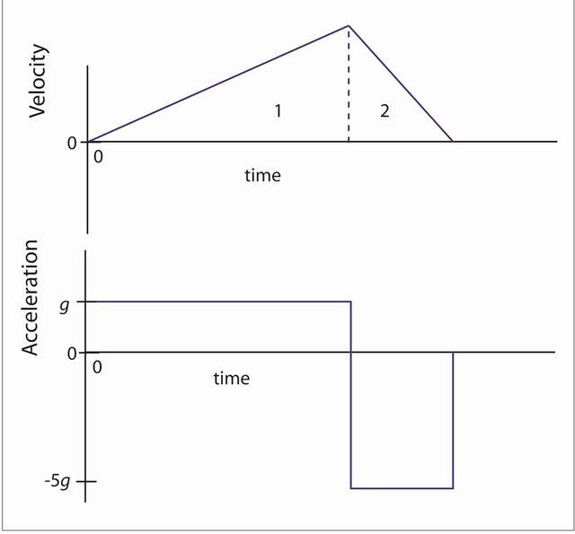

Velocity and acceleration graphs for Problem 2.

After studying this solution for a long time and finding no flaws in the physics, I pulled out my physics book and tried solving other one-dimensional kinematics problems in a similar manner. It quickly became obvious that they could be done using graphs, and in most cases this is the easier method. I was hooked and began teaching one-dimensional problem solving this way in all my classes. The next class period I asked the student whose solution this was why he chose to do the problem this way. He explained that we had emphasized graphs so much in class that they must be more useful than something we are simply supposed to sketch for the problems. I was amazed and appreciative as I now had a new way to teach problem solving. This kind of solution is more visual and helps get students away from hunting for the “correct equation.” It has worked well for me at all levels of introductory physics, conceptual through calculus based. If you find other interesting problems that are especially suited to the above method, I would appreciate your sharing them.

# 6 Review Exercise I

## 6.1 True/False

Indicate whether the sentence or statement is true or false.

____ 1. The slope of a position-time graph represents the velocity.

____ 2. An object dropped from a window falls to the ground. The position-time graph representing the object’s motion would be a straight line.

____ 3. A sprinter darts from the starting blocks at the sound of the starter’s pistol. The position-time graph representing the sprinter’s motion during the first few strides would be a straight line.

____ 4. A car accelerates uniformly when the traffic light turns green. The velocity-time graph representing the car’s motion would be a straight line.

____ 5. The slope of the tangent to a point on a curve that is part of a position-time graph represents the instantaneous velocity.

____ 6. The area under a position-time graph represents the displacement.

____ 7. A velocity-time graph that consists of a straight non-horizontal line represents an object that is travelling with uniform motion.

____ 8. The slope of the line that joins two points on a velocity-time graph represents the average acceleration during that time interval.

____ 9. The velocity of a passenger with respect to a train moving east would be less if the passenger is walking west at a particular speed than it would be if the passenger is walking east at the same speed.

____ 10. When a vector is multiplied by a scalar the resultant vector’s direction is unchanged.

____ 11. Consider a trip from your home to your school and back home again. The magnitude of your displacement is equivalent to your distance travelled.

____ 12. An airplane is flying on a course directed 60º E of S. If this course is maintained, the plane will fly farther south than east.

____ 13. Consider one complete orbit around Earth as taken by astronauts aboard a space shuttle. The magnitude of the average velocity is equivalent to the average speed.

____ 14. The valve on the tire of a bicycle that is travelling due west at a constant speed is exhibiting "uniform motion."

____ 15. An object starts from rest and accelerates uniformly. It will travel one third as far during the first second of its motion than in the subsequent second.

____ 16. An object is thrown vertically upward. At the top of its flight, both the object’s velocity and acceleration are momentarily zero.

____ 17. Two objects accelerate from rest with the acceleration of object A twice that of object B. After accelerating for a given time, object A will have travelled twice the distance of object B.

____ 18. Two objects accelerate from rest with the acceleration of object A twice that of object B. After accelerating for a given time, the speed of object A will be twice that of object B.

## 6.2 Multiple Choice

Identify the letter of the choice that best completes the statement or answers the question.

____ 19. Which of the following is a "scalar" quantity?

a. distance

b. velocity

c. acceleration

d. displacement

e. none of the above

____ 20. Which of the following would be considered a "base" quantity rather than a "derived" quantity?

a. speed

b. velocity

c. distance

d. acceleration

e. none of the above

____ 21. How many "base" quantities are there from which all other quantities are derived?

a. three

b. four

c. five

d. six

e. seven

____ 22. A spark timer/air table produced the tape pictured below.

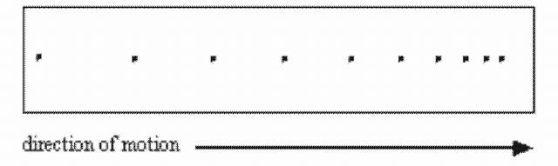

The object, moving to the right, was

a. moving with uniform motion

b. speeding up

c. slowing down

d. travelling with constant speed

e. accelerating then moving with constant speed

____ 23. The term "uniform motion" means

a. acceleration is constant

b. speed is constant

c. velocity is constant

d. displacement is constant

e. velocity is zero

____ 24. A 400-m, 800-m, and 1600-m race are all run around the same 400-m oval track. The winning times for the races were 50 s, 2 min, and 4 min 10 s respectively. Which of the following statements is true?

a. All runners have the same average velocity.

b. The 400-m runner has the greatest average velocity.

c. The 800-m runner has the greatest average velocity.

d. The 1600-m runner has the greatest average velocity.

e. All runners have the same average speed.

____ 25. An 80.4-km trip takes a time of 0.75 h to complete. The average speed, expressed in the correct manner, is

a. 107.2 km/h

b. 1.072 102 km/h

c. 29.8 m/s

d. 1 102 km/h

e. 1.1 102 km/h

____ 26. Using a variety of stopwatches, four students reported the time for a ball to drop to the ground from the same height. The recorded times were 1.85 s, 1.8 s, 1.9 s, and 2 s. The average time, expressed in the correct manner, is

a. 1.888 s

b. 1.89 s

c. 1.8 s

d. 1.9 s

e. 2 s

____ 27. The slope of a position-time graph always represents

a. displacement

b. distance

c. velocity

d. change in velocity

e. acceleration

____ 28. The slope of a velocity-time graph always represents

a. displacement

b. distance

c. change in velocity

d. acceleration

e. change in acceleration

____ 29. The area under a velocity-time graph always represents

a. displacement

b. change in velocity

c. distance

d. acceleration

e. change in acceleration

____ 30. The area under an acceleration-time graph always represents

a. displacement

b. distance

c. velocity

d. change in velocity

e. change in acceleration

____ 31. Study the position-time graph pictured below and select the statement that is true.

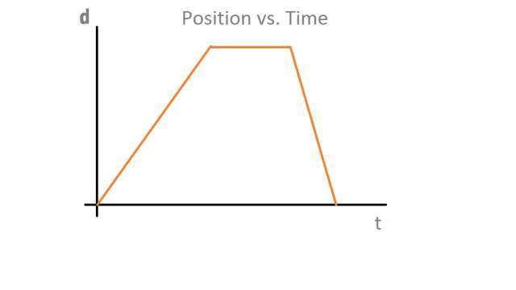

a. The object accelerates, stops, then accelerates in the opposite direction.

b. The object’s speed is greatest during the first segment.

c. The object’s acceleration is greatest during the last segment.

d. The object’s average velocity is zero.

e. The object travels a greater distance in the first segment than in the last segment.

____ 32. The position-time graph pictured below represents the motions of two objects, A and B. Which of the following statements concerning the objects’ motions is true?

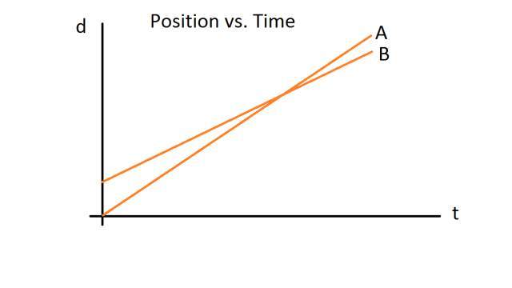

a. Object B travels the greater distance.

b. Object A has the greater speed.

c. Object A leaves the reference point at an earlier time.

d. Both objects have the same speed at the point where the lines cross.

e. Object A is travelling for a longer period of time.

____ 33. The position-time graph pictured below represents a race between three contestants A, B, and C. The race begins at time zero at the sound of the starter’s pistol. Which of the following statements is true?

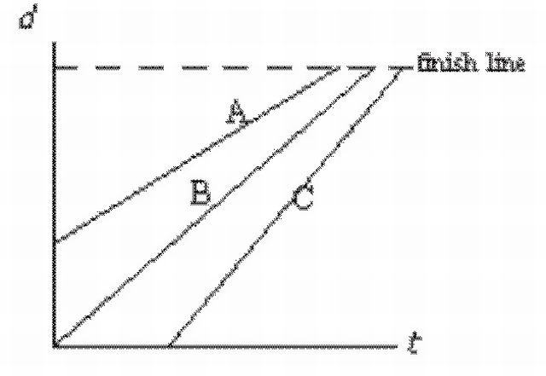

a. The runner who started last finished first.

b. The fastest runner won the race.

c. The runner with a head start won the race.

d. Only one runner began at the sound of the starter’s pistol.

e. All runners ran the same distance.

____ 34. The position-time graph pictured below depicts a person, P, running to catch a bus, B, that has just begun to pull away. Which of the following statements is true?

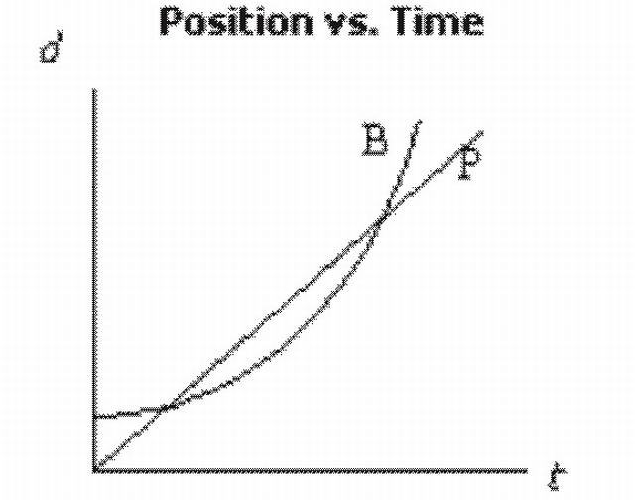

a. The person has no chance of catching the bus.

b. The person’s acceleration is greater than that of the bus.

c. The person has two opportunities to catch up to the bus.

d. The speed of the bus is always greater than that of the person.

e. The person’s speed is always greater than that of the bus.

____ 35. The position-time graph that depicts a ball thrown vertically upward that returns to the same position is

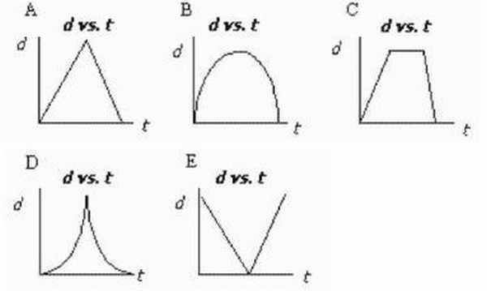

a.A

b. B

c. C

d. D

e. E

____ 36. The position-time graph that represents "uniform motion" is

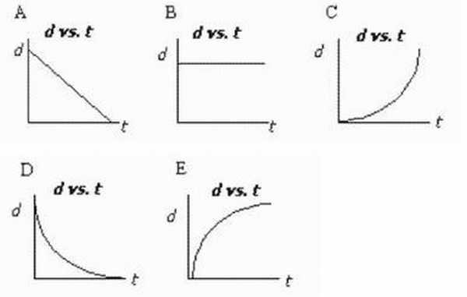

a. A

b. B

c. C

d. D

e. E

____ 37. The velocity-time graph that represents "uniform motion" is

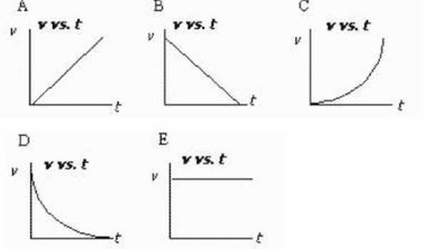

a. A

b. B

c. C

d. D

e. E

____ 38. The velocity-time graph pictured below depicts the motion of a motorcycle. Which of the following statements is true?

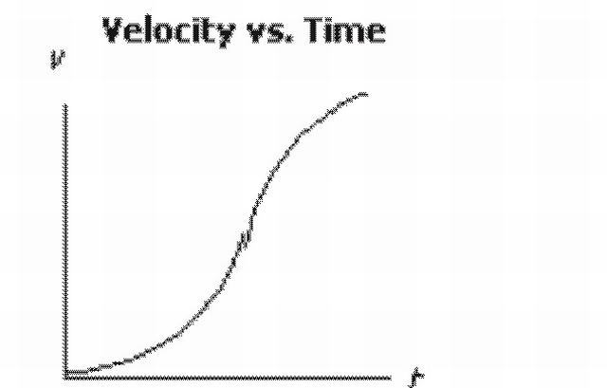

a. The motorcycle is always experiencing an acceleration.

b. The motorcycle’s greatest speed occurs toward the end of the recorded time interval.

c. The motorcycle’s average acceleration is zero.

d. The motorcycle eventually reaches uniform motion.

e. The motorcycle accelerates until it reaches a constant speed.

____ 39. The velocity-time graph pictured below represents the motion of a police car, P, in pursuit of a motorcycle, M. The motorcycle has just passed the police car. Which of the following statements is true?

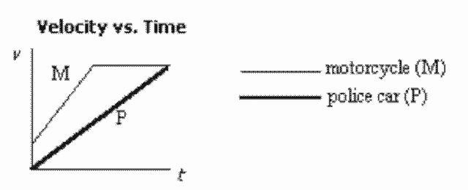

a. Both vehicles are at rest when the pursuit begins.

b. The police car eventually catches the motorcycle.

c. The motorcycle accelerates and then slows down.

d. At the end of the recorded time interval, the police car has yet to catch the motorcycle.

e. The police car passes the motorcycle.

____ 40. Consider the following velocity-time graph and select the statement that is true.

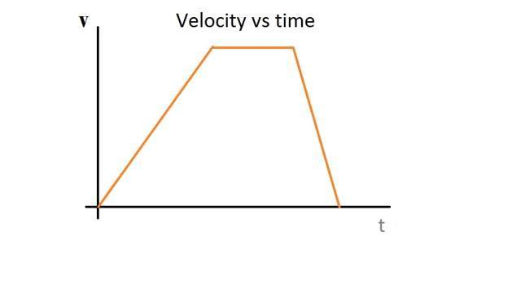

a. At no time can the motion be considered "uniform."

b. The object returns to its original position.

c. The object travels in one direction and then the other.

d. The object is accelerating throughout the entire recorded time.

e. The object speeds up and later slows down.

____ 41. Which of the following velocity-time graphs represents the motion of a ball thrown vertically upward?

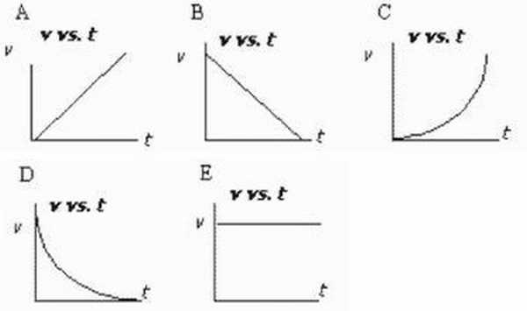

a. A

b. B

c. C

d. D

e. E

____ 42. The following velocity-time graph depicts the motions of two objects, A and B. Which of the statements describing the graph is true?

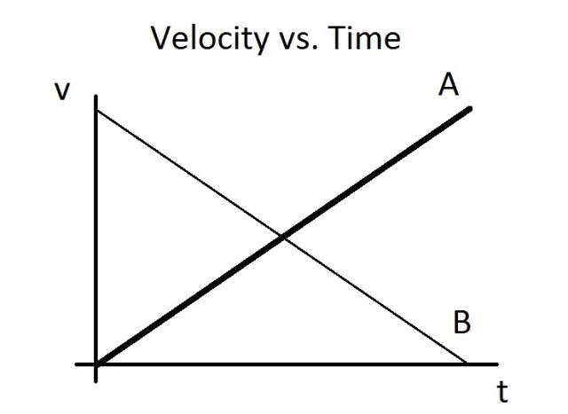

a. Both objects are accelerating uniformly.

b. The two objects are travelling in opposite directions.

c. Both objects start from rest.

d. Object A travels farther than object B.

e. Object B travels farther than object A.

____ 43. Which statement describes the motion represented by the following acceleration-time graph?

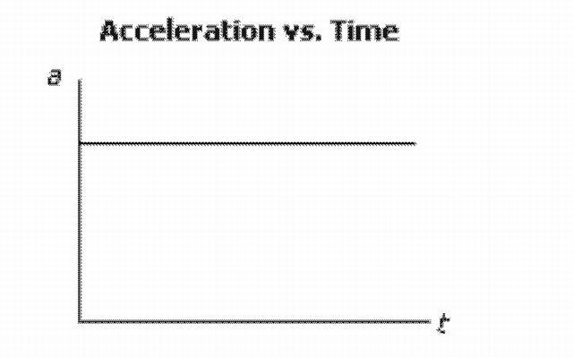

a. The object is moving with uniform motion.

b. The object has a constant velocity.

c. The object has a uniform acceleration.

d. The object is stopped.

e. The object has a changing acceleration.

____ 44. A ball is thrown vertically upward into the air. Which of the following acceleration-time graphs represents the ball’s motion?

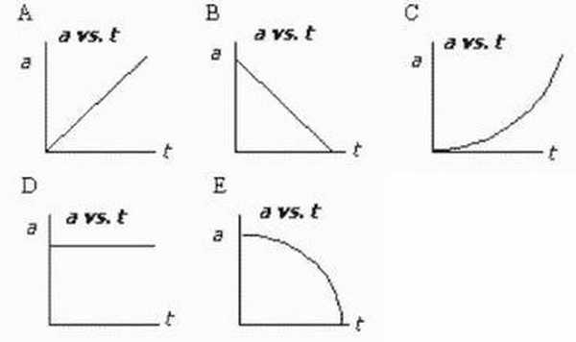

a. A

b. B

c. C

d. D

e. E

____ 45. Four of the five graphs pictured below could all represent the same motion. Which graph does not belong to this group?

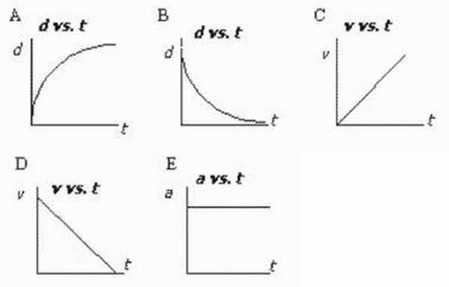

a. A

b. B

c. C

d. D

e. E

____ 46. A cyclist rides a bicycle 4.0 km west, then 3.0 km north. What is the cyclist’s displacement?

a. 7.0 km [37° N of W]

b. 7.0 km [37° W of N]

c. 5.0 km [37° N of W]

d. 5.0 km [37° W of N]

e. 1.0 km [37° W of N]

____ 47. A taxi cab drives 2.0 km [W], then 3.0 km [N], then 4.0 km [W], and finally 5.0 km [N]. The entire trip takes 0.30 h. What is the taxi’s average velocity?

a. 47 km/h [53° W of N]

b. 47 km/h [53° N of W]

c. 33 km/h [53° N of W]

d. 33 km/h [53° W of N]

e. 10 km/h [53° W of N]

____ 48. A motorcycle accelerates from rest at 6.0 m/s2. How much farther will it travel during the second 3.0 s of its motion than during the first 3.0 s?

a. 98 m

b. 81 m

c. 54 m

d. 27 m

e. 15 m

____ 49. The position-time graph below depicts the motions of two objects, A and B. Which of the following statements concerning the objects’ motions is NOT true?

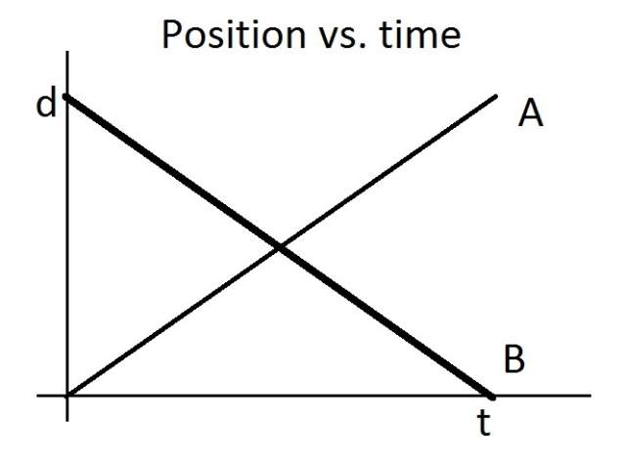

a. The two objects have the same speed.

b. The two objects travel the same distance.

c. The two objects travel with uniform motion.

d. The two objects travel for the same amount of time.

e. The two objects have the same velocity.

____ 50. What type of motion is depicted by the following acceleration-time graph?

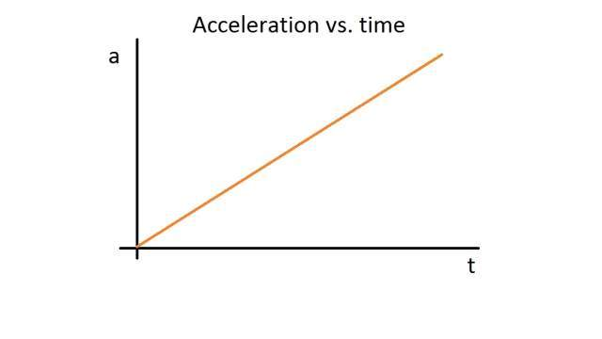

a. constant velocity b. non-uniformly changing acceleration c. constant acceleration d. uniformly changing acceleration e. uniform motion

____ 51. The diagram below shows the first three legs of a trip: A to B, B to C, and C to D. If a person returns from point D to point A, what is the displacement for this fourth and final leg?

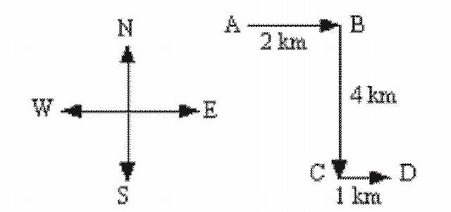

a. 7 km [37° W of N]

b. 5 km [37° W of N]

c. 5 km [37° E of S]

d. 7 km [37° E of S]

e. 5 km [37° N of E]

## 6.3 Completion

Complete each sentence or statement.

52. In mechanics, we are primarily concerned with the base units for time, length, and mass. In addition to these, there are only ____________________ other base quantities from which all other units are derived.

53. Consider a race around a circular track. The values of average speed will likely be ____________________ for all competitors; but the value for the average velocity for all competitors will be ____________________.

54. An object in uniform motion is travelling with constant ____________________.

55. Whenever the slope is found on a position-time graph, one is finding the ____________________.

56. Whenever the slope is taken on a ____________________ graph, one is finding the acceleration.

57. When the ____________________ a velocity-time graph is taken, one is finding the displacement.

58. Plane A flies from Paris to New York, while plane B makes the same trip via London. Assume that the total time taken for both planes is the same. Considering the two trips, both planes have the same average ____________________ but different average ____________________.

59. An object that travels ever-increasing distances in successive equal time intervals is undergoing ____________________.

60. Two observers watching the same object can have very different conclusions about the object’s motion depending on the observers’ _________________________.

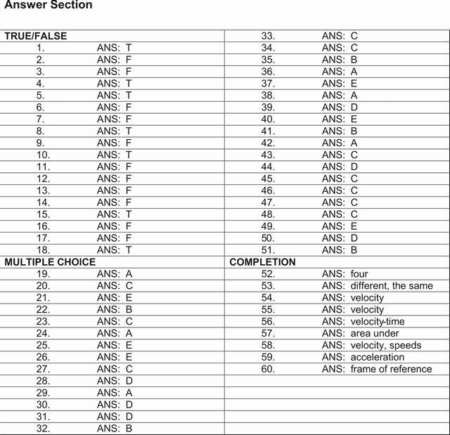

# 7 Review Exercise II

1. A cart travels with a constant nonzero acceleration along a straight line. Which graph best represents the relationship between the distance the cart travels and time of travel?

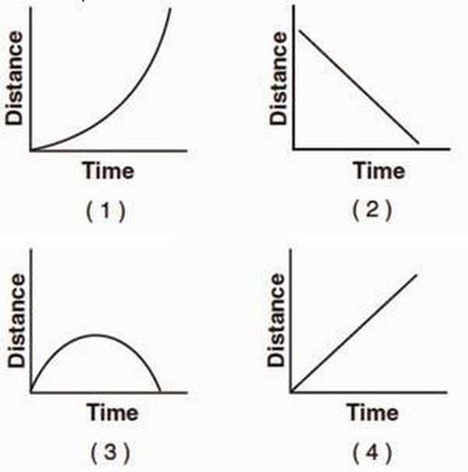

Base your answers to questions 2 through 4 on the information below.

A car on a straight road starts from rest and accelerates at 1.0 meter per second2 for 10 seconds. Then the car continues to travel at constant speed for an additional 20 seconds.

2. Determine the speed of the car at the end of the first 10 seconds.

3. On the grid at below, use a ruler or straightedge to construct a graph of the car’s speed as a function of time for the entire 30-second interval.

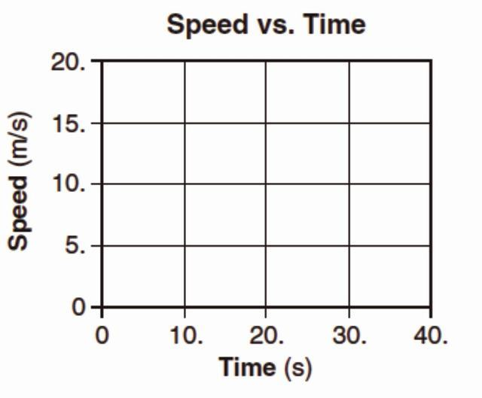

4. Calculate the distance the car travels in the first 10 seconds. [Show all work, including the equation and substitution with units.]

5. A student throws a baseball vertically upward and then catches it. If vertically upward is considered to be the positive direction, which graph best represents the relationship between velocity and time for the baseball? [Neglect friction.]

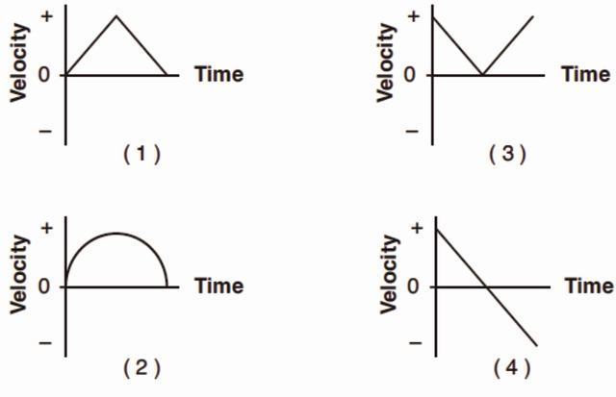

6. The graph below represents the displacement of an object moving in a straight line as a function of time.

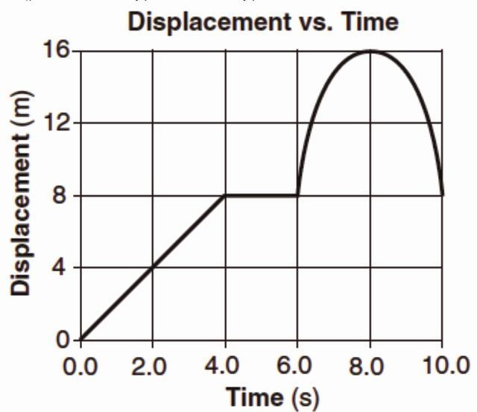

What was the total distance traveled by the object during the 10-second time interval?

1. 0 m

2. 8 m

3. 16 m

4. 24 m

7. Which graph best represents the relationship between the acceleration of an object falling freely near the surface of Earth and the time that it falls?

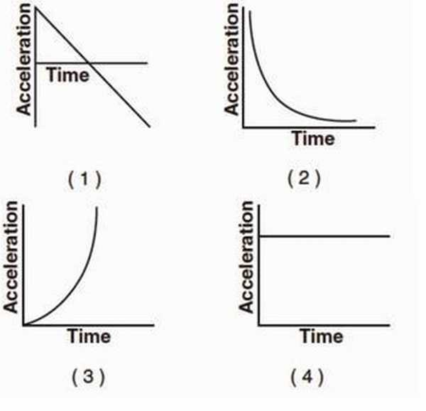

8. Which pair of graphs represent the same motion of an object?

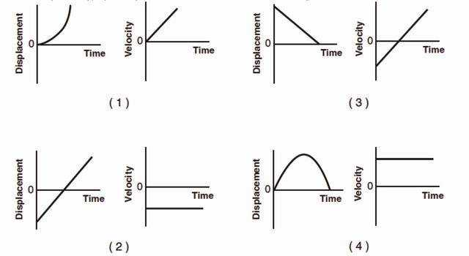

9. The graph below represents the velocity of an object traveling in a straight line as a function of time.

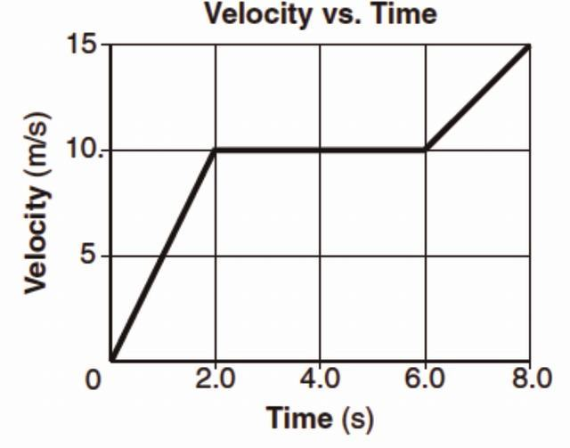

Determine the magnitude of the total displacement of the object at the end of the first 6 seconds.

10. Which graph best represents the motion of a block accelerating uniformly down an inclined plane?

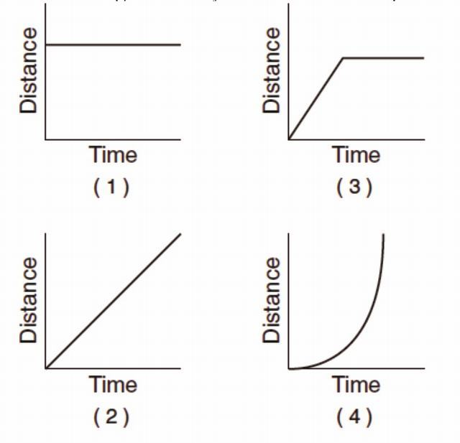

Base your answers to questions 11 and 12 on the graph below, which represents the motion of a car during a 6-second time interval.

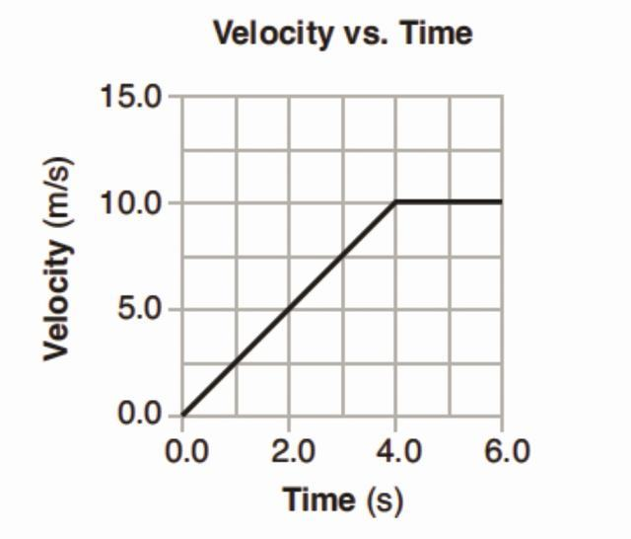

11. What is the acceleration of the car at t=5.0 seconds?

1. 0.0 m/s2

2. 2.0 m/s2

3. 2.5 m/s2

4. 10 m/s2

12. What is the total distance traveled by the car during this 6-second interval?

1. 10 m

2. 20 m

3. 40 m

4. 60 m

13. Which graph best represents the relationship between the velocity of an object thrown straight upward from Earth’s surface and the time that elapses while it is in the air? [Neglect friction.]

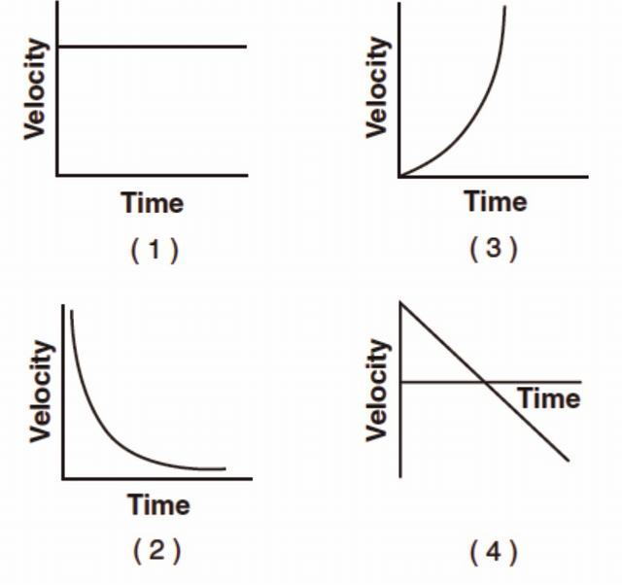

14. The graph below shows the relationship between the speed and elapsed time for an object falling freely from rest near the surface of a planet.

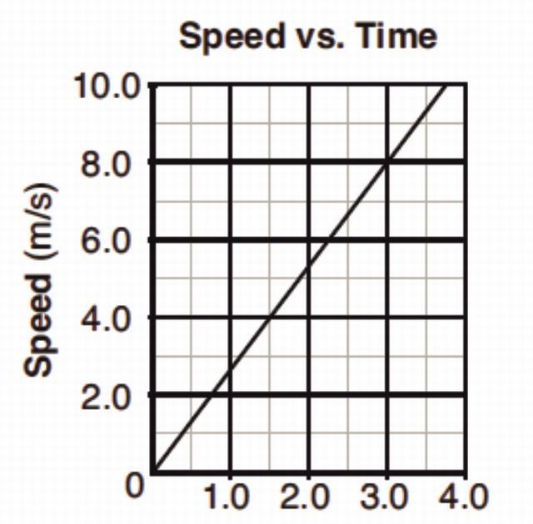

What is the total distance the object falls during the first 3 seconds?

1. 12 m

2. 24 m

3. 44 m

4. 72 m

15. The graph below represents the relationship between speed and time for an object moving along a straight line.

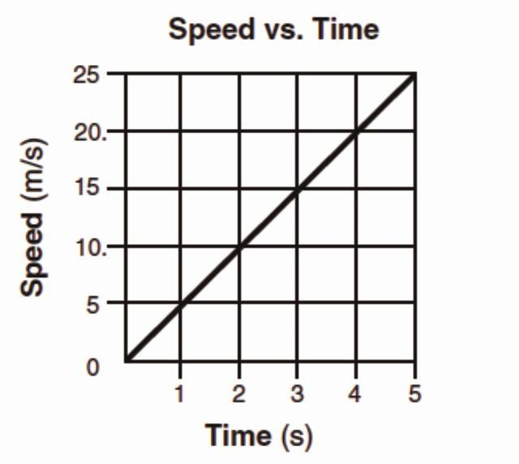

What is the total distance traveled by the object during the first 4 seconds?

1. 5 m

2. 20 m

3. 40 m

4. 80 m

Base your answers to questions 16 and 17 on the graph below, which shows the relationship between speed and elapsed time for a car moving in a straight line.

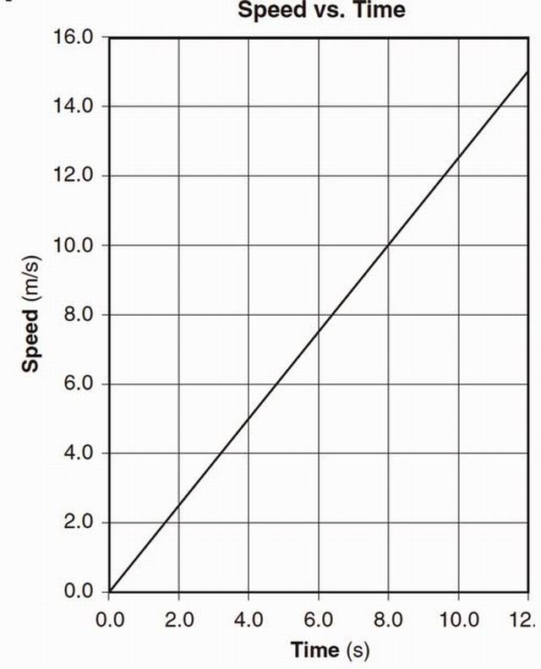

16. Determine the magnitude of the acceleration of the car.

17. Calculate the total distance the car traveled during the time interval 4.0 seconds to 8.0 seconds. [Show all work, including the equation and substitution with units.]

Base your answers to questions 18 through 20 on the graph below, which represents the relationship between velocity and time for a car moving along a straight line, and your knowledge of physics.

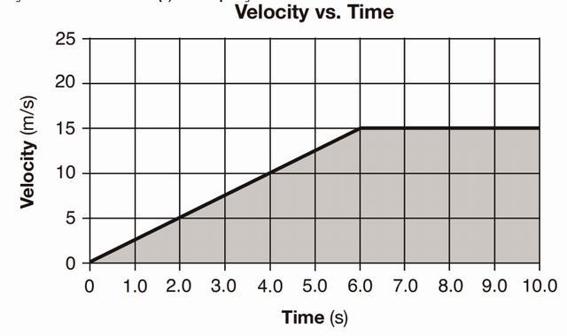

18. Determine the magnitude of the average velocity of the car from t=6.0 seconds to t=10.0 seconds.

19. Determine the magnitude of the car’s acceleration during the first 6.0 seconds.

20. Identify the physical quantity represented by the shaded area on the graph.

\printbibliography

# Part III. Laws of Motion

# 8 Abstract Introduction

## 8.1 Force – Time Graphs

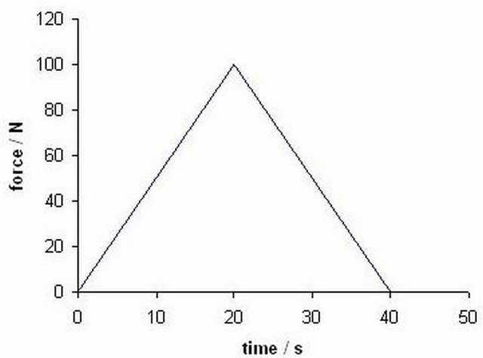

The area under a force – time graph gives us the impulse of the force applied (and hence the change in momentum of the object). For this graph the impulse (the area under the graph) is 2000 kg ms− 1.[[8](" \l "biblio-8)]

## 8.2 Change in Momentum or the "Impulse"

The change in the momentum of a system (or the impulse delivered by the net force) is given mathematically by the Momentum Principle,

△*⟶p* = *⟶Fnet*△*t*[[12](" \l "biblio-12)]

In this form, the change in momentum is calculated over a “discrete” time step. That is, the calculation is done over a known or determined time interval. If the force is non-constant (i.e., depends on location or velocity), this calculation is not exact. In fact, in this case, the net force is the average net force over the time interval. So that a better definition is this:

△*⟶p* = *⟶Fnet, avg*△*t*

This definition works well for case where you might use iterative procedures to determine the change in momentum over small time intervals. If on the other hand, you can analytically integrate the force (e.g., it is or can be put into a form which is time dependent), then you can use the derivative form of the Momentum Principle,

*Δ⟶p* = ∫*titf*\overset → *Fnetdt*

In any event, either (or both) can be useful to think about graphs of force vs time.

### 8.2.1 Force vs Time Graphs

In some situations, it is easier to empirically measure force versus time graphs because the situations lend themselves more easily to these empirical measurements rather than what might be more complex physical theories. This is true in different engineering contexts (e.g., impact design and the flow of fluids). In these cases, you are interested in determining the change in momentum (and thus the velocity) of the system in question1).

Below is a force vs time graph where the “area under the curve” has been highlighted. In this example, we are only looking at the component of the net force in the xx-direction. Such graphs can be produced for each component of the net force, but let’s say that for this system, there was a non-zero component of the net force only in the x-direction.

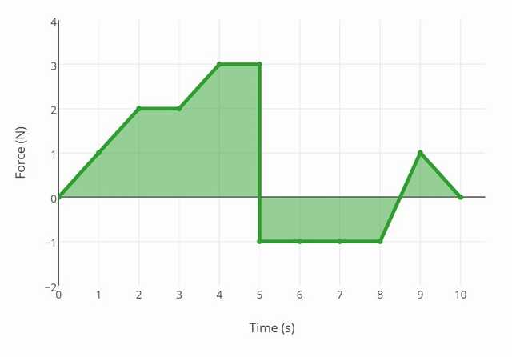

For the above figure, the momentum change over the complete time interval can be determined in a straightforward way due to the simple geometric shapes produced. Area above the zero line are positive momentum changes, and area below are negative. By adding up the “area under the curve” in this way, we obtain a momentum change of 7 Ns.

The figure below shows the force vs time graph for another system. In this case, the graph has a smooth form, which doesn’t appear to be analytic. The “area under the curve” for this graph could be analyzed computationally, by taking small steps (i.e., Riemann Sum), and the change in momentum could be determined.

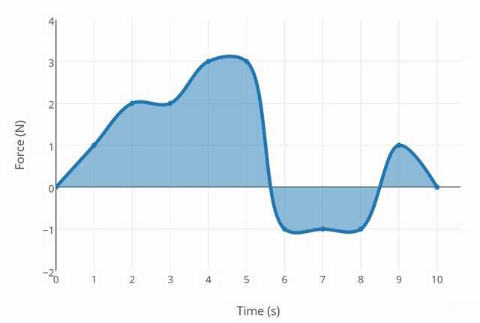

1) It is possible to determine the displacement of such systems as well. This can be done using velocity vs time graphs that are produced from the analysis of force vs time graphs.

## 8.3 Impulse graphs ( A Case Study) [[9](" \l "biblio-9)]

The force on the squash ball in the previous question is an average force and often the force changes during the collision. For this example the force–time graph could look like this.

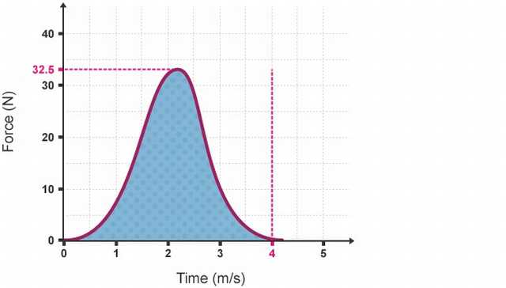

Notice the peak force is greater than the average force calculated.

The area under a force time graph is equal to the impulse. For any collision with a fixed change in momentum, if the time of contact can be increased, the peak force is reduced:

For example if the squash ball was replaced with a softer version of same mass the collision graph would look like this:

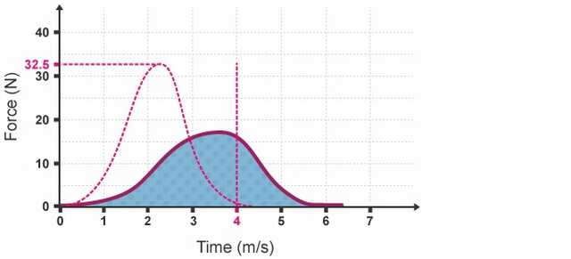

If the squash ball was replaced with a harder version of same mass the collision graph would look like this:

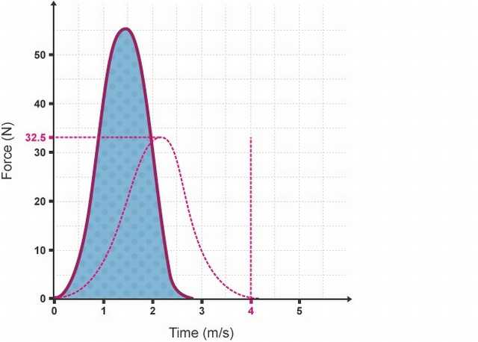

Question Modern cars are designed to crumple on impact in a collision. How does this help to protect the occupants from harm?

Answer The change in momentum (area under the force time graph) can’t be changed at the time of the accident (mass is fixed and it is too late for the driver to slow down!) By increasing the time of collision the peak force is less and hopefully lets the occupants come to less harm as a result.

Question : How do I find "Velocity" from "Force vs. Time" graph?

Solution : You need two additional pieces of information: the mass of the object and its initial velocity. Given those, the relation is:

*v*(*t*) = *vo* + (1)/(*m*)∫0*tF*(*t*)*dt*

# 9 Theory and Problems

## 9.1 Impulse as Force-time Graph

Example : For the graph shown above, assume that it shows a constant force of 25 N acting over a 10 s period of time. Determine the impulse.

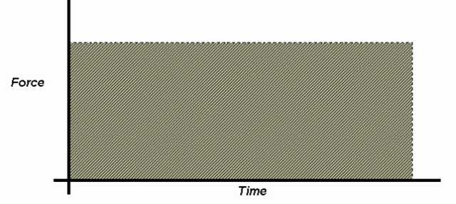

Illustration : Graph of Example (Force as a function of Time)

Solution : (Theory : So far we’ve implied some things about what is constant and what can change in the impulse formula F Δt = m Δv.

We look at situations where we expect the mass of the object will stay constant. • The velocity will change, and that’s why we put a delta in front of it. • Time is changing (sort of) as we measure it over a period of time. • Force must be a constant. We assume that the force being exerted on the object was always the same, causing a constant acceleration. If we are looking at a simple impulse question (where the force is constant), we can figure out exactly what we can interpret from a graph. • Later this may help us to figure out a more complicated question, like if the force changes. The following graph is an example of one of those simple situations where the force remains constant during the entire time. • If we look at what the slope might represent, we get...

slope=rise / run

slope= F / △t ◦

Since nothing in the impulse formula can be rearranged to give us force over time, the slope doesn’t mean anything to us in this situation.

If we look at the area under the line, we get something a bit better...

Area=lw=F△t= △p )

Since area under the line is equal to impulse...

Area=lw

Area=25 × 10

Area=2.5e2

p=2.5e2Ns

If we really wanted to, we could have simply use Δp = FΔt to figure out the impulse. We could do this in this situation because the force is constant. • If we need to do a question where the force is not constant, we can still use the area under the line to get the impulse, even though the formula Δp = FΔt can not be used.

Example : I am in a car that is accelerating from rest at a red light. I want to calculate the impulse that is acting on the car during the first 5.78s. If I know that the force on the car steadily increases from 0 N to 3012 N over this time, determine the impulse. If the mass of the car is 1500 kg, also determine the final velocity of the car.

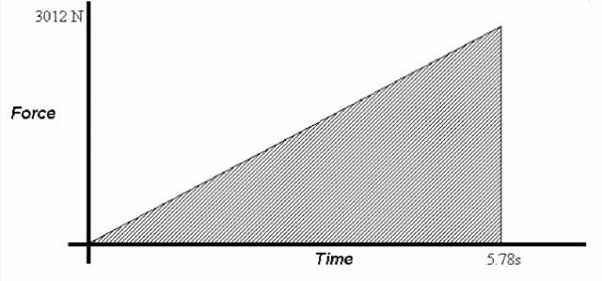

Illustration : Graph for Example (Force as a function of Time)

Solution : Let’s start by graphing the information we were given. We will get a nice linear graph, since it said that the force steadily increases.

If we calculate the area under the graph (a triangle) we will know what the impulse is.

A = ½ bh

= ½ (5.78 s)(3012 N)

= 8704.68 A

= 8.70e3 kgm/s

To calculate the final velocity, we can use the value for the impulse we just got with the right hand side of the impulse formula. Remember that the initial velocity (sitting at the light) is zero...

Δ p=mΔv

Δ p=m(v*f*−v*i*)

Δ p=mv*f*

v*f*=Δ p m

v*f*=8704.68/1500

v*f*=5.80312

v*f*=5.80m/s

The graph that we make does not have to be a pretty right angle triangle either. We can also do some crazy stuff with what we are looking for in the question, as the next example shows.

Example : This graph shows the result of applying 500 kgm/s of impulse to an object as it moved across the floor for 10.0 s. Determine the maximum force that was exerted.

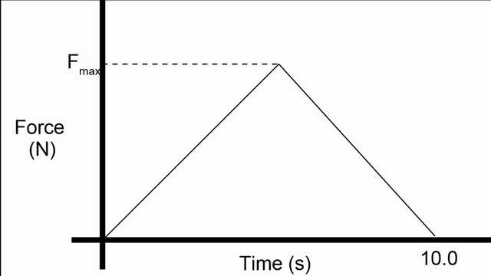

Illustration 3: Pushing object across the floor.

Solution : Even though it is not a right angle triangle, this graph still shows a triangle that we can use the regular area formula with. In this case, we already know the area (the impulse is 500 kgm/s) and we know the base (10.0 s). All we want is the height of the triangle, since that is the magnitude of the maximum force.

Area=bh/2

△p=F△t/2

F=2 △p/ t = 2 × 500/10.0 F=100N

Even if the graph is a curved line, you can still at least estimate the area under the graph. • Although this will only be an approximate area, without getting into calculus it’s as good as you’ll get and as good as you need. ◦ On the graph shown below we have an s-curve that would be difficult to calculate the exact area of. ◦ Instead, we just look at the triangle drawn in red. For the little bit extra it has near the beginning, it misses a bit later on. These two parts should more or less make up for each other, so that the area of the triangle will be about the same as the area under the curve.

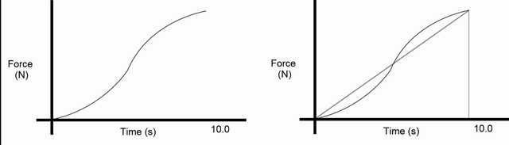

Illustration 4: Instead of trying to figure out the area of the curve exactly, we just use the area of the triangle as an approximation.

## 9.2 Force Time graph with respect to momentum

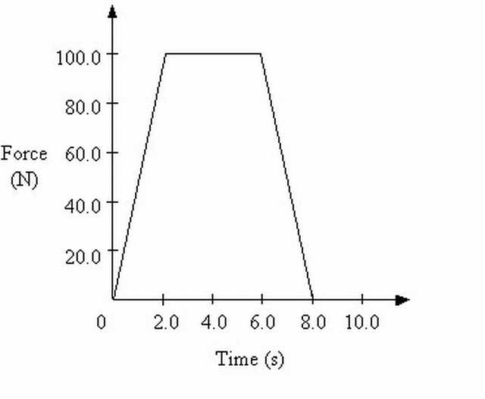

Example : If the mass of the object is 3.0 kg, what is its final velocity over the 8.0 s time period? [[10](" \l "biblio-10)]

Solution : You need the area under the curve, and you do not need calculus, as that is a trapezoid. The area of a trapezoid is the average of the bases times the height, which is (4 + 8)seconds/2*100 N = 600 N*s. Set this to *mv* − *mvo*, and assuming *vo* is zero get v final = 200 m/s.

Example : The graph given below belongs to an object having mass 2kg and velocity 10m/s. It moves on a horizontal surface. If a force is applied to this object between (1-7) seconds find the velocity of the object at 7 seconds. [[11](" \l "biblio-11)]

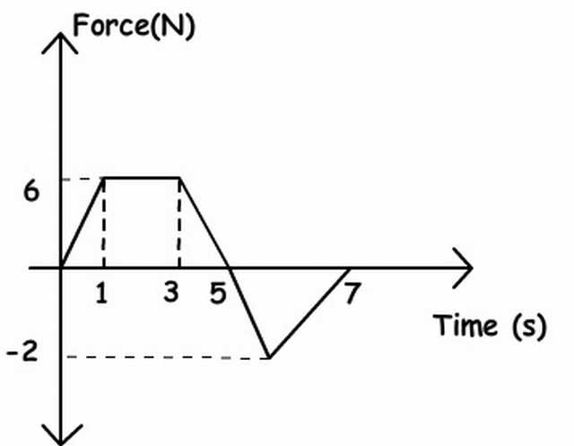

Solution : Area under the graph gives us impulse. First, we find the total impulse with the help of graph given above then total impulse gives us the momentum change. Finally, we find the final velocity of the object from the momentum change.

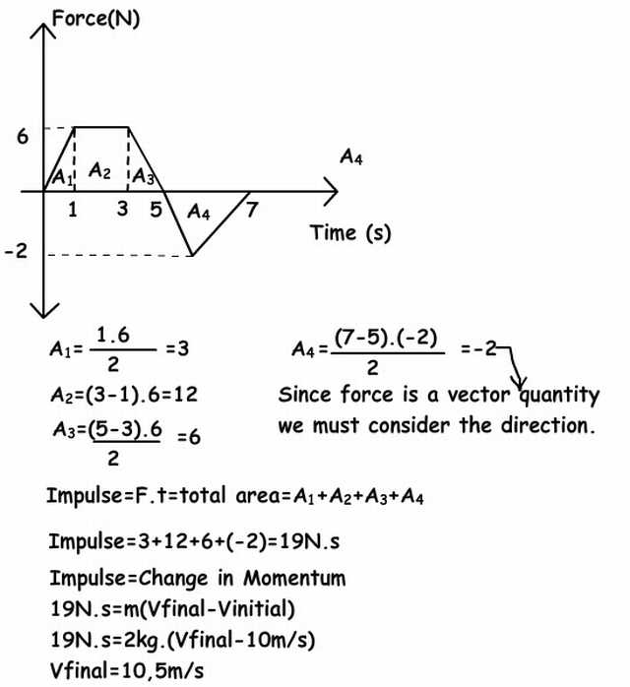

Example : Suppose a force,*F*(*t*) = 6*t*2 − 3*t* + 1, acts on an 7-kg mass for three seconds.

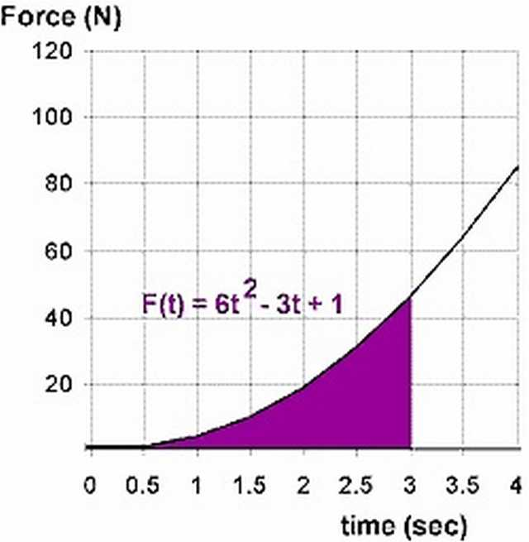

a) What impulse will the 7-kg object receive in the first three seconds?

b) If the mass started from rest, what is its final velocity?

Solution : Force as the rate of change of momentum The impulse equation J = (net F)t = Δp where p = mv can be rearranged to state that the applied net force applied to an object equals the rate of change of the its momentum.

net F = (△*p*)/(△*t*)

net F = (*m*△*v*)/(△*t*)

net F = ma

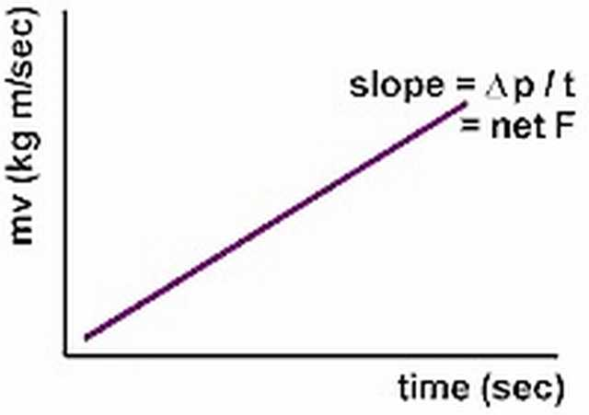

That is, the net force acting on an object can be calculated as the slope of a momentum vs time graph. In terms of the calculus, this result equates to taking the derivative.

(*dp*(*t*))/(*dt*) = *F*(*t*)

Notice that force must expressed as a function in terms of time, not displacement. Calculus will allow us to determine expressions for instantaneous, non-constant forces and thus is applicable to a wider range of situations. Let’s work an example using this relationship.

Using the graph provided below, determine the instantaneous force acting on the 7-kg mass at each of the specified times:

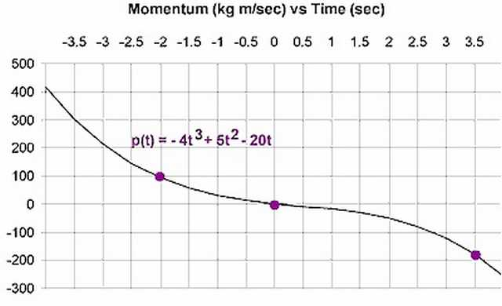

t = -2 seconds,

t = 0 seconds,

t = 3.5 seconds.

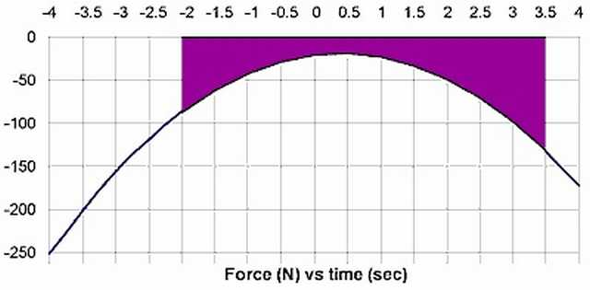

Example : The force shown in the force vs time graph below acts on a 1.7 kg object.

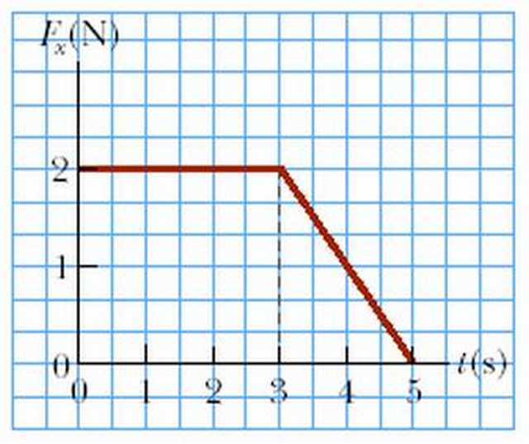

(a) Find the magnitude of the impulse of the force.

Ans : 8 kg m/s.

(b) Find the final velocity of the object if the object was initially at rest.

Ans : 2.76 m/s

(c) Find the final velocity of the object if the object was initially moving along the x axis with a velocity of -1.7 m/s.

Ans : “ “

Note : The force shown in the force vs time graph below acts on a 1.7 kg object. Find the final velocity of the object if the object was initially at rest. Find the final velocity of the object if the object was initially moving along the x axis with a velocity of -1.7 m/s.

Example : Relating Momentum and Impulse

EXPLORATION – An impulsive bike ride Suki is riding her bicycle, in a straight line, along a flat road. Suki and her bike have a combined mass of 50 kg. At t = 0, Suki is traveling at 8.0 m/s. Suki coasts for 10 seconds, but when she realizes she is slowing down, she pedals for the next 20 seconds. Suki pedals so that the static friction force exerted on the bike by the road increases linearly with time from 0 to 40 N, in the direction Suki is traveling, over that 20-second period. Assume there is constant 10 N resistive force, from air resistance and other factors, acting on her and the bicycle the entire time. Step 1 - Sketch a diagram of the situation. The diagram is shown in Figure 6.2, along with the free-body diagram that applies for the first 10 s and the free-body diagram that applies for the 20second period while Suki is pedaling.

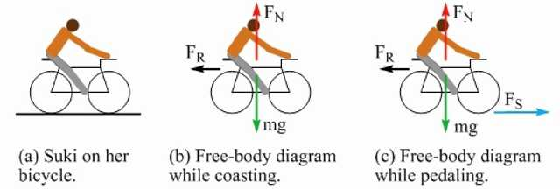

Figure : A diagram of (a) Suki on her bike, as well as free-body diagrams while she is (b) coasting and while she is (c) pedaling. Note that in free-body diagram (c), the static friction force \overset → *FS* gradually increases because of the way Suki pedals.

Step 2 - Sketch a graph of the net force acting on Suki and her bicycle as a function of time. Take the positive direction to be the direction Suki is traveling. In the vertical direction, the normal force exactly balances the force of gravity, so we can focus on the horizontal forces. For the first 10 seconds, we have only the 10 N resistive force, which acts to oppose the motion and is thus in the negative direction. For the next 20 seconds, we have to account for the friction force that acts in the direction of motion and the resistive force. We can account for their combined effect by drawing a straight line that goes from –10 N at t = 10 s, to +30 N (40 N – 10N) at t = 30 s. The result is shown in Figure 6.3.

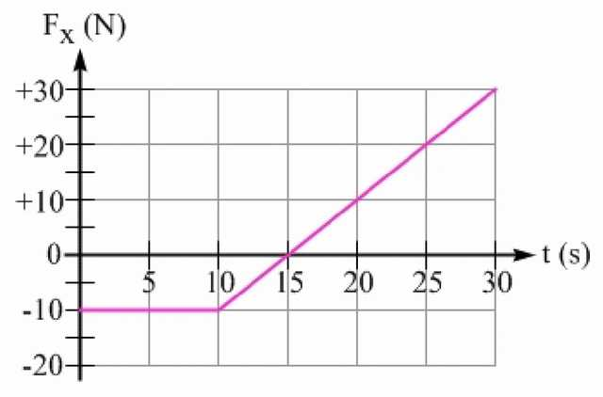

Figure 6.3: A graph of the net force acting on Suki and her bicycle as a function of time.

Step 3 - What is Suki’s speed at t = 10 s? Let’s apply Equation 6.3, which we can write as:

\overset → *Fnet*∆*t* = ∆(*m*\overset → *v*) = *m*∆*⟶v* = *m*(*⟶v10s* − *⟶vi*) .

Solving for the velocity at t = 10 s gives:

*⟶v10s* = *⟶vi* + (*⟶Fnet*△*t*)/(*m*) =  + 8.0*m* ⁄ *s* + (( − 10*N*)(10*s*))/(50*kg*) =  + 8.0*m* ⁄ *s* − 2.0*m* ⁄ *s* =  + 6.0*m* ⁄ *s*

Thus, Suki’s speed at t = 10 s is 6.0 m/s. We can also obtain this result from the forceversus-time graph, by recognizing that the impulse, *⟶Fnet*∆*t* , represents the area under this graph over some time interval ∆t . Let’s find the area under the graph, over the first 10 seconds, shown highlighted in green in Figure 6.4. The area is negative, because the net force is negative over that time interval. The area under the graph is the impulse:

*⟶Fnet*∆*t* =  − 10*N* × 10*s* =  − 100*Ns* =  − 100*kg* *m* ⁄ *s*

Figure 6.4: The green rectangle represents the area under the graph for the first 10 s. The area is negative, because the force is negative. From Equation 6.3, we know the impulse is equal to the change in momentum.

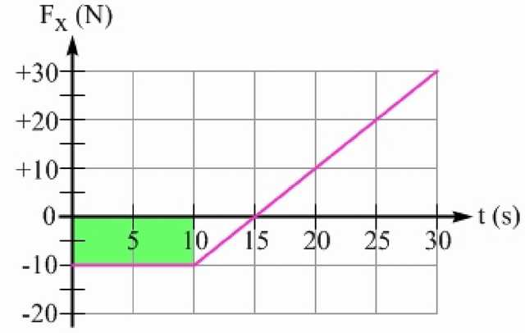

Suki’s initial momentum is

*m⟶vi* = 50*kg* × 8.0*m* ⁄ *s* =  + 400*kg* *m* ⁄ *s* . Her momentum at t = 10 s is therefore + 400kg m/s - 100kg m/s = + 300kg m/s . Dividing this by the mass to find the velocity at t = 10 s confirms what we found above:

*⟶v*10*s* = (*⟶p10s*)/(*m*) = (*⟶pi* + △*⟶p*)/(*m*) = ( + 400*kgm* ⁄ *s* − 100*kgm* ⁄ *s*)/(50*kg*) = ( + 300*kgm* ⁄ *s*)/(50*kg*) =  + 6.0*m* ⁄ *s*

Step 4 - What is Suki’s speed at t = 30 s? Let’s use the area under the force-versus-time graph, between t = 10 s and t = 30 s, to find Suki’s change in momentum over that 20-second period. This area is highlighted in Figure 6.5, split into a negative area for the time between t = 10 s and t = 15 s, and a positive area between t = 15 s and t = 30 s. These regions are triangles, so we can use the equation for the area of a triangle, 0.5 × base × height . The area under the curve, between 10 s and 15 s, is 0.5 × (5.0s) ×( - 10 N) = - 25kg m/s . The area between 15 s and 30 s is 0.5 × (15s) × (30 N) = + 225kg m/s . The total area (total change in momentum) is +200 kg m/s.

Note that another approach is to multiply the average net force acting on Suki and the bicycle (+10 N) over this interval, by the time interval (20 s), for a +200 kg m/s change in momentum.

Figure 6.5: The shaded regions correspond to the area under the curve for the time interval from t = 10 s to t = 30 s.

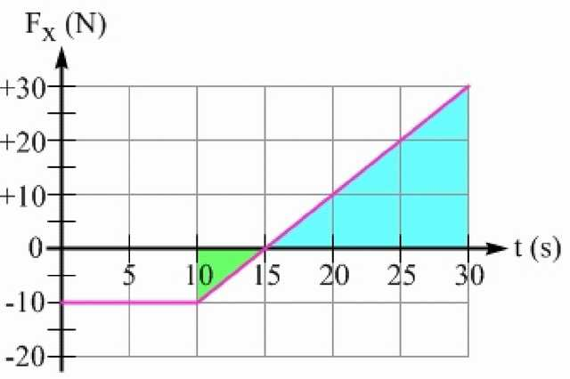

In step 3, we determined that Suki’s momentum at t = 10 s is +300 kg m/s. With the additional 200 kg m/s, the net momentum at t = 10 s is +500 kg m/s. Dividing by the 50 kg mass gives a velocity at t = 30 s of +10 m/s.

Key idea for the graphical interpretation of impulse: The area under the net force versus time graph for a particular time interval is equal to the change in momentum during that time interval.

\printbibliography

# Part IV. Energy Conservation

# 10 Abstract Introduction

## 10.1 KINETIC ENERGY

Objects have energy because of their motion; this energy is called kinetic energy. Kinetic energy of the objects having mass m and velocity v can be calculated with the formula given below;

*Ek* = (1)/(2)*mv*²

As you see from the formula, kinetic energy of the objects is only affected by the mass and velocity of the objects. The unit of the *Ek* is again from the formula kg.m²/s² or in general use joule.

## 10.2 Work Done by a Variable Force

Graphically, the work done on an object or system is equal to the area under a Force vs. displacement graph:

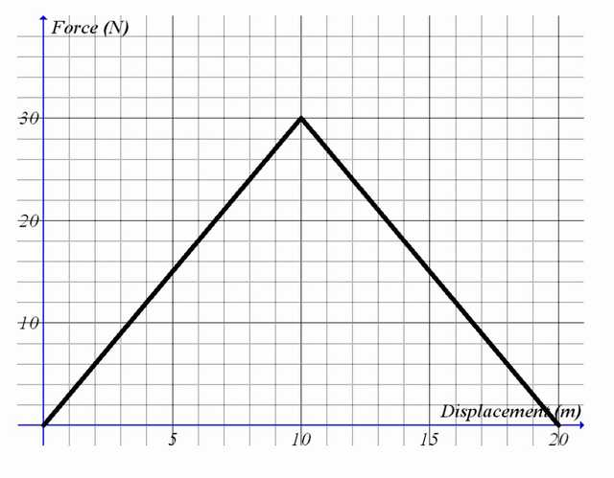

The area under the graph from zero to 20 meters is 300 N m. Thus, the force represented by the graph does 300 J of work. This work is also a measure of the energy which was transferred while the force was being applied

## 10.3 The net force vs. position graph

The area under the net force vs. position graph represents the change in kinetic energy (also known as the net work).

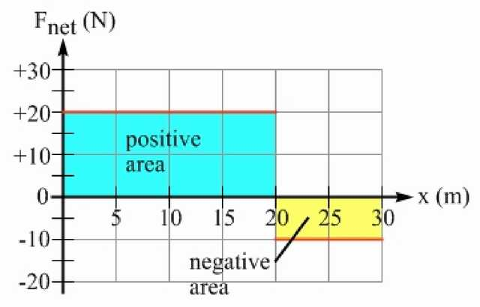

# 11 Theory and Problems

## 11.1 Force vs. Distance graph.

Example : Find the kinetic energy of the ball having mass 0,5 kg and velocity 10m/s.

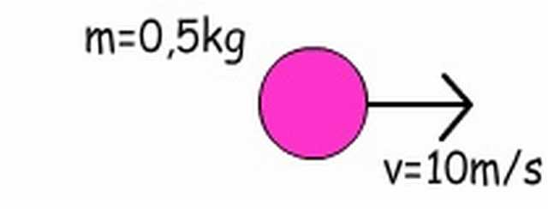

Ek=1/2mv²

Ek=1/2.0, 5. (10) ²

Ek=25joule

As in the case of Kinematics we can use graphs to show the relations of the concepts here. Look at the given graph of

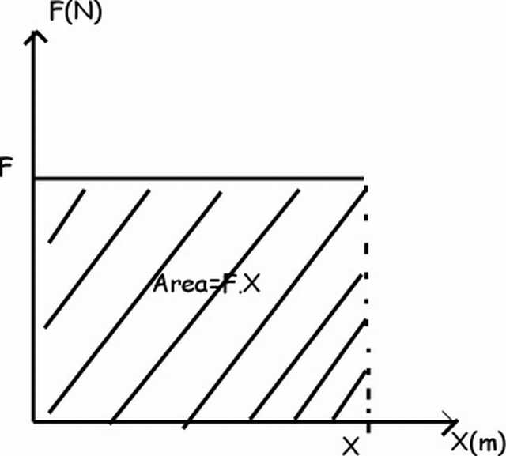

Area under the force vs. distance graph gives us work

Work=Force. Distance=Area=F.X (distance)

We can find energy of the objects from their Force vs. Distance graph.

Example : Find the Kinetic Energy of the object at 14m from the given graph below.

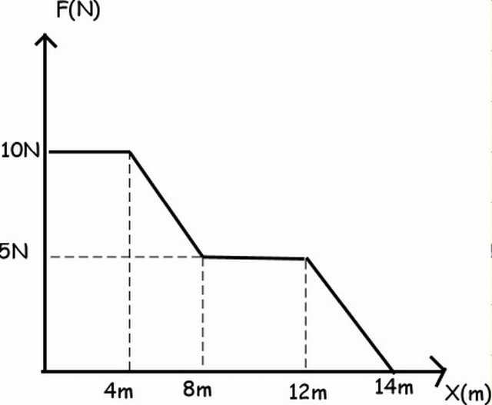

We can find the total kinetic energy of the object after 14m from the graph; we use area under it to find energy.

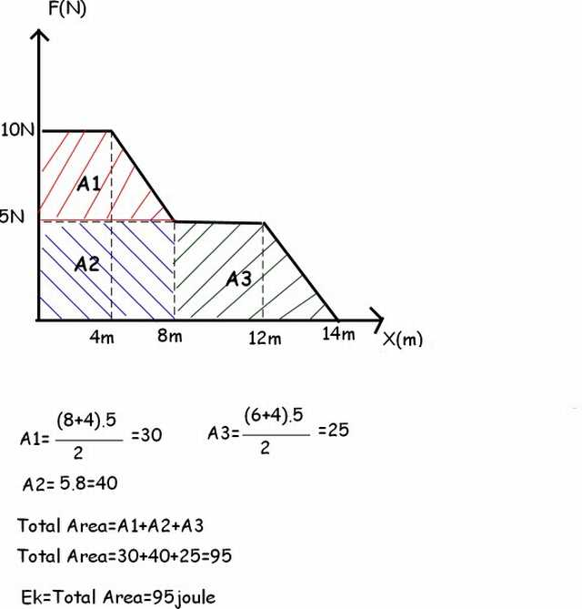

# 12 Review Questions I

Refer to the following information for the next thirteen questions. [[13](" \l "biblio-13)]

A 5.0-kg mass is pushed along a straight line by a net force described in the graph below. The object is at rest at t = 0 and x = 0.

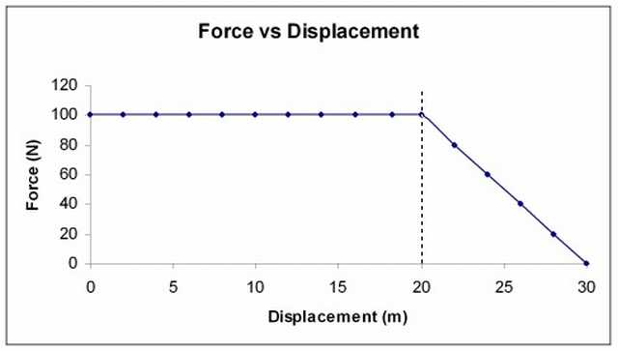

a) During which displacement interval was the object’s acceleration uniform?

b) What acceleration did the object experience when x = 10 meters?

c) How much work was done on the object during the first 20 meters?

d) How much kinetic energy did the object gain during the first 20 meters?

e) What was the object’s instantaneous velocity at x = 20 meters?

f) How much time was required to move it through the first 20 meters?

g) How much did the object’s momentum change in the first 20 meters?

h) What was the object’s instantaneous acceleration at x = 22 meters?

i) Why can’t the kinematics equations for uniformly accelerated motion be used to calculate the object’s instantaneous velocity at x = 30 meters? What method should be used?

j) How much work was done to move the object from 20 meters to 30 meters?

k) What was the object’s instantaneous speed at x = 30 meters?

l) What was the total impulse delivered to the object from x = 0 to x = 30 meters?

m) What percent of the impulse was delivered in the last 10 meters?

\printbibliography

# Part V. Simple Harmonic Motion

# 13 Abstract Introduction

## 13.1 Position vs time

The graph of position verse time is a sine wave with a possible phase shift. The phase shift is how much the ahead or behind the position is on the sine wave. [[14](" \l "biblio-14)]

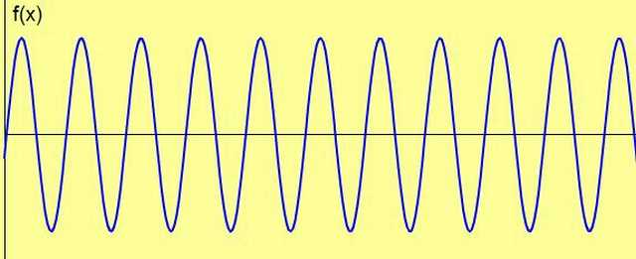

Consider this graph, if the "clock" is started at 0.05 (where the mass is at it’s maximum stretch) seconds then there would be a phase shift of 90 degrees (or we could replace the sine function for a cosine). If the "clock" is started at 0.1 seconds (where mass moves down instead of up; left instead of right) then the phase shift would be 180 degrees (a negative sine function).

## 13.2 Velocity vs time

Consider the position verses time graph, at any point were the mass has reached the amplitude (maximum distance from from the equilibrium point) the speed of the mass at these point is zero. When the position is at zero then the speed is at a maximum (if you don’t believe it, consider conservation of energy). This "shifts" the position graph by 90 degrees "creating" a cosine graph for velocity. The other way of thinking about is velocity is the change in position with respect to time, the change in a sine wave with respect to time is a cosine graph.

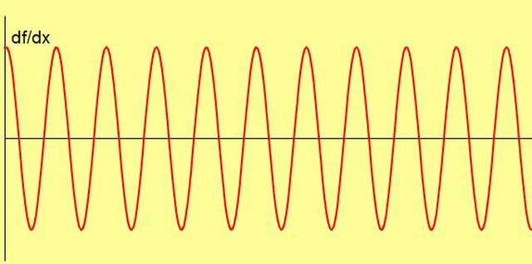

## 13.3 Acceleration vs time

The acceleration verse time graph is the easiest of the graphs to make. The simple harmonic motion is based on a relationship between position and acceleration; x = - Ka. So the graph of position and acceleration should look alike, except for the negative sign. In fact position and acceleration are the same shape just mirror copies of each other.

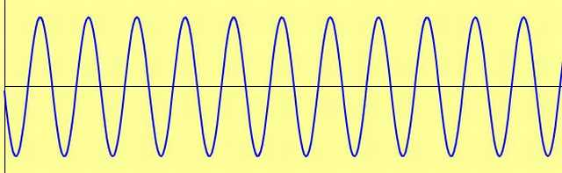

### 13.3.1 Peak Height

It is important to note that the shapes of each graph is simular, that each graph has the same frequency, period and wavelength, but they don’t have the same amplitude, for common simple harmonic motion, the height the peak of the function (not to confused with the amplitude, amplitude refers to the height of the position graph alone, i’m talking about the height of the position, velocity and acceleration graphs) tend to get smaller and smaller starting with the position graph being the tallest and the acceleration being the shortest.

## 13.4 Graphing position, velocity, and acceleration with respect to each other

Graphing position to the other functions can be complicated and when tested on it, most student are unable to give the right answer. First consider this, for simple harmonic motion position and acceleration are proportional. x = -k a this is a linear relationship so the graph is a line, the slope is negative so the line is heading down.

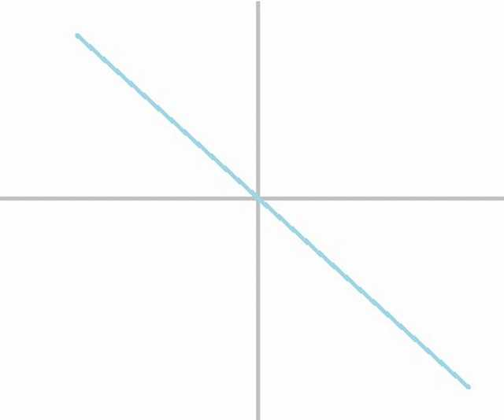

## 13.5 Position and acceleration verses velocity

The position and acceleration verse velocity graph look entirely different. First off the straight line test fails when plotting position vs velocity or acceleration verse velocity. Take the point were x and a are zero, there are two possible answers for the point (the speed maybe at maximum) the object could be moving down or up at the point. That means the velocity can be a positive maximum or a negative maximum, two separate values. Looking a the points were the velocity is equal to zero, there are two possible answers, either at the top or at the bottom. If you continue to plot data points graph that is developed is a ellisipe

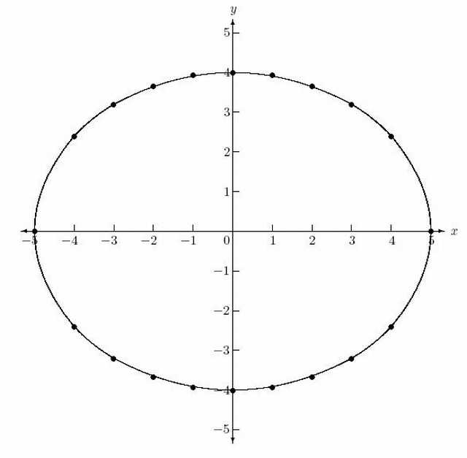

\printbibliography

# Index

Common Graph Forms in Physics:

Curve Fitting:

Double-Inverse Relationship:

Elements of a good Graph:

Exponential Relationship:

Graphical Analysis of Data:

Graphical Representation of Uncertainties:

Inverse Relationship:

Inverse-Square Relationship:

Linear Relationship:

Natural Log (LN) Relationship: [↑](#entry-Natural-Log-(LN)-Relationship-0)

Polynomial of Second Degree:

Power Relationship:

Power Relationship 2:

The First Equation:

Uncertainty in a Slope: