# A Complete Course in Physics (Mechanics->Kinematics Theory) - First Edition

## Rajat Kalia

## 18 November, 2017

Table of Contents

Part: Kinematics

Newton’s Part I: Equations of Motion

Derivation Chapter 1: of Newton’s Equations of Motion from basic forms and graphs

Newton’s Section 1.1: first equation of motion

Basic Derivation (without use of calculus or Subsection 1.1.1: graphs)

Subsection Derivation from v-t graph(Scalar form) 1.1.2:

Subsection Calculus Derivation(to be used in our class) 1.1.3:

Newton’s Section 1.2: second equation of motion

Basic Derivation (without use of calculus or Subsection 1.2.1: graphs)

Subsection Derivation from v-t graph(Scalar form) 1.2.2:

Subsection Calculus Derivation(to be used in our class) 1.2.3:

Newton’s Section 1.3: third equation of motion

Basic Derivation (without use of calculus or Subsection 1.3.1: graphs)

Subsection Derivation from v-t graph(Scalar form) 1.3.2:

Subsection Derivation(to be used in our class) 1.3.3:

Relative Part II: Velocity

Crossing Chapter 2: the River problems (Theory)

Motion Part III: in 2D

2D Chapter 3: Projectile Motion

Projection Section 3.1: at an angle to the Horizontal

Horizontal Section 3.2: Projection (Corollary)

Projection Section 3.3: on Inclined Plane

Index

# [↓](" \l "index-Kinematics)Kinematics

# Part I. ↓Newton’s Equations of Motion

# 1 ↓Derivation of Newton’s Equations of Motion from basic forms and graphs

We will use the basic assumptions like *⟶v* = (*⟶dr*)/(*dt*) (First Equation) and *⟶a* = (*⟶dv*)/(*dt*)(2nd Equation) and the v-t graph to derive the following Newton’s equations of motion for constant acceleration case(i.e. in Newton’s equations we assume that *⟶a* is constant while the basic first and second equation , we can use everywhere[non-uniform acceleration cases too]).

1. *⟶v* = *⟶vo* + *⟶at* (Newton’s first equation of motion)

2. *⟶r* = *⟶ro* + *⟶vot* + (1)/(2)*⟶at*2 (Newton’s second equation of motion)

3. *⟶v*.*⟶v* = *⟶vo*.*⟶vo* + 2*⟶a*.(*⟶r* − *⟶ro*) (Newton’s third equation of motion)

## 1.1 ↓Newton’s first equation of motion

The equation is *⟶v* = *⟶vo* + *⟶at*

We’ll first rewise a 9th class derivation without the use of first equation.

### 1.1.1Basic Derivation (without use of calculus or  graphs)

We define *⟶a* = (*⟶v* − *⟶vo*)/(*t*)

Cross multiplying, \strikeout off\uuline off\uwave off*⟶at* = *⟶v* − *⟶vo*

 ⇒  *⟶v* = *⟶vo* + *⟶at*

### 1.1.2 Derivation from v-t graph(Scalar form)

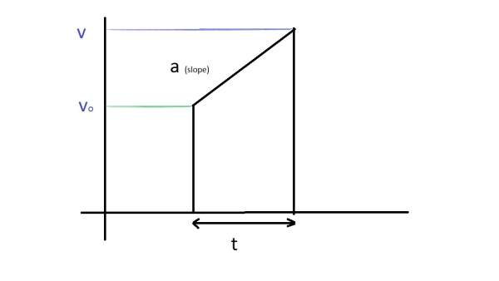

We define the slope of v-t graph as a, so it gives *a* = (*v* − *vo*)/(*t*)

Manipulating the form of this equation, we get *v* = *vo* + *at* , which is newton’s first equation of motion in scalar form.

### 1.1.3 Calculus Derivation(to be used in our class)

By the 2nd equation General Definition, we have

*⟶a* = (*⟶dv*)/(*dt*)

 ⇒ *⟶dv* = *⟶adt*

 ⇒ ∫*⟶vo⟶v⟶dv* = ∫0*t⟶adt*

 ⇒ [*⟶v*]*⟶vo⟶v* = *⟶a*[*t*]0*t*

 ⇒ \strikeout off\uuline off\uwave off*⟶v* − *⟶vo* = *⟶at*

 ⇒  *⟶v* = *⟶vo* + *⟶at* ——— ( Derived)

## 1.2 ↓Newton’s second equation of motion

The equation is *⟶r* = *⟶ro* + *⟶vot* + (1)/(2)*⟶at*2

We’ll first rewise a 9th class derivation without the use of first equation.

### 1.2.1Basic Derivation (without use of calculus or  graphs)

We’ll be using newton’s first equation of motion and the definition of average velocity to derive it.

*⟶v* = (*⟶v* + *⟶vo*)/(2) .i.e. Average velocity vector is the the average of initial velocity and final velocity vectors.

Also, *⟶s* = *⟶vt*

 ⇒ *⟶s* = (*⟶v* + *⟶vo*)/(2)*t*

Substituting, *⟶v* = *⟶vo* + *⟶at* , i.e. the newton’s first equation of motion. We get

*⟶s* = (*⟶vo* + *⟶at* + *⟶vo*)/(2)*t*

Now, *⟶s* = *⟶r* − *⟶ro* , displacement vector is the difference of final position vector and initial position vector.

Manipulating, we get

*⟶r* − *⟶ro* = (2*⟶vo* + *⟶at*)/(2)*t*

OR

*⟶r* = *⟶ro* + *⟶vot* + (1)/(2)*⟶at*2

### 1.2.2 Derivation from v-t graph(Scalar form)

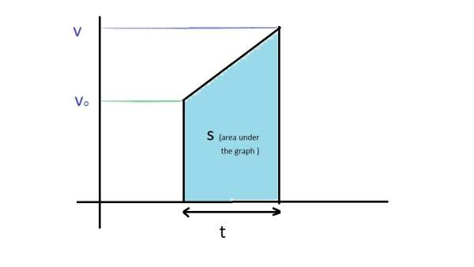

Area under the v-t graph is dispacement(s)

Area of a trapezium is sum of parallel sides X distance between them

 ⇒ *s* = (*v* + *vo*)/(2)*t*

Substituting, the previously derived newton’s first equation of motion in scalar form

 ⇒ *s* = (*vo* + *at* + *vo*)/(2)*t*

OR

*s* = *vot* + (1)/(2)*at*2

### 1.2.3 Calculus Derivation(to be used in our class)

We have, *⟶v* = (*⟶dr*)/(*dt*) , by first equation general definition

Substituting, newton’s first equation of motion

We get

\strikeout off\uuline off\uwave off*⟶vo* + *⟶at* = (*⟶dr*)/(*dt*)

 ⇒ ∫*⟶ro⟶r⟶dr* = ∫0*t*(*⟶vo* + *⟶at*)*dt*

 ⇒ [*⟶r*]*⟶ro⟶r* = [*⟶vot* + (1)/(2)*⟶at*2]0*t*

 ⇒ *⟶r* − *⟶ro* = *⟶vot* + (1)/(2)*⟶at*2

 ⇒ *⟶r* = *⟶ro* + *⟶vot* + (1)/(2)*⟶at*2——— ( Derived)

## 1.3 ↓Newton’s third equation of motion

The equation is *⟶v*.*⟶v* = *⟶vo*.*⟶vo* + 2*⟶a*.(*⟶r* − *⟶ro*)

We’ll first rewise a basic derivation without the use of first equation. It will require dot product.

### 1.3.1Basic Derivation (without use of calculus or  graphs)

We have,

*⟶v* − *⟶vo* = *⟶at* , by newton’s first equation of motion

(*⟶v* + *⟶vo*)/(2)*t* = *⟶s*

Taking dot product

\strikeout off\uuline off\uwave off*⟶(v* − *⟶vo*).((*⟶v* + *⟶vo*)/(2)*t*) = *⟶at*.*⟶s*

Cancelling t, transfering 2 to right hand side in numerator and opeing the brackets, we get

*⟶v*.*⟶v* − *⟶vo*.*⟶vo* = 2*⟶a*.*⟶s*

Manipulating, substituting the value of displacement vector, we get

*⟶v*.*⟶v* = *⟶vo*.*⟶vo* + 2*⟶a*.(*⟶r* − *⟶ro*)

### 1.3.2 Derivation from v-t graph(Scalar form)

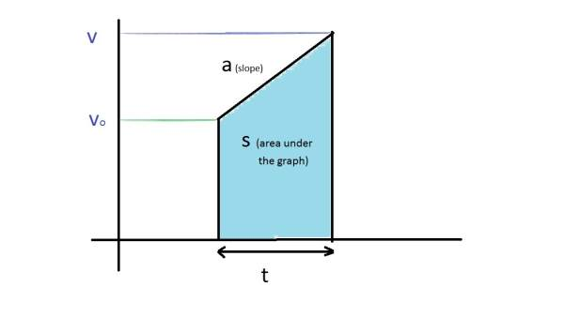

In deriving the newton’s third equation by graph, two values are taken from the graph

*a* = (*v* − *vo*)/(*t*) and*s* = (*v* + *vo*)/(2)*t*

Multiplying both the equations,

*as* = (*v*2 − *vo*2)/(2)

OR

*v*2 − *vo*2 = 2*as*

### 1.3.3 Derivation(to be used in our class)

We have, *⟶v* = (*⟶dr*)/(*dt*) (First Equation) and *⟶a* = (*⟶dv*)/(*dt*)(2nd Equation) as the basic General Definition

Reversing the sides of the second equation and taking dot product, we get

*⟶v*.*⟶dv* = *⟶a*.*⟶dr*

Integrating,

∫*⟶vo⟶v⟶v*.*⟶dv* = ∫*⟶ro⟶r⟶a*.*⟶dr*

 ⇒ [(*⟶v*.*⟶v*)/(2)]*⟶vo⟶v* = *⟶a*.[*⟶r*]*⟶ro⟶r* (This type of Integral in dot product, we’ll study at bachelor’s level, here we can prove it using vector’s components)

Substituting the values of limits,

(*⟶v*.*⟶v* − *⟶vo*.*⟶vo*)/(2) = *⟶a*.*⟶s*

 ⇒ *⟶v*.*⟶v* − *⟶vo*.*⟶vo* = 2*⟶a*.*⟶s* ——— ( Derived)

# Part II. ↓Relative Velocity

# 2 [↓](#index-Crossing-the-River-problems-(Theo)Crossing the River problems (Theory)

Theory Problem 1. Two swimmers leave point A on one bank of the river to reach point B lying right across on the other bank. One of them crosses the river along the straight line AB while the other swims at right angles to the stream and then walks the distance that he has been carried away by the stream to get to point B. What was the velocity u of his walking if both swimmers reached the destination simultaneously? The stream velocity *vo* = 2.0 km/hour and the velocity v’ of each swimmer with respect to water equals 2.5 km per hour.

Solution. **Case I** : Swimmer swims with final velocity along AB, this case is also called the “Shortest Path” case.

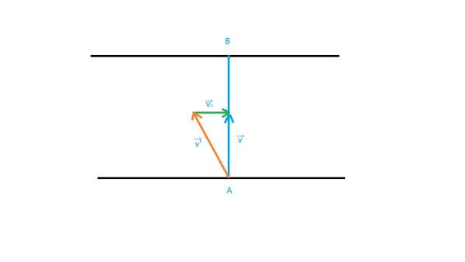

We see that *⟶v’* + *⟶vo* = *⟶v* and they form a right triangle

 ⇒ *v* = √(*v*’2 − *vo*2)

time to reach point B = (*AB*)/(√(*v*’2 − *vo*2))

**Case II** : Swimmer swims at right angle to the stream, this would require the “Shortest time in crossing the river” but the problem requires that he would have to walk to get to B.

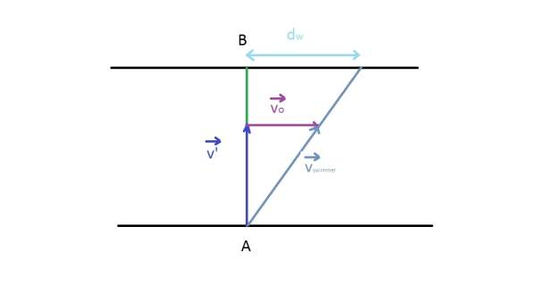

We see that *⟶v’* + *⟶vo* = *⟶v* and they form a right triangle, though this time with \strikeout off\uuline off\uwave off*⟶v* as the hyportenuse. It should be noted however that this time v’, vo and v vectors are different from Case I while the magnitudes of v’ and vo are the same. Our problem Case II is independent in this regard from case I and we can choose the same names without loss of generality

Proceeding to solve the question

(*AB*)/(*v*’) = (*dw*)/(*vo*) (By similarity of triangles, from figure)

 ⇒ *dw* = (*vo*)/(*v*’).*AB*

Time *t*1 to cross the river and reach the point (say C )

*t*1 = (*AB*)/(*v*’)

Time *t*2 to cross the distance dw back to B

*t*2 = (*dw*)/(*u*)

Total time = *t*1 + *t*2 = (*AB*)/(*v*’) + (*dw*)/(*u*) = (*AB*)/(*v*’) + ((*vo*)/(*v*’).*AB*)/(*u*)

Proceeding to solve the problem by comparing both the cases,

(*AB*)/(√(*v*’2 − *vo*2)) = (*AB*)/(*v*’) + ((*vo*)/(*v*’).*AB*)/(*u*)

Solving further, we get the required form, first cancelling AB and cross multiplying v’

(*v*’)/(√(*v*’2 − *vo*2)) − 1 = (*vo*)/(*u*)

 ⇒ *u* = (*vo*)/((*v*’)/(√(*v*’2 − *vo*2)) − 1)

Calculating the value, u = 3 km/hr

Theory Problem 2 : Two boats, A and B, move away from a buoy anchored at the middle of a river along the mutually perpendicular straight lines: the boat A along the river, and the boat B across thg river. Having moved off an equal distance from the buoy the boats returned. Find the ratio of times of motion of boats *τA* ⁄ *τB* if the velocity of each boat with respect to water is *η* = 1.2 times greater than the stream velocity.

Solution:

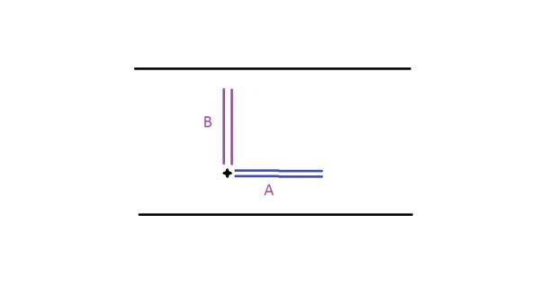

Let the stream velocity be *vo* , then the boat velocity with respect to water is *ηvo* . Also let us assume that the equal distance be d.

**Case A** : Final velocity of boat A in forward journey ( in the stream direction )

*v* = *ηvo* + *vo* = (*η* + 1)*vo*

Time to reach the destination =*t*1 = (*d*)/((*η* + 1)*vo*) ............(1)

Final velocity of boat A in the backward journey ( opposite to the stream direction )

*v* = *ηvo* − *vo* = (*η* − 1)*vo*

Time to reach back to the buoy =*t*2 = (*d*)/((*η* − 1)*vo*) ............(2)

*τA* = *t*1 + *t*2 = (*d*)/((*η* + 1)*vo*) + (*d*)/((*η* − 1)*vo*) = (2*η*)/(*η*2 − 1)(*d*)/(*vo*)

**Case B :** Here we proceed according to the shortest path case in Theory Problem 1.

In Forward Journey (Upwards in the figure)

*t*1 = (*d*)/(√(*η*2 − 1)*vo*)

In Backwards Journey (Downwards in the figure)

*t*2 = (*d*)/(√(*η*2 − 1)*vo*) = *t*1

\strikeout off\uuline off\uwave off*τB* = *t*1 + *t*2 = 2*t*1 = (2)/(√(*η*2 − 1))(*d*)/(*vo*)

(*τA*)/(*τB*) = ((2*η*)/(*η*2 − 1)(*d*)/(*vo*))/((2)/(√(*η*2 − 1))(*d*)/(*vo*)) = (*η*)/(√(*η*2 − 1))

Substituting the value, we get 6/√(11) as the ratio. = 1.81 (approx.)

Theory Problem 3 : A boat moves relative to water with a velocity which is n = 2.0 times less than the river flow velocity. At what angle to the stream direction must the boat move to minimize drifting?

Solution: Let the river flow velocity = *vo* . and velocity of boat relative to water would be then \strikeout off\uuline off\uwave off*v*’ = *vo* ⁄ *n* .

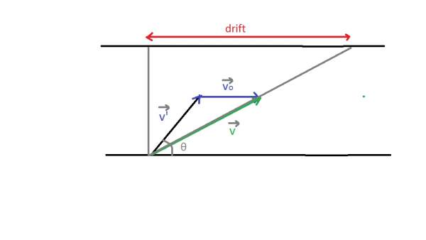

Across component(along y axis) of v is *v*’sin*θ*

Drift component(along x axis) of v is *v*’cos*ϑ* + *vo*

drift = (*AB*)/(*v*’sin*θ*)(*v*’cos*ϑ* + *vo*) = *AB*(cot*θ* + (*vo*)/(*v*’)*cosecθ*) = *AB*(cot*θ* + *ncosecθ*)

Now we have to minimize drift,

At minima, (*d*)/(*dθ*)*drift* = 0

 ⇒ (*d*)/(*dθ*)*AB*(cot*θ* + *ncosecθ*) = 0

 ⇒ *AB*(*cosec*2*θ* + *ncosecθ*cot*θ*) = 0

 ⇒ cos*ϑ* =  − (1)/(*n*)

The only solution in (0,π) is 120*o*.

# Part III. ↓Motion in 2D

# 3 ↓2D Projectile Motion

## 3.1 Projection at an angle to the Horizontal

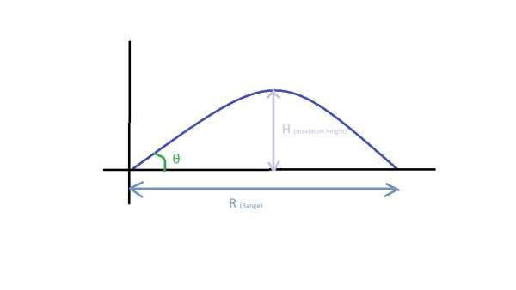

From Figure, we get

*vx* = *u*cos*θ* ..........(1)

*vy* = *u*sin*θ* − *gt* ..........(2)

*x* = *u*cos*θt* ..........(3)

*y* = *u*sin*θt* − (1)/(2)*gt*2 ..........(4)

**Case I : Maximum height, H**

At maximum height, *vy* is zero.

This gives the time at maximum height, (equating equation (2) to zero )

*TH* = (*u*sin*θ*)/(*g*) ———–(Supplementary Result)

Substituting this value of *TH* in y-> equation (4), we get maximum height (H)

*H* = *u*sin*θ*.(*u*sin*θ*)/(*g*) − (1)/(2)*g*((*u*sin*θ*)/(*g*))2

*H* = (*u*2sin2*θ*)/(2*g*) ———–(Primary Result) [Maximum Height]

Also , the value of x at this point

X*H* = *u*cos*θ*.*TH* = (*u*2sin2*θ*)/(2*g*) ———–(Supplementary Result)

**Case II: Range, R and Time of Flight, T**

At R, y=0.

Substituting this value in equation (4), we get

*T* = (2*u*sin*θ*)/(*g*) ———–(Primary Result) [Time of Flight]

Interestingly, *T* = 2*TH* ———–(Supplementary Result)

Substituting the time of flight in x, we get R

*R* = *u*cos*θ*.*T* = *u*cos*θ*.(2*u*sin*θ*)/(*g*)

*R* =  = (*u*2sin2*θ*)/(*g*)———–(Primary Result) [Range]

Also, *R* = 2*XH* implying that Maximum height occours at half the Flight range.

**Case III : Equation of Trajectory**

Eliminating t from the equations of x and y (3 and 4) we get

*y* = *u*sin*θ*.((*x*)/(*u*cos*θ*)) − (1)/(2)*g*.((*x*)/(*u*cos*θ*))2

*y* = *x*tan*θ* − (1)/(2)*g*(*x*2)/(*u*2cos*θ*2)———–(Primary Result) [Equation of Trajectory]

## 3.2 Horizontal Projection (Corollary)

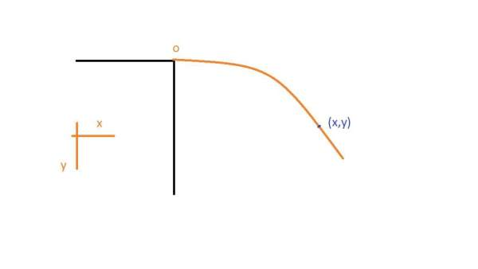

In the case of Horizontal Projection

*vx* = *u*

*vy* = *gt*

*x* = *ut*

*y* = (1)/(2)*gt*2

## 3.3 Projection on Inclined Plane

For an inclined plane, we shift the co-ordinate axis x along the plane and y perpendicular to it.This is not necessary, but convenient usually. However, there are cases when it’s usefull to treat a projectile on a inclined plane as a normal projectile of the above two cases.

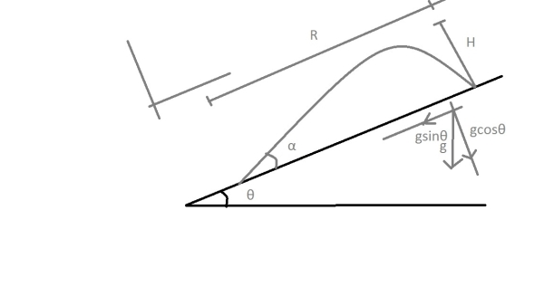

*vx* = *u*cos*α* − *g*sin*θt*

*vy* = *u*sin*α* − *g*cos*θt*

*x* = *u*cos*αt* − (1)/(2)*g*sin*θt*2

*y* = *u*sin*αt* − (1)/(2)*g*cos*θt*2

Case I : Maximum Distance from the plane

At this Distance, *vy* = 0

Solving we get , *tH* = (*u*sin*α*)/(*g*cos*θ*)

Substituting in y, we get

*H* = *u*sin*α*.(*u*sin*α*)/(*g*cos*θ*) − (1)/(2)*g*cos*θ*((*u*sin*α*)/(*g*cos*θ*))2

 ⇒ *H* = (*u*2sin2*α*)/(2*g*cos*θ*)

Case II : Range along the plane, Time to hit the plane

At R, *y* = 0

*tR* = (2*u*sin*α*)/(*g*cos*θ*) = 2*tH* (Even when the maximum distance occours at an unsimmetrical point)

Substituting in x,

*R* = *u*cos*α*.(2*u*sin*α*)/(*g*cos*θ*) − (1)/(2)*g*sin*θ*((2*u*sin*α*)/(*g*cos*θ*))2

 ⇒ *R* = (2*u*2sin*α*cos(*α* + *θ*))/(*g*cos2*θ*)

# Index

2D Projectile Motion:

Crossing the River problems (Theory): [↑](#entry-Crossing-the-River-problems-(Theo)

Derivation of Newton’s Equations of Motion from basic forms and graphs:

Kinematics:

Motion in 2D:

Newton’s Equations of Motion:

Newton’s first equation of motion:

Newton’s second equation of motion:

Newton’s third equation of motion:

Relative Velocity: