# A Complete Course in Commercial and Social Sciences - Third Edition

## Manas Kalia and Kairav Kalia

## 6 March, 2018

Table of Contents

Part: Economics

Part I: Microeconomics

Chapter 1: The Complete Theory in three graphs

Section 1.1: The Indian Economics

Section 1.2: Outside India Economics

Section 1.3: India to Outside and reverse relations in Market

Chapter 2: Conventional Terminology

Section 2.1: Production Frontier

Section 2.2: Budget Line, Constraints map and the condition of tangency

Section 2.3: Supply and Demand Curves ( Understanding Price and Quantity in the Marketplace )

Part II: Marketing

Chapter 3: Consumer Marketing

Chapter 4: Industrial Marketing

Chapter 5: Services Marketing

Part III: Civil Administration

Chapter 6: Police Services

Section 6.1: Police in Countries other than India

Section 6.2: Indian Police

Section 6.3: Punjab Police

Chapter 7: Administration Services

Section 7.1: Indian Foreign Services

Section 7.2: IAS

Section 7.3: Engineering Services

Part: Sociology

Part IV: The Market

Chapter 8: The Indian Context

Section 8.1: Eatables (Kiryana, Mandi, Halwai, Confectionary and Restuarants)

Part V: The Media

Chapter 9: International News Channels

Section 9.1: CNBC

Section 9.2: CNN

Section 9.3: MSN News (via windows e-print media)

Chapter 10: Prominent Indian News Channels

Section 10.1: DD Broadcast ( accross various of its channels )

Section 10.2: AajTak

Section 10.3: Zee News

Section 10.4: NDTV

Section 10.5: Other Smaller Channels

Part VI: The Cream vs the bearers ( in Indian Context and beyond )

Chapter 11: Introduction to the discussion The Cream vs the bearers

Part: Ecology

Part VII: Possibility of Nuclear Holocaust and UN’s non-proliferation treaty (which India doesn’t sign due to security concerns)

Chapter 12: Pakistan vs India, Area of high sensitivity

Chapter 13: Possibility of US using the nukes again , low

Chapter 14: The Role of Sci-Fi (The Phoenix writeup in Xth book, World at arms game by Gameloft, one MIT OCW Course etc. SCI-FI stuff predicting the near future)

Section 14.1: The Phoenix

Section 14.2: World at Arms

Section 14.3: MIT OCW

Index

# Economics

# Part I. Microeconomics

# 1 The Complete Theory in three graphs  [A]  [A] These concepts were first disclosed to me by my mom in childhood, then again told to me by the economics teacher in SMU MBA which I was doing. Evidently both of them probably read from this book as the source. So, cycles go on and knowledge remains in loop.

## 1.1 The Indian Economics

Indian economics and all it’s relations get a graph of this form . It’s called the Caviat.

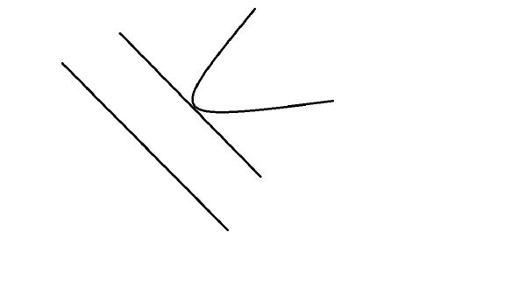

## 1.2 Outside India Economics

It’s called the BLOB. This rule governs all the outside india economics. It’sstrage the economics in India is completely different from that of Outside India.

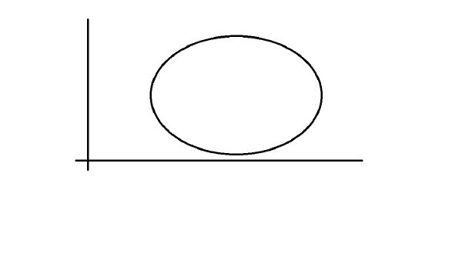

## 1.3 India to Outside and reverse relations in Market

It’s the Starfish relation. Draw a starfish in the middle of a paper and you would get to know about it. Plus it can lose a leg too.

Don’t worry , right now my scanner is not working, I’d have to buy a new one soon. Because of scanner inavailability my Physics Graphs book is also not proceeding furthur. So, keep a eye on furthureditions , I’ll make microeconomics an elaborate section with plenty of examples and also be giving proofs to the Caviat and BLOB and Starfish theorys.

# 2 Conventional Terminology

## 2.1 Production Frontier [[1](" \l "biblio-1)]

A production possibility frontier (PPF) shows the maximum possible output combinations of two goods or services an economy can achieve when all resources are fully and efficiently employed

### 2.1.1 Opportunity Cost and the PPF

Reallocating scarce resources from one product to another involves an opportunity cost

If we increase our output of consumer goods (i.e. moving along the PPF from point A to point B) then fewer resources are available to produce capital goods’

If the law of diminishing returns holds true then the opportunity cost of expanding output of X measured in terms of lost units of Y is increasing.

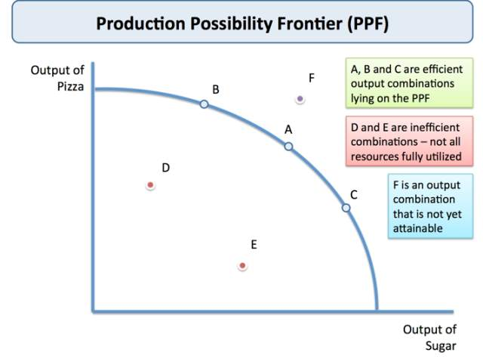

We normally draw a PPF on a diagram as concave to the origin i.e. as we move down the PPF, as more resources are allocated towards Good Y the extra output gets smaller – so more of Good X has to be given up in order to produce Good Y

This is an explanation of the law of diminishing returns and it occurs because not all factor inputs are equally suited to producing items

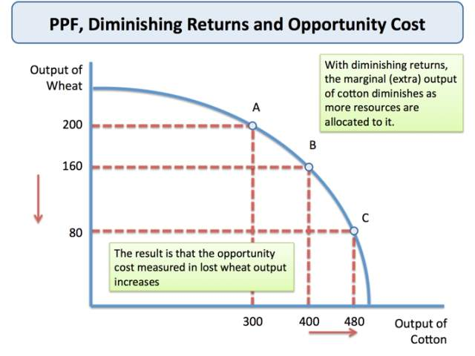

### 2.1.2 PPF and Economic Efficiency

#### 2.1.2.1 Production Possibilities

A production possibility frontier is used to illustrate the concepts of opportunity cost, trade-offs and also show the effects of economic growth.

Points within the curve show when a country’s resources are not being fully utilised

Combinations of the output of consumer and capital goods lying inside the PPF happen when there are unemployed resources or when resources are used inefficiently. We could increase total output by moving towards the PPF

Combinations that lie beyond the PPF are unattainable at the moment

A country would require an increase in factor resources, an increase in the productivity or an improvement in technology to reach this combination.

Trade between countries allows nations to consume beyond their own PPF.

Producing more of both goods would represent an improvement in welfare and a gain in what is called allocative efficiency.

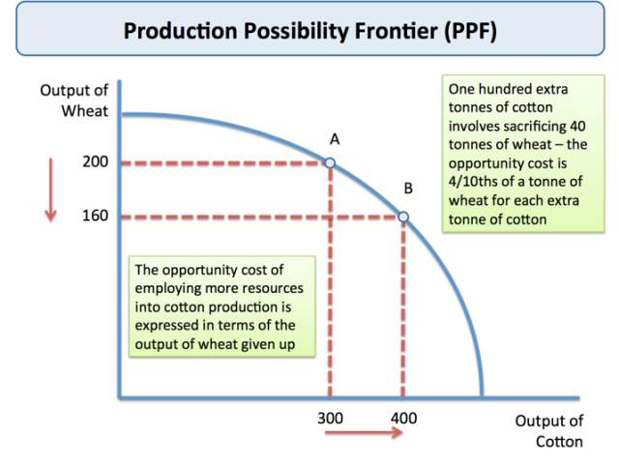

## 2.2 Budget Line, Constraints map and the condition of tangency [[2](" \l "biblio-2)]

In this section, we are going to take a closer look at what is behind the demand curve and the behavior of consumers. How does a consumer decide to spend his/her income on the many different things that he/she wants, i.e., food, clothing, housing, entertainment? We assume that the goal of the consumer is to maximize his/her level of satisfaction or joy, constrained by his/her income.

Economists use the term utility as a measure of satisfaction, joy, or happiness. How much satisfaction does a person gain from eating a pizza or watching a movie? Measuring utility is based solely on the preferences of the individual and has nothing to do with the price of the good. Let’s do an experiment in utility.

Step 01: Get some of your favorite candy, pastries, or cookies.

Step 02: Take a bite and evaluate, on a scale from 0 to 100 (with 100 being the greatest utility), the level of utility from that bite. Record the marginal utility of that bite (i.e., how much you get from that one additional bite).

Step 03: Repeat step 02. It is important to be consistent with each unit consumed, i.e., the same size and no drinking milk or water part way though. When you run out of candy or your marginal utility goes to zero you can stop.

Law of Diminishing Marginal Utility

The law of diminishing marginal utility states that as more of the good is consumed, the additional satisfaction from another bite will eventually decline. The marginal utility is the satisfaction gained from each additional bite. As more of the good is consumed, we gain less additional satisfaction from consuming another unit. Thus even if a good were free and you could consume as much as you wanted, there would be a limit to the amount you would consume due to the law of diminishing marginal utility.

Summing the marginal utilities gives us the total utility. For example, let’s say the first chocolate was an 85 and the second chocolate had a marginal utility of 79, then the total utility from consuming two chocolates is 164. The total utility from consuming three chocolates is 85+79+73 = 237. As long as our marginal utility is positive our total utility increases although with diminishing marginal utility it increases at a decreasing rate.

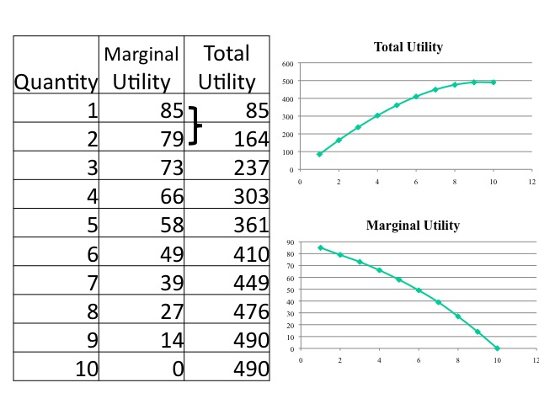

Can marginal utility be negative? Yes. At a holiday dinner, you may overeat and suffer from indigestion afterwards to a point where you regret having eaten too much, but at the time of the dinner, you expected greater utility from eating the last of the meal. We would not willingly consume an item that gave us negative marginal utility. Then why would an individual stuff themselves during a hot dog eating contest where clearly the last hot dogs consumed are making them worse off? Although the marginal utility from the last hot dog itself makes the person worse off, the utility from winning the contest is greater making the marginal utility positive.

The marginal utility of an item can change. For example, during a drought water provides a high positive marginal utility, and with more rain the marginal utility declines. At some point, there is too much rain, it turns from being a good utility to a bad one and the marginal utility of more rain, when it is already flooding, is negative.

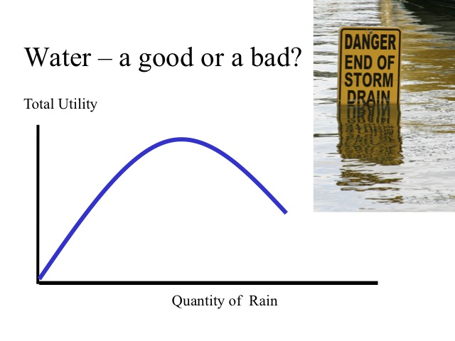

### 2.2.1 Maximizing Utility

Utility values can be determined by an individual ranking his/her preferences from least preferred to most preferred. The resulting ranking or utility values are subjective or individual. They are also ordinal rather than cardinal. Ordinal means that the utility values simply define a ranking of preferences rather than an actual cardinal measurement.

Imagine a class has 10 students in the class and the teacher lined the students up according to height. He then numbered them off according to height, assigning the shortest student a 1 and the tallest student a 10. Is it true that student number 4 is twice tall as student number 2? Of course not. All we know from the ranking is that student number 4 is taller than student number 2. Now, imagine that in another class another teacher has also ranked 10 students according to height. Is it true that student number 10 from the second classroom is taller than student 1 from the first classroom? We cannot say since the ranking is only valid within a particular course. In order to say a student is twice as tall as another student or to be able to compare students between classes, we would need a cardinal measure of height like inches or centimeters.

Since utility is ordinal and not cardinal we cannot make interpersonal comparisons of utility. Does a rich person value a dollar more or less than a poor person? While some would say that a poor person likely has more unmet needs and thus he would value the dollar more. The answer is that it all depends on the preferences of the individuals. A poor person may prefer to live a more simplistic life and place a lower value on having an extra dollar than a rich person who has a “love of money” (1 Timothy 6:10). We simply cannot make such an interpersonal comparison of utility.

So how does the consumer decide what to purchase? Unfortunately everything has a price and consumers only have so much money to spend. Consequently consumers try to spend the limited money they have on what will give them the greatest amount of satisfaction. The decision rule for utility maximization is to purchase those items that give the greatest marginal utility per dollar and are affordable or within the budget. Many grocery stores provide a tag that indicates the price per pound for the good. This allows consumers to compare the cost per pound for different brands or different sizes. The same concept is used for maximizing utility but we divide the marginal utility by the price to get the marginal utility per dollar.

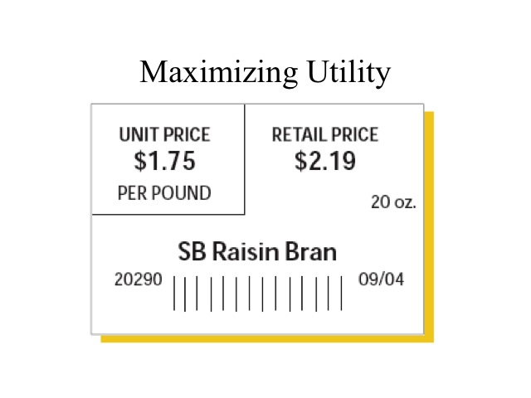

Let’s say that we eat only two goods: milk shakes and pizza where the price of each slice of pizza is $2 and the price of each shake is $1 and we only have $11 to spend. Since the price of each good is different we need to divide the marginal utility by the price to allow for a common comparison. We then compare the marginal utility per dollar for pizzas verses shakes. For the first unit the marginal utility per dollar of a shake is 50 compared to only 45 for the pizza, so we would purchase the first shake. We then compare the marginal utility per dollar of the first pizza (45) to the marginal utility per dollar of the second shake (40) and purchase the first slice of pizza. If the marginal utility per dollar is the same for the two goods and we have income to purchase both then we would do so, as seen in the second slice of pizza and the second shake.

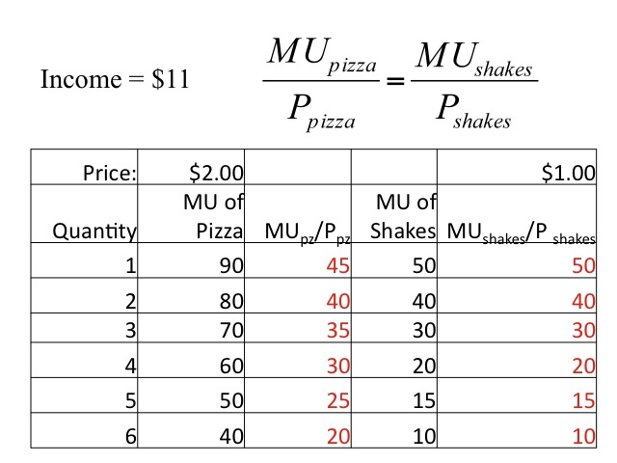

We continue to allocate on budget on those goods that yield the highest marginal utility per dollar. In this example, we would purchase four slices or pizza and three milkshakes and spend our entire budget of $11. The total utility from this purchase would be the sum of the marginal utilities: 50 + 90 + 80 + 40 + 70 + 60 + 30 = 420. At the last items purchased the marginal utility per dollar spent on the two goods is the same, no other combination of pizzas and milk shakes will give us greater utility given our budget.

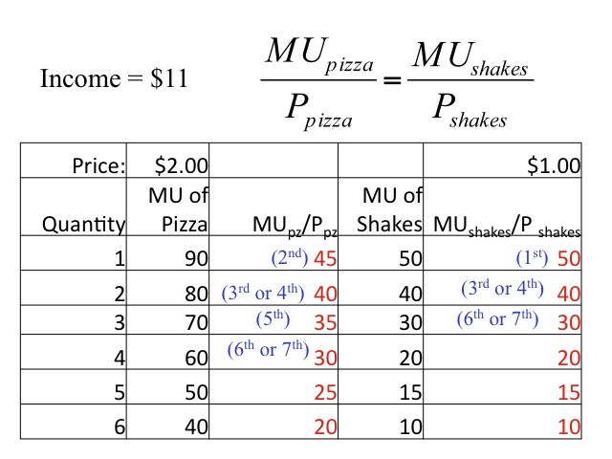

### 2.2.2 Practice

Here is your chance to practice. Holly has $20 to spend on either movies or bowling and wants to maximize her utility. Complete the table and determine how many movies and rounds of bowling will maximize her utility.

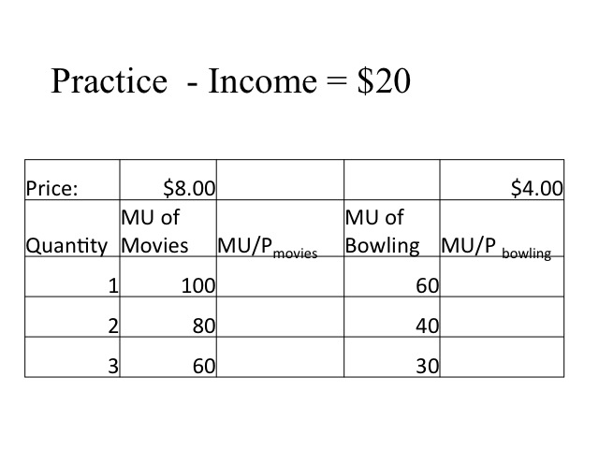

Our first step is to divide the marginal utility of each item by the price. With an income of $20 she is limited in what she can purchase. Since the marginal utility per dollar for bowling (15) is greater than the marginal utility of the first movie (12.5) she would initially go bowling, spending $4. Comparing the first movie (12.5) to the second round of bowling (10) she would go to the movie spending an additional $8 and a total of $12. The decision is a little harder. Holly has eight dollars still to spend and the marginal utility per dollar is the same for each good. If she chooses the movie she will spend all eight dollars, but if she goes bowling she will spend four dollars and still have four to spend. We have assumed that she wants to spend all her money and gains no utility from holding the cash. Since she can’t afford to buy another movie but would instead by a third round of bowling, which only has a marginal utility per dollar of 7.5. Thus we see that to maximize her utility, she would purchase one round of bowling and two movies giving her a total utility of (60 + 100 + 80) = 240. Recall our decision rule is to have the marginal utility per dollar spent on the last items be the same for all goods. In this case, we are unable to have that exactly but we try to get as close as possible. There is no other combination that would give us greater utility given our income.

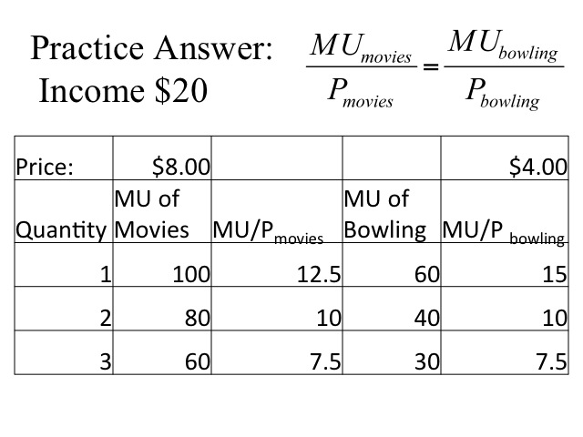

### 2.2.3 Deriving Demand

Knowing how the consumer behaves allows us to derive a demand curve. Let’s say that Suzette eats either an apple or an orange as a snack. She has $12 to spend. Given that each fruit costs two dollars, she will maximize her utility by purchasing 3 apples and 3 oranges. If we are looking at the demand for oranges, this will give us one point on the demand curve. At a price of $2.00, the quantity demanded of oranges is 3.

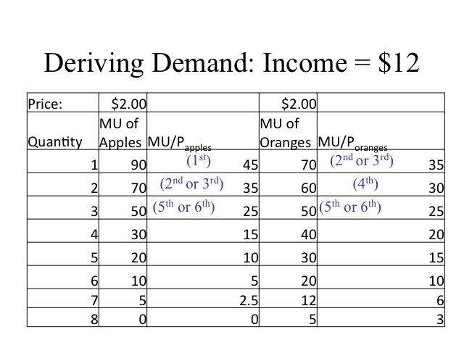

Recall that as we move along the demand curve, the only thing that changes is the price of the good (ceteris paribus or holding all else constant). If the price of oranges decreases to $1, the quantity of oranges demanded increases to 6.

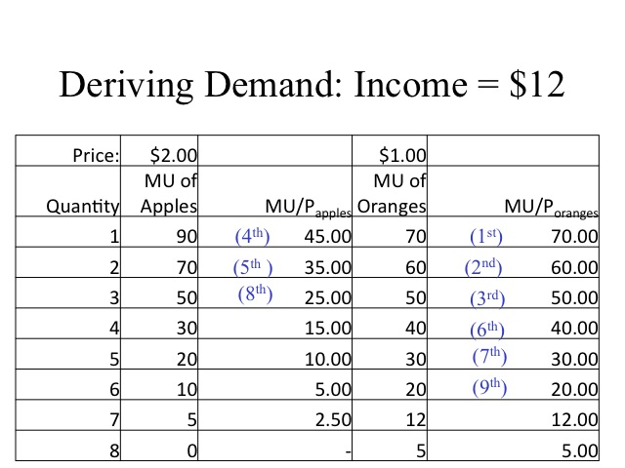

We can plot the two points and create a demand curve for oranges. At a price of $2 the quantity demanded is 3 and at a price of $1 the quantity demanded is 6. Recall that the demand curve reflects the marginal benefit or the willingness to pay of the consumer.

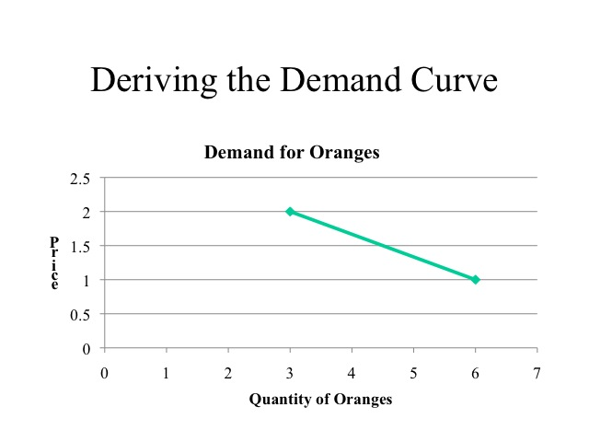

The demand curve can be seen in the diamond-water paradox. Why does water that is essential to sustain life cost so much less than diamonds that are atheistically pleasing, but are relatively unnecessary? Recall that price reflects the scarcity of a good. Overall, the supply of water is relatively abundant while the supply of diamonds is relatively limited. Thus the price we pay for water is low compared to the price of diamonds.

Is it logical for someone who is maximizing his utility to purchase both water and diamonds? When deciding what to purchase we compare the marginal utility divided by the price. With lots of water consumption, the total utility of water is very large but the marginal utility of the last gallon consumed is relatively low. Few diamonds are purchased so while the marginal utility is very large, say the diamond ring you just purchased for your future spouse, the total utility is low since few diamonds are purchased.

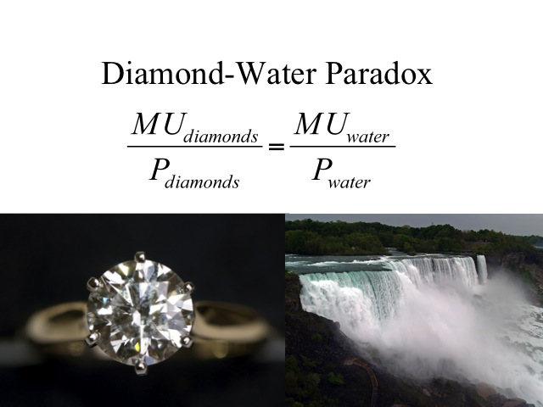

### 2.2.4 How Businesses React

Knowing that individuals experience diminishing marginal utility, how do businesses react? Recall that consumer surplus is the area below the demand curve but above the price. Think of some examples of how businesses react given the law of diminishing marginal utility.

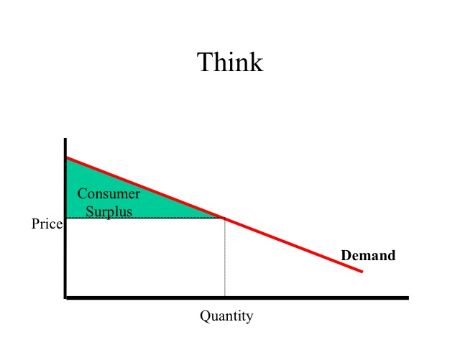

One example is the price per unit based on package size. An ice cream store has three different serving sizes - a 6, 10, and 12 ounce cup. The price of the smallest size, "Like It," is $4.29 or 71.5 cents per ounce. For just 32 cents more, one can have four more ounces, "Love It," making the marginal cost per ounce 8 cents and the average cost per ounce 46 cents. Upgrading to the "Gotta Have It" size adds an additional two ounces with only 15.5 cents per ounce more and an average cost per ounce of only 41 cents. Certainly the large size is cheaper per ounce, but not everyone wants to eat that large of a serving. For those only wanting a small serving, the store takes advantage of their greater willingness to pay for that portion size. Whether its ice cream, eggs, milk, popcorn, or cereal, it is common practice to charge a higher price per unit for a smaller package size. However it pays for consumers to do the math since businesses will at times charge a higher price on the larger packages size. If customers believe that bigger is always cheaper and fail to do the math, they may get caught paying a higher price per unit.

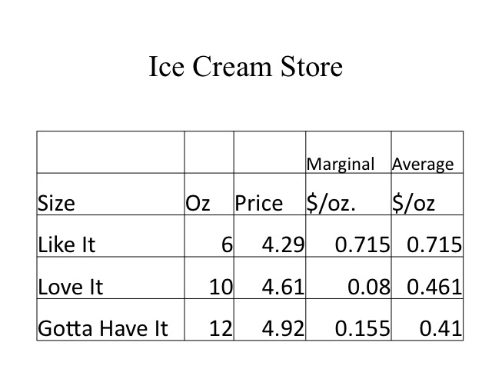

Services often follow a similar pricing scheme with lower average prices for more frequent attendance. For example, below are the prices for the “hopper pass” at Disneyland. Tickets to sporting events follow a similar pricing approach with the per game price being lower if multiple games are purchased, such as the season pass.

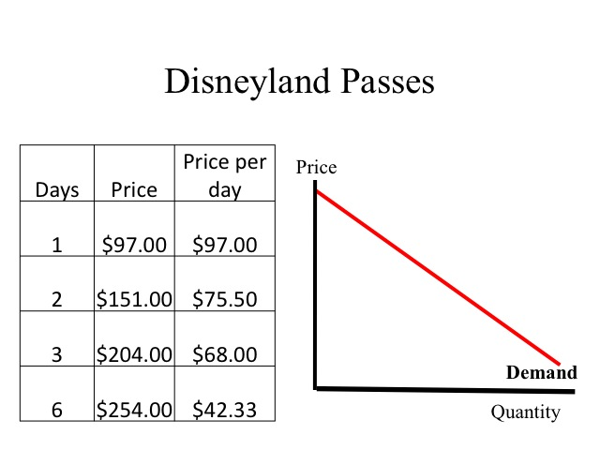

Consider this example. You are on a long airplane ride, seated next to an eccentric looking woman and a businessman. Halfway into the flight, the woman says to you and the businessman, that she is very rich and bored of flying. To break up the monotony, she offers you and the businessman a chance to split $5,000. The rules are as follows: the businessman makes an offer of how to split the money and you either accept or reject. If you accept, you get the agreed upon split. If you don’t, you both get nothing. This is a one time offer. The businessman thinks and offers the following split $4,995 for him and $5 for you. Do you accept or reject the offer? Why?

The answer to these questions will vary among individuals. Some will accept stating they have five dollars more than they did before. Others will reject the offer, saying that it is worth at least five dollars to them to deny they businessman the $4,995. Remember that when we talk about utility, it includes not only monetary items but also the nonmonetary.

In The Theory of Moral Sentiments, Adam Smith wrote: "How selfish soever man may be supposed, there are evidently some principles in his nature which interest him in the fortune of others and render their happiness necessary to him though he derives nothing from it except the pleasure of seeing it.” Remember that utility is derived from many different areas including service and philanthropic acts.

### 2.2.5 Indifference Curves

Indifference curves and budget constraints allow for a more in-depth analysis of demand. For modeling purposes we will look at the two goods. An indifference curve shows the different combinations of the two goods that yield the same level of utility, independent of the price of the goods. Due to the law of diminishing marginal utility, the indifference curve between the two goods is convex to the origin. All combinations of the two goods (pizza and shakes) that are on the indifference curve (A, B, and C) yield the same level of utility, say Utility = 100. Having more of good, yields a higher level of utility (combination D) and having less of the goods yields a lower level of utility (combination E).

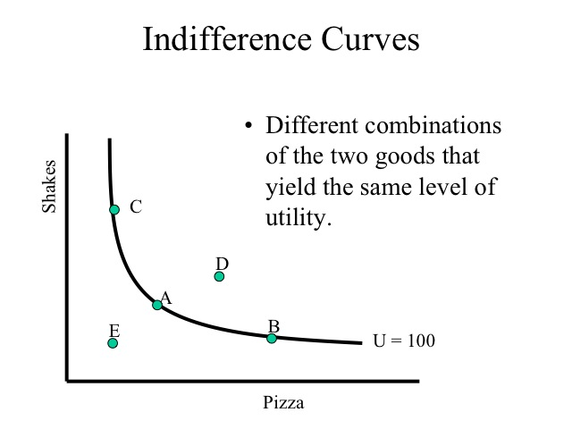

An indifference curve map shows the family of indifference curves. There could be an infinite number of indifference curves that would reflect the level of utility at different combinations of the two goods. Just as a line on a topographical map indicates the different points that are at the same elevation, the different points along an indifference curve, indicate that same level of utility.



Source: U.S. Geological Survey

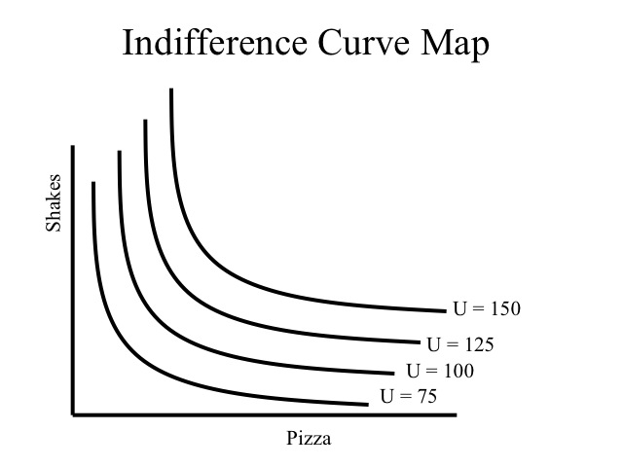

### 2.2.6 Marginal Rate of Substitution

The marginal rate of substitution is the slope of the curve and measures the rate at which the consumer would be willing to give up one good for the other while maintaining the same level of utility. Thus the marginal rate of substitution reflects the ratio of marginal utilities between the two goods.

For example, at point A, the consumer would be willing to trade one shake for one additional slice of pizza. At point B, the consumer already has a lot of pizza but few shakes so the marginal utility from an additional pizza is relatively lower and the marginal utility from the shake he would have to give up would be relatively large, thus to maintain the same level of utility he would have to gain 3 pizzas to willingly give up one half a shake.

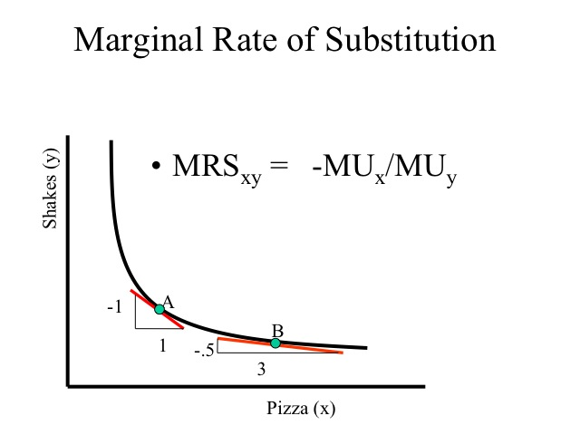

Since any combination of the two goods will only yield one level of utility at a particular point in time, indifference curves will never cross each other.

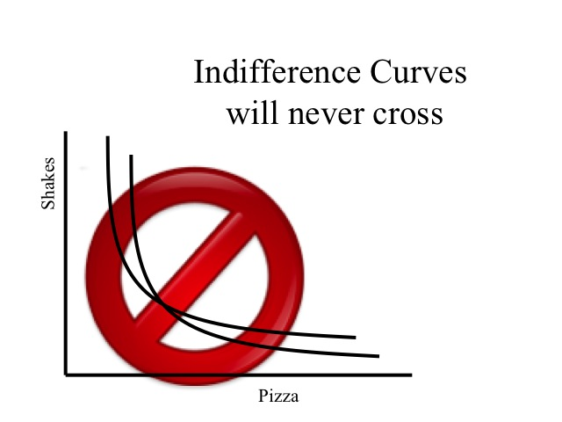

### 2.2.7 Budget Constraint

The budget constraint indicates the combinations of the two goods that can be purchased given the consumer’s income and prices of the two goods. The intercept points of the budget constraint are computing by dividing the income by the price of the good. For example, if the consumer had $8 to spend and the price of pizza was $2 and shakes were $1, then the consumer could buy four pizzas ($8/$2) or eight shakes ($8/$1). Any combination of the two goods that are on or beneath the budget constraint are affordable, while those to the outside (farther from the origin) are unaffordable.

A greater income will cause a parallel shift rightward of the budget constraint while a decrease in income will cause a parallel shift leftward.

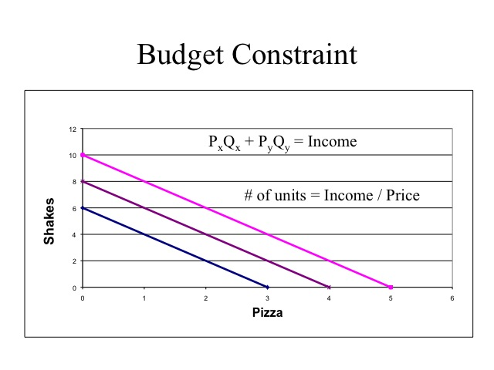

Changing the prices of the goods changes the slope of the budget constraint. If the consumer’s income is $8 and the price of pizza is $2 and the price of shakes is $1, then the budget constraint would be BC1. If the price of pizza drops to $1, then the budget constraint would rotate out on the x-axis to BC2. Alternatively, if the price of shakes increased to two dollars then the budget constraint would become BC3.

The slope of the budget constraint is the negative ratio of the prices (-Px/Py). For example, given the price of pizza (on the x-axis) is $2 and the price of shakes (on the y-axis) is $1, then the slope of the budget constraint would be -2.

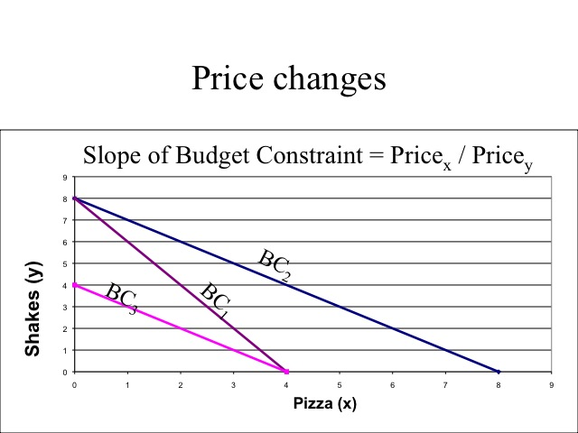

### 2.2.8 Utlity Maximization

Given the goal of consumers is to maximize utility given their budget constraints, they seek that combination of goods that allows them to reach the highest indifference curve given their budget constraint. This occurs where the indifference curve is tangent to the budget constraint (combination A). Note that combinations B and C cost the same amount as A; however, A is on a higher indifference curve. Combination D yields that same utility as C and B but doesn’t use all of the income, thus the consumer can increase utility by consuming more. Combination E is preferred to combination A, but is unattainable given the budget constraint.

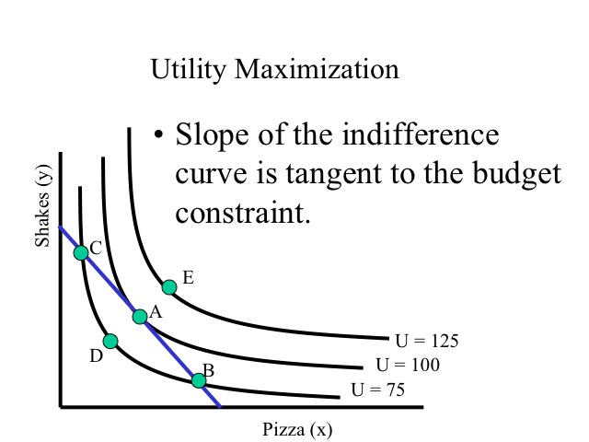

We previously mentioned that utility is maximized where the marginal utility per dollar spent is the same for each of the goods. At the point where the indifference curve is tangent to the budget constraint, the slope of the indifference curve which is the ratio of marginal utilities (-MUx/Muy) is equal to the slope of the budget constraint (- Price x / Price y). This equation can be rewritten to show that the marginal utility per dollar spent will be the same for both goods.

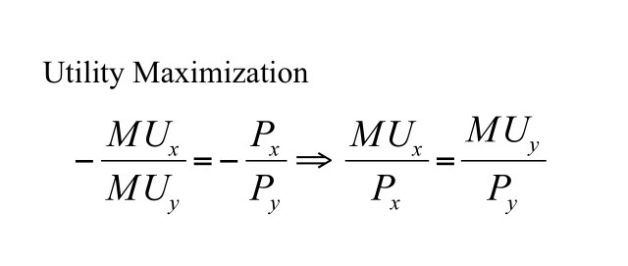

The demand curve can be derived from the indifference curves and budget constraints by changing the price of the good. For example, if the price of pizza is $4, the quantity demanded of pizza is two. If the price of pizza decreases, the budget constraint becomes flatter and the consumer can purchase more pizza, say the price of pizza drops to $2 and consumer purchases 4 units. If the price drops to $1.33, the quantity demanded increases to 5. Plotting each of the price and quantity demanded points creates the demand curve for pizza.

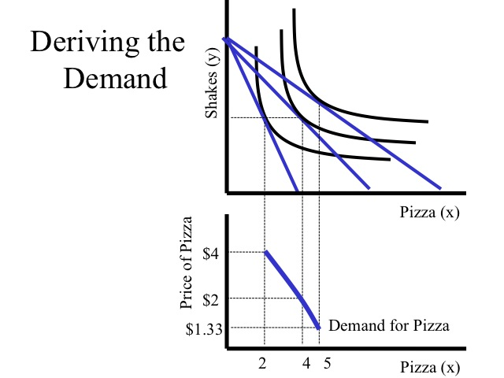

### 2.2.9 Income and Substitution Effects

When discussing why the demand curve is downward sloping, we outlined the substitution effect and income effect. We can observe the changes in quantity demanded along the demand curve due to the change in price; however, the indifference curves and budget constraints can help us analyze the size of the income and substitution effects.

For example, say the consumers income is $15 and the price of apples is $1 and the price of oranges is $3. At these prices the consumer purchases six apples and three oranges. When the price of oranges falls to $1, the consumer purchases eight apples and seven oranges. Thus on the demand curve for oranges, the consumer purchases three oranges when the price is three dollars and seven oranges when the price is one dollar.

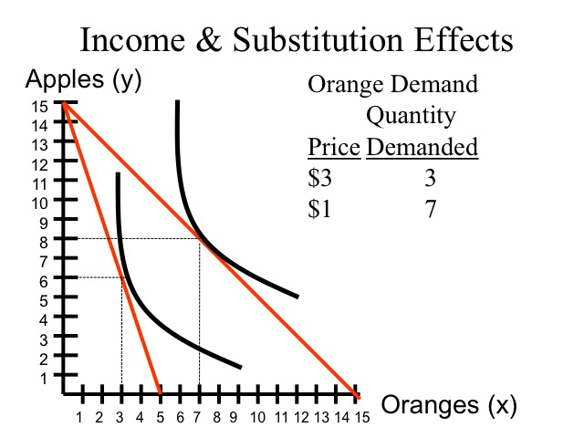

Bringing the new budget constraint back to the original indifference curve allows us to break down the income and substitution effects. Since the slope of the budget constraint reflects the ratio of prices, the substitution effect is the increase in the number of oranges that would be purchased given the new prices, while staying on the original indifference curve that is moving from point A to point B. The movement from point B to point C is the income effect, the additional consumption of oranges due to the increased purchasing power. With a decrease in the price of oranges, the relative price of apples has increased and fewer apples would be consumed due to the substitution effect; however, due to increased purchasing power, more apples are purchased as well as more oranges.

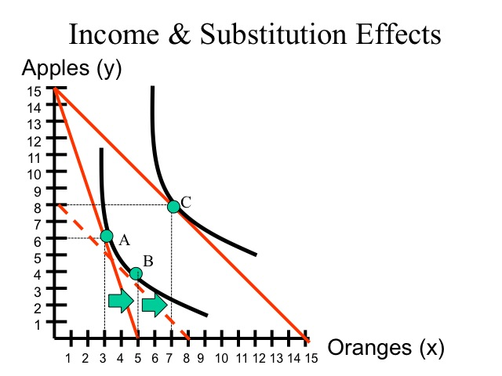

Recall from our elasticity discussion that the income elasticity for an inferior good is negative. For example, as income rises the demand for used clothing decreases. Looking at second-hand clothing on the x-axis, as the price declines the substitution will be positive (movement from point A to point B); however, the income effect (movement from B to C) will be negative.

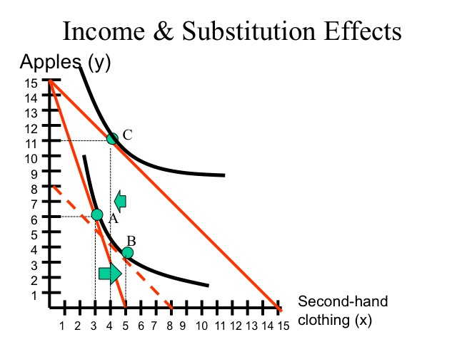

### 2.2.10 Extreme Cases

When examining indifference curves and budget constraints, we can look at a few extremes. One extreme case would be if the two goods are perfect complements. For example, you do not get additional satisfaction from having another right shoe, unless you have a left shoe to go with it. In the case of perfect complements, you always consume at the minimum combination of the two goods.

Another extreme is perfect substitutes. You purchase paper in either the 100 or 200 sheet packs and only value the number of sheets. You are indifferent between having two one-hundred sheet packages or one two-hundred sheet package. In the case of perfect substitutes, there are three different outcomes that will maximize utility. If the price of one package, yields a lower per sheet cost, the consumer will buy only that good, so consumption will take place at one of the two intercepts. The third outcome is when the budget constraint has the same slope as the indifference curve. In this case, any combination along the budget constraint will yield the same level of utility.

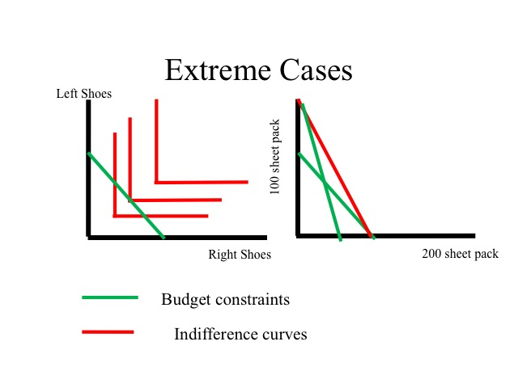

### 2.2.11 Government Food Stamps Example

Why does the government give welfare recipients food stamps instead of cash? Why are food stamps sold on the black market for a discount? Let’s assume a person has $75 of income and receives $75 of food stamps from the government. For simplicity, we will assume that the price of each unit of food and the price of clothing are each one dollar. The budget constraint allows the consumer to purchase up to 150 units of food, but since food stamps can only be used to purchase food, the consumer is limited to only being able to purchase 75 units of other items.

The amount of food and other goods, the individual will purchase depends on the shape of his indifference curve. Provided that the person spends at least 75 dollars on food, he is not constrained by receiving food stamps instead of cash.

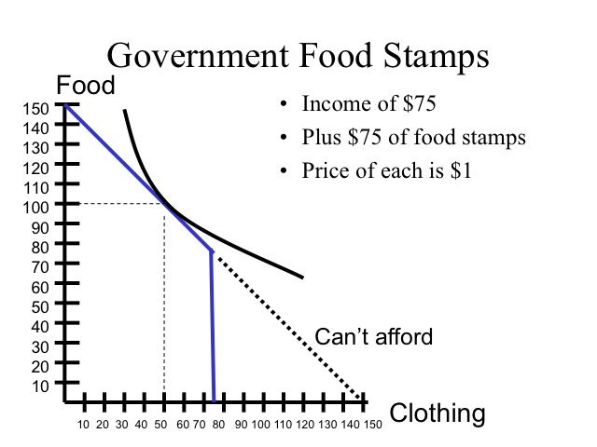

Unfortunately, for those individuals with strong addictions, such as cigarettes or alcohol, their indifference curves reflect the greater value received from the addict substance. Since food stamps only apply to purchasing food, the consumer is not able to get as much utility and is restricted to point A. If the food stamps had been in the form of cash, the consumer would have purchased 40 units of food and 110 units of alcohol, point B, which would yield a higher level of utility.

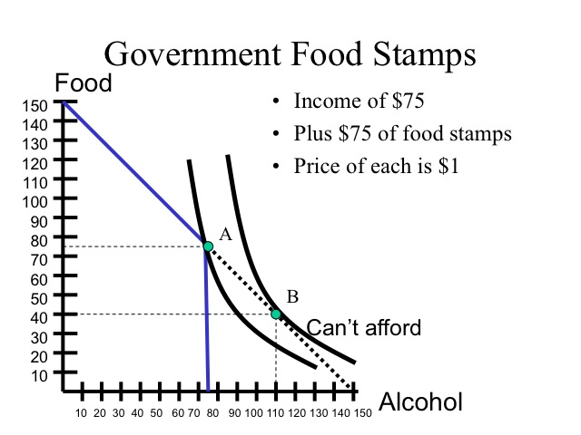

If the consumer could convert a portion of the food stamps to cash, even at a discount, he would be able to reach a higher indifference curve. Assume that he can trade food stamps on the black market for 50 cents on the dollar which extends his budget constraint increasing the amount of alcohol that can be purchased. Selling food stamps at a discount allows the consumer to move to point C, which yields a higher utility than point A.

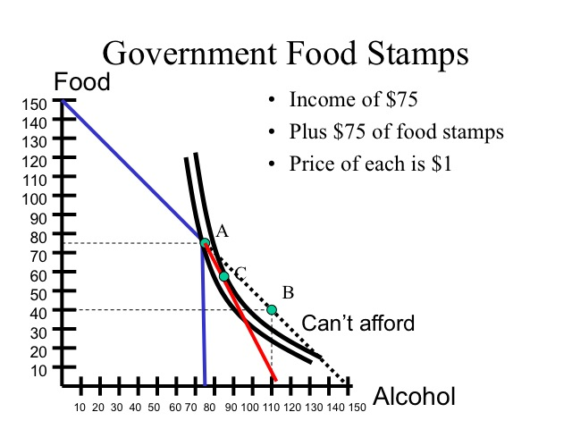

We can also model why individuals purchase items today and carry the debt on their credit cards paying a high interest rate. For example, let’s say the price of each good is $1. Assume Will has $100 of income which he could spend today or invest the money and receive $150 in the future. By waiting, Will would have a greater purchasing power, but his consumption bundle will depend on his preferences. If he has a strong preference for having consumption today, he would be willing to pay a higher price for those goods today. The same is true for those who buy items on credit. They are willing to pay the purchase price plus all the interest, so that they can have it today (so the indifference curve touches the budget constraint at a point closer to the x-axis as seen in the figure).

Similarly, some individuals are willing to pay to go to the expensive theaters to see a movie when it is first released. Others will wait until it comes to the cheap theaters or even until it comes out on DVD/Blu-ray. Although individuals are paying for the “movie experience” and not just the film itself, we can see the time preferences of individuals and the price differentials over time (as represented by different placements of the indifference curves).

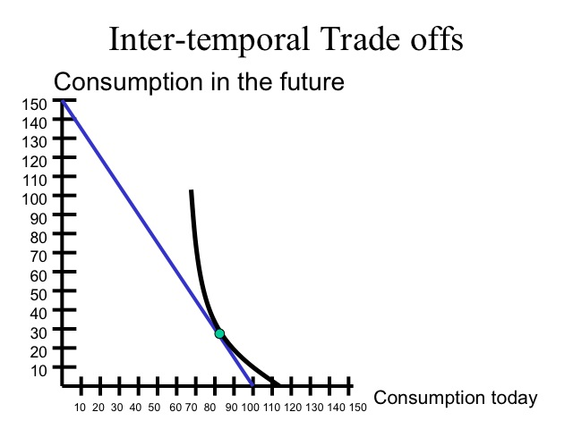

## 2.3 Supply and Demand Curves ( Understanding Price and Quantity in the Marketplace )

Why do parents – and stores – behave this way? The answer is in the laws of supply and demand. Together, these laws give us strong clues about what to produce, how much to produce, and how much to charge. Because supply and demand play such a central role in our economy, it’s important to understand how they operate – and how you can use them to analyze decisions about price and quantity.

### 2.3.1 The Law of Demand

Demand, in economic terms, shows how much of a product consumers are willing to purchase, at different price points, during a certain time period.

After all, we all have limited resources, and we all have to decide what we’re willing and able to purchase – and at what price. As an example, let’s look at a simple model of the demand for a good – let’s say, gasoline. (Note that this example is illustrative only, and not a description of the real gasoline market.)

If the price of gas is $2.00 per liter, people may be willing and able to purchase 50 liters per week, on average. If the price drops to $1.75 per liter, they may be able to buy 60 liters. At $1.50 per liter, they may be prepared to purchase 75 liters. Note that while some gas usage is essential – driving to work, for example – some use is optional. Therefore, as gas prices drop, people may choose to make more optional trips during weekends, and so on.

The resulting demand schedule for gas might look like this.

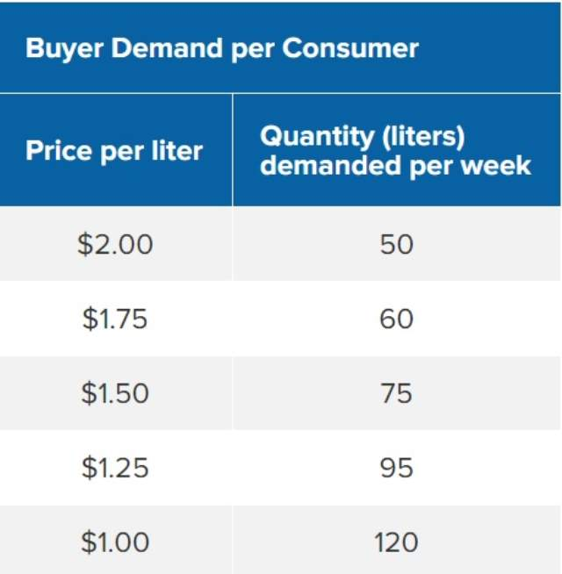

This schedule, and probably your own experience as a consumer, illustrates the law of demand: as price falls, the corresponding quantity demanded tends to increase. Since price is an obstacle, the higher the price of a product, the less it is demanded. When the price is reduced, demand increases.

So, there is an "inverse" relationship between price and quantity demanded. When you graph the relationship, you get a downward-sloping line, like the one shown in figure 1, below:

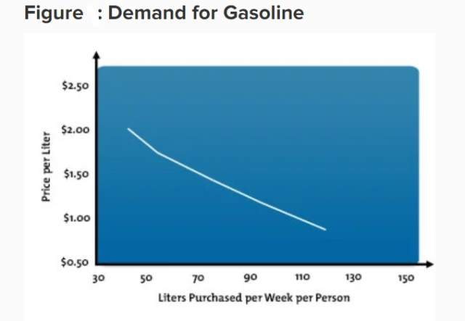

To create a market demand curve for gasoline, individual demand is totaled and combined.

### 2.3.2 Price Elasticity

The extent to which demand changes with price is known as "price elasticity of demand."

Inelastic products tend to be those that people must have, but they use only a fixed quantity of it. Electricity is an example: if power companies lower the price of electricity, consumers may be happy, but they probably won’t use a lot more power in their homes, because they don’t need much more than they already use. However, demand for luxury goods, such as restaurant meals, is extremely elastic – consumers quickly choose to stop going to restaurants if prices go up.

Price elasticity also affects supply. Products with an inelastic supply usually have a long lead time, with little control over the quantity produced. Farm crops are one example, because if there’s a price change, farmers can’t decide halfway through the growing season to produce more or less of a certain crop. On the other hand, products with a high elasticity of supply tend to come from industries that can change their production levels more quickly – for example, oil (although the oil industry may be operating close to full capacity, right now.).

### 2.3.3 The Law of Supply

While demand explains the consumer side of purchasing decisions, supply relates to the producer’s desire to make a profit. A supply schedule shows the amount of product that suppliers are willing and able to produce and make available to the market, at specific price points, during a certain time period. In short, it shows us the quantities that suppliers are willing to offer at various prices.

This happens because suppliers tend to have different costs of production. At a low price, only the most efficient producers can make a profit, so only they produce. At a high price, even high cost producers can make a profit, so everyone produces.

Using our gasoline example, we find that oil companies are willing and able to supply certain amounts of gas at certain prices, as seen below. (Note: we’ve assumed a simple economy in which gas companies sell directly to consumers.)

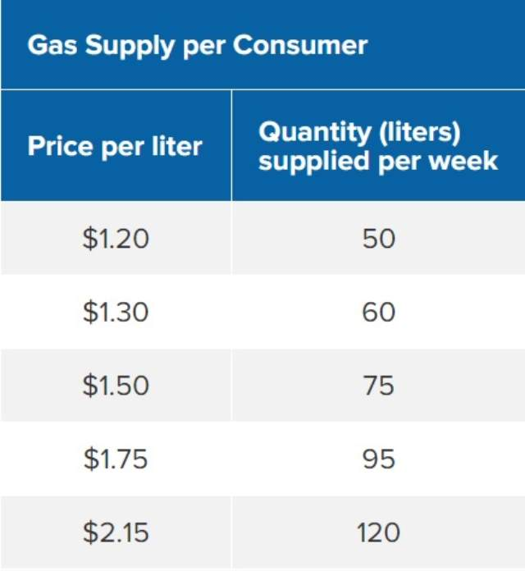

At a low price of $1.20 per liter, suppliers are willing to provide only 50 liters per consumer per week. If consumers are willing to pay $2.15 per liter, suppliers will provide 120 liters per week. The question is this: what prices are needed to convince producers to offer various quantities of a product or service?

As price rises, the quantity supplied rises as well. As price falls, so does supply. This is a "direct" relationship, and the supply curve has an upward slope.

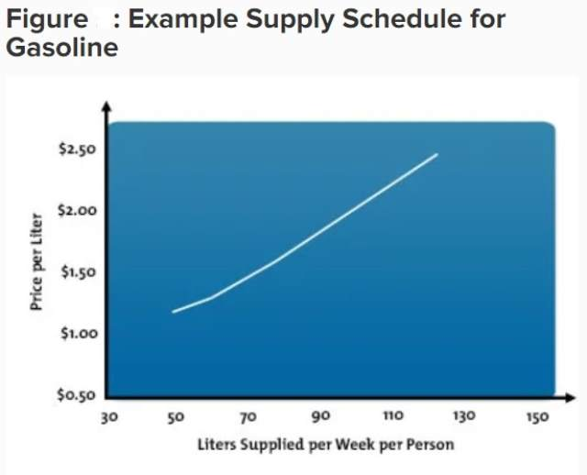

Because suppliers want to provide their products at high prices, and consumers want to purchase the products at low prices, how is the price of goods actually set? Let’s go back to our gas example. If oil companies try to sell their gas at $2.15 per liter, do you think they’ll sell as much? Probably not. Yet, if oil companies lower the price to $1.20 per liter, consumers will be very happy, but will there be enough profit? And furthermore, will there be enough supply to meet the higher demand by consumers? No, and no again.

To determine the price and quantity of goods in the market, we need to find the price point where consumer demand equals the amount that suppliers are willing to supply. This is called the market "equilibrium."

### 2.3.4 Equilibrium: Where Supply Meets Demand

Equilibrium is the point where the quantity demanded equals the quantity supplied. This means that there’s no surplus of goods and no shortage of goods. A shortage occurs when demand is greater than supply – in other words, when the price is too low. A surplus occurs when the price is too high, and therefore consumers don’t want to buy the product.

The great thing about the free market system is that prices and quantities tend to move toward equilibrium and, for the most part, keep the market stable.

Consider our example. At $1.20 per liter, consumer demand exceeds supply, and there’s a shortage of gas in the market. Shortages tend to drive up the price, because consumers compete to purchase the product. However, when prices go up too much, demand decreases, even though the supply may be available. Consumers may start to purchase substitute products, or they simply may not purchase anything. This creates a surplus. To eliminate the surplus, the price goes down and consumers start buying again. In this manner, equilibrium is usually maintained quite efficiently.

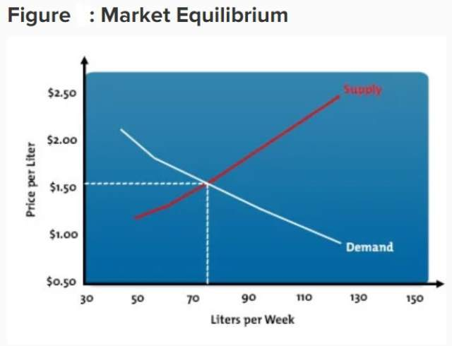

In our gas example, the market equilibrium price is $1.50, with a supply of 75 liters per consumer per week, as shown in figure 3.

Market equilibrium explains movement along the supply and demand curves. However, it doesn’t explain changes in total demand and total supply.

### 2.3.5 Changes in Demand and Supply

A change in price initially results in a movement along a demand or supply curve, and it leads to a change in the quantity demanded or supplied.

But what happens when there’s a long-term change in price?

If consumers are faced with an extreme change in the price of gas, their pattern of demand for gas changes. They not only start choosing different types of transportation – like taking the bus or riding a bicycle to work – but they also start buying more gas-efficient vehicles – like compact cars, motorcycles, or scooters. The effect is a major change in total demand and a major shift in the demand curve. The new schedule for demand is now Demand 2, shown below.

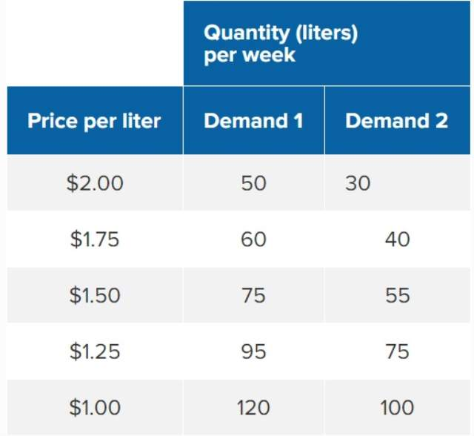

You can see this in the graph in figure 4, below. At each price point, the total demand is less, and the demand curve shifts.

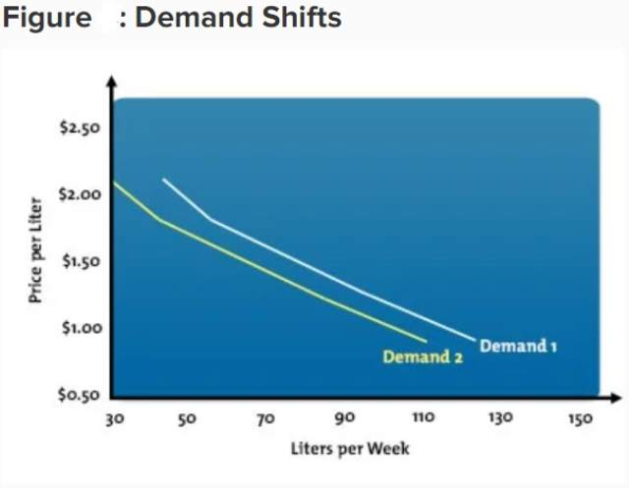

### 2.3.6 Changes in any of the following factors can typically cause demand to shift:

Consumer income.

Consumer preference.

Price and availability of substitute goods.

Population.

With a shift in demand, the equilibrium point also completely shifts.

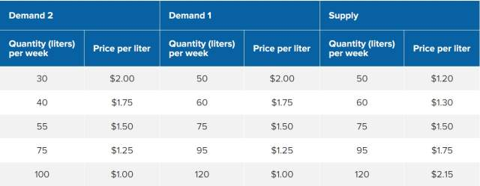

The same type of shift can occur with supply. If the price of drilling for and refining gas increases, or if political events cause suppliers to decrease their output, the supply curve can move. The result is that for the same price, the quantity supplied will be either higher or lower than the current supply curve.

A common complaint with the oil and gas industry is that suppliers deliberately manipulate price by shifting the supply curve. The result is an equilibrium price that’s higher and at a lower quantity, as in the following example.

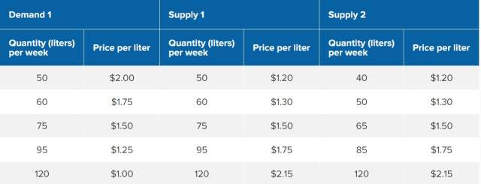

Figure 5, below, shows the curves that result from this schedule.

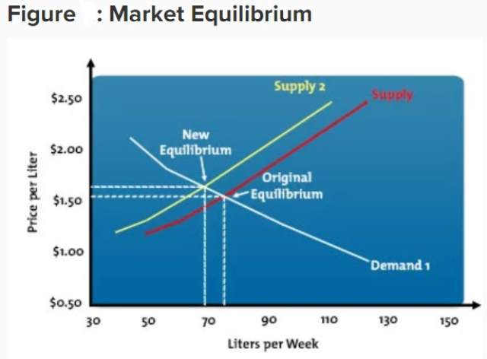

When supply decreases, the supply curve shifts to the left. When supply increases, the supply curve shifts to the right.

Changes in supply can result from events like the following:

Change in production costs. Improved technology that makes production more efficient.Industry growth and shrinkage.

**Key Points**

Although the phrase "supply and demand" is commonly used, it’s not always understood in proper economic terms. The price and quantity of goods and services in the marketplace are largely determined by (a) consumer demand and (b) the amount that suppliers are willing to supply.

Demand and supply can be graphed as curves – and the two curves meet at the equilibrium price and quantity. The market tends to naturally move toward this equilibrium – and when total demand and total supply shift, the equilibrium moves accordingly. It’s an interesting relationship that determines much of what happens in a free market economy. If you understand how these factors influence pricing, supply, and purchasing decisions, it will help you analyze the market and make better price and supply decisions for your company.

**Apply This to Your Life**

Consider these questions in relation to your life and business:

Are your production costs higher or lower than those of your competitors? What does this mean for your business if supply or demand curves shift? Are you charging as much as you could for your product, particularly if demand is strong and supply is weak? Conversely, are you charging too much? Are you paying too much for your inputs, particularly if demand for these inputs is weakening? If demand for your inputs is likely to strengthen, or supply weaken, in the future, how can you protect yourself against this? Are there any other questions you should be asking yourself as a result of knowing about supply and demand curves, equilibria, and shifts in supply and demand curves?

\printbibliography

# Part II. Marketing[↓](" \l "index-Marketing)

# 3 Consumer Marketing

For doing consumer marketing first of all the organization should have funds.

In case of sufficient funds, depending on budget, one can go for

1. TV Channels for Advertisement

2. Newspapers

3. Radio

4. Phone Calls

5. Door to door visits by sales members.

6. Pamphlets and Street Stickers ( Although this has been declared illegal some time before while my brother was in full form and me in small case was practicing via this way and no other way. It led to friction with the govt. and my subsequent captivation by the mental asylum of Chandigarh. Although I now don’t remember which govt. was present during that time when my pamphlets and street stickers were declared illegal . I was married with wife staying with me and finding it difficult to fulfill her needs in terms of money and govt. ( or say the local adminsitration ) was making it more difficult for me to satisfy her. She was not working ofcourse. ). It seems there were miscreants out there with dirty eye on my wife. But the question which arises whether they have a real eye and how long would they not get a real eye. InterstinglyAmit pasted a street sticker outside our house speaking something about mahamurkh, probably telling about himself. It can be congress , it can be shopkeeprs or their BJP , it can be bhapas. Many contenders of the competition. Whoever did it would be thrown out of India.India is my body itself. There are organs, bones, inside my body but then waste also accumulates down to my stomach in the intestine and in the bladder which needs to be excreted or uninated from time to time. It is in reality those people who exist as waste inside my body, those who say lies like it’s illegal to post pamphlets or street stickers and also add shit to my food if serving food somewhere and when these people are excreted from my body(ieindia) can be seen inside the sevage tank. And the real problem is that they know that they are shit or urine in reality or the third form, the fart and don’t shy away from doing such tantrums.And it’s also known that no legitimate resident of India would ever be a traitor of this kind and these people which are being thrown out of india as waste are probably not worth earth and would probably grow as a miniature lifeforms used as food by aliens as usually nobody on earth consumes shit, urine or farts as a regular diet. Usually I have set it a rule for myself that if somebody targets my son manas, i’d let him defend his own self. If somebody targets my limp brother however, he/she would pay serious price. Mom has given all my ideology or the ethical understanding of the world. Though a very clever person herself and a cheapster, I have always kept her at a higher position than my wife.

# 4 Industrial Marketing

When a large organization builds some product, it nees to sell it either to the general public or the secondary industry dependent on it. The industrial ingredient produced by the organization can be large and expensive or small and cheap or various combinations. Moreover there can be organizaitons importing semi finished products form as many as 100 or more different industries. There is no upper and lower limit to how many input sourses of semi finished products can be required for one product of the organization.

# 5 Services Marketing

I’ll have to search the internet or see some courses , kindly keep open to furthur editions of the book.

# Part III. Civil Administration

# 6 Police Services

## 6.1 Police in Countries other than India

### 6.1.1 LAPD of America

We see them in the movies, slightly bad dressed than the FBI . In the Rambo movie we saw them in bad light. In Matrix, not doint much and not strong too. However, they are the common law enforcing agency in the US.

### 6.1.2 NLEA of Britain

We see them in the british movies and recently in news was one Brit Officer who targetted the three attackers with his batton , stopped them but was hit in the face with a knife. But definitly not like the MI-6 James bond we see in 007 movies.

## 6.2 Indian Police

I encountered the Chandigarh police and somewhat the Hydrabadpolice . With one or two (probably rajput guys) misbehaving with me in the police everywhere, others stay calm and don’t see me as a target. However the local people don’t see them as very nice people .

## 6.3 Punjab Police

The most strict of the Police forces in India, led to the end of militancy completely and now maintaining peace properly too.

# 7 Administration Services

## 7.1 Indian Foreign Services

They usually take care of all the inter-nation diplomatic talks. Usually as the team of the Ambassador.

## 7.2 IAS

Though they see themselves as the rulers of India, I don’t have a very good feeling about them. One RajatSaini at IIT Delhi, praised them but they don’t appear to be that good a stuff to discuss here. However , recently there was a case too in chandigarh, with an IAS’s daughter of Chandigarh taking stand against a minister’s son (of Haryana) for eve teasing, there are still higher importance cases like the 10 and 12 year old girls rape cases pending in the court of law to which chandigarh should look forward to for proper justice.

## 7.3 Engineering Services

They are very popular amongst indian masses, e.g. after the complete revamp of IAS exam, which doesn’t ask any technical questions now. The IES exams ask for the complete Engineering you have studied with an IPS/IAS like interview. However, critics to this exam comment and question whether an Engineer can ever be a real administrator or he should prefer PHD and join as a Professor somewhere. However , this is a usefull exam one can look forward to if he/she has both technical/admistration aptitude.

# Sociology

# Part IV. The Market

# 8 The Indian Context

## 8.1 Eatables (Kiryana, Mandi, Halwai, Confectionary and Restuarants)

### 8.1.1 Unprocessed

Wheat or other grains in cereal form.

### 8.1.2 Semi-Processed ( Forfurthur processing at home )

Wheat Flour

Rice

Vegetables

Dals

### 8.1.3 Ready to Eat

#### 8.1.3.1 Ice Creams ,Flavoured Milk

Amul and Mother Dairy are the popular National Brands. Verka is the local brand available in Chandigarh and parts of Punjab.

# Part V. The Media[↓](" \l "index-The-Media)

# 9 International News Channels

## 9.1 CNBC

It has a Divya Sharma (My top student at Alpha Classes) Lookalike Anchor and mostly dicussing Business.

## 9.2 CNN

It’s not available in the Channels present in our Airtel Digital Tv Subscription although earlier when Digital TV hadn’t been a norm , it used to come on our TV.

## 9.3 MSN News (via windows e-print media)

Very Elaborative. It’s an experience , but then sometimes windows people start demanding upgrade to windows 10 killing all our news updates and games with closeure of windows store. 3 of my PC’s had original Windows, one of them gifted to my wife, other now with my brother and this is something of a sort showing that I am a rich person. However her other PC via HCL didn’t have original windows. Apart from it my Macbook Air had orgininal Operating system too. It appears that as a system rule, if somebody uses a pirated software, it’s normalized price needs to be paid to the software owners during system audit. So, with lots of people using Microsoft Office, Photoshop etcsoftwares would be audited when a System Audit Cheque is accepted anywhere into the System. And people don’t fear being audited too, they say we are not afraid to pay the price as it would be lesser than what it is on the web if we buy the original one under the agreement. And mind you , Bill Gates is born rich due to the Microsoft Office Licences Audit by the System. As of today I am using all legal softwares with this document being written in Open Source Lyx for Latex file editing as a word like environment. Though my Reports at the time of my degree, i presented in hardcore latex, however over the time , i have shifted to using the editor.

# 10 Prominent Indian News Channels

## 10.1 DD Broadcast ( accross various of its channels )

## 10.2 AajTak

Aajtak initially started with a small 2 to 4 minutes fast news on DD Metro with brilliant team members and way ahead of it’s times presentation. Later it became a base for the Aamaadmi party as it’s very brilliant members like Ashutosh leaving reporting and goint to join the National Theme Party. I don’t know if the present day team of Aajtak has any links with AamAadmi Party or not. Usually the channels with political bias lose their spirit in small run, even in this special case when the party has emerged of this channel to some extent. News channels like ABP when they first came on TV, they were fast but it was clear that they were party supportive with ABP supporting congress and also defending it. Though at one time it became my favourite News channel but i don’t think it deserves a mention here do to the issues of unclean nutrality.

## 10.3 Zee News

They started as Zee TV, the only channel which used to come via the expensive Cable Connection while DD (Doordarshan) Channels like Doordarshan, DD Jalandhar , DD Metro (this required a special antenna) used to come free via the antenna. Then subsiquently more channels joined the bandwagon ,and side by side Zee grew the number of it’s channels. Howevere, they were traditionally not a news channel but but had more of saasbahu serials as their top item.

### 10.3.1 The Delimma

It’s presently the biggest news channel in terms of the Channel group’s infrastructure capable of covering the news of whole India and many places of world, maintaining neutrality, keeping ethics too. But somehow the news are non-chrispy non-masala mixed though good for a person who wants to listen to true news but not much useful for someone who wants to enjoy the telivision for say half anour to get a break from work etc.

## 10.4 NDTV

It was sued by the BJP , the present ruling party , for giving some controversial news.

## 10.5 Other Smaller Channels

Now there are lots of Channels with the word News in their name, covering various segments of news. They are playing as a group probably to fend from the larger fish in the territory.

# Part VI. The Cream vs the bearers ( in Indian Context and beyond )

# 11 Introduction to the discussion “The Cream vs the bearers”

India starts with the President of India, the moral authority ( though a low caste nowadays ) and then the Prime Minister , the authority on State’s Power . And then we have the Cheif ministers looking after their individual territories. Governers, Mayors etc. Heads of Police.etc people exist who are complete incharge of India. But these people in total would be only a few thousands at the most as far as india is concerned.

Rest of the people, even the rich , the other politicians who are down in the line, the businessmen ( although there is some negative perception about the market , introduced by my mom to me) and the common masses , would come under the bearers banner IMO.

# Ecology

# Part VII. Possibility of Nuclear Holocaust and UN’s non-proliferation treaty (which India doesn’t sign due to security concerns)

# 12 Pakistan vs India, Area of high sensitivity

One major place where there can be a possible Nuclear war is the Pakistan vsIndia , sensitive area. From my meditation experience , I know that pakistan fires nuclear missile on India in future but at that time India has sheldon shield, a type of nuclear shield and the missile pollutes only pakistan area and not India’s. Later however many pakistanis cross to india in an attempt to find cleaner area for survival , that’s near the occourance of Kalki (Kalgi) Avtar near 10000 AD in time(The attack probably occours in 8000-8500 AD).

# 13 Possibility of US using the nukes again , low

It has been criticized hugely for the bad lives of bomb victims in Japan. Even as till our period the bomb victims’s lives have not been extensively filmed, but still there is some awareness in the educated world that the bombs were indeed dropped on Japan. Believe me, US doesn’t want to play the bad guy again. It has only kept few nukes for it’s own protection and for maintining it’s watchdog reputation for the present world.

# 14 The Role of Sci-Fi (The Phoenix writeup in Xth book, World at arms game by Gameloft, one MIT OCW Course etc. SCI-FI stuff predicting the near future)

## 14.1 The Phoenix

In the novel, the plot is such that the Nuclear Holocaust had already taken place and one man Akshay ,who also has a good quality robot friend , survives it with few other fellows and they are trying to unite. And akshay , a good techie , somehow manages to get a branded screwdriver from a fellow survivor and with it’s use his robot starts behaving more humanly and intelligently.

## 14.2 World at Arms

The plot in the game is also after the Holocaust and in not very distant future but probably after our lives we can hope so, maybe in the 2400’s . So, there are small territories owned by groups of people at various places, they either have the nuclear technology or can buy it for small size nuclear attacks and moreover machines have been developing and turning into organic bodies , playing their politics , so , kind of before the “Matrix Movie” plot in the game.

## 14.3 MIT OCW

I haven’t seen this course yet. Other realisitic courses, I have started liking though, MIT, NPTEL,Coursera , etc and even youtube offering plenty of good courses, I have watched bits and pieces here and there but they are a huge knowledgestore.

# Index

Marketing:

The Media: