## The Physics Cook Book

Rajat Kalia and Manas Kalia

27 January , 2019

## Contents

## Test ( Motion in a straight line )

##### Time Allowed : 1 hour ________________________ Maximum Marks : 60

Please read the instructions carefully. You will be alloted 5 minutes specifically for this purpose.

##### Instructions

#### A. General

1. Blank papers, clipboards, log tables, slide rules, calculators, cellular phones, pagers, and electronic gadgets in any form are not allowed.

2. Do not break the seals of the question-paper booklet before instructed to do so by the invigilators.

#### B. Question paper format and Marking Scheme :

1. This question paper consists of 6 questions carrying 10 marks each.

________________________________________________________________________________________________________________________________________

Q1:

A drunkard walking in a narrow lane takes 5 steps forward and 3 steps backward, followed again by 5 steps forward ad 3 steps backward, and so on. Each step is 1 m long and requires 1 s. Plot the x - t graph of his motion. Determine graphically and otherwise how long the drunkard takes to fall in a pit 13 m away from the start.

Q2:

Two trains A and B of length 400 m each are moving on two parallel tracks with a uniform speed of 72kmh-1 ejects its products of combustion at the speed of 1500kmh-1 relative to the jet plane. What is the retardation of the car(assumed uniform). and how long does it take for the car to stop?

Q3:

On a two-lane road, car A is travelling with a speed of 36kmh—1. Two cars B and C approach car A in opposite directions with a speed of 54kmh—1 each. At a certain instant, when the distance AB is equal to AC, both being 1 km, B decides to overtake A before C does. What minimum acceleration of car B is required to avoid an accident ?

Q4:

A ball is dropped from a height of 90 m on a floor. At each collision with the floor, the ball loses one tenth of its speed. Plot the speed-time graph of its motion between t = 0 to 12 s.

Q5:

A man walks on a straight road from his home to a market 2.5 km away with a speed of 5kmh—1. Finding the market closed, he instantly turns and walks back home with a speed of 7.5kmh—1. What is the (a) magnitude of average velocity, and (b) average speed of the man over the interval of time (i) 0 to 30 min, (ii) 0 to 50 min, (iii) 0 to 40 min ?

Q6:

A boy standing on a stationary lift (open from above) throws a ball upwards with the maximum initial speed he can, equal to 49 m s—1. How much time does the ball take to return to his hands? If the lift starts moving up with a uniform speed of 5 m s-1 and the boy again throws the ball up with the maximum speed he can, how long does the ball take to return to his hands ?

## Test ( Motion in a plane )

##### Time Allowed : 1 hour ________________________ Maximum Marks : 60

Please read the instructions carefully. You will be alloted 5 minutes specifically for this purpose.

##### Instructions

#### A. General

1. Blank papers, clipboards, log tables, slide rules, calculators, cellular phones, pagers, and electronic gadgets in any form are not allowed.

2. Do not break the seals of the question-paper booklet before instructed to do so by the invigilators.

#### B. Question paper format and Marking Scheme :

1. This question paper consists of 6 questions carrying 10 marks each.

________________________________________________________________________________________________________________________________________

Q1:

A cyclist starts from the centre O of a circular park of radius 1 km, reaches the edge P of the park, then cycles along the circumference, and returns to the centre along QO as shown in Fig. . If the round trip takes 10 min, what is the (a) net displacement, (b) average velocity, and (c) average speed of the cyclist ?

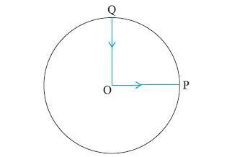

Q2:

A stone tied to the end of a string 80 cm long is whirled in a horizontal circle with a constant speed. If the stone makes 14 revolutions in 25 s, what is the magnitude and direction of acceleration of the stone ?

Q3:

Can you associate vectors with (a) the length of a wire bent into a loop, (b) a plane area, (c) a sphere ? Explain.

Q4:

(a) Show that for a projectile the angle between the velocity and the x-axis as a function of time is given by

θ(t) = tan-1

(b) Shows that the projection angle 0 for a projectile launched from the origin is given by

θo = tan-1

where the symbols have their usual meaning.

Q5:

A bullet fired at an angle of 30° with the horizontal hits the ground 3.0 km away. By adjusting its angle of projection, can one hope to hit a target 5.0 km away ? Assume the muzzle speed to the fixed, and neglect air resistance.

Q6:

A cyclist is riding with a speed of 27 km/h. As he approaches a circular turn on the road of radius 80 m, he applies brakes and reduces his speed at the constant rate of 0.50 m/s every second. What is the magnitude and direction of the net acceleration of the cyclist on the circular turn ?

## Full Test Kinematics

##### Time Allowed : 1.5 Hours ________________________ Maximum Marks : 60

Please read the instructions carefully. You will be alloted 5 minutes specifically for this purpose.

##### Instructions

#### A. General

1. Blank papers, clipboards, log tables, slide rules, calculators, cellular phones, pagers, and electronic gadgets in any form are not allowed.

2. Do not break the seals of the question-paper booklet before instructed to do so by the invigilators.

#### B. Question paper format and Marking Scheme :

1. This question paper consists of 6 questions carrying 10 marks each.

________________________________________________________________________________________________________________________________________

Q1:

A point traversed half the distance with a velocity vo. The remaining part of the distance was covered with velocity v1 for half the time, and with velocity v2 for the other half of the time. Find the mean velocity of the point averaged over the whole time of motion.

Q2:

Two boats, A and B, move away from a buoy anchored at the middle of a river along the mutually perpendicular straight lines: the boat A along the river, and the boat B across the river. Having moved off an equal distance from the buoy the boats returned. Find the ratio of times of motion of boats tA- B" > if the velocity of each boat with respect to water is  = 1.2 times greater than the stream velocity.

Q3:

An elevator car whose floor-to-ceiling distance is equal to 2.7 m starts ascending with constant acceleration 1.2m∕s2 ; 2.0 s after the start a bolt begins falling from the ceiling of the car. Find: (a) the bolt’s free fall time; (b) the displacement and the distance covered by the bolt during the free fall in the reference frame fixed to the elevator shaft.

Q4:

From point A located on a highway (Fig. ) one has to get by car as soon as possible to point B located in the field at a distance l from the highway. It is known that the car moves in the field  times slower than on the highway. At what distance from point D one must turn off the highway?

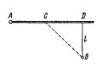

Q5:

A point moves along an arc of a circle of radius R. Its velocity depends on the distance covered s as v = aЦs-" class="sqrt" >, where a is a constant. Find the angle ex between the vector of the total acceleration and the vector of velocity as a function of s.

Q6:

To protect his food from hungry bears, a boy scout raises his food pack with a rope that is thrown over a tree limb at height h above his hands. He walks away from the vertical rope with constant velocity vboy , holding the free end of the rope in his hands (Fig. ).

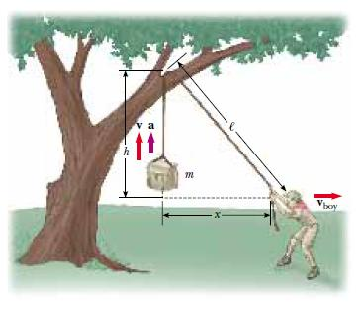 (a) Show that the speed v of the food pack is x-1∕2vboy , where x is the distance he has walked away from the vertical rope.

(b) Show that the acceleration a of the food pack is h2-3∕2vboy2

(c) What values do the acceleration and velocity have shortly after he leaves the point under the pack (x = 0)?

(d) What values do the pack’s velocity and acceleration approach as the distance x continues to increase?

## Laws of Motion

##### Time Allowed : 30 Minutes ________________________ Maximum Marks : 10

Please read the instructions carefully. You will be alloted 5 minutes specifically for this purpose.

##### Instructions

#### A. General

1. Blank papers, clipboards, log tables, slide rules, calculators, cellular phones, pagers, and electronic gadgets in any form are not allowed.

2. Do not break the seals of the question-paper booklet before instructed to do so by the invigilators.

#### B. Question paper format and Marking Scheme :

1. This question paper consists of 1 question carrying 10 marks .

________________________________________________________________________________________________________________________________________

Q:

A thin circular loop of radius R rotates about its vertical diameter with an angular frequency . Show that a small bead on the wire loop remains at its lowermost point for   . What is the angle made by the radius vector joining the centre to the bead with the vertical downward direction for  = ? Neglect friction.

## Hydraulics

##### Time Allowed : 1 hour ________________________ Maximum Marks : 60

Please read the instructions carefully. You will be alloted 5 minutes specifically for this purpose.

##### Instructions

#### A. General

1. Blank papers, clipboards, log tables, slide rules, calculators, cellular phones, pagers, and electronic gadgets in any form are not allowed.

2. Do not break the seals of the question-paper booklet before instructed to do so by the invigilators.

#### B. Question paper format and Marking Scheme :

1. This question paper consists of 4 questions carrying 10 marks each , while Q5 carries 20 marks.

________________________________________________________________________________________________________________________________________

Q1:

Explain why

(a) The blood pressure in humans is greater at the feet than at the brain

(b) Atmospheric pressure at a height of about 6 km decreases to nearly half of its value at the sea level, though the height of the atmosphere is more than 100 km

(c) Hydrostatic pressure is a scalar quantity even though pressure is force divided by area.

Q2:

A U-tube contains water and methylated spirit separated by mercury. The mercury columns in the two arms are in level with 10.0 cm of water in one arm and 12.5 cm of spirit in the other. What is the specific gravity of spirit ?

Q3:

In the previous problem, if 15.0 cm of water and spirit each are further poured into the respective arms of the tube, what is the difference in the levels of mercury in the two arms ? (Specific gravity of mercury = 13.6)

Q4:

Two vessels have the same base area but different shapes. The first vessel takes twice the volume of water that the second vessel requires to fill upto a particular common height. Is the force exerted by the water on the base of the vessel the same in the two cases ? If so, why do the vessels filled with water to that same height give different readings on a weighing scale ?

Q5:

A Pitot tube (Fig. ) is mounted along the axis of a gas pipeline whose cross-sectional area is equal to S. Assuming the viscosity to be negligible, find the volume of gas flowing across the section of the pipe per unit time, if the difference in the liquid columns is equal to △h, and the densities of the liquid and the gas are o and  respectively.

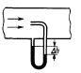

# Electromagnetism

## Physics (Theory) - Electric Charges and Fields

##### Time allowed : 2 hours________________________ Maximum Marks : 41

##### Instructions

1. Please check that this question paper contains 3 printed pages.

2. Please check that this question paper contains 19 questions.

3. 10 minutes time has been allotted to read this question paper. The student will read the question paper only and will not write any answer on the answer script during this period.

#### A. General Instructions :

1. All questions are compulsory.

2. There are 18 questions in total. Questions 1 to 6 carry one mark each, questions 7 to 11 carry two marks each, questions 12 to 16 carry three marks each and questions 17 to 18 carry five marks each.

3. Use of calculators is not permitted.

4. You may use the following values of physical constants wherever necessary:

c = 3  108ms-1

h = 6  626  10-34Js

e = 1  602  10-19C

o = 4  10-7TmA-1

pϵo" > = 9  109Nm2C-2

Mass of electron me = 9·1  10-31kg

Mass of neutron mn~ =" class="cong" >1·675x10-27kg

Boltzmann’s constant k = 1  381  10-23JK-1

Avogadro’s number NA = 6  022  1023∕mol-1

Radius of earth = 6400 km

________________________________________________________________________________________________________________________________________

Q1:

Why is it necessary that the field lines from a point charge placed in the vicinity of a conductor must be normal to the surface of the conductor at every point ?

Q2:

Is the force acting between two point electric charges q1 and q2 kept at some distance apart in air, attractive or repulsive when (i) q1q2 > 0 (ii) q1q2 < 0 ?

Q3:

Figure shows three point charges +2q, —q and + 3q. Two charges + 2q and —q are enclosed within a surface ‘S’. What is the electric flux due to this configuration through the surface ‘S’?

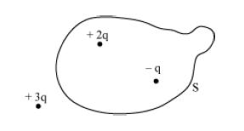

Q4:

In which orientation, a dipole placed in a uniform electric field is in (i) stable, (ii) unstable equilibrium?

Q5:

An electric dipole of dipole moment 20  10-6C.m is enclosed by a closed surface. What is the net flux coming out of the surface ?

Q6:

An electrostatic field line cannot be discontinuous. Why ?

Q7:

Define Electric Flux. Write its S.I. Unit.

Q8:

The sum of two point charges is 7C. They repel each other with a force of 1 N when kept 30 cm apart in free space. Calculate the value of each charge.

Q9:

The electric field E due to a point charge at any point near it is defined as ®0" class="" > where q is the test charge and F is the force acting on it. What is the physical significance of ®m0" class="" > in this expression ? Draw the electric field lines of a point charge Q when (i) Q > 0 and (ii) Q < 0.

Q10:

A spherical Gaussian surface encloses a charge of 8.85  10-10C . (i) Calculate the electric flux passing through the surface. (ii) How would the flux change if the radius of the Gaussian surface is doubled and why ?

Q11:

Define ’electric line of force’ and give its two important properties.

Q12:

A positive point charge (+ q) is kept in the vicinity of an uncharged conducting plate. Sketch electric field lines originating from the point on to the surfaceof the plate. Derive the expression for the electric field at the surface of a charged conductor.

Q13:

A thin conducting spherical shell of radius R has charge Q spread uniformly over its surface. Using Gauss’s law, derive an expression for an electric field at a point outside the shell.

Draw a graph of electric field E(r) with distance r from the centre of the shell for 0  r .

Q14:

Define the term ’electric dipole moment’, Is it scalar or vector?

Deduce an expression for the electric field at a point on the equatorial plane of an electric dipole of length 2a.

Q15:

State Gauss’s theorem in electrostatics. Apply this theorem to derive an expression for electric field intensity at a point near an infinitely long straight charged wire.

Q16:

An electric dipole is held in a uniform electric field. (i) Using suitable diagram, show that it does not undergo any translatory motion, and (ii) derive an expression for the torque acting on it and specify its direction.

Q17:

(a) Using Gauss’ law, derive an expression for the electric field intensity at any point outside a uniformly charge thin spherical shell of radius R and charge densitys C∕m2 . Draw the field lines when the charge density of the sphere is (i) positive, (ii) negative.

(b) A uniformly charged conducting sphere of 2.5m in diameter has a surface charge density of 100mC∕m2 . Calculate the (i) Charge on the sphere (ii) Total electric flux passing through the sphere.

Q18:

Define the term dipole moment ® p" class="mathpalette" > of an electric dipole indicating its direction. Write its SI unit. An electric dipole is placed in a uniform electric field ® E" class="mathpalette" >. Deduce the expression for the torque acting on it. In a particular situation, it has its dipole moment aligned with the electric field. Is the equilibrium stable or unstable ?

## Physics (Theory) - Electrostatic Potential and Capacitance

##### Time allowed : 2 hours________________________ Maximum Marks : 47

##### Instructions

1. Please check that this question paper contains 4 printed pages.

2. Please check that this question paper contains 20 questions.

3. 15 minutes time has been allotted to read this question paper. The student will read the question paper only and will not write any answer on the answer script during this period.

#### A. General Instructions :

1. All questions are compulsory.

2. There are 19 questions in total. Questions 1 to 3 carry one mark each, questions 4 to 11 carry two marks each, questions 12 to 17 carry three marks each and questions 18 to 19 carry five marks each.

3. Use of calculators is not permitted.

4. You may use the following values of physical constants wherever necessary:

c = 3  108ms-1

h = 6  626  10-34Js

e = 1  602  10-19C

o = 4  10-7TmA-1

pϵo" > = 9  109Nm2C-2

Mass of electron me = 9·1  10-31kg

Mass of neutron mn~ =" class="cong" >1·675x10-27kg

Boltzmann’s constant k = 1  381  10-23JK-1

Avogadro’s number NA = 6  022  1023∕mol-1

Radius of earth = 6400 km

________________________________________________________________________________________________________________________________________

Q1:

What is the electrostatic potential due to an electric dipole at an equatorial point ?

Q2:

Derive the expression for the electric potential at any point along the axial line of an electric dipole?

Q3:

A 500 m C Charge is at the centre of a square of side 10cm. Find the work done in moving a charge of 10 m C between two diagonally opposite points on the square.

Q4:

Draw 3 equipotential surfaces corresponding to a field that uniformly increases in magnitude but remains constant along Z-direction. How are these surfaces different from that of a constant electric field along Z-direction ?

Q5:

(i) Can two equipotential surfaces intersect each other? Give reasons.

(ii) Two charges - q and +q are located at points A (0, 0, -a) and B (0, 0, +a) respectively. How much work is done in moving a test charge from point P (7, 0, 0) to Q (-3, 0, O)?

Q6:

Figure shows a sheet of aluminium foil of negligible thickness placed between the plates of a capacitor. How will its capacitance be affected if

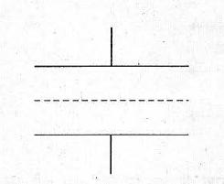

(i) the foil is electrically insulated?

(ii) the foil is connected to the upper plate with a conducting wire?

Q7:

Three points A. Band C lie in a uniform electric field (E) of 5 x 103 NC- 1 as shown in the figure. Find the potential difference between A and C.

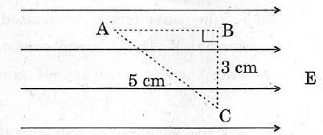

Q8:

(a) Why does the electric field inside a dielectric decrease when it is placed in an external electric field ?

(b) A parallel plate capacitor with air between the plates has a capacitance of 8 pF. What will be the capacitance if the distance between the plates be reduced by half and the space between them is filled with a substance of dielectric constant K = 6 ?

Q9:

A parallel plate capacitor is to be designed with a voltage rating 1 kV using a material of dielectric constant 3 and dielectric strength about 107 Vm1. For safety we would like the field never to exceed say, 10% of the dipole strength. What minimum area of the plates is required to have a capacitance of 50 pF ?

Q10:

4 F capacitor is charged by a 200 V supply. The supply is then disconnected and the charged capacitor is connected to another uncharged 2 F capacitor. How much electrostatic energy of the first capacitor is lost in the process of attaining the steady situation ?

Q11:

Two point charges 4 C and -2C are separated by a distance of 1 m in air. Calculate at what point on the line joining the two charges is the electric potential zero.

Q12:

A parallel plate capacitor is charged by a battery. After some time the battery is disconnected. and a dielectric slab of dielectric constant K is inserted between the plates. How would (i) the capacitance,(ii) the electric field between the plates and (iii) the energy stored in the capacitor, be affected ? Justify your answer.

Q13:

(a) Depict the equipotential surfaces for a system of two identical positive point charges placed a distance ‘d’ apart.

(b) Deduce the expression for the potential energy of a system of two point charges q1 and q2 brought from infinity to the points ® r1" class="mathpalette" > and ® r2" class="mathpalette" > respectively in the presence of external electric field E .

Q14:

A parallel-plate capacitor is charged to a potential difference V by a dc source. The capacitor is then disconnected from the source. If the distance between the plates is doubled, state with reason how the following change:

(i) electric field between the plates

(ii) capacitance, and

(iii) energy stored in the capacitor

Q15:

Deduce an expression for the electric potential due to an electric dipole at any point on its axis. Mention one contrasting feature of electric potential of a dipole at a point as compared to that due to a single charge.

Q16:

A parallel plate capacitor, each with plate area A and separation d, is charged to a potential difference V. The battery used to charge it is then disconnected. A dielectric slab of thickness d and dielectric constant K is now placed between the plates. What change, if any, will take place in (i) charge on the plates (ii) electric field intensity between the plates (iii) capacitance of the capacitor.

Q17:

Explain the underlying principle of working of a parallel plate capacitor. If two similar plates, each of area A having surface charge densities + and - are separated by a distance d in air, write expressions for

(i) the electric field at points between the two plates.

(ii) the potnetial difference between the plates.

(iii) the capacitance of the capacitor so formed.

Q18:

(a) Derive an expression for the torque experienced by an electric dipole kept in a uniform electric field. (b) Calculate the work done to dissociate the system of three charges placed on the vertices of a triangle as shown. Here q = 1.6  10-10C

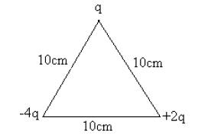

Q19:

Derive the expression for the energy stored in a parallel plate capacitor of capacitance C with air as medium between its plates having charges Q and -Q. Show that this energy can be expressed in terms of electric field asϵoE2Ad where A is the area of each plate and d is the separation between the plates.

How will the energy stored in a fully charged capacitor change when the separation between the plates is doubled and a dielectric medium of dielectric constant 4 is introduced between the plates ?

## Physics (Theory) - Current Electricity

##### Time allowed : 2 hours________________________ Maximum Marks : 42

##### Instructions

1. Please check that this question paper contains 4 printed pages.

2. Please check that this question paper contains 18 questions.

3. 15 minutes time has been allotted to read this question paper. The student will read the question paper only and will not write any answer on the answer script during this period.

#### A. General Instructions :

1. All questions are compulsory.

2. There are 18 questions in total. Questions 1 to 2 carry one mark each, questions 3 to 10 carry two marks each, questions 11 to 18 carry three marks each .

3. Use of calculators is not permitted.

4. You may use the following values of physical constants wherever necessary:

c = 3  108ms-1

h = 6  626  10-34Js

e = 1  602  10-19C

o = 4  10-7TmA-1

pϵo" > = 9  109Nm2C-2

Mass of electron me = 9·1  10-31kg

Mass of neutron mn~=" class="cong" >1·675x10-27kg

Boltzmann’s constant k = 1  381  10-23JK-1

Avogadro’s number NA = 6  022  1023∕mol-1

Radius of earth = 6400 km

________________________________________________________________________________________________________________________________________

Q1:

A wire of resistance 8R is bent in the form of a circle. What is the effective resistance between the ends of a diameter AB?

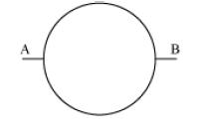

Q2:

A steady current flows in a metallic conductor oL non-uniform cross-section. Which of these quantities is constant along the conductor:

Current, current density. drift. speed, electric field?

Q3:

Draw VI graph for ohmic and non-ohmic materials. Give one example for each.

Q4:

A wire of 15 Q resistance is gradually stretched to double its original length. It is then cut into two equal parts. These parts are then connected in parallel across a 3·0 volt battery. Find the current drawn from the battery.

Q5:

Describe briefly, with the help of a circuit diagram, how a potentiometer is used to determine the internal resistance of a given cell.

Q6:

A cell of emf ’E’ and internal resistance ’r’ is connected across a variable resistor ’R’. Plot a graph showing the variation of terminal potential ’V’ with resistance R. Predict from the graph the condition under which ’V’ becomes equal to ’E’.

Q7:

Derive an expression for drift velocity of free electrons in a conductor in terms of relaxation time.

Q8:

Calculate the current drawn from the battery in the given network.

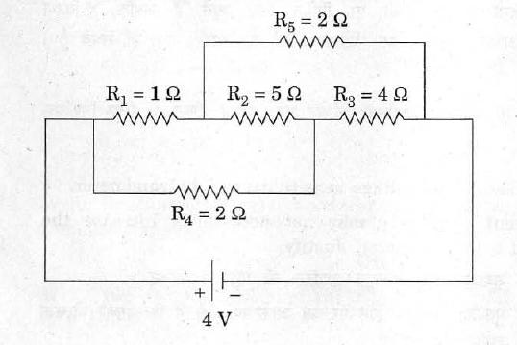

Q9:

Figure shows the circuit diagram of a potentiometer for determining the emf ’e’ of a cell of negligible internal resistance.

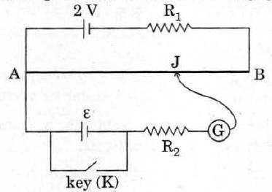

(i) What is the purpose of using high resistance R2 ?

(ii) How does the position of balance point (J) change when the resistance Rl is decreased ?

(iii) Why cannot the balance point be obtained (1) when the emf E is greater than 2 V, and (2) when the key (K) is closed?

Q10:

A cylindrical metallic wire is stretched to increase its length by 5%. Calculate the percentage change in its resistance.

Q11:

Define the term ’resistivity’ and write its S.I. unit. Derive the expression for the resistivity of a conductor in terms of number density of free electrons and relaxation time.

Q12:

Two cells of emf 1.5 V and 2 V and internal resistance 1 ohm and 2 ohm respectively are connected in parallel to pass a current in the same direction through an external resistance of 5 ohm.

(a) Draw the circuit diagram.

(b) Using Kirchhoff’s laws, calculate the current through each branch of the circuit and potential difference across the 5 ohm resistor.

Q13:

State the principle of potentiometer. Draw a circuit diagram used to compare the e.m.f. of two primary cells. Write the formula used. How can the sensitivity of a potentiometer be increased ?

Q14:

State the principle of working of a meter bridge. In a meter bridge balance point is found at a distance l1 with resistances R and S as shown in the figure.

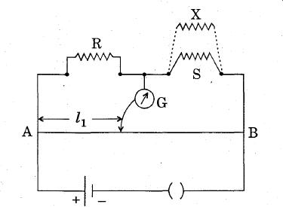

When an unknown resistance X is connected in parallel with the resistance S, the balance point shifts to a distance l2. Find the expression for X in terms of l1, l2 and S.

Q15:

State Kirchhoff’s rules. Use Kirchhoff’s rules to show that no current flows in the given circuit.

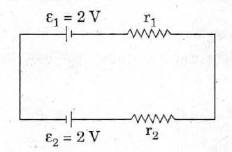

Q16:

State Kirchhoff’s rules of current distribution in an electrical network. Using these rules determine the value of the current in the electric circuit given below.

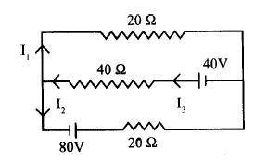

Q17:

For the potentiometer circuit shown in the given figure, points X and Y reprensent the two terminals of an unknown emf E’. A student observed that when the jockey in moved from the end A to the end B of the potentiometer wire, the deflection in the galvanometer remains in the same direction.

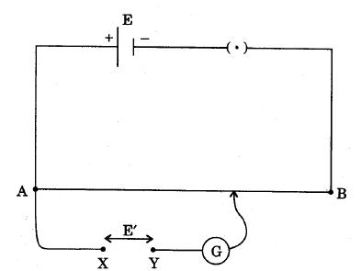

What may be the two possible faults in the circuit that could result in this obsevation ? If the galvanometer deflection at the end B is (i) more, (ii) less, than that at the end A, which of the two faults, listed above, would be there in the circuit ?

Q18:

The given figure shows a network of resistances R1, R2, R3 and R4.

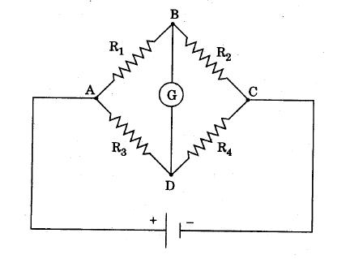

Using Kirchhoff’s laws, establish the balance condition for the network.

## Physics (Theory) - Moving Charges and Magnetism

##### Time allowed : 4 hours________________________ Maximum Marks : 86

##### Instructions

1. Please check that this question paper contains 5 printed pages.

2. Please check that this question paper contains 28 questions.

3. 15 minutes time has been allotted to read this question paper. The student will read the question paper only and will not write any answer on the answer script during this period.

#### A. General Instructions :

1. All questions are compulsory.

2. There are 28 questions in total. Questions 1 to 5 carry one mark each, questions 6 to 13 carry two marks each, questions 14 to 23 carry three marks each and questions 24 to 30 carry five marks each .

3. Use of calculators is not permitted.

4. You may use the following values of physical constants wherever necessary:

c = 3  108ms-1

h = 6  626  10-34Js

e = 1  602  10-19C

o = 4  10-7TmA-1

pϵo" > = 9  109Nm2C-2

Mass of electron me = 9·1  10-31kg

Mass of neutron mn~ =" class="cong" >1·675x10-27kg

Boltzmann’s constant k = 1  381  10-23JK-1

Avogadro’s number NA = 6  022  1023∕mol-1

Radius of earth = 6400 km

________________________________________________________________________________________________________________________________________

Q1:

An electron beam projected along + X-axis, experiences a force due to a magnetic field along the + Y-axis. What is the direction of the magnetic field ?

Q2:

Two wires of equal lengths are bent in the form of two loops. One of the loops is square shaped whereas the other loop is circular. These are suspended in a uniform magnetic field and the same current is passed through them. Which loop will experience greater torque ? Give reasons.

Q3:

An electron does not suffer any deflection while passing through a region of uniform magnetic field. What is the direction of the magnetic field?

Q4:

Magnetic field lines can be entirely confined within the core of a toroid, but not within a straight solenoid. Why?

Q5:

What is the direction of the force acting on a charged particle q, moving with a velocity ®v" class="mathpalette" > in a uniform magnetic field ®B" class="mathpalette" > ?

Q6:

Define current sensitivity and voltage sensitivity of a galvanometer.

Increasing the current sensitivity may not necessarUy increase the voltage sensitivity of a galvanometer. Justify.

Q7:

A charge ’q’ moving along the X-axis with a velocity V is subjected to a uniform magnetic field B acting along the Z-axis as it crosses the origin O.

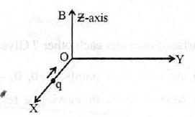

(i) Trace its trajectory.

(ii) Does the charge gain kinetic energy as it enters the magnetic field? Justify your answer.

Q8:

State Biot-Savart law.

A current I flows in a conductor placed perpendicular to the plane of the paper. Indicate the direction of the magnetic field due to a small element ® dl" class="mathpalette" > at point P situated at a distance ®r" class="mathpalette" > from the element as shown in the figure .

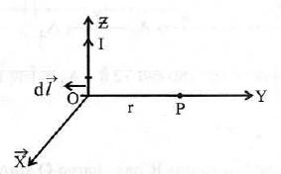

Q9:

Write the relation for the forece acting on a charge carrier q moving with a velocity ®v" class="mathpalette" > through a magnetic field ® B" class="mathpalette" > in vector notation. Using this relation, deduce the conditions under which this force will be (i) maximum (ii) minimum.

Q10:

In an ammeter (consisting of a galvanometer and a shunt), 0.5% of the main current passes through the galvanometer. Resistance of the galvanometer coil is G. Calculate the resistance of the shunt in terms of galvanometer resistance, G.

Q11:

A voltage of 30 V is applied across a carbon resistor with first, second and third rings of blue, black and yellow colours respectively. Calculate the value of current, in mA, through the resistor.

Q12:

A galvanometer has a resistance of It gives full scale deflection with a current of 2 mA. Calculate the value of the resistance needed to convert it into an ammeter of range 0-0.3 A.

Q13:

A wire of length L is bent round in the form of a coil having N turns of same radius. If a steady current I flows through it in a clockwise direction, find the magnitude and direction of the magnetic field produced at its centre.

Q14:

A galvanometer with a coil of resistance 120 ohm shows full scale deflection for a current of 2.5 mA. How will you convert the galvanometer into an ammeter of range 0 to 7.5 A ? Determine the net resistance of the ammeter. When an ammeter is put in a circuit, does it read slightly less or more than the actual current in the original circuit ? Justify your answer.

Q15:

Write the expression for the magnetic moment m due to a planar square loop of side ‘l’ carrying a steady current I in a vector form.

In the given figure this loop is placed in a horizontal plane near a long straight conductor carrying a steady current I1 at a distance l as shown. Give reason to explain that the loop will experience a net force but no torque. Write the expression for this force acting on the loop.

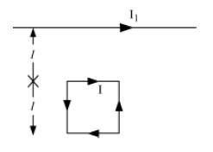

Q16:

A long straight wire of a circular cross-section of radius ‘a’ carries a steady current ‘I’. The current is uniformly distributed across the cross-section. Apply Ampere’s circuital law to calculate the magnetic field at a point ‘r’ in the region for (i) r < a and (ii) r > a.

Q17:

State the underlying principle of working of a moving coil galvanometer. Write two reasons why a galvanometer can not be used as such to measure current in a given circuit. Name any two factors on which the current sensitivity of a galvanometer depends.

Q18:

Derive the expression for force per unit length between two long straight parallel current carrying conductors. Hence define one ampere.

Q19:

State Ampere’s circuital law. Write the expression for the magnetic field at the centre of a circular coil of radius R carrying a current I. Draw the magnetic field lines due to this coil.

Q20:

Write the expression for the force acting on a charged particle of charge q moving with velocity ® v" class="mathpalette" > in the presence of magnetic field ®B" class="mathpalette" > . Show that in the presence of this force (i) the kinetic energy of the particle does not change.

(ii) its instantaneous power is zero.

Q21:

Deduce the expression for the torque experienced by a rectangular loop carrying a steady current ’I’ and placed in a uniform magnetic field ®B" class="mathpalette" > . Indicate the direction of the torque acting on the loop.

Q22:

Deduce the expression for magnetic dipole moment of an electron revolving around the nu,c leus in a circular orbit of radius ’r’. Indicate the direction of the magnetic dipole moment.

Q23:

Depict the field-line pattern due to a current carrying solenoid of finite length.

(i) In what way do these lines differ from those due to an electric dipole?

(ii) Why can’t two magnetic ffeld lines intersect each other?

Q24:

(a) With the help of a labelled diagram, explain the principle and working, of a moving coil galvanometer.

(b) Two parallel coaxial circular coils of equal radius ‘R’ and equal number of turns ‘N’, carry equal currents ’I’ in the same direction and are separated by a distance ‘2R’. Find the magnitude and direction of the net magnetic field produced at the mid-point of the line joining their centres.

OR

Draw a labelled diagram of a moving coil galvanometer. State the principle on which it works. Deduce an expression for the torque acting on a rectangular current carrying loop kept in a uniform magnetic field. Write two factors on which the current sensitivity of a moving coil galvanometer depend.

Q25:

(a) State Biot-Savart’s law. Using this law, derive the expression for the magnetic field due to a current carrying circular loop of radius ‘R’, at a point which is at a distance ‘x’ from its centre along the axis of the loop.

(b) Two small identical circular loops, marked (1) and (2), carrying equal currents, are placed with the geometrical axes perpendicular to each other as shown in the figure. Find the magnitude and direction of the net magnetic field produced at the point O.

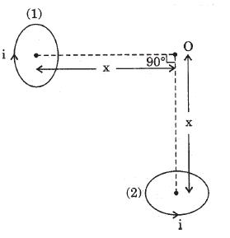

Q26:

Explain the principle and working of a cyclotron with the help of a labelled diagram. A cyclotron’s oscillator frequency is 10 MHz. What should be the operating magnetic field for accelerating protons ? If the radius of its ‘dees’ is 60 cm, what is the kinetic energy of the proton beam produced by the accelerator ? Express your answer in units of MeV. (e = 1.6  10-19 C, mp = 1.67  10-27 kg, 1 MeV = 1.602  10-13 J).

Q27:

Depict the magnetic field lines due to two straight, long, parallel conductors carrying currents I1 and I2 in the same direction. Hence deduce an expression for the force acting per unit length on one conductor due to the other. Is this force attractive or repulsive ? Figure shows a rectangular current-carrying loop placed 2 cm away from a long, straight, current-carrying conductor. What is the direction and magnitude of the net force acting on the loop ?

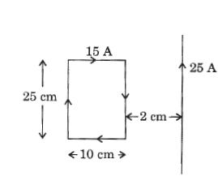

Q28:

(a) Two straight long parallel conductors carry currents I1 and I2 in the same direction. Deduce the expression for the force per unit length between them. Depict the pattern of magnetic field lines around them.

(b) A rectangular current carrying loop EFGH is kept in a uniform magnetic field as shown in the figure.

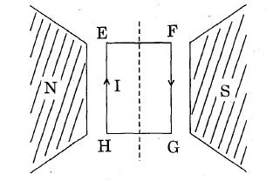

(i) What is the direction of the magnetic moment of the current loop?

(ii) When is the torque acting on the loop (A) maximum, (B) zero?

Q29:

Draw a schematic sketch of a cyclotron. Explain briefly how it works and how it is used to accelerate the charged particles.

(i) Show that time period of ions in a cyclotron is independent of both the speed and radius of circular path.

(ii) What is resonance condition ? How is it used to accelerate the charged particles ?

OR

Explain, with the help of a labelled diagram, the principle and construction of a cyclotron. Deduce an expression for the cyclotron frequency and show that it does not depend on the speed of the charged particle.

Q30:

State Biot-Savart law. Use it to derive an expression for the magnetic field at the centre of a circular loop of radius R carrying a steady current I. Sketch the magnetic field lines for such a current carrying loop.

## Physics (Theory) - Magnetism and Matter

##### Time allowed : 45 Min________________________ Maximum Marks : 17

##### Instructions

1. Please check that this question paper contains 2 printed pages.

2. Please check that this question paper contains 8 questions.

3. 15 minutes time has been allotted to read this question paper. The student will read the question paper only and will not write any answer on the answer script during this period.

#### A. General Instructions :

1. All questions are compulsory.

2. There are 8 questions in total. Questions 1 to 2 carry one mark each, questions 3 to 7 carry two marks each, and question 8 carries five marks .

3. Use of calculators is not permitted.

4. You may use the following values of physical constants wherever necessary:

c = 3  108ms-1

h = 6  626  10-34Js

e = 1  602  10-19C

o = 4  10-7TmA-1

pϵo" > = 9  109Nm2C-2

Mass of electron me = 9·1  10-31kg

Mass of neutron mn~=" class="cong" >1·675x10-27kg

Boltzmann’s constant k = 1  381  10-23JK-1

Avogadro’s number NA = 6  022  1023∕mol-1

Radius of earth = 6400 km

________________________________________________________________________________________________________________________________________

Q1:

Why should the material used for making permanent magnets have high coercivity ?

Q2:

Magnetic field lines can be entirely confined within the core of a toroid, but not within a straight solenoid. Why?

Q3:

Define the terms ’Magnetic Dip’ and ’Magnetic Declination’ with the help of relevant diagrams.

Q4:

Write two characteristic properties to distinguish between diamagnetic and paramagnetic materials.

Q5:

Define magnetic susceptibility of a material. Name two elements, one having positive susceptibility and the other having negative susceptibility. What does negative susceptibility signify?

Q6:

(i) Write two characteristics of a material used for making permanent magnets. (ii) Why is the core of an electromagnet made of ferromagnetic materials?

Q7:

Draw magnetic field line when a (i) diamagnetic, (ii) paramagnetic substance is placed in an external magnetic field. Which magnetic property distinguishes this behaviour of the field line due to the substances?

Q8:

Distinguish the magnetic properties of dia, para- and ferro-magnetic substances in terms of (i) susceptibility, (ii) magnetic permeability and (iii) coercivity. Give one example of each of these materials. Draw the field lines due to an external magnetic field near a (i) diamagnetic, (ii) paramagnetic substance.

## Physics (Theory) - Alternating Current

##### Time allowed : 3 Hours________________________ Maximum Marks : 65

##### Instructions

1. Please check that this question paper contains 4 printed pages.

2. Please check that this question paper contains 23 questions.

3. 15 minutes time has been allotted to read this question paper. The student will read the question paper only and will not write any answer on the answer script during this period.

#### A. General Instructions :

1. All questions are compulsory.

2. There are 23 questions in total. Questions 1 to 3 carry one mark , questions 4 to 13 carry two marks , questions 14 to 17 carry 3 marks, and questions 18 to 23 carry 5 marks each .

3. Use of calculators is not permitted.

4. You may use the following values of physical constants wherever necessary:

c = 3  108ms-1

h = 6  626  10-34Js

e = 1  602  10-19C

o = 4  10-7TmA-1

pϵo" > = 9  109Nm2C-2

Mass of electron me = 9·1  10-31kg

Mass of neutron mn~=" class="cong" >1·675x10-27kg

Boltzmann’s constant k = 1  381  10-23JK-1

Avogadro’s number NA = 6  022  1023∕mol-1

Radius of earth = 6400 km

________________________________________________________________________________________________________________________________________

Q1:

The power factor of an a.c. circuit is 0.5. What will be the phase difference between voltage and current in this circuit ?

Q2:

A bulb and a capacitor are connected in series to an a.c. source of variable frequency. How will the brightness of the bulb change on increasing the frequency of the a.c. source ? Give reason.

Q3:

In a series LCR circuit, the voltages across an inductor, a capacitor and a resistor are 30 V, 30 V and 60 V respectively. What is the phase difference between the applied voltage and the current in the circuit ?

Q4:

(i) Draw the graphs showing variation of inductive reactance and capacitive reactance with frequency of applied a.c. source.

(ii) Can the voltage drop across the inductor or the capacitor in a series LCR circuit be greater than the applied voltage of the a.c. source ? Justify your answer.

Q5:

State the condition under which the phenomenon of resonance occurs in a series LCR circuit. Plot a graph showing variation of current with frequency of a.c. source in a series LCR circuit.

Q6:

A coil Q is connected to low voltage bulb B and placed near another coil P as shown in the figure. Give reasons to explain the following observations:

(a) The bulb ‘B’ lights

(b) Bulb gets dimmer if the coil Q is moved towards left.

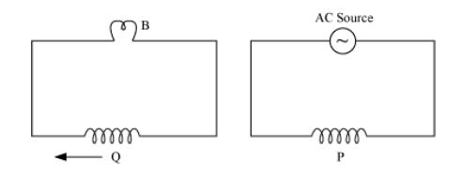

Q7:

Prove that an ideal inductor does not dissipate power in an a.c. circuit.

Q8:

Distinguish between the terms ’average value’ and ’rms value’ of an alternating current. The instantaneous current from an a.c. source is I = 5 sin (314 t) ampere. What are the average and rms values of the current ?

Q9:

An electric bulb B and a parallel plate capacitor C are connected in series to the a.c. mains as shown in the given figure. The bulb glows with some brightness.

How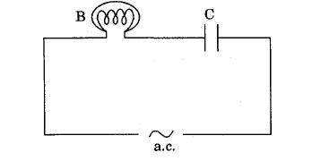 will the glow of the bulb be affected on introducing a dielectric slab between the plates of the capacitor ? Give reasons in support of your answer.

Q10:

Calculate the current drawn by the primary of a transformer which steps down 200 V to 20 V to operate a device of resistance 20 . Assume the efficiency of the transformer to be 80%.

Q11:

An a.c. voltage of 100 V, 50 Hz is connected across a 20 ohm resistor and mH inductor in series. Calculate (i) impedance of the circuit, (ii) rms current in the circuit.

Q12:

Prove that an ideal capacitor, in an a.c. circuit does not dissipate power.

Q13:

Derive an expression for the impedance of a.c. circuit consisting of an inductor and a resistor.

Q14:

Explain with the help of a labelled diagram the underlying principle and working of a step-up transformer. Why cannot such a device be used to step-up d.c. voltage ?

Q15:

Given below are two electric circuits A and B

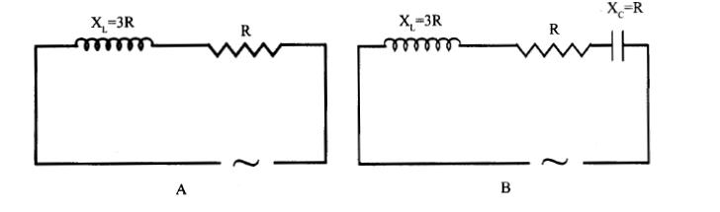

Calculate the ratio of power factor of the circuit B to the power factor of circuit A.

Q16:

A resistor of 200 and a capacitor of 40 mF are connected in series to 220 V a.c. source with angular frequency = 300Hz . Calculate the voltages (rms) across the resistor and the capacitor. Why is the algebraic sum of these voltages more than the source voltage ? How do you resolve this paradox ?

Q17:

An inductor 200 mH… capacitor 500mF, resistor 10W are connected in series with a 100V, variable frequency a.c. source. Calculate the

(i) frequency at which the power factor of the circuit is unity;

(ii) current amplitude at this frequency;

(iii) Q-factor

Q18:

A series LCR circuit is connected to a source having voltage v = vmsint . Derive the expression for the instantaneous current I and its phase relationship to the applied voltage. Obtain the condition for resonance to occur. Define ‘power factor’. State the conditions under which it is (i) maximum and (ii) minimum.

Q19:

Draw a labelled. diagram of a step-up transformer and explain briefly its working.

Deduce the expressions for the secondary voltage and secondary current in terms of the number of turns of primary and secondary windings.

How is the power transmission and distribution over· long distances . done with the use of transformers ?

Q20:

(a) Derive an expression for the average power consumed in a series LCR circuit connected to a.c. source in which the phase difference between the voltage and the current in the circuit is .

(b) Define the quality factor in an a.c. circuit. Why should the quality factor have high value in receiving circuits? Name the factors on which it depends.

Q21:

(a) Derive the relationship between the peak and the nns value of current in an a.c. circuit.

(b) Describe briefly. with the help of a labelled diagram. working of a step-up transformer. A step-up transfonner converts a low voltage into high voltage. Does it not violate the principle of conservation of energy? Explain.

Q22:

Explain the term ’inductive reactance’. Show graphically the variation of inductive reactance with frequency of the applied alternating voltage. An a.c. voltage E = Eo sint is applied across a pure inductor of inductance L. Show mathematically that the current flowing through it lags behind the applied voltage by aphase angle of p- 2" >.

Q23:

Explain the term ’capacitive reactance’. Show graphically the variation of capacitive reactance with frequency of the applied alternating voltage. An a.c. voltage E = Eo sint is applied across a pure capacitor of capacitance C. Show mathematically that the current flowing through it leads the applied voltage by a phase angle of p- 2" >.

## Physics (Theory) - Electromagnetic Induction

##### Time allowed : 1 Hour________________________ Maximum Marks : 27

##### Instructions

1. Please check that this question paper contains 3 printed pages.

2. Please check that this question paper contains 8 questions.

3. 15 minutes time has been allotted to read this question paper. The student will read the question paper only and will not write any answer on the answer script during this period.

#### A. General Instructions :

1. All questions are compulsory.

2. There are 8 questions in total. Questions 1 to 2 carry one mark , questions 3 carries two marks , question 4 carries 3 marks, and questions 5 to 8 carry 5 marks each .

3. Use of calculators is not permitted.

4. You may use the following values of physical constants wherever necessary:

c = 3  108ms-1

h = 6  626  10-34Js

e = 1  602  10-19C

o = 4  10-7TmA-1

pϵo" > = 9  109Nm2C-2

Mass of electron me = 9·1  10-31kg

Mass of neutron mn~=" class="cong" >1·675x10-27kg

Boltzmann’s constant k = 1  381  10-23JK-1

Avogadro’s number NA = 6  022  1023∕mol-1

Radius of earth = 6400 km

________________________________________________________________________________________________________________________________________

Q1:

State the Faraday’s law of electromagnetic induction.

Q2:

A plot of magnetic flux () versus current (I) is shown in the figure for two inductors A and . Which of the two has larger value of self inductance?

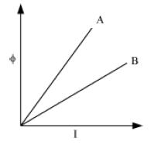

Q3:

In the figure given below, a bar magnet moving towards the right or left induces an e.m.f. in the coils (1) and (2). Find, giving reason, the directions of the induced currents through the resistors AB and CD when the magnet is moving (a) towards the right, and (b) towards the left.

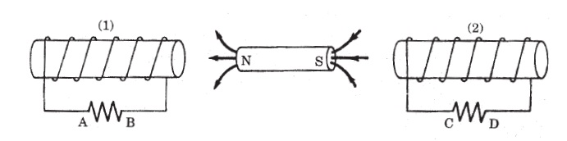

Q4:

(a) Define self inductance. Write its S.1. units. (b) Derive an expression for self inductance of a long solenoid of length l, cross-sectional area A having N number of turns.

Q5:

A jet plane is travelling towards west at a speed of 1800 km/h. What is the voltage difference developed between the ends of the wing having a span of 25 m, if the Earth’s magnetic field at the location has a magnitude of 5x10-4 T and the dip angle is 30o ?

Q6:

State the working principle of an A.C. generator with the help of a labelled diagram. Derive an expression for the instantaneous value of the emf induced in coil. Why is the emf maximum when the plane of the armature is parallel to the magnetic field ?

Q7:

(a) What are eddy currents? Write their two applications.

(b) Figure shows a rectangular conducting loop PQSR in which arm RS of length ’l’ is movable. The loop is kept in a uniform magnetic fi eld ’E’ directed downward perpendicular to the plane of the loop. The arm RS is moved with a uniform speed ’v’,

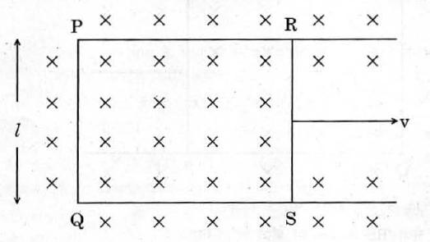

Deduce an expression for

(i) the emf induced across the arm ’RS’,

(ii) the external force required to move the arm, and

(iii) the power dissipated as heat.

Q8:

(a) State Lenz’s law. Give one example to illustrate this law. ”The Lenz’s law is a consequence of the principle of conservation of energy." Justify this statement.

(b) Deduce an expression for the mutual inductance of two long coaxial solenoids but having different radii and different number of turns.

# Optics

## Physics (Theory) - Ray Optics and Optical Instruments

##### Time allowed : 2.5 Hours________________________ Maximum Marks : 58

##### Instructions

1. Please check that this question paper contains 3 printed pages.

2. Please check that this question paper contains 18 questions.

3. 15 minutes time has been allotted to read this question paper. The student will read the question paper only and will not write any answer on the answer script during this period.

#### A. General Instructions :

1. All questions are compulsory.

2. There are 18 questions in total. Questions 1 to 4 carry one mark each, questions 5 to 8 carry two marks each, questions 9 to 10 carry three marks each and question 11 to 18 carry five marks each .

3. Use of calculators is not permitted.

4. You may use the following values of physical constants wherever necessary:

c = 3  108ms-1

h = 6  626  10-34Js

e = 1  602  10-19C

o = 4  10-7TmA-1

pϵo" > = 9  109Nm2C-2

Mass of electron me = 9·1  10-31kg

Mass of neutron mn~ =" class="cong" >1·675x10-27kg

Boltzmann’s constant k = 1  381  10-23JK-1

Avogadro’s number NA = 6  022  1023∕mol-1

Radius of earth = 6400 km

________________________________________________________________________________________________________________________________________

Q1:

A glass lens of refractive index 1.45 disappears when immersed in a liquid. What is the value of refractive index of the liquid?

Q2:

You are given following three lenses. Which two lenses will you use as an eyepiece and as an objective to construct an astronomical telescope ?

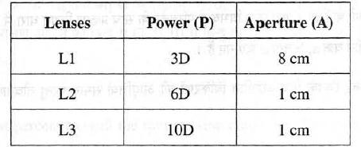

Q3:

Two thin lenses of power + 6 D and - 2 D are in contact. What is the focal length of the combination ?

Q4:

A converging lens of refractive index 1.5 is kept in a liquid medium having same refractive index. What would be the focal length of the lens in this medium?

Q5:

(i) Out of blue and red light which is deviated more by a prism? Give reason. (ii) Give the formula that can be used to determine refractive index of materials of a prism in minimum deviation condition.

Q6:

Define refractive index of a transparent medium. A ray of light passes through a triangular prism. Plot a graph showing the variation of the angle of deviation with the angle of incidence.

Q7:

Draw a ray diagram of an astronomical telescope in the normal adjustment position. State two drawback of this type of telescope.

Q8:

Calculate the distance of an object of height h from a concave mirror of focal length 10 cm, so as to obtain a real image of magnification 2.

Q9:

Three light rays red (R), green (0) and blue (B) are incident on a right angled prism ’abc’ at face ’ab’. The refractive indices of the material of the prism for red, green and blue wavelengths are 1.39, 1.44 and 1.47 respectively. Out of the three which colour ray will emerge out of face ’ac’ ? Justify your answer. Trace the path of these rays after passing through face ’ab’.

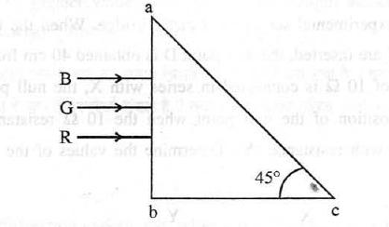

Q10:

State the conditions under which total internal reflection occurs. One face of a prism with a refracting angle of 30° is coated with silver. A ray incident on another face at an angle of 45° is refracted and reflected from the silver coated face and retraces its path. Find the refractive index of the material of the prism.

Q11:

Draw a ray diagram to show the working of a compound microscope. Deduce an expression for the total magnification when the final image is formed at the near point.

In a compound microscope, an object is placed at a distance of 1.5 cm from the objective of focal length 1.25 cm. If the eye piece has a focal length of 5 cm and the final image is formed at the near point, estimate the magnifying power of the microscope.

Q12:

Trace the rays of light showing the formation of an image due to a point object placed on the axis of a spherical surface separating the two media of refractive indices n1 and n2. Establi sh the relation between the distances of the object, the image and the radius of curvature from the central pOint of the spherical surface. 55/l/1 Hence derive the expression of the lens maker’s formula.

Q13:

Draw the labelled ray diagram for the formation of image by a compound microscope. Derive the expression for the total magnification of a compound microscope. Explain why both the objective and the eyepiece of a compound microscope must have short focal lengths.

Q14:

(a) Draw a ray diagram for formation of image of a point object by a thin double convex lens having radii of curvatures Rl and R2 and hence derive lens maker’s formula.

(b) Define power of a lens and give its S.1. units. If a convex lens of focal length 50 em is placed it’} contact coaxially with a concave lens of focal length 20 cm, what is the power ’of the combination ?

Q15:

Draw a labelled ray diagram to show the image formation by an astronomical telescope. Derive the expression for its magnifying power in normal adjustment. Write two basic features which can distinguish between a telescope and a compound microscope.

Q16:

(a) (i) Draw a labelled ray diagram to show the formation of image in an astronomical telescope for a distant object. (ii) Write three distinct advantages of a reflecting type telescope over a refracting type telescope:

(b) A convex lens of focal length 10 em is placed coaxially 5 em away from a concave lens of focal length 10 cm. If an object is placed 30 cm in front of the convex lens, find the position of the fmal image formed by the combined system.

Q17:

(a) With the help of a suitable ray diagram, derive the mIrror formula for a concave mirror. (b) The near point of a hypermetropic person is 50 em from the eye. What is the power of the lens required to enable the person to read clearly a book held at 25 em from the eye?

Q18:

(a) For a ray of light travelling from a denser medium of refractive index n1 to rarer medium of refractive index n2, prove that = sinic, where ic is the critical angle of incidence for the media.

(b) Explain with the help of a diagram, how the above principle is used for transmission of video signals using optical fibres.

## Physics (Theory) - Wave Optics

##### Time allowed : 1.5 Hours________________________ Maximum Marks : 36

##### Instructions

1. Please check that this question paper contains 3 printed pages.

2. Please check that this question paper contains 17 questions.

3. 15 minutes time has been allotted to read this question paper. The student will read the question paper only and will not write any answer on the answer script during this period.

#### A. General Instructions :

1. All questions are compulsory.

2. There are 17 questions in total. Questions 1 to 9 carry one mark each, question 10 carries two marks , questions 11 to 15 carry 3 marks each and questions 16 to 17 carry five marks .

3. Use of calculators is not permitted.

4. You may use the following values of physical constants wherever necessary:

c = 3  108ms-1

h = 6  626  10-34Js

e = 1  602  10-19C

o = 4  10-7TmA-1

pϵo" > = 9  109Nm2C-2

Mass of electron me = 9·1  10-31kg

Mass of neutron mn~=" class="cong" >1·675x10-27kg

Boltzmann’s constant k = 1  381  10-23JK-1

Avogadro’s number NA = 6  022  1023∕mol-1

Radius of earth = 6400 km

________________________________________________________________________________________________________________________________________

Q1:

Calculate the speed of light in a medium whose critical angle is 30°.

Q2:

What type of wavefront will emerge from a (i) point source, and (ii) distant light source ?

Q3:

If the angle between the pass axis of polarizer and the analyser is 45°, write the ratio of the intensities of original light and the transmitted light after passing through the analyser.

Q4:

Draw the wavefront coming out of a convex lens when a point source of light is placed at its focus.

Q5:

Unpolarised light of intensity I is passed through a polaroid. What is the intensity of the light transmitted by the polaroid?

Q6:

Why are coherent sources required to create interference of light ?

Q7:

How would the angular separation of interference fringes in Young’s Double Slit Experiment change when the distance between the slits and the screen is doubled ?

Q8:

How does the angular separation of interference fringes change, in Young’s experiment, if the distance between the slits is increased?

Q9:

How does the fringe width of interference fringes change, when the whole apparatus of Young’s experiment is kept in a liquid of refractive index 1.3?

Q10:

Define the term ’linearly polarised light’.

When does the intensity of transmitted light become maximum, when a polaroid sheet is rotated between two crossed polaroids ?

Q11:

What is an unpolarized light? Explain with the help of suitable ray diagram how an unpolarized light can be polarized by reflection from a transparent medium. Write the expression for Brewster angle in terms of the refractive index of denser medium.

Q12:

In a single slit diffraction experiment, when a tiny circular obstacle is placed in the path of light from a distant source, a bright spot is seen at the centre of the shadow of the obstacle. Explain why?

State two points of difference between the interference pattern obtained in Young’s double slit experiment and the diffraction pattern due to a single slit.

Q13:

(a) Why do we not encounter diffraction effects of light in everyday observations?

(b) In the observed diffraction pattern due to a single slit, how will the width of central maximum be affected if

(i) the width of the slit is doubled;

(ii) the wavelength of the light used is increased? Justify your answer in each case.

Q14:

In Young’s double slit experiment, monochromatic light of wavelength 630 nm illuminates the pair of slits and produces an interference pattern in which two consecutive bright fringes are separated by 8·1 mm. Another source of monochromatic light produces the interference pattern in which the two consecutive bright fringes are separated by 7·2 mm. Find the wavelength of light from the second source.

Q15:

How is a wave front defined? Using Huygen’s construction draw a figure showing the propagation of a plane wave reflecting at the interface of the two media. Show that the angle of incidence is equal to the angle of reflection.

Q16:

State Huygens’s principle. Show, with the help of a suitable diagram, how this principle is used to obtain the diffraction pattern by a single slit.

Draw a plot of intensity distribution and explain clearly why the secondary maxima becomes weaker with increasing order (n) of the secondary maxima.

Q17:

(a) What is plane polarized light? Two polaroids are placed at 90o to each other and the transmitted intensity is zero. What happens when one more Polaroid is placed between these two, bisecting the angle between them? How will the intensity of transmitted light vary on further rotating the third Polaroid?

(b) If a light beam shows no intensity variation when transmitted through a Polaroid which is rotated, does it mean that the light is unpolarized? Explain briefly.

# Modern Physics

## Physics (Theory) - Atoms

##### Time allowed : 30 Min________________________ Maximum Marks : 13

##### Instructions

1. Please check that this question paper contains 2 printed pages.

2. Please check that this question paper contains 6 questions.

3. 15 minutes time has been allotted to read this question paper. The student will read the question paper only and will not write any answer on the answer script during this period.

#### A. General Instructions :

1. All questions are compulsory.

2. There are 6 questions in total. Questions 1 to 2 carry one mark each, question 3 carries two marks each, and questions 4 to 6 carry three marks each .

3. Use of calculators is not permitted.

4. You may use the following values of physical constants wherever necessary:

c = 3  108ms-1

h = 6  626  10-34Js

e = 1  602  10-19C

o = 4  10-7TmA-1

pϵo" > = 9  109Nm2C-2

Mass of electron me = 9·1  10-31kg

Mass of neutron mn~=" class="cong" >1·675x10-27kg

Boltzmann’s constant k = 1  381  10-23JK-1

Avogadro’s number NA = 6  022  1023∕mol-1

Radius of earth = 6400 km

________________________________________________________________________________________________________________________________________

Q1:

Write the expression for Bohr’s radius in hydrogen atom.

Q2:

In the Rutherford scattering experiment the distance of closest approach for an a-particle is do If -particle is replaced by a proton, how much kinetic energy in comparison to -particle will it require to have the same distance of closest approach do ?

Q3:

The energy of the electron in the ground state of hydrogen atom is - 13·6 eV. (i) What does the negative sign signify?

(ii) How much energy is required to take an electron in this atom from the ground state to the first excited state?

Q4:

The energy levels of an atom are as shown below. Which of them will result in the transition of a photon of wavelength 275 nm ?

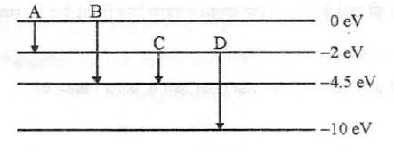

Which transition corresponds to etruSSlon of radiation of maximum wavelength ?

Q5:

Draw a schematic arrangement of the Geiger - Marsden experiment. How did the scattering of a -particles by a thin foil of gold provide an important way to determine an upper limit on the size of the nucleus? Explain briefly.

Q6:

The energy level diagram of an element is given below. Identify, by doing necessary calculations, which transition corresponds to the emission of a spectral line of wavelength 102.7 nm.

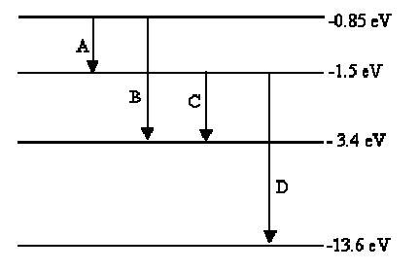

## Physics (Theory) -Nuclei

##### Time allowed : 50 Min________________________ Maximum Marks : 19

##### Instructions

1. Please check that this question paper contains 2 printed pages.

2. Please check that this question paper contains 10 questions.

3. 15 minutes time has been allotted to read this question paper. The student will read the question paper only and will not write any answer on the answer script during this period.

#### A. General Instructions :

1. All questions are compulsory.

2. There are 10 questions in total. Questions 1 to 3 carry one mark each, questions 4 to 8 carry two marks each, and questions 9 to 10 carry three marks each.

3. Use of calculators is not permitted.

4. You may use the following values of physical constants wherever necessary:

c = 3  108ms-1

h = 6  626  10-34Js

e = 1  602  10-19C

o = 4  10-7TmA-1

pϵo" > = 9  109Nm2C-2

Mass of electron me = 9·1  10-31kg

Mass of neutron mn~=" class="cong" >1·675x10-27kg

Boltzmann’s constant k = 1  381  10-23JK-1

Avogadro’s number NA = 6  022  1023∕mol-1

Radius of earth = 6400 km

________________________________________________________________________________________________________________________________________

Q1:

Two nuclei have mass numbers in the ratio 1 : 2. What is the ratio of their nuclear densities?

Q2:

Two nuclei have mass numbers in the ratio 1 : 8. What is the ratio of their nuclear radii ?

Q3:

State the reason, why heavy water is generally used as a moderator in a nuclear reactor.

Q4:

A heavy nucleus X of mass number 240 and binding energy per nucleon 7.6 MeV is split into two fragments Y and Z of mass numbers 110 and 130. The binding energy of nucleons in Y and Z is 8.5 MeV per nucleon. Calculate the energy Q released pr fission in MeV.

Q5:

A radioactive nucleus ’A’ undergoes a series of decays according to the following scheme:

E:\Live\projects\Images\PCB\1e\image33.JPG

The mass number and atomic number of A are 180 and 72 respectively. What are these numbers for A4 ?

Q6:

(a) What is meant by half life of a radioactive element ?

(b) The half life of a radioactive substance is 30 s. Calculate (i) the decay constant, and (ii) time taken for the sample to decay by 3/4 th of the initial value.

Q7:

(a) The mass of a nucleus in its ground state is always less than the total mass of its constituents - neutrons and protons. Explain.

(b) Plot a graph showing the variation of potential energy of a pair of nucleons as a function of their separation.

Q8:

A nucleus 1023Ne undergoes -decay and becomes 1123Na . Calculate the maximum kinetic energy of electrons emitted assuming that the daughter nucleus and anti-neutrino carry negligible kinetic energy.

Q9:

(i) Define ‘activity’ of a radioactive material and write its S.I. units. (ii) Plot a graph showing variation of activity of a given radioactive sample with time. (iii) The sequence of stepwise decay of a radioactive nucleus is

Da " class="" > D1b- " class="" > D2

If the atomic number and mass number of D2 are 71 and 176 respectively, what are their corresponding values of D?

Q10:

Draw a plot showing the variation of binding energy per nucleon versus the mass number A. Explain with the help of this plot the release of energy in the processes of nuclear fission and fusion.

## Physics (Theory) - Dual Nature of Radiation and Matter

##### Time allowed : 45 Min________________________ Maximum Marks : 18

##### Instructions

1. Please check that this question paper contains 2 printed pages.

2. Please check that this question paper contains 10 questions.

3. 15 minutes time has been allotted to read this question paper. The student will read the question paper only and will not write any answer on the answer script during this period.

#### A. General Instructions :

1. All questions are compulsory.

2. There are 10 questions in total. Questions 1 to 4 carry one mark each, questions 5 to 8 carry two marks each, and questions 9 to 10 carry three marks each .

3. Use of calculators is not permitted.

4. You may use the following values of physical constants wherever necessary:

c = 3  108ms-1

h = 6  626  10-34Js

e = 1  602  10-19C

o = 4  10-7TmA-1

pϵo" > = 9  109Nm2C-2

Mass of electron me = 9·1  10-31kg

Mass of neutron mn~=" class="cong" >1·675x10-27kg

Boltzmann’s constant k = 1  381  10-23JK-1

Avogadro’s number NA = 6  022  1023∕mol-1

Radius of earth = 6400 km

________________________________________________________________________________________________________________________________________

Q1:

The figure shows a plot of three curves a, b, c showing the variation of photocurrent vs collector plate potential for three different intensities I1, I2 and I3 having frequencies 1 , 2 and 3 respectively incident on a photosensitive surface. Point out the two curves for which the incident radiations have same frequency but different intensities.

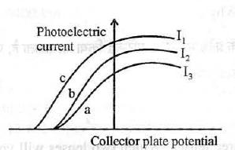

Q2:

The stopping potential in an experiment on photoelectric effect is 1·5 V. What is the maximum kinetic energy of the photoelectrons emitted?

Q3:

An electron and alpha particle have the same kinetic energy. How are the de-Broglie wavelengths associated with them related?

Q4:

An electron and alpha particle have the same de-Broglie wavelength associated with them. How are their kinetic energies related to each other?

Q5:

An electron is accelerated through a potential difference of 64 volts. What is the de-Broglie wavelength associated with it? To which part of the electromagnetic spectrum does this value of wavelength correspond?

Q6:

Plot a graph showing the variation of stopping potential with the frequency of incident radiation for two different photosensitive materials having work functions W1 and W2 (W1 > W2). On what factors does the (i) slope and (ii) intercept of the lines depend?

Q7:

Derive an expression for the de-Broglie wavelength associated with an electron accelerated through a potential V. Draw a schematic diagram of a localised-wave describing the wave nature of the moving electron.

Q8:

Figure shows variation of stopping potential (Vo) with the frequency () for two photosensitive materials M1 and M2·

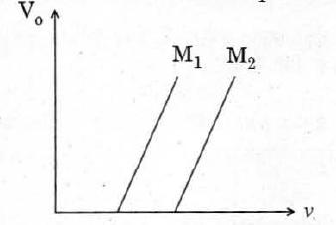

(i) Why is the slope same for both lines?

(ii) For which material will the emitted electrons have greater kinetic energy for the incident radiations of the same frequency? Justify your answer.

Q9:

A proton and an alpha particle are accelerated through the same potential. Which one of the two has (i) greater value of de-Broglie wavelength associated with it, and: (ii) less kinetic energy? Justify your answers.

Q10:

An electromagnetic wave of wavelength  is incident on a photosensitive surface of negligible work function. If the photo-electrons emitted from this surface have the de —Broglie wavelength 1 , prove that  = 12

## Physics (Theory) - Electromagnetic Waves

##### Time allowed : 30 Min________________________ Maximum Marks : 12

##### Instructions

1. Please check that this question paper contains 2 printed pages.

2. Please check that this question paper contains 8 questions.

3. 15 minutes time has been allotted to read this question paper. The student will read the question paper only and will not write any answer on the answer script during this period.

#### A. General Instructions :

1. All questions are compulsory.

2. There are 8 questions in total. Questions 1 to 4 carry one mark each, and questions 5 to 8 carry two marks each.

3. Use of calculators is not permitted.

4. You may use the following values of physical constants wherever necessary:

c = 3  108ms-1

h = 6  626  10-34Js

e = 1  602  10-19C

o = 4  10-7TmA-1

pϵo" > = 9  109Nm2C-2

Mass of electron me = 9·1  10-31kg

Mass of neutron mn~=" class="cong" >1·675x10-27kg

Boltzmann’s constant k = 1  381  10-23JK-1

Avogadro’s number NA = 6  022  1023∕mol-1

Radius of earth = 6400 km

________________________________________________________________________________________________________________________________________

Q1:

Write the following radiations in ascending order in respect of their frequencies:

X-rays, microwaves, UV rays and radio waves.

Q2:

Name the electromagnetic radiations which are produced when high energy electrons are bombarded on a metal target.

Q3:

Name the EM waves used for studying crystal structure of solids. What is its frequency range?

Q4:

Name the part of the electromagnetic spectrum of wavelength 102 m and mention its one application.

Q5:

How does a charge q oscillating at certain frequency produce electromagnetic waves? Sketch a schematic diagram depicting electric and magnetic fields for an electromagnetic wave propagating along the Z-direction.

Q6:

Name the electromagnetic radiations having the wavelength range from 1 mm to 700 nm. Give its two important applications.

Q7:

Answer the following questions:

(a) Optical and radio telescopes are built on the ground while X-ray astronomy is possible only from satellites orbiting the Earth. Why?

(b) The small ozone layer on top of the stratosphere is crucial for human survival. Why ?

Q8:

The oscillating magnetic field in a plane electromagnetic wave is given by

By = ґ10- 6)" class="left" align="middle">sinґ 1011t+ 300x]" class="left" align="middle">T

(i) Calculate the wavelength of the electromagnetic wave.

(ii) Write down the expression for the oscillating electric field.

# Semiconductors

## Physics (Theory) - Semiconductor Electronics: Materials, Devices and Simple Circuits

##### Time allowed : 2.25 Hrs________________________ Maximum Marks : 53

##### Instructions

1. Please check that this question paper contains 4 printed pages.

2. Please check that this question paper contains 15 questions.

3. 15 minutes time has been allotted to read this question paper. The student will read the question paper only and will not write any answer on the answer script during this period.

#### A. General Instructions :

1. All questions are compulsory.

2. There are 15 questions in total. Question 1 carries one mark, questions 2 to 5 carry two marks each, questions 6 to 8 carry two marks each and questions 9 to 15 carries five marks .

3. Use of calculators is not permitted.

4. You may use the following values of physical constants wherever necessary:

c = 3  108ms-1

h = 6  626  10-34Js

e = 1  602  10-19C

o = 4  10-7TmA-1

pϵo" > = 9  109Nm2C-2

Mass of electron me = 9·1  10-31kg

Mass of neutron mn~ =" class="cong" >1·675x10-27kg

Boltzmann’s constant k = 1  381  10-23JK-1

Avogadro’s number NA = 6  022  1023∕mol-1

Radius of earth = 6400 km

________________________________________________________________________________________________________________________________________

Q1:

Give the logic symbol of NOR gate.

Q2:

Draw the circuit diagram of an illuminated photodiode in reverse bias. How is photodiode used to measure light intensity?

Q3:

The following figure shows the input waveforms (A. B) and the output waveform (Y) of a gate. Identify the gate write its truth table and draw its logic symbol.

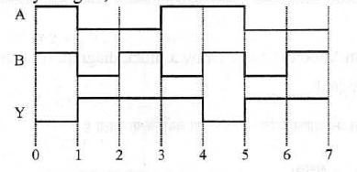

Q4:

Draw the logic symbol of the gate whose truth table is given below :

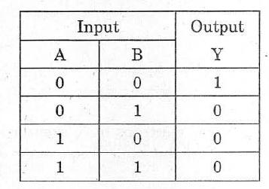

If this logic gate is connected to NOT gate, what will be the output when (i) A = 0, B = 0 and (ii) A = 1, B = 1 ? Draw the logic symbol of the combination.

Q5:

Draw the output wave form at X, using the given inputs A, B for the logic circuit shown below. Also identify the gate.

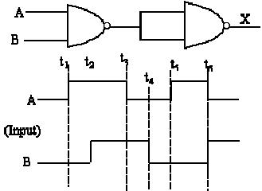

Q6:

With the help of a suitable diagram, explain the formation of depletion region in a p-n junction. How does its width change when the junction is (i) forward biased, and (ii) reverse biased ?

Q7:

Give a circuit diagram of a common emitter amplifier using an n-p-n transistor. Draw the input and output waveforms of the signal. Write the expression for its voltage gain.

Q8:

The figure below shows the V-I characteristic of a semiconductor diode

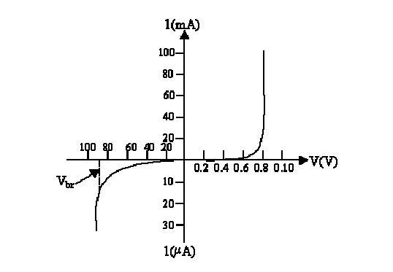 (i) Identify the semiconductor diode used.

(ii) Draw the circuit diagram to obtain the given characteristic of this device.

(iii) Briefly explain how this diode can be used as a voltage regulator

Q9:

(a) Explain the formation of depletion layer and potential barrier in a p—n junction.

(b) In the figure given below the input waveform is converted into the output waveform by a device ‘X’. Name the device and draw its circuit diagram.

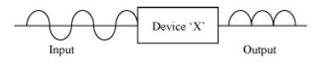

(c) Identify the logic gate represented by the circuit as shown and write its truth table.

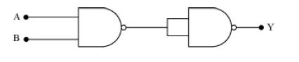

Q10:

(a) With the help of circuit diagram explain the working principle of a transistor amplifier as an oscillator.

(b) Distinguish between a conductor, a semiconductor and an insulator on the basis of energy band diagrams.

Q11:

(i) Draw a circuit diagram to study the input and output characteristics of an n-p-n transistor in its common emitter configuration. Draw the typical input and output characteristics.

(ii) Explain, with the help of a circuit diagram, the working of n-p-n transistor as a common emitter amplifier.

Q12:

How is a zener diode fabricated so as to make it a special purpose diode? Draw J-V characteristics of zener diode and explain the significance of breakdown voltage.

Explain briefly, with the help of a circuit diagram, how a p-n junction diode works as a half wave rectifier.

Q13:

(a) . Explain the formation of ’depletion layer ’ and barrier potential in a p-n junction.

(b) With the help of a labelled circuit diagram explain the use of a p-n junction diode as a full wave rectifier. Draw the input and output waveforms.

Q14:

Draw a circuit diagram of an n-p-n transistor with its emitter base junction forward biased and base collector junction reverse biased. Describe briefly its working. Explain how a transistor in active state exhibits a low resistance at its emitter base junction and high resistance at its base collector junction. Draw a circuit diagram and explain the operation of a transistor as a switch.

Q15:

Distinguish between an intrinsic semiconductor and P-type semiconductor. Give reason, why a P-type semiconductor crystal is electrically neutral, although nh >> ne ?

# Basic Communication Engineering

## Physics (Theory) - Communication Systems

##### Time allowed : 1.5 Hrs________________________ Maximum Marks : 32

##### Instructions

1. Please check that this question paper contains 2 printed pages.

2. Please check that this question paper contains 15 questions.

3. 15 minutes time has been allotted to read this question paper. The student will read the question paper only and will not write any answer on the answer script during this period.

#### A. General Instructions :

1. All questions are compulsory.

2. There are 15 questions in total. Questions 1 to 2 carry one mark each, questions 3 to 11 carry two marks each, and questions 12 to 15 carry three marks each .

3. Use of calculators is not permitted.

4. You may use the following values of physical constants wherever necessary:

c = 3  108ms-1

h = 6  626  10-34Js

e = 1  602  10-19C

o = 4  10-7TmA-1

pϵo" > = 9  109Nm2C-2

Mass of electron me = 9·1  10-31kg

Mass of neutron mn~=" class="cong" >1·675x10-27kg

Boltzmann’s constant k = 1  381  10-23JK-1

Avogadro’s number NA = 6  022  1023∕mol-1

Radius of earth = 6400 km

________________________________________________________________________________________________________________________________________

Q1:

Which part of electromagnetic spectrum is used in radar systems?

Q2:

What is sky wave propagation?

Q3:

Explain the function of a repeater in a communication system.

Q4:

What is the range of frequencies used in satellite communication? What is common between these waves and light waves?

Q5:

By what percentage wi ll the transmission range of a TV tower be affected when the height of the tower is increased by 21 % ?

Q6:

Why are high frequency carrier waves used for transmission ?

Q7:

What is meant by tenn ’ modulation’ ? Draw a block diagram of a simple modulator for obtaining an AM signal.

Q8:

(i) What is line of sight communication?

(ii) Why is it not possible to use sky wave propagation for transmission of TV signals?

Q9:

Write the function of (i) Transducer and (ii) Repeater in the context of communication system.

Q10:

Write two factors justifying the need of modulation for transmission of a signal.

Q11:

A transmitting antenna at the top of a tower has a height of 36 m and the height of the receiving antenna is 49 m. What is the maximum distance between them, for satisfactory communication in the LOS mode? (Radius of earth = 6400 km)

Q12:

What is space wave propagation? Give two examples of communication system which use space wave mode. A TV tower is 80 m tall. Calculate the maximum distance upto which the signal transmitted from the tower can be received.

Q13:

What is meant by detection of a signal in a communication system ? With the help of a block diagram explain the detection of A.M. signal.

Q14:

Distinguish between sky wave and space wave propagation. Give a brief description with the help of suitable diagrams indicating how these waves are propagated.

Q15:

Draw a plot of the variation of amplitude versus w for an amplitude modulated wave. Define modulation index. State its importance for effective amplitude modulation.