Hypertext Kinematics

Rajat Kalia

18 April , 2018
764 41-A , Chd
Table of Contents
Preface Chapter:
Acknowledgements Chapter:
Kinematics Part I:
Abstract Introduction Chapter 1:
Displacement-Time Graph Section 1.1:
Velocity-time graph Section 1.2:
Acceleration-time graph Section 1.3:
One More Go in a different perspective Section 1.4:
Distance-Time Graphs Subsection 1.4.1:
Displacement-time graphs Subsection 1.4.2:
Velocity-time graphs Subsection 1.4.3:
Acceleration-time graphs Subsection 1.4.4:
Self-Test Questions Subsection 1.4.5:
Revision Section 1.5:
Position vs. Time Graphs Subsection 1.5.1:
Average Velocity Subsection 1.5.2:
Average Speed Subsection 1.5.3:
Curved Position vs. Time Graphs Subsection 1.5.4:
Calculating Displacement Subsection 1.5.5:
Curved Velocity vs. Time Graphs Subsection 1.5.6:
Acceleration vs. Time Graphs Subsection 1.5.7:
Calculating Change in Velocity Subsection 1.5.8:
Exercises Section 1.6:
Problems on Position-Time Graph Subsection 1.6.1:
Subjectives Subsubsection 1.6.1.1:
Problems on Velocity-Time Graph Subsection 1.6.2:
Subjective Subsubsection 1.6.2.1:
Miscelleneous Subsubsection 1.6.2.2:
Problems on Area Under v-t graph Subsection 1.6.3:
Problems on Average Velocity Subsection 1.6.4:
Few Basic Problems Chapter 2:
Exercises Section 2.1:
Classical Approach Chapter 3:
The Equations of motion and the origin of Graph Handling Section 3.1:
The First Equation Subsection 3.1.1:
The Second Equation Subsection 3.1.2:
The Acceleration-Position Graph Variate Subsection 3.1.3:
Sign of Acceleration from Position-Time Graph Subsection 3.1.4:
The Average-Velocity / Instantaneous Velocity , Equal Case Subsection 3.1.5:
The Velocity-Displacement Case Subsection 3.1.6:
Motion Under Free Fall due to Gravity Subsection 3.1.7:
Projectile Motion Subsection 3.1.8:
Miscelleneous Subsection 3.1.9:
Question Types Section 3.2:
Passage Type Subsection 3.2.1:
Matching Subsection 3.2.2:
Previous Years IIT Problems Section 3.3:
Exercises Chapter 4:
Review Exercise I Section 4.1:
Review Exercise II Section 4.2:
Newton’s Equations of Motion Part II:
Derivation of Newton’s Equations of Motion from basic forms and graphs Chapter 5:
Newton’s first equation of motion Section 5.1:
Basic Derivation (without use of calculus or graphs) Subsection 5.1.1:
Derivation from v-t graph(Scalar form) Subsection 5.1.2:
Calculus Derivation(to be used in our class) Subsection 5.1.3:
Newton’s second equation of motion Section 5.2:
Basic Derivation (without use of calculus or graphs) Subsection 5.2.1:
Derivation from v-t graph(Scalar form) Subsection 5.2.2:
Calculus Derivation(to be used in our class) Subsection 5.2.3:
SectioNewton’s third equation of motion n 5.3:
Basic Derivation (without use of calculus or graphs) Subsection 5.3.1:
Derivation from v-t graph(Scalar form) Subsection 5.3.2:
Derivation(to be used in our class) Subsection 5.3.3:
Crossing the River problems (Theory) Chapter 6:
2D Projectile Motion Chapter 7:
Projection at an angle to the Horizontal Section 7.1:
Horizontal Projection (Corollary) Section 7.2:
Projection on Inclined Plane Section 7.3:
Index

Preface
This book contains content on the topic Kinematics .

Acknowledgements
I would like to thank my son Manas for his love and support. Moreover , to my father for the day to day needs.

Part I.Kinematics

1Abstract Introduction
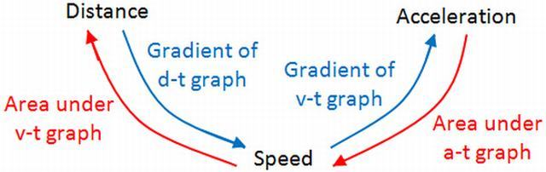
Figure : Graphical Representation of what we are going to learn in this chapter.
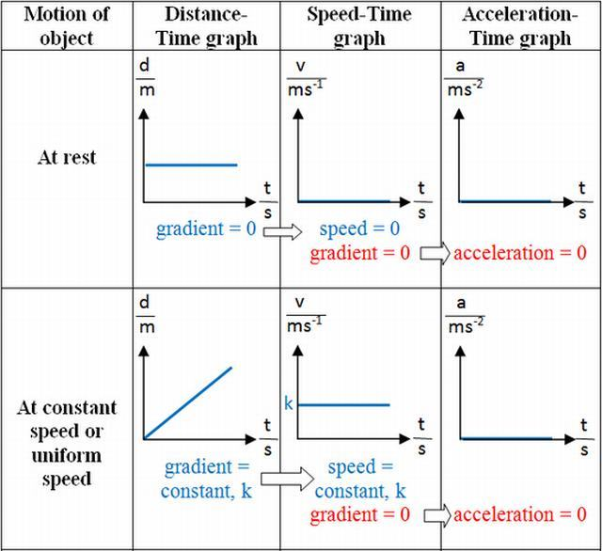
Figure : Some Graphs
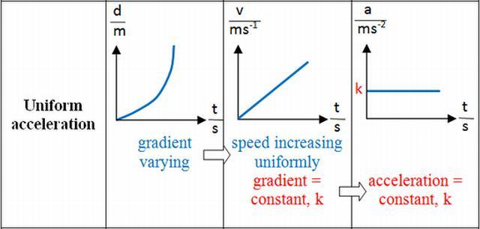
Figure : Few more graphs
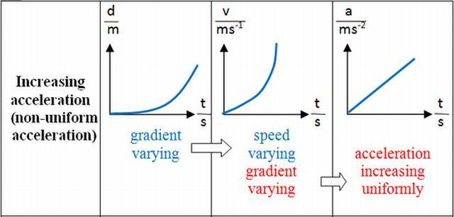
Figure : Few more
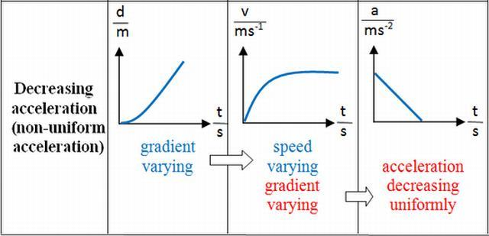
Figure : Just last in this category.
If we have a high velocity, the graph has a steep slope. If we have a low velocity the graph has a shallow slope (assuming the vertical and horizontal scale of each graph is the same).
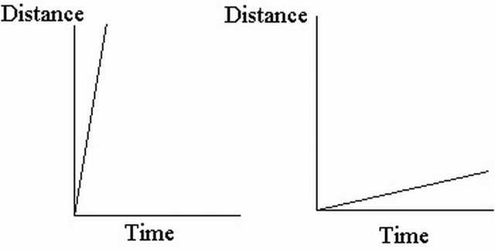
Figure : Graph comparision of high speed vs low speed. [ It may be noted that in Distance-Time Graphs , the slope is Speed (Distance and corresponding Speed both being Scalars), while in Displacement-Time Graphs, the slope is velocity(Displacement and corresponding Velocity both being Vectors).]
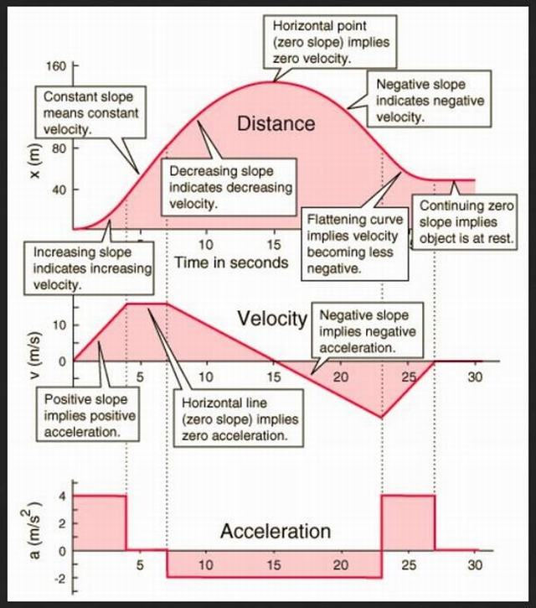
Figure : Graphical representation of the paradigms of this chapter.

1.1Displacement-Time Graph
A displacement-time graph shows the positions of a moving object at different times. Fig. shows the displacement-time graph of a car. From time t = 0 to t = 5s , the car moves forward, and at t = 5s it has a displacement of 60 m. Then it remains stationary there for 5 s, and finally moves back to its starting position in another 5 s.[3]
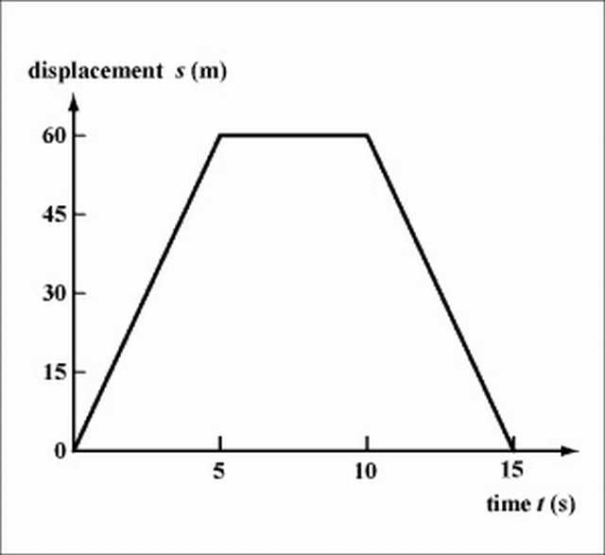
Figure : Displacement-Time Graph of the problem being discussed.
The velocity of motion can be determined from the slope of the displacement-time graph. The velocity of the car is (60)/(5) = 12m ⁄ s from t=0 to t=5s , it is zero (the car is at rest) from t=5s to t=10s and is (0-60)/(15-10) from t=10s to t=15s. The negative slope in the last 5 s indicates that the car is moving backwards. Note that the slope of the graph in each of the time intervals is a constant, showing that the car is in a uniform motion (constant velocity) in each interval.
Question: An object starts from rest and undergoes a positive, constant acceleration for ten seconds, it then continues on with constant velocity. Which of the following graphs correctly describes the situation?
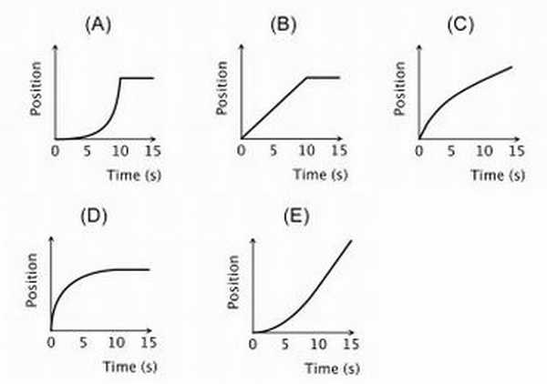
[4]

1.2Velocity-time graph
A velocity-time graph shows the velocities of a moving object at different times. Figure. shows three velocity-time graphs.[3]
Fig. (a) represents motion at a constant velocity, the acceleration is zero and thus the slope of the graph is zero. Fig. represents a uniform acceleration given by
a = (v − u)/(t) = (6 − 0)/(15) = 0.4ms ⁻ ²
,
This is represented by the slope of the velocity-time graph. Fig. represents a uniform deceleration given by ,
a = (v − u)/(t) = (0 − 4)/(15) ≈ − 0.27ms ⁻ ²
which is also represented by the slope of the graph. The negative slope indicates that the object decelerates. Note that the steeper the slope, the larger is the magnitude of the acceleration.
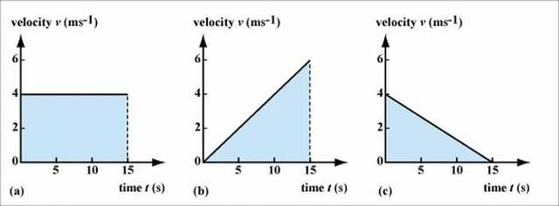
Fig. For the uniform motion shown in Fig. (a), the displacement is given by velocity × time = 4 × 15 = 60 . This is represented by the area of the rectangle under the graph. In fact, for any velocity-time graph, the displacement at a certain time can be calculated from the area under the graph. Following this rule, we can work out the displacement for an object in uniform acceleration or deceleration. For Fig. (b) , the displacement is6 × 15 ⁄ 2 = 45m , while for Fig. (c), the displacement is 4 × 15 ⁄ 2 = 30m
Fig. shows the velocity-time graph of an elevator moving upwards. The elevator is initially at rest on the ground floor. It accelerates from rest for 2.5 s, reaching a velocity of 1ms ⁻ ¹, then it moves at this constant velocity for 5 s, and finally decelerates to rest in 2.5 s.
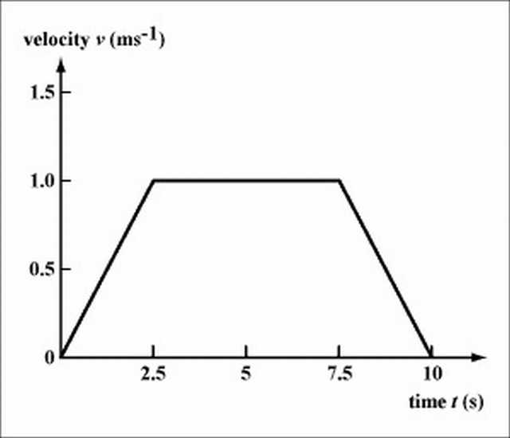
The acceleration of the elevator at each time interval can be deduced from the slope of the graph. In the first 2.5 s, the elevator accelerates at 1/2.5=0.4ms ⁻ ² . The acceleration is zero for the next 5 s, and in the last 5 s the elevator decelerates at(0-1)/(10-7.5)=-0.4ms ⁻ ² to rest (the negative slope indicates a deceleration). Note that for the whole trip, the elevator is going upwards.
The total displacement can be calculated from the area under the graph. In this example, the total displacement of the elevator is the area of the trapezium under the graph, i.e., total displacement =(5+10) × 1/2=7.5m.

1.3Acceleration-time graph
Fig. An acceleration-time graph shows the accelerations of a moving object at different times. Fig. shows the acceleration-time graph constructed from the velocity-time graph in Fig. . It can be seen that during the first 2.5 s and the last 2.5 s, the elevator is moving with a constant acceleration and deceleration respectively, and in between it moves at a constant velocity (zero acceleration).
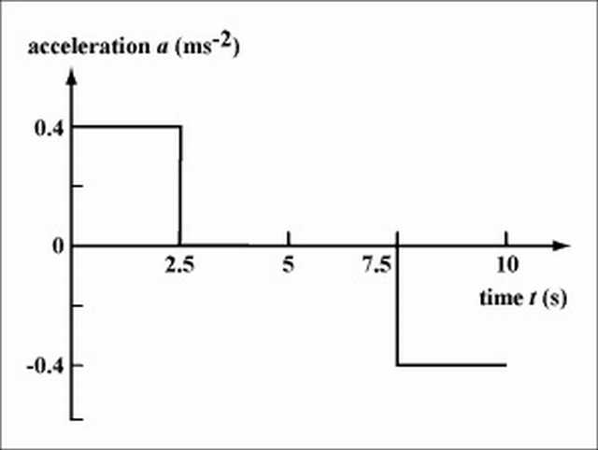
Question: Acceleration vs time graphs for five objects are shown below. All axis have the same scale. Which object has the greatest change in velocity during the interval?
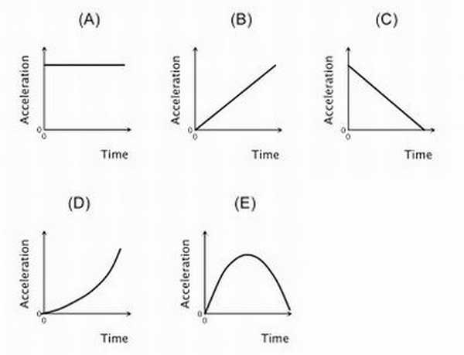
[4]

1.4One More Go in a different perspective

1.4.1Distance-Time Graphs
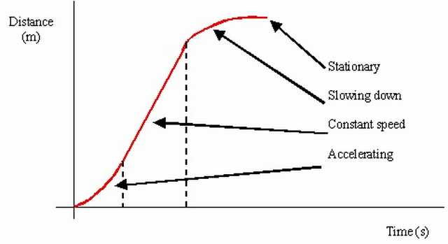
For a distance-time graph, the distance never decreases. When the object is stationary, the distance-time graph will be horizontal. The gradient of a distance-time graph is the instantaneous speed of the object. For straight line with positive gradient, it means that the object is travelling at uniform speed There is no straight line with negative gradient (as the distance never decreases) For curves, it means that the object is travelling at non-uniform speed [5]

1.4.2Displacement-time graphs
The details are similar as distance-time graphs, except that the distance is now displacement, and speed is now velocity. One minor difference: There is a straight line with negative gradient, it means that the object is travelling at uniform velocity in the opposite direction.[5]

1.4.3Velocity-time graphs
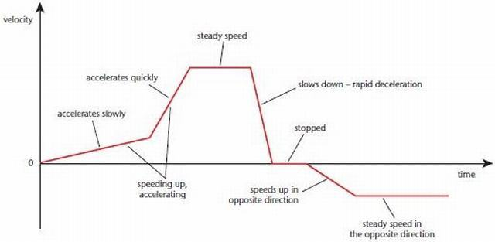
When the object is stationary, it is a straight horizontal line at 0. When the object is undergoing uniform motion, it is a straight horizontal line at vm s−1vm s−1, where v is the velocity of the object. For straight line with positive gradient, it means that the object is accelerating. For straight line with negative gradient, it means that the object is decelerating. For curves, it means that the acceleration of the object is changing. The area under the graph is the change in displacement of the object

1.4.4Acceleration-time graphs
Area under graph is the change in velocity [5]
The figure below shows the displacement-time graph, velocity-time graph and acceleration-time graph for the respective state of motion. It serves as a summary of the text above.
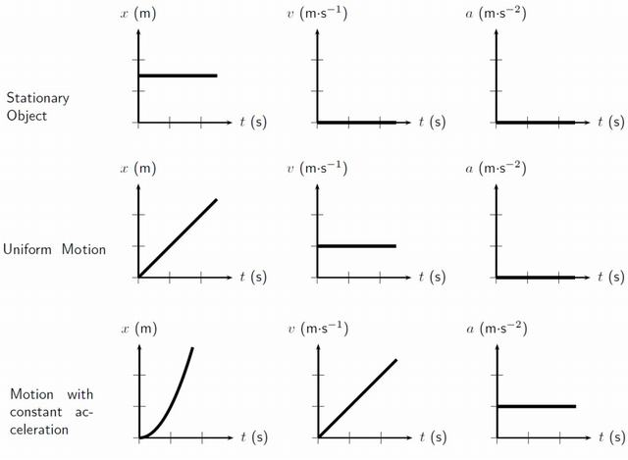
[6]

1.4.5Self-Test Questions [5]
Q Can you tell from a displacement-time graph whether an object is stationary?
Answer Yes. If the object is stationary, it will appear as a horizontal line on a displacement-time graph.
Q How can you obtain the average velocity and instantaneous velocity from a displacement-time graph.
Answer The average velocity can be found by using(total displacement)/(total time taken)
The instantaneous velocity at a point in time can be found from the gradient of the tangent to that point in time.
Q Can you tell from a velocity-time graph whether an object is stationary?
Answer Yes. If the object is stationary, the velocity-time graph will be a horizontal line at v=0.
QHow would you obtain the acceleration of an object from a velocity-time graph? What does the area under a velocity-time graph represent?
Answer The acceleration of an object at a point in time can be obtained from the gradient of the tangent to that point in time.
The area under a velocity-time graph represents the total distance traveled.
Q Can you tell from an acceleration-time graph whether an object is stationary?
Answer No, you cannot. Do you know why?

1.5Revision
Since you are not allowed to use calculators, SAT II Physics places a heavy emphasis on qualitative problems. A common way of testing kinematics qualitatively is to present you with a graph plotting position vs. time, velocity vs. time, or acceleration vs. time and to ask you questions about the motion of the object represented by the graph. Because SAT II Physics is entirely made up of multiple-choice questions, you won’t need to know how to draw graphs; you’ll just have to interpret the data presented in them. Knowing how to read such graphs quickly and accurately will not only help you solve problems of this sort, it will also help you visualize the often-abstract realm of kinematic equations. In the examples that follow, we will examine the movement of an ant running back and forth along a line.[6]
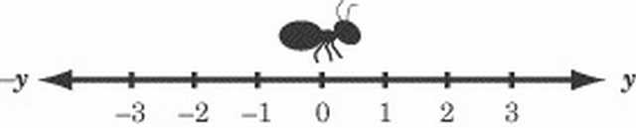

1.5.1Position vs. Time Graphs
Position vs. time graphs give you an easy and obvious way of determining an object’s displacement at any given time, and a subtler way of determining that object’s velocity at any given time. Let’s put these concepts into practice by looking at the following graph charting the movements of our friendly ant.[6]
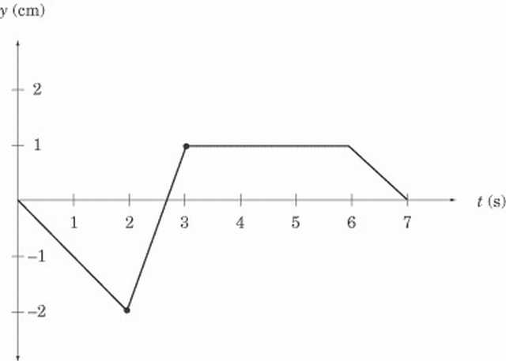
Any point on this graph gives us the position of the ant at a particular moment in time. For instance, the point at (2,–2) tells us that, two seconds after it started moving, the ant was two centimeters to the left of its starting position, and the point at (3,1) tells us that, three seconds after it started moving, the ant is one centimeter to the right of its starting position. Let’s read what the graph can tell us about the ant’s movements. For the first two seconds, the ant is moving to the left. Then, in the next second, it reverses its direction and moves quickly to y = 1. The ant then stays still at y = 1 for three seconds before it turns left again and moves back to where it started. Note how concisely the graph displays all this information. Calculating Velocity We know the ant’s displacement, and we know how long it takes to move from place to place. Armed with this information, we should also be able to determine the ant’s velocity, since velocity measures the rate of change of displacement over time. If displacement is given here by the vector y, then the velocity of the ant is
v = (△y)/(△t)
If you recall, the slope of a graph is a measure of rise over run; that is, the amount of change in the y direction divided by the amount of change in the x direction. In our graph, is the change in the y direction and is the change in the x direction, so v is a measure of the slope of the graph. For any position vs. time graph, the velocity at time t is equal to the slope of the line at t. In a graph made up of straight lines, like the one above, we can easily calculate the slope at each point on the graph, and hence know the instantaneous velocity at any given time. We can tell that the ant has a velocity of zero from t = 3 to t = 6, because the slope of the line at these points is zero. We can also tell that the ant is cruising along at the fastest speed between t = 2 and t = 3, because the position vs. time graph is steepest between these points. Calculating the ant’s average velocity during this time interval is a simple matter of dividing rise by run, as we’ve learned in math class.

1.5.2Average Velocity
velocity = (y_{final} − y_{initial})/(t_{final} − t_{initial})
= (1 − ( − 2) cm)/(3 − 2s)
=3 cm/s to the right
How about the average velocity between t = 0 and t = 3? It’s actually easier to sort this out with a graph in front of us, because it’s easy to see the displacement at t = 0 and t = 3, and so that we don’t confuse displacement and distance.

1.5.3Average Speed
Although the total displacement in the first three seconds is one centimeter to the right, the total distance traveled is two centimeters to the left, and then three centimeters to the right, for a grand total of five centimeters. Thus, the average speed is not the same as the average velocity of the ant. Once we’ve calculated the total distance traveled by the ant, though, calculating its average speed is not difficult:
5cm/3s = 1.67cm/s

1.5.4Curved Position vs. Time Graphs
This is all well and good, but how do you calculate the velocity of a curved position vs. time graph? Well, the bad news is that you’d need calculus. The good news is that SAT II Physics doesn’t expect you to use calculus, so if you are given a curved position vs. time graph, you will only be asked qualitative questions and won’t be expected to make any calculations. A few points on the graph will probably be labeled, and you will have to identify which point has the greatest or least velocity. Remember, the point with the greatest slope has the greatest velocity, and the point with the least slope has the least velocity. The turning points of the graph, the tops of the “hills” and the bottoms of the “valleys” where the slope is zero, have zero velocity.[6]
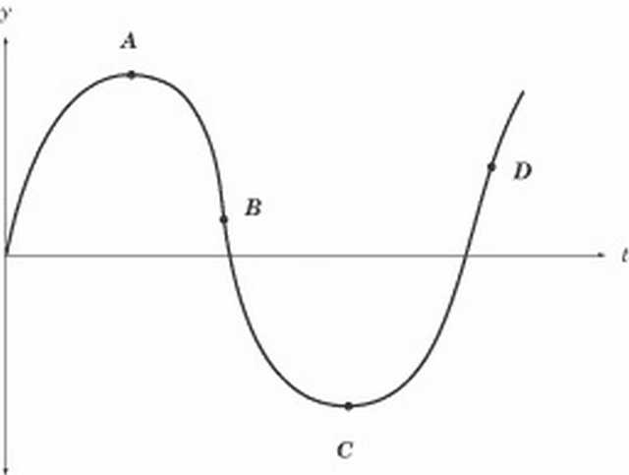
In this graph, for example, the velocity is zero at points A and C, greatest at point D, and smallest at point B. The velocity at point B is smallest because the slope at that point is negative. Because velocity is a vector quantity, the velocity at B would be a large negative number. However, the speed at B is greater even than the speed at D: speed is a scalar quantity, and so it is always positive. The slope at B is even steeper than at D, so the speed is greatest at B. Velocity vs. Time Graphs Velocity vs. time graphs are the most eloquent kind of graph we’ll be looking at here. They tell us very directly what the velocity of an object is at any given time, and they provide subtle means for determining both the position and acceleration of the same object over time. The “object” whose velocity is graphed below is our ever-industrious ant, a little later in the day.
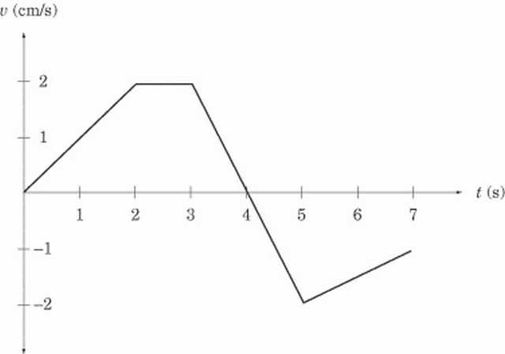
We can learn two things about the ant’s velocity by a quick glance at the graph. First, we can tell exactly how fast it is going at any given time. For instance, we can see that, two seconds after it started to move, the ant is moving at 2 cm/s. Second, we can tell in which direction the ant is moving. From t = 0 to t = 4, the velocity is positive, meaning that the ant is moving to the right. From t = 4 to t = 7, the velocity is negative, meaning that the ant is moving to the left. Calculating Acceleration We can calculate acceleration on a velocity vs. time graph in the same way that we calculate velocity on a position vs. time graph. Acceleration is the rate of change of the velocity vector, , which expresses itself as the slope of the velocity vs. time graph. For a velocity vs. time graph, the acceleration at time t is equal to the slope of the line at t. What is the acceleration of our ant at t = 2.5 and t = 4? Looking quickly at the graph, we see that the slope of the line at t = 2.5 is zero and hence the acceleration is likewise zero. The slope of the graph between t = 3 and t = 5 is constant, so we can calculate the acceleration at t = 4 by calculating the average acceleration between t = 3 and t = 5:
velocity = (y_{final} − y_{initial})/(t_{final} − t_{initial})
=( − 2 − (2) cm ⁄ s)/(5 − 3 s)
= -2 cm/s²
The minus sign tells us that acceleration is in the leftward direction, since we’ve defined the y-coordinates in such a way that right is positive and left is negative. At t = 3, the ant is moving to the right at 2 cm/s, so a leftward acceleration means that the ant begins to slow down. Looking at the graph, we can see that the ant comes to a stop at t = 4, and then begins accelerating to the right. [6]

1.5.5Calculating Displacement
Velocity vs. time graphs can also tell us about an object’s displacement. Because velocity is a measure of displacement over time, we can infer that:
displacement = velocity × time
Graphically, this means that the displacement in a given time interval is equal to the area under the graph during that same time interval. If the graph is above the t-axis, then the positive displacement is the area between the graph and the t-axis. If the graph is below the t-axis, then the displacement is negative, and is the area between the graph and the t-axis. Let’s look at two examples to make this rule clearer. First, what is the ant’s displacement between t = 2 and t = 3? Because the velocity is constant during this time interval, the area between the graph and the t-axis is a rectangle of width 1 and height 2.
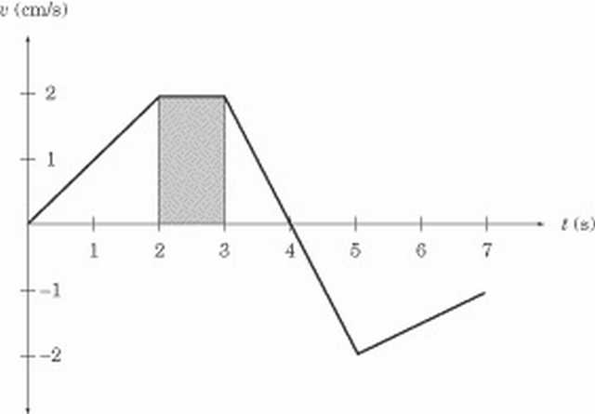
The displacement between t = 2 and t = 3 is the area of this rectangle, which is 2 cm/s.1s = 2 cm to the right. Next, consider the ant’s displacement between t = 3 and t = 5. This portion of the graph gives us two triangles, one above the t-axis and one below the t-axis.
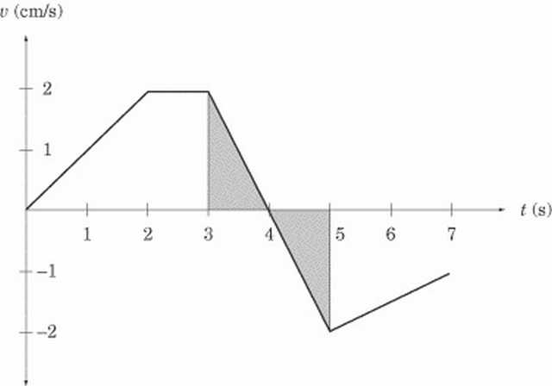
Both triangles have an area of 1 /2(1 s)(2 cm/s) = 1 cm. However, the first triangle is above the t-axis, meaning that displacement is positive, and hence to the right, while the second triangle is below the t-axis, meaning that displacement is negative, and hence to the left. The total displacement between t = 3 and t = 5 is ZERO.
In other words, at t = 5, the ant is in the same place as it was at t = 3. [6]

1.5.6Curved Velocity vs. Time Graphs
As with position vs. time graphs, velocity vs. time graphs may also be curved. Remember that regions with a steep slope indicate rapid acceleration or deceleration, regions with a gentle slope indicate small acceleration or deceleration, and the turning points have zero acceleration.

1.5.7Acceleration vs. Time Graphs
After looking at position vs. time graphs and velocity vs. time graphs, acceleration vs. time graphs should not be threatening. Let’s look at the acceleration of our ant at another point in its dizzy day.
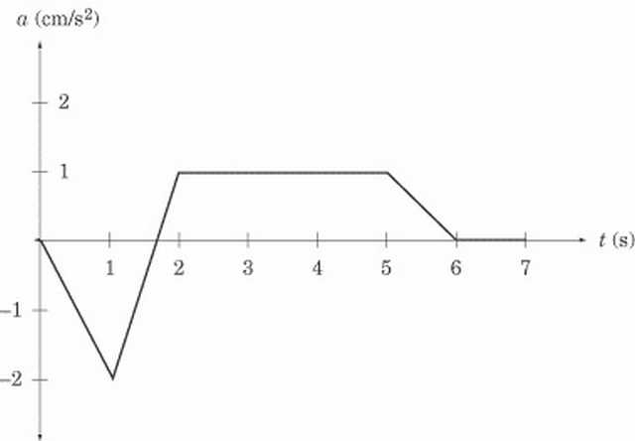
Acceleration vs. time graphs give us information about acceleration and about velocity. SAT II Physics generally sticks to problems that involve a constant acceleration. In this graph, the ant is accelerating at 1 m/s2 from t = 2 to t = 5 and is not accelerating between t = 6 and t = 7; that is, between t = 6 and t = 7 the ant’s velocity is constant.[6]

1.5.8Calculating Change in Velocity
Acceleration vs. time graphs tell us about an object’s velocity in the same way that velocity vs. time graphs tell us about an object’s displacement. The change in velocity in a given time interval is equal to the area under the graph during that same time interval. Be careful: the area between the graph and the t-axis gives the change in velocity, not the final velocity or average velocity over a given time period. What is the ant’s change in velocity between t = 2 and t = 5? Because the acceleration is constant during this time interval, the area between the graph and the t-axis is a rectangle of height 1 and length 3.[6]
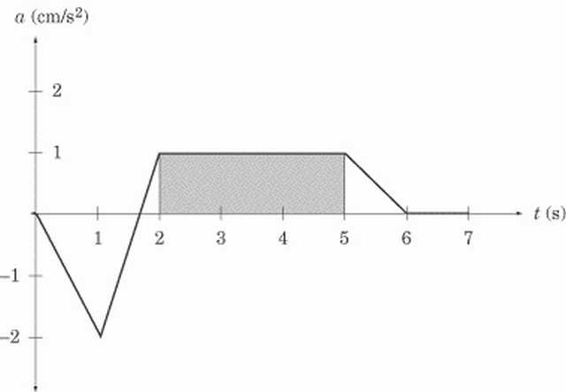
The area of the shaded region, and consequently the change in velocity during this time interval, is 1 cm/s2 · 3 s = 3 cm/s to the right. This doesn’t mean that the velocity at t = 5 is 3 cm/s; it simply means that the velocity is 3 cm/s greater than it was at t = 2. Since we have not been given the velocity at t = 2, we can’t immediately say what the velocity is at t = 5. Summary of Rules for Reading Graphs You may have trouble recalling when to look for the slope and when to look for the area under the graph. Here are a couple handy rules of thumb: The slope on a given graph is equivalent to the quantity we get by dividing the y-axis by the x-axis. For instance, the y-axis of a position vs. time graph gives us displacement, and the x-axis gives us time. Displacement divided by time gives us velocity, which is what the slope of a position vs. time graph represents. The area under a given graph is equivalent to the quantity we get by multiplying the x-axis and the y-axis. For instance, the y-axis of an acceleration vs. time graph gives us acceleration, and the x-axis gives us time. Acceleration multiplied by time gives us the change in velocity, which is what the area between the graph and the x-axis represents. We can summarize what we know about graphs in a table:
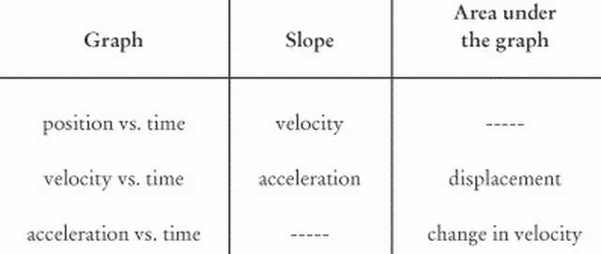

1.6Exercises

1.6.1Problems on Position-Time Graph

1.6.1.1Subjectives
Example : A boy walks at a velocity of 0.5 m/s along a street for 50 s, suddenly he remembers that he has to buy something in a shop that he has passed by, so he turns around and walks at a velocity of -1 m/s for 10 s. He then stops for 30 s at the shop, and finally walks forward again at 0.5 m/s for another 20 s. Plot a displacement-time graph for the motion of the boy.[3]
Solution : See Fig. 5-4.
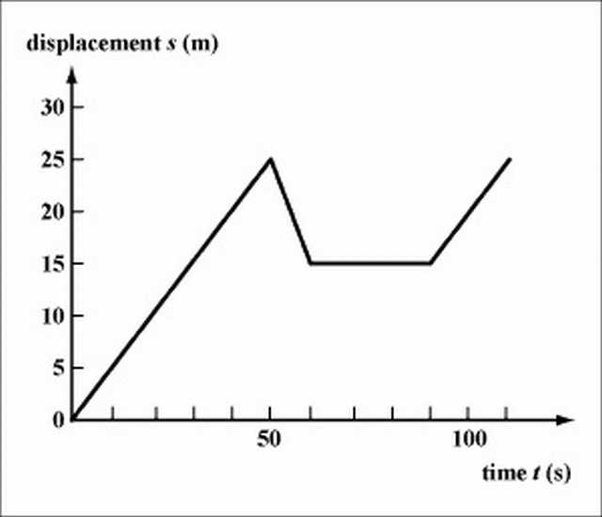
Example : A marathon runner runs at a constant 12 km/h.[1]
a. Express her displacement travelled as a function of time.
b. Graph the motion for 0≤t≤4h
Solution : a. s = 12t, for displacement s and time t.
b. Graph of s = 12t.
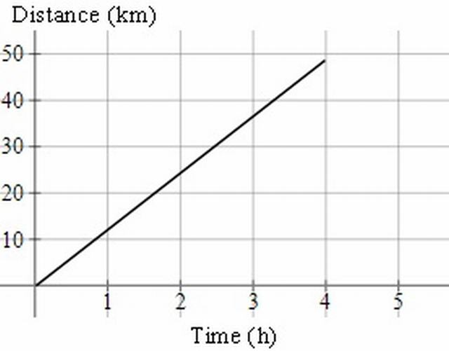
We stop the graph at (4, 48).
Example : This is the graph of a journey by sports car:[1]
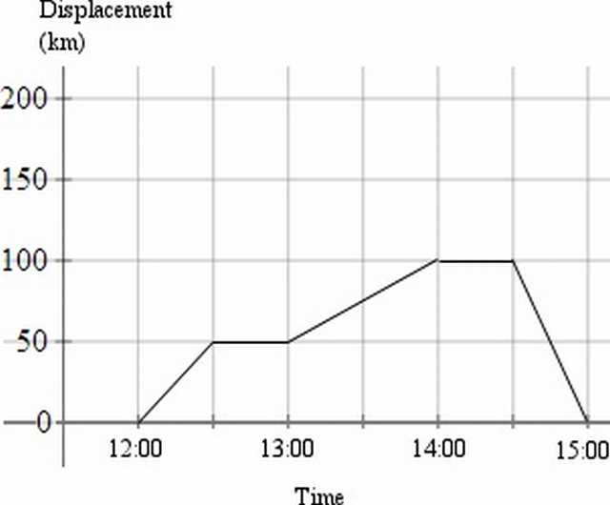
a. What is the velocity for each stage of the journey?
b. What is the average (mean) velocity for the whole journey?
Solution : a. This table outlines the stages of the journey.
12:00 to 12:30 | Travelled 50 km in30 minutes, so 100 km/h
12:30 to 13:00 | Stopped
13:00 to 14:00 | Travelled 50 km in 60 minutes, so 50 km/h
14:00 to 14:30 | Stopped
14:30 to 15:00 | Travelled 100 km back towards the starting point in 30 minutes, so −200 km/h
b. Even though the whole journey was 200 km (100 km out and 100 km back) in 3 hours, the displacement for the journey (the distance from the starting point) is 0km.
So the average velocity is 0 km/h.
On the other hand, the average speed was (200)/(3) = 66.7 km/h
In summary,
ave velocity = (displacement)/(time)
ave speed = (distance)/(time)
Example : A particle in a magnetic field moves as follows:[1]
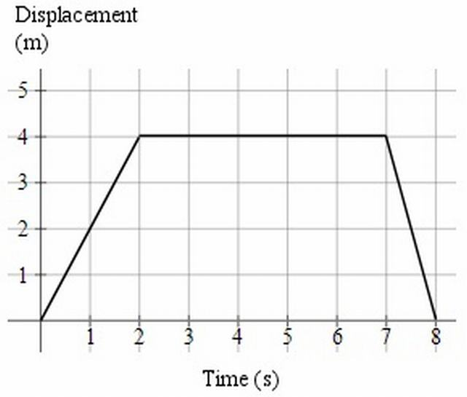
Find the velocity for each part of the motion.
Solution :
For t=0 to 2: (Δs)/(Δt) = (4)/(2) = 2 ms ⁻ ¹
For t=2 to 7: (Δs)/(Δt) = (0)/(5) = 0 ms ⁻ ¹
For t=7 to 8:(Δs)/(Δt) = ( − 4)/(2) = − 4 ms ⁻ ¹
(The velocity is negative, since the particle is going in the opposite direction.)
Example : An object’s position during a 10 second time interval is shown by the graph below:
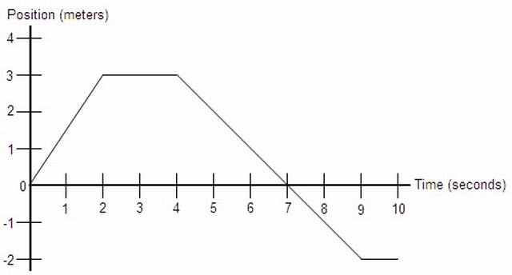
a.) Determine the object’s total distance traveled and displacement.
b.) What is the object’s velocity at the following times: t = 1, t = 3, and t = 6.
c.) Determine the object’s average velocity and average speed from t = 0 to t = 10.
d.) What is the object’s acceleration at t = 5?
Solution : a.) The total distance traveled by the object is the sum of all the distances it traveled during the time interval. In the first two seconds it traveled 3 m. Then it traveled 0 m in the next two seconds. Then over the next five seconds, the object moved 5 m, then remained at rest. so the total distance is 3 + 5 = 8 m. The displacement of the object is simply the final position minus the initial position, or -2 - 0 = -2 m.
b.) Notice that each of these points is in the middle of a line segment on the graph. Because of this, the instantaneous velocity at these points is the same as the average velocity over the time intervals represented by each segment, so: v(t) = (xf - xi)/(tf - ti) v(1) = (3 - 0)/(2 - 0) = 3/2 = 1.5 m/s v(3) = (3 - 3)/(4 - 2) = 0/2 = 0 m/s v(6) = (-2 - 3)/(9 - 4) = -5/5 = -1 m/s
Notice that the formula (xf - xi)/(tf - ti) is the same as the slope formula for this graph. The velocity at any point on a position vs. time graph is simply the slope of the graph at that point. By this definition, we also know that the velocity of any position function is its derivative with respect to time. You can also go from a velocity function to a position function using integration. Go to calculus notes
c.) Average velocity is displacement divided by time. We found in part a that the object’s displacement is -2 m, so: vavg = -2/10 = -0.2 m/s
Average speed is total distance divided be time, and we found in part a that the object’s total distance traveled is 8 m. so: 8/10 = 0.8 m/s
d.) We determined in part b that the object’s velocity is represented by the slope of the line segment on the graph. Since the slope of this segment is constant, the object’s velocity at t = 5 is constant. Since constant velocity means there is no acceleration, a = 0.

1.6.2Problems on Velocity-Time Graph

1.6.2.1Subjective
Example : Fig. shows the velocity-time graph of a train travelling from station 1 to station 2. The train moves along a straight railway.
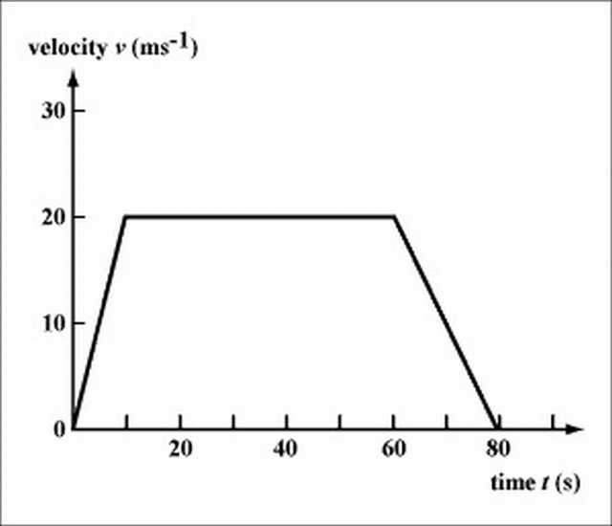
Describe the motion of the train, stating the acceleration and velocity in each stage. What is the displacement of station 2 from station 1?
Solution : From t=0 to t=10s , the train accelerates from v=0 to v=20m/s .
a=20/10=2 m s ⁻ ²
From t=10s to t=60s , the train moves at a constant velocity v=20m/s. a=0 .
From t=60s to t=80s , the train decelerates from v=20m/s back to v=0m/s .
a=(0-20)/(80-60)=-1m s ⁻ ²
Total displacement = the area under the velocity-time graph
s = ((80 + 50))/(2) × 20 = 1300m
Example : A car is initially moving at a velocity of 36 . Suddenly the driver sees a girl running across of the road at 13 m in front of the car. It takes 0.5 s for the driver to react and start braking the car. The car then takes one more second to stop. Plot the velocity-time graph for the car, starting from the time when the driver sees the girl. What is the deceleration of the car? Would the car hit the girl?
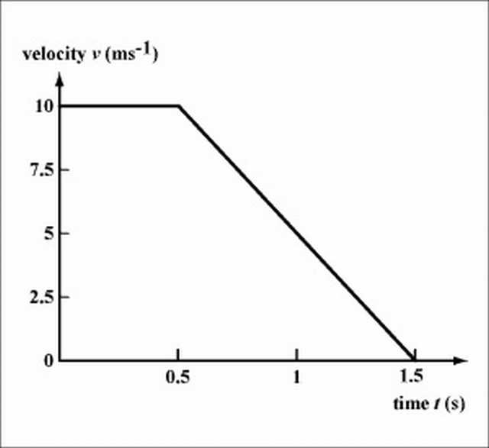
Solution : See Fig. . The car decelerates at 10 ms ⁻ ². It travels a total distance of (0.5+1.5)*10/2=10m , so it would not hit the girl, but stop at a distance of 3 m from the girl.
Note: The total distance travelled by the car after the driver seeing the danger is called the stopping distance. See the next chapter for more analysis on car braking.
Example ; Fig. shows the displacement-time graph of an object. Plot its velocity-time graph. Find the average velocity of the object.
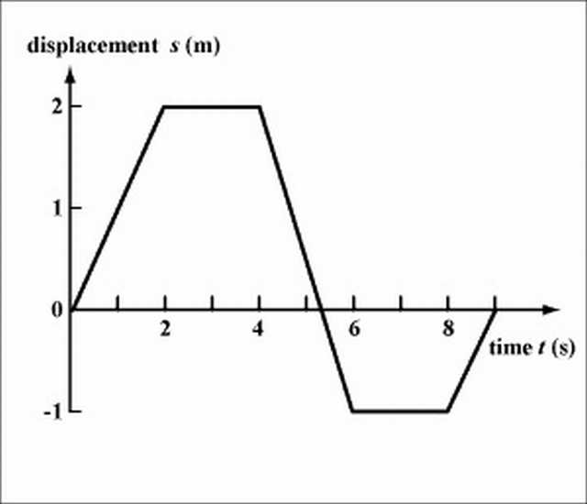
Solution : See Fig. .
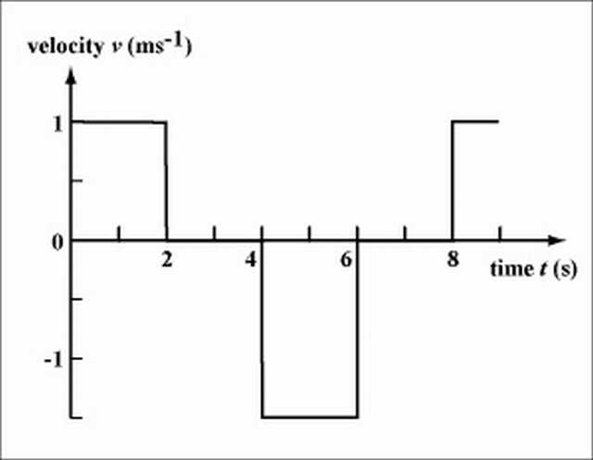
Since the total displacement of the object is zero, the average velocity is also zero.
Note: The object moves backwards from t=4s to t=6s . In this interval, the area bounded by the velocity-time graph is negative (i.e., the area is under the time axis), indicating that the object has a displacement in the opposite direction.
Example : A particle in a generator is accelerated from rest at the rate of 55 ms ⁻² .
a. What is the velocity at t=3 s?
b. What is the acceleration at t=3 s?
c. What is the distance travelled in 3 seconds?
d. Graph the acceleration (as a v - t graph) for 0 ≤ t ≤ 3 s0≤t≤3s.
Solution : a. Velocity =55×3=165 ms ⁻¹
b. The acceleration is a constant 55 ms ⁻² , so at t=3 s, the acceleration will be 55 ms⁻² .
c. The distance travelled in \displaystyle 3 seconds is 165×1.5=247.5 m. We obtain this from the area under the line between 0 and 3 (i.e. the area of the shaded triangle below).
d. Note in the graph that we have velocity on the vertical axis, and the units are m/s.
The graph finishes at (3, 165).
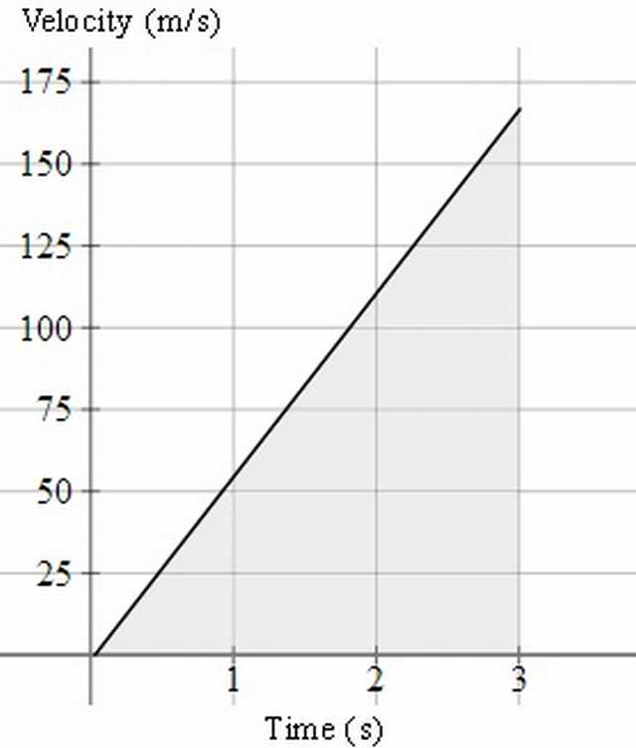
Example : A girl starts from rest and travels along a straight line. The diagram below shows the velocity-time graph of the girl from 0 s to 90 s.
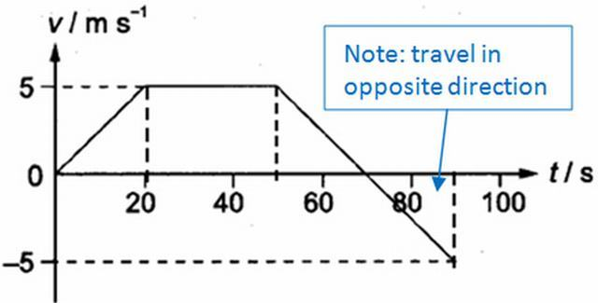
(a) Describe the motion of the girl from 0 s to 40 s.
(b) Find the average velocity of the girl in the first 70 s.
(c) Draw the acceleration-time graph of the girl from 0 s to 90 s.
(d) Find the displacement of the girl from the starting point to the position at 90 s.
Solution : (a) From 0 s to 20 s, she travels with constant acceleration of 0.25 ms^(-2); From 20 s to 40 s, she travels at constant velocity of 5 m/s.
(b) Total displacement = area under v-t graph = ½ (30 + 70) * 5 = 250 m Average velocity = 250/70 = 3.57 m/s
(c) Acceleration is the gradient of v-t graph.
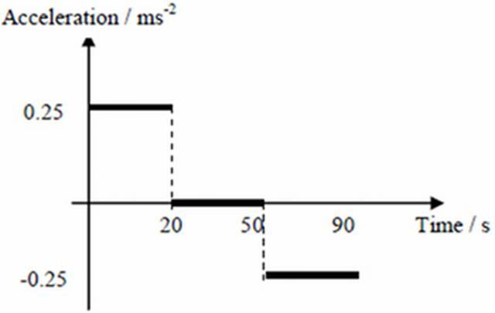
(d) Displacement = area under v-t graph = 250 – ½ * 20 * 5 = 200 m
Tips: (1) It is very easy to mix up kinematics graphs. The only way to differentiate these graphs is to look at the y-axis!
(2) When describing the motion, do it region by region! And always talk about acceleration or speed / velocity with values if applicable. Refer to example above.
Example : Two sport cars start from rest at the same place. One of them, colored red, accelerates at 0.90 ms ⁻² for 15 s, and continues at constant speed thereafter. The other car, colored blue, accelerates at 0.85ms ⁻² for 20 s and then remains at that speed.
Draw both journeys on the same velocity-time graph and determine the time and distance that the second car overtakes the first car.
Solution :
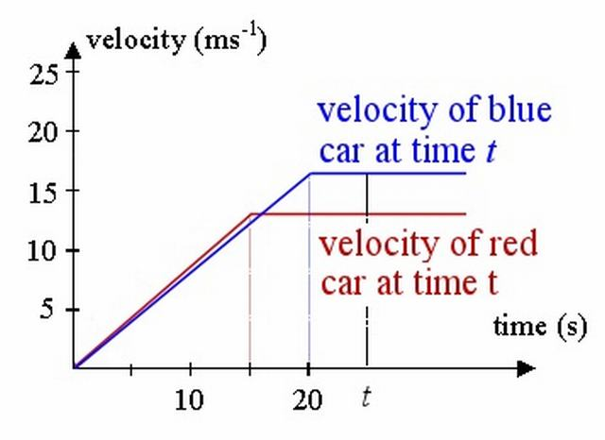
The velocities they reach are 0.9 × 15 = 13.5 ms-1 and 0.85 × 20 = 17 ms-1 respectively.
Similar to the problem above, we have:
First car’s (red) distance at time t is found by finding the area of the trapezoid whose boundary is the t-axis, the red lines and the vertical line representing time at t seconds. This of course assumes t>15 (otherwise, we have negative distances, and the trapezoid only starts at t=15.)
So the distance (at time t) = (1)/(2) × 13.5(t + t − 15)
= The distance of the second car (blue) is found by finding the area of the blue trapezoid, bounded by the blue lines, the t-axis and the vertical line. (And this one assumes t>20, for the same reasons as above.)
So the distance (at time t) = (1)/(2) × 17(t + t − 20)
The distance when they meet is the same, so:
(1)/(2) × 13.5 × (2t − 15)=(1)/(2) × 17 × (2t − 20)
Solving gives:
Time =19.643 s
Distance=163.93 m
Dilemma
However, this solution gives us a dilemma. As mentioned above, the expressions we found for the area of the trapezoids required t to be more than 15 s and 20 s, respectively.
We can confirm the blue car overtakes the red car before 20 seconds, by calculating the distances travelled at that time.
After 20 seconds:
Red car has travelled 0.5×(20+5)×13.5=168.75 m
Blue car has travelled 0.5×20×17=170 m The blue car has travelled further than the red car, so it means it has already overtaken the red car.
Back to the drawing board
So, in fact, for this question we need to consider the area of the blue triangle, not the blue trapezoid.
This is the correct diagram for finding t:
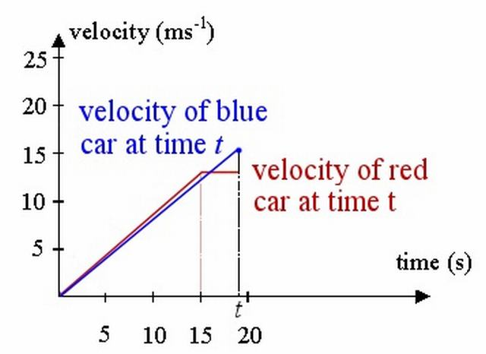
The red car’s distance is fine from before (it’s a trapezoid):
d = (1)/(2) × 13.5(t + t − 15)
But the blue car’s distance at t is the area of the triangle (not trapezoid) bounded by the blue line and the vertical line at t (we are taking (1)/(2) base times height):
distance = (1)/(2) × t × 0.85 × t
Equating these gives:
6.75(2t − 15) = 0.425t²
Solving gives:
t =12.14 s, t = 19.63 s
The first solution has no practical meaning, since t>15 for the expression to work.
So we conclude the time taken for the blue car to overtake the red car is 19.63 s and the distance travelled at that time is 163.7 m.
Further Information
To illustrate we have found the correct answer, below is the graph of distance against time. Labelling of axes is very important in this work!
The red curve corresponds to the acceleration portion of the first race car. At t=15, or point C(15,101.25), the red car stops accelerating and continues at a constant speed (CA is no longer a curve, but a straight line).
The blue curve corresponds to the second (blue) car. It doesn’t accelerate as hard (its curve is below the red curve, indicating it covers less distance in the same time), but it accelerates for longer. At t=20, or point D (20,170), it stops accelerating and its graph is now a straight line.
We can see the curves intersect at time t=19.63 s, or point A (19.63,163.7), as we found in the calculation above. This means they have covered the same distance (163.7 m) at that time, so that’s when the blue car passes the red car.
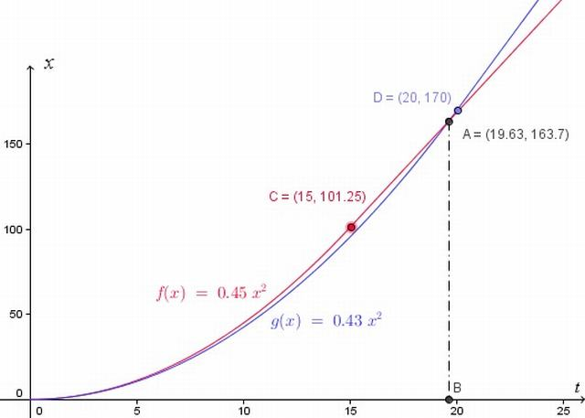

1.6.2.2Miscelleneous
Example : You drive a car in such a way that its motion is described by the velocity-time graph shown here. Draw the displacement-time and acceleration-time graphs that correspond to this motion, and describe in words how the car moves.[2]
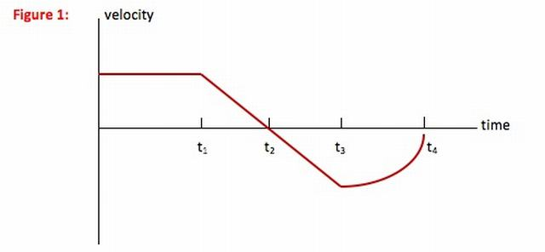
Solution : (Hint : In this problem, you are asked to describe the motion of the car. Whenever you are asked to describe the motion of an object without worrying about the cause of that motion, you have a kinematics problem. This problem is different from most kinematics problems, however, in that you are not asked for a numerical description but rather to use words and graphs to describe how the car moves.)
(Queries : How did you know that x = 0 at t = 0?
You don’t! If you are given a velocity-time graph, you know the initial speed but not the initial location of the object. (Calculus students, remember v = dx/dt, and the derivative of a constant—your initial location—is zero.) I chose to call the location of the car at t = 0 the origin, but you could start your graph at any point. The shape of the graph, however, should look the same.
Why can’t I treat the straight line from t1 to t3 in a single step?
Any time velocity is above the t-axis, it has a positive value and so slope of the x-t graph is also positive. A positive slope means that the line or curve is in such a direction as to make between a 0 and a 900 angle above the +x axis. Any time velocity is below the t-axis, it has a negative value and so the slope of the x-t graph is also negative. A negative slope means that the line or curve is in such a direction as to make between a 0 and a 900 angle below the +x axis.
Why doesn’t the line from t3 to t4 look more curved?
As the velocity-time curve gets closer and closer to v = 0 (the t-axis), velocity’s value is getting smaller regardless of direction. As the value of v decreases, so does the slope of the x-t graph. A decreasing slope means that the slope gets smaller and smaller—the line gets becomes more horizontal.
The curve from t3 to t4 on the x-t graph shown here doesn’t look very curved. This is because its slope goes from the same value as it ended with on the t2 to t3 curve to almost zero (a horizontal line) and so not a lot of change as I have drawn it. Any line you draw that curves down and to the right becoming more horizontal as it goes is fine.)
Select a relation
To go between a velocity-time graph and a displacement-time or acceleration-time graph, you need to understand how velocity, displacement and acceleration are related to each other. In other words, you need to use the definitions of velocity and acceleration:
v = Δx/Δt In words, the value of velocity = the slope of the x-t graph.
a = Δv/Δt In words, the value of acceleration = the slope of the v-t graph.
Hint: Graphing problems seem like they should be straightforward, and the equations that you need are only those given above. It is very, very common, however, to make mistakes on these problems because it feels like the graphs should be pictures of the motion and they are not. In order to avoid those mistakes, make a table based on the sentences above and then draw the graph from the table.
Displacement-Time Graph
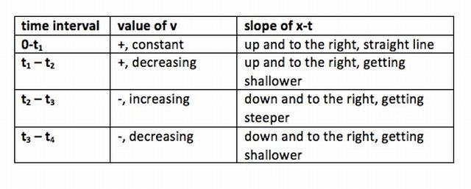
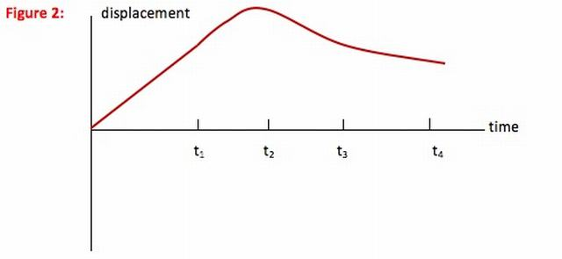
Once you understand the displacement-time graph, continue down to the acceleration-time graph.
Acceleration-time Graph
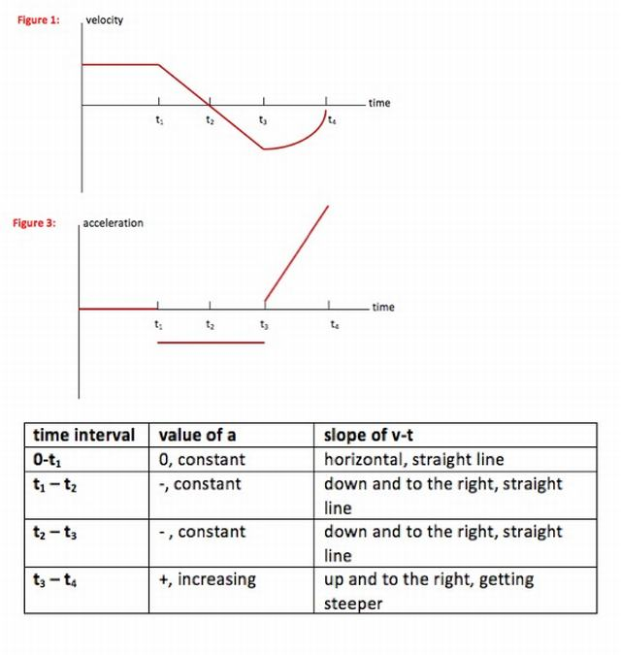
Understand
In this problem, you are given the velocity-time graph for the motion of a car. By relating the value of velocity to the slope of the x-t graph (this is just the definition of velocity) you are able to draw the x-t graph corresponding to this motion.
By relating the slope of the v-t graph to the value of acceleration (this is just the definition of acceleration) you are able to draw the a-t graph corresponding to this motion.
You can describe the motion looking at any of the three graphs. From t = 0 to t1 : The car travels forward (+ direction) with a constant speed. There is no acceleration and the car moves away from its starting point at a constant rate.
From t1 to t2 : The car slows to a stop at a constant rate. It is still moving forward, but the amount of distance it covers in each second is decreasing. Acceleration acts against the motion of the car, or in the negative direction.
From t2 to t3 : The car reverses direction, moving faster and faster (at a constant acceleration) in the negative direction. Acceleration is acting with the motion of the car, so it is also in the negative direction. The amount of distance the car covers each second increases.
From t3 to t4 : The car continues to move in the negative direction but at a decreasing speed. The rate at which the speed decreases is getting greater—the driver is braking harder as the car stops—and so acceleration increases. Acceleration is acting against the motion of the car, or in the positive direction. The car covers less and less distance each second.

1.6.3Problems on Area Under v-t graph
Example : A charged particle in an accelerator starts from rest, accelerates at 1.5 ms ⁻² for3 s and then continues at a steady speed for a further 6 s.
Draw the v-t graph and find the total distance travelled.
Solution:
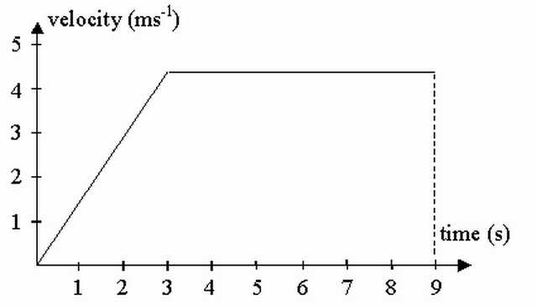
Total distance travelled is the area under the graph (in this case we need to find the area of a trapezium).
distance = ((a + b)h)/(2)
= ((9 + 6) × 4.5)/(2)
=33.75 m
Example : A car is travelling at a constant speed of 72 km/h and passes a stationary police car. The police car immediately gives chase, accelerating uniformly to reach a speed of 90 km/h in 10 s and continues at this speed until he overtakes the other car. Find:
(a) the time taken by the police to catch up with the car,
(b) the distance travelled by the police car when this happens.
Solution :
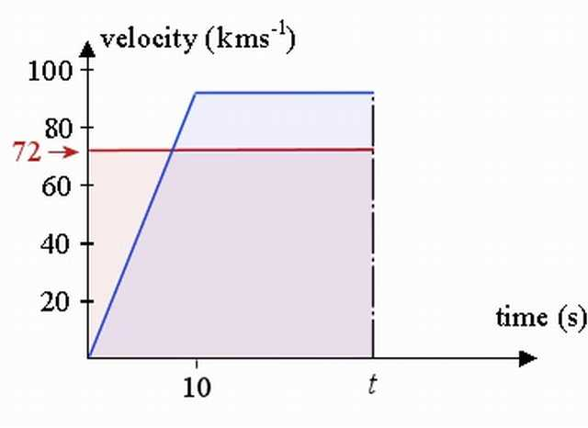
The v-t curve for the car is represented by the red line, while that v-t curve for the police car is the blue line.
We need to find the unknown time t (in seconds), when the police catch up to the car. We find this by comparing the distance travelled by each (it will be the same distance at the overtaking point.) So we need to set the area under the v-t curve for the car (the pink shaded area) to be equal to the area under the v-t curve for the police car (the blue shaded area).
a. The area under the curve for the car at time t (in seconds) is simply 72t. (It is a rectangle, 72 high and width t).
The area under the trapezium (trapezoid) for the police car at unknown time t, using A = (a + b)(h)/(2) is:
(t + t − 10) × (90)/(2)=45(2t − 10)
We set these equal to find the required time: 72t=45(2t−10) That is, when 72t=90t−450 So t=25 s will be the time the police car catches up.
b. Both of the cars have travelled 72 × ((25)/(3600)) × 1000 = 500 m during those 25 s.
[We have used d=s×t and converted from seconds to hours (since the velocities are given in km/h).]

1.6.4Problems on Average Velocity
Example : An object’s velocity during a 10 second time interval is shown by the graph below:
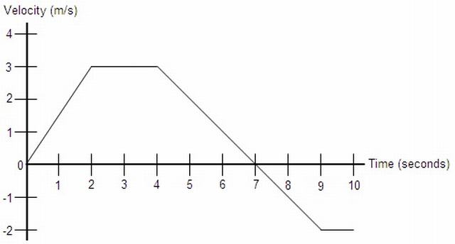
a.) Determine the object’s total distance traveled and displacement.
b.) At t = 0, the object’s position is x = 2 m. Find the object’s position at t = 2, t = 4, t = 7, and t = 10.
c.) What is the object’s acceleration at the following times: t = 1, t = 3, and t = 6.
d.) Sketch the corresponding acceleration vs. time graph from t = 0 to t = 10.
Solution : a.) Recall that the equation for velocity is v = x/t. If we solve this for x, we get x = vt. Notice that this is the same as the area of a rectangles whose sides are lengths v and t, so we can determine that the displacement is the area enclosed by the velocity vs. time graph. So, we will find the area of each section under the graph:
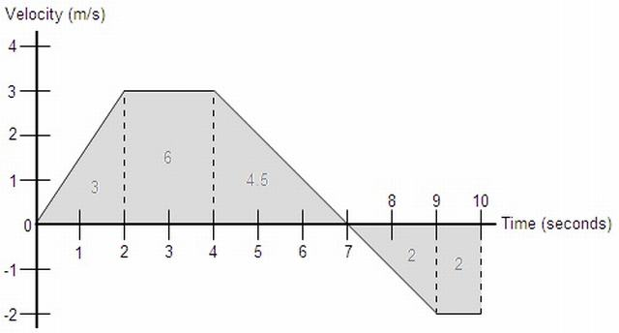
The total distance traveled by the object is simply the sum of all these areas: 3 + 6 + 4.5 + 2 + 2 = 17.5 m The displacement is found in a similar fashion, except areas below the x-axis are considered negative: 3 + 6 + 4.5 - 2 - 2 = 9.5 m Interestingly enough, the area enclosed by any function can be represented by a definite integral. For example, if this graph were defined as a function v(t), then the displacement would be the integral from 0 to 10 of v(t)dt, and the total distance traveled would be the integral from 0 to 10 of |v(t)|dt Go to calculus notes
b.) The position of the object at a given point in time can be found in much the same way we found the displacement in part a, except this time we must also add in the initial value given. So: x(2) = 2 + 3 = 5 m x(4) = 2 + 3 + 6 = 11 m x(7) = 2 + 3 + 6 + 4.5 = 15.5 m x(10) = 2 + 3 + 6 + 4.5 - 2 - 2 = 11.5 m
Notice that this can also be done by adding the integral from 0 to t of v(t)dt to the initial value of 2. Go to calculus notes
c.) Like velocity in part b of problem 22, the instantaneous acceleration at any point along one of the graph’s line segments is the same as the average acceleration across that line segment. The formula for acceleration is aavg = Δv/Δt = (vf - vi)/(tf - ti), so: a(t) = (vf - vi)/(tf - ti) a(1) = (3 - 0)/(2 - 0) = 3/2 = 1.5 m/s2 a(3) = (3 - 3)/(4 - 2) = 0/2 = 0 m/s2 a(6) = (-2 - 3)/(9 - 4) = -5/5 = -1 m/s2
Similarly to the relationship between velocity and position, the formula for acceleration is the same as the slope formula for a velocity vs. time graph. So, we can say that the slope of any velocity vs. time graph is its acceleration. Notice that this definition defines acceleration as the derivative of velocity. So, it is true that for any velocity function v(t), its derivative is an acceleration function a(t). Also, integration can be used to go from an acceleration function to a position function. Go to calculus notes
d.) We know that the acceleration along each line segment of this velocity vs. time graph is equal to the slope of the line segment. We determined these slopes in part c, so the acceleration graph would look like:
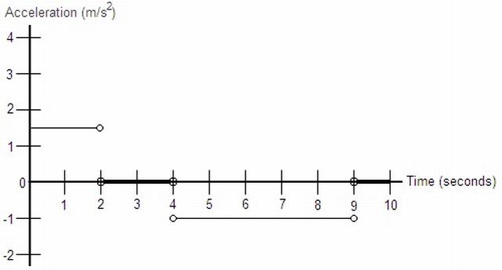
This graph uses horizontal lines instead of points to represent that the acceleration is defined at that value at any point along that section. The open circles at the end of each line segment simply indicate that at those time values, acceleration is not defined at either value represented by the horizontal lines. At these points, acceleration is undefined because it changes instantaneously from one value to the next, which cannot be represented numerically.

2Few Basic Problems
Problem Set 1
Use the following graph to answer Questions #1 - #7.
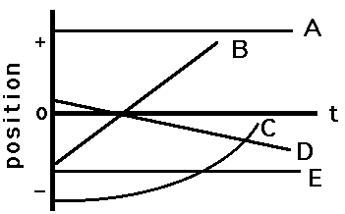
1. Which object(s) is(are) maintaining a state of motion (i.e., maintaining a constant velocity)?
Answer ; Objects A, B, D, and E.
Objects A, B, D, and E are maintaining a state of motion (i.e., remaining with constant velocity) as demonstrated by the constant slope. If the slope is constant, then the velocity is constant.
2. Which object(s) is(are) accelerating?
Answer : Object C
Object C is accelerating. An accelerating object has a changing velocity. Since the slope of a p-t graph equals the velocity, an accelerating object is represented by a changing slope.
3. Which object(s) is(are) not moving?
Answer : Objects A and E.
Objects A and E are not moving. An object which is not moving has a zero velocity; this translates into a line with zero slope on a p-t graph.
4. Which object(s) change(s) its direction?
Answer : None of the objects change direction.
None of these objects change direction. An object changes its direction if it changes from a + to a - velocity (or vice versa). This translates into a p-t graph with a + slope and then a - slope (or vice versa).
5. On average, which object is traveling fastest?
Answer : Object B.
Object B is traveling fastest. To be traveling fastest is to have the greatest speed (or greatest magnitude of velocity). This translates into the line on a p-t graph with the greatest slope.
6. On average, which moving object is traveling slowest?
Answer : Object D.
Object D is traveling slowest. To be traveling slowest is to have the smallest speed (or smallest magnitude of velocity). This translates into the line on a p-t graph with the smallest slope.
7. Which object has the greatest acceleration?
Answer ; Object C.
Object C has the greatest acceleration. It is the only object with an acceleration. Accelerated motion on a p-t graph is represented by a curved line.
Problem Set 2
Use the following graph to answer Questions #8 - #13.
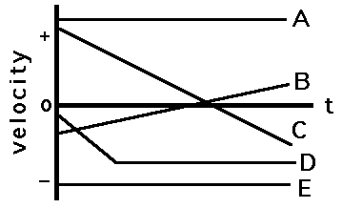
8. Which object(s) is(are) maintaining its state of motion?
Answer : Objects A and E.
Objects A and E are maintaining their state of motion. To maintain the state of motion is to keep a constant velocity (i.e., to have a zero acceleration). This translates into a zero slope on a v-t graph.
9. Which object(s) is(are) accelerating?
Answer : Objects B and C (and D during the first part of its motion).
Objects B and C are accelerating (and for a while, object D). Accelerated motion is indicated by a sloped line on a v-t graph.
10. Which object(s) is(are) not moving?
Answer : Each of the objects are moving.
Each of the objects are moving. If an object were not moving, then the v-t graph would be a horizontal line along the axis (v = 0 m/s).
11. Which object(s) change(s) its direction?
Answer : Objects B and C.
Objects B and C change their direction. An object that is changing its direction is changing from a + to a - velocity. Thus, the line on a v-t graph will pass from the + to the - region of the graph. Object D is not changing its direction; object D first moves in the - direction with increasing speed and then maintains a constant speed.
12. Which accelerating object has the smallest acceleration?
Answer : Object B.
Object B has the smallest acceleration. Acceleration is indicated by the slope of the line. The object with the smallest acceleration is the object with the smallest slope.
13. Which object has the greatest velocity?
Answer : Object A (E is a close second place).
Object A has the greatest velocity (and object E is a "close second"). The velocity is indicated by how far above or how far below the axis the line is. Object A has a large + velocity. Object E has a large (but not as large) - velocity.
Problem Set 3
14. Sketch a position-time graph for an object which is moving with a constant, positive velocity.
Answer : A position-time graph for an object which is moving with a constant, positive velocity is shown below. A positive, constant velocity is represented by a line with constant slope (straight) and positive slope (upwards sloping).
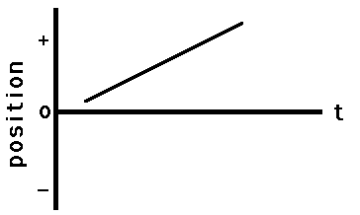
Graph of Question 14
15. Sketch a position-time graph for an object which is moving with a constant, negative velocity.
Answer : A position-time graph for an object which is moving with a constant, negative velocity is shown below. A negative, constant velocity is represented by a line with constant slope (straight) and negative slope (downwards sloping).
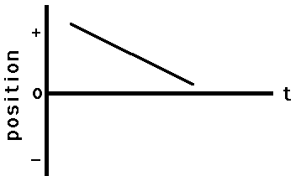
Graph of Question 15
16. Sketch a position-time graph for an object moving in the + dir’n and accelerating from a low velocity to a high velocity.
Answer : A position-time graph for an object moving in the + dir’n and accelerating from a low velocity to a high velocity is shown below. If the object is moving in the + dir’n, then the slope of a p-t graph would be +. If the object is changing velocity from small to large values, then the slope must change from small slope to large slope.
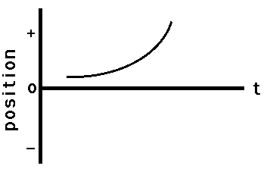
Graph of Question 16
17. Sketch a position-time graph for an object moving in the + dir’n and accelerating from a high velocity to a low velocity.
Answer : A position-time graph for an object moving in the + dir’n and accelerating from a high velocity to a low velocity is shown below. If the object is moving in the + dir’n, then the slope of a p-t graph would be +. If the object is changing velocity from high to low values, then the slope must change from high slope to low slope.
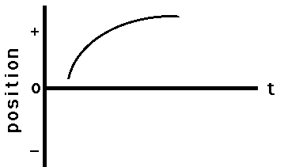
Graph of Question 17
18. Sketch a position-time graph for an object moving in the - dir’n and accelerating from a high velocity to a low velocity.
Answer : A position-time graph for an object moving in the - dir’n and accelerating from a high velocity to a low velocity is shown below. If the object is moving in the - dir’n, then the slope of a p-t graph would be -. If the object is changing velocity from high to low values, then the slope must change from high slope to low slope.
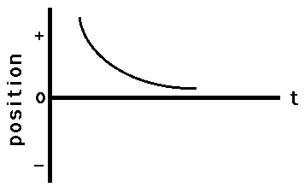
Graph of Question 18
19. Sketch a position-time graph for an object moving in the - dir’n and accelerating from a low velocity to a high velocity.
Answer : A position-time graph for an object moving in the - dir’n and accelerating from a low velocity to a high velocity is shown below. If the object is moving in the - dir’n, then the slope of a p-t graph would be -. If the object is changing velocity from low to high values, then the slope must change from low slope to high slope.
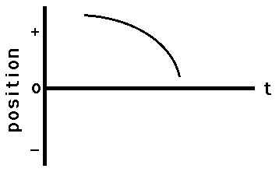
Graph of Question 19
20. Sketch a position-time graph for an object moving in the + dir’n with constant speed; first a slow constant speed and then a fast constant speed.
Answer : A position-time graph for an object moving in the + dir’n with constant speed; first a slow constant speed and then a fast constant speed is shown below. If an object is moving in the + dir’n, then the slope of the line on a p-t graph would be +. At first, the line has a small slope (corresponding to a small velocity) and then the line has a large slope (corresponding to a large velocity).
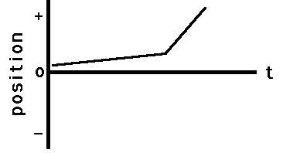
Graph of Question 20
21. Sketch a position-time graph for an object moving in the + dir’n with constant speed; first a fast constant speed and then a slow constant speed.
Answer : A position-time graph for an object moving in the + dir’n with constant speed; first a fast constant speed and then a slow constant speed is shown below. If an object is moving in the + dir’n, then the slope of the line on a p-t graph would be +. At first, the line has a large slope (corresponding to a large velocity) and then the line has a small slope (corresponding to a small velocity).
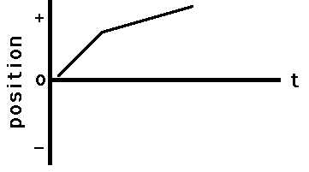
Graph of Question 21
22. Sketch a position-time graph for an object moving in the - dir’n with constant speed; first a slow constant speed and then a fast constant speed.
Answer : A position-time graph for an object moving in the - dir’n with constant speed; first a slow constant speed and then a fast constant speed is shown below. If an object is moving in the - dir’n, then the slope of the line on a p-t graph would be -. At first, the line has a small slope (corresponding to a small velocity) and then the line has a large slope (corresponding to a large velocity).
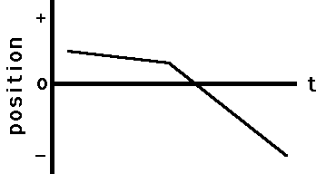
Graph of Question 22
23. Sketch a position-time graph for an object moving in the - dir’n with constant speed; first a fast constant speed and then a slow constant speed.
Answer : A position-time graph for an object moving in the - dir’n with constant speed; first a fast constant speed and then a slow constant speed is shown below. If an object is moving in the - dir’n, then the slope of the line on a p-t graph would be -. At first, the line has a large slope (corresponding to a large velocity) and then the line has a small slope (corresponding to a small velocity).
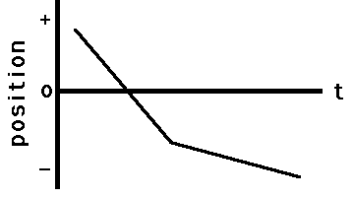
Graph of Question 23
24. Sketch a position-time graph for an object which moves in the + direction at a slow constant speed and then in a - direction at a fast constant speed.
Answer : A position-time graph for an object which moves in the + direction at a slow constant speed and then in a - direction at a fast constant speed is shown below. The object must first have a + slope (corresponding to its + velocity) then it must have a - slope (corresponding to its - velocity). Initially, the slope is small (corresponding to a small velocity) and then the slope is large (corresponding to a large velocity).
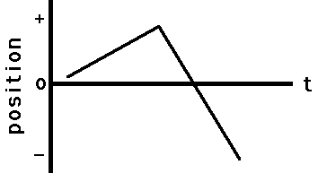
Graph of Question 24
25. Sketch a position-time graph for an object which moves in the + direction at a fast constant speed and then in a - direction at a slow constant speed.
Answer : A position-time graph for an object which moves in the + direction at a fast constant speed and then in a - direction at a slow constant speed is shown below. The object must first have a + slope (corresponding to its + velocity) then it must have a - slope (corresponding to its - velocity). Initially, the slope is large (corresponding to a large velocity) and then the slope is small (corresponding to a small velocity).
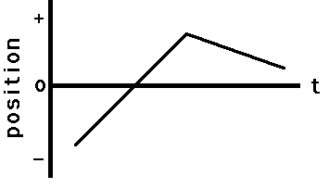
Graph of Question 25
26. Sketch a position-time graph for an object which moves in the - direction at a slow constant speed and then in a + direction at a fast constant speed.
Answer : A position-time graph for an object which moves in the - direction at a slow constant speed and then in a + direction at a fast constant speed is shown below. The object must first have a - slope (corresponding to its - velocity) then it must have a + slope (corresponding to its + velocity). Initially, the slope is small (corresponding to a small velocity) and then the slope is large (corresponding to a large velocity).
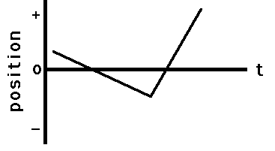
Graph of Question 26
27. Sketch a velocity-time graph for an object moving with a constant speed in the positive direction.
Answer : A velocity-time graph for an object moving with a constant speed in the positive direction is shown below. To have "a constant speed in the positive direction" is to have a + velocity which is unchanging. Thus, the line on the graph will be in the + region of the graph (above 0). Since the velocity is unchanging, the line is horizontal. Since the slope of a line on a v-t graph is the object’s acceleration, a horizontal line (zero slope) on a v-t graph is characteristic of a motion with zeo acceleration (constant velocity).
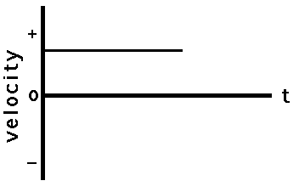
Graph of Question 27
28. Sketch a velocity-time graph for an object moving with a constant speed in the negative direction.
Answer : A velocity-time graph for an object moving with a constant speed in the negative direction is shown below. To have "a constant speed in the negative direction" is to have a - velocity which is unchanging. Thus, the line on the graph will be in the - region of the graph (below 0). Since the velocity is unchanging, the line is horizontal. Since the slope of a line on a v-t graph is the object’s acceleration, a horizontal line (zero slope) on a v-t graph is characteristic of a motion with zeo acceleration (constant velocity).
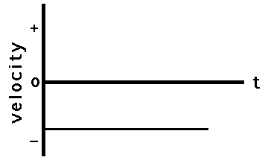
Graph of Question 28
29. Sketch a velocity-time graph for an object which is at rest.
Answer : A velocity-time graph for an object which is at rest is shown below. To be "at rest" is to have a zero velocity. Thus the line is drawn along the axis (v=0).
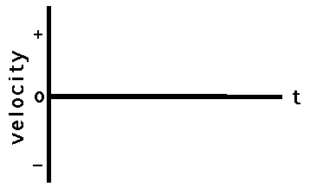
Graph of Question 29
30. Sketch a velocity-time graph for an object moving in the + direction, accelerating from a slow speed to a fast speed.
Answer : A velocity-time graph for an object moving in the + direction, accelerating from a slow speed to a fast speed is shown below. An object which is moving in the + direction and speeding up (slow to fast) has a + acceleration. (If necessary, review the dir’n of the acceleration vector in the Physics Classroom Tutorial.) Since the slope of a line on a v-t graph is the object’s acceleration, an object with + acceleration is represented by a line with + slope. Thus, the line is a straight diagonal line with upward (+) slope. Since the velocity is +, the line is plotted in the + region of the v-t graph.
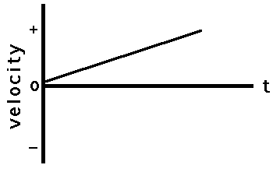
Graph of Question 30
31. Sketch a velocity-time graph for an object moving in the + direction, accelerating from a fast speed to a slow speed.
Answer : A velocity-time graph for an object moving in the + direction, accelerating from a fast speed to a slow speed is shown below. An object whgich is moving in the + direction and slowing down (fast to slow) has a - acceleration. (If necessary, review the dir’n of the acceleration vector in the Physics Classroom Tutorial.) Since the slope of a line on a v-t graph is the object’s acceleration, an object with - acceleration is represented by a line with - slope. Thus, the line is a straight diagonal line with downward (-) slope. Since the velocity is +, the line is plotted in the + region of the v-t graph.
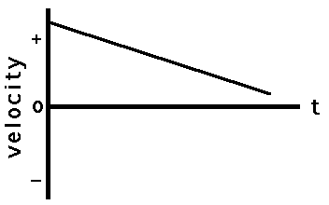
Graph of Question 31
32. Sketch a velocity-time graph for an object moving in the - direction, accelerating from a slow speed to a fast speed.
Answer : A velocity-time graph for an object moving in the - direction, accelerating from a slow speed to a fast speed is shown below. An object whgich is moving in the - direction and speeding up (slow to fast) has a - acceleration. (If necessary, review the dir’n of the acceleration vector in the Physics Classroom Tutorial.) Since the slope of a line on a v-t graph is the object’s acceleration, an object with - acceleration is represented by a line with - slope. Thus, the line is a straight diagonal line with downward (-) slope. Since the velocity is -, the line is plotted in the - region of the v-t graph.
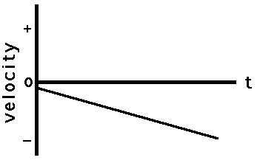
Graph of Question 32
33. Sketch a velocity-time graph for an object moving in the - direction, accelerating from a fast speed to a slow speed.
Answer : A velocity-time graph for an object moving in the - direction, accelerating from a fast speed to a slow speed is shown below. An object whgich is moving in the - direction and slowing down (fast to slow) has a + acceleration. (If necessary, review the dir’n of the acceleration vector in the Physics Classroom Tutorial.) Since the slope of a line on a v-t graph is the object’s acceleration, an object with + acceleration is represented by a line with + slope. Thus, the line is a straight diagonal line with upward (+) slope. Since the velocity is -, the line is plotted in the - region of the v-t graph.
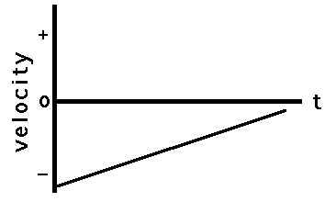
Graph of Question 33
34. Sketch a velocity-time graph for an object which first moves with a slow, constant speed in the + direction, and then with a fast constant speed in the + direction.
Answer : A velocity-time graph for an object which first moves with a slow, constant speed in the + direction, and then with a fast constant speed in the + direction is shown below. Since there are two parts of this object’s motion, there will be two distinct parts on the graph. Each part is in the + region of the v-t graph (above 0) since the velocity is +. Each part is horizontal since the velocity during each part is constant (constant velocity means zero acceleration which means zero slope). The second part of the graph will be higher since the velocity is greater during the second part of the motion.
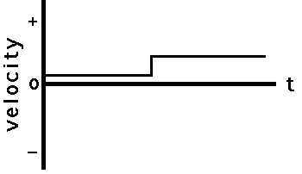
Graph of Question 34
35. Sketch a velocity-time graph for an object which first moves with a fast, constant speed in the + direction, and then with a slow constant speed in the + direction.
Answer : A velocity-time graph for an object which first moves with a fast, constant speed in the + direction, and then with a slow constant speed in the + direction is shown below. Since there are two parts of this object’s motion, there will be two distinct parts on the graph. Each part is in the + region of the v-t graph (above 0) since the velocity is +. Each part is horizontal since the velocity during each part is constant (constant velocity means zero acceleration which means zero slope). The first part of the graph will be higher since the velocity is greater during the first part of the motion.
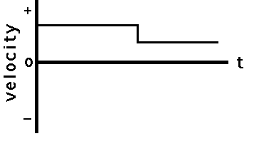
Graph of Question 35
36. Sketch a velocity-time graph for an object which first moves with a constant speed in the + direction, and then moves with a positive acceleration.
Answer : A velocity-time graph for an object which first moves with a constant speed in the + direction, and then moves with a positive acceleration is shown below. Since there are two parts of this object’s motion, there will be two distinct parts on the graph. Each part is in the + region of the v-t graph (above 0) since the velocity is +. The slope of the first part is zero since constant velocity means zero acceleration and zero acceleration is represented by a horizontal line on a v-t graph (slope = acceleration for v-t graphs). The second part of the graph is an upward sloping line since the object has + acceleration (again, the slope = acceleration for v-t graphs)
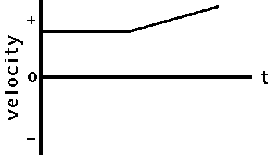
Graph of Question 36
37. Sketch a velocity-time graph for an object which first moves with a constant speed in the + direction, and then moves with a negative acceleration.
Answer : A velocity-time graph for an object which first moves with a constant speed in the + direction, and then moves with a negative acceleration is shown below. Since there are two parts of this object’s motion, there will be two distinct parts on the graph. Each part is in the + region of the v-t graph (above 0) since the velocity is +. The slope of the first part is zero since constant velocity means zero acceleration and zero acceleration is represented by a horizontal line on a v-t graph (slope = acceleration for v-t graphs). The second part of the graph is an downward sloping line since the object has - acceleration (again, the slope = acceleration for v-t graphs)
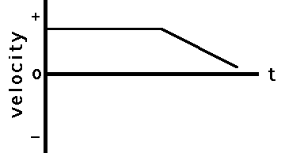
Graph of Question 37

2.1Exercises
Example : Which position-versus-time graph represents the motion shown in the motion diagram?
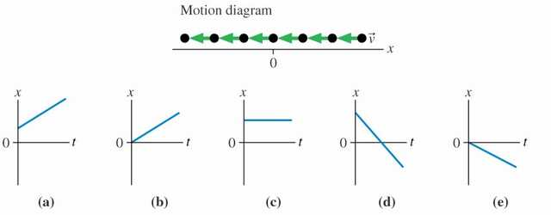
Solution :
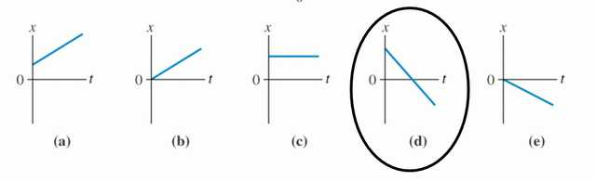
Example : Which velocity-versus-time graph goes with this position-versus-time graph on the left?
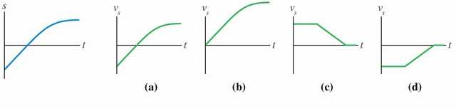
Note that the variable “s” denotes a generic Cartesian coordinate. It could be x or y.
Solution :
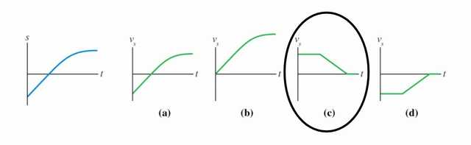
The velocity graph must match the slope of the position graph. The position graph starts with a constant positive slope. Then the slope decreases to zero.
Example : Which position-versus-time graph goes with this velocity-versus-time graph on the left? The particle’s position at ti = 0 s is xi = –10 m .
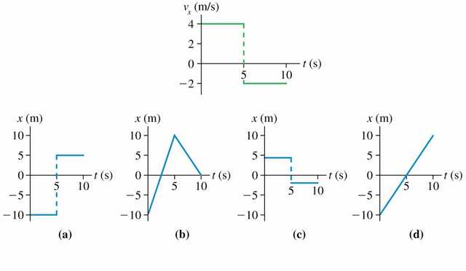
Solution :
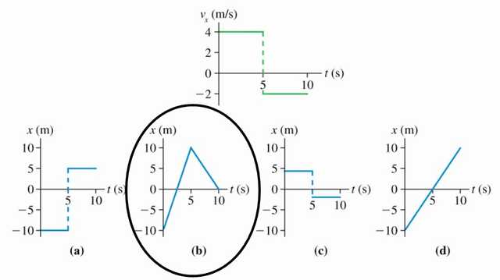
The velocity graph must match the slope of the position graph. The intercept of the position graph is arbitrary.
Example : Which velocity-versus-time graph or graphs goes with this acceleration-versus-time graph? The particle is initially moving to the right and eventually to the left.
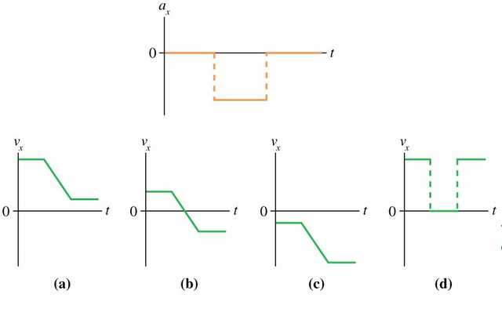
Solution :
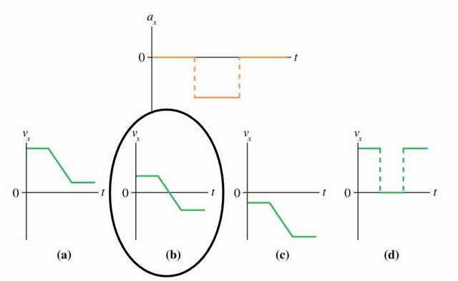
The slope of the velocity graph must match the acceleration graph. The intercept is based on the direction information.
Example : The ball rolls up the ramp, then back down. Which is the correct acceleration graph?
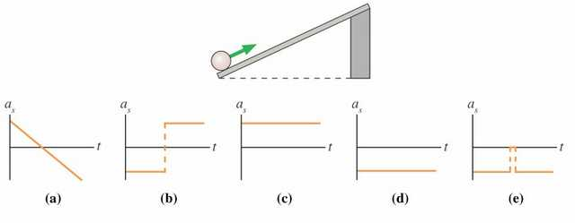
Solution :
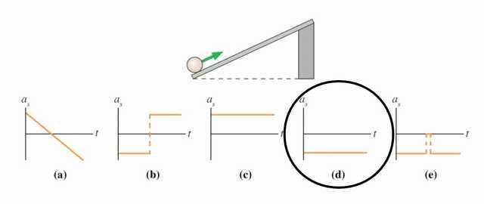
The ball will move up the ramp while slowing down, then it will reach a turnaround point and begin to move down the ramp with increasing speed. The velocity graph at right is consistent with that description. The acceleration graph shown in graph d is consistent with the requirement that it match the slope of the velocity graph.
Example : An expectant father paces back and forth producing the potison-versus-time graph shown here.
(a) Without performing a calculation indicate whether the father’s velocity is positive, negative, or zero on the segments of the graph labeled A, B, C, and C.
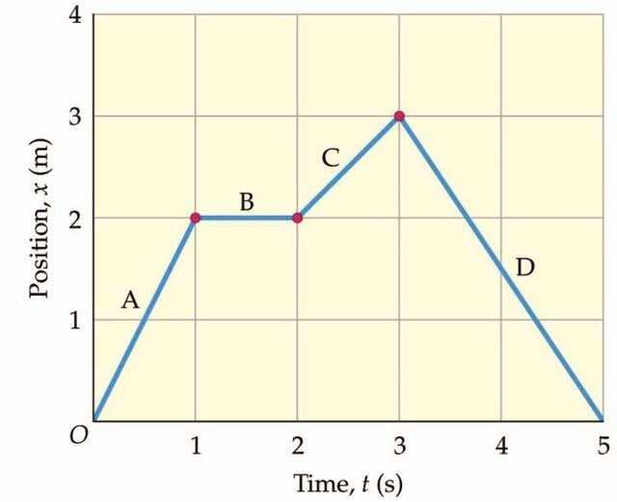
Segment A:
Segment B:
Segment C:
Segment D:
(b) Calculate the average velocity for each segment and show that your results verify your answers to part (a).
Segment A:
Segment B:
Segment C:
Segment D:
Example : 2. A motorcycle moves according to the velocity-versus-time graph shown. Find the displacement of the motorcycle for each of the segments A, B, and C.
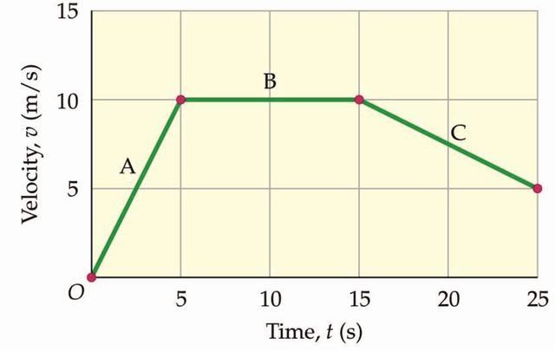
Segment A:
Segment B:
Segment C:
Example : Fig. shows the displacement-time graph of a car during parking. Describe the motion of the car and find the velocity in each time interval.[3]
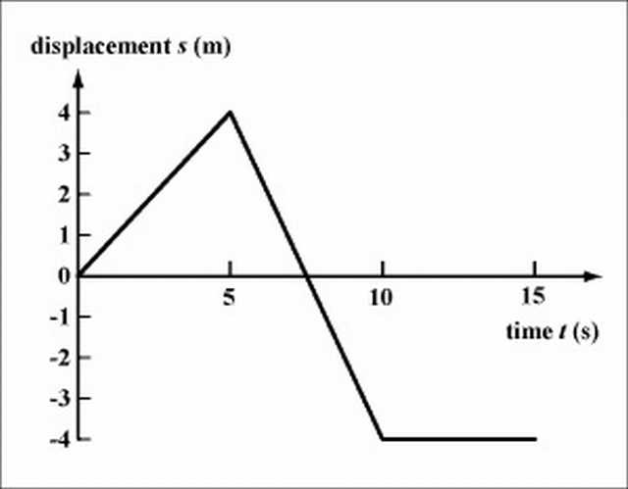
Solution: Stage 1: The car moves forwards from the origin to s=4m in the first 5 s.
v=4/5=0.8m/s (forwards)
Stage 2: The car moves backwards, passes the origin, to s=-4m in the next 5 s.
v=(-4-4)/(10-5)=-1.6m/s (backwards)
Stage 3: The car remains at rest in the last 5 s.
v=0m/s
Example : Fig. is the displacement-time graph for a car encountering a traffic light. Describe the motion of the car at each stage qualitatively.[3]
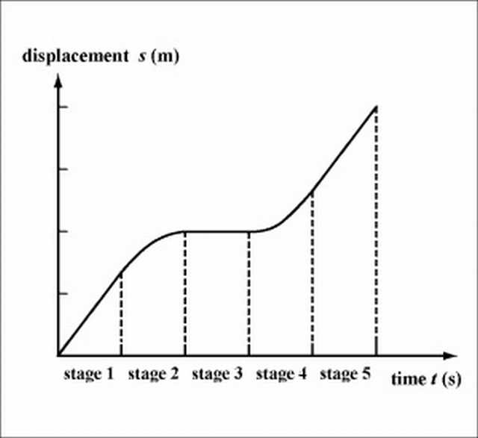
Solution : Stage 1: moving with constant velocity; stage 2: decelerating; stage 3: at rest; stage 4: accelerating; stage 5: moving with the same constant velocity as in stage 1.
Note: In stage 2 the slope of the curve is decreasing, while in stage 4 the slope is increasing. This indicates that the car is decelerating in stage 2 and accelerating in stage 4.
Example : An object’s position during a given time interval is shown by the graph below:
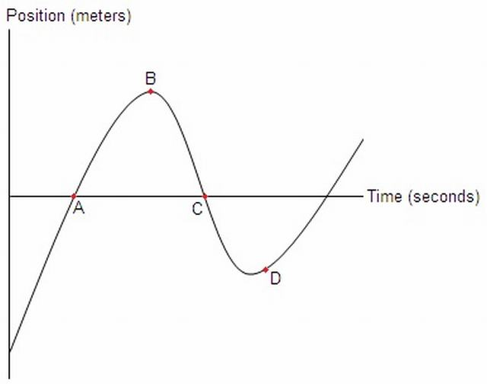
a.) At which of the marked points is the object’s velocity the greatest? The least?
b.) Is the object’s acceleration positive or negative between points A and B?
c.) Suppose this curve can be modeled by the function x(t) = t3 - 9.5t2 + 23t - 9. Find the object’s velocity and acceleration at t = 1, t = 3, and t = 5.
d.) Using the function from part c, determine the object’s maximum and minimum positions and velocities within the interval from t = 1 to t = 6.
Solution : a.) Remember from problem 22 that velocity is the slope of a position vs. time graph such as this. By looking at lines tangent to the curve, we can see which point has the highest and lowest slope:
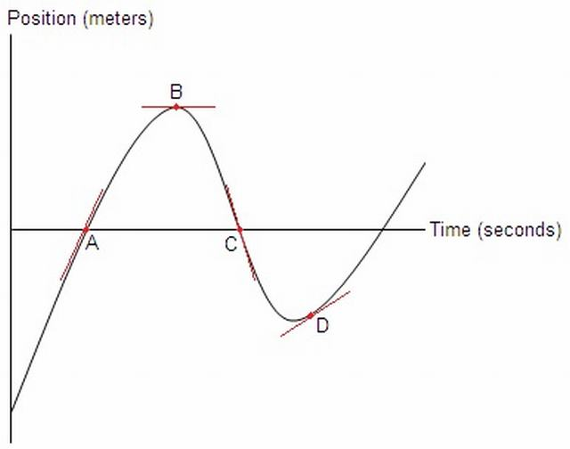
Looking at the red tangent lines, we can immediately eliminate point B as a candidate for both the maximum and minimum velocity, as its tangent is horizontal and thus has a slope of 0. Point C is the only marked point whose tangent line has a negative slope, so point C has the lowest velocity. Looking at points A and D, point A’s tangent line has a steeper positive slope so point A has the highest velocity.
b.) We know that acceleration is a change in velocity, so by asking whether acceleration is positive or negative, we are asking if the velocity is increasing or decreasing. Since velocity is the slope of this graph, we must determine how the slope of the curve is changing between points A and B. Looking at the diagram in part a, we see that the slope at point A is positive, and the slope at point B is 0. As such, the slope, and thus the velocity, must be decreasing. Therefore, the object’s acceleration is negative in this interval.
c.) We know from problem 22 that velocity is the derivative of position, and from problem 23 that acceleration is the derivative of velocity. So, we will begin by differentiating the position function twice: x(t) = t3 - 9.5t2 + 23t - 9 v(t) = 3t2 - 19t + 23 a(t) = 6t - 19
Now that we know the velocity and acceleration functions, all that is left is to plug the values of t into these functions and simplify: v(1) = 3 * 12 - 19 * 1 + 23 = 3 - 19 + 23 = 7 m/s v(3) = 3 * 32 - 19 * 3 + 23 = 27 - 57 + 23 = -7 m/s v(5) = 3 * 52 - 19 * 5 + 23 = 75 - 95 + 23 = 3 m/s
a(1) = 6 * 1 - 19 = 6 - 19 = -13 m/s2 a(3) = 6 * 3 - 19 = 18 - 19 = -1 m/s2 a(5) = 6 * 5 - 19 = 30 - 19 = 11 m/s2
d.) Thinking logically about the graph, the possible candidates for maximum and minimum position are at the end points of the interval and at the spots, like point B, where the slope of the graph is 0. So, first we set the velocity function from part c equal to 0 and solve for t: v(t) = 3t2 - 19t + 23 = 0 t = 1.63008 s or t = 4.70326 s
Note that this was solved using a graphing calculator. The AP exam will not ask you to solve a quadratic this complicated by hand, however you may have to solve a simpler function using the quadratic formula. Also, we keep as many decimal places as we can at this stage in order to maintain accuracy. Now that we know all the possible times at which the position could be at a maximum or minimum within the interval, we simply plug these t values into x(t). Don’t forget to check the end points: x(t) = t3 - 9.5t2 + 23t - 9 x(1) = 5.5 m x(1.63008) = 7.58 m x(4.70326) = -6.93 m x(6) = 3 m
We see that the minimum position is -6.93 m, and the maximum position is 7.58 m. Finding the maximum and minimum velocities is achieved in the same manner, except we set the acceleration function equal to 0 and plug the t values into the velocity funtion: a(t) = 6t - 19 = 0 6t = 19 t = 19/6 = 3.16667 s
v(t) = 3t2 - 19t + 23 v(1) = 7 m/s v(3.16667) = -7.08 m/s v(6) = 17 m/s
So the minimum velocity is -7.08 m/s, and the maximum velocity is 17 m/s.

3Classical Approach

3.1The Equations of motion and the origin of Graph Handling

3.1.1 ↓The First Equation
The Equation v = (dx)/(dt) in linear motion implies
i) The Slope of Position-Time Graph is Instantaneous Velocity.
ii) The Area under the Velocity-Time Graph is Change in Position.
{ The second one requires the manipulation , dx = vdt i.e. ∫dx = ∫vdt }
The equations can be further manipulated to obtain the Speed Time Graph , where
speed = rate of change of distance wrt time
Few of the following examples illustrate this concept:
Example 1:On a displacement-time graph, two straight lines make angles of 30° and 60° with the time-axis. The ratio of the velocities represented by them is
a) 1:√(3)
b) 1:3
c) √(3):1
d) 3:1
{ Hint: The velocity in a displacement-time is given by the slope of the curve. Slope = tan(gent) of angle of inclination of s-t graph. This gives the respective ratios tan 30º / tan 60º
Answer: b) is the correct answer. }
Example 2:A body is moving in a straight line as shown in velocity-time graph. The displacement and distance travelled by body in 8 second are respectively:
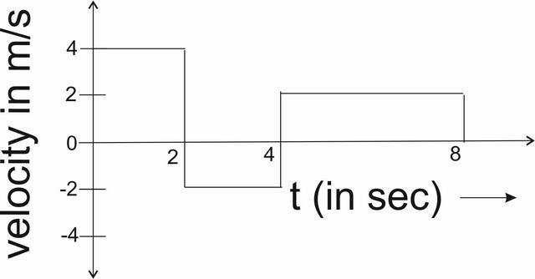
a) 12 m, 20 m
b) 20 m, 12 m
c) 12 m, 12 m
d) 20 m, 20 m
{ Hint: The displacement in a velocity-time graph is given by the area under the graph with proper signs. From 0s - to 2s , the area is 8m . From 2s - to 4s , the area is -4m . From 4s - to 8s , the area is 8m. Adding these 3 values , we get 8m + (-4m) + 8m = 12m. } The distance in a v-t graph is given by the absolute area under the graph. So, taking the absolute values of individual area divisions, we get 8m + 4m + 8m =20m
Answer: a) is the correct answer. }
Example 3: The graph shows position as a function of time for two trains running on parallel tracks. Which statement is true?
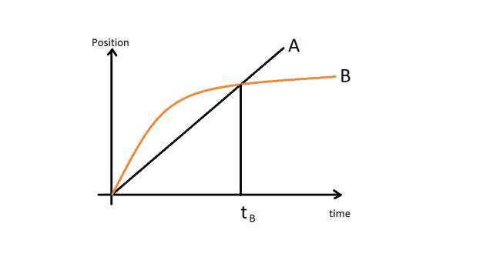
a) At time t_{B} both trains have the same velocity.
b) Both trains have the same velocity at some time after t_{B} .
c) Both trains have the same velocity at some time before t_{B} .
d) Somewhere on the graph, both trains have the same acceleration.
{ Hint: Depending on the question requirements, we’ll have to check all the assertions one by one.
a) In a position time graph, the slope gives velocity. It can be clearly seen that Graph B has a much lower slope than Graph A at time t_{B}. So, the assertion is wrong.
b,c) By drawing a line parallel to the line A which is a tangent to Graph B , it can be seen where the two graphs have same slope. It is clear that the graphs have same slope between 0 and t_{B} as noted from the figure. So, assertion b is wrong while c is correct.
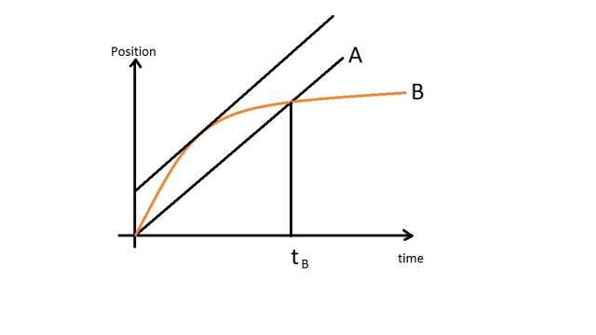
d) As the Graph A has a constant slope, so the acceleration of body A is zero. Whereas Graph B is constantly turning, so the slope can be assumed to be non-zero throughout. According to some revelations, however it is noted that the figure is not clear enough to show whether Graph B is straight after t_{B} or bending. In case it is assumed to be straight, then after t_{B} both trains will have same (zero) acceleration. Also at start both have large (infinite) accelration, in which case the ratio of the two large ( infinite ) values may be calculated if initial conditions are mentioned and is required.
At our level we would assume this assertion to be wrong, however making a note that the image should have been more clearly presented.
Answer: c) is the correct assertion. }
Example 4: The velocity-time graph of a particle in linear motion is as shown. Both v and t are in SI units. The displacement of the particle is
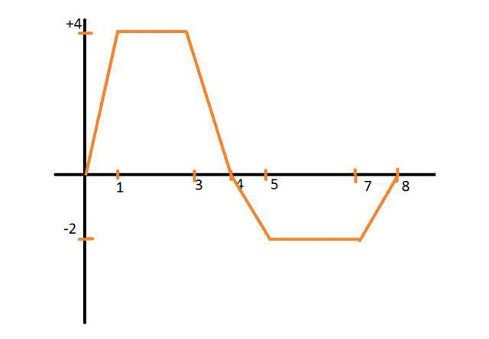
a) 6 m
b) 8 m
c) 16 m
d) 18 m
{ Hint : For displacement calculations, between 0 - to 4 , area of the positive trapesium = (4+2)X4 = 24
between 4 - to 8, area of negative trapesium = (2+4)X(-2) = -12.
So , the answer is +12 , which is not in the options.
So , the anser is None of these. }
Example 5 : A body moves as described by the following v-t graph.
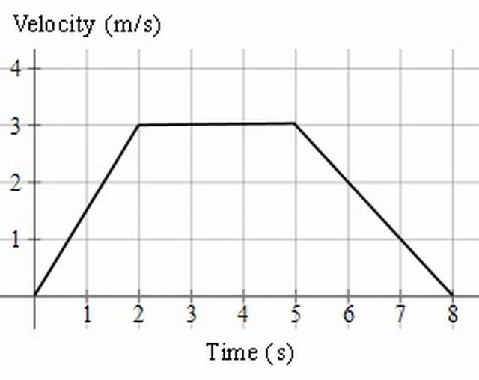
a) Describe the motion.
b) What is the distance travelled during the motion?
c) What is the average speed for the motion?
Solution : a) From t=0 to 2, the acceleration was a = (Δv)/(Δt) = (3)/(2) = 1.5 ms ⁻ ²
From t=2 to 5, the acceleration was 0 ms⁻¹ .
The body was neither speeding up nor slowing down.
From t=5 to 8, the acceleration was a = (Δv)/(Δt) = ( − 3)/(3) = − 1 ms ⁻ ²
The body was slowing down, so the acceleration was negative.
b) The distance travelled is the area of the trapezoid (trapezium).
distance = ((a + b)h)/(2) = ((8 + 3)(3))/(2) = 16.5 m
c) average speed = (distance travelled)/(time taken) = (16.5)/(8)
=2.1 ms⁻¹
Example 6 : A speedboat starts from rest, accelerating at 2 ms −2 for 20 s. It then continues at a steady speed for a further 30 s and decelerates to rest in 30 s. Find:
(a) the distance travelled in m,
(b) the average speed in ms ⁻¹ and,
(c) the time taken to cover half the distance.
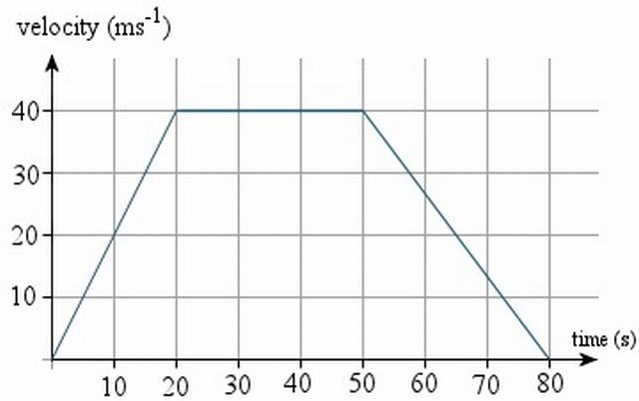
Solution : a) distance=area of trapezium = ((a + b)h)/(2)
= ((80 + 30)(40))/(2)
=2200 m
b) average speed = (distance travelled)/(time taken)
= (2200)/(80)
=27.5 ms ⁻¹
c) We need to find the time when the area of the trapezium is half of its original area, or 1100m , as shown in the graph.
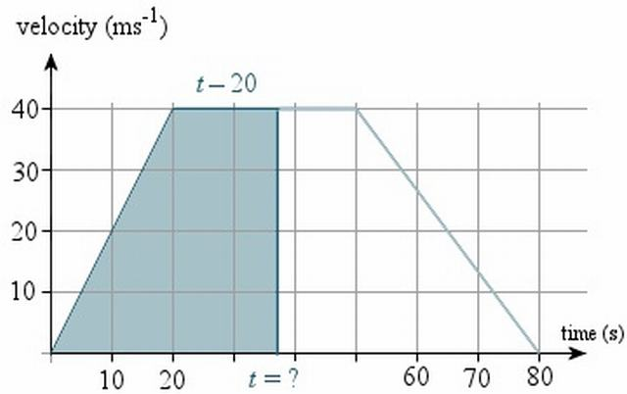
The base of this unknown trapezium has length \displaystyle{t}t, and the top of the trapezium will have length t−20. So we have:
area of trapezium = ((a + b)h)/(2)
1100 = ((t + [t − 20])40)/(2) = 20(2t − 20)
55=2t−20
75=2t
t=37.5s
So it will take 37.5 s to cover half the distance.

3.1.2 ↓The Second Equation
Proceeding similar to above, the equation a = (dv)/(dt) implies
i) The Slope of Velocity-Time Graph is Instantaneous Acceleration.
ii) The Area under Acceleration-Time Graph is Change in Velocity.
{ The second one requires the manipulation , dv = adt i.e. ∫dv = ∫adt }
A few of the following examples illustrate it.
Example 1: A car starts from rest acquires a velocity v with uniform acceleration 2ms ⁻ ² then it comes to stop with uniform retardation 4ms ⁻ ² . If the total time for which it remains in motion is 3 sec, the total distance travelled is:
a) 2 m
b) 3 m
c) 4 m
d) 6 m
{Hint: For solving this problem, we draw the graph of the problem,
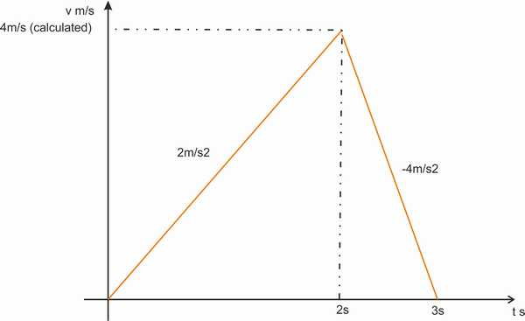
Accordning to graph, let the time when it reaches maximum velocity be T, and the maximum velocity be V.
⇒ V = 2XT and also V = 4X(3-T)
Equating the equations,
2T = 12-4T = V
⇒ 6T = 12
⇒ T = 2
⇒ V = 2T = 4
Calculating the area under the graph using the calculated parameters, Area = 1/2 X 4 X 3 = 6m
So , area under the graph is 6m = displacement . Also, as all the area is on the positive side, so distance = 6m.
}
Example 2: A particle starts from rest. Its acceleration (a) vs time (t) is as shown in the Figure. The maximum speed of the particle will be
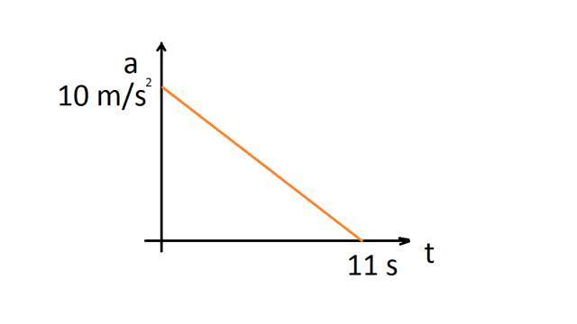

a) 110 m/s
b) 55 m/s
c) 550 m/s
d) 660 m/s
{ Hint : Writing the equation of the graph , we get (a)/(10) + (t)/(11) = 1
⇒ a = (10)/(11)(11 − t)
Integrating, ( we will assume initial velocity to be zero as the body starts from rest. )
v = (10)/(11)(11t − (1)/(2)t²)
Substituting t = 11s
v_{11s} = 55m ⁄ s
Answer: b) is the correct answer }
Example 3: Acceleration-time graph of a particle moving in a straight line is shown in Figure. The velocity of particle at time t = 0 is 2 m/s. Velocity at the end of fourth second is
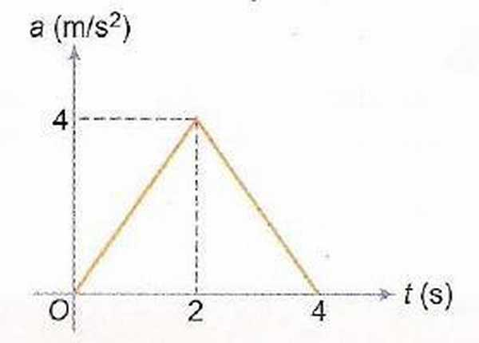

a) 8 m/s
b) 10 m/s
c) 12 m/s
d) 14 m/s
{ Hint: Area under the acceleration-time graph is change in velocity. Area of the triangle is Half ( into ) base ( into ) altitude = 8m/s. Adding the initial value of 2m/s , we get 2 + 8 = 10m/s.
Answer: b) is the correct answer }
Example 4: Each of the three graphs represents acceleration vs time for an object that already has a positive velocity at time t₁ . Which graph/graphs show an object whose speed is increasing for the entire time interva1 between t₁ and t₂ ?
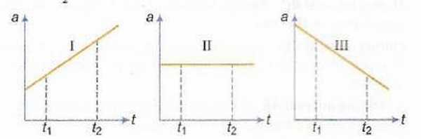

a) Graph I only
b) Graphs I and II
c) Graphs I and III
d) Graphs I, II and III
{Hint: Area under the acceleration time graphs give change in velocity. In all the three figures, the area under the graphs are +ve, hence velocity is increasing in all cases. As the initial velocity is +ve , in all three cases the velocity remains throughout positive. So , the speed is also increasing in all cases.}
Example 5: A body starts from rest and moves along a straight line with constant acceleration. The variation of speed v with distance s is given by the graph
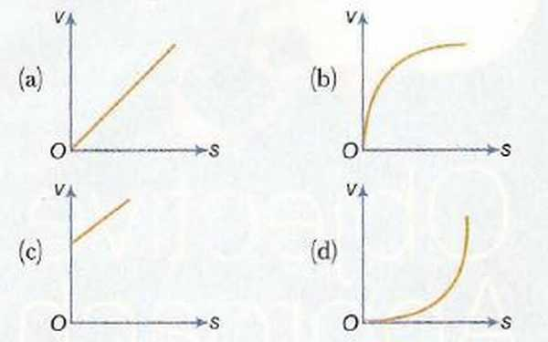

{ Hint: The problem given has v_{o}= 0
Now acceleration = constant ( lets say k ) = (dv)/(dt)
⇒ k = v(dv)/(ds)
⇒ ∫₀^{v}vdv = ∫₀^{s}kds
⇒ v = √(2ks)
The graph is proportional to square root function
Hence , b (as it is the only graph with such a property )
Answer : b) is the correct graph }

3.1.3The Acceleration-Position Graph Variate
This kind of graph requires the manipulation of the Equation a = (dv)/(dt) as follows
a = (dv)/(dx).(dx)/(dt)
⇒ a = (dv)/(dx).v
⇒ adx = vdv and integration can be performed to further solve it.
Example 1: A body, initially at rest, starts moving along x-axis in such a way that its acceleration vs displacement plot is as shown in the Figure. The maximum velocity of the particle is
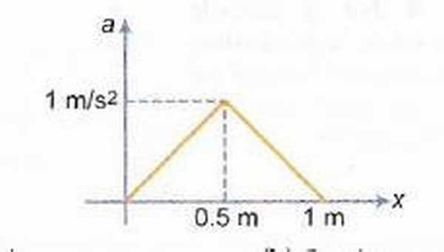

a) 1 m/s
b) 6 m/s
c) 2 m/s
d) None of these
{ Hint : The area under the a-x graph gives change in (v²)/(2) as can be evaluated by Integration method. The area of triange is (0.5) X (1) X (1) = 0.5
⇒ v = 1m/s . Initial position is given to be 0 in the graph. Hence, we take only the positive sign.
Answer : a) is the correct answer. }
Example 2 : A particle initially at rest, it is subjected to a non-uniform acceleration a, as shown in the gure. The maximum speed attained by the particle is
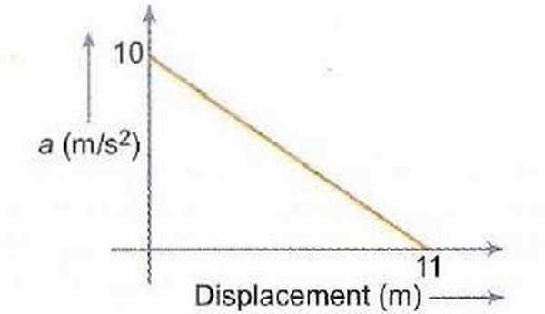

a) 605 m/s
b) 110 m/s
c) 55 m/s
d) 110 m/s
{ Hint: The answer is 55m/s as calculated in the example above(In the second equation section). Hence, c) is the correct response.
Answer : c) is the correct answer. }

3.1.4 ↓Sign of Acceleration from Position-Time Graph
The sign of Acceleration can be determined from the Position-Time Graph. The methodology involves of looking at the Concavity of the Graph
i) If the graph is Concave-Up, the Acceleration is Positive.
ii) If the graph is Concave-Down, the Acceleration is Negative.
iii) If the graph is a straight line, the Acceleration is ZERO. { Irrespective of any other factor , such as the slope or direction of line}
Example 1: The graph given below is a plot of distance vs time. For which labelled region is the “Velocity Positive and the Acceleration Negative”
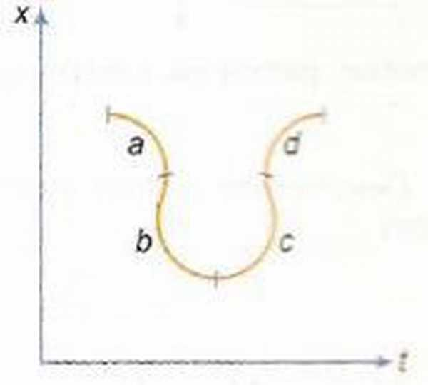
a) a
b) b
c) c
d) d
{ Hint: By the above mentioned propositions, d) is the required section with positive velocity and negative accleration. }

3.1.5 ↓The Average-Velocity / Instantaneous Velocity , Equal Case
We know , that ( in a x-t graph) the slope of the Secant is the Average Velocity , whereas the slope of Tangent is the Instaneous Velocity. The point where these two lines coincide, is the point where Average Velocity is equal to Instantaneous Velocity.
Example 1: Position-time graph is shown which is a semicircle from t = 2 to t = 8 s. Find time t at which the instantaneous velocity is equal to average velocity over first t seconds,
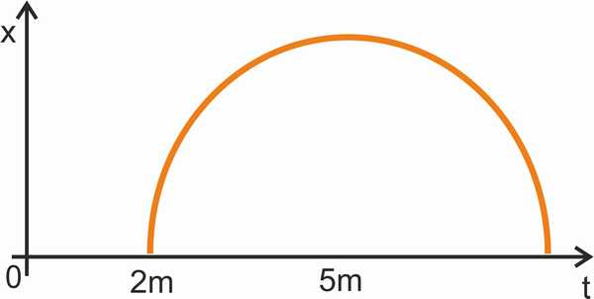
a) 4.8 s
b) 3.2 s
c) 2.4 s
d) 5 s
{ Hint: The tangent from 0 to the circle is drawn. It’s normal passes through the center of the circle. Time at this instant needs to be calculated.
If H=5 , R = 3 , Length of tangent = 4. (By Pythagoras.)
Angle which the tangent makes with the t axis is θ = sin ⁻ ¹(3 ⁄ 5)
So, the projection of tangent on t axis ( i.e. the required time ) = 4 cos θ = 4 × (4)/(5) = 3.2
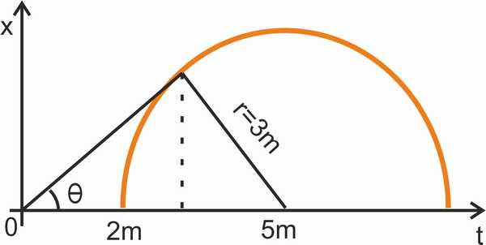
}

3.1.6The Velocity-Displacement Case
This can be handled in a similar way as Acceleration-Displacement case by integrating the respective equation. Here the problem is of v = f(x) type, which can be integrated by writing (dx)/(dt) = f(x)
i.e. dx = f(x)dt
Example 1: The velocity-displacement graph of a particle moving along a straight line is shown here.
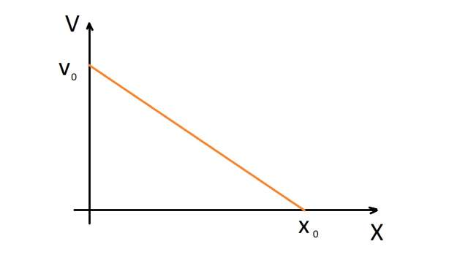

The most suitable acceleration-displacement graph will be
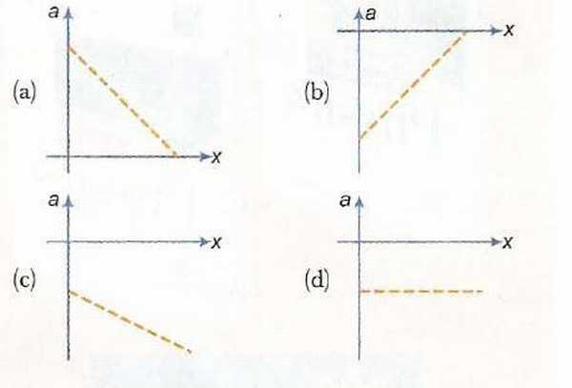
{Hint: Using Co-Ordinate Geometry Result studied in +1 Mathematics, we get the equation of the graph
(v)/(v_{o}) + (x)/(x_{o}) = 1
We are supposed to find the a-x graph from this.
So, we rewrite this equation as v = v_{o}(1 − (x)/(x_{o}))
Differentiating, we get a = − (v_{o})/(x_{o})v = − (v_{o}²)/(x_{o})(1 − (x)/(x_{o}))
Hence b) is the requisite graph, the only graph with a +ve slope , a negative y intercept and a positive x intercept.
Answer: b) is the correct answer. } [A] The problem has been solved wrong in the Extended First Edition and Third Edition released earlier this month. The date is 23-March-2017 today, as of this writing. So, a useful Errata.
Example 2: The velocity (v) of a body moving along the postive x-direction varies with displacement (x) from the origin as p v = k x , where k is a constant. Which of the graphs shown in Fig. correctly represents the displacement-time (x - t) graph of the motion?
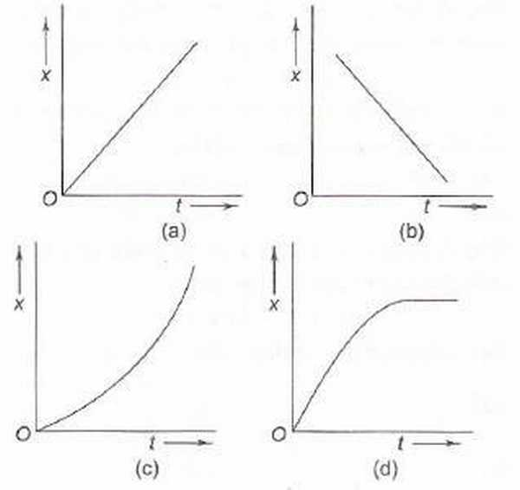

{Hint: The variable p removes the dependence of v on x and gives emphasis only on the first condition that body is moving along positive x-direction. In Graphs a) ,c) body is moving along positive x-direction, However, a) is a specific case when p is proportional to x and not the general case. Only c) covers the general case of all possible p and still moving in positive x-direction. Hence c) is the correct answer
Answer: c) is the required answer. }

3.1.7Motion Under Free Fall ↓ due to Gravity
In such examples, the governing equations rule and the coordi-nate system needs to be properly chosen.
Example 1: Which of the following graphs correctly represents velocity-time relationship for a particle released from rest to fall freely under gravity?
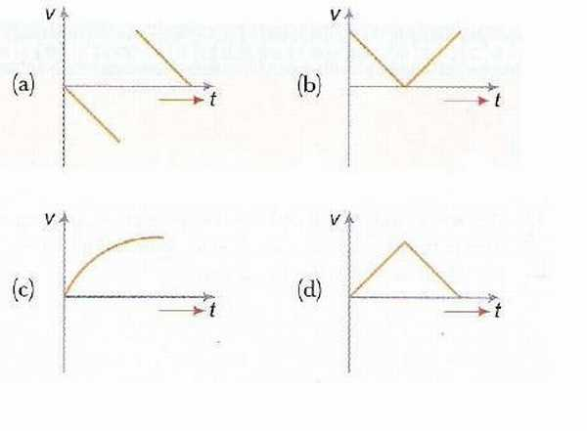

{ Hint: If we take the downward axis as positive, v will keep on increasing till the object hits something.
So, a) is the correct answer.}
Example 2: A body A is thrown vertically upwards with such a velocity that it reaches a maximum height of h. Simultaneously another body B is dropped from height h. It strikes the ground and doesn’t rebound. The velocity of A relative to B vs time graph is best represented by (upward direction is positive.)
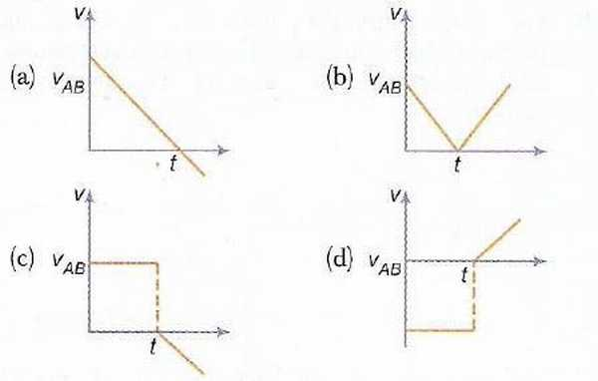

{ Hint: Before the strike, body A has velocity u-gt whereas body B has velocity -gt. So, a constant difference of u remains. Before strike, u − gt_{o} + gt_{o} = u . However , after that it is u-gt , the time being t_{o}=u/g of strike. So, the negative slope line starts from the x-axis and a discontinuity comes into picture.
So , C) is the required graph.}
Example 3 : A ball is thrown vertically downward from a 120-m high building. The ball hits the ground in 2 seconds. How fast was the ball thrown?
Sketches of the velocity and acceleration graphs are shown in Fig. 1. For simplicity, the downward direction is assumed to be positive, and, for ease of calculations, the freefall acceleration g is taken to be 10 m/s2. Knowing that the area under the acceleration graph is equal to the change in velocity (△v ) of the object yields △v = gt = 10 m/s² × 2 s = 20 m/s.
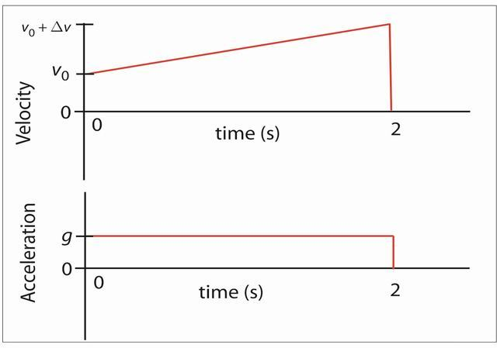
Velocity and acceleration graphs for Problem 1.
The area under the velocity graph is the displacement, which was given to be 120 m. Breaking the area under graph into a rectangle and a triangle yields 120 m = v0 3 t + 1 2 Dv 3 t = 2 s 3 v0 + 1 2 20 m/s 3 2 s. (2) One can easily solve this for the initial velocity of the object, thus obtaining the answer to the problem (50 m/s is a quite unrealistic initial velocity for a thrown ball). No explicit use of the standard kinematic equations is made; the solution is based on only the graphs. The above problem is relatively simple; to see the real power of the method requires a more difficult 1-D kinematics problem.
Example 4 : Determined to test gravity, a student walks off the cN Tower in Toronto, which is 553 m high, and falls freely. His initial velocity is zero. The rocketeer arrives at the roof of the building 5 seconds later to save the student. The rocketeer leaves the roof with an initial velocity downward and then is in freefall. in order both to catch the student and to prevent injury to him, the rocketeer should catch the student at a sufficiently great height and arrive at the ground with zero velocity. The upward acceleration that accomplishes this is provided by the rocketeer’s jet pack, which he turns on just as he catches the student; before then the student is in freefall. To prevent discomfort to the student, the magnitude of the acceleration is limited to five times gravity. How high above the ground must the rocketeer catch the student?
Solution : As I was grading the assignment, one student’s solution stuck out. When I first saw it, I was convinced that something must be wrong as the problem had been difficult for me and could not be that simple. I was wrong. The simple solution consists of sketching the velocity and acceleration graphs for the falling student (Fig. 2; down is taken as the positive direction) and using a bit of reasoning. Since the overall change in the student’s velocity during his motion is zero, the total area under the acceleration-versus-time graph must equal zero. This area consists of a positive part (above the time axis) and a negative part (below the time axis). The two rectangular areas must have equal magnitude, and since their heights differ by a factor of 5, so must their widths (the two corresponding times). Therefore, the freefall time is five times longer than the time for slow-down to rest. Now, looking at the velocity graph, the area labeled 1 corresponds to the displacement while in freefall, and the area labeled 2 represents the displacement after the Rocketeer has caught the student. The triangles forming areas 1 and 2 have the same height, and the base (time) for area 1 is five times the base (time) for area 2. Therefore, area 1 must be five times larger than area 2. This means that area 2 must be 1/6 the total height of the building, or 92.2 m.
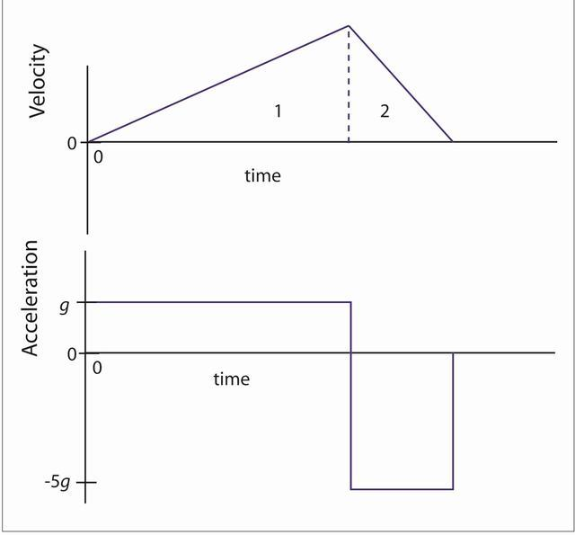
Velocity and acceleration graphs for Problem 2.
After studying this solution for a long time and finding no flaws in the physics, I pulled out my physics book and tried solving other one-dimensional kinematics problems in a similar manner. It quickly became obvious that they could be done using graphs, and in most cases this is the easier method. I was hooked and began teaching one-dimensional problem solving this way in all my classes. The next class period I asked the student whose solution this was why he chose to do the problem this way. He explained that we had emphasized graphs so much in class that they must be more useful than something we are simply supposed to sketch for the problems. I was amazed and appreciative as I now had a new way to teach problem solving. This kind of solution is more visual and helps get students away from hunting for the “correct equation.” It has worked well for me at all levels of introductory physics, conceptual through calculus based. If you find other interesting problems that are especially suited to the above method, I would appreciate your sharing them.

3.1.8Projectile Motion
Example 1: A shell is fired from a gun at an angle to the horizontal. Graphs are drawn for its horizontal component of velocity v_{x} and its vertical component of velocity v_{y}.
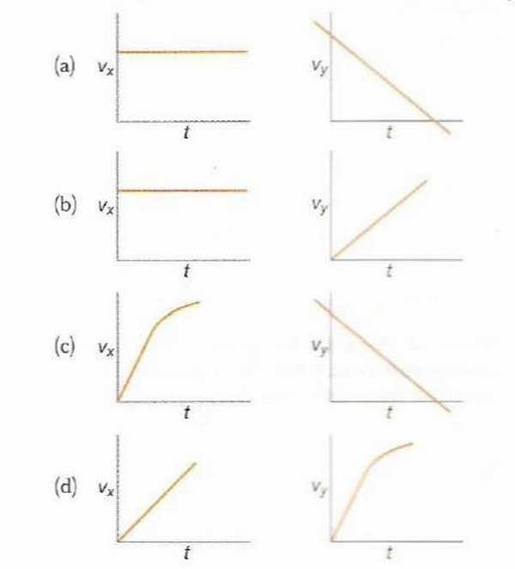

{ Hint: v_{x} would remain constant as ucosθ and v_{y} would linearly decrease and go negative after maximum height is attained(if the fire angle is +ve).
So, a) is the requisite graph.}

3.1.9Miscelleneous
Example 1: Figure shows the displacement-time ( x-t ) graph of body moving in a straight line. Which one of the graphs shown in Fig. represents the velocity- time ( v-t ) graph of the motion of the body.
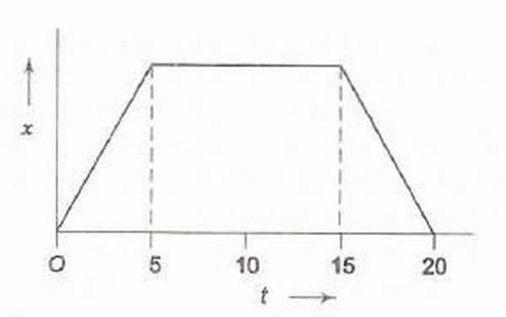

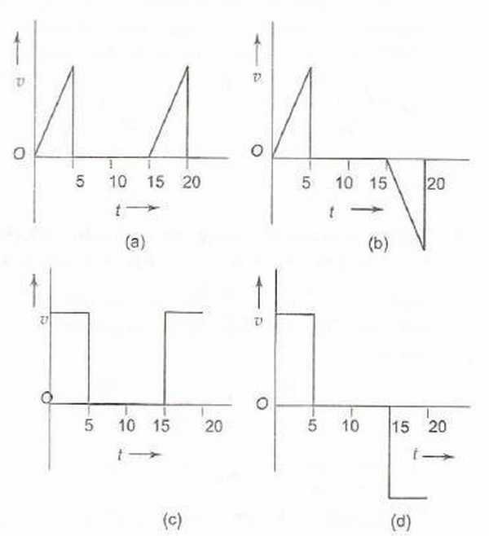

{ Hint: The graph has initially (0-5) a +ve slope, then zero slope and then (15-20) an equal -ve slope
So, d) is the correct answer. }
Example 2: Which of the displacement-time (x−t) graphs shown in Fig. can possibly represent one dimensional motion of a particle?
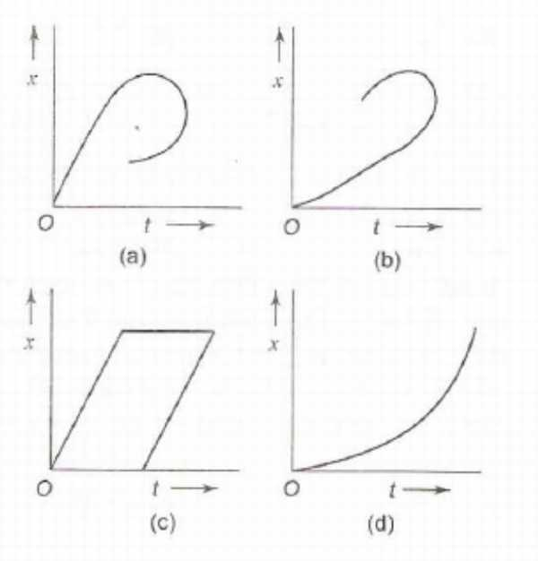

{ Hint: The object cannot be at two positions on a single time instant,
So, d) is the correct option. }
Example 3: A car starts from rest, accelerates uniformly for 4 seconds and then moves with uniform velocity. Which of the (x-t) graphs shown in Fig. represents the motion of the car upto t = 7 s?
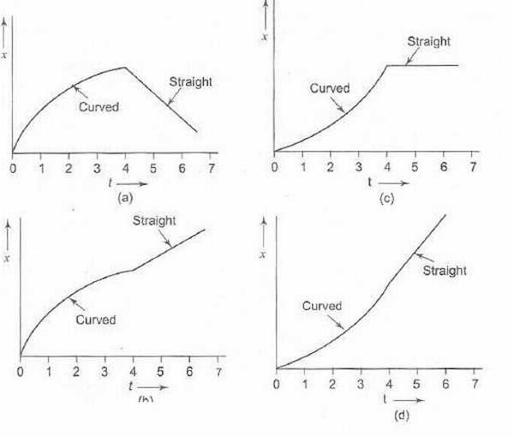

{ Hint: As the car is accelerating upto 4 seconds, the graph should be concave up. Further ahead , it moves with constant velocity , so a positive slope ahead of 4 seconds.
d) is the correct answer. }
Example 4: Two stones are thrown up simultaneously with initial speeds of u₁ and u₂, (u₂ > u₁) . They hit the ground after 6 s and 10 s respectively. Which graph in Fig. correctly represents the time variation of △x = x₂ − x₁, the relative position of the second stone with respect to the first upto t = 10 s? Assume that the stones do not rebound after hitting the ground.
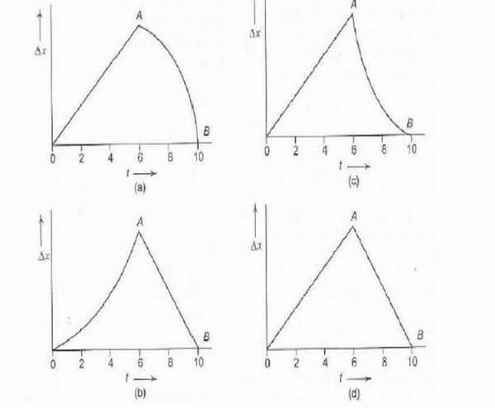

{ Hint : While both are in air, the differece of their velocity vectors would be a constant vector , so △x = c₁t . Also, after the first stone hits ground, △x = c₂t − x_{o} as the velocity component in x direction of second stone is constant. There is no discontinutiy. So, both before and after one hits the ground , it would be a straight line.
Hence, d) is the correct answer. }
Example 5: Figure shows the velocity-time (v - t) graphs for one dimensional motion. But only some of these can be realized in practice. These are
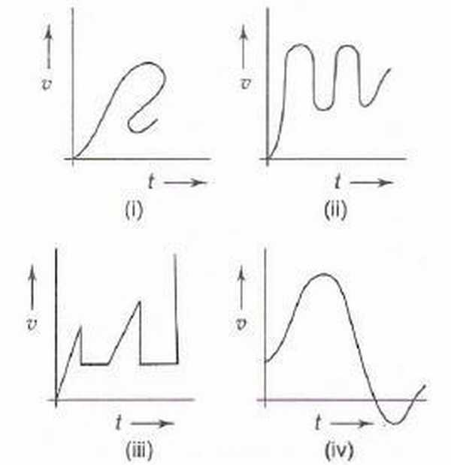

a) (i), (ii) and (iv) only
b) (i), (ii) and (iii) only
c) (ii) and (iv) only
d) all
{ Hint: At one particular instant, the object cannot have two different velocities.
Hence, c) is the correct answer. }
Example 6: Which of the velocity-time (v-t) graphs shown in Fig. can possibly represent one-dimensional motion of a particle?
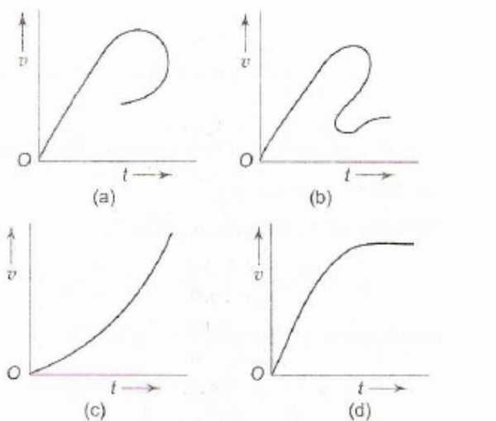

{Hint: In c) , the particle is constantly increasing in one dimension, In d) , it stops near the end.
c),d) are the correct answers. }

3.2Question Types

3.2.1Passage Type
Example:The speed-time graph of the motion of a body is shown in Fig.
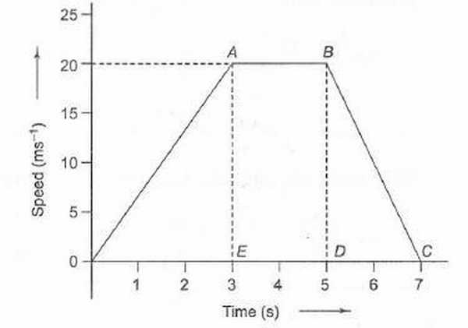

1.The accelerations of the body during the last 2 second is
a) (20)/(3)ms ⁻ ²
b) − (20)/(7)ms ⁻ ²
c) − 10ms ⁻ ²
d) Zero
2.The ratio of distance travelled by the body during the last 2 seconds to the total distance travelled by it is
a) 1/9
b) 2/9
c) 3/9
d) 4/9
3.The average speed of the car during the whole journey is
a) 10 m/s
b) 20 m/s
c) 90/7 m/s
d) 40/7 m/s
{Hint: 1. As no contradictory statements are present, we would take velocity as the value of speed only. Actually velocity is required for calculation of acceleration but here , speed doesn’t contradict anything so we’ll use it’s value for velocity.
-10 from slope, c)
2. Speed time graph’s area is distance. From area calculation, in last 2 seconds, the area is 20 and total area is 90.
So, 2/9 is the required ration b)
3. Total distance from area is 90, and total time is 7.
So, 90/7. c)}
Example:A body starts from rest at time t = 0 and undergoes an acceleration as shown in Fig.Which of the graphs shown in Fig. represents the velocity-time (v-t) graph of the motion of the body from t = 0 s to t = 4 s?
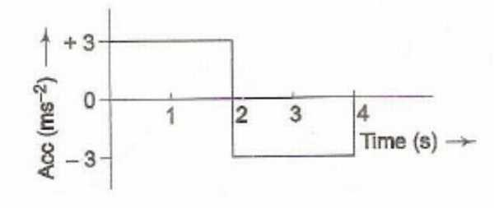

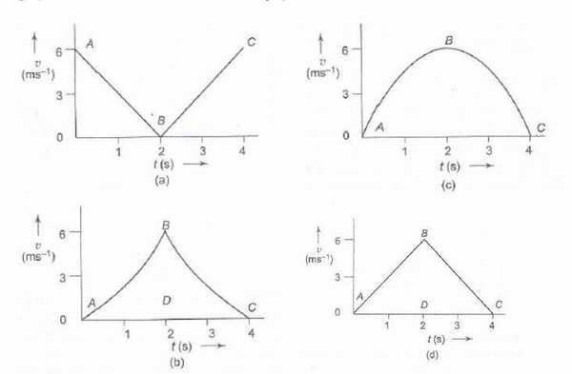

{Hint: d) is the v-t graph by calculating area function.}
1.In Question above, what is the velocity of the body at time t = 2.5 s?
a) 2.5 m/s
b) 3.5 m/s
c) 4.5 m/s
d) 5.5 m/s
2.In above question, how much distance does the body cover from t = 0 s to t = 4 s?
a) 6 m
b) 9 m
c) 12 m
d) 15 m
3In above question, which of the graphs shown in Fig. represents the displacement-time (x-t) graph of the motion of the body from t = 0 s to t = 4 s?
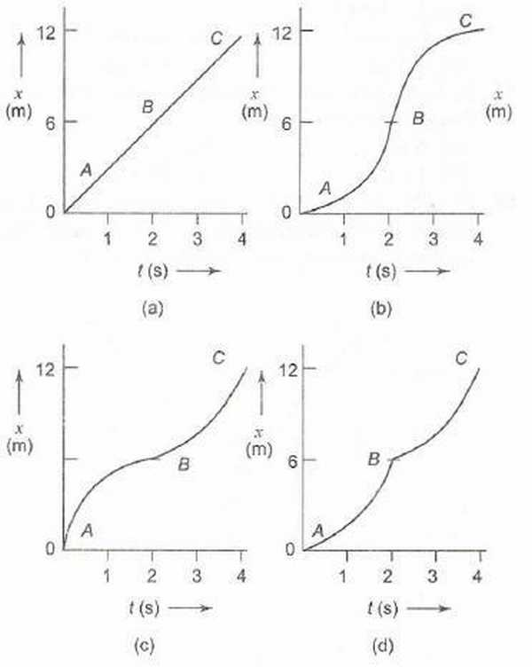

{ Hint: 1. The area under the accln-time graph gives change in velocity. Till 2.5s, 6-1.5=4.5 is the required area.
So, c)
2. Area under the v-t graph d) is 12 till 4 seconds.
So, c)
3. Till 2 seconds , the graph should be concave-up while from 2 to 4 it should be concave-down.
So, b)
}

3.2.2Matching
1.Match the graphs (a), (b), (c) and (d) shown in Fig. with the types of motions (p), (q), (r) and (s) that they represent
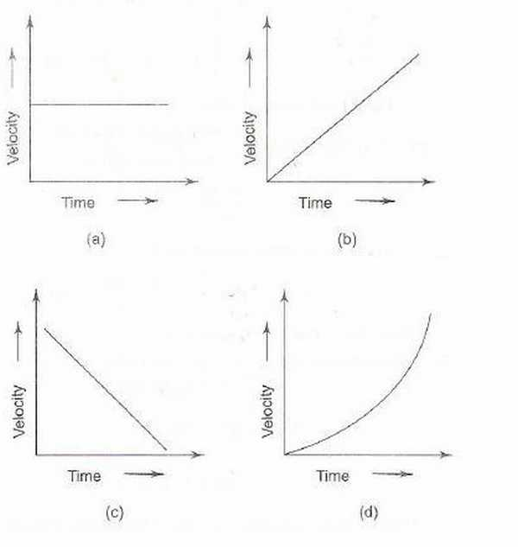

p) Motion with non-uniform acceleration
q) Motion of a body covering equal distances in equal intervals of time
r) Motion having a constant retardation
s) Uniformly accelerated motion.
{ Hint: p->d , q->a, r ->c , s->a,b,c }
2.Figure shows the displacement ·time (x - t) graph of the m-tion of a body.
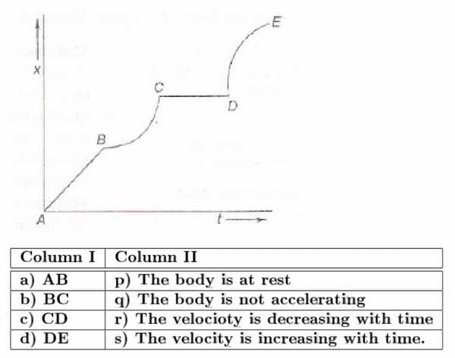

{Hint p- >c, q->a,c, r-> d , s->b }

3.3 ↓Previous Years IIT Problems
Q1:A particle starts from rest. Its acceleration ( a ) versus time ( t ) is as shown in the gure. The maximum speed of the particle will be

a ) 110 m /s
b ) 55 m /s
c ) 550 m /s
d ) 660 m /s
{ Hint : See In chapter examples for solution. }
Q2:If graph of velocity vs. distance is as shown, which of the following graphs correctly represents the variation of acceleration with displacement ?

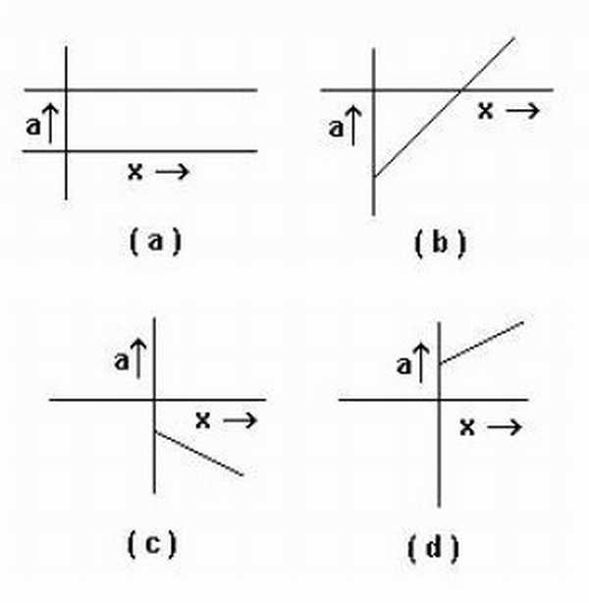

{ Hint : The graph of the question is a straight line with the equation, (x)/(x_{o}) + (v)/(v_{o}) = 1
This gives , v = v_{o}(1 − x ⁄ x_{o})
So, diffrentiating it, we get
a = − v_{o} ⁄ x_{o} which is a constant. Only in a) it is shown to be a constant.
So, a) }
PassageA lift is going up. The variation in the speed of the lift is as given in the graph.
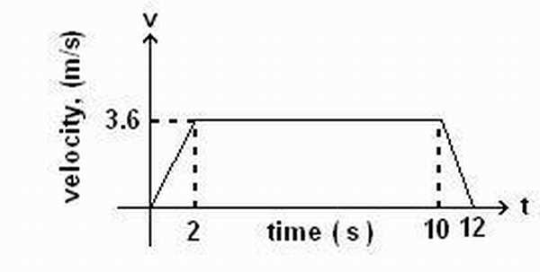

Q3:What is the height to which the lift takes the passengers ?
a ) 3.6 m
b ) 28.8 m
c ) 36 m
d ) cannot be calculated from the above graph
Q4:In the above graph, what is the average velocity of the lift?
a ) 1 m/s
b ) 2.88 m/s
c ) 3.24 m/s
d ) 3 m/s
Q5:In the above graph , what is the average acceleration of the lift?
a ) 1.8m ⁄ s²
b ) −1.8m ⁄ s²
c ) 0.3m ⁄ s²
d ) zero
{Hint: Q3: Area under the graph is 36. Taking initial position as zero, c) is the best fit answer.
Q4. For av. velocity, total displacement / total time should be calculated. which is 36/12 = 3m/s . d ) is the required answer.
Q5. The accln is 1.8 from 0s to 2s, 0 from 2s to 10s and -1.8 from 10s to 12s. So, area under the a-t graph is zero. So av. accln is zero d)
}
Q6:Four persons K, L, M and N are initially at the corners of a square of side of length d. If every person starts moving with velocity v such that K is always headed towards L, L towards M, M towards N and N towards K, then the four persons will meet after
a ) d/v s
b ) d2/ v s
c ) d / 2v s
d ) d / 2v s
{Hint: Not a graphs question, we’ll discuss it in kinematics book. Athough an easy one. It was mistakenly added to graphs book. Let’s use it to signify the fact that even if a diagram is made, it is still not a graph.}
Example.A ball is dropped vertically from a height h above the ground. It hits the ground and bounces up vertically to a height h/2. Neglecting subsequent motion and air resistance, its velocity v varies with the height h as (see Fig.) (l.l.T. 2000)
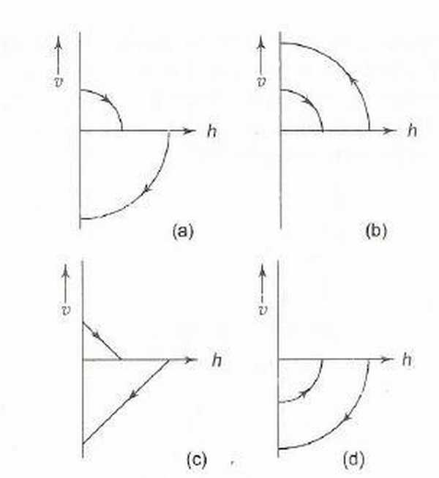

{ Hint : Case 1: Thrown from height h with zero initial velocity, v=-gt and h = h_{o} − 1 ⁄ 2gt², so eliminating t, we get h = h_{o} − v² ⁄ 2g. So, v = − √(2g(h_{o} − h))
Case 2: We assume the opposite for solving purpose that the ball is now thrown from a height h_{o} ⁄ 2 and replace ho only and see the effect. Taking upward velocity as positive , we get v = √(2g(h_{o} ⁄ 2 − h))
a) is the required answer. }

4Exercises

4.1Review Exercise I
Question 1. A spark timer/air table produced the tape pictured below.
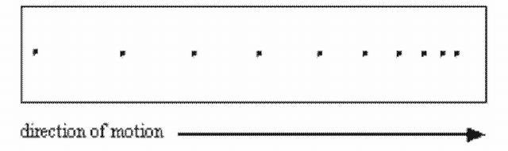
The object, moving to the right, was
a. moving with uniform motion
b. speeding up
c. slowing down
d. travelling with constant speed
{ Hint: c}
Question 2. Study the position-time graph pictured below and select the statement that is true.
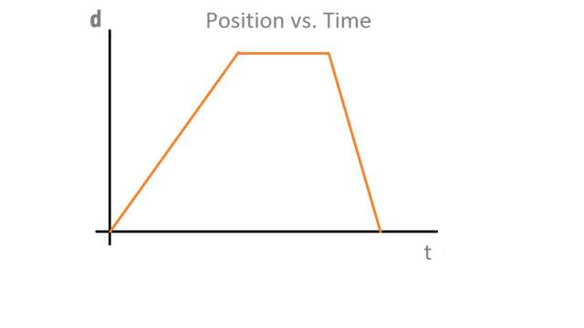
a. The object accelerates, stops, then accelerates in the opposite direction.
b. The object’s speed is greatest during the first segment.
c. The object’s acceleration is greatest during the last segment.
d. The object’s average velocity is zero.
e. The object travels a greater distance in the first segment than in the last segment.
{ Hint : D }
Question 3. The position-time graph pictured below represents the motions of two objects, A and B. Which of the following statements concerning the objects’ motions is true?
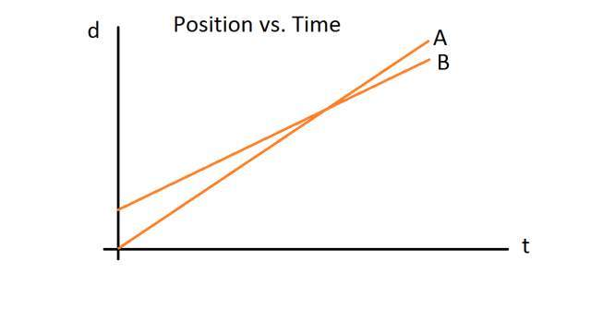
a. Object B travels the greater distance.
b. Object A has the greater speed.
c. Object A leaves the reference point at an earlier time.
d. Both objects have the same speed at the point where the lines cross.
e. Object A is travelling for a longer period of time.
{ Hint : B }
Question 4. The position-time graph pictured below represents a race between three contestants A, B, and C. The race begins at time zero at the sound of the starter’s pistol. Which of the following statements is true?
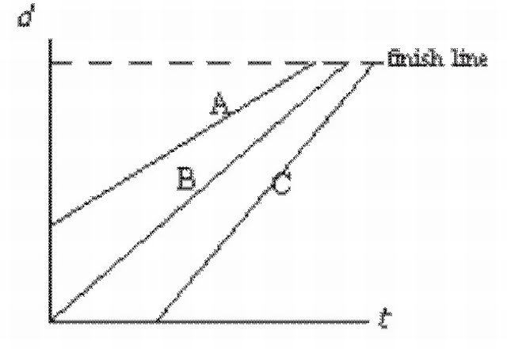
a. The runner who started last finished first.
b. The fastest runner won the race.
c. The runner with a head start won the race.
d. Only one runner began at the sound of the starter’s pistol.
e. All runners ran the same distance.
{ Hint : C }
Question 5. The position-time graph pictured below depicts a person, P, running to catch a bus, B, that has just begun to pull away. Which of the following statements is true?
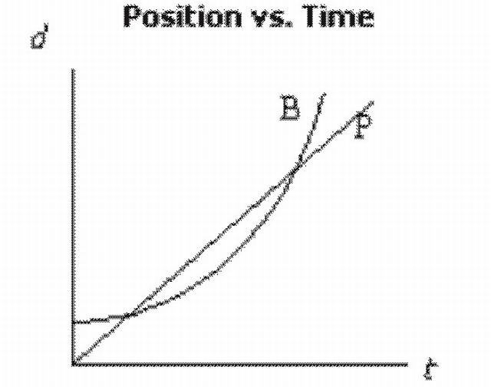
a. The person has no chance of catching the bus.
b. The person’s acceleration is greater than that of the bus.
c. The person has two opportunities to catch up to the bus.
d. The speed of the bus is always greater than that of the person.
e. The person’s speed is always greater than that of the bus.
{ Hint : C}
Question 6. The position-time graph that depicts a ball thrown vertically upward that returns to the same position is
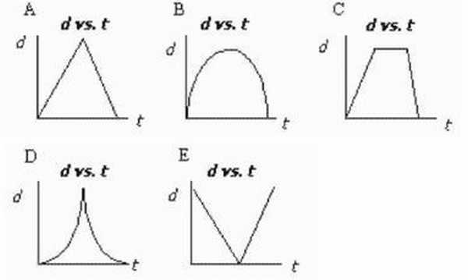
a.A
b. B
c. C
d. D
e. E
{ Hint : B }
Question 7. The position-time graph that represents "uniform motion" is
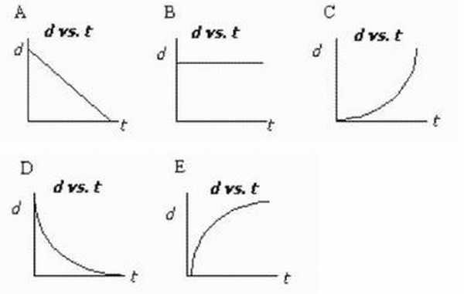
a. A
b. B
c. C
d. D
e. E
{ Hint : A}
Question 8. The velocity-time graph that represents "uniform motion" is
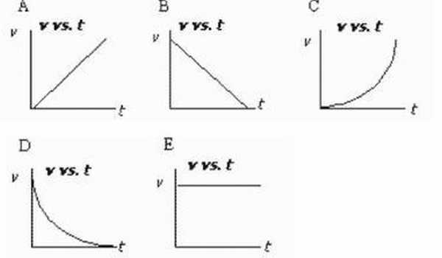
a. A
b. B
c. C
d. D
e. E
{ Hint : E }
Question 9. The velocity-time graph pictured below depicts the motion of a motorcycle. Which of the following statements is true?
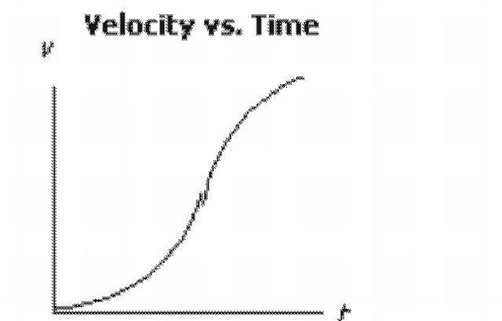
a. The motorcycle is always experiencing an acceleration.
b. The motorcycle’s greatest speed occurs toward the end of the recorded time interval.
c. The motorcycle’s average acceleration is zero.
d. The motorcycle eventually reaches uniform motion.
e. The motorcycle accelerates until it reaches a constant speed.
{ Hint : A }
Question 10. The velocity-time graph pictured below represents the motion of a police car, P, in pursuit of a motorcycle, M. The motorcycle has just passed the police car. Which of the following statements is true?
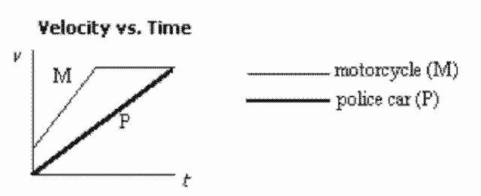
a. Both vehicles are at rest when the pursuit begins.
b. The police car eventually catches the motorcycle.
c. The motorcycle accelerates and then slows down.
d. At the end of the recorded time interval, the police car has yet to catch the motorcycle.
e. The police car passes the motorcycle.
{ Hint : D }
Question 11. Consider the following velocity-time graph and select the statement that is true.
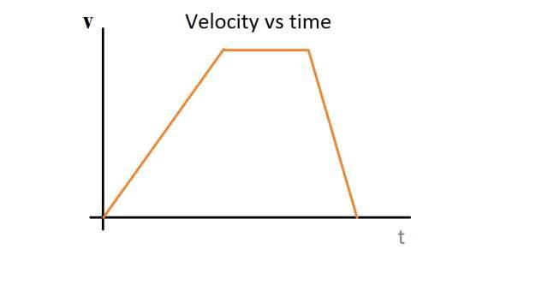
a. At no time can the motion be considered "uniform."
b. The object returns to its original position.
c. The object travels in one direction and then the other.
d. The object is accelerating throughout the entire recorded time.
e. The object speeds up and later slows down.
{ Hint : E }
____ 41. Which of the following velocity-time graphs represents the motion of a ball thrown vertically upward?
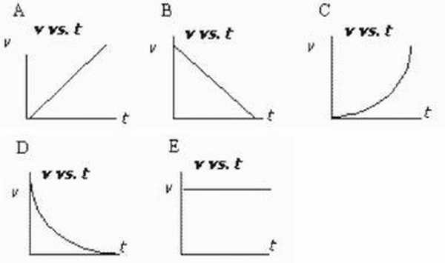
a. A
b. B
c. C
d. D
e. E
{ Hint : B }
____ 42. The following velocity-time graph depicts the motions of two objects, A and B. Which of the statements describing the graph is true?
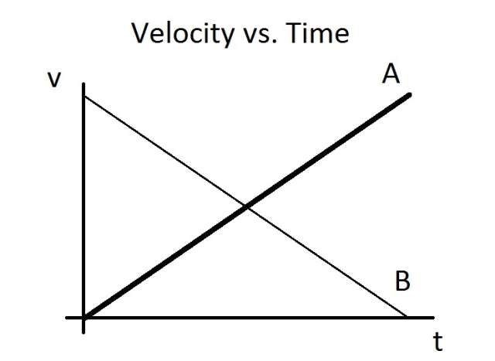
a. Both objects are accelerating uniformly.
b. The two objects are travelling in opposite directions.
c. Both objects start from rest.
d. Object A travels farther than object B.
e. Object B travels farther than object A.
{ Hint : A }
____ 43. Which statement describes the motion represented by the following acceleration-time graph?
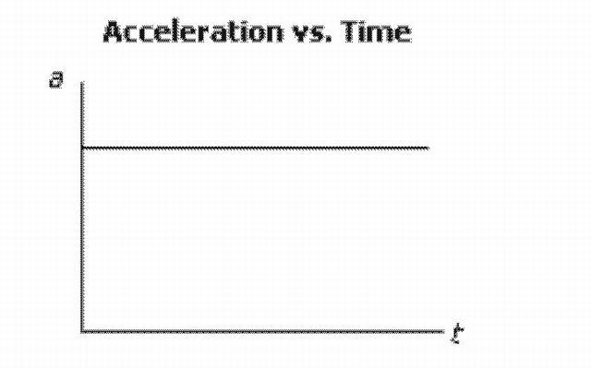
a. The object is moving with uniform motion.
b. The object has a constant velocity.
c. The object has a uniform acceleration.
d. The object is stopped.
e. The object has a changing acceleration.
{ Hint : C }
____ 44. A ball is thrown vertically upward into the air. Which of the following acceleration-time graphs represents the ball’s motion?
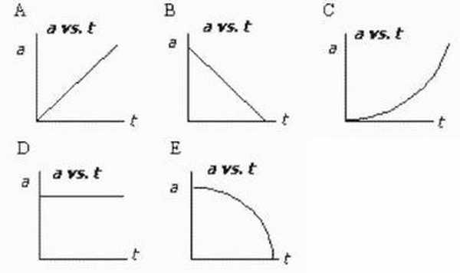
a. A
b. B
c. C
d. D
e. E
{ Hint : D }
____ 45. Four of the five graphs pictured below could all represent the same motion. Which graph does not belong to this group?
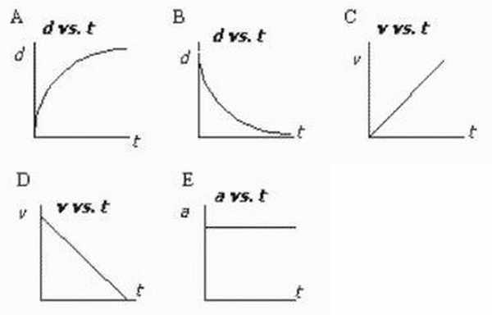
a. A
b. B
c. C
d. D
e. E
{ Hint : C }
____ 49. The position-time graph below depicts the motions of two objects, A and B. Which of the following statements concerning the objects’ motions is NOT true?
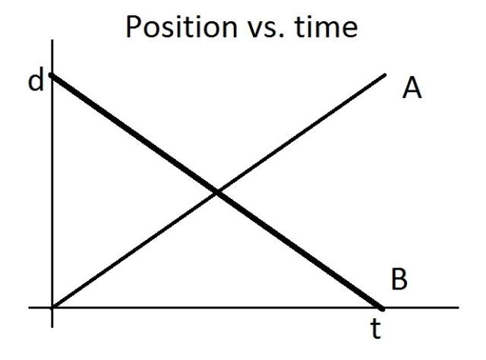
a. The two objects have the same speed.
b. The two objects travel the same distance.
c. The two objects travel with uniform motion.
d. The two objects travel for the same amount of time.
e. The two objects have the same velocity.
{ Hint : E }
____ 50. What type of motion is depicted by the following acceleration-time graph?
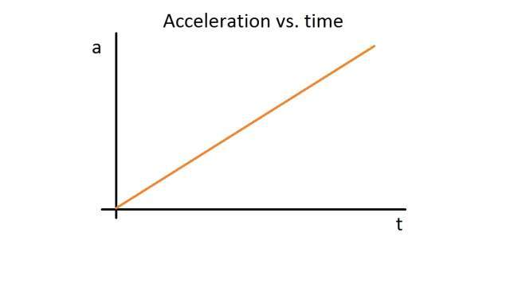
a. constant velocity b. non-uniformly changing acceleration c. constant acceleration d. uniformly changing acceleration e. uniform motion
{ Hint: D}
____ 51. The diagram below shows the first three legs of a trip: A to B, B to C, and C to D. If a person returns from point D to point A, what is the displacement for this fourth and final leg?
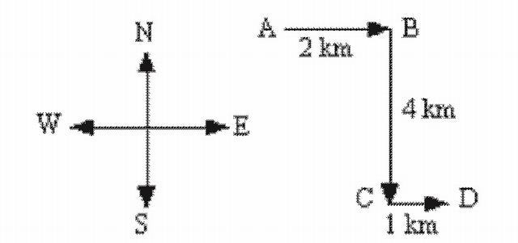
a. 7 km [37° W of N]
b. 5 km [37° W of N]
c. 5 km [37° E of S]
d. 7 km [37° E of S]
e. 5 km [37° N of E]
{ Hint : B }

4.2Review Exercise II
1. A cart travels with a constant nonzero acceleration along a straight line. Which graph best represents the relationship between the distance the cart travels and time of travel?
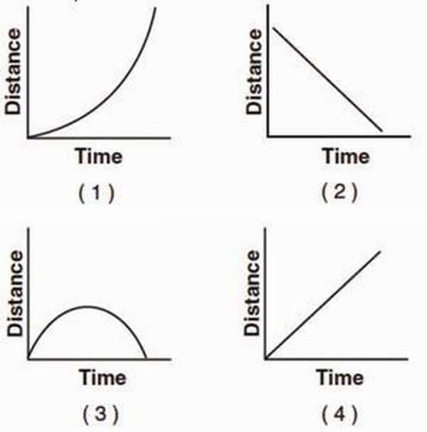
{ Hint: First of all the graph should be a parabola. Secondly, it can’t be (3) as distance can only increase. }
Base your answers to questions 2 through 4 on the information below.
A car on a straight road starts from rest and accelerates at 1.0 meter per second² for 10 seconds. Then the car continues to travel at constant speed for an additional 20 seconds.
2. Determine the speed of the car at the end of the first 10 seconds.
{ Hint : v=at, so v at 10 s = 10 m/s}
3. On the grid at below, use a ruler or straightedge to construct a graph of the car’s speed as a function of time for the entire 30-second interval.
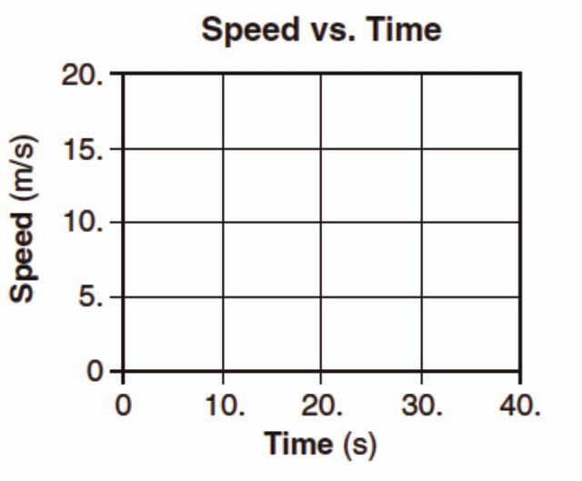
{ Hint: Try out yourself. }
4. Calculate the distance the car travels in the first 10 seconds. [Show all work, including the equation and substitution with units.]
{ Hint: s=1 ⁄ 2at² = 50m }
5. A student throws a baseball vertically upward and then catches it. If vertically upward is considered to be the positive direction, which graph best represents the relationship between velocity and time for the baseball? [Neglect friction.]
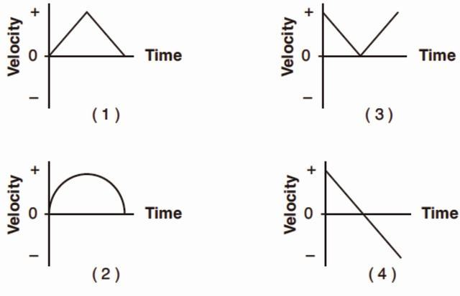
{ Hint : v=u-gt, so velocity is continually decreasing with 9.81 m/s and even turns negative, equal to the initial value in magnitude on return and opposite direction if air drag is neglected.
D) is the correct option. }
6. The graph below represents the displacement of an object moving in a straight line as a function of time.
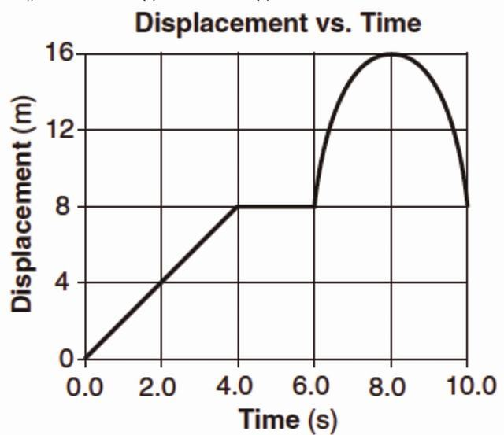
What was the total distance traveled by the object during the 10-second time interval?
1. 0 m
2. 8 m
3. 16 m
4. 24 m
{ Hint: The object moves 16m forward and 8m backward. So, distance is 24 m.
4) is the correct option. }
7. Which graph best represents the relationship between the acceleration of an object falling freely near the surface of Earth and the time that it falls?
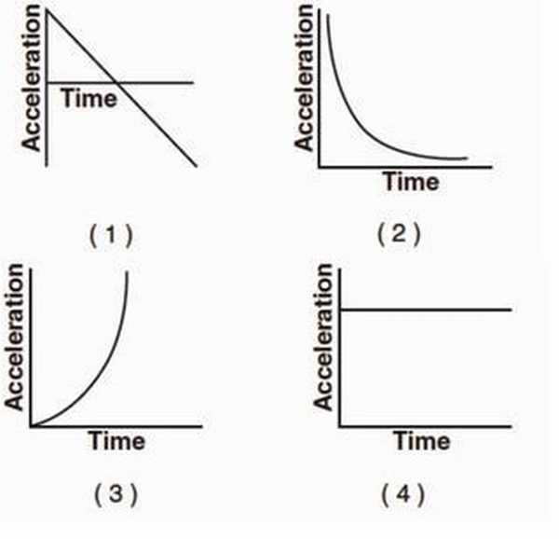
{ Hint : Acceleration due to gravity near the earth surface is constant, being 9.81 m ⁄ s² }
8. Which pair of graphs represent the same motion of an object?
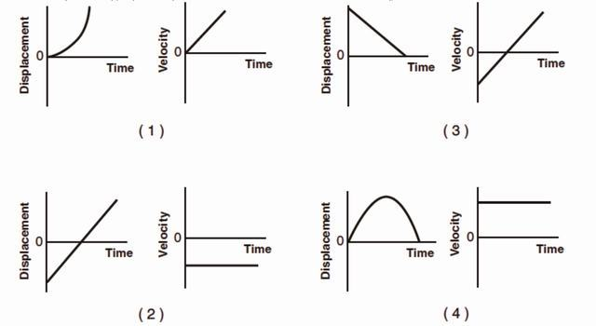
{ Hint : A) }
9. The graph below represents the velocity of an object traveling in a straight line as a function of time.
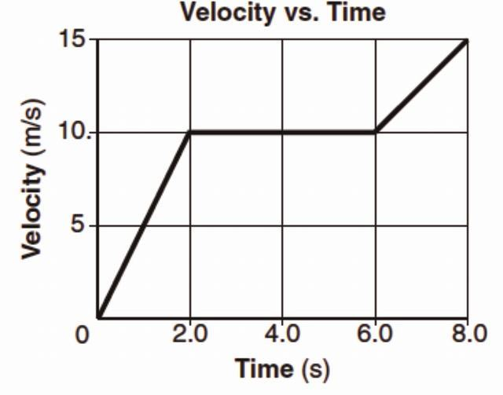
Determine the magnitude of the total displacement of the object at the end of the first 6 seconds.
{Hint 50m, area under the graph till 6s.: }
10. Which graph best represents the motion of a block accelerating uniformly down an inclined plane?
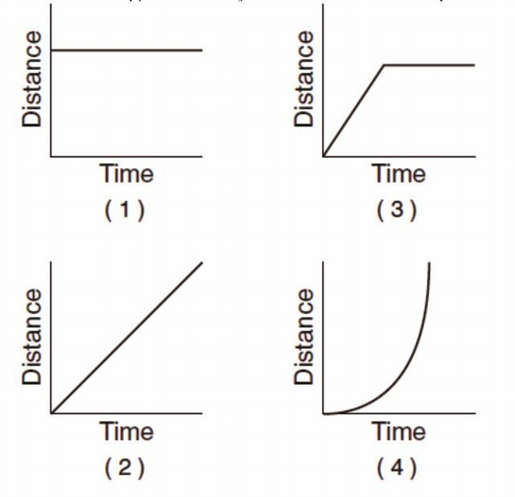
{Hint: (4) as the graph would be a function of t², calculated via the usual equations of motion for uniformly accelerated motion.}
Base your answers to questions 11 and 12 on the graph below, which represents the motion of a car during a 6-second time interval.
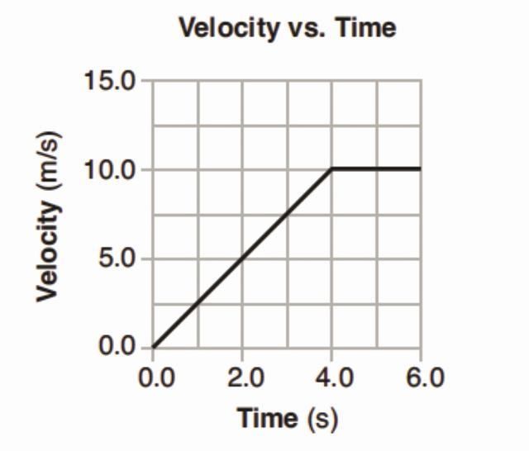
11. What is the acceleration of the car at t=5.0 seconds?
1. 0.0 m/s2
2. 2.0 m/s2
3. 2.5 m/s2
4. 10 m/s2
{Hint : It is the slope of v-t graph, at t=5.0, the graph has zero slope. So, (1)}
12. What is the total distance traveled by the car during this 6-second interval?
1. 10 m
2. 20 m
3. 40 m
4. 60 m
{ Hint : Area under the v-t curve, 40m, So, (3)}
13. Which graph best represents the relationship between the velocity of an object thrown straight upward from Earth’s surface and the time that elapses while it is in the air? [Neglect friction.]
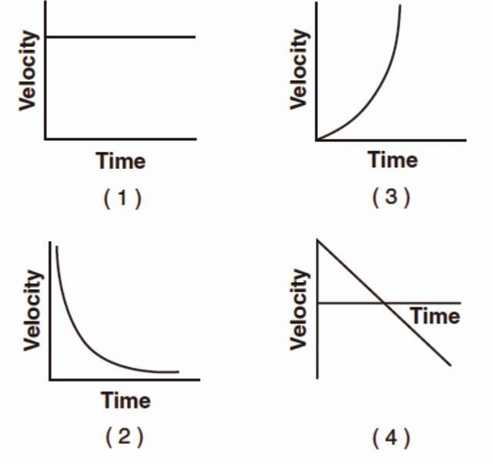
{ Hint : (4) }
14. The graph below shows the relationship between the speed and elapsed time for an object falling freely from rest near the surface of a planet.
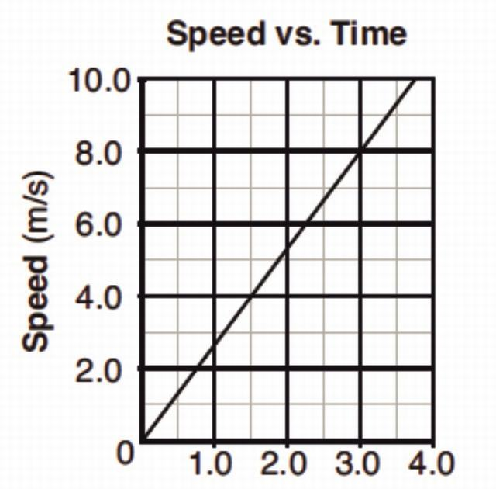
What is the total distance the object falls during the first 3 seconds?
1. 12 m
2. 24 m
3. 44 m
4. 72 m
{ Hint : Area under the graph between 0 and 3, 12m}
15. The graph below represents the relationship between speed and time for an object moving along a straight line.
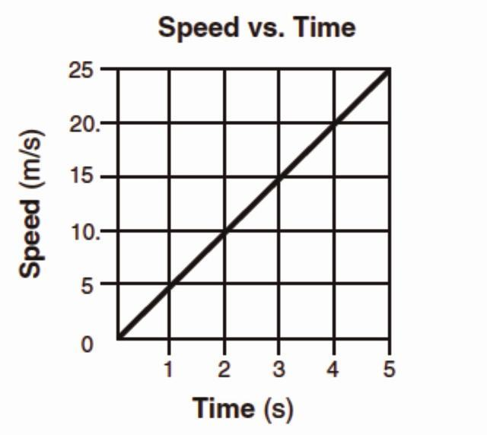
What is the total distance traveled by the object during the first 4 seconds?
1. 5 m
2. 20 m
3. 40 m
4. 80 m
{ Hint : 40m , So, 3}
Base your answers to questions 16 and 17 on the graph below, which shows the relationship between speed and elapsed time for a car moving in a straight line.
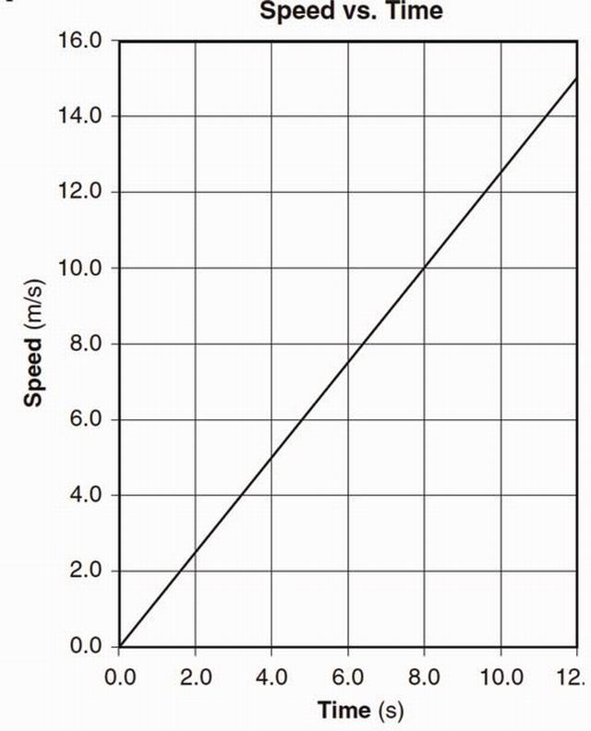
16. Determine the magnitude of the acceleration of the car.
{ Hint : Slope of the line , 1.25m/s2 }
17. Calculate the total distance the car traveled during the time interval 4.0 seconds to 8.0 seconds. [Show all work, including the equation and substitution with units.]
{ Hint : It’s the area of trapezium with parallel sides , 5 and 10 and distance between them as 4 , = 30m }
Base your answers to questions 18 through 20 on the graph below, which represents the relationship between velocity and time for a car moving along a straight line, and your knowledge of physics.
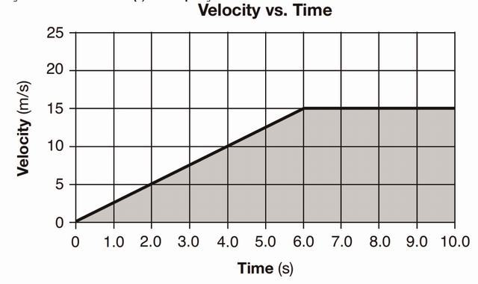
18. Determine the magnitude of the average velocity of the car from t=6.0 seconds to t=10.0 seconds.
{ Hint : Velocity is constant between 6 and 10 , ie 15 m/s}
19. Determine the magnitude of the car’s acceleration during the first 6.0 seconds.
{ Hint : Slope of the graph is 1.5 m/s2}
20. Identify the physical quantity represented by the shaded area on the graph.
{ Hint : Dispacement of the car from initial position by t=10.0s , calculated to be 105m}
\printbibliography

Part II. ↓Newton’s Equations of Motion

5 ↓Derivation of Newton’s Equations of Motion from basic forms and graphs
We will use the basic assumptions like ⟶v = (⟶dr)/(dt) (First Equation) and ⟶a = (⟶dv)/(dt)(2nd Equation) and the v-t graph to derive the following Newton’s equations of motion for constant acceleration case(i.e. in Newton’s equations we assume that ⟶a is constant while the basic first and second equation , we can use everywhere[non-uniform acceleration cases too]).
1. ⟶v = ⟶v_{o} + ⟶at (Newton’s first equation of motion)
2. ⟶r = ⟶r_{o} + ⟶v_{o}t + (1)/(2)⟶at² (Newton’s second equation of motion)
3. ⟶v.⟶v = ⟶v_{o}.⟶v_{o} + 2⟶a.(⟶r − ⟶r_{o}) (Newton’s third equation of motion)

5.1 ↓Newton’s first equation of motion
The equation is ⟶v = ⟶v_{o} + ⟶at
We’ll first rewise a 9th class derivation without the use of first equation.

5.1.1Basic Derivation (without use of calculus or graphs)
We define ⟶a = (⟶v − ⟶v_{o})/(t)
Cross multiplying, \strikeout off\uuline off\uwave off⟶at = ⟶v − ⟶v_{o}
⇒ ⟶v = ⟶v_{o} + ⟶at

5.1.2Derivation from v-t graph(Scalar form)
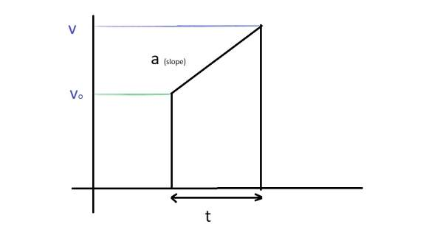
We define the slope of v-t graph as a, so it gives a = (v − v_{o})/(t)
Manipulating the form of this equation, we get v = v_{o} + at , which is newton’s first equation of motion in scalar form.

5.1.3Calculus Derivation(to be used in our class)
By the 2nd equation General Definition, we have
⟶a = (⟶dv)/(dt)
⇒ ⟶dv = ⟶adt
⇒ ∫_{⟶vo}^{⟶v}⟶dv = ∫₀^{t}⟶adt
⇒ [⟶v]_{⟶vo}^{⟶v} = ⟶a[t]₀^{t}
⇒ \strikeout off\uuline off\uwave off⟶v − ⟶v_{o} = ⟶at
⇒ ⟶v = ⟶v_{o} + ⟶at ——— ( Derived)

5.2 ↓Newton’s second equation of motion
The equation is ⟶r = ⟶r_{o} + ⟶v_{o}t + (1)/(2)⟶at²
We’ll first rewise a 9th class derivation without the use of first equation.

5.2.1Basic Derivation (without use of calculus or graphs)
We’ll be using newton’s first equation of motion and the definition of average velocity to derive it.
⟶v = (⟶v + ⟶v_{o})/(2) .i.e. Average velocity vector is the the average of initial velocity and final velocity vectors.
Also, ⟶s = ⟶vt
⇒ ⟶s = (⟶v + ⟶v_{o})/(2)t
Substituting, ⟶v = ⟶v_{o} + ⟶at , i.e. the newton’s first equation of motion. We get
⟶s = (⟶v_{o} + ⟶at + ⟶v_{o})/(2)t
Now, ⟶s = ⟶r − ⟶r_{o} , displacement vector is the difference of final position vector and initial position vector.
Manipulating, we get
⟶r − ⟶r_{o} = (2⟶v_{o} + ⟶at)/(2)t
OR
⟶r = ⟶r_{o} + ⟶v_{o}t + (1)/(2)⟶at²

5.2.2Derivation from v-t graph(Scalar form)
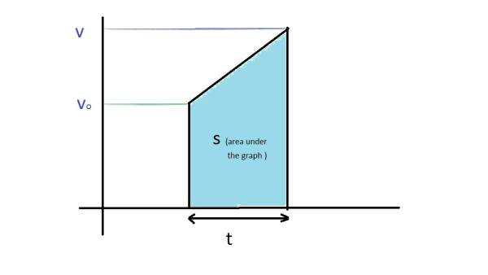
Area under the v-t graph is dispacement(s)
Area of a trapezium is sum of parallel sides X distance between them
⇒ s = (v + v_{o})/(2)t
Substituting, the previously derived newton’s first equation of motion in scalar form
⇒ s = (v_{o} + at + v_{o})/(2)t
OR
s = v_{o}t + (1)/(2)at²

5.2.3Calculus Derivation(to be used in our class)
We have, ⟶v = (⟶dr)/(dt) , by first equation general definition
Substituting, newton’s first equation of motion
We get
\strikeout off\uuline off\uwave off⟶v_{o} + ⟶at = (⟶dr)/(dt)
⇒ ∫_{⟶ro}^{⟶r}⟶dr = ∫₀^{t}(⟶v_{o} + ⟶at)dt
⇒ [⟶r]_{⟶ro}^{⟶r} = [⟶v_{o}t + (1)/(2)⟶at²]₀^{t}
⇒ ⟶r − ⟶r_{o} = ⟶v_{o}t + (1)/(2)⟶at²
⇒ ⟶r = ⟶r_{o} + ⟶v_{o}t + (1)/(2)⟶at²——— ( Derived)

5.3 ↓Newton’s third equation of motion
The equation is ⟶v.⟶v = ⟶v_{o}.⟶v_{o} + 2⟶a.(⟶r − ⟶r_{o})
We’ll first rewise a basic derivation without the use of first equation. It will require dot product.

5.3.1Basic Derivation (without use of calculus or graphs)
We have,
⟶v − ⟶v_{o} = ⟶at , by newton’s first equation of motion
(⟶v + ⟶v_{o})/(2)t = ⟶s
Taking dot product
\strikeout off\uuline off\uwave off⟶(v − ⟶v_{o}).((⟶v + ⟶v_{o})/(2)t) = ⟶at.⟶s
Cancelling t, transfering 2 to right hand side in numerator and opeing the brackets, we get
⟶v.⟶v − ⟶v_{o}.⟶v_{o} = 2⟶a.⟶s
Manipulating, substituting the value of displacement vector, we get
⟶v.⟶v = ⟶v_{o}.⟶v_{o} + 2⟶a.(⟶r − ⟶r_{o})

5.3.2Derivation from v-t graph(Scalar form)
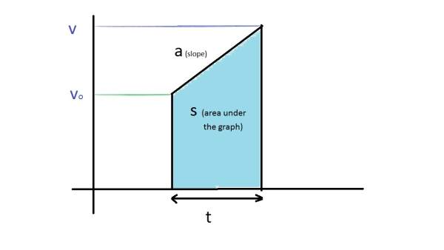
In deriving the newton’s third equation by graph, two values are taken from the graph
a = (v − v_{o})/(t) ands = (v + v_{o})/(2)t
Multiplying both the equations,
as = (v² − v_{o}²)/(2)
OR
v² − v_{o}² = 2as

5.3.3Derivation(to be used in our class)
We have, ⟶v = (⟶dr)/(dt) (First Equation) and ⟶a = (⟶dv)/(dt)(2nd Equation) as the basic General Definition
Reversing the sides of the second equation and taking dot product, we get
⟶v.⟶dv = ⟶a.⟶dr
Integrating,
∫_{⟶vo}^{⟶v}⟶v.⟶dv = ∫_{⟶ro}^{⟶r}⟶a.⟶dr
⇒ [(⟶v.⟶v)/(2)]_{⟶vo}^{⟶v} = ⟶a.[⟶r]_{⟶ro}^{⟶r} (This type of Integral in dot product, we’ll study at bachelor’s level, here we can prove it using vector’s components)
Substituting the values of limits,
(⟶v.⟶v − ⟶v_{o}.⟶v_{o})/(2) = ⟶a.⟶s
⇒ ⟶v.⟶v − ⟶v_{o}.⟶v_{o} = 2⟶a.⟶s ——— ( Derived)

6 ↓Crossing the River problems (Theory)
Theory Problem 1. Two swimmers leave point A on one bank of the river to reach point B lying right across on the other bank. One of them crosses the river along the straight line AB while the other swims at right angles to the stream and then walks the distance that he has been carried away by the stream to get to point B. What was the velocity u of his walking if both swimmers reached the destination simultaneously? The stream velocity v_{o} = 2.0 km/hour and the velocity v’ of each swimmer with respect to water equals 2.5 km per hour.
Solution. Case I : Swimmer swims with final velocity along AB, this case is also called the “Shortest Path” case.
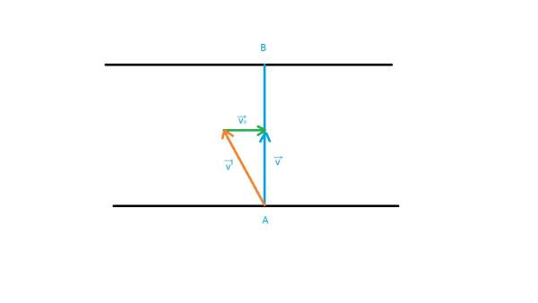
We see that ⟶v’ + ⟶v_{o} = ⟶v and they form a right triangle
⇒ v = √(v’² − v_{o}²)
time to reach point B = (AB)/(√(v’² − v_{o}²))
Case II : Swimmer swims at right angle to the stream, this would require the “Shortest time in crossing the river” but the problem requires that he would have to walk to get to B.
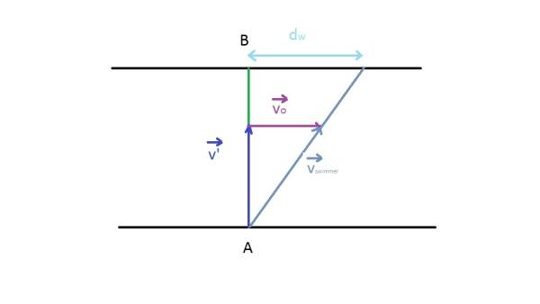
We see that ⟶v’ + ⟶v_{o} = ⟶v and they form a right triangle, though this time with \strikeout off\uuline off\uwave off⟶v as the hyportenuse. It should be noted however that this time v’, vo and v vectors are different from Case I while the magnitudes of v’ and vo are the same. Our problem Case II is independent in this regard from case I and we can choose the same names without loss of generality
Proceeding to solve the question
(AB)/(v’) = (d_{w})/(v_{o}) (By similarity of triangles, from figure)
⇒ d_{w} = (v_{o})/(v’).AB
Time t₁ to cross the river and reach the point (say C )
t₁ = (AB)/(v’)
Time t₂ to cross the distance dw back to B
t₂ = (d_{w})/(u)
Total time = t₁ + t₂ = (AB)/(v’) + (d_{w})/(u) = (AB)/(v’) + ((v_{o})/(v’).AB)/(u)
Proceeding to solve the problem by comparing both the cases,
(AB)/(√(v’² − v_{o}²)) = (AB)/(v’) + ((v_{o})/(v’).AB)/(u)
Solving further, we get the required form, first cancelling AB and cross multiplying v’
(v’)/(√(v’² − v_{o}²)) − 1 = (v_{o})/(u)
⇒ u = (v_{o})/((v’)/(√(v’² − v_{o}²)) − 1)
Calculating the value, u = 3 km/hr
Theory Problem 2 : Two boats, A and B, move away from a buoy anchored at the middle of a river along the mutually perpendicular straight lines: the boat A along the river, and the boat B across thg river. Having moved off an equal distance from the buoy the boats returned. Find the ratio of times of motion of boats τ_{A} ⁄ τ_{B} if the velocity of each boat with respect to water is η = 1.2 times greater than the stream velocity.
Solution:
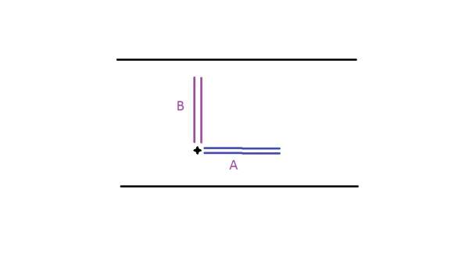
Let the stream velocity be v_{o} , then the boat velocity with respect to water is ηv_{o} . Also let us assume that the equal distance be d.
Case A : Final velocity of boat A in forward journey ( in the stream direction )
v = ηv_{o} + v_{o} = (η + 1)v_{o}
Time to reach the destination =t₁ = (d)/((η + 1)v_{o}) ............(1)
Final velocity of boat A in the backward journey ( opposite to the stream direction )
v = ηv_{o} − v_{o} = (η − 1)v_{o}
Time to reach back to the buoy =t₂ = (d)/((η − 1)v_{o}) ............(2)
τ_{A} = t₁ + t₂ = (d)/((η + 1)v_{o}) + (d)/((η − 1)v_{o}) = (2η)/(η² − 1)(d)/(v_{o})
Case B : Here we proceed according to the shortest path case in Theory Problem 1.
In Forward Journey (Upwards in the figure)
t₁ = (d)/(√(η² − 1)v_{o})
In Backwards Journey (Downwards in the figure)
t₂ = (d)/(√(η² − 1)v_{o}) = t₁
\strikeout off\uuline off\uwave offτ_{B} = t₁ + t₂ = 2t₁ = (2)/(√(η² − 1))(d)/(v_{o})
(τ_{A})/(τ_{B}) = ((2η)/(η² − 1)(d)/(v_{o}))/((2)/(√(η² − 1))(d)/(v_{o})) = (η)/(√(η² − 1))
Substituting the value, we get 6/√(11) as the ratio. = 1.81 (approx.)
Theory Problem 3 : A boat moves relative to water with a velocity which is n = 2.0 times less than the river flow velocity. At what angle to the stream direction must the boat move to minimize drifting?
Solution: Let the river flow velocity = v_{o} . and velocity of boat relative to water would be then \strikeout off\uuline off\uwave offv’ = v_{o} ⁄ n .
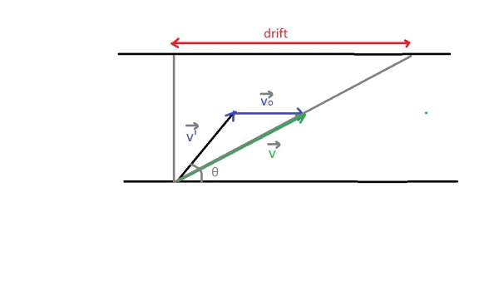
Across component(along y axis) of v is v’sinθ
Drift component(along x axis) of v is v’cosϑ + v_{o}
drift = (AB)/(v’sinθ)(v’cosϑ + v_{o}) = AB(cotθ + (v_{o})/(v’)cosecθ) = AB(cotθ + ncosecθ)
Now we have to minimize drift,
At minima, (d)/(dθ)drift = 0
⇒ (d)/(dθ)AB(cotθ + ncosecθ) = 0
⇒ AB(cosec²θ + ncosecθcotθ) = 0
⇒ cosϑ = − (1)/(n)
The only solution in (0,π) is 120º.

7 ↓2D Projectile Motion

7.1Projection at an angle to the Horizontal
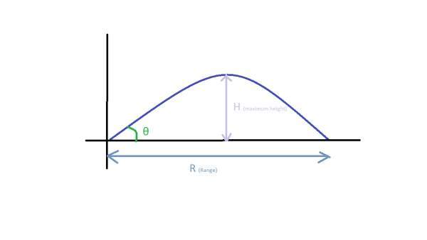
From Figure, we get
v_{x} = ucosθ ..........(1)
v_{y} = usinθ − gt ..........(2)
x = ucosθt ..........(3)
y = usinθt − (1)/(2)gt² ..........(4)
Case I : Maximum height, H
At maximum height, v_{y} is zero.
This gives the time at maximum height, (equating equation (2) to zero )
T_{H} = (usinθ)/(g) ———–(Supplementary Result)
Substituting this value of T_{H} in y-> equation (4), we get maximum height (H)
H = usinθ.(usinθ)/(g) − (1)/(2)g((usinθ)/(g))²
H = (u²sin²θ)/(2g) ———–(Primary Result) [Maximum Height]
Also , the value of x at this point
X_{H} = ucosθ.T_{H} = (u²sin2θ)/(2g) ———–(Supplementary Result)
Case II: Range, R and Time of Flight, T
At R, y=0.
Substituting this value in equation (4), we get
T = (2usinθ)/(g) ———–(Primary Result) [Time of Flight]
Interestingly, T = 2T_{H} ———–(Supplementary Result)
Substituting the time of flight in x, we get R
R = ucosθ.T = ucosθ.(2usinθ)/(g)
R = = (u²sin2θ)/(g)———–(Primary Result) [Range]
Also, R = 2X_{H} implying that Maximum height occours at half the Flight range.
Case III : Equation of Trajectory
Eliminating t from the equations of x and y (3 and 4) we get
y = usinθ.((x)/(ucosθ)) − (1)/(2)g.((x)/(ucosθ))²
y = xtanθ − (1)/(2)g(x²)/(u²cosθ²)———–(Primary Result) [Equation of Trajectory]

7.2Horizontal Projection (Corollary)
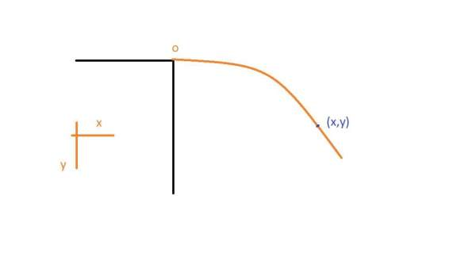
In the case of Horizontal Projection
v_{x} = u
v_{y} = gt
x = ut
y = (1)/(2)gt²

7.3Projection on Inclined Plane
For an inclined plane, we shift the co-ordinate axis x along the plane and y perpendicular to it.This is not necessary, but convenient usually. However, there are cases when it’s usefull to treat a projectile on a inclined plane as a normal projectile of the above two cases.
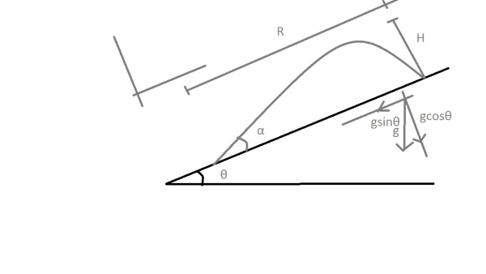
v_{x} = ucosα − gsinθt
v_{y} = usinα − gcosθt
x = ucosαt − (1)/(2)gsinθt²
y = usinαt − (1)/(2)gcosθt²
Case I : Maximum Distance from the plane
At this Distance, v_{y} = 0
Solving we get , t_{H} = (usinα)/(gcosθ)
Substituting in y, we get
H = usinα.(usinα)/(gcosθ) − (1)/(2)gcosθ((usinα)/(gcosθ))²
⇒ H = (u²sin²α)/(2gcosθ)
Case II : Range along the plane, Time to hit the plane
At R, y = 0
t_{R} = (2usinα)/(gcosθ) = 2t_{H} (Even when the maximum distance occours at an unsimmetrical point)
Substituting in x,
R = ucosα.(2usinα)/(gcosθ) − (1)/(2)gsinθ((2usinα)/(gcosθ))²
⇒ R = (2u²sinαcos(α + θ))/(gcos²θ)

Index
2D Projectile Motion: ↑
Crossing the River problems (Theory): ↑
Derivation of Newton’s Equations of Motion from basic forms and graphs: ↑
Motion Under Free Fall: ↑
Newton’s Equations of Motion: ↑
Newton’s first equation of motion: ↑
Newton’s second equation of motion: ↑
Newton’s third equation of motion: ↑
Previous Years IIT Problems: ↑
Sign of Acceleration from Position-Time Graph: ↑
The Average-Velocity / Instantaneous Velocity , Equal Case: ↑
The First Equation: ↑
The Second Equation: ↑

