- Extended First Edition

MANISH KALIA
B.TECH (Delhi COLLEGE OF ENGINEERING)

Master Kairav Kalia
(Kid)

Review By Rajat Kalia

9DE

30-January-2019

Part - I

Algebra

Progressions
INTRODUCTION

Sequence and Series is one of the most important chapter that is covered in the syllabus for IIT-JEE. The summation of series is one of the most important way to reduce large series into some value and it is widely used throughout the syllabus. The tricks and techniques discussed here are very useful and are widely used in other chapters as well. The A.M- G.M inequality which will be discussed here is also a very important result that is used widely.
So Let us Probe more into this Chapter...

Arithmetic Progression (A.P):
A sequence of numbers is said to be in A.P when difference is constant for all
n ∈ N. This constant is called common difference. If a the first term and d the common difference of the A.P then,
1) n^{th} term t_{n} = a+ (n-1) d.
Proof
1st term of A.P = a = a+ (1-1) d.
2nd term of A.P = a+d = a+ (2-1) d.
3rd term of A.P = a+2d = a + (3-1) d.
4th term of A.P = a+3d = a + (4-1) d.
∴ n^{th} term of A.P = a + (n-1) d.
2) Sum of n terms
Why?
Let S_{n} = a + (a+d) + (a+2d) + ------- + a+ (n-2) d + a+ (n-1) d --------- (1)
Or S_{n} = a+ (n-1) d + a+ (n-2) d + ------------ + (a+d) + a ---------- (2)
Now adding (1) and (2) we get
Arithmetic Means (A.M):
The n number A₁, A₂, A₃---------, A_{n} are arithmetic means between a and b if a, A₁, A₂, -----A_{n}, b are in A.P.
Since a is first term and b is (n+2) ^{th} term.
Note:
1)
Why?
2) Arithmetic mean A of n numbers a₁, a₂, ----------- a_{n} is given by,
Illustration 1:
For what value of n is A.M between a and b?
A.M between a and b is
Properties of A.P:
1) If a fixed number is added (substracted) to each term of a given A.P. then resulting sequence is also A.P with same common difference as given A.P.
Dumb Question:
1) Why common difference has not changed?
Ans: Suppose the original A.P had , now let g be substracted from each term. So . Therefore only the first term of A.P has changed.
2) If each term of an A.P is multiplied (or divided) by fixed constant then resulting sequence is also an A.P with common difference multiplied (or divided) by same constant.
3) Sum and difference of corresponding terms of two A.P’s will form an A.P.
Why?
Let first A.P be
And second A.P be
So, resulting sequence is A.P with first term a₁+a₂ and common difference d₁+d₂.
4) If we want to pick terms of an A.P then convenient way of doing that is,
For three term’s in A.P we choose a-d, a, a+d.
For four terms in A.P we choose a-3d, a-d, a+d, a+3d.
5)
6) If a, b, c are in A.P ⇒ 2b = a+c or b-a = c-b.
7) The sum of the terms of an A.P equidistant from beginning and end is constant and equal to sum of first and last term.
= Constant = .
Illustration 2:
Find the number of terms in the series of which the sum is 300.
Solution:
Here we observe that a=20, , and S_{n} = 300.
Dumb Question:
1) Why do we get n as 25 and 36 both?
Ans: This clearly indicates that sum of terms from n = 26 to 36 is zero.
i.e.
Geometric Progression:
A sequence is a G.P when its first term is non-zero and each of its succeeding term is r times the preceding term. The fixed term r is known as common ratio of G.P.
If a is first term of an G.P and r its common ratio then,
1) n^{th} term .
Why?
Let us observe the pattern
So, clearly .
2) The sum of first n terms
Why?
Case 1: Suppose r=1
So,
= na
Case 2: If r ≠ 1.
3) If |r|<1 and n→ ∞ then
Why?
Dumb Question:
1) Why r^{n}=0?
Ans: Here |r|<1 so as we multiply r by itself so the value goes down and down. For example. Suppose r = ½, so r²=1/4 is less than ½ and so the value keeps going down.
Illustration 3:
If a₁, a₂, a₃ are 3 consecutive terms of a G.P with common ratio k and a₁<0. Find values of k for which a₃> 4a₂-3a₁ is satisfied.
Solution:
Now since a₁, a₂, a₃ are in G.P
So a₂ = a₁k.
a₃ = a₁k².
∴ a₁k² > 4a₁k-3a₁.
⇒ a₁ (k²-4k+3) > 0.
Or a₁ (k-1) (k-3) > 0.
Since a₁<0 so it means (k-1) (k-3) < 0.
⇒ 1<k<3.

Geometric Means (G.M)
If G₁, G₂, G₃, G₄---------G_{n} are in G.M’s between a and b then a, G₁, G₂, ----------- G_{n}, b are in G.P.
Now b is t_{n+2} so b = ar^{n+1}
Note:
1) The product of n G.M’s between a and b is equal to n^{th} power of one G.M between a and b
i.e. G₁, G₂------- G_{n} = .
Why?
2) If a₁, a₂, ------- a_{n} are n non-zero numbers then their G.M is given by
Illustration 4:
If we insert odd number (2n+1) G.M’s between 4 and 2916 then find the value of (n+1) ^{th} G.M?
Solution:
Now 4, G₁, G₂, G₃----------- G_{n+1}, ------- G_{2n}, G_{2n+1}, 2916 are in G.P. So G_{n+1} will be the middle mean of (2n+1) odd means and so it will be equidistant from 1st and last term.
So, 4, G_{n+1}, 2916 are also in G.P.
And thus,
= 108.
Properties of G.P:
1) If each term of a G.P is multiplied (or divided) by some non-zero quantity the resulting progression is G.P with some common ratio.
Why?
Suppose the G.P is with
Now this G.P is multiplied by some k (≠0).
So G.P will be
So, only the first term of G.P has changed and the common ratio remains unaffected.
2) If a₁, a₂, -------- and b₁, b₂, ---------- be two G.P’s of common ratio r₁ and r₂ respectively, then a₁b₁, a₂b₂, ------ and will also form G.P common ratio will be r₁r₂ and respectively.
Why?
Let the series a₁, a₂--------- have the n^{th} term as and the series b₁, b₂-------- have n^{th} term as .
So the series a₁b₁, a₂b₂ ------- will have n^{th} term as
So the common ratio now becomes r₁r₂.
3) If we have to take three terms in G.P we take them as with common ratio r and four terms as with common ratio r².
4) If a, b, c are in G.P then b² = ac.
5) If a₁, a₂, a₃ -------- a_{n} is a G.P then loga₁, loga₂--------- loga_{n} is an A.P.
Why?
Now a₁, a₂, a₃ ------- a_{n} form a G.P.
So
This is clearly term of an A.P.
Dumb Question:
1) How does loga₁ + (i-1) logr represents term of an A.P?
Ans: Let loga₁ = A
And logr = D
So, loga₁+ (i-1) logr = A+ (i-1) D.
So, A+ (i-1) D is term of an A.P with first term as A and common difference as D

Illustration 5:
If x = 1+ a+ a²+a³+ --------+∞ and y = 1+b+b²+ b³+ ------ +∞ Show that,
Where 0<a<1 and 0<b<1.
Solution:
Given x = 1+ a+ a²+a³+ --------+∞
y = 1+b+b²+ b³ ------ +∞
Since 0<a<1, 0<b<1
∴ 0<ab<1.
Now

Arithmetic Geometric Series (A.G.P):
Suppose a₁, a₂, a₃, ------- a_{n} be an A.P and b₁, b₂, b₃, ------- b_{n} is a G.P Then the sequence a₁b₁, a₂b₂, -------- a_{n}b_{n} is A.G.P.
A.G.P is of form
Where clearly
1) Sum of n terms of an A.G.P
Why?
Let
Now if we multiply the series by r then.
So on substraction,
2) Sum of infinite series S∞.
Why?
If |r|<1 then
So,
Illustration 6:
If sum to infinity of the series then find x.
Solution:
We know that
Here a=1, b=1, r=x, d = 3
Dumb Question:
1) Why ?
Ans: For infinite series to be summable |x| needs to be less than 1 hence
Harmonic Progression (H .P):
The sequence a₁, a₂, ------ a_{n} is said to be a H.P if is an A.P.
The n^{th} term of a H.P (t_{n}) is given by .

Harmonic Means (H .M):
If H₁, H₂, H₃-------- H_{n} be n H.M’s between a and b then a, H₁, H₂, H₃-------- H_{n}, b
is a H.P.
This means is a A.P.
And hence
Note:
1) If a₁, a₂, a₃---------a_{n} are n non-zero numbers then H.M(H) of these number
is given by
2) If a, b, c are in H.P then
Why?
a, b, c are in H.P so, are in A.P
And hence
Illustration 7:
If the (m+1)^{th}, (n+1)^{th} and (r+1)^{th} term of an A.P are in G.P m, n, r are in H.P, Show
that ratio of the common difference to the first term in the A.P is (-2/n).
Solution:
Let ‘a’ be the first term and ‘d’ be common difference of the A.P. Let x, y, z be the
(m+1)^{th}, (n+1)^{th} and (r+1)^{th} term of the A.P then x = a+md, y = a+nd, z = a+rd. Since
x, y, z are in G.P.
∴ y² = xz i.e. (a+nd)² = (a+rd) (a+md)
Now m, n, r in H.P

Some Important Theorems:
If A, G, H are respectively AM, GM, HM between two positive unequal quantities
then.
1) A>G>H
Why?
First of all let us Prove A>G.
The two numbers be x, y.
So to prove
Hence A>G -------- (1)
Now Let us Prove G>H
Again
Combining (1) and (2) we get A>G>H.
Why G²=AH?
Let x, y be two numbers.
So,
Hence
Illustration 8:
If a, b, c, d, be four distinct positive quantities in H.P then show that a+d>b+c.
Solution:
a, b, c, d are in H.P
Then A.M > H.M
For first three terms
⇒ a+c>2b ------ (1)
And for last three terms
⇒ b+d > 2c ------ (2)
From (1) and (2)
a+c+b+d > 2b+2c
⇒ a+d > b+c.

Some Special Series:
1) .
Why?
This is an A.P with a =1 and d=1
So,
2)
Proof:
Adding all we get,
3)
Proof:
Adding all we get,
Illustration 9:
If S₁, S₂, S₃, ------- S_{n} are the sums of infinite geometric series whose first term are
1, 2, 3, --------n and whose common ratios are respectively then
find the value of .
Solution:
The r^{th} series has the first term a = r.
Common ratio = , Sum = S_{r}.
Some Special Series
1)Method of Difference:
Suppose a₁, a₂, a₃--------- is a sequence such that sequence a₂-a₁, a₃-a₂, -------- is either an A.P or a G.P. Then n^{th} term of this sequence may be found as follows:
Let
So, we find value of a_{n} and hence S_{n}.

Dumb Question:
1) How do we ensure that value of a_{n} can be calculated?
Ans: The terms form either an A.P or a G.P. So
we can always sum them up.
2) Method of V_{n}:
Let T₁, T₂, T₃------- be terms of a sequence. If there exists a sequence V₁, V₂, V₃---- Satisfying then,
Illustration 10:
. Then
find the sum to infinite terms of the series on the left hand side.
Solution:
Adding L.H.S =
Thus
∴ Sum of infinite terms
PROBLEMS (EASY TYPE)
1) If the roots of the equation are in A.P then what will be
their common difference?
Solution:
Sum of three numbers a-d, a, a+d are in A.P.
= 3a = 12
∴ a = 4 is a root of cubic
∴ (x-4) (x²-8x+7) = 0
∴ x = 1, 4, 7 or 7, 4, 1 and d = ±3.
2) The sum of the squares of three distinct real numbers which are in G.P is S² if their sum is αS, show that .
Solution: Let the three numbers in G.P is
Since r is real {the number in G.P are different}.
Fig (1)
Critical points of α² are 1/3, 3, 1 from wavy curve method.
3) Find the sum
1.2.3.4.5+2.3.4.5.6+3.4.5.6.7+-------+ (n-4) (n-3) (n-2) (n-1) n
Solution:
The given sum =
3) Prove that natural number 7.7.7------7 consisting of seven is a composite number
divisible by a multiple of 7.
Solution:
7.7.7------7 = 7×1.1.1----1
= 7×integer×integer.
4) If a, b, c are in H.P and b, c, d are in G.P and c, d, e are in A.P show that
Solution:
Given a, b, c are in H.P
b, c, d are in G.P
And c, d, e are in A.P
We want the relation in a, b, e
Then eliminate c, d from (1), (2) and (3)
From (1) ab+bc = 2ac
From (3) and (4)
Substituting the values of c and d from (4) and (5) in (2) we get,
5) Balls are arranged in rows to form an equilateral triangle the first row consist of one
ball, the second row of two balls and so on. If 669 more balls are added then all the balls
can be arranged in the shape of a square and each of the sides then contains 8 balls less
than each side of the triangle then find the initial number of balls.
Solution:
S = 1+2+3+4+-------+n =
S+669 = (n-8)² by given condition
Or
∴ S = 1540.
Check: 1540+669 = 2209 = (55-8)² = (47)².
6) The equation has four positive roots then find the value
of (p, q).
Solution: Let the roots be α,β, γ, δ.
∴ α+ β+ γ+ δ = 4. and α.β.γ.δ = 1.
∴ A.M = G.M of the roots
∴ All the roots are equal and each equal to 1.
Comparing we get p = 6, q = -4.
7) If a₁, a₂, a₃, --------- a_{n} are in A.P where a_{i} ≠ kπ for all i, prove that
Cosec a₁.Cosec a₂ + Cosec a₂.Cosec a₃ + --------+Cosec a_{n-1}.Cosec a_{n}
=
Solution:
L.H.S =
8) Prove that if S = a+b+c [a, b, c>0].
Solution:
We have to prove
9) Two consecutive numbers from 1, 2, 3-------n are removed. Arithmetic mean of
the remaining numbers is . Find n and those removed number.
Solution:
Let p and (p+1) be removed numbers from 1, 2, 3, ------ n then sum of remaining
numbers.
Since n and p are integers so n must be even let n=2r.
We get
Since p is an integer then (1-r) must be divisible by 4.
Let r = 1+4t we get
n = 2+8t and p = 16t²-95t+1.
Now 1≤p<n.
⇒ 1≤ 16t²-95t+1< 8t+2.
⇒ t = 6.
⇒ n = 50 and p = 7.
Hence removed numbers are 7 and 8.
10) Find the sum of infinitely decreasing G.P whose third term, the triple product of
the first term by the fourth term A.P with the common difference equal to 1/8.
Solution:
Let G.P be a, ar, ar²------ Since the G.P is infinite and decreasing -1< r< 1 and r>0, so
0< r<1 and so a>0 according to the hypothesis.
ar², 3a ar³, ar are in A.P with common difference 1/8.
From (3) we get a = 1
Hence G.P is
PROBLEMS (MEDIUM TYPE)
1) A sequence a₁, a₂, a₃, ------- a_{n} of real numbers is such that a₁= 0, |a₂| = |a₁+1|, |a₃|
= |a₂+1|, ---------- |a_{n}| = |a_{n-1}+1|. Prove that arithmetic mean of a₁, a₂, -------- a_{n} can not
be less than -1/2.
Solution:
Let us add one more number a_{n+1} to the given sequence. The number a_{n+1} is such
that |a_{n+1}| = |a_{n}+1|.
Squaring all numbers we have,
Adding the above equalities we get,
Dumb Question:
1) Why ?
Ans: a_{n+1} is given to be a real no in the question and hence is going to be a
positive number.
There fore .
2) There are (4n+1) terms in a certain sequence of which the first (2n+1) terms form
an A.P of common difference 2 and the last (2n+1) terms are in G.P of common ratio
1/2. If the middle terms of both A.P and G.P be the same what is the mid term of this sequence.
Solution: d=2, r=1/2
If there be odd number of terms then mid term = .
T_{2n+1} is the mid term of sequence of (4n+1) odd terms a+2nd = a+4n ------ (1)
This mid term is the last term of A.P and first term of following G.P. Each of (2n+1)
terms with this term being common to both.
T_{n+1} and t_{n+1} are mid terms of A.P and G.P
T_{n+1} = a+nd = a+2n.
By given condition T_{n+1}= t_{n+1}.
Hence mid term of sequence by (1) is
Dumb Question:
1) Why middle term of the G.P is ?
Ans: Well the first term of the G.P is the last term of the A.P
So, the first term = a+2(2n+1-1)
= a+4n.
Now the (n+1)^{th} term of the G.P is
3) If then find .
Solution:
Putting n = 1, 2, 3, ------n
4) Evaluate sum of n terms of the series
Solution:
5) Find the sum of
Solution:
If S be the sum then consider
6) If 2a+b+3c = 1 and a>0, b>0, c>0 find the greatest value of and obtain the corresponding values of a, b, c.
Solution:
Consider the positive numbers {As there is a⁴, take
4 equal parts of 2a; as there is b² take 2 equal parts of b; as there is c² take 2 equal
parts of 3c}.
For the numbers,
So the greatest value of =
Now when the value is greatest the numbers themselves have to be equal.
7) If where x∈R then find .
Solution:
8) Let S_{n}, n=1, 2, 3, ------- be the sum of infinite geometric series whose first term is n and the common ratio is evaluate.
Solution:
And
From (1) and (2) we get,
Dumb Question:
1)
Ans:
S_{n} is n+1
So, S_{r} = r+1.
9) Prove that the numbers of the sequence 121, 12321, 1234321, ----- are each a perfect square of odd integer.
Solution:
We have first term T₁ = 121 = 10² + 2×10 + 1
Second Term T₂ = 12321 = 10⁴ +2×10³ + 3×10² +2×10+1.
Third Term
------------------------------------------------
n^{th} term T_{n} = 123---------- n (n+1) n ---------- 4321
Substracting we get,
And
Substracting we get,
Substituting the values of S₁ and S₂ from (2) and (3) in (1) we get
Since sum of digits of is divisible by 9.
is a positive integer.
Thus T_{n} is a perfect square.
10) Sum to n terms:
Solution:
Regrouping the terms the series becomes
The number of terms in each group will depend on n.
If n=3m i.e. n is divisible by 3
Sum of the first group = 1+4+7+--------- to m terms;
Sum of the second group;
Sum of the third group =
When n is divisible by 3.
If n=3m+1 i.e. When n is divided by 3. The remainder is 1. In this case the first group
will have m+1 term while others will have m terms each.
∴ In (1) we shall get
When n is of the form 3m+1.
If n=3m+2 i.e. When n is divided by 3, the remainder is 2. In this case the first and the second group will have (m+1) terms each while the third will have m terms.
∴ In (1) we shall get,
In (2) we shall get
There fore the sum
(Using 3)

Where n is of the form 3m+2.
KEYWORDS
- Arithmetic Progression (A.P.)
- Common Difference.
- Term.
- Arithmetic Mean (AM).
- Sequence.
- Geometric Progression (GP).
- Common Ratio.
- Geometric Mean (GM).
- Arithmetic Geometric Progression (AGP).
- Harmonic Progression (H.P.).
- Harmonic Mean (H.M.).

Progression and Series
MCQ-Single Correct
1. For any three positive real numbers a, b and c, . Then :
(1) b, c and a are in G.P. (2) b, c and a are in A.P.
(3) a, b and c are in A.P. (4) a, b and c are in G.P. [2017]
2. If the 2nd, 5th and 9th terms of a non-constant A.P. are in G.P., then the common ratio of this G.P. is:
(1) (2) 1
(3) (4) [2016]
3. If the sum of first ten terms of the series is , then m is equal to :
(1) 101 (2) 100
(3) 99 (4) 102 [2016]
4. The sum of first 9 terms of the series is :
(1) 96 (2) 142
(3) 192 (4) 71 [2015]
5. If m is the A.M. of two distinct real numbers l and n and ,and are three geometric means between l and n, then equals
(1) (2)
(3) (4) [2015]
6. Three positive numbers from an increasing G.P. If the middle term in this G.P. is doubled, the new numbers are in A.P. Then the common ratio of the G.P. is
(1) (2)
(3) (4) [2014]
7. If , then k is equal to
(1) (2)
(3) 100 (4) 110 [2014]
8. The sum of first 20 terms of the sequence 0.7, 0.77, 0.777, …… , is
(1) (2)
(3) (4) [2013]
9. If 100 times the 100th term of an AP with non-zero common difference equals the 50 times its 50th term, then the 150th term of this AP is
(1) 150 (2) Zero
(3) -150 (4) 150 times its 50th term. [2012]
10. Let be the term of an AP . If and , then the common difference of the A.P. is
(1) (2)
(3) (4) [2011]
11. A person is to count 4500 currency notes. Let denote the number of notes he counts in the minute. If and are in A.P. with common difference , then the time taken by him to count all notes is
(1) 34 minutes (2) 125 minutes
(3) 135 minutes (4) 24 minutes [2010]
12. The sum to the infinity of the series is
(1) 2 (2) 3
(3) 4 (4) 6 [2009]
13. The first two terms of a geometric progression add up to 12. The sum of the third and the fourth terms is 48. If the terms of the geometric progression are alternately positive and negative, then the first term is
(1) -4 (2) -12
(3) 12 (4) 4 [2008]
14. In a geometric progression consisting of positive terms, each term equals the sum of the next two terms. Then the common ratio of this progression equals
(1) (2)
(3) (4) [2007]
15. If p and q are positive real numbers such that , then the maximum value of is
(1) 2 (2) ½
(3) (4) [2007]
16. Let be terms of an A.P. If = , , then equals
(1) (2)
(3) (4) [2006]
17. If are in H.P., then the expression is equal to
(1) (2)
(3) (4) [2006]
18. If the coefficients of , and terms in the binomial expansion of are in A.P. , then m and r satisfy the equation
(1)
(2)
(3)
(4) [2005]
19. If , , where a,b,c are in A.P. and ,,, then x, y , z are in
(1) G.P. (2) A.P.
(3) Arithmatic-Geometric Progression
(4) H.P. [2005]
20. If in a triangle ABC, the altitudes from the vertices A,B,C on opposite sides are in H.P., then sin A, sin B, sin C are in
(1) G.P. (2) A.P.
(3) Arithmatic-Geometric Progression
(4) H.P. [2005]
21. Let two numbers have arithmetic mean 9 and geometric mean 4. Then these numbers are the roots of the quadratic equation
(1) (2)
(3) (4) [2004]
22. Let be the term of an A.P. whose first term is a and common difference is d. If for some positive integers , and , then a – d equals
(1) 0 (2) 1
(3) (4) [2004]
23. The sum of the first n terms of the series is when n is even. When n is odd the sum is
(1) (2)
(3) (4) [2004]
24. Let f(x) be a polynomial function of second degree. If f(1)=f(-1) and a,b,c are in A.P., then f’(a), f’(b) and f’(c) are in
(1) A.P. (2) G.P.
(3) H.P.
(4) Arithmatic-Geometric Progression [2003]
25. If and are both in G.P. with the same common ratio, then the points , and
(1) lie on a straight line (2) lie on an ellipse
(3) lie on a circle (4) are vertices of a triangle [2003]
26. The real number x when added to its inverse gives the minimum value of the sum of x equal to
(1) 2 (2) 1
(3) -1 (4) -2 [2003]
27. Let and respectively be the maximum ranges up and down an inclined plane and R be the maximum range on the horizontal plane. Then are in
(1) arithmetic-geometric progression
(2) A.P. (3) G.P. (4) H.P. [2003]
28. If 1, , are in A.P. , then x equals
(1) (2)
(3) (4) [2002]
29. is equal to
(1) 425 (2) -425
(3) 475 (4) -475 [2002]
30. Sum of infinite number of terms in G.P. is 20 and sum of their squares is 100. The common ratio of G.P. is
(1) 5 (2)
(3) (4) [2002]
31. The value of is
(1) 1 (2) 2
(3) 3/2 (4) 4 [2002]
32. Fifth term of a G.P. is 2, then the product of its 9 terms is
(1) 256 (2) 512
(3) 1024 (4) none of these [2002]
33. If a,b,c are distinct positive real numbers and , then is
(1) less than 1 (2) equal to 1
(3) greater than 1 (4) any real number [2002]
Assertion-Reason Type
- Statement-I is True; Statement-II is true; Statement-II is not a correct explaination of Statement-I.
- Statement-I is True; Statement-II is False.
- Statement-I is False; Statement-II is true
- Statement-I is True; Statement-II is true; Statement-II is a correct explaination of Statement-I.

1. Statement-I : The sum of the series 1+ (1 +2 +4) + (4 + 6 + 9) + (9 + 12 + 16) + …… + (361 + 380 + 400) is 8000.
Statement-II : for any natural number n. [2012]

The Quadratic Equation

Quadratic equation is nothing but polynomial equation with degree 2.The graph of quadratic equation i.e. represents a parabola.
It is often claimed that Babylonians (about 400 BC) were first to solve quadratic equation. However this is not true, Savasorda in 1145 came with complete solution of quadratic equation about 900 years from then we have many interesting things to calculate like intervals of values of x for which quadratic expression is of
one sign and many more things.
So let us start solving “QUADRATIC EQUATION”
INTRODUCTION:
An equation of form = 0 where a, b, c e C is called quadratic equation.
- If a = 0 then one root is and other root is
- If a=b=0 then both roots are .
In general roots of equation are given by
Where is known as Discriminant.
Nature of roots:
1) The quadratic equation has real and equal roots if D=0.
2) The quadratic equation has real and distinct roots if D>0
3) The quadratic equation has complex roots with non-zero imaginary parts if D<0.
4) p+iq is a root of quadratic equation if p-iq is a root of equation.
More:
a) In general if a polynomial equation with all real coefficients has a root p+iq then p-iq will also be root of equation.
b) So, any polynomial equation with all real coefficients will have non-real complex roots in conjugate pairs.
5) If a, b, c Q and p+√q (q is not a perfect square) is an irrational root of quadratic equation then p-√q is also a root.
More:
a) In general if polynomial equation with all coefficients rational has an irrational root p+√q then p-√q will also be a root of equation.
b) So polynomial equation with all rational coefficients will have irrational roots in conjugate pair.
6) If quadratic equation is satisfied by more than two distinct numbers (real or imaginary) then it becomes an identity i.e. a=b=c=0
Illustration 1:
If a+b+c=0 then find the nature of the root of the equation ?
Solution:
So the roots are real and equal.
Relation between roots and coefficients:
= 0 a ¹ 0, a, b, cÎC, If a,b are roots then a+b = , ab =
Factorization is = a(x-a) (x-b), If a and b are given then equation is
x2-(a+b) x+ab=0.
Illustration 2:
If one root of equation is square of other then find the relation between p and q.
Solution: Let one root be a, so other root is a2
So, a+a2 = -p and a(a2) = q
Now (a+a2)3 = (-p)3
Common roots
If and
1) have a common root, then and common root is given by,
How?
Let a be a common root then
And
Solving we get
Eliminating a we get
Illustration 3:
Find the condition on a, b, c and d such that equations and have a common root.
Solution: Let a be a common root
Now from (2) and (3) we find the condition i.e.
Lagrange’s Identity:
If a1, a2, a3, b1, b2, b3ÎR then,
Cauchy Swartz inequality:
Illustration 4:
If a1, a2, ----------an ÎR+ then show that
Solution:
Since a1, a2, ----------an ÎR+ so we can take root of each of the ai’s
Now using the Cauchy Swartz inequality we get,
Equation of Higher Degree:
Consider the equation;
Also,
Illustration 5:
and f (0), f (-1) are odd integers then prove that f(x) =0 cannot have all integral roots.
Solution:
f (0) =d, f (-1) = -1+b-c+d
As given in the equation, d is odd and also -1+b-c+d = odd
Or b-c = 1+odd-d
= even-odd
= odd ------------ (1)
So,d and b-c are odd
Now let a, b, g be integral roots
abg are 3 integers whose product is odd.
So, a, b, g are odd.
Again ab+ga+bg = c
And a+b+g = -b
Now b and c will also be odd and so b-c will be even which contradicts (1).
So roots cannot be all integers.
Wavy Curve Method:
Let where and are fixed numbers satisfying the condition, First we mark the numbers on the real axis and the plus sign in interval of the right of the largest of these numbers i.e. on right of an. If kn is even, put plus sign on left of an otherwise put minus sign.
Now in next interval the sign is put according to this rule: When passing through a_{n-1}
f (x) changes sign if is odd number otherwise it has same sign. Similar rule is applied for the next interval and so on.
Union of all intervals with plus sign give solution of f (x)>0 and solution of f (x) <0 is union of all intervals in which we put the minus sign.
Illustration 6:
Solve the inequality
Solution:
Fig (1)
Sign of quadratic expression:
The expression f(x) = y = , a ¹ 0, a, b, cÎR can be written as
Which represents a parabola with vertex and axis
:
1) If a>0
Fig (2)
2) If a<0
Fig (3)
1) If a>0
Fig (4)
2) If a<0
Fig (5)
1) If a>0
2) If a<0
Illustration 7:
Find the condition so that function will assume all real values?
Solution:
y =
Now the determinant D of this equation must be greater than zero for all values of y
Now in this equation A>0 so B2-4AC should be less than zero i.e. B2-4AC<0 for this condition to hold
i.e. c lies between a and b.
So, a<c<b if a<b
Or b<c<a if b<a.
Intervals of roots
Let , a ¹ 0, a, b, cÎR and a>0 suppose k, k1, k2, p, qÎR and k1<k2 then
1) If D³0, f (k)>0 and then both roots of f (x) = 0 are greater than k why?
a>0 and D³0
\Shape of parabola is like this
Fig (8)

Now , so k is on left hand side of the point
Also f (k)>0, so it is possible only when k<a.
So,a, b>k.
1) If D³0, f (k)>0 and then both roots of f (x) =0 are less than k. Why?
As D³0 and a>0 so shape of parabola is like this
Fig (9)
Now f (k)>0 so k>b or k<a
And also
So, k<a is ruled out
Therefore k>b
Hence, k>a,b.
2) If D>0 and f (k) <0 then k lies between root of f (x) = 0 why?
D>0 and a>0
So the shape of parabola is
Fig (10)
Now f (k) <0, so clearly a<k<b.
4) If D>0 and f (k1)´f (k2) <0, then exactly one root of equation f (x) = 0 lies in interval (k1, k2). When (k2>k1) Why?
Since f (k1)´f (k2) <0
So, f (k1) and f (k2) should be of opposite sign.
Fig (11)
1) Now let f(k1)<0 and f(k2)>0
So, a<k1<b and k2>b (because k2>k1)
And hence b lies in interval (k1, k2).
2) Second case is f (k1) >0 and f (k2) <0
So, a< k2<b and k1<a (because k2>k1)
Hence a lies in interval (k1, k2).
So exactly one root lies in interval (k1, k2).
5) If D³0, f (p)>0 and f (q)>0, q>p then both the roots of the equation f(x) = 0 will
lie between p and q, if why?
Suppose both roots lie in interval (p, q)
Now D³0, a>0 therefore shape of parabola is
Fig (12)
a, b lies in interval (p, q)
So, b<q and p<a
And hence p<a<b<q
6) If D³0, and then both roots of the equation f(x) = 0 are positive. Why?
Also so, product of root is positive, and hence clearly both roots are positive.

Illustration 8:
For what values of ‘a’ exactly one root of the equation lies between 1 and 2.
Solution: Since exactly one root of given equation lie between 1 and 2,
So f (1)´f (2) <0
Here f(x) =
So, f (1)´f (2) <0
Some important results using differentiability:
1) If f(x) = 0 has a real root a of multiplicity g (g>1) then f(x) = (x-a)gg (a) where g(a)¹0. Also f(x) = 0 has a as a real root with multiplicity (g-1)
2) If f(x) = 0 has n real roots then f (x) = 0 has (n-1) real roots.
Illustration 9:
A polynomial p(x) has as one of the factors, other roots of this polynomial lie in the range Prove that g(x) where g(x) = p1(x) has at least one positive root.
Solution:
Now p(x) has a root 2 with multiplicity 2.
So the derivative of p(x), p1(x) or g(x) must has 2 as root with multiplicity 2-1=1.
So g(x) has at least one positive root which is 2.
Easy (Quadratic)
Q-1: The roots of the quadratic equation are a and b2 Where then Show that has roots (a+ib)100 and (a-ib)100
Solution:
Product = 1.
Required equation is
Q-2: If a, b are the roots of the equation then prove that
Q-3: If then find value of expression .
Solution:
Q-4: Solve the equation
Solution:
Since x=0 is not a solution of given equation. Dividing by x2 in both sides of (1) we get,
Putting in equation (2) then (2) reduces in the form,
Consequently the original equation is equivalent to the collection of equations,
We find that
Q-5: If aÎz and the equation (x-a) (x-10) +1=0 has integral roots, then what is the value
Of ‘a’?
Solution:
As both x and a are integers and hence given equation implies that either x-a =1 and
x-10= -1 or x-a = -1 and x-10=1.
x=9 and hence a=8 or x=11 and a=12.
Therefore possible values of a’s are 8, 12.
Q-6: Find the values of ‘a’ for which inequality is true for at least one
Solution: The required condition will be satisfied if – The quadratic expression (quadratic in tanx).
1) f (x) = has positive discriminant and ,
2) At least one root of f(x) =0 is positive as tanx>0, for all
For (1) discriminant >0
For (2) we first find the condition, that both the roots of
(t=tanx) are non positive for which,
Sum of roots<0, product of roots 0
- (a+1) <0 and – (a-3) 0 -1 <a 3
Condition (2) will be fulfilled of a -1or a>3 - - - - - - - - - -(b)
Required value of a is given by intersection of (a) and (b)
Hence
Q-7: Solve the equation- where (x) and [x] are the integer just less than or equal to x and just greater than or equal to x respectively.
Case 1: If x I,
Then (x) = [x] - - - - - - - - (1),
Case 2: if x l
Then (x) = [x]-1
Hence the solution of original equation is, x=0, .
Q-8: If the equation has real roots a, b, c being real numbers and if m and n are real number such that m2>n>0 then prove that the equation has real roots.
Solution: Since roots of the equation are real
and discriminant of
Hence roots of equation are real.
Q-9 If graph of function is strictly above the x-axis then show that -15<a<-2
Solution: Y has to be positive
16x2+8(a+5) x-(7a+5) = +ve
Since sign of first term is +ve therefore the expression will be +ve if D<0.
Q-10: For real roots what is the solution of the equation
Solution:
Divide by where t is +ve being exponential function.
The other value is rejected as t is +ve.
Q-11: Obtain a quadratic expression in x and solve for it if
Here

Because,
But clearly x is positive
Q-12: Solve for x
Solution: Here A.M of {x-1, x-5} =A.M of {x-2, x-4} =x-3, put x-3=y then,
x-1= y+2, x-2=y+1, x-4=y-1, x-5=y-2.
The equation becomes,
Medium
Q-1: Prove that has no integral solution
Solution: Let then the equation is
As u, v are integers, >1402
But 37² = 1369, 38² = 1444
Minimum possible value of v=38.
Also
v must be even.
Let v=38+2k where k N
Hence D=0
i.e. which is incorrect.
u, v cannot have positive integral solutions.
So, x, y cannot have integral solutions.
Q-2: If a, b are the roots of and also of and if are the roots
of then prove that n must be even integer
Solution:
Sincea, b are the roots of
This is true only if n is an even integer.
Q-3: Show that the equation
has no imaginary roots,
Where A, B, C---------K, a, b, c------k and l are real.
Solution: Assume a+ib is an imaginary root of the given equation then conjugate of this root a-ib is also root of this equation.
Putting x = a+ib and x = a-ib in the given equation then,
The expression in bracket 0
2ib = 0 b = 0 (because i 0)
Hence all roots of the given equation are real.
Q-4: Solve in
Solution:
The A.M of x+3, x-1 is , i.e. (x+1)
Put x+1 = y then x+3 = y+2, x-1 = y-2
The equation becomes
The corresponding equation =0 has roots 1, -1.
The sign scheme of y R is as follows.
Fig (13)
y²-1, 0 holds if y -1 or y 1
Now y -1 x+1 -1 or x -2
y 1 x+1 1 or x 0
Hence x -2 or x 0
Therefore the solution set =.
Q-5: let a, b, c be real, if has two real roots a and b where a< -1 and
b >1 then show that
Solution:
Fig (14)
Q-6: If a<b<c<d prove that the equation (x-a) (x-c) + k (x-b) (x-d) = 0 has real roots for all k R.
Solution:
Equation (1) will have real roots if,
Now the discriminant of the equation corresponding (2) is,
Because a<b<c<d
Also (b-d)2>0 so (2) is true for all k R.
Hence given equation have real roots.

Hard
Q-1: If p be the first of n arithmetic means between two numbers and q be the first of n harmonic means between the same two numbers, prove that q cannot lie between
Solution: Let the numbers be x, y. Let the n AMs between them be A1, A2, -------- An
Then y = (n+2) th term = x + (n+1) d (d being the common difference)
Equation (1) Þ y = (n+1) p-nx putting this in (2).
The corresponding equation in q is
The sign scheme for (3) is as shown
(3) q can not lie between
Subsequently:
a) If a>1 then system (2) has no solutions, and therefore the original equation has no solution.
b) If a=1, then system (2) has only unique solution i.e. x= -1 and the conditions of the original equation are not satisfied. Hence the original equation has no solution.
c) If 0<a<1 then -1<-a<0 and therefore the interval [-a-2, -a] contains no less than four integers provided the inequality -a-2£ -4 holds true. Now solve the system.
Fig (16)
Thus , then the given equation has no less than four different integer solutions.
d) If -1<a<0 then 0<-a<1 and therefore the interval [-a-2, -a] contains no less than four integer provided the inequality -a-2 £ -3 holds true. Now solve the system.
Thus , then the given equation has no less than four different integer solutions.

Q-2: Find all values of a for which the equation has no less than four different integer solution.
Solution: The given equation can be written in the form,
The given equation is equivalent to the system,
The equation |A|+|B| = A-B
Holds true A 0 and B 0
Now consider following cases
Case 1: If a=0
Then system (1) gives equation have all xÎR as their solutions.
Fig (17)
Case 2: If a ¹0 then system (1) is equivalent to
Now,
For a<1, a 0
-a-2+a<0
For a=1
-a-2+a=0
For a>1
-a-2+a>0
Fig (18)
e) If a= -1 then the interval [-1, 1] contains only three integer i.e. condition of the problem are not satisfied.
f) If a<-1 then -1<-a-2<0 and therefore the interval [-a-2, -a] contains no less than four integers. It is necessary that the inequality –a ³ 3 hold true thus for a £ -3 the given equation has no less than four integer solutions.
Combining all the results we get the set of required values for a,
Q-3: Solve for x
Solution:
Here,

KEYWORDS
- Quadratic
- Root
- Discreminant
- Polynomial
- Coefficient
- Common roots
- Lagrange’s Identity
- Cauchy Swartz Inequality
- Multiplicity

Quadratic Equations
MCQ-Single Correct
1. If, for a positive integer n, the quadratic equation, x(x + 1) + (x + 1)(x + 2) + …..+(x + )(x + n) = 10n has two consequitive integral solutions, then n is equal to :
(1) 12 (2) 9
(3) 10 (4) 11 [2017]
2. The sum of all real values of x satisfying the equation
(1) -4 (2) 6
(3) 5 (4) 3 [2016]
3. Let α and β be the roots of equation . If , for , then the value of is equal to :
(1) -6 (2) 3
(3) -3 (4) 6 [2015]
4. Let α and β be the roots of the equation p ≠ 0. If p, q , r are in A.P. and , then the value of |α - β| is
(1) (2)
(3) (4) [2014]
5. If the equations x² + 2x + 3 = 0 and ax² + bx + c = 0 , a , b, c ε R, have a common root , then a : b : c is
(1) 3 : 2 : 1 (2) 1 : 3 : 2
(3) 3 : 1 : 2 (4) 1 : 2: 3 [2013]
6. The equation has
(1) infinite number of real roots
(2) exactly one real root
(3) no real roots (4) exactly four real roots. [2012]
7. Let for and If , p(x) =0 only for x = -1 and p(-2) = 2, then the value of p(2) is
(1) 6 (2) 18
(3) 3 (4) 9 [2011]
8. Sachin and Rahul attempted to solve a quadratic equation. Sachin made a mistake in writing down the constant term and ended up in roots (4,3) . Rahul made a mistake in writing down coefficient of x to get roots (3,2). The correct roots of equation are
(1) -6,-1 (2) -4,-3
(3) 6,1 (4) 4,3 [2011]
9. If α and β are the roots of the equation then =
(1) -1 (2) 1
(3) 2 (4) -2 [2010]
10. If the roots of the equation be imaginary, then for all real values of x, the expression is
(1) greater than 4ab (2) less than 4ab
(3) greater than -4ab (4) less than -4ab [2009]
11. The quadratic equations x² – 6x +a = 0 and x² – cx + 6 = 0 have one root in common. The other roots of the first and second equations are integers in the ratio 4 : 3. Then the common root is
(1) 1 (2) 4
(3) 3 (4) 2 [2008]
12. If the roots of the quadratic equation x² + px + q = 0 are tan30º and tan15º, respectively then the value of 2 + q – p is
(1) 2 (2) 3
(3) 0 (4) 1 [2006]
13. All the values of m for which both roots of the equations are greater than -2 but less than 4, lie in the interval
(1) -2 < m < 0 (2) m > 3
(3) -1 < m < 3 (4) 1 < m < 4 [2006]
14. If x is real, the maximum value of is
(1) ¼ (2) 41
(3) 1 (4) 17/7 [2006]
15. The value of α for which the sum of the square of roots of the assume the least value is
(1) 1 (2) 0
(3) 3 (4) 2 [2005]
16. If roots of the equation x² – bx + c = 0 be the consecutive integers, then b² -4c equals
(1) -2 (2) 3
(3) 2 (4) 1 [2005]
17. If both the roots of the quadratic equation x² – 2kx + k² + k – 5 = 0 are less than 5, then k lies in the interval
(1) (5,6] (2) (6,∞)
(3) (-∞,4) (4) [4,5] [2005]
18. If ( 1 – p ) is a root of quadratic equation x² + px + (1 – p) = 0, then its roots are
(1) 0,1 (2) -1,2
(3) 0,-1 (4) -1,1 [2004]
19. If one root of the equation x2 + px + 12 = 0 is 4, while the equation x2 + px + q = 0 has equal roots, then the value of ‘q’ is
(1) (2) 4
(3) 3 (4) 12 [2004]
20. If the sum of the roots of the quadratic equation ax² + bx + c = 0 is equal to the sum of the squares of their reciprocals, then , and are in
(1) arithmetic progression (2) geometric progression
(3) harmonic progression
(4) arithmetic-geometric-progression [2003]
21. The number of real solutions of the equation x² – 3 |x| + 2 = 0 is
(1) 2 (2) 4
(3) 1 (4) 3 [2003]
22. The value of ‘a’ for which one root of the quadratic equation is twice as large as the other , is
(1) 2/3 (2) -2/3
(3) 1/3 (4) -1/3 [2003]
23. If α ≠ β but α² = 5α – 3 and β² = 5β – 3, then the equation whose roots are and is
(1) 3x² – 25x +3 = 0 (2) x² + 5x -3 = 0
(3) x² - 5x + 3 = 0 (4) 3x² – 19x +3 = 0 [2002]
24. Difference between the corresponding roots of x² + ax + b = 0 and x² + bx + a = 0 is same and a ≠ b, then
(1) a + b + 4 = 0 (2) a + b - 4 = 0
(3) a – b – 4 = 0 (4) a – b + 4 = 0 [2002]
25. If p and q are the roots of the equation x² + px + q = 0, then
(1) p = 1 , q = -2 (2) p = 0 , q = 1
(3) p = -2 , q = 0 (4) p = - 2 , q = 1 [2002]
26. Product of real roots of the equation t²x² + |x| + 9 = 0
(1) is always positive (2) is always negative
(3) does not exist (4) none of these [2002]

The Binomial Theorm
Binomial Theoram is one chapter in which you see a question and then realise that it can easily be done in 2 or 3 ways. Definitely one of the most interesting chapters which uses concepts from calculus, trignometry, complex number prognessiong and wkhat not Binomial theoram finds use in number theory as well. So, let us prober deeper into this section.
Binomial theorm
Definition of Bionomial theoram
If n is a +ve integer and x₁ y are 2 complex number then .
(x + y)^{n} ^{n} C_{r} x^{n-r} y^{r}
= ^{n}C_{o}X^{n} - ^{n}C₁ X^{n-1} y + ^{n}C₂ X^{n-2} y² +............+ ^{n} C_{n} y^{n}
Similarly (x - y) ^{n} = ^{n}CoX^{n} - ^{n}C₁ X^{n-1} y + ^{n}C₂ X^{n-2} y² +.......+ (-1) ^{n} ^{n} C_{n} y^{n}
The oefficients ^{n} C_{o}, ^{n}C₁, .................^{n}C_{n} are called Bionomial coeff.
Some important facts
(i) There are (n + 1) tevms in the expression .
(ii) lthe sum of in dices. Of x and y in each term of expansion is n .
(iii) The bionomial 3efficent of the terms equidistant from begining and the end are equal .
(iv) The r-th term from end in (x + y)^{n} = (h + r + 2) th term from beginning .
General term.
In the expansion of (x + y)^{n} the (r + 1^{tn}) term from beginning of expansion is
Tr + 1 = ^{n}C_{r} a^{n-r} b^{b}
Illustration 1
Expand by biobomial theoram .
Ans:- Using bionomial theoram we get
= 32 a⁵ -
Illustration 2.
If the ratio of 7th term from beginning to the seventh term from the end in the expassion of then what is n .
Ans T₇ from end of (a + b)^{n} is same as T₇ from beginning of (b + a)^{n}
of (a + b)^{n}
or
or
or ( 2 ^{1/3} 3 ^{1/3} ) ^{n - 12} =
=>
or
So, n = 9

Greates Binomial coefficient(or Middle terms)
(1) If n is even, then there is only one middle term which (h/2 + 1) ^{th} term i.e.
T_{n/2} + 1 = ^{n} C_{n/2} X ^{n/2}
and ^{n}C_{n/2} is greatest bionomial coefficient
(2) If n is each them trere are two middle terms which are ^{th} and ^{th} terms i.e
= a ^{(n+1)/2} b^{(n-1)/2}
and
And, are greatest bionoimial ccoefficients
Numarically Greatest term of Bionmial expansion
(a + x)^{n} = Co a^{n} + C₁ a^{n-1} x.........+ C_{n-1}ax^{n-1} + C_{n}x^{n}.
The numerically greatest term will be T_{r+1} where r = ....
If itself is a natural number then T_{r} = T_{r+1}
both are numerically greatest terms.
Why ?
If for given a, x and n
then
So, when
Illustration 3
Show that middle term in the expansion of (1 + x)^{2n} is img........... where n isa +ve integer.
Ans This number of terms in expassion of (1 + x)^{2n} is 2n + 1 (odd)
So, its middle term is (n + 1)^{th} term.
Required Term = T_{n+1} = ^{2n} C_{n} x^{n}
= x^{n}
= x^{n}
= x^{n}.
= x^{n}
=
= 2^{n} x^{n}
Illustration 4
find the greatest term in the expansion of
Ans Let us find r =
So, r =
=
= 7
T_{r+1} = T₈ is greatest term
Now T₈ = ²⁰ C₇
=
Summation of series of Bionomial co-efficients.
Series of Bionomia cofficients cn be umme by uing methods like by taaking prouct o expnion of two bionomial by differentiating bionomial expansion, integraating bionomial expansion by equating real and imaginory part of a eries etc.
(1) Sum of sevies by taking product o expnsions of two bionomials if we find the product of binomial coefficients in tnhe sevies then this method can be used .

Illustration 5
Prove that C₀² + C₁² + C₂²+..............C_{n}² =
Ans : We know .
(1 + x)^{n} = C₀+ C₁ C₂ x².......+C_{n-1}x^{n-1} + C_{n}x^{n}
Also. (x + 1)^{n} = C₀ x^{n} + C₁ x^{n-1} + C₂ x^{n-2}+........... + C_{n-1}x + C_{n}
Now Let us multiply the two expansions and compare the coefficient of x^{n} on both side .
(1 + x)^{n} (x - 1)^{n} = (C₀ + C₁ x + C₂ x² ........+C_{n}x + x^{n}) X
(C₀ x^{n} + C₁ x^{n-1} + C₂ x^{n-2}+........... + C_{n-1}x + C_{n} )
Coefficient of x^{n} in (1 + n)^{n} (1 + n)^{n}
=> Coeff. of x^{n} in (1 + x)^{2n}
= 2n_{Cn}
Coeff. of x^{n} in ( C₀ + C₁ x+ C₂ x² +......C_{n} x^{n} ) X
(C₀x^{n} + C₁x^{n} + ..........+C_{n})
= C₀² + C₁ ² + C₂²+............+ C_{n-1}² + C_{n}²
C₀² + C₁ ² + C₂²+............+ C_{n-1}² + C_{n}²
So, Comparing the coefficients un the 2 sidse we get .
C₀² + C₁² + C₂²+............+ C_{n-1}² + C_{n}²= 2n _{Cn}
=
(2) Sum of sevies by use of differentiation:
When numericals occur as product of bionomial Coefficients this method is used .
Illustration 6
Find thesum of the following sevies.
C₀ + 2C₁ + 3C₂ +...............+ (n + 1) C_{n}?
Ans We know that
(1 + x)^{n} = C₀ + C₁x +C₂ x² + ..................+C_{n} x^{n}
So, Multiplying both sides with x we get
x(1 + x)^{n} = C₀ x + C₁ x² + C₂ x³ + ........+C_{n} x ^{n+1}
Now differentiating both sides with respect x we get
xn(1 + x)^{n-1} + (1 + x)^{n} = C₀ + 2C₁x + 3c₂ x²+...........+(n + 1) C_{n} x^{n}
Now put x = 1
So, n 2^{n-1} + 2^{n} = C₀ + 2c₁ + 3C₂+...........+ (n + 1)C_{n}
So, C₀ + 2c₁ + 3C₂+...........+(n + 1)C_{n} = (n + 2)2^{n-1}
Dumb Question:- Why did we multiplied binomial expansion with x initially ?
Ans Observe that the numerical with binomial coefficients were one more in value that the corresponding power of x, So we needed to multiply the expansion by x.
(3) Sum of series by use of integration
When numerical occur as the denominator of the binomial Coefficient we apply this method.
Illustration 7.
Find the sum of series 2C_{o} + 2 ²
And
We know
(1 + x) ^{n} = C₀ + C₁ x + C₂ x² +..........+ C_{n}x^{n}
Integrating both sides with respect to x we get
(C₀ + C₁ x + C₂ x² +..........+ C_{n}x^{n) dx}
=>
2C_{o} + 2²
=
(4) Sum of the series by equation real and imaginary parts.
Sometimes the use of complex nos make the calculation very easy

Illustration 8
If (3 + 4x)^{n} = P₀+ P₁x + P₂x² +...+ P_{n}x^{n} then prove that (P_{o} - P₂ + P₄...)² + (P₁ - P₃+ P₅ ....)² = 25^{n}
Ans . Let us put x = i in the expansion
(3 + 4x)^{n} = P_{o}+ P₁x + P₂ x² +.............+P_{n}x^{n}
So, we get
(3 + 4i)^{n} = (P_{o} + P₂ + P₄ ...........) + i (P₁ -P₃ + P₅ ...............)
Now equating the square of the modulus, we get
(P_{o} + P₂ + P₄ ...........) ²+ (P₁ -P₃ + P₅ ...............)²
= (3²+ 4²) ^{n}
= 25 ^{n}
Dumb Question Why did P₄ got a +ve sign in front of it ?
Ans P₄ is Coefficient of x⁴ . So,when we put i. i⁴ gives the sign and .
i⁴ = (i²)² = (-1)² = 1
Binomial Series (for negative or fractional indices)
If and | x | < 1, then
(1 + x)^{n} = 1 + nx +
General term = T _{r+1}
Illustration 9
Find the coefficients of x⁴andx⁻⁴ in expansion of
, | < x < 2 .
=
=
=
Coefficient of x⁴ = 0 +
Coefficient of x⁻⁴ =
Binomial Theoram
If n is a positive integer then
( a₁ + a₂ + ........+ a_{m}) ^{n} a₁^{n1}a₂^{n2}. a₃^{n3}.......a_{m} ^{nm}
Where the summation is taken over all non-negative integers n₁, n₂ ..........n_{m} such that n₁+ n₂ + n₃+.....+ n_{m} = n
and the number of terms in the expansion is
= number of non-negative integral sol^{n} of equation
n₁ + n₂ +..........+n_{m}
= ^{n + m -1} C_{m-1}
Illustration 10 .
find the total number of terms in the kexpansion
of (x + y + z + w) ^{n}
Ans. From Hultinomial Theorm
(x + y + z +w )^{n} = x₁^{n1} y ^{n2} z^{n3} w^{n4}
where n₁, n₂, n₃, n₄ are non negative integers subject to the condition n₁ + n₂ + n₃ + n₄ = n
Hence no of distinct terms
= Coefficient of x^{n}in (xº + x¹ + x² +.......+x^{n})⁴
= Coefficient of x^{n} in
= Coefficient of x ^{n}in (1 - x^{n+1})⁴ (1 - x)⁻¹
= Coefficient of x ^{n}in (1 - x)⁻⁴ (since x^{n+1}
= n + 3_{Cn}
=
Dumb Question Why is no of disfinft terms equal to coefficient
of x^{n} in (xº + x¹ + x²+....................+x^{n} )⁴ ?
Ans This is actually a problem of permutation and combipnation
But Let us discuss it here very brifly .
Equation is n₁ + n₂ + n₃ + n₄ = n
Now n₁ can vary from o to n
Similar is the case for n₂, n₃ and n₄.
So, xº + x¹ + x² +..................+ x^{n} for n₁
and (xº + x¹ + x² +..................+ x)⁴ for all n₁, n₂ + n₃ and n₄.
And then we try to find coeft of x^{n} as n₁ n₂+ n₃ + n₄ head to sum to n
Easy
(1)Prove that C_{o} + C₁ + C₂+..........C_{n} = 2^{n}
Ans we know
C_{o} + C₁ + C₂+..........C_{n}x^{n} = (1 + x) ^{n}
Now put x = 1 or both sides
C_{o} + C₁ + C₂+..........C_{n} = 2^{n}
(2) find the sum kof series ^{20 C}_{r} ?
Ans We know = ²⁰ C_{r} = 2²⁰
Now L.H.S. mhas 21lterms out of which 10 pairs are equal.
because ^{n}C_{r}= ^{n}C_{n - r}
So, L.H.S. 2 ²⁰ C_{r} - ²⁰ C₁₀ = 2²⁰
So, 2 = 2 ²⁰ + ²⁰ C₁₀
or (2 ²⁰ + ²⁰ C₁₀)

(3) Find the digit at unit place in the number .
16 ¹⁹⁸⁶ + 11¹⁹⁸⁶ - 6¹⁹⁸⁶. ?
And Let E = 16 ¹⁹⁸⁶ + 11¹⁹⁸⁶ - 6¹⁹⁸⁶
So, E = (10 + 6)^{n} + (1 + 10)^{n} - 6 ^{n}
where N = 1986
= 10^{N} + ^{N} C₁ 10^{N-1} 6 + ..........+ ^{N}C_{N-1} 10. 6^{n-1} + 6^{N}
+ 1 + ^{N} C₁ 10. + ^{N} C₂ 10² + .........+ ^{N} C_{N}10 ^{N} - 6^{N}
= 1 + All inteqers being multiple of 10
So, The digit at unit place is 1.
(4) Find the value of x for which the sixth term of is equal to 21 and binomial coefficient of second, third and fourth terms are first, third and fifth terms of an aritnmetic progression .
Ans The sixth term of the given binomial exponsion is
^{m}C₅ ..................(1)
The other given lcondition is, m_{C1} + m_{C3} = 2 m_{C2}
=> m² - 9m + +14 = 0 => (m - 7) (m - 2) = 0
or m = 7 Since m = 2 is not possible .
Put m = 7 in equation (1) to get x = 0, 2
Dumb Question Why m cannot be 2 ?
If m = 2 then there cannot be 6th term in the expansion and hence it is ruled out .
If n is any positive integer show that . 2^{3n+3} - 7n - 8 is divisible by 49 ?
The given expression
= 2^{3n+3} - 7n - 8
= 2^{3(n+1)} - 7n - 8
= 8 ^{n+1} - 7n - 8
=(1 + 2)^{n+1} - 7n - 8
= 8 (1 + 7) ^{n}- 7n - 8
= 8 (1 + ^{n}C₁ 7 + ^{n} C₂. 7²........^{n}C_{n} 7^{n} ) - 7_{n} - 8
= 8 + 56_{n} + 8 (^{n}C₂ 7² ........+ ^{n} C_{n} 7 ^{n} ) - 7_{n}- 8
= 49 _{n} 8 (^{n} C₂ 7² +..............+ ^{n} C_{n 7}^{n} )
= 49 (n + 8 ( ^{n} C₂ + .......+ ^{n} C_{n} 7 ^{n-2} ) )
So, 2^{3n+3} - 7_{n} - 8 is divisible by 49 .
(6) Find the coefficient of x ⁵⁰ in the polynoamial
(1 + x) + 2(1 + x)² + 3(1 + x)³+.........+1000 (1 + x) ¹⁰⁰⁰ ?
Ans Let P(x) = (1 + x) + 2(1 + x)² + 3(1 + x)³+.........+1000 (1 + x) ¹⁰⁰⁰
Now (1 + x) p(x) - P(x)
= (1 + x)² + 2(1 + x)³ + 3(1 + x)⁴ +.........+999 (1 + x) ¹⁰⁰⁰+ 1000(1 + x) ¹⁰⁰⁰
- (1 + x) - 2 (1 + x)² - 3 (1 + x)³ ....................- 1000 (1 + x)¹⁰⁰⁰
= 1000 (1 + x)¹⁰⁰¹ - (1 + x) - (1 + x)² - (1 + x)³-.................-(1 + x)¹⁰⁰⁰
1000 (1 + x) ¹⁰⁰¹ - [ (1 + x)- (1 + x)² +.........+ (1 + x)¹⁰⁰⁰]
= 1000 (1 + x)¹⁰⁰¹-
= 1000 (1 + x) ¹⁰⁰¹ -
= P(x) =
So, coefficient of x⁵⁰ in P(x)
= 1000 X ¹⁰⁰⁰ C₅₁ = ¹⁰⁰⁰C₅₂
=
=
(7) If (1 + x )^{n} = a_{o} + a₁x + a₂x²+ ..........+a_{n} x^{n} then find
value of ?
Ans Clearly a_{r} = ^{n} C_{r}
So,
=> 1 +
So,
Sum the following series
C_{o} + 5c₁ + ac₂ + ac₂+.........................+(4n + 1)c_{n}
Ans Let S = C_{o} + 5c₁ + ac₂ + ac₂+.........................+(4n + 1)c_{n}............(1)
Sine C_{r} = C_{n} -r
So, S C_{n} + 5C_{n-1} + ª C_{n} +.............+ (4n = 1)C_{o}
or S = (4n + 1) C_{o} + (4n - 3) C₁+..................+5C_{n-1}+c_{n}......(2) Now Adding (i) + (2) we get
25 = (4n + 2) C_{o} + C₁ +............C_{n} )
=> S = (2n + 1) 2^{n}
So, C_{o} + 5C₁ + 9C₂ + ........+ (4n + 1) C_{n} = (2n + 1) 2^{n}

(9) If is an odd natural lnumber then what is the value
Of ?
Ans Since n is odd, the number of terms will be n + 1 which is even, Now since is an integer we make pairs of terms equidistant from the beginning and end .
So,
(-1) ^{r}
(-1) ^{r} = 0
f
Hence = 0
Dumb Question : Why (-1) ^{n-2r} is -1 for all v )
Ans Since n is odd so, n - 2r is odd as 2r is even .
Thus (-1) ^{odd} = -1 .
(10) find the sum of the series .
Ans
=
= +............up to m terms
=
=
=
=
(11) Prove the following identity
^{n} C_{o} + ^{n+1} C₁ + ^{n+2} C₂+...........+^{n+r} C_{r} = ^{n+r+1} C_{r}
Ans ^{n} C_{o} is coefficient of x^{n} in expansion of (x + 1)^{n}
^{n+1} C₁ is coefficient of x^{n} in expansion of (x + 1)^{n+1}
....................................................................
^{n+r} C_{r} is coefficient of (x + 1) ^{n+r}
Thus L.H.S. is coefficient of x^{n} inexpansion of
(x + 1)^{n} + (x + 1)^{n+1} +................+ (x + 1)^{n+r}
Or coefficient of x^{n} in (x + 1) ^{n}
Or coefficient of x^{n} in
Or coefficient of x^{n+1} in (x + 1)^{n+r+1} - (x - 1) ^{n}
=^{n+r+1} c_{n+1} (since (x + 1)^{n} has no ten containing x ^{n+1} )
= ^{n+r+1}C_{r}
Medium.
(1) Given that 4th term in expansion of has the maximum numberical value, find the range of value of x for which this will be true .
Ans According to the question
| t₄ | | t₃ |, | t₄ | | t₅ |
Now, t_{r+1} = ¹⁰C_{r}2^{10-r}
t₄ = ¹⁰ C₃ 2⁷
t ₃ = ¹⁰ C₂ 2⁸
and t₅ =¹⁰ C₂ 2⁶
Now, | t₄ | | t₃ |
=> ¹⁰ C₃ 2⁷
=> | x | 2 ...........(1)
and | t₄ | | t₅ |
¹⁰C₃ 2⁷
=> | x | 0 .............(2)
Clearly
=
is a positive proper fraction
and so g = is also a positive proper fraction.
Thus, 0 < f < 1 and 0 < g < 1
Now, [R] + f - g
= 2
= 2 X inteqer = even integer.
f - g must be an integer because [R] is ans itneger .
Now f - g = 0 i.e f = g .
R. F{ [R] + f } = ( [R] + f ) g
=
=
=
= 4 ^{2n + 1}
Dumb Question.
Why f - g is zero ?
Thus we get | x | 2 and | x |
So, x

Dumb Question
Why we had an interval in answer ?
Ans . Well we have the situation
| x | 2 and
So, | x | 2 means
x 2 or x - 2
Similariey | x |
and hence we get the interal
(2) Let R = and F = R - [R] where [] denotes the greatest integral funftion. Prove that RF = 4^{2n+1}.
Ans R = [R] + F =
= ^{2n+1}C_{o} + ^{2n+1}C₁ . 11 +............+ ^{2n+1}C_{2n+1} 11^{2n+1} .....................(1)
Let g =
= ^{2n+1} C_{o} - ^{2n+1} C₁11 +............+ ^{2n+1}C_{2n+1} 11^{2n+1} .....................(2)
F and g both are positive proper fraction. i.e.
O < f < 1, O< g < 1
So, F - g con not be any integer exept zero because where both f and g not kintegers how can there difference be.
(3) If (1 + x + x²)^{n} = a_{o} + a₁x + a₂x² + a₃ x³ +........+ a_{2n}x
^{2n} then show that
a_{o} + a₃ + a₆ +..........=a₁ + a₄ + a₇ +.............
= a₂ + a₅ + a₈ + .....................
Ans Putting x = 1, w, w² where w is a non ,real cine root of unity ?
So, Z^{n} = a_{o} + a₁ + a₂ +..................................(1)
O = a₀+ a₁ w + a₂ w²+ ..............( + w + w² = o ) .......(2)
0 = a₀ + a₁ w² + a₂ w⁴ ...............( 1 + w + w² = 0 ) ...........(3)
Adding these .
3^{n} 3 a₀ + a₁ (1 + w + w²) + a₂ (1 + w + w⁴ ) + a₃ (1 + w³+ w⁶) + .........
= 3(a₀ + a₃ + a₆ +................)
=>a₀ + a₃ + a₆ + ...........3^{n-1}
from (1) + (2) X w² + (3) X w.......we get
3^{n} + O X w² + O X W
= a₀ (1 + w² + w ) + a₁ (1 +w³+ w³ ) + a₂ (1 + w⁴ + w⁵ + a₃ (1+ w⁵ + w⁷) + a₄ (1 + w⁶ + w⁹ ) +.........
img..........3^{n} = 3(a₁ + a₄ + a₇ + ..............)
So, a₁ + a₄ + a₇ + .................3^{n-1}
Again from (1) + (2) x w + (3) w² we get
3^{n} = a₀ (1 + w + w² ) + a₁ (1 + w² + w⁴ ) +a₂ (1 + w ³ + w³ ) +.........
= 3(a₂+ a₅ a₈+..........)
a₂ + a₅ + a₈ +..............=3^{n-1}
Dumb Question.
Why 1 + w⁴ +w⁵ is equal to zero and
1 + w⁶ +w⁹ is 3.?
1 + w⁴ +w⁵ = 1 + w +w² (using w³ = 1 )
= 0
Also 1 + w⁶ +w⁹ = 1 + (w³) ² + (w³) ³
= 1 + 1 + 1
= 3 .
(4) Find the value of C₀ - C₁
Ans . Let C_{o} - C₁
=
So, (1 - y)^{n} = C₀ - C₁ y + C₂y² - C₃ y³ +........(-1)^{n} y^{n}
defferentiating w.r.t. y we get
-n (1 - y)^{n-1} = - C₁ + 2C₂ y - 3C₃ y² +............
Now A =
and B = -C₂ + 2C₂
= - n
= - n
So, C₀ - C₁
= A + B
=
= 0
(5) Prov that ^{n} C_{m} sin (mx) cos ((n-m)x) = 2^{n-1} sin <(nx)
Ans ^{n} C_{m} sin (mx) cos (n - m) x.
= ^{n} C₀ (0.x ) cos nx + ^{n}C₁ sin x ccos (n -1) x
=^{n} C₂ sin 2x cos (n - 2) x + .................
.................= ^{n} C_{n} sin nx cos (0 . x)
=> 2 ^{n} C_{m} sin (m x) cos (n - m) x
[ ^{n} C₀ (0 . x) cos nx + ^{n} sin nx cos 0 . x]
+ [ ^{n} C₁ sin x cos (n - 1) x + ^{n} C_{n-1} sin (n - 1) x . cos x ]
......+ [^{n} C_{n} sin nx cos(0 . x) + ^{n}C₀ sin (0 . x) cos nx ]
Using ^{n} C_{r} = ^{n} C_{n-r} we get
2 ^{n} C_{m} sin (m x) cos (n - m ) x
= ^{n} C₀ [ sin (0 . x) cos (n x) + sin (n x) cos (0 . x)]
+ ^{n} C₁ [ sin x cos (n -1) x + sin (n - 1) x cosx ] + .......
...........+ ^{n} C_{n}[ sin x cos (0 . x) + cos (n x )sin (0 . x)]
NOw using sin (A + B) = sinA cos B + cosA sinB we get
( ^{n} C₀ + ^{n} C₁ + ^{n} C₂ +.................+^{n} C_{n} ) sin nx = 2^{n} sin nx.
So, ^{n} C_{m} sin (m x) cos (n - m) x = 2^{n-1} sin (nx)
(6) If a_{n} = then prove that 2 < a_{n} < 3 img......

Also show that
n^{n-1} > (n + 1)^{n} ; 3 ,
Ans . We get a_{n} =
= 1 + n + .....................
= 1 + 1 + + ..............
= 2 + Positive quantity
a_{n} > 2 . ...............(1)
Alos, a_{n} < 1 + 1 +
< 1 + 1 +
< 1 +
< 1 +
< 3 ...................(2)
From (1) and (2) we get
2 < a_{n} < 3
So, a_{n} < 3
Or < 3
or < n ( n 3 )
or..........img
So, (1 + )^{n} < n⁴. n
or (n + 1)^{n} < n^{n+1}
Dumb Question
Why img..........
img............
Ans We are dividing one by a smaller no because all natural no.s except 2 are bigger than 2 only
So,
as
3 > 2 so,
For other factor also
So, 1 + 1 + is less than 1 + 1 +
Hard
(1) Prove that (-1 ) ^{r-1 3n} C_{2r-1} = 0 where k=
is an even positive inteqer.
Ans Given n is an even positive inteqer.
Let n = 2m R = 3m
L.H.S. (-3)^{r-1} ^{3n}C _{2r-1} = (-3) ^{r-1} ^{6m} C_{2r-1}
= ^{6m} C₁ - 3 ^{6m} C₃ + 3² ^{6m} C₅-........+ (-3)^{3m-16m} C_{6m} -1 ..........(1)
(1 + i ) ^{6m} = ^{6m} C_{o} + ^{6m} C₁ (i ) + ^{6m} C₂ (i )²+ .........+ ^{6m}C_{6m-1}(i ) ^{6m-1}+ ^{6m} C_{6m}(i )^{6m}img ................
or 2^{6m} =6m C_{o} + ^{6m} C₁ (i ) + ^{6m} C₂ (i )²+ .........+ ^{6m}C_{6m-1}(i ) ^{6m-1}+ ^{6m} C_{6m}(i )^{6m}
or 2^{6m}( cos 2 + i sin 2 m )
=( ^{6m}C_{o} - 3 ^{6m} C₂ + 3² ^{6m} - .....+ (-3) ^{3m} ^{6m} C_{6m}) + i ( ^{6m}C_{o} - 3 ^{6m} C₂ + 3² ^{6m} - .....+ (-3) ^{3m} ^{6m} C_{6m})
Companing imaqinary part on both sides we get .
( ^{6m} C₁ - 3 ^{6m} C₃ +3² ^{6m}C₅...........+ (-3) ^{3m-1 6m}C_{6m-1} ) = 0
Or ( ^{6m} C₁ - 3 ^{6m} C₃ +3² ^{6m}C₅...........+ (-3) ^{3m-1 6m}C_{6m-1} ) = 0
=> (-3) ^{r-1} ^{6m} C_{2r-2} = 0
Or (-33) ^{r-1} ^{3n} C_{2r-1} = 0 (where n = 2m)
Dumb Question: How did ( cos + i sin ) ^{6m} be came cos 2 m + i sin2m ?
inmg........
Ans We used Eulers Rule which is (( cos + sin ) ^{m} = cosm +sin
So, ( cos + i sin ) ^{6m} = cos ^{6m}+ i sin ^{6m})
= cos 2m + i sin 2m

(2) If n > 3 then prove that
C₀ ab - C₁(a - 1) + C₂ (a - b) (b - 2) - ...............+ (-1) ^{n} C_{n} = 0
Ans Now, (1 + x)^{n} = 1 + nx + x³ +..........+x put x = - 1
0 = 1 - n + + ..........++ (-1) ^{n} ...................(1)
Now replace n by n - 1
So, 0 = 1 - (n - 1) + +.................+ (- 1) ^{n-1}..............(2)
Multiplying (1) by a and (2) by n and odding we get.
a - na + a + .................+ (-1)^{n}a + n - n(n -1) +- ............+ (-1)^{n-1}n = 0
=> a - n (a-1)+ -...........+(-1) ^{n}(a-n) = 0....................(3)
Now Replace n by n-1 and a by a-1 in (3) to get
(a - 1) - (n - 1) (a - 2) + (a - 3) + ........+ (-1) ^{n-1} (a - n) = 0......(4)
Multiplying (3) by b and (4) by n we get .
ab - n(a - 1) ^{b} + (a - 2)b +...........+(-1)^{n} (a - n)b
+ n(a - 1) -n (n - 1)(n - 2)+...........+(-1)^{n-1} (a - n)n = 0
On the other hand
(......(((x - 2)² - 2 )² -..........-2)²
= ((......((x - 2)² - 2 )² -........-2)²-2)²
k - 1tirmes
= [ ( R_{k-1}x³ x² + R_{k-1} x + 4) - 2 ]²
= ( R_{k-1}x³ x² + R_{k-1} x + 2)²
= R²_{k-1} x⁶ + 2R_{k-1k-1}x⁵+ (_{k-1}²+ 2p_{k-1}R_{k-1}) x⁴
+ (4R _{k-1} + 2_{k-1}P_{k-1}) x³
+ (P^{k-12} 4_{k-1}) x² + 4P_{k-1}x + 4 .
= [R² _{k-1}x³ + 2R_{k-1k-1} x² + (²_{k-1}+ 2P_{k-1} R_{k-1}) x+4R _{k-1} + 2_{k-1}P_{k-1})] x²
+(P^{k-12} 4_{k-1}) x² + 4P_{k-1}x + 4 .
Whence P_{k} = 4P_{k-1} and _{k}= P²_{k-1}+4 _{k-1}
Since (x - 2)² x² 4x + 4
We have P₁ = - 4.
So, P₂ = - 4², P₃ = - 4³...........
and so, P_{k} = - 4^{k}
NOw let us compute _{k}
= P² _{k-1} +4_{k-1}
=>P² _{k-1} +4(P² _{k-1} +4_{k-2})
P_{k-1}² + 4 (P_{k-2}² + 4 _{k-2})
= P_{k-1}² + 4 P_{k-2}² + 4² P_{k-3}² +.............+4^{k-2}P₁ + 4^{k-1}₁
=> ab - n (a - 1)(b - 1) (a - 2)(b - 2)............+ (-1)^{n}
Or. C₀ ab - C₁(a - 1) (b - 1) + C₂ (a - 2)(b - 2).........
+(- 1)^{n} C_{n} (a - n) b - n) = 0
(3) Determine coefficients in x² appeating parantheses have been removed and like terms have been callected is the expression
(.........(( x - 2)² - 2)² .........-2 )²
Ans Let us first of all determine constant term which is obtained from the expression.
[ (( x - 2)² - 2)² .........-2 ]²
k times
For kthis we put x = 0 i.e it is equal to
(.........((- 2)² - 2)² .........-2 )²
k times
(.........(( 4 - 2)² - 2)² .........-2 )²
(R -1)times
= (......(4 - 2)²-............-2)²
(R - 2) times
=((4 - 2)² - 2)² = (4 - 2)² = 4
Now let us denote ny P_{k} the coe fficient of x by P_{k}the coefficient of x² and the R_{k} the coefficient of x³ the sum of terms involving x to the powers higher than 2 then we can write
(.........(( x - 2)² - 2)² -.........-2 )²= R_{k} x³ + _{k}x² +P_{k}x + 4
Now by substituting img ..........= 1, P₁ = - 4, P₂ =-4².....
into this expression we get,
_{k}= 4^{2k-2} + 4.4^{2k-4}+ 4² 4^{2k-6}+........4^{k-2} 4² + 4^{k-1} 1.
= 4^{2k-2} + 4.4^{2k-3}+ 4² 4^{2k-4}+........4^{k} ++4^{k-1}
= 4^{k-1} [ 1 + 4 + 4² +..........+4^{k-1}]
=4^{k-1}
=
So, Coefficient of x² in the given expression is
Dumb Question. What is the significance of the subscript in R_{k} ,_{k} , P_{k} etc?
Ans One may note that the expression in a very symetric kind of fexpression where things are repeated k times The subscript k denotes that repetition olnly .
One should always remember that symetry isan important thing in matrematics and should be always used aas an important tool

KEYWORDS
- Binomial theorm
- Binomial Coefficient
- General term
- Multinomial Theorm
- Binomial Series
- Middle Term

Binomial Theorem
MCQ-Single Correct
1. The value of + + + + … + is :
(1) (2)
(3) (4) [2017]
2. If the number of terms in the expansion of x ≠ 0, is 28, then the sum of the coefficients of all the terms in this expansion, is :
(1) 2187 (2) 243
(3) 729 (4) 64 [2016]
3. The sum of coefficients of integral powers of x in the binomial expansion of is :
(1) (2)
(3) (4) [2015]
4. If the coefficients of x³ and x⁴ in the expansion of ( 1 + ax + bx²)(1 – 2x)¹⁸ in powers of x are both zero, then (a,b) is equal to
(1) (2)
(3) (4) [2014]
5. The term independent of x in the expansion of is
(1) 120 (2) 210
(3) 310 (4) 4 [2013]
6. If n is a positive integer, then is
(1) an even positive integer.
(2) a rational number other than positive integers.
(3) an irrational number.
(4) an odd positive integer. [2012]
7. The remainder left out when is divided by 9 is
(1) 0 (2) 2
(3) 7 (4) 8 [2009]
8. In a binomial distribution B, if the probability of at least one success is greater than or equal to , then n is greater than
(1) (2)
(3) (4) [2009]
9. The sum of the series is
(1) (2)
(3) 0 (4) [2007]
10. In the binomial expansion of n ≥ 5 the sum of 5th and 6th terms is zero, then a/b equals
(1) (2)
(3) (4) [2007]
11. For natural numbers m, n if , and a₁ = a₂ = 10, then (m,n) is
(1) (20,45) (2) (35,20)
(3) (45,35) (4) (35,45) [2006]
12. The value of is
(1) (2)
(3) (4) [2005]
13. If the coefficient of x⁷ in equals the coefficient of x⁻⁷ in , then a and b satisfy the relation
(1) a – b = 1 (2) a + b = 1
(3) (4) ab = 1 [2005]
14. If x is so small that x³ and higher powers of x may be neglected, then may be approximated as
(1) (2)
(3) (4) [2005]
15. The coefficient of the middle term in the binomial expansion in powers of x of and of is the same if α equals
(1) -5/3 (2) 3/5
(3) -3/10 (4) 10/3 [2004]
16. The coefficient of x^{n} in expansion of (1 + x)(1 – x)^{n} is
(1) (n – 1) (2) (-1)^{n}(1-n)
(3) (4) [2004]
17. If and then is equal to
(1) n/2 (2) n/2 -1
(3) n -1 (4) n – ½ [2004]
18. The number of integral terms in the expansion of is
(1) 32 (2) 33
(3) 34 (4) 35 [2003]
19. If x is positive, the first negative term in the expansion of (1 + x)^{27/5} is
(1) 7th term (2) 5th term
(3) 8th term (4) 6th term [2003]
20. The positive integer just greater than (1 + .0001)¹⁰⁰⁰ is
(1) 4 (2) 5
(3) 2 (4) 3 [2002]
21. r and n are positive integers r > 1, n > 2 and coeffient of (r + 2)^{th} term and 3r^{th} term in the expansion of (1 + x)^{2n} are equal, then n equals
(1) 3r (2) 3r + 1
(3) 2r (4) 2r + 1 [2002]
22. The coefficients of x^{p} and x^{q} in the expansion of (1 + x)^{p+q} are
(1) equal (2) equal with opposite signs
(3) reciprocals of each other (4) none of these [2002]
23. If the sum of the coefficients in the expansion of is 4096, then the greatest coefficient in the expansion is
(1) 1594 (2) 792
(3) 924 (4) 2924 [2002]
Assertion – Reason Type
1. Let S₁ = , S₂ = and S₃ = [2010]
Statement – I : S₃ = 55 × 2⁹
Statement – II : S₁ = 90×2⁸ and S₂ = 10×2⁸
2. Statement-I : . [2008]
Statement-II :

Logarithms
Definition:-
We define log as, a^{y} = x than y = log_{a}x. in log_{a}x. both x and a are positive ie. x > 0 and a > 0 and also a 1.
Dumb Question:- Why a cannot be 1 ?
Ans:- Suppose a is 1 then let us attempt to y such that y = log₁x.
Now according to definition of log.
1^{y} = x.
But no matter what power we raise to 1 the answer will be. 1 only so we will never never be able to find y.
Hence a cannot be 1.
Some important formulae:- (Formulaes marked with * are important. This is not be printed)
1. log_{a}a = 1.
2. log_{any}1 = 0.
3. log_{c}a = log_{b}a.log_{c}b.
Why ?
Let log_{b}a = x and log_{c}b = y
So, by definition, a = b^{x} ..................................... (i)
b = c^{y} ...................................... (ii)
Using (i) & (ii) a = c^{xy}
Now taking log on both sides.
log_{c}a = xy
log_{b}a.log_{c}b.
Illustration - 1.
Find value of log₂10.log₁₀2 ?
Using formula 3 we get.
log₂10.log₁₀2 = log₁₀10
Now using formula 1 we get
log₁₀10 = 1
Hence log₂10.log₁₀2 = 1
4. log_{a}(m.n) = log_{a}m + log_{a}n
Why ?
Let log_{a}m = x
log_{a}n = y
So, m = a^{x} and n = a^{y} [Using definition]
m.n = a^{x}.a^{y} = a^{x + y}
=> log_{a}(mn) = log_{a}a^{x + y}
= x + y
= log_{a}m + log_{a}n.

5. log_{a}(m/n) = log_{a}m - log_{a}n
Why ?
Let log_{a}m = x
log_{a}n = y
m = a^{x} and n = a^{y} [Using definition]
m/n = a^{x}/a^{y} = a^{x - y}
=> log_{a}m/n = x - y
= log_{a}m - log_{a}n
6. log_{a}m^{n} = n log_{a}m.
why ?
Let log_{a}m^{n} = y
By definition a^{y} = m^{n}
or, a^{y/x} = m
Again using definition of log
log_{a}m = y/x
or n log_{a}m = y
so, log_{a}m^{n} = n log_{a}m.
Illustration - 2. If log₁₂27 = a, then log₃16 = ??
log₃16 = log₃2⁴ = 4 log₃2 ............................................... (i)
Now, log₁₂27 = log₁₂3³
= 3 log₁₂3
=
So, log₃2 =
Now, log₃ =
*7. log = log_{a}n
log = p log_{a}q^{n} - (Using formula 6.)
= p - (Using formula 3.)
= - (Using formula 6.)
= - (Using formula 3.)
*8. = n
Illustration - 3.
Evaluate.
= (Using formula 7)
(Using formula 6)
= 9 (using formula 8)
Hence = 9
log_{p}a > log_{p}b
=> a b if p is greater than 1 i.e. p > 1
or b a if p is positive and less than 1, 0 < p < 1
Remembering Tip:- If base if > 1 then inequality remains same and if base is + ve but less than 1 then sign of inequality is reversed.
Why ?
Let log_{p}a = x
log_{p}b = y
So, a = p^{x}
and b = p^{y}
Now x > y is given
So, if p > 1
then a b
and if 0 < p < 1
then a b

Illustration - 4.
If log_{0.2}(x - 1) < log_{0.4}(x - 1) then x lies interval.
Now, log_{0.2}(x - 1) <
=> log_{0.2}(x - 1) < log_{0.2}(x - 1)
=> log_{0.2}(x - 1) < 0
or, log_{0.2}(x - 1) < 0 = log_{0.2}1
Since 0.2 is less than 1 so, x - 1 > 1 or x > 2
log - flow Questions
Easy
Q1. Find the value of log₈128 ?
Ans:- log₈128 =
= log₂2
=
Q2. What is the approx vaslue of log₁9.903 ?
Ans:- The value does not exist because the base of a logarithm cannot be 1.
Q3. Find solution of the equation ?
Ans:- = 2⁻ ⁶
So, = - 6
- = log₃x
So, x =
Q4. Find equation log_{e}x + log_{e}(1 + x) = 0 free from log ?
Ans:- log_{e}x + log_{e}(1 + x) = 0
=> log_{e}(x(1 + x)) = 0
So, x(1 + x) = 1
or, x² + x + 1 = 0
Q5. If log₂x X log₂ + 4 = 0 then find the value of x.
Ans:- log₂x X (log₂x - log₂16) + 4 = 0
=> (log₂x)² - 4 log₂2 log₂x + 4 = 0
=> (log₂x)² - 4 log₂2 + 4 = 0
=> (log₂x - 2)² = 0
=> log₂x = 2
or, x = 4.
Q6. If 2 log₈N = p, log₂2N = q and q - p = 4 then find the value of N ?
Ans:- p = 2 log₈N
= log₂N
q = log₂2N
= log₂2 + log₂N
= 1 + log₂N
q - p = 1 + log₂ N - log₂N
= 1 + log₂N = 4 (Given)
So, log₂N = 9
0r N = 2⁹ = 512
Q7. If a, b, c are consecutive positive integrals and log(1 + ac) = 2K then find value of K ?
Ans:- Let a = n
b = n + 1
c = n + 2
So, log(1 + ac) = log(1 + n(n + 2))
= log(1 + n² + 2n)
= log(n + 1)²
= 2 log(n + 1)
= 2 logb
Value of K is logb.
Q8. Find value of x if log₃x.log_{y}3.log₂y = 5 ?
Ans:- log₃x.log_{y}3.log₂y = log₃x.log₂3
= log₂x
= 5 (Given)
So, x = 2⁵ = 32.
Q9. The value of e^{ln(ln 7)} IS 7, True or false.
Ans:- e^{ln(ln 7)} = ln 7^{ln e}
= ln 7
So, it is false.

Q10. The value of is greater then 2. true or false ?
Ans:-
=
Now, 12 > ²
So,
or > 2
So, It is true.
Logarithms - flow Questions
Medium
Q1. If a, b, c are distinct positive numbers each different from 1 such that
[log_{b}a log_{c}a - log_{a}a] + [log_{a}b log_{c}b - log_{b}b] + [log_{a}c log_{b}c - log_{c}c] = 0 then find the value of abc ?
Ans:- Let us change all logarithms to base
So, the eq^{n} now becomes
= 0 where x = etc.
So, = 3
or, x³ + y³ + z³ - 3xyz = 0
or, (x + y + z)(x² + y² + z² - xy - yz - zx) = 0
Since we have, x² + y² + z² - xy - yz - zx = [(x - y)² + (y - z)² + (z - x)²] 0
** Tip: Writing x² + y² + z² - xy - yz - zx as [(x - y)² + (y - z)² + (z - x)²] which is non-negative for real x, y, z is an useful magnipulation is solving many questions.
So, we calculate x + y + z = 0 that is
= 0
or, = 0
or, abc = 1
Dumb Question:- Why x² + y² + z² - xy - yz - zx is not equal to 0 ?
Ans:- x² + y² + z² - xy - yz - zx = [(x - y)² + (y - z)² + (z - x)²]
Now since it is given in question that x, y, z are distinct positive numbers, this cannot be equal to zero.
Q2. If log_{a}(ab) = x, then find value of log_{b}(ab) ?
Ans:- log_{a}(ab) = log_{a}a + log_{a}b = 1 + log_{a}b = x
So, log_{a}b = x - 1
or log_{b}a =
or, log_{b}a + log_{b}b = + 1
=> log_{b}(ab) =
=
Q3. Find the least value of the expression
2 log₁₀x - log_{x}(0.01) for x > 1
Ans:- 2log₁₀x = log_{x}(0.01)
= 2 log₁₀ x - log_{x}10⁻²
= 2(log₁₀x + log_{x}10)
= 2(log₁₀x + )
= 2
= 2 + 4
So, the minimum value is 4

Dumb Question:- How does log₁₀x + was equated to + 2 ?
Ans:- log₁₀x + = + - 2 + 2
= + 2
Since x is given to be > 1. So, log₁₀x is a positive no.
Q4. Solve log_{2x + 3}(6x² + 23x + 21) = 4 - log_{3x + 7}(4x² + 12x + 9)
Ans:- log_{2x + 3}(6x² + 23x + 21) = 4 - log_{3x + 7}(4x² + 12x + 9)
=> log_{2x + 3}[(2x + 3)(3x + 7)] = 4 - log_{3x + 7}(2x + 3)²
=> 1 + log_{2x + 3}(3x + 7) = 4 - 2 log_{3x + 7}(2x + 3)
log_{2x + 3}(3x + 7) = 3 -
Let log_{2x + 3}(3x + 7) = y
y = 3 -
y² - 3y + 2 = 0
=> (y - 1)(y - 2) = 0
So, y = 1, y = 2
So, log_{2x + 3}(3x + 7) = 1
=> 3x + 7 = 2x + 3
=> x = - 4
But, this means that 2x + 3 = - 5 is a -ve value and base cannot be -ve. So, y = 1 is ruled out.
So, Now let us test y = 2
log_{2x + 3}(3x + 7) = 2
=> (2x + 3)² = 3x + 7
4x² + 12x + 9 - 3x - 7 = 0
4x² + 9x + 2 = 0
=> x = - 2, -
Following similar argument as above x = -2 is rule out, So, the final solution is x = -
Dumb Question:- Why x = -2 sol^{n} was ruled out ?
Ans:- If x = -2 then 2x + 3 = -1.
Again, the base cannot be a -ve no, so x = -2 is ruled out.
**Tip :- Never obtain a sol^{n} and believe it is a solution, always try and cross check or other way could be that you write conditions which sol^{n} should satisfy while solving the question itself definitely - a cleaner aproach.
Q5. Find the value of x satisfying the equation.
= (x - 1)⁷ ?
Ans:- L.H.S. is a positive no being an exponential.
So, R.H.S. should also be +ve.
R.H.S. will be +ve if x > 1 and in that case |x - 1| = x - 1.
Hence, we can write given eq^{n} as
= (x - 1)⁷
This gives log₃x² - 2 log_{x}9 = 7
Now if log₃x = y, then eq^{n} reduces to
2y - = 7
or, 2y² - 7y - 4 = 0
or, y = 4, -
or, log₃x = 4, -
=> x = 3⁴, 3 ⁻
Since x > 1 so, x = 3 ^{- is rejected.}
^{Hence x = 81}

Dumb Question:- Why would R.H.S. be positive only if x > 1 ?
Ans:- R.H.S. is (x - 1)⁷
Now suppose if x < 1 then we have (-ve no) odd number.
Now let us explain this with an example say (- 2)⁷ = - 128 which is - ve.
So, clearly R.H.S. will be +ve only if x > 1.
HARD
Q1. If n is a natural no such that n = and P₁, P₂,.....P_{K} are distinct primes then show that logn > Klog2.
Ans:- Since n is a natural no and P₁, P₂ ......... P_{K} are prime nos, so, a₁, a₂ ....... a_{K} have to be natural nos.
So, a_{i} ...... 1 for ie. 1, 2, ............. K
Now logn = a₁logP₁ + a₂logP₂ + .................. + a_{K} logP_{K}
logP₁ + logP₂ + ..................... + logP_{n}
Now, since P₁, P₂ .................... P_{K} are distinct primes.
So, P_{i} 2 for i.e. 1, 2, ................. K.
So, logP_{i} > log2
Hence logn log2 + log2 + .................... + log2 = K log2
Hence logn K log2
Dumb Questions:- Why a₁, a₂, .................... a_{K} are natural no.
Ans:- Suppose a₁, ........... a_{K} - ve no.
than we will have a denominator will not be able to cancel with numerator because the prime nos do not cancel each other. Also if the a_{i} will be an irrational no so again n cannot be natural no.
Q2. Prove that
Ans:- Since
=
=
=
=
&
So, = R (say)
So, R =
Case I: If b a 1
then P =
=
So, = 2¹ = 2
Case II: If 1 < b < a
then P =
=

KEYWORDS
- log
- Logarithm
- Exponential

Trigonometry

Basic Trigonometry
The word trignometry is devided from 2 greek words
(1) Trigonon and
(2) Meetron
Trignon means triangle and metron means measure So, is science of measuning angle .A very interesting branch, it is used in almost all other branches of mathematic whether it be coordinatc goemetry or it be calculus.
For a given angle in a right angle these ate six fossible ratios of 2 sides and hence there are 6 trignometric functions. These are extremely useful in simplefying many cliculations in mathematics. So lets stady these in more details.
Trignometric functions:
Let O be centre if circle of radius r . Let a may po form an angle at centre of circle. Drop a pm.
So, in OPM we obserre.
sin = , cos=
ton = ;
Further more about these 6 trignometric ratios is covered in this table.
Illustration 1.
Find the sol^{r} of the equation e^{ln cos x} = 2 ?
e^{ln cos x} = cos x ^{lne} = cos x
cos x = 2
Now the range of cos x is - 1 to 1 .
So, the equation has no solution .
Trignometric function of allied angles:
If is any angle then - , etc are called allied angles of
Remork: (1) If we have allied angle where n is any integer then ratio remains the some and sign ( +ve and -ve) is given according to the quadrant in which lies
(assuming Ist Quadrant).
(2) If we have allied angle where P is an odd integer then ratio changes i.e 'sine' changs to 'cosine' ; 'cosine' changes t 'sine'; tangent and 'cosecant' changes to 'secant'changes to 'cotangent', 'secant' changes t 'cosecant' and ' cosecant' changes to 'secant' The sign (+ve or -ve ) is given according t quadrant in which lies(assumtg IstQuadrant.
Illustration 2:
Find the value of tan (1020⁰) ?
1020⁰ = 10 X 90⁰ + 30⁰
If lies in the IV ^{th} Quadrant.
So, tan (10 X 90⁰ + 30⁰ ) = - tan 30⁰
= -
Trignometric Ratios of Compound angles:
(1) sin (A + B) = sin A cos B + cos A sin B
Why?
Draw < A o B = < A and < boc = < B .
And find any point P on oc.
Draw PM and PN to OA and oB respectively.
Through N draw NR parrallel to AO t meet MP in R and other N OA
< R P N = 90⁰ - < P N R
= < R N O = < NO = < A
So, sin (A + B) = sin A o P =
=
= sin A cos B + cos A sin B .
(2) os (A + B) = cos A cos B - sin A sin B
Why ?
cos(A + B) = sin( - (A + B))
= sin(( - A) - (-B))
= sin ( - A) cos (- B) + cos ( - A) sin(- 6)
= cos A cos B - sin A sin B .
3) sin (A + B) = sin A cos B - cos A sin B
4) cos (A + B) = cos A cos B + sin A sin B
5) tan (A + B) =
6) tan (A + B) =
7) cot (A + B) =
8) cot (A + B) =
Illustration 3:
If A + B = 45 ⁰, show that (1 + tan A) (1 + tan B) = 2.
Ans:- tan (A + B) =
1 = ( A + B = 45º.so tan (A + B) = 1 )
So, tan A + tan B + tan A tan B = 1
or, tan A + tan B + tan A + tan B + 1 = 2
or, (tan A + 1) (tan B + 1) = 2
Some more farmulae:
1) 2 sin A cos B = sin (A + B) + sin(A - B)
Why ?
Add sin (A + B) = sin A cos B + cosA sin B
& sin (A + B) = sin A cos B - cos A sin B
2) 2cos A sin B =sin(A + B) - sin(A - B)
3) 2cos A cos B =cos(A + B) - cos(A - B)
4) 2sin A sin B =cos(A + B) - cos(A - B)
5) sin C + sin D = 2 sin cos
Why ?
Put A + B = C
and A - B = D
in sin (A + B) + sin (A - B) = 2sin A cos B .
6) sin C - sin D = 2 cos sin
7) cis C + cos D = 2 cos cos
8) cos C - cos D = 2 sin sin
Illustration 4:
Proove that sin = 0
Ans:- sin
= sin
= [ using sin()= sin, sin () = - sin]
= sin
= sin
= sin - sin - sin
= 0
Trignometri Ratios multiples of an angle :
1) sin 2 = 2sin cos=
why ? sin (A +B) = sin A cos B + cos A sin B
Put A = B =
So, sin 2 = 2sin cos
=
=
2) cos2 = cos² -sin² = 1 - 2 sin²
= cos² - 1
=
3) tan 2 =
4) sin 3 = 3 sin - 4sin²
Why ?
sin3 = sin ( + 2 )
sin ( + 2) = sin cos²+ cos sin²
= sin ( 1 - 2 sin²) + cos (2sincos)
= sin - 2sin³ + 2sin (1 - sin²)
= 3 sin - 4 sin³
5) cos 3 = 4 cos³ - 3 cos
6) tan 3 =
Illustration 5:
sin x + sin y = a and cos x + cos y = b , show that
sin (x + y) = and tan (x - y)
Ans:- sin x + sin y = a
=> 2 sin = a ...................(1)
cos x + cos y = b
=> 2 cos = b ...................(2)
=> tan
sin (x + y) =
=
Squaring (1), (2) and adding .
4 cos² = a² +b²
or cos² =
sin² = 1 -
=
tan²
tan =
Illustration 6:-
Find the value of sin18⁰ ?
Ans:- Let 18⁰
So, 5 = 90⁰
=> 2 = 90⁰ - 3
Or, sin 2 = sin (90⁰ - 3)
=> sin 2 =cos3
=> 2sin cos= cos(4 cos² - 3)
=> 2sin = 4cos² - 3 ( cos 0)
= 1 - 4sin²
=> 4sin² + 2 sin - 1 = 0
So, sin =
=
But since sin > 0 we have sin =
So, sin 18 º =
Dumb Question:- Why cos is not equal to 0 ?
Ans: cos 90⁰ si O and cos Oº is 1
So, cos being a continous function.
cosi.e. cos 18⁰ would have some value between o and 1.
Some nice manipulations:
1)
Why ? = cos² sin² 2sin cos
= 1 2sincos
= 1 sin²
2)
Why ?
=
3) cos Asin A =
Why !
cos A sin A =
=
=
Expressing sin in terms of sin A:
=
=
The ambiguity of sign is removed from following figure.
Dumb Question: Where does this diagram come from ?
Ans:-
So, if is in I ^{st} or IInd quadrent
then is + ve.
So, A/2 lie from 2_{n} for to be + ve
Similarily for
Illustration 7:
If cos 25⁰ + sin 25 ⁰ = P , then find value of cos 50⁰ in trems of P ?
Ans:- cos50⁰ = cos² 25 ⁰ - sin² 25⁰
= (cos 25⁰ + sin25⁰)(cos 25⁰ - sin25⁰)
P(cos25⁰ - sin25⁰)
Also, (cos25⁰ - sin25⁰)² + (cos25⁰ - sin25⁰)² = 1 + 1
cos25⁰ - sin25⁰ = +
(+ve sign as cos 25⁰ > sin 25⁰)
cos50⁰ =
The qreatest and least valume of expression (a sin + b cos)
- a sin + b cos
Why?
Let a = r cos
b = r sin so that r =
So, a sin + b cos = r (sin cos + cossin )
= r sin ( + )
Now sin ( + has minimum and maximum value as + 1 and - 1 esppectively.
So, - r rsin ( + ) r
So, - a sin + b cos
Illustration 8:
Find the minimum and maximum value of
6 sin x cos x + 4cos² 2x ?
Ans:- 6 sin x cos x + 4cos² 2x = (2sin x cos x ) + 4cos 2x
= 3 sin 2x + 4cos 2x .
- 3sin 2x + 4cos2x
=> Minimum value of 6sin x cos x + 4 cos 2x is - 5
and maximum value is 5.
Sum of sine and cosine senies when angles are in AP .
(1) sin + sin =
Why ?
2sin
2sin
2sin
By adding these n lines we have.
2sin
= 2sin
S =
(2)
=
Illustration 9:
Find sum of sin -............+ 0 n terms. Ans:- Now, sin
sin
sin
........................................................
Hence the series is
sin ............
=
=

Conditional Identities.
If A + B + C = 180º then .
(i) sin 2A + sin 2B + sin 2c = 4sinA sin B sinC.
Why ?
A + B + C = 180º
So, A + B = 180º - C
sin(A + B) = sin C
cos (A + B) = - cos C
sin 2A + sin 2B + sin 2C = 2 sin (A + B) cos (A - B) + 2sin C cos C.
= 2sin C cos (A - B) + 2sin (- cos (A + B))
= 2sin C (cos (A - B) - cos (A + B))
= 2sin C (2sin A sin B)
= 4sin A sin B sin C .
(ii) cos 2A + cos 2B + cos 2C = - 1 - 4cos A cosB cosC
(iii) sinA + sinB + sinC = 4 cos
(iv) cosA + cosB + cosC = 1 + 1 + 4sin
(v) tanA + tanB + tanC =tanA tanB tanC
Why ?
tan (A + B + C) =
=
=
So, since tan (A + B + C) = tan (180⁰) = 0
So, tanA + tanB + tanC - tanA + tanB + tanC = 0
=> tanA + tanB + tanC = tanA + tanB + tanC.
(vi) cotA + cotB + cotA + cotC + cotB cotC = 1
(vii)
(viii)
Illustration 10:
If A + B + C = 180 º then prove that
sin² A + sin² C = 2 + 2 cosA cosB cosC.
Ans:- sin²A + sin²B + sin²C = 1/2 (1 - cos²A + 1 - cos²B + 1 - cos²C)
= (3 - (cos2A + cos2B + cos2C))
= [3 - (- 1 - 4cosA cosB cosC)]
= [4 + 4cosA cosB cosC]
= cosA cosB cosC
= 2 + 2 cosA cosB cosC
1) Question - If sin + cosec = 2 then what is the value of sin² + coses².
Solution:- sin² + cosesc² = (sin + cosec)² - 2sin cosec
= (1 + 1)² - 2.1 = 2
2) Prove that 2(sin⁶ + cos⁶) - 3(sin⁴ + cos⁴ ) + 1 = 0
Solution:- L.H.S. 2 [ (sin² + cos²)³ - 3sin²cos²(sin²+ cos²) ] -[ (sin² + cos²)³ - 3sin²cos²] + 1
= 2 [ 1 - 3 sin²cos²] - 3 [ 1 - 2sin²cos²] + 1
= 0
3) Prove that for all real
Solution sin² + cos⁴ - cos² + 1
=
=
Also, sin² + cos² = cos⁴- cos² + 1
= cos²(cos² - 1) + 1
= 1 - sin² cos² 1
[ becaise sin² cos² 0]
4) Evaluate sin 78 º - sin66º - sin42 º + sin6º
= (sin 78º - sin42º) - ( sin66º - sin6º)
= 2cos 60º sin18º - 2cos36º. sin30º
= sin18º - cos36º
=
= -
(5) If a then find the maximum value of sinA sinB .
Solution:- sinA sinB = 2 sinA sinB
= [ cos (A - B) - cos (A + B)]
= [cos (A - b) - cos 90º]
= cos (A - B)
So maximum valuie of sinA sinB =
(6) Prove that cosec 20º - sec 20º = 4
Soluction- L.H.S. =
=
=4.
= 4.
= 4.
= 4 = R.H.S.
(7) Find the value of,
When | tanA | < | and | A | is acure,
Solution:-
=>
=>
=> and in this interval casA > sinA }
=> => cotA
When |tanA| < 1 and |A| is acute.
Q. Find a and b such that for all x, a
Soluction:- 3 cosx + 5 sin(x - ) = 3 cosx + 5 sinx cos - 5 cosx sin
= (3 - 5/2)cosx + 5 sinx
= cosx + sinx
a =
and b =
(9) Find the maximum and minimum value of cos² - 6 sin cos + 3 sin² + 2
Soluction:- cos² - 6 sin.cos + 3 sin² + 2
= (1 - sin²) - 3 sin2 + 3 sin² + 2
= 2 sin² - 3 sin2 + 3
= (1 - cos2) - 3sin2 + 3
= 4 - (cos2 + 3 sin2) ................................................. (i)
as we have -
or 4 -

(10) If a triangle ABC show that -
Solution:- Dr = sinA + sinB - sinC
Similarly N_{r} = 4
L.H.S. =
(11) Prove that tanA + 2 tan2A + 4 tan 4A + 8 cot 8A = cot A
L.H.S. = tanA + 2 tan2A + 4 tan4A +
= tanA + 2 tan2A + 4 cot4A
= tanA + 2 tan2A + 4
= tanA + 2 cot2A
= tanA +
= cotA = R.H.S.
(12) If 2 cosA = x + 1/x , 2 cosB = y + 1/y show that 2 cos(A - B) = x/y + y/x
Soluction:- 2 cosA = x + 1/x since 4 sin²A = 4 - 4 cos²A
= 4 - (x + 1/x)²
4 sin²A = - [(x + 1/x)² - 4]
4 sin²A = - i²[(x - 1/x)²]
2 sinA = i(x - 1/x)
Similarily 2 cosB = y + 1/y
2 sinB = i(y - 1/y)
Now, 2 cos(A - B) = 2[cosA cosB + sinA sinB]
= R.H.S.
Medium
Q-1 Determine the smallest positive value of x(in degrees ) for which tan (x + 100⁰) = tan (x + 50⁰) tan x. tan (x - 50⁰)
Soluction:- Rearranging expression-
Applying componedo and dividendo, we get-
=> cos50º + 2sin (2x + 50º) . cos (2x + 50º) = 0
=> cos 50º + sin (4x + 100º ) = 0
=> cos50º + cos (4x + 10º ) = 0
=> cos (2x + 30º) cos(2x - 20º ) = 0
=> x = 30º , 55º
The smallest value of x = 30º
Dump Question:- Why we rearranged tha (x + 100º) = tan (x + 50º)tan x tan(x -50º)
as = tan(x + 50º) tanx.
Ans:- Well the motiration behind doing this was the fact that the sum of x + 100º and x - 50º is 2x + 50 º and also the sum of x + 50º and x is 2x + 50º
And, what more the variable x is removed when we substract the one angle from another.
The usefulness of this obserration is clearly when we use compendo and dividerdo.
Question:- If , prove that (a - b cos2)(a - b cos2) is independent of and .
Soluction:- Let us put tan = t₁ and tan = t₂
t₁².t₂² = ......................................................... (i)
Also, cot2 =
cos2 =
Now a - b cos2 = a - b
=
= [by (i)]
=
Similarily (a - b cos2) =
Hence a - b cos2)(a - b cos2) = (a + b)²t₁²t₂² = a² - b²
Which is independent of and .
Q. Show that
Soluction:- We know where
Also
and
Dumb Question:- How should I approach when I look such a question for first time ?
Ans:- Look, here was the anle and so we observed that if some how could be expressed in tems of then our work will be done and so we procceded.
Q. In any triangle ABC prove that
Sin³A cos(B - C) + sin³B cos(C - A) + sin³C cos(A - B) = 3 sinA sinB sinC
Solution:- L.H.S. = sin²A sin(B + C) cos(B - C) + sin²B sin(C + A) cos(C - A) + sin²C sin(A + B) cos(A - B)
= sin²A (sin2B + sin2C) + sin²B (sin2C + sin2A) + sin²C (sin2A + sin2B)
= sin²A (sinB cosB + sinC cosC) + sin²B (sinC cosC + sinA cosA) + sin²C (sinA cosA + sinB cosB)
= sinA sinB (sinA cosB + cosA sinB) + sinB sinC (sinB cosC + cosB sinC) + sinC sinA (sinA cosC + cosA sinC)
= sinA sinB sin(A + B) + sinB sinC sin(B + C) + sinC sinA sin(A + C)
= 3sinA sinB sinC = R.H.S.
Dumb Question:
How did sinA sinB sin(A + B) + sinB sinC sin(B + C) + sinC sinA sin(A + C) became equal to 3 sinA sinB sinC.
Ans:- Since A + B + C = 180⁰ (Givien that A, B, C are angles of )
So, A + B = 180⁰ -C
and thus sin(A + B) = sin(180⁰ - C)
= sinC
So, sinA sinB sin(A + B) = sinA sinB sinC
Similarily sinB sinC sin(B + C) = sinA sinB sinC
and sinA sinC sin(A + c) = sinA sinB sinC
Q. Show that for all real , the expression, a sin² + b sin cos + c cos² lies between.
and
Soluton:- Expression = (1 - cos2) + sin2 + (1 + cos2)
= + ( sin2 - cos2)
But - 1 sin(2 - ) 1
maximum value of expression-
and minimum value of the expression-
Q-6. If tan + sin = m and tan - sin = n then show that m² - n² = 4
Solution:- (m + n) = 2 tan , m - n = 2 sin
m² - n² = 4 tan. sin
4 = 4
= 4 sin
= 4 sin tan
Dumb Question:-
Why was equated to tan and not - tan ?
Ans:- Yes actually it could have been both, nothin is mentioned here in the question in the question so this ambiquity has arised.
Q-7. Evaluate
Solution:- Sum =
Using-
So,
Hard
Q-1. If m² + m¹² + 2mm¹ cos = 1
n² + n¹² + 2nn¹ cos = 1 and mn + m¹ n¹ + (mn¹ + m¹ n) cos = 1 then prove that m² + n² = cosec²
Solution:- m² + m¹² + 2mm¹ cos
or (m²cos² cos² + m² sin²) + m¹² + 2mm¹ cos = 1
or m² cos² + 2mm¹ cos + m¹² = 1 - m² sin²
or (m cos + m¹)² = 1 - m² sin² ...............................................(i)
Similaily, n² + n¹² + 2nn¹ cos = 1
=> n²(n cos + n¹)² = 1 - n² sin² ...............................................(ii)
Finally, mn + m¹n¹ + (mn¹ + m¹n cos = 0
=> (mn cos² + mn sin²) + m¹n¹ cos + m¹ n cos = 0
=> mn cos² + m¹ n cos + m¹ n¹ + mn¹ cos = -mn sin²
=> n cos(m cos + m¹) + n¹ (m¹ + m cos) = - m sin²
=> (m cos + m¹)(n cos + n¹) = - mn sin²
=> (m cos + m¹).(n cos + n¹)² = m²n² sin⁴
=> (1 - m² sin²)(1 - n² sin² = m²n² sin⁴ (Using (i) and (ii))
=> 1 - (m² + n²) sin² + m²n² sin⁴ = m²n² sin⁴
=> (m² + n²) sin² = 1
=> m² + n² = cosec²
Q-2. Show that
Solution: Let (Note )
or
or 2 sin² cos2 = 3 sin - 4 sin³
or 4 cos.cos2 = 3 - 4 sin² ( sin 0)
or 4 cos.(2 cos² - 1)
This is a third degree equation in cos and each of satisfied it.
roots of (1) are
= sum of roots = - ................................................. (2)
............................................. (3)
.................................................................................... (4)
Now
[Using (2), (3), (4)]
Hence
Dumb Question:- How was equated to .
Ans:-
=
Q-3. If A + B + C = , sinA sinB sinC = P and cosA cosB cosC = 2 then otain the cubic equation whoose roots are tanA, tanB and tanC.
Solution:- The required cubic equation is
(x - tanA)(x - tanB)(x - tanC) = 0
or x³ - (tanA + tanB + tanC) x² + x(tanA tanB + tanB tanC + tanC tanA)
- tanA tanB tanC = 0 ...............................................(1)
Now tanA. tanB. tanC = .........................................................................(2)
Also tan(A + B) = tan( - C) = - tanC
or = - tanC
or tanA + tanB + tanC = tanA tanB tanC = ..............................................................(3) [Using (2)]
Now sin²A + sin²B + sin²C
= [3 - (cos2A + cos2B + cos2C)]
= [3 - {2 cos(A + B).cos(A - B) + 2 cos²C - 1}]
= [4 - {- 2cosC cos(A - B) + 2cos²C}]
= [4 + 2 cosC{cos(A - B) + cos(A + B)}]
= 2(1 + cosA cosB cosC) = 2(1 + q)
sin²A sin²B sin²C (cosec²B cosec²C + cosec²C cosec²A + cosec²A cosec²B ) = 2(1 + q)
or p²{(1 + cot²B)(1 + cot²C) + (1 + cot²C) (1 + cot²A) + (1 + cot²A) (1 + cot²B)} = 2(1 + q)
or p²{3 + 2 (cot²A + cot²B + cot²C) + cot²B cot²C + cot²C cot²A + cot²A cot²B)} = 2(1 + q)
or p²[3 + 2{cotA + cotB + cotC)² - 2(cotA cotB + cotB cotC + cotC cotA)} + {(cotB cotC + cotC cotA + cotA cotB)² - 2 cotA cotB x cotC(cotA + CotB + cotC)}] = 2(1 + q)
or p² [3 + 2{(cotA + cotB + cotC)² - 2
+ {1 - 2.(cotA + cotB + cotC)}] = 2 (1 + q) ..........................................(4)
[cotA. cotB = 1 if A + B + C = ]
Let y = tanA tanB + tanB tanC + tanC tanA
= tanA tanB tanC(cotC + cotA + cotB)
= (cotA + cotB + cotC )
cotA + cotB + cotC = ........................................................(5)
(4) gives
or
or -2(1 + q)
or q²y² - q²y - (1 - q) = 0
y =
........................................................... (6)
From (1), (2), (3), (4), (5) and (6),
x³ - x² + x - = 0 where y =
or x³ x² - x - = 0 when y = -
The required equation is
qx³ - px² + (q + 1)x - p = 0
or qx³ - px² - x - p = 0
Dumb Question:-
How does suddenly we started evaluating sin²A + sin²B + sin²C ?
Ans:- The aim that we were trying to achievc at that point of time was to calculat the value of tanA tanB + tanB tanC + tan A tanC.
Now when we try to evaluate this we realize that cotA + cotB + cotC needs to evaluated and thus we tried to make a equation is terms of cotA + cotB +cotC
So, all this factors were take in account and then only the sin²A + sin²B + sin²C was eqaluated.
Key words:
(1) Trigonometry
(2) Quadrant
(3) Sin
(4) Cos
(5) Tan
(6) Cot
(7) Sec
(8) Cosec
(9) Allied angles.
(10) Compound angles.
(11) Perpendicular
(12) Hypotenuse
(13) Base

Solutions of Triangle
Every triangle has 3 angles and 3 sides. Given any 3 quantities out of 3 angles and 3 sides (at least one of which is a side) are given then remaining 3 can be found , which is termed as solution of the triangle. Many interesting relation among these quantities will be discussed in this section. Which formula is to be used where is a very important point here, as a use of wrong formula might lead to large calculations. So be prepared to see some very interesting stuff.

Terminology
Side AB , BC, CA of a ΔABC are denoted by c, a, b respectively and is semi perimeter of the triangle and Δ denotes area of the triangle.
Since Rule:

How?
Fig (1)
Draw AD perpendicular to opposite side meeting it in point D.
In ΔABD,
⇒ AD = cSinB
In Δ ACD,
⇒ AD = bSinC
Equating 2 values of AD we get
cSinB = bSinc
Similarly drawing a perpendicular line from B upon CA we have
Illustration 1:
Given that ∠B=30, C=10 and b=5 find the angles of A and C of triangle.
Ans:
Fig (3)

By using sine rule,
Cosine Rule:

How?

Fig (4)
Let ABC be a triangle and let perpendicular from A on BC meet it in point D
Now AB²= AD²+BD²
= (BC-CD) ²+ (AC²-DC²)
= BC²+CD²-2BC.CD+AC²-DC²
= AC²+BC²-2BC.CD ------------------ (1)
So, equation (1) is now
c² = b²+a²-2abCosC
Similarly CosA, CosB can be found.
Illustration 2:
Show that the triangle is obtuse angled when sides of triangle 3x+4y, 4x+3y, 5x+5y units where x, y>0.
Ans:
Let a= 3x+4y
b= 4x+3y
c= 5x+5y
Since x, y>0 so c is largest side and angle C will be largest angle.
So,
Now since x, y>0
So, Cos C<0
And thus angle C is obtuse.
Projection Formula:
1) a = bCosC + cCosB
2) b = cCosA + aCosC
3) c = aCosB + bCosA
How?
Fig (5)
Let us draw a perpendicular line from C on Side AB
So, AB=BD+AD
Illustration 3:
Drive Projection formula using the Cosine Rule
Ans:

Napier Analogy:

How?

Illustration 4:
If in a triangle ABC, a = 6, b = 3, and Cos (A-B) = 4/5 then find the angle C.
Ans:
Cos (A-B) = 4/5
Componendo and dividendo:
Trigonometric ratios of half angles:
How?
Since A is angle of triangle, so 0<A<180 and thus A/2 is acute.
So, Sin A/2 has to be +ve and thus

Area of Triangle ABC:
How?
Fig (6)
Let there be a triangle ABC and draw a perpendicular AD on the side BC from A
So, now Δ = ½ AD.BC.
In triangle ABD
Why?

Solution:
m-n theorem

If in a triangle ABC, point D divides BC in the ratio m: n and ∠ADC =Q then,

Fig (7)
1) (m+n) CotQ = mCotα-nCotβ

2) (m+n) CotQ= nCotβ-mCotC

Illustration 5:
Find the value of y in
?
Ans:
So, y = 0.

CIRCUMCIRCLE:
The Circle passing through points A, B, C of a triangle ABC, its radius is denoted by R.

How?
Bisect the 2 side BC and AC in D and E respectively and draw DO and EO perpendicular to BC and CA
Fig (8)
So, O is center of circumcircle.
Now ΔBOD ≅ΔDOC (By RHS congruency rule)
So, ∠BOD = ∠DOC
= ½ ∠BOC
= ∠BAC
= ∠A
Now, in ΔBOD, BD = BO Sin (∠BOD)
Illustration 6:
If in the ΔABC, O is circumcenter and R is the circumradius and R₁, R₂, R₃, are circumradii of the triangle OBC, OCA, OAB respectively then prove that
Ans:

Fig (9)
Clearly in Δ OBC, ∠BOC = 2A, OB = OC = R, BC = a

Incircle:
The Circle which touches all the sides of ΔABC internally its radius is denoted by r.
How?
Bisect the ∠B and ∠C by line BI and CI meeting in I
So now I is in center of the circle. Draw ID, IE and IF ⊥ to 3 sides.
So, ID = IE = IF = r
Fig (10)
Now we have
Area of ΔIBC = ½ ID.BC= ½ r.a
Area of ΔIAC = ½ IE.AC= ½ r.b
Area of ΔIAB = ½ IF.AB= ½ r.c
Area of ΔABC= area of ΔIBC + area of ΔIAC + area of ΔIAB.

Now what about r =

Illustration7:
A, B, C are the angles of a triangle, prove that:

Ans:
Excircles or Escribed circles:
The circle which touch BC and the two sides AB and AC produced is called escribed circle. Opposite the angle A and its radius is denoted by r₁. Similarly radii of circle opposite the angle B and C are denoted by r₂ and r₃ respectively.
How?
Fig (11)
Produce AB and AC to L and M. Bisect ∠CBL and ∠BCM by lines BI and CI and, let these lines meet in I.
Draw ID, IE, IF ⊥ to 3 sides respectively.
I is center of the escribed circle and so ID=IF=IE=r₁.
Now area of ΔABC + area of ΔIBC = area of ΔIAB + area of ΔIAC
So, Δ+ ½ (ID) (BC) = ½ (IF) (AB) + ½ (IE) (AC)
⇒ Δ + ½ r₁a = ½ r₁c + ½ r₁b
So, Δ = ½ r₁ (b+c-a)
= ½ r₁ ((a+b+c)-2a)
= ½ r₁ (2s-2a)
= r₁ (s-a)
Now what about

Illustration 8:
Show that

Orthocenter and Pedal Δ:
Let ABC be any triangle and let AD, BE and CF be the altitudes of ΔABC. Then the ΔDEF formed by joining point D, E and F the feet of ⊥ is called the pedal Δ of ΔABC.

Fig (12)
Now
1) AH = 2RCosA, BH = 2RCosB, CH = 2CosC
How?

2) HD = 2R CosB CosC, HE = 2R CosA CosC, HF = 2R CosA CosB
Why?
Fig (14)
HD = BD tan ∠HBD
= BD tan (90⁰ - c)
= AB CosB.CotC
Illustration 9:
Prove that centroid, orthocenter and circumcenter of a Δ are collinear and centroid divides the line joining orthocenter and circumcenter in ratio 2:1.
Ans:
Fig (15)
Let O and P be circumcenter and orthocenter respectively. Draw OD and PK ⊥ to BC.
Let AD and OP meet in G.
Now the ΔAGP and ΔDGO are equiangular which is clearly due to the fact that OD and PK are parallel lines.
Now OD = OB Cos ∠BOD
= OB CosA
= RCosA
Also AP = 2RCosA
So, by similar triangles,
So, point G is centroid of the Δ
Again by the same proposition
So, centroid divides line joining circumcenter to orthocenter in ratio 1:2.
Bisectors of theangles:
If AD is the angle bisector of ∠A then AD

How?
Fig (16)
Now area of ΔABD + area of ΔADC = area of ΔABC
⇒ ½ AB.AD Sin (A/2) + ½ AC.AD Sin (A/2) = ½ AB.AC SinA
⇒ AD (AB Sin (A/2) + AC Sin (A/2)) = AB.AC.2Sin (A/2) Cos (A/2)
⇒ AD (b+c) = 2bc Cos (A/2)

How?
Now in ΔABD
Now by using sine rule.

Medians:

If AD is a median then
How?
Fig (17)
In ΔADC use cosine law
So AD² = AC²+DC²-2AC.DC.CosC

Illustration 10
In a ΔABC prove that where AD is the median through A and
AD⊥AC
Ans:
Fig (18)

In ΔADC
AD² = DC²-AC²
But
Solution of triangles
When any 3 of the 6 elements (except all 3 angles) of a Δ given, the triangle is completely known. This process is called solution of triangle.
Case 1: When the sides a, b, c are given then how to find?
Similarly B and C can be obtained.

Case 2: When two side’s b, c and included angle A are given then how to find?
So, B and C can be evaluated.
The third side is given by a
Case 3: When 2 sides’ b and c and angle B (opposite to side b) are given
1) If angle B is acute.
a. No triangle possible if b<cSinB
b. One right angled Δ, right angled at C if b=cSinB
c. two Δ’s are possible if cSinB<b<c

How?
So, for real values of a
∴ If b<cSinB no triangle is possible.
Now if b=cSinB
Then
So, a right angle triangle with angle c= 90⁰ is possible
Now,
Is positive (B is acute)
But if is also be positive
Then
Or c²>b²
Or c>b,
So, if CSinB<b<c
Then 2Δ’s are possible.
2) If ∠B is obtuse: only one Δ is possible if b>c

How?
CosB=
Or
a =
Since B is obtuse CosB<0
So, a cannot be as it is less than zero.
So, only possibility is a = but this will be
Positive only if
Or c²<b²
Or c<b so, one Δ is possible if b>c.

Q-3: If p, q are perpendiculars from the angular points A and B of the ΔABC drawn to any line
Through the vertex C then prove that
Solution:
Let ∠ACE = α clearly from fig we get

Fig (21)

Q-4: Find the expression for area of cyclic quadrilateral.
Solution: A quadrilateral is cyclic quadrilateral if its vertices lie on a circle.
Let ABCD be a cyclic quadrilateral such that AB=a, BC=b, CD=c and DA=d.
Then ∠B+∠D = 180 and ∠A+∠C = 180
Let 2s = a+b+c+d be the perimeter of the quadrilateral.
Fig (22)
Now, Δ = area of cyclic quadrilateral ABCD
= area of ΔABC + area of ΔACD
Using Cosine formula in a triangle ABC and ACD we have

Q-5: Find the distance between the circumcenter and incenter.
Solution:
Let O be the circumcenter and I be the incenter of ΔABC. Let OF be perpendicular to AB and IE be perpendicular to AC and ∠OAF = 90-C.
∴∠OAI = ∠IAF-∠OAF
Fig (23)
Also,
Q-6: Prove that Where r = inradius, R=circum radius r₁, r₂, r₃ are exradii.
Solution:
L.H.S =
= R.H.S.
Q-7: Solve in terms of K where K is perimeter of Δ ABC.
Solution:
Here,

Q-8: Find the sides and angles of the pedal triangle.
Solution:

Fig (19)
Since the angle PDC and PEC are right angles, the points P, E, C and D lie on a circle.
∴∠PDE = ∠PCE = 90-A
Similarly P, D, B and F lie on a circle and therefore
∠PDF = ∠PBF = 90-A
Hence ∠FDE = 180-2A
Similarly ∠PEF = 180-2B
∠EFD = 180-2C
Also from triangle AEF we have

Q-9: Prove that in a ΔABC
Solution:
L.H.S =
Q-10: Find the radii of the inscribed and the circumscribed circle of a regular polygon of n side
with each side and also find the area of the regular polygon.
Solution:
Fig (20)
Let AB, BC and CD be three successive sides of the polygon and O be the center of both
the incircle and the circumcircle of the
polygon.
If a be a side of the polygon, we have a=BC=2BL=2RSinBOL =
Now the area of the regular polygon = n times the area of the ΔOBC

Q-11: If a₁b and A are given in a triangle and c₁, c₂ are the possible values of the third side,
prove that
Solution:
Q-12: Prove that in a triangle the sum of exradii exceeds the inradius by twice the diameter of
the circumcircle.or prove that r₁+r₂+r₃ = r+4R.
Solution: Let the exradii be r_{1,} r_{2,} r₃ and inradius = r, circum radius = R.
Then we have to prove that r₁+r₂+r₃ = r+4R.
Now,
Medium
Q-1:
In a ΔABC the angles A, B, C are in A.P show that
Solution:
Here, A, B, C are in A.P So B=A-α; C=A-2α
Also

Q-2: If in a ΔABC, CosA.CosB+SinA.SinB.SinC = 1, Show that a: b: c = 1:1:√2
Solution: Given relation yields,
Hard
Q-1: The internal bisectors of the angles of the ΔABC meet the sides BC, CA and AB at P, Q, and R respectively. Show that the area of the ΔPQR is equal to
Solution:
Let the bisector of the angles meet at I. then I is the incenter. Let ID⊥BC, then ID = inradius = r.
Q=∠BIP-∠BID =
Fig (24)
Now from ΔDIP,

Q-2: Show that the ΔABC is equilateral if its circumradius is double of the inradius.
Solution:
Here R=2r (given) .We know that,
So, triangle is equilateral.

The Coordinate Geometry

Circle
Most of the things that we see around us are circular. Sun, moon on full moon day bangle mery-go around, which you loved so much when you where a child; all happened to circles. Ever wondered how a circle can be represented mathematically; well no!!, then we will tell you in this chapter. Also we will take about tangent normulas, chords which we all have hear about. So let us prove deep in to circles.
Definition: locus of a set of points equidistant from a fixed point Equation ofcircle -
(x - h)²+ (y - k)² = r ²
x²h ₂ - 2hx + y² - 2ky + k²- r² = 0
x²+ y² + 2gx + 2fy + C = 0
Center
Genreal second degree equation-
ax²+ by² + 2hxy + 2yx +2fy +C = 0
this equation refresent circle when,
a = b,h = 0 , g² + f² C
Equation of circle in different forms -
(1) Centre(h₁K) radius a :-
(x - h)² + (y - k)² = a²
standard form (when center is origin):-
x² + y² = a²
(2).center (h,k)and pass through origin-
x² + y² - 2hx - 2ky = 0
Why :-
here
(x - h)² + (y - k)² = r² = h² + k²
x²+ y² - 2hx - 22ky = 0
Center(h,k) and touches the axis of x-y
x²+y²- 2hx - 2ky + h²= 0
(x - h)² + (y - k)² = k²
or, x²+ y² - 2hx - l2ky + h² = 0
(4)Center(h,k) and touches the axis of y-
x² + y²-2hx -2ky + k² = 0
Why :-
From fig it is clear that radius will be h .
(x - h)² + (y - k)² = h²
or, x²+ y²- 2hx - 2ky +k² = 0
Circle which touches both the axis:-
Center will be(h, h)and radius will be h. But since center would be in any of the four quadrants its coordinates can be taken as radius h.
Illustration -1-. Find the equation of circle passing through (-2, 3) and touching both the axes.
Solution- As the circle toucher both theaxed and lies in 2ndquadrant, lits centre is Where r is the radius , Distance of center from (- 2, 3) = radius .
the circle are :- (x + r)² + (y - r)² = r²
X² + y²+ 2agx + 2fy +c = 0 ----equation of circle.
x intercept
Why :-
let it cut the axis x ie y = 0
in points (x₂,0) and (x₂, 0)
x₁, x₂ are the roots of x² + 2yx + c = 0
x₁, x₂ = - 2y , x₁ . x₂ = c
Intercelt = x₂ - x₁
= [(x₂ + x₁)²- 4x ₁x₂] ^{1/2} =
similarily .y intercept =
(6) Circle whose diameter is the line joining two point A (s₁, y₁ ) and B (x₂, y₂)-
Diametric form:-
(xx- x₁)(x - x₂) + (y - y₁(y - y₂) = 0
Why :-
Angle in a semicircle is a right angle
m₁m₂ = - 1
or (x - x₁)(x - x₂) + (y - y₁)(y - y₂) = 0
(7) Parametric form-
general point of a circle if centre is (0,0) isparameter (radius)
Illustration -2- Find the equation a circle which touches the .y axis at (0, 4) and cuts an intercept of length .6 units on x axis .
Solution- The equation of circle toching x = 0 at (0,4) can be taken as (x - 0)² + (y - 4² ) + kx = 0
x² + y² + kx - 8y + 16 = 0
the circle cuts x -axis point (x₁, 0) .8 (x₂, 0 )given by, x² + kx + 16 = 0
Xintercept difference of root of this quadratic equation 6 = | x₂ - x₁|
36 = (x₂ + x₁)² - 4x₁ .x₂
36 = k²- 4 (16)
k = 10
Hence the required circle is ,
x² + y²10 x - 8y + 16 = 0
Some natations in a circle-
1) s = x² + y² + 2gx + 2fy + c
2) s₁= x x₁² + y₁² + 2yx₁ + 2fy₁ + c
3) T = xx₁ + yy₁ + g(x + x₁) + f (y + y₁) + c
Standrad form-
1)s = x² + y² - a ²
2)s =₁x₁² + y₁ ² - a²
3) T = xx₁ + yy₁ - a2
* If s₁> 0 point lies out side the circle
* If s₁< 0 point lies in side the circle
* If s₁ 0 point lies upon the circle
Why :-
Let equation of circle be X² + y² + 2yx + 2fy + c = 0
having centre C( -y, -f) and radius
Let P (x₁, y₁) be any point then :-
P lies outside the circle if :-
PC > r
=> x₁ ² + y₁² +2 yx ₁ + 2fy₁ + c > 0
P lies on the circle if :-
PC = r
=> x₁ ² + y₁² +2gx₁ +2fy ₁ + c = 0
P lies inside the circle if :-
PC < r
=> x₁² + y₁² +2gx₁ 2fy₁ + c < 0
Dumb question :-
How does PC > r leads to -
x₁²+ y₁² + 2gx₁ + 2fy₁ + c > 0
Ans-
and r =
Now PC > r
=> PC² > r²
=> (x₁ +y)²+(y₁ +f)² > y² + f ²- c
=> x₁² + y₁² 2gx, + 2fy₁ + c > 0
(1) A line L and a circle intersed in two point A and B .
=> d < r
=> Perpendi cular distance of line L from the centre of circle is less than the radius, and the length of te chors AB is :-
(2) A line L and +a circle touch each other at a point P.
=> d = r
=> Perpendicular distance of L from the centre of circle = radius.
(3) A line L and a circle may not intersect at all
=> .d > r
=> Perpendicular distance of line from the centre of circle is greater than the radius .
(4) A line y = mx + c touches circle x² + y² = a²
If :- perpendicular distance of line from centre of the circle
= radius of the circle
Illustration- For what value of m, will line y = mx does not intersect the circle x²+y² + 20 X +20y + 20 = 0
Solution- IF the line y = mx does not intersect the circle ; the perpendicular distance of the line from the centre of the circle must be greater than its radius .
Centre of circle (-10, -10) ; radius
distance of line mx - y = 0 from (-10, -10)
=> |m(-10)-(-10)|
=>(2m + 1) (m + 2) < 0
=> -2 < m < - 1/2
Intersection of line with circle-
Let the line be y = mx + d and circle is x²+ y² +2gx + 2fy + c
thes x. Coordinate of their point of intersection are given by, (1 + m²)x2+ (2g + 2fm +2dm) x + d²+ 2fd + = o
Why :-
When the two curves intersect, both the curves will be simultaneously satisfied.
So y = mx + d can be replaced in
x²y² + 2gx + 2fy + c =0
=> x² + (mx + d )² + 2gx + 2f (mx + d) + c =0
=> (1 + m)² + (2g + 2fm + 2dm) x + d² + 2fd + c = 0
if. (i) B² - 4AC = 0 then line touches the circle.
(ii) B² - 4AC = > 0 then the line intersect circle at 2 different point.
(iii) B² - 4AC = < 0 then no real intersecti takes place.
Illustration 4- Find the point on the circle x² + y²
= 4 whose distance from the line 4x + 3y = 12 is 4/5 .
Soluction- Let A,B be the point on x²/u> + y² = 4 luing ar a distance 4/5 from 4x + 3y = 12
=> AB will be parallel to 4x + 3y = 12
distance between the two line is
=> C = 16, 8
=> the equation of AB is :- 4x + 3y = 8 4x + 3y = 16
the point A,B can be formed by sliving for point of intersection of x² y² = 4 with AB.
AB(4x + 3y - 8 = 0)
=>
=> 25 x² - 64x + 28 = 0
=> x = 2, 14/25
y = 0, 48/25
AB (4x + 3y - 16 = 0)
=> => 25 x² - 128 x + 220 = 0
=> D < 0 => no real roots
Hence these are two pointr on circle at distance 4/5 from liine
A(2,0) . & B (14/25, 48/25)
Alter native method -
let P be the point on the circle x² + y²= 4 distance . 4/5 from given line. the distsnce from line = 4/5
Solve for to get the point .
Equation of tangent in general form is :-
xx₁ + yy₁+ g(x + x₁) + f(y + y₁) + c = 0
equation of tangent on standard form :-
xx₁ + yy₁ a² = 0
Why :-
Slope of tangent = -
equation of tangent :-
y - y₁ - (x - x₁)
(y - y₁) (y₁ + f) = - (x₁ + y) (x - x₁)
on solving we get,
xx₁ + yy₁ + g (x + x₁) + f (y + y₁) + = 0
Equation of tangen T = 0 >
Dumb question- Why slope of tangent ?
Ans - The slope of line Joining the centre to point of contact is
Now tangent os perpendicular to this line -
slope of tangent is -
Note:- Golden rule to write equation of tangent is to replace. x² xx₁, y² yy
1
2x x + x₁, 2y = y + y₁ in equation of circle where (x₁, y₁) is of contact.
Equation of tangent.
Lngth of tangent:-
length
Why :-
let equation of circle be
x² + y² + 2gx + 2fy + c = 0
then center is c(-g, -f) and radius = f
length of tangent = PA
on solving we get ,
length of tangent
length
Condition of or line y = mx + c to be a ltangent to x²+ y² = a² -
Condition:-
c² = a² (1 + m²)
Equation of tangent:-
y = mx
Why -?
putting y = mx + c in x² + y² = a²
x² + (mx + c)² = a²
(1 + m²) x² + 2mxc + c² - a² = 0
4m ² - c² -4 (c² - a² ) (1 + m²) = 0
c² = a²(1 + m²)
Similarily when circle equation is -
(x - h)² + (y - k)² = a²
equation of tangent with slope m
=> (y - k) = m (x - h)
Dumb question :- Why D is taken zero ?
Ans- Line is touching circle.
It means on ksolving line and circle -
We will get only are solution -
It means quadratic of x will lhave repeated roots if means D = 0
Illustration- Find the equation of two tangents drawn to the circle x² + y² - 2x + 4y = 0 from point (0, 1)
Solution- let m be the slope of the tangent .
For true lengths here will be two values of m which are requited.
As the regent pases through (0, 1) its equation will be .
(y - 1) = m(x - 0)
mx - y + 1 = 0
Now the centre of circle (x² + y² - 2x + 4y = 0) is (1,-2) and radius r =
So using the condition of tangencu distance of centre (1, - 2) from line = radius (r)
=> m = 2, -1/2
equation of tangents are :-
2x - y = 1 = 0 and x = 2y - 2 = 0
Illustration:- Find the equation mcircle passing through (-4, 3)an touching the line x + y = 2 and x - y = 2.
Solution .- let (h, k) be the centre of the circle the ditance of the centre from th given line and the given point must be equation to radius :-
<>br /> Consider
=> h + k - 2 = (h - k - 2)
Case(I)- h + k - 2 = h - k -2 => k = 0
=> (h - 2)² = 2(h + 4)² + 18
=> h² + 20h + 46 = 0
=> k = 10
radius =
Circle is :
Case(II) - h + k - 2 = - (h - k - 2)
=> k² = 72 + 2 (k - 3)²
=> k² = 12 k + 90 = 0
The equation has no real roots. Hence no circle is possible for h = 2 .
Hence only two circle are possible (k = 0)
Pair of tangents -
T ² = ss₁
Equation of normal-
The normal to a curve at any P of a curve is the straight line which passes through P and is perpendicular to the tangent at P .
The equation of normal to the circle x² + y² + 2gx + 2fy + c = 0 at any point l(x₁,y₁) is :-
y(x₁ + g) - x (y₁ + f) +fx₁ + gy₁ = 0
Why :-
normal will be OP
slope OP =
equation of normal -
on sloving we get,
y(x₁ + y) - x(y₁ + f) + fx₁ - gy₁ = 0
With respect to circle S = 0
Equation of chord of contact:-
T = 0
Why :-
Equation of circle S = 0
Whose, S = x² + y² - a²
Equation of AP => xx₂ + yy₂ - a² = 0
Equation of BP => xx₃ + yy₃ - a² = 0
Both passes through P .
x₁x₂+ y₁y₂ - a² = 0 ..............(1)
x₁x₃+ y₁y₃ - a² = 0 ..............(2)
Now consider
xx₁+ yy₁ - a² = 0 ..............(3)
from (1), (2) and (3) it is lvery that clear that A and B
lies on (3)
equation of AB is xx₁+ yy₁ - a² = 0
=> T = 0
Equation of chord lhaving mid point (x₁, y₁)
Only one such chord is possible
Equation of chord
T - s₁ = 0
xx₁+ yy₁ +g(x + x₁) + f (y + y₁) + c
= x₁² + y₁² + 2gx₁ + 2fy₁ + c
Slop of CP = -
Equation of CP =>
(y - y₁) = -(x - x₁)
on solving we get,
T = S₁
T - S₁ = 0
Illustration- Find the co-ordinates of the point from which tangen are drawn to the circle x² + y² - 6x - 4y + 3= 0 such that mid point of its chord of contact is (1, 1).
Ans- S = x² + y² - 6x - 4y + 3
T_{AB} = xx₁ + yy₁ - 3(x + x₁) - 2(y₁ + y₁) + 3
(x₁ - 3) x + (y₁ - 2) y - 3x₁ - 2y₁ + 3= 0........(1)
Equation of AB T - S₁ = 0
on solving
2x + y = 3 ............(2)
Comparing (1) and (2)
on solving, .
x₁ = - 1, y₁ = 0
In previous illastration why .
Why not x₁ - 3 =2
y x₁ - 3 =2 ?
Solution - On comparing two equation -
a₁ x + b₁y + c₁ = 0
a₂ x + b₂y + c₂ = 0
If both the above equation are of some line, then we get :-
Two circle touching each other -
(a) External tiuch-
c₁ c₂ = r₁ r₂
Point P divides the line Joining c₁ & c₂ internally in th ratio
r₁; r₂
( b) Internal touch:-
c₁ c₂ = | r₁ - r₂|
point P divider the line Joining c₁ & c₂ externally in the ratio r₁ : r₂.
Conclition :-
|(r₁ - r₂)| < c₁ c₂ < r₁ - r₂
(a)One is completely inside other-
Conclition :-
c₁c₂ < r₁ - r₂
Illustration- Examine if the two circle x² + y² - 8y - 4 = 0 & x² + y² - 2x -4y = 0 touch each other find the point contact if they touch.
Solution- For x² + y² -2x - 4y = 0 centre c₁(1, 2)
& x² + y² -8x - 4 = 0 centre c₂(0, 4)
using
Now c₁c₂ =
=> r₂ - r₁=
For point of contact -
Let P(x, y) be the point of contact,
Pdivixles c₁c₂ externally in ratio of = 1 : 2
using section formula, we get,
P(x, y)(2, 0) is the point of contact .
15 and touching the circle x² + y² = at point (6, 8).
solution- Case: It the required circle touches x² + y²
at (6, -8) centerally .
then P(6, -8) divider OA in the ratio 2 : 3 internally .
Let centre of the circle be (h, k). Now using section formula,
=> h = 15, & k = -20
=> (x - 15)² + (y + 20)² = 225 is the required circle .
Case-2 If the required circle touches x² + y² = 100 at (6, -8)internally, then P(6, - 8) divides oa in the ratio 2 : 3 exerternally .
=> h = - 3 and k = 4
=> (x + 3d)² + (y - 4)² = 225 is the required circle .
(1) If two circle neither intersect nor touch eache other then they have 4 common tangents.
DCT means direct common tangent
TCT means Transverse common tangent .
(2) If two circle touch each other extenally then there are 3 common tangents .
(3) If two circle intersect each other at 2 point then there are 2 common tangents.
tangent is possible .
(5) If two circle are concentric then there is no common tangent between them .
Director circle - The locus of meeting point of perpendicular two is also a circle concertric with the given circle is called director circle of the given circle .
Equation of given circle -
(x -h)² + (y -k)² = r²
Equation of director circle-
(x -h)² + (y -k)² = 2r²
Question- The line and meet at point (h, k) find the locus of point (h, k) for various values of .
Ans- Note that the line and are perpendicular to each othe and both are tangent to circle x² + y² = a² .
So, the locus of point of intersection of the two kof tangents ie, (h, k) is director circle with equation -
(1)Equatio of family of circle passing through point of intersection of a circle (s = 0) and a line (L =0) is given by -
Illustration- Tangents PA and PB are drawn from the point P to circle x² + y² = a² . find the equation of circum circle ofPAB and the area of PAB.
sloution - AB is the chord of contact for point P.
Equation of AB is :-
hx + ky = a²
The circum circle of PAB passes through the intersection of circle. x² + y² - a² = 0 and the line hx + ky - a² = 0.
using S + KL = 0 (family of circle)
we can write equation of circle:-
(x² + y² - a² + k(hx + kg - a²) = 0 where k is paramete.
As this circle passes trough p(h, k);
=> h² + k² - a² + k(h² + k² - a²) = 0
=> k = - 1
The circle kis = 1/2 PM AB(PM AB)
PM = distance of p from AB
PA = length of tangent from P =
area =
area
Note taht h² + k² - a² > 0
(h, k) lies outside the circle .
(2) Equation of family of circle passing through points of intersection of two given circle -
S + KS¹ = 0
(3) Equation of family of circle through .
two fixed given points .
S and L can be find out as fallows
S = (x - x₁) (x - x₂) + (y - y₁) (y - y₂) = 0
(diametric form)
Illustration- Find the value of t so that the point (1, 1), (2, -1), (3, -2). and (12, t) are concyclic .
We will find the equatiion of the circle passing through A, B & C and then find t so that D lies on that circle .
Any circle passing through A, B can be taken as :-
(x - 1)(x - 2) + (y - 1)(y + 1) + K
=> x² + y² - 3x + 1 + k (2x + y - 3) = 0
c(3, -2) lies on this circle .
=> 9 + 4 - 9 + 1 + k(6 - 2 - 3) = 0
=> k = - 5
=> circle through A; B & C is :-
x² + y² - 3x + 1 - 5 (2x + y - 3) = 0
x² + y² - 13x - 5y + 16 = 0
Point D (12, t) .will lie on this circle if :-
=> 144 + t² - 156 - 5t + 16 = 0
=> t² - 5t + 4 = 0
=> t = 1, 4
=> for t = 1, 4 the point are concyclic.
(4) Equation of family of circles through .
one point an a fixed given line-
S = (x - x₁)² + (y - y₁)² = 0
Illustration- Find the equation of a circle touching the line x + 2y = 1 at the point (3, - 1) and passing through the point (2, 1).
the point (3, 1) can be talen as :-
(x - 3)² + (y + 1)² + k(x + 2y - 1) = 0 (using family of circle )
As the circle passes through (2, 1)
(2 - 3)² + (1 + 1)² + k(2 + 2) = 0
=> k = - 5/3
=> the required circle is :-
3 (x² + y² - 23x - 4y + 35 = 0
Orthognal cut of two circle-
If two circle are cutting each other orthogonally then the tangents at the point of intersection is perpendicular to each other :-
(O₁o₂)² = r₁² + r₂²
(g₁ - g₂)² + (f₁ - f₂)² = g₁² + f₁² - c₁ + g₂² + f₂² - c₁
2g₁g₂ + 2f₁f₂ = c₁ + c₂
Illustration - The center of circle S .line on the line 2x - 2y + 9 = 0 and S cuts at right anges the circle x² + y² = 4 . Show that S passes through two fixed point and fond heir coordinates
Contre lies on 2x - 2y + 9 = 0
=> - 2g + 2f + 9 = 0 ..........(1)
So cuts x² + y² - 4 = 0 orthogonally -
=> 2g (0) + 2f (0) = c - 4
=> c = 4 ...............(2)
Using (1) and (2) the equation of S be come :-
x² + y² + (2f + 9) x ++2fy + 4 = 0
=> (x² + y² + 9x + 4) + f(2x + 2y) = 0
We can compare this equation with the equation the family of circle through the point of interectin of a circle and a line (S + FL = 0, where f is a parameter).
Hence the circle S always pass through two fixed point A and B . Which are the point of intersection of x² + y² + 9x + 4 = 0 and 2x + 2y = 0
Solving these equation we get,
x² +xy² + 9x + 4 = 0
=> x = - 4, -1/2 => y = 4, 1/2
=>A (- 4, 4) & B (- 1/2, 1/2)
Radical axes- Locus of a point which moves such mthat mthe tangents drawn from tjhis point oto the two given circle will be of equal in lingth .
l₁ = l₂
S₁ = S₁¹
equation of radical axes S₁ = S₁¹ = 0
Illustration- Find the equation of radical axes of the circle
S = x² + y² + 4x - 6y + 3 = 0
S¹ = 3x² + 3y² - 12x + 9y + 1 = 0
Ans- S₁ = S₁¹
=> x₁² + y₁² + 4x₁ - 6y₁ + 3 = x₁² + y₁² - 4x₁ + 3y₁ + 1/3
=> 24 x₁ - 27y₁ + 8 = 0
Important Results:-
(1)When circle are touching each other, the radical axes is the common tangent beween them.
axes is common chord between them :-
Radical centre- If there are thre circle (whose centre are not clooinear.) then there will be three radical axes. All these three radical axes are concurrent . And the point of concurrency is called radical centre.
* Radical axes are perpendical to kthe line Joining centre of the circles .
L₂₃S₂ -S₃ = 0
L₁₂ S₁ - S₂ = 0
adding above three -
L₁₃ = - (L₂₃ + L₁₂)
pair of lines.
Co axal System of circle-
A system of circle is said to be co axial when they have common radical axis ie, when radicaal axis of each pair of circles of system is same .
Illustration-
For what values of l and m the circle 5(x² + y²) + ly - m =0 belongs to the coaxal system determined by pthe circle .
x² + y² + 2x + 4y - 6 = 0 and 2² + y²) - x = 0 ?
Ans- If the radical axis for each pair of the three given circle is the same them the result is established.
Let the circle be .
S₁ = x² + y² + 2x + 4y - 6 = 0
S₂ = x² + y ² - 1/2 x = 0
S₃ = x² + y₂ + l/2y - m/5 = 0
the equation of radical axis of circle S₁ = 0, S₂ = 0 is S₁ - S₂ = 0
ie, x² + y² + 2x + 4y - 6 (x² + y² - 1/2x) = 0
or, 5/2x + 4y - 6 = 0
or, 5x + 8y - 12 = 0 ......................................................(1)
the equation of the radical axis of circle S₂ = 0, S₃ = 0 is S₂ - S₃ = 0
ie, x² + y² - 1/2x - (x² + y² + l/5y - m/5) = 0
or, 5x + 2ly - 2m = 0 .................................................(2)
(1) and (2) must be identical, so comparing them,
l = 4, m = 6
(Q | ) Find the equation of a circle which touches the line x + y = 5 at the point A(-2, 7) and cuts the circle x² + y² + 4x - 6y + 9 = 0 orthogonally .
(A |)
Since the circle is touching the line x + y - 5 = 0 at
(-2, 7), its equation can be written as
(x + 2)² + (y - 7)² + K(x + y - 5) = 0 (whose k b vatiable
=> x² + y² + x (K + 4) + y(K -14) + 53 - 5 K = 0
It is orthogonal to the circle
x² + y² + 4x - 6y + 9 = 0
=> 2g₁ g₂ + 2f₁ f₂ = c₁ + c₂
=> 2(K + 4) - 3(K - 14) = 53 - 5 K + 9
4K = 12
K = 3
eqn of circle,
x² + y² + 7x - 11y + 38 = 0
DUNB QUESTION
(Q) Why in this question we used family of circles and not did it directly by taking an an arbitrary circle and applying the given information ?
(A) Whenever it is given that kthe the circle is fouduing a line L and the point of contact P is also given, then always as e the following pointly.
(x - x₁)² + (y -y₁)² + K L = 0 K is variable .
It makes the solution very easy as only one variable is left and we have used 2 conditions namely
(a) Line L is tangent to circle.
(b) Point of coutact lis P .
So only are mose in formation is needed to define the circle .
To define a circle we any three paramets
(Q2) Find the equation of circle passing through (- 2₁ 3) and touching both the axes.
(A2)
As the circle touches both the axes and lies in second quadeant, its contre is ;
C(- r₁ r) where r is the radius.
Distance of contre from (- 2, 3) = eadius.
The circles we (x + r)² + (y - r)² = r²
(Q3) If ; i =1,2,3,4 are four distinct points on a circle, show that m₁ m₂ m₃ m₄ = 1
Let the eqn of circle be
x² + y² + 2gx + 2fy + c = 0
Now since is on the circle,
=> mi⁴ + 2g mi³ + cmi² + 2f mi + 1 = 0
The roots of this on are (m₁,m₂, m₃, m₄)
Product of the roots m₁,m₂, m₃, m₄ = = 1
Hence prooved .
Dumb question
(Q) Why are the roots of the above equation m₁,m₂, m₃,
m₄and how is m₁,m₂, m₃, m₄=18
(A) Since
individually satiefy the equation of circle, hence they all must be the solution of m : . And hence it is equation of degree 4. For a fore degree eqn ax⁴ + bx³ + cx² + dx + e = 0 .
product of roots = e/a .
m₁,m₂, m₃, m₄ = 1.
(Q4) For what value of m, will the line y = mx does not intersect the circle
x² + y² + 20x + 20y + 20 = 0
(A4) If the line y = m, does not ointersect the circle, the perpendicular distance of the line from the contre must be greater than its radius.
Contre of the circle (- 10, - 10); radius 6r = 61.
distance of the line mx - y = 0 from (- 10, - 10) .
= (2m + 1)(m + 2) < 0
=> - 2 < m < - 1/2
(Q5) Secants are drawn from origin to the circle (x - h)² + (y - k)² = r². Find the locus of the mid - point of the portion of secants intercept inside the circle.
(A5)
Let C(h₁ k) be the centre of the given circle . and P(x₁, y₁) be the mid point of the postion AB of the secant O AB.
=>
Slope COP) slope(CP) = - 1
=> x₁² + y₁² - hx₁ - ky₁ = 0
the locus of the poine P : x² + y² - hx - ky = 0
A circle has radius equal to 3 units and its centre lies the line y = x - 1 . Find the equation of the circle if it passes through (7, 3) .
Ans - Let the centre of the circle be
It lies of the line y = x - 1
=> . Hence the centre is
=> The equation of the circle is
It passes through (7, 3)
Hence the required equation are,
x² + y² - 8x - 6y + 16 = 0
and x² + y² - 14x - 12y + 76 = 0
Que - Prove that the circle x² + y² - 6x - 4y + 9 = 0 bisects the circumference of lthe circle.x² + y²- 8x - 6y + 23 = 0
Ans The given circles are
S₁x² + y² - 6x - 4y + 9 = 0 ........................................(1)
and S₂x² + y² - 8x - 6x + 23 = 0 .................................(2)
Equation of the common chord of circle (1) and (2) which is also the radical axis of the circle S₁ and ₂ is,
S₁ - S₂ = 0 or 2x + 2y - 14 = 0
or x + y - 7 = 0 .......(3)
Centre if the circle S₂ is (4, 3). clearly, line (3) passes through h point (4, 3) and hence line (3) is equation of diameter of circle (2)
Hance circle (1) bisects the circumfrance of circle(2)
extesnally. Find the angle beween the direct common tangents it given that r₁ > r₂.
Ans - let us draw the diagram.
Cleatly
Now,
Q. Find th number of common tangents that can be drawn to circle x² + y² - 4x - 6y - 3 = 0
and x² + y² + 2x + 2y + 1 = 0 ?
Ans. The circle x² + y² - 4x - 6y - 3 = 0 has
Centre C₁ (2, 3) and radius r₁ = 4.
And the circle x² + y² + 2x + 2y + 1 = 0 has
Centre C₂ (-1, -1) and radius r₂ = 1
Now C₁C₂ =
= 5
Also r₁ + r₂ = 4 + 1 = 5 .
So, the two circle touch each other externally and thus 3 common tangents are possible.
Q. If two circle cut the third circle orthogonally, prove that their common chord will pass through centre of third circle.
Ans. Let us take equation of two circle as .
Let third circle be x² + y² + 2fy + c = 0 .....................................(3)
The circle (1) and (3) cut orthergonally .
So, = a + c. ...................................(4)
= a + c. .......................................(5)
from (4) and (5)
= 0
, as then circles would be same
So, g = 0
centre of third is (0, -f)
The common chord of (1) and (2) has equation S₁ - S₂
i.e x² + y² + 2₁x + a - (x² + y² + 2₂x + a) = 0
=> 2(₁ - ₂)x = 0
or x = 0
So centre (0, - f) satisfies equation x = 0.
Dumb Question. Why the equation of circle were taken to be x² + y² + 2i x + a = 0 ? Where did the 'y' term went ?
Ans- Such equation of the circle can be taken if we chose the axis suitably .
The axis can be chosen as the nline joining the centre of two circles as x - axis and the point midway between the centre as origin.
And then we can obtain the equation as used in the question
(Q 1) Let AB be a chord of the circle x² + y² = r² substens aright angle at the centre . Show that the locu of the coutroid of the triangle PAB as P mo ves on the circle is a circle.
ODB is isosceles with OD = OB = x(say)
We may assume AB is parallel to and below x - axis .
x² + x² = r²=> x = r/
B is and t is
Let P be and centroid of PAB be G
=> 3 x₁ =
Eliminating , we get
or x₁₂ + Locus of (x₁, y₁) is circle
(Q Dumb question )
Why was x² = r ²/2 implied
x = r 1 and correspondingly
A .
(A) We have assumed OD as '+' ve y axis and OB '+' ve axis .
x - co-ordinate of B is positive
x = and its y co-ordinate (iv)quadrent is below y - axis axis
B
For A, x - co-ordinate on left of 0.
x = , and its y - co-cordinate is '-' ve (i.e. (iii) quadrant)
A .
(Q 2) The centre of circle S on use line 2x - 2y + 9 = 0 and cuts at right angles the circle x² + y² = 4 Show that S passes through two fixed point and find their co-ordinates.
(A 2) Let the circle S be : x² + y² + 2gx + 2fy + c =
centre lies on 2x - 2y + 9 = 0.
=> -2g + 2f + 9 = 0 .....................................(1)
S cuts x² + y² - 4 = 0 orthogonelly .
2g (0) + 2f (0) = c - 4 .
c = 4 - ........................................................(ii)
Using (i) and (ii) the equation of S becomes:
x² + y² + (2f + a) x + 2fy + 4 = 0
(x² +y² + 9x +4) + & (2x + 2y) =0
=> The circle S always passes through 2 fixed point A and B which are point of intersection of x² + y² + ax + 4 = 0 and 2x + 2y = 0
(as the above eqn can be compared to family circle S + KL = 0, where K is parameter).
Solving these eqn we get
x² + x² + 9x + 4 = 0
x = - 4, -1/2
y = 4 1/2 A (-4, 4), B (-1/2, 1/2)
Q3: The circle of X²+Y²-4X-4Y+4=0 is inscribed in atraingle has two sides long
the co-ordinates axes . the locus ofthe circumcenter of the traingle is x + y - xy + k
find the value of k.
The given circle is (x-2)²+(y-2)²=4
=>centre=(2,2) and radius=2.
Let oab be the traingle in which the circle is inscribed. as OAB is right angled, the circumcentre is mid point of AB. Let p=(x₁,y₁) be the circumcentre.
A=(2x,0) & B(0,2y₁) THe eqn of AB is:,
As AOB touches the circle, distance of AB=radius.
as the center (2,2) lies on the origin side of the line
dumb question
(q) why is taken - lies on the origin side of the line
the expression has the same sign as the constant term (-1) in the eqn-
is negative
Q4: Two circles each of radius 5 units touch each other at (1,2).if the equation of their common tangent is 4x+3y=10, find the equation of the circles.
Equation of common tangent is 4x+3y=10. the 2 circles touch each other at (1,2)
. EQuation of family of circles touching a given line 4x+3y=10 at a given point (1,2) is
. (x-1)²+(y-2)²+k(4x+3y-10)=0,
x2+y²+(4k-2)x+(3k-4)y+5-10k=0
and radius ²= g²+f²-c=(2k-1)²+()²-(5-10)
as the radius of the reqd. circle is 5
(2k-1)²+-(5-10k)=5²
Put the values of k in 1 to get the Equation of reqd. circles
The reqd circles are
P is a variabe point on the line y=4.Tangent are drawn t the circle x²+y²=4 from p to touch it at A and B. the parallelogram. PAQB is completed. Prove that the locus of the point (y+4)(x²+y²)=2y²
p lies on (y=4), then AB is chord of contact with respect to circle x²+y²=4 whose equation is
. hx + 4y = 4.........(1)
solving with circle we get
or x²(16+h²)-8hx-48=0
above gives abscissas of the point A And b,
x₁+x₂=
Also the points A and B lie on(1)
h(x₁+x₂)+ 4(y₁+y₂)=y+4
4(y₁+y₂)=
y₁+y₂=
Now if the point q be , then the figure PAQ being a paralelogram its diagnal bisect
x₁x₂=h+=......(2)
y₁+y₂=4+=
Now we have to eliminate the variable between(2) and (3) to find the locus of Q i.e,
dividing 4=h
or h=put in (3) and we get
(4+)()=32
locus is (y+4(x²+y²)=2y²

Q11. find all common tangents to s1=x2+y2-2x-6y+9=0
S2=x2+y2+6x-2y-1
The centres and radii of the circles are c₁(1,3) and r₁=
c₂(-3,1) and r₂=
Transverse common tangents are tangents drawn from the point p which divides c1c2 internally
in the ratio of radii 1:3.
Direct common tanent are tangents drawn from the point q which divides c1c2 externally in th ratio 1:3
co-ordinate of p are:
co-ordinate of q are:
Transverse tangents are the tangents through any line through (0,5/2) is
(y-5/2)=mx or mx-y+5/2=0
apply the usual condition of tangency to any of the circle,
=> eqn of transverse tangents
3x+4y-10=0,x=0
direct tangents are tangents drawn from the p and q(3,4). let the eqn be (y-4)=m(x-3)
proceeding in same way,
hence eqns of direct common tangents are
y=4,4x-3y=0
(Dumb question)
How does P and Q divide c1c2 externally and internally in the ratio r1:r2 and why in first case m is (for transverse tangents)
why?
In C₂MQ and C₁NQ
C₂mq=c₁NQ=90
MQC₂=NQC₁(vertically opposite)
Hence,
Now,(m),
Eqn was
But since there are 2 values of m as there have to be 2 transverse tangents(isolated is not possible)
hence eqn is (o)m²-m-3/4=0
Now product of roots
if one is real and finite other root is infinite
Find the interval of values of a for which t line y+x=0 bisects 2 chord drawn from point to the circle
let m,n=
Equation of the circle reduces
x²+y²-mx-ny=0
let p(t,-t) be a point on the line y+x=0
Equatin of the chord passing through (t,-t) as mid -point
since chord (1) also passes through (m,n) it shows satisfy the equation of chord i.e
on substituting the values of m& n, we get
Now if there exists 2 chords passing through (m,n) and are bisected by the line y+x=0 then the equation of(2) should have real and distinct roots. D>0 => 18a²-16(1+2a²)/2>0
a²-4>0=>(a+2)(a-2)>0
hence values of a are
Q.3: the circle x2+y2 =1 cuts the x-axis at p and Q. another circle with center at Q and veriable redius intercept the first circle at R above x-axis and the line segment PQ at s. find the maximum of the triangle QSR.
Equation of circle I is x² + y² = 1. it acts x-axis at point p(1,0) and Q (-1,0) Let the radius of the variable circle be r. center of the variable circle is Q(-1,0). Let the radius of the variable circle is (x+1)²+y²=r².........(2)
solving circle (1) and variable circle we get coordinate of r as
Area of the
to maximise the area of the traingle to maximise the square,
For A(r) to be maximum or minimum A'r=0
see yourself A''<0.
Area is maximum for
Maximum area of QRS =
(Q.4) y = mx is a chord of the corcle of radius and whose diameter is along the axis of x. find the equation of the circle whose diameter is the chord and hence find the locus of center for all value of m.
Ans. The circle whose chordf is y = mx and center lies on x-axis will touch y-axis at origin. The equation of such circle is given by (x-a)² +y²=a²=>x²+y²-2ax=0.......(1)
furher family of circles passing through the intersection of circle (1) and the line y=mx is
x²+y²-x(2a+km)+ky=0
center of the circle is =(a + km/2.- k/2)
we require that the member of this family whose diameter is y=mx.
-k/2=am+km²/2
=> k=-2ma/(1+m²) => center of the requird circle lies on y=mx
Put the value of k in (1) to get the eqn of circle
(1+m²(x²+y²)-2a(x+my)=0........(2)
let the coordinate of the point whose locus is reqd. be (x1,y1)
=>(x1,y1) is the centre of the circle (2)
on squaring and adding (3) and (4) we get:
substituting the value of (1+m²in (3) to get:)
x1²+y1²=ax1
required locus: x,sup>2+y²=ax Tangents PA and PB are drawn from point (h,k) to the circle x²+y²=a²
find the equation of circumcircle of PAB and the area of PAB
AB is the chord of contact for point p. Equation of ab is HX+ky=a²
the circumcircle of PAB passes through the intersection
of circle. x²+y²-a²=0 and the line hx+ky-a=0
using s+kl=0, we can write the wequation of circle as: (x²+k²-a²)+k(h²+k²-a²)=0
=.k=-1
The circle is x²+y²-hx-ky=0
Area of PAB= 1/2 PM X AB (PM is to AB)
PM= distance of p from AB
=
PA= length of tangent from p
AREA=
AREA=
Note that h² + k² > a² (h, k) lies outside the circle.

KEYWORDS
- Center
- Circle
- Radius
- Diameter
- Semicircle.
- Chord
- Tangent
- Normal
- Chord of contact
- External touch
- Internal touch
- Point of contact
- Direct tangent
- Transverse Tangent
- Concentric

Circle
MCQ Single Correct
1. The radius of a circle, having minimum area, which touches the curve and the lines is :
(1) (2)
(3) (4) [2017]
2. If one of the diameters of the circle , given by the equation , , is a chord of the circle S , whose centre is at (-3,2), then the radius of S is :
(1) (2) 5
(3) 10 (4) [2016]
3. The number of common tangents to the circles and , is :
(1) 2 (2) 3
(3) 4 (4) 1 [2015]
4. Let C be the circle with centre at (1,1) and radius =1. If T is the circle centred at (0,y) , passing through origin and touching the circle C externally, then the radius of T is equal to
(1) (2)
(3) (4) [2014]
5. The circle passing through (1,-2) and touching the axis of x at also passes through the point
(1) (2)
(3) (4) [2013]
6. The length of the diameter of the circle which touches the x-axis at the point (1,0) and passes through the point (2,3)
(1) 6/5 (2) 5/3
(3) 10/3 (4) 3/5 [2012]
7. The equation of the circle passing through the points (1,0) and (0,1) and having the smallest radius is
(1) (2)
(3) (4) [2011]
8. The circle intersects the line at two distinct points if
(1) (2)
(3) (4) [2010]
9. If P and Q are the points of intersection of the circles and , then there is a circle passing through P, Q and (1,1) for
(1) all values of p (2) all except one value of p
(3) all except two values of p (4) exactly one value of p [2009]
10. The point diametrically opposite to the point P (1,0) on the circleis
(1) (3,-4) (2) (-3,4)
(3) (-3,-4) (4) (3,4) [2008]
11. Consider a family of circles which are passing through the point (-1,1) and are tangent to x-axis. If (h,k) are the co-ordinates of the centre of the circles, then the set of values of k is given by the interval
(1) (2)
(3) (4) [2007]
12. If the lines and are two diameters of a circle of area square units, the equation of the circle is
(1) (2)
(3) (4) [2006]
13. Let C be the circle with centre (0,0) and radius 3 units. The equation of the locus of the mid points of the chords of the circle C that subtend an angle of at its centre is
(1) (2)
(3) (4) [2006]
14. If the circles and intersect in two distinct points P and Q then the line passes through P and Q for
(1) exactly one value of a (2) no value of a
(3) infinitely many values of a
(4) exactly two values of a [2005]
15. A circle touches the x-axis and also touches the circle with centre at (0,3) and radius 2. The locus of the centre of the circle is
(1) an ellipse (2) a circle
(3) a hyperbola (4) a parabola [2005]
16. If a circle passes through the point (a,b) and cuts the circle orthogonally, then the equation of the locus of its centre is [2005]
(1)
(2)
(3)
(4)
17. If a circle passes through the point (a,b) and cuts the circle orthogonally, then the locus of its centre is [2004]
(1)
(2)
(3)
(4)
18. A variable circle passes through the fixed point A (p,q) and touches x-axis. The locus of the other end of the diameter through A is
(1) (2)
(3) (4) [2004]
19. If the lines and lie along diameters of a circle of circumference , then the equation of the circle is
(1) (2)
(3) (4) [2004]
20. The intercept on the line y = x by the circle is AB. Equation of the circle on AB as a diameter is
(1) (2)
(3) (4) [2004]
21. If the two circles and intersect in two distinct points, then
(1) (2)
(3) r = 2 (4) [2003]
22. The lines and are diameters of a circle having area as 154 sq units. Then the equation of the circle is
(1) (2)
(3) (4) [2003]
23. If the chord of the circle subtends an angle of measure at the major segment of the circle then the value of m is
(1) (2)
(3) (4) none of these [2002]
24. The centres of a set of circles, each of radius 3, lie on the circle . The locus of any point in the set is
(1) (2)
(3) (4) [2002]
25. The centre of the circle passing through (0,0) and (1,0) and touching the circle is
(1) (2)
(3) (4) [2002]
26. The equation of a circle with origin as a centre and passing through equilateral triangle whose median is of length 3a is
(1) (2)
(3) (4) [2002]

Parabola
Parabola is a curve of infinite extent and is not often obsened in real life as circles or shaight line are . However, the parabplaic curres are very important and have some vert good propertvies like the light raus reflected from parabolic surface passes through one foxed point. This property of parabola is luidely used in making lenses and in optics.
The brridges also take parabolic shape have been centuries lod. So, now let us start studying this interesting curre in more detail.
Parabola is locus of point which moves such that its distance from fixed point (focus) is always equat to its distance from fixed line (directrix) i.e. eccentricity, e = 1 .
Note: The distance from fixed point to the distance from fixed line is calle
General second degree equation: eccentncity.
The equation ax² by + 2hxy + 2gx + 2fy + c = 0
(1) Second degrel thrms make a perfict square. or n ² = ab.
Why ?
Let the fixed point be . and fixed line ax + by + 1 = 0 Let variable point be (h,k).
Now,according to the definition of parabola.
the distance of (h,K) from () is same as distance from line ax + by + 1 = 0.
So locus of
On simplification, we get
(a² + b²)=(ax + by + 1)²
The expression reduces to
b² x ² + a² y² - 2abxy + .....linear terms .... + conjtant=(bx - ay)² + ......linear terms + constant = 0.
So, second deqree terms make perfect squarc.
Dumb Question: Why is h²= ab same as second term making a perfect squarc ?
Ans The second degree terms in equation are
ax² + by²+ 2hxy .
Now if h² = ab
then
So, the two thing are same .
(2)
Illustration 1
Ide ntify the locus of point which move such that its distance from given point and line is equal ?
(i) (-3,7) is the point and x + 2y - 8 = 0 is given line .
Ans Now according to the question, let the point whose locus is to be determined be (x,y).
or,
=>. 5 (x² + 9 + bx + y² + 49 -14y)
= x²4y² + 64 -16 x - 32y +4xy
= 4x² + y² - 4xy + 46x - 38y + 226 = 0
Considening 2⁰ term, 4x² y² - 4xy = (2x - y)² which is a perfect square.
Now consider
So, the locus is a parabola
(ii) (-6,7) is point and x + 2y - 8 = 0 is given line .
Ans. Note taht (- 6,7) satisfies the given line .
So, the locus is stratight line itself .
Standared Equation of parabola.
Important properties
(i) Vertex 0 (0,0)
(ii) Focus s(9,0)
(iii) Foot of directrix (-9,0)
(iv) Directrix x + a = 0
(v) Equation of catus rectum x = a
and length of Latus retum = 4a .
(vi) Axis y= 0.
(vii) Extremiofies of latus retum (9₁ 2a) & (9₁-2a)
Note : Two parabolas are said to be equal if their length of latus rectii are equal
Types of parabola
x + a = 0 y² = 4ax, a > 0 Y² = - 4ax, a > 0
s
Transformation of parabola.
(a) (y - R)² = 4a (x - h) , a > 0
The vcetex will be (h , k), openitng of parabola will be on = ve side of axis, axis will be || to x axis and dire ctrox well be || to y axis.
(b) (y - R²) = 4a (x-h), a < 0
Same as above except, the opening of parabolanwill be on -ve side of x - axis .
s
(c) (x -h ²) = 4a (y - yR), a > 0
The vertex will be at (h,K) opening of parabola will be on +ve side of yaxis , axis will be || t y - axid and directrix || to x - axis
(d) (x -h ²) = 4a (y-K), a < 0
Same ad above except, lthe opening of parabola will be on -ve side of y-axis .
Illustration 2.
Find the vertex, axis, focus, and latus rectum of parabola
4y²+ 12x -x - 20y + 67 = 0
Ans The equation can be written as
y²- 5y = - 3x - 67/4 .
i.e. (y-5/2²) = - 3x - 64/2 + 25/4 .
= - 3(x + 7/2)
So, this a transformed parabola whose vertex is (-7/2, 5/2), the axis is y = 5/2.
The length of latus rectum = |4a| = 3
and a = -3/4 .
So, focis is (-7/2 - 3/4 1 5/52)
= (-17/4 1 5/2).
Natations :
For standard parabola (y² = 4ax)
1) Sy²- 4ax
2) S₁y ₁²- 4ax₁
3) Tyy₁-2a(x + x₁)
4) F(at ,² 2at)
Position of a point (x₁,y₁) w. r. t y² = 4ax
If S₁ > 0 => Outside parabola.
S₁ < 0 => Inside parabola.
S₁ 0 => On parabola.
Why ?
Suppose a point is outside parabola .
s So, PL > PM.
=> PL ² PM²
or y₁² > y₂²
or y₁² > 4ax₁( M lics oh parabola).
So, S₁ > 0 => Point is outside parabola .
Similarily when point is inside the parabola .
S₁ < 0 .
Dumb Question:- What dose inside and outside the parabola mean in a curre like parabola which is not closed ?
Ans :- the wird "outside" refers to the region from where tangent can be drawn . On other hand, the region from where tangent cannot be drawn is fefference as "in side" the parabola.
Par ame tric form.
x = at², y = 2at where t is a parameter represents the parametric form.
(at², 2at) is general point on parabola y² = 4ax .
Illustration 2.
Find the equations of the parabola if the extremeties of its latus ractum are (3,5) and (3,7).
Ans.
Now the length of latus ractuin is
So, 4a = 2 or a = 1/2 .
Now middle point of catus ractum is
(3+3/2, 5+7/2) = (3,6) which is focus of parabola.
So the two cases as shown in figure below are possible.
Since the vertex is at a distance a away from the parabola the vertices are (7/2, 6) and (5/2,6).
Now lBy transformation of parabolas the two parabolas possible are
(y-6)² = 4(1/2) (x-5/2)
& (y-6)² = 4(1/2) (x-7/2).
So, equation of parabolas are
(y-6)² = 2 (x-5/2)
& (y-6)² =2 (x-7/2)
Dumb Question . Why two aprabolas are possible ?
Ans In this question only lasus ractum is given and two parabola are possible having same latus ractum on either side as shown in figure
Tangents to a parabola :
Let us find equation of tangents to parabola y² = 4ax
(i)Equation of tangent of slope m : -
y = mx + a/m
And, the point of contact is p = (a/m², 2a/m)
Why ?
Let line y = mx + c . be tangent to parabola y ² = 4ax.
Saluing the two curres tom gether.
We get, (mx + c)² = 4ax .
Since the line is tangent, this equation will have repeated roots.
So, D = O.
Now, (mx)² + (2mc - 4a) x + c² = 0
is equation.
D = 4 (mc-2a)² - 4m² c ² = 0
=, (mc - 2a)² - m²c² = 0
=, (mc - 2a - mc)(mc - 2a + mc) = 0
=| - 4a (mc - a) = 0
=, c = a/m
(ii) Equation of tangent at (x₁,y₁)
yy₁ = 2a (x+x₁)
Why?
Now y² = 4ax .
so, dy/dx = 2a/y
= is slope of tangent at (x₁,y ₁)
So,
Put m - 2a / y₁ in equation y = mx + a/m
=> y = 2a/y₁ x + ay₁/2a
=> yy₁ = 2ax + 4ax₁/2
(iii) Equation of tangent at (at ², 2at)
ty = x + at²
Why ?
Put x₁ = at ²| y₁ = 2at in
Equation yy₁ = 2a (x + x1)
=> (2at) ly = 2a (x + at)²
= ty = x + at²
Illustation 4.
Prove that line x + my + am² = 0 touches the parabola y ² = 4ax. Also find or dinates of point of contact .
Ans:- Solving, parabola y² = 4ax with line
x + my + am² = 0, we get
y² 4a (-my - am²)
or. y ² + 4amy + 4a²m² = 0
or. (y + 2am)² = 0 .
Since above is a perfect square, therefore both the values of y are equal. Hence given line is tangent to parabola and ordinates of the point to contact is - 2am (from y - 2am = 0)
Ptting, value of m in equation of the line we get x = am².
Hence point of contact is (am², - 2am)
Illustration 5
Find equation of straught lines touching both x²+ y² = 2a² and y² = 8a
Ans:- the parabola is y² = 8ax
or y² = 4 (2a) x .
So, equation of tangent is
y = mx + 2a/m
or. m²x - lmy + 2a = 0
Since this is tan gent to x² + y² = 2a², So the length of perpendicular from (0,0) must be equal to the radius ie
or
=> m⁴ + m² - 2 = 0
=> (m²+2)(m²-1) = 0
=> m²-1 = 0
=>
So, the equired tangent is
Equation of pair of tangents.
The equation of pair of tangent from (x₁,y ₁) is
t² = ss₁
or. (yy₁- 2a(x + x₁))² = (y² - 4ax)(y₁² - 4ax¹)
Why ?
Let p(x₁1 y₁) be point from which tangents is drawin to y² = 4ax
Let m(h₁R) be any point on either of tangent of straight line joining p and M is
As this is tangent to given parabola, it should be of the form.
y = mx + a/m .-------(3)
Comparing (2) and (3) we get
Eliminating M from equation(4) and (5) we get .
=> a(h - x₁)² = (K-y₁)(hy₁- K x₁)
Putting (x₁y₁) in place of (h₁K) gibes equation of locus of M. as
a(x - x₁)₂ = (y - y₁)(xy₁ - yx₁)
Which on rearranging gives .
Illustration 6.
Find the equation of tangents drawn to y² + 12x = 0from point (3,8).
Ans Now, y² = - 12x
or 4a = - 12
=> a = - 3
On . Comparing with standard form of tangent to parabola should be
y = mx + a/m or y = mx -3/m
Since tangent passes through (3,8) we ha
8 = 3m -3/m
or. 3mm² - 8m -3 = 0
or (m - 3) (3m+1) = 0
=> m = 3, -1/3
Hence there _{L} two tangents tnrough point (3,8)which are
3x - y -1 = 0
& x + 3y -27 = 0
Dumb Question Why tangent was taken in the form y = mx + a/m .?
Ans Whenever we have to take tangent from a point lying outside the parabola it is preferabee to take equation in this form as it is left second by satistying given opoint in the equation.
Normal to a parabola.
(1) Equation of normal at point (t)
y = -tx +2at +at³
Why?
Slope of normal at (at², 2at)
Equation of normal at (at²,2at) is y - 2at = - t (x-at²)
or y = - tx + 2at + at³
(2) Equation of normal slope m
Putting m = - t in above equation
y = mx - 2am - am³ (3) Equation of normal at (x₁,y₁)
y-y₁= -y₁/2a (x - x₁)
Some important point .
(1) Maximum 3 normals can be drawn from anyn piont (h₁K ) to parabola y² = 4ax .
Why?
Equation of normal is
y = - tx + 2at + at³
So, 3 different value of t are possible when we put (h₁ K) in given eqquation
i.r K = - t(n) + 2at + at³
Hence, 3different normals are possing .
(2) Three distirnt normals can be drawn from point (h₁ K ) to parabola y₂4qx iff 4 > 2a .
Illustration 7.
Three normal to y² = 4x pass through point (15,12) Show that one the normal is given by y =x - -3 and find equation of the others.
Ans:- y² = 4x .
=> 4a =4 ie a = 1.
Any normal to parabola is
y = mx - 2am - am³
putting a= 1 , we get
y = mx - 2am - am³
As it passses through (15,12) we get
12 = 15m - 2m - m³
or m³ - 13m + 12 = 0
or (m - 1) (m + 4) (m - 3) = 0
m = 1, 3; - 4.
Hence three naormals are
y = x - 3
y = -4x + 72
y = 3x - 33.
Dumb Question. How was m³ - 13m + 12 = 0
factorized into (m - 1) (m + 4)(m - 3) = 0. ?
Ans:- It was given in the question kthat it is to lbe shown that y = x - 3 is nirmal .
So, m = 1 should be factor of m³- 13m + 12 = 0 which it is.
Hence m³- 13 + 12 = 0 is written as
(m -1 ) (m² + m - 12 ) = 0
or (m -1) (m + 4) (m - 3) = 0
Chord of contact .
Equation of chord of contact: -
T 0
or yy₁ - 2a (x + x) = 0.
Why ?
Let point p(x₁, y₁) be
A (p₁q ) and B (h₁K ) on the parabola.
Equation of PB is lKy - 2a(x + h) = 0
Both these stangents pass through p(x + x₁)
9y₁ = 2a (x₁ + p)
and Ky₁= 2a (x ₁ + h)
Now consiedr equation yy₁ - 2a (x + x₁ ) = 0
This equation is of first degree in x & y and it represcnts straight lline passing through
A (p₁q ) and B (h₁K )
Hence, equation yy₁- 2a (x + x₁) = 0
represents equation of line A B which is called chord of contact of point (x₁1y ₁)
Illustration 8.
From point (- 1, 2) tangent line are drawn to parabola y² = 4ax. find equation of hord of contact . Also find area of triangle formed by hoed of contac and the tangents.
Ans. Chord of lcontact of 0(-1,2) is
yy₁ = 2a (x + x₁)
or y = x - 1
Solving with parabola y = ² 4x we get the points
The distance of point 0(-1, 2)from line y = x -1 (Chord of contact) is
Chord of mid point ( x₁,y₁)
Note: Only one such chord is possible .
Why?
Any line through point (x₁, y₁) is
(y - y₁) = m(x - x₁ ----(1)
Now wehave to derermine value of m₁ its slope.
If it meets parabolain P( at₁, 2at₁ )and
then its equation is
y(t₁ + t₂) - 2x - 2at₁t₂ = 0 ----(2)
So, by companing slopes in (1) and (2) we get
Since (x₁,y₁) is mid point of
Putting
On reamanging, we get
yy₁ - 2a(x + x₁) = y₁² - 4ax₁
or
Eauation of chord.
(i) Equation of chord joing (x₁),y₁) and (x₂, y₂) is
y(y₁ + y₂) = 4ax + y₁y₂
(ii)Equation of chard joing (at₁², 2at₂) and(at₁², 2at₂) is
y(t₁ + t₂) = 2 (x + at₁ t₂)
Note that both these results can be obtained by finding the middle point of the line joinign the two points and then using chord with mid point equation.
Illustration 9.
Show that locus of mid point of any focal chord is y² = 2ax - 2a²
Ans Let the mid point be (h₁K)
So, the equation of this kchord is
i.e yK - 2a (x+h) = K² - 4ah.
Now this chord is focal chord, si it must pass through (9,0).
=> (9,0) must satisty
yk -2a (x+h) = K² - 4aK
or . 0 - 2a(a + h) = k² - 4ah
or k² - 2ah + 2a² = 0
Locus is y²2ax + 2a² = 0
or y² = 2ax - 2a².
Diamcter
Thelocus of middle point of a system of || chords of a parabola is called a diamcter .
If y = mx + c represents a system of | | chord of parabola y² = 4ax, then likne y = 2a/m is equation of diamcter and this will meet parabola at
Why?
The chords y = mx + c where c varies infersed the parabola y² = 4ax at point y₁ and y₁
Now, y' and y" are roots of equation
Which is obtained by solving y = mx + c
With y²= 4ax .
Equation is Let the middle point of the chords be (h,k)
So,
The equation of diametcr is y = 2a/m
llustration 10.
The general equation to a system of parrallel chords in parabola is 4x - y + K = 0 . What is equation of corresponding diamcter ?
Ans Equation of parabola is y
And the equation of system of | | chords
is 4x = y + K = y .
m = 4 .
So, diameetcr
or 56y = 25.
Some Important and useful results
1. Focal distance of a point (at²,2at) is a + at²
Why?
Now focal distance = Pf = PB = a + at²
= a +x,sub>1 (if (s₁, y₁) is point )
2. Foot of perperdicilar drawn from focus of parabola to any tangent will lie on tangent at vertex.
Why?
Equation of tangent is y = mx + a/m ---(1)
Equation of normal is
or my + x = a ----(2)
Solving (1) & (2) we get
x = 0, y =a/m .
(O,a/m) is the point and clearly it lies or y - axis
3. The circle descvibed on any focal chord as diamcter touches the directrix of the parabola .
OR.
Any two tangents drawn from point on the directrix to parabola are perpendicular to each other and the chord of contact is focal chord .
4.) If any focal chord meets parabola at t₁and t₂.
then t₁t₂ = - 1 .
Why ?
Slope of AC = slope of AB
So,
=>t₁(1 - t₂²) = t₂(1 - t₁²)
t₁- t₁t₂(t₂) = t₂ - t₁t₂ (t₁)
(t₁ -t₂) + t₁t₂(t_{1- t2}) = 0
(t₁ -t₂)( 1 + t₁t₂) = 0
=> t₁t₂ = - 1.
Dumb Question Why t₁ - t₂ 0?
Ans If t₁ -t₂ = 0 => t₁ = t₂
So, this will mcan that point B and C are same point which is not true .
Hence t₁ - t₂ 0
5). If any chord joining t₁ and t₂ subtends right angle at vertex that t₁t₂ = - 4 .
Why?
Slope of VA slope of VB = - 1 .
t₁t₂ = - 4 .
6). Normal at t meets parabola at point (- t -2/t)
Why ?
Normal at t is ly = - tx + 2at + at³
It meets parabola at t¹
t¹ will also satisfy the equation
2ar¹ = - t (at'²) + 2at + at³
or t(t'² - t²) + 2 ( t'-t) = 0
or (t'-t) (t(t' + t) + 2) = 0
=> t' = t or t' = - t -2/t
But t' t as lpoint is different . So, t' = - t-2/t
7) If two normals at point t₁ and t₂ meet again on parabola then t₁t₂ = 2 .
Why ?
Now (from previous result) and also
=> t₁t₂ = 2
8) Point of intersection of tangents at t₁ and t₂ is (at₁ t₂ ,a (t₁= t₂)).
9) Point of intersection of normal drawn at t₁ and t₂ is
[2a + a (t₁²+t₂² + t₁ t₂), - at₁t₂(t₁ + t₂)].
(10) Reflection property of parabola. the tangent (pT) and normal (PN) ofparabola y²=4ax at p are the internal and external bisectors of SPM and Bp is to axis of parabola and BPN=SPN diagram 25
Illustration:
A ray of light coming along line y=b from the positive direction of x-axis strikes a concave mirror whose intersection with x-y plane is a parabola y²= 4ax. Find equation of reflected ray and show it passes through focus of parabola
. both a and b are positive.
Ans:- given parabola is y²=4ax.
Equation of tangent at
diagram26
slope of tangent=
hence, slope of normal
slope of reflected ray
=tan(180-2)
=-tan 2
=(y-b)(4a²-b²)=-(4ax-b²)b
which clearly passes through focus s(a,0)
Easy :-
E_1 show that the line xcos +ysin=p
touches the parabola y²
=4ax if p cos+a sin²=0
and that the point of contact is (atan² ,-2atan)
Solution: The given line is
xcos +ysin=p
or y=-xcot+pcosec
m=-cot and c=p cosec
since the given line touches the parabola
c=
or cm=a
or(pcosec)(-cot=a
and point of contact is
E-2 show that normal to the parabola y₂=8x at the point(2,t) meets
it again t (18,-12). find also the length of the normal chord.
solution-
s comparing the given parabola(i.e, y²=8x) with =4ax
4a=8
a=2
since normal at (x1,y1) to the
parabola y²=4ax is
y-y1=
Here x1=2 and y1=4
equation of normal is,
y-4=
= y-4=-x+z
=y+x-6=0............(1)
diagram solving (1) and y2 =8x
y2=8(6-y)
=y²+8y-48=0
(y+12)(y-4)=0
y=-12 and x=2
hence point of intersection of normal and parabola are(18,-12) and(2,4) therefore
normal meets the parabola at(18,-12)
and length of normal chord is distance between their points
E-3 IF Three distinct and real normals can be drawn to y²=8x from the point (a,0) then show that a>4.
ans:- Equation of normal in terms of m is y=mx-4m-2m³=0
it passes through (a,0) then am-4m-2m³=0
m(a-4-2m2)=0
= m=0, m2=
for three distinct normal , (a-4)>0
=a>4
E-4 if y+b=m,(x+a) and y+b=m(x+a) are two tangents to the parabola y²4ax, then show that m1m2=-1
which lies on the directrix x+a=0. hence th etwo tangents intersect on directrix which we know is the locus of perpendicular tangents .
hence m1.m2=-1
E-5 show that the parametric representation (2+t₂,2t+1)
represents a parabola with vertex at (2,1).
Ans:- x=2+t², y=2t+1.
Eliminating t= we get (y-1) ² =4(x-2)
i.e, a parabola with vertex at (2,1).
Ans: Equation of the given parabola can be written as,
9x²+12x+4+18y-18=0
i.e, (3x+2)²=18(y-1)
Equation of tangent to the above parabola can be written as-
IF the tangent passes through (0,1) then we have,
0.m² -4m-3=0
gives,m=-
hence equation of the required lines are,
i.e, 12x+9y-1=0
and y-1=0
E-8: the tangents to the parabola y² =4ax at p(at²,2at) and q(at₂²,2at²) intersect at r. prove that the area of the triangle
PQR is
Ans:
equation of tangents at p(at²,2at1) and Q(at₂²,2at₂)
are, t₁y=x+at1²............(1)
and t₂y=x+at₂²
since point of intersection of (1) and (2) is r(at₁t₂) (at₁t₂,a(t₁+t₂)
E-6 the normals with slopes m1, m2, and m3 are drawn from apoint p not on the axis of the parabola y²
=4ax ifv m1 and m2= results in the locus of p being a part of parabola, find the value of
Ans:
Any normal of the parabola y²=4x with slope m is
y=mz-2m-m³
thus, m1.m2.m3=-k
m₃=-k(m1m2=
=
m₃ is aroot of(1) then,
=k3+(2-h)k²-k³=0
locus of p(h,k) is,
y³+(2-x)y²-y³=0
(p does not lie on the axis of the parabola)
=y²=²x-2²+³
it is a part of the parabola y²=4x
then ²=4
and -2²+³=0
=-2=0
=2
E-7: find the equation of aline which touches the parabola
9x²+12x+18y-14=0
and passes through the point (0,1).
AREA OF TRAINGLE: .
Expanding with respect to first row-
.
E-9: Find the length of the normal chord to the parabola y²=4x which substends a right angle
at the vertex Ans:- a=1 for parabola PQ being normal chord.
PQ substend a right angle at vertex,
E - 10. An equilateral triangle SAB is inscribed in the parabola y2 = 4ax Having its focus at 'S'.
It chord AB lies towards the left of S. Then find the side length of this triangle.
Ans:
let A=(at₁²,2at₁),B=(at₂²-2at₁)
we have
Q� Prove that 9x2 - 24xy + 16y2 - 20x - 15 y -
60 = 0 represents a parabola. Also find its focus and directrix.
Ans: Here h²-ab=(-12)²-9x16=144-144=0 also
the equation represents a parabola Now, the equation is(3x-4y)²=5(4x+3y+12) clearly
, the lines 3x-4y=0 and 4x+3y+12=0 are perpendicular to each other.so, let
the equation of the parabola becomes -
Now if
then we havefrom the equations of tranformation in(1)
The equation of directrix is,
The directrix is
Dump Question: The was written as Y and was
written as y.how?
Ans: The lines 3x-4y=0 and 4x+3y+12=0 are to each other as clear from
their slopes. so, the rotation of axis and transformation of axes was performed
to get the desired easy form of parabola.
Q.2:- Three normals from a point to the parabola y2 = 4ax meet the axis of the parabola in points whose abscissa
are in A.P. Find the locus of the point. Ans : The equation of any normal to
the parabola is Y = mx - 2am -am3 It passes through the point (h,k) if am³
+ m (2a - h) + k = 0 ??????. (1) the normal cuts the axis of the parabola viz
, y = 0 at point where x = 2a + am2 hence the abscissa of the point in which
the normal through (h,k) meet the axis of the parabola are. X₁ = 2a + am1² , x₂ = 2a + am₂³ , x₃ = 2a + am₃ ² Since X₁ ,x₂, x₃ are in A.P. (2a + am2¹) +( 2a + am2³) = 2 (2a + am2²)
= m₁²+m₂²=2m₂²..........(2)
also from (1) m₁+m₂+m₃=0..............(3)
from (3) (m₁+m₂)²=m₂²==m₁²+m₃²+2m₁m₃=m₂²
Since m₂ is a root of (1), am₂ ³+m₂(2a-h)+k=0
= 2 k+m ₂ (2a-h) + k = 0
27 ak² = 2 (h - 2a)³
Hence the locus of(h,k) is 27ay²=2(x-2a)³ M-3- prove that the length of the intercept on the normal at the point p(at²,2at) of a parabola
y²=4ax made by the circle on the line joining the focus and point p as diameter is a
ANS: let the normal at p(at²,2at) cut the circle in k and the axis of parabola at g then pk is required intercept.
SP=PM=a+at²
Since angle in a semicircle being right angle .SPR=90.
and normal at p(at²,2at) is
y = - tx+2at+at³
= tx + y - 2at - at³=0
SK is the perpendicular distance from s(a,0) to the normal(1)
in SPK
(PK)² = (SP)² - (SK)²
= a²(1+t²)² - a²t² (1 + t²)
= a² (1+t²)
Dumb Question:- why is SP=PM in the above question? Ans: the point p lies on the parabola . so the distance of p from directrix is same as the distance from the focus. and hence SP=PM. Q-4:- Three normals are drawn from the point (0,0) to the currve y²=x. show that c must be greater than 1/2. one normal is always the x-axis . Find c for which the other two normals are perpendicular to each other.
Ans: Equation to normal to the parabola
is passing through (c,o)
Then only one normal will be there i.e , x axis
Now the slope of other two normal are
For these normals to be to each other
we need m₂.m₃=-1
so,
M-3:- Find the equation to the common tangents to the circle x²+y²=2a²
and the parabola y²=8ax.
Ans :-
The Equation of any tangent to the parabola y²=8ax i.e,
will touch the circle x²+y²=2a² if
radius =
= length of the perpendicular from the centre(0,0) to the line
or, m²(1+m²)=2
or, m⁴+m²-2=0
or,(m²+2)(m²-1)=0
But m²+2=0 gives non real values of m.
m²-1=0;
m=
Putting m in (1) we get the equation of common tangents are
the equations of common tangents are.
y = x 2a
or y=x + 2a and y=-(x+2a)
Dumb question : why y= x2a gave only four equations of straight line
y=x+2a & y= -(x+2a) where as four lines are possible?
Ans:- Note that the equation of tangent in y=
So, it is not possible m with x be +ve and m with 2a be -ve . hence y=x-2a & y=-x+2a are impossible solutions.
Q.7: Prove that the circle circumscribing the triangle formed by tangents to a parabola passes through the focus
Ans: Let P(at₁², 2at₁),q(at₂²,2at₂) and r(at₃²,2at₃) be three points on the parabola y²=4ax
The equation of tangents at P't₁1 and Q't2' are
Y t₁1 = x + at₁²
Y t₂ = x + at₂²
Solving these, x = at₁t₂² and y = a(t₁ + t₂ )
The point of intersection C of the tangents at P and Q is
{ at₁ t₂ , a(t₁ + t₂ )}.
similarly other points of intersection of tangents are
B = {at₃t₁, a(t₃+t₁)},A={at₂t₃,a(t₂+t₃)}
let the equation of circumcircle of the ABC be
x²+y²+2gx+2fy+c=0------------(1)
(1) will pass through the focus (a,0) if
a² + 2ga + c=0..........................(2)
A,B,C are points on (1) .so-
a² t₁² t₂² +a² (t₁+t₂)²+ 2g.at₁t₂+2.f.a(t₁+t₂)+c=0.........(3)
a² t₂² t₃² +a² (t₂+t₃)²+ 2g.at₂t₃+ 2.f.a(t₂+t₃)+c=0...........(4)
a² t₃² t₁² +a² (t₃+t₁)²+ 2g.at₃t₁+ 2.f.a(t₃+t₁)+c=0...........(5)
(3)-(4)
a² t₂²( t₁²-t ₃²+a² (t₁-t₃)(t₁+2t₂ +t₃+2g.at₂(t₁- t₃₎+2.f.a(t₁-t₁)+c=0
or, a² t₂² (t₁+t₃+a²(t₁+2t₂ +t₃2g.at₂t₂+ 2.f.a=0..........(6)
similarly (4)-(5)
=> a²[t₂² (t₁ + t₃) - ₃²(t₂ + t₁) + t₂ - t₃] + 2g.a(t₂ - t₃) = 0
or,a [t₂t₃(t₂ - t₃) + t₁(t₂² - t₃²) + t₂-t₃)] + 2g(t₂-t₃) = 0
or,a[t₂t₃ + (t₁t₂) + t₁t₃ + 1] + 2g=0
2g=-a(1 + t₁t₂ + (t₂t₃) + t₃t₁)
From t₃x(6) - t₂ X(7),we get
2f=-a(t₁ + t₂ + t₃-t₁t₂t₃)
putting values of 2g, 2f in (3) we get
the equation of the circumcircle is-
-
it passes through(a,0) because.-
-
Hence the problem.-
Dumb Question: How does the fact that the circle x²+y²+2gx+2fy+c=0 passes through(a,0) leads to the condition -
a²+2ga+c=0-
Ans:- Since the circle passes through (a,0) the equation of circle must satisfy the point(a,0)-
so, a²+0²+2g(a)+2f(0)+c=0-
0r a²+2ga+c=0 is obtained.-
let c1 and c2 be respectively the parabola x²=y-1 and y^{2=x} p be any point on c1 and q be any point on c2. Let p1 and Q1 be reflections of P and Q-
respectively with respect to the line=y
prove that p1 lies on c2, Q1 lies on c1 and PQ> min[pp1,QQ1]-
Hence or otherwise determine points p₀ and Q _{0 on} the parabolas c1 and c2 respectively. such that p₀Q₀ (Pq)-for all pairs of points (p,Q) with p on c1 and Q on c2.-
Ans:
Let co-ordinates of p and q are p(t, t²+1) and Q (s² + 1, s) which lies on x²=y-1
and y²=x-1 respectively.-
p1 and Q1 be reflections of P and Q respectively with respect to the line y=x then-
we have, (PQ₁)²=(t-s)²+(t²-s²)²
(p₁Q)²
=>PQ1=PIQ
Thus PP1QQ1 is an isosceles trapezium
we have Pq> min {PP1,QQ1}
Let us take min {PP1,QQ1}=PP₁
then (PQ)²=(pp₁)²
=>(t ²+1-t)²+(t-t²-1)²=2(t²-t+1)²=f(t)say
we have f'(t)=4(t²-t+1)(2t-1)
NOw
Also
Hence f(t) is least when t=1/2 point p₀ on c1 is and p1(which we take as Q₀
and c2 are .Note that PQ for all pairs of(P,Q) with p on C1 and Q on c2.
Hence proved.
Dumb Question:- f' (t) is4(t²-t+1)(2t-1), but the only solution is t=1/2. what about the factor t²-t+1?
Ans:- Note that t²-t+1=
Now, this a positive quantity if t is + ve.
The coordinate plane is a real plane Where the points can take only real values and hence t has to real only. So, t2 - t + 1 cannot be zero.
=k (from the equation)
from (1) the equation of the axis of the parabola in x,y coordinate becomes-
The given parabola is x²=-8k(y-2k)........(9)
solving (8) and (9) we get
here D= 64k²-64t²(a²t²-k²
the axis given by(8) touches the given parabola.
Note:- if we take , the points of intersection of the axis and the given parabola will be imaginary.
Que:- A parabola drawn touching the axis of x at the origin and having its vertex at a given distance k from the x - axis . Prove that
the axis of parabola is a tangent to the parabola x2 + 8k(y - 2k) = 0.
Ans : Let the equation of the parabola be Y2 = 4ax
Any tangent to it at the point (at², 2at) is
Yt = X +at².........(1) The normal at the point( at², 2at) is
Y + tX = 2at + at³........(2)
Take the equations of transformation -
in xy coordinates p=(0,0) and PT is the axis which is
tangent to the parabola at the origin.
Now,
the axis of the parabola(y=0) becomes-
the distance of the vertex v(0,0) in the x,y coordinates from pt -

KEYWORDS
- Parabola
- Focus
- Directrix
- Eccentricity
- Vertex
- Axis
- Latus Rectum
- Diameter
- Focal Distance
- Focal Chord

Parabola
MCQ-Single Correct
1. Let P be the point on the parabola, which is at a minimum distance from the centre C of the circle, . Then the equation of the circle, passing through C and having its centre at P is :
(1)
(2)
(3)
(4) [2016]
2. The centres of those circles which touch the circle, , externally and also touch the x-axis, lie on :
(1) an ellipse which is not a circle.
(2) a hyperbola.
(3) a parabola.
(4) a circle [2016]
3. Let O be the vertex and Q be any point on the parabola, . If the point P divides the line segment OQ internally in the ratio , then the locus of P is :
(1) (2)
(3) (4) [2015]
4. The slope of the line touching both the parabolas and is
(1) (2)
(3) (4) [2014]
5. If two tangents drawn from a point P to the parabola are at right angles, then the locus of P is
(1) (2)
(3) (4) [2010]
6. The area of the region bounded by the parabola , the tangent to the parabola at the point (2,3) and the x-axis is
(1) 3 (2) 6
(3) 9 (4) 12 [2009]
7. A parabola has the origin as its focus and the line x = 2 as the directrix. Then the vertex of the parabola is at
(1) (0,2) (2) (1,0)
(3) (0,1) (4) (2,0) [2008]
8. The locus of the vertices of the family of parabolas is
(1) (2)
(3) (4) [2006]
9. Let P be the point (1,0) and Q a point on the locus . The locus of mid point of PQ is
(1) (2)
(3) (4) [2005]
10. If and the line passes through the points of intersection of the parabolas and , then
(1) (2)
(3) (4) [2004]
11. The normal at the point on a parabola meets the parabola again in the point , then
(1) (2)
(3) (4) [2003]
12. Two common tangents to the circle and parabolaare
(1) (2)
(3) (4) [2002]

Assertion-Reason Type
- Statement-I is True; Statement-II is true; Statement-II is not a correct explaination of Statement-I.
- Statement-I is True; Statement-II is False.
- Statement-I is False; Statement-II is true
- Statement-I is True; Statement-II is true; Statement-II is a correct explaination of Statement-I.
1. Given : A circle, and a parabola, .
Statement-I : An equation of a common tangent to these curves is
Statement-II : If the line, is their common tangent, then m satisfies
2. Statement-I : An equation of a common tangent to the parabola and the ellipse is .
Statement-II : If the line , is a common tangent to the parabola and ellipse , then m satisfies .
3. Let the tangent to the parabola be , .
Now, its distance from the centre of the circle must be equal to the radius of the circle.
So,
So, the common tangents are and .

Hyperbola
Hyperbola is a very important lonic section. It has a wide use in further engineering courses. Hyperbola is a very special curve which is very rarely seen in day to day life. The new concepts such as touching the curve at infinity fills us with a great excitement to read this chapter, so enjoy the curve named hyperbola by getting into the chapter and feel the touch of the line to the line to the curve at infinity.
DEFINATION:
The locus of point which moves in a plane such that its distance from a fixed point called focus is e times (e > 1) its distance from a fixed line called directrix.
EQUATION OF HYPERBOLA
The standard equation of hyperbola is:
where b² = a²(e²-1)
Why ?
Let s be the focus & ZM the directix of the hyperbola. Draw SZ ZM & Divided SZ internally & externally in the ratio e:1 (e>1) & let A & A' be their internal & external points of division, then
SA = eAZ & ...................(1)
SA'= eA'Z ........................(2)
Points A & A' will lie on the hyperbola. Let AA' = ZA & take C, the mid point of AA' of AA' as origin.
i.e. CA = CA' = a
Let P be any point on the hyperbola.
Then adding (1)& (2) we get
SA + SA' = e( AZ + A'Z)
(CS - CA) + (CS + CA') = eAA'
2cs + CA' - CA = e(za)
But CA' = CA, Hence
2CS = 2ae
CS = ae
Thus focus S is ( ae, 0)
Now subtrating (1) from (2) use get
SA'- SA = C(A'Z - AZ)
AA' = e[( CA' + CZ) - (CA - CZ)]
AA' = e[2CZ + CA' - CA]
But CA'= CA, then
2a = e(2cz)
CZ = a/e
Thus directrix is x = a/e
Now draw PM MZ
We know by the definaton of hyperbola, that
= SP = ePM
= (sp)² = e²(pm)²
=
= (x - ae)² + y² = (ex - a)²
= x² + a²e² - 2aex + y² = e²x² + a² - 2aex
= x²(e² - 1) - y ² = a²(e² - 1)
=
=
where b² = a²(e² - 1)
ILLUSTRATION : 1 .
Find the equation of hyperbola whose foci are (2, 4) & (10, 4) & eccentricity is 2.
Ans: We know that the center of hyperbola is the mid point of two foci i.e. coordinates of centers are (6, 4). We also know that the distance between two foci is 2ae.
i.e (10 - 2)² + (4 - 4)² = (zae)²
2ac = 8
4a = 8
a = 2
b² = a ²(e² -1), Hence
a = 2
b² = 4(4 - 1) = 12
The required equation of hyperbola is
SOME TERM RELATED TO HYPERBOLA
(i) CENTER : This is the mid point of line joining the two foci. In standard form C is (0,0).
(ii) ECCENTRICITY : This is the ratio of the distances of any point on hyperbola from focus to the directrix. Here we have
& b² = a²(e² - 1)
e =
(iii) FOCI: Foci consists of two points on the transvers axis of hyperbola whose mid point is the center of hyperbola. Coordinates: (Iae, 0)
(iv) DIRECTRICES : There are the two lines perpendicula to the transverse axis on oppsite sieds of centre. In standard form directrices are
(v) AXES : In standard form points A(a,0) & A'(-a, 0) are called the vertices of hyperbola line AA' is called transverse axis & perpendicular to this is called conjugate axis.
(vi) DOUBLE ORDINATES : This is the length of the chord of hyperbola with end points as a, a', which is perpendicular to the transverse axis.
If the abscissa of Q is h then
Hence coordinates of Q & Q' are & .
(vii) LATUS RECTUM: The double coordinates which pass through foci are called Latus rectums. The abscissa of Latus rectums are Iae. Hence the coordinates are , & the length of Lotus rectum is .
(viii) FOCAL CHORD : A chord of hyperbola that passes through focus is called the focal chord of hyperbola.
(ix) PARAMETRIC EQUATION OF HYPERBOLA: The parametric equations of given hyperbola
are
x = a sec
y = b tan
why ?
Let be the hyperbola with centre C & transverse axis AA', Then the circle drawm with centre C & segment AA' as diameter is called auxiliary circle. Equation is:
x² + y ² = a²
Let P be any point on hyperbola & Q on circle Draw PN perpendicular to axis & NQ be the tangent ot circle, then join CQ.
Let eccentric angle of P
since Q = (a cos , a sin )
x = CN = a sec
But P(x, y) lies on hyperbola, then
y = b tan
Hence the parametric equations of hyperbola are x= sec , y = tan
ILLUSTRATION : 2. Find the centre, foci, vertices, eccentricity, length, of axes, Latus Rectum & directrices of the hyperbola 3x² - 2y² + 12x + 4y + 4 =0
Ans: 3x² - 2y² + 12x + 4y + 4
= 3(x² + 4x + 4 - 4) - 2 (y ² - 2y + 1 - 1) + 4
3(x+2)² - 12 - 2(y - 1)² + 2 + 4 = 0
3(x + 2)² - 2 (y - 1)² = 6
Centre = (- 2, 1)
Here a² = 2
b² = 3
Hence
foci = (± ae, 0) =
vertics = (± ae,0) =
eceentricity =
length of axex = 2a & 2b
=
Latus Rectum =
Directrices =

FOCAL DISTANCES OF A POINT:
Another Defination of hyperbola is that the difference of focal distances of any point on hyperbola is constant & equal to the length of transverse axis of the hyperbola.
Why ?
Let the hyperbola be
We know that
Distance from focus = (Distance from Directrix)
Hence Distance of point P(x₁, y₂) from S,(ae,0) is
SP = ePM = e = ex₁ - a
Similarly S'P = e(PM') = e = ex₁ + a
Hence S'P - SP = 2a
= Transverse axis
Hence Hyperbola is the Locus of a point which moves in a plane such that the difference of its distances from two fixed points i.e. foci is constant.
POINT AND HYPERBOLA
The point (x₁, y₂) lies outside, on ,or inside the hyperbola accordingly as < , = or > 0
Why ?
Let P = (x₁, y₂) & Q = (x₁ y₁)
Draw QL perpendicular to x axis then
QL > PL
y₁ > y₂
Adding on both sides
But
Hence
When point lies outside. Similarly we can prove that when point lies on of inside the hyperbola Then
LINE AND A HYPERBOLA
The line y = mx + c will cut the hyperbola in two points, one point or will not cut accordingly as c² >, = or < a²m² - b²
Why ?
Let the line be y = mx + c ............................................. (1)
& the hyperbola .......................................... (2)
Eliminating y form (1) & (2) we get
x²(a²m² - b²) + 2mca²x + a²(b² + c²) = 0
This is a quadratic is x, hence
Discriminant = b² - 4ac
= 4m²c²a⁴ - 4(a²m² - b²)(a²)(b² + c²)
= c² + b² - a²m²
Line will cut in two points if D > 0
c² + b² - a²m² > 0 c² >a²m² - b²
Line will touch the parabola if D = 0
i.e. c² + b² - a²m² = 0 c² = a²m² - b²
Line will not be touch or be touch a chord of parabola
if D < 0 i.e. c² + b² - a²m² < 0
c² < a²m² - b²
ILLUSTRATION : 3.
For what values of K will the line y = 3x + K be a chord to the hyperbola
Ans: For this hyperbola we have
a² = 9 & b² = 45
From the equation of given line
m = 3 & c = k
Hence we know that for a line to be a chord to hyperbola c² > a²m² - b²
i.e. K² > 9 x 9 - 45
K² > 36
K² - 36 > 0
(K - 6)(K + 6) > 0
Hence
EQUATIONS OF TANGENT
(a) POINT FORM:
The equation of tangent to the hyperbola at (x ₁y₁) is
i.e. T = 0 where T =
Why ?
The equation of hyperbola is:
Differentiating w.r.t.x. we get
Equation of tangent when it passes through (x₁y₁) is
(y - y₁) =
a²y₁y - a²y₁² = b²x₁x - b²x₁²
Dividing whole equation by a²b² we get
But as (x₁, y₁) lies on hyperbola
is the requurired equation
(b) PARAMETRIC FORM:
The equation of tangent to hyperbola at
(a sec, b tan) is
Why ?
We have to paranetric equations of hyperbola as
x = a sec & y = b tan
Differentiating both equations we get dx = a sec tan d & dy = b sec² d
Hence dividing these equations we get,
Hence the equations of tangent is (y - b tan) =
ay sincos - ab sin² = cosbx - ab
say sin cos - bx cos = - ab cos²
is required equation.
SLOPE FORM:
The equations of tangent to the hyperbola of slope m is y = mx ± & coordinates of points of contact are
Why ?
Let the line with slope m be
y = mx + c, tangent to
Eliminating y from these two equations we get
(a²m² - b²)x² + 2 mca²x + a²(c² + b²) = 0
This is a quadratic equations in x hence for only one solution D should be zero.
D = b² - 4ac = 4m²c²a⁴ - 4(a²m² - b²(a²b² + c²) = 0
c² = a²m² - b²
c =
Hence the equation of tangent is:
y = mx .................................. (1)
Now, we also know that the equation of tangent at (x₁, y₁) is
......................................... (2)
Comparing (1) & (2) as they are the same equation we get
&
Hence the coordinates of point of contact are .

ILLUSTRATION : 4.
Find the equations of the tangent to the hyperbola which is perpendicular to the line 3y + x =1
Let the slope of line be m then
m = 3
& a² = 2 & b² = 9
Hence equations of tangents are:
i.e. y = 3x +
& y = 3x -
equations are
y = 3x + 3
& y = 3x - 3
EQUATIONS OF NORMAL
(a) POINT FORM:
Equations of normal to the hyperbola at (x₁,y₁) is = a² + b²
Why ?
The equations of hyperbola is
- 1 = 0
Differentiating w.r.t.x we get
Hence the equation of normal is
(y - y₁) = (x - x₁)
b²x₁y - b²x₁y₁ = - a²y₁x + a²x₁y₁
Dividing whole equation by x₁y₁
is the required equation
(b) PARAMETRIC FORM:
The equation of normal at (a sec, tan) to the hyperbola is
xa cos + by cot = a² + b²
Why ?
We know that the parametric equations of hyperbola are
x = a sec y = tan
Differentiating them we get
dx = a sec tand & dy = bsec²d
Dividing them we get
Hence the equation of normal is
(y - b tan) = (x - a sec)
by - b² tan = - ax sin + a²t an
ax sin + by = (a² + b²)tan
Dividing whole equation by tan we get
= a² + b²
as cos + by cot = a² + b² is required equation.
(c) SLOPE FORM:
The equations of the mormals of slope m to the hyperbola are given by
Why ?
We know that the equation of normal at (x₁, y₁) is = a² + b²
since m is the slope, then
& (x₁, y₁) lies on
y₁ = ±
Hence the equation of normal in term of slope is
y - = m
y = mx ± is the required equation of normal in slope form.
Illustration : 5.
Find the equation of normal to at the poimt whose eccentric angle is .
Ans: We know the equation of normal in terms of eccentric angle is
ax cos + by cot = a² + b²
Here = 45⁰, a = , b = 2
ax cos45⁰ + by cot45² = a² + b²
.x. + 2.y.1 = 2 + 4
x + 2y = 6 is the required equation.
EQUATION OF A CHORD BISECTED AT A GIVEN POINT:
The equation of a chord of hyperbola , bisected at (x₁, y₁) is T = S₁ where T = - 1 & S₁ = - 1
i.e. =
Why ?
Let QR be the chord whose mid point is P. Since Q & R lies on hyperbola.
= 1 .............................. (i) & also
= 1 .............................. (ii)
Subtracting (ii) from (i) we get
(y₂² - y₃²)
Hence slope of chord joining Q & R is
The equation of chord QR is
yy₁a² - y₁²a² = xx₁b² - x₁²b²
Dividing whole equation by a²b² we get
T = S₁
is the required equation of chord with given mid point.
PAIR OF TANGENTS
The combined equation of pair of tangents drawn from a point (x₁, y₁) to the hyperbola is
i.e. SS₁ = T²
where S = ; S₁ = ; T =
Why ?
Let R(h, k) be any point on pair of tangents PQ or PT from any external point P(x₁, y₁) to the hyperbola .
Equation of PR is
But this line is a tangent to the hyperbola so it must be of the form.
y = mx ±
Here c = & m =
- b²
(hy₁ - kx₁)² = a²(k - y₁)² - b²(h - x₁)²
Hence locus of (h, k) is
(xy₁ - yx₁)² = a²(y - y₁)² - b²(x - x₁)²
(xy₁ -- yx₁)² = - (b²x² - a²y²) - (b²x₁² - a²y₁²) - 2(a²yy₁ - b²xx₁)
Dividing whole equation by a²b² we get
Adding 1 + on both sides we get
i.e. SS₁ = T²

Illustration : 6.
Find the equation of pair of tangents drawm from a point P(1, 1) to the hyperbola = 1.
Ans: Here a² = 2 b² = 1
S = - 1
S₁ = - 1 = -
T = - 1 = - y - 1
Hence equation is SS₁ = T²
- 3(x² - 2y² - 2) = (x - 2y - 2)²
4x² - 2y² - 4x + 8y - 4xy - 2 = 0
2x² - y² - 2x + 4y - 2xy - 1 = 0 is the equation of pair of tangents.
CHORD OF CONTACT:
If the tangent from a point P(x', y') to the hyperbola touch the equation of chord of contact QR is
Why ?
Let Q = (x₁, y₁) & R = (x₂, y₂)
We know that PQ & Pr are tangents, hence equation of PQ is
= 1 ......................................... (i)
equation of PR is
= 1 ........................................ (ii)
Since both (i) & (ii) passes through P(x', y')
= 1 ........................................ (iii)
& = 1 ........................................ (iv)
By looking carefully at (iii) & (iv) we can say that (x₁, y₁) & (x₂, y₂) lies on
= 1 i.e. T = 0.
POLE AND POLAR:
Let P(x₁, y₁) be any point inside or outside the hyperbola the if any straight line drawn through P intersects the hyperbola at A & B. Then the locus of points of intersection of tangents to the hyperbola at A & B is called the polar of the given point P with respect to hyperbola & the point P is called the pole of the polar.
Why ?
Let P be (x₁, y₁) & hyperbola be . If tangents to the hyperbola at A & B meets at Q(h, k), then AB is the chord ofcontact with respect to Q(h,k).
Equation of AB is
But P(x₁, y₁) lies on it, hence
= 1
Hence locus of Q(h, k) is
This is required equation of polar with (x₁, y₁) as its pole.
Illustration : 7.
Find the pole of given line y = mx + c with respect to hyperbola .
Ans: Let the pole of line be (, ) then the polar with respect to hyperbola is
= 1
But we have given the polar to be
y = mx + c
Hence by comparing the coefficients we get
&
Hence pole is
DEAMETER:
The locus of the middle points of any set of parallel chords of a hyperbola is called a diameter & the point where diameter intersects the hyperbola iscalled the vertex of diameter & equation of diameter is y = .
Why ?
Let y = mx + c be a set of parallel chords with c as a variable.
By solving y = mx + c , we get
= 1
(a²m² - b²)x² + 2mca²x + a²(b² + c²) = 0
This equation has roots x₁ & x₂
x₁ + x₂ = ......................................... (i)
But (h, k) is the middle point of QR then,
h = .................................................. (ii)
From (i) & (ii)
h =
c =
We also know that (h, k) lieson y = mx + c
k = mh + c
k = mh + - mh
k = .
CONJUGATE DIAMETERS
Two diameters are said to beconjugate when each bisects all chords parallel to the others.
Why ?
Let one set of parallell chords be
y = mx + c .............................................. (i)
then its diameter is y =
Let other set of parallel chords be
y = m₁x + c
then its diameter is y = ........................ (ii)
But slope of equation (i) & (ii) are same, therefore
= m
mm₁ =
Therefore product of the slopes of two conjugate diameter is .
Illustration : 8.
Find the condition for the lines 2Ax² + 2Hxy + By² = 0 to be conjugate diameter of = 1.
Ans: Let the slope of lines whose equation is 2Ax² + 2Hxy + By² = 0 be m₁ & m₂ then we know that
m₁m₂ = ........................................... (i)
We also know that if m₁ & m₂ are the slopes of two conjugate diameters then
m₁m₂ = ........................................... (ii)
Hence by (i) & (ii)
10A = 3B is the required condition.
DIRECTOR CIRCLE:
The locus of the point of intersection of the tangent to the hyperbola , which are perpendicular to each other is called director circle & the equation of director is
x² + y² = a² - b² (a > b )
Why ?
The equation of tangent to hyperbola with slope m is
y = mx + ................................... (i)
& the perpendicular tangent with slope - is
y = - x + ................................... (ii)
x + my = .................................... (iii)
Squaring & adding equations (i) & (iii) we get
(y - mx)² + (x + my)² = a²m² - b² + a² - b²m²
(1 + m²)(x² + y²) = (1 + m²)(a² - b²)
(1 + m²)[x² + y² - (a² - b²)] = 0
As 1 + m² 0, therefore
x² + y² = a² - b² is the equation of director circle of hyperbola.
Illustration : 9.
Find the radius of the director circle of the hyperbola .
Ans: We know the equation of director circle of is
x² + y² = a² - b²
Here a² = 4 & b² = 2
Therefore x² + y² = 4 - 2 = 2
x² + y² = ()² = r²
Here r = , Hence the radiusof director circle is units.
ASYMPTOTES
An asymptote of a hyperbola or any curve is a straight line which touches the curve at infinity at two points. The equation of asymptotes is y = ±
Why ?
Let y = mx + c be an asymptote to
Hence solving bot we get
(a²m² - b²)x² + 2a²mcx + a²(b² + c²) = 0
Now thishas two solutions for x & the asymptote touches the hyperbola at therefore both the roots must be . By looking at the above equation the only way that can be a solution is to be zero. Therefore
a²m² - b² = 0 & 2a²mc = 0
m = ± & c = 0
Substituting m & c in y = mx + c
We get
y = ± x is the required equation of asymptotes.
Illustration : 10.
Find the angle between asymptotes of hyperbola = 1.
Ans: THe equation of asymptotes is
y = ± = ±
Now we have to find angle between two lines
y = & y = -
If m₁ & m₂ are slopes than angle between them is
Hence the acute angle between the asymptotes is
& the obstuse angle is

CONJUGATE HYPERBOLA
The hyperbola whose transverse & conjugate axes are respectively the conjugate & transverse axes of the standard hyperbolais called the conjugate hyperbola of the standard given hyperbola. The conjugate hyperbola of is = - 1.
SOME RESULTS OF CONJUGATE HYPERBOLA
(a) Length of Transverse axis = 2b
(b) Length of conjugate axis = 2a
(c) Foci = (0, ±be)
(d) Equation of Directrices = y = ± b/e
(e) Eccentricity = e =
(f) Length of Latus Rectum =
(g) Parametric co-ordinates = (a tan, b sec)
(h) Equation of transverse axis = x = 0
(i) Equation of conjugate axis = y = 0
Illustration : 11.
Find the length of transverse axis, conjugate axis eccentricity, coordinates of foci, vertices, length of latus rectum & equation of directrices of the hyperbola 9x² - 4y² = - 36.
Ans: The hyperbola is
9x² - 4y² = - 36
= - 1 i.e of the form
= - 1 where a = 2 & b = 3
Length of transverse axis = 2b = 6units
Length of conjugation axis = 2a = 4 units
Eccentricity =
Vertices = (0, ± b) = (0, ± 3)
Length of Latus Rectum = units
Equation of directrices = y = ± b/e
= y = ±
= y = ±
= y = ±
RECTANGULAR HYPERBOLA DEFINITION
(1) A hyperbola whose asymptotes include aright angle is called a rectangular Hyperbola. THe general form of the equation of hyperbola is x² - y² = a² = b².
Why ?
The asysmptotes of a hyperbola is
y = ±
If these are at right angles than
m₁m₂ = - 1
= - 1
b² = a²
Hence the equation of ractangular hyperbola is = 1
x² - y² = a²
(2) If the length of transverse & conjugate axes of any hyperbola are equal, it is called as rectangular hyperbola.
Why ?
IF a = b, then = 1 become
= 1 x² - y² = a²
RECTANGULAR HYPERBOLA (xy = c²)
The equation of Rectangular Hyperbola is x² - y² = a²
i.e. (x + y)(x - y) = a²
We know that x + y =0 & x - y = 0 are at 45⁰ & 135⁰ to the x axis. Now if we can rotate the axes through = - 45⁰ without changing the origin.
So, we can replace (x, y) by
(x cos - y sin, x sin + y cos) i.e.
The equation x² - y² = a² becomes
= a²
xy =
Let = c² = any positive constant
Therefore xy = c² is the another form of Rectangular hyperbola.
RESULTS OF RECTANGULAR HYPERBOLA
(a) The parametric coordinates are x = ct & y = c/t.
(b) Equation of chord joining t₁ & t₂ is
x + yt₁t₂ = c(t₁ + t₂)
(c) Equation of tangent at t is + yt = x.
(d) Point of intersection of tangents at 't₁' & 't₂' is .
(e) Equation of normal at 't' is
xt³ - yt - ct⁴ + c = 0.
(f) Points of intersection of normals at 't₁' & 't₂' is
Illustration : 12.
Find the eccentricity of Rectangular Hyperbola.
Ans: For the hyperbola = 1; c =
Therefore for = 1 we have b = a
Hence eccentricity of Rectangular hyperbola is .
Easy
1. For what value of k does = 1 represents a hyperbola ?
Ans: We know that the standard form of hyperbola can be = 1 or = - 1.
CASE - I
= 1
As a² & b² are +ve quantities greater than zero simultaneously, therefore
3 + > 0 & 6 - > 0
> - 3 & < 6
Hence common solution is
- 3 < < 6
CASE II
= - 1 or = 1
Here also - a² & - b² are -ve quantities.
Therefore
3 + < 0 & also 6 - < 0
< - 3 & > 6
There is no common solution.
Hence the only solution is
- 3 < < 6 or (- 3, 6)
Q.2. Find the value of c if the ellipse = 1 & x² - y² = c² cut at right angles ?
Ans: The curves cut at right angle means that the tangents at the point of intersection of two curves are at right angles. If m₁ is the slope of the tangent to ellipse & m₂ is the slope of the tangent to hyperbola, then
m₁ = .......................... (i)
m₂ = ....................................... (ii)
using (i) & (ii)
m₁m₂ = - 1
= 1
But = 1 as (x₁y₁) lies on hyperbola
x₁² = 9/2 ................................................ (iii)
y₁² = 4/2 ............................................... (iv)
Bur x₁² - y₁² = c² .......................................... (v)
Using (iii) & (iv) in (v) we get
c² = c = ±
Q.3. Prove that if normal to the hyperbola xy = c² at any point t₁ meets the curve again at t₂, then, t₁³t₂ = - 1.
Ans: Equation of normal at point t₁ is
yt₁ - xt₁³ = c - ct₁⁴
Now if this normal again meets at 't₂', then (ct₂, ) must satisfy the normal
t₁ - ct₂t₁³ = c - ct₁⁴
ct₁³[t₂ - t₁] = [t₁ - t₂]
ct₁³t₂[t₂ - t₁] + c(t₂ - t₁) = 0
c(t₂ - t₁)(t₁³ + 1) = 0
As t₂ t₁ & c > 0
t₁³t₂ + 1 = 0
t₁³t₂ = - 1
Q.4. If (a sec, b tan) & (a sec, b tan) are the end points of a focal chord of the hyperbola = 1, then prove that tan tan = .
Ans: The equation of chord joining the points (a sec, b tan) & (a sec, b tan) is
It passes through focus (ae, 0), then
Applying componendo & dividendo we get
Q.5. Find the locus of poles of normal chords of the rectyangular hyperbola xy = c².
Ans: Equation of normal at any t is
xt³ - yt = c(t⁴ - 1) ........................................ (i)
Lert its ple be P(x₁, y₁) then the equation of polar is
xy₁ + x₁y = 2c²..................................................... (ii)
Comparing the coefficients of equations (i) & (ii) as they represent same equation
t² = - .............................................................. (iii)
& .......................................................... (iv)
From (iii) & (iv)
(x₁² - y₁²)² = - 4c²x₁y₁
Hence locus of (x₁, y₁) is
(x - y)² + 4c²xy = 0
Q.6. Find the co-ordinates of the foci & equation of the directrices of rectangular hyperbola xy = c² ?
Ans: When the hyperbola x² - y² = a² converts into xy = c² by rotation by - 45⁰ then a² = 2c².
So, for = 1
Coordinates of foci are (± ae, 0) = (± a, 0)
Also directrices are x = ± = ±
Now we replace for (x, y) & 2c² = a².
Foci = = ± a & = 0
x = y = ± 2a
So Foci are (± 2a, ± 2a)
i.e. (± c, ± c)
Also directrices are
= ±
x + y = ± a
x + y = ± c ( a² = 2c²)
are the directrices of the rectangular hyperbola.

Q.7. If the tangent at P of the hyperbola xy = c² meets the asymptotes ate L & M & C is the centre of hyperbola. Prove that PL = PM = CP.
Ans:
Let P(ct, ) be any point, then equation of tangent at P is
x + t²y = 2ct
It meets the asymptotes i.e. x = 0 & y = 0 at L, M respectively.
L = (2ct, 0)
& M = (0, )
Clearly mid point of LM is
= (ct, ) = P
Therefore PL = PM = ................................................... (i)
& CP =
But ML =
ML = 2
ML = 2CP
CP = ................................................. (ii)
By (i) & (ii)
PL = PM = CP
Q.8. Find the equation of hyperbola whose asymptotes are 2x + y + 2 = 0 & x + y + 3 = 0 & which passes through (0, 1), also find the equation of conjugate Hyperbola.
Ans: We know that the combined equation of asymptotes & hyperbola differ by a constant.
The combined equation of assymptotes is
(2x + y + 2)(x + y + 3) = 0
2x² + y² + 3xy + 8x + 5y + 6 = 0
Then let the equation of hyperbola be
2x² + y² + 3xy + 8x + 5y + 6 + = 0
As it passes through (0, 1) we get
0 + 1 + 0 + 0 + 5 + 6 + = 0
= - 12
Hence the equation of hyperbola is
2x² + y² + 3xy + 8x + 5y - 6 = 0
We also know that
The equation of conjugate hyperbola = 2(combined equation of assymptotes) - (equation of hyperbola)
equation of conjugate hyperbola is
2(2x² + y² + 3xy + 8x + 5y + 6) - (2x² + y² + 3xy + 8x + 5y - 6)
equation of conjugate hyperbola is
2x² + y² + 3xy + 8x + 5y + 18 = 0
Q.9. If the polars of (x₁, y₁) & (x₂, y₂) with respect to hyperbola = 1 are at right angles, then show that = 0.
Ans: Equation of polar of (x₁, y₁) & (x₂, y₂) with respect to hyperbola = 1 are
= 1 & = 1
Therefore the slopes are
&
Since the polars are at right angles
x = - 1
Q.10. Prove that product of perpendiculars from any point on the hyperbola = 1 to its asymptotes is .
Ans: The asymptotes are
y = & y = -
Let the point be P (x₁, y₁)
Perpendicular distance from y = is
L₁ =
Perpendicular distance from y = - is
L₂ =
L₁L₂ =
But = 1 (x₁, y₁ lies on hyperbola)
L₁L₂ =
L₁L₂ =
MEDIUM
Q.1. Show that the locus of the centre of circle which touches two given circles externally is a hyperbola.
Ans: Let C₁, C₂ be the centres of the two given circles & p & q be their radii. Let be the radius of the circle touching them externally & c be its centre, then,
CC₁ = p + r
CC₂ = q +
We can see that
CC₁ - CC₂ = p - q = constant
Here we observe that the difference of distances of the centre from two fixed points is constant. Hence it satisfies the property of hyperbola the locus of centre is a hyperbola.
Q.12. Find the locus of mid points mid of the chord of x² + y² = 16 which are tangets to the hyperbola = 1.
Ans: The equation of chord of circle with (h, k) as mid point is
T = S₁
i.e. hx + ky - 16 =h² + k² - 16
hx + ky = h² + k² .................................................... (i)
If (i) is the tangent to hyperbola therefore it must be of the form
sec - tan = 1
here a = 2 b = 3
sec - tan = 1 .................................................. (ii)
Equating coefficients of (i) & (ii)
& tan = -
Using sec² - tan² = 1 we get
4h² - 9k² = (h² + k²)²
Locus of (h, k) is (x² + y²)² = 4x² - 9y²
Q.13. A circle with cintre (3, 2) & of variable radius cuts the rectangular hyperbola x² - y² = 9a² at the points A, B, C, D. Find the locus of centroid of triangle ABC ?
Ans: The equation of circle is
(x - 3)² + (y - 3)² = ² .................................. (i)
& hyperbola is
x² - y² = 9a² ..................................................... (ii)
Eliminating y from (i) & (ii) we get
4x⁴ - 24x³ + .............................. = 0
It is a equation of power four, having roots as x₁, x₂, x₃, x₄.
Let (h, k) be the centroid of PQR
Then,
h =
& k =
We have x₁ + x₂ + x₃ + x₄ = 6 ................................. (iii)
& similarly y₁ + y₂ + y₃ + y₄ = 6

Therefore using (iii) & (iv) we get
h =
& k =
But (x₄, y₄) lies on hyperbola
x₄² - y₄² = 9a²
9(h - 2)² - 9(k - 2)² = 9a²
(h - 2)² - (k - 2)² = a²
Hence the Locus of (h, k) is
(x - 2)² - (y - 2)² = a²
Q.14. A normal to the hyperbola = 1 meets the axes in M & N & lines MP & NP are drawn perpendicular to the axes meeting at P. Find the Locus of P.
Ans:
Equation of normal at Q is ax cos + by cot = a² + b². The normal meets the x-axis at M
M =
& N =
Equating of line MP is
x = .................................... (i)
& equating of line NP is
y = .................................... (ii)
From (i) & (ii)
sec² - tan² = 1
a²x² - b²y² = (a² + b²)²
is the required Locus of P.
Q.15. A point P moves such that the tangents from it to the hyperbola 4x² - 9y² = 36 are mutually perpendicular. Find the Locus of P.
Ans: We can write the combined equation of both thetangents. Let P = (,
Then, SS₁ = T²
S< = 4x² - 9y² - 36
T = 4x - 9y - 36
S₁ = 4² - 9² - 36
Using SS₁ = T²
(4x² - 9y² - 36)(4² - 9² - 36) = (4x - 9y - 36)²
This is an equation of pair of lines, if these are perpendicular
then the coefficient of x² + coefficient of y² = 0
Coefficient of x²
= - 144 - 36² ............................... (i)
Coefficient of y²
= 324 - 36² ................................. (ii)
by (i) & (ii)
- 36² - 36² = - 180
² + ² = 5
Therefore the Locus of (, ) is x² + y² = 5
Which is the equation of director circle. Hence we can say that the Locus of point of intersection of two perpendicular tangents is the director circle.
HARD
Q.16. The normals at three points P, Q, R on a rectangular hyperbola intersects at a point T on the curve. Prove that the centre of hyperbola is the centroid of triangle PQR.
Ans: Equation of normal at any point (ct, ) on xy = c² is
xt³ - yt - ct⁴ + c = 0
It will pass through T. So, ht³ - kt - ct⁴ + c = 0 .......................... (i)
Let T = (h, k) & k = ........................................................ (ii)
Curve P is the parameter
By equations (i) & (ii) we get
cqt³ - t - ct⁴ + c = 0
qt³ - - t⁴ + 1 = 0
q²t³ - t - qt⁴ + q = 0
q(qt³ + 1) - t(qt³ + 1) = 0
(q - t)(qt³ + 1) = 0
but q t
qt³ + 1 = 0 ............................................. (iii)
This is a cubic equation in t representing the points P, Q, R where normals are drawn.
Let the roots be t₁, t₂, t₃ such that
P = (ct₁, q = (ct₂, ) R = (ct₃, )
From equation (iii) we get
t₁ + t₂ + t₃ = 0 ........................................ (iv)
& t₁t₂ + t₂t₃ + t₁t₃ = 0 ................................. (v)
Now the centroid of Triangle PQR is
x = c(t₁ + t₂ + t₃)
= c(0) (From equation (iv)
= 0
y = + +
= 0 (From equation (v))
Hence the centroid of PQR is (0, 0) which is the centre of the given hyperbola.
Dumb Question: Initially we have considered the point 't' & Later use considered t₁, t₂, t₃ so this t is t₁ or t₂ or t₃ ?
Ans: Initially we have written that consider any point 't' which can be either t₁ or t₂ or t₃. If it is t₁, other two are t₂, t₃ & if its is t₂, other two are t₁, t₃ & so on. These three point forms a symmet4ry, therefore t is general, either t₁, t₂ or t₃.
Q.17. The chord of contact of the tangents through P to the hyperbola = 1 subtends a right angle at the centre. Prove that the Locus of P is the ellipse ?
Ans: Let the point P be (h, k), then the equation of chord of contact is
= 1
Now we know that the equations of line passing through origin & the points of intersection of chord of contact with hyperbola is obtained by homogenizing the hyoerbola.
Therefore
= 1
Can be written as
= (1)² =
because = 1
=
This is a homogeneous equation representing pair of staright lines, if these subtend a right angle at the centre than
Coefficient of x² + coefficient of y² = 0
Multiplying by a⁴b⁴ we get
a²b² - h²b⁴ - a⁴b² - k²a⁴ = 0
b⁴h² + a⁴k² = a²b²(b² - a²)
Hence the Locus of (h, k) is
b²x² + a²y² = a²b²(b² - a²)
Hence the Locus is an ellipse.
Dumb Question: Why we have homogenised the hyperbola ?
Ans: Let us consider a general curve
ax² + 2hxy + by² + 2gx + 2fy + c = 0
& any general line lx + my + n = 0
By making the curve homogeneous means
By usig given line make the curve homogeneous of degree 2.
Consider lx + my + n = 0 , then
l =
Now consider curve
ax² + 2hxy + by² +2gx.1 + 2fy.1 +c.(1)² = 0
ax² + 2hxy + by² +2gx + 2fy + c² = 0
Hence this is a curve passing through origin & also homogeneous & because it is obtained by the help of curve & the line it represents the pair ofstaright lines passing through origin & points of intersection of line with the curve.
i.e. of OA & OB.
KEYWORDS
- Focus
- Vertex
- Directrix
- Eccentricity
- Latus Rectum
- Abscissa
- Ordinate
- Centre
- The Axis
- Double Ordinate
- Focal Chord
- Parametric Equation
- Eccentric Angle
- Focal Distance
- Conjugate Hyperbola
- Tangent
- Normal
- Slope
- Pair of Tangents
- Chord of Contact
- Pole
- Polar
- Diameter
- Conjugate Diameter
- Director Circle
- Asymptotes
- Rectangular Hyperbola
- Locus
- Transverse Axis
- Conjugate Axis
Hyperbola
MCQ-Single Correct
1. A hyperbola passes through the point and has foci at . Then the tangent to this hyperbola at P also passes through the point :
(1) (2)
(3) (4) [2017]
2. The eccentricity of the hyperbola whose length of the latus rectum is equal to 8 and the length of its conjugate axis is equal half of the distance between its foci, is :
(1) (2)
(3) (4) [2016]
3. The equation of the hyperbola whose foci are (-2,0) and (2,0) and eccentricity is 2 is given by
(1) (2)
(3) (4) [2011]
4. For the hyperbola , which of the following remains constant when α varies?
(1) eccentricity (2) directrix
(3) abscissae of vertices (4) abscissae of foci [2007]
5. The locus of point moving under the condition that the line is a tangent to the hyperbola is
(1) an ellipse (2) a circle
(3) a parabola (4) a hyperbola [2005]

3D-Geometry
Three dimensional geometry developed accordance to Einsteins field equations. It is useful in several branches of science like it is useful in Electromagnetism. It is used in computer alogorothms to construct 3D models that can be interactively experinced in virtual reality fashion. These models are used for single view metrology. 3-D Geometry as carrier of information about time by Einstein. 3-D Geometry is extensively used in quantum & black hole theory.
Section Formula:
(1) Integral division: If R(x, y, z) is point dividing join of P(x₁, y₁, z₁) & Q(x₂, y₂, z₃) in ratio of m : n.
Then, x = 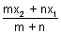, y = 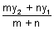, z = 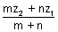
(2) External division: Coordinates of point R which divides join of P(x₁, y₁, z₁) & Q(x₂, y₂, z₂) externally in ratio m : n are 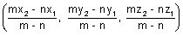
Illustration: Show that plane ax + by + cz + d = 0 divides line joining (x₁, y₁, z₁) & (x₂, y₂, z₂) in ratio of 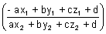
Ans: Let plane ax + by + cz + d = 0 divides line joining (x₁, y₁, z₁) & (x₂, y₂, z₂) in ratio K : 1
Coordinates of P
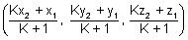
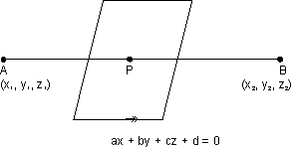
must satisfy eq. of plane.
ax + by + cz + d = 0
[Dumb Question: Why coordinates of P satisfy eq. of plane ?
Ans: Point P lies in the plane so, it satisfy eq. of plane.]
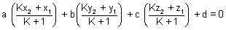
a(Kx₂ + x₁) + b(Ky₂ + y₁) + c(Kz₂ + z₁) + d(K + 1) = 0
K(ax₂ + by₂ + cz₂ + d) + (ax₁ + by₁ + cz₁ + d) = 0
K = - 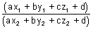
Direction Cosines:
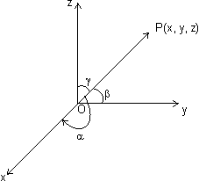
Let is a vector , , inclination with x, y & z-axis respectively. Then cos, cos & cos are direction cosines of . They denoted by
, , direction angles.
& lies 0 , ,
Note: (i) Direction cosines of x-axis are (1, 0, 0)
Direction cosines of y-axis are (0, 1, 0)
Direction cosines of z-axis are (0, 0, 1)
(ii) Suppose OP be any line through origin O which has direction l, m, n
(r cos, r cos, r cos) where OP = r
coordinates of P are (r cos, r cos, r cos)
or x = lr, y = mr, z = nr
(iii) l² + m² + n² = 1
Proof: || = || =
||² = x² + y² + z² = l²||² + m²||² + n²||²
l² + m² + n² = 1
(iv)
Direction ratios: Suppose l, m, & n are direction cosines of vector & a, b, c are no.s such that a, b, c are proportional to l, m, n. These a, b, c are c/d direction ratios.
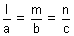= k
Suppose a, b, c are direction ratios of vector having direction cosines l, m, n. Then,
= l = a, m = b, n = c
l² + m² + n² = 1
a²² + b²² + c²² = 1 = ± 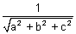
l = ± 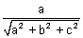, m = ± 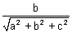, n = ± 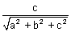
Note: (i) If having direction cosines l, m, n. Then, l = , m = , n =
(ii) Direction ratios of line joining two given points
(x₁, y₁, z₁) & (x₂, y₂, z₂) is (x₂ - x₁, y₂ - y₁, z₂ - z₁)
(iii) If direction ratio's of are a, b, c
= 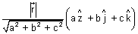
(iv) Projection of segment joining points P(x₁, y₁, z₁) and Q(x₂, y₂, z₂) on a line with direction cosines l, m, n, is:
(x₂ - x₁)l + (y₂ - y₁)m + (z₂ - z₁)n
Illustration: If a line makes angles , & with coordinate axes, prove that sin² + sin² + sin² = 2
Ans: Line is making , & with coordinate axes.
Then, direction cosines are l = cos, m = cos & n = cos.
But l² + m² + n² = 1
cos² + cos² + cos² = 1
1 - sin² + 1 - sin² + 1 - cos² = 1
sin² + sin² + sin² = 2
Angle b/w two vectors in terms of direction cosines & direction ratios:
(i) Suppose & are two vectors having d.c's l₁, m₁, n₁ & l₂, m₂, n₂ respectively. Then,
&
Dumb Question: How ?
Ans: 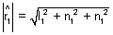
But l₁² + m₁² + n₁² = 1
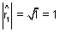
So,
cos = 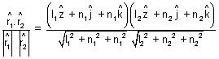
cos = l₁l₂ + m₁m₂ + n₁n₂
(ii) IF a₁, b₁, c₁ and a₂, b₂, c₂ are d.r.s of & . Then
&
cos = 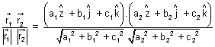
cos = 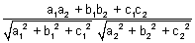
Note: (i) If two lines are then,
cos = 0 or l₁l₂ + m₁m₂ + c₁c₂ = 0
or a₁a₂ + b₁b₂ + c₁c₂ = 0
(ii) If two lines are || then
cos = 1 or 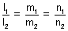
or 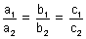
Illustration: Find angle b/w lines whose direction cosines are 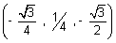 & 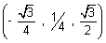.
Ans: Let be angle
cos = l₁l₂ + m₁m₂ + n₁n₂
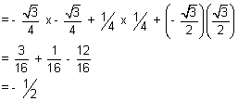
cos = - = 120⁰
Straight line:
Vectorial eq. of line:
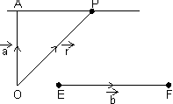
Let a line passing through a point of P.V. & || to given line EF().
Then, eq. of line
Proof: Let P be any point on line AP & its P.V. is
Then, = = (By law)
Dumb Question: Why = ?
Ans: Since is || to EF of P.V.
So, =
Note: Eq. of line through origin & || to is =
Cartesion eq. of straight line:
Passing through point & parallel to given vector .
Let line is passing through A(x₁, y₁, z₁) & || to EF whose d.r.'s are a, b, c.
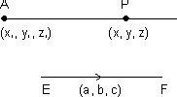
d.r.'s of AP = (x - x₁, y - y₁, z - z₁)
d.r.'s of EF = (a, b, c)
Since EF || AP, then,
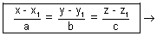b Eq. of line in parametric form.
Illustration: Find eq. of line || to & passing through pt.(1, 2, 3) ?
Ans: A(1, 2, 3) =
eq. of line passing through & || to
= () + ()
Vector eq. of line passing through two given points:
Vector eq. of line passing through two points whose P.V. S & is:
= + ( - )
Proof: is collinear with
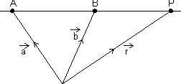
=
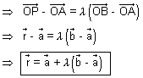
Cartesian form:
Eq. of line passing through (x₁, y₁, z₁) & (x₂, y², z₂)
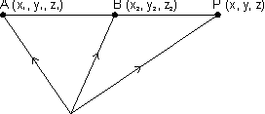
D.R.'s of AB = (x₂ - x₁, y₂ - y₁, z₂ - z₁)
D.R.'s of AP = (x - x₁, y - y₁, z - z₁)
Since AB || AP
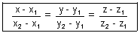
Illustration: Find cartesian eq. of line are 6x + 2 = 3y - 1 = 2z + 2. Find its direction ratios.
Ans: 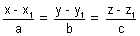 is cartesion eq. of line
6x + 2 = 3y - 1 = 2z + 2
6(x + ) = 3(y - ) = 2(z + 1)
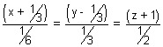
on comparing a = , b = , c =
Angle b/w Two lines:
=
Angle b/w two lines cos = 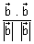
If
=
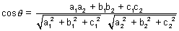
Condition for perpendicularity:
. = 0 a₁a₂ + b₁b₂ + c₁c₂
Condition for parallelism:
Dumb Question: Why angle between pair of lines
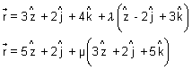
Ans: &
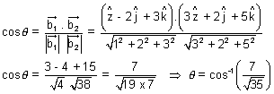
Perpendicular distance of point froma line:
(a) Castesian form:
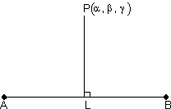

Suppose 'L' is foot of line of .
Since L lies on line AB so,
coordinate of L is
=
i.e. L(x₁ + a, y₁ + b, z₁ + c)
direction ratios of PL are:
(x₁ + a - , y₁ + b - , z₁ + c - )
also direction ratios of AB are (a, b, c)
Since PL AB
a(x₁ + a - ) + b(b - ) + c(z₁ + c - ) = 0
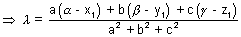

Vector Form:
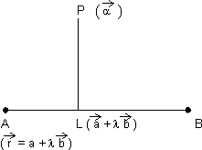
Since L lies on line AB
P.V. of L = P.V. of line AB
= +
dr's of
Since
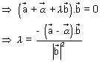
P.V. of L is +
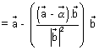
Reflection of point in straight line:
Castesian Form:
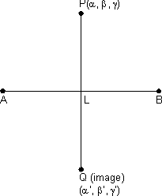
From above, we get coordinate of L(foot of )
But L is mid point of PQ
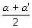= x₁+ a, 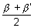= y₁ + b, 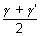= z₁ + c
' = 2(x₁ + a) - , ' = 2(y₁ + b) - , ' = 2(z₁ + c) -
Vector Form:

From above, we get
P.V. of L, +

Let P.V. of Q is 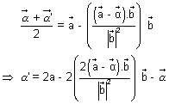
Since L is mid point of PQ
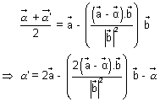
Illustration: Find reflection of point P(2, 3, 1) in line 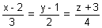
Ans:
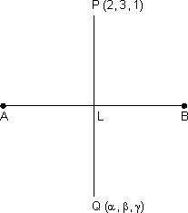
Since L lies on line AB
coordinate of L (3 + 2, 2 + 1, 4 - 3)
DR's of PL are
= (3 + 2 - 2, 2 + 1 - 3, 4 - 3 - 1)
= (3, 2 - 2, 4 - 4)
DR's of AB are (3, 2, 4)
Since PL AB
3(3) + 2(2 - 2) + 4(4 - 4) = 0
9 + 4 - 4 + 16 - 16 = 0
29 = 20 =
Since L is mid point of PQ
So, 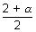= 3 + 2, 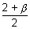= 2 + 1, 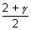= 4 - 3
= (6 + 4 - 2), = (4 + 2 - 3), = 8 - 6 - 1
= 6 + 2, = 4 - 1, = 8 - 7
where =
Skew lines: Those lines which do not lies in same plane.
Shortest distence b/w two skew lines:
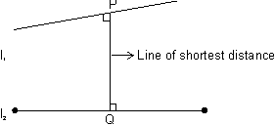
The line which is to both line l₁ & l₂ are c/d line of shortest distance.
Vector Form:
Let l₁ & l₂ are:
& respectively.
Since is to both l₁ & l₂ which are parallel to &
is || to x
Let be unit vector along , then = ± 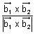
PQ = Projection of on
= .
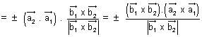
Dumb Question: How PQ = Projection on ?
Ans: Form fig., it is clear that PQ is projection of on .
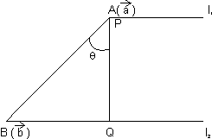
PQ = 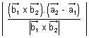
Cartesian form: Two skew lines
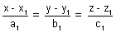 & 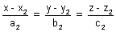
Shortest distance :
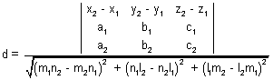
Condition for lines to intersect:
Two lines intersects if shortest distance = 0
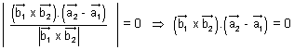
or 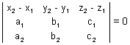
Shortest distance b/w parallel line:
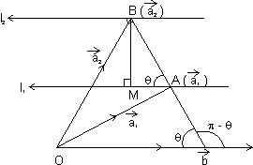
Let l₁ & l₂ are
respectively
& BM is shortest distance b/w l₁ & l₂
sin = BM = AB sin = || sin
| x | = || || sin( - )
= || || sin = (|| sin) || =
Dumb Question: Why we have taken sin( - ) ?
Ans:
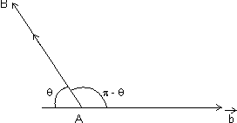
Since direction of vector is opposite to || lines. So, we have taken ( - ) instead of
BM = 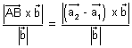
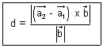
Illustration: Find shortest distance b/w lines:
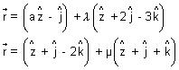
Ans: 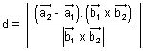
On comparing
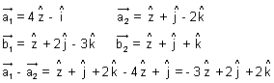
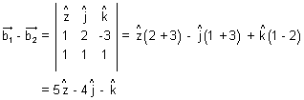
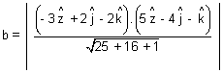
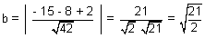
Plane:
(i) Eq. of plane passing through a given point (x₁, y₁, z₁) is:
a(x - x₁) + b(y - y₁) + c(z - z₁) = 0 where a, b, c constants.
Proof: General eq. of plane is ax + by + cz + d = 0 ....................................... (i)
It is passes through (x₁, y₁, z₁)
ax₁ + by₁ + cz₁ + d = 0 ............................................. (ii)
By (i) - (ii), we get
a(x - x₁) + b(y - y₁) + c(z - z₁) = 0
Intercept form of a plane:
eq. of plane of intercepting lengths a, b & c with x, y & z-axis respectively is,
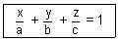
Illustration: A variable plane moves in such a way that sum of reciprocals of its intercepts on 3 coordinate axes is constant. Show that plane passes through fixed point.
Ans: Let eq. of plane is 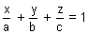. Then, intercepts of plane with axes are:
A(a, 0, 0), B(0, b, 0), c(0, 0, c)
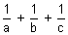 = constant (k) (given)
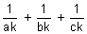= 1 & comparing with fixed point 
x = , y = , z =
This shows plane passes through fixed point (, , )
Vector eq. of plane passing through a given point & normal to given vector:
VEctor eq. of plane passing through u point of P.V. & normal to vector is ( - ). = 0
Dumb Question: What is normal to vector ?
Ans: Plane normal to vector means the every line in plane is to that given vector.
Proof: Let plane passes through A() & normal to vector & be P.V. of every point 'P' on palne.
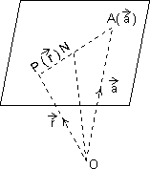
Since lies in plane & is normal to plane.
. = 0
( - ). = 0 ( = - )
eq. of plane ( - ). = 0
Eq. of plane in normal form:
Vector eq. of plane normal to unit vector & at O distance d from origin is . = d.
Proof:
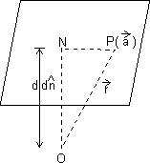
ON is to plane such that & =
Since . = 0
( - ). = 0
( - d).d = 0 .d - d². = 0
d(.) - d² = 0 . = d
eq. of plane is . = d
Cartesian Form: Let l, m, n be d.r.'s of normal to given plane & P is length of from origin to plane, then eq. of plane is lx + my + nz = P.

Dumb Question: How this lx + my + nz = P is eq. of plane ?
Ans: Since . = P = d is eq. of plane
&
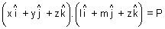
lx + my + nz = P
Illustration: Find vector eq. of plane which is at a distance of 8 units from origin & which is normal to vector .
Ans: d = 8 & =
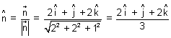
eq. of plane is, . = d
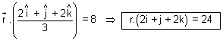
Eq. of plane passing through 3 given points:
Eq. of plane passing through three points A, B, C having P.V.'s , , respectivelt.
Let be P>V> of any point P is the plane.
So, vectors,
= - , = - , = - are coplanar
Hence, .( x ) = 0
( - ).{( - ) x ( - )} = 0
( - ).( x - x - x - x ) = 0
( - ).( x + x + x ) = 0
.( x + x + x ) = .( x ) + .( x ) + .( x )
[] + [] + [] = []
Note: If P is length of from origin on this plane,
then P = 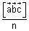 n = | x + x + x |
Eq. of plane that passes through a point A with position vector & is || to given vectors & :
Derivation:
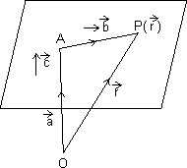
Let be P.V. of any point P in plane
Then, = - = -
Sincen x are || to plane.
So, vector - , & are coplanar
( - ).( x ) = 0
.( x ) = .( x )
[] = []
Cartesian form: Eq. of plane passing through a point (x₁, y₁, z₁) & || to two lines having direction ratios (₁, ₁, ₁) & (₂, ₂, ₂) is:
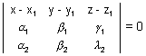
Illustration: Find eq. of plane passing through points
P(1, 1, 1), Q(3, -1, 2), R(-3, 5, -4).
Ans: Let eq. of plane is ax + by + cz + d = 0
It passes through P(1, 1, 1). So,
eq. of plane
a(x - 1) + b(y - 1) + c(z - 1) = 0 .......................................... (i)
But it also passes through Q & R
2a - 2b + c = 0] x (- 2)
- 4a + 4b - 5c = 0
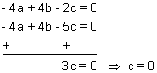
Similarly a = 6, b = 6
Putting these in eq. (i)
We get, 6(x - 1) + 6(y - 1) = 0 x + y = 2
Angle b/w two planes:
. = d₁ . = d₂ are two planers, then
cos = 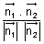
Note: Angle b/w planes is defined as angle b/w their normals.
Cartesion Form: Let planes are a₁x + b₁y + c₁z + d₁ = 0 & a₂x + b₂y + c₂z + d₂ = 0
cos = 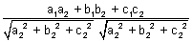
Condition for :
. = 0
or a₁a₂ + b₁b₂ + c₁c₂ = 0
Condition for parallelism:
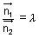 or 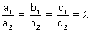
Angle b/w line & a plane:
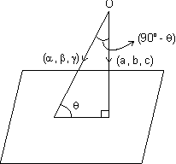
If , , be direction ratios of line & ax + by + cz + d = 0 be eq. of plane in which normal has d.r's a, b, c. Q is angle b/w line & plane.
cos(90⁰ - ) = 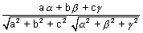
Vector form: If is angle b/w line & plane . = d
sin = 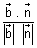
Illustration: Find angle b/w line 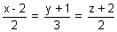& 3x + 2y - 2z + 3 = 0.
Ans: D.r's of line are 2, 3, 2 & d.r's of normal to plane are 3, 2, - 2
sin = 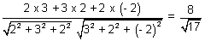
= sin⁻¹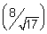
Eq. of plane passing through the Line of Intersection of planes
a₁x + b₁y + c₁z + d₁ = 0 & a₂x + b₂y + c₂z + d₂ = 0 is
(a₁x + b₁y + c₁z + d₁) + k(a₂x + b₂y + c₂z + d₂) = 0
Dumb Question: How this eq. is that of required plane ?
Ans: Let P(, , ) be point on line of intersection of two planes. So, it lies on both the planes.
i.e. a₁ + b₁ + c₁ + d₁ = 0
& a₂ + b₂ + c₂ + d₂ = 0
So, point P(, , ) should lie on required plane.
i.e. (a₁ + b₁ + c₁ + d₁) + k(a₂ + b₂ + c₂ + d₂ ) = 0
P(, , ) lies on. plane (a₁x + b₁y + c₁z + d₁) + k(a₂x + b₂y + c₂z + d₂) = 0
Vector Form:
. = d₁ & . = d₂
So, eq. of required plane is (. - d₁) + k(. - d₂) = 0
Illustration: Find eq. of plane constaining line of intersection of plane x - y + z + 7 = 0 and x + 3y + 2z + 5 = 0 & passing through (1, 2, 2).
Ans: Eq. of plane through line of intersection of given planes is,
(x - y + z + 7) + (x + 3y + 2z + 5) = 0 ....................................... (i)
It passes through (1, 2, 3)
(1 - 2 + 2 + 7) + (1 + 3 x 2 + 2 x 2 + 5) = 0
8 + (7 + 4 + 5) = 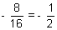
Putting = - in eq. (i)
We get,
(x - y + z + 7) + (- )(x + 3y + 2z + 5) = 0
2x - 2y + 2z + 14 - x - 3y - 2z - 5 = 0
x - 5y + 9 = 0
Two sides of plane:
If ax + by + cz + d = 0 be a plane then points (x₁, y₁, z₁) & (x₂, y₂, z₂) are points lies on
Same side if 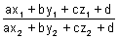> 0 & opposite side if < 0
Distance of point from a plne:
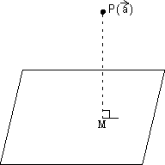
Length of from a point having P.V. to plane . = d is given by
P = 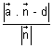
Proof: PM is length of from P to plane. Since line PM passes through P() & || to vector which is normal to plane.
eq. of line = x ....................................................... (i)
Since point M is intersection of line & plane. So, it lies on line as well as plane
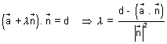
Putting in eq. (i)
= + 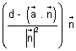
= P.V. of M - P.V. of P = + -
Dumb Question: How P.V. of M is + 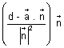
Ans: M lies on line as well as plane. On solving value of for line eq. We get P.V. of M.
So, this is P.V. of M
PM = || = 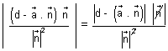
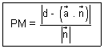
Cartesian Form: Length of from point P(x₁, y₁, z₁) to plane ax + by + cz + d = 0, Then eq. of PM is
= r
[Dumb Question: How this eq. of PM comes ?
Ans: It is passes through point (x₁, y₁, z₁) & || to normal of plane so, we get this eq.]
Coordinates of any point on PM are
(x₁ + ar, y₁ + br, z₁ + cr)
But this also coordinate of M & M also lies on plane
a(x₁ + ar) + b(y₁ + br) + c(z₁ + cr) + d = 0
i.e. r = - 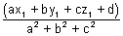
PM =
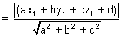
Distance b/w parallel planes:
Distance b/w || planes is difference of length of from origin to two planes.
Let ax + by + cz + d₁ = 0 & ax + by + cz + d₂ = 0
D = 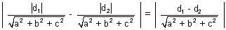
Vector Form: . = d₁ & . = ₂
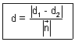
Illustion: Find distance b/w parallel planes
x + 2y + 2z + 2 = 0 & 2x + 4y + 4z + 3 = 0
Ans: Distance b/w ax + by + cz + d₁ = 0 & ax + by + cz + d₂ = 0 is
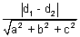
x + 2y + 2z + 2 = 0 & x + 2y + 2z + = 0
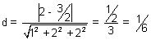

Equation of planes Bisecting Angle b/w Two planes:
Eq. of planes bisceting angle b/w planes, a₁x + b₁y + c₁z + d₁ = 0 and a₂x + b₂y + c₂z + d₂ = 0 is,
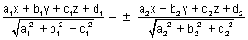
Proof: Let P(x, y, z) be point on plane bisecting angle b/w two planes 7 PL & PM is length of from P to planes.
By property of angle bisector.
PL = PM
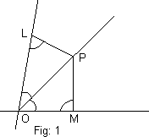
[Dumb Question: How PL = PM ?
Ans: In fig 1. OPL & OPM are congruent by AAA symmetry. So, all sides are equal.
So, PL = PM.]
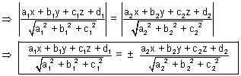
Note: (i) Eq. of bisector of angle b/w two planes containing origin is
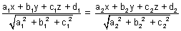
(ii) Bisector of acute & obtuse angles b/w:
Let a₁x + b₁y + c₁z + d₁ = 0
& a₂x + b₂y + c₂z + d₂ = 0 where d₁, d₂ > 0
(a) If a₁a₂ + b₁b₂ + c₁c₂ > 0, origin lies in obtuse angle bisector & eq. of bisector of acute angle is
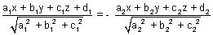
(b) If a₁a₂ + b₁b₂ + c₁c₂ < 0, origin lies in atute angle bisector & eq. of acute angle bisector is

Illustration: Find eq. of bisector planes of angle b/w planes 2x + y - 2z + 3 = 0 & 3x + 2y - 6z + 8 = 0 specify obtuse & acute angle bisectors.
Ans: 2x + y - 2z + 3 = 0 & 3x + 2y - 6z + 8 = 0 where d₁, d₂ > 0
Now a₁a₂ + b₁b₂ + c₁c₂ = 2 x 3 + 1 x 2 + 2 x 6 > 0
...................................... (i)
(i) is obtuse angle bisector plane
& ................................................ (ii)
(ii) is acute angle bisector plane.
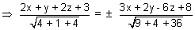
14x + 7y - 14z + 21 = ± 9x + 6y - 18z + 24
For obtuse angle bisector plane, Take -ve sign
5x + y + 4z - 3 = 0
Intersection of line & plane:
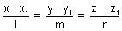= r & plane ax + by + cz + d = 0
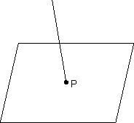
Let P be point of intersection coordinate of P(x₁ + lr, y₁ + mr, z₁ + nr)
But it satisfy eq. of plane.
a(x₁ + lr) + b(y₁ + mr) + c(z₁ + nr)
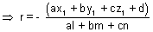
Condition for line to be || to a plane:
be || to plane ax + by + cz + d = 0
if al + bm + cm = 0 or sin = 0
Condition for a line to lie in the plane:
line lie in plane ax + by + cz + d = 0
if al + bm + cn = 0 & ax₁ + by₁ + cz₁ + d = 0
Dumb Question: How line be || to plane if al + bm + cn = 0 ?
Ans: If is angle b/w line & plane, then
sin = 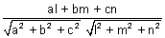 [Previously desired]
line is || to plane if sin = 0 or al + bm + cn = 0
Sphere:
Equation of sphere whose centre is & radius is a:
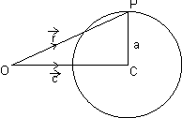
In OPC,
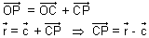
| - | = CP = a (radius)
| - |² = a² ( - ).( - ) = A²
R² - 2. + c² = a² r² - 2. + (c² - a²) = 0
Cartesian Form:
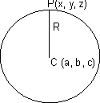
From Fig. CP = R
CP² = R²
By distance formula.
(x - a)² + (y - b)² + (z - c)² = R²
GEneral eq. of sphere:
x² + y² + z² + 2ux + 2vy + 2wz + d = 0 is a sphere with centre (- u, - v, - w) &
radius =
Illustration: Find centre & radius of sphere 2x² + 2y² + 2z² - 2x - 4y + 2z + 3 = 0
Ans: 2x² + 2y² + 2z² - 2x - 4y + 2z + 3 = 0
or x² + y² + z² - x - 2y + z + = 0
centre is (- coeff. of x, - coeff. of y, - coeff. of z)
centre (, 1, - )
radius = 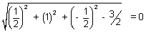
Thus sphere is point circle.
Diameter form of Eq. of sphere:
Vector Form: Suppose & be P.V of extremities A & B of diameter AB of sphere. Let be P.V. of any point P on sphere. Then,
= - & B = -
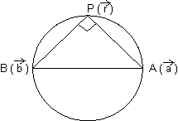
Since, diameter of sphere subtends a right at any point of sphere.
APB = . = 0
( - ).( - ) = 0
||² - ( + ). + . = 0
or AP² + BP² = AB²
| - |² + | - | = | - |²
Cartesian Form: If A(x₁, y₁, z₁) & B(x₂, y₂, z₂) are extremities of diameter then, eq. of sphere is (x - x₁)(x - x₂) + (y - y₁)(y - y₂) + (z - z₁)(z - z₂) = 0
Section of sphere by plane:
If sphere is intersection by a plane. We get circle by intersection.
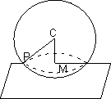
PM is radius of circle
PM =
Condition of Tangency of plane to a sphere:
Vector Form: Plane . = d touches sphere | - | = R
if 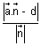= R
Dumb Question: Why = R ?
Ans: A plane touches to sphere if distaqnce from centre of sphere is equal to radius.
Cartesian Form: Plane ln + my + nz = p touches (ul + vm + wn + p)² = (l² + m² + n²)(u² + v² + w² -d)
Illustration: Find eq. of sphere whose centre has P.V. & which touches plane .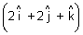 = 10
Ans: Center =
It touches plane . = 10
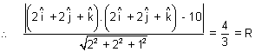
eq. of sphere | - | =
Easy Type
Q.1. Find ratio in which 2x + 3y + 5z = 1 divides line joining the points (1, 0, 2) & (1, 2, 5)
Ans: Let the ratio be k = 1 at point P
Then, P = 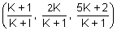must satisfy 2x + 3y + 5z = 1
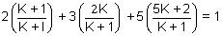
2(K + 1) + 6K + 25K + 10 = K + 1 K + 1 + 6K + 25K + 10 = 0
32K + 11 = 0 K =
Thus line divides externally in rstio of 11:32

Q.2. What are direction cosines of a line which is equally inclined to axes ?
Ans: If , , are angles, if line is equally inclined
= =
l² + m² + n² cos² + cos² + cos² = 1
3 cos² = 1 cos = ± = cos = cos
d.c's arw (, , ) or (- , - , - )
Q.3. Find direction cosines of line which is to lines with d.r (1, -2, -2) & (0, 2, 1)
Ans: Let l, m, n be d.c's line 1 to given line, d.c's are proportional to d.r's
d.c'r of lines are (, - 2, - 2) & (0, 2µ, µ)
Since line is to given lines
l + (- 2m) + (- 2n) = 0 l - 2m - 2n = 0
& 0 + 2mµ + nµ = 0 2m + n = 0
By cross multiplication,
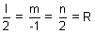
l = 2R, m = - R & n = 2R
l² + m² + n² = 1
4R² + R² + 4R² = 1 9R² = 1 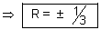
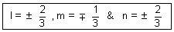
Q.4. Prove that line x = ay + b, z = cy + d & x = a'y + b', z = c'y + d' are if aa' + cc' + 1 = 0
Ans: Ist line is x = ay + b, z = cy + d
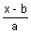 = y, 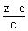= y = 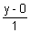= ................................ (i)
and IInd line 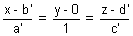................................................. (ii)
These lines are if
aa' + |x| + cc' = 0 aa' + cc' + 1 = 0
Dumb Question: For what value of k, lines 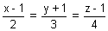 & 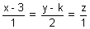intersect?
Ans: =
and = µ
Since these lines have point of intersection in common. then
(2 + 1, 3 - 1, 4 + 1) = (µ + 3, 2µ + k, µ)
or 2 + 1 = µ + 3 ....... (i), 3 - 1 = 2µ + k ....... (ii) & 4 + 1 = µ ....... (iii)
on solving (i) & (iii), we get = - 3/2 & µ = - 5
Substituting in (ii)
- - 1 = - 10 + k k =
Q.6. Show that points and are equidistant from plane .() + 9 = 0
Ans: .() = - 9
length of from ()
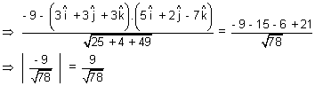
So, length of is equal.
Q.7. Find the point in which the plane; = ( - ) + m( + + ) + n( + - ) is cut by line through point 2 + 3 & parallel to .
Ans: eq. of line through point 2 + 3 & || to
= (2 + 3) +
Since line cuts plane
For one point,
(2 + 3) + = - + m( + + ) + n( + - )
Equating coeff. of , & on both side, we get
m + n = 1, m - n = 4, - m + n =
m = , n = & = - 4
P.V. of required point is: 2 + 3 - 4
Q.8. Show that line of intersection of planes .() = 0 & .() = 0 is equally inclined to & .
Ans: Note: Line of intersection of two planes will be to normals to the planes. Hence it is || to vector
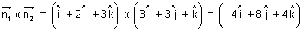
Now,
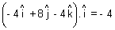
& 
So, line is equally inclined to &
Q.9. Projection of line segment on 3 axes 4, 5 & 13 respectively. Find length & direction cosines of line segment.
Ans:
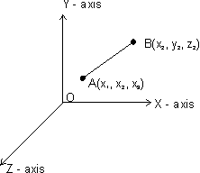
= (x₂ - x₁) + (y₂ - y₁) + (z₂ - z₁)
Projection of on x-axis
= . = (x₂ - x₁) = 4
Projection of on y-axis
= . = (y₂ - y₁) = 5
Projection of on z-axis
= . = (z₂ - z₁) = 13
Length of AB =
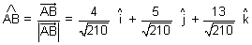
d.r's = 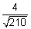, 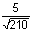& 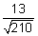
Q.10. Find locus of mid point of chords of sphere r² - 2. + k = 0 if chords being drawn || to vector .
Ans: r² - 2. + k = 0 is sphere of centre chord AB || .
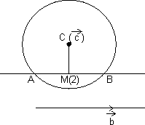
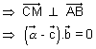
locus of M is ( - ). = 0
. = . represents a plane.
Dumb Question: Why is same as ?
Ans: Since || . So, if is . So, it will also to .
Medium Type
Q.1. If a variable plane forms a tetrahedron of constant volume 27k³ with coordinate planes, find locus of centroid of tetrahedron.
Ans: sLet variable plane cuts coordinate axes at A(a, 0, 0), B(0, b, 0), C(0, 0, c)
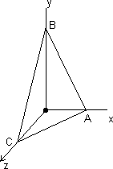
Then, eq. of plane will be
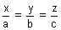 = 1
Let P, , ) be centroid of terahedron OABC,
then, = , = , =
[Dumb Question: How this centroid tetrahedron OABC comes = , = , = ?
Ans: Centroid of tetrahedrold
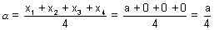
where (x₁, y₁, z₁), (x₂, y₂, z₂), (x₃, y₃, z₃) & (x₄, y₄, z₄) are coordinate of tetrahedron.]
Volume of tetrahedron = (Area of AOB).OC
27k³ = (ab)c =
27k³ = 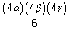
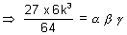
Required locus of P(, , ) is
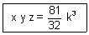
Q.2. Find vector eq. of straight line passing through intersection of plane
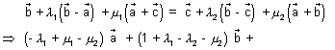
, , are non coplanar vectors.
Ans: At points of intersection of two planes.
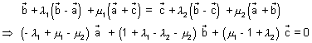
Since , , are non coplanar, then
- ₁ + µ₁ - µ₂ = 0, 1 + ₁ - ₂ - µ₂ = 0, µ₁ - 1 + ₂ = 0

On solving, we get ₁ = 0 & µ₁ = µ₂
= + ₁( - ) + µ₁( + )
Since ₁ = 0
= + µ₁( + ) is required eq. of straight line.
Q.3. Prove that three lines from O with direction cosines l₁, m₁, n₁; l₂, m₂, n₂; l₃, m₃, n₃ are coplaner if
l₁(m₂n₃ - n₂m₃) + m₁(n₂l₃ - l₂n₃) + n₁(l₂m₃ - l₃m₂) = 0
Ans: Note: Three given lines are coplanar if they have common perpendicular. Let d.c's of common be l, m, n
ll₁ + mm₁ + nn₁ = 0 ............................. (i)
ll₂ + mm₂ + nn₂ = 0 ............................. (ii)
ll₃ + mm₃ + nn₃ = 0 ............................. (iii)
Soplving (ii) & (iii) by cross multiplication ......
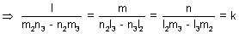
l = k(m₂n₃ - n₂m₃), m = k(n₂l₃ - n₃l₂), n = k(l₂m₃ - l₃m₂)
Substituting in (i), we get
k(m₂n₃ - n₂m₃)l₁ + k(n₂l₃ - n₃l₂)m₁ + k(l₂m₃ - l₃m₂)n₁ = 0
l₁(m₂n₃ - n₂m₃) + m₁(n₂l₃ - n₃l₂) + n₁(l₂m₃ - l₃m₂) = = 0
Q.4. Solve the equation x + y + z =
Ans: x + y + z = .................................. (i)
Taking dot product by x , we get
x.( x ) + y.( x ) + z.( x ) = .( x )
x[] = [] x = 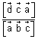
& z = 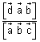
x + y + z =
[] + [] + [] = [] is required solution.
Q.5. If planes x - cy - bz = 0, cx - y + az = 0 & bx + ay - z = 0 pass through a straight line, the find value of a² + b² + c² + 2abc.
Ans: Givem planes are:
x - cy - bz = 0 ............................. (i)
cx - y + az = 0 ............................. (ii)
& bx + ay - z = 0 ............................. (iii)
Eq. of plane passing through line of intersection of plane (i) & (ii) is
(x - cy - bz) + (cx - y + az) = 0
x(1 + c) - (c + ) + z(- b + a) = 0 ............................. (iv)
If plane (iv) & (iii) are same, then,
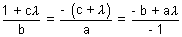
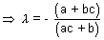 and 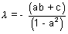
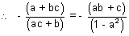
a - a³ + bc - a²bc = a²bc + ac² + ab² + bc
a(2abc + c² + b² + a² - 1) = 0
a² + b² + c² + 2abc = 1
Hard Type
Q.1. Show that distance of a point A() to line = + t is 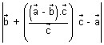which is also equal to 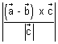.
Ans:
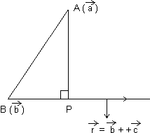
Let P is point on line such that & P.V. of P is = + t
. = 0
( - ).( - ) = 0 ........................... (i)
( + t - ).( + t - ) = 0
( - + t).(t) = 0
t. - t + t² = 0
t( - ) + t²c² = 0
t = 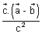..................................... (ii)
From (i) & (ii)
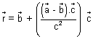
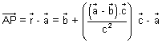
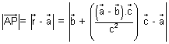 ....................................... (iii)
Also, PA² = AB² - BP² = ||² - ||²
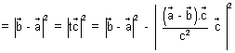
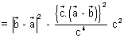
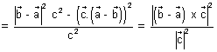 ....................................... (iv)
Dumb Question: How this eq. (iv) const.
Ans: We know that (AB)² -
Q.2. If direction cosines of variable line in two adjacent points be l, m, n & l + l, m + m, n + n show that small anhgle 5 b/w two position is
² = l² + m² + n²
Ans: As we know l² + m² + n² = 1
and (l + l)² + (m + m)² + (n + n)² = 1
l² + (l²) 2ll + m² + (m)² + 2mm + n² + (n)² + 2nn = 1
l² + m² + n² + (l)² + (m)² + (n)² + 2(ll + mm + nn) = 1
(l)² + (m)² + (n)² = - 2(ll + mm + nn) ............................ (i)
is angle b/w two positions.
cos = l(l + l) + m(m + m) + n(n + n)
1 - 2 sin² = 1 + ll + mm + nn ........................................... (ii)
From (i) & (ii)
(l)² + (m)² + (n)² = 4 sin²
4()² = (l)² + (m)² + (n)²
()² = (l)² + (m)² + (n)²
Dumb Question: How sin² is equal to ()² ?
Ans: Since is very small so, is very small
So, sin as 0
So, for approsmation we have taken.
Q.3. Find image of point P(3, 5, 6) in plane 2x + y + z = 0 & find eq. of sphere having point P(3, 5, 6) & its image point of extremities of diameter.
Ans:
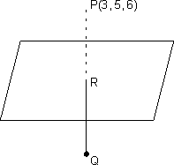
2x + y + z = 0
P(3, 5, 6)
dr's iof normal to plane (i) are 2, 1, 1
Let be image of point P in plane (i)
Eq of P R is,
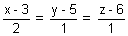 = r
R(2r + 3, r + 5, r + 6)
[Dumb Question: How eq. of line PR come ?
Ans: d.r's of normal to plane is same as d.r's of line PR i.e. 2, 1, 1
So, we get eq. of line PR]
But R lies on (i)
2(2r + 3) +(r + 5) + (r + 6) = 0
6r + 17 = 0 r = -
R 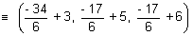
Since R lies mid point of PQ
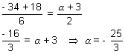
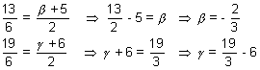
Q = 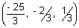
Eq. of sphere when extremities (x₁, y₁, z₁) & (x₂, y₂, z₂) are given:
(x - x₁)(x - x₂) + (y - y₁)(y - y₂) + (z - z₁)(z - z₂) = 0
(x - 3)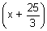 + (y - 5)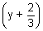 + (z - 6)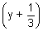 = 0
x² + y² + z² + 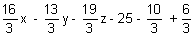= 0
x² + y² + z² + 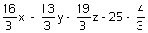= 0
3x² + 3y² + 3z² + 16x - 13y - 19z - 79 = 0
KEYWORDS
- Direction Cosines
- Direction Ratios
- Reflection of a point
- Skew Lines
- Shortest distance
- Intersection of lines.
- Normal. FV
- Angle bisector.
- Tangency of plane to sphere

Part-II

Functions
FUNCTION & GRAPH
Functions:
Let A B be two non empty sets & F is a relation which associates each elemenet of set A with unique element of set B, then F is c/d a function from A to B.
Set A is called domain of F & B be the co domain of F.
Set of elements of B, which are images of elements of set A is c/d range of F.
F : A B ("F is function of A into B")
If a A then element in B which is assigned to 'a' is called image of 'a' & denoted by F(a).
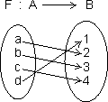
let A = {a, b, c, d}, B = {1, 2, 3, 4, 5}
So, F(a) = 2, F(b) = 3, F(c) = 5, F(d) = 1
Dumb Question: What is non empty set ?
Ans: A set which contain at least one element
eg. A = {1, 2} is non empty set but B = { } is empty set.
No. of Function (or Mapping) From A to B:
Let A = {x₁, x₂, x₃, .......... , x_{m}} F : A B
& B ={y₁, y₂, y₃, .......... , y_{n}}
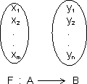
Then if each element in set A has n images in set B.
Thus, total no. of functions from A to B = n^{m}
Dumb Question: How total no. of function from A to B = n^{m} ?
Ans: x₁, element in set A take n images
x₂ element in set A take n images
.............................................
.............................................
x_{m} can take n images.
Total no. of function from A to B
n x n x ............... m times = n^{m}
Domain: Domain of y = f(x) is set all real x for which f(x) is defined (real).
How to find Domain:
(i) Expression under even root (i.e. square root, 4th root) 0
(ii) Denominator 0
(iii) If domain of y = (x) & y = y(x) are D₁ & D₂ respectively then domain of f(x) ± y(x) of f(x).g(x) is D₁ D₂.
(iv) Domain of 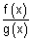is D₁ D₂ - {g(x) = 0}.
Illustration: Find domain of single valued function y = f(x) given by eq. 10^{x} + 10^{y} = 10.
Ans: 10^{x} + 10^{y} = 10 10^{y} = 10 - 10^{x}
y = log₁₀(10 - 10^{x}) {a^{m} = b m = log_{a}b}
Now, 10 - 10^{n} > 0
10¹ > 10^{x} 1 > x
domain x (- , 1)
Dumb Question: What is single value Function ?
Ans. For every point of domains, these is unique image only.
Range: Range of y = f(x) is collection of all output & {F(x)} corresponding to each real no. is domain.
How to find range:
First of all final domain of y = f(x)
(i) If domain Finite no. of points range set of corresponding f(x)values.
(ii) If domain R or R - {some finite points}
Then express x in terms of y. From this find y for x to be defined. (i.e. find values of y for which x exists)
(iii) If domain a finite interval, find least and greatest value for range using mono tonicity.
Illustration: Find range of function y = log_{e}(3x² - 4x + 5).
Ans: y is defined if 3x² - 4x + 5 > 0
[Dumb Question: Why 3x² - 4x + 5 > 0 ?
Ans: ln x is defined only if x > 0]
if x is 0 ln x = - & for - ve x
ln is not defined,
D = 16 - 4 x 3 x 5 = - 44 < 0
& coeff. of x² = 3 > 0
3x² - 4x + 5 > 0 v x R
domain R
y = log_{e}(3x² - 4x + 5) 3x² - 4x + 5 = e^{y}
3x² - 4x + (5 - e^{y}) = 0
Since x is real, So, D 0
(- 4)² - 4(3)(5 - e^{y}) > 0 e^{y} >
y log
range [log, )
CLASSIFICATION OF FUNCTIONS
1. Constant Function: If range of function f consists of only one no. then f is c/d constant function.
Range = { a }
domain x R
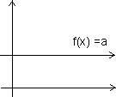
2. Polynomial function: A function y = f(x) = a₀x^{n} + a₁x^{n-} + ...... + a_{n} where a₀, a₁, ....... a_{n} are real constants & n is non -ve integer, then f(x) is c/d polynomial function. If a₀ = 0, then n is degree of polynomial function.
Graph of f(x) = x²
f(x) = x² is called square function. Domain R
Range R⁺ {0} or [0, ]
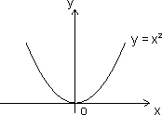
Graph of f(x) = x³:
f(x) = x² is cube function
domain R
Range R
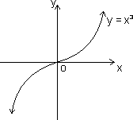
(3) Rational Function: It is ratio of two polynomials
Let P(x) = a₀x^{n} + a₁x^{n - 1} + .......... + a_{n}
Q(x) = b₀x^{m} + b₁x^{m - 1} + .......... + b_{m}
Then f(x) = is a rational function if Q(x) 0
Domain R {x | Q(x) = 0}
i.e. Domain R except those points for which denomiator = 0
Graph of f(x) =
f(x) = is called reciprocal function with coordinate axis as asymptotes.
Domain R - {0}
Range R - {0}
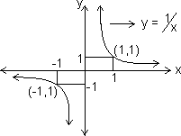
Graph of f(x) =
f(x) =
Domain R - {0}
Range (0, )
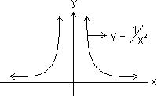
Dumb Question: For y = , how domain & range is R - {0} ?
Ans: For domains
f(x) = + & f(x) = -
So, f(x) is not defined at x = 0
Similarly for Range
as x ± f(x) 0
But we exclude ±
So, Range R - {0}
(4) Irrational Function: Algebraic function containing terms having non-integral rational powers of x are c/d irrational functions.
Graph of f(x) =
f(x) = Domain R⁺ {0} or {0, )
Range R⁺ {0} of [0, )
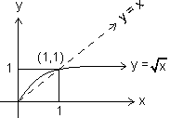
Grafh of f(x) =
f(x) =
domains R
Range R
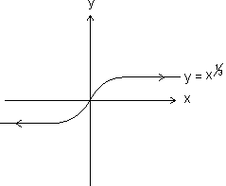
(5) Identity Function: The function y = f(x) = x for all x R c/d identity function on R
Domain R
Range R
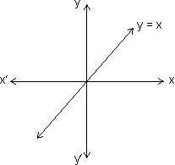

Absolute Value of Modulus Function:
y = |x| = 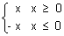
Domain R Range (0, )
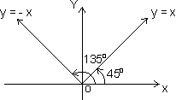
Properties of modulus function:
(i) |x| a - a x a (a 0)
(ii) |x| a x - a or x a (a )
(iii) |x + y| |x| + |y|
(iv) |x + y|
Illustration: Find domain of y = 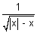
Ans: y is defined if (|x| - x) > 0
|x| > x which hold for -ve x only
Hence domain (- , 0)
(7) Signum Function:
y = Sgn(x) = 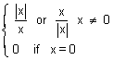
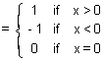
Domain x R
Range {- 1, 0, 1}
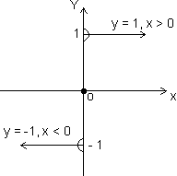
(8) Greatest integer function:
[x] indicates integral part of x which is nearest & smaller integer to x. It is also c/d floor of x or stepwise function.
[2.3] = 2 [5] = 5, [- 0.6] = - 1
In general
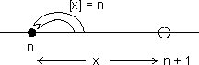
n n < n + 1 (n Integer)
[n] = n
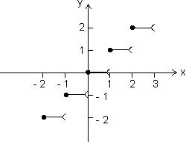

x | [x]
0 x < 1  1 x < 2  2 x < 3  - 1 x < 0  - 2 x < - 1 | 0  1  2  - 1  - 2
Properties of greatest integer function:
(i) [x] = x holds if x I I Integer.
(ii) [x + I] = [x] + I if I is integer.
(iii) [x + y] [x] + [y]
(iv) If [(x)] I, then (x) I.
(v) If [(x)] I, then (x) < I + 1
(vi) If [x] > n x n + 1, n I.
(vii) [- x] = - [x] if x I
& [- x] = - [x] - 1 if x I.
(viii) [x + y] = [x] + [x + y - [x]] for all x, y R.
(ix) [x] + 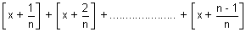
= [n x], n N N natural no.
Illustration: y = 2[x] + 3 & y = 3[x - 2] + 5 then find value of [x + y].
Ans: 2[x] + 3 = 3[x - 2] + 5
2[x] + 3 = 3[x] - 6 + 5 [x] = 4
4 < 5
x = 4 + f (f fraction)
y = 2[x] + 3 = 11
[x + y] = [4 + f + 11] = [15 + f] = 15
(9) Fractional part function:
y = {x}
Let x = I + f, I = [x] & f = {x}
y = {x} = x - [x]
x | {x}
0 x < 1  1 x < 2  2 x < 3  - 1 x < 0  - 2 x < - 1 | x  x - 1  x - 2  x + 1  x + 2
Domain x R
Range (0, 1)
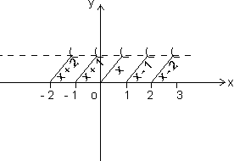
Properties of fraction part of x
(i) {x} = x if 0 < 1
(ii) {x} = 0 if x I
(iii) {- x} = 1 - {x} if x I
Illustration: Prove that [x] + [y] [x + y] where x = [x] + {x}
Ans: x + y = [x] + {x} + [y] + {y}
[x + y] = [[x] + [y] + {x} + {y}]
= [x] + [y] + [{x} + {y}] [By [x + I] = [x] + I]
[x + y] [x] + [y]
(10) Exponential Function:
f(x) = a^{x}, a > 0, a 1
Domain R
Range (0, )
Case I: a > 1
f(x) = a^{x} increase with increase in x.
i.e. f(x) is increasing function ob R
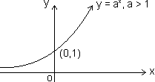
Case II: 0 < a < 1
f(x) = a^{x} decrease with increase in x
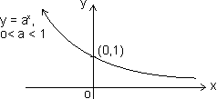
Dumb Question: How range comes out (0, ) ?
Ans: y = a^{x}
Let a > 1
As x
Since a > 1
So, a^{x}
and when x -
a^{x} 0
range (0, )
Logorithmic function:
f(x) = log_{a}x (x, a > 0) & a 1
Domain (0, )
Range R
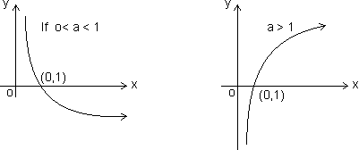
Properties:
(i) Log_{a}a = 1 (ii) log_{b}m a = log_{b}a {a, b > 0, b 1 m R}
(iii) log_{a}b = 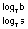 {a, b > 0, a, b 1 & m > 1}
(iv) {a, m > 0 & a 1}
(v) {a, b, c > 0 & c 1}
(vi) log_{m}a < b 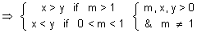
(vii) log_{m}a < b 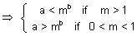
Dumb Question: Why b 1 in log_{b}a ?
Ans: log_{b}a = c b^{c} = a
if b = 1
1^{c} a
Now whatever value of c, 1^{c} a, so, b 1
Illustration: Find domain of f(x) = log₁₀(1 + x³)
Ans: f(x) = log₁₀(1 + x³) exists if
1 + x³ > 0
(1 + x)(1 - x + x²) > 0
But 1 - x² + x² > 0 as D < 0 & a > 0
So, 1 + x > 0
x > - 1
x (- 1, )
Trignometric Function:
(1) Sine Function:
f(x) = sinx
Domain R
Range [-1, 1]
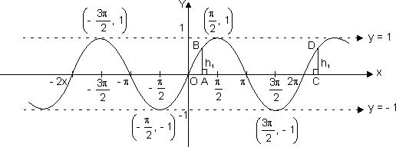
(2) Cosione Function:
f(x) = cos x
Domain R
Range [-1, 1]
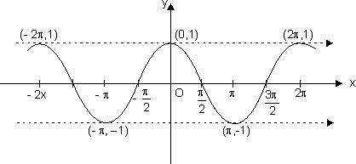

(3) Tangent Function:
f(x) = tan x
Domain R - {(2n + 1) }
Range R
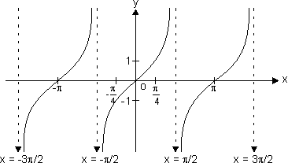
y = tan x increases strictly from - to as x increases from - to , to
x = ± , ± , .......... are asymptotes to y = tan x.
Dumb Question: What is asymptotes ?
Ans: A curve which is tangent to given curve at infinity.
(d) Coecant function:
f(x) = cosec x
Domain R - {n | n I}
Range R - (- 1, 1)
n = n n I is asymptote to y = cosec x
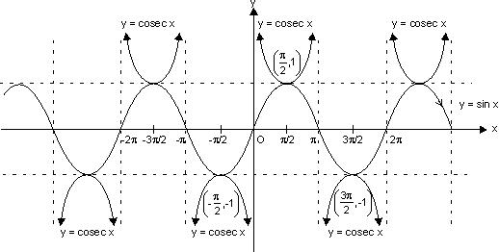
(e) Secant Function:
f(x) = sec x
Domain R - {(2n + 1) | n I}
Range R - (- 1, 1)
x = (2n + 1), n I are asymptote to y = sec x.
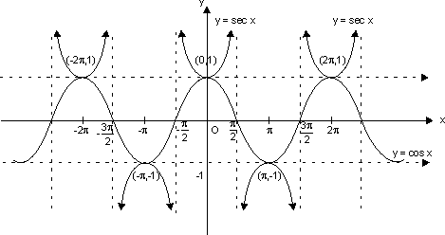
(f) Cotangent Function:
f(x) = cot x
Domain R - {n | n I}
Range R
It has x = n n I as asymptotes.
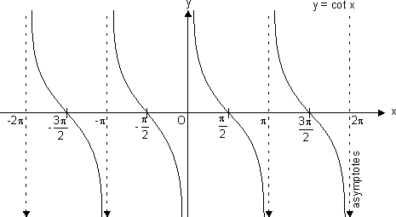
Inverse Function:
(i) Graph of y = sin⁻¹ x;
where
x [-1, 1]
and y 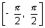
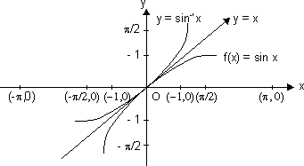
As the graph of f⁻¹ is mirror image of f(x) about y = x.
(ii) Graph of y = tan⁻¹x;
Here,
Domain [-1, 1]
Range [0, ]
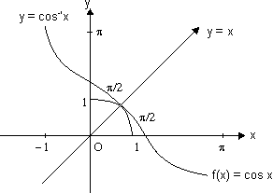
(iii) Graph of y = tan⁻¹x;
Here ,
Domain R
Range .
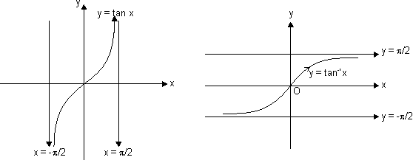
(iv) Graph of y = cot⁻¹x;
We know that the function f:(0, ) R, given by f() = cot is invertible.
Thus, domain of cot⁻¹x R and Range (0, ).
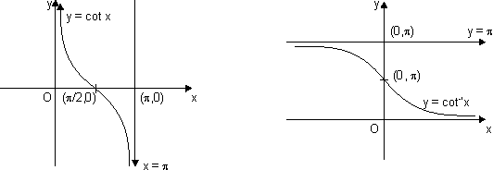
(v) Graph for y = sec⁻¹x;
The function f : [0, ] - (- , - 1) [1, ] given by f() = sec is invertible.
y = sec⁻¹x, has domain R - (- 1, 1) and range [0, ] - : shown as
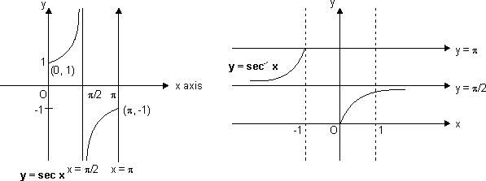
(vi) Graph for y = cosec⁻¹x;
As we know, f: - {0} (- 1, 1) is invertible given by f() = cos.
y = cosec⁻¹x; domain R - (- 1, 1)
Range - {0}>
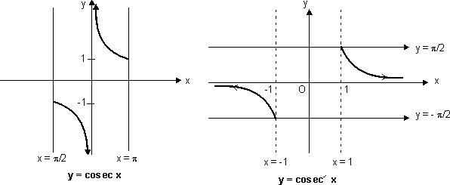
Sketch of y = sin(sin⁻¹x):
Domain x [-1, 1]
and range y = x y [-1, 1]
Sketch y = sin(sin⁻¹x) only
when x [-1, 1] & y = x
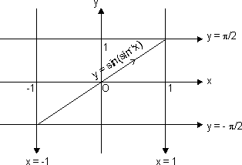
Sketch of curve y = cos(cos⁻¹x):
Domain x [-1, 1]
and range y = x y [-1, 1]
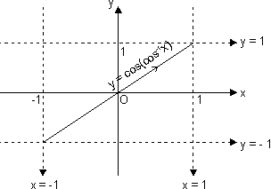
Sketch of curve y = tan(tan⁻¹x):
Domain, x R
Range y = x y r
We should sketch
y = tan(tan⁻¹x) = x v x R
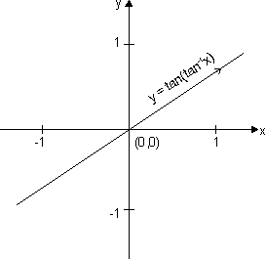
Sketch of curve y = cosec(cosec⁻¹x):
Domain x R - (-1, 1)
Range y = x y R - (-1, 1)
y = cosec(cosec⁻¹x) = x only
when x (-, -1) (1, )
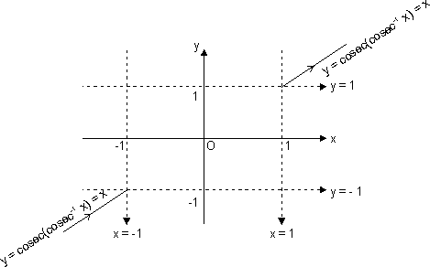

Functions:
Sketch of curve y = sec(sec⁻¹x):
Domain R - (-1, 1)
& range y = x y R - (-1, 1)
y = sec(sec⁻¹x) = x, only when x (-, -1) (1, )
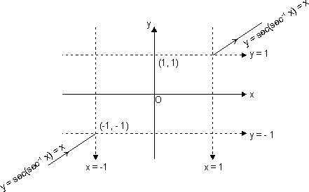
Sketch of y = cot(cot⁻¹x):
Domain R - (-1, 1)
& range y = x y = R
We should sketch
y = cot(cot⁻¹x) = x v x R
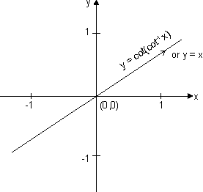
Sketch of y = sin⁻¹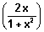:
Domain [-1, 1] v x R
& range y 
b/c y = sin⁻¹
y 
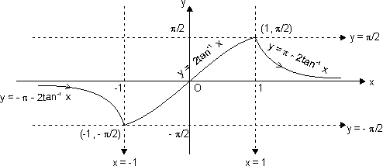
Dumb Question: How domain is [-1, 1] v x R ?
Ans: 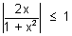 i.e. 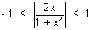
2|x| 1 + x² |x|² - 2|x| + 1 0
(|x| - 1)² 0
x R
Let x = tan
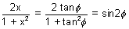
y = sin⁻¹(sin2) = 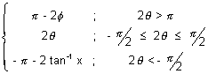
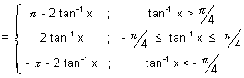
This curve has sharp edge at x = ± 1
So, not differentiable at x = ± 1
Dumb Question: How does y = - 2 for 2 >
Ans: Since our y . So, if 2 > to make it we substract it from - 2 because sin( - 2) = sin2
Sketch of y = cos⁻¹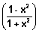
For domain
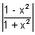1 |1 - x²| 1 + x²
Which is true for all n; as 1 + x² > 1 - x² x R
domain [-1, 1]
For range
y =cos⁻¹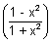
y (0, )
Let x = tan
y = cos⁻¹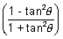 = cos⁻¹(cos2)
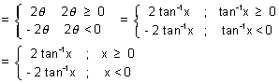
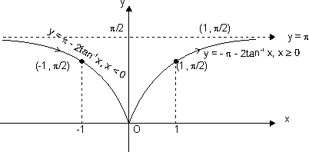
Dumb Question: How cos⁻¹(cos2) = - 2 tan⁻¹x when x < 0 or < 0
Ans: Range of y [0, ]. So, when < 0 or x < 0
Then we have to make it b/w [0, ]
So, cos⁻¹(cos2) = - 2 when < 0
because
cos(- 2) = cos2
This curve has sharp edge at x = 0. So, not differentiable at x = 0.
Sketch of y = tan⁻¹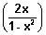
For domain
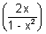R except 1 - x² = 0
i.e. x ± 1
or x R - {1, -1}
domain R
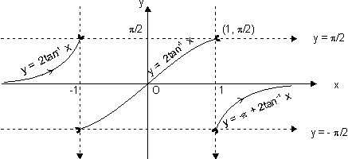
Range y = tan⁻¹
as y = tan⁻¹ y 
Let x = tan
y = tan⁻¹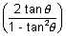 = tan⁻¹(tan2) = 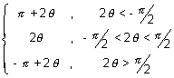
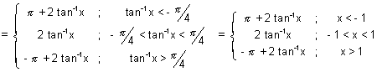
Dumb Question: Why y = tan⁻¹(tan2) = - + 2 tan⁻¹x, for > ?
Ans: Range of y & when > So, 2 > .
To make it within range we substract So, it comes under range.
Because of tan(- + 2) = tan2, this can be done.
This curve is neither continous nor differentiable at x = {-1, 1}
Sketch of curve y = tan⁻¹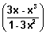
For domain,
y = tan⁻¹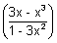
x r except 1 - 3x² = 0 x ±
x R - {± }
domain R
For range
y = tan⁻¹
y
Let x = tan
y = tan⁻¹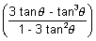 = tan⁻¹(tan3) = 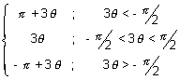
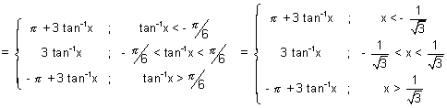
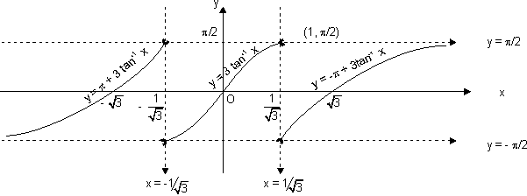
Dumb Question: Why tan⁻¹(tan3) = + 3 if < - ?
Ans: Range of tan⁻¹(tan3) is but if < - So, 3 < - So, to make it within given range. We add to it.
and in IIIrd quadrant.
tan( + 3) = tan3
So, this is done.
This curve is neither cont. nor differentiable at x = ± .
Sketch of y = sin⁻¹(3x - 4x³):
For domain
y = sin⁻¹(3x - 4x³)
x [-1, 1]
For range
y = sin⁻¹(3x - 4x³) y 
Let x = sin
y = sin⁻¹(sin3) = 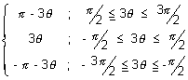
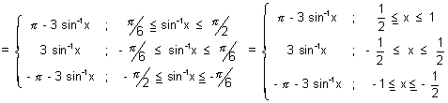
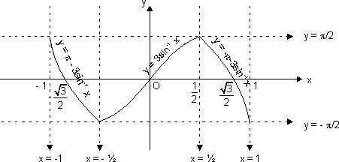
This curve has sharp edge at x = ± 1/2 so, not differentiable at x = ± 1/2.
ketch of curve y = cos⁻¹(4x³ - 3x)
Domain [-1, 1] range [0, ]
Let x = cos
y = cos⁻¹(cos3) = 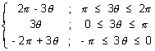
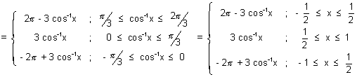
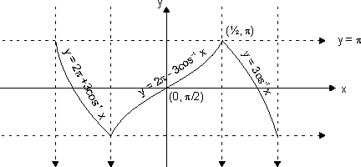
This curve has sharp edge at x = ± 1/2. So, not differentiable at x = ± 1/2.
Dumb Question: Why y = cos⁻¹(cos3) = 2 - 3 if .
Ans: Range of y [0, ) if 3 2. So, it s out of range so, it make it within range, we subtract it from 2
and cos(2 - 3) = cos3
Odd and Even functions: A function is said to be an odd function if, f(-x) = - f(x) for all x.
Graph of odd function is symmetrical in opposite quadrants. eg.
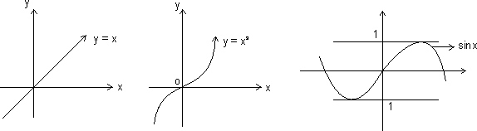
Even function: A function f(x) is said to be an even of f(-x) = f(x) for all x.
Graph is symmetrical about y-axis.
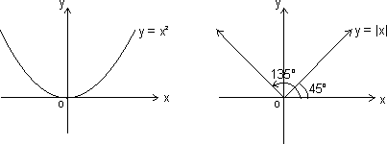
Properties:
(i) Product of two odd functions or two even functions is an even function.
(ii) Product of odd and even function is an odd function.
(iii) Every function y = f(x) can be expressed as sum of an even and odd function.
Illustration: IF f is an even function, find real values of x satisfying eq. f(x) = f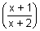
Ans: Since f(x) is even function
f(x) = f(-x)
Thus, x =  or - x = 
x² + x - 1 = 0 or - x² - 3x - 1 = 0
x = 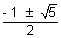 or x = 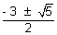
x = 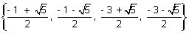
Periodic Function: A function f(x) is said to be periodic function if, there exists a +ve real no. such that,
f(x + T) = f(x), v x R
Then, f(x) is periodic with period T, where T is least +ve value.
eg. sin x is priodic with period 2.
Illustration: Prove that f(x) = x - [x] is periodic function. Also find its period.
Ans: Let T > 0,
Then, f(x + T) = f(x), v x R
(x + T) - [x + T] = x - [x] v x R
[x + T] - [x] = T v x R
T = 1, 2, 3, 4, .............. {Since subtraction of two integer}
Smallest value of T satisfying
f(x + T) = f(x) is 1
So, period with period 1.
Properties of periodic function:
(i) If f(x) is periodic with period T, then,
c.f(x), f(x + c) & f(x) ± c is periodic with period T.
eg. if sin x has period 2. Then f(x) = 5 sinx + 4 is also periodic with period 2.
(ii) If f(x) is periodic with period T, then, kf(cx + d) has period
f(x) = 7 sin2x - 12 has period = as sinx is periodic with period 2.
(iii) If f₁(x), f₂(x) are periodic functions with periods T₁, T₂ respectively then; h(x) = af₁(x) ± bf₂(x) has period as
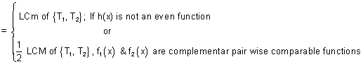
LCM of 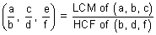
Note: LCM of rational and irrational is not possible. eg. 2 is irrational & 1 is rational.
Composite Function:
Let two function,
f : x Y₁ and g : Y₁ Y
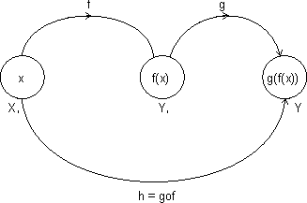
Let another function h : X Y
Such that
h(x) = g(f(x)) = (gof)(x)
domain (gof) = {x : x domain (f), f(x) domain (a)}
domain fog(x) = {x : x domain (g), g(x) domain f}
gof exist iff range of f domain of g
fog exist iff range of g domain of f.
Properties of composite function:
(i) f is even, g is even fog is even function.
(ii) f is odd, g is odd fog is odd function.
(iii) f is even, g is odd fog is even function.
(iv) f is odd, g is even fog is even function.
Illustration: Let g(x) = 1 + x - [x] & f(x) = 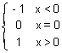. Find fog(x).
Ans: g(x) = 1 + x - [x] = 1 {x}
g(x) is greater than J.
So, f(g(x)) = 1. since f(x) = 1 for all x > 0
f(g(x)) = 1 for all x R.
Mapping of function: A function exists only if,” to every element in domain there exists unique image in co domain.
f : A B
One - One Mapping (Injective): A function f: A B is said to bwe one-one mapping if different elements of A have different images in B. no two elements of set A can have same 'f' image
eg.
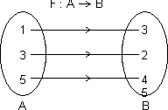
f(x) is one-one
Methods to find one-one mapping:
(1) Graphically: A fun. is one-one if no line 11 to x-axis meets graph of function at more than one point.
By Calculus: If f(x) is function and if f'(x) 0 v x domain i.e. increasing or f'(x) 0 v x domain i.e. decreasing, then one-one.
No. of one-one Mapping: If A & B are finite sets having m & h elements, then, no. of one-one function from A to B
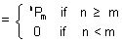
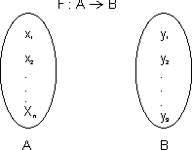
Dumb Question: How No. of one-one mapping is ^{n}P_{m} if n m.
Ans: x₁ can take n images
x₂ can take (n - 1) images
.....................................
.....................................
.....................................
.....................................
x_{m} can take (n - m + 1) images
No. of mapping = n(n - 1)(n - 2) ............... (n - m + 1) = ^{n}P_{m}
Many one Mapping: A mapping f : A B is many one if two or more elements of set A have the same image in B.
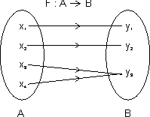
i.e. f(x³) = f(x₄) = y₃
Onto Function (Surjective): If function f : A B is such that each element of B is the 'f' image of at least one element in A.
i.e. range of f = co domain f(A) = B
Into Function: A function of f : A B is into if there exists an element in B having no pre image in A.
No. of one-one onto mapping (bijection): If A & B are finite sets & f : A B is a bijection.
Then A & B have same no. of elements.

Total no. of bijection A B = n !
Dumb Question: How total no. of bijection A B = n ! ?
Ans: x₁ can take n images
x₂ can take (n - 1) images
x₃ can take (n - 2) images
.....................................
.....................................
.....................................
x_{m} can take 1 images
No. of mapping = n(n - 1)(n - 2) ............... 1 = n !
Functions:
Illustration: Find no. of surjection from A B
A = {1, 2, 3, 4} & B = {a, b}
Ans:
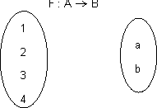
1 2 images
2 2 images
3 2 images
4 2 images
Total no. of function = 2 x 2 x 2 x 2 = 2⁴
But there are two function f(x) = a for all x A & g(x) = b for all x A are not surjective.
Total no. of surjection from A to B = 2⁴ - 2 = 14
Inverse function: Let f : A B be one-one & onto function then there exists a unique function.
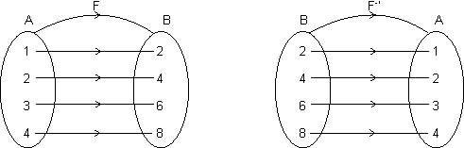
g : B A such that f(x) = y g(y) = x, v x A & y B
Then g is c/d inverse of F.
So, g = f⁻¹ : B A = {(f(x), x) | (x, f(x) f}
Domain of f = {1, 2, 3, 4} = range of f⁻¹
Range of f = {2, 4, 6, 8} = domain of f⁻¹.
Illustration: If f(x) = 3x - 5, then find f⁻¹(x).
Ans: f(x) = 3x - 5 which linear function so bijective.
Let f(x) = y Y = 3x - 5
x = 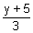 f⁻¹(y) = 
f⁻¹(x) = 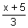
Note: (1) Graph of y = f(x) and y = f⁻¹(x) are mirror images to each other.
(2) If f : A B & g : B C are two bijections, then gof : A C is bijection & (gof)⁻¹ = (f⁻¹og⁻¹).
(3) If fog = gof then either f⁻¹ = g or g⁻¹ = f and (fog)(x) = (gof)(x) = (x)
Easy Type
Q.1. Find domain of f(x) = log₁₀log₁₀(1 + x³)
Ans: Let log₁₀(1 + x³) = y
f(x) = log₁₀y y > 0
log₁₀(1 + x³) > 0 (1 + x³) > 10⁰
x³ > 0 x (0, )
Q.2. Find domain of y =
Ans: Let log₂x = z
z is defined if x > 0 .......................................... (i)
and - 1 z 1 or - 1 log₂x 1
1/2 x 2 ................................................. (ii)
But y is defined if
sin⁻¹z 0 or sin⁻¹log₂(x) 0 ..................... (iii)
log₂x 0 x 2⁰ x 1 .................. (iv)
From (i), (ii) & (iv)
1 x 2
domain x [1, 2]
Q.3. Find values of 'a' for which f(x) = tan⁻¹(x² - 18x + 9) > 0 for x R.
Ans: f(x) > 0 v x R
x² - 18x + a > 0 v x R
ax² + bx + c > 0 if D < 0 & a > 0
D = (18)² - 49 < 0 a > 81
a (81, )
Q.4. f(x) = 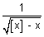 find domain of f9x).
Ans: f(x) =  exists if
[x] - x > 0 [x] > x
But by definition of greatest integer function
[x] x as x = [x] + {x}
So, it is not possible that [x] > x
domain f(x) =
Q.5. Solve 4{x} = x + [x]
Ans: x = [x] + {x}
4{x} = [x] + {x} + [x] {x} = 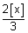
But 0 {x} < 1
0 < 1 0 [x] < 3/2
[x] = 0 or 1
If [x] = 1, then {x} = 2/3
Thus, x = [x] + {x} = 1 + 2/3 = 5/3
If [x] = 0, {x} = 0
x = 0
Solutions x {0, 5/3}
Q.6. Find range for y = 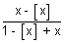.
Ans: y = = 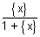
Domain R
y =  {x} = 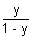
Since 0 {x} < 1 0 < 1 0 y < 1/2
range = (0, 1/2)
Q.7. Let f(x) be periodic & k bca +ve real no. such that f(x + k) + f(x) = 0 v x R. Prove that f(x) f(x) is periodic with period 2k.
Ans: f(x + k) + f(x) = 0 v x R
f(x + k) = - f(x) v x R ................................................... (i)
put x = x + k
f(x + 2k) = -f(x + k) v x R
from (i)
f(x + 2k) = f(x), v x R
f(x) is peruiodic with period 2k.
Q.8. Find period of f(x) = tan3x + sin
Ans: Period for tan 3x is 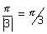
Period for sin is |2 x = 6
LCM of sin⁻¹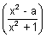 <
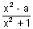< 1 1 - 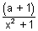< 1, v x R
- - < 0
a + 1 > 0
a (-1, )
Q.10. If f : R R f(x) = x² + 1, then find value of f⁻¹(17).
Ans: f(x) = x² + 1
f⁻¹(17) f(x) = 17
x² + 1 = 17 x = ±4
x = {4, -4}
Medium Type
Q.1. Find domain of function. f(x) = 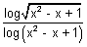
Ans: log(x² - x + 1) is defined when
x² - x + 1 > 0 & x² - x + 1 1
x R and x 0, 1
x R - {0, 1} ..................................... (i)
[Dumb Question: How x² - x + 1 > 0 v x R & why x² - x + 1 1 ?
Ans: ax² + bx + c > 0 v x R if a > 0 & D < 0
For x² - x + 1, a = 1 > 0 & D = 1 - 4 = - 3 < 0
So, x² - x + 1 > 0 for all x R
& If x² - x + 1 = 1 then logx² - x + 1 = 0
& 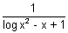= which is not desired.]
Again log(sin⁻¹⁾ exists when x² + x + 1 > 0 & x² + x + 1 1
i.e. 0 < x² + x + 1 1
x² + x 0 x [-1, 0] .............................. (ii)
From (i) & (ii)
x [-1, 0)
Q.2. Find domain of f(x) = 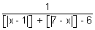 where {} is greatest integer function.
Ans: f(x) is defined when
[|x - 1|] + [|7 - x|] - 6 0
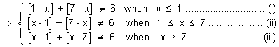
Taking (i)
[1 - x] + [7 - x] 6 1 + [-x] + 7 + [-x] 6
2[-x] - 2 [-x] - 1
x (0, 1] ................................... (1)
From (ii)
[x - 1] + [7 - x] 6 [x] - 1 + 7 + [-x] 6
[x] + [-x] 0 x Integer
x {1, 1, 3, 4, 5, 6, 7} ................. (2)
From (iii)
x [7, 8) ..................................... (3)
From (1), (2) & (3)
Domain f(x) R - {(0, 1] {1, 2, 3, 4, 5, 6, 7} [7, 8)}
Q.3. f(x, y) is periodic function satisfying condition f(x, y) = f((2x + 2y),(2y - 2x)) v x,y R. Now g(x) = f(2^{x}, 0) then prove that g(x) is periodic function, find its period.
Ans: f(x, y) = f(2x + 2y, 2y - 2x) ....................................... (i)
Put x = 2x + 2y & y = 2y - 2x
f(2x + 2y, 2y - 2x) = f(2(2x + 2y) + 2(2y - 2x), 2(2y - 2x) - 2(2x + 2y)) [By (i)]
f(x, y) = f(2x + 2y, 2y - 2x) = f(8y, - 8x)
f(x, y) = f(8y, - 8x) ..................................................... (ii)
f(8y, - 8x) = f{8(- 8x), - 8(8y)} [By (ii)]
f(x, y) = f(2x + 2y, 2y - 2x) = f(8y, - 8x) = f(- 64x, - 64y)
f(x, y) = f(- 64x, - 64y) ............................................... (iii)
f(- 64x, - 64y) = f(64 x 64 x, 64 x 64y) = f(2¹²x, 2¹²y) [By (iii)]
f(x, y) = f(2¹²x, 2¹²y)
f(2^{x}, 0) = f(2¹².2^{x}, 0) = f(2^{12 + x}, 0)
g(x, 0) = f(2^{x}, 0) = f(2^{12 + x}, 0)
g(x, 0) = g(x + 12, 0)
g(x) is periodic with period
Q.4. Let f(x) = 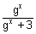. Show that f(x) + f(1 - x) = 1 & hence, evaluate
Ans: f(x) = ................................................. (i)
and f(1 - x) = 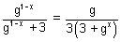.............................. (ii)
Adding (i) & (ii), we get
f(x) + f(1 - x) = + 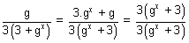
f(x) + f(1 - x) = 1 ............................................. (iii)
Now, putting x = 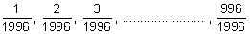in (iii).
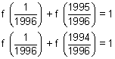
........................
........................
........................
........................
........................
........................
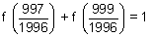
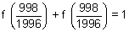 or 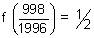
Adding all.
[Dumb Question: For what is added ?
Ans: For 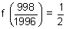]
= 997 + = 997.5
Q.5. Let g(x) be inverse of f(x) and f'(x) = 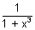. Then find g'(x) in terms of g(x).
Ans: Since g(x) is inverse of f(x)
(gof)(x) = x
g{f(x)} = x
g'{f(x)} f'(x) = 1
g'{f(x)} = 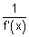= 1 + x³
g'{f(g(x))} = 1 + (g(x))³
g'(x) = 1 + (g(x))³
Dumb Question: How f(g(x)) = x ?
Ans: Since g(x) is inverse of f(x)
f(x) is also inverse of g(x)
By inverse property
f(g(x)) = x

Hard Type
Q1. Prove that a² + b² + c² + 2abc < 2 where a, b, c, are sides of ABC such that a + b + c = 2
Ans: a + b + c = 2
1 - a + 1 - b + 1 - c = 1
x + y + z = 1 where x = 1 - a, y = 1 - b, z = 1 - c
Sine in
Sum of two sides > third side
a + b > c 0 < c < 1
Similarly 0 < a, b < 1
hence 0 < x, y, z < 1
Now,
a² + b² + c² + 2abc = (1 - x)² + (1 - y)² + (1 - z)² + 2(1 - x)(1 - y)(1 - z)
= 3 - 2(x + y + z) + x² + y² + z² + 2{1 - (x + y + z) + (xy + yz + zx) - xyz}
= 1 + x² + y² + z² - 2xyz + 2(xy + yz + zx)
= 1 + (x + y + z)² - 2xyz
= 2 - 2xyz < 2 as 0 < x, y, z < 1
a² + b² + c² + 2abc < 2
Dumb Question: How 0 < c < 1 ?
Ans: Since g_{n} ,
Sum of two sides > third side
a + b > c ............................................. (i)
or a + b + c > 2c
2 > 2c c < 1 ..................................... (ii)
Since c is side of
c > 0 ............................................... (iii)
From (ii) & (iii)
0 < c < 1
Q.2. A function R R is f(x) = 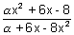. Find integral value of for which f is onto.
Ans: Since f : R R is onto mapping
Range = codomain = R
 assumes all real values of x
Let y = 
x²( + 8y) + 6x(1 - y) - (8 - y) = 0 v y R
D 0
36(1 - y)² + 4( + 8y)(8 + y) 0
[y²(8 + 9) + y(² + 46) + (8 + 9) 0
ax² + bx + c 0 v x R if a > 0 & D 0
(² + 46)² - 4(8 + 9)(8 + 9) 0 & (8 + 9) > 0
(² + 46)²) - [2(8 + 9)]² 0 & > -
(² + 46 - 16 - 18)(² + 46 + 16 + 18) 0 & > -
( - 14)( - 2)( + 8)² 0 and > -
[2, 14] {-8} and > -
[2, 14]
Q.3. Solve the eq. [x]{x} = x
Ans: x = [x] + {x} .................................. (i)
[x]{x} = [x] + {x} {x} = 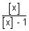............................. (ii)
[x] 1 in eq. (ii)
But if [x] = 1, then
{x} = x which is donje only when,
x [0, 1) ................................................. (iii)
& [x] = 1 [1, 2) ................................. (iv)
From (iii) & (iv) no value of x,
when [x] = 1
As we know
{x} [0, 1)
0 < 1
 < 1 & 0
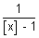< 0 & {[x] 0 or [x] > 1}
[x] < 1 & {[x] 0 or [x] > 1}
[x] 0
x = [x] + {x} = [x] + 
x = 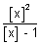, where x takes values less than 1.
x = , where x < 1
x = , where [x] is any non positive integer.
Q4. Sketch y = (x - 1)(x - 2)
Ans: y = (x - 1)(x - 2)
(i) put y = 0 x = 1, 2
(ii) y = x² - 3x + 2
= 2x - 3 &
as > 0
minimaq at x = 3/2.
(iii) Increases when x > 3/2 & decreases when x < 3/2.
y = x² - 3x + 2
when x = 3/2
y = 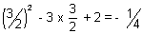
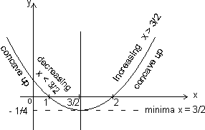
Q5. Sketch curve y = (x - 1)(x - 2)(x - 3)
Ans: y = (x - 1)(x - 2)(x - 3)
(i) Put y = 0 x = 1, 2, 3
(ii) y = x³ - 6x² + 11x - 6
= 3x² - 12x + 11 & = 6x - 12
when = 0 x = 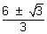
Maxima when x = 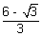 as = - 2
Minima when x = 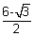 as = 2
(iii) = 3x² - 12x + 11
= 3(x - )(x - )
> 0 or Increases when
x <  or x > 
Decreases when < 0
or < x < 
(iv) Concave upwards when x > 2 & concave down when x < 2.
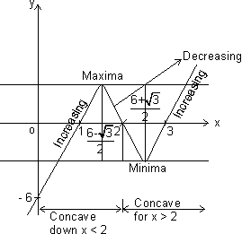
x = 2 is point where concavity of curve changes.
KEYWORDS
- Function
- Domain
- Co-domain
- Range
- Identity Function
- Constant Function
- Logarithmic Function
- Modulus Function
- Signum Function
- Greatest Integer Function
- Fractional Integer Function
- Fractional Part Function
- Odd & Even Function
- Periodic Function
- Composite Function
- Mapping
- Bijective
- Surjective
- Injective
- Inverse of Function.

Functions
MCQ-Single Correct
1. The function f : defined as , is :
(1) invertible.
(2) injective but not surjective.
(3) surjective but not injective.
(4) neither injective nor surjective. [2017]
2. Let a , b , c ε R. If f(x) = is such that a + b + c = 3 and f(x+y) = f(x) +f(y) +xy x , y ε R, then is equal to :
(1) 330 (2) 165
(3) 190 (4) 255 [2017]
3. If and then S:
(1) contains exactly one element.
(2) contains exactly two elements.
(3) contains more than two elements
(4) is an empty set [2016]
4. For real x, let , then
(1) f is one-one but not onto R
(2) f is onto R but not one-one
(3) f is one-one and onto R
(4) f is neither one-one nor onto R [2009]
5. Let f : be a function defined as f(x) = 4x +3, where Y = {y ε N : y = 4x +3 for some xεN }. Show that f is invertible and its inverse is
(1) g(y) = (2) g(y) =
(3) g(y) = (4) g(y) = [2008]
6. The largest interval lying in for which the function
is defined , is
(1) (2)
(3) (4) [2007]
7. Let f : , be a function defined by , then f is both one-one and onto when B is the interval
(1) (2)
(3) (4) [2005]
8. A real valued function f(x) satisfies the functional equation f(x-y) = f(x) f(y) – f(a – x) f(a + y) where a is a given constant and f(0) = 1, f(2a – x) is equal to
(1) -f(x) (2) f(x)
(3) f(a) + f(a-x) (4) f(-x) [2006]
9. The range of the function f(x) = is
(1) { 1, 2, 3} (2) {1,2,3,4,5}
(3) {1,2,3,4} (4) {1,2,3,4,5,6} [2004]
10. If f : , defined by , is onto, then the interval of S is
(1) [0,3] (2) [-1,1]
(3) [0,1] (4) [-1,-3] [2004]
11. The graph of the function is symmetrical about the line x = 2 , then
(1) f(x + 2) = f(x -2) (2) f(2+x) = f(2-x)
(3) f(x) = f(-x) (4) f(x) = -f(-x) [2004]
12. The domain of the function is
(1) [2,3] (2) [2,3)
(3) [1,2] (4) [1,2) [2004]
13. A function f from the set of natural numbers to integers defined by
f(n) = is
- one-one but not onto (2) onto but not one-one
(3) one-one and onto both (4) neither one-one nor onto [2003]
14. If satisfies f(x+y) = f(x) + f(y), for all x,y ε R and f(1) = 7, then is
(1) (2)
(3) 7n(n+1) (4) [2003]
15. Domain of definition of the function f(x) = , is
(1) (1,2) (2)
(3) (4) [2003]
16. The function f(x) = , is
(1) an even function (2) an odd function
(3) a periodic function
(4) neither an even nor an odd function [2003]
17. The period of is
(1) (2)
(3) (4) [2002]
18. Which one is not periodic
(1) (2)
(3) cos4x + (4) [2002]
19. If f(x+y) = f(x).f(y) x,y and f(5) = 2, f’(0) = 3, then f’(5) is
(1) 0 (2) 1
(3) 6 (4) 2 [2002]
20. The domain of is
(1) [1,9] (2) [-1,9]
(3) [-9,1] (4) [-9,-1] [2002]

Assertion – Reason Type
1. Let f be a function defined by
Statement – I : The set { x : f(x) = } = {1,2}.
Statement – II : f is bijection and = , .
2. Let f(x) = ,
Statement – I : The set { x : f(x) = } = {0,-1}
Statement – II : f is a bijection.

Limits and Continuity
INTRODUCTION

To find limit of a function is an interesting concept where it may be possible that value of the function does not exist at a point but we try to find the value in the neighborhood of the point. We will talk about this in more detail in the chapter. In the other part of the chapter we will discuss continuity of a function which is closely related to the concept of limits. There are some functions for which graph is continuous while there are others for which this is not the case…
Definition of Limit:
We sometime come across situations when the values of the function ‘f’ for values of ‘x’ near a point ‘c’ lie near a number ‘l’ which is not equal to f (c) or that value lie near no number at all.
Dumb Question:
1) How is it possible that function has different value near point c and at c?
Ans: Let us explain it with help of an example, Consider

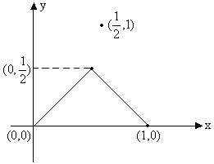
Fig (1)
In this function clearly the value of function near 1/2 lies near 1/2 but the value of
function at 1/2 is 1 which is not equal to 1/2.
So, there is need to introduce the notion of limit. A function f is said to tends to a limit l as x tends to ‘a’, if on approaching the point x=a from the values just greater than or just smaller than x=a, f(x) has tendency to move more closer to value l.
Mathematically we write this as
Which is equivalent to,
|f(x)-l| < ε ∀ x whenever 0 < |x-a| <δ, and ε and δ are sufficiently small positive numbers.

Right and Left hand limits:
Right hand limit:
If for every numbers ε>0 there exists corresponding number δ>0 such that for all x satisfying
a < x < a+δ
⇒ |f(x)-l)| <ε
Example: 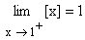
Left hand limit:
If for every number ε>0 there exists a corresponding δ>0 such that for all x satisfying a-δ< x < a ⇒ |f(x)-l|<ε
Example:
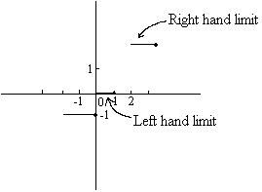
Fig (2)
Note that limit of a function exists at any point if and only if left hand limit is equal to right hand limit at that point.
Illustration 1:
Find the value of Where
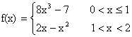
Solution:
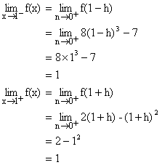
So, right hand limit and left hand limit are equal. Hence

Discovering infinity:
Infinity () is a symbol and not a number it is symbol for something which keeps increasing and passes all limits. Similarly - is symbol of a variable that continuously decrease and passes all limits.
Remember the following points:
1) We cannot plot on paper.
2) + = .
3) - is indeterminate.
4) × = .
5) 0 × is indeterminate.
6) 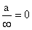If a is finite.
7) , ⁰, are all indeterminate.
Dumb Question:
1) It is often said ‘ + a’ where a is finite is . How is this possible?
Ans: Consider like an ocean. Now ‘a’ is like a bucket of water. If you add a bucket of water to ocean will the volume of ocean increase? It will remain ocean. So similarly remains on adding a finite number to it.
Illustration 2:
Find the value of ?
Solution:
= +
=
∴The value of = .

Theorem on Limits:
Let and . If l and m exist then,
1) .
2) .
3) 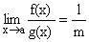Provided m ¹ 0.
4) Where k is constant.
5) If f(x) £ g(x) then l £ m.
6) 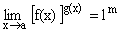.
7) If f(x) £ g(x) £ h(x) for all x.
and then (Squeeze play/ Sandwitch Theorem).
Illustration 3:
If [x] denotes the integral part of x, then find 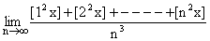.
Solution:
Let
Now we know
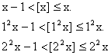
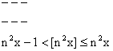
\ Adding them all gives us
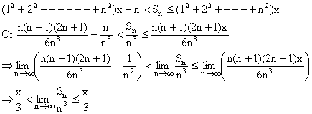
By using squeeze play theorem we get,
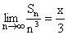.

Some important expansions (Power Series):
1) 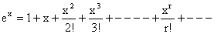.
2) 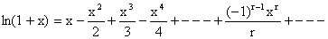 Here -1 < x £ 1.
3) 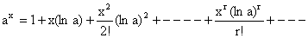.
4) 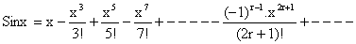.
5) 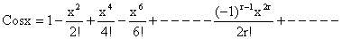.
6) 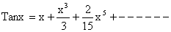.
7) 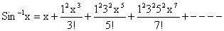.
8) 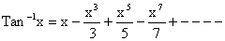
9) 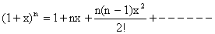(For rational or integral n).
Illustration 4:
Find the series expansion of Sin²x?
Solution:
Now we know that
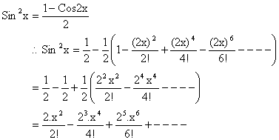
Note that many other series could be found in that way as we found the series for Sin²x.

Some Standard results on limits:
1)
2) 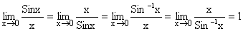
3) 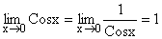
4) 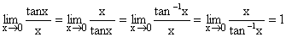
5) 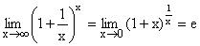
6) 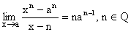
7) 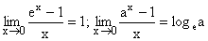
8) 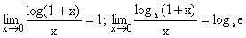
9) 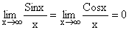
10)
Note: These limits could be derived using the series expansion or by L¹ Hospital’s rule which will discussed in a later section.
Illustration 5:
Find the value of 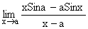?
Solution:
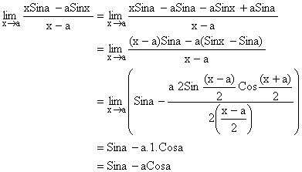

Evaluation of Limits:
1) Direct Substitution:
If we get a finite number by direct substitution of point we are done.
Illustration 6: Find 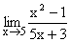?
Solution:
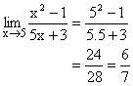

2) Algebraic Limits:
A) Factorization process of finding limit.
If direct substitution of x=a in a rational function takes useless form like 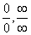then a factor of (x-a) can be cancelled from both numerator and denominator. Now again use direct substitution to see if limit can be evaluated.
Illustration 7:
Find 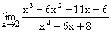?
Solution:
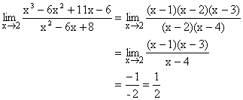
B) Using the result 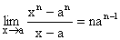
Illustration 8: Evaluate 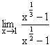?
Solution:
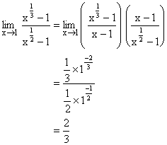
C) Using rationalization:
Some factor which creates form is cancelled by rationalization and limit is evaluated.
Illustration 9: Evaluate 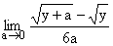?
Solution:
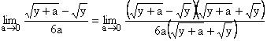
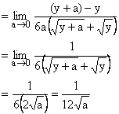
D) Limits where x®
We write down expression as a rational function and then divide each term by highest power of x obtained from numerator and denominator.
Illustration 10: Find the value of 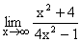?
Solution:
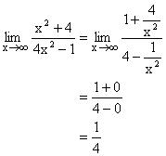
3) Trigonometric Limits:
The trigonometric limits are those which involve trigonometric ratios. The use of the result 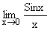is a integral part of evaluation of such limits.
Illustration 11: Evaluate 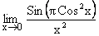?
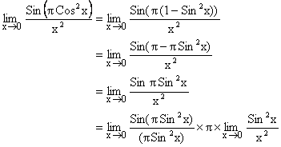
= 1´ p ´ 1
= p.
4) Exponential and Logarithmic Limits:
These are the limits which involve use of logarithmic and exponential functions. Some of the standard limits help us in solving these limits.
Illustration 12:
Find the following limits 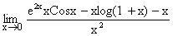
Solution:
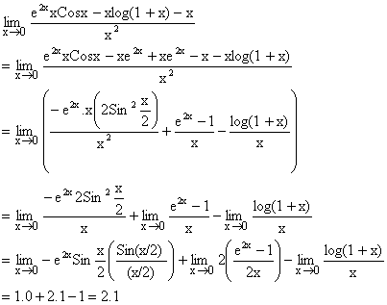

L’ Hospital’s Rule:
L’ Hospital’s Rule is applied only to the two forms 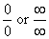.The rule states that if 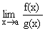is of the form then 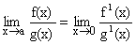 provided later limit exists. But if still it takes the form then we differentiate numerator and denominator again.
i.e. 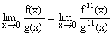and this process continues till we find that form is removed.
Illustration 13:
Evaluate
Solution:
Let A =
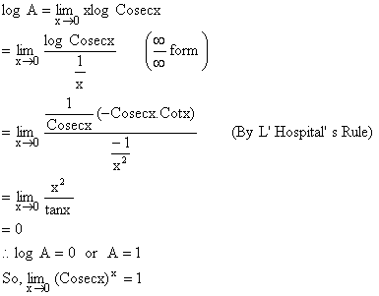

Continuity at point:
A function ‘f’ is said to be continuous at a point ‘a’ in domain of f, if following conditions are met.
1) f (a) exists.
2) exists finitely which essentially means that 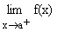and 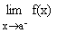both exist finitely and are equal.
3) . If anyone or more conditions are not met than function f is said to be discontinuous at point ‘a’. Geometrically graph of function exhibit a break at point x=a.
Illustration 14: Discuss the continuity of function y = f(x) as shown by graph below at the point x=1.
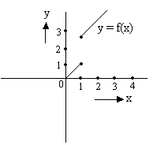
Fig (3)
Solution:
Now clearly the function exhibits a break at point x=1 and is thus discontinuous at x=1. But if we go by the rules mentioned in above article we observe that.
And
So does not exists and thus the function is discontinuous at x=1.
Continuity of function in open interval:
A function f is said to be continuous in (a, b) if f is continuous at each and every point belonging to interval (a, b).
Continuity of function in closed interval:
A function f is said to be continuous in closed interval [a, b] if
1) f is continuous in open interval (a, b) and
2) exists finitely and and
3) 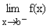exists finitely and 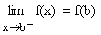.
Illustration 15:
Consider a function f(x) which is continuous in [1, 2] and given that f (1) = -1 and f (1) = 2, prove that there exists a point x such that f(x) =1.
Solution:
Let us arbitrarily choose some graph for f(x)
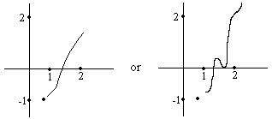
Fig (4)
For that matter function f(x) can take any shape. But since the function f is continuous between 1 and 2 it must be defined on all values lying between 1 and 2 and the function’s curve will go from y = -1 to y = 2 through some path. Whatever path be chosen y =1 will lie in between (Remember there cannot be a sudden jump because function is continuous)
Hence there exists a point x-where f(x) = 1.
Properties of continuous functions:
Let f(x) and g(x) are continuous functions at x=a then
1) K f(x) is continuous where K is constant
2) f(x) ± g(x) is continuous at x=a.
3) f(x) ´g(x) is continuous at x=a.
4) f(x)/g(x) is continuous at x=0 provided g (a) ¹ 0.
5) If m = f(x) is continuous at x=x₀ and f (m) is continuous at the point m₀ = f(x₀), then composite function f (f(x)) is continuous at point x₀.
6) If f(x) is continuous on [a, b] such that f (a) and f (b) are of opposite signs. Then there exists at least one solution of equation f(x) = 0 in the open interval (a, b).
7) Functions like sinx, cosx, tanx, cotx, secx, cosecx, logx, e^{x} etc are continuous in their domain.
Dumb Question:
1) How can function like tanx be continuous?
Ans: Please read the point mentioned above carefully. It is written that tanx is continuous in its domain. The points (2n+1)p/2 when tanx® do not lie in the domain of function f.
Illustration 16:
Let function 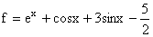Prove that there is a solution for equation f(x) =0 in the interval [0, 1].
Solution:
We observe that e^{x}, cosx, sinx, all are continuous functions in interval [0, 1]. So the function f is also continuous in [0, 1].
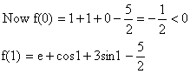
Since 0<1< (p/2) so cos1 and sin1 are positive quantities and e> .
So, f (1)>0.
Now f (0) and f (1) are of opposite signs. So f(x) =0 has a solution in interval [0, 1].
Classification of discontinuities:
1) Removable discontinuity:
Here at a point x=a of discontinuity, exists but f (a) is either undefined or if defined it does not tally with .
In this case the removal of discontinuity is achieved by modifying definition of function suitably so that f (a) tallies with which is found existing.
2) Irremovable discontinuity:
Here does not exist even though f (a) exists or additionally f (a) also does not exist.
Here, since does not exist, no modification of definition at x=a can succeed to make exist. Hence discontinuity remains irremovable.
Illustration 17:
Consider the function
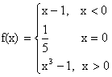
Discuss the continuity of function at x=0. If discontinuous suggest how to remove discontinuity.
Solution:
Let us plot the function f(x)
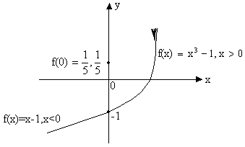
Fig (5)
Now
And 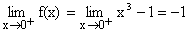
So, = = -1
But f (0) = .
\f (x) has removable discontinuity and f(x) can be made continuous by taking f (0) = -1.
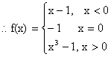

PROBLEMS (EASY TYPE)
1) Prove that 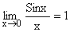
Solution:
And so 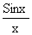assumes the indeterminate form 0/0 when x tends to 0.
We know for 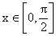
Sinx < x < Tanx
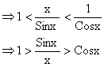
This is true for x>0, the same holds when x<0 in that Sin (-x)/ (-x) = and
Cos (-x) = Cosx.
Now since , it follows from sandwitch theorem,
.
2) Find the value of 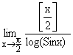.
Solution: As 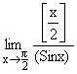
\ 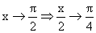
Where 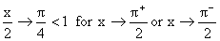
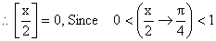
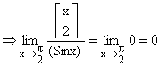
3) Evaluate 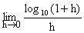.
Solution:
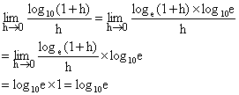
4) Evaluate 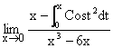.
Solution:
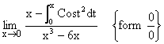
Applying L-Hospital’s Rule we get,
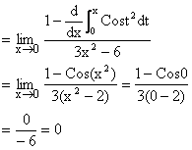
5) Find 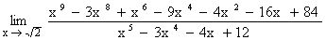.
Solution:
For both the numerator and denominator are 0.
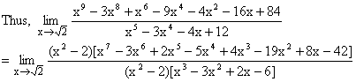
Given [x²-2 ¹ 0].
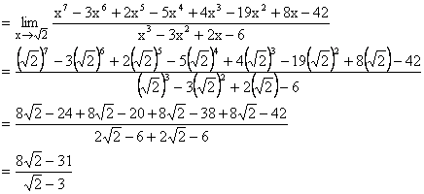
6) If 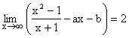then find the values for a and b.
Solution:
We have 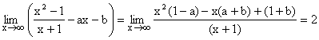
Since, limit of above expression is a finite non-zero number.
\ degree of numerator = degree of denominator
Þ 1-a = 0 Þ a = 1
\ Putting a = 1 in above limit we get
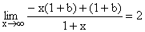
Þ - (1+b) = 2 Þ b = -3
Hence a = 1 and b = -3.
7) Let
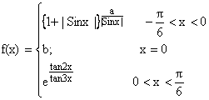
Determine a and b such that f(x) is continuous at x=0.
Solution:
Since f(x) is continuous at x=0.
Therefore R.H.L = L.H.L = f (0)
R.H.L at x = 0.
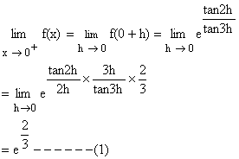
Again L.H.L at x = 0
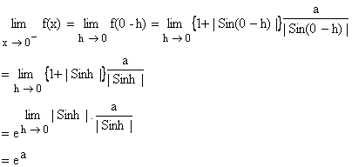
And f (0) = b ------ (2)
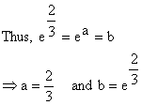

8) A function is defined as follows,
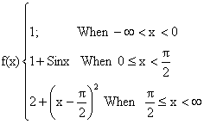
Discuss continuity of f.
Solution:
Continuity at x = 0
L.H.L at x = 0
R.H.L at x = 0
f (0) = 1+Sin0 = 1
= L.H.L = R.H.L = f (0) so f (x) is continuous at x = 0.
Continuity at 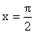
L.H.L at = 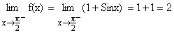
R.H.L at = 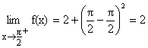
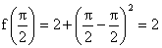
\ R.H.L = L.H.L = 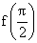
So, f(x) is continuous at .
Hence f(x) is continuous over the whole real number.
9) Discuss the continuity of the function:
g (x) = [x] + [-x] at integral values of x.
Solution:
Here x can assume two values a) Integers b) Non-Integers
a) If x is an integer
[x] = x and [-x] = -x Þ g(x) = x-x = 0.
b) If x is not an integer.
Let x = n+f Where n is an integer and f Î (0, 1).
Þ [x] = [n+f] = n.
Þ [-x] = [-n-f] = [(-n-1) + (1-f)] = (-n-1). (Because 0<f<1 Þ (1-f) <1)
Hence g(x) = [x] + [-x] = n + (-n-1) = -1.
So we get;
g(x) = 0; if x is an integer
= -1; if x is not an integer
Let us discuss the continuity of g(x) at a point x=a (Where a Î integer).
L.H.L = (as x®a⁻, x is not an integer)
R.H.L = (as x®a⁺, x is not an integer)
But g (a) = 0 because a is an integer.
Hence g(x) has a removable discontinuity at integral values of x
\ g (x) = [x] + [-x], xÏ integer.
= -1, x Î integer.
10) Let f(x) = x- |x-x²|, -1£ x £ 1. Discuss the continuity of f(x) in the closed interval
[-1, 1]. Draw the graph of f(x) in that interval.
Solution:
Here f(x) = x-|x (1-x)|
= x- |x| |x-1|, -1£ x £ 1.
Now using definition of modulus function we have
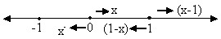
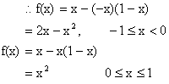
We know that polynomials are continuous every where, so only doubtful point is the turning point x=0 of definition.
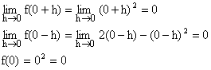
So f(x) is continuous at x=0.
Hence f(x) is continuous in [-1, 1].
Hence the graph of f(x) is continuous in [-1, 1] and
f (x) = 2x-x² in -1£ x < 0
x² in 0£ x £ 1.
\ The graph of f(x) is as follows;
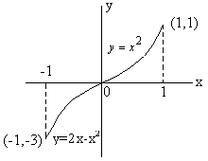
11) A function f(x) is defined by
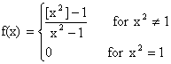
Discuss the continuity of f(x) at x=1.
Solution:
We have
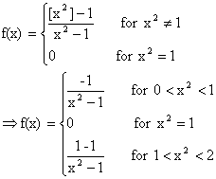
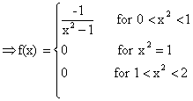
\ R.H.L at x² =1
Þ
Also L.H.L at x²=1
Þ 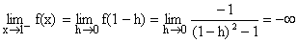
does not exist {as R.H.L ¹ L.H.L}
Hence f(x) is not continuous at x=1.

PROBLEMS (MEDIUM TYPE)
1) Without expansion or using L-Hospital’s Rule prove that 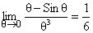.
Solution:
Let the limit be P then
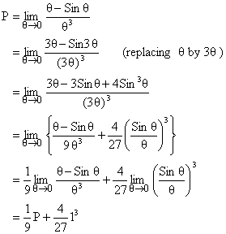
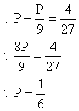
Dumb Question:
1) How can we replace q by 3q in the limit without changing it?
Ans: Since q ® 0, 3q will also tend to zero and thus there is no effect on the limit and thus it remains same.
2) Prove that
If x is rational.
If x is irrational.
Solution:
We know that |Cosq| £ 1 for all q.
If |Cos (n!p x) | = P <1,
limit =
As P^{2m} ® 0 When m® .
If |Cos (n!p x) | =1.
limit =
Now |Cos (n!p x) | =1
Þ n!px = kp, Where k is an integer.
\x = which is a rational number.
\ From (2) limit = 2 if x is rational.
Again |Cos (n!p x) |<1
Þ |Cos (n!p x) | ¹ 1 for all n Î N.
Þ n!px ¹ kp for all nÎN, k Î Z
Þ x ¹ for all n Î N, k Î Z.
Þ x is not rational i.e. x is irrational.
\From (1) limit = 1 if x is irrational.
3) Given 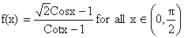except at 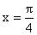. Define 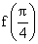so that f(x) may be continuous at .
Solution:
f (x) will be continuous at ,
If 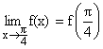
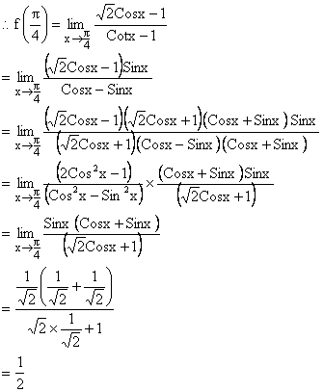
Dumb Question:
1) Why did we multiply by in both numerator and denominator?
Ans: The basic aim to do the multiplication was to cancel out Cos2x which was making the limit an indeterminate form.
4) Prove that (where [] denotes greatest integer function) is continuous in 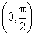.
Solution:
Here or , Where x = tanx ³ 0.
Then for a ÎN we discuss continuity of f(x) as L.H.L at x=a,
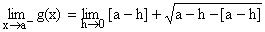
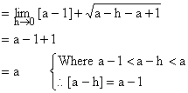
Now R.H.L at x=a.
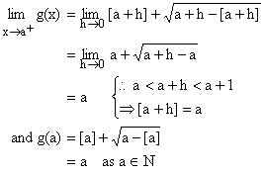
So, g(x) is continuous for all a ÎN, Now g(x) is clearly continuous in (a-1, a) for all
a ÎN.
Hence g(x) is continuous in [0,].
Now let f(x) = tanx which is continuous in .
So g {f(x)} is continuous in .
Hence is continuous in .

Find the point of discontinuity of 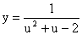where 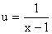.
Solution:
The function 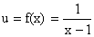is discontinuous at the point x=1 ----- (1)
The function 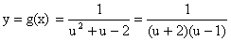is discontinuous at u=-2 and u=1.
When u = -2, 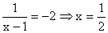
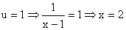
Hence composite function y = g(x) is discontinuous at three points 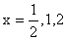.
6) If 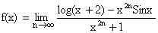examine the continuity of f(x) at x=1.
Solution:
To examine the continuity at x=1, we are required to derive the definition of f(x) in the intervals x<1, x>1 and at x=1, i.e. on and around x=1.
Now if 0<x<1
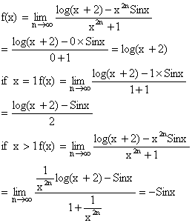
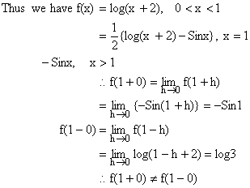
So f(x) is not continuous at x=1.
Dumb Question:
1) How does 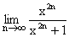varies with the value of x?
Ans: Now suppose x<1
So,
∴ =0
If x =1 then 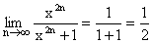
If x>1 then
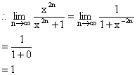
7) Show 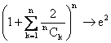as n→ (for n ≥ 6)
Solution:
Let 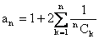while for n ≥ 6.
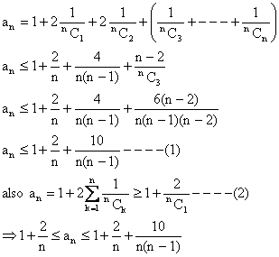
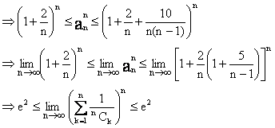
∴ By squeeze principle for limits,
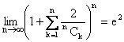.
KEYWORDS
- Limit
- Extending/Approaching
- Right Hand Limit
- Left Hand Limit
- Infinity m
- Sandwich Theorm/Squeeze play Theorm
- Power Series
- L-Hospital’s Rule
- Continuity
- Removable discontinuity
- Irremovable discontinuity

DIFFERENTIABILITY
INTRODUCTION
For many years the path in which planets were revolving round the sun was not known. After many years of observation Kepler conducted that planets move around the sun in elliptical orbits. But he could not give logical reasoning for his claim. But once Newton and Leibniz gave the fundamental theorem of calculus, the reasoning for this and many more things became quiet clear. Since then differential calculus has proved itself to be indispensable in development of mathematics and physics sciences.
In this section we will talk about some techniques of differentiation and their application to various question

So let us start with DIFFERENTIATION.
Definition of Derivative:
The derivative f¹(x) of a function y = f(x) at a given point x is defined as
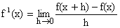
Where f¹(x) is called derivative of f(x) with respect to x.

Derivation of f(x) from first principle (i.e. Definition on ab-init):
Let y = f(x) for an increment dx in x, let dy be the corresponding increment in y.
y + dy = f (x+dx).
dy = f (x+dx)-f(x)
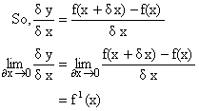
f¹(x) if exists is called derivative of f(x) w.r.t x.
Note: 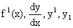all represents the same thing.
Illustration 1:
Find the derivative of w.r.t x using the first principle?
Solution:
Let y =
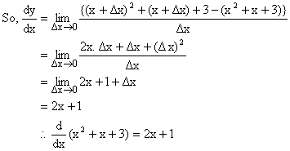

Right and Left Derivative of a function:
The Right hand derivative of a function at point ‘a’ denoted by is defined as
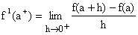
Similarly left hand derivative of function at ‘a’ denoted by is defined as
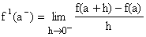
Differentiability of a function at a point:
A function f(x) is said to be differentiable at a point ‘a’ if
1) Both and are exist and are finite.
2) = .
Illustration 2:
Prove that function |x-1| is not differentiable at x=1.
Solution:
Let us find the right hand derivative and left hand derivative of this function.
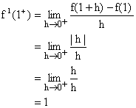
Similarly
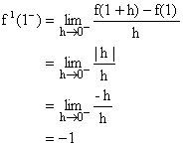
Now since , so the function is not differentiable at x = 1.

Geometrical Interpretation of a Derivative:
Let us take two point P[c, f(c)] and Q[c+h, f(c+h)] on curve y = f(x).
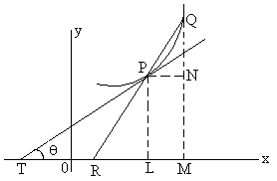
Fig (1)
We join PQ so that it is a secant to curve.
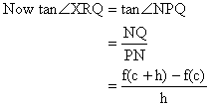
Now as h approaches O the point Q moving along curve approaches point P, the chord PQ approaches tangent line TP and ÐXRQ approaches ÐXTP denoted by Q.
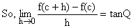
Hence f¹(c) is slope of tangent to the curve y = f(x) at point (c, f(c)).
Illustration 3:
Show that tangent to hyperbola 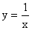at (1, 1) makes an angle with x-axis.
Solution:
Let the angle the tangent makes beq.
So, we know that
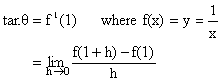

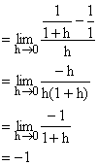
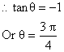

Derivability of f(x) on an interval
f(x) is said to be derivable on the closed interval [a, b] if
1) For the points a and b, , and finitely exist.
2) For any point c such that a<c<b, and finitely exist and equal.
3) f(x) is said to be derivable on open interval (a, b) for any point c such that a<c<b,
And finitely exists and are equal.
Illustration 4:
Consider the function;
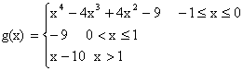
Discuss differentiability of g(x) in [-1,¥].
Solution:
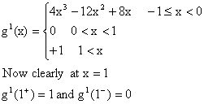
So, g(x) is not differentiable at x=1.

Relationship between continuity and differentiability:
If a function f is differentiable at a point ‘a’ then it is continuous at that point but if a function f is continuous at a point ‘a’ then it need not necessarily be differentiable at that point.
For Example:
y = |x| + 1 is continuous at x=0 but not differentiable.
Dumb Question:
1) How do we know that |x|+1 is not differentiable at x=0?
Ans:
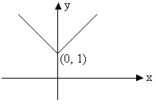
Fig (2)
The graph of function y = |x| + 1 looks like the figure mode above.
Now remember that derivative of a function represents the slope of graph at that point. So if there is no tangent line at certain point, function is not differentiable at that point or in other words function is not differentiable at corner point of a curve. And hence not differentiable at x=0.
Tips to check differentiability and continuity:
1) It is advantageous to check differentiability first because every differentiable function is continuous.
2) On the other hand every discontinuous function is non-differentiable.
3) If right hand derivative is not equal to left hand derivative but both exist finitely at x=a then function is not differentiable but continuous at x=a.
4) Continuity of a function does not imply its differentiability.
5) Also, non-differentiability of a function does not mean that it is discontinuous at point a.

Illustration 5:
Function f is defined by;
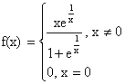
Show that f is continuous but not derivable at x=0.
Solution:
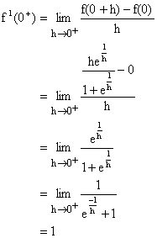
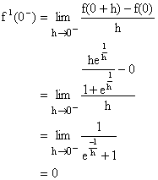
So, f(x) is not derivable at x=0.
But since both and exist finitely the function is continuous at x=0.

Dumb Question:
1) Why 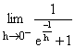 is 0 and 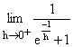is 1?
Ans:
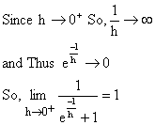
But when 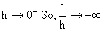 and thus
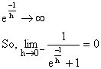
General Theorem on Differentiation:
1) (Constant) = 0 why?
Proof: Let f(x) = k.
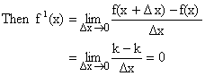
Therefore (Constant) = 0.
2) [c f(x)] = c (f(x)); where c is a constant why?
Let g(x) = c.f(x)
Where c is constant and f(x), xÎR be a differential function of x. We then have,
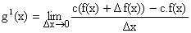

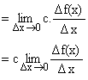
Thus [c f(x)] = c (f(x)).

3) 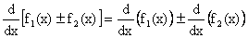 Why?
Proof:
Let y = f₁(x) + f₂(x), Where f₁(x) and f₂(x) are differentiable functions of x.
Then
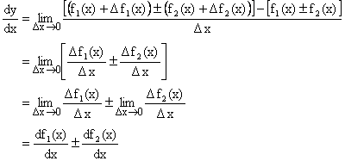
Thus .
4) 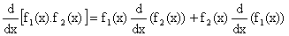Why?
Proof:
Let y = f₁(x).f₂(x) where both f₁(x) and f₂(x) are differentiable function of x.
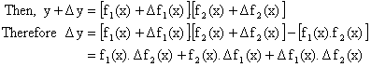
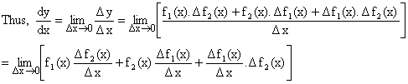

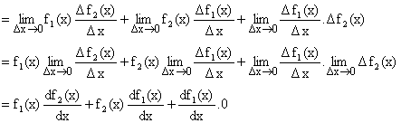

5) 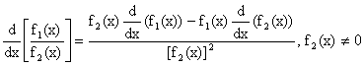 Why?
Proof:
Let 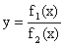, where f₁(x) and f₂(x) are differentiable functions at all points in its domain and f₂(x) ¹ 0.
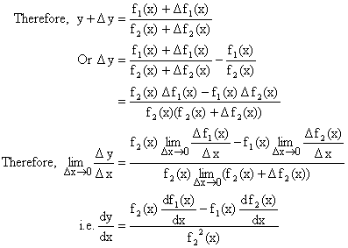
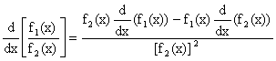

6) 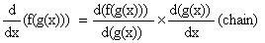Why?

Proof:
Let y = f (t), t = g(x)
Then y = f (g(x)) is a function of x.
Dy = f (t+Dt) - f (t)
And Dt = g (x+Dx) - g(x)
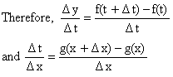
Assuming that for sufficient small values of Dx, Dt ¹ 0 this will necessarily be the case if 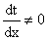then since g is differentiable it is continuous and hence when Dx®0, x+Dx®x any g(x+Dx) ® g(x).
Therefore t+Dt®t and Dt®0, since Dt ¹ 0 and Dx®0 we may write,
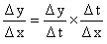.
Clearly f and g are both continuous functions because they are differentiable thus Dt®0 when Dx®0 and Dy®0 when Dt®0.
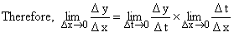
Hence 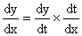

Standard Formulae of Differentiation:
1) 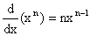
Proof:
Let
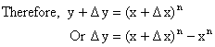

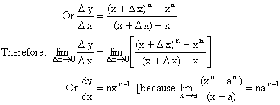
Thus 
2) 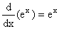
Proof:
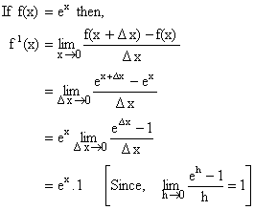
Thus 
3) 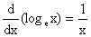
Proof:
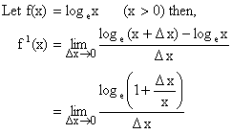

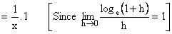
So, 
4) 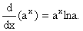
Proof:
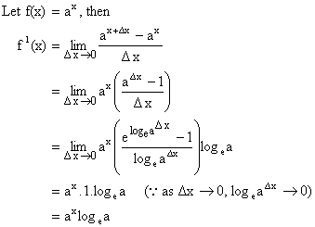

5) 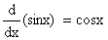
Proof:
Let f(x) = sinx then,
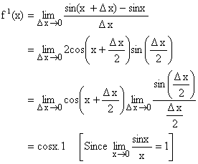
Hence, 

6) 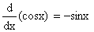
7) 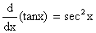
8) 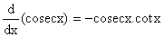
9) 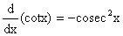
10) 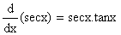 Why?
Proof:
Let f(x) = secx
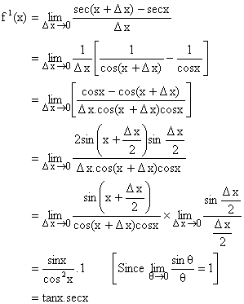
Hence, 
11) 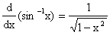
Proof:
Let then x = siny.
Differentiating w.r.t x we get,
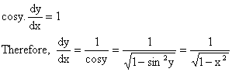
Hence, 
12) 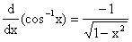
13) 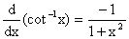
14) 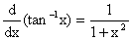
15) 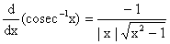
16) 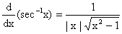Why?
Proof:
Let y = sec⁻¹x then secy = x.
Differentiating w.r.t x we have,
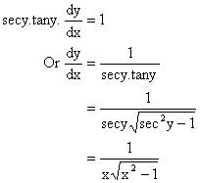
Hence, 

Dumb Question:
Why and not 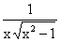?
Ans:
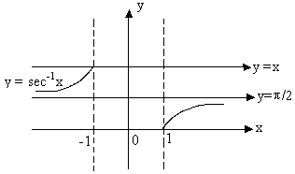
Fig (4)
Note that y = sec⁻¹x is an increasing function in its domain.
So, 
Illustration 6:
Differentiate 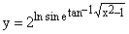
Solution:
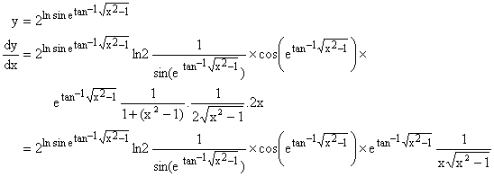
Different Methods of Differentiation:
1) Differentiation of a function defined parametrically:
Let x, y be function of parameter t, i.e.
x = f (t), y = f (t) then,

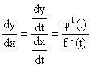
Illustration:
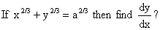
Solution:
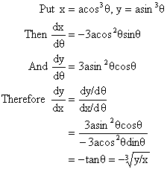
2) Logarithmic Differentiation:
The process of taking logarithm on both sides and then differentiating is called logarithmic differentiation.
Illustration 8:
Differentiate w.r.t x.
Solution:
Let y = .
Taking logarithm on both sides, then we have
logy = sinx.logx
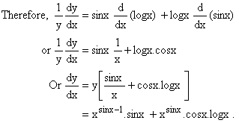
3) Differentiation of Implicit function:
If the relation between x and y is given by equation containing both and this equation is not immediately solvable for y, then y is called implicit function of x.
Illustration 9:
If Then prove that 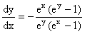
Solution:
Given that differentiating on both sides w.r.t x we have,
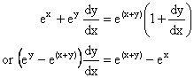
Hence, 

4) Differentiation of a function w.r.t other functions:
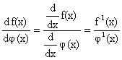
Illustration:
1) Differentiate 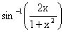with respect to tan⁻¹x.
Solution:
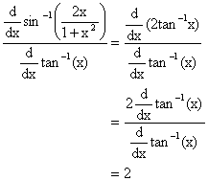

2) Differentiate ln tanx with respect to
Solution:
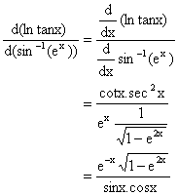
5) Higher Order derivatives:
Let y = f(x) be differentiable function such that z = f¹(x) is also differentiable. Then second derivative of y = f(x) is denoted by 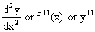and 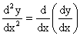.
In general 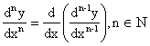
Illustration 11:
For the curve find the rate of change of slope at (4, 27).
Solution:
We know that slope of a curve is given by . Now let g(x) denote slope of curve.
So, 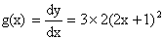
Now rate of change of slope =
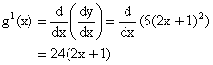
So rate of change of slope at (4, 27)
= 24(2´4+1)
= 216.

DIFFERENTIATION (EASY TYPE)
1) Differentiate 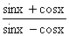with respect to x.
Solution:
Let y =  then,
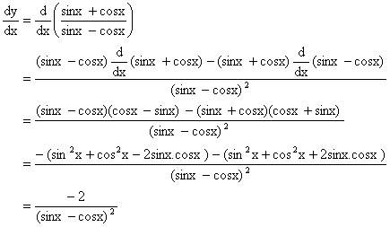
2) Let f be twice differentiable such that f¹¹(x) = -f(x) and f¹(x) = g(x). Where h (5) = 11, find h (10).
Solution:
Given on differentiating both sides w.r.t x we get
Now
From (1) and (2) we get,
Therefore h¹(x) = 0.
So, h(x) must be constant [as d/dx constant = 0]
But h (5) = 11 so h (x) = 11
Hence, h (10) = 11.

3) Find the sum of series 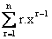using calculus.
Solution:
Let which is a geometric progression.
Therefore = 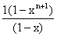
On differentiating both sides, we get,
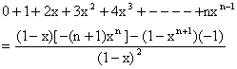
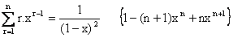
4) If and then find .
Solution:
Differentiating w.r.t x, we get,
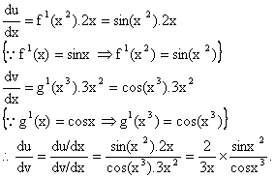

5) If 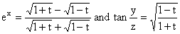then find at 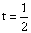.
Solution:
Putting t = cosq.
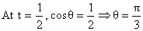
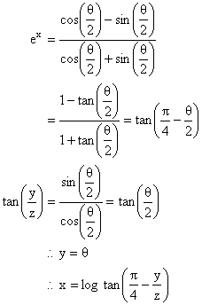
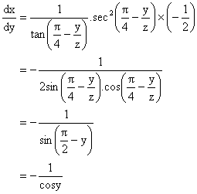
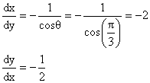

6) If a polynomial of degree 3 then find 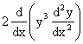in terms of P(x) and its derivative.
Solution:
We have
And
Also
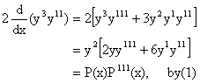
7) If 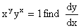
Solution:
Taking log on both sides
ylogx + xlogy = log1.
Differentiating on both sides we get,
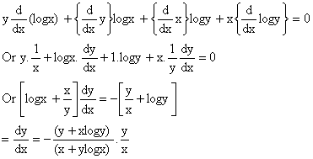
8) If x = a (t+sint) and y = a (1-cost), Then find 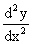
Solution:
Here x = a (t+sint) and y = a (1-cost).
Differentiating both sides w.r.t t we get,
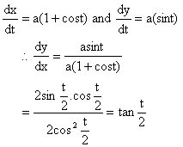
Again differentiating both sides we get,
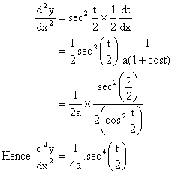

9) Find 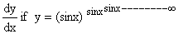
Solution:
We have
Therefore by taking log on both sides we get,
logy = y log sinx.
Differentiating both sides w.r.t x we get,
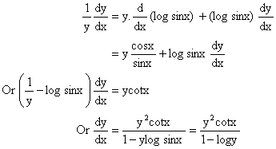

10) Is f(x) differentiable at x=0 if f(x) is defined as follow
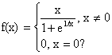
Solution:
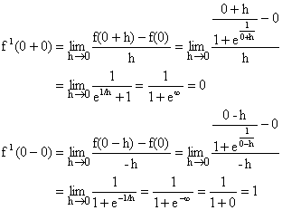
Here f(x) is not differentiable at x=0.
11) Determine the values of x for which the following function fails to be continuous or differentiable.
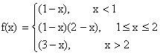
Justify your Answer.
Solution:
By given definition it is clear that the function f is continuous and differentiable at all points except possibility at x=1 and x=2.
Continuity at x=1,
L.H.L =
R.H.L =
Also f (1) = 0, Hence f(x) is continuous at x=1.
Now differentiability at x=1.
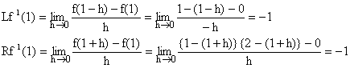
Since so we get f(x) is differentiable at x=1.
Continuity at x=2.
Since R.H.L ¹ L.H.L
Therefore f(x) is not continuous at x=2. As such f(x) can not be differentiable at x=2. Hence f(x) is continuous and differentiable at all points except at x=2.

12) If
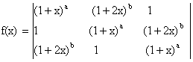 Then find a) Constant term b) Coefficient of x.
Solution:
Here 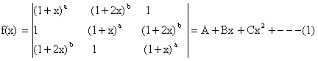
Putting x =0 we get
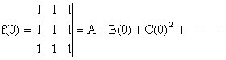
Þ A=0
Again Differentiating (1) w.r.t x we get,

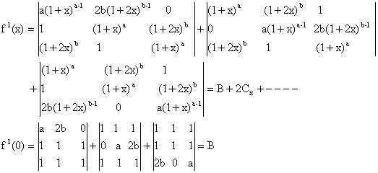
Therefore Coefficient of constant term = Coefficient of x = 0.

(MEDIUM TYPE)
1) Let f(x) be a real function not identically zero such that , nÎN and x, y are any real numbers and f¹(0) ³ 0. Find the values of f (5) and f¹(10).
Solution:
Here ------ (1)
Putting x=0, y=0 we get f (0) = f (0) + {f (0)}^{2n+1}.
\ f (0) = 0.
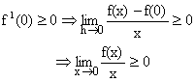
\ If x ³ 0, f(x) ³ 0 -------- (2)
Putting x = 0, y = 1 in (1)
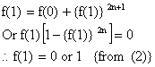
Putting y=1 in (1) for all real x,
f (x+1) = f(x) + {f (1)}^{2n+1}------ (3)
\f (1) = 0 Þ f(x+1) = f(x)
Þ f (1) = f (2) = f (3) = ------ = 0
i.e. f(x) is identically zero.
\ f (1) ¹ 0 Hence f (1) =1.
So from (3) f(x+1) = f (x) +1 ---- (4)
\ f (5) = f (4) +1 = {f (3) + 1}+ 1
= {f (2) +1} +2
= {f (1) +1} +3
=f (1) +4
=1+4
=5
Also (4)Þ f(x) is a function whose value increases by 1.When variable x is increased by 1.
\f (x) = x \f¹(x) = 1
\ f¹(10) =1.

Dumb Question:
1) Why does the equation has the solution as f (1) = 0, 1? Some complex solution could also be possible.
Ans: It is mentioned in the question that function f is real valued function, so the value of f (1) has to be real and cannot be complex.
2) If f be a function such that f (xy) = f (x). f (y), " yÎR and f (1+x) = 1+x (1+ g(x)). Where , find the value of 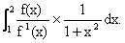
Solution:
We know,
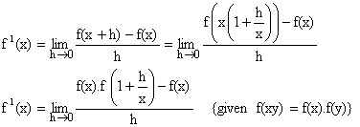

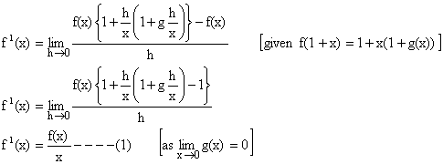
To find 
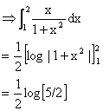

) Let f be differentiable function such that, 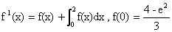 find f(x)?
Solution:
Given that
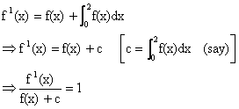
Integrating above expression both sides,
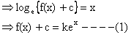
Where k is a constant of integration
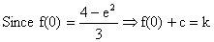

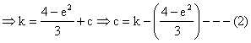
From (1) and (2) we get,
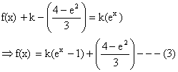
Now to find constant of integration k.
Integrating both sides from 0 to 2 we get,
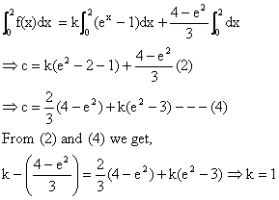
Putting k=1 in (3) we get,
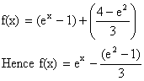
4) Let f(x+y) = f(x) –f (y) + 2xy -1 for all x, y ÎR, if f(x) is differentiable and prove that f(x)>0 for all xÎR.
Solution:
Putting x = 0 = y in given functional equation, we get f (0) = -1.
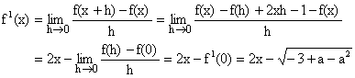

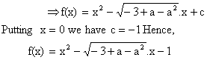
The discriminant
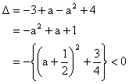
Hence, f(x) > 0 for all xÎR.
Dumb Question:
1) How does 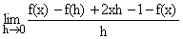transform to 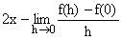?
Ans:
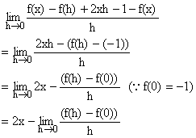
5) If then express y as an explicit function x and prove that 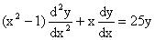.
Solution:
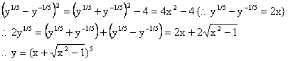
Differentiating w.r.t x,
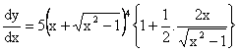
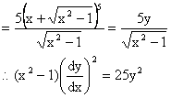
Differentiating w.r.t x,
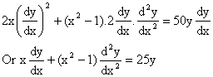
Therefore 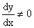for then y is constant.
Dumb Question:
1) Why is ?
Ans:
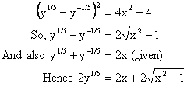
6) The function y = f(x) is defined as follows, x = 2t-|t|, y = t² + t |t|, tÎR. Then discuss the continuity and differentiability of the function at x=0 also draw the graph of the function in the interval [-1, 1].
Solution:
When t < 0, x = 2t -(-t) = 3t < 0.
y = t² + t (-t) = 0.
\y = 0 when x<0.
When t ³ 0, x = 2t-t = t ³ 0.
y = t²+t (t) = 2t² = 2x²
\ y = 2x² when x ³ 0.
Thus the function is as follows.
f (x) = 0, x<0
=2x², x ³ 0
Now,
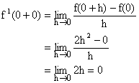
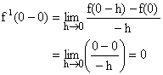
\f (x) is differentiable (finitely) at x=0.
\ f (x) is also continuous at x = 0.
Being a polynomial function f(x) is continuous at other points of the interval [-1, 1].
Now in the interval [-1, 1] we have y = 0 in [-1, 0], y = 2x² in [0, 1]
So the graph is as below.
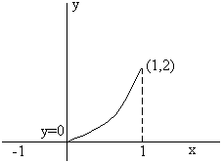
Fig (5)

(HARD TYPE)
1) 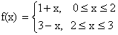
Determine f {f(x)} and hence find the points of discontinuity and non-differentiability. Also draw the graph of f {f(x)} in [0, 3].
Solution:
Clearly f {f(x)} = 1+ f(x), 0 £ f(x) £ 2
3 - f(x), 2 < f(x) £ 3
When 0 £ f(x) £ 2
0 £ 1+x £ 2, if 0 £ x £ 2 {using first piece of definition}
Þ -1 £ x £ 1 if 0 £ x £ 2
Þ 0 £ x £ 1 (taking the interval of common points)
\ 0 £ f(x) £ 2 when 0 £ x £ 1 and f(x) = 1+x --------- (1)
When 0 £ f(x) £ 2
0 £ 3-x £ 2 If 2 < x £ 3 (using the second piece of definition)
Þ -3 £ -x £ -1 If 2 < x < £ 3
Þ 1 £ x £ 3 If 2 < x £ 3
Þ 2 < x £ 3 (taking interval of common points)
\0 £ f(x) £ 2 when 2 < x £ 3 and f(x) = 3-x ----- (2)
When 2 < f(x) £ 3
2<1+x £ 3 If 0 £ x £ 2 (using the first piece of definition)
Þ 1< x £ 2 If 0 £ x £ 2
Þ 1< x £ 2
\2< f(x) £ 3 when 1< x £ 2 and f(x) = 1+x ------- (3)
When 2< f(x) £ 3
2<3-x £ 3 If 2 < x £ 3 (using second piece of definition)
Þ -1 < -x £ 0 If 2 < x £ 3
Þ 0 £ x <1 If 2 < x £ 3
Þ xÎf.

Thus we get
f {f(x)} = 1+1+x = 2+x, 0 £ x £ 1 {from (1)}
= 1+3-x = 4-x, 2 < x £ 3 {from (2)}
= 3-(1+x) = 2-x, 1 < x £ 2 {from (3)}
Hence the function is
f {f(x)} = 2+x, 0 £ x£ 1
2-x, 1< x £ 2
4-x, 2 < x £ 3

As the polynomial functions are continuous and differentiable every where f {f(x)} is continuous and differentiable in [0, 3] except perhaps at the turning points of definition, namely, x = 1, 2 denote f {f(x)} by g(x).
Now g (1+0) = 2-1=1
g (1-0) = 2+1 = 3
So g(x) is not continuous at x=1.
g (2+0) = 4-2 =2
g (2-0) = 2-2 = 0
So, g(x) is not continuous at x=2.
Hence g(x) is also not differentiable at x = 1, 2.
\The points of discontinuity and non-differentiability are x=1, 2.
Now we have to draw the graph for y = f {f(x)} where
y = 2+x in [0, 1],
y = 2-x in [1, 2]
y = 4-x in [2, 3]
The graph is discontinuous at x = 1, 2.
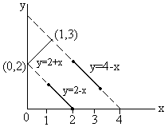
Fig (6)
Dumb Question:
1) In the above solution, there is a condition 0 £1+x £2 if 0 £ x £ 2 from that it is inferred that 0 £ x£ 1 How?
Ans:
0 £1+x £2 if 0 £ x £ 2
Þ -1 £ x £ 1 if 0 £ x £ 2
Now clearly both the conditions need to be satisfied simultaneously. So the intersection of these two conditions will give the desired results.
i.e. 0 £ x £ 1
2) If then find 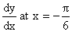from the first principle.
Solution:
Clearly the definition of the function f(x) is 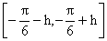where h is a very small positive quantity, remains the same, so 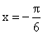 is not a turning point of definition.
Now,
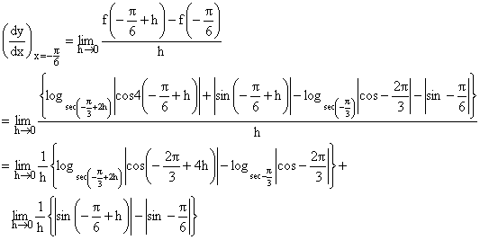

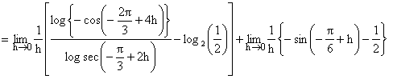
(Using definition of mod)
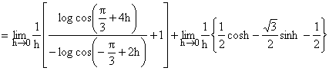
Now 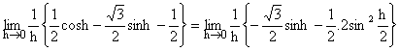
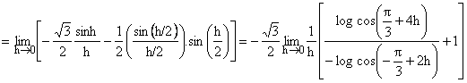
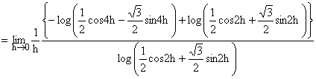
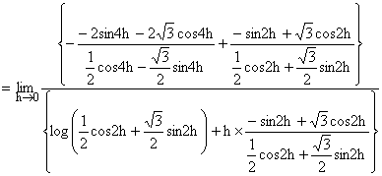
(Using L-Hospital Rule)
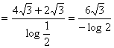

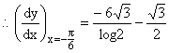

3) Let a+b =1, 2a²+2b² =1 and f(x) be a continuous function such that f (2+x) +f(x) = 2 for all xÎ(0, 2) and p = 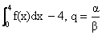then find the least positive integral values of ‘a’ for which the equation ax²-bx+c = 0 has both roots lies between p and q;
Where a, b, c ÎN.
Solution:
Given a+b =1 --------- (1)
2a²+2b² =1 -------- (2)
Solving equation (1) and (2) we get,
a = b = .
Þ 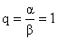----------- (3)
Given f(x+2) +f(x) = 2 for all x Î[0, 2] -------- (4)
Now p = 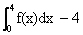
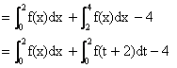
(let x = t+2 for second integration}
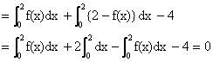
Then p =0, q=1
Let the roots of equation ax²-bx+c = 0 be a and b
\f (x) = ax²-bx+c= a(x-a) (x-b) -------- (5)
Since equation f(x) = 0 has both roots between 0 and 1.
\f (0).f (1) > 0 ------- (6)
But f (0).f (1) = c (a-b+c) = an integer ------- (7)
Therefore least value of f (0). f (1) = 1 -------- (8)
Now from equation (5)
f (0).f (1) = a a b a (1- a) (1-b)
= a²ab (1- a) (1- b) --------- (9)
As we know
a (1- a) has greatest values 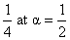and b (1- b) has greatest value 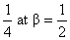
But b ¹ a
Thus from equation (8) greatest value of
f (0). f (1) < ------ (10)
From (8) and (10)
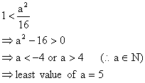
{As a Î Natural number}
Dumb Question:
1) Why c (a-b+c) is an integer?
Ans: It is given in the question that a, b, c ÎN
So, cÎN and a-b+cÎI
So, c (a-b+c) ÎI
Hence c (a-b+c) is an integer.

KEYWORDS
- Derivative
- First Principle
- dy/dx
- Right Hand Derivative
- Left Hand Derivative
- Parametric
- Logarithmic Differentiation
- Implicit function
- Chain Rule

Limits Continuity and Differentiability
MCQ-Single Correct
1. If for , the derivative of is . g(x), then g(x) equals :
(1) (2)
(3) (4) [2017]
2. equals :
(1) (2)
(3) (4) [2017]
3. Let then log p is equal to :
(1) 1 (2) ½
(3) ¼ (4) 2 [2016]
4. For , and g(x) = f(f(x)), then :
(1) g’(0) = cos(log2)
(2) g’(0) = -cos(log2)
(3) g is differentiable at x = 0 and g’(0) = - sin(log2)
(4) g is not differentiable at x = 0 [2016]
5. is equal to :
(1) 3 (2) 2
(3) ½ (4) 4 [2015]
6. If the function, g(x) = is differentiable, then the value of k + m is :
(1) 16/5 (2) 10/3
(3) 4 (4) 2 [2015]
7. is equal to
(1) (2) 1
(3) - π (4) π [2014]
8. If , then at x = 1 is equal to
(1) ½ (2) 1
(3) (4) [2013]
9. is equal to :
(1) 1/2 (2) 1
(3) 2 (4) -1/4 [2013]
10. Let f: be such that exists and , then equals
(1) 2 (2) 3
(3) 0 (4) 1 [2011]
11. If function f(x) is differentiable at x = a, then is
(1) (2)
(3) (4) [2011]
12. Let f : be a positive increasing function with . Then
(1) 2/3 (2) 3/2
(3) 3 (4) 1 [2010]
13. Let f : be a differentiable function with f(0) = -1 and f’(0) =1. Let . Then g’(0) =
(1) -4 (2) 0
(3) -2 (4) 4 [2010]
14. Let y be an implicit function of x defined by . Then y’(1) equals
(1) -1 (2) 1
(3) log 2 (4) - log 2 [2009]
15. Let f(x) = . Then which one of the following is true?
(1) f is neither differentiable at x = 0 nor at x = 1
(2) f is differentiable at x = 0 and at x = 1
(3) f is differentiable at x = 0 but not at x = 1
(4) f is differentiable at x = 1 but not at x = 0 [2008]
16. The set of points where is differentiable is
(1) (2)
(3) (4) [2006]
17. If , then is
(1) (2)
(3) xy (4) [2006]
18. Let and be the distant roots of , then is equal to
(1) (2) 0
(3) (4) [2005]
19. Suppose f(x) is differentiable x = 1 and then f’(1) equals
(1) 3 (2) 4
(3) 5 (4) 6 [2005]
20. Let f be differentiable for all x. If f(1) = -2 and for , then
(1) (2)
(3) f(6) < 5 (4) f(6) = 5 [2005]
21. If f is a real-valued differentiable function satisfying , x , y ε R and f(0) = 0 , then f(1) equals
(1) -1 (2) 0
(3) 2 (4) 1 [2005]
22. If , then the values of a and b, are
(1) (2) a = 1,
(3) (4) a = 1 and b = 2 [2004]
23. Let , , . If f(x) is continuous in , then is
(1) 1 (2) ½
(3) -1/2 (4) -1 [2004]
24. If , x > 0 , then is
(1) (2)
(3) (4) [2004]
25. is
(1) 1/8 (2) 0
(3) 1/32 (4) [2003]
26. If , the value of k is
(1) 0 (2) -1/3
(3) 2/3 (4) -2/3 [2003]
27. Let f (a) = g(a) = k and their derivatives , exist and are not equal for some n.Further if then the value of k is
- 4 (2) 2
(3) 1 (4) 0 [2003]
28. If f(x) =
then f(x) is
- Continuous as well as differentiable for all x
- Continuous for all x but not differentiable at x = 0
- Neither differentiable nor continuous at x = 0
- Discontinuous everywhere [2003]
29.
is
(1) (2) zero
(3) (4) [2003]
30. , , ([x] denotes greatest integer less than or equal to x)
(1) has value -1 (2) has value 0
(3) has value 1 (4) does not exist [2002]
31. is
(1) (2)
(3) (4) [2002]
32. f is defined in [-5,5] as f(x) = x, if x is rational and = -x, if x is irrational. Then
(1) f(x) is continuous at every x, except x = 0
(2) f(x) is discontinuous at every x, except x = 0
(3) f(x) is continuous everywhere
(4) f(x) is discontinuous everywhere
33. If , then is
(1) (2)
(3) - y (4) [2002]
34. If f(1) = 1, f’(1) = 2, then is
(1) 2 (2) 4
(3) 1 (4) ½ [2002]
35. is
(1) 1 (2) -1
(3) 0 (4) does not exist [2002]
36.
(1) (2)
(3) (4) 1 [2002]
37. Let f(x) = 4 and f’(x) = 4 , then equals
(1) 2 (2) -2
(3) -4 (4) 3 [2002]

Assertion – Reason Type
1. Define F (x) as the product of two real functions , and [2011]
as follows
F (x) =
Statement-I : F(x) is continuous on R
Statement-II : and are continuous on R
2. Let be a continuous function defined by , [2010]
Statement-I : , for some
Statement-II : , for all
3. Let f(x) = x|x| and g(x) = sin x [2009]
Statement-I : gof is differentiable at x = 0 and its derivative is continuous at that point.
Statement-II : gof is twice differentiable at x = 0.

Applications of Derivatives
Derivative as rate of change:
If variable quantity y is function of t i.e. y = f(t), then small change in time y in y
Average rate of change =
when t 0, rate of change becomes instantaneous
i.e. 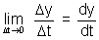
Illustration: If radius of circle increasing at uniform rate of 2 cm/s, find rate of increasing of area of circle, at instant when radius is 20 cm.
Ans: = 2 cm/s
Area of circle = r²
Differentiating w.r.t. to t,
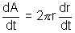
> = 2 x 20 x 2 = 80 cm²/s
Slopes of tangent & Normal:
Slope of tangent:
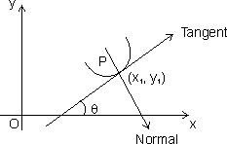
Let y = f(x) be cont. & P(x₁, y₁) be point on it.
Then 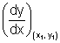is slope of tangent to curve y = f(x) at point P.
Note: (1) If tangent is 11 to x-axis, then
= 0
(2) If tangent is to x-axis, then
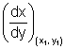= 0
Dumb Question: How = 0 when tangent is 11 to x-axis.
Ans: We know that slope of line = tan where 0 with x-axis in anticlockwise direction.
If tangent is 11 to x-axis
= 0 or tan = 0
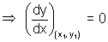
Slope of Normal: Normal to curve at P is line to tangent at P & passing through P(x₁, y₁)
Slope of normal at P = - 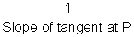
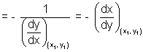
Note: (i) If normal is 11 to x-axis
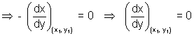
(ii) If normal is to x-axis
- = 0
Illustration: Find point on curve y = x³ - 3x at which tangent is 11 to x-axis.
Ans: Let the point be P(x₁, y₁) on curve y = x³ - 3x .................................... (i)
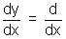 (x³ - 3x) = 3x² - 3
= 3x₁² - 3
But tangent is 11 to x-axis
= 0
3x₁² - 3 = 0 x₁ = ±1 ........................................ (ii)
Since P(x₁, y₁) lies on curve.
y₁ = x₁³ - 3x₁
x₁ = 1 where x₁ = - 1
y₁ = 1 - 3 = - 2 y₁ = - 1 + 3 = 2
Points are (1, - 2) & (- 1, 2)
Equations of tangent & Normals:
Eq. of tangent:
Slope of tangent at P(x₁, y₁) = tan = 
Since it passes through P(x₁, y₁)
eq. of tangent is
(y - y₁) = (x - x₁)
Eq. of Normal:
Slope of Normal = - 
Eq. of normal is
(y - y₁) = - (x - x₁)
Illustration: Find eq. of tangent & normal to curve 2y = 3 - x² at (1,1)
Ans: Eq. of given curve is 2y = 3 - x² ...................................... (i)
differentiating (i) w.r.t. x 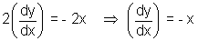
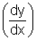_{(1, 1)} = - 1
eq. of tangent at (1, 1) is
y - 1 = - 1(x - 1) x + y = 2
& eq. of normal at (1,1) is
y - 1 = 1(x - 1) = y - x = 0
Angle of intersection of two curves:
It is angle b/w tangent s to the two curves at this point of intersection.
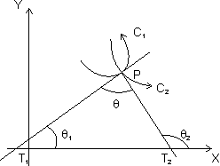
Let C₁ & C₂ be two curves of eq. is = f(x) & y = g(x) respectively.
Let is angle b/w two tangents of two curves & tangents PT₁ & PT₂ makes angle ₁ & ₂ respectively with x-axis.
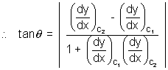

troduction
Dumb Question: How this derived ?
Ans: Let m₁ = tan ₁ = 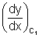
m₂ = tan ₂ = 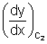
From fiq, = + ₁
= ₂ - ₁
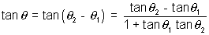
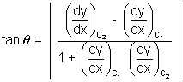
Orthogonal curves: If angle of intersection of two curves is right angle, two curves are c/d orthogonal curves.
If curves are orthogonal, =
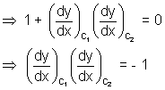
Illustration: Find angle of intersection of curves y = x² & y = 4 - x²
For intersection points of given curves,
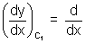(x²) = 2x
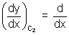(4 - x²) = - 2x
At x = - ,
= 2 x = 2 & = - 2
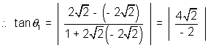
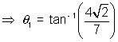
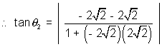
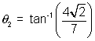
Both angles are equal.
Length of Tangent, Sub-Tangent, Normal & sub-Normal:
Length of Tangent: Length of segment PT of tangent b/w point of tangent & x-axis is c/d length of tangent.
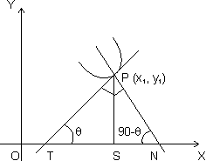
PT = 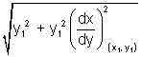
Subtangent: Projection of segment PT along x-axis i.e. St c/d subtangent.
Length of Normal: Length of segment PN intercapted b/w point on curve r x-axis.
PN = 
Subnormal: Projection of segment PN along x-axis i.e. c/d subnormal.
SN = |y, 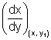
Dumb Question: How these relation derived ?
Ans: Since PT makes angle with x-axis, then
tan = 
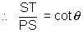
Subtangent = ST = PS cot
But PS = y₁ & cot = [see in fig.]
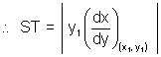
= cot(90 - ) PS tan
Subnormal = SN = 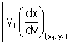
Length of tangent = PT = 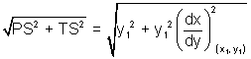
Length normal = PN = 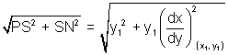
Illustration: Show that curve y = be^{x/a}. subnormal varies as square of ordinate ?
Ans:
[Dumb Question: What is ordinate ?
Ans: y-axis component is c/d ordi i.e. in P(x₁, y₁)y₁ is ordinate of point P.
y = be^{x/a} ............................................... (i)
differentiating curve y = be^{x/a} w.r.t. x.
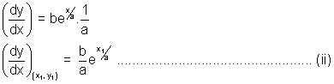
& Let P(x₁, y₁) lie on curve
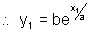
Length of subnormal = 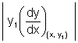
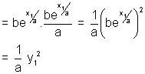
So, subnormal varies as square of ordinate.

Rolle's Theorem:
Statement: Let f be real valued function defined on closed interval [a, b] such that,
(i) f(x) is continuous in closed interval [a, b].
(ii) f(x) is differentiable in open interval (a, b).
(iii) f(a) = f(b)
Then there is at least one value of C of x in (a, b) for which f'(c) = 0
Proof: Case I: f(x) is constant function in interval [a, b] then f'(x) = 0 for all x [a, b]
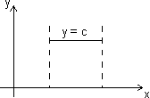
Hence, follows Rolle's theorem, we can say that f'(c) = 0 where a < c < b.
Case II: f(x) is not constant in interval [a, b] & sionce f(a) = f(b)
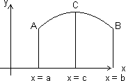
Let f(x) increases for x > a.
Since f(a) = f(b), so, function must increase to some value x = c & decreasing upto x = b.
At x = c function has maximum value.
Let h be small quantity, then,
f(c + h) - f(c) < 0 & f(c - h) - f(c) < 0
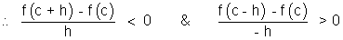
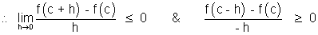
But if 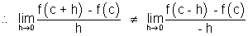
Then Rolle's theorem cannot applicable b/c. f(x) is not differentiable at x = c
Only possible way for Rolle's theorem, when
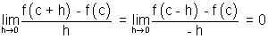
f'(c) = 0 where a < c < b
Note: (i) Polynomial function is everywhere cont. & differentiable.
(ii) Exponential function, sine & cosine function are everywhere cont. & differentiable.
(iii) Logarithmic function is cont. & differentiable in its domain.
(iv) tanx is not cont. & differentiable at x = ± , ± , ...............
(v) |x| is not differentiable at x = 0.
Illustration: Verify Rolle's theorem for function f(x) = x³ - 3x² + 2x in interval [0, 2].
Ans: (a) f(x) is polynomial so, it is cont. & differentiable everywhere.
(b) f'(x) = 3x² - 6x + 2 clearly exista for all x (0,2)
(c) f(0) = 0, f(2) = 2³ - 3(2)² + 2(2) = 0
f(0) = f(2)
So, All conditions of Rolle's theorem are satisfied.
So, there exist some c (0,2) such that f'(c) = 0
f'(c) = 3c² - 6c + 2 = 0 c = 1 ±
Lagrange's Mean Value Theorem:
Statement:
(i) f(x) is cont. in closed interval [a, b].
(ii) is differentiable in open interval (a, b)
Then there is at least one value c (a, b) such that
f'(c) = 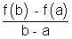
Geometrical interpretation:
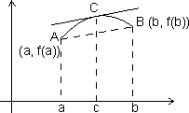
Let A, B be points on curve y = f(x) corresponding to x = a & x = b, so that
A = [a, f(a)] & B = [b, f(b)]
Slope of chord AB = 
But slope of chord AB = f'(c), the slope of tangent to curve at x = c.
Accordin to LMVT, if a curve has tangent at each of its points then there is a point 'c' on this curve in between A & B, the tangent at which is paralled to chord AB.
Illustration: Find c of LMVT for which f(x) = in [1, 5].
Ans: (1) f(x) has definite & unique value of each x [1, 5]
So, every point in interval [1, 5] the value of f(x) is equal to limit of f(x).
f(x) is cont. in [1, 5]
(2) f'(x) = - 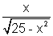exists for all x [1, 5]
f(x) is differentiable in (1, b)
So, there must br some c such that
f'(c) = 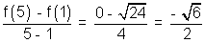
But f'(c) = 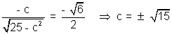
Application of derivative in determining the nature of roots of cubic polynomial:
Let f(x) = x³ + ax² + bx + c be given cubic polynomial.
f(x) = 0
f'(x) = 3x² + 2ax + b ....................................................... (i)
Let D = 4a² - 12b = 4(a² - 3b) be discriminate of eq. f'(x) = 0
Case I: If D < 0 f'(x) > 0 v x R
f(x) = - and
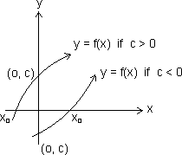
from fig. graph of y = f(x) cut x-axis only once. So, we have only real root (say x₀)
x₀ > 0 if c < 0 & x₀ < 0 if c > 0
Case II: If D > 0, f'(x) = 0
have two real roots.
f'(x) = 3(x - x₁)(x - x₂)
f'(x) < 0, x (x₁, x₂)
f'(x) > 0, x (- , x₁) U (x₂, )
f(x) would increase in (-, x₁) & (x₂, ) and would decrese in (x₁, x₂)
x = x₁ would be point of local maxima & x = x₂ would be point of local minima.
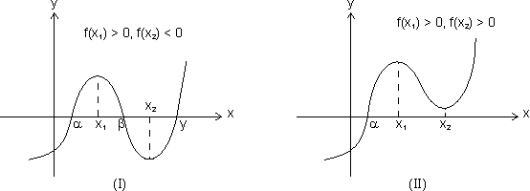
3 distict roots x = , , One real root x = & two imaginary root
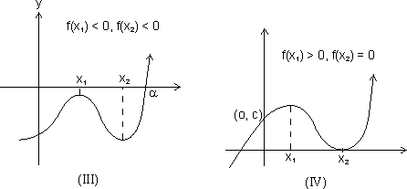
One real root x = 9 & Three roots x = , n₂, x₂
two imaginary roots. (x₂ is repeated root)
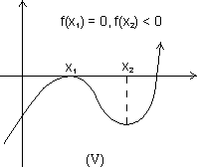

Threen real roots x = n₁, x₂,
(x₁ is repeated roots)
Results:
(a) From I graph, f(x₁) > 0, f(x₂) < 0
f(x₁) f(x₂) < 0, f(x) = 0 would have 3 real & distinct roots.
(b) Fromn II & III graph f(x₁) f(x₂) > 0, f(x) = 0 have one real & two imaginary roots.
(c) f(x₁ f(x₂) = 0, f(x) = 0 have 3 real roots but of root would be repeated.
Case III: D = 0, f'(x) = 3(x - x₁)⁰ where x₁ is root of f'(x).
f(x) = (x - x₁)³ + K
Then, f(x) = 0, has three real roots if K = 0
f(x) = 0 has one real root if K 0
Illustration: Find values of a so that x³ - 3x + a = 0 has three real & distinct roots.
Ans: Let f(x) = 3x³ - 3x + a
f'(x) = 3x² - 3 = 3(x - 1)(x + 1)
x₁ = 1, x₂ = - 1
f(x₁) = f(1) = a - 2
f(x₂) = f(- 1) = a + 2
Since roots would be real & distinct if
f(1) f(- 1) < 0 (a - 2)(a + 2) < 0
- 2 < a < 2

Increasing function:
(a) Strictly increasing function:
A function f(x) is c/d strictly increasing function in its domain if x₁ < x₂
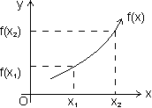
For strictly increasing function f'(x) > 0 v x domain
Dumb Question: How f'(x) > 0n v x domain for strictly increasin function.
Ans: As x₁ < x₂
f(x₁) < f(x₂)
So, f(x) < f(n + h)
f'(x) = 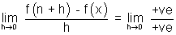
f'(x) > 0
Types of strictly increasing function:
(1) Concave up: When f'(x) > 0 & f"(x) > 0 v x domain
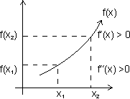
(2) Concave down: f'(x) > 0 & f"(x) < 0 v x domain
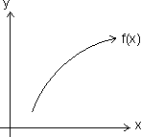
(3) When f'(x) > 0 & f"(x) = 0 v x domain
f'(x)> 0 & f"(x) = 0
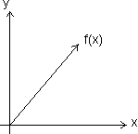
Increasing function:
A function f(x) is said to be non decreasing if for x₁ < x₂
Laet us see in fig.
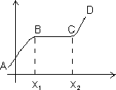
For portion ABCD, x₁ < x₂
f(x₁) < f(x₂)
for BC, x₁ < x₂
f(x₁) = f(x₂)
Dumb Question: What is diff. b/w strictly increasing & increasing function ?
Ans: Strictly function for x₁ < x₂, f(x₂) is always greater than f(x₁) but in increasing function for x₁ < x₂, f(x₂ may be greater or equal to f(x₁).
Decreasing functions:
(a) Strictly decreasing function:
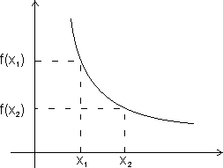
A function f(x) ic c/d strictly decreasimg in its domain if x₁ < x₂
f(x₁) > f(x₂)
For strictly decreasing function.
f'(x) < 0
Dumb Question: How f'(x) < 0 for strictly decreasing ?
Ans: As x₁ < x₂ f(x₁) > f(x₂)
So, f(x + h) < f(x)
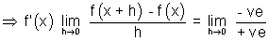
f'(x) < 0
Types of strictly decreasing function:
(i) Concave up:
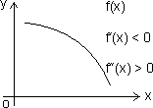
When f'(x) < 0
f''(x) > 0 v x domain
(ii) Concave down:
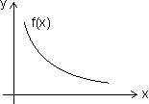
When f'(x) < 0 & f''(x) < 0 v x domain
(iii)
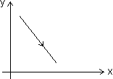
When f'(x) < 0 & f'(x) = 0 v x domain
(5) Non-increasing function:
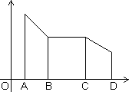
A function f(x) is c/d non-increasing if for x₁ < x₂
for x₁ < x₂
f(x₁) f(x₂)
For AB & CD, x₁ < x₂
f(x₁ > f(x₂)
Bc, x₁ < x₂
f(x₁ = f(x₂)
Illustration: Find interval in which f(x) = x³ - 3x² - 9x + 20 is strictly increasing or decreasing.
Ans: f(x) = x³ - 3x² - 9x + 20
f'(x) = 3x² - 6x - 9
f'(x) = 3(x - 3)(x + 1)
For strictly increasing
f'(x) > 0
3(x - 3)(x + 1) > 0 (x - 3)(x + 1) > 0
(x + 1) < 0 or (x - 3) > 0
x < - 1 or x > 3
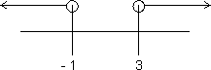
x (- , - 1) U (3, )
For strictly decreasing
f'(x) < 0
(x + 1)(x - 3) < 0
x (- 1, 3)
Properties of Monotonic function:
(1) If f(x) is strictly increasing function on [a, b]
{ f'(x) exists & f'(x) is also strictly increasing on [a, b].
(2) If f(x) & g(x) are also two continous & differentiable functions & fog(x) & gof(x) exists . then,
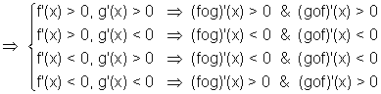
In other words
(i) If f(x) & g(x) are both strictly increasing or strictly decreasing.
(fog)(x) & (gof)(x) both are strictly inctreasing.
(ii) If amongst two functions f(x) & g(x), one is strictly increasing other is strictly decreasing.
(fog)(x) & (gof)(x) both are strictly decreasing.
Illustration: Let Ø(x) = sin(cosx) then check it whethe5r increasing ordecreasing in [0, ].
Ans: Ø(x) will be increasing if Ø'(x) > 0
Ø(x) = sin(cosx)
Ø'(x) = cos(cosx).(- sinx)
So, it is clearly decreasing for x [0, ] as Ø'(x) 0
Other method: f(x) = sinx & I(x) = cosx are increasing & decreasing in [0, ]
fog(x) = Ø(x) = sin(cosx) is decreasing.
Critical Points:
It is collection of points for which,
(i) f(x) does not exists.
(ii) f'(x) does not exists.
(iii) f'(x) = 0
All values of x obtained from above conditions are c/d critical points.
Illustration: Find critical points for f(x) = (x - 2)^{2/3}(2x + 1)
Ans: f(x) = (x - 2)^{2/3}(2x + 1)
f'(x) = 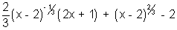
f'(x) = 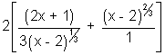
Clearly f'(x) doesnot defined at x = 2 so, x = 2 is critical point.
Dumb Question: Why f'(x) is not defined at x = 2 ?
Ans: Putting x = 2, f'(x) = which is not defined.
Another critical point
f'(x) = 0
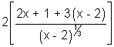= 0 x = 1
So, x = 1 & x = 2 are two critical points of f(x)
Maxima & Minima:
Maxima: A function f(x) is said have maxima at x = a if f(a) f(a + h) where h 0 (very small & a lies in its domain.
Minima: A function f(x) is said to have minima at x = b if f(b) f(b + b) & f(b) f(b - b) where h 0 (very small)
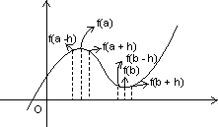
Methods for finding extremum of continuone functions:
(a) First derivative test:
(i) When f(x) attains maximum at x = a:
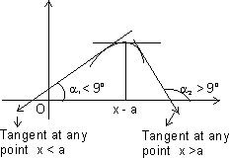
From graph,
For x < a, ₁ < 90⁰ tan₁ > 0 or increasing for x < a
For x = a, tan = 0 or neither increasing nor decreasing for x = a.
For x > a, ₂ > 90⁰ tan₂ < 0 or decreasing for x > a
So,
f(x) is maximum at x =a
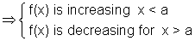
(ii) When f(x) attains minimum at x = b:
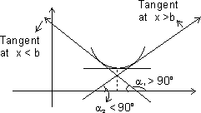
From graph,
For x < b, ₁ > 90⁰ tan₁ < 0 or decreasing when x - < b
For x = b, tan = 0 or neither increasing nor decreasing for x = b
For x > b, ₂ < 90⁰ tan₂ > 0 or increasing when x > b
So,
f(x) is minimum at x = b
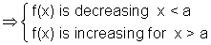
Illustration: Let f(x) = x³ - 3x² + 6, find point at which f(x) have local maximum & local minimum.
Ans: f(x) = x³ - 3x² + 6
f'(x) = 3x² - 6x
Critical points are if f'(x) = 0
3x² - 6x = 0 x² - 2x = 0
x = 0, 2
At x = 0, f'(x) change sign from + ve to - ve & f'(x) changes sign from - ve to + ve at x = 2.
So, at x = 0, function has local maxima 7 at x = 2 it has local minima.
Second Derivative Test:
(1) First we find root of f'(x) = 0.
Let x = a is one roots of f'(x) = 0
(2) Now find f''(x) at x = a
(i) If f''(a) = -ve, then f(x) is max. at x = a.
(ii) If f''(a) = +ve, then f(x) is min. at x = a
(iii) If f''(a) = 0
Then find F'''(x) at x = 0
If f'''(a) = 0 then f(x) has neither maximum nor minimum at x = a.
But if f'''(a) = + ve, then find f'^{v}(a),
(a) If f'^{v} = + ve, then f(x) is min. at x = a.
(b) If f'^{v}(a) = - ve, then f(x) is max. at x = a.

Dumb Question: How y = |x² - 3| = - (x² - 3) for neighbour hood of x = .
Ans: y = |x² - 3| since |x² - 3| is + ve quantity.
If we put x = , x² - 3 = - 1 but is + ve quantity so, we put - ve to make it + ve.
So, y = |x² - 3| = - (x² - 3)
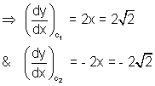
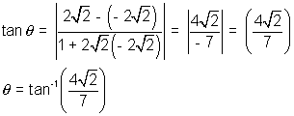
Q.6. If ax² + bx + c = 0, a,b,c R. Find condition that this eq. would have at least one root in (0, 1).
Ans: Let f'(x) = ax² + bx + c
Integrating both sides,
f(x) = 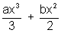+ cx + d ......................................... (i)
f(0) = d & f(1) = 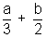+ c + d
Since, Rolle's theorem is applicable.
[Dumb Question: Why Rolle's theorem is applicable ?
Ans: Rolle's theorem is applicable b/c f(x) is polynomial function which is continuous & differentiable everywhare.]
f(0) = f(1)
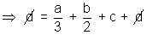
2a + 3b + 6c = 0
required condition.
Q.7. Let f(x) & g(x) be differentiable for 0 x 2 such that f(0) = 2, g(0) = 1 & f(2) = 8. Let there exists a real no. c in [0, 2] such that f'(c) = 3g'(c) find value of g(2).
Ans: As f(x) & g(x) are cobt. & differentiable in ... then there exists atleast one value 'c' such that
f'(c) = 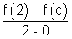
g'(c) = 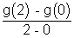
But 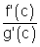= 3
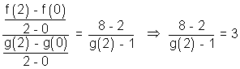
g(2) = 3
Q.8. f(x) is a polynomial of degree 4 with real coeff. such that f(x) = 0 is satisfied by x = 1, 2, 3 only, them and f'(1) f'(2) f'(3) ?
Ans: f(x) = 0 has only roots 1, 2, 3 only
But it is degree 4 eq.
Any one of 1, 2, or 3 is 4 repeated root of f(x) = 0
f'(1) or f'(2) or f'(3) any one of them must be zero.
f'(1) f'(2) f'(3) = 0
Q.9. Find interval for which f(x) = x - cosx is increasing or dectreasing.
Ans: f(x) = x - cosx
Differentiating w.r.t. x
f'(x) = 1 - sinx
we know
-1 sinx | for all x R
.... sin 0 for x v R.
Q.10. If a < 0, & f(x) = e^{ax} + e^{-ax} is monotonically decreasing. Find interval to which x belongs.
Ans: Given a < o &
f(x) = e^{ax} + e^{-ax} is decreasing
f'(x) < 0 ae^{ax} - ae^{-xx} < 0
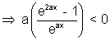
But a < 0
(e^{2ax} - 1) > 0 e^{2ax} > 1
2ax > 0 ax > 1
x < 0 as a < 0
Medium Type:
Q.1. Find values of 'k' for which point min. of function f(x) = 1 + k²x - x³ satisfy inequality 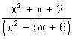< 0.
Ans: 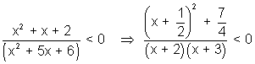
Since 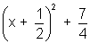it always +ve
(x + 2)(x + 3) < 0
- 3 < x < - 2 ........................................................ (i)
f(x) = 1 + k²x - x³
f'(x) = k² - 3x²
f''(x) = - 6x
For max/min, f(x) = 0
x = ±
Let x₁ = & x₂ = -
f''(x₁) < 0 & f''(x₂) > 0
f(x) is max. at x = x₁ & min. at x = x₂
But x₂ is min. which lies b/w
- 3 < x₂ < - 2 (from relation (i))
- 3 < - < - 2
3 > |k| > 2
k (- 3, - 2) U (2, 3)
Q.2. If f(x) = , x > 0 determine bigger of two no. & ^{e}.
Ans. y = f(x) = , x > 0
Taking log on both sides
ln y = ln x
Differentiating both side
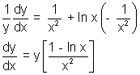
f'(x) = [1 - ln x]
Let f'(x) = 0
log x = 0 or x = e
f''(x) = 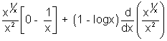
f''(e) = 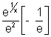+ 0
f''(e) < 0
f(x) has maxima at x = e
f(e) > f() for all x > 0
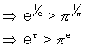
Q.3. If f(x) = ax³ + bx² + cx + d where a, b, c, d are real no.s & 3b² < c², is an increasing cubic function & g(x) = af'(x) + bf''(x) + c², then prove that 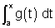is an increasing function.
Ans: f(x) = ax³ + bx² + cx + d
f'(x) = 3ax² + 2bx + c
Since f(x) is increasing
f'(x) > 0 3ax² + 2bx + c > 0
3a > 0 & D < 0
3a > 0 & b² - 3ac < 0
a > 0 & b² < 3ac ........................................ (i)
g(x) = af'(x) + bf''(x) + c²
g(x) = 3a²x² + 2abx + ac + 6abx + 2b² + c²
g(x) = 3a²x² + 8abx + (2b² + c² + ac)
D = 64a²b² - 4.3a²(2b² + c² + ac)
= 4a²(10b² - 3c² - 3ac)
Since 3ac > b² from (i)
- 3ac < - b²
4a²(10b² - 3c² - 3ac) < 4a²(10b² - 3c² - b²)
= 4a²(9b² - 3c²)
Since 3b² < c²
= 12a²(3b² - c²) = -ve
D < 0
g(x) > 0 v x R
is increasing function.

Q.4. If at each point of curve y = x³ - ax² + x + 1 tangent is inclined at acute angle with +ve direction of x-axis. Find interval in which a lies.
Ans: y = x³ - ax² + x + 1
Sine tangent is inclined at an acute angle with the direction of x-axis.
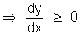
= 3x² - 2ax + 1 0 for all x R
But if ax² + bx + c 0 for x R
a > 0 & D 0
D = (2a)² - 4(3)(11)
= 4(a² - 3)
D 0
(a² - 3) 0 (a - )(a + ) 0
- a
Dumb Question: How 0 if angle is acute.
Ans: Since = tan & if is lessthan . So, tan 0. So, 0
Q.5. If f(x) = log_{e}x & g(x) = x² & c (4, 5), then find value of c log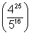
Ans: log(4²⁵) - log5¹⁶
25 log4 - 16 log5
Since domain is [4, 5]
So, let
Ø(x) = x² (log4) - 16 logx i9s cont. [45, 5] & differentiable on (4, 5)
By LMUT,
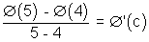, c (4, 5)
Ø(5) - Ø(4) = log
But, Ø'(c) = (c² log4 - 8) ........................................ (i)
also Ø'(c) = 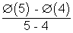........................................... (ii)
By (i) & (ii)
(c² log_{e}4 - 8) = log_{e}
c log = 2(c² log4 - 8)
Hard Type:
Q.1. Let S be square of unit area. Consider aany quadrilateral which has one vertex on each side of s. If a, b, c, & d denote lengths of side of quadrilateral, prove that
2 a² + b² + c² + d² 4
Ans:
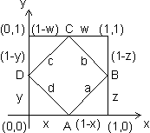
Let S be square of unit area & ABCD be quadrilateral of sides a, b, c & d
a² = (1 - x)² + z²
b² = w² + (1 - z)²
c² = (1 - w)² + (1 - y)²
d² = x² + y²
a² + b² + c² + d² = {x² + (1 - x)²} + {y² + (1 - y)²} + {z² + (1 - z)²}
+ {w² + (1 - w)²}
where 0 x, y, z, w 1
Let f(x) = x² + (1 - x)², 0 x 1
Then f'(x) = 2x - 2(1 - x)
f'(x) = 0 for min/max.
4x - 2 = 0 x =
Again f''(x) = 4 > 0 when x =
f(x) is min. at x = & m,ax. at x = 1
a² + b² + c² + d² = 4{x² + (1 - x)²}
Max. value of x² + (1 - x)² = 1² + (1 - 1)² = 1
Min. value of x² + (1 - x)² = 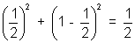
2 a² + b² + c² + d² 4
Q.2. Let a + b = 4 & a < 2 & let g(x) be differentiable function. If > 0 v x prove that 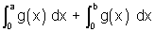increases as (b - a) increases.
Ans: Let (b - a) = t & since a + b = 4
a = 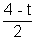 & b = 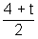 & t > 0
[Dumb Question: Why t = b - a > 0 ?
Ans: Since a < 2 &n & a + b = 4. So, b > 2
b - a > 0 or t > 0]
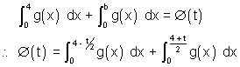
Ø(t) = 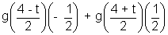 [By Leibniz rule]
[Dumb Question: What is Leibniz rule ?
Ans: Ø(t) = 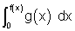]
Ø'(t) = g(f(x)) f'(x)
Since g(x) is increasing
x₂ > x₁ g(x₂) > g(x₁)
Now, >  & g(x) is increasing
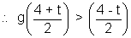
Ø'(t) = 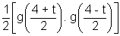> 0
Ø'(t) > 0
Ø'(t) is increases as t increases.
Q.3. Tangent represented by graph of function y = ... at the point with absciss a x = 1 from an angle & at point x = 2 an angle of & at the point x an angle of . Find value of 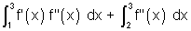.
Ans: Given
at x = 1, = tan =
at x = 1, f'(1) = tan =
at x = 2 f'(2) = tan =
at x = 3 f'(3) = tan = 1
Then, 
Let f'(x) = t
f''(x) dx = dt
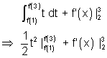
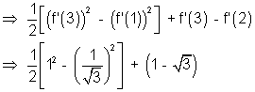
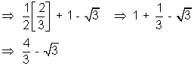

KEYWORDS
- Derivative
- Tangent
- Normal
- Orthognal Curves
- Sub Tangent
- Sub Normal
- Rolle’s Theorm
- Lagrange’s Mean Value Theorm
- Maxima
- Minima
- Monotonicity

Applications of Derivatives
MCQ-Single Correct
1. Twenty meters of wire is available for fencing off a flower-bed in the form of a circular sector.
Then the maximum area ( in sq. m ) of the flower bed is
- 12.5 (2) 10
(3) 25 (4) 30 [2017]
2. The normal to the curve at the point where the curve intersects the y-axis passes through the point :
(1) (2)
(3) (4) [2017]
3. A wire of length 2 units is cut into two parts which are bent respectively to form to form a square of side = x units and a circle of radius = r units. If the sum of the areas of the square and the circle so formed is minimum, then :
(1) (2) x = 2r
(3) 2x = r (4) 2x = [2016]
4. Consider f(x) = , . A normal to y = f(x) at also passes through the point :
(1) (2)
(3) (4) (0,0) [2016]
5. Let f(x) be a polynomial of degree four having extreme values at x = 1 and x = 2 . If , then f(2) is equal to :
(1) -4 (2) 0
(3) 4 (4) -8 [2015]
6. The normal to the curve, , at (1,1) :
(1) meets the curve again in the second quadrant.
(2) meets the curve again in the third quadrant.
(3) meets the curve again in the fourth quadrant.
(4) does not meet the curve again. [2015]
7. If x = -1 and x = 2 are extreme points of f(x) = + , then
(1) (2)
(3) (4) [2014]
8. If f and g are differentiable functions in [0,1] satisfying f(0) = 2 = g(1), g(0) = 0 and f(1) = 6, then for some
(1) 2f’(c) = g’(c) (2) 2 f’(c) = 3 g’(c)
(3) f’(c) = g’(c) (4) f’(c) = 2 g’(c) [2014]
9. The real number k for which the equation, has two distinct real roots in [0,1]
(1) lies between 2 and 3 (2) lies between -1 and 0
(3) does not exist (4) lies between 1 and 2 [2013]
10. The intercepts on x-axis made by tangents to the curve, , , which are parallel to the line y = 2x , are equal to
(1) (2)
(3) (4) [2013]
11. The curve that passes through the point (2,3) , and has the property that the segment of any tangent to it lying between the coordinate axes is bisected by the point of contact, is given by
(1) (2)
(3) 2y -3x = 0 (4) [2011]
12. Let f : be defined by f(x) = . If f has a local minimum at x = -1 , then a possible value of k is
(1) 0 (2) -1/2
(3) -1 (4) 1 [2010]
13. The equation of the tangent to the curve that is parallel to the x-axis, is
(1) y = 1 (2) y = 2
(3) y = 3 (4) y = 0 [2010]
14. Given P(x) = such that x = 0 is the only real root of P’(x) = 0 . If P(-1) < P(1) , then in the interval [-1,1]
(1) P(-1) is the minimum and P(1) is the maximum of P
(2) P(-1) is not minimum but P(1) is the maximum of P
(3) P(-1) is the minimum and P(1) is not the maximum of P
(4) neither P(-1) is the minimum nor P(1) is the maximum of P [2009]
15. The shortest distance between the line and the curve is
(1) (2)
(3) (4) [2009]
16. How many real solutions does the equation have?
(1) 7 (2) 1
(3) 3 (4) 5 [2008]
17. Suppose the cube has three distinct real roots where p > 0 and q > 0. Then which one of the following holds?
(1) The cubic has minima at and maxima at
(2) The cubic has minima at and maxima at
(3) The cubic has minima at both and
(4) The cubic has maxima at both and [2008]
18. A value of C for which the conclusion of Mean Value Theorm holds for the function f(x) = on the interval [1,3] is
(1) 2log₃e (2) log_{e}3
(3) log₃e (4) log_{e}3 [2007]
19. The function f(x) = is an increasing function in
(1) (2)
(3) (4) [2007]
20. A body falling from rest under gravity passes a certain point P. It was at a distance of 400m from P, 4s prior to passing through P. If g = 10 m/s² , then the height above the point P from where the body began to fall is
(1) 720m (2) 900m
(3) 320m (4) 680m [2006]
21. The function has a local minimum at
(1) x = 2 (2) x = -2
(3) x = 0 (4) x = 1 [2006]
22. Angle between the tangents to the curve at the points (2,0) and (3,0) is
(1) (2)
(3) (4) [2006]
23. Area of the greatest rectangle that can be inscribed in the ellipse is
(1) 2ab (2) ab
(3) (4) [2005]
24. The normal to the curve y = at any point ‘’ is such that
(1) If passes through the origin
(2) If makes angle with the x – axis
(3) It passes through
(4) It is at a constant distance from the origin [2005]
25. A function is matched below against an interval where it is supposed to be increasing. Which of the following pairs is incorrectly matched?
Interval Function
- [2005]
26. A spherical iron ball 10 cm in radius is coated with a layer of ice of uniform thickness, then mels at a rate of 50 cm³/min. When the thickness of ice is 5 cm, then the rate at which the thickness of ice decreases , is
(1) (2)
(3) (4) [2005]
27. A lizard, at an initial distance of 21 cm behind an insect, moves from rest with an acceleration of 2 cm/s² and pursues the insect which is crawling uniformly along a straight line at a speed of 20 cm/s. Then the lizard will catch the insect after
(1) 20 s (2) 1 s
(3) 21 s (4) 24 s [2005]
28. Two points A and B move from rest along a straight line with constant acceleration f and f’ respectively. If A takes m sec. more than B and describes ‘n’ units more than B in acquiring the same speed then
(1) (f-f’)m² = ff’n (2) (f + f’)m² = ff’n
(3) (4) (f’ – f)n = ½ ff’m²
[2005]
29. A particle is projected from a point O with velocity u at an angle of 60º with the horizontal. When it is moving in a direction at right angles to its direction at O, its velocity then is given by
(1) u/3 (2) u/2
(3) 2u/3 (4) u/ [2005]
30. If the equation
a_{n}x^{n} + a_{n-1}x^{n-1} + …… + a₁x = 0 , , , has a positive root , then the equation na_{n}x^{n-1} + (n-1)a_{n-1}x^{n-2} + ……. + a₁ = 0 has a positive root, which is
- Greater than α (2) smaller than α
(3) greater than or equal to α
(4) equal to α [2005]
31. A point on the parabola at which the ordinate increases at twice the rate of the abscissa is
(1) (2,4) (2) (2,-4)
(3) (4) [2004]
32. A function y = f(x) has a second order derivative f’’(x) = 6(x-1). If its graph passes through the point (2,1) and at that point the tangent to the graph is y = 3x – 5, then the function is
(1) (2)
(3) (4) [2004]
33. The normal to the curve x = a(1 + cosθ), y = a sinθ at ‘θ’ always passes through the fixed point
(1) (a,0) (2) (0,a)
(3) (0,0) (4) (a,a) [2004]
34. If 2a + 3b + 6c = 0, then at least one root of the equation lies in the interval
(1) (0,1) (2) (1,2)
(3) (2,3) (4) (1,3) [2004]
35. If the function f(x) = 2x³ – 9ax² + 12a²x +1, where a > 0, attains its maximum and minimum at p and q respectively such that p² = q, then a equals
(1) 3 (2) 1
(3) 2 (4) ½ [2003]
36. Two particles start simultaneously from the same point and move along two straight lines, one with uniform velocity and the other from rest with uniform acceleration . Let α be the angle between their directions of motion. The relative velocity of the second particle with respect to the first is least after a time
(1) (2)
(3) u sin α (4) [2003]
37. Two stones are projected from the top of a cliff h meters high, with the same speed u so as to hit the ground at the same spot. If one of the stones is projected horizontally and the other is projected at an angle θ to the horizontal then tan θ equals
(1) (2)
(3) (4) [2003]
38. A body travels a distance s in t seconds. It starts from rest and ends at rest. In the first part of the journey, it moves with constant acceleration f and in the second part with constant retardation r. The value of t is given by
(1) (2)
(3) (4) [2003]
39. If 2a + 3b + 6c = 0 (a, b, c ε R), then the quadratic equation ax²+bx+c = 0 has
(1) atleast one root in [0,1]
(2) atleast one root in [2,3]
(3) atleast one root in [4,5]
(4) none of these [2002]
40. f(x) and g(x) are two differentiable functions on [0,2] such that f’’(x) – g’’(x) = 0 , f’(1) = 2g’(1) = 4, f(2) = 3 g(2) = 9 , then f(x) – g(x) at x = 3/2 is
(1) 0 (2) 2
(3) 10 (4) 5 [2002]
41. The maximum distance from origin of a point on the curve x = a sin t – b sin , y = cos t – b cos , both a, b > 0 is
(1) a – b (2) a + b
(3) (4) [2002]

Assertion – Reason Type

1. Consider the function, f(x) = |x-2|+ |x-5|,
Statement – I : f’(4) = 0
Statement – II : f is continuous in [2,5], differentiable in (2,5) and f(2) = f(5)
2. Let a, b ε R be such that the function f given by f(x) = ln |x| + bx² +ax, has extreme values at x = -1 and x = 2.
Statement – I : f has local maximum at x = -1 and x = 2
Statement – II : a = ½ and b = -1/4.
3. Let f be a function defined by f(x) =
Statement-I : x = 0 is point of minima of f.
Statement – II : f’(0) = 0.

Indefinite Integration
Indefinite Integration
Basic Concept
Let F(x) be a differentiable function of x such that . Then F (x) is called the integral of f(x). Symbiotically, it is written as
f (x), the function to be integrated is called the integrand.
F(x) is also called the anti-derivate (or primitive function) of f (x).
Constant of Integration:
As the differential coefficient of a constant is zero, we have
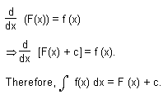
This constant c is called the constant of integration and can take any real value.
Properties of Indefinite Integration
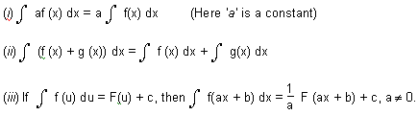
Basic Formulae
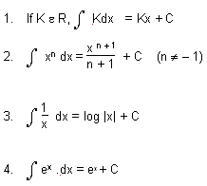
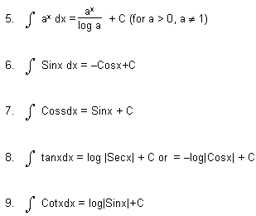
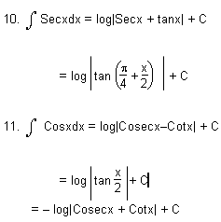
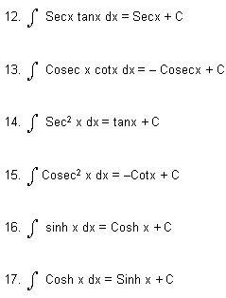
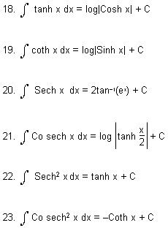
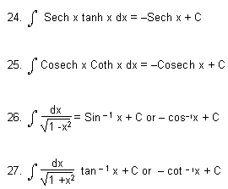
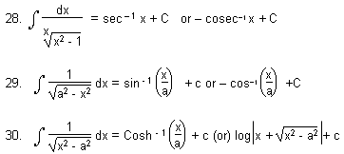
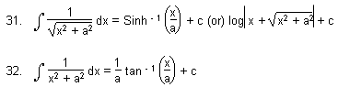
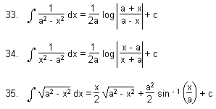
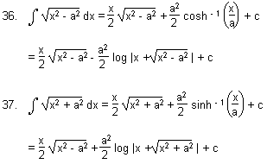
Method of Integration:
If the integrand is not a derivative of a known function, then the corresponding integrals cannot be found directly. In order to find the integral of complex problems, generally three rules of integration are used.
- Integration by substitution or by change of the independent variable.
- Integration by parts.
- Integration by partial fractions.
Integration by substitution
There are following types of substitutions

- Direct Substitution
–– If integral is of the form , then put
g(x) =t
, provided exists

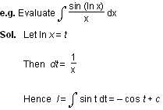
- Standard Substitutions
- For terms of the form x2 + a2 or put x = a tan or a cot
- For terms of the form x2 - a2 or put x = a sec or a cosec
- For terms of the form a2 - x2 or put x = a sin or a cos
- If both are present then put x = a cos
- For the type put x = a cos² + b sin²
- For the type put the expression within the bracket = t
- For the type put
- For again put (x + a) = t (x + b)
- Indirect Substitution
–– If the integrand is of the form
F(x)g(x), where
g(x) is a function of the integral of f(x), then put integral of f(x) =t
.

e.g. Evaluate
Sol. Integral of the numerator =
Put
x^{3/2}
= t
We get
l =
- Derived Substitution:
–– Some time it is useful to write the integral as a sum of two related integrals which can be evaluated by making suitable substitutions.

Examples of such integrals are:

A. Algebraic Twins

Method:
* Make the integration in the form

or
*If
is present then put
If
is present then put
B. Trigonometric twins

Integration by Parts
1. If
u and v be two function of x
, then integral of product of these two functions is given by
Note:
In applying the above rule care has to be takne in the selection of the first function (u) and the second function (v). Normally we use the following methods:

(i) If in the product of two functions, one of the functions in not directly integrable (
e.g.
sin⁻¹x
, cos⁻¹x
, tan⁻¹x
etc.) then we take it as the first function and the remaining function is taken as the second function
e.g.
In the integration
x tan⁻¹xdx, tan⁻¹x is taken as the first function and x
as the second function.

(ii) If there is no other function, then unity is taken as the second function
e.g.
In the integration of
tan⁻¹xdx, tan⁻¹ is taken as the first function and 1 as the second function.

(iii) If both of the function are directly integrable then the first function is chosen in such a way that the derivative of the function thus obtained under integral sign is easily integrable. Usually we use the following preference order for the first function (inverse, Logarithmic, Algebraic, Trigonometric, Exponential)

In the aove stated order, the function on the left is always chosen as the first function. This rule is called as ILATE
e.g.
In the integration of
x sin x dx, x is taken as the first function and sinx is taken as the second function.
Important Result:
*
In the integral , if
g(x) ex dx, if g(x) cna be expressed as g(x) =f(x) +f'(x)

then
Some times to solve integral of the form
we write it as
and solve the integral with the help of integration by parts, taking
as the first function.
e.g.

is solved by writting it as

and this integral can be solved by parts.
Algebraic Integrals
I. Integral of the form
In these types of integrals we write
px + q =l
(diff. coefficient of ax² + bx + c) + m
Find l and m
by comparing the coefficient of x
and constant term on both sides of the identify. In this way the question will reduce the sum of two integrals which can be integrated easily.

Integral of the type
In this case substitute
ax² +bx + c = M ( px ² + qx + r ) + N
(2px + q) + R
Find M, N and R
. The integration reduces to integration of three independent functions.
II. Integration of Irrational Algebraic Fractions
1. Rational fucntion of ( x + b)^{1/n}
and x
can be easily evaluated by the substitution
t^{n} = ax + b
. Thus
2. In the integration of
the substitution
x – k = 1 /t
reduces the integration
to the problem of integrating an expression of the form
3. .
Here we substitute,
x – k = 1/t
.

This substitution will reduce the given integral to
4. To integrate
we first put
x = 1/t , so that
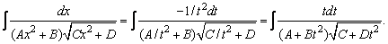
Now the substitution
C + Dt² = u²
reduces it to the form
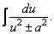
III. Integration of the function of the type
,
Where m, n, p are rational numbers

This integral is expressed through elementary functions only if one of the following conditions is fulfilled:

(1) If p is an integer,

(2) If
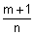
is an intger,

(3) If

+ p is an integer.

1st case :
(a) If p is a positive integer, remove the brackets (a + bxn)p according to the Newton binomial and calculate the integrals of powers.

(b) If p is a negative integer, then the substitution x = tk, where k is the common denominator of the fractions m and n, leads to the integral of a rational fraction;
2nd case :
If

is an integer, then the substitution a + bx
^{n} = t^{k}
is applied, where k is the denominator of the fraction p;
3rd case :
If

+ p is an integer, then the substitution a + bx
^{n} = xnt^{k}
is applied, where k is the denominator of the fraction p.
Example :
(i)
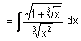
(ii)
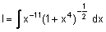

(iii)

(iv)
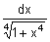

Trignometric Integrals
I. Integral of the form
Universal substitution tan .
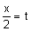
In this case sin
x=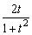; cosx= 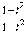, x= 2 tan- 1 t; dx=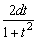
If R (- sin x, cos x) = - R (sin x, cos x), then the substitution cos x = t is applied.

If R (sin x, - cos x) = - R (sin x, cos x), then the substitution sin x = t is applied.

If R (- sin x, - cos x) = R (sin x, cos x), then the substitution tan x = t is applied.
II. Integral of the form
(i)
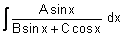

(ii)
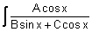
dx

(iii)
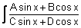
dx

(iv)
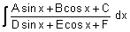
This type of integration can be solved by converting the Nr in the form Nr = P(Dr) + Q + R the value of P, Q, R can be findout by comparing the coeffcient of both sides.
III. Integral of the form
(i)
(ii)
(iii)
Transform the product of trigonometric function into a sum or difference, using one of the following formulas:

sin ax sin bx = [cos(a-b) x - cos (a+b)x]

cos ax cos bx = [cos (a - b) x + cos (a + b) x]

sin ax cos bx = [sin (a - b) x + sin (a + b) x]

IV. Integral of the form
, where m and n are integers.

(i) If m is an odd positive number, then apply the substitution cos x = t.

(ii) If n is an odd positive number, apply the substitution sin x = t.

(iii) If m and n are even non-negative numbers, use the formulas

(iv)
where (o <x< ?/2) and
p and q
are rational numbers.

Substitute sin
x= t

V. Integral of the form
–

= when
VI. Integral of the form
(i)
(ii)
(iii)
(iv)

This type of integration can be solved by multiplying sec
²x, in N^{r} and D^{r}
and substituting tan x = t, or cot x = t.
VII. Integral of the form
(i)
(ii)
(iii)
To solve this type of integration

1) convert sinx and cosx in terms of tan x/2 by putting.
2) Write N^{r}
in the form sec² x/2 and Dr in the form tan x/2.

3) Substitute tan x/2 = t, so that sec²
x/2 dx = 2dt
VIII.
If D^{r}
is in the form K + L sin x cos x, then Nr must be in the form of sin x + cos x, or sin x - cos x.

(1) If N^{r} has sinx+ cosx then substitute sinx – cosx = t
(cos x + sinx)dx = dt
(2) Nr has sinx- cosx then substitute sin x + cosx = t
(cos x - sinx)dx = dt
Note: If sinx- cosx=
t 1 - sin 2x = t²
sin 2x= 1 -t² If sinx + cosx =t
1 + sin 2x =t²
sin 2x = t² - 1
INTEGRATION BY Partial fraction
Let
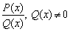
is a proper algebric function.

The partial fractions depend on the nature of the factors of Q(x). We have deal with the following different type when the factors of
Q(x) are

(i) Linear and non-repeated

(ii) Linear and repeated

(iii) Quadratic and non-repeated

(iv) Quadratic and repeated
Case I :
When denominator is expressible as the product of non-repeated linear factors :

Let Q (x) = (x - a₁) (x - a₂) (x - a₃) ... (x - a_{n}).

Then we assume that ;
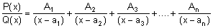
where A₁, A₂, ...., A_{n}
are constants and can be determined by equating numerator on R.H.S to numerator on L.H.S. and then substituting x = a₁, a₂, .... a_{n},
Case II :
When the denominator
Q(x) is expressible as the product of the linear factors such that some of them are repeating. (Linear and Repeated)

Let, Q(x) = (x-a)^{k} (x-a₁) (x-a₂) ... (x-a_{r}). Then we assume that
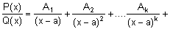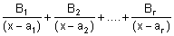
Case III :
When some of the factors in denominator are quadratic but non-repeating.

Corresponding to each quadratic factor ax² + bx + c, we assume the partial fraction of the type
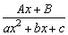
, where A and B are constants to be determined by comparing coefficients of similar powers of x in numerator of both sides.
Case IV :
When some of the factors of the denominator are quadratic and repeating. For every quadratic repeating factor of the type
(ax² + bx + c)^{k}
, we assume :
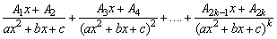
Short cut Method of Finding the Constant of a Non-repeated Linear Factor in Denominator

Let

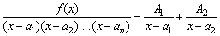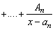

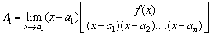

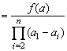

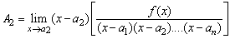

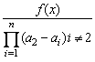

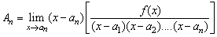

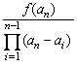

Indefinite Integrals
MCQ-Single Correct
1. Let I_{n} = , (n > 1). If I₄ + I₆ = a tan⁶x + bx⁵ + C, where C is a constant of integration, then the ordered pair (a,b) is equal to :
(1) (2)
(3) (4) [2017]
2. The integral is equal to :
(1) (2)
(3) (4) [2016]
3. The integral equals :
(1) (2)
(3) (4) [2015]
4. The integral is equal to
(1) (2)
(3) (4) [2014]
5. If , then is equal to [2013]
(1)
(2)
(3)
(4)
6. The value of is
(1)
(2)
(3)
(4) [2008]
7. is equal to
(1) (2)
(3) (4) [2005]
8. If , then the value of (A,B) is
(1) (sinα, cosα) (2) (cosα, sinα)
(3) (-sinα, cosα) (4) (-cosα, sinα) [2004]
9. is equal to
(1)
(2)
(3)
(4) [2004]

Definite Integrals
1. If f and F are two continuous functions defind on [a, b] such that
then the number

F(b) - F(a) is called definite integration of f between a and b and is denoted by
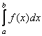
i.e.,
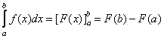
This is called fundamental theorem of integral calculus. Here 'a' is called lower limit (LL) and 'b' is upper limit (U.L) and
always.
Also
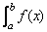dx
denotes algebric sum of the area bounded by curve
y = f(x) , ordinates
x = a, x = b and x - axis.

2.

is always unique.

-  is also defined as an infinite limit sum..
4.
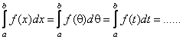
Properties of Definite Integration:
1.
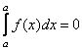
2.
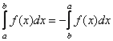
3.
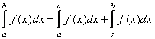
where a < c < b

4.
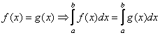
but converse need not be true

5.
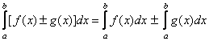
6.
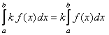
7.
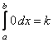
8.
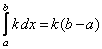
9.
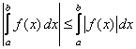
10.
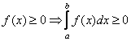
If but converse need not be true.

11.
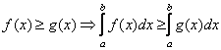
If but converse need not be true.

12.
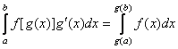
(change limit Theorem)

13.
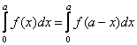
14.
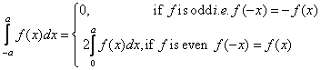
15.
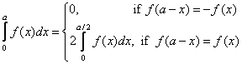
16.
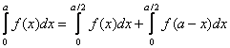
17.
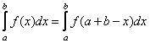
18.
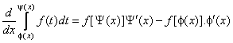
This is called
Leibnitz rule
.19.
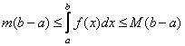
where m and M are respectively the minimum and maximum values of
f(x) in [a, b]
20. If f is a periodic function with period
T
, i.e., if f(x + T) =f(x) then
a)
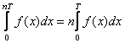
b)
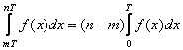
c)
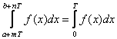
where m, n are integers

d)
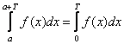
i.e., it is not dependent on 'a'

21.
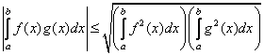
This is called cauchy - schwartz inequality
WALLI'S FORMULAE :

22. 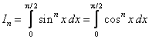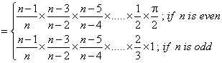
23. 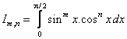
Case (1)
: If m is odd and n is either even or odd

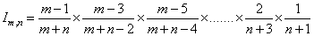

Case (2)
: If m is even and n is even

Case (3)
: If m is even and n is odd.

Reduction Formulae on Definite Integration
:

24. If
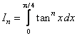
then
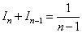
(where n > 2)

25. If
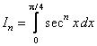
then
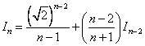
26. If
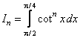
then
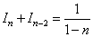
27. If
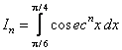
then
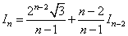

28.
By parts Formulae on Definite Integration :
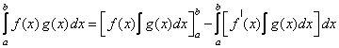
29. If a function has finite number of points of discontinuties in [a, b] then the function is definite integrable in that interval.

30.
Definite integration as infinite limit sum :
1)
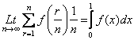
2)
Working rule :

Step I
: First reduce the given infinite limt into the form
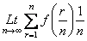

Step II
: Replace r/n with x and 1/n with dx

Step III
: Replace
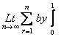

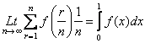
Note :
1)
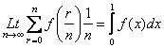
2)
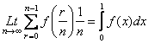
3)
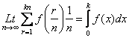

Definite Integrals
MCQ-Single Correct
1. The integral is equal to
(1) -2 (2) 2
(3) 4 (4) -1 [2017]
2. is equal to :
(1) (2)
(3) 3log3 -2 (4) [2016]
3. The integral is equal to :
(1) 4 (2) 1
(3) 6 (4) 2 [2015]
4. The integral equals
(1) (2)
(3) (4) [2014]
5. If g(x) = then g(x + π) equals
(1) g(x) (2) g(x) . g(π)
(3) (4) g(x) + g(π) [2012]
6. Let [.] denotes the greatest integer function, then the value of is
(1) ¾ (2) 5/4
(3) 0 (4) 3/2 [2011]
7. Let p(x) be a function defined on R such that p’(x) = p’(1-x), for all x ε [0,1] , p(0) = 1 and p(1) = 41 . Then equals
(1) 21 (2) 41
(3) 42 (4) [2010]
8. , [*] denotes the greatest integer function, is equal to
(1) (2) 1
(3) -1 (4) [2009]
9. Let I = and J = . Then which one of the following is true?
(1) I > 2/3 and J > 2 (2) I < 2/3 and J < 2
(3) I < 2/3 and J > 2 (4) I > 2/3 and J < 2 [2008]
10. The value of the integral, is
(1) ½ (2) 3/2
(3) 2 (4) 1 [2006]
11. is equal to [2006]
(1) (2)
(3) (4)
12. is equal to
(1) (2)
(3) (4) [2006]
13. The value of , a > 1, where [x] denotes the greatest integer not exceeding x is
(1) af(a) – {f(1) +f(2)+……+f([a])}
(2) [a] f(a) – {f(1) +f(2) + ….. +f([a])}
(3) [a]f([a]) – {f(1) + f(2) + ….+f(a)}
(4) af([a]) – {f(1) + f(2) + …..+f(a)}[2006]
14. equals
(1) (2)
(3) tan1 (4) [2005]
15. If , , and then
(1) I₂ > I₁ (2) I₁ > I₂
(3) I₃ = I₄ (4) I₃ > I₄ [2005]
16. Let f : be a differentiable function having f(2) = 6 , f’(2) = . Then equals
(1) 24 (2) 36
(3) 12 (4) 18 [2005]
17. The value of , a > 0 , is
(1) aπ (2)
(3) (4) [2005]
18. is
(1) e (2) e - 1
(3) 1-e (4) e + 1 [2004]
19. The value of is
(1) (2)
(3) (4) [2004]
20. The value of is
(1) 0 (2) 1
(3) 2 (4) 3 [2004]
21. If , then A is
(1) 0 (2) π
(3) π/4 (4) 2π [2004]
22. If , I₁ = and I₂ = then the value of is
(1) 2 (2) -3
(3) -1 (4) 1 [2004]
23. If f(y) = e^{y} , g(y) = y ; y > 0 and F(t) = then
(1) F(t) = 1-e^{-t}(1+t) (2) F(t) = e^{t} – (1+t)
(3) F(t) = te^{t} (4) F(t) = te^{-t} [2003]
24. If f(a + b –x) = f(x), then is equal to
(1) (2)
(3) (4) [2003]
25. The value of is
(1) 3 (2) 2
(3) 1 (4) 0 [2003]
26. The value of the integral is
(1) (2)
(3) (4) [2003]
27. Let . If then one of the possible values of k, is
(1) 15 (2) 16
(3) 63 (4) 64 [2003]
28. Let f(x) be a function satisfying f’(x) = f(x) with f(0) = 1 and g(x) be a function that satisfies f(x) + g(x) = x² . Then the value of the integral , is
(1) (2)
(3) (4) [2003]
29. is
(1) 2 - (2)
(3) (4) [2002]
30. I_{n} = , then equals
(1) ½ (2) 1
(3) ∞ (4) 0 [2002]
31. is
(1) 20 (2) 8
(3) 10 (4) 18 [2002]
32. If y = f(x) makes positive intercept of 2 and 0 unit in x and y axes and encloses an area of ¾ square units with the axes then is
(1) 3/2 (2) 1
(3) 5/4 (4) -3/4 [2002]
33. is
(1) (2) π²
(3) 0 (4) [2002]

Assertion – Reason Type
1. Statement – I : The value of the integral is equal to . [2013]
Statement – II : .

Matrices
Matrices and determinants are very nice ways to vepresent bunch of number. matrices as well as determinants dlong with some very nice properties that each of then have, prove to be very useful in solving equations, finding area of polygons etc. Matrices a also find use in Linear Algebra which is beyond the scope of JEE syllabus.
So, Let us study these in details.
Matrices And Determinants
MATRICES
A rectangular away of elements or symbols.along sows and wlumns in colled a matricx .
Equal MAtrices :- Two matrices are eqnal if they have the same order and each element of ove is equal to the corresponding of the other.
Classification (Secondaty Information):-
Row Matrix
A mstrix lhaving a single row .
Column Matrix
A matrix with a single column .
Square Matrix
An m X n matrix is said to be a square matrix if m = n i.e. no. of rows = no. o of columns.
eg: A - 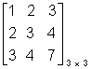
Trace of a Matrix
The sum of the elements of O square matrix A lying along the principal diagonal .
Properties of trace of a matrix(Secondary Information) :-
(i) tr (A) = tr (A)
(ii) tr (A + B) = tr (A) + tr (B)
(iii) tr (A B) = tr (B A)
Diagonal Matrix (Secondary Information) :-
A square matrix with all the elemente O except the diagonal elements.
Scalar Matrix:- A diagonal matrix whose all the leading elements are equal.
Unit or Identify Matrix:-
A diagonal matrix of order n which has only unity for all its diagonal elements. is called unit or Identify matrix of order n and is denoted by In.
Triangnlar Matrix (Secondary Information):
A square matrix in which all the elements below the diagonal are zero is called upper triangnlar and square matrix in which all the elements above diagonal are zero is called lower triangnlar matrix
Null Matrix :-
MAtrix with all elements O.
Transpose of a Matrix:- The matrix obtaired from a given matrix A, by inter changing rows and columns is called transpose of A and is denoted by a^{T} . or A ¹.
Properties of Transpose (Secondary In formation):-
(i) (A^{T})^{T} = A
(ii) (A + B)^{T} = A^{T} + B^{T}
(iii) (A)^{T} = . A^{T}
(iv) (A B)^{T} = B^{T} A^{T}.
Conjugate of a Matrix:- A matrix obtained from any given matrix A coutaining complex number as its elements, or replaing its elements by the corresponding conjugate complex no is called conjugate of A and is denoted by .
Properties of conjugate (Secondary Information:-
(i) = A
(ii)
(iii)
(iv)
Transpose Conjugate of a Matrix:-
The transpose of conjugate of a matrix denoted by .
Properties of Transpose of conjugate:-
(Secondary Information):-
(i)
(ii)
(iii)
(iv)
ALGEBRA OF MATRICES:-
Addition and Subtraction:- Any two matrices can be added lif they are of same order and the (or Subtrected)
resulting matrix is of same order, corresponding elements are added or subtracted .
Scalar Multiplication:-
The matrix obtained by multiplleying every element of by a scalar is called the scalar multiple of A by and is denoted by A .
Multipliecation of Matrices:-
Two matrices can be multiplied lonly when the no of columns in the first is equal to the no . of rows inm the second. Such matrices are called conformable for multiplication.
If A B = c
A - [a_{ij}] _{mXn} B - [b_{ke}] _{nXp}
C _{ij}² 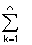a _{ik} b _{kj}
Special Matrices (Secondary Information:-
Symmetric and Skew Symmetric Matrices:-
A square matriex is A is said to be symmetric if
A = A^{T}.
and skew symmetric if A = - A^{T}.
Unitary Matrix
A matrix is unitary if A = 1
Hermition and skew - Harmition Matrix :-
A square matrix is said to mermition if A = .
and skew Hermition if = - A .
Singular Matrix :- Ahy square matrix A is singular if | A | = O .
Orthogonal Matrix :- Any squrae matrix A of order n is said to be orthogonal if A A^{T} = A^{T} A = I_{n}.
Idempotent Matrix :- A square matrix is called idmpotent provided it satisfies the selation A² = A .
In volutary Matrix :-
A matrix such A ² = I .
Nilpotent Matrix
A square matrix such that A ^{m} = O where m is Q posetive integer .
Adjoint of a Square Matrix
Let A be a square matrix of order n and let C_{ij} ;be cofactor of a_{ij} in A. Then the transpose of the matrix of cofacturs of elements of A is called the adjoint of A and is denoted by adj A .
We have
A (adj A) = | A | I_{n} = (adj A) A
Onverse of a Matrix
A no n - singular square matrix of ordere n is invertible if there exists a square matrix B of the same order such that AB = I_{n} = BA .
A⁻¹ = B
A⁻¹ = adj A .
properties of inverse of a matrix :-
(Secondary Information).
(i) (A B)⁻¹ = B⁻¹ A ⁻¹
(ii)(ABC ........ ) ⁻¹ = ........C⁻¹ B⁻¹ A⁻¹
(iii) (A^{T}) ⁻¹ = (A⁻¹ )^{T}
(iv) A is a no n - singular matrix of order n . There |adj A| = |A| ^{1-n}
(v) (A B) = adj B . adj A .
(vi) A is are invetible square matrix . There
adj (A^{T}) = (adj⁻A)^{T}
(vii) If A is a no n - singular square matrix, there
adj(adj⁻A) = |A|^{n-2} A .
System of Simultaulons Linear Equations :-
a₁₁ x₁ + a₁₂ x₂ + ....... + a_{1n} x_{n} = b₁
a₂₁ x₁ + a₂₂ x₂ + ....... + a_{2n} x_{n} = b₂
a_{n1} x₁ + a_{n2} x₂ + ....... + a_{nn}x_{n} = b_{n}
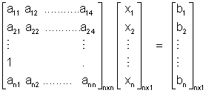
AX = B
X = A⁻¹ B
(i) If A is non singular, the system of equation AX = B has a uonique so1⁴ given by X = A ⁻¹ B .
(ii) If A is singular and (adj A) B = O, there system of equation given by AX = B is cousistent with. Infinefely many solutions.
(iii) If A is a singular matrix,and (adj A) . B O, then the system of equation given by AX = B is inconsistent
DUMB QUESTION
Q1. If co-ordinates (x, y)one rotated by are augleabout the arigin the new coordinetes are represnted by matrix . How ?
Sol^{n} :- 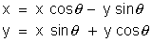
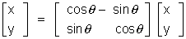
Illustration :-
Q1. A = 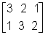and B 2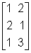 show that A B B A .
Sol^{n} :- A . B = = 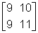
B . A = = 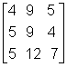
Q 2. Show taht A = 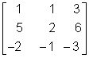is ...of index 3.
Solution :- A² = 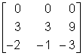
A³ = A² - A = 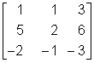
= 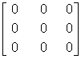
A³ = 0 i.e. A^{k} = 0
DETERMINAATS :-
The experssion 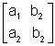is colled a determinant.
Calculation of determinants
= a₁ b₂ - a₂ b₁
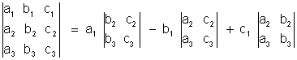
= a₁ (b₂ c₃ - b₂ b₃) - b₁ (a₂ c₃ - c₂ a₃) + c₁ (a₂ b₃ - b₂ c₃)
Properties of determinants (Secondary Information) :-
1. If rows be changed into columns and columns into the rows, the determinant remain unaltered .
2. If any two rows or columns of a determinant are interchanged the resulting determinant is the negative of the original determinant .
3. If two rows (or ltwo columns) in a determinant have corresponding entries that are equal, the value of the determinant K, then determinant is multiplied by K .
4. If each of the entries in a row (or column) of a determinant is multiplied by K, then determinant is multiplied by K .
5. If each entry in a row (or column) of a determinant is written as the sum of two or more trems than the determinant can be written as the sum of two more determinants .
6. If to each element of a line (row or column) of a determinant be adeled the equimultiples of the corresponding elements of one or more parallel lines, the determinant remains unaltered .
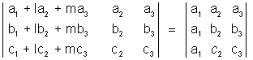
7. If each entry in any cow (or column) of determinant is zero, then the volue of detrminant equal to zero .
8. If determinant varishes for X = a, then (X - a) is a factor of D .
Product of two Determinants :-
Differentiation of a determinant (Sexondary Information) :-
(X) = 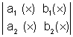then (X) = 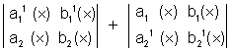
Similarly if
(X) =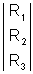, then¹ (X) = 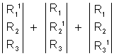
Summation of Determinants :-
(Secondary Information)
Let r = 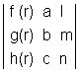
Then 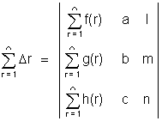
Integration of Determinants (Secondary Information ) :-
(X) = 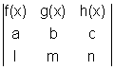
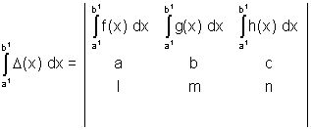
Special Determinants (Secondary Information) :-
1. Symmetric Determinant :-
The elements situted at equal distance from the diagonal are equal both in magnitude and sign.
eg. 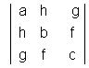
Skew symmetric determinant :- Determinant of skew symmetric matrix .
3. Circulant :- The elements of the rows (or columns) are in cyclic arangements .
eg . 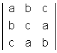
Solution of system of Linear Equations :-
a₁X + b₁ y + c₁ z = d₁
a₂X + b₂ y + c₂ z = d₂
a₃X + b₃ y + c₃ z = d₃.
D = 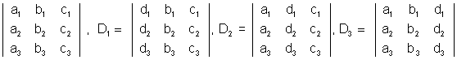
X = D1/D Y = D2/D Z = D3/D
The following cases arise
(1) D O, the system has one unique solution .
D = O, D₁, D₂, D₃ O, then system is incories tant .
(2) D₁ = O, and D₁ = D₂ = D₃ = O, then the system has infinite solutions .
Illustrations
Q 1. Without expanding, show taht 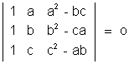
Solution :- L H S = 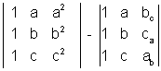= 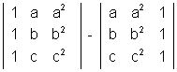[ R₁ a R₁, R₂ b R₂, R₃ c R₃ and abc taken common]
= 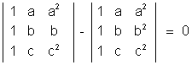
Q 2. Prove that
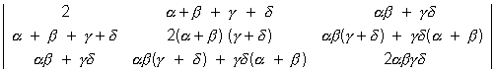=
Solution : L H S :-
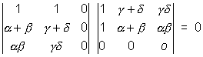
ASSIGNMENTS
EASY
E 1. If a₁b₁ c and d are real constants and A
= 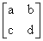,prove that A² - (a + b)A + (ab - bc) I = 0
Sol :- A ² = 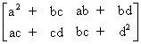
A² = A² - (a + b) A + (ab + bc)I
= 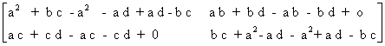
E 1 A = 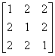show taht A ² 4 A - 5 I = o
SOl :- A ² = 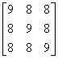
A² - 4 A - 5 I = 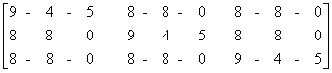
E 3. Solve syste the equation .
X + 3y - 2z = 0., 2x - x - 4z = 0, x - 11y + 14z = 0
Sol :- 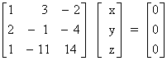=> A X = B .
|A| = 0
Solving the terme of z .
x = 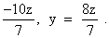.
=> x = - 10 k , y = 8 k , z = 7 K
E 4 . For what value of x, the matrix
A = 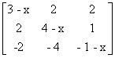is singular .
Solution :- | A | = 0
=> x [(3 - x) (1 + x - 4) - 0 + 2 (2 - 2) ] = 0
x (3 - x) (x - 3) = 0 img x = 0, 3
E 5 :- Evaluate 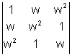
Sol :- Applying c¹ c₁ + c₂ c₃
=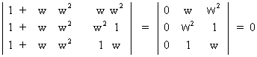
E 6 :- For what value of K do the following homogenous system of equations passes a row trivial solution .
x + ky + 3z = 0
3x + ky - 2z = 0
2x + 3y - 4z = 0
Sol :- D = 0
D = 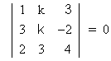
R₁ - 3R₁ and R₃ - 2R₁
=> 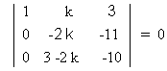
k = 33/2
E 7. Evoluate 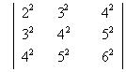
Sol :- R₂ - R₁, R₃ - R₂ then C₂ - C₁ and C₃ - C₂
D = 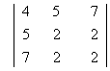
c₃ - c₂
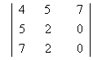= 2 [ 10 - 14 ] = - 8
E 8. If 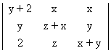= K X Y 2 , Find K .
Solution :- Putting x = 1, y = 1, z = 1 [As if in true for any volues of x₁ y₁ z₁
k = 4
MEDIUM
M 1. Determine and if 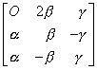is or thogonal
Sol^{n}:- AA¹ = 1
=>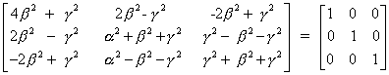
=> 4
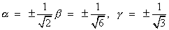

M 2. Using elementary row trans formations find the inverse of the matrix A = 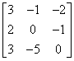
Sol^{n} :- A = I A
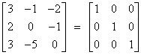A
. R₁ R₁ - R₂
. R₂ - 2R₁ and R₃ R₃ - 3R₁
. R₂ 1/2 R₂
. R₁ R₁ + R₁ and R₃R₃ + 2R₂
. R₃ 1/2 R₃ and .R₁ R₁ + 1/2 R₃ and R₂R₂ - 1/2 R₃
We get :-
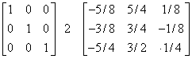A
A ⁻¹ = 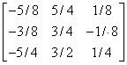
M 3 If a, b and c are P^{th}1 q^{th} and r^{th} terms of are
H.P., prove taht 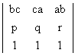= 0
Solution :- A : First term, D : Common difference
1/a = A +(p -1) D, 1/b = A +(q - 1) D, 1/c = A + (r - 1)D
abc 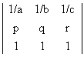
R₁R₁ - D R₂ - (A - D)r ,
= abc 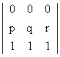= 0
M 4 . for what valume of m, does the system of equation 3x + my - mand 2x - 5y = 20 lhas a solution satisfying the condstion. x > 0, y > 0.
Solution = 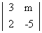= - (15 + 2_{m})
₁ = - 25m 2 = 60 - 2m
X = 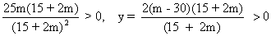
=> m > 30 or m < -15/2
HARD
H 1. Show that the produst of two triangular matrices is itself triangular.
Sol^{n}:- A = [Aij]_{nxn} and B = [bjk]_{nxn}
aij = 0 , i > j and bjk = 0 j > k
AB = [cik]_{nxn} then cik = aij bik
Suppose i > k
if j < i, then aij = 0 => aik = 0
if i < j, then j > k , because i > k , => bjk = 0
=> cik = 0
Hence c i k = 0 for i > k
Hence AB is also triangular .
H 2 . Without expanding at any stage show taht
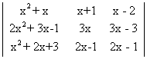= AX + B
Where A and B are determinants of order 3 not involving X:
Solution:- L.H.S. = 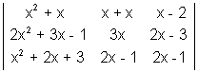
"R₁ + R₃ - R₂" and then "C₁ - C₃" and C₂ - C₃"
L.H.S. = 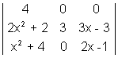
"R₂ - R₁ and R₃ - R₁"
L.H.S. = 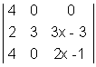
= 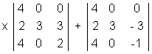
= Ax + B = R.H.S.
KEYWORDS
- Matrix
- Diagonal Matrix
- Row Matrix
- Column Matrix
- Scalar Matrix
- Unit or Identity Matrix
- Triangular Matrix
- Null Matrix
- Transpose Matrix
- Conjugate of a Matrix
- Symmetric and Skew Symmetric Matrices
- Hermitian and Skew-Hermetian Matrices
- Unit any Matrix
- Singular Matrix
- Orthognal Matrix
- Involutary Matrix
- Square Matrix
- Adjoint of a Matrix
- Cofactor
- Determinant
- Symmetric and Skew-Symmetric Determinant
- Circulant
Matrices
MCQ-Single Correct
- If A = , then is equal to:
(1) (2)
(3) (4) [2017]
2. If A = and , then 5a +b is equal to :
(1) 5 (2) 4
(3) 13 (4) -1 [2016]
3. If A = is a matrix satisfying the equation , where I is identity matrix, then ordered pair (a,b) is equal to :
(1) (-2,1) (2) (2,1)
(3) (-2,-1) (4) (2,-1) [2015]
4. If A is a non-singular matrix such that AA’=A’A and , then BB’ equals
(1) I + B (2) I
(3) (4) [2014]
5. If P = is the adjoint of a matrix A and |A|=4, then α is equal to
(1) 11 (2) 5
(3) 0 (4) 4 [2013]
6. Let A = . If u₁and u₂ are column matrices such that Au₁= and Au₂ = , then u₁+ u₂ is equal to
(1) (2)
(3) (4) [2012]
7. If is the complex cube root of unity and matrix H = , then is equal to
(1) (2) H
(3) 0 (4) -H [2011]
8. The number of non-singular matrices, with four entries as 1 and all other entries as 0, is
(1) 5 (2) 6
(3) at least 7 (4) less than 4 [2010]
9. Let A be a square matrix all of whose entries are integers. Then which one of the following is true?
(1) If detA = ±1 , then exists but all its entries are not necessarily integers
(2) If detA = ±1 , then exists and all its entries are non-integers
(3) If detA = ±1 , then exists and all its entries are integers
(4) If detA = ±1 , then need not exist [2008]
10. Let A = . If || = 25, then equals
(1) (2) 1
(3) 1/5 (4) 5 [2007]
11. If A and B are square matrices of size such that , then which of the following will be always true?

- A = B
- AB = BA
- Either of A or B is a zero matrix
- Either of A or B is an identity matrix [2006]
12. Let A = and B = , a , b N. Then
(1) there cannot exist any B such that AB = BA
(2) there exist more than one but finite number of B’s such that AB = BA
(3) there exists exactly one B such that AB = BA
(4) there exist infinitely many B’s such that AB = BA [2006]
13. If , then the inverse of A is

- A + I (2) A
(3) A – I (4) I – A
14. If A = and I = , then which one of the following holds for all , by the
principle of mathematical induction
- (2)
(3) (4) [2005]
15. Let . The only correct statement about the matrix A is
(1) A is a zero matrix (2)
(3) does not exist
(4) A = (-1)I, where I is a unit matrix [2004]
16. Let (10) and . If B is the inverse of matrix A , then α is
(1) -2 (2) 5
(3) 2 (4) -1 [2004]
17. If and , then
(1) ,
(2) ,
(3) ,
(4) [2003]

Assertion-Reason type

1. Consider the following relation R on the set of real square matrices of order 3. [2011]
R = {(A,B)|A = for some invertible matrix P}.
Statement – I : R is an equivalence relation.
Statement-II : For any two invertible matrices M and N, .
- Statement-I is True; Statement-II is true; Statement-II is not a correct explaination of Statement-I.
- Statement-I is True; Statement-II is False.
- Statement-I is False; Statement-II is true
- Statement-I is True; Statement-II is true; Statement-II is a correct explaination of Statement-I.
- Let A be a matrix with non-zero entries and let , where I is identity matrix.
Define Tr(A) = sum of diagonal elements of A and |A| = determinant of matrix A. [2010]
Statement-I : Tr(A) = 0
Statement-II : |A|=1
- Statement-I is True; Statement-II is true; Statement-II is not a correct explaination of Statement-I.
- Statement-I is True; Statement-II is False.
- Statement-I is False; Statement-II is true
(4) Statement-I is True; Statement-II is true; Statement-II is a correct explaination of Statement-I.
3. Let A be a matrix [2009]
Statement-I : adj(adj A) = A
Statement-II : |adj A| = |A|
- Statement-I is True; Statement-II is true; Statement-II is not a correct explaination of Statement-I.
- Statement-I is True; Statement-II is False.
- Statement-I is False; Statement-II is true
(4) Statement-I is True; Statement-II is true; Statement-II is a correct explaination of Statement-I.
4. Let A be a matrix with real entries. Let I be the identity matrix. Denote by tr(A), the sum of diagonal entries of A. Assume that [2008]
Statement-I : If and , then det A = -1.
Statement-II : If and , then
- Statement-I is True; Statement-II is true; Statement-II is not a correct explaination of Statement-I.
- Statement-I is True; Statement-II is False.
- Statement-I is False; Statement-II is true
- Statement-I is True; Statement-II is true; Statement-II is a correct explaination of Statement-I.

Solutions

1. = = =

= =
=
Option (2) , is the correct answer.

2. = , =
= =
=

Probability
Dispute in 1654 led to the creation of a mathematical theory of prabability by two famous french mathematicians Blaise Pascal and Pierrede Fermet . First fundamental principles of prabobility theory were formulated for Ist time In popular dice game. Consisted in throwing a pair of dice 24 time, the problem was to decide whether or not to bet even money on occurrence of at least one "double six" during 24 throws. By gambling rule chevalier de mere believed it would be profitable but c caluclation shows just opposite .
Dutch scientist christion Huygens in 1657 published the first book of probability entitled De Ratiociniis in Ludo Aleac.
In 1812 pierse de laplace introduced a host of new ideas and mathematical techniques in his p book .
Equally likely - If two events are called equally likely if none of the events have preference of occurence of other .
Nutually exclusive :- If occurence of one event rules out lthe ocurrence of other .
Exhaustive :- Set of event in experiment is said to exhaustive it nothing happen than those listed possible out comes can occur as a consequence of the experiment .
Total out comes of experiment is called sample space .
A; 'm' out comes favour the occurence of event A .
P (A) = 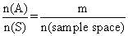
P() = complement of A P (A^{c})
P ()= 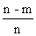= 1 - P (A)
P(A) + P() = 1
0 P (A) 1 sure ivent
Impossible event img sure event
Example of kequally likely events :-
When a unbiased coin is tossed then occrenice of head or tail are equally likely .
Example of mutually exclusive event -
Let sample space of unbised die is die is S = {1, 2, 3, 4, 5, 6} in which E₁ = {1, 2, 3,} = ecent of occurrence lof no. less than 4 & E₂ = {5, 6} = event of occurrence of no. greater than 4.
cleaarly . E₁ E₂ =
so, E₁ and E₂ are mutually exclusive .
Examples of exhaustiv event :-
Let sample space of unbiased die is S = {1, 2, 3, 4,5, 6} in which E₁ = { 1, 2, 3, 4} = Event of occurence of no . less tahn 5.
& E₂ = {3, 4, 5, 6} = Event of occurence of no. Greater than 2.
Then E₁U E₂ = {1, 2, 3, 4, 5, 6} = 5
Hence E₁ & E₂ are exhaustive events .
Odds in favour :- If 'a' is no of cases favourable to odds in favour of E are a : b & odds against of E are b : a.
P (E) = 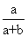
& P (E¹) = 
P(E) + P(E¹) = 1
Illustration :- A person while dialing 7 digit phone no. forget last two digit and he randonly dials 2 numbers .
Find the chance of currect no.
Ans - There are 10 digit on phone.
1st digit can be dialled in 10 ways.
2^{n} digit can be dialled in 10 way .
sample space (total no. of ways two digit can be dialled)
= 10 X 10 = 100
But there is only 1 currect no.
So, P (A) = 1/100
Independent and dependedt event :- Two event are said to be independent if occurence or non - occurence of are does affects the probabitity of occurence or non-occurence of the other .
eg. Occurence of head or tail is independent on each other.
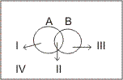

Venn diagram :-
I A (A but not B )
II A B
III B ( B but not A
IV
P(A or B) = P(at least one of A or B)
P(A img B) = P(A) + P(B) - P(A img B)
= I + II +III
= (I + II) + (III + II) - II
P(A B) = P(A) + P(B) - P (A B)
P (A B) = P ( A ) + ( B ) + P (A B )
= P(A) + P( B)
=| - P ( )
P (exactly one A or B) = I + III = P ()
=P(A) + P(B) - 2P (A B)
= P(A B ) - 2P(a B)
Note :- For mutually exclusive event
P(A B) = 0
For exhaustive event
(A img B) = Sample space
Conditional probability :-
Probability of ocurence of an event B when it is known that some event A has already occured .It is P(B/A)
P(B/A) = 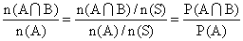
P(B/A) = 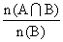, 0 P(B) 1
P(B A) =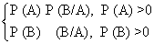
P(B/A) = P(A )
Note - For independent events -
P(A B) = P(A). P(B)
Dumb Question :- How P(A B) = P(A) P(A/B)
Ans - P(A/B) = probabilituy of ocurence of A in B
ie, simultanous occurence
Probability of simultaneous occurence of A and B
P(A/B) = Probability of B
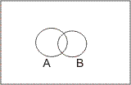
P(A/B) = 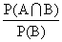
Illustration - If 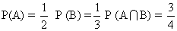
Find
Ans -
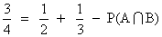
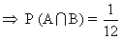
P(A/B) = 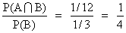
= 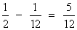
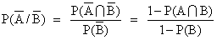
=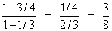
P(A / B) + = 1 = 1
= 1 - P(A / B)
= 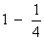
=
Bernoulli strial :- An experiment 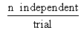out come
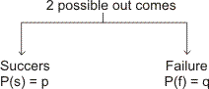
p + q = 1
P(getting r' s success) = n C_{r} p^{r} q^{n-r}
P 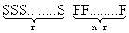
= p^{r} q^{n-r} nC_{r} img arrangement in a row
P (getting r + 1 success) = nC_{r+1} q^{n-r-1}p ^{r+1}

Bagrang's relation ship
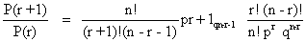
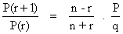
Dumb Question :- How relation P (getting r' s success)
= P^{r} q^{n-r} nC _{r}
Ans - In this P is probability of getting success and q is probability of getting failure and p + q = 1
Sclection of r success out of n out comes = nC_{r}
img..... P(getting r' s success)
= P x P x P...............r times x q x q x.............(n - r) times x nC_{r}
Illustration :- A die is rolled n times. Find the value of n if probability of getting at least one ace is 91/216
Ans P(getting at least one ace) = 1 - P(no ace)
P(1) = 1/6 P(not 1) = 5/6
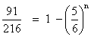
=> n = 3
Probability theorem - (Baye's theorem)
If an event A can occur with n mutually exclusive, exhaustive
event B₁, B₂, ..............B_{n} and probability of P(A/B₁),
P(A/B₂), ................P(A/B_{n}) is known. Then probability .
P(Bi/A) = 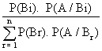
P(A img B_{i}) = P(Bi). P(A/Bi)
= P (A). P(Bi/A)
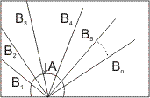
P(A) = P(A img B₁) + P(A img B₂) + ......+ P(B_{n}) P(A/B_{n})
= P(B_{i}) P(A / B_{i})
=P(A). P(B_{i} / A)
P(A) =
=P(B₁) P(A / B₁) P (A / B₂) + ............+ P(B_{n}) P(A / B_{n})
P(B_{r}) P (A / B_{r})
Illustration :- A bag cintains 5 balls of unknown color. Two balls are drqwn and both are found to be white. Find the chance that there are 4 white ball in box . Assume any no. of white ball equally likely .
Ans - A : Two balls drawn from a bag contuins 5 balls.
both are white
B₀ : 0 white ball
B₁ : 1 white ball
B₂ : 2 white ball
B₃ : 3 white ball
B₄ : 4 white ball
B₅ : 5 white ball
P(B₀) = P(B₀) = P(B₁) = P(B₃) = P(B₄) =P(B₅) =P(B₆) = 1/6
P(A/B₀) = 0 P(A/B₁) = 0
P(A/B₂) = 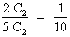
P(A/B₃) = 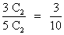
P(A/B₄) = 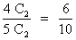
P(A/B₅) = 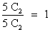
P(B₄/A) =
=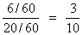

Dumb question - Why probability of P(A/B₀) and P(A/B₁) is zero ?
Ans - Because in event we are getting 2 white ball.
and when in sample we have none or one white we can not get 2 white ball.
Stockist approach :-
Q- A bag contains 5 fair coin, 2 doulaly headed coin, 2 doubly tailed and are biased coin. Probability of head with biased = 2/3 . A coin is selected and tossed. If head appeared same coin is tossed and if tail appears another coin selected from remaining and tosed. Find the chasce -
(1) Same .coin is tessed twice .
(2) Chance .head appears in both toss.
(3)If head appears in both wins. find the chance that it is doubly headed coin .
Ans - Total coin = 5 + 2 + 2 + 1 = 10
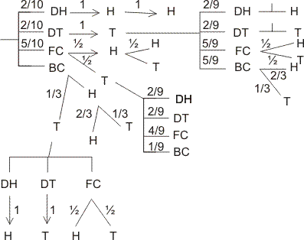
(1) P(getting H in I ^{st} toss) =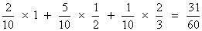
(2) P(getting both (H H) in 2 toss) = 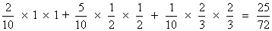
(3) P(Doubly head / H H ) 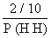
=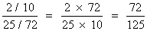
In finite samble space (Geometrical probaility ) :-
(1) If a point is randomly sclected from area 'S' which indudes an area 6 then chance that it is sclected from area 6
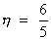
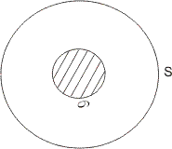
(2) If a point is randomly taken from line AB of length L then chance that it is selected from the segment PQ(l) contained by AB is = l/2
Illustration :- In a circle of radius 'a'. Find the probalility that point is close to the circumference than to its centre.
Ans - n(S) =
E : Point is close to circumference than oits centre.
P(E) = 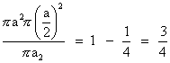
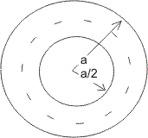
Dumb question - How probability of " point is close to circumference than its centre " is 3/4 .
Ans - A point is close to circumference than its centre when it lies in region of outside the circle of r = a/2 and inside the circle of r = a .
P(E) = 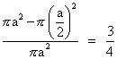
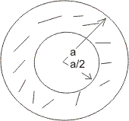
Easy level
Q. 1 - A natural no. is randomly selected. Find the chance that digit in unit place of its square is 4.
Ans :-
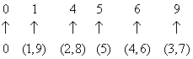
There are only two digit (2 and 8). Whose square's unit place is 4.
So, P(E) = 2/10 = 1/5
Q. 2 4 red and 3 white ball are arranged | n a row. Find chance that two ball at extreme are whit .
Ans :- Case I:- alike balls
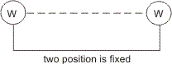
n(S)=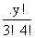
n(A)= 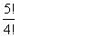
P(A)= 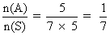
Case2:- Different balls-
n(S) = 7!
n(A) = 3C₂. 2!, 5!
P(A) = 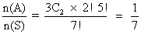
Q. 3- P(A) = 1/2 ,P(B) = 1/2 . Find the least and greatest valume of intersection P(A img B).
Ans - P(A B) = P(A). P(B/A)
P(A B) greatest = 1/2 if P(B/A) = 1
= 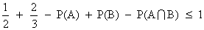
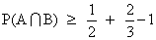
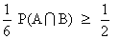
Q. 4- A and B are independent then show that and are also independent .
Ans - Note - If and are independent. then P(A) . P(B)
T.PT :-
L. H. S. :- { 1 - P(A) } { 1 - P(B)}
= 1 - P(A) - P(B) + P(A) . P(B)
= 1 - [P(A) + P(B) - P(A B)]
= 1 - P(A B)
= P ()
Q. 5 - Two cords are drawn from 52 cards pack. Find the chance that both the cards are aces.
Ans- n(S) = no. of ways drawing 2 cards from 52 cards.
= 52 C₂
n(A) = no. of ways drawing 2 ace cards from 4 ace card
= 4 C₂
P(E) = 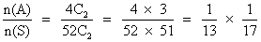
P(E) =

Q. 6- In a bag 4 cards morked with 'I' and. 4 marked with 'T' are present . 3 time a card is drawn without .
replacement. Find the chance of forming wird 'I I T'.
Ans - Total no. of way
= n(S) = 8C₃
drawing 3 cards
n(A) = 4C₂ X 4C₁
P(E)= 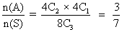
Dumb question :-
How does n(A) = 4C₂ X 4C₁ ?
Ans:- For wird 'I I T' we reguire 2I'_{s} and I 'T' So, out of 4 I' s we require 2 I' _{s} and out of 4 T'_{s} ,we require 1 T. So, n(A) = 4C₁
Q. 7 - Probability of a no. appearing if a clice is rolled is proportipnal lto the ,no. Find the chance of getting aprime no ?
Ans- Probability . P(1) = P(2) = 2
P(3) = 3 P(4) = 4 P(5) = 5
P(6) = 6
P(1) probability of getting 1 if clice is ralled
P(1) + P(2) + P(3) + P(4) + P(5) + P(6) =
= 21
But 21 = 1 total prabability
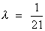
P(prime) = P(2) + P(3) + P(5) = 10 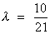
Q. 8 - A Coin is tossed l4 time if head appeared 1 point awarded and tail appeared 2 point given. Find expectation of player ?
Ans- P(4) = P(HHHH) =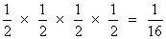
P(5) = P ( HHHT/HHTH/HTHH/THHH )
= 4 X 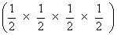
=
P(6) = P (HHTT/HTHT/HTTH/TTHH/THTH/THHT)
= 6 X ( 1/2 X 1/2 X 1/2 X 1/2 X )
= 6/16
P(7) = P(HTTT/THTT/TTHT/TTTH )
= 4 x 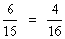
P(8) = P(TTTT) = 
P(4) probability of getting 4 points.
Expectation = 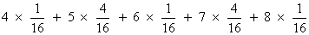
= [ 4 + 20 + 36 + 28 + 8 ]
= 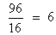
Dumb question :- What is expectati0n ?
Ans - If P be probability of success of a person in any event and M be prize money which be will receive in case of sussess, themn,
Expectation = PM = probability of success X prize money
Q. 9- There are 3 compartment in a box. A ball is randomly drawn from anyone compartment. Find chance it is ded
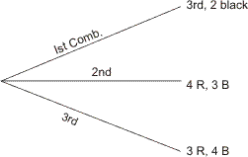
Ans - E₁ frawn from I_{st} compartment
E₂ frawn from II_{nd} compartment
E₃ frawn from III_{rd} compartment
E . bll is red
P( E₁ ) = P( E₃ ) = 1/3 ( equally likely event )
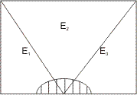
P(E) = P( E img E₁) + P( E img E₂) + P( E img E₃)
= P( E₁ ) P( E / E₁ ) + P( E / E₂ ) + P( E / E₂ ) + P( E/E₃ ). P( E / E₃ ) = 3 / 7
P(E) = 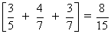
Q. 10 A coin is tossed till head and tail appears, it can be tossed 5 time max . First 2 throws are H H . Find the chance that coin tossed 5 time.?
Ans- Ist two throws are H H and if 3 ^{rd} and 4th throw are also H H . So we have to go for 5th throw for getting tail.
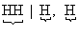
P(A) = 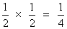

Medium level
Q. 1- A, B and C are three event such that -
P(exatly one A or B) = P(exactly one B C)
=> P(exactly one C or A) = P
and = p² and A, B and C are
exhaustive. Find = value of P .
Ans - Not :- In exhaustive events
= 1
P = P (a) + P (B) - 2P ( A B )
P = P (B) + P (C) - 2P ( B C )
P = P (C) + P (A) - 2P ( C A )
3 P = 2 (P(A) + P(B) + P(C)) - 2P(A B) + P(A B) + P(C A))
P(A) + P(B) + P(C)[ ( A B) + P(B C) +P(C A) ]
+ [ P(A B) + P(B C) +P(C A) ] P(A) + P(B) + P(C) ...........(1)
P(A B C) = P(A) + P(B) + P(C) - [ P(A B) + P(B C) + P(C A) + P(A B C)........(2)
+ P (ABC) = P(ABC)
If A, B and C are exhaustive .
then P(A BC)=P(A) + P(B) + P(C) holds -
From eqn ........... (2)
P(A B C) = P(A B) + P(B C) + P(C A)
P utting in eqn ............ (1)
+ P(ABC) = P(ABC)
+ P² = 1 ..............(3)
On solving
P =
Q. 2. 12 face cards are removed from 52 cards and remaining 40 cards are well shuffled and 4 cards are drawn from pack of 40 cards. Find the chance that all four are of different suit and different denomination .
Ans- Heart Diamond club spade
n(s) = 40 C₄
No. of way drawing Ist card = 40 ways
No. of way drawing 2nd card = 27 ways
No. of way drawing 3rd card = 16 ways
No. of way drawing 4th card = 7 ways
Total no. of way of drawing all 4 cards = 40 X 27 X 16 X 7
Dumb question - Why NO. of ways of drawing 2nd card is 27 ?
Ans- Let Ist card drawn is ace of Heart. So, no, Heart and no ace card is further selected. So remaining cards are (40 - 10 - 3) = 27
So, 27 ways
P(E)= i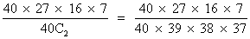
Q. 3 - There are two luts of article one lot contains 3 defective and 5 good article and other lot contains 4 defective and 8 good articles. A lot is randomly seleste a and 3 articles are drawn . this lot will be rejected if 2 or mor than 2 article are found to be defective. Find the chance that this be rejected.
And - E₁ Ist lot is chosen
E₂ 2nd lot is chosen
E lot is rejected
P(E) = P(E¹) P(E/E₁) + P(E₂). P(E/E₂)
P(E₁) = P(E₂) = 1/2 (equally likely events)
P(E) 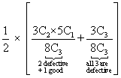+ 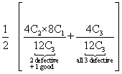
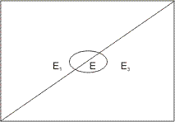
Q. 4 A boy contains | coin of worth M rupees and n coins of total . Worth of M rupees. Coins are drawn without replace -ment till coin whose valime is M, is drawn, I Find the expectaion of draw .
Ans - P(drawing M in Ist draw) = 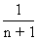
P(drawing M in 2nd) drawn) = 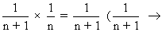other coin draw, 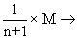drawing of M)
P(drawing M in (r + 1)^{th} draw) =
Expectation = M coin draw In Istdraw, + 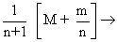Mcoin draw in IInd draw , + 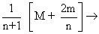In 3rd draw
= 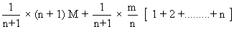
= 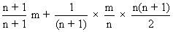
Expectation = 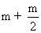
Q. 5 - A letter is known to khave either from Agra or from Mathura or. Satara. on the stamp two consecultive word 'RA'are legible. Find the chance that letter from Agra .
Ans- A : .Two consecutive word 'RA'are legible .
B₁: . letter is from
B₂: . letter is from
B₃: . letter is from
P(B₁) = P(B₂) = P(B₃) =
P(B/B₁) = 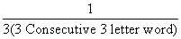=
P(A/B₂) = 1/6. P(A/B₂) = 1/5.
P(A) = P(B₁). P(A/B₁) + P(B₂)+ P(A/B₂) + P(B₃) P(A/B₃)
= 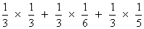
P (B₁ / A) = 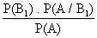
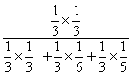
P(B ₁ / A) =

Dumb question - Q. How . P(A/B₁) = ?
And - B₁ Letter from AGRA
So, in AGRA there are 3 two letter consecutive word AG, Ga, RA
and A RA is legible
So, there is only one 'RA'
P(A / B₁) =
Hard level
Q. 1 Aline of length L is divided (broken ) in to there parts randomly . Find the chance that these parts are the possible sides of
Ans- For to be sides of ,
x > o, y > o
L > X + y
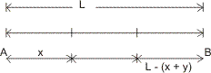
Sum of two sides .> third side
x + y > L -(x + y)
(x + y) > .........................(1)
L - x > X
=> ...................(2)
L - y > y
..................(3)
n(s) x L x L =
(from eqn. L > x + y)
n(A) = Area of ABC
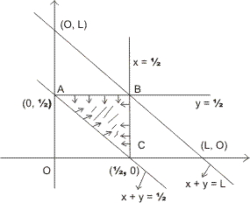
x x
= x
P( E )= 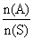
= 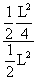=
Q. 2 A box contains 6 balls. It is equally likcly that ball is white or black . Two balls are drawn from this bag one is foond black and one is whit.
find the chance that there is 3 black ball in the box .
Ans . 1st ball can be white of black = 2 way
2nd ball can be white of black = 2 way
img ............Total no. of ways in which 6 balls can be white of black
= 2 X 2 X 2 X 2 X 2 X 2 = 2⁶ ways
n(s) = 2⁶
P(B _{o}) = , P(B₁) = 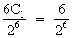
P(B ₂) = 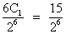, P(B ₃) 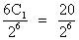
P(B₄) 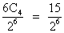, P(B ₅) 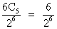
P(B ₆) = 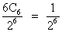
A Two balls drawn from bag & of diff. color
P(A / B₀) = o [b/c in draw of 2 balls one black ball is there]
P(A / B₁) = 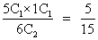
P(A / B₂) = 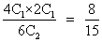
P(A / B₃) = 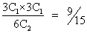
P(A / B₄) = 
P(A / B ₅) = 
P(A / B₆) = 0
P(A) = P(B_{o}) P(A / B_{o}) + P(B₁) P(A / B₁) + P(B₂) P(A / B₂) + P(B₃) P(A / B₃) + P(B₄) P(A / B₄) + P(B₅) P(A / B₅) + P(B₆) P(A / B₆)
= 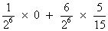+ 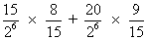
+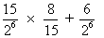 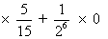
P(B₃/ A) = 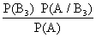
= 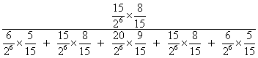
= 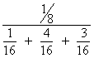
P(B₃ / A) = 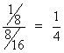
Q. 3- Three whole no. is selected at random and multipliea find the chance that-
(1) Their product is divisible by 5 but not 10.
(2)Divisible by 10 .
(3) is an even no.
Ans- E₁ Digits at unit plce of 3 whole no. 1, 3, 7, 9
E₂ digits at unit place of whole no. is 1, 3, 5, 7, 9
E₃ digits at unit place of 3 whole no;s is 1, 2, 3, 4, 5, 6, 7, 8, 9 there are 10 digits -
P(E₁) = 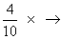Ist Whole no. , 2nd Whole no., 3rd Whole no., = 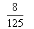
P(E₂) = 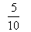=
P(E₃) = =
divisible by 5 not by 10 at unit place only 5 is there .
(1) P(divisible by 5 not by 10 ) = P(E₂) - P(E₁)
= - = 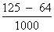
= 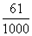
(2) (divisible by 10 means last digit is zers )
= 1 - - = 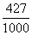
Dumb question -
Q. How P(disivible by 5 not by 10 ) = P(E₂) - P(E₁)
Ans- Divisible by 5 not 10 only when at uniy place only 5 is there.
P(E₁) = Prob. of having 1, 3, 7, 9 at unit place
P(E₂) = Prob. of having '5' at unit place
= P(E₂) - P(E₁)
=P (divisible by 5 not by 10)
(3) P(even) = 1 - P(E₂) [ have digit 2, 4, 6, 8 at unit place ]
= 1 -
=
KEYWORDS
- Sample Space
- Equally likely events
- Mutually exclusive events
- Exhastive events
- Independent events
- Expectation value
- Bernoulli’s trial
- Boye’s theorm
- Infinite sample space

