A Complete Course in Mathematics - Extended First Edition

Kairav Kalia and Manish Kalia

12 May, 2017
Table of Contents
Chapter: Preface
Chapter: Acknowledgements
Part I: Calculus
Chapter 1: Preliminaries
Section 1.1: Relations
Section 1.2: Real Numbers
Section 1.3: Absolute value of a real number
Chapter 2: Functions
Section 2.1: Domain of Definition and Range
Section 2.2: Periodicity
Section 2.3: Injectivity, Surjectivity and Bijectivity
Section 2.4: Inverse of a function
Section 2.5: End Chapter Problems
Chapter 3: Limits
Chapter 4: Continuity & Diffrentiability
Chapter 5: The Derivative
Section 5.1: Preliminaries
Section 5.2: Basics of Derivatives
Section 5.3: Derivatives of Trigonometric functions
Section 5.4: Derivatives of Exponential and Logarithmic Functions
Section 5.5: The Chain Rule
Section 5.6: Derivatives of Inverse Trigonometric Functions
Section 5.7: Partial Derivatives
Section 5.8: Differentials
Section 5.9: Differentiation of Implicit functions
Section 5.10: Differentiation of Parametric functions
Section 5.11: Higher order derivatives
Section 5.12: Logarithmic Dierentiation(Revisiting Logarithms)
Chapter 6: Applications of Derivatives
Section 6.1: Rate of Change
Section 6.2: Maxima and Minima
Section 6.3: Tangents and Normals
Chapter 7: Indefinite Integrals
Chapter 8: Definite Integrals
Chapter 9: Applications of Integrals
Section 9.1: Areas
Section 9.2: Curved Surface Area and Volume
Chapter 10: Diffrential Equations
Part II: Coordinate Geometry
Chapter 11: The Straight Line
Part III: Algebra
Chapter 12: Complex Numbers
Chapter 13: Quadratic Equations
Chapter 14: Probability
Chapter 15: Logarithms Worksheet
Chapter 16: Matrices
Part IV: Trigonometry
Chapter 17: Heights and Distances
Chapter 18: Trigonometric Identities
Chapter 19: Trigonometric Equations
Chapter 20: Properties of Triangle
Chapter 21: Inverse Trigonometry
Index

Preface
This book is an outcome of great research and problem solving strategies developed over time and honed by the students of more than a decade having studied under us.
Over the past 11 years (since 2007) , Manish Kalia has taught large volumes of students and has always supplied quality content to them in terms of newly created questions.
He has since the very early days of his teaching, been relished amongst students and always been applauded to the greatest for his in-class teaching skills.

Acknowledgements
We would like to thank the family first of all, then our well wishers, then those who have been part of our success and helped us achieve it.

Part I. Calculus

1 Preliminaries

1.1 Relations
Q: Show that the relation R in the set of real numbers defined as R = {(a, b):√(a) + 3≤b} is neither reflexive nor symmetric nor transitive.

1.1.1 Problems for Practice

1.1.1.1 Matrix match type problems
Matrix 1: Under column-I properties of relations are mentioned. Match the stated property with the relations listed under column-II , that satisfies it
Column I | Column II
(A) Equivalence | (P) The relation R in the set of
 | natural numbers N, defined as
 | R = {(a, b):a > b²}
(B) Reflexive | (Q) Relation R defined in the
 | set {1, 2, 3, 4, 5} defined by
 | R = {(a, b):a² + ab − 2b² = 0}
(C) Symmetric | (R) Relation R defined on the set
 | of real numbers ℝ , defined by
 | R = {(a, b):√(a) + 5 < b}
(D) Transitive | (S) Relation R in the set
 | A = {xϵℤ;0 ≤ x ≤ 9},given by
 | R={(a, b):(a − b)⁴ is divisible by 3}

1.2 Real Numbers
When we talk of functions, we talk of only real valued functions. So, it is important that we brush up our theory of real numbers done in junior classes.
Definition
Any decimal fraction, terminating or nonterminating, is called a ↓real number.
The set of real numbers is represented by the symbol ℝ.

1.2.1 Rational Numbers
Every rational number↓ can be written in the form (p)/(q) where p and q are integers. The set of rational numbers is reqresented by the symbol ℚ. i.e. ℚ = {(p)/(q) | q ≠ 0, p & q ϵ ℤ} where ℤ is the set of Integers. The decimal representation of a rational number can be either ↓terminating or ↓non-terminating reccuring. e.g.
3.24 is a terminating decimal represenation.
5.3 is a non-terminating recurring decimal representation.
Properties
- The set of rational numbers is closed with respect to the operations of addition, subtraction and product. i.e. If p and q are two rational numbers, then p + q , p − q and pq are rational. Also (p)/(q) is rational provided q ≠ 0.[↓Closure Property]
- Between any two rational numbers p & q , there exist infinite rational numbers.[Property of Denseness]
Q. Find all the rational values of x for which y = √(x² + x + 5) is a rational number.
Sol. Suppose x and y are rational numbers . Then the sum x + y = q is a rational number.We now express x in terms of q .
y + x = √(x² + x + 5) + x = q

√(x² + x + 5) = q − x

x² + x + 5 = q² − 2qx + x²

x = (q² − 5)/(1 + 2q), q ≠ − (1)/(2)
To prove the reverse i.e. y = √(x² + x + 5) is a rational number if x = (q² − 5)/(1 + 2q), q ≠ − (1)/(2)
Its easy to check
y = √(x² + x + 5) = √(((q² − 5)/(1 + 2q))² + ((q² − 5)/(1 + 2q)) + 5)

= √((q⁴ + 2q³ + 11q² + 10q + 25)/((1 + 2q)²))

= √(((q² + q + 5)/(1 + 2q))²)
It may be observed that q² + q + 5 is positive for all values of q.Hence
y = (q² + q + 5)/(|1 + 2q|)
which is rational for q ≠ − (1)/(2).
Note : The sole purpose of adding x to y was to eliminate the square term of x . The same goal can be achieved by subtracting x from y.

1.2.2 Irrational Numbers
↓Non-terminating non-repeating decimal fractions are called Irrational numbers . In fact, all real numbers which are not rational are Irrational numbers. The set of Irrational numbers can be represented by the symbol T or ℝ − ℚ .
Properties
- The sum,difference,product and quotient of two Irrational numbers may be rational or irrational.ie. The set T is not closed with respect to addition,subtraction,multiplication and division.[Closure Property↓]
- The sum, difference,product and quotient of a rational number and an Irrational number is Irrational.
- There exist infinite rational and irrational numbers between two real numbers.[Property of Denseness↓]
Q. Prove that for every rational number r satisfying r² < 3 one can always find a larger rational number r + k(k > 0)for which (r + k)² < 3.
Sol. We know, there exist infinite rational numbers between a rational number and an irrational number. So, there will be infinite rational numbers between r and √(3) . So, there exist infinite values of k satisfying the condition.Let us take the case when r is sufficiently close to √(3).In that case, we can chose a k such that k → 0. This implies k² < k. i.e. (r + k)² < r² + 2rk + k. It is sufficient to put r² + 2rk + k = 3.i.e.
k = (3 − r²)/(1 + 2r)
It may be observed that any rational number smaller than (3 − r²)/(1 + 2r) in magnitude will also satisfy the condition.

1.2.3 Problems for practice

1.2.3.1 Subjective Problems
Q1. Find all the rational values of x for which y = √(49x² + 5x + 3) is a rational number.
Q2. Prove that for every rational number s satisfying s² > 5 one can always find a smaller rational number s − k(k > 0)for which (s − k)² > 5.
Q3. Does 219.15155155551555555551……… represent a rational number?. Give reason.
Q4. Represent √(31) − 3 and √(52) on the number line.

1.2.3.2 Multiple Answer MCQ’s
Q1. Which of the following are rational numbers.
a) (√(3))/(2 + √(3))
b) (2)/(6)
c) (√(5) − 2)(√(5) + 2)
d) (11π)/(7π)

1.2.3.3 Write the Answer Type Questions
Q1: The solution set of (7)/(x − 2) ≥ 5 is

1.2.3.4 Assertion-Reason Type Questions
Each question in this section has four choices (a),(b),(c) and (d) out of which only one is correct. Mark your choices as follows:
(a) STATEMENT-1 is True, STATEMENT-2 is True, STATEMENT-2 is the correct explaination of STATEMENT-1.
(b) STATEMENT-1 is True, STATEMENT-2 is True, STATEMENT-2 is NOT the correct explaination of STATEMENT-1.
(c) STATEMENT-1 is True, STATEMENT-2 is False.
(d) STATEMENT-1 is False, STATEMENT-2 is True
Q1: STATEMENT-1: For every rational number r satisfying r² < 2 one can always find a larger rational number r + k(k > 0)for which (r + k)² < 2.
STATEMENT-2: There exist infinite rational numbers between any two rational numbers.

1.2.3.5 Hints and Solutions
Subjective Problems
Q1 x = (3 − q²)/(14q − 5) , qϵℚ & q ≠ (5)/(14) {Hint: Put y − 7x = q to get the answer. Also, equivalently if we had put y + 7x = q we would have got , x = (q² − 3)/(14q + 5), q ≠ − (5)/(14)}
Q2 {Hint: Let us take s² − 2sk = 5 which would imply s² − 2sk + k² > 5 . ie k = (s² − 5)/(2s)}
Q3 No , it is not a rational number. {Hint. 2^{n − 1}fives between nth and (n + 1)th unity. The pattern is definite but non periodic.}
Q4 {Hint. √(n) can be drawn by the following method of construction. Draw an arc from the origin of length (n − 1)/(2) . From the point where it cuts the y axis, draw an arc of length (n + 1)/(2) intersecting the x-axis at P. The distance OP is √(n) .}
Multiple Answer MCQ’s
Q1 B,C,D
Write the Answer Type Questions
Q1 the half open interval (2,17/5] [A] Intervals can be of the following kinds

Assertion Reason Type Questions
Q1 B

1.3 Absolute value of a real number
The magnitude of a number is called the ↓Absolute value of the number.Also,it is the distance of the point representing the number from origin on the number line . e.g. |2 − √(5)| = √(5) − 2.
Mathematical Definition
|x| = ⎧⎨⎩ − x , x < 0 x , x≥0
Some alternate definitions of |x| are
|x| =⎧⎪⎨⎪⎩ √(x²) max{x, − x} x.sgn(x)

1.3.1 Properties of Absolute value
- |x| = α(α > 0) ⇒ x = ±α
- |x|≤α(α > 0) ⇒ − α≤x≤α
- |x|≥α(α > 0) ⇒ x≥αor x≤ − α
- |x + y|≤|x| + |y| ↓{Equality occurs when x and y are of same sign. i.e. xy≥0 e.g.|( − 5) + ( − 2)| = | − 5| + | − 2| as (-5).(-2) is positive }[The Triangle Inequality] [B]

\begin_inset Separator latexpar\end_inset
  - |x − y|≤|x| + |y| {Equality occurs when x and y are of opposite sign. i.e. xy≤0}
  - |x + y|≥||x| − |y|| {Equality occurs when x and y are of opposite sign. i.e. xy≤0}
  - |x + y|≥|x| − |y| {Equality occurs when x and y are of opposite sign i.e. xy≤0 and |x|≥|y|}
  - |x − y|≥||x| − |y|| {Equality occurs when x and y are of same sign. i.e. xy≥0}
  - |x − y|≥|x| − |y| {Equality occurs when x and y are of same sign . i.e. xy≥0 and |x|≥|y|}
- |xy| = |x||y|
- |(x)/(y)| = (|x|)/(|y|),y ≠ 0

1.3.2 ↓The Wavey-Curve Technique
Let us consider, that we have an expression of the form
e = ((x + 1)(x − 1)(x − 3))/(x − 2)
and we have to find the values of x for which this expression is > 0 , < 0 or = 0 . To find the sign of the expression, we first of all mark these points on the number line . Then we draw a curve like the one shown in the figure
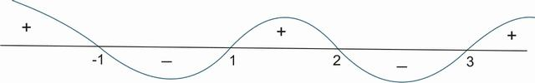
We start from the right hand side , draw a positive section of curve between ∞ and the right most point. Then, at the rightmost point( 3 in this case) , we switch the sign of the curve to negative and take it below the axis. Like this , we change sign of the curve at every ↓Critical point( ie. at 3,2,1,-1 in this case). Now from this curve, we try to find out the sign of the expression
e = ((x + 1)(x − 1)(x − 3))/(x − 2)
e > 0 whenever + sign appears in the wavey-curve( i.e. when wavey-curve is above the axis)
⇒ e > 0 for xϵ( − ∞, − 1)∪(1, 2)∪(3, ∞) [C]

e < 0 whenever - sign appears in the wavey-curve( i.e. when wavey-curve is below the axis)
⇒ e < 0 for xϵ( − 1, 1)∪(2, 3)
e = 0 for all the critical points in the numerator( if and only if they don’t appear in the denominator too)
⇒ e = 0 for xϵ{ − 1, 1, 3}
e = Not defined for all the critical points in the denominator.
e = Not defined for xϵ{2}
{Note: It may be noted, that if we have to find x such that e ≥ 0 , then we will take the union of the values of x found out for e > 0 and e = 0
i.e. e ≥ 0 for xϵ(( − ∞, − 1)∪(1, 2)∪(3, ∞))∪{ − 1, 1, 3} . The same expression can be written by using a closed interval at the points where e = 0 i.e. e ≥ 0 for xϵ( − ∞, − 1]∪[1, 2)∪[3, ∞)
In a similar way, we can find the values of x for which e ≤ 0. The solution is xϵ[ − 1, 1]∪(2, 3]. }
Example
We have to find the sign of E = ((x + 2)⁶(3x + 1)³)/((1 − x))
To find the sign of such an expression, we first of all make the coefficients of x as 1 in all terms. This gives
E = − (27(x + 2)⁶(x + (1)/(3))³)/(x − 1)
The critical points of this expression are x = { − 2, − (1)/(3), 1} . The wavey-curve will start with a negative sign at ∞ as there is a - sign in front of E. The curve will then change sign at the first critical point -1. Thereafter , the curve will change sign 3 times at the point x = − (1)/(3). (It may be noted that if a curve changes sign an odd number of times, it is equivalent to change of sign just one time) . Then the curve changes sign 6 times at x = − 2.(change of sign an even number of times means the sign is retained).Things will be more clear from the adjoining figure.
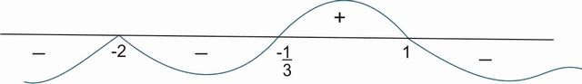
⇒ E > 0 for xϵ( − (1)/(3), 1)
Similarly, E < 0 for xϵ( − ∞, − 2)∪( − 2, − (1)/(3))∪(1, ∞).
Also, E = 0 for xϵ{ − 2, − (1)/(3)} and E is not defined for xϵ{1}
Q Solve for x
a) |2x + 5| = 6
b) |5x + 7| = |7x − 9 |
c) |3x − 5| < 1
d) |x² − 5x + 6| > x² − 5x + 6
e) |x| = x + 7
f) |x| = x − 5
g)|((x − 5)³)/((x + 2)(x − 3))| > ((x − 5)³)/((x + 2)(x − 3))
h) |cosx| = cosx + 1
i) |(x² + 2x + 5) + (3 − 5x)| = |x² + 2x + 5| + |3 − 5x|
j) |(x⁸ − 4) − (x⁴ + 2)| = |x⁸ − 4| − |x⁴ + 2|
k) x² − |x| − 2 = 0
l) |x + 2| = |x − 2| + 2|x|
m) |(3x + 5)/(5x + 7)| − |(7x + 9)/(5x + 7)| = 1
n)2^{|x + 1|} − |2^{x} − 1| = 2^{x} + 1
Sol. a) 2x + 5 = ±6
⇒ 2x = 1 or 2x = − 11
⇒ x = (1)/(2) or − (11)/(2)
b) |5x + 7| = |7x − 9 |
⇒ (5x + 7) = ±(7x − 9)
⇒ 5x + 7 = 7x − 9 or 5x + 7 = − (7x − 9)
⇒ 2x = 16 or 12x = 2
⇒ x = 8 or x = (1)/(6) i.e. xϵ{8, (1)/(6)}
c) Method 1: |3x − 5| < 1
⇒ − 1 < 3x − 5 < 1 (Property 2)
⇒ 4 < 3x < 6
⇒ (4)/(3) < x < 2 i.e xϵ((4)/(3), 2)
Method 2: |3x − 5| < 1
Squaring both sides, we get
(3x − 5)² < 1
⇒ 9x² − 30x + 25 < 1
⇒ 9x² − 30x + 24 < 0
⇒ 3x² − 10x + 8 < 0
⇒ (3x − 4)(x − 2) < 0
⇒ xϵ((4)/(3), 2)
d) |x² − 5x + 6| > x² − 5x + 6
{Note: It can be observed that |y| is strictly greater than y if y < 0}
⇒ x² − 5x + 6 < 0
⇒ (x − 2)(x − 3) < 0
⇒ 2 < x < 3 i.e. xϵ(2, 3)
e) Case I: x ≥ 0
This assumption would imply that |x| = x
⇒ x = x + 7 which is not true for any x. Hence , no solution exists.
Case II: x < 0
⇒ − x = x + 7
⇒ 2x = − 7 or x = − (7)/(2) (which satisfies the condition x < 0)
f)Case I: x ≥ 0
⇒ x = x − 5 which is not true for any x. Hence , no solution exists for x ≥ 0.
Case II: x < 0
⇒ − x = x − 5
⇒ 2x = 5 or x = (5)/(2)
This value of x does not satisfy x < 0 . Hence , no solution exists for x < 0 also.
g)|((x − 5)³)/((x + 2)²(x − 3))| > ((x − 5)³)/((x + 2)²(x − 3))
It may be observed that |y| > y is only possible when y < 0
⇒ ((x − 5)³)/((x + 2)²(x − 3)) < 0
⇒ xϵ(3, 5)
[Note:The solution to such equations can be found out with the help of Wavey-Curve Technique as discussed in the Lectures]
h) |cosx| = cosx + 1
Case I: cosx ≥ 0
⇒ cosx = cosx + 1
which is not possible for any x. Hence , no solution exists for cosx ≥ 0.
Case II:cosx < 0
⇒ − cosx = cosx + 1
⇒ 2cosx = − 1
⇒ cosx = − (1)/(2) (which satisies our assumption that cosx < 0)
⇒ x = 2nπ±(2π)/(3) , nϵZ.
i) |(x² + 2x + 5) + (3 − 5x)| = |x² + 2x + 5| + |3 − 5x|
|x + y| = |x| + |y| ⇒ xy ≥ 0(equality condition in Property 4)
i.e x & y are of the same sign
Now x² + 2x + 5 = (x + 1)² + 4 > 0
⇒ 3 − 5x ≥ 0
i.e x ≤ (3)/(5) or xϵ(-∞,(3)/(5))
j)|(x⁸ − 4) − (x⁴ + 2)| = |x⁸ − 4| − |x⁴ + 2|
We know, |x − y| = |x| − |y| if xy ≥ 0 & |x|≥|y|
Also , it may be noted that x⁴ + 4 > 0∀x
⇒ Our conditions reduce to x⁸ − 4 ≥ x⁴ + 2
⇒ x⁴ − 2 ≥ 1
⇒ x⁴ ≥ 3
⇒ x ≥ ⁴√(3) or x ≤ − ⁴√(3) i.e. xϵ( − ∞, − ⁴√(3))∪(⁴√(3), ∞)
k)x² − |x| − 2 = 0
⇒ |x|² − |x| − 2 = 0
⇒ (|x| − 2)(|x| + 1) = 0
⇒ |x| = 2 or |x| = − 1(Rejected)
⇒ x = ±2 i.e xϵ{ − 2, 2}
l)|x + 2| = |x − 2| + 2|x|
We first of all find the ↓critical points. |x + 2| = 0 gives the point − 2. Similarly, the points 2,0 are obtained by euating the other modulus terms to zero. So, there are 3 critical points ie at x = { − 2, 0, 2}. We plot these points on the number line and divide the whole number line at these critical points.
Case I : x < − 2
The equation becomes
− (x + 2) = − (x − 2) − 2x
⇒ 2x = 4
⇒ x = 2 (which is rejected as it does not belong to the interval ( − ∞, − 2))
Case II: − 2 ≤ x < 0
The equation becomes
x + 2 = − (x − 2) − 2x
⇒ x = 0 (Which is rejected as it does not belong to the interval [ − 2, 0))
Case III : 0 ≤ x < 2
The equation becomes
x + 2 = − (x − 2) + 2x
which is true for all x , but our interval is [0, 2)
⇒ xϵ[0, 2) is a solution
Case IV : x ≥ 2
The equation in this case becomes
x + 2 = (x − 2) + 2x
⇒ x = 2 (which is accepted as it lies in the interval chosen i.e. [2, ∞))
Hence x = 2 is a solution
Now we combine all the solutions obtained from different intervals. So, the final solution is the union of all the cases i.e. xϵ[0, 2)∪{2}
⇒ The complete solution set is xϵ[0, 2]
m)|(3x + 5)/(5x + 7)| − |(7x + 9)/(5x + 7)| = 1
First thing to be noted is that 5x + 7 ≠ 0
i.e. x ≠ − (7)/(5)
⇒ |3x + 5| − |7x + 9| = |5x + 7|
Now in this case, the critical points are − (9)/(7), − (7)/(5) and − (5)/(3). Plotting them on the number line, we get the intervals as shown below
Case I: x < − (9)/(7)
⇒ − (3x + 5) + (7x + 9) = − (5x + 7)
⇒ 9x = − 11
⇒ x = − (11)/(9) ( which lies in the interval defined by x < − (9)/(7))
Case II: − (9)/(7) ≤ x < − (7)/(5)
⇒ − (3x + 5) − (7x + 9) = − (5x + 7)
⇒ − 5x = 7
⇒ x = − (7)/(5) (which is rejected because in the beginning we fixed x ≠ − (7)/(5) . Also the point − (7)/(5) does not lie in the interval − (9)/(7) ≤ x < − (7)/(5) )
Case III : − (7)/(5) ≤ x < − (5)/(3)
⇒ − (3x + 5) − (7x + 9) = + (5x + 7)
⇒ − 15x = 21
⇒ x = − (7)/(5) (which is rejected because in the beginning we fixed x ≠ − (7)/(5) due to domain restrictions.)
Case IV: x ≥ − (5)/(3)
⇒ (3x + 5) − (7x + 9) = (5x + 7)
⇒ − 9x = 11
⇒ x = − (11)/(9) (Rejected because − (11)/(9) does not belong to the interval x ≥ − (5)/(3))
Hence, the only solution is x = − (11)/(9).
n)2^{|x + 1|} − |2^{x} − 1| = 2^{x} + 1
The critical points lie at |x + 1| = 0 and |2^{x} − 1| = 0 . i.e at x = − 1 and x = 0 respectively. So , dividing the number line as done previously
Case I: x < − 1
⇒ 2 ^{− (x + 1)} + (2^{x} − 1) = 2^{x} + 1
⇒ 2 ^{− (x + 1)} = 2
⇒ − (x + 1) = 1
⇒ x = − 2 (Accepted )
Case II: − 1 ≤ x < 0
⇒ 2^{x + 1} + 2^{x} − 1 = 2^{x} + 1
⇒ 2^{x + 1} = 2
⇒ x + 1 = 1
⇒ x = 0 (Rejected as it does not lie in the interval − 1 ≤ x < 0 )
Case III: x ≥ 0
⇒ 2^{x + 1} − (2^{x} − 1) = 2^{x} + 1
⇒ 2^{x + 1} = 2.2^{x} ( which is true for all x belonging to the interval x ≥ 0)
⇒ The solution to Case III is xϵ[0, ∞)
Hence, the general solution to this problem is xϵ{ − 2}∪[0, ∞).

1.3.3 Problems for Practice

1.3.3.1 Subjective Problems
Q1: Solve for x
a) |sinx| = − sinx + 2
b) |((x + 3)⁴(x − 3)³)/((x + 1)(x − 1))| < − ((x + 3)⁴(x − 3)³)/((x + 1)(x − 1))
c) |x² + 3x + 2| = − (x² + 3x + 2)

1.3.3.2 Single Answer MCQ’s
Q1: The complete solution set of (1)/(|(4)/(x) − 10|) < 3 is
a) xϵℝ − ((12)/(31), (12)/(29))
b) xϵ((12)/(31), (12)/(29)) − {(2)/(5)}
c) xϵℝ − {0} − [(12)/(31), (12)/(29)]
d) None of these
Q2: The point in the co-ordinate plane satisfying |7x + 5| = − |3 − 3y| is
a)( − 2, 3)
b)( − (5)/(7), 1)
c) ( − 5, − 3)
d) None of these
Q3: The complete solution set of |cotx| = cotx + 2√(3) is
a){x:x = nπ + (π)/(3) , nϵℤ}
b){x:x = nπ − (π)/(3) , nϵℤ}
c){x:x = nπ + (π)/(6) , nϵℤ}
d){x:x = nπ − (π)/(6) , nϵℤ}
Q4: The area bounded by the curves given by |x| + |2y| = 2 is
a) 2 units
b) 4 units
c) 6 units
d) 8 units

1.3.3.3 Multiple answer MCQ’s
Q1: The solution set of 2|tanx| = tanx + √(3) contains
a){x:x = nπ + (π)/(3) , nϵZ}
b){x:x = nπ − (π)/(3) , nϵZ}
c){x:x = nπ + (π)/(6) , nϵZ}
d){x:x = nπ − (π)/(6) , nϵZ}

1.3.3.4 Matrix Match Type Problems
Matrix 1: Under Column I , some equations are given . Under Column II, some solutions satisfying some of the equations are given. Match the entry in Column I with the solution satisfying it in Column II.{Note: [ ] is the Greatest Integer Function}
Column I | Column II
(P)|sin ⁻ ¹x| = sin ⁻ ¹x + (π)/(6) | (A)-(1)/(2)
(Q)ln|x| = |lnx| | (B)1
(R)|[x]| = [|x|] | (C)(3)/(2)
(S)|x² − 3x + 2| > x² − 3x + 2 | (D)2

1.3.3.5 Linked Comprehension Type Problems
Comprehension 1: Consider the equation y = |(x⁴ − 9) − (x² − 3)| − |x⁴ − 9| + |x² − 3|. The sign of y depends on the value of x. Read the following questions based on this information and answer them carefully.
Q1: The value(s) of x for which y > 0 is/are :
a)xϵR
b)xϵ( − √(3), √(3))
c)xϵ( − ⁴√(3), √(3))
d)None of these
Q2: The value(s) of x for which y ≤ 0 is/are :
a)xϵR
b)xϵ( − √(3), √(3))
c)xϵ( − ⁴√(3), √(3))
d)None of these
Comprehension 2: The first 3 terms of an A.P. are |3x|, |3x − 1|and |3x + 1|. Based on this information, give the answers to the questions below
Q1: The value of x is
a) 1
b) 2
c) -1
d) None of these
Q2: The 10th term of the A.P. is
a) (1)/(4)
b) (5)/(4)
c)(19)/(4)
d) None of these
Q3: The sum of first 15 terms of the series is
a) (225)/(4)
b)(359)/(4)
c)(433)/(4)
d) None of these
Comprehension 3: A function f_{n}(x) is defined for all nϵN and f_{n + m}(x) is defined as f_{n + m}(x) = f_{n}(f_{m}(x)) where f₁(x) = (2x − 1)/(x + 1) for xϵR − { − 1}. Using this definition , f₂(x) = f₁(f₁(x)) = (x − 1)/(x) for xϵR − { − 1, 0}. Similarly f₃(x) = f₁(f₂(x)) = (2 − x)/(1 − 2x) for xϵR − { − 1, 0, (1)/(2)}and so on. Based on the information, answer the questions below.
Q1: The domain of definition of g(x) = |ln(f₃₄(x))| is
a) ( − ∞, 1) − { − 1, 0, (1)/(2)}
b) ( − ∞, 1] − { − 1, 0, (1)/(2)}
c) (1, ∞) − {2}
d) None of these
Q2: The complete solution set of |f₇₁(x)| > |(1)/(f₇₃(x))| is
a) ( − 1, 1)
b) ℝ − {2} − [ − 1, 1]
c) ℝ − { − 1, 1, 2}
d) None of these
Q3: The values of x for which |f₅₆(x)| > f₅₆(x) belong to the interval
a) ((1)/(2), 2)
b) (2, ∞)
c) (0, 1)
d) None of these

1.3.3.6 Hints and Solutions
Subjective Questions
Q1 a)x = 2nπ + (π)/(2) , nϵZ
{Hint: The solution of the equation is all values of x which satisfy the equation , sinx = 1}
b) No Solution i.e xϵφ
{Hint: It may be observed that |y| < − y is never true . Even |y| < y also gives no solution.}
c) xϵ[ − 3, − 2]
{Hint: |y| = − y ⇒ y ≤ 0 }
Single Answer MCQ’s
Q1) C
{Hint: (1)/(|(4)/(x) − 10|) < 3
⇒ |(4)/(x) − 10| > (1)/(3)
Case I : (4)/(x) − 10 > (1)/(3)
⇒ (4)/(x) > (31)/(3)
⇒ (1)/(x) > (31)/(12)
⇒ 0 < x < (12)/(31)
Case II: (4)/(x) − 10 < − (1)/(3)
⇒ (4)/(x) < (29)/(3)
⇒ (1)/(x) < (29)/(12)
⇒ (1)/(x) < 0 or 0 < (1)/(x) < (29)/(12)
⇒ x < 0 or x > (12)/(29)
Combining all cases, we get xϵ( − ∞, 0)∪(0, (12)/(31))∪((12)/(29), ∞) i.e. xϵℝ − {0} − [(12)/(31), (12)/(29)]}
Q2) B
Q3) D
Q4) B
Multiple Answer MCQ’s
Q1) A,D
Matrix Match Type Problems
Matrix 1:
P → A
Q → B, C, D
R → B, C, D
S → C
Linked Comprehension Type Problems
Comprehension 1: Q1) D Q2)A
{Hint:a) y > 0
⇒ |(x⁴ − 9) − (x² − 3)| − |x⁴ − 9| + |x² − 3| > 0
⇒ |(x⁴ − 9) − (x² − 3)| > |x⁴ − 9| − |x² − 3|
Now we know that |x − y|≥|x| − |y| {Equality occurs when x and y are of same sign . i.e. xy≥0 and |x|≥|y|}
⇒ |(x⁴ − 9) − (x² − 3)| = |x⁴ − 9| − |x² − 3| when (x⁴ − 9)(x² − 3)≥0 and |x⁴ − 9|≥|x² − 3|
i.e when (x² − 3)²(x² + 3)≥0 and |x² − 3|(x² + 3)≥|x² − 3|
i.e when (x² − 3)²(x² + 3)≥0 and |x² − 3|(x² + 2)≥0 which is true for all x.
i.e ∀xϵℝ , y is identically equal to zero.
Hence y > 0 has no solution
and y≤0 is true for all xϵℝ. i.e (b) → A}
Comprehension 2: Q1) D Q2)C Q3)A
{Hint: a)|3x|, |3x − 1|and |3x + 1|are in A.P.
⇒ 2 × |3x − 1| = |3x| + |3x + 1|
The critical points in this case are { − (1)/(3), 0, (1)/(3)}
Case I : xϵ( − ∞, − (1)/(3))
In this case equation becomes
2 × − (3x − 1) = − 3x − (3x + 1)
⇒ − 6x + 2 = − 6x − 1 which gives no solution
Case II: xϵ[ − (1)/(3), 0)
In this case , the equation becomes
2 × (3x − 1) = − 3x − (3x + 1)
⇒ 6x − 2 = − 6x − 1
⇒ x = (1)/(12) ( which is accepted as (1)/(12)ϵ[ − (1)/(3), 0))
Case III : xϵ[0, (1)/(3))
In this case , the equation becomes
2 × (3x − 1) = 3x − (3x + 1)
⇒ 6x − 2 = − 1
⇒ x = (1)/(6) (which is rejected as (1)/(6)∉[0, (1)/(3))
Case IV :xϵ[(1)/(3), ∞)
In this case, the equation becomes
2 × (3x − 1) = 3x + (3x + 1)
i.e 6x − 2 = 6x + 1 . Hence no solution in this case also.
Combining all the cases, we get x = (1)/(12)
b) Substituting the value of x , the series becomes {(1)/(4), (3)/(4), (5)/(4), ⋯⋯⋯}
Hence, the series has first term a = (1)/(4) and common difference d = (1)/(2).
T₁₀ = a + (10 − 1)d = (1)/(4) + 9 × (1)/(2) = (19)/(4)
c) The sum of first 15 terms of the series is
S₁₅ = (n)/(2)(2a + (n − 1)d) = (15)/(2)(2 × (1)/(4) + 9 × (1)/(2)) = (15)/(2) × (15)/(2) = (225)/(4)}
Comprehension 3: Q1) A Q2)B Q3)C
{Hint: f₁(x) = (2x − 1)/(x + 1) for xϵR − { − 1}
f₂(x) = f₁(f₁(x)) = (x − 1)/(x) for xϵR − { − 1, 0}
f₃(x) = f₁(f₂(x)) = (2 − x)/(1 − 2x) for xϵR − { − 1, 0, (1)/(2)}
On simlar lines, we can find f₄(x) = f₁(f₃(x)) = (1)/(1 − x) for xϵR − { − 1, 0, (1)/(2), 1}
f₅(x) = f₁(f₄(x)) = (1 + x)/(2 − x) for xϵR − { − 1, 0, (1)/(2), 1, 2}
f₆(x) = f₁(f₅(x)) = x for xϵR − { − 1, 0, (1)/(2), 1, 2}
It may be noted that this function repeats itself after a gap of 6 .i.e f_{6n + r}(x) = f₆(f₆...ntimes(f_{r}(x)))) = f_{r}(x) for xϵR − { − 1, 0, (1)/(2), 1, 2}
Q1: f₃₄(x) = f₄(x) for xϵR − { − 1, 0, (1)/(2), 1, 2}
⇒ f₃₄(x) = (1)/(1 − x) for xϵR − { − 1, 0, (1)/(2), 1, 2}
⇒ g(x) = |ln(f₃₄(x))| has domain given by
(1)/(1 − x) > 0 for xϵR − { − 1, 0, (1)/(2), 1, 2}
i.e x < 1 and xϵR − { − 1, 0, (1)/(2), 1, 2}
i.e xϵ(( − ∞, 1) − { − 1, 0, (1)/(2)})
Q2: |f₇₁(x)| > |(1)/(f₇₃(x))|
i.e we have to solve |f₅(x)| > |(1)/(f₁(x))| for xϵR − { − 1, 0, (1)/(2), 1, 2}
i.e |(1 + x)/(2 − x)| > |(1)/((2x − 1)/(x + 1))|for xϵR − { − 1, 0, (1)/(2), 1, 2}
i.e |2x − 1| > |2 − x| for xϵR − { − 1, 0, (1)/(2), 1, 2}
Squaring both sides we get
4x² − 4x + 1 > 4 + x² − 4x for xϵR − { − 1, 0, (1)/(2), 1, 2}
i.e. 3x² > 3 for xϵR − { − 1, 0, (1)/(2), 1, 2}
⇒ xϵ(ℝ − {2} − [ − 1, 1])
Q3: |f₅₆(x)| > f₅₆(x)
⇒ |f₂(x)| > f₂(x) for xϵR − { − 1, 0, (1)/(2), 1, 2}
⇒ f₂(x) < 0 for xϵR − { − 1, 0, (1)/(2), 1, 2}
⇒ (x − 1)/(x) < 0 for xϵR − { − 1, 0, (1)/(2), 1, 2}
⇒ xϵ((0, 1) − {(1)/(2)})
These values are a substet of (0, 1).}

2 Functions
↓Functions are one of the most important areas of mathematics because they lie at the heart of much of mathematical analysis.

2.1 Domain of Definition and Range
Q: For the function f(x) = (x)/(x + 2) , find f(x + 3) , f(3x) ,3f(x) , 3f(3x + 3) , f(x³) , (f(x))³ with their respective domains of definition.
Sol: f(x + 3) = (x + 3)/(x + 5) where x + 5 ≠ 0 i.e D_{f(x + 3)} = ℝ − { − 5}
f(3x) = (3x)/(3x + 2) where 3x + 2 ≠ 0 i.e. D_{f(3x)} = ℝ − { − (2)/(3)}
3f(x) = (3x)/(x + 2) where x + 2 ≠ 0 i.e. D_{3f(x)} = ℝ − { − 2}
3f(3x + 3) = (3x)/(3x + 5) where 3x + 5 ≠ 0 i.e. D_{3f(3x + 3)} = ℝ − { − (5)/(3)}
f(x³) = (x³)/(x³ + 2) where x³ + 2 ≠ 0 i.e. D_{f(x}³₎ = ℝ − { − ³√(2)}
(f(x))³ = ((x)/(x + 2))³ where x + 2 ≠ 0 i.e. D_{(f(x))}³ = ℝ − { − 2}
Q: Find the domains of definition of the following functions:
a) √(2 − x) − ³√(x) + ⁴√(2 + x)
b) √(x² + x − 2)
c) (√(x² − 3x + 2))/(√(4 − x²))
d) √(tanx)
e) √( − sinx − (1)/(2))
f) √(1 − cosecx)
g) log((x³(x² − 4))/((x² − 1)(x + 3)))
h) √(logx)
i) √(log_{x}(2 − x))
j) cos ⁻ ¹((x)/(2) − 2) − log((x)/(2) − 2)
k) √([x] − x) where [ ] represents the greatest integer function
l) √(sin(([x])/(2)π))
m) (1)/(√(|x| − x))

2.1.1 Problems for Practice

2.1.1.1 Subjective Problems
Q1: (i) Prove that for the logarithmic function y = ln|x| , if the argument takes values in a G.P. , then the corresponding values of the function y are in A.P.\begin_inset Separator latexpar\end_inset
- (ii)Prove that for the exponential function y = e^{x} , if the argument takes values in a A.P.. , then the corresponding values of the function y are in G.P.

2.1.1.2 Hints and Solutions
Subjective Problems
Q1 : {Hint: (i) Let the arguments be defined by the general term x_{n} = ar^{n − 1} . Then the value of the function corresponding to it will be y_{n} = ln|ar^{n − 1}| = ln|a| + (n − 1)ln|r|. This means that two consecutive terms y_{n} and y_{n − 1} differ by a constant .i.e. y_{n} − y_{n − 1} = ln|r|. Hence , these terms are in A.P.
(ii)Proceeding in a similar manner , if we take the argument as a general term of an A.P. then the corresponding values of the function will have a constant common difference.}

2.2 Periodicity

2.2.1 Problems for practice

2.2.1.1 Subjective Problems
Q1: Find the range of the function defined on R given by
f(x) = ⎧⎨⎩ e^{x − n} ;n≤x≤n + (2)/(3) sin((3π)/(2)x) ;n + (2)/(3) < x < n + 1
where nϵZ.

2.3 Injectivity, Surjectivity and Bijectivity

2.3.1 Problems for Practice

2.3.1.1 Subjective Problems
Q1: Check whether the function f:( − ∞, − 3) → [ − (1)/(4), 0] given by f(x) = (x + 1)/(x² + 2x + 5) is bijective in its domain or not. Given that f(x) is strictly decreasing in the domain.

2.3.1.2 Single Answer MCQ’s
Q1: A function f:R → [1, 2] given by f(x) = log₃(9 − 6|cosx|) is
a) One-one only
b) Onto only
c) One-one and onto
d) None of these
Q2: Let f:[0, ∞) → S defined as f(x) = 2^{x(1 − x)} be onto, then the set S is
a) [0, ∞)
b) [1, ∞)
c) [2 ^{− (1)/(4)}, 1]
d) [2 ^{− (1)/(4)}, ∞)

2.3.1.3 Hints and Solutions
Single Answer MCQ’s
Q1: B
Q2: D

2.4 Inverse of a function

2.4.1 Problems for practice

2.4.1.1 Subjective Problems
Q1: Check whether the function f:( − ∞, 0) → (0, ∞) given by f(x) = (1)/(√(|x| − x)) is one-one and onto. Find it’s inverse if possible.
Q2: A function f:R − { − 2, 2} → ( − ∞, (5)/(2)]∪(3, ∞) given by f(x) = 3 + (1)/(|x| − 2) . Divide the domain into minimum number of suitable subsets so that the function becomes invertible on each individual domain. Also find the inverse on each of these domains.

2.4.1.2 Single Answer MCQ’s
Q1: A function on f:[2, 4) → ( − ∞, 0] is given by f(x) = − 2 + log₂( − x² + 4x). Then f ⁻ ¹(x) is given by
a) 2±2√(1 − 2^{x})
b) 2 − 2√(1 − 2^{x})
c)2 + 2√(4 − 2^{x})
d) None of these

2.4.1.3 Hints and Solutions
Single Answer MCQ’s
Q1: D

2.5 End Chapter Problems

3 Limits
Q: Evaluate the limits
a)\undersetn → ∞limcos(√(n² + n)π)
Sol. a) Case I :

4 Continuity & Diffrentiability

4.5.1 Problems for Practice

4.5.1.1 Multiple answer MCQ’s
Q1: If x = ³√(a^{tan − 1t}) , y = ³√(a^{cot − 1t}) , then (dy)/(dx) =
a) − (y)/(x)
b) − (a^{π ⁄ 6})/(x²)
c) − (1)/(x²)
d) − (a)/(x²)

5 The Derivative
Before we go into the details of the concept of derivatives, let us rst do some hands on problems and learn the use of derivatives.

5.1 Preliminaries

5.1.1 Overview of functions
The amount of functions which we require in this course would be clear by the following example
Q: For the function f(x) = (x)/(x + 2) , find f(x + 3) , f(3x) , \strikeout off\uuline off\uwave off3f(x)\uuline default\uwave default , 3f(3x + 3) , f(x³) , (f(x))³

5.2 Basics of Derivatives
The derivative of a function f(x) is written as (d)/(dx)f(x).
- Rule : (d)/(dx)(constant) = 0 [ Read as : Derivative of a constant = 0]
Q : Find the derivatives of the follwoing functions
a) f(x) = 1
b) f(x) = 5
c) f(x) = ³√(4)
c) f(x) = π
d) f(x) = e³
e) f(x) = 6!
f) f(x) = tan((π)/(3))
g) f(x) = sin ⁻ ¹( − (1)/(2))
h) f(x) = log₁₀16
Sol: All the derivatives are zero as the functions are constants. [ You don’t need to worry about the expressions like sin ⁻ ¹ and log . You are going to learn them in due course. For the time being this information would be handy: Any function with constant argument is constant if defined. Here , sin ⁻ ¹ has a constant argument i.e − (1)/(2)]
- Rule (d)/(dx)(x^{n}) = nx^{n − 1} , where n is a real number.
Q: Find the derivatives of the following functions
a) f(x) = x
b) f(x) = x³
c) f(x) = x⁵
d) f(x) = √(x)
e) f(x) = ³√(x)
f) f(x) = x^{π}
g) f(x) = (1)/(x)
Sol: a) (d)/(dx)f(x) = (d)/(dx)(x¹)
Now we apply the formula. Here n = 1
⇒ (d)/(dx)(x) = 1.x⁰ = 1
b) Applying the formula again here, for n = 3
⇒ (d)/(dx)(x³) = 3.x³ ⁻ ¹ = 3x²
c) As in previous cases, (d)/(dx)(x⁵) = 5x⁴
d) f(x) = √(x) can be written as x^{(1)/(2)}. So, we apply the formula for n = (1)/(2)
⇒ (d)/(dx)(√(x)) = (1)/(2)x^{(1)/(2) − 1} = (1)/(2)x ^{− (1)/(2)} = (1)/(2√(x))
e) Here, n = (1)/(3)
⇒ (d)/(dx)(³√(x)) = (1)/(3)x ^{− (2)/(3)} = (1)/(3³√(x²))
f)(d)/(dx)(x^{π}) = πx^{π − 1} [ Remember that n needs not be a rational number or an integer. It can be an irrational number also like π .]
g) Here, for n = − 1
⇒ (d)/(dx)(x ⁻ ¹) = − 1.x ⁻ ¹ ⁻ ¹ = − x ⁻ ² = − (1)/(x²)
Rule : (d)/(dx)(f₁(x) + f₂(x) + f₃(x)......... + f_{n}(x)) = (d)/(dx)(f₁(x) + (d)/(dx)(f₂(x) + (d)/(dx)(f₃(x)......... + (d)/(dx)(f_{n}(x)\begin_inset Separator latexpar\end_inset
Example (d)/(dx)(x² + x) = (d)/(dx)(x²) + (d)/(dx)(x) = 2x + 1
Rule : (d)/(dx)(c.f(x)) = c(d)/(dx)(f(x))\begin_inset Separator latexpar\end_inset
Example (d)/(dx)(3x²) = 3.(d)/(dx)(x²) = 3(2x) = 6x
Q: Find the derivatives of the following functions
a) f(x) = x³ + x² + x
b) f(x) = 3x⁷ − 5x⁴ + x³
c) f(x) = 5x^{(5)/(2)} + 8⁵√(x)
d) f(x) = x + 2√(x) + 3³√(x) + 4⁴√(x)
e) f(x) = (d)/(dx)(x² + 2x + 1)
Sol. a) f ⁄ (x) = (d)/(dx)(x³) + (d)/(dx)(x²) + (d)/(dx)(x)
⇒ f ⁄ (x) = 3x² + 2x + 1
b) f ⁄ (x) = (d)/(dx)(3x⁷) − (d)/(dx)(5x⁴) + (d)/(dx)(x³)
⇒ f ⁄ (x) = 3(d)/(dx)(x⁷) − 5(d)/(dx)(x⁴) + (d)/(dx)(x³)
⇒ f ⁄ (x) = = 21x⁶ − 20x³ + 3x²
c) f ⁄ (x) = 5 × (5)/(2) × x^{(3)/(2)} + 8 × (1)/(5) × x ^{− (4)/(5)} = (25)/(2)x^{(3)/(2)} + (8)/(5)x ^{− (4)/(5)}
d) f ⁄ (x) = 1 + x ^{− (1)/(2)} + x ^{− (2)/(3)} + x ^{− (3)/(4)}
e) f(x) = 2x + 2
⇒ f ⁄ (x) = 2
Rule : (d)/(dx)(f(x + c)) = f ⁄ (x + c)\begin_inset Separator latexpar\end_inset
Example (d)/(dx)(x + 1)³\begin_inset Separator latexpar\end_inset
To evaluate this, let us first of all assume f(x) = x³
⇒ f(x + 1) = (x + 1)³
Now, f ⁄ (x) = 3x²
⇒ f ⁄ (x + 1) = 3(x + 1)²
Q: Find the derivatives of the following functions
a) f(x) = (x + 1) + (x + 2)² + (x + 3)³ + (x + 4)⁴
b) f(x) = (x + 1) + √(x + 2) + ³√(x + 3) + ⁴√(x + 4)
c) f(x) = (x + π) + ((x + 2π)²)/(2!) + ((x + 3π)³)/(3!)
d) f(x) = (x − 1) − 2(x − 2)²
Sol: a) f ⁄ (x) = (d)/(dx)(x + 1) + (d)/(dx)(x + 2)² + (d)/(dx)(x + 3)³ + (d)/(dx)(x + 4)⁴ = 1 + 2(x + 2) + 3(x + 3)² + 4(x + 4)³
b) f ⁄ (x) = 1 + (1)/(2)(x + 2) ^{− (1)/(2)} + (1)/(3)(x + 3) ^{− (2)/(3)} + (1)/(2)(x + 4) ^{− (3)/(4)}
c) f ⁄ (x) = 1 + (x + 2π) + ((x + 3π)²)/(2!)
d) f ⁄ (x) = 1 − 4(x − 2)
Rule : (d)/(dx)(f(cx + d)) = f ⁄ (cx + d).c\begin_inset Separator latexpar\end_inset
Example : (d)/(dx)(3x + 2)²\begin_inset Separator latexpar\end_inset
Now, to evaluate this derivative, let us assume f(x) = x² .Its derivative, we already know, i.e. f ⁄ (x) = 2x .
Using the above rule, (d)/(dx)f(3x + 2) = f ⁄ (3x + 2).3 = 2(3x + 2) × 3 = 6(3x + 2)
Example 2: (d)/(dx)(1 − 2x)⁵\begin_inset Separator latexpar\end_inset
Let, f(x) = x⁵ ⇒ f ⁄ (x) = 5x⁴
f ⁄ (1 − 2x) = 5(1 − 2x)⁴ × ( − 2) = − 10(1 − 2x)⁴
Q: Find the derivatives of the following functions
a)f(x) = (x + 1) + (2x + 1)² + (3x + 1)³ + (4x + 1)⁴
b) f(x) = x^{n} + (2x)^{n} + (3x)^{n}
c) f(x) = (2x + 1) − (3x − 1)² − (1 − 4x)³
d) f(x) = (1 − αx)^{m} + (2 − βx)^{n} − (3 − γx)^{p}
e) f(x) = √(1 − 2x) + ³√(2 − 3x) − ⁴√(4x + 3)
Sol. a)f ⁄ (x) = (d)/(dx)(x + 1) + (d)/(dx)(2x + 1)² + (d)/(dx)(3x + 1)³ + (d)/(dx)(4x + 1)⁴ = 1 + 2(2x + 1).2 + 3(3x + 1)².3 + 4(4x + 1)³.4 = 1 + 4(2x + 1) + 9(3x + 1)² + 16(4x + 1)³
b) f ⁄ (x) = nx^{n − 1} + 2n(2x)^{n − 1} + 3n(3x)^{n − 1}
c) f ⁄ (x) = 2 − 6(3x − 1) + 12(1 − 4x)²
d) f ⁄ (x) = − αm(1 − αx)^{m − 1} − βn(2 − βx)^{n − 1} + γp(3 − γx)^{p − 1}
e) f ⁄ (x) = − (1 − 2x) ^{− (1)/(2)} − (2 − 3x) ^{− (2)/(3)} − (4x + 3) ^{− (3)/(4)}
Rule : (d)/(dx)(fg) = f ⁄ g + g ⁄ f [ The Product Rule]\begin_inset Separator latexpar\end_inset
Example (d)/(dx)(√(x).(x + 2)²)\begin_inset Separator latexpar\end_inset
To evaluate this, let us assume f(x) = √(x) and g(x) = (x + 2)² . Now, f ⁄ (x) = (1)/(2)(x) ^{− (1)/(2)} and g ⁄ (x) = 2(x + 2)
⇒ (d)/(dx)(fg) = f ⁄ g + g ⁄ f = ((1)/(2)(x) ^{− (1)/(2)}).((x + 2)²) + (2(x + 2)).(√(x)) . The result can be furthur simplified if needed. [It should be noted that the result f ⁄ g + g ⁄ f can be written in various equivalent forms like fg ⁄ + gf ⁄ = g ⁄ f + f ⁄ g etc.]
Q: Find the derivatives of the following functions
a) f(x) = x(x + 1)
b) f(x) = (x + 1)(x + 2)
c)f(x) = (2x + 1)(3x + 2)
d) f(x) = x^{n}(x + n)^{n}
e) f(x) = x³(x + a) + (x + b)⁵(x + 2b) − (x + c)(x + 2c)⁶
f) f(x) = (3x + 1)²(4x + 2)³
g) f(x) = (2 − 3x)³(3x − 4)³
h) f(x) = (1 + x)(2 − x) − (1 + 2x)(2 − 4x) + (1 + 3x)(2 − 16x)
i) f(x) = (x + a)(x + b)(x + c)
j) f(x) = (x − α)^{m}(x − β)^{n}(x − γ)^{p}
k) f(x) = (2x − 1)³(3x − 2)⁴(4x − 3)⁵
l) f(x) = (x − 1)(x − 2)²(x − 3)³(x − 4)⁴
m) f(x) = (ax − b)^{(1)/(m)}(c − dx)^{(1)/(n)}(ex − f)^{(1)/(p)}
Sol. a)To be able to find this derivative, let g(x) = x and h(x) = x + 1
⇒ f(x) = g(x).h(x)
⇒ f ⁄ (x) = g ⁄ (x).h(x) + h ⁄ (x).g(x)
⇒ f ⁄ (x) = 1.(x + 1) + 1.(x)
⇒ f ⁄ (x) = (x + 1) + x = 2x + 1
b) f ⁄ (x) = (x + 1) + (x + 2)
c) f ⁄ (x) = 2(3x + 2) + 3(2x + 1)
d) f ⁄ (x) = nx^{n − 1}(x + n)^{n} + nx^{n}(x + n)^{n − 1}
e) f ⁄ (x) = x³ + 3x²(x + a) + 5(x + b)⁴(x + 2b) + (x + b)⁵ − (x + 2c)⁶ − 6(x + c)(x + 2c)⁵
f) f ⁄ (x) = 6(3x + 1)(4x + 2)³ + 12(3x + 1)²(4x + 2)²
g) f ⁄ (x) = − 9(2 − 3x)²(3x − 4)³ + 9(2 − 3x)³(3x − 4)²
h) f ⁄ (x) = − (1 + x) + (2 − x) − 2(2 − 4x) + 4(1 − 2x) + 3(2 − 16x) − 16(1 + 3x)
i) Let f(x) = g(x).h(x)where g(x) = x + a and h(x) = (x + b)(x + c)
⇒ g ⁄ (x) = 1 and h ⁄ (x) = (x + b) + (x + c)
Also , f ⁄ (x) = g ⁄ (x).h(x) + h ⁄ (x).g(x)
i.e. f ⁄ (x) = 1.(x + b)(x + c) + ((x + b) + (x + c)).(x + a)
⇒ f ⁄ (x) = (x + a)(x + b) + (x + b)(x + c) + (x + a)(x + c)
The derivative of product of three functions can be written in a general form
(d)/(dx)(uvw) = u.(d)/(dx)(vw) + vw.(d)/(dx)(u)
⇒ (d)/(dx)(uvw) = u.(v.(d)/(dx)w + w.(d)/(dx)v) + vw.(d)/(dx)(u)
⇒ (d)/(dx)(uvw) = uv(d)/(dx)w + uw(d)/(dx)v + vw(d)/(dx)u
j) f ⁄ (x) = (x − α)^{m}(x − β)^{n}.p(x − γ)^{p − 1} + (x − α)^{m}(x − γ)^{p}.n(x − β)^{n − 1}+(x − β)^{n}(x − γ)^{p}.m(x − α)^{m − 1}
k) f ⁄ (x) = 3.2(2x − 1)²(3x − 2)⁴(4x − 3)⁵ + 4.3(2x − 1)³(3x − 2)³(4x − 3)⁵+ 5.4(2x − 1)³(3x − 2)⁴(4x − 3)⁴
l)f ⁄ (x) = (x − 2)²(x − 3)³(x − 4)⁴ + (x − 1)(x − 3)³(x − 4)⁴.2(x − 2) + (x − 1)(x − 2)²(x − 4)⁴3.(x − 3)² + (x − 1)(x − 2)²(x − 3)³4(x − 4)³
m)f ⁄ (x) = (e)/(p)(ax − b)^{(1)/(m)}(c − dx)^{(1)/(n)}(ex − f)^{(1)/(p) − 1}- (d)/(n)(ax − b)(ex − f)^{(1)/(p)}(c − dx)^{(1)/(n) − 1}.+ (a)/(m)(c − dx)^{(1)/(n)}(ex − f)^{(1)/(p)}(ax − b)^{(1)/(m) − 1}
- Rule : (d)/(dx)((f)/(g)) = (f ⁄ g − g ⁄ f)/(g²) [ The Quotient Rule]\begin_inset Separator latexpar\end_inset
  - Example (d)/(dx)(((1 − 2x)^{(5)/(2)})/((1 + 2x)^{(3)/(2)}))\begin_inset Separator latexpar\end_inset
    - To evaluate this, let f(x) = (1 − 2x)^{(5)/(2)} and g(x) = (1 + 2x)^{(3)/(2)}
    - ⇒ f ⁄ (x) = (5)/(2)(1 − 2x)^{(3)/(2)}( − 2) = − 5(1 − 2x)^{(3)/(2)}. Similarly, g ⁄ (x) = 3(1 + 2x)^{(1)/(2)}
    - Applying the rule, we get the derivative equal to, (d)/(dx)(((1 − 2x)^{(5)/(2)})/((1 + 2x)^{(3)/(2)}))\strikeout off\uuline off\uwave off =\uuline default\uwave default ( − 5(1 − 2x)^{(3)/(2)}.(1 + 2x)^{(3)/(2)} − 3(1 + 2x)^{(1)/(2)}(1 − 2x)^{(5)/(2)})/(((1 + 2x)^{(3)/(2)})²)
Q: Find the derivatives of the following functions
a) f(x) = (x + 1)/(x + 2)
b) f(x) = ((x + 1)³)/((x + 2)²)
c) f(x) = ((3x − 1))/((2x − 1)²) + ((2x + 1)³)/((3x + 1)²)
d) f(x) = ((ax − α)(bx − β)(cx − γ))/((ax + α)(bx + β)(cx + γ))
Sol. a) f ⁄ (x) = (1.(x + 2) − 1.(x + 1))/((x + 2)²) = (1)/((x + 2)²)
b) f ⁄ (x) = (3(x + 2)²(x + 1)² − 2(x + 1)³(x + 2))/((x + 2)⁴)
c) f ⁄ (x) = ((2x − 1)².3 − 2(2x − 1)(3x − 1))/((2x − 1)⁴) + (2(2x + 1)²(3x + 1)² − 3(2x + 1)³(3x + 1))/((3x + 1)⁴)
d) Let us assume f(x) as the product of three terms u, v and w , where u = (ax − α)/(ax + α) , v = (bx − β)/(bx + β) and w = (cx − γ)/(cx + γ)
(du)/(dx) = ((ax + α)a − (ax − α)a)/((ax + α)²) = (2aα)/((ax + α)²) . Similarly, (dv)/(dx) = (2bβ)/((bx + β)²) and (dw)/(dx) = (2cγ)/((cx + γ)²)
Hence, f ⁄ (x) = (bx − β)/(bx + β).(cx − γ)/(cx + γ).(2aα)/((ax + α)²) + (ax − α)/(ax + α).(cx − γ)/(cx + γ)(2bβ)/((bx + β)²) + (ax − α)/(ax + α).(bx − β)/(bx + β)(2cγ)/((cx + γ)²)

5.3 Derivatives of Trigonometric functions
Rule : (d)/(dx)(sinx) = cosx
It can be proved using the first principle , which is beyond the scope of this book. However , interested students can read it from the corresponding NCERT book on Mathematics for +2.
Rule : (d)/(dx)(cosx) = − sinx \begin_inset Separator latexpar\end_inset
(d)/(dx)(cosx) = (d)/(dx)(sin((π)/(2) − x)) = cos((π)/(2) − x).( − 1) = − sinx
Rule : (d)/(dx)(tanx) = sec²x \begin_inset Separator latexpar\end_inset
(d)/(dx)(tanx) = (d)/(dx)((sinx)/(cosx))
= (cosx.(d)/(dx)(sinx) − sinx.(d)/(dx)(cosx))/(cos²x)
= (cosx.cosx − sinx.( − sinx))/(cos²x)
= (1)/(cos²x) = sec²x
Rule : (d)/(dx)(cotx) = − cosec²x \begin_inset Separator latexpar\end_inset
(d)/(dx)(cotx) = (d)/(dx)((cosx)/(sinx))
= (sinx.( − sinx) − cosx.cosx)/((sinx)²)
= − (1)/(sin²x) = − cosec²x
Alternately, it can be proved by taking cotx = tan((π)/(2) − x) and then differentiating both sides.
(d)/(dx)(cotx) = (d)/(dx)(tan((π)/(2) − x))
= sec²((π)/(2) − x).( − 1)
= − cosec²x
Rule : (d)/(dx)(secx) = secx.tanx \begin_inset Separator latexpar\end_inset
(d)/(dx)(secx) = (d)/(dx)((1)/(cosx))
= (cosx(d)/(dx)(1) − 1(d)/(dx)(cosx))/(cos²x)
= (sinx)/(cos²x) = secx.tanx
Rule : (d)/(dx)(cosecx) = − cosecx.cotx\begin_inset Separator latexpar\end_inset
It can be proved by taking either cosecx = (1)/(sinx) or by taking cosecx = sec((π)/(2) − x). The students should try it themselves.
Q: Find the derivatives of the following functions
a) f(x) = sin57º
b) f(x) = cos(3x + 2)
c) f(x) = tan(1 − 2x).sec(3x)
d)f(x) = (sin(5x + 1))/(cot(1 − 4x))
e) f(x) = sinx.cosx + tanx.secx − cotx.cosecx
Sol. a) It can be observed that f(x) is a constant.
⇒ f ⁄ (x) = 0
b) f ⁄ (x) = − sin(3x + 2).3 = − 3sin(3x + 2)
c) f ⁄ (x) = tan(1 − 2x).(d)/(dx)sec(3x) + sec(3x).(d)/(dx)tan(1 − 2x) = tan(1 − 2x).sec(3x).tan(3x).3 + sec(3x).sec²(1 − 2x).( − 2)
d) f ⁄ (x) = (1)/(cot²(1 − 4x))(cot(1 − 4x).cos(5x + 1).5 − sin(5x + 1).( − cosec²(1 − 4x)).( − 4))
e) f ⁄ (x) = cosx.cosx + sinx.( − sinx) + sec²x.secx + tanx.tanx.secx − ( − cosec²x).cosecx − cotx.( − cosecx.cotx)
⇒ f ⁄ (x) = cos²x − sin²x + sec³x + tan²x.secx + cosec³x + cot²x.cosecx

5.4 Derivatives of Exponential and Logarithmic Functions
- Rule : (d)/(dx)(e^{x}) = e^{x}
- Rule : (d)/(dx)(lnx) = (1)/(x)
Q: Find the derivatives of the following functions
a) f(x) = e^{3x − 3}
b) f(x) = ln(1 − 2x)
c) f(x) = (1)/(e^{2x})
d) f(x) = (lnx)/(e^{4x})
e) f(x) = ln2x.e^{2x}
f) f(x) = cosecx.lnx.x³
g) f(x) = (e^{x} + e ^{− x})/(e^{x} − e ^{− x})
Sol. a) Let g(x) = e^{x}
Then f(x) = g(3x − 3)
⇒ f ⁄ (x) = g ⁄ (3x − 3).3
⇒ f ⁄ (x) = e^{3x − 3}.3 = 3e^{3x − 3}
b) f ⁄ (x) = (1)/(1 − 2x).( − 2) = ( − 2)/(1 − 2x)
c) Now f(x) can be written in a simpler form i.e. f(x) = e ^{− 2x}
⇒ f ⁄ (x) = e ^{− 2x}.( − 2) = − 2e ^{− 2x}
d) f ⁄ (x) = (e^{4x}.(1)/(x) − lnx.e^{4x}.4)/((e^{4x})²) = (1 − xlnx.4)/(xe^{4x})
e) f ⁄ (x) = ln2x.e^{2x}.2 + (1)/(2x)e^{2x}.2 = e^{2x}(2ln2x + (1)/(x))
f)f ⁄ (x) = cosecx.lnx.(d)/(dx)x³ + cosecx.x³.(d)/(dx)lnx + lnx.x³(d)/(dx)cosecx
⇒ f ⁄ (x) = cosecx.lnx.3x² + cosecx.x³.(1)/(x) + lnx.x³.( − cosecx.cotx)
g) f ⁄ (x) = ((e^{x} − e ^{− x})(d)/(dx)(e^{x} + e ^{− x}) − (e^{x} + e ^{− x})(d)/(dx)(e^{x} − e ^{− x}))/((e^{x} − e ^{− x})²)
⇒ f ⁄ (x) = ((e^{x} − e ^{− x})(e^{x} − e ^{− x}) − (e^{x} + e ^{− x})(e^{x} + e ^{− x}))/((e^{x} − e ^{− x})²)
⇒ f ⁄ (x) = ( − 4)/((e^{x} − e ^{− x})²)

5.5 The Chain Rule
If there exists a composite function y = f(g(x)) . Then (dy)/(dx) can be expressed in a more convenient form i.e (dy)/(dx) = (df(g(x)))/(dg(x)).(dg(x))/(dx) . Ofcourse, the composite function can be further branched. In that case, the chain would become longer.
A slightly easier to understand definition also exists viz (dy)/(dx) = (dy)/(du).(du)/(dv).(dv)/(dx)
The proposition would be more clear with a few examples
- Example 1 : y = sin(x³)\begin_inset Separator latexpar\end_inset
  - ⇒ y = f(g(x))where f(x) = sin(x)and g(x) = x³
  - ⇒ f ⁄ (x) = cosx and g ⁄ (x) = 3x²
  - ⇒ (dy)/(dx) = (df(g(x)))/(dg(x)).(dg(x))/(dx) = f ⁄ (g(x)).g ⁄ (x)
  - ⇒ (dy)/(dx) = cos(x³).3x²
- Example 2 : y = (tan((lnx)³))²\begin_inset Separator latexpar\end_inset
  - ⇒ y = f(g(h(k(x)))) where f(x) = x² , g(x) = tanx , h(x) = x³ and k(x) = lnx
  - ⇒ (dy)/(dx) = f ⁄ (g(h(k(x)))).g ⁄ (h(k(x))).h ⁄ (k(x)).k ⁄ (x)
  - ⇒ (dy)/(dx) = 2tan((lnx)³).sec²((lnx)³).3(lnx)².(1)/(x)
Q: Find the derivatives of the following functions
a) f(x) = e^{x2}
b) f(x) = ln(cotx)
c) f(x) = cos(1 + x²)
d) f(x) = e^{2sinx}
e)f(x) = √(x² + x + 1)
f) f(x) = e^{ex}
g) f(x) = sin((1 + x²)/(1 − x²))
h) f(x) = ln(√(x) + (1)/(√(x)))
Sol. a) f ⁄ (x) = e^{x2}.2x
b) f ⁄ (x) = (1)/(cotx).( − cosec²x) = − secx.cosecx
c) f ⁄ (x) = − sin(1 + x²).2x
d) f ⁄ (x) = e^{2sinx}.2cosx
e) f ⁄ (x) = (1)/(2√(x² + x + 1)).(2x + 1)
f) f ⁄ (x) = e^{ex}.e^{x}
g) f ⁄ (x) = cos((1 + x²)/(1 − x²)).(d)/(dx)((1 + x²)/(1 − x²))
⇒ f ⁄ (x) = cos((1 + x²)/(1 − x²)).((1 − x²)2x − (1 + x²).( − 2x))/((1 − x²)²)
⇒ f ⁄ (x) = cos((1 + x²)/(1 − x²)).(4x)/((1 − x²)²)
h) f ⁄ (x) = (1)/(√(x) + (1)/(√(x))).((1)/(2√(x)) − (1)/(2).x ^{− (3)/(2)})

5.6 Derivatives of Inverse Trigonometric Functions
To prove that the derivative of y = sin ⁻ ¹x is (1)/(√(1 − x²))
We can prove this by the use of the Chain Rule and subsequent differentiation
We have y = sin ⁻ ¹x
⇒ siny = x
Differentiating both sides w.r.t. x , we get
cosy.(dy)/(dx) = 1
⇒ (dy)/(dx) = (1)/(cosy) = (1)/(√(1 − x²))
- Derivative of y = cos ⁻ ¹x is − (1)/(√(1 − x²))\begin_inset Separator latexpar\end_inset
We have y = cos ⁻ ¹x
⇒ cosy = x
Differentiating both sides w.r.t. x , we get
− siny.(dy)/(dx) = 1
⇒ (dy)/(dx) = − (1)/(siny) = − (1)/(√(1 − x²))
- Derivative of y = tan ⁻ ¹x is (1)/(1 + x²)\begin_inset Separator latexpar\end_inset
We have y = tan ⁻ ¹x
⇒ tany = x
Differentiating both sides w.r.t. x , we get
sec²y.(dy)/(dx) = 1
⇒ (dy)/(dx) = (1)/(sec²y) = (1)/(1 + tan²y) = (1)/(1 + x²)
- Derivative of y = cot ⁻ ¹x is − (1)/(1 + x²)\begin_inset Separator latexpar\end_inset
We have y = cot ⁻ ¹x
⇒ coty = x
Differentiating both sides w.r.t. x , we get
− cosec²y.(dy)/(dx) = 1
⇒ (dy)/(dx) = − (1)/(cosec²y) = − (1)/(1 + cot²y) = − (1)/(1 + x²)
- Derivative of y = sec ⁻ ¹x for x > 0 is (1)/(x√(x² − 1))\begin_inset Separator latexpar\end_inset
We have y = sec ⁻ ¹x
⇒ secy = x
Differentiating both sides w.r.t. x , we get
secy.tany.(dy)/(dx) = 1
⇒ (dy)/(dx) = (1)/(secy.tany) = (1)/(x√(x² − 1))
- Derivative of y = cosec ⁻ ¹x for x > 0 is -(1)/(x√(x² − 1))\begin_inset Separator latexpar\end_inset
We have y = cosec ⁻ ¹x
⇒ cosecy = x
Differentiating both sides w.r.t. x , we get
− cosecy.coty.(dy)/(dx) = 1
⇒ (dy)/(dx) = − (1)/(cosecy.coty) = − (1)/(x√(x² − 1))
Q: Differentiate the following trigonometric Inverse functions with respect to x
a) y = cos ⁻ ¹(3x²)
b) y = tan ⁻ ¹(x³)
c) y = cot ⁻ ¹(lnx)
d) y = sin ⁻ ¹(e ^{− x4})
e) y = sin ⁻ ¹(cosx³)
Sol. a) (dy)/(dx) = − (1)/(√(1 − 9x⁴)).6x
b) (dy)/(dx) = (1)/(1 + x⁶).3x²
c) (dy)/(dx) = (1)/(1 + (lnx)²).(1)/(x)
d) (dy)/(dx) = (1)/(√(1 − (e ^{− x4})²)).e ^{− x4}.( − 4x³)
e) (dy)/(dx) = (1)/(√(1 − cos²x³)).( − sinx³).3x²

5.7 Partial Derivatives
We define a function of more than one variables with the help of an example
Let f(x, y, z, t) = x²y³z⁴ + t . Now the value of this function varies not only as a function of x but also as a function of y , z and t. To find the parital derivative w.r.t a particular variable, we treat all the other variables as constants and differentiate. In the present example, the parial derivative w.r.t x is given by (∂f)/(∂x) = 2xy³z⁴(Keeping y ,z and t as constants). Similarly , partial derivative w.r.t y is (∂f)/(∂y) = 3x²y²z⁴ , (∂f)/(∂z) = 4x²y³z³ and (∂f)/(∂t) = 1.
Q: Evaluate the following partial derivatives.
a) For f = x² + y³ + z , find (∂f)/(∂x) , (∂f)/(∂y) and (∂f)/(∂z)
b) For f = tan ⁻ ¹(xyz) , find (∂f)/(∂x) , (∂f)/(∂y) and (∂f)/(∂z)
c) For f = e^{xy}lnz , find (∂f)/(∂x) , (∂f)/(∂y) and (∂f)/(∂z)
Sol. a) (∂f)/(∂x) = 2x
(∂f)/(∂y) = 3y²
(∂f)/(∂z) = 1
b) (∂f)/(∂x) = (1)/(1 + (xyz)²).yz
(∂f)/(∂y) = (1)/(1 + (xyz)²).xz
(∂f)/(∂z) = (1)/(1 + (xyz)²).xy
c) (∂f)/(∂x) = ye^{xy}lnz
(∂f)/(∂y) = xe^{xy}lnz
(∂f)/(∂z) = e^{xy}.(1)/(z)

5.8 Differentials
The law of differentials can be explained by the help of an example
If T is a function of four variables x, y ,z and t . Then the differential dT can be expressed as
dT = ((∂T)/(∂x))dx + ((∂T)/(∂y))dy + ((∂T)/(∂z))dz + ((∂T)/(∂t))dt
Q : Find df if f = r²sinθcosφ
Sol. Now df = ((∂f)/(∂r))dr + ((∂f)/(∂θ))dθ + ((∂f)/(∂φ))dφ
So, we first of all evaluate (∂f)/(∂r) , (∂f)/(∂θ) and (∂f)/(∂φ).
(∂f)/(∂r) = 2rsinθcosφ
(∂f)/(∂θ) = r²cosθcosφ
(∂f)/(∂φ) = − r²sinθsinφ
⇒ df = 2rsinθcosφdr + r²cosθcosφdθ − r²sinθsinφdφ
Q : Find dη if η = xyz + x²y²z²
Sol. Now dη = ((∂η)/(∂x))dx + ((∂η)/(∂x))dx + ((∂η)/(∂x))dx
(∂η)/(∂x) = yz + 2xy²z²
(∂η)/(∂y) = xz + 2x²yz²
(∂η)/(∂z) = xy + 2x²y²z
⇒ dη = (yz + 2xy²z²)dx + (xz + 2x²yz²)dx + (xy + 2x²y²z)dx

5.9 Differentiation of Implicit functions
Implicit functions are the functions in which one variable is not explicitly expressed in terms of the other variables. Example can be y = xe^{y} . Here y is a function of both x and y . To evaluate (dy)/(dx) in such a case, the method of differentials is used. e.g. in this case
dy = ((∂(xe^{y}))/(∂x))dx + ((∂(xe^{y}))/(∂y))dy
⇒ dy = (e^{y})dx + (xe^{y})dy
⇒ dy(1 − xe^{y}) = e^{y}dx
⇒ (dy)/(dx) = (e^{y})/(1 − xe^{y})
Q : Find (dy)/(dx) if x = y + y² + y³
Sol. You can either proceed by the method of differentials or there is a slightly better approach as shown below
Differentiate both sides w.r.t y . This gives
(dx)/(dy) = 1 + 2y + 3y²
⇒ (dy)/(dx) = (1)/((dx)/(dy)) = (1)/(1 + 2y + 3y²) .
Q : Find (dy)/(dx) if x² + y² + 2xy² + x + 3y + 5 = 0
Sol. Differentiating both sides w.r.t. x , we get
2x + 2y(dy)/(dx) + 2y² + 4xy(dy)/(dx) + 1 + 3(dy)/(dx) + 0 = 0
⇒ (2x + 2y² + 1) + (2y + 4xy + 3)(dy)/(dx) = 0
⇒ (dy)/(dx) = − (2x + 2y² + 1)/(2y + 4xy + 3)

5.10 Differentiation of Parametric functions
The independent variables are expressed in terms of a new dependent variable. Such representation of a curve or a body is called parametric representation
e.g. x = at² , y = 2at is a parametric representation of the curve y² = 4ax . Here in the representation a third variable t has been introduced.
To find (dy)/(dx) in such a case, we evaluate (dy)/(dt) and (dx)/(dt) first and use chain rule to find (dy)/(dx) as follows: (dy)/(dx) = (dy)/(dt).(dt)/(dx) = ((dy)/(dt))/((dx)/(dt)) . In this particular example , (dy)/(dx) = (2a)/(2at) = (1)/(t)
Q: Find (dy)/(dx) if x = a(t − sint) and y = a(1 − cost)
Sol. To evaluate (dy)/(dx) , we first of all find (dy)/(dt) and (dx)/(dt)
(dy)/(dt) = asint
(dx)/(dt) = a(1 − cost)
⇒ (dy)/(dx) = (asint)/(a(1 − cost)) = (sint)/(1 − cost)
Q: Find (dy)/(dx) if x = e^{kt} and y = e ^{− kt}
Sol. To evaluate (dy)/(dx) , we first of all find (dy)/(dt) and (dx)/(dt)
(dy)/(dt) = e ^{− kt}( − k)
(dx)/(dt) = e^{kt}(k)
⇒ (dy)/(dx) = (e ^{− kt}( − k))/(e^{kt}(k)) = − e ^{− 2kt}
Q If x and y are connected parametrically by the equations given in Exercises , without eliminating the parameter, Find (dy)/(dx)
a) x = 2at³, y = at⁵
b) x = acosθ,y = bcosθ
c) x = sint, y = cos3t
d) x = t, y = (1)/(t)
e) x = cos2θcos3θ , y = sin2θsin3θ

5.11 Higher order derivatives
- The second order derivative of y w.r.t x can be represented as (d²y)/(dx²) . It can be evaluated by differentiating (dy)/(dx) again w.r.t. x . If y and x are expressed parametrically, then (d²y)/(dx²) can be evaluated with the help of chain rule i.e. (d²y)/(dx²) = (d)/(dx)((dy)/(dx)) = (d)/(dt)((dy)/(dx)).(dt)/(dx) .
- The higher order derivatives can be found out in a similar manner by further differentiating the derivatives of y .
Q: Find (d²y)/(dx²) if y = x³ + 3x² + 2x + 1
Sol. It can be easily observed found out that (dy)/(dx) = 3x² + 6x + 2 . Now, (d²y)/(dx²) = (d)/(dx)((dy)/(dx)) = (d)/(dx)(3x² + 6x + 2) = 6x + 6
Q: Find (d²y)/(dx²) if y³ + x³ − 3x²y = 0 .
Sol. Differentiate the expression w.r.t x first.
⇒ 3y²(dy)/(dx) + 3x² − 6xy − 3x²(dy)/(dx) = 0
⇒ (3y² − 3x²)(dy)/(dx) + (3x² − 6xy) = 0...(I)
⇒ (dy)/(dx) = − (3x² − 6xy)/(3y² − 3x²) = (6xy − 3x²)/(3y² − 3x²)
Differentiating this expression (I) again w.r.t. x , we get
(d)/(dx)((3y² − 3x²)(dy)/(dx)) + (d)/(dx)(3x² − 6xy) = 0
⇒ (d)/(dx)(3y² − 3x²).(dy)/(dx) + (3y² − 3x²)(d²y)/(dx²) + (d)/(dx)(3x² − 6xy) = 0
⇒ (6y(dy)/(dx) − 6x).(dy)/(dx) + (3y² − 3x²)(d²y)/(dx²) + (6x − 6y − 6x(dy)/(dx)) = 0
⇒ 6y((dy)/(dx))² − 12x.(dy)/(dx) + (6x − 6y) + (3y² − 3x²)(d²y)/(dx²) = 0
⇒ (d²y)/(dx²) = − (6y((dy)/(dx))² − 12x.(dy)/(dx) + (6x − 6y))/(3y² − 3x²)
⇒ (d²y)/(dx²) = − (6y((6xy − 3x²)/(3y² − 3x²))² − 12x.((6xy − 3x²)/(3y² − 3x²)) + (6x − 6y))/(3y² − 3x²)
Q: Find (d³y)/(dx³) if x and y are expressed parametrically as x = e ^{− t} and y = t³ .
Sol. We first of all find (dy)/(dt) and (dx)/(dt)
(dy)/(dt) = 3t² and (dx)/(dt) = − e ^{− t}
⇒ (dy)/(dx) = − (3t²)/(e ^{− t}) = − 3e^{t}t²
⇒ (d²y)/(dx²) = (d)/(dt)((dy)/(dx)).(dt)/(dx) = (d)/(dt)( − 3e^{t}t²).(dt)/(dx)
⇒ (d²y)/(dx²) = ((d)/(dt)( − 3e^{t}t²))/((dx)/(dt))
⇒ (d²y)/(dx²) = ( − 3(e^{t}t² + 2te^{t}))/( − e ^{− t}) = 3e^{2t}(t² + 2t)
Proceeding furthur in a similar manner
(d³y)/(dx³) = ((d)/(dt)((d²y)/(dx²)))/((dx)/(dt))
⇒ (d³y)/(dx³) = ((d)/(dt)(3e^{2t}(t² + 2t)))/( − e ^{− t}) = − 6e^{3t}(t² + 3t + 1)
Q: If y = 5cosx3sinx, prove that (d²y)/(dx²) + y = 0
Q: If y = 3cos(lnx)+4sin(lnx) , show that x²y₂ + xy₁ + y = 0

5.12 Logarithmic Dierentiation(Revisiting Logarithms)
Let us first learn the basic definition of logarithms. First of all , we have a exponential equation of the form a^{α} = b . This equation can be written in the logarithmic form asα = log_{a}b. So, we understand that logarithms is just another way of writing an equation which has exponents involved in it.
Logarithms have few basic properties :
- log_{a}p = (log_{b}p)/(log_{b}a) (Base Change Formula)
- log_{a}pq = log_{a}p + log_{a}q
log_{a}p^{n} = nlog_{a}p
Now suppose, we have a function of the form,
y = f(x) = [u(x)]^{v(x)}.
By taking logarithm (to base e) the above may be rewritten as
lny = v(x)ln[u(x)]
Using chain rule we may dierentiate this to get
(1)/(y).(dy)/(dx) = v(x).(1)/(u(x)).u’(x) + v’(x)ln[u(x)]
The main point to be noted in this method is that f (x) and u(x) must always be positive as otherwise their logarithms are not defined.
Q: Differentiate the following functions w.r.t. x
a) f(x) = √(((x − 3)(x² + 8))/(x² + 3x + 4))
b) f(x) = x^{sinx}, x > 0
c) f(x) = cosx.cos2x.cos3x
d) f(x) = (lnx)^{cosx}
e) f(x) = (lnx)^{x} + x^{lnx}
f) f(x) = (sinx)^{x} + sin ⁻ ¹√(x)

6 Applications of Derivatives

6.1 Rate of Change

6.1.1 Problems for practice
Subjective Problems
Q1: A ladder 13m long is leaning against a wall. Its upper edge is pulled upwards at a rate of 12cm ⁄ s. Its lower edge slides on the ground. What is the rate of change of the angle θ ,which the ladder makes with the ground, w.rt. time , when the foot of the ladder is 12m away from the wall.

6.1.1.1 Linked Comprehension Type Problems
Comprehension 1: A Scientist at CERN labs recently designed a gadget to measure the variations of pressure of Helium gas with change in its volume. The gadget consists of a hollow frustrum(of a cone) with constant base angle 45º and variable dimensions. The frustrum is closed at bottom and open at top. A spherical ball with variable radius r is dropped inside the frustrum from the open face. The ball expands to fit the frustrum and touches it at the top edge and the centre of the base{as shown in the Figure}. Helium gas is then put in the cavity between the ball and frustrum. The ball now contracts and the frustrum also contracts maintaining a constant angle 45º and touching the ball only at the top edge and the centre of the base.{Note: The area of the portion of sphere outside the frustrum is 2πr²(1 − (1)/(√(2)))}
Q1: Express the volume of the frustrum in terms of r.
a)(1)/(3)πr³(2 + (1)/(√(2)))
b)(1)/(3)πr³(2 − (1)/(√(2)))
c)(1)/(3)πr³(7 + (19)/(4)√(2))
d) None of these
Q2: The volume of the portion of sphere outside the frustrum is
a) (1)/(3)πr³(2 − (5)/(4)√(2))
b) (1)/(3)πr³(2 − √(2))
c)(1)/(3)πr³((2 − √(2))/(2))
d) None of these
Q3: What is the rate of change of the volume of the cavity w.r.t. r
a) πr²((5)/(2) + (7)/(2)√(2))
b) πr²(5 + (7)/(2)√(2))
c) πr²(3 + 5√(2))
d) None of these.
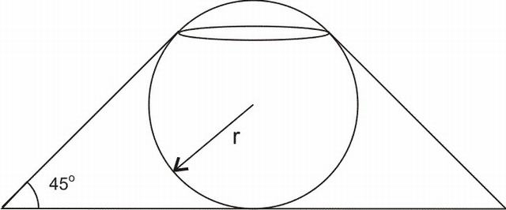
Q4: The pressure of the gas inside the cavity varies as PV^{γ} = k(a constant) , then the rate of change of Pressure of the gas inside the cavity w.r.t. time is { at the instant when (dr)/(dt) = − 2 units/sec , r = 3 units }
a) (2γk)/([π(3 + 5√(2))]^{γ + 1}).(1)/(3^{2γ})
b) (6γk)/([π(5 + (7)/(2)√(2))]^{γ}).(1)/(3^{2γ + 1})
c) (2γk)/((3 + 5√(2))^{γ − 1}).(1)/(3^{2γ + 1})
d) None of these

6.1.1.2 Hints and Solutions
Linked Comprehension Type Questions
Comprehension 1
Answers: Q1) C , Q2) A ,Q3) B ,Q4) B.
{Hint: Q1) Let r₁be the radius of the top opening, r₂ be the radius of the base and h be the height of the frustrum.
From adjoining diagram, it is clear that
r₁ = (r)/(√(2)) , r₂ = r(√(2) + 1) & h = r(1 + (1)/(√(2)))
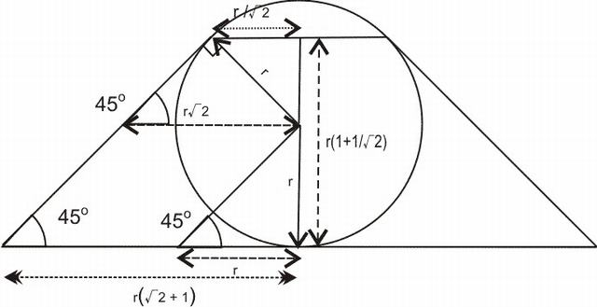
We know that the volume of a frustrum is V = (1)/(3)πh(r₁² + r₂² + r₁r₂)
⇒ V = (1)/(3)πr(1 + (1)/(√(2)))(((r)/(√(2)))² + (r(√(2) + 1))² + (r)/(√(2)).r(√(2) + 1))
⇒ V = (1)/(3)πr³(7 + (19)/(4)√(2))
Q2: To find the volume of the portion of sphere outside the frustrum, we first find the volume of 3Dimensional Portion of the sphere shown in figure
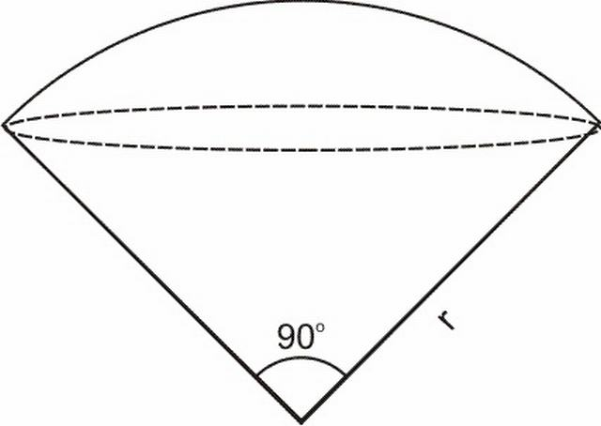
Let it’s volume be v and the upper Curved Surface Area be a
Using the concept of Solid Angle, (v)/(V) = (a)/(A) { = (Ω)/(4π)} (where V is the Volume of the Complete Sphere , A is the Surface Area of the Sphere and Ω is the solid angle)
⇒ (v)/((4)/(3)πr³) = (2πr²(1 − (1)/(√(2))))/(4πr²)
⇒ v = (2)/(3)πr³(1 − (1)/(√(2)))
Alternatively, this Volume can be found out by generating diffrential cones of base area dA and slant height r.These diffrential cones are generated by joining the boundaries of the diffrential area with the centre of the sphere . The volume of one such cone will be
dV = (1)/(3)rdA
Adding these diffrential cones, we get the volume of the portion of sphere as
v = (1)/(3)ra = (1)/(3)r.2πr²(1 − (1)/(√(2)))=(2)/(3)πr³(1 − (1)/(√(2))) which is the same as found above.
Now we need to subtract the volume of the cone from this volume to get the required volume of the portion of sphere outside the frustrum.
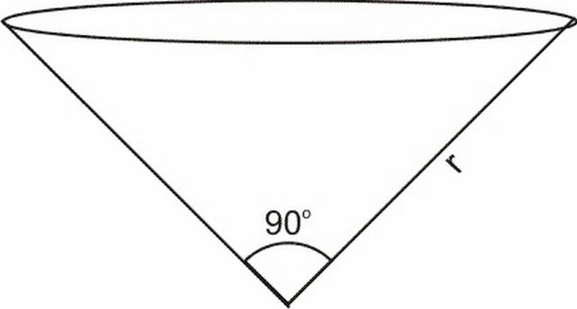
V_{cone} = (1)/(3)π((r)/(√(2)))².(r)/(√(2))
V_{portion} = v − V_{cone}
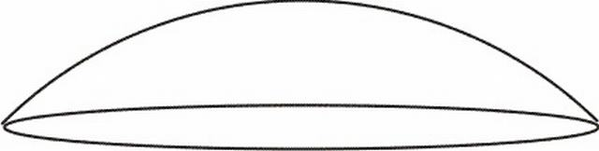
V_{portion} = (2)/(3)πr³(1 − (1)/(√(2))) − (1)/(3)π((r)/(√(2)))².(r)/(√(2))
V_{portion}=(1)/(3)πr³(2 − (5)/(4)√(2))
{The student may note that the concept of Solid angle can be developed intuitively without any prior knowledge of the concept}
Q3: From the figure , it is clear that
V_{cavity} = V_{Frustrum} + V_{Portion} − V_{Sphere}
⇒ V_{Cavity =} (1)/(3)πr³(7 + (19)/(4)√(2)) +(1)/(3)πr³(2 − (5)/(4)√(2)) -(4)/(3)πr³
⇒ V_{Cavity} = (1)/(3)πr³(5 + (7)/(2)√(2))
⇒ (dV_{Cavity})/(dr) = πr²(5 + (7)/(2)√(2))
Q4:PV^{γ} = k
⇒ P = (k)/(V^{γ})
⇒ P = (k)/(((1)/(3)πr³(5 + (7)/(2)√(2)))^{γ})
⇒ (dP)/(dt) = (k)/(((1)/(3)π(5 + (7)/(2)√(2)))^{γ}).( − 3γ)/(r^{3γ + 1}).(dr)/(dt)=(6γk)/([π(5 + (7)/(2)√(2))]^{γ}).(1)/(3^{2γ + 1})}

6.2 Maxima and Minima

6.2.1 Problems for Practice

6.2.1.1 Subjective Problems
Q1: A thin rectangular sheet is inscribed in a sphere of radius R . What can be its maximum area.
Q2: A cylinder of height h is inscribed in a right circular cone having base radius R and semi verticlal angle α . What is the rate of change of volume of cylinder w.r.t. α at the instant when α = (π)/(4).

6.2.1.2 Single Answer MCQ’s
Q1: From a military base located at the origin, a Surface-to-Surface Missile(STSM) was fired onto a target city located at (8,0) along the path y = 8x − x². Sometime later, a Radar located in the target city detected the missile and an Anti-Ballistic Interceptor Missile(ABIM) was fired from the city along the path y = √(8x − x²) [D] A guided missile may move along a non-parabolic path as it is propelled by rockets or jet enginesto intercept the missile. Ironically, the ABIM made substantial damage to the military base and the target city was also destroyed. What was the maximum distance between the trajectories of the two missiles?
a) 4 units
b) 8 units
c) 12 units
d) 16 units

6.2.1.3 Linked Comprehension Type Problems
Comprehension 1: A circular sheet of radius R is taken and a sector of angle θ is cut out of it. A cone is made of this cut-out sector(Curved Surface only). The volume of the cone depends on the angle θ of the sector.
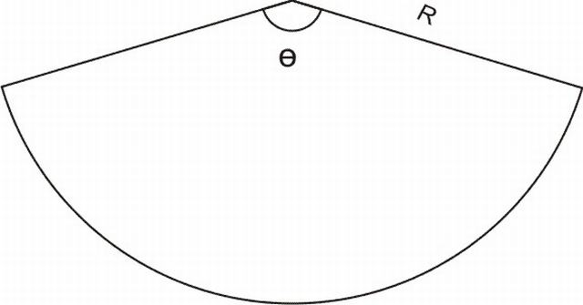
Q1: The angle θ for which the volume of the cone generated is the maximum is
A)(1)/(√(2)).2π
B)√((2)/(3)).2π
C)√((3)/(4)).2π
D)None of these
Q2: The Volume of the cone with the maximum volume is
A)(√(3))/(4)πR³
B)(1)/(6√(2))πR³
C)(2)/(9√(3))πR³
D)None of these
Q3: The semi-vertical angle of the cone with maximum volume is
A)(π)/(6)
B)(π)/(4)
C)(π)/(3)
D)None of these
Comprehension 2: S is an ellipse in the Cartesian plane with its major axis parallel to x-axis, having centre at ((1)/(2), 1) , eccentricity (1)/(√(2)) and passing through the intersection of y = f(x) and the line 2x + y = 1 . Further f(x) is a polynomial satisfying the property relation f(x + y) = f(x) + f(y) ∀x, y and f(1) = c , where 0 ≤ c ≤ 32
Q1: The minimum possible area of the ellipse is
a) (π√(2))/(11)
b) (2√(2)π)/(11)
c) (π√(2))/(9)
d) None of these
Q2: The equation of auxillary circle for the ellipse of maximum area, is
a) (x − (1)/(2))² + (y − 1)² = (1)/(4)
b) (x − (1)/(2))² + (y − 1)² = 2
c) (x − (1)/(2))² + (y − 1)² = (17)/(9)
d) None of these
Q3: \undersetc → 0 ⁺ lim{f(1 + f ⁄ (x))}^{f(x)} for x > 0 , is
a) 1
b) 0
c) 17
d) None of these

6.2.1.4 Hints and Solutions
Q1) C
Linked Comprehension Type Problems
Comprehension 1:
Answers: Q1) B Q2)C Q3)D
{Hints:Q1) The area of the sector is A = (θ)/(2π).πR²=(θ)/(2)R²
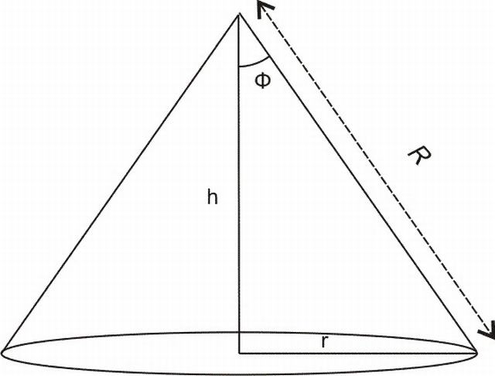
When the cone is generated from the sector, its Curved Surface Area will be equal to the area of the sector.
⇒ πrR = (θ)/(2)R²
⇒ r = (θ)/(2π)R
Also h = √(R² − r²)=√(R² − ((θ)/(2π)R)²)
V(Volume of the Cone) =(1)/(3)πr²h
⇒ V = (1)/(3)π((θ)/(2π)R)²√(R² − ((θ)/(2π)R)²)
⇒ V=(1)/(3)π(R³)/((2π)³)θ²√((2π)² − θ²)
⇒ (dV)/(dθ)=(1)/(3)π(R³)/((2π)³)[2θ√((2π)² − θ²) + (θ²( − 2θ))/(2√((2π)² − θ²))]
= (1)/(3)π(R³)/((2π)³)[(2θ((2π)² − θ²) + ( − θ³))/(√((2π)² − θ²))]
As is clear, the points θ = 0 & θ = 2π will yield a minima each. There will be an intermediate maxima between these two points.
⇒ The point of maxima will lie at θcorresponding to
2((2π)² − θ²) − θ² = 0
⇒ 2(2π)² − 3θ² = 0
⇒ θ = √((2)/(3)).2π
Q2: Volume of the cone is given by
V = (1)/(3)π((θ)/(2π)R)²√(R² − ((θ)/(2π)R)²)
Substituting θ = √((2)/(3)).2π
V = (2)/(9√(3))πR³units
Q3: It can be observed from the figure that for the semi-vertical angle φ,
sinφ = (r)/(R)
⇒ sinφ = (((θ)/(2π)R))/(R)
⇒ sinφ = (θ)/(2π) = √((2)/(3))
⇒ φ = sin ⁻ ¹√((2)/(3))}
Comprehension 2:
Answers: Q1) C Q2)B Q3)A
{ Hint: Q1: It can be easily verified that f(x) = cx
Solving it with 2x + y = 1 gives
x = (1)/(c + 2) , y = (c)/(c + 2)
The equation of ellipse will be
((x − (1)/(2))/(a))² + ((y − 1)/(b))² = 1
Now, since the eccentricity is (1)/(√(2)) , b² = a²(1 − e²) i.e. b² = (a²)/(2)
Hence the equation of ellipse becomes
((x − (1)/(2))²)/(a²) + ((y − 1)²)/((a²)/(2)) = 1
Now, x = (1)/(c + 2) , y = (c)/(c + 2) lies on it
⇒ (((1)/(c + 2) − (1)/(2))²)/(a²) + (((c)/(c + 2) − 1)²)/((a²)/(2)) = 1
⇒ a² = (c² + 32)/(4(c + 2)²)
Area of ellipse =πab = (πa²)/(√(2))
Area → min ⇒ (d)/(dc)((πa²)/(√(2))) = 0
i.e. (d)/(dc)(π(c² + 32)/(4√(2)(c + 2)²)) = 0
⇒ (π(c − 16))/(√(2)(c + 2)³) = 0
This gives c = 16 . Also it may be noted that the derivative is negative in the left neighbourhood of c = 16 and positive on the right neighbourhood of c = 16 . Hence, c = 16 is a point of minima.
⇒ A_{min} = (πa²)/(√(2)) = (π√(2))/(9)
Q2: It is easy to observe that maxima of A can occur at c = 0 or c = 32
At c = 0 , a² = 2
At c = 32 , a² = (32 × 33)/(4 × (34)²) < (1)/(4)
Hence, the maximum occurs at c = 0
The equation of auxillary circle is
(x − (1)/(2))² + (y − 1)² = a²
i.e. (x − (1)/(2))² + (y − 1)² = 2
Q3: \undersetc → 0 ⁺ lim{f(1 + f ⁄ (x))}^{f(x)} for x > 0 , is
= \undersetc → 0 ⁺ lim(c(1 + c))^{cx}
= e\undersetc → 0 + limln(c(1 + c)).cx
= e\undersetc → 0 + lim(ln(c(1 + c)))/((1)/(c)).x
Applying L’Hospital Rule
= e\undersetc → 0 + lim((2c + 1)/((c(1 + c))))/( − (1)/(c2)).x
= e⁰ = 1}

6.3 Tangents and Normals

6.3.1 Problems for Practice

6.3.1.1 Multiple Answer MCQ’s
Q1: The point(s) on the curve y² + 4 = 8x , where the tangent makes equal intercepts with the axes , is/are
a)((5)/(2), 4)
b)((5)/(2), − 4)
c)((5)/(4), 4)
d)((5)/(4), 2)

6.3.1.2 Matrix Match Type Problems
Matrix 1: Under Column I, equations of some curves are listed. Under Column II, equations of some lines are listed. An entry in Column I is linked to an entry in column II , if the entry in Column II is either a tangent or a normal to the curve given in the entry in Column I.
Column I | Column II
P)y² − 6y − 4x + 21 = 0 | A)x = 2
Q)x² − 4x + 4y − 4 = 0 | B)y = 3
R)x² + y² − 4x − 6y + 5 = 0 | C)y = x + 1
S)x² + y² − 6y + 7 = 0 | D)y = x + 5
 | E)y + x = 5

6.3.1.3 Answers
3.3.1.1(Multiple Answer MCQ’s)
Q1: A,B
3.3.1.2(Matrix Match Type Problems)
Matrix 1:
(P)⟼B,C,E
(Q)⟼A,C,E
(R)⟼A,B,C,D,E
(S)⟼B,C,D,E

7 Indefinite Integrals
Q1: Evaluate the following Integrals
a)∫(x²e^{x})/((x + 2)²)dx
Sol: a) ∫(x²e^{x})/((x + 2)²)dx
= ∫((x² − 4 + 4))/((x + 2)²)e^{x}dx
= ∫((x − 2)/(x + 2) + (4)/((x + 2)²))e^{x}dx
Now we know, if f(x) = (x − 2)/(x + 2) , then f ⁄ (x) = (4)/((x + 2)²)
Hence, ∫(x²e^{x})/((x + 2)²)dx = ((x − 2)/(x + 2))e^{x} + C

7.3.1.1 Subjective Problems
Q1: Evaluate the Integral
∫(x^{4m} + x^{2m} + x^{m})((3)/(2)x^{3m} + 3x^{m} + 6)^{(1)/(m)}dx for x > 0
Q2: Evaluate the Integral
∫cosec ⁻ ¹((√(9x² + 12x + 29))/(3x + 2))dx

7.3.1.2 Single Answer MCQ’s
Q1: The integral ∫(dx)/(sin(x − a)cos(x − b)) equals
a)(1)/(cos(a − b))ln|(sin(x − a))/(cos(x − b))| + C
b)(1)/(sin(a − b))ln|(cos(x − a))/(cos(x − b))| + C
c)(1)/(cos(a − b))ln|(cos(x − a))/(sin(x − b))| + C
d) None of these
Q2: If ∫(4x² + 2x + 1)/(x(2x − 1)(2x + 1))dx = Aln|x| + Bln|2x − 1| + Cln|2x + 1| + D . Then, A + B − C equals
a) 0
b) 1
c) 3
d) None of these

7.3.1.3 Hints and Solutions
Single Answer MCQ’s
Q1: Answer : A
{Hint: ∫(dx)/(sin(x − a)cos(x − b)) = (1)/(cos(a − b))∫(cos((x − b) − (x − a)))/(sin(x − a)cos(x − b))dx = (1)/(cos(a − b))∫(cos(x − a)cos(x − b) + sin(x − a)sin(x − b))/(sin(x − a)cos(x − b))dx =
(1)/(cos(a − b))(∫(cos(x − a))/(sin(x − a))dx + ∫(sin(x − b))/(cos(x − b))dx) = (1)/(cos(a − b))(ln|sin(x − a)| − ln|cos(x − b)|) + C = (1)/(cos(a − b))ln|(sin(x − a))/(cos(x − b))| + C }
Q2:Answer : A
{Hint:We first of all make the partial fractions of (4x² + 2x + 1)/(x(2x − 1)(2x + 1)) . If we want to do it with the method of vedic mathematics, we must make the coefficients of all the x equal in all the fractions. We make it equal to 2 for our convenience.
i.e (2(4x² + 2x + 1))/(2x(2x − 1)(2x + 1)) = (a)/(2x) + (b)/(2x − 1) + (c)/(2x + 1)
⇒ a = (2(1))/(( − 1)(1)) = − 2 , b = (2(3))/((1)(2)) = 3 and c = (2(1))/(( − 1)( − 2)) = 1
⇒ ∫(4x² + 2x + 1)/(x(2x − 1)(2x + 1))dx = ∫( − (2)/(2x) + (3)/(2x − 1) + (1)/(2x + 1))dx
= − ln|x| + (3)/(2)ln|2x − 1| + (1)/(2)ln|2x + 1| + Integration Constant
Comparing this with the given equation Aln|x| + Bln|2x − 1| + Cln|2x + 1| + D , we get A = − 1, B = (3)/(2) and C = (1)/(2)
⇒ A + B − C = − 1 + (3)/(2) − (1)/(2) = 0}

8 Definite Integrals

8.3.1 Problems for Practice

8.3.1.1 Single Answer MCQ’s
Q1: ∫₀²tan ⁻ ¹((4x − 4)/(4 + 2x − x²))dx equals
a) 0
b) 1
c) − (π)/(4)
d) (π)/(3)
Q2: If for t > 0 , the definite integral ∫₀^{t2}x^{(3)/(2)}f(x)dx = 2t⁵. Then f(√(2)) equals
a) (2(√(2)))/()
Q3: ∫ _{− e}^{2 − e − 2}|(log|x|)/(x)|dx equals
a) 2
b) -2
c) 4
d) -4
Q4: \undersetx → 0lim∫_{x}^{tanx}(1)/(t³)dt equals
a) 0
b) (1)/(2)
c) (1)/(3)
d) None of these
Q5: If ∫₁^{logx}t⁵f(t)dt = log(x) − 1 , then f(2)equals
a) 0
b) 1
c) (1)/(2)
d) (1)/(32)

8.3.1.2 Multiple Answer MCQ’s
Q1: f(x) is a twice diffrentiable function on ( − ∞, ∞) such that f(x) = f(2 − x) and f ⁄ ((2)/(√(7))) = 0 , then
A) f ⁄ (1) = 0
B ) f ⁄ (x) vanishes at least thrice in [0, 2].
C) ∫ ₋ ₁¹f(x + 1)tanxdx = 0
D) ∫₀¹f(t)e^{sin(π)/(2)t}dt = ∫₁²f(2 − t)e^{sin(π)/(2)t}dt

8.3.1.3 Matrix Match type Problems
Matrix 1: In Column I, some expressions containing Integrals are given.In Column II, some values are given . Match the expression in Column I with the values in Column II.
Column I | C II
(P)(∫₅⁴⁵ln(x^{(3)/(2)})dx)/(∫_{√(5)}^{3√(5)}xln(x²)dx) | (A)0
(Q) 16∫₀^{(1)/(√(2))}x³dx − ∫ _{− √(2)}^{7√(2)}([(x + √(2))/(16)])³dx | (B)1
where [ ] is the greatest integer function.
(R) 5∫_{(2)/(5)}^{(3)/(5)}e^{(5x − 2)3}dx + ∫ ₋ ₂ ⁻ ³e ^{− (t + 2)3}dt | (C)2
(S)(2)/(3)∫ ₋ ₁²cos²(((x + 1)⁵)/(243))dx + 4∫₀^{(1)/(2)}sin²(32x⁵)dx | (D)3

8.3.1.4 Hints and Solutions
Single Answer MCQ’s
Q1 a) A
{ Hint : a)Let I = ∫₀²tan ⁻ ¹((4x − 4)/(4 + 2x − x²))dx
⇒ I = ∫₀²tan ⁻ ¹((x − 1)/(1 + (x)/(2) − (x²)/(4)))dx
⇒ I = ∫₀²tan ⁻ ¹(((x)/(2) − (1 − (x)/(2)))/(1 + (x)/(2)(1 − (x)/(2))))dx
Now , we know that ∀xϵ(0, 2), both (x)/(2) and (1 − (x)/(2)) lie in the interval (0, 1).
⇒ I = ∫₀²(tan ⁻ ¹((x)/(2)) − tan ⁻ ¹(1 − (x)/(2)))dx
⇒ I = ∫₀²tan ⁻ ¹((x)/(2))dx − ∫₀²tan ⁻ ¹(1 − (x)/(2))dx
Now, applying the property, ∫_{a}^{b}f(x)dx = ∫_{a}^{b}f(a + b − x)dx on the second integral, we get
⇒ I = ∫₀²tan ⁻ ¹((x)/(2))dx − ∫₀²tan ⁻ ¹(1 − ((2 − x))/(2))dx
⇒ I = ∫₀²tan ⁻ ¹((x)/(2))dx − ∫₀²tan ⁻ ¹((x)/(2))dx = 0
Multiple Answer MCQ’s
Q1: A, B, C ,D
Matrix Match type Problems
Matrix 1:
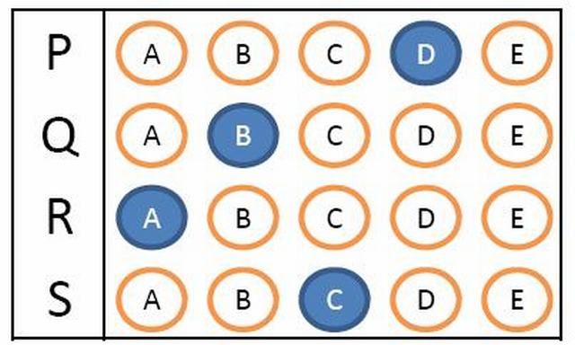

9 Applications of Integrals

9.1 Areas

9.1.1 Problems for Practice

9.1.1.1 Subjective Problems
Q1: For x ≥ 0 , the curve y = x²sinx forms alternate humps and ditches with respect to the x axis. Find the ratios of the areas of the second hump and the first ditch.

9.1.2 Hints and Solutions
Subjective Problems
Q1:

9.2 Curved Surface Area and Volume
Q: A cork ball of radius R is taken and it is cut with a knife at a distance (R)/(2) from the centre . Find the volume of the smaller of the cut portions.
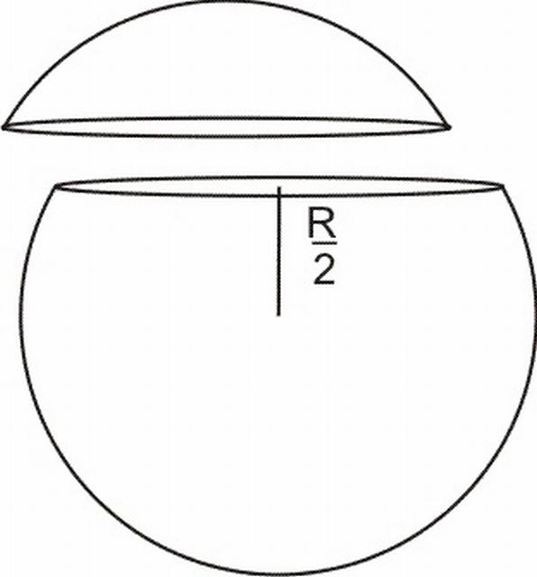
Sol: To calculate the volume of the portion of ball, we divide it into diffrential cylinders. Let us keep a single parameter θ to exress the radius and height of the diffrential cylinders. The parameter θ varies from (π)/(3) to 0 as the distance of the cylinder from the centre varies from 0 to (R)/(2) and the radius varies from (R√(3))/(2) to 0. The distance h of the diffrential cylinder from the centre is given by
h = Rcosθ
⇒ dh = − Rsinθdθ( The height of the diffrential cylinder)
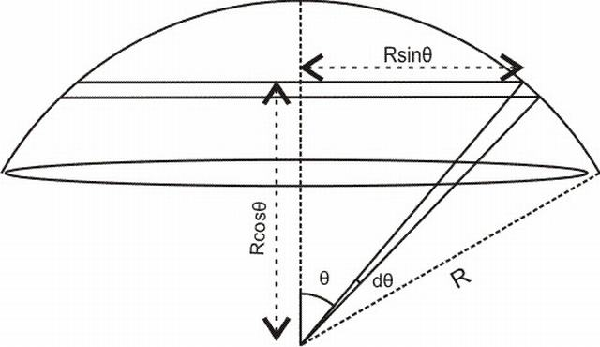
Also, r = Rsinθ(Radius of the diffrential cylinder)
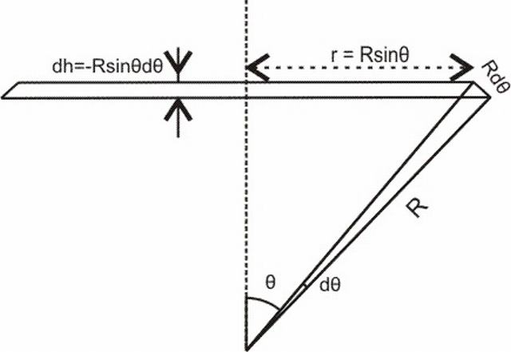
Note that dθ is so small that the curve on the edges will vanish and the figure will be a cylinder.
Hence we can find the volume of the diffrential cylinder
⇒ dV = πr²dh = π(Rsinθ)²( − Rsinθdθ)
⇒ dV = − πR³sin³θdθ
⇒ V = ∫_{(π)/(3)}⁰ − πR³sin³θdθ
⇒ V = πR³∫₀^{(π)/(3)}sin³θdθ
⇒ V = πR³∫₀^{(π)/(3)}sinθ(1 − cos²θ)dθ
⇒ V = πR³(∫₀^{(π)/(3)}sinθdθ − ∫₀^{(π)/(3)}sinθcos²θdθ)
⇒ V = πR³([ − cosθ]₀^{(π)/(3)} − [( − cos³θ)/(3)]₀^{(π)/(3)})
⇒ V = πR³( − ((1)/(2) − 1) + (1)/(3)((1)/(8) − 1))
⇒ V = (5)/(24)πR³

9.2.1 Problems for Practice

9.2.1.1 Linked Comprehension Type Problems
Comprehension 1: An unnamed space project, by a major space organization is in the form of a cone with a paraboloid cavity at the bottom. The parabolic cavity has its focus at the centre of the base of the cone and it touches the the outer curved surface of the cone at the base edge. The height of the cavity is ’a’. The body of the project is made of solid Lead and a coating of carbon of thickness 2μm is made on both the curved surfaces(CSA of cone and the paraboloid cavity). A diagram is given to make the situation more clear.
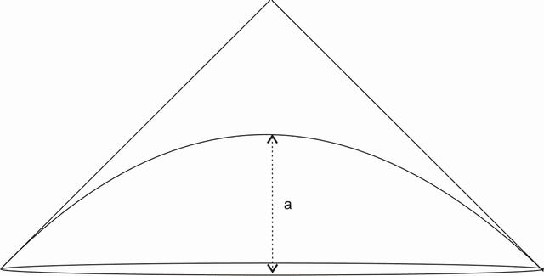
Q1: The height of the space project is
a) (3)/(2)a
b) 2a
c) 4a
d) None of these.
Q2: The volume of lead in the project is
a) (2)/(3)πa³
b) πa³
c) (4)/(3)πa³
d) None of these
Q3: The total amount of Carbon used in the project is
a)(8)/(3)πa²(3√(2) − 2) × 10 ⁻ ⁶m³
b)(8)/(3)πa²(5√(2) − 2) × 10 ⁻ ⁶m³
c)(8)/(3)πa²(7√(2) − 2) × 10 ⁻ ⁶m³
d) None of these
Comprehension 2: Two adjacent BSNL towers have the following specifications. One is located in Sector-36, Chandigarh and forms a Hemi-Spherical cell of radius 300m . Second one is located in Village Attawa and forms a hemi-spherical cell of radius 400m. Both the towers are at a distance of half a kilometer.[It may be assumed that the Transmitters are at ground level.]
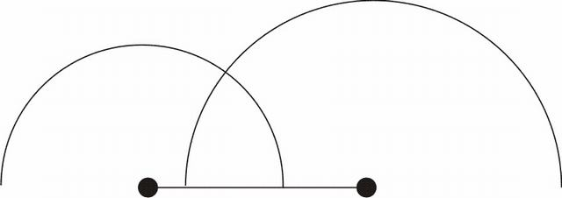
Q1: The angle of intersection of the cells is
a) (π)/(6)
b) (π)/(3)
c) (π)/(2)
d) None of these
Q2: The maximum height at which a person carrying a mobile phone can stand to recieve signals from both the towers is
a)90m
b)160m
c)240m
d) None of these
Q3: The volume of the portion which recieves signals from both the towers is
a)(92)/(3)π × 10⁵m³
b)92π × 10⁵m³
c)(92)/(5)π × 10⁵m³
d)None of these

9.2.1.2 Hints and Solutions
Linked Comprehension type problems
Comprehension 1: Answers Q1) B Q2) A Q3) C
{Hint: Let us choose a coordinate axis as shown in the figure.
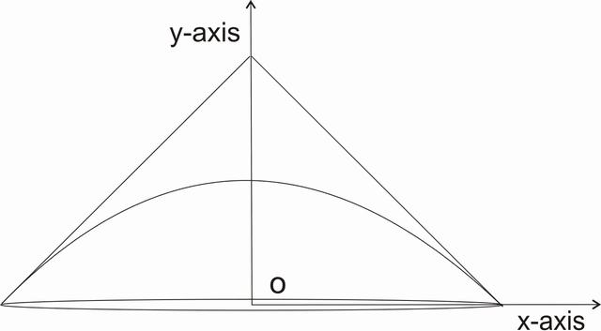
a) The parabola is a downward facing parabola with with vertex at (0, a) and focus at O(0, 0). Its equation is given by x² = − 4a(y − a).[ We are working in the cross-sectional plane only.] . We know that the latus rectum of the parabola is of length 4a. This means the points where the parabola touches the cone have co-ordinates (2a, 0) and ( − 2a, 0). The slope of tangent at these two points can be found out by diffrentiating the curve
2x = − 4a(dy)/(dx)
⇒ (dy)/(dx) = − (x)/(2a)
⇒ (dy)/(dx)|_{(2a, 0)} = − 1
Hence the cone has a base angle of 45º .i.e the height of the project is 2a.
b) The volume of the cone is equal to V_{Cone} = (1)/(3)πr_{base}²h = (1)/(3)π(2a)²(2a) = (8)/(3)πa³
Now our concern is to find the volume of the cavity. To do this, we devide the cavity into diffrential cylinders of radius x and height dy.
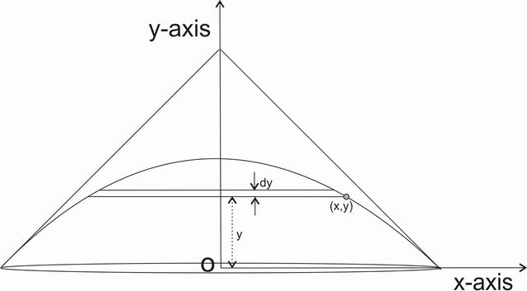
The volume of a diffrential cylinder is
dV = πx²dy
⇒ V_{Cavity} = ∫₀ªπx²dy
⇒ V_{Cavity} = π∫₀ª( − 4a(y − a))dy [ We know the equation of the parabola as x² = − 4a(y − a)]
⇒ V_{Cavity} = − 4aπ∫₀ª(y − a)dy = − 4aπ[(y²)/(2) − ay]₀ª = − 4aπ( − (a²)/(2)) = 2πa³
Hence, V_{Lead} = V_{Cone} − V_{Cavity} = (8)/(3)πa³ − 2πa³ = (2)/(3)πa³
c) The curved surface area of the cone is πr_{cone}l_{cone} = π(2a)(2√(2)a) = 4√(2)πa²
The curved surface area of the cavity can be found out by taking diffrential elements as shown in the figure.
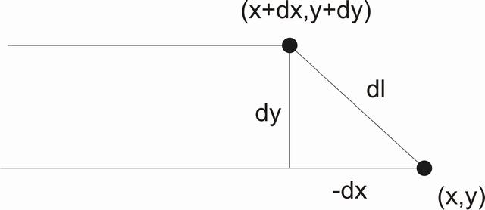
It may be noted that x co-ordinate is decreasing, i.e. dx is negative.
Diffrential surface area = 2πx√(( − dx)² + (dy)²) = 2πx√(dx² + dy²) = 2πx|dx|√(1 + ((dy)/(dx))²) = 2πx( − dx)√(1 + ( − (x)/(2a))²) = − (π)/(2a)2x√(4a² + x²)dx
Integrating this diffrential area, we get the Curved Surface Area of the Parabolic Cavity as
C.S.Area = ∫_{2a}⁰( − (π)/(2a)2x√(4a² + x²)dx) = ∫₀^{2a}(π)/(2a)2x√(4a² + x²)dx = (π)/(2a)∫₀^{2a}2x√(4a² + x²)dx = ↓(π)/(2a)((4a² + x²))/((3)/(2))^{(3)/(2)}]₀^{2a} = (π)/(3a)[(8a²)^{(3)/(2)} − (4a²)^{(3)/(2)}] = πa²[(16√(2) − 8)/(3)]
Hence, the total C.S.A is 4√(2)πa² + πa²[(16√(2) − 8)/(3)] = πa²[(28√(2) − 8)/(3)] = (4)/(3)πa²(7√(2) − 2)
⇒ The amount of carbon used is C.S.A × 2μm³ = (4)/(3)πa²(7√(2) − 2) × 2 × 10 ⁻ ⁶m³ = (8)/(3)πa²(7√(2) − 2) × 10 ⁻ ⁶m³}
Comprehension 2 : Answers : Q1)C Q2)C Q3) A
{Hint: The adjoining figure clearly explains all the parameters required for finding the angle between the cells
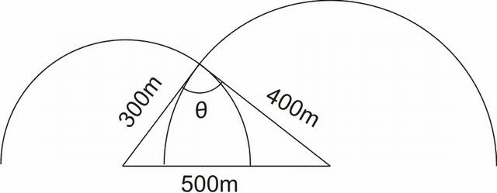
a)It may be noted that (300)² + (400)² = (500)². Hence, the intervening angle is 90º
b) We may redraw the figure as shown below
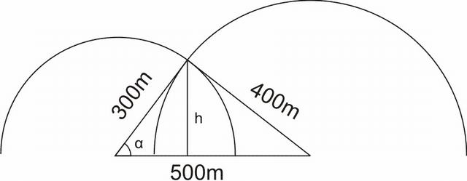
cosα = (300)/(500) = (3)/(5)
⇒ h = 300 × sinα = 300 × (4)/(5) = 240m
c) If we complete the spheres , the required volume will be half of the intersecting portions of the spheres.
V_{reqd} = (1)/(2) × Common portion of the complete spheres
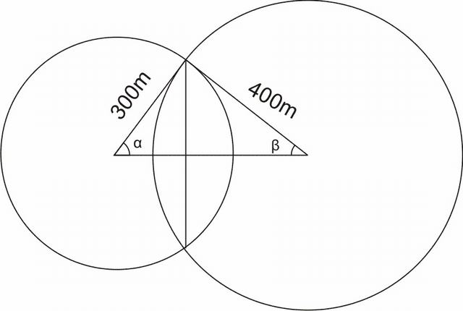
We know cosα = (3)/(5) . On similar lines , we can find cosβ = (4)/(5)
⇒ V_{reqd} = (1)/(2)(V_{left} + V_{right})[ where V_{left} is the volume of the portion of right cell subtending an angle 2β at the center of the right cell. Similar is the case with V_{right}.
From the cork ball example done earlier, we know that V_{left} = ∫₀^{β}πR_{right}³sin³θdθ = πR_{right}³([ − cosθ]₀^{β} − [( − cos³θ)/(3)]₀^{β}) = πR_{right}³( − ((4)/(5) − 1) + (1)/(3)((64)/(125) − 1)) = π(400)³((14)/(375))
On similar grounds V_{right} = ∫₀^{α}πR_{left}³sin³θdθ = πR_{left}³([ − cosθ]₀^{α} − [ − (cos³θ)/(3)]₀^{α}) = πR_{left}³( − ((3)/(5) − 1) + (1)/(3)((27)/(125) − 1)) = π(300)³((52)/(375))
⇒ V_{reqd} = (1)/(2)(V_{left} + V_{right}) = (1)/(2)((π(100)³)/(375))[4³ × 14 + 3³ × 52] = (92)/(3)π × 10⁵m³}

10 Diffrential Equations

10.2.1.1 Matrix Match type Problems
Matrix 1: Under Column I, some families of curves are mentioned. Under Column II, the diffrential equations reprsenting them are given. Match the curves in Coloumn I with the diffrential equations which can possibly represent them under Column II.
Column I | Column II
(P) A circle of arbitrary radius | (A) (x − y)²(1 + (y ⁄ )²)
’a’ in the second quadrant tou- | = (x + yy ⁄ )²
ching both the coordinate axes.
(Q) A circle of arbitrary radius | (B) (x + y)²(1 + (y ⁄ )²)
’b’ in the fourth quadrant tou- | = (x + yy ⁄ )²
ching both the coordinate axes.
(R) A circle of arbitrary radius | (C) (x + y)²(1 + (y ⁄ )²)
’c’ , touching the lines x = − 2c | = (1)/(9)(x + yy ⁄ )²
and y = 2c
(S) A circle of arbitrary radius | (D) (3x + y)²(1 + (y ⁄ )²)
’d’ touching the lines x = 2d | = (x + yy ⁄ )²
and y = − 2d
 | (E) (x + 3y)²(1 + (y ⁄ )²)
 | = (x + yy ⁄ )²

10.2.1.2 Hints and Solutions
Matrix Match type Problems
Matrix 1:
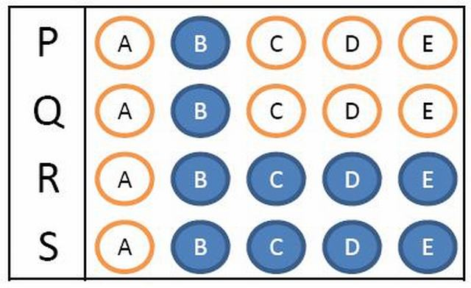

Part II. Coordinate Geometry

11 The Straight Line

11.2.1.1 Single Answer Type
Example 1 : i) If a, b, c form a G.P. with common ratio r, the product of the y-coordinates of the points of intersection of the line ax+by+c=0 and the currve y² + 2x = 0 . ii) Will the intersection coordinates be real if we choose the intersecting curve to be y² = 2x .
i)
a) -r²
b) -2r
c) -2r²
d) r/2
ii)
a) Yes
b) No
c) Can’t say
d) None of these.
{ Hint : Answer i) c) ii) b)
Solution : i) As a, b, c are in GP, put b =ar, c= ar²
This gives, ax + ary + ar² = 0
i.e. x + ry + r² = 0
putting x = − (y²)/(2), we get
− y² + 2ry + 2r² = 0
Sum of roots =y₁ + y₂= 2r
Product of roots =y₁y₂= − 2r²
|y₁ − y₂| = √((y₁ + y₂)² − 4y₁y₂) = √(4r² + 8r²) = Real
Hence, the equation will have real y-coordinates . This can be figured out by drawing the graph of the solution.
ii) In this case, x = (y²)/(2)
y² + 2ry + 2r² = 0
Sum of roots =y₁ + y₂= − 2r
Product of roots =y₁y₂= 2r²
|y₁ − y₂| = √((y₁ + y₂)² − 4y₁y₂) = √(4r² − 8r²) = Imaginary
Hence, the equation will not have real roots.
}
Example 2: Orthocentre of the triangle with vertices (0,0) , (4,0), (0,3) is
a) (3/4,4)
b) (3,4)
c) (0,0)
d) None of these
,{ Hint : By inspection c) (0,0) is the requisite answer . It can be further generalized that the orthocenter of the triangle formed by lines x=0,y=0 and any other third line is indeed (0,0). }
Example 3 : A straight line through the origin divides the parallel lines ⁷√(3)x + 5y + 8 = 0 and 3⁷√(3)x + 15y = 10 in the ratio
a) 8/5
b) 5/8
c) 2/9
d) 0.3
{Hint : Let the line be y=mx
The point of interesection with the first line would be (( − 8)/(⁷√(3) + 5m), ( − 8m)/(⁷√(3) + 5m))
Similarly, the point of intersection with the second line would be ((10 ⁄ 3)/(⁷√(3) + 5m), (10m ⁄ 3)/(⁷√(3) + 5m))
Using section formula, the ratio in which (0.0) divides these the line segment joining these two points would be 8X3/10 = 8/5 }
Example 4 : The sum of distances of a point from two perpendicular lines is 2√(2) . The are enclosed by the locus of these points is.
a) 16
b) 12
c) 32
d) 8
{ Hint : Answer 16 a)
Let’s take the two lines to be x=0 and y=0
⟹ The equation of locus is |x| + |y| = 2√(2)
⟹ The equation is basically 4 line segments joining the vertices as a square as for the values x > 2√(2) or y > 2√(2), the equality can’t hold for real values of x and y.
So, the area diagonals are of length 4√(2) each. That implies, the area of square is 16 Units.}

11.2.1.2 Subjective Problems
Example : The number of integral points ( integral point means both the coordinates should be integer ) that lie exactly in the interior of the triangle with vertices (0,0),(0,m),(n,0) where m,n are both +ve integers with m>n. {Subjective}
{ Hint : By inspection, moving down from the topmost point, at the line y=m-1, the farthermost point inside the triangle is the left hand limit of n/m . On this line, the integral points is Zero or [(n)/(m)].
On the line y=m-2, the number of points is [(2n)/(m)]
Proceeding in this way, on the last line with integral points, the equation is y=1, and the number of points is [((m − 2)n)/(m)]
Hence , the total number of such points is [(n)/(m)] +[(2n)/(m)]+......+ [((m − 2)n)/(m)]}

Part III. Algebra

12 Complex Numbers
Matrix 1: A line az + az + c + c = 0 is taken in the argand plane. The equation of line after applying the transformation given, is to be found. Column I contains the transformation while column II contains the resulting equations.
Column I | Column II
(P)The line is translated a distance Re(a) | (A)az + az = c + c + 2Re(ia²)
along the positive x-axis , Im(a) along
positive y-axis , and then reflected in
the real axis
(Q)The line is translated a distance Re(a) | (B)az + az + c + c = 0
along the positive x-axis , Im(a) along
positive y-axis , and then reflected in
imaginary axis
(P)The line is translated a distance Im(a) | (C)az + az + c + c − 2|a|² = 0
along the positive x-axis , Re(a) along
negative y-axis , and then reflected in
the real axis
(P)The line is translated a distance Im(a) | (D)az + az + 2|a|² = c + c
along the positive x-axis , Re(a) along
positive y-axis , and then reflected in
imaginary axis
 | (E) az + az + 2Im(a²) = c + c

13 Quadratic Equations

13.2.1.1 Linked Comprehension type Problems
Comprehension 1: Let a , b , c be three distinct real numbers and f(x) be a quadratic polynomial satisfying the equation
[ 9a² 9a 1 9b² 9b 1 9c² 9c 1 ][ f( − 1) f( − 2) f( − 3) ] = [ 16a² + 10a 16b² + 10b 16c² + 10c ] . Let V be a point of local maxima of y = f(x) and A be the point where y = f(x) meets the x-axis and B be a point on y = f(x) such that AB subtends a right angle at V
Q1: The curve f(x) is given by
A) f(x) = − (2)/(9)x² + 2
B) f(x) = − (x²)/(10) + 16
C) f(x) = − (x²)/(16) + 10
D) None of these
Q2: The equation of chord AB can be
A) 5x + 6y + 15 = 0
B) 6x + 5y + 15 = 0
C) 65x + 27y + 106 = 0
D) None of these
Q3: The area of the region lying between the curve and the chord AB is
A) (3445)/(8)unit²
B) (3445)/(64)unit²
C) (3445)/(128)unit²
D) None of these

14 Probability

14.2.1.1 Matrix Match Type Problems
Matrix 1: A student goes to exam on a bicycle or scooter or car or on foot. The probabilities of his using bicycle, scooter car or being on foot are (1)/(10) , (1)/(5) , (3)/(10) or (2)/(5) respectively. The probability of reaching late at the examination centre by using these modes are (1)/(3),(1)/(4),(1)/(12) and (1)/(24) respectively. The student reached the exam centre on time. Under Column I, the modes of travel are given and under Column II, the probabilies that the student used the particular mode of transport provided that he reached the exam centre on time. Match the corresponding entries.
Column I | Column II
(P) Bicycle | (A) (2)/(5)
(Q)Scooter | (B) (1)/(5)
(R)Car | (C) (2)/(15)
(S)On Foot | (D) (4)/(15)

14.2.1.2 Linked Comprehension Type Questions
Comprehension 1: There are n biased coins and n boxes numbered 1 to n. The coins are tossed and each put into its corresponding box. For the k^{th} coin, the odds in favour of appearance of head are k and the odds against are 2n − k . Let E_{n} denote the event of selecting the k^{th} box and H denote the event that the selected box contains a Head.
Q1: If P(E_{k}) = c∀k , then P(E_{m}|H) where mϵ{1, 2, 3, ......n} is\begin_inset Separator latexpar\end_inset
- A) (m)/(n(n + 1))
B) (2m)/(n(n + 1))
C) (c)/(n + 1)
D) (2)/(n + 1)
Q2: If P(E_{k}) ∝ k for k = 1, 2, 3........n . Find P(H)\begin_inset Separator latexpar\end_inset
- A) (2n + 1)/(6n)
B) (2n + 1)/(4n)
C) (2)/(3)
D) (1)/(3)
Q3: Evaluate the probability P that only the m^{th} box contains a head .Its value for m = 3, n = 5 is\begin_inset Separator latexpar\end_inset
- A) 0.12
B) 0.0832
C) 0.648
D) None of these

14.2.1.3 Hints and Solutions
Matrix Match Type Problems
Matrix 1:Answers
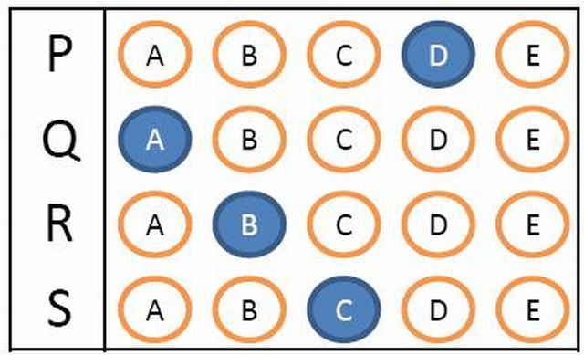
Linked Comprehension Type Questions
Comprehension 1 Answers Q1) B Q2) A Q3) C

15 Logarithms Worksheet
Q1: Find the domains of definition of the following functions:
a)log((x³(x² − 4))/((x² − 1)(x + 3)))
b)√(logx)
c) √(log_{x}(2 − x))
Q2 Matrix 1: Under Column I , some equations are given . Under Column II, some solutions satisfying some of the equations are given. Match the entry in Column I with the solution satisfying it in Column II.{Note: [ ] is the Greatest Integer Function}
Column I | Column II
(P)|sin ⁻ ¹x| = sin ⁻ ¹x + (π)/(6) | (A)-(1)/(2)
(Q)ln|x| = |lnx| | (B)1
(R)|[x]| = [|x|] | (C)(3)/(2)
(S)|x² − 3x + 2| > x² − 3x + 2 | (D)2

Q3 Comprehension 1: A function f_{n}(x) is defined for all nϵN and f_{n + m}(x) is defined as f_{n + m}(x) = f_{n}(f_{m}(x)) where f₁(x) = (2x − 1)/(x + 1) for xϵR − { − 1}. Using this definition , f₂(x) = f₁(f₁(x)) = (x − 1)/(x) for xϵR − { − 1, 0}. Similarly f₃(x) = f₁(f₂(x)) = (2 − x)/(1 − 2x) for xϵR − { − 1, 0, (1)/(2)}and so on. Based on the information, answer the questions below.
1: The domain of definition of g(x) = |ln(f₃₄(x))| is
a) ( − ∞, 1) − { − 1, 0, (1)/(2)}
b) ( − ∞, 1] − { − 1, 0, (1)/(2)}
c) (1, ∞) − {2}
d) None of these
2: The complete solution set of |f₇₁(x)| > |(1)/(f₇₃(x))| is
a) ( − 1, 1)
b) ℝ − {2} − [ − 1, 1]
c) ℝ − { − 1, 1, 2}
d) None of these
3: The values of x for which |f₅₆(x)| > f₅₆(x) belong to the interval
a) ((1)/(2), 2)
b) (2, ∞)
c) (0, 1)
d) None of these
Q4: (i) Prove that for the logarithmic function y = ln|x| , if the argument takes values in a G.P. , then the corresponding values of the function y are in A.P.\begin_inset Separator latexpar\end_inset
- (ii)Prove that for the exponential function y = e^{x} , if the argument takes values in a A.P.. , then the corresponding values of the function y are in G.P.

16 Matrices
Q: Invent a 3 × 3 magic matrix M with the entries 1 , 2 , 3 , ........9. All rows and columns and diagonals add to 15 . The first row could be ( 8, 3, 4) . What could be M.
Q: If A = [ 1 i − i 1 ] . Find A^{T}A.
Q: Find the adjoints of the following matrices
a) [ 15 7 8 14 ]
b) [ 7 0 0 7 ]
c) [ 1 2 3 4 ]
Q: If A = [ 2x + 6 26 2z + 48 t² + 41 ]
= [ x² − x 1 y² − y 2 z² − z 3 t² − t 4 ][ 1 2 2 3 3 4 ][ 1 2 ]
Then , A can be
a) [ 10 26 46 47 ]
b) [ 10 26 54 42 ]
c) [ 10 26 46 42 ]
d) [ 10 26 54 41(9)/(25) ]

16.2.1.1 Linked Comprehension Type Questions
Comprehension 1: Two vectors v = (1, 2, 3) and w = (1, 3, 4) are taken and put in the columns of a matrix as
M = [ 1 1 2 3 3 4 ]
The linear combination of these two vectors can be expressed as
c[ 1 2 3 ] + d[ 1 3 4 ] = [ 1 1 2 3 3 4 ][ A B ]
Q1: A relation between A , B , c and d is \begin_inset Separator latexpar\end_inset
- a) 6c + 8d = A + B
b) 8c + 6d = A + B
c) 6c + 8d = 6A + 8B
d) None of these
Q2: The matrix [ A B ] in the equation
[ 1 1 2 3 3 4 ][ A B ] = [ 2 5 8 ] is given by\begin_inset Separator latexpar\end_inset
- a) [ 1 1 ]
b) [ 1 2 ]
c) [ 2 2 ]
d) None of these

16.2.1.2 Matrix Match Type Problems
Matrix 1 : Three elementary matrices E = [ 1 0 0 2 1 0 0 0 1 ] , F = [ 1 0 0 0 1 0 − 1 0 1 ] , G = [ 1 0 0 0 1 0 0 − 1 1 ] are given. Under column I , resultant matrices (lower triangular) obtained from E, F, G or their inverses are given. Match the matrices given in column I with their corresponding expressions given under column II :
Column I | Column II
(P)[ 1 0 0 − 2 1 0 − 1 1 1 ] | (A)EFG
(Q)[ 1 0 0 2 1 0 − 1 − 1 1 ] | (B)EF ⁻ ¹G
(R)[ 1 0 0 − 2 1 0 1 1 1 ] | (C)E ⁻ ¹FG ⁻ ¹
(S)[ 1 0 0 2 1 0 1 − 1 1 ] | (D)E ⁻ ¹F ⁻ ¹G ⁻ ¹
 | (E)G ⁻ ¹F ⁻ ¹E ⁻ ¹

Part IV. Trigonometry

17 Heights and Distances

17.2.1 Problems for Practice

17.2.1.1 Subjective Problems
Example : Consider a regular Octagon, the unequal diagonals are in the ratio :
{ Hint: Let the centre to any vertex distance be r
A₀A₂ = 2rSin(2π)/(8)
A₀A₃ = 2rSin(3π)/(8)
A₀A₄ = 2rSin(4π)/(8)
So the ratio is Sin(2π)/(8):Sin(3π)/(8):Sin(4π)/(8)
= 1 ⁄ √(2):√(2 + √(2)) ⁄ 2:1
}

18 Trigonometric Identities

18.2.1 Problems for Practice

18.2.1.1 Subjective Problems
Q1: Prove the following Identities
a)(2cos2^{n}θ + 1)/(2cosθ + 1) = (2cosθ − 1)(2cos2θ − 1)(2cos2²θ − 1)………(2cos2^{n − 1}θ − 1)

18.2.1.2 Single Answer MCQ’s
Q1: If x = rsinαsinβcosγ , y = rsinαsinβsinγ , z = rsinαcosβ , w = rcosα then x² + y² + z² + w² is independent of
A) r, α, β, γ
B) r, α, β
C) α, β, γ
D) None of these
Q2: If tanθ = (√(6)a)/(2) − (1)/(2√(6)a) , then secθ − tanθ is equal to
(A) √(6)a, (1)/(√(6)a)
(B) − √(6)a, (1)/(√(6)a)
(C) √(6)a, − (1)/(√(6)a)
(D) None of these
Q1: tan(π)/(96) + 2tan(π)/(48) + 4tan(π)/(24) + 8 + 8√(3) is equal to
A) cot(π)/(96) − 6
B) cot(π)/(96)
C) 32
D) None of these

18.2.1.3 Multiple Answer Type Questions

19 Trigonometric Equations

19.2.1.1 Single Answer MCQ’s
Q1: The number of solutions of 8^{cosec2x} + 8 ^{− cot2x} = (33)/(2) , 0 ≤ x ≤ 2π is
A) 4
B) 6
C) 8
D) None of these
Q1: The number of distinct real solutions of
(x² + 3)(cosecx + cotx) − 3x + √(3)[x(cosecx + cotx) − (x² + 3)] = 0 on − 2π ≤ x ≤ 2π is
A) 1
B) 2
C) 4
D) None of these
Q3 : If − π ≤ θ ≤ π and r, θ satisfy rsinθ = 3 and r = 3(2 + 3sinθ) , then the number of ordered pairs (r, θ), which are solutions is/are
A) 0
B) 1
C) 2
D) None of these
Q4: If 0 ≤ x, y, z, t ≤ 2π and sinx + (siny)/(2) + (sinz)/(3) = − t² + 2t − (17)/(6) , then the value of x + y + z is
A) (3π)/(2)
B) (5π)/(2)
C) (7π)/(2)
D) (9π)/(2)

19.2.1.2 Multiple Answer Type Questions
Q1: If cosθ = a for exactly one value of θϵ[0, (7π)/(6)] , then the value of ’a’ can be
A) 0
B) (√(3))/(2)
C) − 1
D) − (1)/(2)
Q2: If sin⁹x + cos⁶x = 1 in the interval − 3π ≤ x ≤ 2π, then which of these statements is/are correct
A) The number of roots of the equation is 7.
B) The sum of roots is − 4π
C) The ratio of the number of roots on the left side of zero to the number of roots on the right side on the right side of zero, on the number line is (4)/(3).
D) None of these

20 Properties of Triangle

20.2.1.1 Single Answer MCQ’s
Q1: The angles of a right angled triangle are in A.P. The ratio of the area of circumcircle of the triangle to the area of the triangle is
A) (2π)/(√(3))
B) (π)/(√(3))
C) (π)/(3)
D) None of these
Q1: In a △ABC , with sides a,b,c and ∠B = (π)/(6) , ∠C = (π)/(4) . The area of the triangle is
A) ((√(3) − 1))/(4)a²
B) (1)/(2)a²
C) ((√(3) + 1))/(4)a²
D) None of these
Q2. The area of △ABC is (b + c)² − a² . Then which of following statements is true
A) ∠A is acute
B) ∠A is right angle
C) ∠A is obtuse
D) None of these

20.2.1.2 Multiple Answer Type Questions

20.2.1.3 Assertion-Reason Type Questions
Q1: Statement 1: If the sides of a triangle are 3,4,5 then the altitudes of the triangle are (1)/(3), (1)/(4), (1)/(5).
Statement 2: If the sides of a triangle are in A.P. then the altitudes of the triangle are in H.P.

20.2.1.4 Linked Comprehension Type Questions
Comprehension 1: For a quadrilateral with sides a, b , c , d , semi-perimeter ’s’ and sum of any two opposite angles = 2α , the area △ is given by
△² = (s − a)(s − b)(s − c)(s − d) − abcdcos²α
Now, we take a special quadrilateral which can be inscribed in a circle C₁ and a circle C₂ is inscribed in it
Q1: The area of a special quadrilateral △ is given by
A) √(s(s − a)(s − b)(s − c))
B) (s²)/(3)
C) √(abcd)
D) √(3abcd)
Q2: The radius of the inscribed circle C₂ is given by
A) (△)/(s)
B) (2△)/(s)
C) (3△)/(s)
D) (4△)/(s)
Q3: Cosine of the angle between the diagonals of the special quadrilateral is given by
A) ±(ab − cd)/(s²)
B) ±(ac − bd)/(△)
C) ±(ab − cd)/(ab + cd)
D) ±(ac − bd)/(ac + bd)
Q4: If B is the angle between sides a and b of the special quadrilateral then tan(B)/(2) is given by
A) √((ab)/(cd))
B) √((cd)/(ab))
C) (ab)/(cd)
D) (cd)/(ab)

21 Inverse Trigonometry

21.2.1 Problems for Practice

21.2.1.1 Single Answer MCQ’s
Q1: The number of solutions of the equation sin ⁻ ¹(1 − x) − 2sin ⁻ ¹(x) = (π)/(2) is/are
a) One
b) Two
c) Three
d) None of these
Q2: If (1)/(√(2)) < x < 1 , the number of solutions of the equations
tan ⁻ ¹((1)/(x) − 1) + tan ⁻ ¹((1)/(x)) + tan ⁻ ¹((1)/(x) + 1) = tan ⁻ ¹(3x) is
A) 0
B) 3
C) 4
D) None of these
Q3: The equation cos ⁻ ¹x = 3cos ⁻ ¹a has a solution for
A) all real values of a
B) all real values of a satisfying a ≤ 1
C) all real values of a satisfying (1)/(2) ≤ a ≤ 1
D) all real values of a satisfying (1)/(√(2)) ≤ a ≤ (√(3))/(2)

21.2.1.2 Multiple Answer Type Questions

21.2.1.3 Linked Comprehension Type Problems
Comprehension 1: A function f:((5π)/(2), (7π)/(2)) → ( − 1, 1) is defined by f(x) = sinx. Its inverse is denoted by f ⁻ ¹(x) = sin ⁻ ¹x . Another function g:(2π, 3π) → ( − 1, 1) is defined by g(x) = cosx . Its inverse is denoted by g ⁻ ¹(x) = cos ⁻ ¹x . An onto function h:( − 1, 0) → R_{h} is given by h(x) = f ⁻ ¹(x) − g ⁻ ¹(x) . Now answer the following questions.
Q1: g ⁻ ¹( − x) is given by
a) π − g ⁻ ¹(x)
b) 5π − g ⁻ ¹(x)
c) (5π)/(2) − g ⁻ ¹(x)
d) None of these
Q2: Set ’R_{h}’ is
a) {(π)/(2)}
b) ((5π)/(2), 3π)
c) (0, (π)/(2))
d) None of these
Q3: If a function v:( − ∞, 0] → [3π, (7π)/(2)) is defined by v(x) = f ⁻ ¹((2^{x} − 2 ^{− x})/(2^{x} + 2 ^{− x})) , then v(x) is
a) Injective Only
b) Surjective Only
c) Bijective
d) None of these.

Index
Absolute value of the number: ↑
Closure Property of Irrational Numbers: ↑
Closure Property of Rational Numbers: ↑
Critical Points in a Wavey-Curve: ↑
Critical Points in an Absolute value expression: ↑
Functions: ↑
Non terminiating Non-recurring decimal Expansion: ↑
Non-Terminating Recurring Decimal Expansion: ↑
Property of Denseness: ↑
Rational numbers: ↑
Real Numbers: ↑
Terminating Decimal Expansion: ↑
The Triangle Inequality: ↑
The Wavey-Curve Technique: ↑

