Bit-coin Miner – Hardware Implementation

Team A-SIC-BUNCH
Karthik Tripurari [ktj2102]
Neeraja Ramanan [nr2404]
Rajat Kumar [rk2653]
Kanad Sinha [ks2935]

Design Master: Karthik Tripurari
Validation Master: Kanad Sinha

EECS 4340: Computer Hardware Design
Final Project
- Design Overview

- Brief Introduction to Bitcoin

Bitcoin is a form of decentralized, peer-to-peer digital currency, with no central authority required for creating, controlling or validating it or its transactions. These functions are instead performed by the nodes in the network itself in a distributed manner.

Nodes in the bitcoin network generate bitcoin currency by a process called mining, which involves solving a computationally intensive proof-of-work problem, namely encryption using the SHA-256 hash, repeatedly until a satisfactory value is found (hence, whereas regular currencies are based on the supply/availability of some valuable material (generally gold), bitcoin can be considered to be based on the computation required and energy consumed to solve such a problem).

- Design

A very high-level overview of the modules of the system that we plan to build for the purpose of bitcoin mining is as follows:
- SHA functionality – This will be the most important module of the chip, and might have sub-modules implementing the main functions of the algorithm, which should be in turn be optimized and parallelized as much as possible. The final chip may have multiple numbers of this module.
- Communication – The chip will have two separate modules for interfacing with external memory and the internet.
- Interfacing with user – So that a usable status output can be generated, which may then be fed to say, a display.
- Main module – This is the main top module which will meaningfully connect the other modules to one another.

- Unit Level Interfaces

The miner slave module will have the following connections:
- Data in/out [16-bit bidirectional]: This bus is used to transfer data in/out of the module serially.
- clk
- rst
- Interrupt [1-bit input]: This input will be used by the master chip to signal the miner to stop working on the current header when header data changes.
- Sub-unit partitioning and interfaces, Test harness structure

- Sub-unit Interfaces:

The slave miner unit consists of the following modules.

    - Bus controller: This module is responsible for interacting with the master unit and receiving/transmitting data in/out serially. A block diagram is shown below.
Bus Controller

clk

rst

mem_write
rst

data_o_valid

    - Memory: This module will store the header, some temporary variables and the final values computed by the SHA units.
    - Distribution Unit: This module is responsible for distributing data to the SHA-compute farm and gathering the final value once it’s found. A simplified block-diagram is shown below.

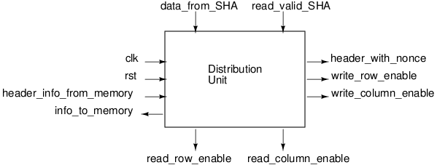

    - SHA-compute farm: This module contains an array of SHA computation units, each of which would be responsible for computing double-SHA values on header for a particular nonce. A simplified block diagram is shown below.

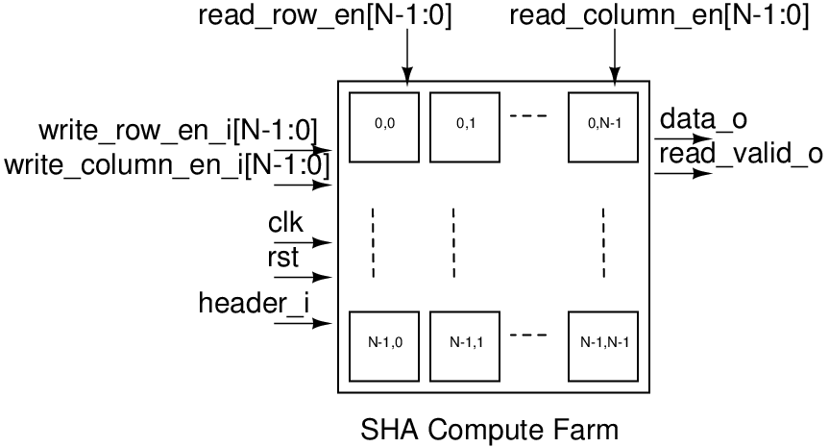

- As mentioned above, the SHA farm consists of SHA computation units. A block diagram is shown below.

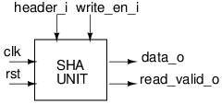

- Test harness

- Microarchitecture Design

- Verification Strategy

- Performance Estimates

- Area Estimates

- Bugs, Coverage

- Document History

- 8th November, ’11: Section I first draft checked in [Kanad]
- 15th November, ’11: Document skeleton filled in, along with first draft of Sections 3 and 4. [Kanad]

