## **Introduction**

Nowadays, Retail Banks are more focused on finding or discriminating the right clients and the wrong ones (Defaulters). From a Credit Risk perspective a Good Client will be a customer/applicant who has least chances to do default (a row risk client) i.e. the applicant has low chances to perform default in his obligations. This detection process of identifying or separating a Good & bad applicant/client is where Credit Risk Scorecard comes into play. It is an automated application which help banks to consistently assess each client in a shorter period of time ie. To detect his chances of delinquency (Probability of Default). With integration of loan approval I.T applications it help banks to speed up the loan application process, reducing the man hours resulting in increasing in the productivity with complete transparency.

Credit Risk Scorecard is basically a group of features, which is statistically determined to be predictive in distinguishing Good and Bad applicants.

## **Problem**

Financial institutions have started paying lot of attention in tracking the performance of existing Scorecard Models. This tracking of PD models helps them in understanding the population shift in their data and knowing the change in delinquency pattern of users which will help them in improving their bad definition and validating clients.

In this article we take up a problem to propose and implement a simple scorecard tracking methodology that can be used by Banks to track their Credit risk Models. In this we will be focusing on how to measure the performance of existing PD model by tracking its performance over the Development and Current data. This will give us information’s on how well the Scorecard is performing, whether it needs any further tuning or not, the current Bad definition still holds good for the current data or not. Helping them in visualizing insights and distribution on the current population shift and determining existing delinquency pattern of customers which will further help financial constitutions to derive a new Bad definition depending upon the current delinquency patterns of customers.

However for different models we will have different variables/characteristics but more or less the tracking process will be the same.

### **Investigation**

Data Gathering: In order to define the factors for Scorecard Tracking Project, we must first gather the data with all the required fields in a specific database format. Parameters generally include the “Good” “Bad” definitions, establishing the Development and Current windows, defining the data exclusions. The following are the general Data Fields that are generally collected from applications from past two to five years depending on the requirement:

●     Unique Identification number/Loan ID

●   Loan Application Date

●     Accept/Reject Indicator

●      Loan Disbursement Date

●     Product code

●     Emi Frequency

●     Emi Date

●     EMI payment date

●     Current account Status

Information Gathering :

Scorecards are developed using an assumption that performance shown by clients in future will reflect the performance of the past users i.e assuming the economic conditions as constant we judge customers on the basis of past customer’s delinquency pattern.

In order to perform this tracking analysis we need to gather data for accounts opened during a specific time period and then monitor their performance for another specific period of time and see whether there is any change in any delinquency pattern in these two data. We need to create two data sets from the user database ie. Development data, Recent Data. Based on these two data sets we will be performing tracking analysis and will see whether current Bad definition still holds good for Recent Data. Monitoring the scorecard is divided into Front-End and Back-End analysis :

1.    Front-End – Measures the degree of variance in score distribution between the Development and Current populations. It includes:

a.     Population Stability Index (PSI) :Measures the change in score distribution.

b.    Characteristic Stability Index :Measures the change at characteristic level.

2. Back-End – Measures the predictive power of the scorecard on the Recent population and compares this performance to that of Development population.

a.     Vintage Analysis – Analyse portfolio performance on a vintage basis.

b.    Gini & KS comparisons – Quantifies the strength of the scorecard.

### **Front End Analysis**

Population Stability Index : Population stability measures changes in the score distribution between the development population and the recent population. This change in score distribution is measured by the population stability index. It an important metric to identify a shift in population for credit scorecards.

A good place to start this comparison is by checking how two populations are distributed across the risk bands created through the scorecard. The following is a representation for the of the shift in population among Development and Current data. Here Current Apps %’ is the population distribution for the Current data and ‘Development Apps%’ is the population distribution for the Development data in each score bands. This change in score distribution is measured by the Population Stability Index, which for this analysis is 0.02, indicating little or no change in the score distributions.

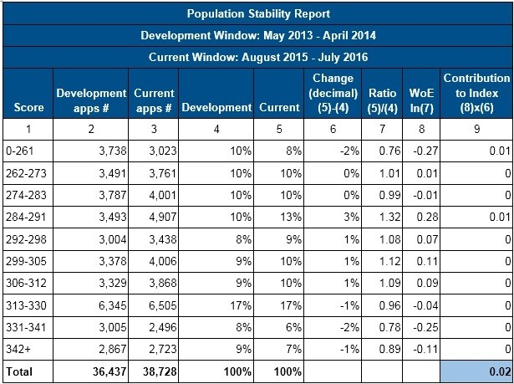

The last column in the above table is what we care for. Index for each score band which is calculated by taking the difference between Recent and development applications (in %) and multiplying it with the log of ratio between current and development.

PSI is calculated by :PSI=((Recent% - Dev%) * (ln (Current%Dev%))

The final value for the PSI i.e. 0.02 which is the sum of all the values of the last column. Now the question is how to interpret this value? The rule of thumb for the PSI is displayed below:

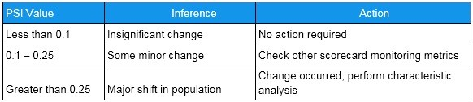

In this case we have observed a slight movement from the lower and higher Score bands, toward the middle score bands, however, the shift is immaterial. As we are getting a desired PSI value according to the benchmark so we won't need a further Character Analysis in this case. So, the Population Stability Index is one of the metrics to keep a check on changing conditions – however, the idea is clear that one has to capture robust metrics to keep a close look on the ever changing economic winds to prevent a crash landing.

Characteristic Analysis:

Characteristic Analysis measures the change between development and the recent population at a characteristic level. The change in distributions are added for each characteristic to estimate the impact on the total score. It answers which variable is causing a shift in population distribution. It compares the distribution of an independent variable in the current data set to a development data set. It detects shifts in the distributions of input variables that are submitted for scoring over time.

It helps us to determine which variable has the most influence in causing the model score shift.In above case as the change at an overall score level was insignificant, the change at a characteristic level will follow the same trend. If a scorecard constitutes 9 characteristics and a change in any of these 9 characteristic of more than 5 points is deemed significant. In below example we will see how to perform a Characteristic Analysis for one variable (Salary ) we can use the same methodology on the remaining characteristics to detect the influencing variable

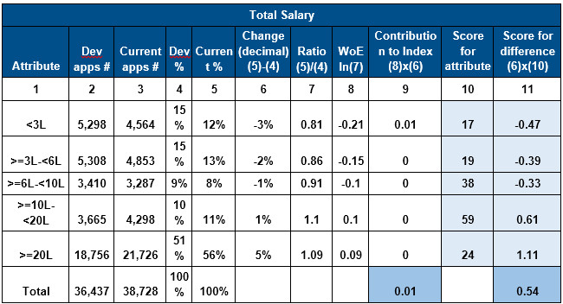

Finally the summation of this score is used to detect whether there is any shift in this variable or not. Salary has a score difference of 0.54, indicating little or no change. Generally a characteristic with more than score difference of 5 is considered deemed significant.

Final Decision report

In the end a Final Decision report is prepared by analyzing accept rate for each score band. This report is generated for both Development & Recent populations and the trend in acceptance rate is compared using this final report. The Final Decision report analyses accept rate by score band. The expected trend is accept rate increasing as score increases, thereby minimizing the impact of riskier accounts on the portfolio performance.

Back End Analysis

Vintage Analysis:  Vintage Analysis in credit Risk models helps you to understand the Maturity of a portfolio and to establish the independent variable. The independent variable in credit risk modelling usually depends of the maturity and the default point. For example, one of the standards in Basel II is to modeling the probability that a client hit the 90 day past due during the next 12 months. The examination of loans by the period in which they were originated is knows a Vintage Analysis. In addition of monitoring your portfolio’s performance we are also analyzing how loans of different age are performing i.e how they performs over their life span. It tells when the delinquency rate gets constant over a tenure so that we can set a trademark or we can fix a period throughout which we gonna monitor each applicant. This vintage curve is monitored for both the Development and Current data across all the 30,60,90 DPD and the change in curve is monitored across both the data. It helps in knowing whether the current Bad definition holds for the current data or not. It checks for the shift in delinquency pattern of applicants over the loan tenure.

Roll Rate Analysis : Comparing worst delinquencies in a specified previous “n” months with respect to the next “n” months and then calculating the number of accounts(in %) who maintained their delinquency or got better/worst.It is a method of analyzing or determining the chances/probability of a customer that he will stay as a delinquent customer or he will move into backward delinquent bucket or move into forward delinquency bucket ie. getting worse with time. In simpler words its purpose is to evaluate the probability of a client whether he will move into forward bucket ie getting worse or moving into lower bucket ie. getting better with time. It gives an idea on no return point ie. it helps to identify a point of no return. Typically customers who reach 90+ DPD bucket have the least chances to get cured or to roll back thus confirming the bad definition.

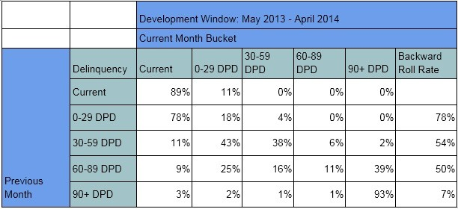

For example in this table we are comparing delinquency buckets of present month with respect to previous month. In Row 1 11% of the applicants who were in current (zero delinquency) bucket went to 0-29 DPD. In Row 2 78% applicants went from 0-29 DPD to Current bracket (roll backward), 4% went to 30-59 DPD (roll forward) ie. went into higher delinquency bucket. As we can see in the last column of the table there is a “Backward roll rate” column so what does it infer??

In Row 3 we can see that 54% of the applicants who were in 30-59 DPD last month rolled backward to previous DPD bucked ie. improvement in their delinquency. While in Row 5 only 7% of the applicants went to previous buckets. So our definition of bad ie. 90 DPD makes more sense. Conversely 0-29 or 30+ DPD will be less significant as 78% and 54% of the customers respectively have the chances to roll back to previous buckets thus confirming out Bad Definition of 90+ DPD as correct.

We should be Comparing this analysis for both the Development and Recent Population data and see if there’s any significant change in BAD definition or not ie. the point of no return has changed or not .

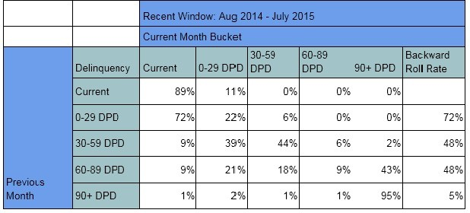

●     The backward roll rate for 60-89 DPD for both the development (50%) and recent (48%) populations are largely in line, however, there has been a deterioration in the backward roll rate for the 90+ DPD from development (7%) to the recent (5%) population (If the backward roll rate for the 90+ DPD segment improved significantly for the recent population, the bad definition could potentially be inappropriate)

●     As the backward roll-rate has slightly deteriorated for the earlier delinquency ranges and more for the 90+ DPD range, the chosen bad definition of 90+ DPD over a 12 month window holds for both the development and recent populations

Gini and KS Statistics: It is a scorecard performance statistics which measure the overall strength of the scorecard in separating Good and Bad accounts. This was conducted for both the Development and Recent populations.

### **KS Statistics**

This technique is mostly used to validate a PD model ie. its ability to discriminate between Good and Bad customers giving us the predictive power of the existing model. It is a point estimate and tells the score-band where the difference between cumulative good and cumulative bad customers is maximum.

Ks =Cumulative % Event-Cumulative % Non Event

Steps :

1.    Arrange the scorebands (deciles) in increasing order.

2.    Find the difference between Cumulative % Good and Cumulative % Good for each decile.

3.  The maximum difference is the Ks value.

Ideally KS value should be in first of the 3 Deciles and score lying between 40-70%.

### Ginni Coefficient

It a common measurement technique which helps us to measure the effectiveness of a scorecard in discriminating Goods/Bads. It is mostly used for assessing predictive power of a credit risk model. It measures the degree to which the model has better discrimination power than the model with random scores.

The GINI co-efficient for measuring credit models also has values between 0 and 1. A higher value means that a particular credit model can better discriminate among good and risky borrowers. A value of 1 means that the model predicts perfectly, and with certainty, which borrowers will repay and which borrowers will default. A value of 0 means that the model is completely random, or in other words, it is the statistical equivalent of a coin toss, resulting in a 50/50 probability of repayment or default for each applicant.

Ginni is nothing but the ratio of the area under the curve (A) but above the line of perfect randomness to the entire area above the line of perfect randomness (A+B). It compares the Lorentz curve the cumulative distribution with the line of perfect randomness. See the graph below.

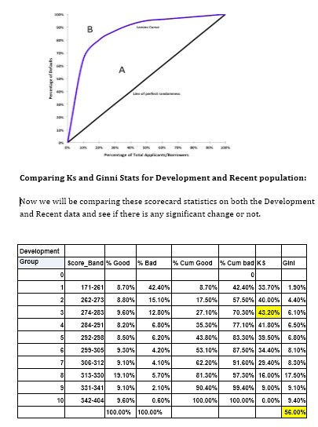

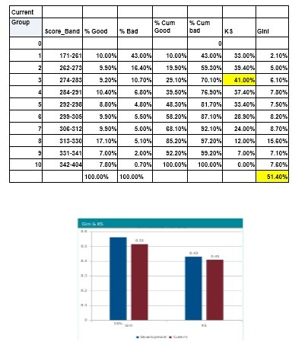

From the above table and plotted graph we can make following observation:

●     The Gini Coefficient value has slightly reduced from 56% at time of development, to 51% for the recent population. A Gini of 51% is classified as very strong for an application scorecard and hence the predictive power of the scorecard will add value to the decision making process.

●      The KS has reduced marginally from 43% to 41% which is still a good score for an application scorecard.

Conclusion

In this step-by-step guide to application scorecards tracking we have covered all the steps in tracking application scorecards using PSI, Characteristic Analysis, showing vintage analysis, rollrates, scorecard statistics etc. The following are the conclusions that we have drawn from our above problem case:

●     We saw a Population Stability Index of 0.02, indicating almost no change in score distributions in recent population as compare to development data.

●     As the Population Stability Index does not indicated any significant change in score distributions, so similarly, there are no characteristics indicating a shift in their distributions. This is an optional step it is needed only when we have a PSI>.25 showing change in score distribution.

●     Roll Rate analysis (Backward) showed us that our current default definition of 90+DPD still holds good for the recent population.

●     A marginal decrease in the Gini coefficient was observed, from 56% at development to 51% for the current period. A Gini of 51% is still considered strong for application scorecards as any value below 30 represents a weak model. The KS has reduced marginally from 43% to 41%.

However we need to continue with the scorecard monitoring to ensure stability of the scorecard performance, specifically on population shift and certain characteristics for closer monitoring going forward.