Credit Risk

# Credit Risk Definitions

|  |  |  |
| --- | --- | --- |
| Term | Definition | Explanation |
| Credit | Funds lent out to borrowers. The borrowers can be both retail or commercial borrowers. Retail refers to household borrowers and commercial borrowers are mainly firms. | To assess those sources from where stochasticity in the cash flow of banks would arise from the funds which are lent out to households and/or commercial borrowers. |
| Risk | An event which creates a stochasticity in the cash flow of the banks. |  |

# Banks

|  |  |  |
| --- | --- | --- |
| Term | Definition | Additional Details |
| Banks | Financial institutions which channelise the funds across the economy. | Formula: Demand = Supply → Investment = Savings |
| How can the banks do this? | There are two sides for the funds: (i) Demand for funds, (ii) Supply of funds. The bank’s objective is two-pronged:  1. Efficiently channelise the funds from the suppliers to the demanders  2. Make profits in between. | Banks make profits through interest differentials: by borrowing from a low-risk segment (Households) and lending to high-risk segments (Entrepreneurs, producers). |

# Economic Agents and Funds Flow

|  |  |  |
| --- | --- | --- |
| Economic Agent | Role | Funds |
| Household | Supplier of funds → deposits the funds with the bank | Deposits ₹5000 @ 4% |
| Bank | Channels the funds | Holds ₹5000 |
| Producer | Demands the funds | Requires ₹5000 |

### ****1. Consider the 5 Cs of Credit Risk****

The 5 Cs of credit risk provide banks and lending institutions a framework to identify the inherent risks in lending and mitigate credit risks. The 5 Cs are:

**Character**  
Evaluates the counterparty’s or borrower’s credit history, credit scores, payment behavior, and references.

**Capacity**  
Assessment to determine the ability to repay the debt and ascertain the debt-to-income ratio.

**Collateral**  
Evaluation of assets & collaterals pledged by the borrower for a loan; essential for credit risk mitigation.

**Conditions**  
Analysis of external factors and economic conditions that may impact the loan terms and the borrower’s ability to repay.

**Capital**  
Refers to the down payment or investment made by a borrower to secure a loan. This helps banks mitigate credit risk in case of a default.

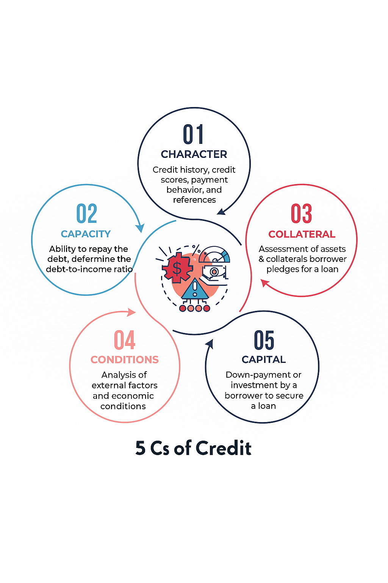

## ****2. Robust Credit Policies & Procedures****

Prepare a credit policy with well-defined criteria outlining the **guidelines and procedures** for making decisions to safeguard the bank against financial risks. This sets the foundation for **effective credit risk management**.

The policy should clearly state:

Terms of sale

Credit extension

Collection process

## ****3. Robust Underwriting Standards****

Robust underwriting standards are stringent and well-defined **guidelines for banks and financial institutions**. They help ensure that only **eligible and low-risk individuals or entities** are approved for loans, thereby:

Safeguarding against excessive risk

Minimizing adverse selection

Maximizing profitability

### It also helps determine:

✅ Amount of debt that should be issued

✅ Terms of the loan

✅ Interest rates

### According to the ****Federal Deposit Insurance Corporation (FDIC)****

While the FDIC doesn’t set underwriting standards, it provides **guidelines and best practices** for banks, including:

✔ Evaluate the applicant’s repayment willingness and capacity

✔ Review credit history and performance on past/existing obligation

✔ Assess income (including self-employment & investment income)

✔ Consider the borrower’s overall credit relationship with the bank

## ****4. Adequate Allowance for Loan and Lease Losses (ALLL)****

The purpose of ALLL, originally referred to as **"reserve for bad debts,"** is to estimate **credit losses** in the bank’s portfolio of loans and leases.

Banks and financial institutions must maintain ALLL to absorb estimated credit losses and ensure they have **sufficient funds** to cover potential losses and maintain **adequate allowances**.

As per [FDIC](https://www.fdic.gov/" \t "_new), banks must develop a program to regularly review the adequacy of their allowance, which is critical to covering inherent losses.  
For this, banks must:

Understand the purpose of the allowance

Identify bad loans promptly

Implement a robust analytical process for estimating inherent losses in loan and lease portfolios

## ****5. Credit Risk Monitoring Processes****

Regular monitoring and assessment of changes in a borrower’s **risk profile** is crucial for banks to identify and manage potential credit risks. It involves:

📌 Periodic credit assessment

📌 Account review

📌 Timely follow-up on overdue payments

📌 Implementing effective collection strategies

These practices help banks **respond quickly to changes** and **minimize losses**. Changes that require attention include:

📉 Change in credit score (increase/decrease)

🗃️ Bankruptcy filings

🏢 Business structure or location changes

🔒 Company closure

⚖️ Lawsuits or liens

🔄 Change in management

Credit monitoring enables banks to make **informed decisions**, such as putting accounts on hold in case of legal or financial risks.

## ****6. Stress Testing****

Regular **stress tests** help banks and financial institutions identify potential **sources of credit risk** and vulnerabilities in the loan and lease portfolios.

Stress testing helps banks:

Analyze the ability to withstand recession

Assess the impact of adverse economic conditions

Identify weaknesses or vulnerabilities

Ensure sufficient capital adequacy ratio (CAR) to withstand shocks

Maintain regulatory compliance

Communicate risk clearly to all stakeholders

## ****7. Scenario-Based Analysis****

Scenario-based analysis helps banks:

Analyze the impact of specific economic scenarios

Create plausible future scenarios

Estimate potential credit losses

Identify areas requiring attention

Develop proactive risk mitigation strategies

## ****8. Build a Skilled Credit Risk Management Team****

Banks must have a skilled credit risk management team with **diverse skill sets**, including:

Statistical modeling

Risk assessment

Data analysis

Credit evaluation

They can hire experienced:

Credit officers

Loan underwriters

Analysts

Additionally, banks should **leverage digital learning solutions** to build a sustainable and measurable risk management workforce.

Key elements include:

🧠 Identifying relevant skill gaps

🔄 Ensuring continuous workforce training (skilling, reskilling, and upskilling)

📊 Assessing expertise and capabilities based on various parameters

## ****Credit Risk Mitigation Techniques****

Banks and financial institutions can use the following techniques to minimize the **adverse impact of credit risks**:

### ****1. Diversify Portfolios****

Avoid concentrating credit with a few customers or sectors. Instead, diversify across:

📊 Different asset classes (e.g., stocks and bonds) with varying risk levels

🌐 Different industries and sectors

🌍 International markets to avoid geopolitical risk

⌛ Both long-term and short-term investments

✅ This reduces concentration risk and cushions against adverse events or losses.

### ****2. Obtain Credit Insurance****

Banks can buy **credit insurance** as an added layer of protection.  
Credit insurance helps cover significant **losses due to borrower default** or economic downturns.

### ****3. Collateral for Security****

Banks can request **collateral** from borrowers to reduce risk.  
In case of default, the bank can seize and sell the collateral to recover the loss.

### ****4. Effective Collection Strategies****

Strong collection strategies help **reduce credit risk** and **recover outstanding debts**, including:

📅 Timely follow-ups on overdue payments

💬 Offering revised payment plans

🤝 Maintaining open communication with borrowers

### ****5. Collaborate with Credit Reporting Agencies****

Banks must work with credit reporting agencies and leverage their credit data to:

📊 Assess the creditworthiness of potential borrowers

🧠 Make informed decisions before extending loans or credit lines

This collaboration helps in early detection of risky borrowers and improves lending decisions.

### ****Conclusion****

Robust credit risk management relies on:

✅ Well-defined credit policies

✅ Comprehensive credit assessments

✅ Diversified portfolios

✅ Use of assets and collateral for securing loans

✅ Continuous credit monitoring

By implementing these best practices, **banks and financial institutions** can:

Reduce credit risk

Prevent financial losses

Ensure long-term success in their lending operations