# INVENTION DISCLOSURE FORM

Details of Invention for better understanding:

**1. TITLE:** AI Voice Recorder with Lesson Summarizer

**2. INTERNAL INVENTOR(S)/ STUDENT(S):** All fields in this column are mandatory to be filled

|  |  |
| --- | --- |
| A. Full name | **Rajat kumar** |
| ­­­­­Mobile Number | 7455893566 |
| Email (personal) | Rajatkumar39008@gmail.com |
| UID/Registration number | 12303780 |
| Address of Internal Inventors | School Of Computer Science and Engineering  Lovely Professional University, Punjab-144411, India |
| Signature (Mandatory) |  |
| B. Full name | Shreya Nigam |
| ­­­­­Mobile Number | 6306444186 |
| Email (personal) | nigamshreya21@gamil.com |
| UID/Registration number | 12309320 |
| Address of Internal Inventors | School Of Computer Science and Engineering  Lovely Professional University, Punjab-144411, India |
| Signature (Mandatory) |  |
| C. Full name | Dr.Ishan kumar |
| ­­­­­Mobile Number |  |
| Email (personal) |  |
| UID/Registration number | 23347 |
| Address of Internal Inventors | School Of Computer Science and Engineering  Lovely Professional University, Punjab-144411, India |
| Signature (Mandatory) |  |

**3. DESCRIPTION OF THE INVENTION:**

**1.1. Purpose**

The function of the AI Voice Recorder with Lesson Summarizer is to improve the classroom experience through an intelligent device that captures lessons and automatically creates short, simplified notes for students and teachers alike. It reduces the requirement for manual note-taking, benefits absent learners, and facilitates inclusive education through functions such as translation of languages and grade-level accommodations. By making review easier, the invention creates improved understanding, retention, and accessibility in today's classrooms.

**________________________________________**

**2. Technical Workings**

Audio Capture & Transcription

The technology employs a mobile or desktop app that captures live audio during a lesson. The audio is then processed using sophisticated speech recognition technology to translate spoken words into text in real time or after the session.

**Natural Language Processing (NLP) & Summarization**

After transcribing, the text is run through NLP algorithms to detect the lesson's structure, key points, and supporting facts. The AI creates two summaries:

A comprehensive one for the instructor (emphasizing what was covered, time spent, and key themes).

A condensed, grade-level-adapted one for students (emphasizing key takeaways, definitions, and bite-sized facts).

**Smart Timestamps**

The system tags significant lesson segments (e.g., recurring points or statements such as "this is important") with timestamps. These timestamps are clickable links, enabling teachers or students to skip to relevant areas within the audio.

**Language Translation**

For multilingual classroom support, the system has been integrated with a translation API (e.g., Google Translate) to translate summaries into several languages. Users can select their desired language from a dropdown list.

**Teacher Voice Notes**

Instructors can insert brief voice messages post-lesson or while recording, which are inserted into the summary. Such as, "This will be on the quiz" or "Review this before next class." These notes appear as playable icons alongside corresponding content.

**Sharing & Access**

The audio recordings and notes can be exchanged through email, stored in cloud storage (Google Drive, OneDrive, etc.), or exported as PDF. The teacher can send the summaries to absent parents or students directly.

**Offline Mode**

In case of weak or no internet connection, the app stores everything locally on the device and records it. When online, it syncs and processes the information automatically.

**______________________________________**

**3. Unique Attributes**

**Dual-User Design:** Produces various summaries for teachers and students from a single audio source.

**Grade-Level Adjuster:** Condenses or expands notes dependent upon the chosen school level.

**Click-to-Replay Timestamps:** Facilitates easy access and interactivity when reviewing key sections of the lesson.

**Voice-Embedded Feedback:** Provides teachers with a vehicle to directly affect the manner students read back content.

**Multilingual Support:** Increases accessibility for ESL students and multicultural classrooms.

**Offline Capability:** Assures dependability in low-connectivity situations.

**4. Conclusion**

The AI Voice Recorder with Lesson Summarizer is an innovative education device that revolutionizes the recording, reflection, and dissemination of classroom material. By integrating speech recognition, summarization AI, timestamping, and translation functionalities, it is an all-inclusive learning aid that caters to both instructors and learners. Its intelligent, user-friendly design educates and assists all users, increases classroom productivity, and facilitates learning to be more personalized, accessible, and efficient.

**A. PROBLEM ADDRESSED BY THE INVENTION**

**Today's classrooms are confronted with many challenges that affect the effectiveness of teaching, the efficiency of learning, and student engagement. The AI Voice Recorder with Lesson Summarizer solves the following major issues:**

**1. Burden of Manual Note-Taking**

Students tend to have difficulty taking detailed notes in quick-paced lessons. This can result in lost information, incomplete knowledge, and heightened stress—particularly for younger students or students with learning disabilities.

**2. Teachers' Repetition of Lessons**

Teachers are also often compelled to reteach material to absent or struggling students. Not only does this take valuable class time, but it also takes away from the teacher's capacity to deliver new information in an effective manner.

**3. Inadequate Study Materials**

Not all students have available to them neat notes or summaries that are specifically prepared for their level of understanding. General or too obtuse summaries often leave the student finding it difficult to study effectively, particularly between grades.

**4. Restricted Access for Multilingual Learners**

In culturally diverse classrooms, non-native-speaking students might have trouble keeping up with lessons as they happen in real time. Language barriers constrain access to primary content and are likely to further exacerbate learning gaps if translation tools are absent.

**5. Trouble Reviewing Specific Concepts**

Students frequently need to go back to a particular segment of a lesson (e.g., a definition, a crucial explanation), but existing tools lack timestamped access to identify precise moments in recorded material, so review is not efficient.

**6. Isolated Communication Between Students and Teachers**

There is rarely an easy manner for instructors to insert personal reminders, test strategies, or highlighted areas of attention within the coursework after class. Students lose the benefit of teacher knowledge when absent.

**7. Inequity for Absent Students**

During absences by students, they usually have to depend on fellow students' notes or second-hand descriptions, often incomplete or flawed. This renders the learning environment unequal and impairs overall performance in class.

**8. Conclusion**

The AI Voice Recorder with Lesson Summarizer addresses these issues by employing artificial intelligence to create structured, simplified, and accessible lesson summaries automatically. Equipped with timestamped highlights, multilingual translation, and role-based content (for students and teachers), this invention facilitates fair access to education, enhances retention, and supports better communication between teachers and learners. It revolutionizes classroom engagement, minimizes repetition, and enables studying to be more efficient and inclusive for every student.

1. **OBJECTIVE OF THE INVENTION  
   • Improve Teaching and Learning Effectiveness**One of the main aims of the AI Voice Recorder with Lesson Summarizer is to enhance general classroom productivity through time saving on manual note-taking and redundant teaching. The system records lessons automatically and turns them into organized overviews, and students get to listen more and understand more while having teachers spend more time interacting constructively with their students. **• Support Inclusive and Personalized Education**One of the principal aims of the invention is to enable support of varied learning settings through the provision of functionalities such as grade level-correct summaries and multilingual translation. This way, different students of varied ability, grade levels, and linguistic backgrounds obtain unambiguous, readable content appropriately modified for them, contributing towards improved learning equity and inclusion overall.  
   **• Support Learning Continuity for Absent Students**The invention also works to reduce learning loss in cases where students miss school because they are ill, traveling, or for some other reason. Instant access to summary lessons and most important moments through timestamps allows for no one student to fall behind and enables the continuity of learning.  
   **• Improve Teacher-Student Communication**Another goal is to improve the students-teachers feedback loop. With the ability to insert voice notes into summaries, teachers can provide individualized tips and exam-related advice, guiding students better on what to prioritize for study.  
     
   **A. STATE OF THE ART/ RESEARCH GAP/NOVELTY:  
     
   Sr. No. Study Abstract Research Gap Novelty**
2. **1 AI-Based Note-Taking Tools in Education**

This research examines AI tools that aid student notetaking by recording lecture material and summarizing it through NLP models.  
The majority of tools are intended for personal use and do not distinguish between outputs for teachers and students.  
The invention generates role-based summaries, providing customized content for students and teachers from the same lecture.

**2 Classroom Automatic Speech Recognition (ASR)**

Studies investigate applying ASR to live transcription in classrooms to enhance accessibility for students with disabilities.  
Current systems only emphasize raw transcription and not contextual summarization or organization.  
This invention combines summarization and keyword extraction to facilitate content review and comprehension.  
**3 Multilingual Learning Apps with Translation Capabilities**

Learning apps such as Google Classroom and Duolingo provide multilingual students with simple translation capabilities.  
These learning apps do not translate educational abstracts or grade content.\tThe invention provides AI-translated, grade-level summaries, which increase diversity inclusion in classrooms.

**4 Video/Audio Review Tools with Timestamps**

Platforms such as Zoom provide timestamped recordings for review after meetings.  
These do not have automatic timestamping of significant events during real-time teaching.  
This uses AI to automatically generate intelligent timestamps for significant lesson points, making it easier to navigate and review.

**5 Teacher Voice Note and Feedback Tools**

Sometimes, teachers can include feedback or voice notes.  
Separate from content or platforms, feedback is separated and decreases context and clarity.  
The invention integrates teacher voice notes into summaries directly, providing in-context, targeted guidance to students.  
 **Conclusion:**The AI Voice Recorder with Lesson Summarizer fills some of the fundamental gaps in existing education technologies by providing an integrated platform that merges real-time speech-to-text transcription, dual-role summarization, multi-lingual capabilities, intelligent timestamping, and in-line teacher voice commentary. In contrast to other tools that only partially function, this invention is a complete, class-use ready solution that improves the efficiency of learning, accessibility, and student engagement. Its distinct blend of functionalities establishes a new benchmark for intelligent classroom assistance systems.  
 **B. DETAILED DESCRIPTION:**

• The AI Voice Recorder with Lesson Summarizer is an intelligent learning support system that captures classroom lectures and automatically produces clear, concise lesson summaries for both teachers and students. This invention combines sophisticated speech recognition, natural language processing (NLP), and artificial intelligence (AI) to facilitate classroom communication, reinforce learning, and enhance accessibility.  
**________________________________________  
 2. System Components  
2.1 Recording and Transcription Module  
Audio Capture Unit:**

An in-built or attached microphone records the teacher's voice for a lesson with one tap. This can be embedded in a mobile app, tablet, or classroom device.

**Speech-to-Text Engine:**

Transcribes live or recorded speech into a text transcript based on real-time speech recognition technologies like Whisper, Google Speech-to-Text, or comparable APIs.

**2.2 Summarization Engine  
Dual Summary Generator:  
Teacher Summary:** Gives a brief, organized summary of the lesson material (e.g., "Topic: Water Cycle; Covered: Evaporation, Condensation, Precipitation").

**Student Summary:** Generates a reduced version of the material based on grade level, emphasizing main points and easy-to-understand language (e.g., "Water goes up, forms clouds, and comes down as rain.").

**Grade-Level Adjuster:** Teachers choose a grade level, and the AI automatically adjusts complexity and vocabulary to meet the learner's ability to comprehend.

**2.3 Smart Tagging and Timestamping Module  
• AI Timestamp Detection:** Emphasizes key lesson points (e.g., "10:05 – Photosynthesis begins") by identifying cue phrases such as "This is important," or duplicated keywords.

**• Clickable Links:** Timestamps are shown in clickable form that users can tap to replay significant audio parts or advance to related notes.

**2.4 Translation and Accessibility Layer  
•Multilingual Support:** Translates summaries automatically into several languages (e.g., Spanish, Mandarin) using translation APIs to enable multilingual classrooms.

**•Offline Mode:** Recorded and summarized content are stored locally and synced when the connection is reestablished if there is no internet access.

**2.5 Teacher Voice Note Integration  
•Annotation Interface:** Enables short (e.g., 10-second) voice annotation by the teacher to highlight particular sections of the lesson (e.g., "This will be on the test.").

**•Playback Icon**: Voice notes are inserted into the summary and symbolized by a play icon beside applicable content.

**•2.6 Sharing and Export Options  
•PDF Export**: Summaries can be downloaded and saved as organized PDFs. **•Sharing Tools:** Notes can be shared using email, Google Drive, or messaging platforms, enabling the teacher to quickly transmit them to absent students or parents.  
**________________________________________  
Technical Functionality  
3.1 AI-Powered Lesson Summarization**

**• Context Understanding:** NLP and ML models trained on educational material are used by the system to extract key concepts and present them in bite-sized summaries.

**• Role-Based Filtering**: Based on whether the user is a student or teacher, the summary is presented differently—teachers are given a more detailed breakdown, whereas students are provided with key concepts and definitions.

**3.2 Timestamped Lesson Mapping  
• Dynamic Tagging:** Machine learning identifies topic changes and highlights key content based on teacher prompts and repetition patterns.  
**• Interactive Review**: Users are able to review any point in the recording via an indexed list of key points with accompanying timestamps.  
**3.3 Grade-Level Optimization  
• Simplification Algorithms:** Language models simplify or expound lesson summaries depending on the chosen grade level, making sure that content is suitable for the age group.

**• Vocabulary Matching:** Includes vocabulary and examples appropriate to each grade, enhancing understanding and retention.  
 **4. Unique Features  
 4.1 Shared Resource Creation**

**•** Unlike most AI summarizers that are standalone tools, this system is intended for shared use—teachers develop content that is automatically transformed and presented to students in usable forms. **4.2 Adaptive Learning Enhancement  
Voice Emphasis Tools:** Teachers can emphasize important ideas with voice a nnotations, instructing students on what to pay attention to when revising.

**•Fun Feedback System:** At the end of each summary creation, students get positive feedback in the form of stars, badges, or messages ("Nice work reviewing today's topic!") to encourage them.

**4.3 Seamless Usability and Integration**• The interface is one-tap easy, so even non-technical teachers can use it.  
• Integration with popular educational platforms (Google Classroom, Microsoft Teams) makes syncing with current classroom tools a breeze.  
 **Conclusion**The AI Voice Recorder with Lesson Summarizer is an education technology that integrates artificial intelligence, real-time audio processing, and natural language understanding to optimize classroom learning as efficient, inclusive, and accessible. Through the production of adaptive, dual-format summaries augmented with timestamps, translations, and teacher commentary, this system converts passive listening into active, structured, and revisitable learning. Its scalable, user-centric design facilitates modern education's increasing need for automation, equity, and multilingual communication in diverse learning environments.

**Process Workflow:**

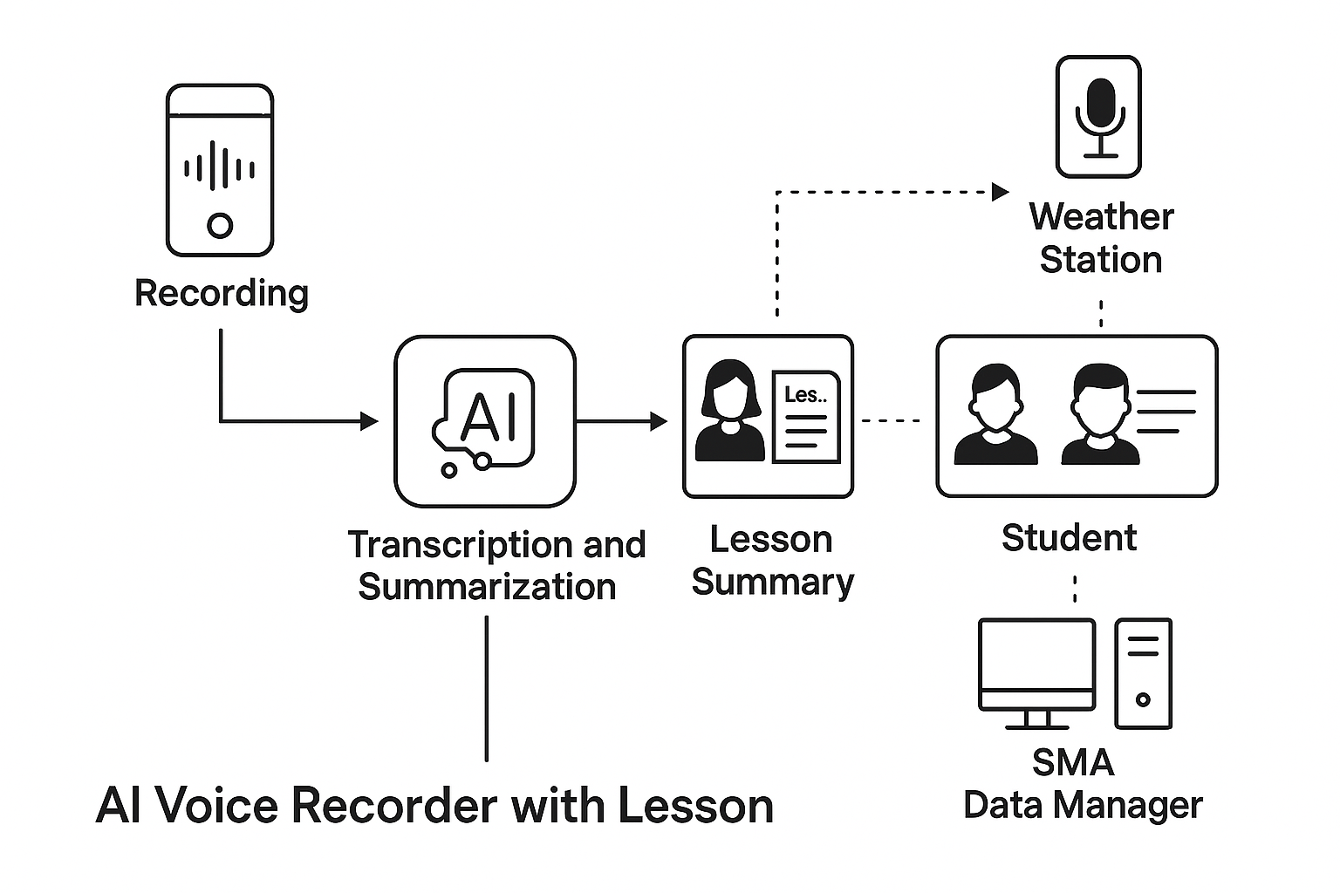

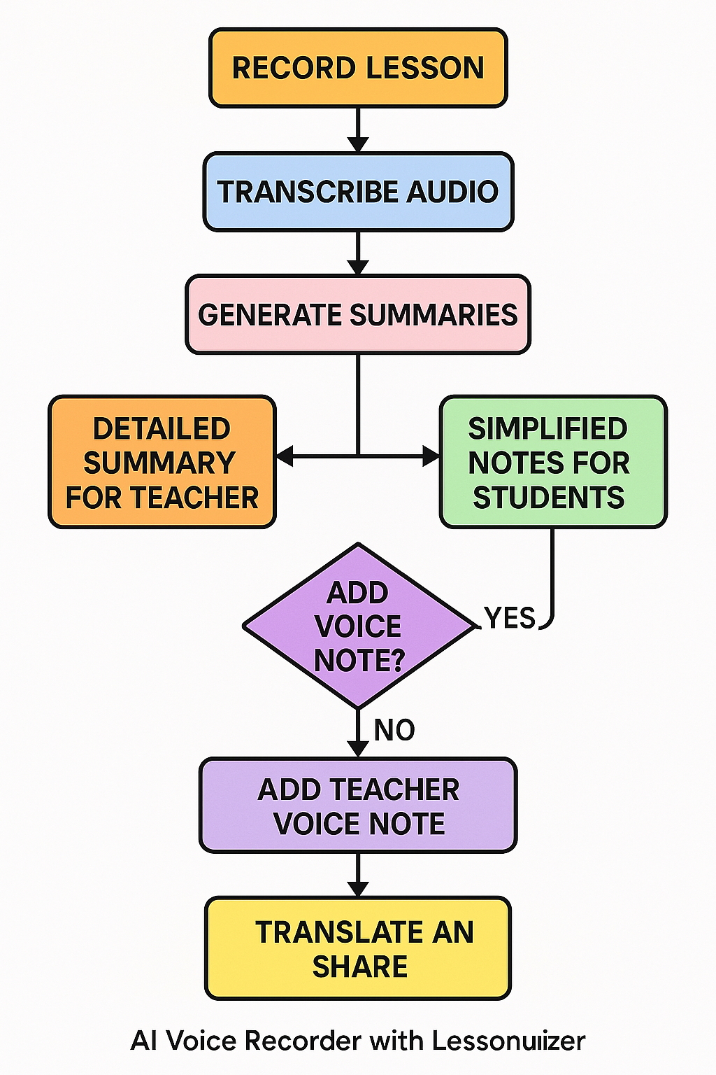

• E. RESULTS AND ADVANTAGES

The AI Voice Recorder with Lesson Summarizer presents a revolutionary solution that closes the gap between instructional delivery and learning, turning ordinary classrooms into smart, inclusive, and highly efficient learning spaces. The following are the most important results and advantages that distinguish this system from other educational tools:

**• 1. Increased Educational Efficiency**

**• Reduced Redundancy for Teachers:** Teachers no longer have to repeat material for students who are absent or during revisions because lessons are automatically summarized, conserving precious instructional time.

**• Improved Focus for Students**: Students can concentrate more on comprehension instead of rushing to take notes, knowing that correct summaries will be provided.

**• 2. Smart, Personalized Content Delivery**

**• Grade-Level Note Simplification:** Summaries by AI are adjusted for complexity according to the chosen grade level. A 3rd grader and a 10th grader get context-relevant material, making them easier to understand and remember.

**• Dual-View Outputs:** Separate summaries for students and teachers facilitate better communication and enable more valuable post-class review.

**• 3. Real-Time Intelligence and Accessibility**

**• Timestamps for Key Moments**: Significant points are automatically time-marked (e.g., "10:05 – Photosynthesis explained"), facilitating easier review, revision, or highlighting for exams.

**• Teacher Voice Annotations:** Teachers can include 5–10 second voice annotations (e.g., "This will be in the test"), giving AI-created content a personal touch.

**• 4. Multilingual and Inclusive Learning**

**• Real-Time Translation:** Summaries are translated into several languages, so the system is extremely effective in multilingual classrooms or with ESL (English as a Second Language) students.

**• Universal Accessibility**: Allows all students—regardless of disabilities or learning difficulties—to view structured, simplified lesson materials.

**• 5. Flexibility and Scalability**

**• Classroom to Cloud**: Functions on mobiles, tablets, or web-based platforms, providing compatibility with varied school tech infrastructures.

**• Offline Mode:** Recorded lessons and saved locally in instances of limited internet connectivity, syncing upon regaining connection necessary for resource-strained or rural schools.

**• 6. Reduced Cost and Maintenance**

**• No Manual Transcription Required:** Avoids expenses related to hiring note-takers, transcription facilities, or additional teaching staff.

**• Low Maintenance:** Being software-first, it steers clear of physical wear-and-tear or reliance on costly hardware.

**________________________________________**

**• 7. Enhanced Teacher-Student Collaboration**

**• Mutual Learning Resource**: No longer a one-way device, teachers and students both gain equally—teachers receive feedback-ready summaries, students receive tailored revision material.

**• Student Engagement Lift:** Amusing, animated feedback ("Great job!" or "Lesson saved! ⭐") boosts usage in younger learners**.**

**• Comparison to Current Prior Art**

The AI Voice Recorder with Lesson Summarizer differs from the other learning tools and systems in a number of innovations:

**• Compared to Simple Audio Recorders:** Older recorders are unintelligent—this system not only records but interprets, summarizes, and contextualizes lessons**.**

**• Compared to Note-Taking Apps:** While numerous apps organize notes, they require manual input. This system automatically produces notes with context-sensitive AI.

**• Compared to Smartboards or EdTech Suites:** In contrast to heavy or infrastructure-dependent tech, this is lightweight, mobile, and customized for dynamic real-world classroom demands.

**• Conclusion**

AI Voice Recorder with Lesson Summarizer is not merely a tool, but a clever classroom companion. By overcoming access challenges, conserving time, offering individualized learning, and being multilingually inclusive, it revolutionizes the way information is recorded, disseminated, and remembered. It is a next-generation innovation in education—intelligent, flexible, and made for every student.

**B. EXPANSION:**

To guarantee comprehensive functionality, accessibility, and general use of the AI Voice Recorder with Lesson Summarizer, some critical variables need to be taken into consideration. These variables impact the design, performance, and utility of the system across different educational environments:

**______________________________________**

**1. Device and Platform Compatibility**

**• Form Factor Flexibility:** The system should be compatible on a variety of platforms, such as smartphones, tablets, and specific classroom devices. This guarantees usability in technologically rich as well as resource-constrained educational settings.

**• Operating Systems:** Supporting key operating systems (iOS, Android, Windows, etc.) allows for wider accessibility across schools utilizing different devices.

**________________________________________**

**2. AI Processing and Summarization Accuracy**

**• Speech Recognition Accuracy:** High-fidelity speech-to-text, particularly in the noisy classroom setting, is crucial. Support for various accents and speech patterns is a usability plus**.**

**• Natural Language Understanding (NLU):** The AI needs to correctly identify and extract key topics, learning goals, and repeated themes to create meaningful summaries.

**• Role-Based Summaries:** Tailoring outputs separately for teachers and students enhances relevance—teachers get formatted summaries and students receive simplified, child-friendly notes.

**3. Smart Timestamping and Navigation**

**• Real-Time Tagging:** The system should identify prominent clues (e.g., "this is important," teacher stress, or subject changes) and create clickable timestamps for easy access.

**• Replay Capabilities:** Facilitating rapid entry to precise points enhances review efficiency for teachers and students alike.

**4. Multilingual and Accessibility Support**

**• Language Translation:** Integration with translation APIs enables automatic translation of summaries into other languages, supporting multilingual classrooms.

**• Accessibility Features:** Text-to-speech inclusion, screen reader support, and visual aids improves access for students with disabilities.

**________________________________________**

**5. Teacher Voice Note Integration**

**• Supplemental Audio Notes**: Teachers are able to record brief audio inserts (e.g., tips on exams) that are included in the summary and tagged to timestamps.

**• Student Interface:** They are provided as highlighted, tappable icons, which provides an individual engagement with the content.

**_____________________________________**

**6. Sharing and Storage of Content**

**• Export Options:** Notes and summaries must be made easily shareable through email, Google Drive, or downloadable PDFs to facilitate asynchronous learning and parental engagement.

**• Cloud Sync and Offline Mode:** The system must accommodate local recording with delayed cloud sync to provide functionality in regions of low connectivity.

**_____________________________________**

**7. User Interface and Experience Design**

**• Grade-Level Adjuster:** Teachers can choose the grade level, and the system will adjust language complexity and depth of content automatically.

**• Visual Engagement:** Welcoming animations and encouraging feedback (e.g., stars, badges, or encouraging messages) encourage regular use by students.

**• Minimalist Controls:** A simple, intuitive UI enables teachers to start recording and reviewing summaries with little training.

**________________________________________**

**8. Data Privacy, Compliance, and Security**

**• Student Data Protection:** The system should be FERPA, GDPR, and other data privacy compliant to safeguard student and teacher recordings.

**• Secure Storage:** Audio file and summary encryption ensures secure storage and prevents unauthorized access.

**________________________________________**

**9. Maintenance and Technical Support**

**• System Updates**: Periodic AI model updates and bug fixes should be supported to maintain long-term effectiveness.

**• Training Materials:** Easy-to-use onboarding guides and support materials enable users to learn and utilize all features efficiently.

**________________________________________**

**Conclusion**

By accommodating these primary implementation variables, the AI Voice Recorder with Lesson Summarizer can successfully convert classroom audio into organized, tailored, and disseminable content. The platform improves learning continuity, minimizes note-taking load, and offers equal access to lesson materials—either for in-class consumption, remote learning, or catching up on missed material. Careful thought on these aspects guarantees scalability, flexibility, and sustained educational effect.

1. **WORKING PROTOTYPE/ FORMULATION/ DESIGN/COMPOSITION**

**Prototype not ready for work. At least one year will be required to finish it.**

**• D. EXISTING DATA:**

In support of the development and validation of the AI Voice Recorder with Lesson Summarizer, it is crucial to rely on available data and comparison studies that showcase the increasing importance of AI in education, the efficacy of speech recognition and summarization technology, and the advantages of individualized learning aids. Below are a number of categories of available data that support the practicability, applicability, and possible influence of this invention.

**________________________________________**

**• 1. Performance of Speech Recognition and Summarization Systems**

**• Accuracy of ASR in Classroom Environments:** Studies by the Stanford Human-Centered AI Initiative and APIs such as Google's Speech-to-Text API suggest that automatic speech recognition (ASR) can achieve greater than 90% accuracy in controlled environments and continues to advance in noisy environments using methods such as speaker diarization and real-time noise filtering.

• **Advancements in Educational Summarization:** Natural Language Processing (NLP) technologies such as models such as OpenAI's GPT and BERT have shown impressive capabilities in the generation of readable, succinct summaries from long-form audio or text-based data. Such models are being integrated in platforms like Otter.ai and Notion AI, confirming their value in education environments.

**• 2. Benefits of AI-Powered Learning Tools**

**• Better Student Performance:** According to a 2022 McKinsey & Company study of AI in K-12, students who applied AI-powered tools to support learning achieved 15–20% better on retention-based tests through bite-sized, contextualized explanations.

**• Teacher Time Savings:** AI-based tools that take over notetaking or grading can save teachers as much as 2–4 hours a week, as reported by the Brookings Institution, so that they can spend more time on one-on-one instruction and feedback.

**• 3. Language Accessibility and Multilingual Education**

**• Multilingual Tool Effect in Classrooms:** Statistics from UNESCO reveal that language-embracing classrooms drastically enhance comprehension and participation by non-native language speakers. Automatically translated summary tools narrow the gap in language barriers and create equalities.

**• World Applications:** Examples of applications like Microsoft Translator for Education and Google Translate within Google Classroom have already established the validity of embedded multilingual assistance, with recorded performance enhancements in participation among ELL (English Language Learner) students.

**• 4. Grade Level or Learning Needs Customization**

**• Adaptive Learning Technologies:** A study in the Journal of Educational Psychology indicates how AI that adapts content complexity according to age or skill results in increased engagement and long-term retention, particularly in children.

**• Curriculum Mapping for Summarization**: Initiatives like Khan Academy's learning model and IBM Watson Education illustrate how AI can match summaries and content to age and grade-level education standards for better consistency with grade-level expectations.

**• 5. Trends in Classroom Adoption of Technology**

**• Emergence of AI in Classrooms**: The OECD 2021 EdTech Report identifies an increasing trend toward AI-based classroom tools, as more than 60% of schools surveyed across OECD countries investigate AI utilization in teaching and learning.

**• Education Use of Devices:** Based on EdTech Magazine, more than 70% of American schools are using tablets or laptops in class today, making app or mobile-based solutions such as your system viable for large-scale implementation.

**• 6. Comparison between Notetaking and Learning Tools**

**• Manual vs. Automated Notes:** Research conducted by Harvard's Graduate School of Education reveals that students using organized AI-developed notes understand more than others using only hand-written notes, particularly when summarizations contain pictures and timestamps.

**• User Satisfaction & Usability:** Applications such as Sonocent Audio Notetaker and Glean indicated a user satisfaction rate of above 80%, with students testifying to increased reduced stress levels and enhanced attention during class sessions.

**• Conclusion**

Current evidence from educational research, pilot initiatives, and commercial EdTech solutions firmly underpins the creation of the AI Voice Recorder with Lesson Summarizer. From the extremely high accuracy of ASR and NLP to established effects on student achievement, multilingual access, and teacher effectiveness, the underlying technologies for this invention are mature and widely established. These findings assist in establishing the practical feasibility, widespread appeal, and innovative benefit of your system. You integrate these findings into your application to bolster its applicability and underscore its future transformative impact on learning.

**4. USE AND DISCLOSURE (IMPORTANT):**

A. Did you describe or show your invention/design to any person or in any conference?

➡ NO

B. Did you make any effort to commercialize your invention (e.g., did you approach any companies to buy or produce your invention)?

➡ NO

C. Was your invention described in any printed publication, or any other kind of media, e.g., the Internet?

➡ NO

D. Do you have any partnership with any other institution or organization on the same? Give name and other details.

➡ NO

E. Name of Regulating body or any other clearances if applicable.

➡ NO

5. Give links and dates for such actions if the information has been put in public (Google, research papers, YouTube videos, etc.) prior to being shared with us

➡ NA

6. Offer the terms and conditions of the MOU even if the work is carried out in collaboration within or outside university (Any Industry, other Universities, or any other organization)

➡ NA

7. Possible Opportunities of Commercialization

**➡ YES**

This invention has excellent commercialization potential in the emerging EdTech sector. The fact that it can automatically create bite-sized lesson summaries for teachers as well as students, and other features such as grade-level adaptation of notes, multilingual translation, timestamp tagging, and offline usage, render it a usable and scalable option for classrooms globally.

**______________________________________**

**8. List of companies which can be approached for commercialization along with the website link**

Some of the firms in EdTech and AI learning technology with potential as a partner for commercializing the AI Voice Recorder with Lesson Summarizer are as follows:

**1. Khan Academy**

o Summary: A not-for-profit providing customized, AI-based learning resources with potential for smart summarization technologies.

Website: https://www.khanacademy.org

**2. Microsoft Education**

**Summary:** Provides software such as Microsoft Teams for Education, Immersive Reader, and AI tools with which classroom summarization systems may integrate.

Website: https://education.microsoft.com

**3. Google for Education**

**Overview:** Supports Google Classroom, Docs, and Translate tools which may be beneficially enhanced with AI summarization and multilingual classroom integration.

Website: https://edu.google.com

**4. Duolingo**

**Overview:** Popular for language learning through AI, they might take an interest in this tool's translation and classroom communication capabilities.

Website: https://www.duolingo.com

**5. Notion AI**

Overview: Provides notetaking and summarizing features for students and teachers. Might be interested in classroom-specific use.

Website: https://www.notion.so/product/ai

**________________________________________**

**9. Any fundamental patent we have utilized, and we must pay royalty to them**

➡ None as of now. No royalties paid. (A search of prior art will ensure patent independence prior to final filing.)

**10. FILING OPTIONS: Mention the extent of your work that may be submitted for provisional/complete/ PCT filings**

**➡ PROVISIONAL**

**6.**

**11. KEYWORDS**

• AI in Education

• Smart Lesson Recorder

• AI Note Generator

• Voice-to-Text for Classrooms

• Student Learning Assistant

• Teacher Summary Tool

• Natural Language Processing

• Real-Time Lesson Summarizer

• Multilingual Education Tool

• Grade-Based Note Customization

• Educational AI Assistant

• Classroom AI Recorder

• Timestamped Lecture Notes

• Offline Learning App

• EdTech Innovation

• Bite-Sized Study Notes

• Accessible Learning AI

• Digital Notetaking

• Personalized Education

**NO OBJECTION CERTIFICATE**

This is to certify that University/Organization Name or its associates shall have no objection if Lovely Professional University files an IPR (Patent/Copyright/Design/any other…….) entitled "…………………." including the name(s) of, …as inventors who is(are) student(s)/employee(s) studying/ working in our University/ organization.

Further Name of the University/Organization shall not provide any financial assistance in respect of said IPR nor shall raise any objection later with respect to filing or commercialization of the said IPR or otherwise claim any right to the patent/invention at any stage.

(Authorised Signatory)