**EXPERIMENT**

**AIM**

**Fuzzy Controller Design using *fuzzy* GUI tool in MATLAB**

**CODE**

This code plots the output of scope using the *plot* function

%%experiment 3

figure(); plot(without_fuzzy(:,1),without_fuzzy(:,2));

xlabel('time in sec');

ylabel('amplitude');

**SIMULATION DIAGRAM**

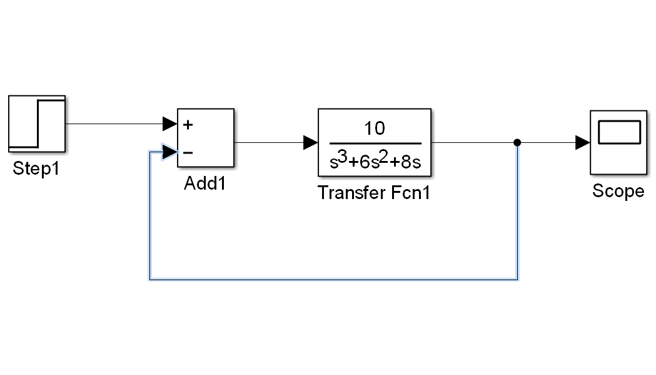

**Time domain plot of the system:**



This represents the fact that the output of the system has a peak overshoot at 2.45 seconds with its magnitude 20%

Also, Settling time is very high.

Steady state value is 1.

**MATLAB COMMAND**

Fuzzy tool box can be opened using the fuzzy toolbox option present in the MATLAB user Interface or can be accessed as following:

**>>fuzzy** presents us with the following GUI.

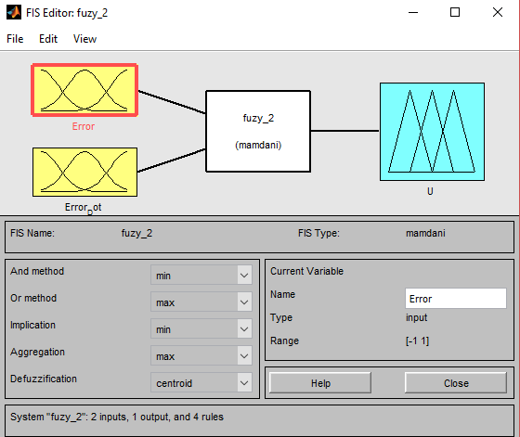

**Membership Functions:**

1. **Error**

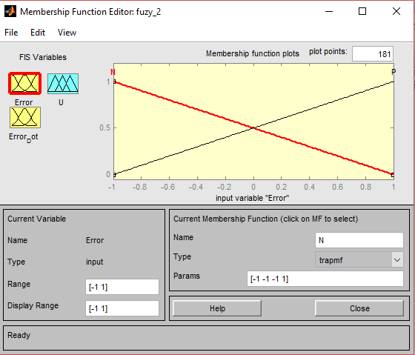

**Error function is defined as above.**

1. **Error Dot**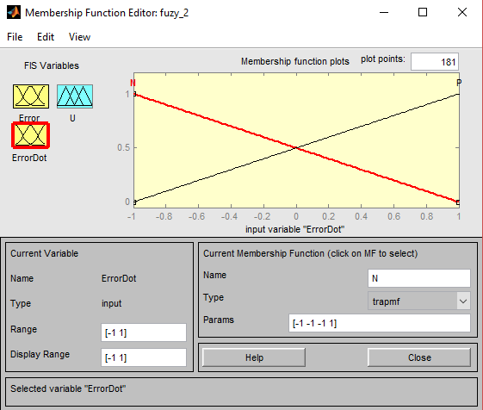

**Change of error is defined as above.**

1. **U**

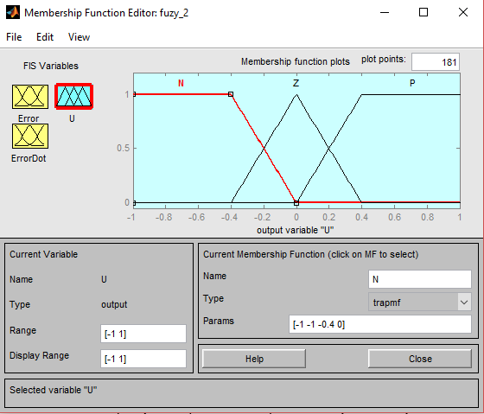

**U is the output variable decided and its shape is as described above.**

**Fuzzy Rules**

As per TABLE 1, we have following rules defined in fuzzy RULES option.

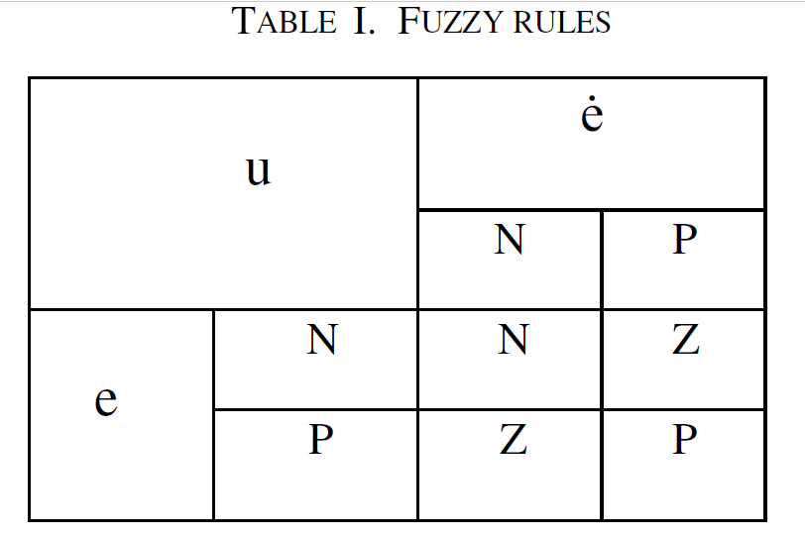

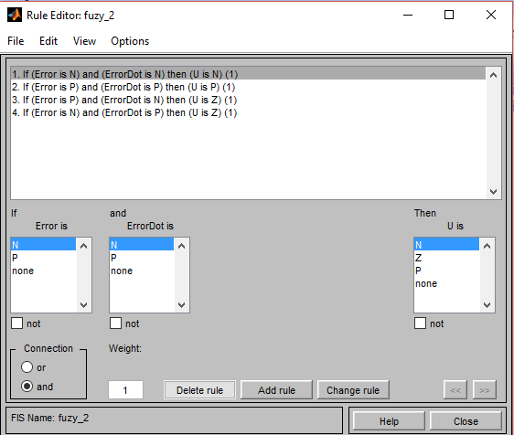

**SIMULATION MODEL USING FUZZY CONTROLLER**

After exporting the fuzzy system to WORKSPACE, create a **Simulink** **Model** as shown below:

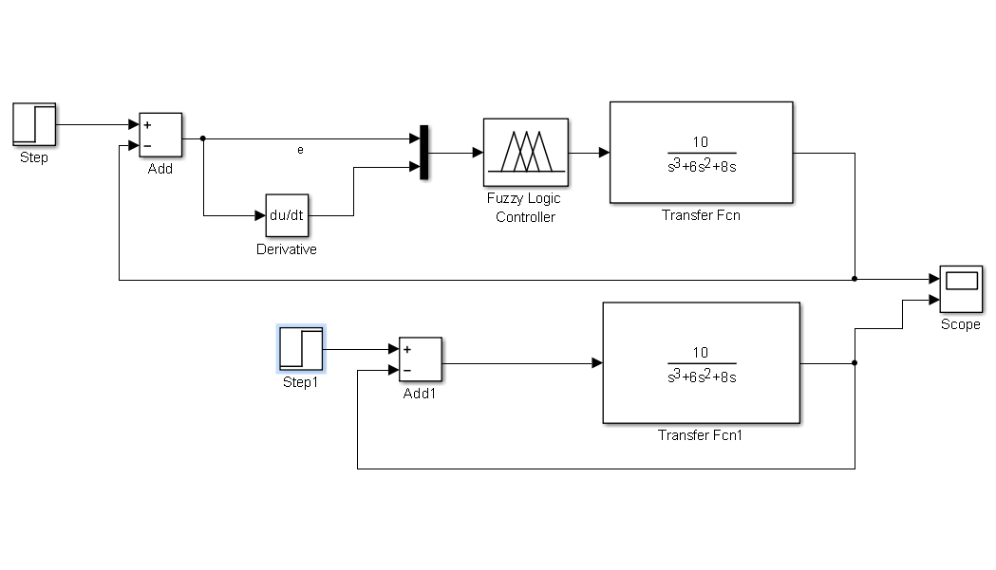Run the simulation to obtain the output (unit step response) of the system using the fuzzy logic controller:

