**Integration of Node JS and MongoDb**

1. **Version Support**
   1. **Node :** 8.10.1 or above
   2. **NPM :** 5.6.0 or above
   3. **Mongo Db :** 3.2.X or above
2. **MongoDb Setup**
   1. Download and install MongoDb, follow this link <https://www.mongodb.com/download-center#enterprise>
   2. Create new folder **data** in your C drive
   3. Inside data folder again create new folder **db.** ForExample: C:\data\db
   4. Start Mongo Db server C:\Program Files\MongoDB\Server\3.2\bin > **mongod.exe**
   5. Now create database and collection(table) using MongoDb
   6. Open cmd in the same folder and run command **mongo.exe**
      1. Create Database : run **use database_name.** For ex “use test”, it will create a database with name test
      2. Create Collection: After switching into database test run **db.createCollection(“employee_details”)**
      3. Run **show dbs,** if it will show the name of your database and then database is created
      4. Create Database: run **db.employee_details.insert({name:"rajat",id:"101"})**
      5. For verification run : **db.employee_details.find()** if it is printing output

|  |
| --- |
| { "_id" : ObjectId("5b3dbd2d0691635dfad42b53"), "name" : "rajat", "id" : "101" } |

Then you have successfully created the database.

1. **Node JS Setup**
   1. Create new node project
   2. Open Node JS terminal and run following commands:
      1. npm install
      2. npm init
   3. Create new file by name **index.js** and insert this code

var express = require('express');

var app = express();

app.get('/', function(req, res){

res.send("Node is saying Hello!!");

});

app.listen(3000, console.log('Server Listening on port 3000'));

* 1. Now run **node index.js** and then open <http://localhost:3000/>
  2. If it prints “Node is saying Hello”, we are going good and Node setup is done.

1. **Using Node JS with MongoDb**
   1. Run “ **npm install mongodb –save ”** in the Node terminal
   2. Now import the MongoDb dependencies in the project

var MongoClient = require('mongodb').MongoClient;

var url = "mongodb://localhost:27017/mydb";

* 1. Now Connect Node with Mongo server, copy the following code:

MongoClient.connect(url, function(err, db) {

if (err) throw err;

var dbo = db.db("test");

console.log("Database created!");

dbo.createCollection("employeee_details", function(err, res) {

console.log("Collection created!");

db.close();

});

var myobj = [

{ name: "Rajat", id: "101" },

];

dbo.collection("users").insertMany(myobj, function(err, res) {

console.log(res);

db.close();

});

1. **Steps for verification**
   1. Start Mongo Db server: C:\Program Files\MongoDB\Server\3.2\bin > **mongod.exe** command
   2. Run **node app.js** command, if it is giving output in console like

|  |
| --- |
| Server Listening on port 3000  Database created!  Collection created!  { result: { ok: 1, n: 1 },  ops: [ { name: 'Rajat', id: '101', _id: 5b3dc2e0e7e69d3218c54115 } ],  insertedCount: 1,  insertedIds: { '0': 5b3dc2e0e7e69d3218c54115 } } |

Then everything is working fine.

**ScreenShots:**

1. **MongoDb**

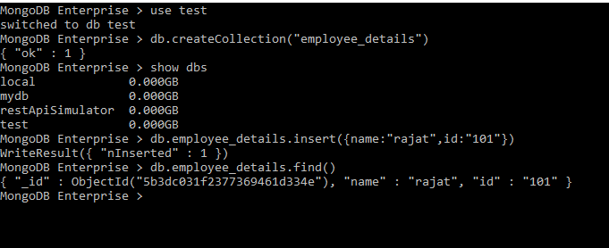

**2.Node** 