Because my interests generated from my past that is I was very curious about computers and the backend part of how does it works, the root of interest was the subject called information technology in my 9-10th grade and then I opted for bifocal i.e. computer science in my 11-12th hence the path was set and I wanted to do engineering as it allows me to

implement my creative and problem solving skills. I am always been interested in solving a real-world problem of society which can have a positive impact.

Intriguingly, I've long pondered the question: 'Where does all the data of companies get stored?' This question

resurfaced during my current pursuit of an honors degree in data science. I was fortunate to find the answer during a pre-placement talk by Mr. Kulkarni, which only deepened my commitment to engineering, especially in the context of data and technology solutions."

# What are the roles and responsibilities?

"The job roles at CtrlS encompass a wide range of responsibilities, and they vary depending on the specific position. Here are some general insights into the roles:

**Operating Systems Administrators (Linux and Windows):** These professionals are responsible for configuring, maintaining, and ensuring the security of both Linux and Windows operating systems. They manage system updates, performance optimization, and troubleshooting.

**Databases Administrators:** Database administrators handle the installation, configuration, and management of databases, ensuring data integrity, availability, and security. They also optimize database performance and handle backup and recovery procedures.

**Networking Administrators:** Networking administrators manage the company's network infrastructure. Their

responsibilities include configuring and maintaining network devices, troubleshooting connectivity issues, and ensuring network security and performance.

**SAP Basis and Hana:** Professionals in this role focus on SAP system administration, including SAP HANA. They are responsible for the installation, maintenance, and optimization of SAP systems, ensuring they operate smoothly.

**Desk Support:** Desk support professionals provide IT support to end-users within the organization. They address user issues, troubleshoot problems, and assist with software and hardware-related inquiries.

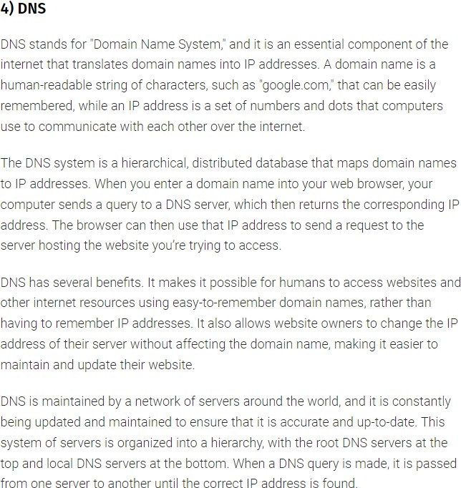 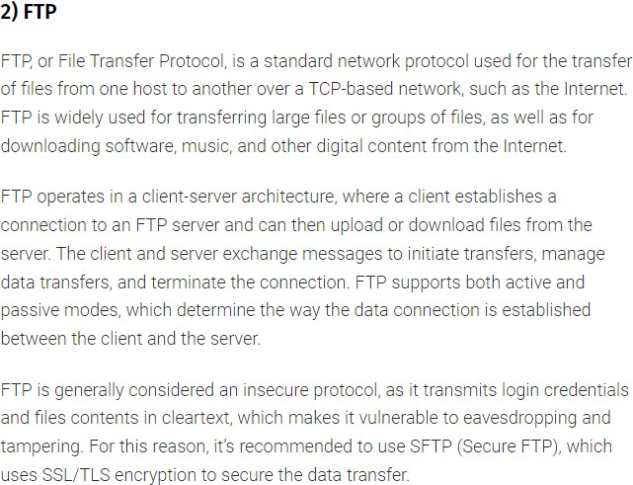

# Difference between HTTP and HTTPS

HTTP and HTTPS are both protocols used for transmitting data over the web, but they have a crucial difference concerning security.

HTTP transfers data in plain text, making it vulnerable to eavesdropping or tampering by malicious entities. In contrast, HTTPS incorporates an additional layer of security using SSL (Secure Sockets Layer) or TLS (Transport Layer Security). This layer encrypts the data being transferred, ensuring that any intercepted information remains unreadable.

<https://www.geeksforgeeks.org/difference-between-http-and-https-2/>

# What is static variable

<https://www.scientecheasy.com/2021/10/java-static-interview-questions.html/>

# Difference between Delete Truncate and Drop

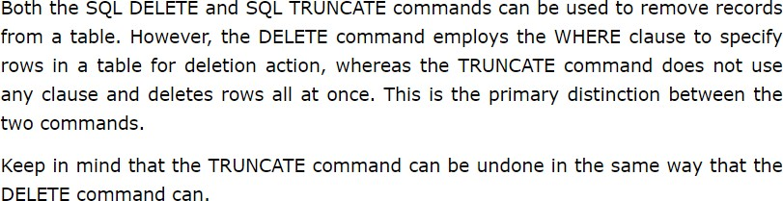

<https://www.tutorialspoint.com/difference-between-delete-and-truncate-in-sql-query>

# Be sure of networking and operating system concepts DHCP, DNS, AD

**OSI layers**

**https://www.geeksforgeeks.org/open-systems-interconnection-model-osi/**

**TCP/UDP**

# Protocols in each OSI layer?

*OS :* <https://www.youtube.com/watch?v=3obEP8eLsCw>

*NETWORKING:* <https://www.interviewbit.com/networking-interview-questions/>

# Difference between microprocessor and micro controller

<https://www.geeksforgeeks.org/whats-difference-between-microcontoller-%C2%B5c-and-microprocessor-%C2%B5p/>

# what is the difference between dbms and rdbms

<https://www.interviewbit.com/blog/difference-between-dbms-and-rdbms/>

<https://www.youtube.com/watch?v=dl00fOOYLOM>

# How to configure log shipping for different domain servers ?.

<https://www.sqlshack.com/how-to-configure-sql-server-log-shipping/>

<https://www.geeksforgeeks.org/pascal-triangle/>

# Can C handle errors and exceptions

<https://www.tutorialspoint.com/cprogramming/c_error_handling.htm>

# They asked about project, then questions from C , comp networks and OPERATING systems

* **some python programs, about myself, about our projects**

# Learn the port numbers.. Socket address definition.. Ipv4 ipv6 address definitions etc

* **Whats the difference between Lan and Wan.. Difference between switch and router..**

# Write a c program for Pascal triangle

* **what does tier 4 of CtrlS tier network security mean?**

# Brief duscussions on my resume and questions on ece.