Name: Rajat Chaudhari

Rollno: 1814068

Batch: A1

# Exp:3

**Jenkins installation**

1. Download Generic Java Package(.war)

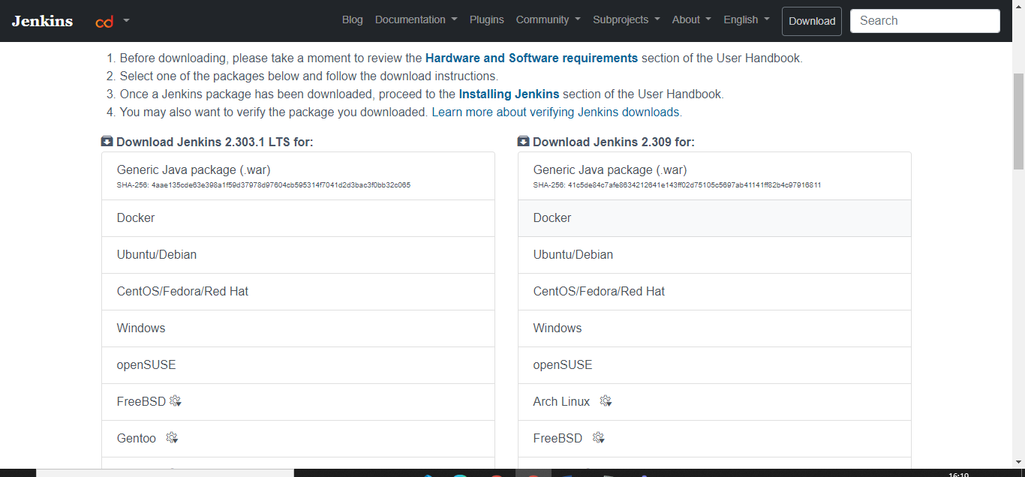

1. Java is already installed in the system

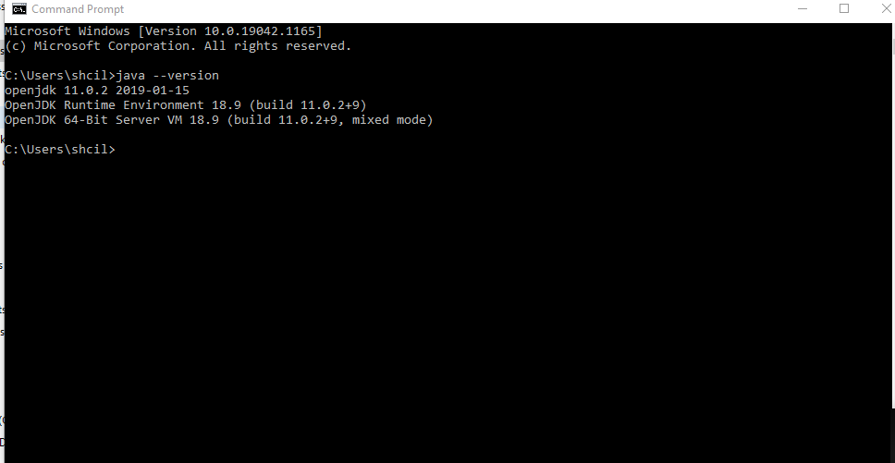

1. Run the jar file

Java –jar C:\Users\shcil\Downloads\jenkins.war

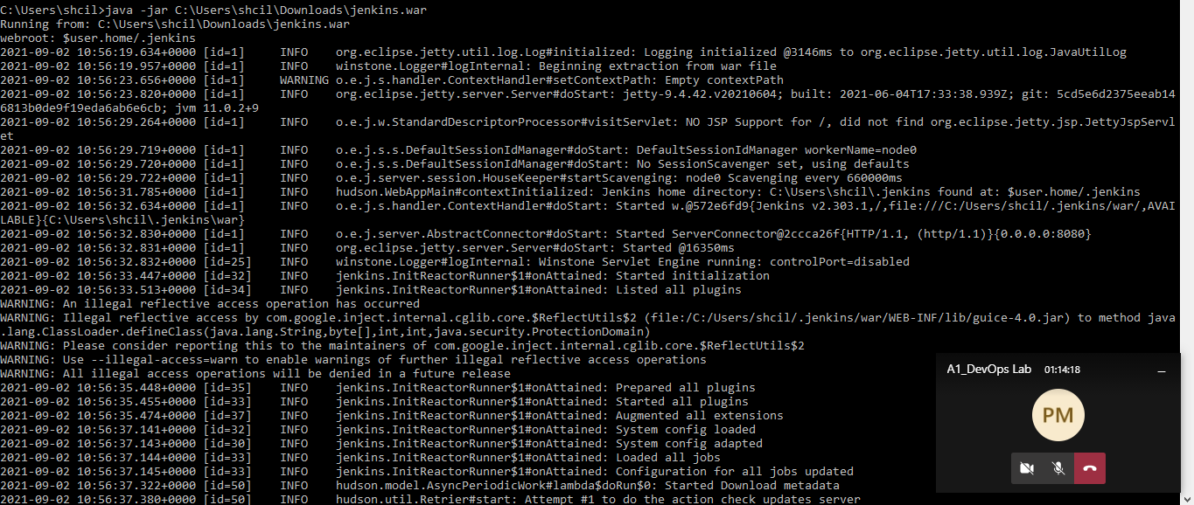

1. Note down the secret key

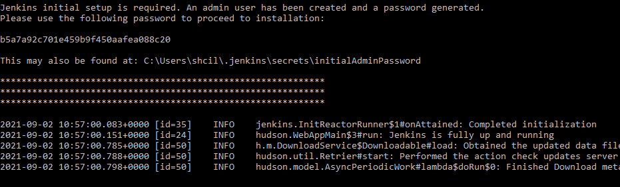

1. Run Jenkins on localhost8080 and copy the above secret key into administrator password.

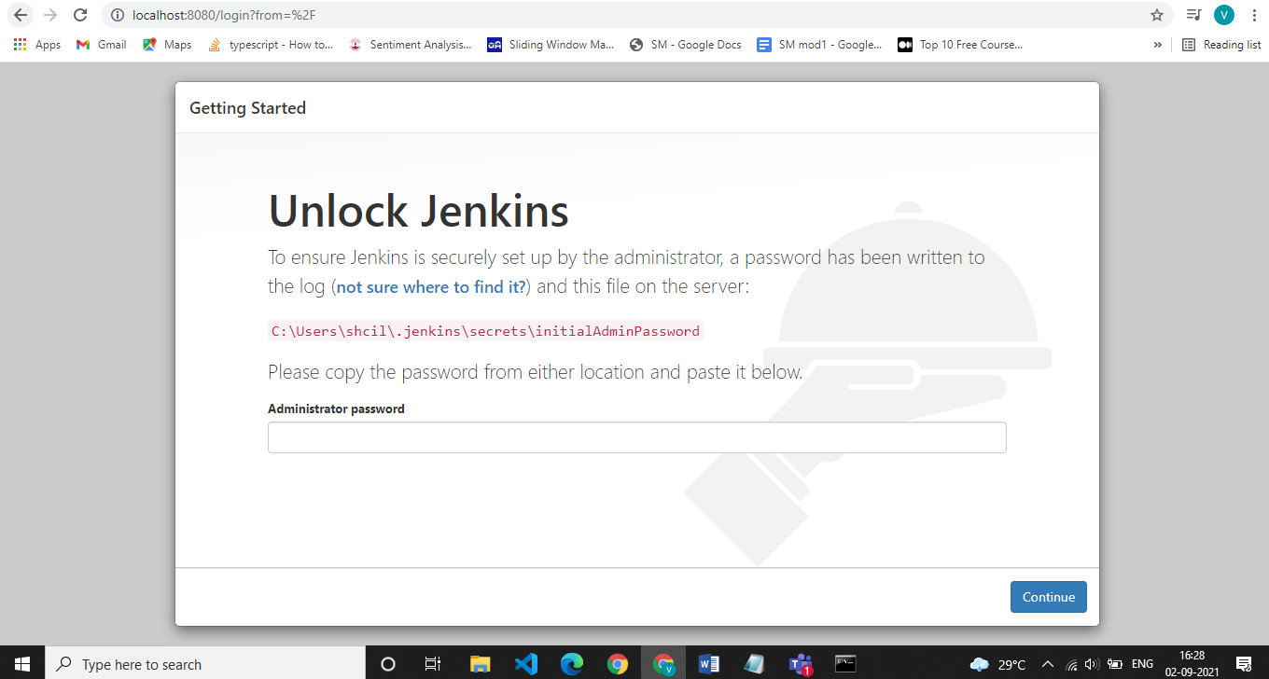

1. Install suggested plugins

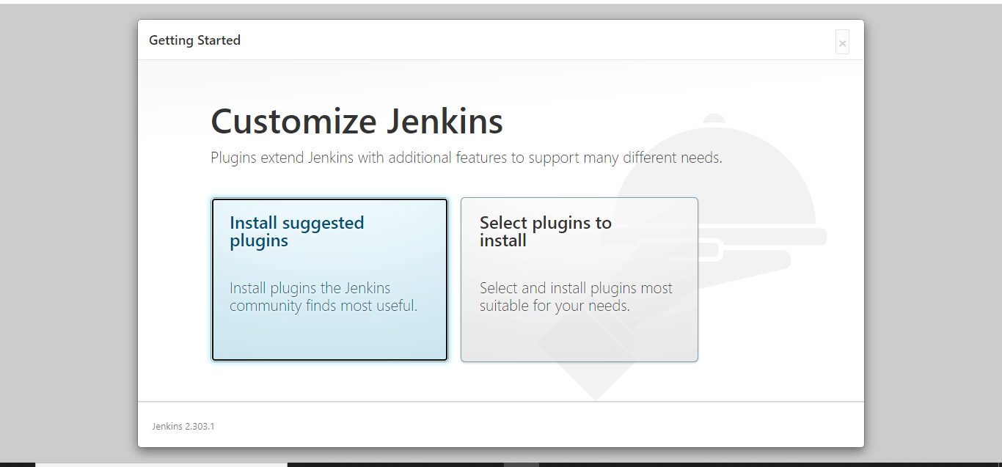

1. Make an admin

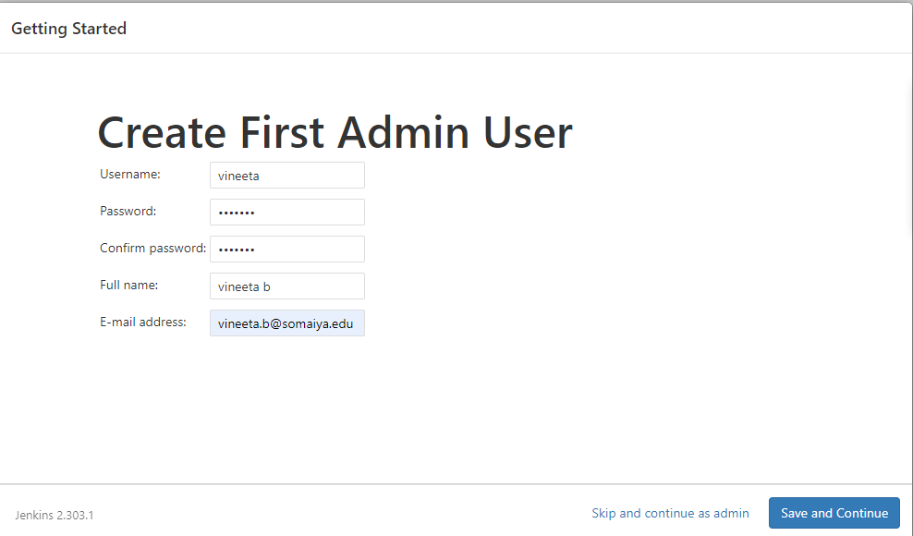

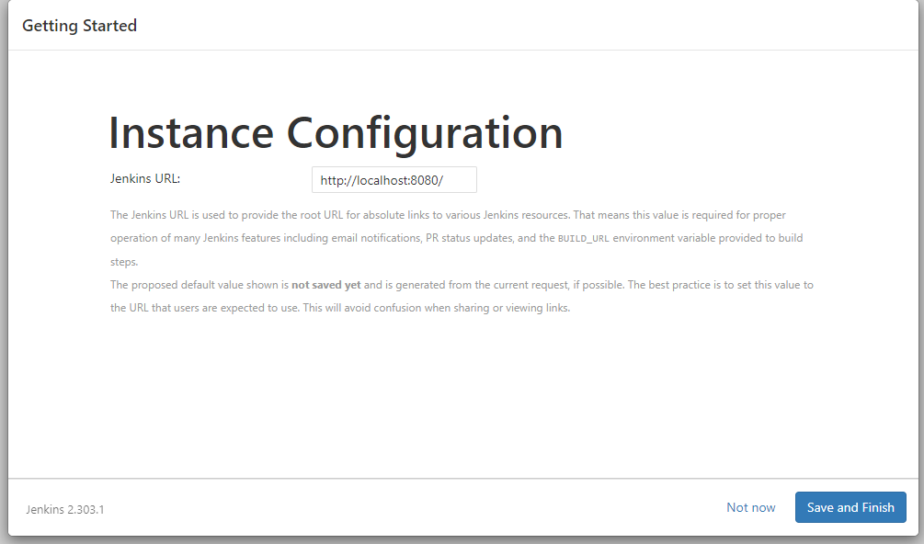

1. We have successfully installed Jenkins

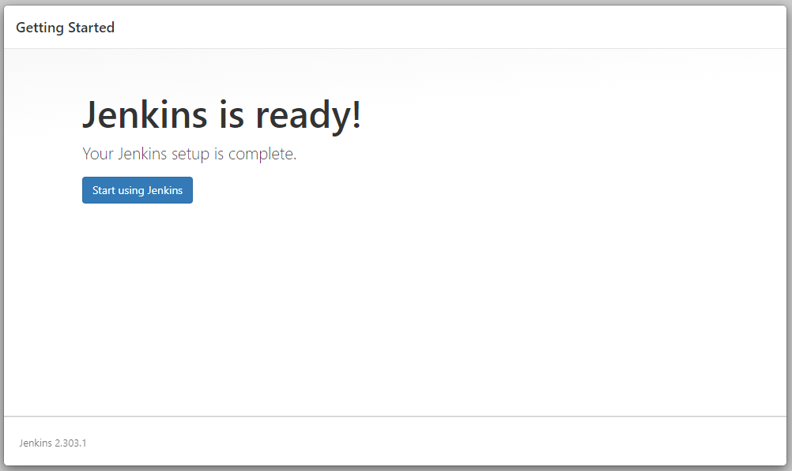

9.

