Name: Rajat Chaudhari Roll Number: 1814068 Batch: A1

# DevOps Inlab 2

1. Initialising Git Repository

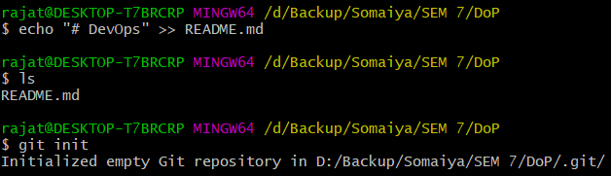

1. Adding Readme to the repository

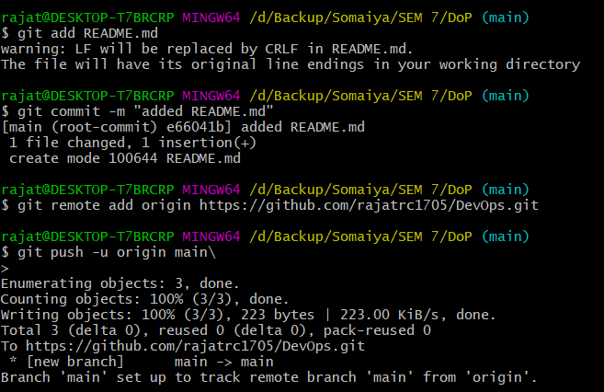

1. Make changes in the Readme on the repository and **pull them to local repository.**

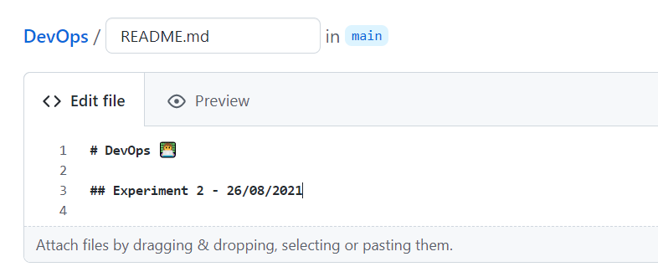

Pulling the changes with pull command

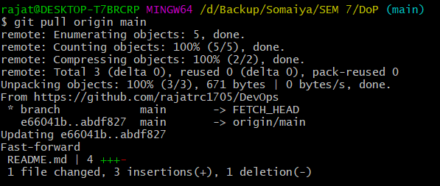

1. **Push** the inlab writeup to the git repository using **add, commit, push** commands.

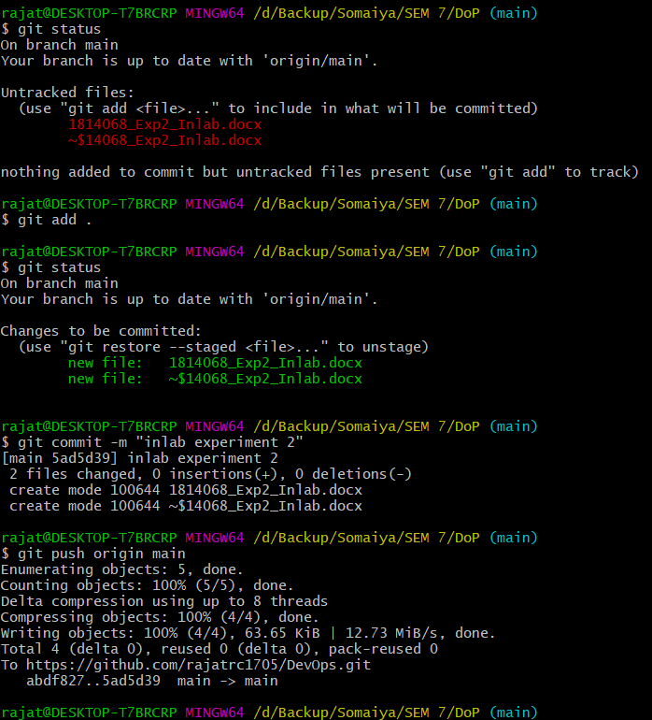

1. Creating new feature branch

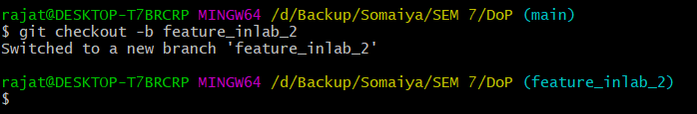

Making changes to readme

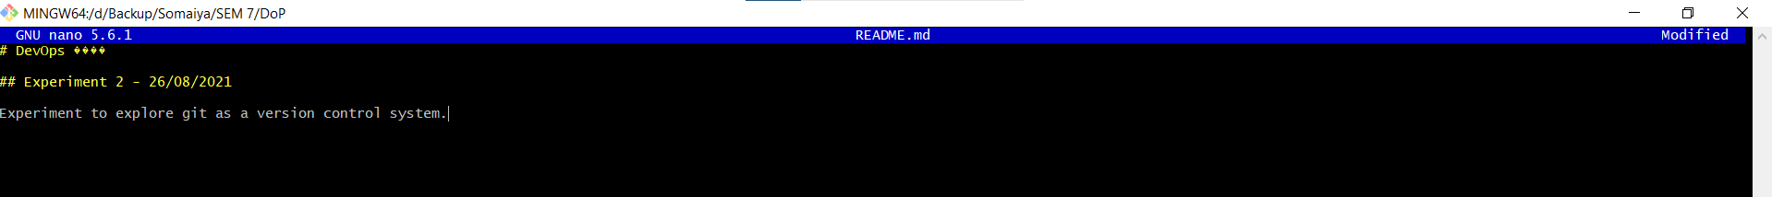

Pushing the changes to github