**Capabilities covered:**

* Implement Web UI that meets the functional specifications
* Add actions, interactions, business logic using JavaScript (ES6 & TS)
* Develop responsive pages using Material Design, Bootstrap & Media Query

## Problem Statement: Blog messages

Blog is another word for weblog. A weblog is a [website](http://simple.wikipedia.org/wiki/Website) that is like a diary or [journal](http://simple.wikipedia.org/wiki/Journal). Most people can create a blog and then write on that blog. Bloggers (a word for people who write on blogs) often write about their [opinions](http://simple.wikipedia.org/wiki/Opinion) and thoughts.

**Description:**

Develop an input page to accept current system date/time.

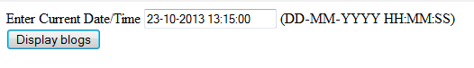

* JavaScript validation: Date/Time field can’t be empty
* Validate input field against following date format “DD-MM-YYYY HH:MM:MM:SS”
* Apply CSS style sheet
* On clicking “Display blogs” button messages stored in local file has to display as listed below:

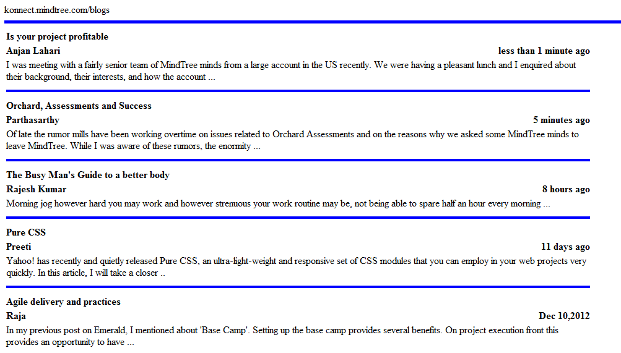

* if duration < 1 minute , it should display “**less than 1 minute ago**”
* if duration > 1 minute and < hour, it should display <n> minutes ago ( e.g. **5 minutes ago**)
* if duration > 1 hour and < 1 day , it should display **<n> hours ago**
* if duration > 1 day and < 1 month it should display **<n> days ago**
* if duration > 1 month, it should display actual date of blog (e.g. **Dec 10,2012**)