**New Wheels Project**

**Introduction to SQL**

Partha Sarathy Mohapatra

# **Problem Statement**

**Business Context**

A lot of people in the world share a common desire: to own a vehicle. A car or an automobile is seen as an object that gives the freedom of mobility. Many now prefer pre-owned vehicles because they come at an affordable cost, but at the same time, they are also concerned about whether the after-sales service provided by the resale vendors is as good as the care you may get from the actual manufacturers.

New-Wheels, a vehicle resale company, has launched an app with an end-to-end service from listing the vehicle on the platform to shipping it to the customer's location. This app also captures the overall after-sales feedback given by the customer.

**Objective**

New-Wheels sales have been dipping steadily in the past year, and due to the critical customer feedback and ratings online, there has been a drop in new customers every quarter, which is concerning to the business. The CEO of the company now wants a quarterly report with all the key metrics sent to him so he can assess the health of the business and make the necessary decisions.

As a data analyst, you see that there is an array of questions that are being asked at the leadership level that need to be answered using data. Import the dump file that contains various tables that are present in the database. Use the data to answer the questions posed and create a quarterly business report for the CEO.

# 

# **Business Questions**

## **Question 1: Find the total number of customers who have placed orders. What is the distribution of the customers across states?**

**Solution Query:**

**Unique Customer orders**

select count(distinct customer_id) from order_t;

Total Customer orders

select count(*) from order_t;

Distribution of the customers across states

select state,count(customer_id) from customer_t group by state;

**Output:**

* A black screen with white text

  Description automatically generated
* A black screen with white text

  Description automatically generated
* A screenshot of a computer

  Description automatically generated

**Observations and Insights:**

* Total orders 1000 by customers
* Out of which 994 unique customers have ordered
* California, Texas and Florida are the top 3 states with highest customers

## **Question 2: Which are the top 5 vehicle makers preferred by the customers?**

**Solution Query:**

select vehicle_maker,count(vehicle_maker) as count from product_t where product_id in (select product_id from order_t) group by vehicle_maker order by count desc limit 10;

**Output:**

**Observations and Insights:**

* Chevrolet, Ford, Toyota are the topmost preferred vehicle makers.
* Mercedes-Benz, GMC, Buick are also among the top 10 preferred vehicle makers.
* MG,Citroen, Austin and Ram are the least preferred vehicle makers.

## **Question 3: Which is the most preferred vehicle maker in each state?**

**Solution Query:**

WITH vehicle_ranking AS ( SELECT c.state, p.vehicle_maker, COUNT(o.order_id) AS total_orders, RANK() OVER (PARTITION BY c.state ORDER BY COUNT(o.order_id) DESC) AS veh_rank FROM order_t o INNER JOIN customer_t c ON c.customer_id = o.customer_id INNER JOIN product_t p ON p.product_id = o.product_id GROUP BY c.state, p.vehicle_maker ) SELECT state, vehicle_maker, total_orders FROM vehicle_ranking WHERE veh_rank = 1;

**Output:**

**Observations and Insights:**

* There are many states with multiple vehicle makers having same no of orders.
* Chevrolet, Dodge and Pontiac are the highest ranked vehicles in 17,12 and 11 states respectively.
* Jaguar, Maybach and Oldsmobile are highest ranked vehicles in one state only.

## 

## **Question 4: Find the overall average rating given by the customers. What is the average rating in each quarter?**

## **Consider the following mapping for ratings:** **“Very Bad”: 1, “Bad”: 2, “Okay”: 3, “Good”: 4, “Very Good”: 5**

**Solution Query:**

**Average rating**

mysql> SELECT

-> AVG(

-> CASE

-> WHEN customer_feedback = 'Very Bad' THEN 1

-> WHEN customer_feedback = 'Bad' THEN 2

-> WHEN customer_feedback = 'Okay' THEN 3

-> WHEN customer_feedback = 'Good' THEN 4

-> WHEN customer_feedback = 'Very Good' THEN 5

-> END

-> ) AS avg_feedback

-> FROM order_t

-> ;

**Avg rating per quarter**

mysql> SELECT

-> quarter_number,

-> AVG(

-> CASE

-> WHEN customer_feedback = 'Very Bad' THEN 1

-> WHEN customer_feedback = 'Bad' THEN 2

-> WHEN customer_feedback = 'Okay' THEN 3

-> WHEN customer_feedback = 'Good' THEN 4

-> WHEN customer_feedback = 'Very Good' THEN 5

-> END

-> ) AS avg_feedback

-> FROM order_t

-> GROUP BY quarter_number;

**Output:**

**Observations and Insights:**

* Avg rating by all customers is 3.135
* Avg rating is highest in the 2nd & 3rd quarter
* Avg rating is the lowest in the 4th quarter

**Question 5****: Find the percentage distribution of feedback from the customers. Are customers getting more dissatisfied over time?**

**Solution Query:**

SELECT

quarter_number,

customer_feedback,

COUNT(customer_feedback) * 100.0 /

(SELECT COUNT(*) FROM order_t WHERE quarter_number = o.quarter_number) AS feedback_percentage

FROM order_t o

GROUP BY quarter_number, customer_feedback

ORDER BY quarter_number, feedback_percentage DESC;

**Output:**

* 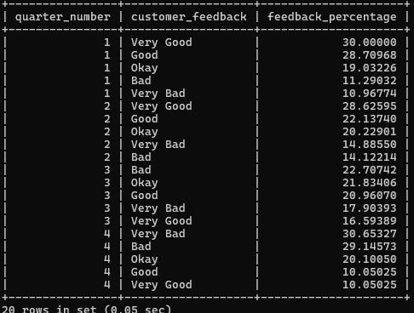

**Observations and Insights:**

* Over every quarter the good feedback is going downhill.
* Negative feedback seems to be increasing

## 

## **Question 6: What is the trend of the number of orders by quarter?**

**Solution Query:**

select quarter_number,count(order_id) as no_of_orders from order_t group by quarter_number order by quarter_number;

**Output:**

**Observations and Insights:**

* There seems to be falling orders every quarter
* Q1 with 310 and Q4 with 199 orders.

## 

## **Question 7:** **Calculate the net revenue generated by the company.** **What is the quarter-over-quarter % change in net revenue?**

**Solution Query:**

**Total Revenue**

select sum((vehicle_price*(1-(discount/100)))*quantity) as Total_Revenue from order_t;

**QoQ % Change**

SELECT

quarter_number,

net_revenue,

LAG(net_revenue) OVER (ORDER BY quarter_number) AS previous_quarter_revenue,

(net_revenue - LAG(net_revenue) OVER (ORDER BY quarter_number)) / LAG(net_revenue) OVER (ORDER BY quarter_number) * 100 AS qoq_percentage_change

FROM (

SELECT

quarter_number,

SUM(quantity * (vehicle_price*(1-(discount/100)))) AS net_revenue

FROM order_t

GROUP BY quarter_number

) AS revenue_per_quarter;

**Output:**

**Total Revenue**

**QoQ % Change**

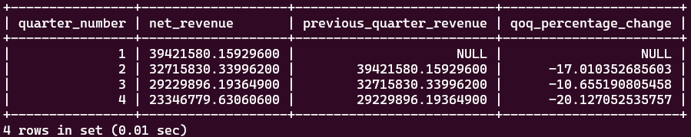

**Observations and Insights:**

* The total revenue stands at 124714086.32
* The revenue growth seems to be decreasing after every quarter
* Q4 seems to have the highest decline in revenue.

## 

## **Question 8:** **What is the trend of net revenue and orders by quarters?**

**Solution Query:**

select quarter_number,COUNT(order_id) AS total_orders,SUM(quantity*vehicle_price*(1-(discount/100)))

AS net_revenue from order_t group by quarter_number order by quarter_number; **Output:**

**Observations and Insights:**

* Revenue and Orders both are failing

## 

## **Question 9: What is the average discount offered for different types of credit cards?**

**Solution Query:**

select credit_card_type, avg(o.discount) as avg_discount from customer_t c inner join order_t o on o.customer_id=c.customer_id group by c.credit_card_type order by avg_discount;

**Output:**

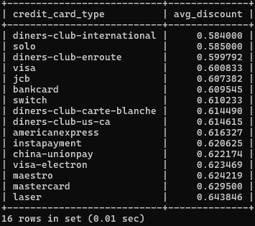

**Observations and Insights:**

* Diners-club-international gives the lowest discount followed by solo card
* Laser card followed by mastercard provide the highest discount

## 

## **Question 10: What is the average time taken to ship the placed orders for each quarter?**

**Solution Query:**

select quarter_number, avg(datediff(ship_date,order_date)) as ship_time_in_days from order_t group by quarter_number order by quarter_number;

**Output:**

**Observations and Insights:**

* Avg Shipping days has increased from 2 months to 6 months from Q1 to Q4

# **Business Metrics Overview**

|  |  |  |  |
| --- | --- | --- | --- |
| **Total Revenue** | **Total Orders** | **Total Customers** | **Average Rating** |
| 48610993.7813 | 1000 | 994 | 3.135 |
| **Last Quarter Revenue** | **Last quarter Orders** | **Average Days to Ship** | **% Good Feedback** |
| 8573149.2806 | 199 | 97.96 | 44.1 |

# **Business Recommendations**

* New wheels need to improve the shipping time of the orders.
* Company needs to focus more on understanding failing satisfaction level of customers and act on it.
* Company should do a market survey to understand the falling sales.