**New Wheels Project**

**Introduction to SQL**

# **Problem Statement**

**Business Context**

A lot of people in the world share a common desire: to own a vehicle. A car or an automobile is seen as an object that gives the freedom of mobility. Many now prefer pre-owned vehicles because they come at an affordable cost, but at the same time, they are also concerned about whether the after-sales service provided by the resale vendors is as good as the care you may get from the actual manufacturers.

New-Wheels, a vehicle resale company, has launched an app with an end-to-end service from listing the vehicle on the platform to shipping it to the customer's location. This app also captures the overall after-sales feedback given by the customer.

**Objective**

New-Wheels sales have been dipping steadily in the past year, and due to the critical customer feedback and ratings online, there has been a drop in new customers every quarter, which is concerning to the business. The CEO of the company now wants a quarterly report with all the key metrics sent to him so he can assess the health of the business and make the necessary decisions.

As a data analyst, you see that there is an array of questions that are being asked at the leadership level that need to be answered using data. Import the dump file that contains various tables that are present in the database. Use the data to answer the questions posed and create a quarterly business report for the CEO.

# 

# **Business Questions**

## **Question 1****: Find the total number of customers who have placed orders.** **What is the distribution of the customers across states?**

**Solution Query:**

* **Find the total number of customers who have placed orders**

Query -> select count(distinct customer_id) from order_t;

* **What is the distribution of the customers across states?**

Query->SELECT state,

COUNT(customer_id) AS total_customers

FROM customer_t

GROUP BY 1

ORDER BY 2 DESC;

**Output:**

**Observations and Insights:**

* Total Unique customers that placed order is 994.
* Texas and California are having most number of customer followed by Florida and New York.

## **Question 2:** **Which are the top 5 vehicle makers preferred by the customers?**

**Solution Query:**

SELECT

vehicle_maker AS top_vehicle_makers,

COUNT(customer_id) AS total_customers

FROM product_T JOIN customer_t

GROUP BY 1

ORDER BY 2 DESC

LIMIT 5;

**Output:**

**Observations and Insights:**

* Chevrolet and Ford are top vehicle makers followed by Toyota.
* Dodge and Pontiac are also in top 5 vehicle makers

## **Question 3****: Which is the most preferred vehicle maker in each state?**

**Solution Query:**

SELECT *

FROM

(

SELECT

state,

vehicle_maker,

COUNT(customer_id) AS total_customers,

RANK() OVER (PARTITION BY state ORDER BY COUNT(customer_id) DESC) AS ranking

FROM product_t

JOIN order_t USING(product_id)

JOIN customer_t USING(customer_id)

GROUP BY 1, 2

) AS preferred_vehicle

WHERE ranking = 1

ORDER BY 3 DESC;

**Output:**

**Observations and Insights:**

* In Texas Chevrolet is top choice of customers
* In Florida Toyota is top choice of customers
* In California there is equal domination of Nissan,Ford, Chevrolet,Audi and Dodge
* There is different vehicle maker are choice of customers in different state

## 

## **Question 4:** **Find the overall average rating given by the customers. What is the average rating in each quarter?**

## **Consider the following mapping for ratings: “Very Bad”: 1, “Bad”: 2, “Okay”: 3, “Good”: 4, “Very Good”: 5**

**Solution Query:**

* Overall average rating

SELECT

AVG(

CASE

WHEN customer_feedback = 'very bad' THEN '1'

WHEN customer_feedback = 'bad' THEN '2'

WHEN customer_feedback = 'okay' THEN '3'

WHEN customer_feedback = 'good' THEN '4'

WHEN customer_feedback = 'very good' THEN '5'

END

)as avg_rating

FROM order_t;

* Average rating in each quarter

WITH rating AS

(

SELECT

customer_feedback,

quarter_number,

CASE

WHEN customer_feedback = 'very bad' THEN '1'

WHEN customer_feedback = 'bad' THEN '2'

WHEN customer_feedback = 'okay' THEN '3'

WHEN customer_feedback = 'good' THEN '4'

WHEN customer_feedback = 'very good' THEN '5'

END AS total_rating

FROM order_t

)

SELECT

quarter_number,

ROUND(AVG(total_rating), 2) AS average_rating

FROM rating

GROUP BY 1

ORDER BY 1 ASC;

**Output:**

**Observations and Insights:**

* Average rating of customer is around 3.135
* Average rating is highest in 1st Quarter
* Average rating is going down each quarter with lowest of 2.4 in 4th quarter.

## **Question 5:** **Find the percentage distribution of feedback from the customers. Are customers** **getting more dissatisfied over time?**

**Solution Query:**

WITH cust_feed AS

(

SELECT

quarter_number,

ROUND(SUM(CASE WHEN customer_feedback = 'very good' THEN 1 ELSE 0 END), 2) AS very_good,

ROUND(SUM(CASE WHEN customer_feedback = 'good' THEN 1 ELSE 0 END), 2) AS good,

ROUND(SUM(CASE WHEN customer_feedback = 'okay' THEN 1 ELSE 0 END), 2) AS okay,

ROUND(SUM(CASE WHEN customer_feedback = 'bad' THEN 1 ELSE 0 END), 2) AS bad,

ROUND(SUM(CASE WHEN customer_feedback = 'very bad' THEN 1 ELSE 0 END), 2) AS very_bad,

ROUND(COUNT(customer_feedback), 2) AS total_feedback

FROM order_t

GROUP BY 1

ORDER BY 1 ASC

)

SELECT

quarter_number,

ROUND((very_good/total_feedback), 2) AS very_good,

ROUND((good/total_feedback), 2) AS good,

ROUND((okay/total_feedback), 2) AS okay,

ROUND((bad/total_feedback), 2) AS bad,

ROUND((very_bad/total_feedback), 2) AS very_bad

FROM cust_feed

GROUP BY 1

ORDER BY 1 ASC;

**Output:**

**Observations and Insights:**

* As we can clearly see that very_good rating percentage is continuously decreasing with each quarter.
* Like that good rating is also decreasing each quarter,
* Okay rating is quite same in each quarter.
* While bad and very_bad rating continuously increasing by each quarter.
* With these observations we can clearly see that customer are getting more dissatisfied over time**.**

## 

## **Question 6:** **What is the trend of the number of orders by quarter?**

**Solution Query:**

SELECT

quarter_number,

COUNT(order_id) AS total_orders

FROM order_t

GROUP BY 1

ORDER BY 1;

**Output:**

**Observations and Insights:**

* Total orders are highest in 1st quarter as 310.
* Least orders i.e. 199 received in last quarter
* We can see orders are continuously decreasing with each quarter.

## 

## **Question 7: Calculate the net revenue generated by the company. What is the quarter-over-quarter % change in net revenue?**

**Solution Query:**

* Net revenue generated by the company

select ROUND(sum(quantity*(vehicle_price-(discount/100)*vehicle_price)),2)

as net_revenue

from order_t;

* quarter-over-quarter % change in net revenue.

WITH QoQ AS

(

SELECT quarter_number,

ROUND(SUM(quantity * (vehicle_price - ((discount/100)*vehicle_price))), 0) AS revenue

FROM order_t

GROUP BY quarter_number)

SELECT quarter_number, revenue,

ROUND(LAG(revenue) OVER(ORDER BY quarter_number), 2) AS previous_revenue,

ROUND((revenue - LAG(revenue) OVER(ORDER BY quarter_number))/LAG(revenue) OVER(ORDER BY quarter_number), 2) AS qoq_perc_change

FROM QoQ;

**Output:**

**Observations and Insights:**

* Net revenue is around 124714086.32
* Revenue use declining in each quarter.

## 

## **Question 8:** **What is the trend of net revenue and orders by quarters?**

**Solution Query:**

SELECT

quarter_number,

ROUND(SUM(quantity*vehicle_price), 0) AS revenue,

COUNT(order_id) AS total_order

FROM order_t

GROUP BY 1

ORDER BY 1;

**Output:**

**Observations and Insights:**

* We can see orders and revenue is highest in first quarter
* Orders are decreasing in each quarter so it the revenue

## 

## **Question 9: What is the average discount offered for different types of credit cards?**

**Solution Query:**

SELECT

credit_card_type,

ROUND(AVG(discount), 2) AS average_discount

FROM order_t t1

INNER JOIN customer_t t2

ON t1.customer_id = t2.customer_id

GROUP BY 1

ORDER BY 2 DESC;

**Output:**

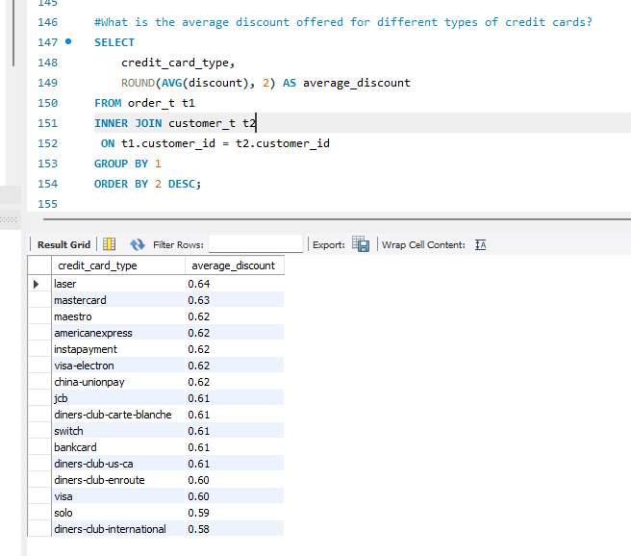

**Observations and Insights:**

* laser cards give the highest average discount followed by MasterCard.
* diners-club-international card gives lowest discount.

## 

## **Question 10:** **What is the average time taken to ship the placed orders for each quarter?**

**Solution Query:**

SELECT

quarter_number,

ROUND(AVG(DATEDIFF(ship_date, order_date)), 0) AS average_shipping_time

FROM order_t

GROUP BY 1

ORDER BY 1;

**Output:**

**Observations and Insights:**

* Average shipping time is getting increased in each quarter

# **Business Metrics Overview**

|  |  |  |  |
| --- | --- | --- | --- |
| **Total Revenue** | **Total Orders** | **Total Customers** | **Average Rating** |
| 124714086.32 | 1000 | 994 | 3.135 |
| **Last Quarter Revenue** | **Last quarter Orders** | **Average Days to Ship** | **% Good Feedback** |
| 23346780 | 199 | 97.9 | 44.1 |

# **Business Recommendations**

* As we can see from rating trend that customers are getting dissatisfied bad rating are getting increased while good rating getting decreased in each quarter so New wheel need to understand what is causing issue and need to work on the their service to improve customer satisfaction
* From shipping time, we can see increase in shipping time in each quarter. New wheels need to work on this and should decrease shipping time.
* New wheel sale is getting decreased in each quarter for this they need to check with customer and do market survey to understand reason for the same.