Design patterns:
General repeatable solution to a commonly occurring problem in software design
1. Creational: Used for creating or instantiating objects and classes
a. Factory method - Classes
b. Abstract factory - Objects
c. Builder - Objects
d. Prototype - Objects
e. Singleton - Objects

2. Structural: Used for structuring more than 1 classes or objects together.
a. Adapter (Class) - Classes
b. Adapter (Object) - Objects
c. Bridge - Objects
d. Composite - Objects
e. Decorator - Objects
f. Facade - Objects
g. Flyweight - Objects
h. Proxy - Objects

3. Behavioural: Used for identify & setting up common communication patterns among objects
a. Interpreter - Classes
b. Template method - Classes
c. Chain of responsibility - Objects
d. Command - Objects
e. Iterator - Objects
f. Mediator - Objects
g. Memento - Objects
h. Observer - Objects
g. State - Objects
e. Strategy - Objects
f. Visitor - Objects
Design patterns categories:
Gang of Four (GoF)" book Design Patterns: Elements of Reusable
They defined 23 design patterns categorized into 3 groups:
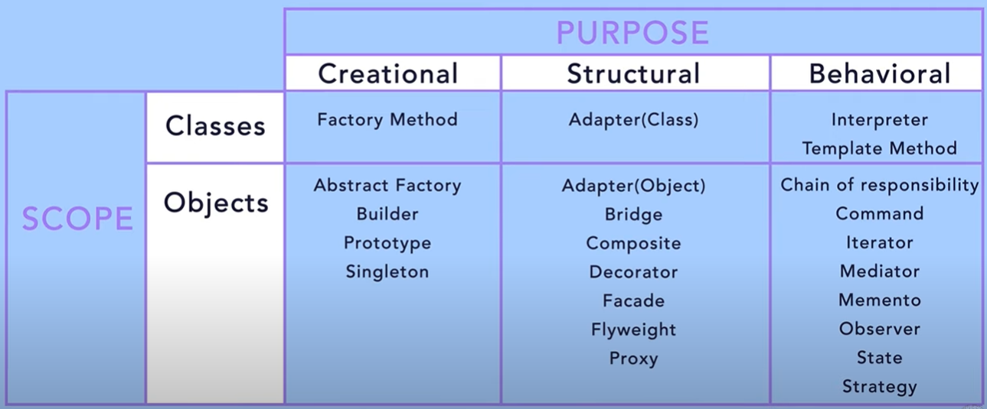

✅ Must Know for Interviews & Daily Work
- Singleton (but be careful, overused)
- Factory Method & Abstract Factory (object creation without exposing logic)
- Builder (when object has many optional parameters)
- Observer (used in Qt signals/slots, GUIs, event systems)
- Strategy (replaceable algorithms)
- Decorator (adding functionality dynamically)
- Adapter (working with incompatible interfaces)
- Facade (simplify complex systems)
- Command (undo/redo systems, encapsulating requests)
- Iterator (standard in STL, iterating collections)
🚀 Good to know (occasionally asked in interviews)
- Prototype
- Composite
- State
- Proxy
- Visitor
🟢 Day-to-day C++ relevance
- STL uses Iterator, Strategy (sort with comparator), Observer (event-driven)
- Qt framework uses Observer (signals/slots), Factory, Command
- Multithreading often needs Singleton (logger, thread pool)
- Enterprise-level code often uses Facade, Adapter, Builder

Creational design patterns:
- Factory design patter (FDP):
  - It creates Obj for you, rather you initiating obj directly
  - Also known as Virtual constructor
How to implement:
- Define an interface or an abstract class for creating an obj but let the subclass decide which class to initiate.
- runtime it creates objects based on the passed parameter while creating object
Advantages:
- Less Code changes if we change object creation process.
- We create obj without exposing the creation logic to the client.
- We get benefits if virtual constructor
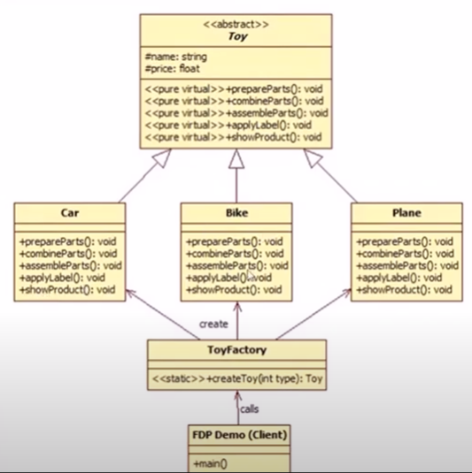

Code:
Main:
// FactoryDesignPattern.cpp : This file contains the 'main' function. Program execution begins and ends there.
#include <iostream>
#include "ToyFactory.h"

int main()
{
std::cout << "Hello World!\n";
//Factory design pattern
//Example of toy factory
int choice;
while(1){
std::cout << "Enter 1 for Car or 2 for Bike or 3 for Plane " << std::endl;
std::cin >> choice;
if (choice == 1) {
std::cout << "You have chosen Car" << std::endl;
}
else if (choice == 2) {
std::cout << "You have chosen Bike" << std::endl;
}
else if (choice == 3) {
std::cout << "You have chosen Plane" << std::endl;
}
else {
std::cout << "Invalid choice" << std::endl;
return 0;
}
Toy* toy = ToyFactory::createToy(choice);
if(toy) {
toy->showProduct();
delete toy;
}
else {
std::cout << "Toy not created" << std::endl;
}
}
}

ToyFactory.h

#pragma once
#include <iostream>
#include <string>

class Toy {
private:
std::string name;
float price;
public:
virtual void prepareProduct() = 0;
virtual void assembleProduct() = 0;
virtual void showProduct() = 0;

};

class Car : public Toy {
public:
void prepareProduct() override {
std::cout << "Preparing Car" << std::endl;
}
void assembleProduct() override {
std::cout << "Assembling Car" << std::endl;
}
void showProduct() override {
std::cout << "Car is ready" << std::endl;
}
};

class Bike : public Toy {
public:
void prepareProduct() override {
std::cout << "Preparing Bike" << std::endl;
}
void assembleProduct() override {
std::cout << "Assembling Bike" << std::endl;
}
void showProduct() override {
std::cout << "Bike is ready" << std::endl;
}
};
class Plane : public Toy {
public:
void prepareProduct() override {
std::cout << "Preparing Plane" << std::endl;
}
void assembleProduct() override {
std::cout << "Assembling Plane" << std::endl;
}
void showProduct() override {
std::cout << "Plane is ready" << std::endl;
}
};

class ToyFactory
{
public:
static Toy* createToy(int choice) {

Toy* toy = nullptr;
switch (choice) {
case 1:
toy = new Car();
break;
case 2:
toy = new Bike();
break;
case 3:
toy = new Plane();
break;
default:
std::cout << "Invalid choice" << std::endl;
return nullptr;
}
toy->assembleProduct();
toy->prepareProduct();
return toy;
}
};

- Abstract factory design pattern:

