**## 1. In Depth Exploration**

**Q1. Data type of all columns in the “customers” table.**

select

column_name, data_type

from `Target`.INFORMATION_SCHEMA.COLUMNS

where table_name = 'customers';

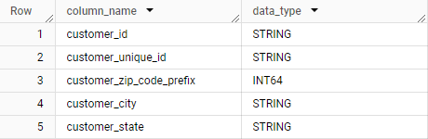

**Q2. Get the time range between which the orders were placed.**

select

min(order_purchase_timestamp) as First_order,

max(order_purchase_timestamp) as Last_order

from `Target.orders`;



**Q3. Count the Cities & States of customers who ordered during the given period.**

select

count(distinct c.customer_city) as City_Count,

count(distinct c.customer_state) as State_Count

from `Target.customers` c

join `Target.orders` o

on c.customer_id = o.customer_id;



**## 2. In-depth Exploration**

**Q1. Is there a growing trend in the no. of orders placed over the past years?**

with cte1 as

(select

distinct (year_month),

count(order_id) as order_count

from (

select

*,

format_date('%Y-%m',order_purchase_timestamp) as year_month

from `Target.orders`

)

group by 1

order by 1)

select

year_month,

order_count,

lag(order_count) over(order by year_month) as previous_month,

concat(round(((order_count - lag(order_count) over(order by year_month)) / lag(order_count) over(order by year_month))*100,2)," ","%") as pct_change

from cte1

order by 1;

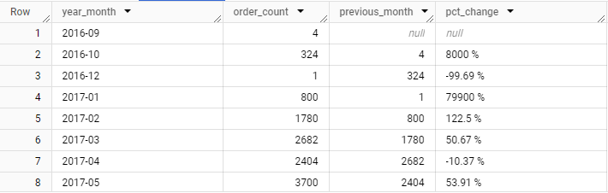

**Q2. Can we see some kind of monthly seasonality in terms of the no. of orders being placed?**

select

distinct (year_month),

count(order_id) as order_count

from (

select

*,

format_date('%Y-%m',order_purchase_timestamp) as year_month

from `Target.orders`

)

group by 1

order by 1;

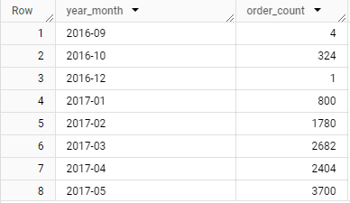

**Q3. During what time of the day, do the Brazilian customers mostly place their orders? (Dawn, Morning, Afternoon or Night)**

**-- 0-6 hrs : Dawn**

**-- 7-12 hrs : Mornings**

**-- 13-18 hrs : Afternoon**

**-- 19-23 hrs : Night**

select

case when extract(hour from order_purchase_timestamp) between 0 and 6 then 'Dawn'

when extract(hour from order_purchase_timestamp) between 7 and 12 then 'Mornings'

when extract(hour from order_purchase_timestamp) between 13 and 18 then 'Afternoon'

else 'Night'

end as time_of_day,

count(order_id) as order_count

from `Target.orders`

group by 1

order by 2 desc;

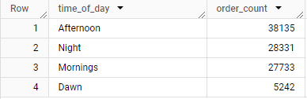

**## 3. Evolution of E-commerce orders in the Brazil region:**

**Q1. Get the month on month no. of orders placed in each state.**

select

c.customer_state,

format_date('%Y-%m',o.order_purchase_timestamp) as year_month,

format_date('%B', o.order_purchase_timestamp) AS month_name,

count(o.order_id) as order_count

from `Target.customers` c

inner join `Target.orders` o

on c.customer_id = o.customer_id

group by 1,2,3

order by 1,2

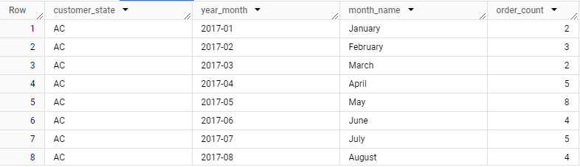

**Q2. How are the customers distributed across all the states?**

select

c.customer_state as State_Name,

count(distinct o.order_id) as order_count

from `Target.customers` c

inner join `Target.orders` o

on c.customer_id = o.customer_id

group by 1

order by 2 desc;

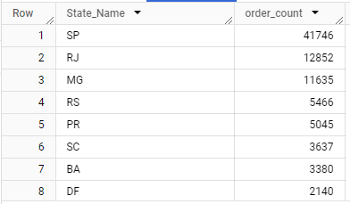

**## 4. Impact on Economy: Analyze the money movement by e-commerce by looking at order prices, freight and others.**

**Q1. Get the % increase in the cost of orders from year 2017 to 2018 (include months between Jan to Aug only).**

with cte1 as (

select

format_date('%Y',o.order_purchase_timestamp) as year,

format_date('%m',o.order_purchase_timestamp) as month,

round(sum(p.payment_value),2) as Total_Payment

from `Target.orders` o

left join `Target.payments` p

on o.order_id = p.order_id

group by 1,2

order by 1 asc,2 asc

),

cte2 as (

select

month,

sum(case when year = '2017' then Total_Payment else 0 end) as Total_Payment_2017,

sum(case when year = '2018' then Total_Payment else 0 end) as Total_Payment_2018,

from cte1

where month between '01' and '08'

group by 1

order by 1

)

select

month,

Total_Payment_2017,

Total_Payment_2018,

round(((Total_Payment_2018 - Total_Payment_2017)/(Total_Payment_2017)) * 100,2) as Pct_change

from cte2;

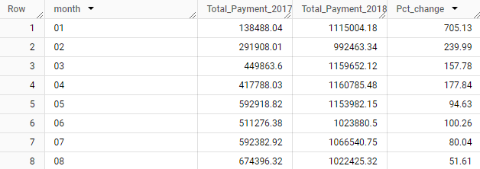

**Q2. Calculate the Total & Average value of order price for each state.**

select

c.customer_state,

round(sum(p.payment_value),2) as Total_Payment,

round(avg(p.payment_value),2) as Avg_Payment

from `Target.customers` c

left join `Target.orders` o

on c.customer_id = o.customer_id

left join `Target.payments` p

on o.order_id = p.order_id

group by 1

order by 1;

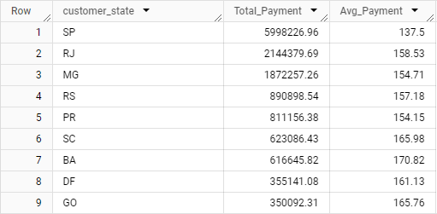

**Q3. Calculate the Total & Average value of order freight for each state.**

select

c.customer_state,

round(sum(o2.freight_value),2) as Total_Freight,

round(avg(o2.freight_value),2) as Avg_Freight

from `Target.customers` c

left join `Target.orders` o

on c.customer_id = o.customer_id

left join `Target.order_items` o2

on o.order_id = o2.order_id

group by 1

order by 1;

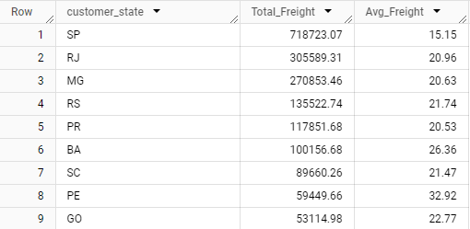

**## 5. Analysis based on sales, freight and delivery time.**

**Q1. Find the no. of days taken to deliver each order from the order’s purchase date as delivery time. Also, calculate the difference (in days) between the estimated & actual delivery date of an order. Do this in a single query.**

with cte as (

select

order_purchase_timestamp as Order_date,

order_delivered_customer_date as Delivery_date,

order_estimated_delivery_date as Estimated_delivery_date,

date_diff(order_delivered_customer_date, order_purchase_timestamp, Day) as time_to_deliver,

date_diff(order_estimated_delivery_date, order_delivered_customer_date, Day) as diff_estimated_delivery

from `Target.orders` o

order by 4 asc, 5 asc

)

select

Order_date,

Delivery_date,

Estimated_delivery_date,

time_to_deliver,

diff_estimated_delivery

from cte

where time_to_deliver is not null

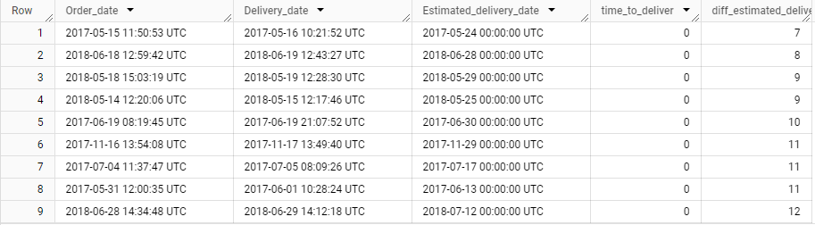

**Q2. Find out the top 5 states with the highest & lowest average freight value.**

with cte1 as (

select

c.customer_state,

round(avg(o2.freight_value),2) as Avg_Freight,

dense_rank() over(order by round(avg(o2.freight_value),2) desc) as rnk

from `Target.customers` c

left join `Target.orders` o

on c.customer_id = o.customer_id

left join `Target.order_items` o2

on o.order_id = o2.order_id

group by 1

),

top5 as (

select

customer_state,

Avg_Freight,

rnk

from cte1

where rnk <= 5

),

bottom5 as (

select

customer_state,

Avg_Freight,

rnk

from cte1

order by rnk desc

limit 5

)

select

'Top 5' AS Category,

customer_state,

Avg_Freight

from top5

union all

select

'Bottom 5' AS Category,

customer_state,

Avg_Freight

from bottom5

order by Category desc, Avg_Freight desc;

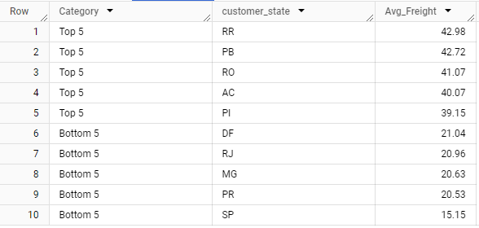

**Q3. Find out the top 5 states with the highest & lowest average delivery time.**

with cte as (

select

c.customer_state,

avg(date_diff(o.order_delivered_customer_date, o.order_purchase_timestamp, Day)) as time_to_delivery

from `Target.orders` o

right join `Target.customers` c

on o.customer_id = c.customer_id

where o.order_delivered_customer_date is not null

group by 1

),

ranked_data as (

select

customer_state as state,

time_to_delivery as avg_delivery_time,

dense_rank() over(order by time_to_delivery asc) as rnk_asc,

dense_rank() over(order by time_to_delivery desc) as rnk_desc

from cte

)

select

'Top 5' as category,

state,

avg_delivery_time

from ranked_data

where rnk_asc <= 5

union all

select

'Bottom 5' as category,

state,

avg_delivery_time

from ranked_data

where rnk_desc <= 5

order by category, avg_delivery_time;

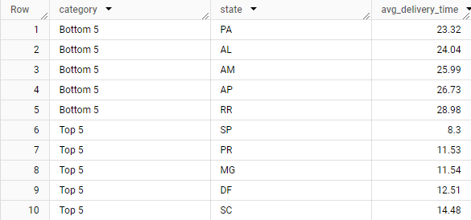

**Q4. Find out the top 5 states where the order delivery is really fast as compared to the estimated date of delivery.**

select

c.customer_state,

round(avg(datetime_diff(o.order_estimated_delivery_date, o.order_delivered_customer_date, Day)),2) as diff_estimated_delivery

from `Target.customers` c

left join `Target.orders` o

on c.customer_id = o.customer_id

where o.order_delivered_customer_date is not null and order_estimated_delivery_date is not null

group by 1

order by 2 asc

limit 5

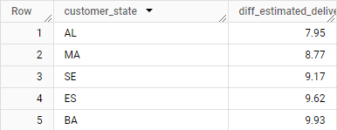

**## 6. Analysis based on the payments:**

**Q1. Find the month on month no. of orders placed using different payment types.**

select

format_date('%B-%Y',o.order_purchase_timestamp) as month_year,

p.payment_type,

count(o.order_id) as order_count

from `Target.orders` o

left join `Target.payments` p

on o.order_id = p.order_id

group by 1,2

order by 1 asc

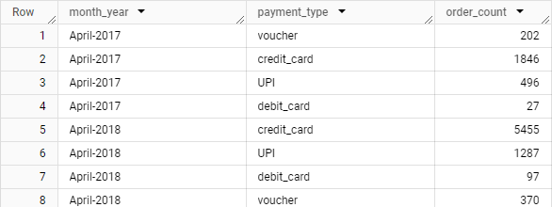

**Q2. Find the no. of orders placed on the basis of the payment installments that have been paid.**

select

distinct(p.payment_installments),

count(o.order_id) as order_count

from `Target.orders` o

left join `Target.payments` p

on o.order_id = p.order_id

where p.payment_installments is not null and p.payment_installments != 0

group by 1

order by 1 asc

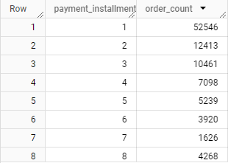

**Insights:**

1. **Seasonal Payment Trends:**
   * Certain months show a higher usage of specific payment methods, potentially linked to promotions or customer behavior.
2. **Installment Usage:**
   * Installments are preferred during large purchases, suggesting customer sensitivity to upfront costs.
3. **Time Range of Orders:**
   * The company's operations span a wide time frame, providing a substantial dataset for analyzing seasonal and yearly trends.
4. **Geographical Spread:**
   * The orders come from diverse cities and states, indicating a good reach across the country.
5. **Delivery Efficiency:**
   * Certain states have significantly faster delivery times compared to the estimated delivery date.
6. **Challenging States:**
   * Some states have consistently high delivery times, possibly due to logistical challenges or remote locations.
7. **Top States for Fast Delivery:**
   * Some states have consistently high delivery times, possibly due to logistical challenges or remote locations.
8. **Freight Costs:**
   * Freight costs vary significantly across states, with some states showing much higher average freight charges.

**Recommendations:**

1. **Payment Campaigns:** 
   * Launch targeted campaigns during peak months, offering incentives for specific payment types.
2. **Upsell Opportunities:** 
   * Promote high-value products with attractive installment options to increase average order value.
3. **Expand Marketing Campaigns:** 
   * Focus marketing efforts during peak ordering times (e.g., afternoon and evening) to boost sales.
4. **Target Underrepresented States:** 
   * Identify and target states with low customer activity to improve market penetration.
5. **Improve Logistics:**
   * Focus on states with slower delivery times by optimizing routes, increasing warehouse coverage, or collaborating with local courier services.
6. **Reward Fast Deliveries:**
   * Promote fast delivery states as examples of company reliability in marketing campaigns.
7. **Leverage Delivery Success:** 
   * Highlight states with exceptional delivery performance as part of customer testimonials and case studies.
8. **Optimize Freight Costs:** 
   * Negotiate better shipping rates with logistics partners for states with high freight costs.