**Repository**

<https://github.com/rajatshri22/MOVIE-PIC-REPO>

**Repository Environments**

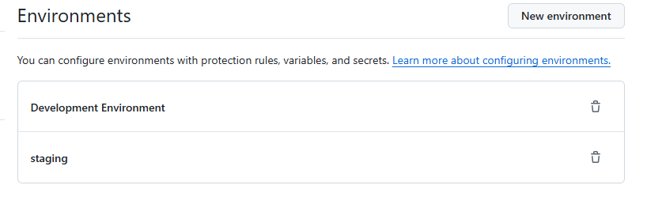

**Repository Secrets**

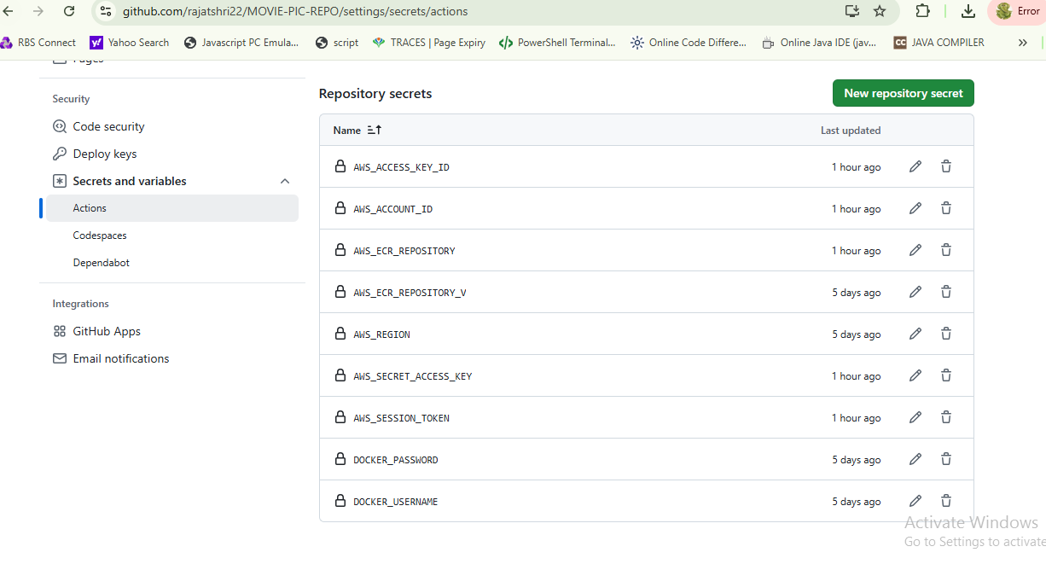

**Frontend Continuous Integration**

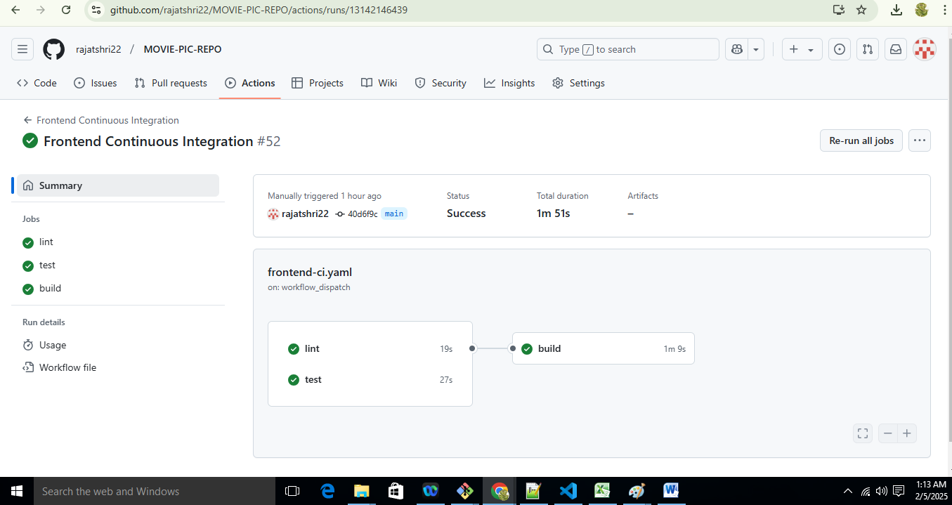

**Frontend Continuous Deployment**

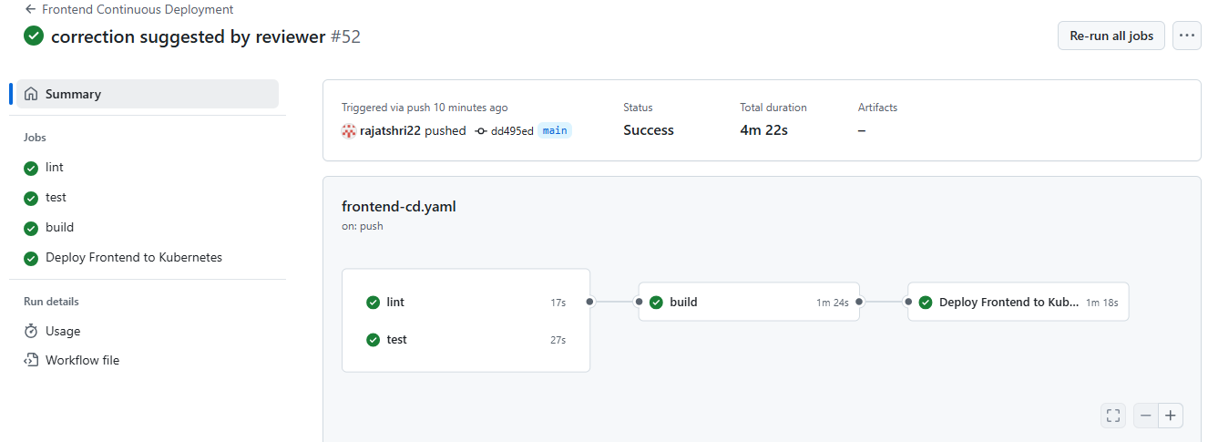

**Backend Continuous Integration**

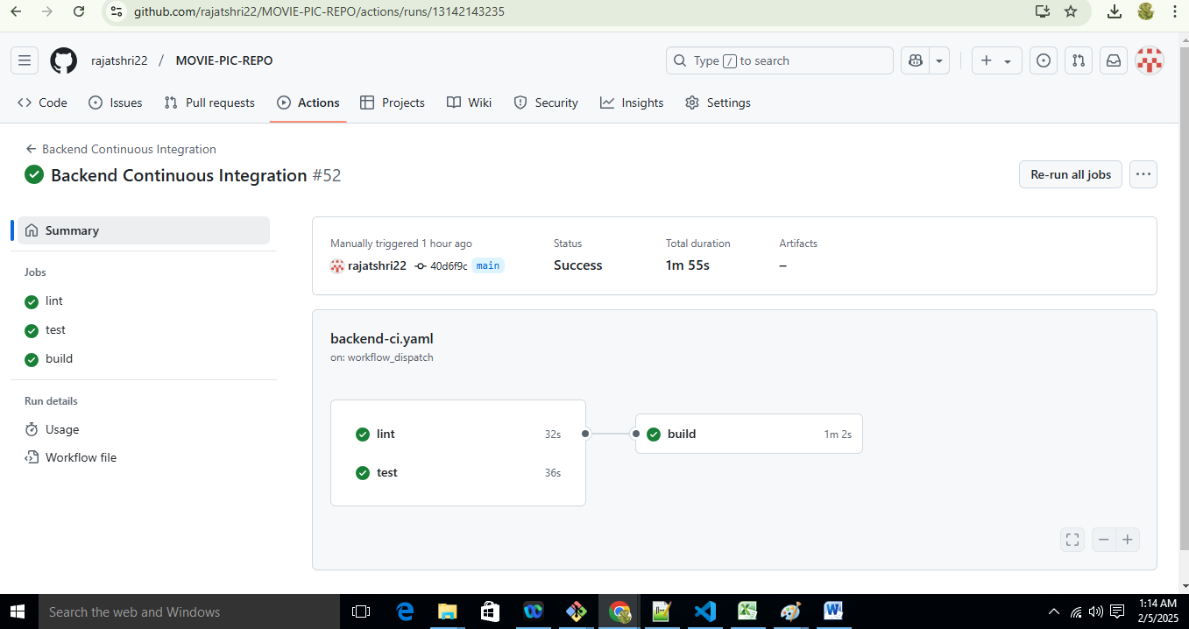

**Backend Continuous Deployment**

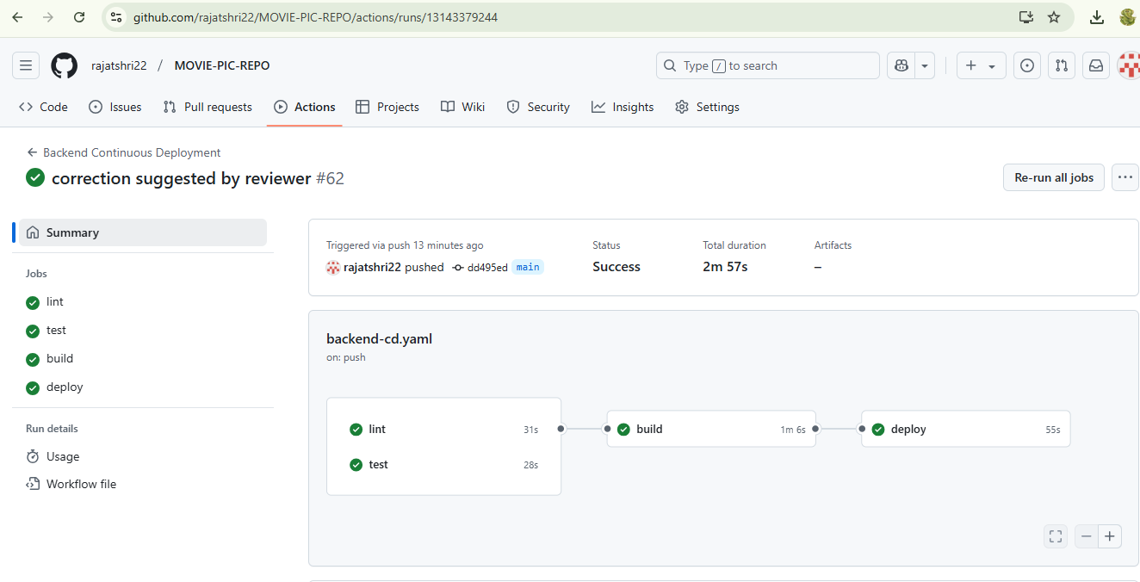

**ECR**

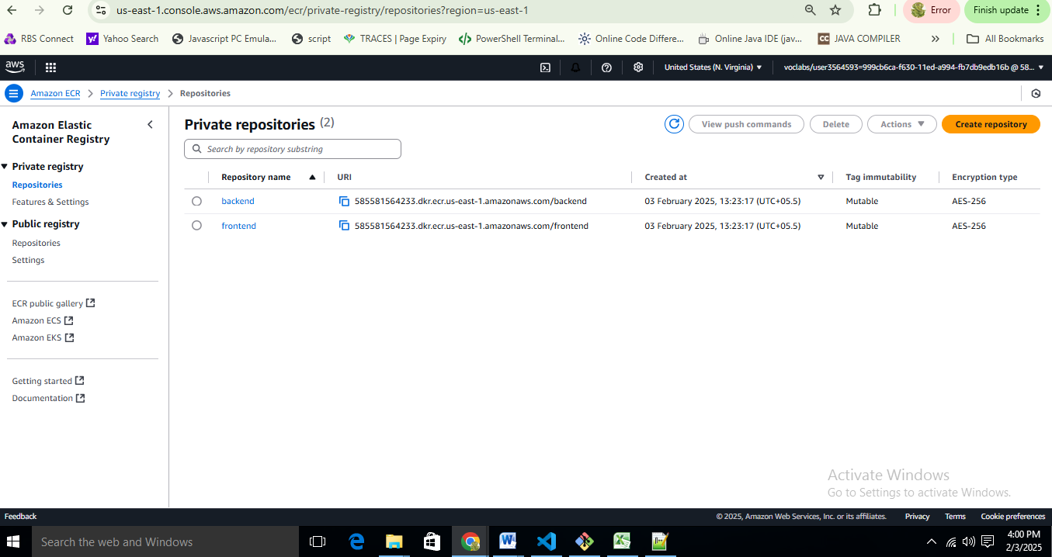

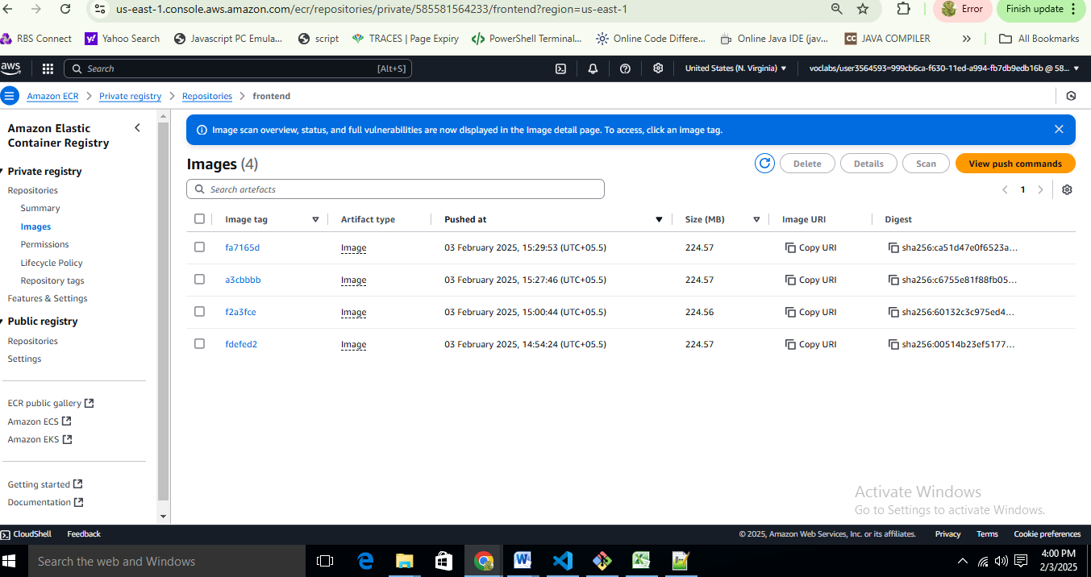

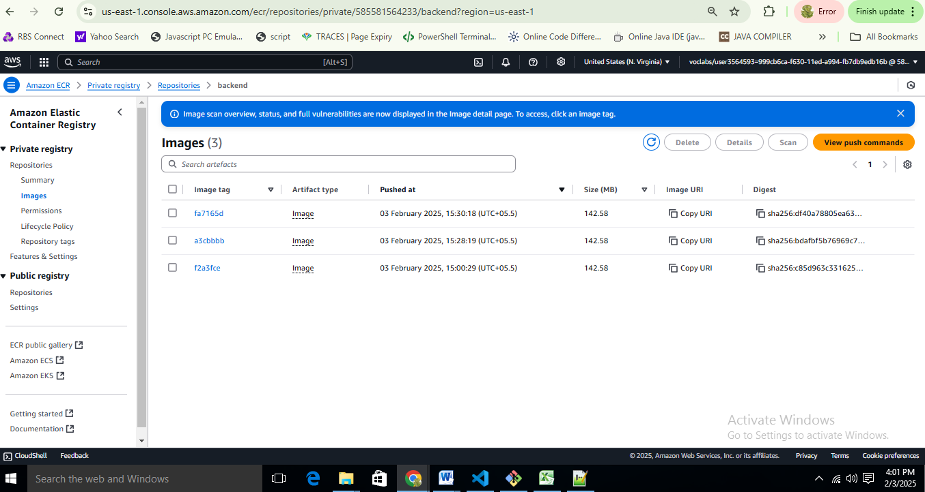

**EKS Cluster**

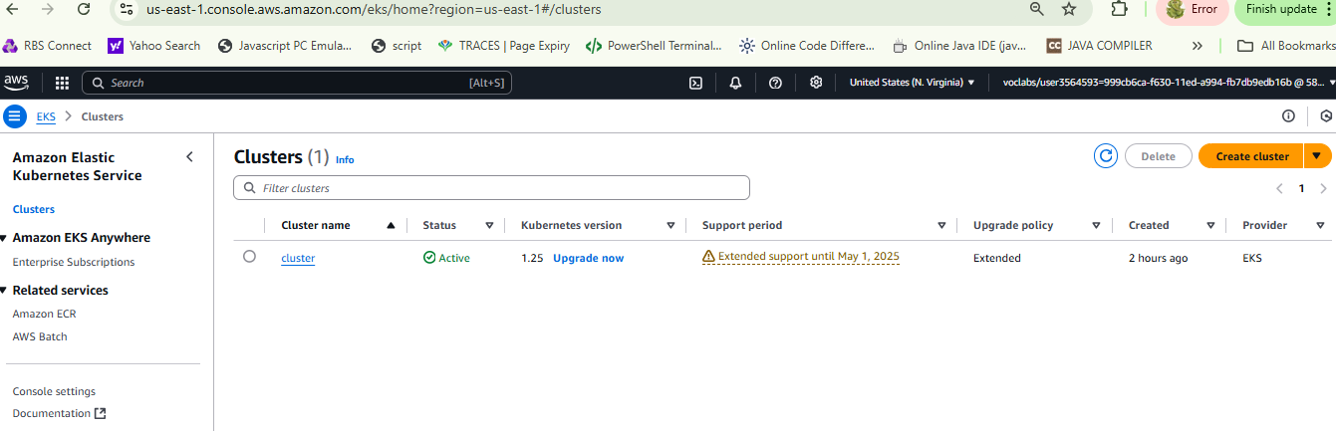

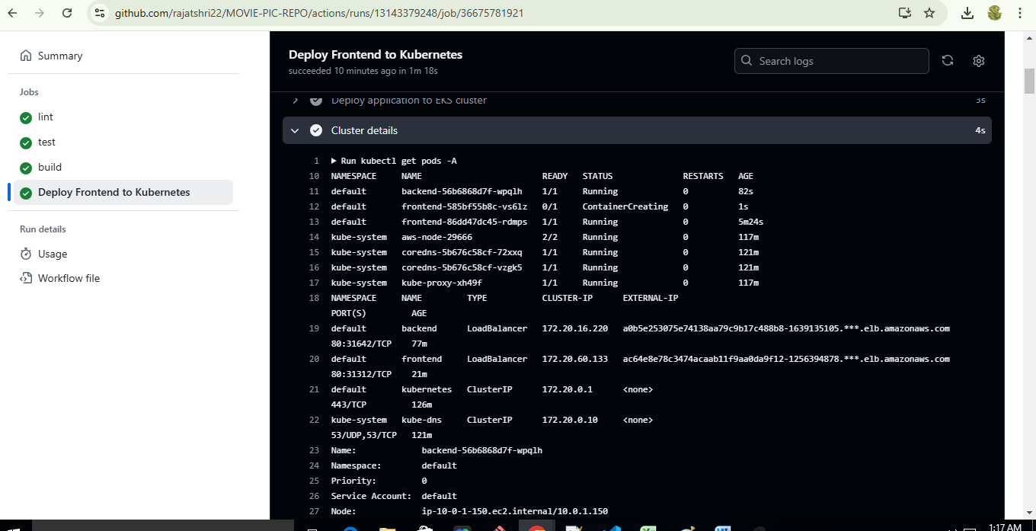

**Application URL:**

<http://ac64e8e78c3474acaab11f9aa0da9f12-1256394878.us-east-1.elb.amazonaws.com>

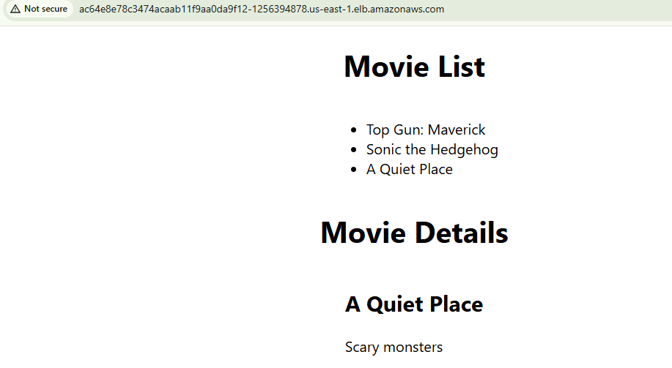

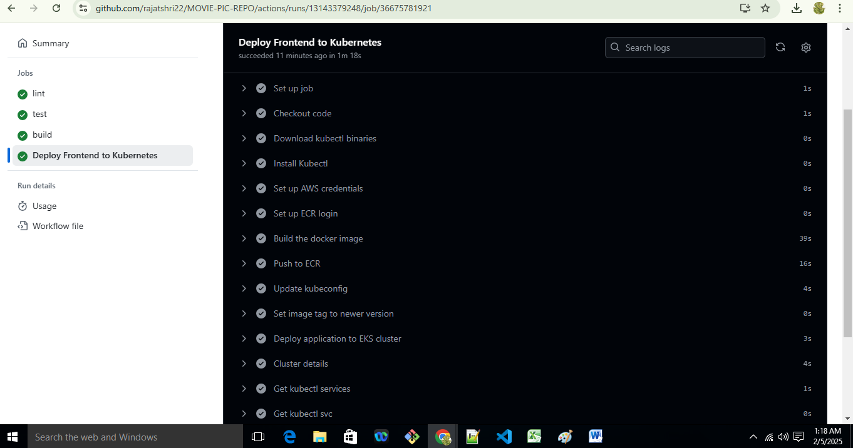

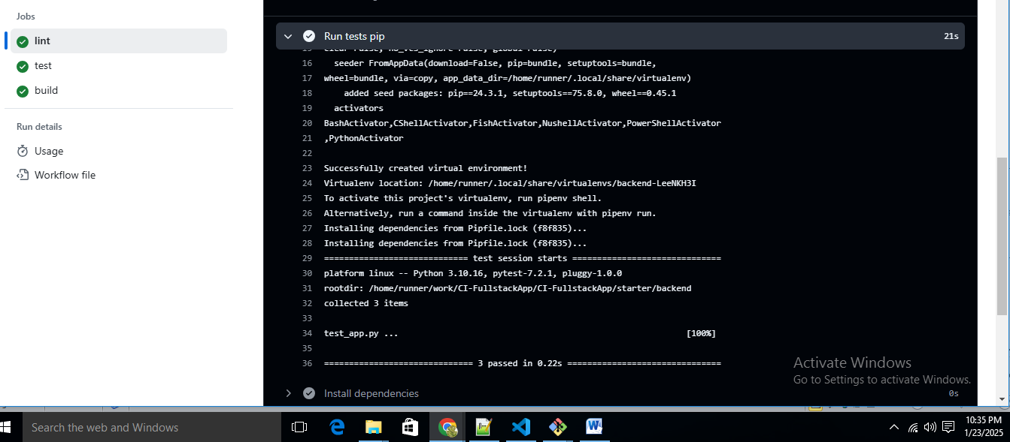

**Terraform resources deployment**

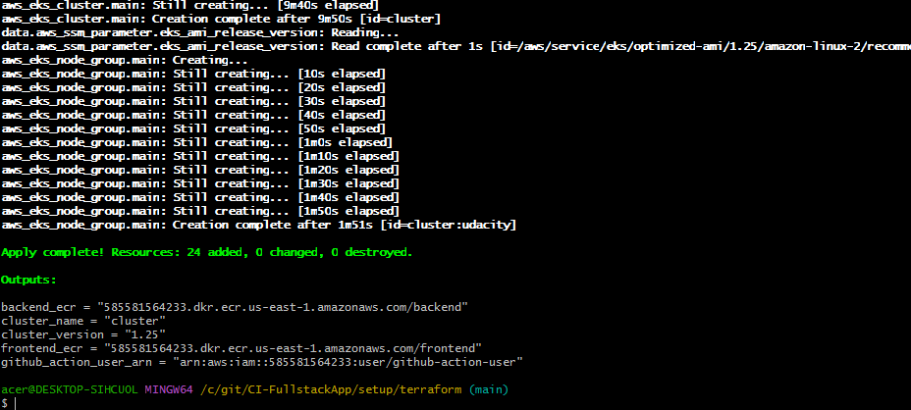

**ECR Frontend and Backend Images**

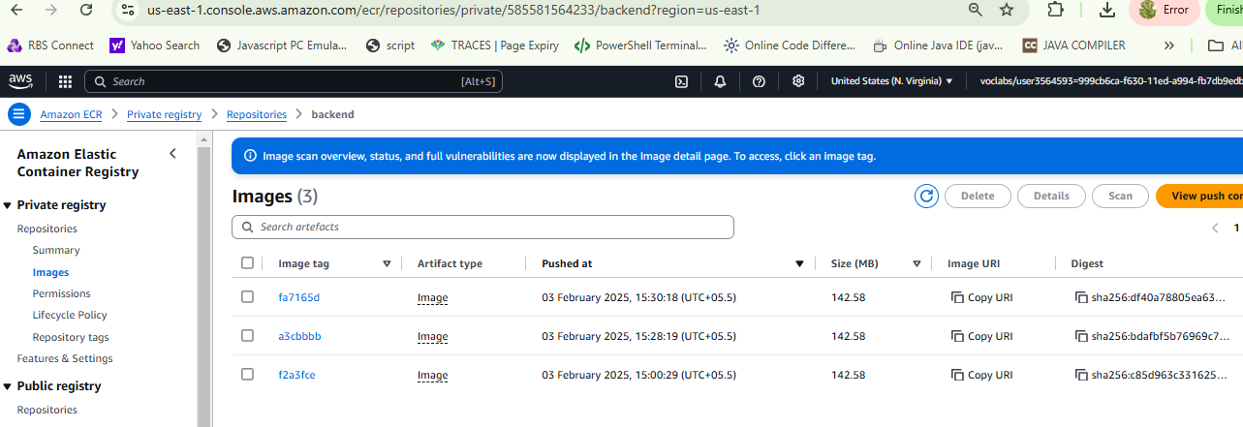

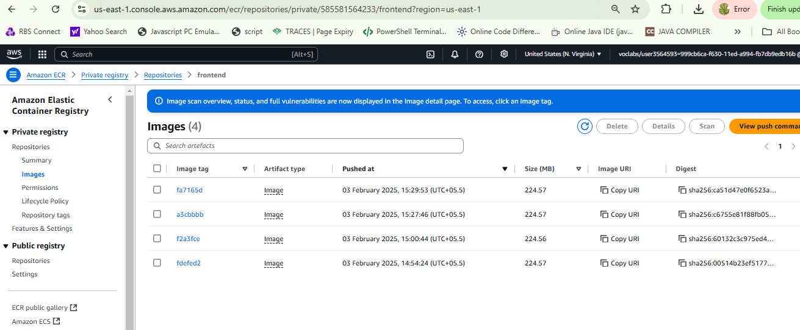

**Application URL**: <http://ac64e8e78c3474acaab11f9aa0da9f12-1256394878.us-east-1.elb.amazonaws.com>

